1 Illinois Number Pooling IIS Flows

5/18/98 – Illinois flows with Lockheed Martin Updates proposed after the 5/5/1998 meeting and the addition of the supplemental flows.

2 Subscription Version Query Scenario

2.1 Subscription Version Query with LNP Type “POOL”
This scenario shows subscriptionVersion query from service provider systems to the NPAC SMS.

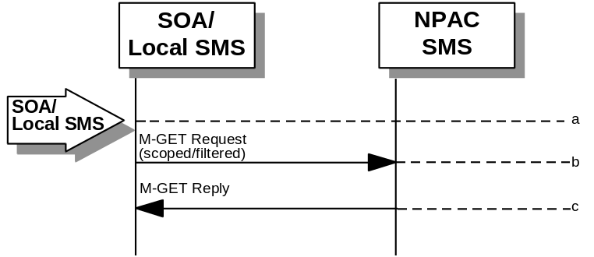
- Action is taken by either a service provider SOA or Local SMS for retrieving one or more versions of a subscription for a pooled number.
- The service provider SOA or Local SMS issues a scoped filtered M-GET from the lnpSubscriptions object to retrieve a specific version for a subscription version TN or can request all subscription versions. However, the service provider SOA is limited by a scope and filter in their search capabilities. The filter will currently support all the attributes on the subscriptionVersionNPAC.
- The NPAC SMS replies with the requested subscriptionVersion data if the requested number of records is less than or equal to “Max SubscriberQuery” specified in the NPAC SMS. Otherwise a complexityLimitation error will be returned.
- The query return data includes:
subscriptionTN
subscriptionLRN
subscriptionNewCurrentSP
subscriptionOldSP
subscriptionNewSP-DueDate
subscriptionNewSP-CreationTimeStamp
subscriptionOldSP-DueDate
subscriptionOldSP-Authorization
subscriptionOldSP-AuthorizationTimeStamp
subscriptionActivationTimeStamp
subscriptionBroadcastTimeStamp
subscriptionConflictTimeStamp
subscriptionCustomerDisconnectDate
subscriptionDisconnectCompleteTimeStamp
subscriptionEffectiveReleaseDate
subscriptionVersionStatus (active or old for Pooled Numbers)
subscriptionCLASS-DPC
subscriptionCLASS-SSN
subscriptionLIDB-DPC
subscriptionLIDB-SSN
subscriptionCNAM-DPC
subscriptionCNAM-SSN
subscriptionISVM-DPC
subscriptionISVM-SSN
subscriptionEndUserLocationValue
subscriptionEndUserLocationType
subscriptionBillingId
subscriptionLNPType
subscriptionPreCancellationStatus
subscriptionCancellationTimeStamp
subscriptionOldTimeStamp
subscriptionModifiedTimeStamp
subscriptionCreationTimeStamp
subscriptionOldSP-CancellationTimeStamp
subscriptionNewSP-CancellationTimeStamp
subscriptionOldSP-ConflictResolutionTimeStamp
subscriptionNewSP-ConflictResolutionTimeStamp
subscriptionPortingToOriginal-SPSwitch
subscriptionFailedSP-List
subscriptionDownloadReason
- Subscription Versions with an LNP Type of POOL will be returned if they match the query selection criteria.

3 Audit Scenario

3.1 SOA Initiated Audit with LNP Type “POOL”
In this scenario, the SOA initiates an audit to the NPAC SMS due to suspected subscription version discrepancies.

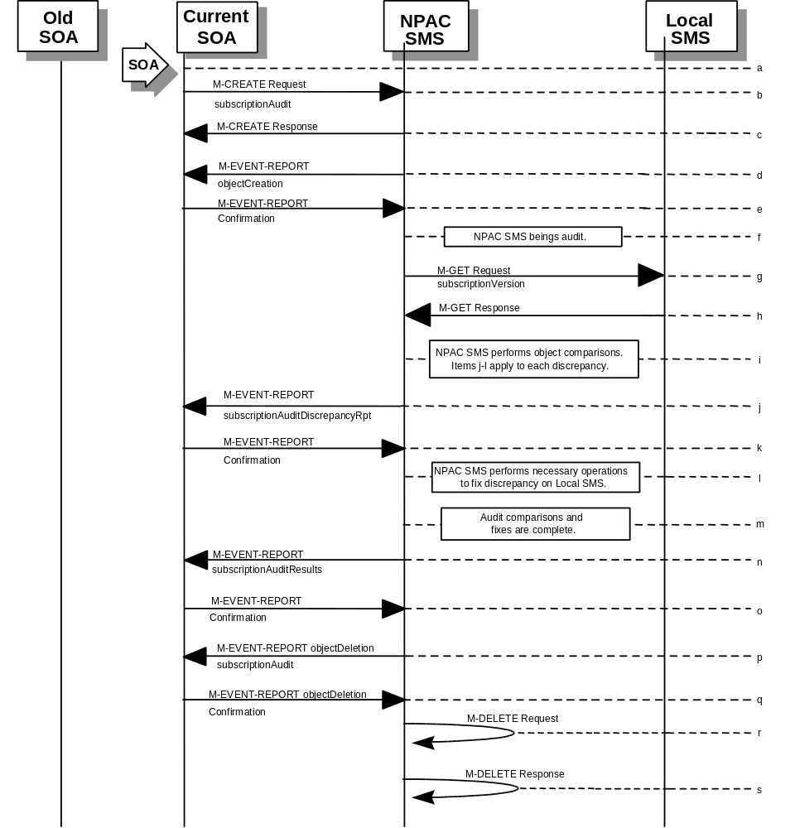
- Action is taken by SOA personnel to start an audit due to suspected network discrepancies.
- The SOA sends an M-CREATE request to the NPAC SMS, requesting an audit. The SOA must specify the following attributes in the request:
subscriptionAuditName - English audit name
subscriptionAuditRequestingSP - the service provider requesting the audit
subscriptionAuditServiceProvIdRange - which service provider or all service providers
for audit
subscriptionAuditTN-Range - TNs to be audited
- If these attributes are not specified, then the create will fail with a missingAttributesValue error. The SOA may also specify the following attributes in the request:
subscriptionAuditAttributeList - subscription version attributes to be audited
subscriptionAuditTN-ActivationRange - time range of activation for subscription versions to be audited
- The subscriptionAuditId and the subscriptionAuditStatus will be determined by the NPAC SMS. If any values are deemed invalid, an invalidArgumentValue error will be returned. NOTE: The subscriptionAuditTN-Range will be limited based on the maximum range size specified in the NPAC SMS. If the limit specified is exceeded, the create request will fail with an invalidAttributeValue error.
- Once the NPAC SMS creates the audit request object, it sends an M-CREATE response back to the SOA that initiated the request.
- NPAC SMS sends M-EVENT-REPORT to the service provider SOA for the subscriptionAudit creation.
- The service provider SOA confirms the M-EVENT-REPORT.
- NPAC SMS begins audit.
- NPAC SMS issues a scoped and filtered M-GET for the subscription versions in the audit, to all LSMS’s accepting downloads for the NPA-NXX of the subscription version.
- Local SMS returns M-GET query data.
- NPAC SMS performs the necessary comparisons of each subscription version object.
- If a discrepancy is found, NPAC SMS issues a subscriptionAuditDiscrepancyRpt M-EVENT-REPORT.
- Service provider SOA confirms the M-EVENT-REPORT.
- If a discrepancy is found, NPAC SMS issues the necessary operation to the Local SMS to correct the discrepancy (M-CREATE, M-DELETE, or
M-SET).
- NPAC SMS has completed the audit comparisons and corrections.
- NPAC SMS issues the subscriptionAuditResults M-EVENT-REPORT to the service provider SOA.
- The Service provider SOA confirms the M-EVENT-REPORT.
- The NPAC SMS then sends an objectDeletion M-EVENT-REPORT to the SOA for the subscriptionAudit object.
- The service provider SOA confirms the M-EVENT-REPORT.
- The NPAC SMS issues a local M-DELETE request for the subscriptionAudit object to/from the NPAC SMS. This will attempt to delete the subscriptionAudit object on the NPAC SMS.
- The M-DELETE response is received on the NPAC SMS indicating whether the subscriptionAudit object was deleted successfully.

4 Resynchronization Scenario

4.1 Sequencing of Events on Initialization/Resynchronization of Local SMS with LNP Type “POOL”
If the resynchronization flag is TRUE upon association establishment, the NPAC SMS will hold updates to the Local SMS until the flag is turned off. At that time all updates issued since the association establishment will be sent.
If any of the requests in this scenario fail, the Local SMS must correct the problem - retry the action instead of continuing.
In the case of subscription versions with LNP Type of POOL, the NPAC SMS suppresses notifications to the resyncing service provider’s SOA.

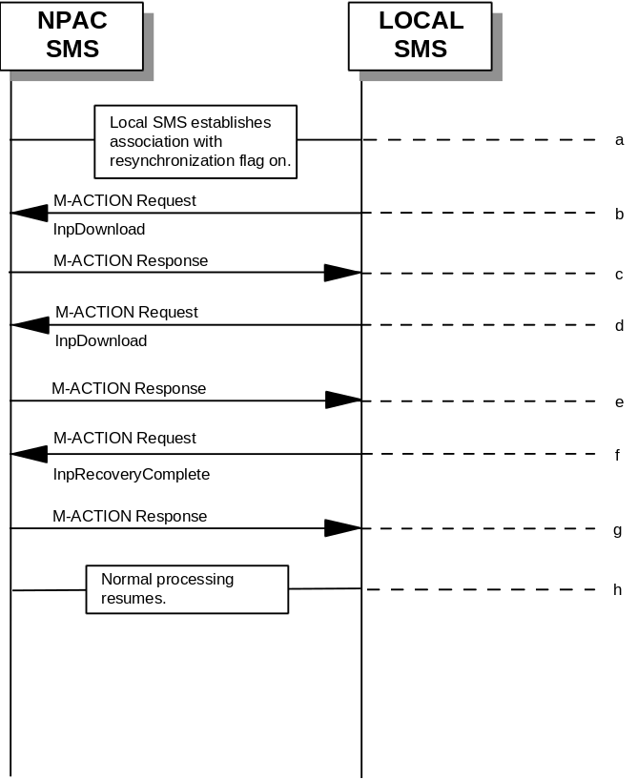
- Local SMS establishes association with resynchronization flag on.
- Local SMS sends M-ACTION to start network data download. The Local SMS specifies the start time.
- NPAC SMS responds to M-ACTION with updates.
- Local SMS sends M-ACTION to start subscription data download. The Local SMS specifies the start time.
- NPAC SMS responds to M-ACTION with subscription version updates.
- Local SMS sends M-ACTION to set resynchronization flag off.
- NPAC SMS replies with data updates since association establishment.
- Normal processing resumes.

5 Activate Scenarios

5.1 Active Subscription Version(s) Create on Local SMS with LNP Type “POOL”: Success
The NPAC personnel can port a block of TN’s to a block holder. The LNP type of the numbers being ported is “POOL”. In this scenario, the Number Pooling Block information has been entered into the NPAC SMS and the NPAC personnel have initiated the port of the block of TN’s.

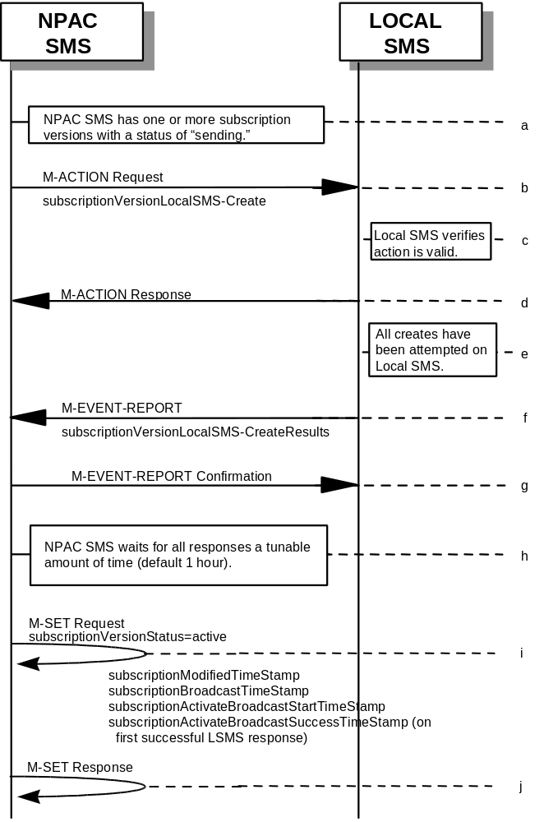
- NPAC SMS has one or more subscription versions with a status of “sending ” that have been activated by the NPAC SMS Personnel as a result of a port of a block of pooled numbers to the block holder.
- NPAC SMS issues the subscriptionVersionLocalSMS-Create action to the Local SMS, if it is accepting downloads for the NPA-NXX of the subscriptionVersion. This action contains all data necessary to create the subscription version. The start and stop TN range will be included in the data sent to the LSMS. This field is not included on any other subscriptionVersionLocalSMS-Create action.
- The Local SMS verifies the action is valid, but does not attempt to create the subscription version(s).
- The Local SMS responds to the M-ACTION.
- The Local SMS proceeds to execute all the creates specified by the action.
- The Local SMS sends to the NPAC SMS the M-EVENT-REPORT specifying the success or failure of the creates.
- NPAC SMS confirms the M-EVENT-REPORT.
- NPAC SMS waits for all responses a tunable amount of time. The default is 1 hour.
- The NPAC SMS issues an M-SET request setting the subscriptionVersionStatus to “active”, on the subscriptionVersionNPAC. The subscriptionModifiedTimeStamp, subscriptionBroadcastTimeStamp, subscriptionActivateBroadcastStartTimeStamp, and subscriptionActivateBroadcastSuccessTimeStamp (on first successful LSMS response), are set accordingly.
- NPAC SMS responds to the M-SET.

- NPAC personnel will handle failures if Local SMSs do not respond.

5.2

Create Subscription Version with LNP Type “POOL”: Resend Successful to Local SMS Action
This scenario shows the successful resend of a subscription version create with an LNP Type of “POOL”. The resend of a failed subscription version create can only be performed by authorized NPAC personnel.

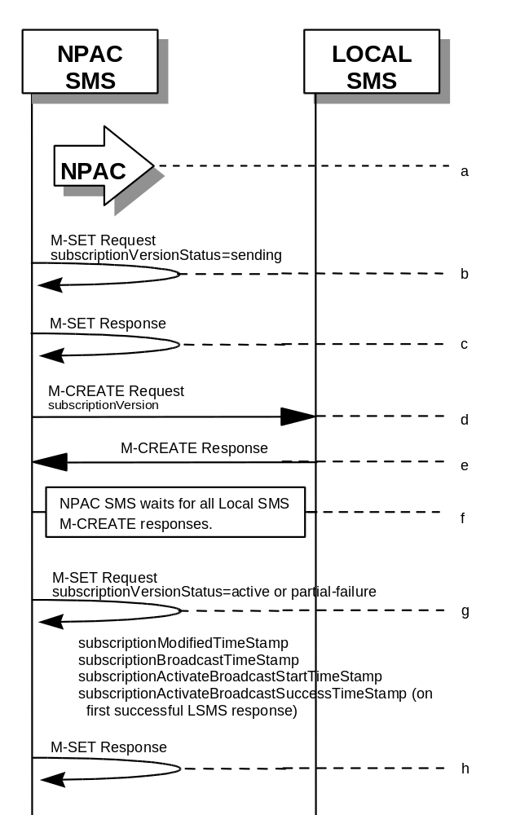
- NPAC personnel take action to resend a failed subscriptionVersion create for a subscription version with an LNP Type of “POOL”.
- NPAC SMS issues M-SET to the subscriptionVersionNPAC. The subscriptionVersionStatus is updated to “sending”.
- NPAC SMS issues M-SET response indicating success or failure.
- The NPAC SMS issues an M-CREATE for the subscriptionVersion to each of the Local SMSs that previously failed, and is accepting downloads for the NPA-NXX of the subscriptionVersion.
- Each Local SMS will reply to the M-Create.
- NPAC SMS waits for all Local SMSs to report successful subscription version creation.
- The NPAC SMS issues an M-SET request setting the subscriptionVersionStatus to “active” or “partial-failure” (along with subscriptionFailed-SP-List), on the subscriptionVersionNPAC. The subscriptionModifiedTimeStamp, subscriptionBroadcastTimeStamp, subscriptionActivateBroadcastStartTimeStamp, and subscriptionActivateBroadcastSuccessTimeStamp (on first successful LSMS response), are set accordingly.
- NPAC SMS responds to the M-SET.

5.3

Subscription Version with LNP Type of POOL: Resend Failure to Local SMS
This scenario shows a failure on a resend of a Subscription Version with an LNP Type of “POOL” to a Local SMS. The resend of a failed create version can only be performed by authorized NPAC SMS personnel.

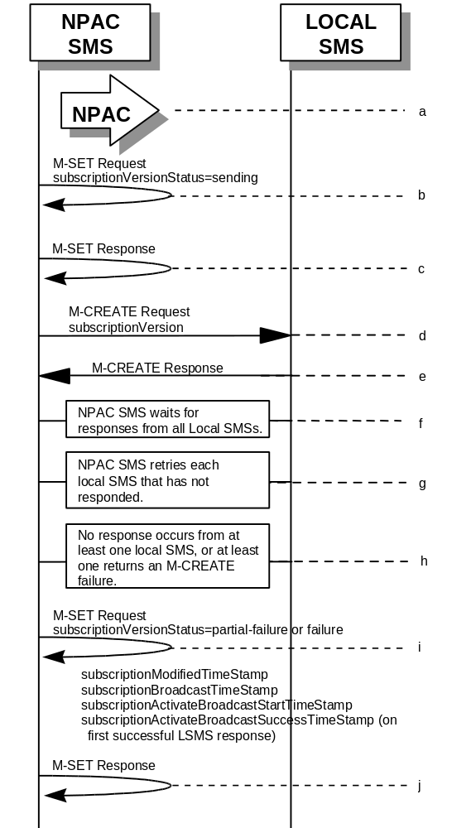
- The NPAC personnel issues a resend for the failed or partially failed subscriptionVersion.
- NPAC SMS issues M-SET to the subscriptionVersionNPAC. The subscriptionVersionStatus is updated to “sending”.
- NPAC SMS issues M-SET response indicating success or failure.
- The NPAC SMS issues an M-CREATE for the subscriptionVersion to each of the Local SMSs for which the M-CREATE previously failed, and is accepting downloads for the NPA-NXX of the subscriptionVersion.
- One or more Local SMSs respond to the M-CREATE.
- NPAC SMS waits for responses from each Local SMS.
- NPAC SMS resends, to each unresponsive Local SMS, up to a tunable number of retries at a tunable interval.
- No responses occur from at least one or all Local SMSs, or one or all Local SMSs return an M-CREATE failure.
- NPAC SMS issues M-SET to the subscriptionVersionStatus to “partial-failure” or “failed” in the subscriptionVersionNPAC object, subscriptionFailed-SP-List,. The subscriptionModifiedTimeStamp, subscriptionBroadcastTimeStamp, subscriptionActivateBroadcastStartTimeStamp, and subscriptionActivateBroadcastSuccessTimeStamp (on first successful LSMS response), are set accordingly.
- NPAC SMS issues M-SET response.

6 Modify Scenarios

6.1 SubscriptionVersion Modify Active Version with LNP Type of “POOL”
This scenario shows the modification of an active subscription version with an LNP Type of “POOL”. NPAC Personnel can only perform the modification of an active subscription version with an LNP Type of “POOL”.

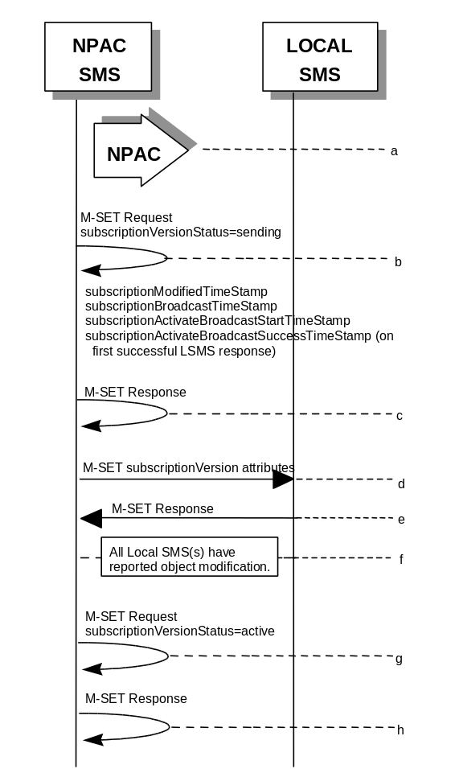
- Action is by NPAC Personnel to modify an active subscription version with an LNP Type of “POOL”. The following attributes can be modified:
subscriptionLRN
subscriptionCLASS-DPC
subscriptionCLASS-SSN
subscriptionLIDB-DPC
subscriptionLIDB-SSN
subscriptionCNAM-DPC
subscriptionCNAM-SSN
subscriptionISVM-DPC
subscriptionISVM-SSN
subscriptionEndUserLocationValue
subscriptionEndUserLocationType
subscriptionBillingId
- NPAC SMS issues M-SET to the subscriptionVersionNPAC. The subscriptionVersionStatus is updated to “sending,” and any other modified attributes are updated. The subscriptionModifiedTimeStamp, subscriptionBroadcastTimeStamp, subscriptionActivateBroadcastStartTimeStamp, and subscriptionActivateBroadcastSuccessTimeStamp (on first successful LSMS response), are set accordingly.
- NPAC SMS issues M-SET response indicating success or failure.
- NPAC SMS issues M-SET to all Local SMSs for the updated attributes, that are accepting downloads for the NPA-NXX of the subscriptionVersion. If the update involves multiple subscription version objects, a scoped and filtered request will be sent.
- Local SMSs reply to M-SET.
- All Local SMSs have reported the object modification.
- NPAC SMS issues M-SET to update the current subscriptionVersionNPAC object subscriptionVersionStatus to “active.”
- NPAC SMS responds to M-SET.

6.2

SubscriptionVersion Modify Active: Failure to Local SMS
This scenario shows the broadcast of a modified active subscription with an LNP Type of “POOL” that fails to one or more of the Local SMSs.

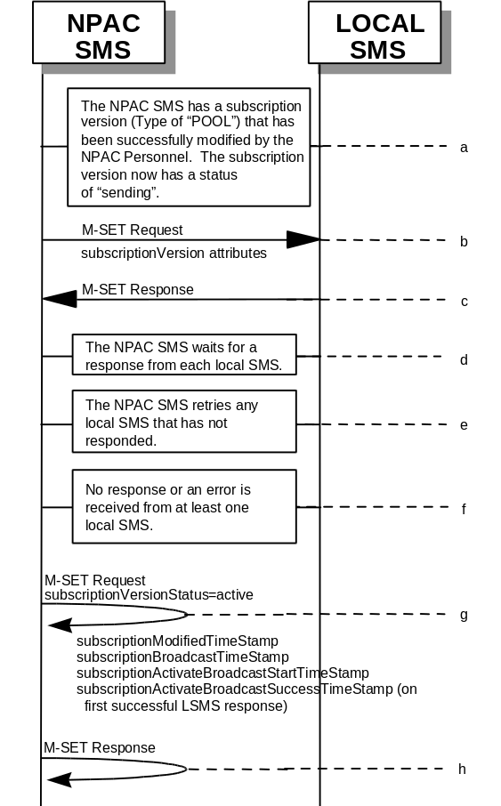
- The NPAC SMS has an active subscription version with an LNP Type of “POOL” that has been successfully modified by the NPAC Personnel. The subscription version now has a status of “sending”.
- The NPAC SMS issues M-SET to all Local SMSs for the updated attributes, that are accepting downloads for the NPA-NXX of the subscriptionVersion.
- Local SMSs should respond successfully to the M-SET.
- NPAC SMS waits for responses from each Local SMS.
- NPAC SMS retries any Local SMS that has not responded.
- No response or an error is received from at least one Local SMS.
- NPAC SMS issues the M-SET to update the current subscriptionVersionNPAC object’s subscriptionVersionStatus to “active” from “sending”. It will also update the subscriptionFailed-SP-List with the service provider ID and name of the Local SMS that failed to successfully receive the broadcast. The subscriptionModifiedTimeStamp, subscriptionBroadcastTimeStamp, subscriptionActivateBroadcastStartTimeStamp, and subscriptionActivateBroadcastSuccessTimeStamp (on first successful LSMS response), are set accordingly.
- NPAC SMS responds to the M-SET.

6.3

Subscription Version Modify Active: Resend Successful to Local SMS
This scenario shows the successful resend of a modification of an active subscription with an LNP Type of “POOL”. The resend of a failed modified active version can only be performed by authorized NPAC personnel.

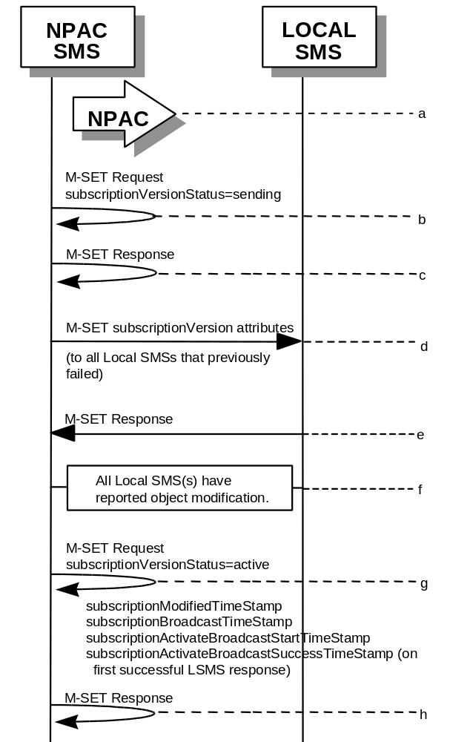
- Action is taken by NPAC personnel to resend the failed modified active version with an LNP TYPE of “POOL”.
- NPAC SMS issues M-SET to the subscriptionVersionNPAC. The subscriptionVersionStatus is updated to “sending”.
- NPAC SMS issues M-SET response indicating success or failure.
- NPAC SMS issues M-SET to all Local SMSs that previously failed for the updated attributes, and are accepting downloads for the NPA-NXX of the subscriptionVersion.
- Local SMSs reply to M-SET.
- All Local SMSs have reported the object modification.
- NPAC SMS issues M-SET to update the current subscriptionVersionNPAC object subscriptionVersionStatus to “active.” The subscriptionModifiedTimeStamp, subscriptionBroadcastTimeStamp, subscriptionActivateBroadcastStartTimeStamp, and subscriptionActivateBroadcastSuccessTimeStamp (on first successful LSMS response), are set accordingly.
- NPAC SMS responds to M-SET.

6.4

Subscription Version Modify Active: Resend Failure to Local SMS
This scenario shows a failure on a resend of a modified active subscription with an LNP Type of “POOL” that failed previously to one or more of the Local SMSs. Authorized NPAC personnel can only perform the resend of a failed modified active version.

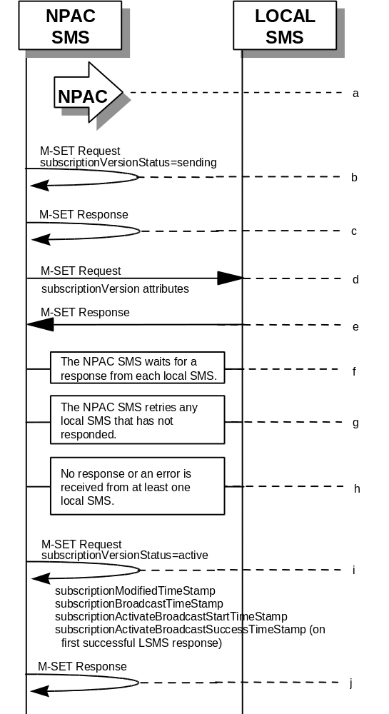
- The NPAC SMS has an active subscription version with an LNP Type of “POOL” that failed a modify broadcast. The NPAC personnel issues a resend for the failed modified version and the subscription version now has a status of “sending”.
- NPAC SMS issues M-SET to the subscriptionVersionNPAC. The subscriptionVersionStatus is updated to “sending”.
- NPAC SMS issues M-SET response indicating success or failure.
- The NPAC SMS issues M-SET to all Local SMSs that previously failed for the updated attributes, and are accepting downloads for the NPA-NXX of the subscriptionVersion.
- Local SMSs should respond successfully to the M-SET.
- NPAC SMS waits for responses from each Local SMS.
- NPAC SMS retries any Local SMS that has not responded.
- No response or an error is received from at least one or all Local SMSs.
- NPAC SMS issues the M-SET to update the current subscriptionVersionNPAC object’s subscriptionVersionStatus to “active” from “sending”. It will also update the subscriptionFailed-SP-List with the service provider ID and name of the Local SMSs that failed to successfully receive the broadcast. The subscriptionModifiedTimeStamp, subscriptionBroadcastTimeStamp, subscriptionActivateBroadcastStartTimeStamp, and subscriptionActivateBroadcastSuccessTimeStamp (on first successful LSMS response), are set accordingly.
- NPAC SMS responds to the M-SET.

7 Port-To-Original Scenarios

7.1 Port to Original for a Pooled Number: Success
This scenario shows the broadcast of a Port to Original subscription that is successful to all of the Local SMSs.

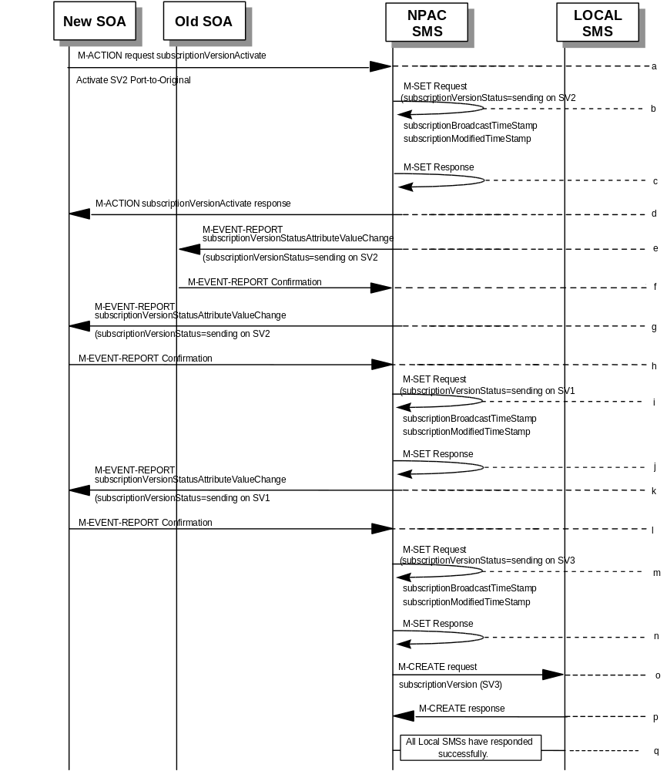
(continued on next page)
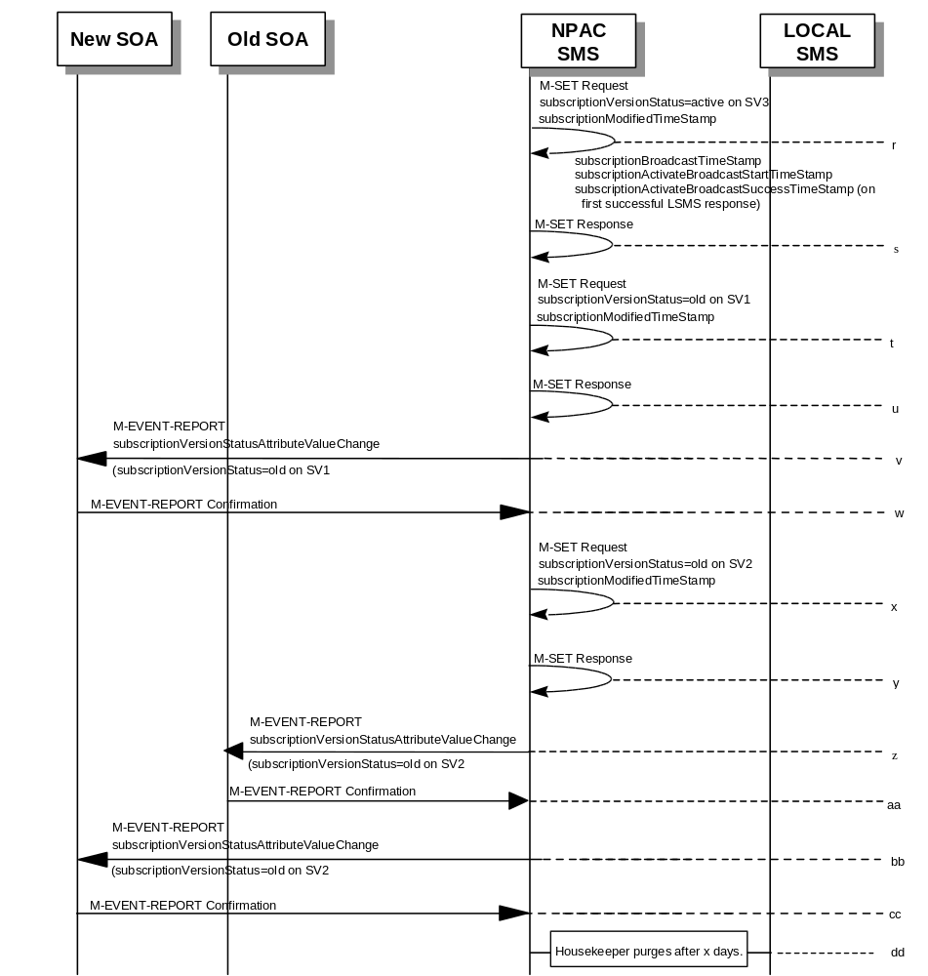

SV1 is the currently active Subscription Version.
SV2 is the current pending Subscription Version with the Port-To-Original flag set to TRUE.
SV3 is the pool reinstatement Subscription Version with LNPType = Pool that reinstates default routing to the block holder.
- The new service provider SOA issues a subscriptionVersionActivate M-ACTION to the NPAC SMS lnpSubscriptions object to activate the pending subscription version SV2 by specifying the subscription version ID, subscription version TN, or a range of subscription version TNs.
- The NPAC SMS issues an M-SET request setting the subscriptionVersionStatus to “sending”, subscriptionBroadcastTimeStamp and subscriptionModifiedTimeStamp on the subscriptionVersionNPAC on SV2.
- NPAC SMS responds to the M-SET.
- The NPAC SMS responds with the M-ACTION response. An error will be returned if the service provider is not the new service provider (accessDenied) or if there is no version to be activated (invalidArgumentValue) or if any other failures occur.
- If the M-ACTION was successful, the NPAC SMS sends to the old service provider SOA a subscriptionVersionStatusAttributeValueChange for the subscriptionVersionStatus being set to sending on SV2.
- The old service provider SOA returns an M-EVENT-REPORT confirmation to the NPAC SMS.
- If the M-ACTION was successful, the NPAC SMS sends to the new service provider SOA a subscriptionVersionStatusAttributeValueChange for the subscriptionVersionStatus being set to sending on SV2.
- The new service provider SOA returns an M-EVENT-REPORT confirmation to the NPAC SMS.
- The NPAC SMS issues an M-SET request setting the subscriptionVersionStatus to “sending”, subscriptionBroadcastTimeStamp and subscriptionModifiedTimeStamp on the subscriptionVersionNPAC on SV1.
- NPAC SMS responds to the M-SET.
- If the M-ACTION was successful, the NPAC SMS sends to the new service provider SOA a subscriptionVersionStatusAttributeValueChange for the subscriptionVersionStatus being set to sending on SV1.
- The new service provider SOA returns an M-EVENT-REPORT confirmation to the NPAC SMS.
- The NPAC SMS issues an M-SET request setting the subscriptionVersionStatus to “sending”, subscriptionBroadcastTimeStamp and subscriptionModifiedTimeStamp on the subscriptionVersionNPAC on SV3.
- NPAC SMS responds to the M-SET.
- NPAC SMS sends out an M-CREATE on the subscription Version SV3 to all Local SMSs, that are accepting downloads for the NPA-NXX of subscription Version SV3. If the M-CREATE is for multiple subscription versions, a scoped and filtered operation will be sent. The SV3 created on the Local SMS systems contains the default block routing information and has an LNP Type of “POOL”. The NPAC SMS would put this information on SV3 in the NPAC SMS for the port since no routing information is sent for this type of port (POOL) over the SOA to NPAC SMS interface. The NPAC SMS schedules an LSMS Response Timer for each subscription version.
- Each Local SMS responds with a successful M-CREATE reply.
- All Local SMSs respond successfully.
- NPAC SMS issues an M-SET updating the subscriptionVersionStatus of SV3 to active. The subscriptionModifiedTimeStamp, subscriptionBroadcastTimeStamp, subscriptionActivateBroadcastStartTimeStamp, and subscriptionActivateBroadcastSuccessTimeStamp (on first successful LSMS response), are set accordingly.
- NPAC SMS responds to the M-SET.
- NPAC SMS issues an M-SET updating the subscriptionVersionStatus of SV1 to old. It also sets the subscriptionModifiedTimeStamp.
- NPAC SMS responds to the M-SET.
- The NPAC SMS sends to the new service provider SOA a subscriptionVersionStatusAttributeValueChange for the subscriptionVersionStatus being set to old on SV1.
- The new service provider SOA returns an M-EVENT-REPORT confirmation to the NPAC SMS.
- NPAC SMS issues an M-SET updating the subscriptionVersionStatus of SV2 to old. It also sets the subscriptionModifiedTimeStamp.
- NPAC SMS responds to the M-SET.
- The NPAC SMS sends to the old service provider SOA a subscriptionVersionStatusAttributeValueChange for the subscriptionVersionStatus being set to old on SV2.
- The old service provider SOA returns an M-EVENT-REPORT confirmation to the NPAC SMS.
- The NPAC SMS sends to the current/new service provider SOA a subscriptionVersionStatusAttributeValueChange for the subscriptionVersionStatus being set to old on SV2.
- The current/new service provider SOA returns an M-EVENT-REPORT confirmation to the NPAC SMS.
- After a tunable amount of days, the subscription versions SV1 and SV2 are purged by the NPAC SMS housekeeping process.

7.2

Port to Original for a Pooled Number: Failure to All Local SMSs
This scenario shows the broadcast of a Port to Original subscription that fails to all of the Local SMSs.

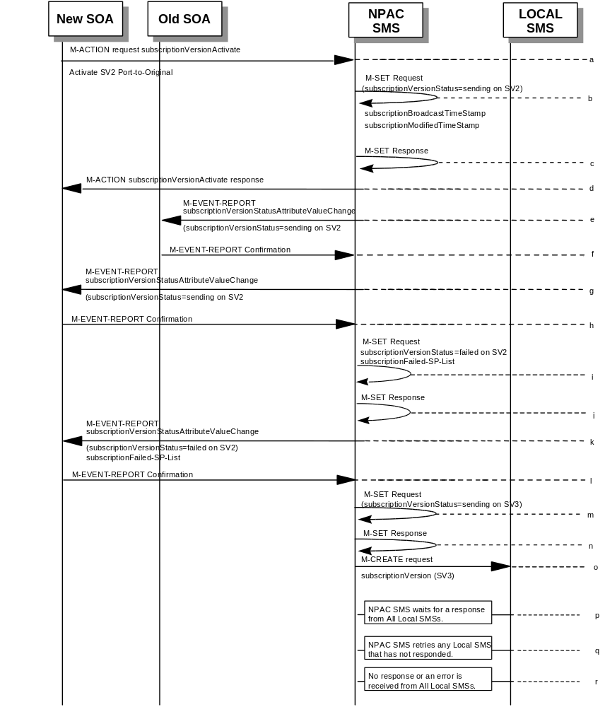
(continued on next page)
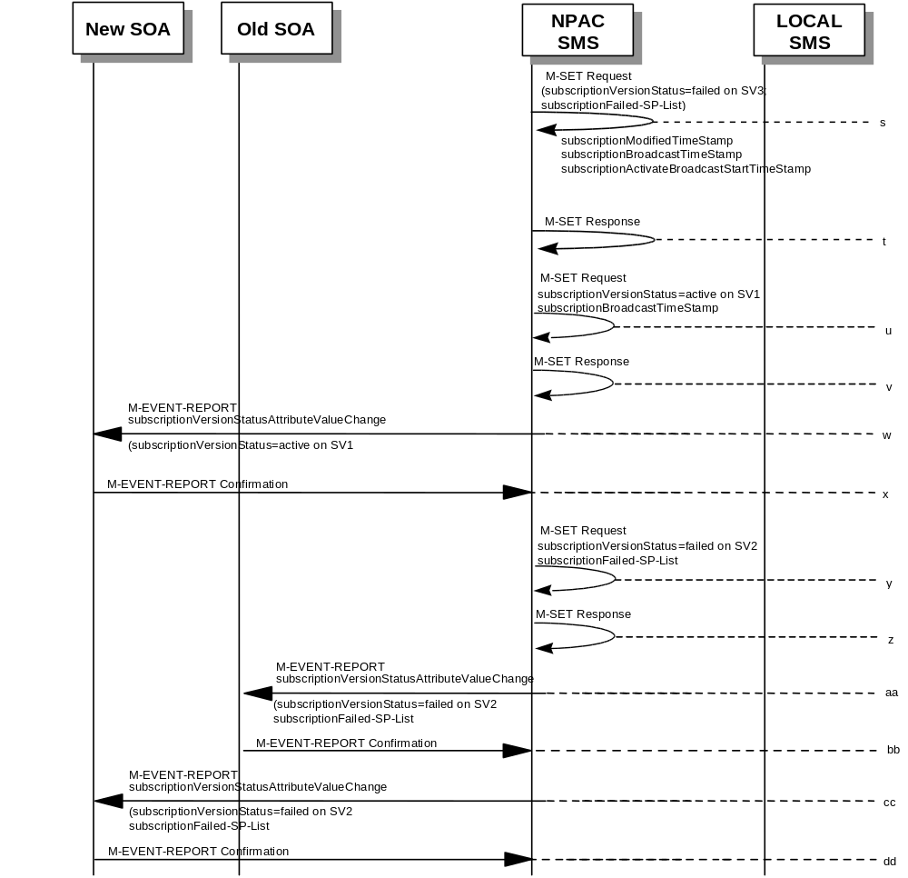

SV1 is the currently active Subscription Version.
SV2 is the current pending Subscription Version with the Port to Original flag set to TRUE.
SV3 is the pool reinstatement Subscription Version with LNPType = Pool that reinstates default routing to the block holder.
- The new service provider SOA issues a subscriptionVersionActivate M-ACTION to the NPAC SMS lnpSubscriptions object to activate the pending subscription version SV2 by specifying the subscription version ID, subscription version TN, or a range of subscription version TNs.
- The NPAC SMS issues an M-SET request setting the subscriptionVersionStatus to “sending”, subscriptionBroadcastTimeStamp and subscriptionModifiedTimeStamp on the subscriptionVersionNPAC on SV2.
- NPAC SMS responds to the M-SET.
- The NPAC SMS responds with the M-ACTION response. An error will be returned if the service provider is not the new service provider (accessDenied) or if there is no version to be activated (invalidArgumentValue) or if any other failures occur.
- If the M-ACTION was successful, the NPAC SMS sends to the old service provider SOA a subscriptionVersionStatusAttributeValueChange for the subscriptionVersionStatus being set to sending on SV2.
- The old service provider SOA returns an M-EVENT-REPORT confirmation to the NPAC SMS.
- If the M-ACTION was successful, the NPAC SMS sends to the new service provider SOA a subscriptionVersionStatusAttributeValueChange for the subscriptionVersionStatus being set to sending on SV2.
- The new service provider SOA returns an M-EVENT-REPORT confirmation to the NPAC SMS.
- The NPAC SMS issues an M-SET request setting the subscriptionVersionStatus to “sending”, subscriptionBroadcastTimeStamp and subscriptionModifiedTimeStamp on the subscriptionVersionNPAC on SV1.
- NPAC SMS responds to the M-SET.
- If the M-ACTION was successful, the NPAC SMS sends to the new service provider SOA a subscriptionVersionStatusAttributeValueChange for the subscriptionVersionStatus being set to sending on SV1.
- The new service provider SOA returns an M-EVENT-REPORT confirmation to the NPAC SMS.
- The NPAC SMS issues an M-SET request setting the subscriptionVersionStatus to “sending”, subscriptionBroadcastTimeStamp and subscriptionModifiedTimeStamp on the subscriptionVersionNPAC on SV3.
- NPAC SMS responds to the M-SET.
- NPAC SMS sends out an M-CREATE on the subscription Version SV3 to all Local SMSs, that are accepting downloads for the NPA-NXX of subscription Version SV3. If the M-CREATE is for multiple subscription versions, a scoped and filtered operation will be sent. The SV3 created on the Local SMS systems contains the default block routing information and has an LNP Type of “POOL”. The NPAC SMS would put this information on SV3 in the NPAC SMS for the port since no routing information is sent for this type of port (POOL) over the SOA to NPAC SMS interface. The NPAC SMS schedules an LSMS Response Timer for each subscription version.
- NPAC SMS waits for a response from each Local SMS.
- NPAC SMS retries any Local SMS that has not responded.
- No response or an error is received from all Local SMSs.
- NPAC SMS issues the M-SET to update the current subscriptionVersionNPAC object’s subscriptionVersionStatus to “failed”, for SV3. It also sets the subscriptionFailed-SP-List. The subscriptionModifiedTimeStamp, subscriptionBroadcastTimeStamp, and subscriptionActivateBroadcastStartTimeStamp, are set accordingly.
- NPAC SMS responds to the M-SET.
- NPAC SMS issues the M-SET to update the current subscriptionVersionNPAC object’s subscriptionVersionStatus to “active” from “sending”, for SV1. The subscriptionBroadcastTimeStamp is set accordingly.
- NPAC SMS responds to the M-SET.
- The NPAC SMS sends to the current/new service provider SOA a subscriptionVersionStatusAttributeValueChange for the subscriptionVersionStatus being set to active on SV1.
- The current/new service provider SOA returns an M-EVENT-REPORT confirmation to the NPAC SMS.
- NPAC SMS issues the M-SET to update the current subscriptionVersionNPAC object’s subscriptionVersionStatus to “failed” from “sending”, for SV2. It will also update the subscriptionFailed-SP-List with the service provider ID and name of all the Local SMSs.
- NPAC SMS responds to the M-SET.
- The NPAC SMS sends to the old service provider SOA a subscriptionVersionStatusAttributeValueChange for the subscriptionVersionStatus being set to failed on SV2, along with the subscriptionFailed-SP-List.
- The old service provider SOA returns an M-EVENT-REPORT confirmation to the NPAC SMS.
- The NPAC SMS sends to the current/new service provider SOA a subscriptionVersionStatusAttributeValueChange for the subscriptionVersionStatus being set to failed on SV2, along with the subscriptionFailed-SP-List.
- The current/new service provider SOA returns an M-EVENT-REPORT confirmation to the NPAC SMS.

7.3

Port to Original for a Pooled Number: Partial Failure to one or more Local SMSs
This scenario shows the broadcast of a Port to Original subscription that fails to one or more, but not all, of the Local SMSs.

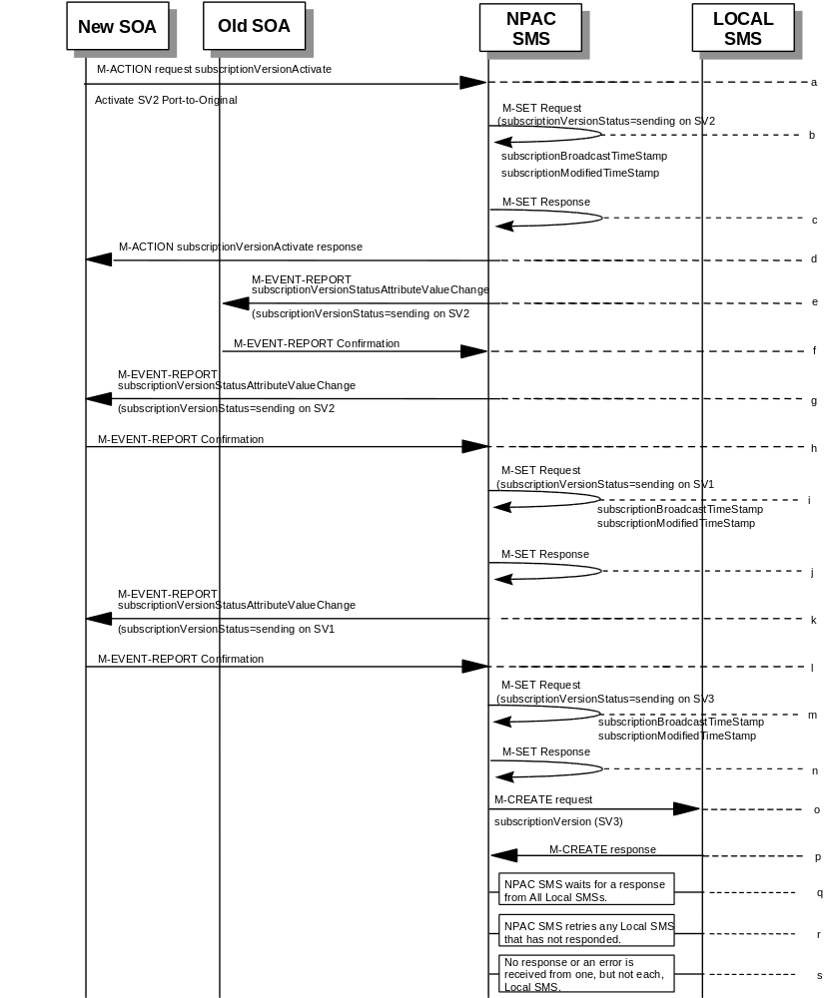

(continued on next page)
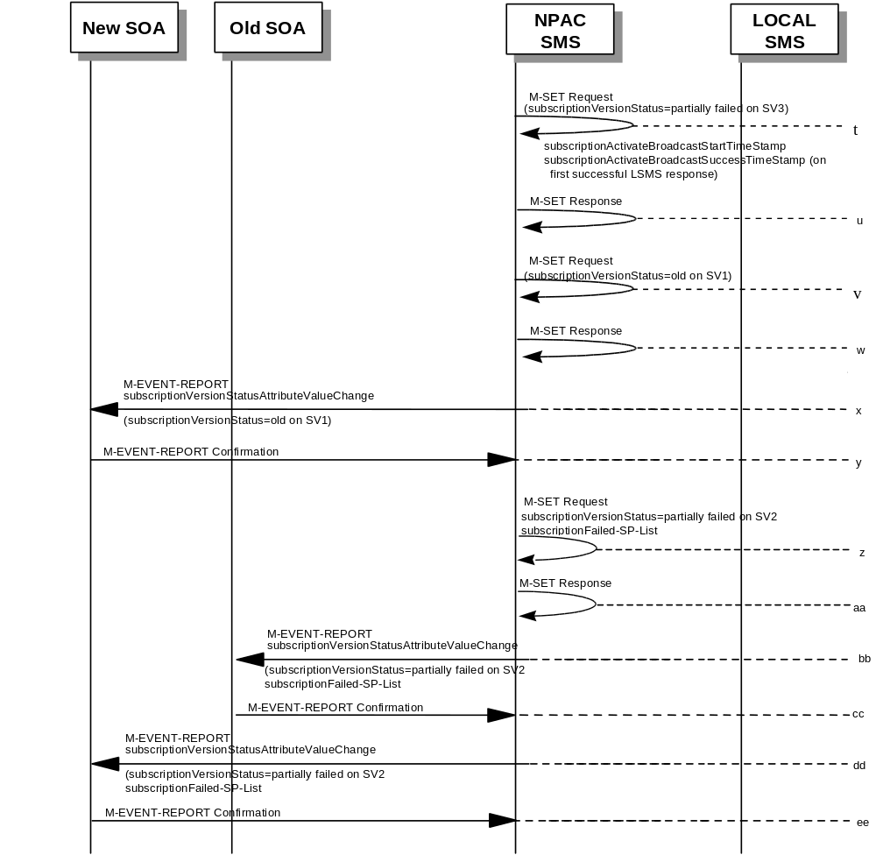
SV1 is the currently active Subscription Version.
SV2 is the current pending Subscription Version with the Port-To-Original flag set to TRUE.
SV3 is the pool reinstatement Subscription Version with LNPType = Pool that reinstates default routing to the block holder.
- The new service provider SOA issues a subscriptionVersionActivate M-ACTION to the NPAC SMS lnpSubscriptions object to activate the pending subscription version SV2 by specifying the subscription version ID, subscription version TN, or a range of subscription version TNs.
- The NPAC SMS issues an M-SET request setting the subscriptionVersionStatus to “sending”, subscriptionBroadcastTimeStamp and subscriptionModifiedTimeStamp on the subscriptionVersionNPAC on SV2.
- NPAC SMS responds to the M-SET.
- The NPAC SMS responds with the M-ACTION response. An error will be returned if the service provider is not the new service provider (accessDenied) or if there is no version to be activated (invalidArgumentValue) or if any other failures occur.
- If the M-ACTION was successful, the NPAC SMS sends to the old service provider SOA a subscriptionVersionStatusAttributeValueChange for the subscriptionVersionStatus being set to sending on SV2.
- The old service provider SOA returns an M-EVENT-REPORT confirmation to the NPAC SMS.
- If the M-ACTION was successful, the NPAC SMS sends to the new service provider SOA a subscriptionVersionStatusAttributeValueChange for the subscriptionVersionStatus being set to sending on SV2.
- The new service provider SOA returns an M-EVENT-REPORT confirmation to the NPAC SMS.
- The NPAC SMS issues an M-SET request setting the subscriptionVersionStatus to “sending”, subscriptionBroadcastTimeStamp and subscriptionModifiedTimeStamp on the subscriptionVersionNPAC on SV1.
- NPAC SMS responds to the M-SET.
- If the M-ACTION was successful, the NPAC SMS sends to the new service provider SOA a subscriptionVersionStatusAttributeValueChange for the subscriptionVersionStatus being set to sending on SV1.
- The new service provider SOA returns an M-EVENT-REPORT confirmation to the NPAC SMS.
- The NPAC SMS issues an M-SET request setting the subscriptionVersionStatus to “sending”, subscriptionBroadcastTimeStamp and subscriptionModifiedTimeStamp on the subscriptionVersionNPAC on SV3.
- NPAC SMS responds to the M-SET.
- NPAC SMS sends out an M-CREATE on the subscription Version SV3 to all Local SMSs, that are accepting downloads for the NPA-NXX of subscription Version SV3. If the M-CREATE is for multiple subscription versions, a scoped and filtered operation will be sent. The SV3 created on the Local SMS systems contains the default block routing information and has an LNP Type of “POOL”. The NPAC SMS would put this information on SV3 in the NPAC SMS for a the port since no routing information is sent for this type of port (POOL) over the SOA to NPAC SMS interface. The NPAC SMS schedules an LSMS Response Timer for each subscription version.
- Local SMSs should respond successfully to the M-CREATE.
- NPAC SMS waits for a response from each Local SMS.
- NPAC SMS retries any Local SMS that has not responded.
- No response or an error is received from at least one, but not all, Local SMSs.
- The NPAC SMS issues an M-SET request setting the subscriptionVersionStatus to “partially failed”, on the subscriptionVersionNPAC on SV3. The subscriptionActivateBroadcastStartTimeStamp, and subscriptionActivateBroadcastSuccessTimeStamp (on first successful LSMS response), are set accordingly.
- NPAC SMS responds to the M-SET.
- The NPAC SMS issues an M-SET request setting the subscriptionVersionStatus to “old”, on the subscriptionVersionNPAC on SV1.
- NPAC SMS responds to the M-SET.
- If the M-ACTION was successful, the NPAC SMS sends to the new service provider SOA a subscriptionVersionStatusAttributeValueChange for the subscriptionVersionStatus being set to old on SV1.
- The new service provider SOA returns an M-EVENT-REPORT confirmation to the NPAC SMS.

- NPAC SMS issues the M-SET to update the current subscriptionVersionNPAC object’s subscriptionVersionStatus to “partially failed” from “sending”, for SV2. It will also update the subscriptionFailed-SP-List with the service provider ID and name of the discrepant Local SMSs.
- NPAC SMS responds to the M-SET.
- The NPAC SMS sends to the old service provider SOA a subscriptionVersionStatusAttributeValueChange for the subscriptionVersionStatus being set to partially failed on SV2, along with the subscriptionFailed-SP-List.
- The old service provider SOA returns an M-EVENT-REPORT confirmation to the NPAC SMS.
- The NPAC SMS sends to the current/new service provider SOA a subscriptionVersionStatusAttributeValueChange for the subscriptionVersionStatus being set to partially failed on SV2, along with the subscriptionFailed-SP-List.
- The current/new service provider SOA returns an M-EVENT-REPORT confirmation to the NPAC SMS.

7.4

Port to Original for a Pooled Number: Resend Successful
This scenario shows how a port-to-original (resend) port of a pooled number is processed.

(continued on next page)
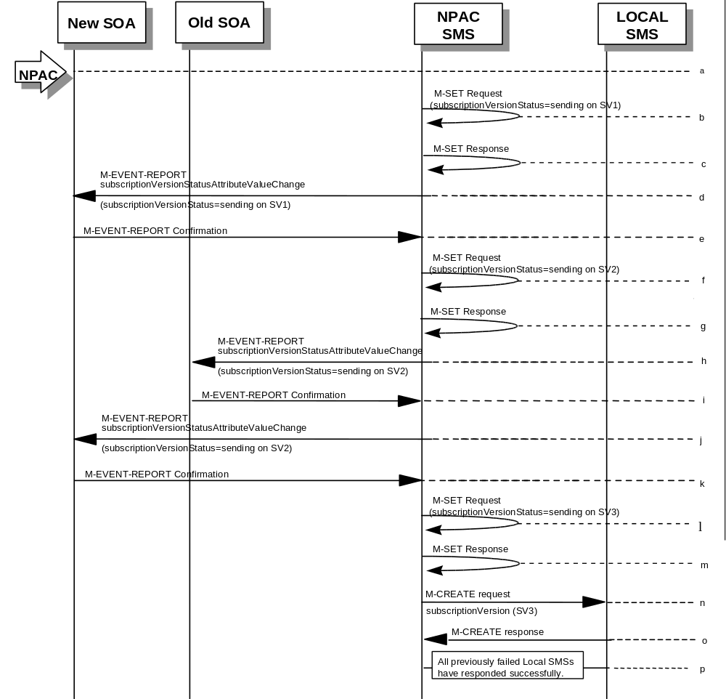

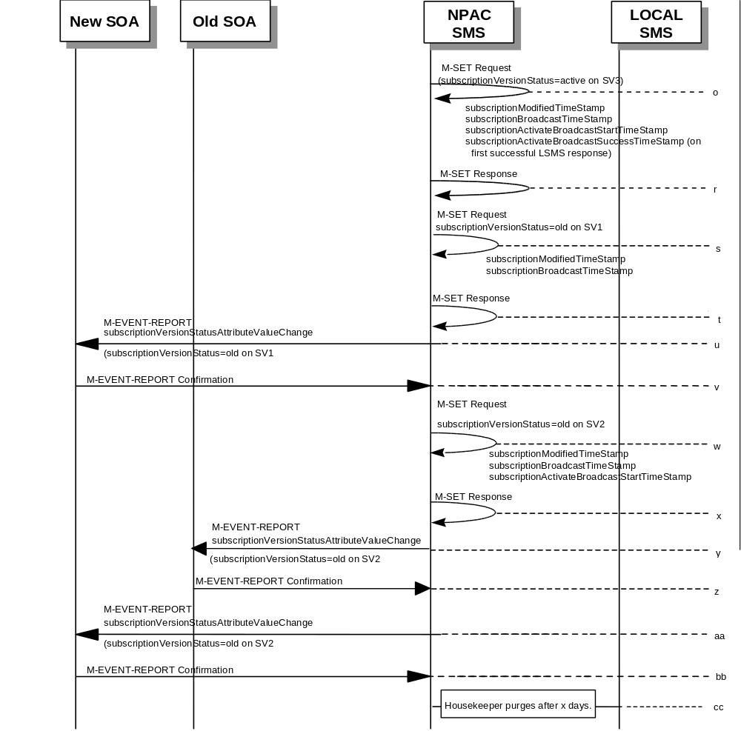

SV 1 is the currently active Subscription Version.
SV 2 is the failed or partially failed Subscription Version with the Port-To-Original flag set to TRUE, and the subscriptionFailed-SP-List.
SV3 is the failed or partially failed pool reinstatement Subscription Version with LNPType = Pool that reinstates default routing to the block holder.
- NPAC personnel take action to resend a failed port-to-original for a subscription version.
- The NPAC SMS issues an M-SET request setting the subscriptionVersionStatus to “sending”, subscriptionBroadcastTimeStamp and subscriptionModifiedTimeStamp on the subscriptionVersionNPAC on SV1.
- NPAC SMS responds to the M-SET.
- The NPAC SMS sends to the new/current service provider SOA a subscriptionVersionStatusAttributeValueChange for the subscriptionVersionStatus being set to sending on SV1.
- The new/current service provider SOA returns an M-EVENT-REPORT confirmation to the NPAC SMS.
- The NPAC SMS sets the subscriptionVersionStatus to sending on the subscriptionVersionNPAC on SV2.
- NPAC SMS responds to the M-SET.
- The NPAC SMS sends to the old service provider SOA a subscriptionVersionStatusAttributeValueChange for the subscriptionVersionStatus being set to sending on SV2.
- The old service provider SOA returns an M-EVENT-REPORT confirmation to the NPAC SMS.
- The NPAC SMS sends to the new service provider SOA a subscriptionVersionStatusAttributeValueChange for the subscriptionVersionStatus being set to sending on SV2.
- The new service provider SOA returns an M-EVENT-REPORT confirmation to the NPAC SMS.
- The NPAC SMS issues an M-SET request setting the subscriptionVersionStatus to “sending”, subscriptionBroadcastTimeStamp and subscriptionModifiedTimeStamp on the subscriptionVersionNPAC on SV3.
- NPAC SMS responds to the M-SET.
- NPAC SMS sends out an M-CREATE on the subscription Version SV3 to all Local SMSs that previously failed, that are accepting downloads for the NPA-NXX of the subscription Version SV3. If the M-CREATE is for multiple subscription versions, a scoped and filtered operation may be sent. The NPAC SMS schedules an LSMS Response Timer for each subscription version.
- Each previously failed Local SMS responds with a successful M-CREATE reply.
- All previously failed Local SMSs respond successfully.
- The NPAC SMS issues an M-SET request setting the subscriptionVersionStatus to “active”, on the subscriptionVersionNPAC on SV3. The subscriptionActivateBroadcastStartTimeStamp, and subscriptionActivateBroadcastSuccessTimeStamp (on first successful LSMS response), are set accordingly.
- NPAC SMS responds to the M-SET.
- NPAC SMS issues an M-SET updating the subscriptionVersionStatus of SV1 to old. It also sets the subscriptionModifiedTimeStamp.
- NPAC SMS responds to the M-SET.
- The NPAC SMS sends to the current/new service provider SOA a subscriptionVersionStatusAttributeValueChange for the subscriptionVersionStatus being set to old on SV1.
- The current/new service provider SOA returns an M-EVENT-REPORT confirmation to the NPAC SMS.
- NPAC SMS issues an M-SET updating the subscriptionVersionStatus of SV2 to old. The subscriptionModifiedTimeStamp, subscriptionBroadcastTimeStamp, and subscriptionActivateBroadcastStartTimeStamp, are set accordingly.
- NPAC SMS responds to the M-SET.
- The NPAC SMS sends to the old service provider SOA a subscriptionVersionStatusAttributeValueChange for the subscriptionVersionStatus being set to old on SV2.
- The old service provider SOA returns an M-EVENT-REPORT confirmation to the NPAC SMS.
- The NPAC SMS sends to the new service provider SOA a subscriptionVersionStatusAttributeValueChange for the subscriptionVersionStatus being set to old on SV2.
- The new service provider SOA returns an M-EVENT-REPORT confirmation to the NPAC SMS.
- After a tunable amount of days, the subscription versions SV1 and SV2 are purged by the NPAC SMS housekeeping process.

7.5

Port to Original for a Pooled Number: Resend Failure to Local SMS
This scenario shows a failure on a resend of a subscription port to original for a Pooled Number, that failed previously to one or more of the Local SMSs. The resend of a failed port-to-original for a subscription can only be performed by authorized NPAC personnel.
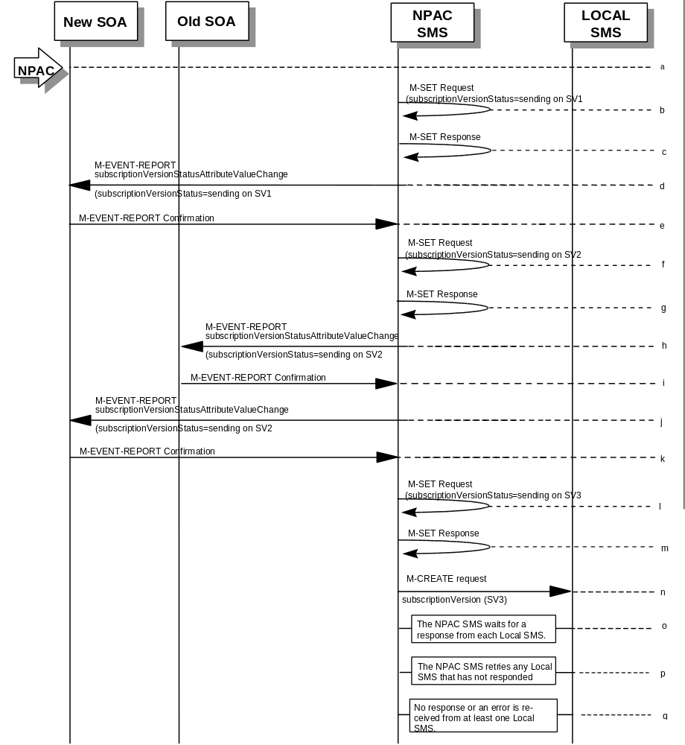
(continued on next page)
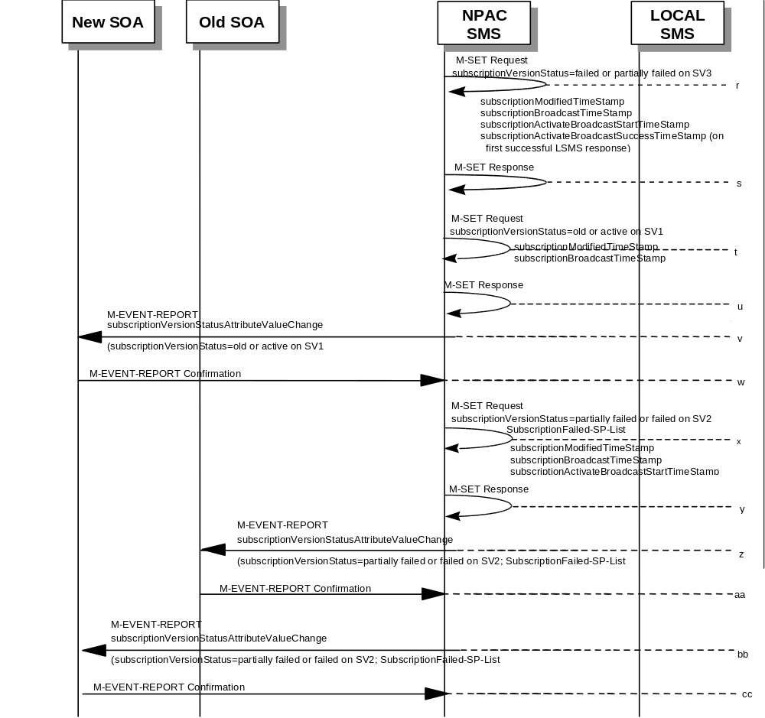

SV 1 is the currently active Subscription Version.
SV 2 is the failed or partially failed Subscription Version with the Port-To-Original flag set to TRUE, and the subscriptionFailed-SP-List

SV3 is the failed or partially failed pool reinstatement Subscription Version with LNPType = Pool that reinstates default routing to the block holder.
- NPAC personnel take action to resend a failed port-to-original for a subscription version.
- The NPAC SMS issues an M-SET request setting the subscriptionVersionStatus to “sending”, subscriptionBroadcastTimeStamp and subscriptionModifiedTimeStamp on the subscriptionVersionNPAC on SV1.
- NPAC SMS responds to the M-SET.
- The NPAC SMS sends to the new/current service provider SOA a subscriptionVersionStatusAttributeValueChange for the subscriptionVersionStatus being set to sending on SV1.
- The new/current service provider SOA returns an M-EVENT-REPORT confirmation to the NPAC SMS.
- The NPAC SMS sets the subscriptionVersionStatus to sending on the subscriptionVersionNPAC on SV2.
- NPAC SMS responds to the M-SET.
- The NPAC SMS sends to the old service provider SOA a subscriptionVersionStatusAttributeValueChange for the subscriptionVersionStatus being set to sending on SV2.
- The old service provider SOA returns an M-EVENT-REPORT confirmation to the NPAC SMS.
- The NPAC SMS sends to the new service provider SOA a subscriptionVersionStatusAttributeValueChange for the subscriptionVersionStatus being set to sending on SV2.
- The new service provider SOA returns an M-EVENT-REPORT confirmation to the NPAC SMS.
- The NPAC SMS issues an M-SET request setting the subscriptionVersionStatus to “sending”, subscriptionBroadcastTimeStamp and subscriptionModifiedTimeStamp on the subscriptionVersionNPAC on SV3.
- NPAC SMS responds to the M-SET.
- NPAC SMS sends out an M-CREATE on the subscription Version SV3 to all Local SMSs that previously failed, that are accepting downloads for the NPA-NXX of the subscription Version SV3. If the M-CREATE is for multiple subscription versions, a scoped and filtered operation may be sent. The NPAC SMS schedules an LSMS Response Timer for each subscription version.
- NPAC SMS waits for a response from each Local SMS.
- NPAC SMS retries any Local SMS that has not responded.
- No response or an error is received from at least one Local SMS.
- The NPAC SMS issues an M-SET request setting the subscriptionVersionStatus to”failed” or “partially failed”, on the subscriptionVersionNPAC on SV3. The subscriptionModifiedTimeStamp, subscriptionBroadcastTimeStamp, subscriptionActivateBroadcastStartTimeStamp, and subscriptionActivateBroadcastSuccessTimeStamp (on first successful LSMS response), are set accordingly.
- NPAC SMS responds to the M-SET.
- NPAC SMS issues an M-SET updating the subscriptionVersionStatus of SV1 to “old” or “active” (if all Local SMSs accepting download for the NPA-NXX failed) from “sending”. It will also update the subscriptionFailed-SP-List with the service provider ID and name of the Local SMSs that failed to successfully receive the broadcast. The subscriptionModifiedTimeStamp, and subscriptionBroadcastTimeStamp, are set accordingly.
- NPAC SMS responds to the M-SET.
- The NPAC SMS sends to the current/new service provider SOA a subscriptionVersionStatusAttributeValueChange for the subscriptionVersionStatus being set to “old” or “active” on SV1.
- The current/new service provider SOA returns an M-EVENT-REPORT confirmation to the NPAC SMS.
- NPAC SMS issues an M-SET updating the subscriptionVersionStatus of SV2 to failed or partially failed. It also sets the subscriptionFailed-SP-List. The subscriptionModifiedTimeStamp, subscriptionBroadcastTimeStamp, and subscriptionActivateBroadcastStartTimeStamp, are set accordingly.
- NPAC SMS responds to the M-SET.
- The NPAC SMS sends to the old service provider SOA a subscriptionVersionStatusAttributeValueChange for the subscriptionVersionStatus being set to “partially failed” or “failed” on SV2, along with the subscriptionFailed-SP-List.
- The old service provider SOA returns an M-EVENT-REPORT confirmation to the NPAC SMS.
- The NPAC SMS sends to the current/new service provider SOA a subscriptionVersionStatusAttributeValueChange for the subscriptionVersionStatus being set to “partially failed” or “failed” on SV2, along with the subscriptionFailed-SP-List.
- The current/new service provider SOA returns an M-EVENT-REPORT confirmation to the NPAC SMS.

8 Disconnect Scenarios

8.1 SubscriptionVersion Disconnect of a Subscription Version with an LNP TYPE of “POOL”
NPAC personnel in case of errors in block porting can remove pooled TN’s that have not been ported away from the block holder.
In this scenario, the NPAC personnel disconnect the Pooled TN. The disconnect is always immediate.

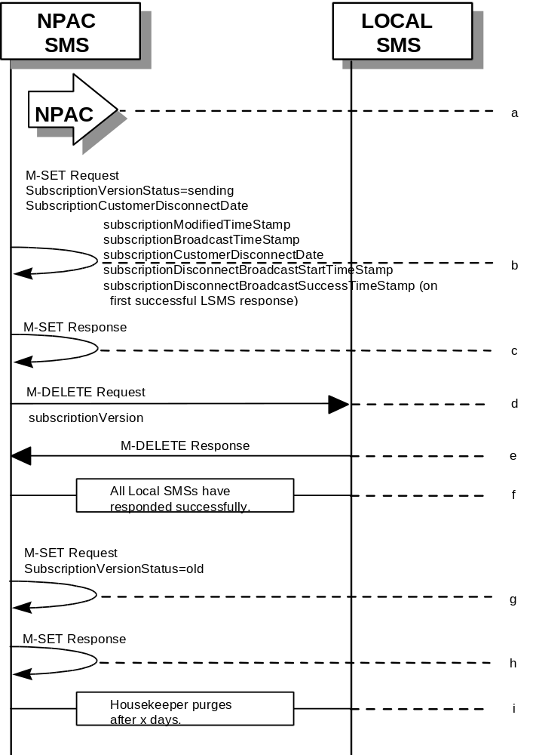
- NPAC personnel take action to disconnect a subscription version with an LNP Type of “POOL”.
- NPAC SMS issues an M-SET to set the subscriptionCustomerDisconnectDate to the current date. The subscriptionVersionStatus goes to “sending ”. The subscriptionModifiedTimeStamp, subscriptionBroadcastTimeStamp, customerDisconnectDate, subscriptionDisconnectBroadcastStartTimeStamp, and subscriptionDisconnectBroadcastSuccessTimeStamp (on first successful LSMS response), are set accordingly.
- NPAC SMS responds to whether M-SET was successful.
- NPAC SMS sends out an M-DELETE on the subscriptionVersion to all Local SMSs, that are accepting downloads for the NPA-NXX of the subscriptionVersion. If the M-DELETE is for multiple subscription versions, a scoped and filtered operation will be sent.
- Each Local SMS responds with a successful M-DELETE reply.
- All Local SMSs respond successfully.
- NPAC SMS issues M-SET updating the subscriptionVersionStatus to old for subscriptionVersionNPAC objects. It also sets the subscriptionModifiedTimeStamp and subscriptionDisconnectCompleteTimeStamp.
- NPAC SMS responds to M-SET.
- After a tunable amount of days, the subscription version is purged by the NPAC SMS housekeeping process.

8.2

SubscriptionVersion Disconnect: Failure to Local SMS for Subscription Version with LNP Type of “POOL”
This scenario shows the broadcast of a disconnected subscription with an LNP Type of “POOL” that fails to all of the Local SMSs.

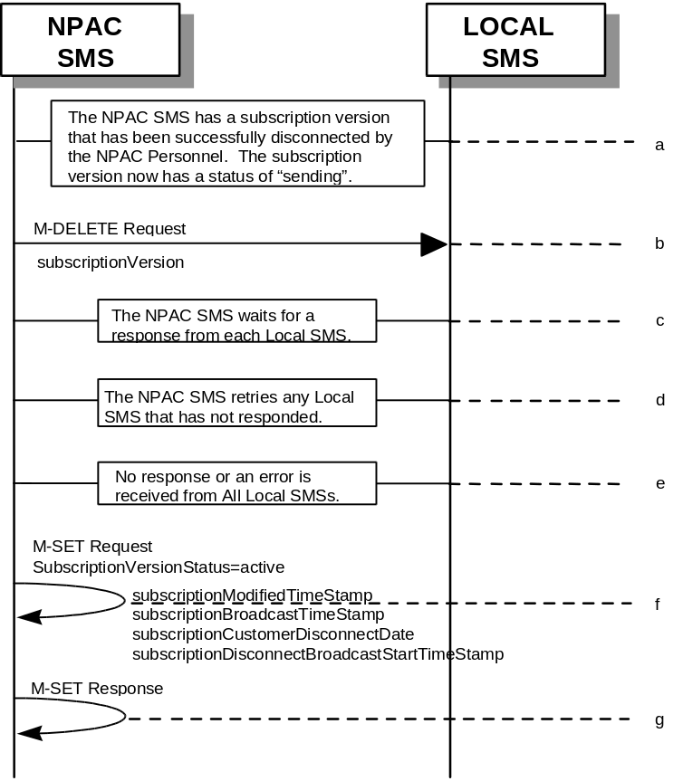
- The NPAC SMS has an active subscription version with an LNP Type of “POOL” that has been successfully disconnected by the NPAC Personnel. The subscription version now has a status of “sending”.
- NPAC SMS issues the M-DELETE to all Local SMSs for the subscriptionVersion, that are accepting downloads for the NPA-NXX of the subscriptionVersion.
- NPAC SMS waits for a response from each Local SMS.
- NPAC SMS retries any Local SMS that has not responded.
- No response or an error is received from all Local SMSs.
- NPAC SMS issues the M-SET to update the current subscriptionVersionNPAC object’s subscriptionVersionStatus to “active” from “sending”. It will also update the subscriptionFailed-SP-List with the service provider ID and name of all the Local SMSs. The subscriptionModifiedTimeStamp, subscriptionBroadcastTimeStamp, customerDisconnectDate, and subscriptionDisconnectBroadcastStartTimeStamp, are set accordingly.
- NPAC SMS responds to the M-SET.

8.3

SubscriptionVersion Disconnect: Partial Failure to Local SMS for a Subscription Version with LNP Type of “POOL”
This scenario shows the broadcast of a disconnected subscription with LNP Type of “POOL” that fails to one or more, but not all, of the Local SMSs.

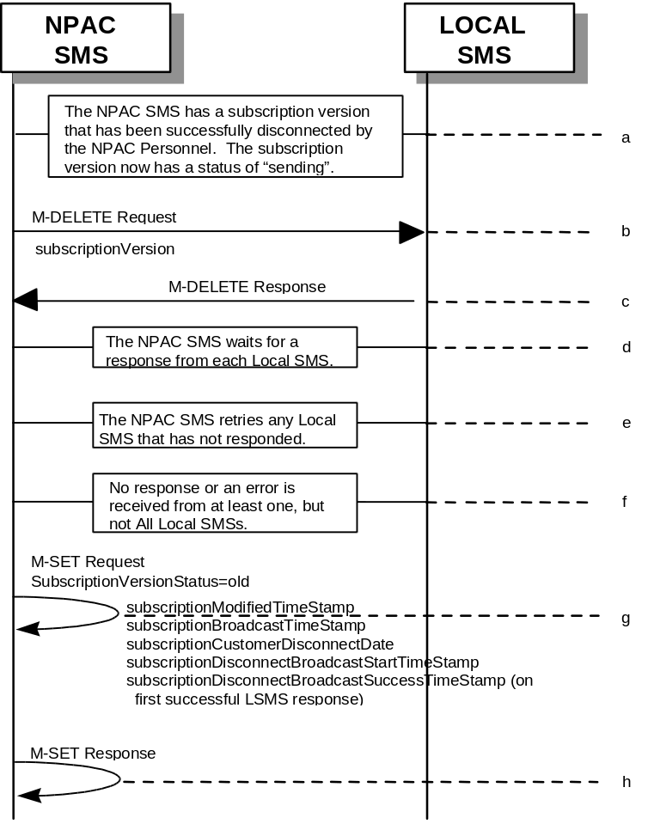
- The NPAC SMS has an active subscription version that has been successfully disconnected by NPAC personnel using the subscriptionVersionDisconnect action. The subscription version now has a status of “sending”.
- NPAC SMS issues the M-DELETE to all Local SMSs for the subscriptionVersion, that are accepting downloads for the NPA-NXX of the subscriptionVersion.
- Local SMSs should respond successfully to the M-DELETE.
- NPAC SMS waits for a response from each Local SMS.
- NPAC SMS retries any Local SMS that has not responded.
- No response or an error is received from at least one, but not all Local SMS(s).
- NPAC SMS issues the M-SET to update the current subscriptionVersionNPAC object’s subscriptionVersionStatus to “old” from “sending”. It will also update the subscriptionFailed-SP-List with the service provider ID and name of the Local SMSs that failed to successfully receive the broadcast. The subscriptionModifiedTimeStamp, subscriptionBroadcastTimeStamp, customerDisconnectDate, subscriptionDisconnectBroadcastStartTimeStamp, and subscriptionDisconnectBroadcastSuccessTimeStamp (on first successful LSMS response), are set accordingly.
- NPAC SMS responds to the M-SET.

8.4

Subscription Version Disconnect: Resend Successful to Local SMS for a Subscription Version with LNP Type of “POOL”
This scenario shows a successful resend of a disconnect for a subscription with an LNP Type of “POOL” that fails to one or more of the Local SMSs. The resend of a failed disconnect can only be performed by authorized NPAC personnel.

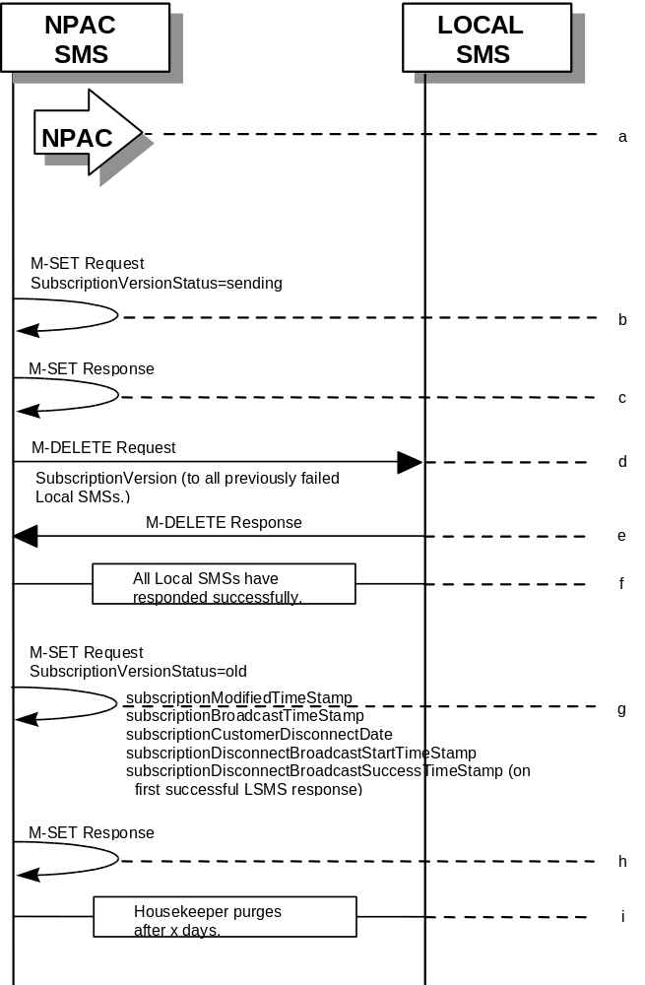
- NPAC personnel take action to resend a failed disconnect for a subscription version with LNP Type of “POOL”.
- NPAC SMS issues an M-SET to the existing subscriptionVersionNPAC object to set the status to “sending”.
- NPAC SMS responds to whether M-SET was successful.
- NPAC SMS sends out an M-DELETE on the subscriptionVersion to all previously failed Local SMSs, that are accepting downloads for the NPA-NXX of the subscriptionVersion.
- Each Local SMS responds with a successful M-DELETE reply.
- All Local SMSs respond successfully.
- NPAC SMS issues M-SET updating the subscriptionVersionStatus to old for subscriptionVersionNPAC objects. The subscriptionModifiedTimeStamp, subscriptionBroadcastTimeStamp, customerDisconnectDate, subscriptionDisconnectBroadcastStartTimeStamp, and subscriptionDisconnectBroadcastSuccessTimeStamp (on first successful LSMS response), are set accordingly.
- NPAC SMS responds to M-SET.
- After a tunable amount of days, the subscription version is purged by the NPAC SMS housekeeping process.

8.5

Subscription Version Disconnect: Resend Failure to Local SMS for a Subscription Version with LNP Type of “POOL”
This scenario shows a failure on a resend of a subscription version disconnect that failed previously to one or more of the Local SMSs. The resend of a failed disconnect for a subscription with LNP Type of “POOL” can only be performed by authorized NPAC personnel.

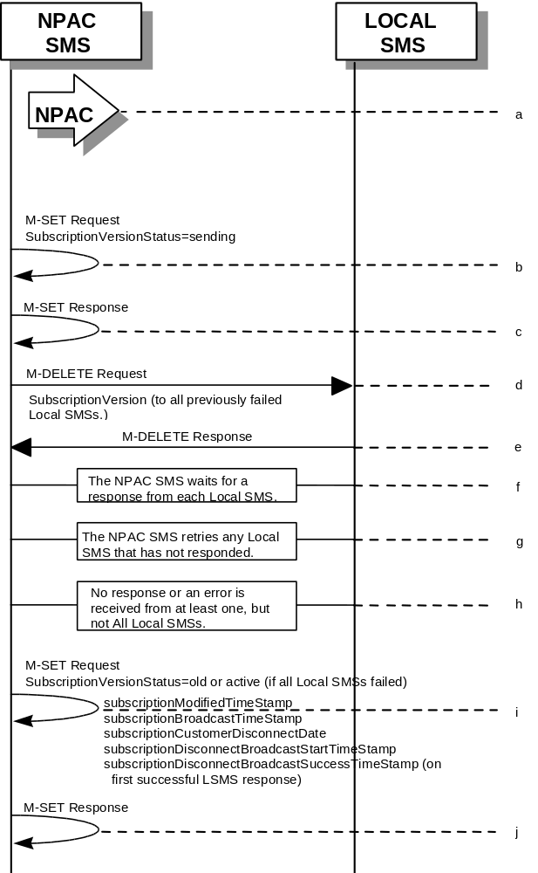
- NPAC personnel take action to resend a failed disconnect for a subscription version with LNP Type of “POOL”.
- NPAC SMS issues an M-SET to the existing subscriptionVersionNPAC object to set the status to “sending”.
- NPAC SMS responds to whether M-SET was successful.
- NPAC SMS issues the M-DELETE to all Local SMSs for which the disconnect previously failed for the subscriptionVersion, and are accepting downloads for the NPA-NXX of the subscriptionVersion.
- Local SMSs should respond successfully to the M-DELETE.
- NPAC SMS waits for a response from each Local SMS.
- NPAC SMS retries any Local SMS that has not responded.
- No response or an error is received from at least one or all Local SMSs.
- NPAC SMS issues the M-SET to update the current subscriptionVersionNPAC object’s subscriptionVersionStatus to “old” or “active” (if all Local SMSs failed) from “sending”. It will also update the subscriptionFailed-SP-List with the service provider ID and name of the Local SMSs that failed to successfully receive the broadcast. The subscriptionModifiedTimeStamp, subscriptionBroadcastTimeStamp, customerDisconnectDate, subscriptionDisconnectBroadcastStartTimeStamp, and subscriptionDisconnectBroadcastSuccessTimeStamp (on first successful LSMS response), are set accordingly.
- NPAC SMS responds to the M-SET.

9 Disconnect Scenarios (with return to Block Holder)

9.1 SubscriptionVersion Immediate Disconnect (with return to Block Holder)
The current service provider can disconnect an active subscription version that will return to the block holder. In this scenario, the disconnect is immediate where the TN returns to the block holder.

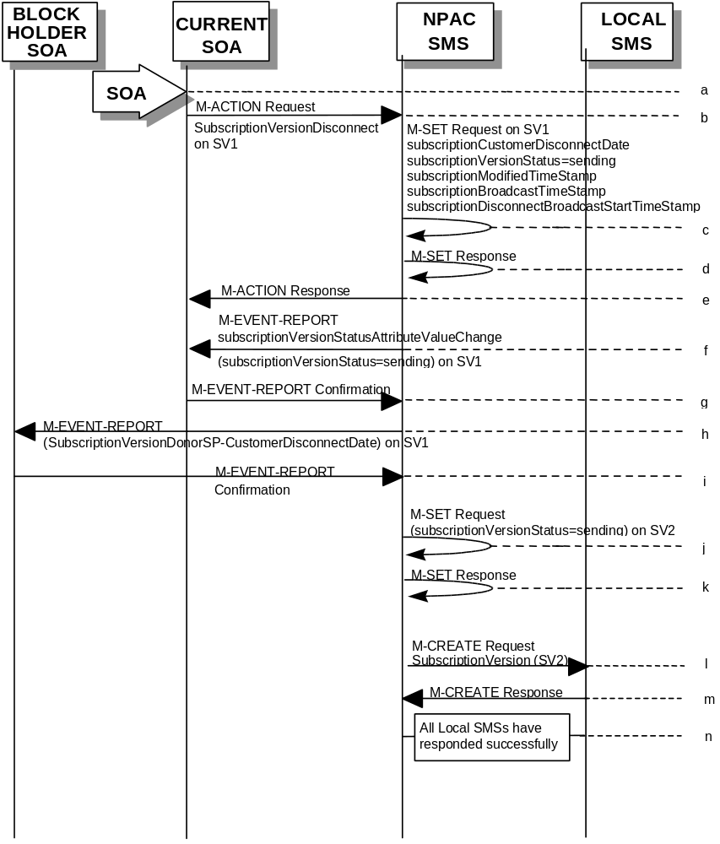

(continued on next page)

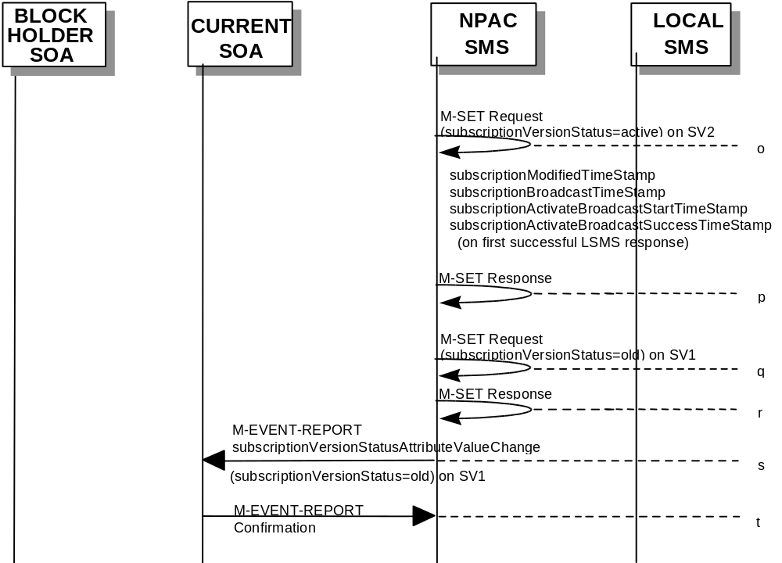
SV1 is the currently active Subscription Version.

SV2 is the pool reinstatement Subscription Version with LNPType = Pool that reinstates default routing to the block holder.
- Current service provider SOA personnel take action to disconnect a subscription version.
- Service provider SOA issues an M-ACTION request to disconnect to the lnpSubscriptions object. The M-ACTION specifies either the subscriptionVersionId, or subscriptionTN or range of TNs, and also has NOT future dated (i.e., used the current date) the subscriptionEffectiveReleaseDate and the subscriptionCustomerDisconnectDate. The subscription version status must be active and no pending, failed, conflict or cancel-pending versions can exist.
- NPAC SMS issues an M-SET to set the subscriptionCustomerDisconnectDate according to the disconnect action for SV1. The subscriptionVersionStatus for SV1 goes to “sending ”. The subscriptionModifiedTimeStamp, subscriptionBroadcastTimeStamp, customerDisconnectDate, and subscriptionDisconnectBroadcastStartTimeStamp, are set accordingly.
- NPAC SMS responds to whether M-SET was successful.
- NPAC SMS responds to the M-ACTION. If the action failed, an error will be returned and processing will stop on this flow.
- NPAC SMS notifies service provider SOA of status change to “sending” for SV1.
- Service provider SOA confirms event report.
- NPAC SMS sends the Donor service provider SOA notification that the subscription version is being disconnected with the customer disconnect date. This SOA is the block holder SOA.
- The Donor service provider SOA confirms the M-EVENT-REPORT.
- NPAC SMS issues M-SET updating the subscriptionVersionStatus to sending for subscriptionVersionNPAC objects for SV2.
- NPAC SMS responds to M-SET.
- NPAC SMS sends out an M-CREATE of a subscriptionVersion to all Local SMSs, that are accepting downloads for the NPA-NXX of the subscriptionVersion for SV2. If the M-CREATE is for multiple subscription versions, a scoped and filtered operation will be sent. The subscription version created on the Local SMS systems contains the default block routing information for the TN and has an LNP Type of “POOL”. The NPAC SMS schedules an LSMS Response Timer for each subscriptionVersion SV2.
- Each Local SMS responds with a successful M-CREATE reply.
- All Local SMSs respond successfully.
- NPAC SMS issues M-SET updating the subscriptionVersionStatus to active for subscriptionVersionNPAC objects for SV2. The subscriptionModifiedTimeStamp, subscriptionBroadcastTimeStamp, subscriptionActivateBroadcastStartTimeStamp, and subscriptionActivateBroadcastSuccessTimeStamp (on first successful LSMS response), are set accordingly.
- NPAC SMS responds to M-SET.
- NPAC SMS issues M-SET updating the subscriptionVersionStatus to old for subscriptionVersionNPAC objects for SV1. It also sets the subscriptionModifiedTimeStamp and subscriptionDisconnectCompleteTimeStamp.
- NPAC SMS responds to M-SET.
- NPAC SMS issues an M-EVENT-REPORT to current service provider SOA of subscriptionVersionStatusAttributeValueChange being set to old on SV1.
- The current service provider SOA confirms the M-EVENT-REPORT.

9.2

SubscriptionVersion Disconnect With Effective Release Date (with return to Block Holder)
In this scenario, a future dated request is submitted to disconnect an active subscriptionVersion that will return to the block holder.

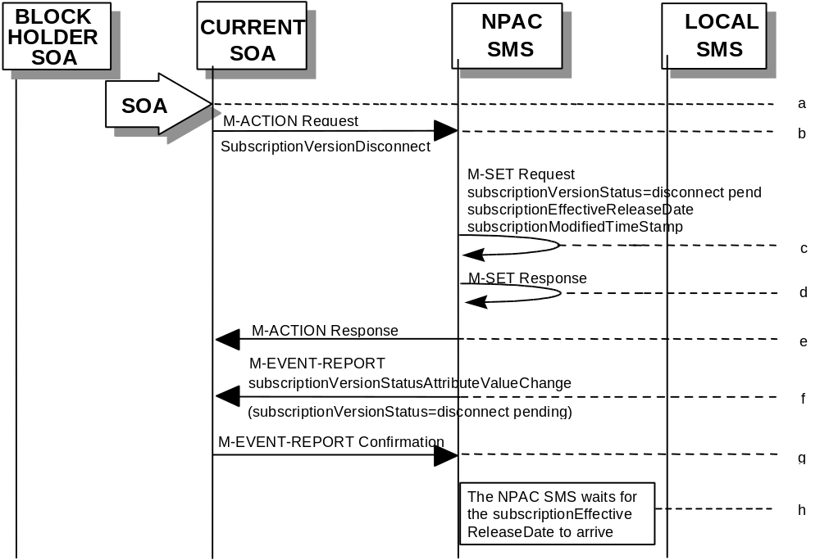

- Current service provider SOA personnel take action to disconnect a subscription version.
- Current service provider SOA issues an M-ACTION request to disconnect the lnpSubscriptions object. The M-ACTION specifies either the subscriptionVersionId, or subscriptionTN, or range of TNs, and also has future dated the subscriptionEffectiveReleaseDate and the subscriptionCustomerDisconnectDate. The subscription version status must be active and no pending, failed, conflict, conflict-pending, or cancel-pending versions can exist.
- NPAC SMS issues an M-SET to set the status to disconnect-pending, and set the subscriptionEffectiveReleaseDate and the subscriptionModifiedTimeStamp of the existing subscriptionVersionNPAC.
- NPAC SMS responds to M-SET.
- NPAC SMS responds to M-ACTION. If the action fails, no modifications are applied and the processing stops.
- NPAC SMS sends the subscriptionVersionStatusAttributeValueChange M-EVENT-REPORT to the current service provider SOA.
- The current service provider SOA issues the M-EVENT-REPORT confirmation.
- The NPAC SMS waits for the subscriptionEffectiveReleaseDate date to arrive.

9.3

SubscriptionVersion Disconnect: Failure to Local SMS (with return to Block Holder)
This scenario shows the broadcast of a disconnected subscription that fails to all of the Local SMSs.

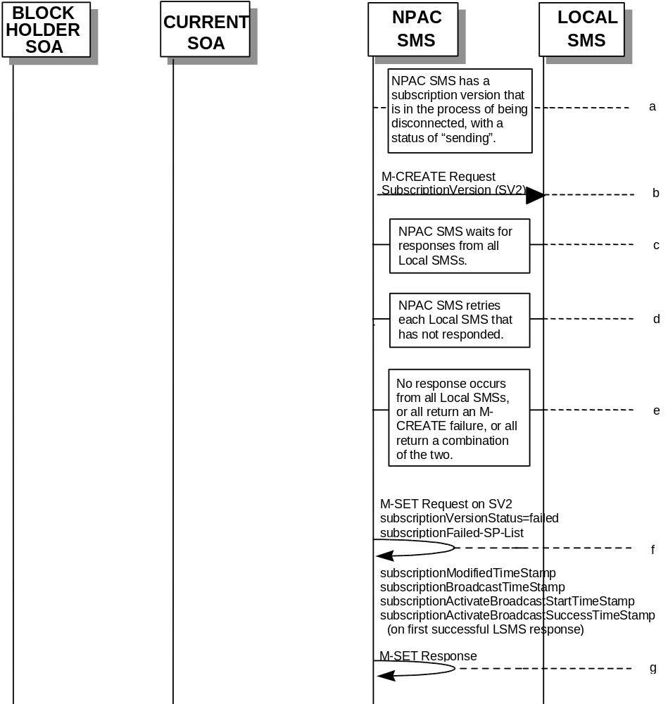

(continued on next page)

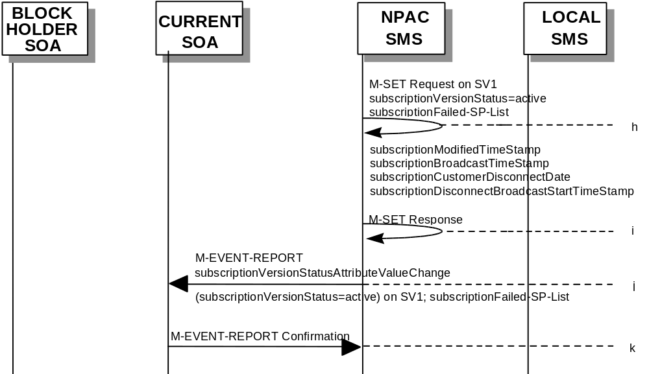
SV1 is the currently active Subscription Version.

SV2 is the pool reinstatement Subscription Version with LNPType = Pool that reinstates default routing to the block holder.
- The NPAC SMS has an active subscription version that has been successfully disconnected by the current service provider using the subscriptionVersionDisconnect action. The subscription versions SV1 and SV2 now has a status of “sending”.
- NPAC SMS issues the M-CREATE to all Local SMSs for the subscriptionVersion SV2, that are accepting downloads for the NPA-NXX of the subscriptionVersion SV2. The NPAC SMS schedules an LSMS Response Timer for each subscriptionVersion SV2.
- NPAC SMS waits for a response from each Local SMS.
- NPAC SMS retries any Local SMS that has not responded.
- No response or an error is received from all Local SMSs.
- NPAC SMS issues the M-SET to update the current subscriptionVersionNPAC object’s subscriptionVersionStatus to “failed” from “sending”, for SV2. It will also update the subscriptionFailed-SP-List with the service provider ID and name of all the Local SMSs. The subscriptionModifiedTimeStamp, subscriptionBroadcastTimeStamp, and subscriptionActivateBroadcastStartTimeStamp, are set accordingly.
- NPAC SMS responds to the M-SET.
- NPAC SMS issues the M-SET to update the current subscriptionVersionNPAC object’s subscriptionVersionStatus to “active” from “sending”, for SV1. It will also update the subscriptionFailed-SP-List with the service provider ID and name of all the Local SMSs. The subscriptionModifiedTimeStamp, subscriptionBroadcastTimeStamp, customerDisconnectDate, and subscriptionDisconnectBroadcastStartTimeStamp, are set accordingly.
- NPAC SMS responds to the M-SET.
- NPAC SMS sends the subscriptionVersionStatusAttributeValueChange
M-EVENT-REPORT to the current service provider SOA with the current status, for SV1, along with the subscriptionFailed-SP-List.
- Current service provider SOA issues the M-EVENT-REPORT confirmation.

9.4

SubscriptionVersion Disconnect: Partial Failure to Local SMS (with return to Block Holder)
This scenario shows the broadcast of a disconnected subscription that fails to one or more, but not all, of the Local SMSs.

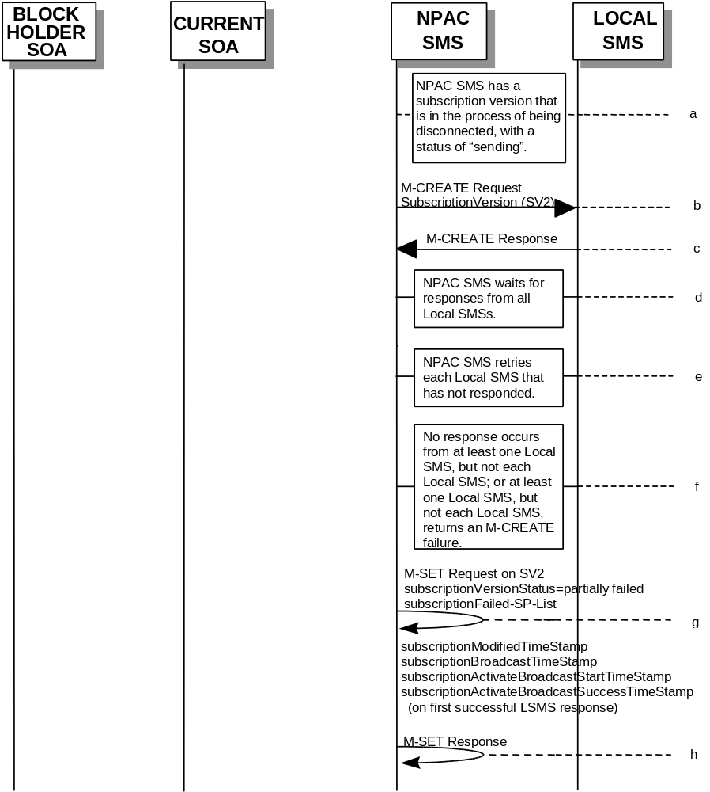

(continued on next page)

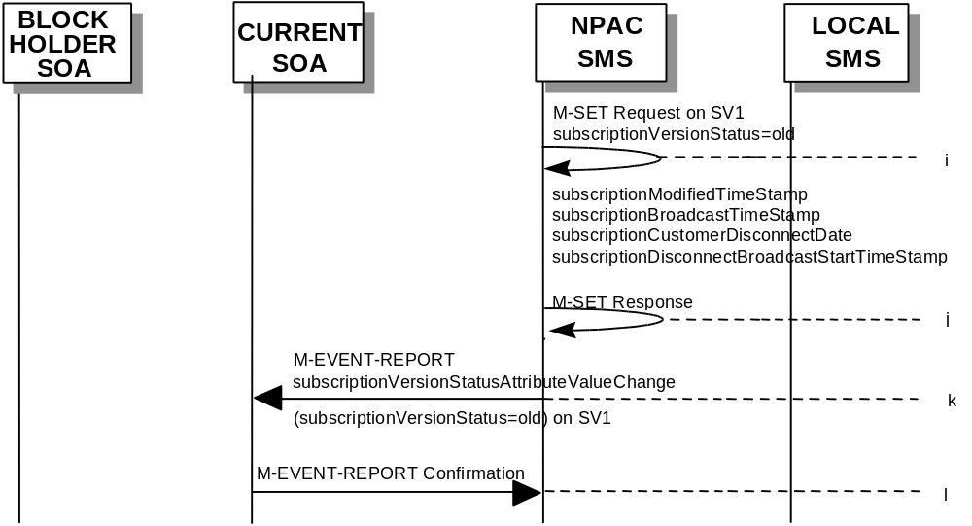
SV1 is the currently active Subscription Version.

SV2 is the pool reinstatement Subscription Version with LNPType = Pool that reinstates default routing to the block holder.
- The NPAC SMS has an active subscription version that has been successfully disconnected by the current service provider using the subscriptionVersionDisconnect action. The subscription version SV1 now has a status of “sending”.
- NPAC SMS issues the M-CREATE to all Local SMSs for the subscriptionVersion SV2, that are accepting downloads for the NPA-NXX of the subscriptionVersion SV2. The NPAC SMS schedules an LSMS Response Timer for each subscriptionVersion SV2.
- Local SMSs should respond successfully to the M-CREATE.
- NPAC SMS waits for a response from each Local SMS.
- NPAC SMS retries any Local SMS that has not responded.
- No response or an error is received from at least one, but not each, Local SMS.
- NPAC SMS issues the M-SET to update the current subscriptionVersionNPAC object’s subscriptionVersionStatus to “partially failed” from “sending”, for SV2. It will also update the subscriptionFailed-SP-List with the service provider ID and name of the Local SMSs that failed to successfully receive the broadcast. The subscriptionModifiedTimeStamp, subscriptionBroadcastTimeStamp, subscriptionActivateBroadcastStartTimeStamp, and subscriptionActivateBroadcastSuccessTimeStamp (on first successful LSMS response), are set accordingly.
- NPAC SMS responds to the M-SET.
- NPAC SMS issues the M-SET to update the current subscriptionVersionNPAC object’s subscriptionVersionStatus to “old” from “sending”, for SV1. The subscriptionModifiedTimeStamp, subscriptionBroadcastTimeStamp, customerDisconnectDate, subscriptionDisconnectBroadcastStartTimeStamp, are set accordingly.
- NPAC SMS responds to the M-SET.
- NPAC SMS sends the subscriptionVersionStatusAttributeValueChange
M-EVENT-REPORT to the current service provider SOA with the current status, for SV1.
- Current service provider SOA issues the M-EVENT-REPORT confirmation.

9.5

Subscription Version Disconnect: Resend Successful to Local SMS (with return to Block Holder)
This scenario shows a successful resend of a disconnect for a subscription that fails to one or more of the Local SMSs. The resend of a failed disconnect can only be performed by authorized NPAC personnel.

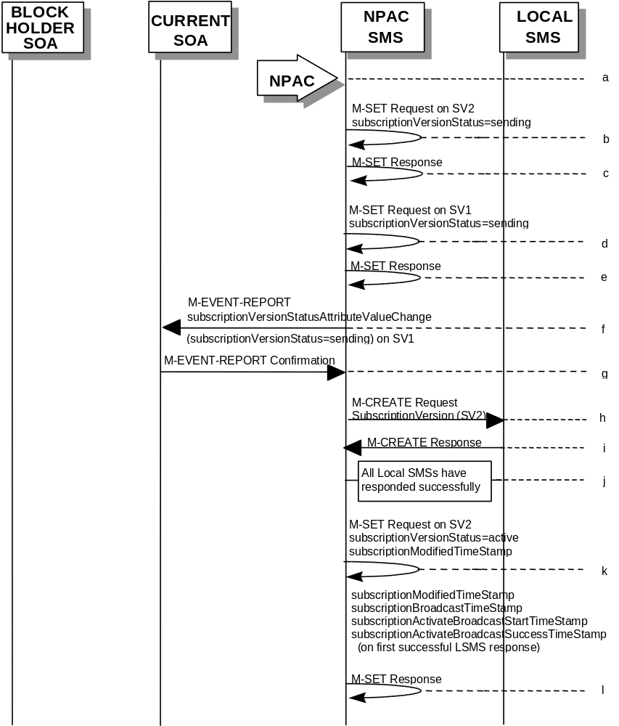

(continued on next page)

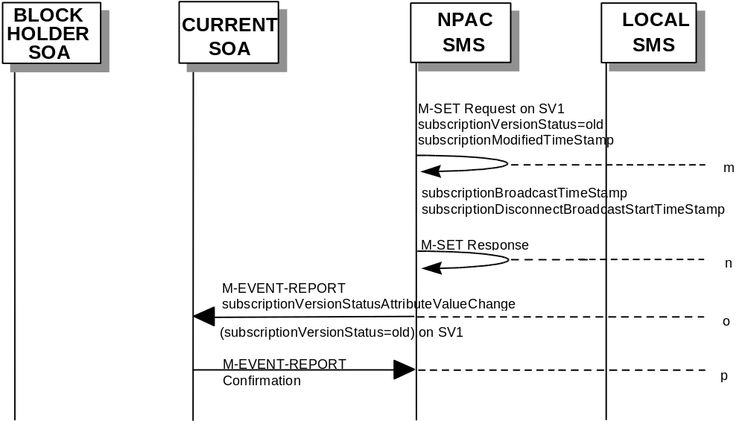
SV1 is the currently active Subscription Version.

SV2 is the pool reinstatement Subscription Version with LNPType = Pool that reinstates default routing to the block holder.
- NPAC personnel take action to resend a failed disconnect for a subscription version SV1.
- NPAC SMS issues an M-SET to the existing subscriptionVersionNPAC object to set the status to “sending”, for SV2.
- NPAC SMS responds to whether M-SET was successful.
- NPAC SMS issues an M-SET to the existing subscriptionVersionNPAC object to set the status to “sending”, for SV1.
- NPAC SMS responds to whether M-SET was successful.
- NPAC SMS issues an M-EVENT-REPORT to the current service provider SOA of status change to “sending”, for SV1.
- Current service provider SOA responds to M-EVENT-REPORT.
- NPAC SMS sends out an M-CREATE on the subscriptionVersion SV2 to all previously failed Local SMSs, that are accepting downloads for the NPA-NXX of the subscriptionVersion SV2. The NPAC SMS schedules an LSMS Response Timer for each subscriptionVersion SV2.
- Each Local SMS responds with a successful M-CREATE reply.
- All Local SMSs respond successfully.
- NPAC SMS issues M-SET updating the subscriptionVersionStatus to active for subscriptionVersionNPAC objects, for SV2. The subscriptionModifiedTimeStamp, subscriptionBroadcastTimeStamp, subscriptionActivateBroadcastStartTimeStamp, and subscriptionActivateBroadcastSuccessTimeStamp (on first successful LSMS response), are set accordingly.
- NPAC SMS responds to M-SET.

- NPAC SMS issues M-SET updating the subscriptionVersionStatus to old for subscriptionVersionNPAC objects, for SV1. The subscriptionModifiedTimeStamp, subscriptionBroadcastTimeStamp, subscriptionDisconnectBroadcastStartTimeStamp, are set accordingly.
- NPAC SMS responds to M-SET.
- NPAC SMS issues an M-EVENT-REPORT to the current service provider SOA of status change to “old”, for SV1.
- Current service provider SOA responds to M-EVENT-REPORT.

9.6

Subscription Version Disconnect: Resend Failure to Local SMS (with return to Block Holder)
This scenario shows a failure on a resend of a subscription disconnect that failed previously to one or more of the Local SMSs. The resend of a failed disconnect for a subscription can only be performed by authorized NPAC personnel.

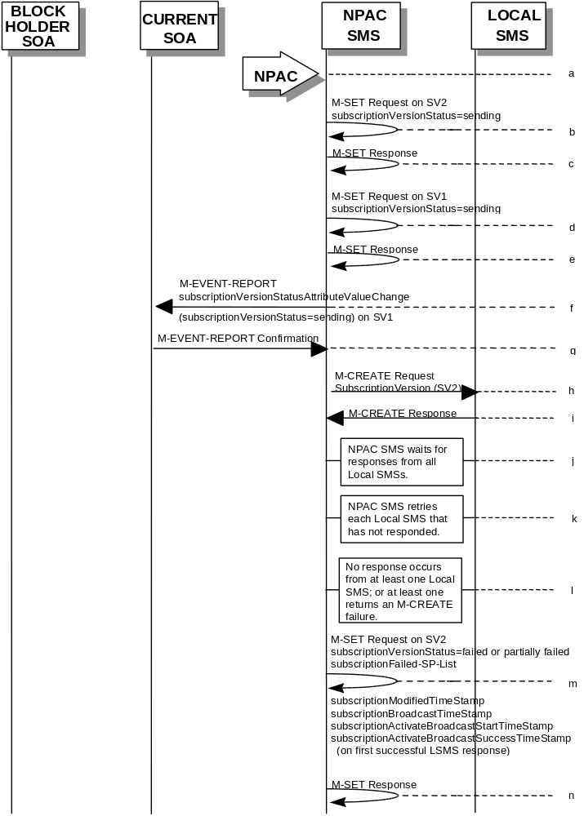
(continued on next page)

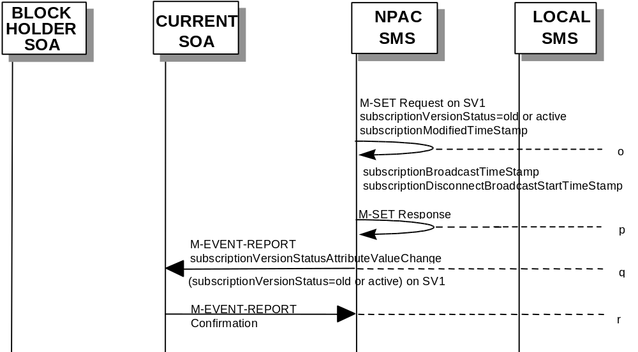
SV1 is the currently active Subscription Version.

SV2 is the pool reinstatement Subscription Version with LNPType = Pool that reinstates default routing to the block holder.
- NPAC personnel take action to resend a failed disconnect for a subscription version.
- NPAC SMS issues an M-SET to the existing subscriptionVersionNPAC object to set the status to “sending”, for SV2.
- NPAC SMS responds to whether M-SET was successful.
- NPAC SMS issues an M-SET to the existing subscriptionVersionNPAC object to set the status to “sending”, for SV1.
- NPAC SMS responds to whether M-SET was successful.
- NPAC SMS issues an M-EVENT-REPORT to the current service provider SOA of status change to “sending”, for SV1.
- Current service provider SOA responds to M-EVENT-REPORT.
- NPAC SMS issues the M-CREATE to all Local SMSs for which the disconnect (M-CREATE) previously failed for the subscriptionVersion SV2, and are accepting downloads for the NPA-NXX of the subscriptionVersion SV2. The NPAC SMS schedules an LSMS Response Timer for each subscriptionVersion SV2.
- Local SMSs should respond successfully to the M-CREATE.
- NPAC SMS waits for a response from each Local SMS.
- NPAC SMS retries any Local SMS that has not responded.
- No response or an error is received from at least one Local SMSs.
- NPAC SMS issues the M-SET to update the current subscriptionVersionNPAC object’s subscriptionVersionStatus to “failed” or “partially failed” from “sending”, for SV2. It will also update the subscriptionFailed-SP-List with the service provider ID and name of the Local SMSs that failed to successfully receive the broadcast. The subscriptionModifiedTimeStamp, subscriptionBroadcastTimeStamp, subscriptionActivateBroadcastStartTimeStamp, and subscriptionActivateBroadcastSuccessTimeStamp (on first successful LSMS response), are set accordingly.
- NPAC SMS responds to the M-SET.
- NPAC SMS issues the M-SET to update the current subscriptionVersionNPAC object’s subscriptionVersionStatus to “old” or “active”, for SV1. The subscriptionModifiedTimeStamp, subscriptionBroadcastTimeStamp, subscriptionDisconnectBroadcastStartTimeStamp, are set accordingly.
- NPAC SMS responds to the M-SET.
- NPAC SMS sends the subscriptionVersionStatusAttributeValueChange
M-EVENT-REPORT to the current service provider SOA with the current status, for SV1.
- Current service provider SOA issues the M-EVENT-REPORT confirmation.

