NATIONAL NUMBER POOLING

IIS FLOWS

December 16, 1998
Table of Contents
1 Service Provider NPA-NXX-X 4
1.1 Service Provider NPA-NXX-X Create by NPAC SMS 5
1.2 Service Provider NPA-NXX-X Modification by NPAC SMS 7
1.3 Service Provider NPA-NXX-X Deletion by NPAC SMS Prior to Number Pool Block Existence 8
1.4 Service Provider NPA-NXX-X Query by SOA or LSMS 9
2 Number Pool Block 10
2.1 Number Pool Block Create/Activate by SOA 11
2.2 Number Pool Block Create by NPAC SMS 14
2.3 Number Pool Block Create Broadcast: Successful 16
2.4 Number Pool Block Create Broadcast to Local SMS: Failure 20
2.5 Number Pool Block Create Broadcast to Local SMS: Partial Failure 23
2.6 Number Pool Block Create Resend Broadcast 27
2.7 Number Pool Block Create Successful Resend Updates 30
2.8 Number Pool Block Create Failed Resend NPAC SMS Updates 32
2.9 Number Pool Block Create Partial-Failure Resend NPAC SMS Updates 34
2.10 Number Pool Block Modify by NPAC SMS 36
2.11 Number Pool Block Modify by Block Holder SOA 39
2.12 Number Pool Block Modify Broadcast to Local SMS Success 41
2.13 Number Pool Block Modify Broadcast to Local SMS Failure 44
2.14 Number Pool Block Modify Broadcast to Local SMS Partial Failure 46
2.15 Number Pool Block Modify Resend Broadcast 49
2.16 Number Pool Block Modify Successful Resend Updates 52
2.17 Number Pool Block Modify Failure Resend Updates 54
2.18 Number Pool Block Modification of SOA-Origination Indicator 56
2.19 Number Pool Block De-Pool by NPAC SMS 57
2.20 Number Pool Block De-Pool Broadcast Success 59
2.21 Number Pool Block De-Pool Broadcast to Local SMS Failure 64
2.22 Number Pool Block De-Pool Broadcast to Local SMS Partial Failure 66
2.23 Number Pool Block De-Pool Resend Broadcast 70
2.24 Number Pool Block De-Pool Successful Resend Updates 73
2.25 Number Pool Block De-Pool Resend Failure Updates 76
2.26 Number Pool Block De-Pool Resend Partial Failure Updates 78
2.27 Number Pool Block Query by SOA or LSMS 80
3 Port-to-Original Subscription Version Flows 81
3.1 Subscription Version Port-to-Original of a Ported Pool TN Activation by SOA 82
3.2 Subscription Version Create Port-to-Original of a Pool TN: Failure to All Local SMSs 91
3.3 Subscription Version Create Port-to-Original of a Pool TN: Partial Failure to One or More Local SMSs 97
3.4 Subscription Version Create Port-to-Original of a Pool TN: Resend Successful to Local SMS 103
3.5 Subscription Version Create Port-to-Original of a Pool TN: Resend Failure to Local SMS 112
3.6 Subscription Version Create Port-to-Original of a Pool TN: Resend Partial Failure to Local SMS 115
3.7 Subscription Version Port-to-Original of a Pool TN – Creation Prior to NPA-NXX-X Effective Date 118
4 Disconnect Subscription Version Scenarios 119
4.1 Subscription Version Immediate Disconnect After the Activation of the Number Pool Block 120
4.2 Subscription Version Disconnect With Effective Release Date 126
4.3 Subscription Version Disconnect of a Ported Pooled TN After Block Activation: Failure to Local 128
4.4 Subscription Version Disconnect of a Ported Pooled TN: Partial Failure to Local SMS 131
4.5 Subscription Version Disconnect of a Ported Pooled TN: Resend Successful to Local SMS 135
4.6 Subscription Version Disconnect of a Ported Pooled TN: Resend Failure to Local SMS 141
4.7 Subscription Version Disconnect of a Ported Pooled TN: Resend Partial Failure to Local SMS 146
4.8 Subscription Version Immediate Disconnect of a Contaminated Pooled TN Prior to Block Activation (after Effective Date) 152
5 Resynchronization 155
5.1 Sequencing of Events on Initialization/Resynchronization of EDR Local SMS 156
5.2 Sequencing of Events on Initialization/Resynchronization of Non-EDR Local SMS 159
6 Audits 162
6.1 SOA Audit Create for Subscription Versions within a Number Pool Block 163
6.2 NPAC SMS Audit Create 171
7 NPA-NXX Split 175
8 Mass Update 178

Service Provider NPA-NXX-X
This section contains the flows that demonstrate service provider NPA-NXX-X creation, modification, deletion and query.

Service Provider NPA-NXX-X Create by NPAC SMS

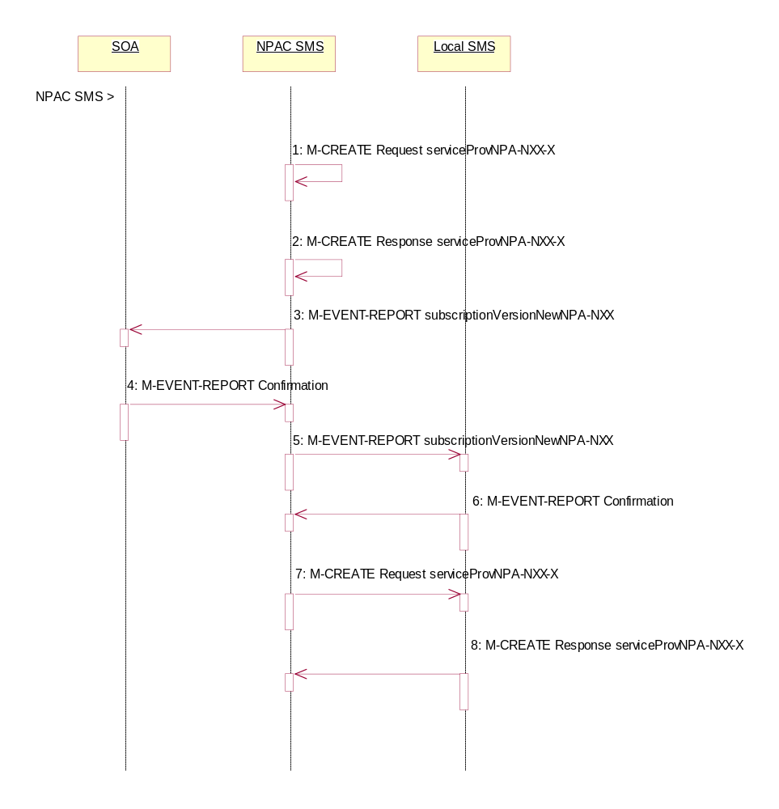
In this scenario, the NPAC SMS creates the serviceProvNPA-NXX-X object at the request of the number pool administrator.

Action is taken by NPAC SMS personnel to create the serviceProvNPA-NXX-X object.
- The NPAC SMS sends an M-CREATE request to itself in order to create a local serviceProvNPA-NXX-X object. The NPAC SMS provides the following attributes:
serviceProvNPA-NXX-X-Value
serviceProvNPA-NXX-EffectiveTimeStamp
Block holder SPID

The NPAC SMS validates the following:
- NPA-NXX of the serviceProvNPA-NXX-X-value is an existing NPA-NXX.
- The effective date is greater than or equal to the effective date of the serviceProvNPA-NXX.
- The effective date is greater than or equal to the current date plus the effective date tunable number of days.
- Verify no serviceProvNPA-NXX-X object exists with this NPA-NXX-X value.
- The service provider ID is an existing service provider.

The NPAC SMS rejects the request if any subscriptionVersionNPAC objects exist with a status of pending, conflict, cancel-pending or failed for a TN specified by the serviceProvNPA-NXX-X-value and an active subscriptionVersionNPAC object does not exist for that TN or the subscription version is a Port-To-Original request.
- The NPAC SMS receives the M-CREATE request and sets the serviceProvNPA-NXX-X-ID, serviceProvNPA-NXX-X-CreationTimeStamp and serviceProvNPA-NXX-X-ModifiedTimeStamp. The NPAC SMS then issues a response indicating whether the serviceProvNPA-NXX-X object was successfully created.
- If the serviceProvNPA-NXX-X object was successfully created and this is the first usage of the NPA-NXX, the NPAC SMS sends the subscriptionVersionNewNPA-NXX notification to all SOAs.
- The SOAs confirm the subscriptionVersionNewNPA-NXX M-EVENT-REPORT.
- If the serviceProvNPA-NXX-X object was successfully created and this is the first usage of the NPA-NXX, the NPAC SMS sends the subscriptionVersionNewNPA-NXX notification to all Local SMSs.
- The Local SMSs confirm the subscriptionVersionNewNPA-NXX M-EVENT-REPORT.
- If the serviceProvNPA-NXX-X object was successfully created, the NPAC SMS sends an M-CREATE request for the serviceProvNPA-NXX-X object to all Local SMSs who support the object according to the “NPAC Customer LSMS NPA-NXX-X Indicator” in their service provider profile on the NPAC SMS and are receiving data for the NPA-NXX. The following attributes are sent in the M-CREATE:
serviceProvNPA-NXX-X-ID
serviceProvNPA-NXX-X-Value
serviceProvNPA-NXX-X-CreationTimeStamp
serviceProvNPA-NXX-X-EffectiveTimeStamp
serviceProvNPA-NXX-X-ModifiedTimeStamp
serviceProvNPA-NXX-X-DownloadReason
- The Local SMS responds by sending the M-CREATE response indicating whether the serviceProvNPA-NXX-X object was created successfully.

Service Provider NPA-NXX-X Modification by NPAC SMS
In this scenario, the NPAC SMS modifies the serviceProvNPA-NXX-X object at the request of the number pool administrator.

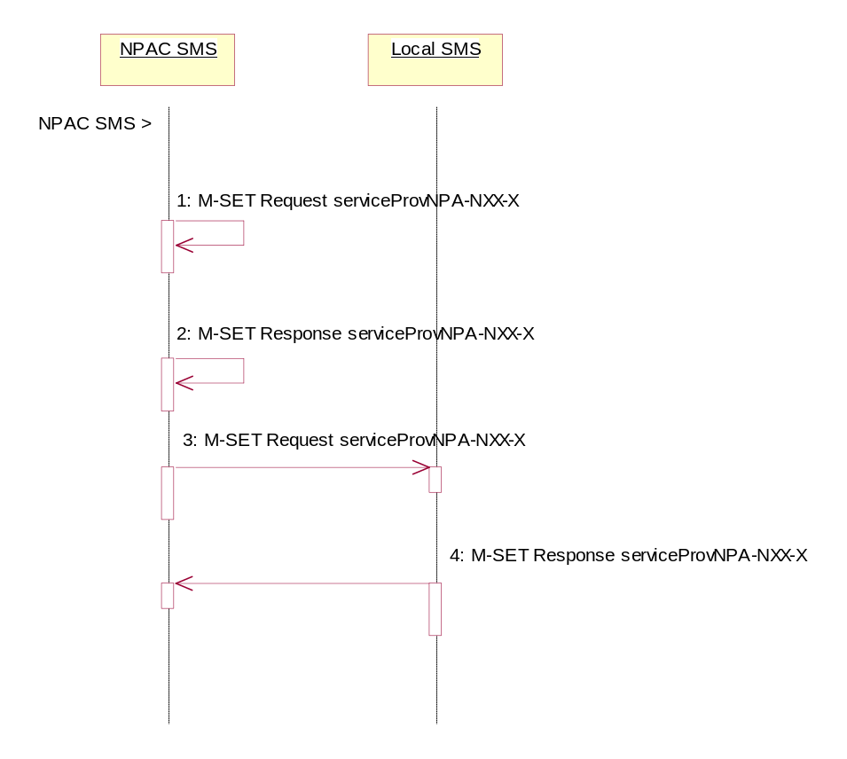
Action is taken by NPAC SMS personnel to initiate a modification to the serviceProvNPA-NXX-X object.
- NPAC SMS sends the M-SET request to itself to update the serviceProvNPA-NXX-X-EffectiveTimeStamp. The serviceProvNPA-NXX-X-ModifiedTimeStamp is also set.
- NPAC SMS responds indicating whether the modification was successful. The update request will fail if the effective timestamp is within the Block Holder Effective Date Window’s tunable number of days to the creation timestamp of the object or if the current date is greater than or equal to the object’s current effective timestamp.
- NPAC SMS sends the M-SET request to update the serviceProvNPA-NXX-X to all Local SMS that support the object according to the “NPAC Customer LSMS NPA-NXX-X Indicator” in their service provider profile on the NPAC SMS and are receiving data for the NPA-NXX.
- Local SMS respond to the M-SET indicating whether the modification was successful.

Service Provider NPA-NXX-X Deletion by NPAC SMS Prior to Number Pool Block Existence
In this scenario, the NPAC SMS deletes the serviceProvNPA-NXX-X object at the request of the number pool administrator. This deletion takes place prior to the effective date or after the effective date, but prior to the number pool block object being created for the NPA-NXX-X value.

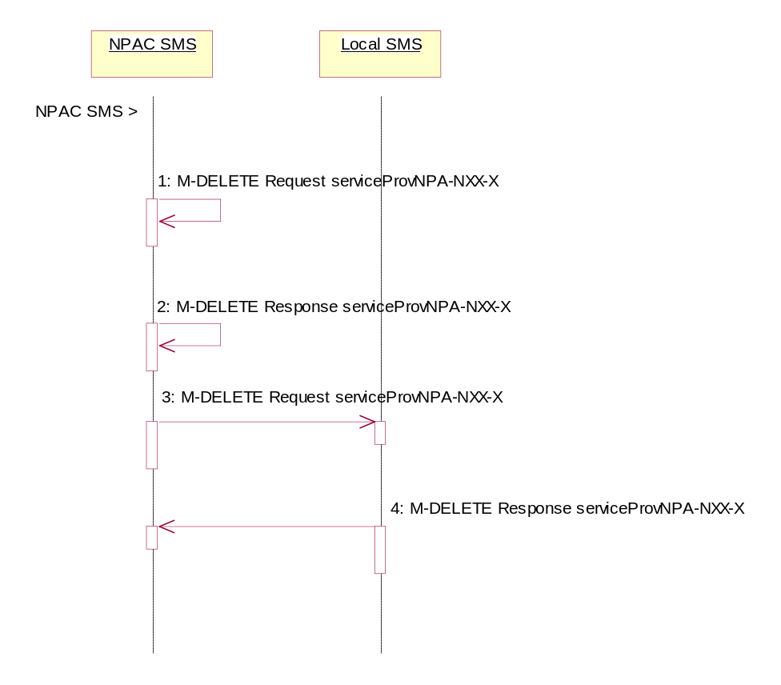
Action is taken by NPAC SMS personnel to delete a serviceProvNPA-NXX-X object.
- The NPAC SMS sends an M-DELETE request to itself in order to delete the local serviceProvNPA-NXX-X object.
- The NPAC SMS receives the M-DELETE response indicating whether the serviceProvNPA-NXX-X object was successfully deleted.
- If the serviceProvNPA-NXX-X object was deleted, the NPAC SMS sends the M-DELETE request to all Local SMS for the serviceProvNPA-NXX-X object who support the object according to the “NPAC Customer LSMS NPA-NXX-X Indicator” in their service provider profile on the NPAC SMS and are receiving data for the NPA-NXX.
- The Local SMS responds by sending the M-DELETE responds indicating whether the serviceProvNPA-NXX-X object was deleted successfully.

Service Provider NPA-NXX-X Query by SOA or LSMS
In this scenario, the service provider queries the NPAC SMS for one or more serviceProvNPA-NXX-X objects from the SOA or Local SMS.

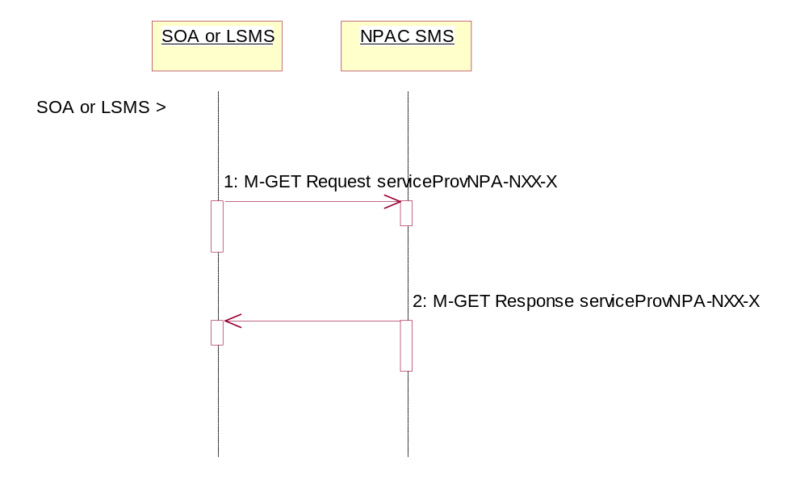
Service provider personnel take action to query the NPAC SMS for one or more serviceProvNPA-NXX-X objects.
- SOA or Local SMS sends an M-GET for a single serviceProvNPA-NXX-X object by serviceProvNPA-NXX-X-ID or a scope and filtered M-GET for one or more serviceProvNPA-NXX-X objects.
- If the NPAC SMS finds one or more serviceProvNPA-NXX-X objects that match the input criteria, the NPAC SMS responds with the single or linked reply of serviceProvNPA-NXX-X object(s). Otherwise it returns an empty result.

Number Pool Block

This section contains the flows that demonstrate number pool block creation, modification and deletion.

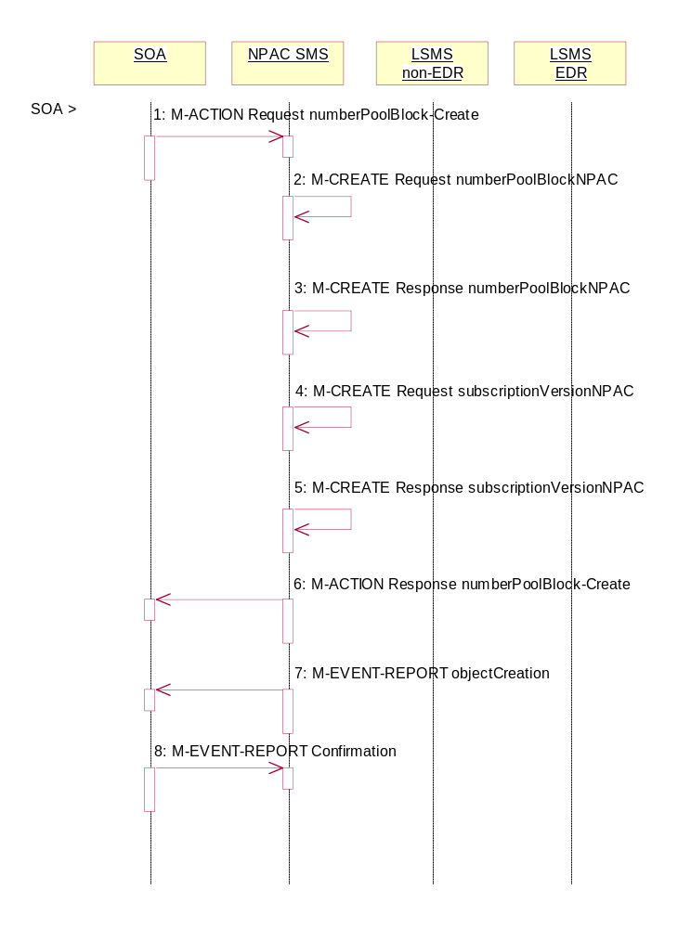
Number Pool Block Create/Activate by SOA
In this scenario, the block holder service provider sends in the M-ACTION for the number pool block to be created.

Action is taken by the block holder service provider SOA to create a number pool block.

- The block holder service provider SOA sends the M-ACTION numberPoolBlock-Create to the NPAC SMS. The block holder service provider must provide the following attributes:

numberPoolBlockNPA-NXX-X
numberPoolBlockLRN
numberPoolBlockSPID
numberPoolBlockCLASS-DPC
numberPoolBlockCLASS-SSN
numberPoolBlockCNAM-DPC
numberPoolBlockCNAM-SSN
numberPoolBlockISVM-DPC
numberPoolBlockISVM-SSN
numberPoolBlockLIDB-DPC
numberPoolBlockLIDB-SSN

The NPAC SMS verifies the following and returns the indicated error if the condition fails:
- The serviceProvNPA-NXX-X object exists for the given numberPoolBlockNPA-NXX-X. If the condition fails, error returned is ‘no-npa-nxx-x-found’.
- The service provider associated with the SOA is equal to the numberPoolBlockSPID and is owner of the corresponding serviceProvNPA-NXX-X object. If the condition fails, error returned is ‘soa-not-authorized’.
- All attributes are valid. If the condition fails, error returned is ‘invalid-data-values’.
- A numberPoolBlockNPAC object does not already exist or one exists with a status of ‘old’ with an empty list of failed service providers for the given numberPoolBlockNPA-NXX-X. If the condition fails, error returned is ‘number-pool-block-already-exists’.
- The current date is greater than or equal to the serviceProvNPA-NXX-X-EffectiveTimeStamp of the corresponding serviceProvNPA-NXX-X object. If the condition fails, error returned is ‘prior-to-effective-date’.
- There are no subscription version objects within the given TN range with a status of pending, conflict, cancel-pending or failed (“pending-like”) and no active subscription version for that TN. If the condition fails, error returned is ‘invalid-subscription-versions’.

Any other error will be returned as “failed”. If an error is found, the NPAC SMS returns the M-ACTION reply with the error. No further processing occurs.

- If the request is valid, the NPAC SMS creates the numberPoolBlockNPAC object. The numberPoolBlockSOA-Origination indicator is set to TRUE. The numberPoolBlockActivationTimeStamp, numberPoolBlockCreationTimeStamp, numberPoolBlockBroadcastTimeStamp and numberPoolBlockModifiedTimeStamp are set. The numberPoolBlockStatus is set to “sending”.

- The NPAC SMS responds to the M-CREATE.

- If the request is valid, the NPAC SMS will create the corresponding subscriptionVersionNPAC object(s). If an active, partial-failure, sending or disconnect-pending (“active-like”) subscription version exists within the block’s TN range, no new subscription version will be created for that TN. For the subscription versions created, the subscriptionLNPType will be set to ‘pool’, subscriptionVersionStatus will be set to “sending” and the subscriptionModifiedTimeStamp, subscriptionActivationTimeStamp, subscriptionBroadcastTimeStamp and subscriptionCreationTimeStamp will be set.

- The NPAC SMS will respond with the M-CREATE response.

- NPAC SMS responds to the M-ACTION.

- NPAC SMS sends the M-EVENT-REPORT objectCreation for the numberPoolBlockNPAC to the SOA. The following attributes will be sent in the objectCreation notification:

numberPoolBlockId
numberPoolBlockSOA-Origination
numberPoolBlockCreationTimeStamp
numberPoolBlockStatus
numberPoolBlockNPA-NXX-X
numberPoolBlockSPID
numberPoolBlockLRN
numberPoolBlockCLASS-DPC
numberPoolBlockCLASS-SSN
numberPoolBlockCNAM-DPC
numberPoolBlockCNAM-SSN
numberPoolBlockISVM-DPC
numberPoolBlockISVM-SSN
numberPoolBlockLIDB-DPC
numberPoolBlockLIDB-SSN

- The block holder SOA confirms the M-EVENT-REPORT.

Number Pool Block Create by NPAC SMS

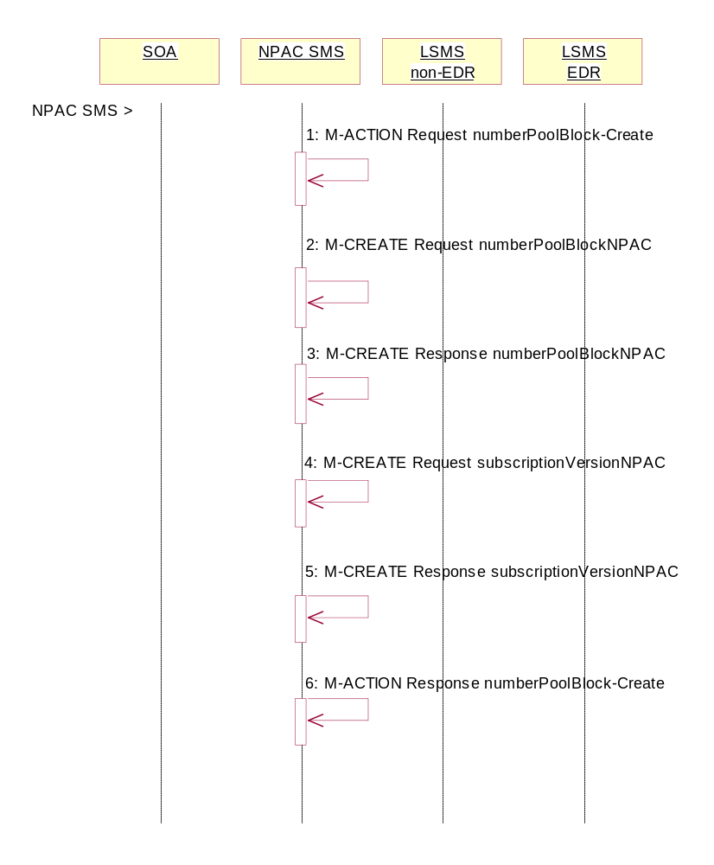
In this scenario, the NPAC SMS creates the number pool block on or after the effective date of the serviceProvNPA-NXX-X object. Since the SOA does not send in the creation request, all notifications (M-EVENT-REPORTs) to the SOA will be suppressed.
Action is taken by the NPAC SMS to create a number pool block.

- NPAC SMS personnel create the numberPoolBlockNPAC on the NPAC SMS for a service provider block holder using the M-ACTION, numberPoolBlock-Create. The following attributes are required:
numberPoolBlockNPA-NXX-X
numberPoolBlockSPID
numberPoolBlockLRN
numberPoolBlockCLASS-DPC
numberPoolBlockCLASS-SSN
numberPoolBlockCNAM-DPC
numberPoolBlockCNAM-SSN
numberPoolBlockISVM-DPC
numberPoolBlockISVM-SSN
numberPoolBlockLIDB-DPC
numberPoolBlockLIDB-SSN

The NPAC SMS verifies the following and returns the indicated error if the condition fails:
- The serviceProvNPA-NXX-X object exists for the given numberPoolBlockNPA-NXX-X. If the condition fails, error returned is no-npa-nxx-x-found.
- The service provider associated with the SOA is equal to the numberPoolBlockSPID and is owner of the corresponding serviceProvNPA-NXX-X object. If the condition fails, error returned is soa-not-authorized.
- All attributes are valid. If the condition fails, error returned is invalid-data-values.
- A numberPoolBlockNPAC object does not already exist or one exists with a status of ‘old’ with an empty list of failed service providers for the given numberPoolBlockNPA-NXX-X. If the condition fails, error returned is number-pool-block-already-exists.
- The current date is greater than or equal to the serviceProvNPA-NXX-X-EffectiveTimeStamp of the corresponding serviceProvNPA-NXX-X object. If the condition fails, error returned is prior-to-effective-date.
- There are no subscription version objects within the given TN range with a status of pending, conflict, cancel-pending or failed (“pending-like”) and no active subscription version for that TN. If the condition fails, error returned is invalid-subscription-versions.

Any other error will be returned as “failed”. If an error is found, the NPAC SMS returns the M-ACTION reply with the error. No further processing occurs.

- The NPAC SMS creates the numberPoolBlockNPAC object. The numberPoolBlockSOA-Origination indicator is set to FALSE. The numberPoolBlockCreationTimeStamp, numberPoolBlockActivationTimeStamp, numberPoolBlockBroadcastTimeStamp and numberPoolBlockModifiedTimeStamp are set. The numberPoolBlockStatus is set to “sending”.

- NPAC SMS responds to the M-CREATE.

- The NPAC SMS creates the corresponding subscriptionVersionNPAC object.(s). If an active, partial-failure, sending or disconnect-pending (“active-like”) subscription version exists within the block’s TN range, no new subscription version will be created for that TN. For the subscription version created, the subscriptionLNPType will be set to ‘pool’, the subscriptionVersionStatus will be set to “sending” and the subscriptionModifiedTimeStamp, subscriptionActivationTimeStamp, subscriptionBroadcastTimeStamp and subscriptionCreationTimeStamp will be set.

- NPAC SMS responds to the M-CREATE.

- NPAC SMS responds to the M-ACTION.

Number Pool Block Create Broadcast: Successful
In this scenario, the number pool block and corresponding subscription versions have been created on the NPAC SMS. The NPAC SMS now begins to broadcast the subscriptionVersions and numberPoolBlock data to the Local SMSs.

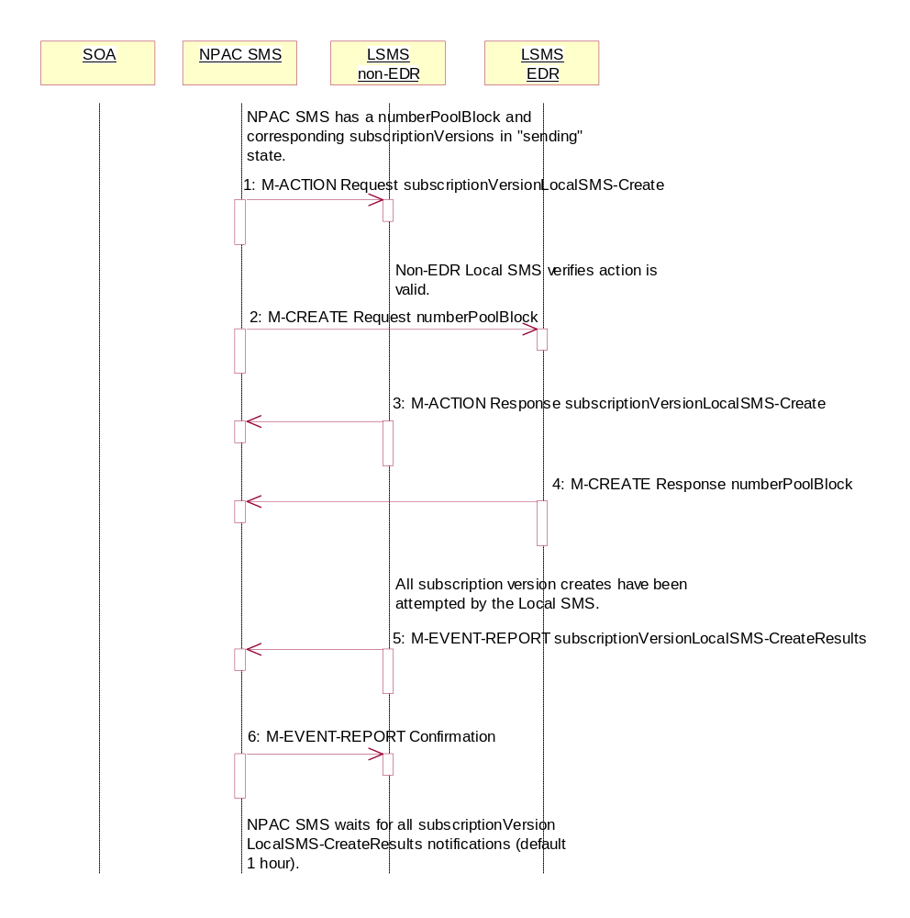
Number Pool Block Create Broadcast Successful to Local SMS

- NPAC SMS issues the subscriptionVersionLocalSMS-Create action to the non-EDR Local SMS, if it is accepting downloads for the NPA-NXX of the subscription versions. This action contains all data required to create the subscription versions with the subscriptionLNPType of ‘pool’.
- At the same time as step 1, the NPAC SMS sends the M-CREATE for the numberPoolBlock to the EDR Local SMS.
- The non-EDR Local SMS verifies the action is valid and returns the M-ACTION reply. If the non-EDR Local SMS does not respond to the M-ACTION request, the NPAC SMS will retry the request a tunable amount of times.
- The EDR Local SMS sends to the NPAC SMS the results of the M-CREATE. If the EDR Local SMS fails to respond, the NPAC SMS will retry the M-CREATE request a tunable amount of times.
- The non-EDR Local SMS proceeds to execute all the creates specified by the action. The non-EDR Local SMS sends to the NPAC SMS the M-EVENT-REPORT specifying the success or failure of the subscription version creates.
- NPAC SMS confirms the M-EVENT-REPORT.
The NPAC SMS now waits for all the subscriptionVersionLocalSMS-CreateResults M-EVENT-REPORTs a tunable amount of time (default 1 hour).

Number Pool Block Create: Successful Broadcast

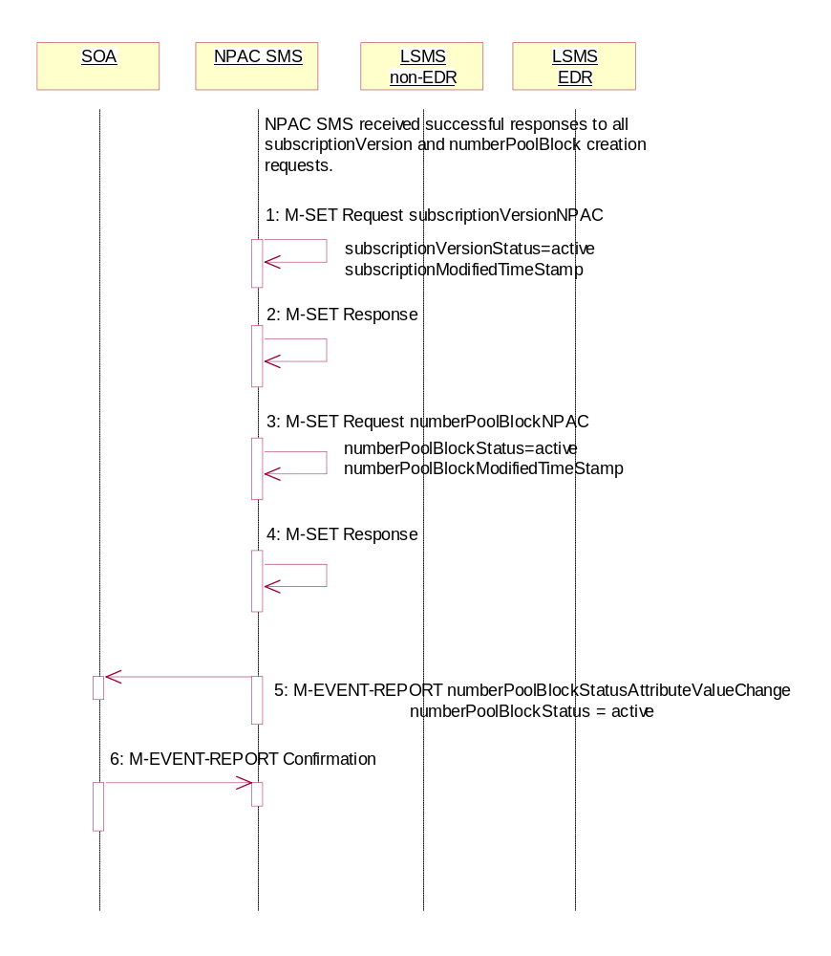
In this scenario, the NPAC SMS has just completed the successful broadcast of a numberPoolBlock and corresponding subscriptionVersions.

- NPAC SMS updates all the subscriptionVersionNPACs that were broadcasted by setting the subscriptionVersionStatus to ‘active’ and setting the subscriptionModifiedTimeStamp to the current date and time.
- NPAC SMS responds to the M-SET.
- NPAC SMS updates the numberPoolBlock by setting the numberPoolBlockStatus to ‘active’ and setting the numberPoolBlockModifiedTimeStamp to the current date and time.
- NPAC SMS responds to the M-SET.
- If the numberPoolBlockSOA-Origination indicator is set to TRUE, the NPAC SMS sends the M-EVENT-REPORT, numberPoolBlockStatusAttributeValueChange, to the block holder SOA for the number pool block. The status attribute value change would contain the numberPoolBlockStatus set to ‘active’.
- Block holder SOA confirms the M-EVENT-REPORT.

Number Pool Block Create Broadcast to Local SMS: Failure
In this scenario, the NPAC SMS has a numberPoolBlock and corresponding subscriptionVersions in ‘sending’ state for creation to the Local SMSs and no Local SMS will respond successfully to the broadcast.

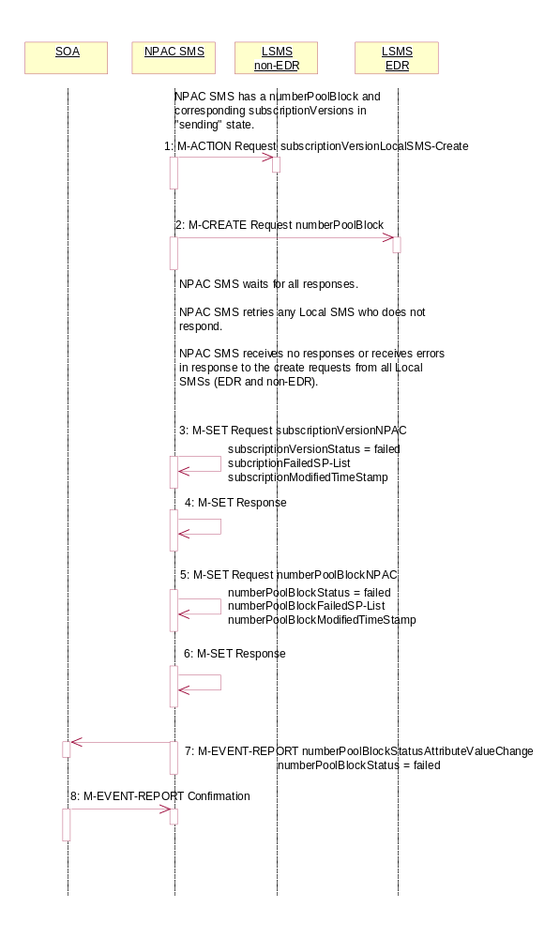

- NPAC SMS sends the M-ACTION subscriptionVersionLocalSMS-Create request to all the non-EDR Local SMSs.
- At the same time as step 1, NPAC SMS sends the M-CREATE numberPoolBlock request to all the EDR Local SMSs.

NPAC SMS waits for all the responses.
NPAC SMS retries any Local SMS who does not respond.
NPAC SMS receives no responds or receives errors in response to the create requests from all Local SMSs (EDR and non-EDR).

- NPAC SMS sets each subscriptionVersionNPAC’s subscriptionVersionStatus to ‘failed’. The subscriptionFailed-SP-List gets updated with the failed service providers and the subscriptionModifiedTimeStamp gets set.
- NPAC SMS responds to the M-SET.
- NPAC SMS sets the numberPoolBlock’s numberPoolBlockStatus to ‘failed’. The numberPoolBlockFailed-SP-List gets updated with the failed service providers and the subscriptionModifiedTimeStamp gets set.
- NPAC SMS responds to the M-SET.
- If the numberPoolBlock’s SOA Origination indicator is set to ‘true’, the NPAC SMS sends the M-EVENT-REPORT, numberPoolBlockStatusAttributeValueChange, for the numberPoolBlock with the numberPoolBlockStatus set to ‘failed’ and the numberPoolBlockFailed-SP-List to the block holder SOA.
- The SOA confirms the M-EVENT-REPORT.

Number Pool Block Create Broadcast to Local SMS: Partial Failure

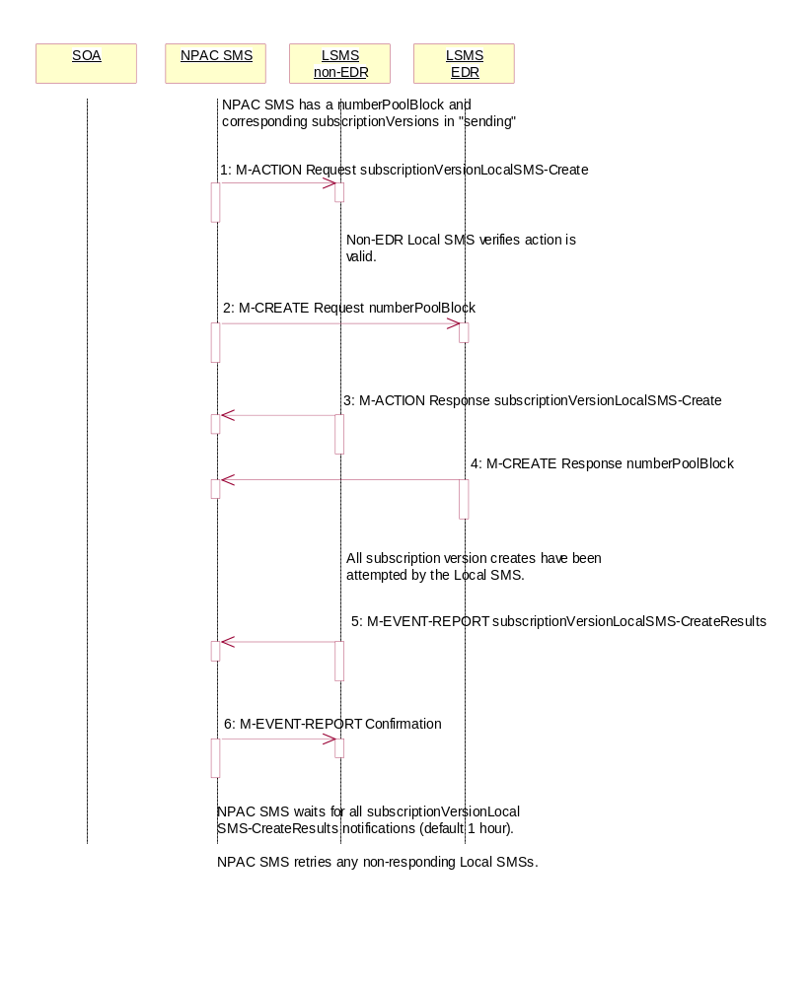
In this scenario, the NPAC SMS has a numberPoolBlock and corresponding subscriptionVersions in ‘sending’ state for creation to the Local SMSs and some but not all Local SMS will respond successfully to the broadcast resulting in a state of “partial-failure” for one or more of the subscription versions and the number pool block.

Number Pool Block Create Partial-Failure Broadcast to Local SMSs

- NPAC SMS issues the subscriptionVersionLocalSMS-Create action to the non-EDR Local SMS, if it is accepting downloads for the NPA-NXX of the subscription versions. This action contains all data required to create the subscription versions with the subscriptionLNPType of ‘pool’.
- At the same time as step 1, NPAC SMS sends the M-CREATE for the numberPoolBlock to the EDR Local SMS.
- The non-EDR Local SMS verifies the action is valid and returns an acknowledgment. If the non-EDR Local SMS fails to respond, the NPAC SMS will retry the M-ACTION request a tunable amount of times.
- The EDR Local SMS sends to the NPAC SMS the results of the M-CREATE. If the EDR Local SMS fails to respond, the NPAC SMS will retry the M-CREATE request a tunable amount of times.
- The non-EDR Local SMS proceeds to execute all the creates specified by the action. The non-EDR Local SMS sends to the NPAC SMS the M-EVENT-REPORT specifying the success or failure of the creates.
- NPAC SMS confirms the M-EVENT-REPORT.

The NPAC SMS now waits for all the subscriptionVersionLocalSMS-CreateResults M-EVENT-REPORTs responses a tunable amount of time (default 1 hour).

Number Pool Block Create Broadcast Partially Failed NPAC SMS Updates
All retries have been exhausted and the time for the subscriptionVersionLocalSMS-CreateResults to be received has expired for a broadcast of a number pool block create.

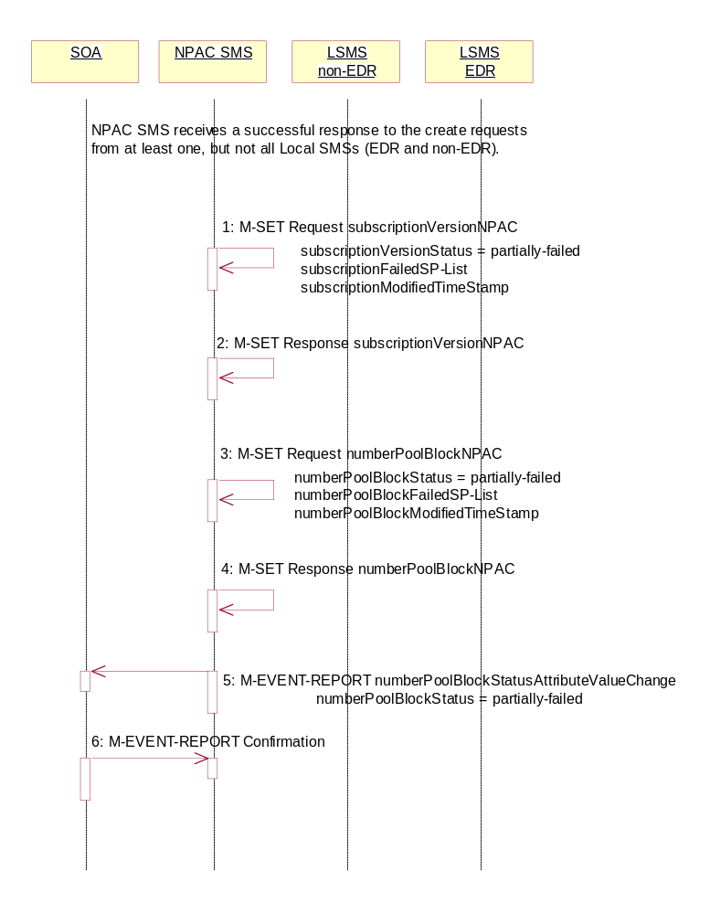
NPAC SMS receives a successful response to the create request from at least one, but not all, Local SMSs (EDR and non-EDR).

The NPAC SMS must now set the numberPoolBlock to partial-failure and subscriptionVersion objects to partial-failure or active depending upon which Local SMSs failed the request. If an EDR Local SMS failed, the numberPoolBlock and ALL subscriptionVersions broadcast will be set to partial-failure. If a non-EDR Local SMS failed all the creates, the numberPoolBlock and ALL subscriptionVersion broadcast will be set to partial-failure. If a non-EDR Local SMS fails only some of the subscriptionVersion creates, the numberPoolBlock will be set to partial-failure along with the subscriptionVersions the non-EDR Local SMS failed. The other subscription versions may be set to ‘active’ if all EDR Local SMSs were successful and all other non-EDR Local SMSs were successful for those subscription versions.

The subscriptionFailed-SP-List on the number pool block object contains all the service providers who failed to receive either the number pool block or any of the subscription versions. The subscriptionFailed-SP-List on each subscription version object contains only those service providers who failed to receive that subscription version or the number pool block object.

The partial-failure status will be removed from both objects when all subscriptionVersions and numberPoolBlocks are successfully resent or recovered.

- NPAC SMS issues an M-SET to the subscriptionVersionNPAC(s) setting the subscriptionVersionStatus to ‘partially-failed’ or ‘active’ and setting the subscriptionFailed-SP-List to the list of failed service providers. The subscriptionModifiedTimeStamp is also set.
- NPAC SMS responds to the M-SET.
- NPAC SMS issues an M-SET to the numberPoolBlockNPAC setting the numberPoolBlockStatus to ‘partially-failed’ and setting the numberPoolBlockFailed-SP-List to the list of failed service providers. The numberPoolBlockModifiedTimeStamp is also set.
- NPAC SMS responds to the M-SET.
- If the numberPoolBlockSOA-Origination indicator is set to ‘true’, the NPAC SMS sends the block holder SOA the M-EVENT-REPORT, numberPoolBlockStatusAttributeValueChange, with the numberPoolBlockStatus set to ‘partially-failed’ and the numberPoolBlockFailed-SP-List.
- The block holder SOA confirms the M-EVENT-REPORT.

Number Pool Block Create Resend Broadcast
In this scenario, the NPAC SMS has a number pool block and corresponding subscription versions with LNP type of ‘pool’ in a failed or partially-failed state. The NPAC SMS will resend the requests to the Local SMSs.

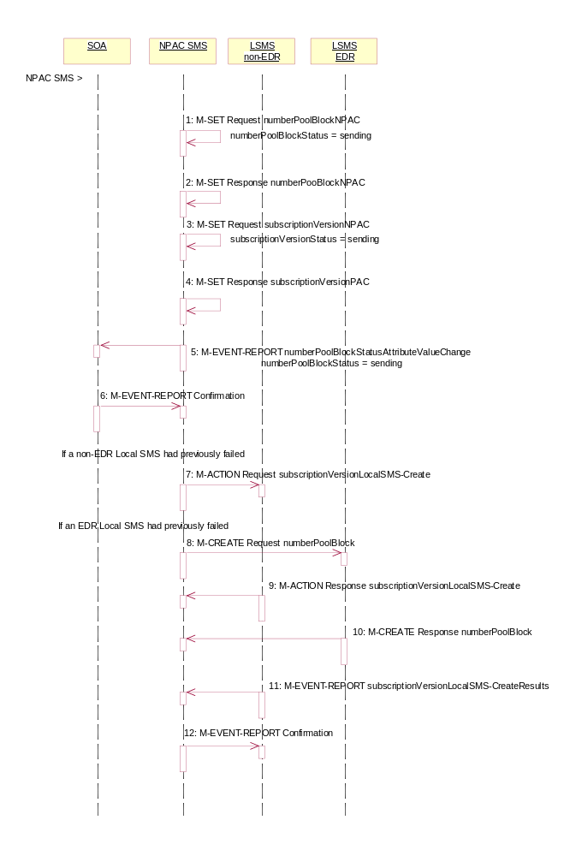
Action is taken by the NPAC SMS personnel to resend a previously failed activation of a number pool block and corresponding subscription versions.
- NPAC SMS issues the M-SET to modify the numberPoolBlockStatus to ‘sending’ on the number pool block object. The numberPoolBlockModifiedTimeStamp and numberPoolBlockBroadcastTimeStamp also get set.
- NPAC SMS responds to the M-SET.
- NPAC SMS issues the M-SET to modify the subscriptionVersionStatus to ‘sending’ on the subscription version object. The subscriptionModifiedTimeStamp and subscriptionBroadcastTimeStamp also get set.
- NPAC SMS responds to the M-SET.
- If the numberPoolBlockSOA-Origination indicator is set to TRUE, the NPAC SMS sends the M-EVENT-REPORT, numberPoolBlockStatusAttributeValueChange, to the block holder SOA. The status attribute value change would contain the numberPoolBlockStatus set to ‘sending’.
- Block holder SOA confirms the M-EVENT-REPORT.
- NPAC SMS issues the subscriptionVersionLocalSMS-Create action to the non-EDR Local SMS if it had previously failed the create request. This action contains all data to create the subscription versions with LNP type of ‘pool’. If the create is for a single subscription version, the M-CREATE will be sent.
- At the same time as step 7, the NPAC SMS sends the M-CREATE for the numberPoolBlock to the EDR Local SMS if it had previously failed the create request.
- The non-EDR Local SMS verifies the action is valid and returns the M-ACTION reply. If the non-EDR Local SMS does not respond to the M-ACTION request, the NPAC SMS will retry the request a tunable number of times.
- The EDR Local SMS sends to the NPAC SMS the results of the M-CREATE. If the EDR Local SMS fails to respond, the NPAC SMS will retry the M-CREATE request a tunable amount of times.
- The non-EDR Local SMS proceeds to execute all the creates specified by the action. The non-EDR Local SMS sends to the NPAC SMS the M-EVENT-REPORT specifying the success or failure of the subscription version creates.
- NPAC SMS confirms the M-EVENT-REPORT.
The NPAC SMS now waits for all the subscriptionVersionLocalSMS-CreateResults M-EVENT-REPORTs a tunable amount of time (default 1 hour).

Number Pool Block Create Successful Resend Updates

In this scenario, the NPAC SMS has successfully re-sent the creation of a number pool block and corresponding subscription versions. The NPAC SMS now updates the state of the objects on the NPAC SMS.
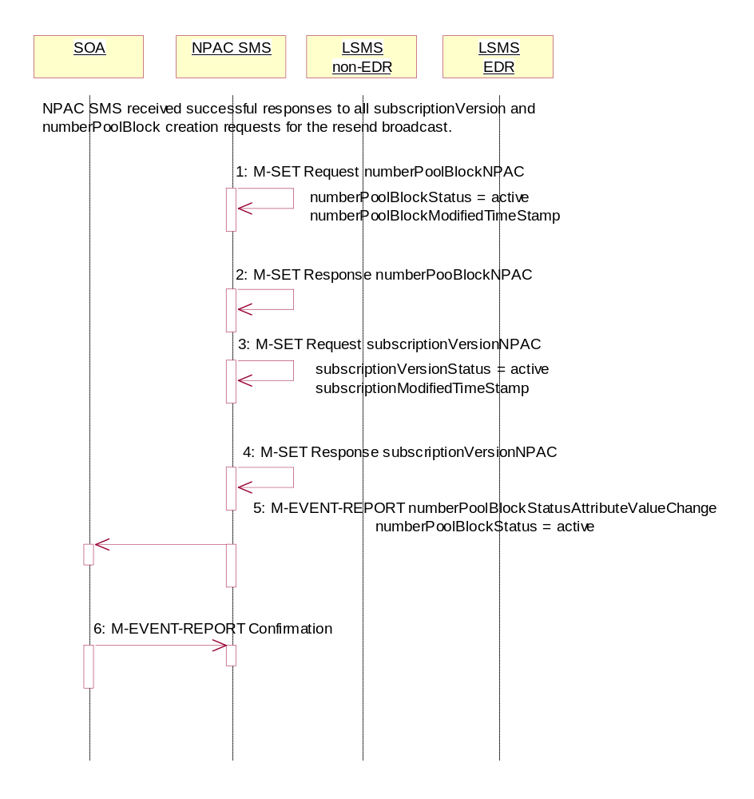

- NPAC SMS updates the numberPoolBlockNPACs by setting the numberPoolBlockStatus to ‘active’ and setting the numberPoolBlockModifiedTimeStamp to the current date and time.
- NPAC SMS responds to the M-SET.
- NPAC SMS updates all the subscriptionVersionNPACs that were broadcasted by setting the subscriptionVersionStatus to ‘active’ and setting the subscriptionModifiedTimeStamp to the current date and time.
- NPAC SMS responds to the M-SET.
- If the numberPoolBlockSOA-Origination indicator is set to TRUE, the NPAC SMS sends the M-EVENT-REPORT, numberPoolBlockStatusAttributeValueChange,to the block holder SOA for the number pool block. The status attribute value change would contain the numberPoolBlockStatus set to ‘active’.
- Block holder SOA confirms the M-EVENT-REPORT.

Number Pool Block Create Failed Resend NPAC SMS Updates
In this scenario, the NPAC SMS has unsuccessfully resent the creation of a number pool block and corresponding subscription versions and the status is still failed for the objects. The NPAC SMS now updates the state of the objects on the NPAC SMS.

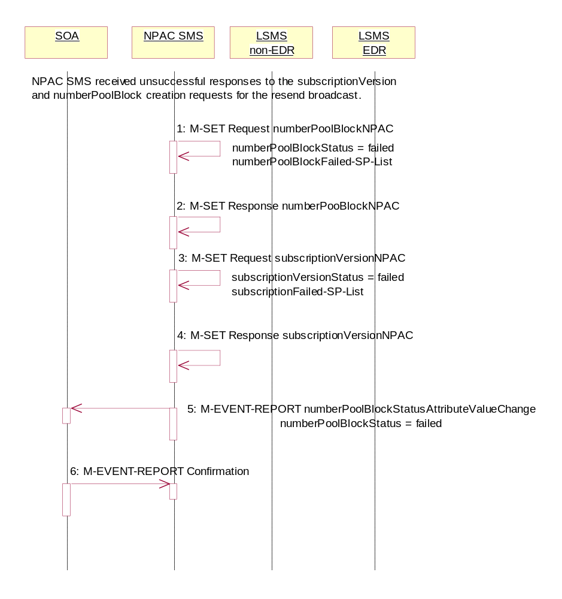
- NPAC SMS updates the numberPoolBlock by setting the numberPoolBlockStatus back to ‘failed’, updating the numberPoolBlockFailed-SP-List with the failed service providers who failed the subscription version and number pool block download and setting the numberPoolBlockModifiedTimeStamp to the current date and time.
- NPAC SMS responds to the M-SET.
- NPAC SMS updates all the subscriptionVersionNPACs that were broadcasted by setting the subscriptionVersionStatus back to ‘failed’, updating the subscriptionFailed-SP-List with the failed service providers who failed either the number pool block or subscription version create and setting the subscriptionModifiedTimeStamp to the current date and time.
- NPAC SMS responds to the M-SET.
- If the numberPoolBlockSOA-Origination indicator is set to TRUE, the NPAC SMS sends the M-EVENT-REPORT, numberPoolBlockStatusAttributeValueChange,to the block holder SOA for the number pool block. The status attribute value change would contain the numberPoolBlockStatus set to ‘failed’ and the numberPoolBlockFailed-SP-List.
- Block holder SOA confirms the M-EVENT-REPORT.

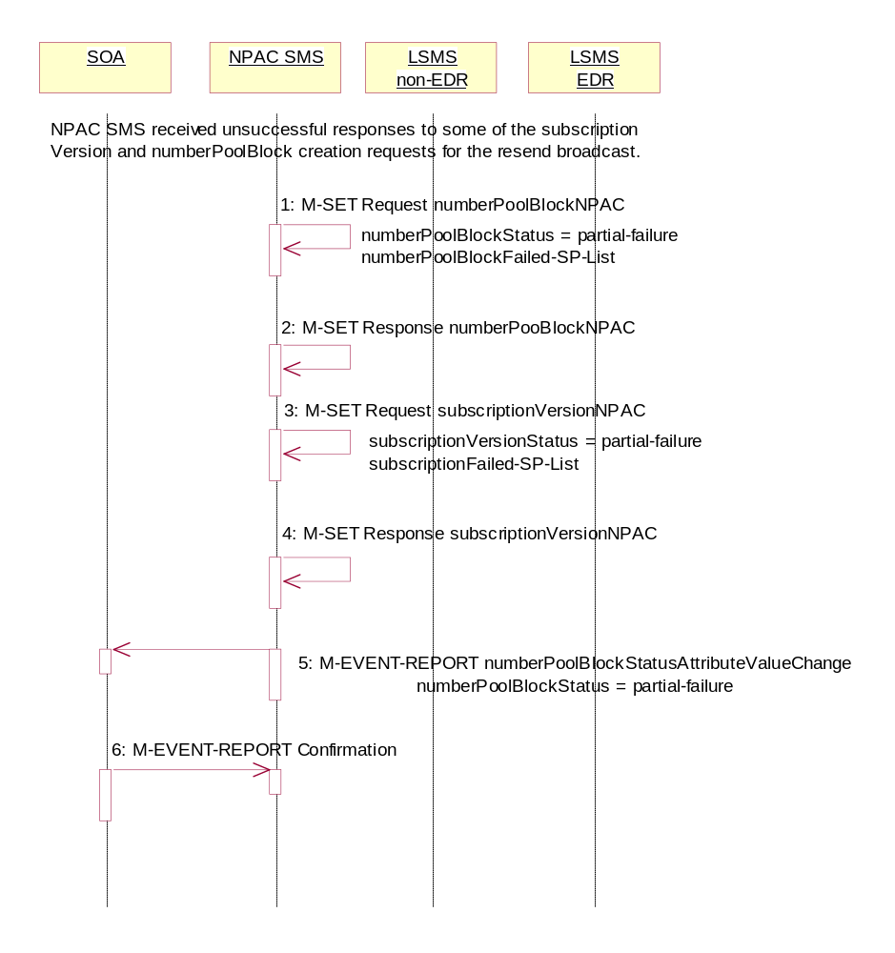
Number Pool Block Create Partial-Failure Resend NPAC SMS Updates
In this scenario, the NPAC SMS has unsuccessfully re-sent the creation of a number pool block and corresponding subscription versions and the status is now partial-failure for the objects. The NPAC SMS now updates the state of the objects on the NPAC SMS.

- NPAC SMS updates the numberPoolBlock by setting the numberPoolBlockStatus to ‘partial-failure’, updating the numberPoolBlockFailed-SP-List with the failed service providers who failed the number pool block or subscription version create and setting the numberPoolBlockModifiedTimeStamp to the current date and time.
- NPAC SMS responds to the M-SET.
- NPAC SMS updates each of the subscriptionVersionNPAC that was broadcasted by setting the subscriptionVersionStatus to ‘partial-failure’ or ‘active’, updating the subscriptionFailed-SP-List with the failed service providers who failed the number pool block or subscription version create and setting the subscriptionModifiedTimeStamp to the current date and time.
- NPAC SMS responds to the M-SET.
- If the numberPoolBlockSOA-Origination indicator is set to TRUE, the NPAC SMS sends the M-EVENT-REPORT, numberPoolBlockStatusAttributeValueChange, to the block holder SOA for the number pool block. The status attribute value change would contain the numberPoolBlockStatus set to ‘partial-failure’ and the failed service provider list.
- Block holder SOA confirms the M-EVENT-REPORT.

Number Pool Block Modify by NPAC SMS
This scenario shows the modification of a number pool block object by NPAC Personnel at the request of the block holder service provider.

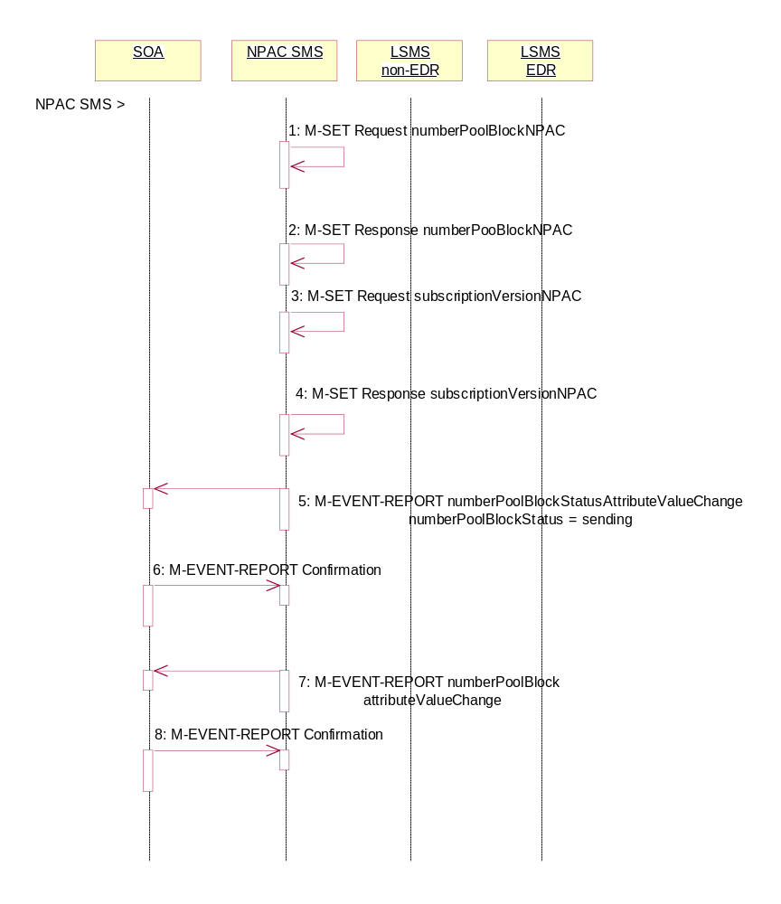
Action is taken by NPAC personnel to modify the data on a number pool block.
- NPAC SMS issues the M-SET to modify attribute data on a single numberPoolBlock. The following attributes can be modified:
numberPoolBlockLRN
numberPoolBlockCLASS-DPC
numberPoolBlockCLASS-SSN
numberPoolBlockCNAM-DPC
numberPoolBlockCNAM-SSN
numberPoolBlockISVM-DPC
numberPoolBlockISVM-SSN
numberPoolBlockLIDB-DPC
numberPoolBlockLIDB-SSN

numberPoolBlockSOA-Origination

In addition, the numberPoolBlockStatus gets set to ‘sending’ and the numberPoolBlockBroadcastTimeStamp and numberPoolBlockModifiedTimeStamp get set to the current date and time.

- NPAC SMS responds to the M-SET.

- NPAC SMS issues the M-SET to modify the attribute data on the corresponding subscriptionVersionNPAC object(s). Only the following attribute can be modified:

subscriptionLRN
subscriptionCLASS-DPC
subscriptionCLASS-SSN
subscriptionCNAM-DPC
subscriptionCNAM-SSN
subscriptionISVM-DPC
subscriptionISVM-SSN
subscriptionLIDB-DPC
subscriptionLIDB-SSN

In addition, the NPAC SMS sets the subscriptionVersionStatus to ‘sending’ and the numberPoolBlockBroadcastTimeStamp and numberPoolBlockModifiedTimeStamp get set to the current date and time.

- NPAC SMS responds to the M-SET.

- If the numberPoolBlockSOA-Origination indicator is set to TRUE, the NPAC SMS sends the M-EVENT-REPORT, numberPoolBlockStatusAttributeValueChange, to the block holder SOA. The status attribute value change would contain the numberPoolBlockStatus set to ‘sending’.
- Block holder SOA confirms the M-EVENT-REPORT.
- If the numberPoolBlockSOA-Origination indicator is set to TRUE, the NPAC SMS sends the M-EVENT-REPORT, attribute value change, to the block holder SOA. The attribute value change would include any of the following attributes that were updated:

numberPoolBlockLRN
numberPoolBlockCLASS-DPC
numberPoolBlockCLASS-SSN
numberPoolBlockCNAM-DPC
numberPoolBlockCNAM-SSN
numberPoolBlockISVM-DPC
numberPoolBlockISVM-SSN
numberPoolBlockLIDB-DPC
numberPoolBlockLIDB-SSN
numberPoolBlockSOA-Origination

- Block holder SOA confirms the M-EVENT-REPORT.

Number Pool Block Modify by Block Holder SOA
This scenario shows the modification of a number pool block object by the block holder SOA Personnel.

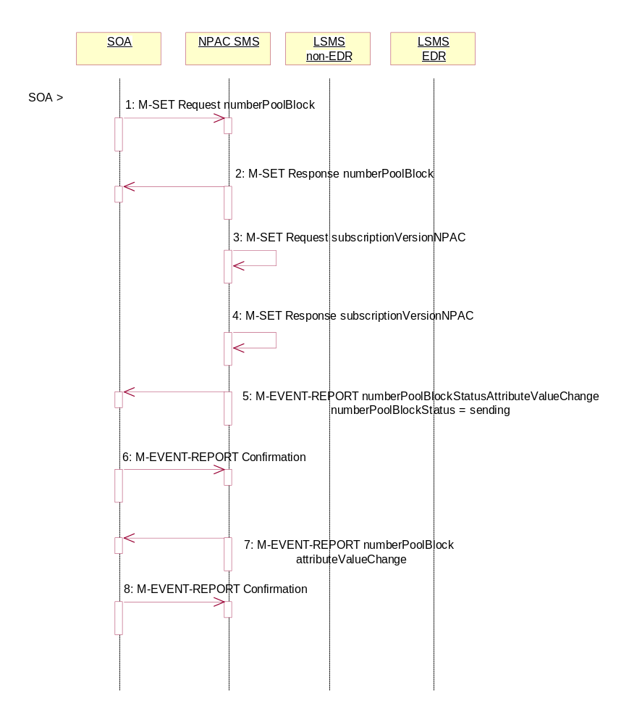
- Block holder SOA issues the M-SET by either directing the request to a specific number pool block or issuing a scope and filtered request specifying the numberPoolBlockNPA-NXX-X and numberPoolBlockStatus to modify attribute data on the numberPoolBlock. The following attributes can be modified:
numberPoolBlockLRN
numberPoolBlockCLASS-DPC
numberPoolBlockCLASS-SSN
numberPoolBlockCNAM-DPC
numberPoolBlockCNAM-SSN
numberPoolBlockISVM-DPC
numberPoolBlockISVM-SSN
numberPoolBlockLIDB-DPC
numberPoolBlockLIDB-SSN

In addition, the numberPoolBlockStatus gets set to ‘sending’ and the numberPoolBlockBroadcastTimeStamp gets set.

- NPAC SMS responds to the M-SET.

- NPAC SMS issues the M-SET to modify the attribute data on the corresponding subscriptionVersionNPAC object(s). Only the following attribute can be modified:

subscriptionLRN
subscriptionCLASS-DPC
subscriptionCLASS-SSN
subscriptionCNAM-DPC
subscriptionCNAM-SSN
subscriptionISVM-DPC
subscriptionISVM-SSN
subscriptionLIDB-DPC
subscriptionLIDB-SSN

In addition, the NPAC SMS sets the subscriptionVersionStatus to ‘sending’.

- NPAC SMS responds to the M-SET.

- The NPAC SMS sends the M-EVENT-REPORT, numberPoolBlockStatusAttributeValueChange, to the block holder SOA. The status attribute value change would contain the numberPoolBlockStatus set to ‘sending’.
- Block holder SOA confirms the M-EVENT-REPORT.
- The NPAC SMS sends the M-EVENT-REPORT, attribute value change, to the block holder SOA. The attribute value change would include any of the following attributes that were updated:

numberPoolBlockLRN
numberPoolBlockCLASS-DPC
numberPoolBlockCLASS-SSN
numberPoolBlockCNAM-DPC
numberPoolBlockCNAM-SSN
numberPoolBlockISVM-DPC
numberPoolBlockISVM-SSN
numberPoolBlockLIDB-DPC
numberPoolBlockLIDB-SSN

- Block holder SOA confirms the M-EVENT-REPORT.

Number Pool Block Modify Broadcast to Local SMS Success
In this scenario, the NPAC SMS has made a modification to a number pool block object and is about to broadcast the data to the Local SMS.

Number Pool Block Modify Successful Broadcast to Local SMS

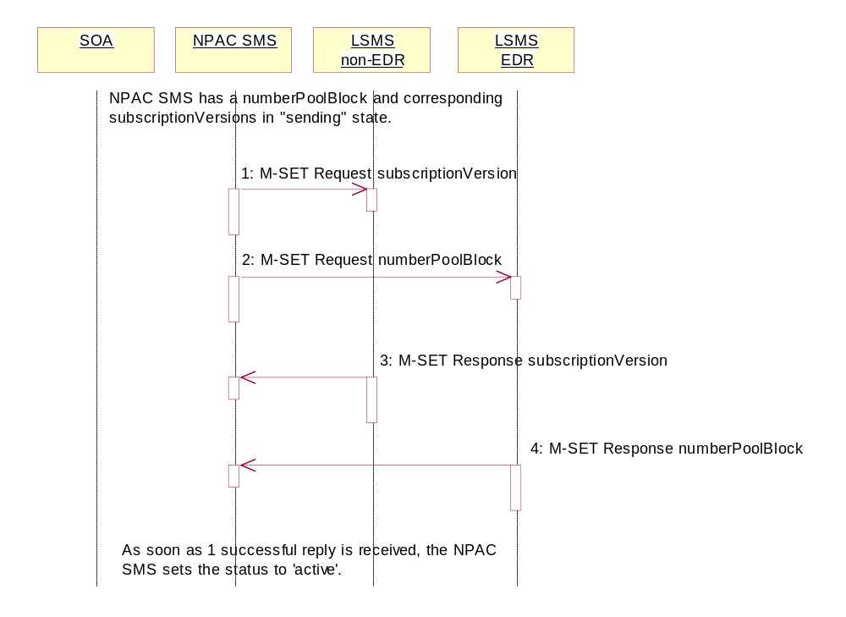
The NPAC SMS has a number pool block object and corresponding subscription version objects in a state of ‘sending’.
- NPAC SMS sends the M-SET for the updated attributes on the subscription version object(s) to the non-EDR Local SMS who are accepting downloads for the NPA-NXX.
- At the same time, the NPAC SMS sends the M-SET for the updated attributes on the number pool block object to the EDR Local SMS.
- Non-EDR Local SMS responds to the M-SET.
- EDR Local SMS responds to the M-SET.
As soon as 1 successful response is received to either M-SET, the status of the subscriptionVersionNPAC and numberPoolBlockNPAC object goes to ‘active’.

Number Pool Block Modify Successful Broadcast NPAC SMS Updates

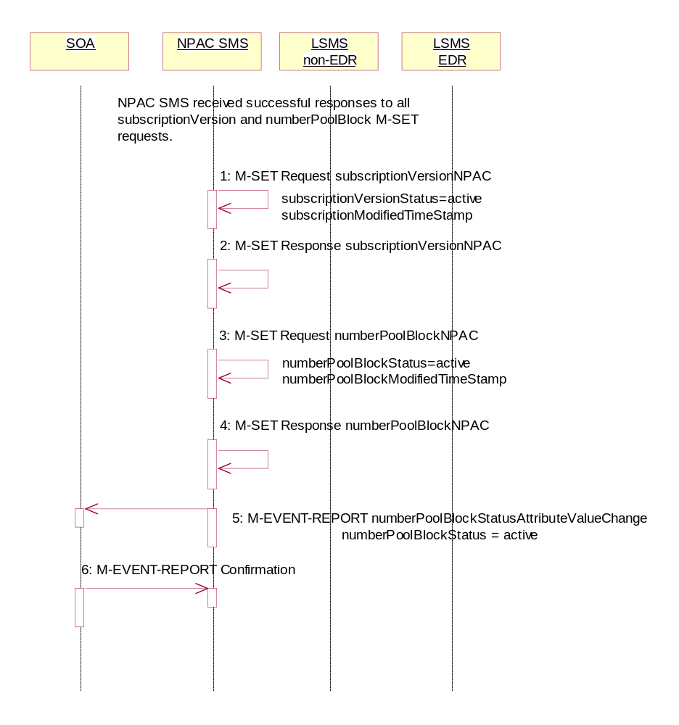
In this scenario, the NPAC SMS has received successful M-SET responses from all the Local SMS for the numberPoolBlock and corresponding subscriptionVersions.

As soon as the first successful response is received, the NPAC SMS sets the status of the subscriptionVersionNPAC objects and numberPoolBlockNPAC object to ‘active’. The numberPoolBlockStatusAttributeValueChange, however, is not sent out until all replies have been received or the retries have been exhausted.
- NPAC SMS updates all the subscriptionVersionNPACs that were broadcasted by setting the subscriptionVersionStatus to ‘active’ and setting the subscriptionModifiedTimeStamp to the current date and time.
- NPAC SMS responds to the M-SET.
- NPAC SMS updates the numberPoolBlock by setting the numberPoolBlockStatus to ‘active’ and setting the numberPoolBlockModifiedTimeStamp to the current date and time.
- NPAC SMS responds to the M-SET.
- If the numberPoolBlockSOA-Origination indicator is set to TRUE, the NPAC SMS sends the M-EVENT-REPORT, numberPoolBlockStatusAttributeValueChange, to the block holder SOA. The status attribute value change would contain the numberPoolBlockStatus set to active.
- Block holder SOA confirms the M-EVENT-REPORT.

Number Pool Block Modify Broadcast to Local SMS Failure

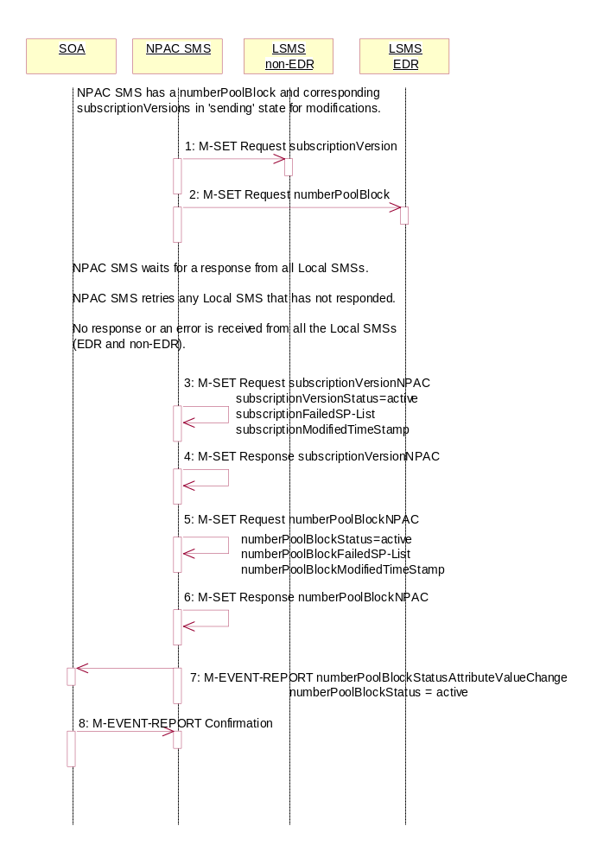
NPAC SMS has a numberPoolBlock and corresponding subscriptionVersion in ‘sending’ state for modifications. In this scenario, no Local SMSs will respond successfully to the M-SET requests.

- NPAC SMS sends the M-SET with the modifications for the subscriptionVersion to the non-EDR Local SMS.
- At the same time as step 1, NPAC SMS sends the M-SET with the modifications for the numberPoolBlock to the EDR Local SMS.
NPAC SMS waits for a response from all Local SMSs.
NPAC SMS retries any Local SMS that has not responded.
No response or an error is received from all the Local SMSs (EDR and non-EDR).
- NPAC SMS returns the subscriptionVersionStatus to ‘active’, sets the subscriptionFailed-SP-List to the list of failed service providers and sets the subscriptionModifiedTimeStamp.
- NPAC SMS responds to the M-SET.
- NPAC SMS returns the numberPoolBlockStatus to ‘active’ and sets the numberPoolBlockFailed-SP-List to the list of failed service providers. The numberPoolBlockModifiedTimeStamp also gets set.
- NPAC SMS responds to the M-SET.
- If the numberPoolBlockSOA-Origination indicator is set to ‘true’, the NPAC SMS sends the block holder SOA the M-EVENT-REPORT, numberPoolBlockStatusAttributeValueChange, with the numberPoolBlockStatus set to active and the numberPoolBlockFailed-SP-List.
- SOA confirms M-EVENT-REPORT.

Number Pool Block Modify Broadcast to Local SMS Partial Failure
In this scenario, the NPAC SMS has a numberPoolBlock and corresponding subscriptionVersion object(s) in a state of ‘sending’ for a modification to the Local SMS. The broadcast, however, will result in a partial-failure state for both the numberPoolBlock and corresponding subscriptionVersions.

Number Pool Block Modify Partial Failure Broadcast to Local SMSs

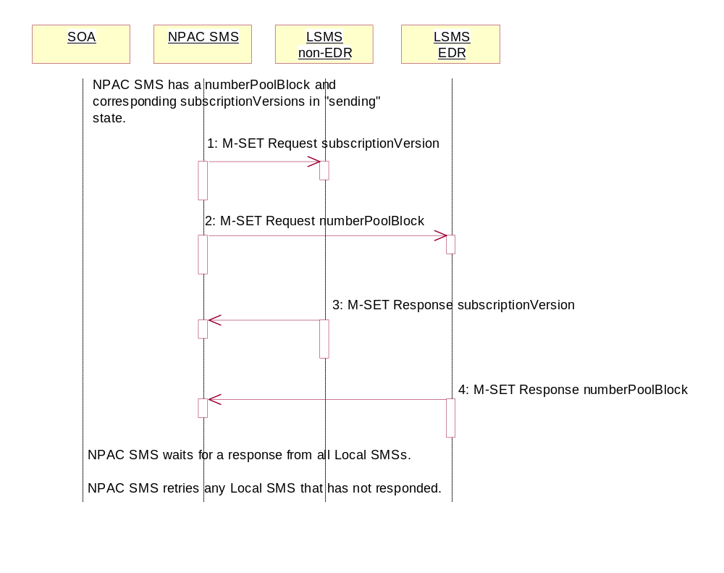
The NPAC SMS has a number pool block object and corresponding subscription version objects in a state of ‘sending’.
- NPAC SMS sends the M-SET for the updated attributes on the subscription version object(s) to the non-EDR Local SMS who are accepting downloads for the NPA-NXX.
- At the same time as step 1, NPAC SMS sends the M-SET for the updated attributes on the number pool block object to the EDR Local SMS who are accepting downloads for the NPA-NXX.
- Non-EDR Local SMS responds successfully to the M-SET.
- EDR Local SMS responds successfully to the M-SET.

NPAC SMS waits for a response from all Local SMSs.
NPAC SMS retries any Local SMS that has not responded.

Number Pool Block Modify Broadcast Partial Failure NPAC SMS Updates

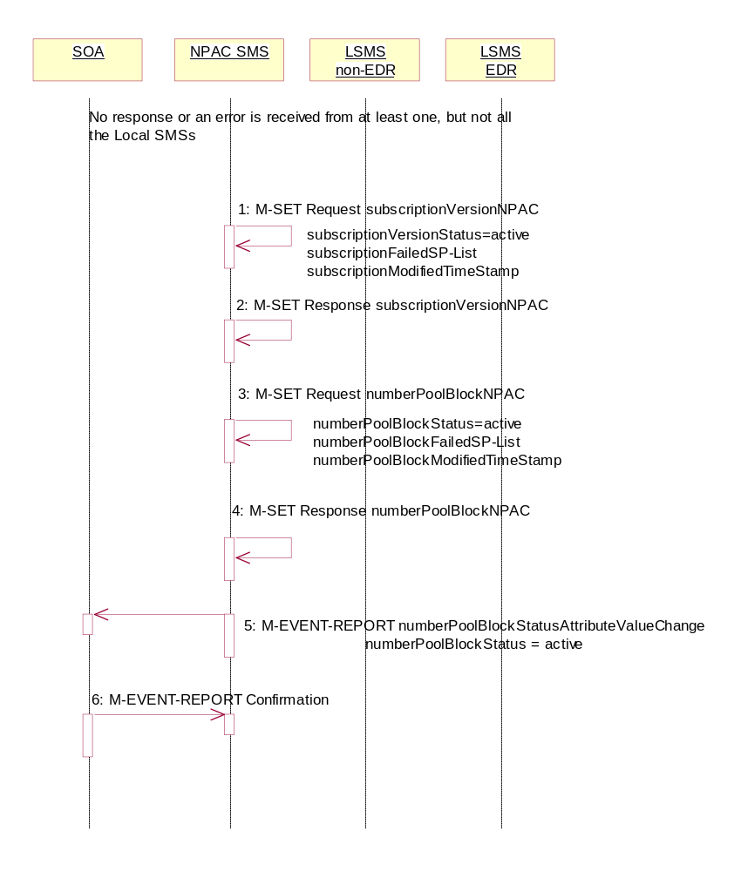
The NPAC SMS has attempted to broadcast the number pool block modification to the Local SMSs. However, at least 1, but not all Local SMSs have responded successfully to the M-SETs.

Once the first successful M-SET response is received, the NPAC SMS sets the status to ‘active’ for the numberPoolBlock and subscriptionVersion objects. Once all retries are exhausted, the NPAC SMS sets
the numberPoolBlockFailed-SP-List and sends the status attribute value change.

The numberPoolBlockSP-List on the number pool block object contains all the service providers who failed to receive either the number pool block or any of the subscription versions. The subscriptionFailed-SP-List on the subscription version object contains only those service providers who failed to receive that subscription version or the number pool block object.

- NPAC SMS updates the subscriptionVersionNPACs with a LNP type set to ‘pool’ that were broadcasted by setting the subscriptionVersionStatus to ‘active’ and updating the subscriptionFailed-SP-List to the list of failed service providers. The subscriptionModifiedTimeStamp is set to the current date and time.
- NPAC SMS responds to the M-SET.
- NPAC SMS updates the numberPoolBlock by setting the numberPoolBlockStatus to ‘active’ and setting the numberPoolBlockFailed-SP-List to the list of currently failed service providers. It also sets the numberPoolBlockModifiedTimeStamp and numberPoolBlockBroadcastTimeStamp to the current date and time.
- NPAC SMS responds to the M-SET.
- If the numberPoolBlockSOA-Origination indicator is set to TRUE, the NPAC SMS sends the M-EVENT-REPORT, numberPoolBlockStatusAttributeValueChange, to the block holder SOA. The status attribute value change would contain the numberPoolBlockStatus set to ‘active’ and the numberPoolBlockFailed-SP-List.
- Block holder SOA confirms the M-EVENT-REPORT.

Number Pool Block Modify Resend Broadcast
In this scenario, the NPAC SMS must resend a previously failed modification to a number pool block and corresponding subscription versions of type ‘pool’.

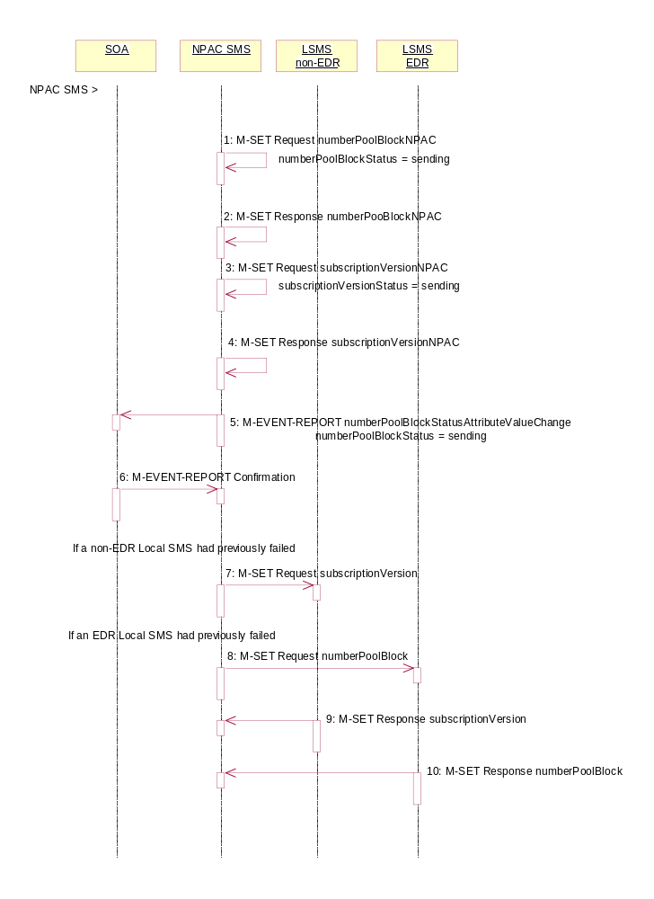
Action is taken by the NPAC SMS personnel to resend a previously failed modification of a number pool block and corresponding subscription versions with a LNP type of ‘pool’.
- NPAC SMS issues the M-SET to modify the numberPoolBlockStatus to ‘sending’ on the number pool block object. The numberPoolBlockModifiedTimeStamp and numberPoolBlockBroadcastTimeStamp also get set.
- NPAC SMS responds to the M-SET.
- NPAC SMS issues the M-SET to modify the subscriptionVersionStatus to ‘sending’ on the subscription version object. The subscriptionModifiedTimeStamp and subscriptionBroadcastTimeStamp also get set.
- NPAC SMS responds to the M-SET.
- If the numberPoolBlockSOA-Origination indicator is set to TRUE, the NPAC SMS sends the M-EVENT-REPORT, numberPoolBlockStatusAttributeValueChange, to the block holder SOA. The status attribute value change would contain the numberPoolBlockStatus set to ‘sending’.
- Block holder SOA confirms the M-EVENT-REPORT.
- NPAC SMS issues the M-SET for the subscription versions to the non-EDR Local SMS if it had previously failed the modify request and if it is accepting downloads for the NPA-NXX.
- At the same time as step 7, the NPAC SMS sends the M-SET for the numberPoolBlock to the EDR Local SMS if it had previously failed the modify request and if it is accepting downloads for the NPA-NXX.
- The non-EDR Local SMS sends to the NPAC SMS the results of the M-SET. If the non-EDR Local SMS fails to respond, the NPAC SMS will retry the M-SET request a tunable amount of times.
- The EDR Local SMS sends to the NPAC SMS the results of the M-SET. If the EDR Local SMS fails to respond, the NPAC SMS will retry the M-SET request a tunable amount of times.

Number Pool Block Modify Successful Resend Updates

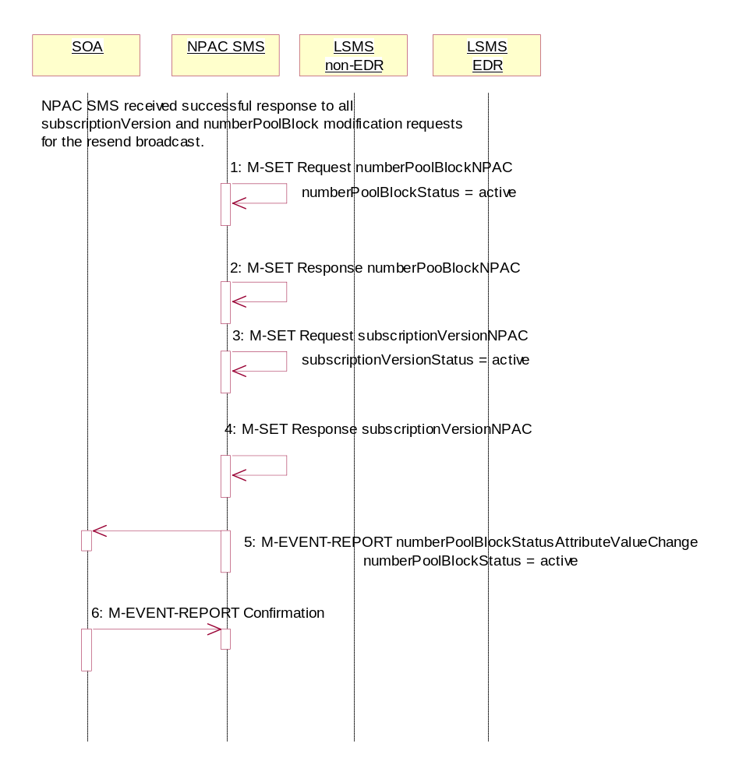
In this scenario, the NPAC SMS has received all successful responses to the modify request for a number pool block and corresponding subscription version with LNP type equal to ‘pool’.

- NPAC SMS updates the numberPoolBlockNPACs by setting the numberPoolBlockStatus to ‘active’ and setting the numberPoolBlockModifiedTimeStamp to the current date and time.
- NPAC SMS responds to the M-SET.
- NPAC SMS updates all the subscriptionVersionNPACs that were broadcasted by setting the subscriptionVersionStatus to ‘active’ and setting the subscriptionModifiedTimeStamp to the current date and time.
- NPAC SMS responds to the M-SET.
- If the numberPoolBlockSOA-Origination indicator is set to TRUE, the NPAC SMS sends the M-EVENT-REPORT, numberPoolBlockStatusAttributeValueChange,to the block holder SOA for the number pool block. The status attribute value change would contain the numberPoolBlockStatus set to ‘active’.
- Block holder SOA confirms the M-EVENT-REPORT.

Number Pool Block Modify Failure Resend Updates

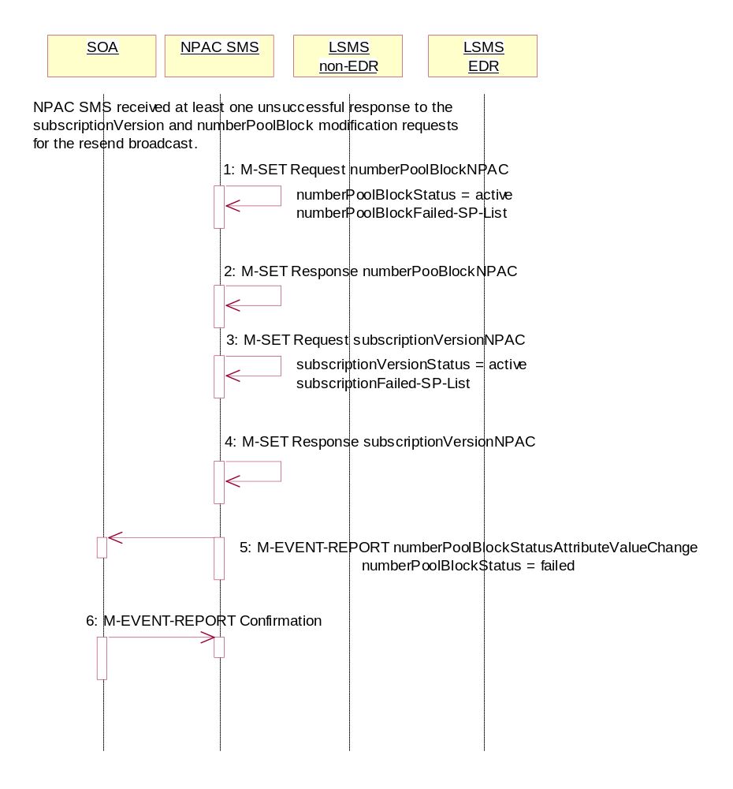
In this scenario, the NPAC SMS has not received all successful responses to the modify request for a number pool block and corresponding subscription version with LNP type equal to ‘pool’.

- NPAC SMS updates the numberPoolBlockNPAC by setting the numberPoolBlockStatus back to ‘active’, updating the numberPoolBlockFailed-SP-List with the failed service providers who failed the subscription version and number pool block download and setting the numberPoolBlockModifiedTimeStamp to the current date and time.
- NPAC SMS responds to the M-SET.
- NPAC SMS updates each of the subscriptionVersionNPAC that was broadcasted by setting the subscriptionVersionStatus back to ‘active’, updating the subscriptionVersionFailed-SP-List with the failed service providers who failed either the number pool block or subscription version create and setting the subscriptionModifiedTimeStamp to the current date and time.
- NPAC SMS responds to the M-SET.
- If the numberPoolBlockSOA-Origination indicator is set to TRUE, the NPAC SMS sends the M-EVENT-REPORT, numberPoolBlockStatusAttributeValueChange,to the block holder SOA for the number pool block. The status attribute value change would contain the numberPoolBlockStatus set to ‘active’ and the numberPoolBlockFailed-SP-List with any of the failed service providers who failed the subscription version and/or number pool block download.
- Block holder SOA confirms the M-EVENT-REPORT.

Number Pool Block Modification of SOA-Origination Indicator

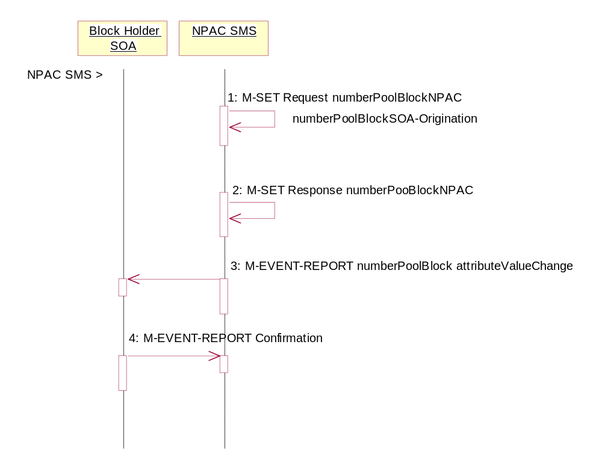
A block holder service provider has asked the NPAC SMS to change the value of the numberPoolBlockSOA-Origination indicator on a number pool block.
Action is taken by NPAC SMS personnel to modify a number pool block object.
- NPAC SMS locally M-SETs the number pool block object changing the value of the numberPoolBlockSOA-Origination indicator.
- NPAC SMS successfully responds to the M-SET.
- The NPAC SMS issues the M-EVENT-REPORT attribute value change to the block holder SOA for the number pool block that contains the numberPoolBlockSOA-Origination indicator.
- The block holder SOA confirms the M-EVENT-REPORT.

Number Pool Block De-Pool by NPAC SMS
This scenario reflects the events that occur when a block is “de-pooled” after the serviceProvNPA-NXX-X object has become effective and active. Only NPAC Personnel are allowed to remove a number pool block object at the request of the number pool block administrator.

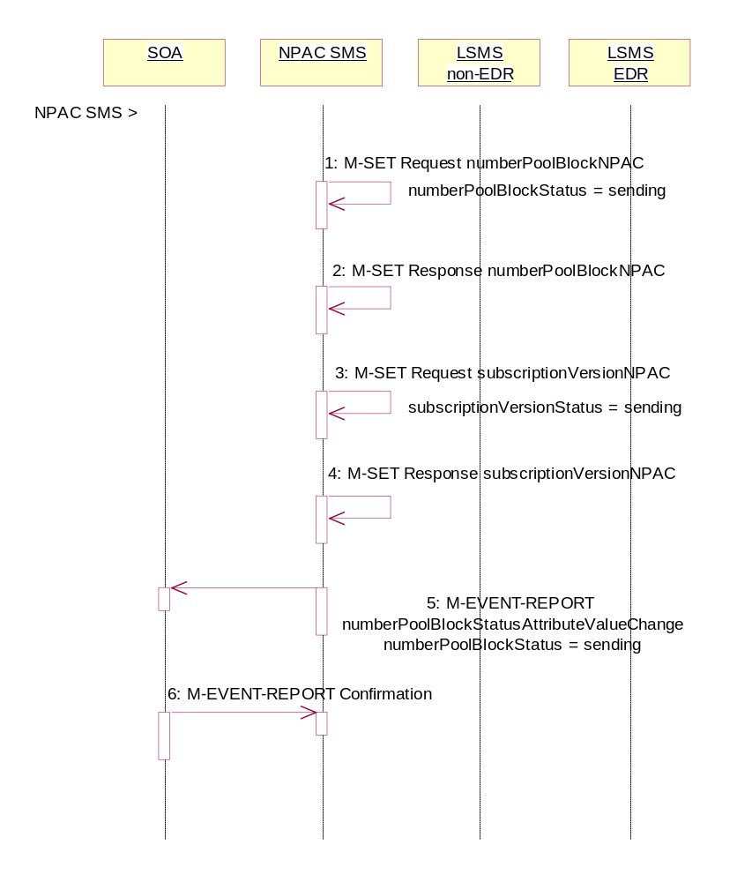
The removal of the serviceProvNPA-NXX-X object is a cascading request. First, all subscription versions with the LNP type equal to ‘pool’ must be removed from the non-EDR Local SMSs and the number pool block must be removed from all the EDR Local SMSs. Once this broadcast is successful for all service providers, the NPAC SMS will remove the serviceProvNPA-NXX-X object and broadcast that object deletion to the Local SMSs.

Action is taken by NPAC personnel to ‘de-pool’ a block of TNs.
- NPAC SMS issues the M-SET to update the numberPoolBlockStatus to ‘sending’ and the numberPoolBlockBroadcastTimeStamp gets set.
- NPAC SMS responds to the M-SET.
- NPAC SMS issues the M-SET to update the corresponding subscriptionVersions within the block range with LNP type equal to ‘pool’ to a status of ‘sending’ and the subscriptionModifiedTimeStamp gets set.
- NPAC SMS responds to the M-SET.
- If the numberPoolBlockSOA-Origination indicator is set to TRUE, the NPAC SMS sends the M-EVENT-REPORT, numberPoolBlockStatusAttributeValueChange, to the block holder SOA. The status attribute value change would contain the numberPoolBlockStatus set to ‘sending’.
- Block holder SOA confirms the M-EVENT-REPORT.

Number Pool Block De-Pool Broadcast Success
In this scenario, the NPAC personnel have initiated the “de-pool” of a block of TNs. The NPAC SMS already has the numberPoolBlock and corresponding subscriptionVersions in the “sending” state.

Number Pool Block De-Pool Successful Broadcast of Subscription Version and Number Pool Block Deletes
In this scenario, the NPAC SMS will send all the M-DELETE requests for the number pool block and subscription versions to the Local SMSs and get successful replies to all the requests.

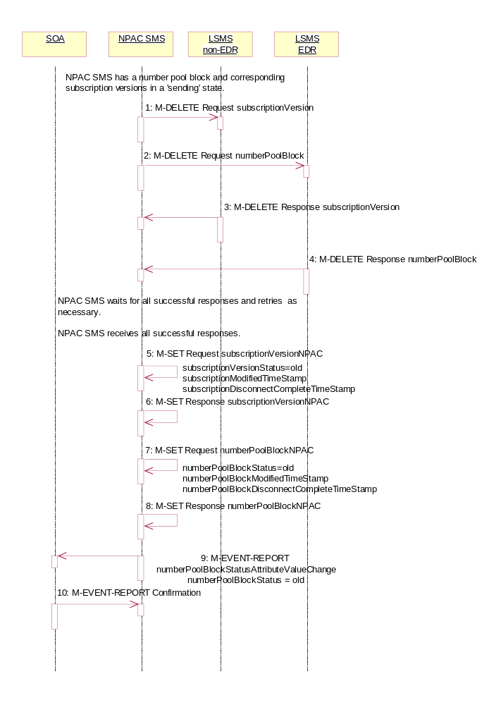
The NPAC SMS has a number pool block object and corresponding subscription version objects in a state of ‘sending’.
- NPAC SMS sends the M-DELETE for the subscription version object(s) to the non-EDR Local SMS who are accepting downloads for the NPA-NXX. The subscription version TNs are within the block range and have the LNP type set to ‘pool’.
- At the same time, NPAC SMS sends the M-DELETE for the number pool block object to the EDR Local SMS.
- Non-EDR Local SMS respond successfully to the M-DELETE.
- EDR Local SMS respond successfully to the M-DELETE.
NPAC SMS waits for all the successful responses and retries as necessary.
NPAC SMS receives all successful responses.
- NPAC SMS updates all the subscriptionVersionNPACs that were broadcasted by setting the subscriptionVersionStatus to ‘old’ and setting the subscriptionModifiedTimeStamp and subscriptionDisconnectCompleteTimeStamp to the current date and time.
- NPAC SMS responds to the M-SET.
- NPAC SMS updates the numberPoolBlock by setting the numberPoolBlockStatus to ‘old’ and setting the numberPoolBlockModifiedTimeStamp and numberPoolBlockDisconnectCompleteTimeStamp to the current date and time.
- NPAC SMS responds to the M-SET.
- If the numberPoolBlockSOA-Origination indicator is set to TRUE, the NPAC SMS sends the M-EVENT-REPORT for the numberPoolBlockStatusAttributeValueChange to the block holder SOA. The status attribute value change would contain the numberPoolBlockStatus set to ‘old’.
- Block holder SOA confirms the M-EVENT-REPORT.

Number Pool Block De-Pool Broadcast Successful NPA-NXX-X Updates

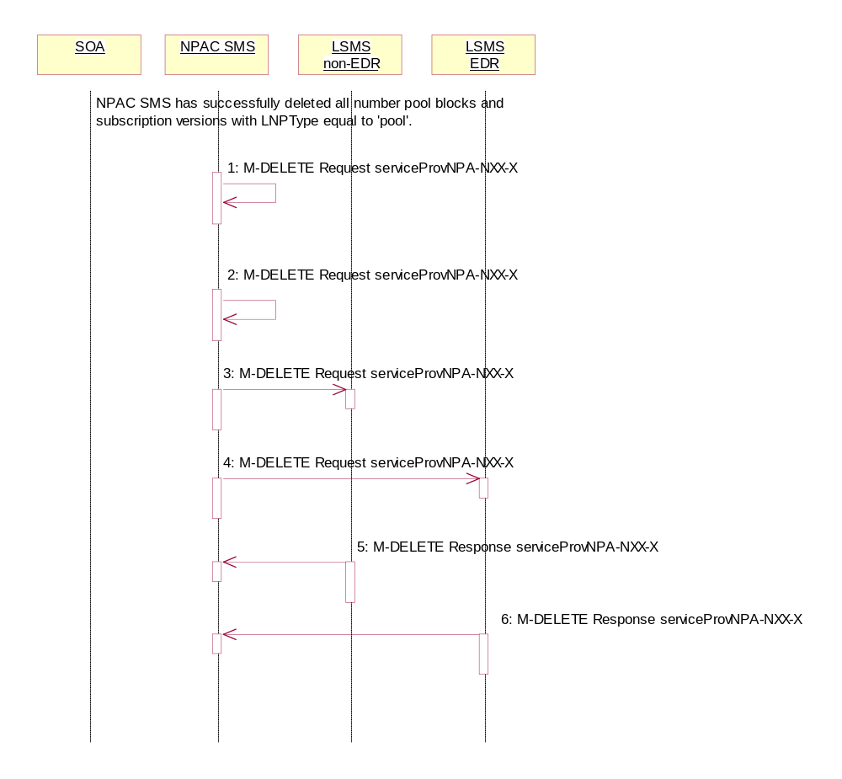
NPAC SMS has received successful responses to all numberPoolBlock and subscriptionVersion M-DELETE requests. The NPAC SMS now proceeds to delete the service provider NPA-NXX-X object.
- NPAC SMS issues the M-DELETE to remove the serviceProvNPA-NXX-X object locally.
- NPAC SMS responds successfully to the M-DELETE request for the serviceProvNPA-NXX-X object.
- The NPAC SMS sends the M-DELETE for the serviceProvNPA-NXX-X object to the non-EDR Local SMS who are supporting the object according to the “NPAC Customer LSMS NPA-NXX-X Indicator” in their service provider profile on the NPAC SMS.
- The NPAC SMS sends the M-DELETE for the serviceProvNPA-NXX-X object to the EDR Local SMS who are supporting the object according to the “NPAC Customer LSMS NPA-NXX-X Indicator” in their service provider profile on the NPAC SMS.
- Non-EDR Local SMS respond successfully to the M-DELETE.
- EDR Local SMS respond successfully to the M-DELETE.

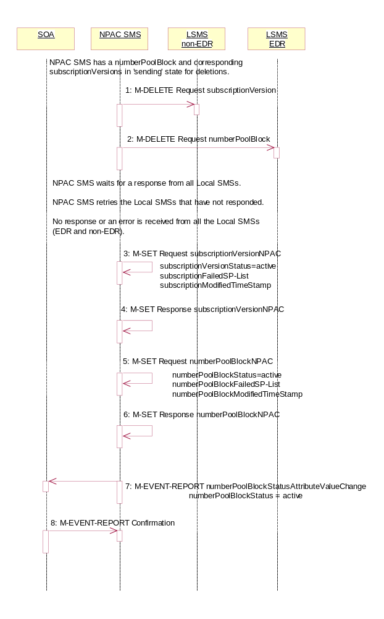
Number Pool Block De-Pool Broadcast to Local SMS Failure
This scenario shows the failure of a broadcast for a de-pool of a number pool block. The M-DELETE has been issued on the serviceProvNPA-NXX-X object and now the NPAC SMS is attempting to broadcast the all the M-DELETEs associated with the block removal.

- NPAC SMS sends the M-DELETE with the modifications for the subscriptionVersion to the non-EDR Local SMS.
- At the same time as step 1, NPAC SMS sends the M-DELETE with the modifications for the numberPoolBlock to the EDR Local SMS.
NPAC SMS waits for a response from all Local SMSs.
NPAC SMS retries the Local SMSs that have not responded.
No response or an error is received from all the Local SMSs (EDR and non-EDR).
- NPAC SMS sets the subscriptionVersionStatus to ‘active’, sets the subscriptionFailed-SP-List to the list of failed service providers and sets the subscriptionModifiedTimeStamp.
- NPAC SMS responds to the M-SET.
- NPAC SMS sets the numberPoolBlockStatus to ‘active’ and sets the numberPoolBlockFailed-SP-List to the list of failed service providers. The numberPoolBlockModifiedTimeStamp also gets set.
- NPAC SMS responds to the M-SET.
- If the numberPoolBlockSOA-Origination indicator is set to ‘true’, the NPAC SMS sends the originating SOA the M-EVENT-REPORT numberPoolBlockStatusAttributeValueChange with the numberPoolBlockStatus set back to ‘active’ and numberPoolBlockFailed-SP-List.
- SOA confirms M-EVENT-REPORT.

Number Pool Block De-Pool Broadcast to Local SMS Partial Failure

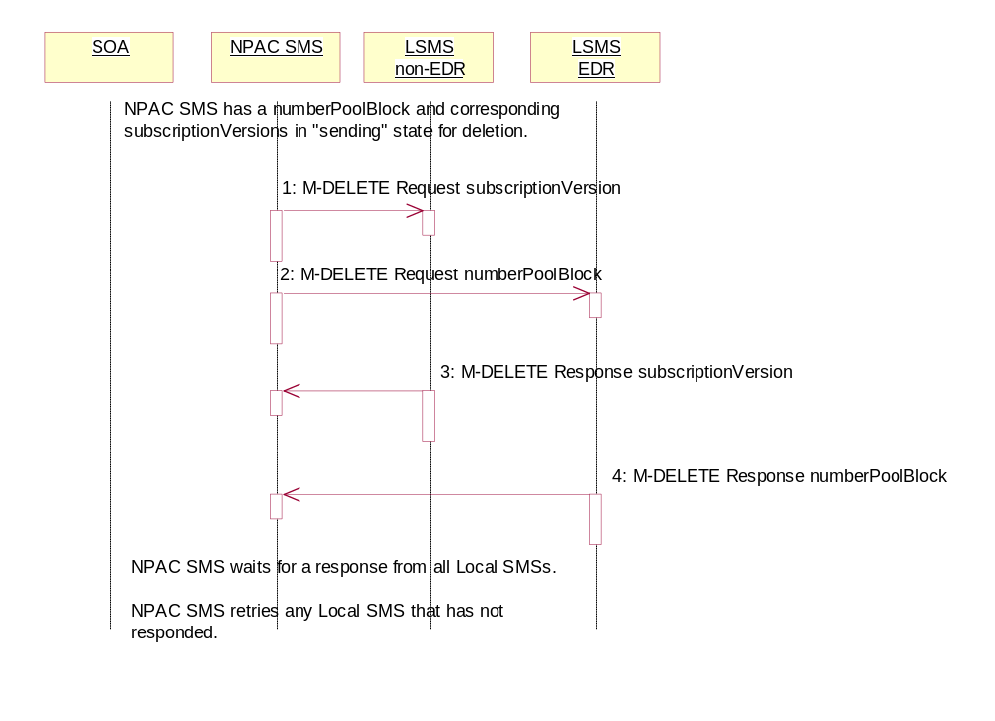
This scenario shows the processing of a partial-failure for the de-pool of a number pool block. The M-DELETE has been issued on the serviceProvNPA-NXX-X object on the NPAC SMS and now the NPAC SMS is attempting to broadcast the all the M-DELETEs associated with the block removal to the Local SMSs.

Number Pool Block De-Pool Partial Failure Broadcast to Local SMS of Subscription Versions and Number Pool Block

The NPAC SMS has a number pool block object and corresponding subscription version objects in a state of ‘sending’.

- NPAC SMS sends the M-DELETE for the subscription version object(s) to the non-EDR Local SMS who are accepting downloads for the NPA-NXX.
- NPAC SMS sends the M-DELETE for the number pool block object to the EDR Local SMS.
- Non-EDR Local SMS responds to the M-DELETE for the subscriptionVersion.
- EDR Local SMS responds to the M-DELETE for the numberPoolBlock.
NPAC SMS waits for a response from all Local SMSs.
NPAC SMS retries any Local SMS that has not responded.

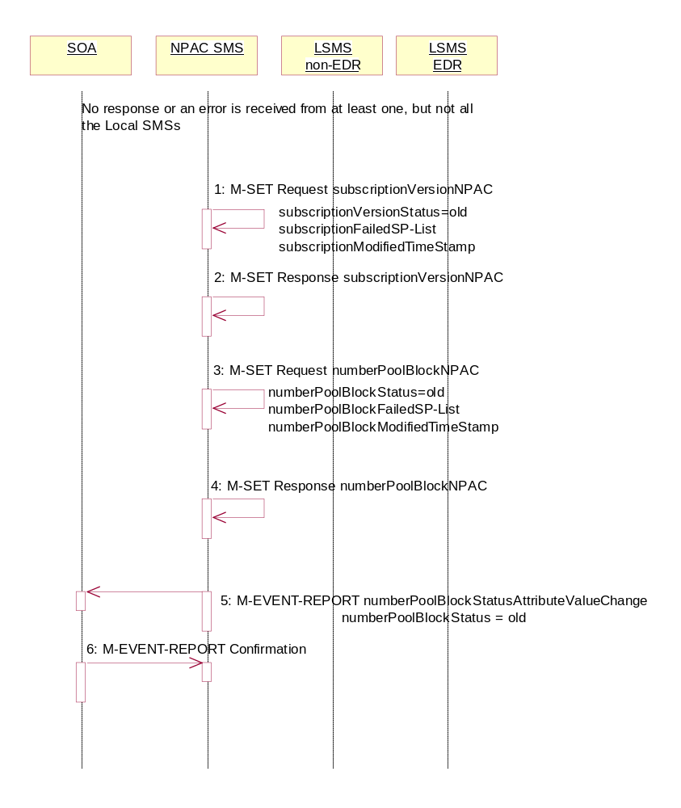

Number Pool Block De-Pool Broadcast Partial Failure NPAC SMS Updates
The NPAC SMS broadcast of a block deletion partially failed. The NPAC SMS now updates the states of the objects on the NPAC SMS.

No response or an error is received from at least one Local SMS.

- NPAC SMS updates each of the subscriptionVersionNPACs that was broadcasted by setting the subscriptionVersionStatus to ‘old’ and updating the subscriptionFailed-SP-List to the list of failed service providers. The subscriptionModifiedTimeStamp is set to the current date and time.
The subscriptionFailed-SP-List will reflect the list of the EDR service providers that failed on the number pool block broadcast and any non-EDR service provider that failed to receive any subscription version.
- NPAC SMS responds to the M-SET.
- NPAC SMS updates the numberPoolBlock by setting the numberPoolBlockStatus to ‘old’ and setting the numberPoolBlockFailed-SP-List to the list of currently failed service providers. It also sets the numberPoolBlockModifiedTimeStamp to the current date and time.
The numberPoolBlockFailed-SP-List will reflect the list of the EDR service providers that failed on the number pool block broadcast and any non-EDR service provider that failed to receive any subscription versions.
- NPAC SMS responds to the M-SET.
- If the numberPoolBlockSOA-Origination indicator is set to TRUE, the NPAC SMS sends the M-EVENT-REPORT for the subscription version status attribute value change to the block holder SOA. The numberPoolBlockStatusAttributeValueChange would contain the numberPoolBlockStatus set to ‘old’ and the numberPoolBlockFailed-SP-List.
- Block holder SOA confirms the M-EVENT-REPORT.

Number Pool Block De-Pool Resend Broadcast
In this scenario, the NPAC SMS resends the broadcast of a de-pool of a block because the first attempt did not complete successfully.

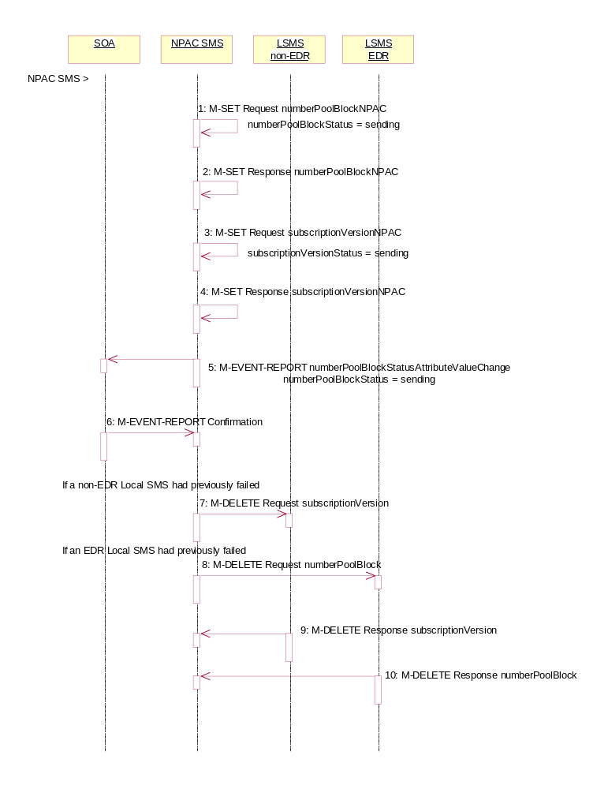
Action is taken by the NPAC SMS personnel to resend a previously failed de-pool of block data.
- NPAC SMS issues the M-SET to modify the numberPoolBlockStatus to ‘sending’ of the number pool block object. The numberPoolBlockModifiedTimeStamp and numberPoolBlockBroadcastTimeStamp also get set.
- NPAC SMS responds to the M-SET.
- NPAC SMS issues the M-SET to modify the subscriptionVersionStatus to ‘sending’ of the subscription version object. The subscriptionModifiedTimeStamp and subscriptionBroadcastTimeStamp also get set.
- NPAC SMS responds to the M-SET.
- If the numberPoolBlockSOA-Origination indicator is set to TRUE, the NPAC SMS sends the M-EVENT-REPORT, numberPoolBlockStatusAttributeValueChange, to the block holder SOA. The status attribute value change would contain the numberPoolBlockStatus set to ‘sending’.
- Block holder SOA confirms the M-EVENT-REPORT.
- NPAC SMS issues the M-DELETE for the subscription versions to the non-EDR Local SMS if it is accepting downloads for the NPA-NXX and had previously failed the delete request.
- At the same time as step 7, the NPAC SMS sends the M-DELETE for the numberPoolBlock to the EDR Local SMS if it is accepting downloads for the NPA-NXX and had previously failed the delete request.
- The non-EDR Local SMS sends to the NPAC SMS the results of the M-DELETE. If the non-EDR Local SMS fails to respond, the NPAC SMS will retry the M-DELETE request a tunable amount of times.
- The EDR Local SMS sends to the NPAC SMS the results of the M-DELETE. If the EDR Local SMS fails to respond, the NPAC SMS will retry the M-DELETE request a tunable amount of times.

Number Pool Block De-Pool Successful Resend Updates
In this scenario, the NPAC SMS successfully rebroadcast the number pool block and subscription version deletes to the Local SMS. It now proceeds to update the status of the number pool block and corresponding subscription versions and then sends the NPA-NXX-X delete to the Local SMSs.

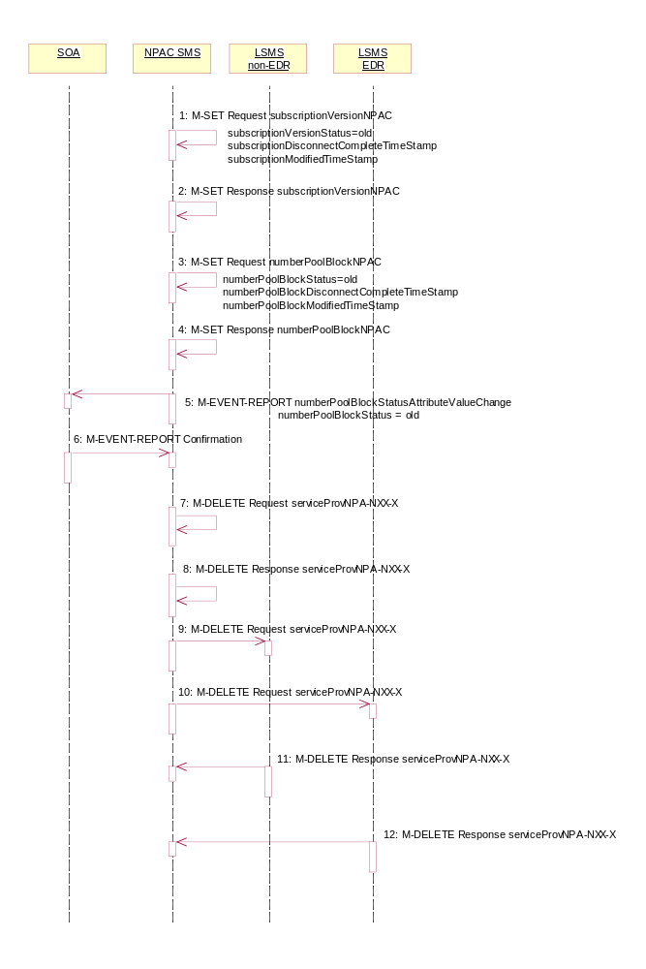
- NPAC SMS updates all the subscriptionVersionNPACs that were broadcasted by setting the subscriptionVersionStatus to ‘old’ and setting the subscriptionModifiedTimeStamp and subscriptionDisconnectCompleteTimeStamp to the current date and time.
- NPAC SMS responds to the M-SET.
- NPAC SMS updates the numberPoolBlock by setting the numberPoolBlockStatus to ‘old’ and setting the numberPoolBlockModifiedTimeStamp and numberPoolBlockDisconnectCompleteTimeStamp to the current date and time.
- NPAC SMS responds to the M-SET.
- If the numberPoolBlockSOA-Origination indicator is set to TRUE, the NPAC SMS sends the M-EVENT-REPORT for the numberPoolBlockStatusAttributeValueChange to the block holder SOA. The status attribute value change would contain the numberPoolBlockStatus set to ‘old’.
- Block holder SOA confirms the M-EVENT-REPORT.
- NPAC SMS issues the M-DELETE to remove the serviceProvNPA-NXX-X object locally.
- NPAC SMS responds successfully to the M-DELETE request for the serviceProvNPA-NXX-X object.
- The NPAC SMS sends the M-DELETE for the serviceProvNPA-NXX-X object to the non-EDR Local SMS that support the object according to the “NPAC Customer LSMS NPA-NXX-X Indicator” in their service provider profile on the NPAC SMS.
- The NPAC SMS sends the M-DELETE for the serviceProvNPA-NXX-X object to the EDR Local SMS that support the object according to the “NPAC Customer LSMS NPA-NXX-X Indicator” in their service provider profile on the NPAC SMS.
- Non-EDR Local SMS respond successfully to the M-DELETE.
- EDR Local SMS respond successfully to the M-DELETE.

Number Pool Block De-Pool Resend Failure Updates
In this scenario, the NPAC SMS was not successful in the resend of a previously failed de-pool attempt and proceeds to update the status of the number pool block and corresponding subscription versions.

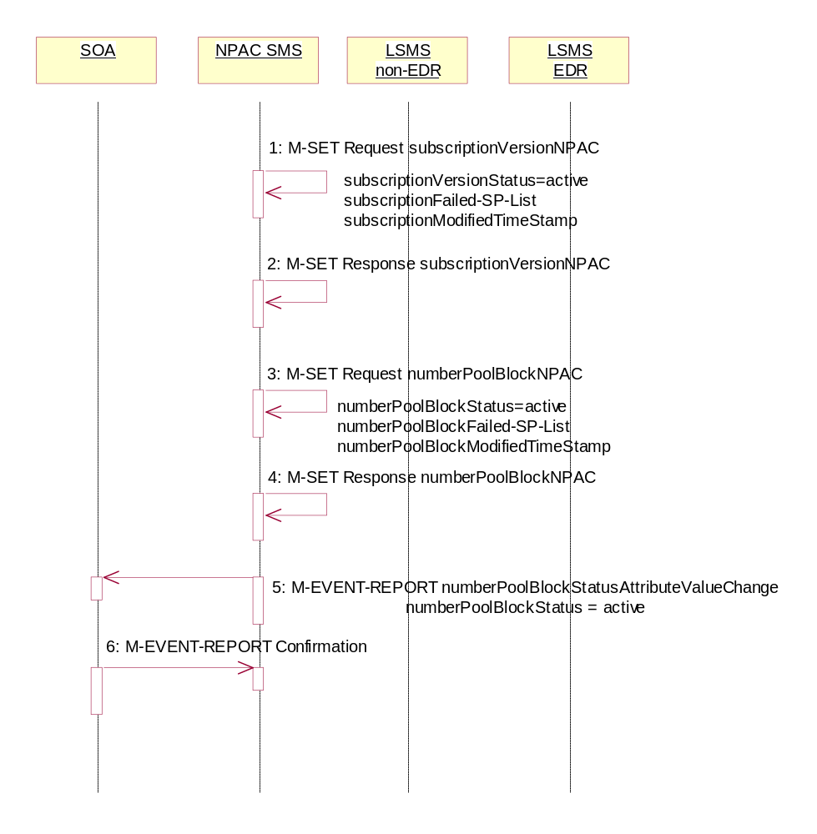
- NPAC SMS sets the subscriptionVersionStatus to ‘active’, sets the subscriptionFailed-SP-List to the list of failed service providers and sets the subscriptionModifiedTimeStamp on the subscription version objects.
- NPAC SMS responds to the M-SET.
- NPAC SMS sets the numberPoolBlockStatus to ‘active’ and sets the numberPoolBlockFailed-SP-List to the list of failed service providers on the number pool block object. The numberPoolBlockModifiedTimeStamp also gets set.
- NPAC SMS responds to the M-SET.
- If the numberPoolBlockSOA-Origination indicator is set to ‘true’, the NPAC SMS sends the originating SOA the M-EVENT-REPORT numberPoolBlockStatusAttributeValueChange with the numberPoolBlockStatus set back to ‘active’ and numberPoolBlockFailed-SP-List.
- SOA confirms M-EVENT-REPORT.

Number Pool Block De-Pool Resend Partial Failure Updates

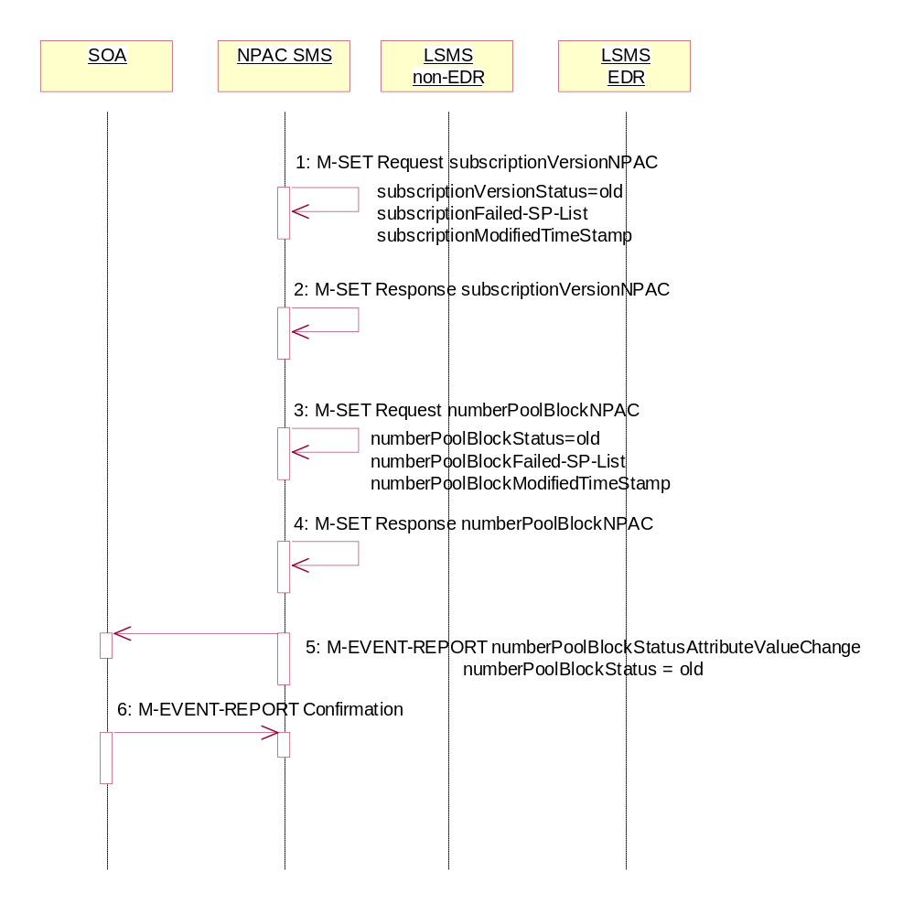
In this scenario, the NPAC SMS has attempted to resend a failed de-pool attempt and has resulted in partial-failure. The NPAC SMS proceeds to update the status of the objects locally.

- NPAC SMS sets the subscriptionVersionStatus to ‘old’, sets the subscriptionFailed-SP-List to the list of failed service providers and sets the subscriptionModifiedTimeStamp and the subscriptionDisconnectCompleteTimeStamp to the current date and time on the subscription version objects.
- NPAC SMS responds to the M-SET.
- NPAC SMS sets the numberPoolBlockStatus to ‘old’ and sets the numberPoolBlockFailed-SP-List to the list of failed service providers on the number pool block object. The numberPoolBlockModifiedTimeStamp and numberPoolBlockDisconnectCompleteTimeStamp also get set.
- NPAC SMS responds to the M-SET.
- If the numberPoolBlockSOA-Origination indicator is set to ‘true’, the NPAC SMS sends the originating SOA the M-EVENT-REPORT numberPoolBlockStatusAttributeValueChange with the numberPoolBlockStatus set to ‘old’ and numberPoolBlockFailed-SP-List.
- SOA confirms M-EVENT-REPORT.

Number Pool Block Query by SOA or LSMS

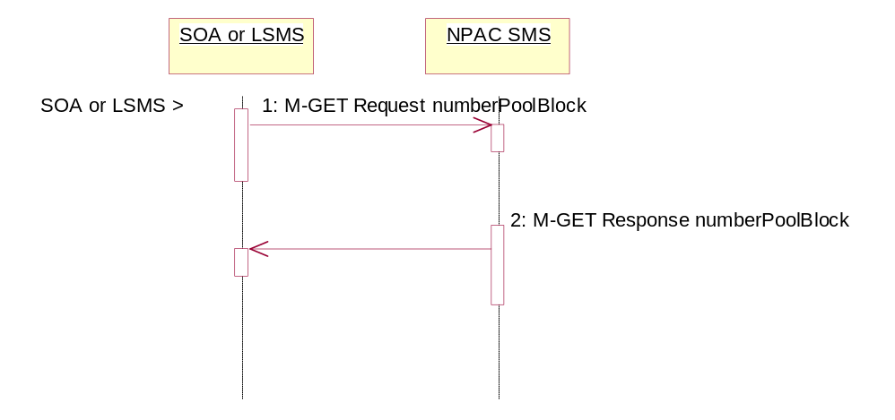
In this scenario, the service provider personnel queries for one or more number pool block objects from the SOA or Local SMS.
Action is taken by service provider personnel to query one or more numberPoolBlock objects for all attributes.
- SOA or Local SMS sends the M-GET request for either requesting a single numberPoolBlock object by numberPoolBlockId or requesting one or more numberPoolBlock objects using a scope and filtered request.
- If the requested object(s) exist, the NPAC SMS will respond with a single or linked M-GET reply. If no objects are found, the NPAC SMS will respond with an empty result. All attributes are returned in the query.

Port-to-Original Subscription Version Flows
This section contains Port-to-Original flows whose subscription version TNs are part of a pooled block and therefore the behavior of these scenarios is different than normal Port-to-Original subscription version processing.

Subscription Version Port-to-Original of a Ported Pool TN Activation by SOA
The following scenarios show the broadcast of a Port-to-Original subscription version that is successfully sent to all of the Local SMSs. In this scenario:
- SV1 is the currently active Subscription Version.
- SV2 is the current pending Subscription Version with the Port-To-Original flag set to TRUE.
- SV3 is the pool reinstatement Subscription Version with LNP type = Pool that reinstates default routing to the block holder.
The creation of a port-to-original request will be rejected if the block holder service provider and new service provider are not the same and if the TN is part of a pooled TN range.

Port-to-Original Activation by SOA of a Pooled TN
This scenario shows the activation by the new service provider SOA and the update to ‘sending’ of the 3 subscription versions.

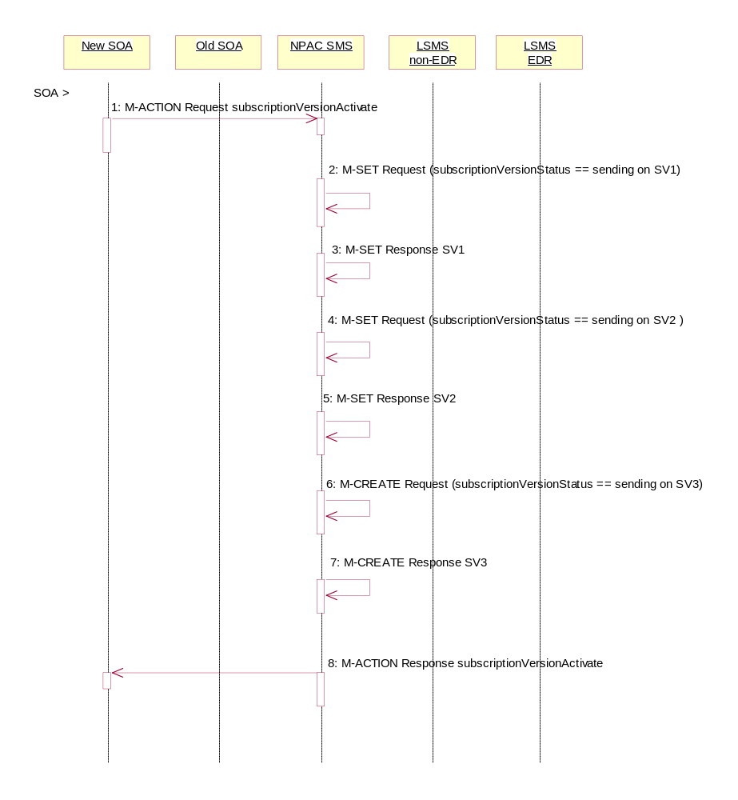
- The new, block holder service provider SOA issues a subscriptionVersionActivate M-ACTION to the NPAC SMS lnpSubscriptions object to activate the pending subscription version SV2 by specifying the subscription version ID, subscription version TN, or a range of subscription version TNs that are within the block.
- The NPAC SMS issues an M-SET request setting the subscriptionVersionStatus to “sending”, subscriptionBroadcastTimeStamp and subscriptionModifiedTimeStamp on the subscriptionVersionNPAC on SV1.
- NPAC SMS responds to the M-SET.
- The NPAC SMS issues an M-SET request setting the subscriptionVersionStatus to “sending”, subscriptionBroadcastTimeStamp and subscriptionModifiedTimeStamp on the subscriptionVersionNPAC on SV2.
- NPAC SMS responds to the M-SET.
- The NPAC SMS issues an M-CREATE request for SV3 and the subscriptionVersionStatus is set to “sending”, the subscriptionLNPType is set to ‘pool’, the subscriptionActivationTimeStamp, subscriptionCreationTimeStamp, subscriptionBroadcastTimeStamp and subscriptionModifiedTimeStamp are set to the current date and time. All routing information originates from the numberPoolBlock that exists for the specified TN(s).
- NPAC SMS responds to the M-CREATE.
- The NPAC SMS responds with the M-ACTION response. An error will be returned if the service provider is not the new service provider (soa-not-authorized) or if there is no version to be activated (no-version-found) or if any other failures occur (invalid-data-values, failed).

Successful Broadcast of Port-to-Original Activation Request

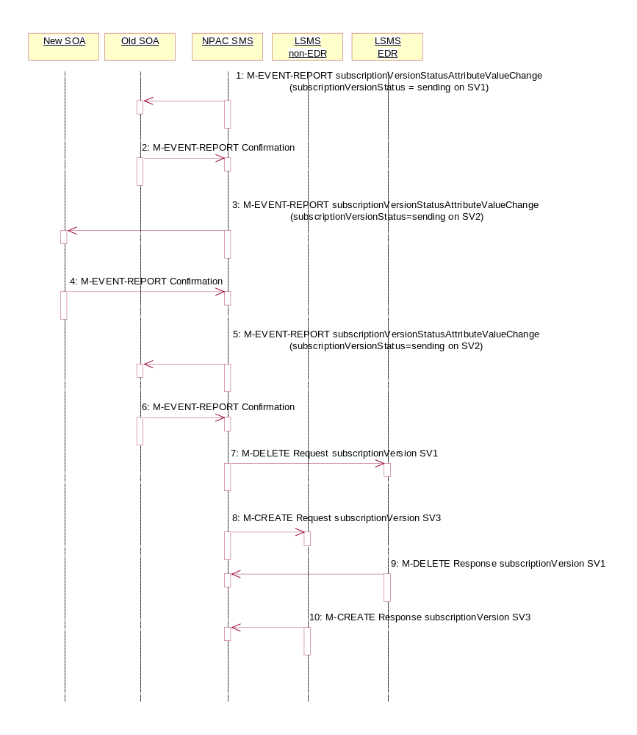
- The NPAC SMS has the port-to-original request of a pooled TN in sending mode. In this scenario, the broadcasts begin.

- If the M-ACTION was successful, the NPAC SMS sends to the old service provider SOA, who is the current service provider for SV1, a subscriptionVersionStatusAttributeValueChange for the subscriptionVersionStatus being set to sending on SV1.
- The old service provider SOA returns an M-EVENT-REPORT confirmation to the NPAC SMS.
- If the M-ACTION was successful, the NPAC SMS sends to the new service provider SOA a subscriptionVersionStatusAttributeValueChange for the subscriptionVersionStatus being set to sending on SV2.
- The new service provider SOA returns an M-EVENT-REPORT confirmation to the NPAC SMS.
- If the M-ACTION was successful, the NPAC SMS sends to the old service provider SOA a subscriptionVersionStatusAttributeValueChange for the subscriptionVersionStatus being set to sending on SV2.
- The old service provider SOA returns an M-EVENT-REPORT confirmation to the NPAC SMS.
- NPAC SMS issues the M-DELETE to the EDR Local SMS for the SV1 that are accepting downloads for the NPA-NXX. The EDR Local SMS will revert back to using the routing information in the number pool block object for the TN in the subscription version. If the EDR Local SMS fails to respond, the NPAC SMS will retry the M-DELETE request a tunable amount of times.
- At the same time as step 7, the NPAC SMS sends out an M-CREATE on the subscription version SV3 to all non-EDR Local SMSs, that are accepting downloads for the NPA-NXX of subscription Version SV3. If the create is for multiple subscription versions, the M-ACTION subscriptionVersionLocalSMS-Create will be used instead. The SV3 created on the non-EDR Local SMS systems contains the default block routing information and has a LNP type of ‘pool’. If the non-EDR Local SMS fails to respond, the NPAC SMS will retry the M-CREATE request a tunable amount of times.
- The EDR Local SMS responds to the M-DELETE.
- Each non-EDR Local SMS responds to the M-CREATE.

Successful Broadcast Complete NPAC SMS Updates for a Port-to-Original Request
In this scenario, the NPAC SMS has successfully completed the broadcast of the port-to-original of a pooled TN. The NPAC SMS now updates the status of the subscription versions on the NPAC SMS.
All Local SMSs respond successfully to the port-to-original broadcast of a pooled TN.

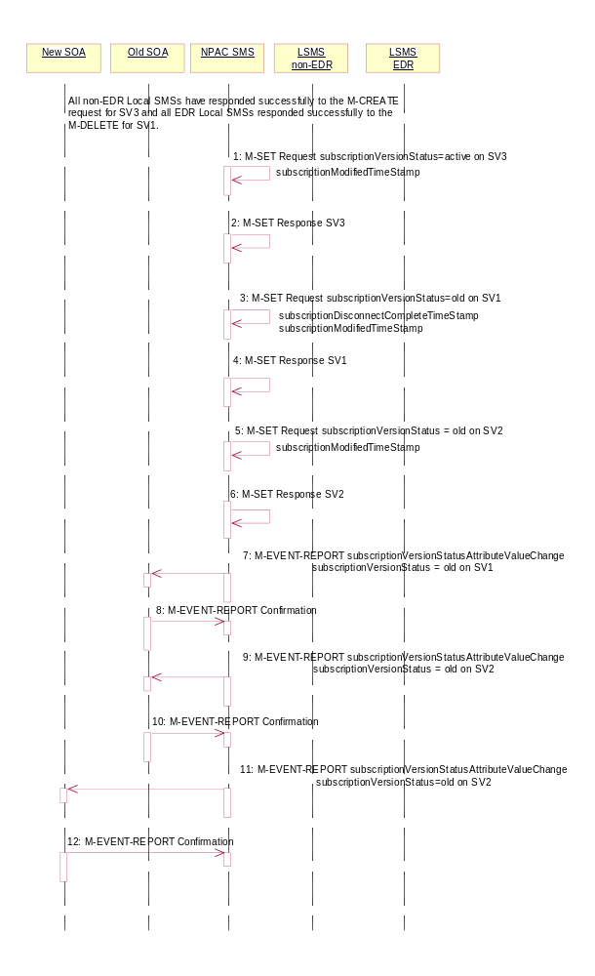
- NPAC SMS issues an M-SET updating the subscriptionVersionStatus of SV3 to active. The subscriptionModifiedTimeStamp is also set.
- NPAC SMS responds to the M-SET.
- NPAC SMS issues an M-SET updating the subscriptionVersionStatus of SV1 to old. It also sets the subscriptionDisconnectCompleteTimeStamp and subscriptionModifiedTimeStamp.
- NPAC SMS responds to the M-SET.
- NPAC SMS issues an M-SET updating the subscriptionVersionStatus of SV2 to old. It also sets the subscriptionModifiedTimeStamp.
- NPAC SMS responds to the M-SET.
- The NPAC SMS sends to the old service provider SOA, who is the current service provider on SV1, a subscriptionVersionStatusAttributeValueChange for the subscriptionVersionStatus being set to old on SV1.
- The old service provider SOA returns an M-EVENT-REPORT confirmation to the NPAC SMS.
- The NPAC SMS sends to the old service provider SOA a subscriptionVersionStatusAttributeValueChange for the subscriptionVersionStatus being set to old on SV2.
- The old service provider SOA returns an M-EVENT-REPORT confirmation to the NPAC SMS.
- The NPAC SMS sends to the current/new service provider SOA a subscriptionVersionStatusAttributeValueChange for the subscriptionVersionStatus being set to old on SV2.
- The current/new, block holder service provider SOA returns an M-EVENT-REPORT confirmation to the NPAC SMS.
- After a tunable amount of days, the subscription versions SV1 and SV2 are purged by the NPAC SMS housekeeping process.

Subscription Version Create Port-to-Original of a Pool TN: Failure to All Local SMSs
This scenario shows the broadcast of a Port-to-Original subscription version that fails to all of the Local SMSs.
- SV1 is the active Subscription Version.
- SV2 is the pending Subscription Version with the Port to Original flag set to TRUE.
- SV3 is the pool reinstatement Subscription Version with LNP type = Pool that reinstates default routing to the block holder.

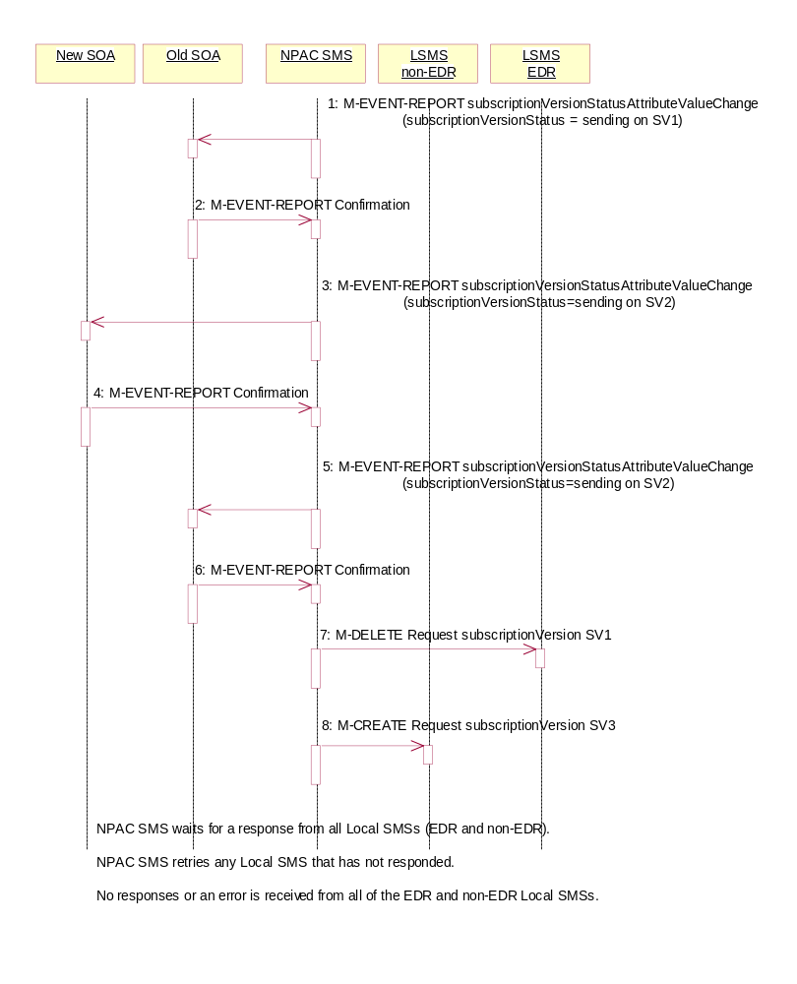
Failure Broadcast of Port-to-Original Request
In this scenario, the NPAC SMS has the required subscription versions in a ‘sending’ state. The NPAC SMS begins the broadcast.

- If the M-ACTION was successful, the NPAC SMS sends to the old service provider SOA, who is the current service provider for SV1, a subscriptionVersionStatusAttributeValueChange for the subscriptionVersionStatus being set to sending on SV1.
- The old service provider SOA returns an M-EVENT-REPORT confirmation to the NPAC SMS.
- If the M-ACTION was successful, the NPAC SMS sends to the new service provider SOA a subscriptionVersionStatusAttributeValueChange for the subscriptionVersionStatus being set to sending on SV2.
- The new service provider SOA returns an M-EVENT-REPORT confirmation to the NPAC SMS.
- If the M-ACTION was successful, the NPAC SMS sends to the old service provider SOA a subscriptionVersionStatusAttributeValueChange for the subscriptionVersionStatus being set to sending on SV2.
- The old service provider SOA returns an M-EVENT-REPORT confirmation to the NPAC SMS.
- NPAC SMS issues the M-DELETE to the EDR Local SMS for the SV1. The EDR Local SMS will revert back to using the routing information in the number pool block object for the TN in the subscription version.
- At the same time as step 7, the NPAC SMS sends out an M-CREATE on the subscription version SV3 to all non-EDR Local SMSs, that are accepting downloads for the NPA-NXX of subscription Version SV3. If the create is for multiple subscription versions, the M-ACTION subscriptionVersionLocalSMS-Create will be used instead, The SV3 created on the non-EDR Local SMS systems contains the default block routing information and has a LNP type of “pool”.
- The NPAC SMS waits for a response from all Local SMSs (EDR and non-EDR).
- The NPAC SMS retries any Local SMS that has not responded successfully.
- No response or an error is received from all of the EDR and non-EDR Local SMSs.

Updates to NPAC SMS after Failure of Port-to-Original Broadcast
The NPAC SMS has just completed an unsuccessful broadcast to the LSMSs of a port-to-original of a pooled TN. The NPAC SMS now proceeds to update the status on the NPAC SMS.

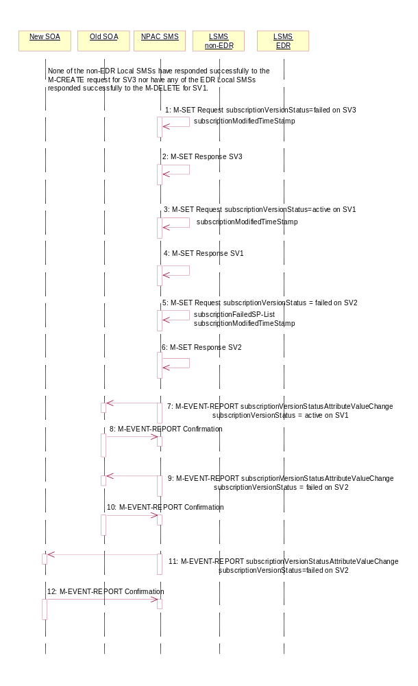
None of the non-EDR Local SMSs has responded successfully to the M-CREATE request for SV3 nor have any of the EDR Local SMSs responded successfully to the M-DELETE for SV1.

- NPAC SMS issues an M-SET updating the subscriptionVersionStatus of SV3 to failure and the subscriptionModifiedTimeStamp is also set to the current date and time.
- NPAC SMS responds to the M-SET.
- NPAC SMS issues an M-SET updating the subscriptionVersionStatus of SV1 to active. It also sets the subscriptionModifiedTimeStamp to the current date and time.
- NPAC SMS responds to the M-SET.
- NPAC SMS issues an M-SET updating the subscriptionVersionStatus of SV2 to failed. It also sets the subscriptionModifiedTimeStamp to the current date and time and sets the subscriptionFailed-SP-List. The failed SP list contains the EDR and non-EDR Local SMSs who failed to receive the broadcast of SV1 and SV3.
- NPAC SMS responds to the M-SET.
- The NPAC SMS sends to the old service provider SOA, who is the current service provider on SV1, a subscriptionVersionStatusAttributeValueChange for the subscriptionVersionStatus being set to active on SV1.
- The old service provider SOA returns an M-EVENT-REPORT confirmation to the NPAC SMS.
- The NPAC SMS sends to the old service provider SOA a subscriptionVersionStatusAttributeValueChange with the subscriptionVersionStatus being set to failed and the subscriptionFailed-SP-List for SV2.
- The old service provider SOA returns an M-EVENT-REPORT confirmation to the NPAC SMS.
- The NPAC SMS sends to the current/new, block holder service provider SOA a subscriptionVersionStatusAttributeValueChange with the subscriptionVersionStatus being set to failed and the subscriptionFailed-SP-List for SV2.
- The current/new service provider SOA returns an M-EVENT-REPORT confirmation to the NPAC SMS.

Subscription Version Create Port-to-Original of a Pool TN: Partial Failure to One or More Local SMSs
This scenario shows the broadcast of a Port-to-Original subscription version that fails to one or more, but not all, of the Local SMSs.
SV1 is the active Subscription Version.
SV2 is the pending Subscription Version with the Port-To-Original flag set to TRUE.
SV3 is the pool reinstatement Subscription Version with LNP type = Pool that reinstates default routing to the block holder.

Port-to-Original Activation Partial Failure Broadcast of a Pooled TN

- The NPAC SMS has the port-to-original request of a pooled TN in sending mode. In this scenario, the broadcasts begin that will result in a partial failure.

- If the M-ACTION was successful, the NPAC SMS sends to the old service provider SOA, who is the current service provider for SV1, a subscriptionVersionStatusAttributeValueChange for the subscriptionVersionStatus being set to sending on SV1.
- The old service provider SOA returns an M-EVENT-REPORT confirmation to the NPAC SMS.
- If the M-ACTION was successful, the NPAC SMS sends to the new service provider SOA a subscriptionVersionStatusAttributeValueChange for the subscriptionVersionStatus being set to sending on SV2.
- The new service provider SOA returns an M-EVENT-REPORT confirmation to the NPAC SMS.
- If the M-ACTION was successful, the NPAC SMS sends to the old service provider SOA a subscriptionVersionStatusAttributeValueChange for the subscriptionVersionStatus being set to sending on SV2.
- The old service provider SOA returns an M-EVENT-REPORT confirmation to the NPAC SMS.
- NPAC SMS issues the M-DELETE to the EDR Local SMS for the SV1. The EDR Local SMS will revert back to using the routing information in the number pool block object for the TN in the subscription version.
- NPAC SMS sends out an M-CREATE on the subscription version SV3 to all non-EDR Local SMSs, that are accepting downloads for the NPA-NXX of subscription Version SV3. If the create is for multiple subscription versions, the M-ACTION subscriptionVersionLocalSMS-Create will be used instead, The SV3 created on the non-EDR Local SMS systems contains the default block routing information and has a LNP type of “pool”.
- The EDR Local SMS responds to the M-DELETE.
- Each non-EDR Local SMS responds to the M-CREATE.

Partial-Failure Broadcast Complete NPAC SMS Updates of a Port-to-Original
In this scenario, the NPAC SMS has already performed the broadcast of the activation of the port-to-original activation. The broadcast resulted in a partial failure status. The NPAC SMS now updates the objects on the NPAC SMS.

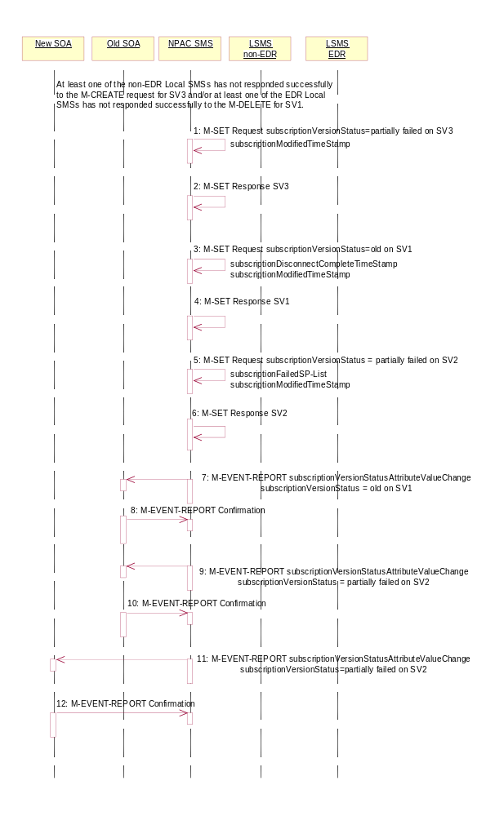
At least one of the non-EDR Local SMSs has not responded successfully to the M-CREATE for SV3 and/or at least one of the EDR Local SMSs has not responded successfully to the M-DELETE for SV1.

- NPAC SMS issues an M-SET updating the subscriptionVersionStatus of SV3 to partial failure. The subscriptionModifiedTimeStamp is also set to the current date and time.
- NPAC SMS responds to the M-SET.
- NPAC SMS issues an M-SET updating the subscriptionVersionStatus of SV1 to old. It also sets the s subscriptionDisconnectCompleteTimeStamp and subscriptionModifiedTimeStamp to the current date and time.
- NPAC SMS responds to the M-SET.
- NPAC SMS issues an M-SET updating the subscriptionVersionStatus of SV2 to partially failed. It also sets the subscriptionModifiedTimeStamp to the current date and time and sets the subscriptionFailed-SP-List. The failed list contains the both the EDR and non-EDR Local SMSs who did not complete the broadcast of SV1 and SV3 successfully.
- NPAC SMS responds to the M-SET.
- The NPAC SMS sends to the old service provider SOA, who is the current service provider on SV1, a subscriptionVersionStatusAttributeValueChange for the subscriptionVersionStatus being set to old on SV1.
- The old service provider SOA returns an M-EVENT-REPORT confirmation to the NPAC SMS.
- The NPAC SMS sends to the old service provider SOA a subscriptionVersionStatusAttributeValueChange with the subscriptionVersionStatus being set to partially failed and the subscriptionFailed-SP-List for SV2.
- The old service provider SOA returns an M-EVENT-REPORT confirmation to the NPAC SMS.
- The NPAC SMS sends to the current/new service provider SOA a subscriptionVersionStatusAttributeValueChange with the subscriptionVersionStatus being set to partially failed and the subscriptionFailed-SP-List for SV2.
- The current/new service provider SOA returns an M-EVENT-REPORT confirmation to the NPAC SMS.

Subscription Version Create Port-to-Original of a Pool TN: Resend Successful to Local SMS
This scenario shows how the successful resend of a failed port-to-original broadcast is processed. In this scenario the following subscription versions are used:

- SV1 is the active Subscription Version.
- SV2 is the partially failed or failed Subscription Version with the Port-To-Original flag set to TRUE.
- SV3 is the pool reinstatement Subscription Version with LNP type = Pool that reinstates default routing to the block holder.
In this scenario, the NPAC SMS must resend the port-to-original request. Either at least 1 EDR LSMS failed to receive the M-DELETE for SV1 or at least 1 non-EDR LSMS failed to receive the M-CREATE for SV3. The NPAC SMS will resend the necessary operations to the failed LSMSs.

Port-to-Original NPAC SMS Initiates Successful Resend

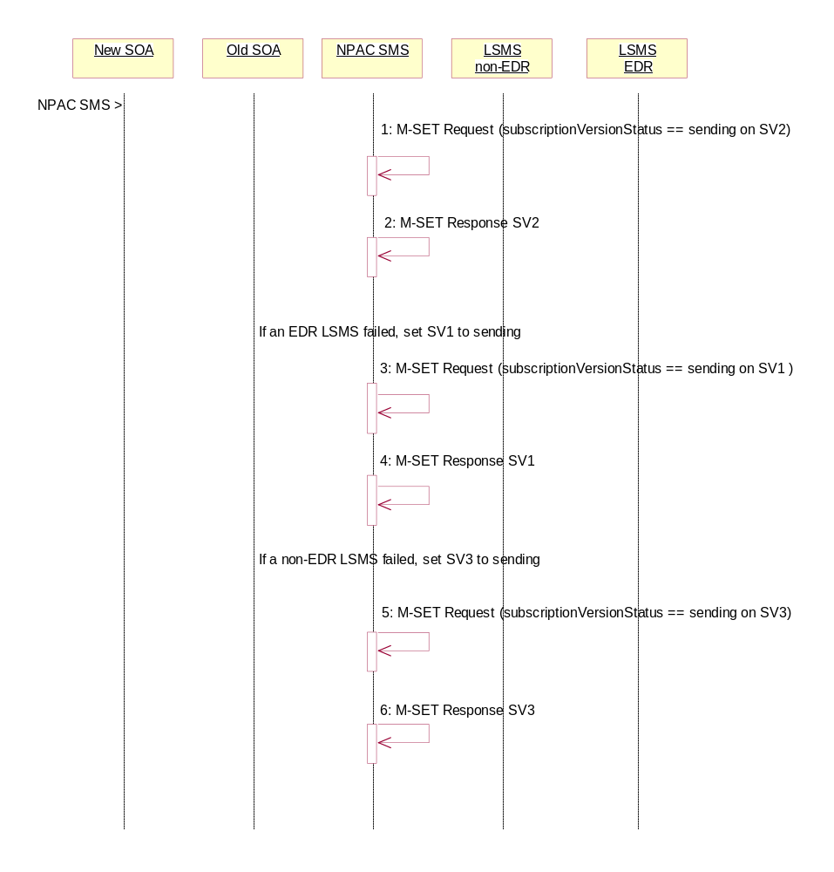
- The NPAC SMS issues an M-SET request setting the subscriptionVersionStatus to “sending”, subscriptionBroadcastTimeStamp and subscriptionModifiedTimeStamp on the subscriptionVersionNPAC on SV2.
- NPAC SMS responds to the M-SET.
- If one of the failed LSMSs is an EDR LSMS, the NPAC SMS issues an M-SET request setting the subscriptionVersionStatus to “sending”, subscriptionBroadcastTimeStamp and subscriptionModifiedTimeStamp on the subscriptionVersionNPAC on SV1.
- NPAC SMS responds to the M-SET.
- If one of the failed LSMSs is a non-EDR LSMS, the NPAC SMS issues an M-SET request setting the subscriptionVersionStatus to “sending”, the subscriptionActivationTimeStamp, subscriptionBroadcastTimeStamp and subscriptionModifiedTimeStamp on the subscriptionVersionNPAC on SV3.
- NPAC SMS responds to the M-SET.

Successful Resend Broadcast of a Port-to-Original of a Pooled TN
The NPAC SMS has the necessary subscription versions in sending mode. It now broadcasts the data.

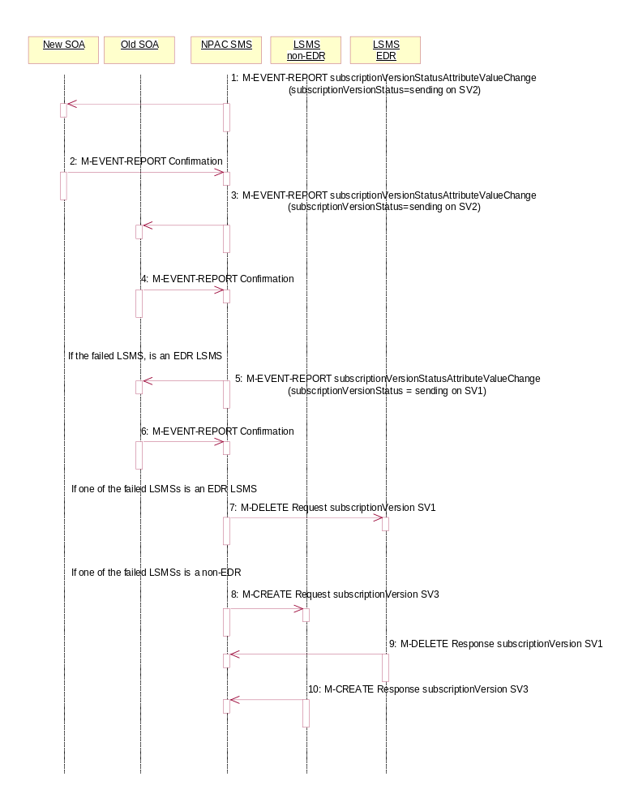
- The NPAC SMS sends to the new service provider SOA a subscriptionVersionStatusAttributeValueChange for the subscriptionVersionStatus being set to sending on SV2.
- The new service provider SOA returns an M-EVENT-REPORT confirmation to the NPAC SMS.
- The NPAC SMS sends to the old service provider SOA a subscriptionVersionStatusAttributeValueChange for the subscriptionVersionStatus being set to sending on SV2.
- The old service provider SOA returns an M-EVENT-REPORT confirmation to the NPAC SMS.
- If one of the failed Local SMSs was an EDR LSMS, the NPAC SMS sends to the old service provider SOA, who is the current service provider for SV1, a subscriptionVersionStatusAttributeValueChange for the subscriptionVersionStatus being set to sending on SV1.
- The old service provider SOA returns an M-EVENT-REPORT confirmation to the NPAC SMS.
- If one of the failed Local SMSs is an EDR LSMS, the NPAC SMS issues the M-DELETE to the failed EDR Local SMS for the SV1. The EDR Local SMS will revert back to using the routing information in the number pool block object for the TN in the subscription version.
- If one of the failed Local SMSs is a non-EDR LSMS, the NPAC SMS sends out an M-CREATE on the subscription version SV3 to the failed non-EDR Local SMSs, that are accepting downloads for the NPA-NXX of subscription Version SV3. If the M-CREATE is for multiple subscription versions, a scoped and filtered operation will be sent. The SV3 created on the non-EDR Local SMS systems contains the default block routing information and has a LNP type of “pool”.
- If a request was sent, the EDR Local SMS responds to the M-DELETE.
- If a request was sent, the non-EDR Local SMS responds to the M-CREATE.
- All previously failed Local SMSs respond successfully.

Updates to NPAC SMS after Successful Resend of Port-to-Original Request of a Pooled TN

The NPAC SMS just successfully re-broadcasted the necessary updates to the Local SMS. It now updates the status of the objects on the NPAC SMS.

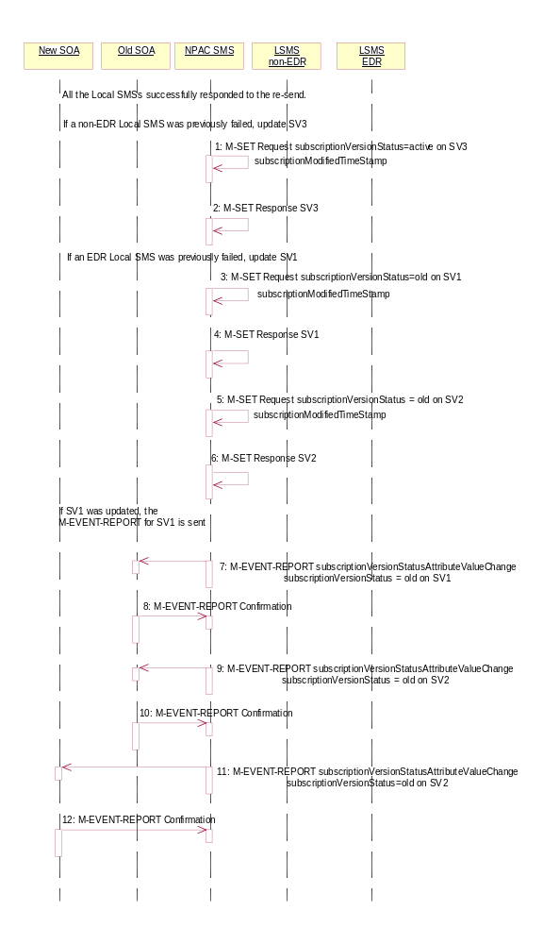
- If a non-EDR Local SMS was successfully re-broadcasted, the NPAC SMS issues an M-SET updating the subscriptionVersionStatus of SV3 to active. The subscriptionModifiedTimeStamp is also set.
- NPAC SMS responds to the M-SET.
- If an EDR Local SMS was successfully re-broadcasted, the NPAC SMS issues an M-SET updating the subscriptionVersionStatus of SV1 to old. It also sets the subscriptionModifiedTimeStamp. If the subscription status was previously set to “failed”, the subscriptionDisconnectCompleteTimeStamp is set when the first successful response is received.
- NPAC SMS responds to the M-SET.
- NPAC SMS issues an M-SET updating the subscriptionVersionStatus of SV2 to old. It also sets the subscriptionModifiedTimeStamp.
- NPAC SMS responds to the M-SET.
- The NPAC SMS sends to the old service provider SOA, who is the current service provider on SV1, a subscriptionVersionStatusAttributeValueChange for the subscriptionVersionStatus being set to old on SV1.
- The old service provider SOA returns an M-EVENT-REPORT confirmation to the NPAC SMS.
- The NPAC SMS sends to the old service provider SOA a subscriptionVersionStatusAttributeValueChange for the subscriptionVersionStatus being set to old on SV2.
- The old service provider SOA returns an M-EVENT-REPORT confirmation to the NPAC SMS.
- The NPAC SMS sends to the current/new service provider SOA a subscriptionVersionStatusAttributeValueChange for the subscriptionVersionStatus being set to old on SV2.
- The current/new service provider SOA returns an M-EVENT-REPORT confirmation to the NPAC SMS.

- After a tunable amount of days, the subscription versions SV1 and SV2 are purged by the NPAC SMS housekeeping process.

Subscription Version Create Port-to-Original of a Pool TN: Resend Failure to Local SMS
This scenario shows how the unsuccessful resend of a failed port-to-original broadcast is processed. In this scenario, the following subscription versions are used:
- SV1 is the active Subscription Version.
- SV2 is the failed Subscription Version with the Port-To-Original flag set to TRUE.
- SV3 is the pool reinstatement Subscription Version with LNP type = Pool that reinstates default routing to the block holder and its current status is failed.
In the following scenario, the NPAC SMS must resend the port-to-original request. All the EDR LSMS failed to receive the M-DELETE for SV1 and all the non-EDR LSMSs failed to receive the M-CREATE for SV3. The NPAC SMS will resend the necessary operations to the failed LSMSs, but the resend will result in total failure again. The scenario would work just as a successful resend, except for when the NPAC SMS sets the final statuses on the NPAC SMS.

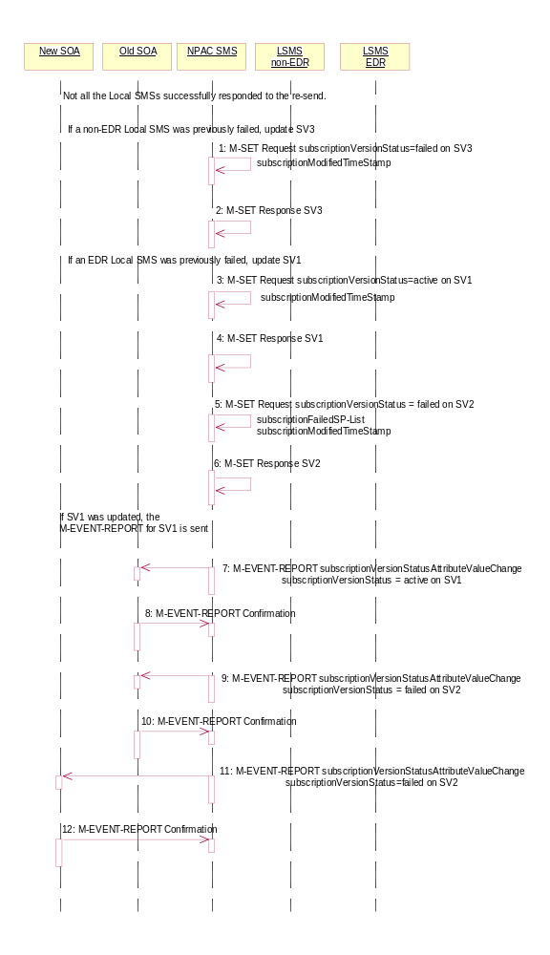
- If all non-EDR Local SMS failed the broadcast, the NPAC SMS issues an M-SET updating the subscriptionVersionStatus of SV3 to failed. The subscriptionModifiedTimeStamp is also set.
- NPAC SMS responds to the M-SET.
- If all the EDR Local SMS failed the broadcast, the NPAC SMS issues an M-SET updating the subscriptionVersionStatus of SV1 back to active. It also sets the subscriptionModifiedTimeStamp.
- NPAC SMS responds to the M-SET.
- NPAC SMS issues an M-SET updating the subscriptionVersionStatus of SV2 back to failed and setting the subscriptionFailed-SP-List to the list of all the service providers that failed to receive the broadcast successfully (EDR and non-EDR). It also sets the subscriptionModifiedTimeStamp.
- NPAC SMS responds to the M-SET.
- The NPAC SMS sends to the old service provider SOA, who is the current service provider on SV1, a subscriptionVersionStatusAttributeValueChange for the subscriptionVersionStatus being set back to active on SV1.
- The old service provider SOA returns an M-EVENT-REPORT confirmation to the NPAC SMS.
- The NPAC SMS sends to the old service provider SOA a subscriptionVersionStatusAttributeValueChange for the subscriptionVersionStatus being set to failed on SV2 with the subscriptionFailed-SP-List.
- The old service provider SOA returns an M-EVENT-REPORT confirmation to the NPAC SMS.
- The NPAC SMS sends to the current/new service provider SOA a subscriptionVersionStatusAttributeValueChange for the subscriptionVersionStatus being set to failed on SV2 with the subscriptionFailed-SP-List.
- The current/new service provider SOA returns an M-EVENT-REPORT confirmation to the NPAC SMS.

Subscription Version Create Port-to-Original of a Pool TN: Resend Partial Failure to Local SMS
This scenario shows how the unsuccessful resend of a partially failed port-to-original broadcast is processed. In this scenario, the following subscription versions are used:
- SV1 is the old Subscription Version.
- SV2 is the partially failed Subscription Version with the Port-To-Original flag set to TRUE.
- SV3 is the pool reinstatement Subscription Version with LNP type = Pool that reinstates default routing to the block holder and its current status is partially failed.
In the following scenario, the NPAC SMS must resend the port-to-original request. At least 1 of the EDR LSMSs failed to receive the M-DELETE for SV1 and/or at least 1 of the non-EDR LSMSs failed to receive the M-CREATE for SV3. The NPAC SMS will resend the necessary operations to the failed LSMSs, but the resend will result in partial failure again. The scenario would work just as a successful resend, except for when the NPAC SMS sets the final statuses on the NPAC SMS.

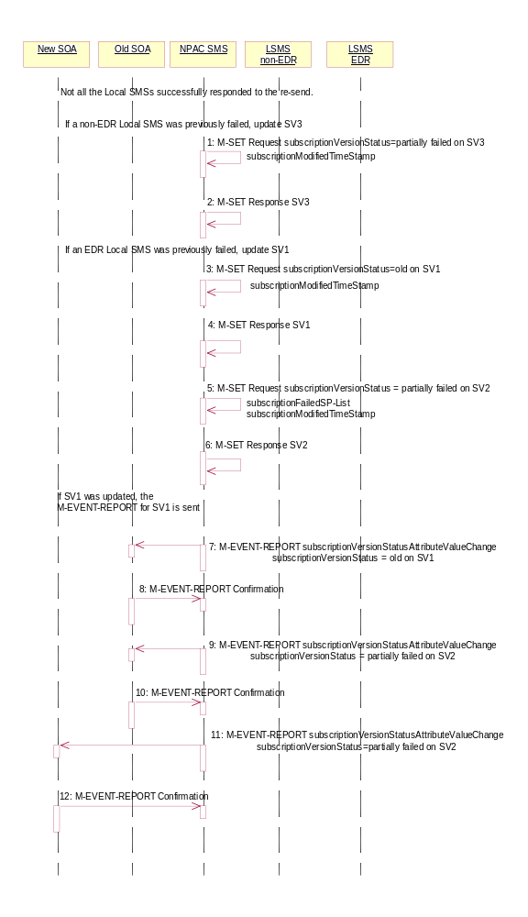
- If a non-EDR Local SMS was re-broadcasted and not successful, the NPAC SMS issues an M-SET updating the subscriptionVersionStatus of SV3 to partially failed. The subscriptionModifiedTimeStamp is also set.
- NPAC SMS responds to the M-SET.
- If an EDR Local SMS was re-broadcasted and not successful, the NPAC SMS issues an M-SET updating the subscriptionVersionStatus of SV1 back to old. It also sets the subscriptionModifiedTimeStamp.

- NPAC SMS responds to the M-SET.
- NPAC SMS issues an M-SET updating the subscriptionVersionStatus of SV2 to partially failed. It also sets the subscriptionModifiedTimeStamp and setting the subscriptionFailed-SP-List to the list of all the service providers that failed to receive the broadcast successfully (EDR and non-EDR).
- NPAC SMS responds to the M-SET.
- If SV1 was updated, the NPAC SMS sends to the old service provider SOA, who is the current service provider on SV1, a subscriptionVersionStatusAttributeValueChange for the subscriptionVersionStatus being set back to old on SV1.
- The old service provider SOA returns an M-EVENT-REPORT confirmation to the NPAC SMS.
- The NPAC SMS sends to the old service provider SOA a subscriptionVersionStatusAttributeValueChange for the subscriptionVersionStatus being set to partially failed on SV2 and the subscriptionFailed-SP-List.
- The old service provider SOA returns an M-EVENT-REPORT confirmation to the NPAC SMS.
- The NPAC SMS sends to the current/new service provider SOA a subscriptionVersionStatusAttributeValueChange for the subscriptionVersionStatus being set to partially failed on SV2 and the subscriptionFailed-SP-List.
- The current/new service provider SOA returns an M-EVENT-REPORT confirmation to the NPAC SMS.

Subscription Version Port-to-Original of a Pool TN – Creation Prior to NPA-NXX-X Effective Date
In this scenario, the service provider SOA attempts to create a port-to-original request prior to the effective date of the corresponding serviceProvNPA-NXX-X object. The NPAC SMS will reject this request, as a port-to-original request can not be created prior to the effective date of the corresponding serviceProvNPA-NXX-X.

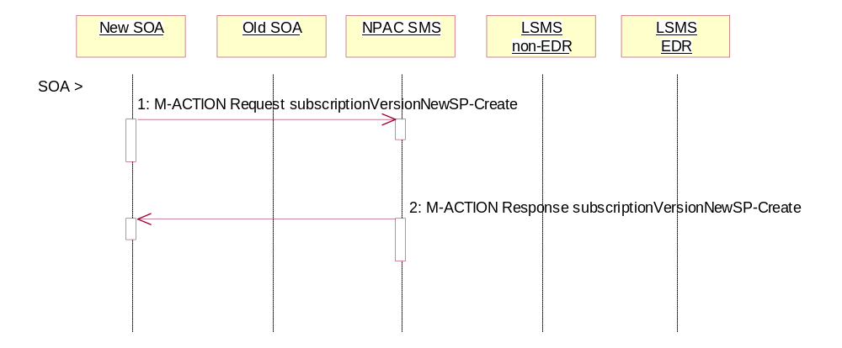
SOA personnel take action to create a port-to-original request.
- The new service provider SOA sends a valid, M-ACTION, subscriptionVersionNewSP-Create request with the subscriptionPortingToOriginal-SPSwitch set to ‘TRUE’ for a TN within a pooled block.
- NPAC SMS replies with an error, ‘soa-not-authorized’.

Disconnect Subscription Version Scenarios
This section contains the flows describing disconnects of subscription versions whose TNs are part of a pooled TN block.

Subscription Version Immediate Disconnect After the Activation of the Number Pool Block
The current service provider can disconnect an active subscription version that will return to the block holder after the number pool block has been activated. In this scenario, the disconnect is immediate where the TN returns to the block holder and the number pool block is active. In this scenario:
- SV1 is the currently active Subscription Version that will be disconnected.
- SV2 is the pool reinstatement Subscription Version with LNP type = pool that reinstates default routing to the block holder.
SV1 will be broadcast to the EDR Local SMSs to disconnect the ported TN and revert to the number pool block routing information. SV2 will be broadcast to the non-EDR Local SMSs with the number pool block routing information.

SOA Initiates Successful Disconnect Request of Ported Pooled TN
In this scenario, the SOA sends in the disconnect action to a ported, pooled TN.

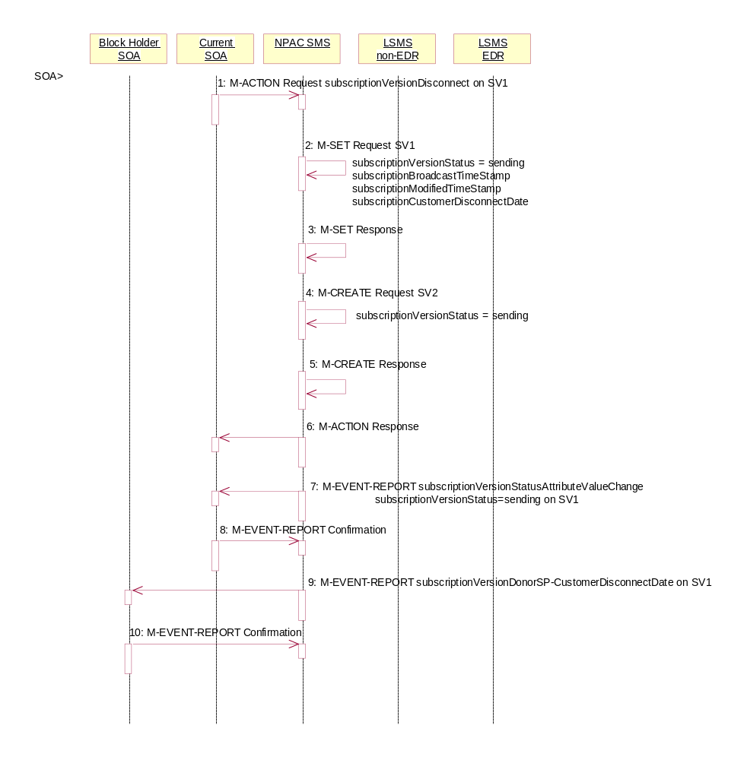
- Current service provider SOA personnel take action to disconnect a subscription version.
- Service provider SOA issues an M-ACTION request to disconnect to the lnpSubscriptions object. The M-ACTION specifies either the subscriptionVersionId, or subscriptionTN or range of TNs, and also has NOT future dated (i.e., used the current date) the subscriptionEffectiveReleaseDate and the subscriptionCustomerDisconnectDate. The subscription version status must be active and no pending, failed, conflict or cancel-pending versions can exist.
- NPAC SMS issues an M-SET to set the subscriptionCustomerDisconnectDate according to the disconnect action for SV1. The subscriptionVersionStatus for SV1 goes to “sending ”. The subscriptionModifiedTimeStamp and subscriptionBroadcastTimeStamp are set accordingly.
- NPAC SMS responds to whether M-SET was successful.
- NPAC SMS issues M-CREATE to create SV2. The routing information comes from the numberPoolBlock object that contains the TN. The status is set to ‘sending’. The subscriptionActivationTimeStamp, subscriptionBroadcastTimeStamp, subscriptionCreationTimeStamp and subscriptionModifiedTimeStamp are all set.
- NPAC SMS responds to M-CREATE.
- NPAC SMS responds to the M-ACTION. If the action failed, an error will be returned and processing will stop on this flow.
- NPAC SMS notifies service provider SOA of status change to “sending” for SV1.
- Service provider SOA confirms event report.
- NPAC SMS sends the Donor service provider SOA notification that the subscription version is being disconnected with the customer disconnect date. This SOA is the block holder SOA.
- The donor service provider SOA confirms the M-EVENT-REPORT.

Successful Broadcast of Disconnect of a Ported Pooled TN After Block Activation

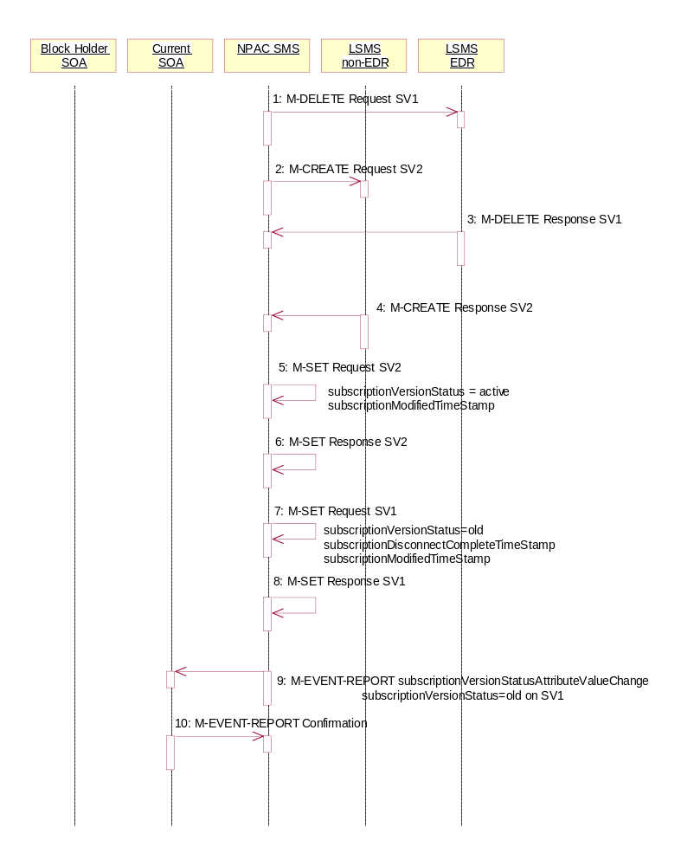
The NPAC SMS is ready to broadcast the disconnect of the ported, pooled TN.

- NPAC SMS sends the M-DELETE request to the EDR Local SMS to delete the existing subscription version and cause the routing to return to the number pool block. If a range of subscription versions is being removed, the M-DELETE will be scoped and filtered for the appropriate subscription versions by TN.
- At the same time as step 1, the NPAC SMS sends out the M-CREATE of a subscription version to all non-EDR Local SMSs that are accepting downloads for the NPA-NXX of the subscription version for SV2. If the M-CREATE is for multiple subscription versions, the subscriptionVersionLocalSMS-Create M-ACTION will be sent. The subscription version for the TN has a LNP type of ‘pool’.
- EDR Local SMS sends its successful M-DELETE reply.
- Non-EDR Local SMS responds with a successful M-CREATE reply.
- NPAC SMS issues M-SET updating the subscriptionVersionStatus to active for subscriptionVersionNPAC objects for SV2. The subscriptionModifiedTimeStamp is also set.
- NPAC SMS responds to M-SET.
- NPAC SMS issues M-SET updating the subscriptionVersionStatus to old for subscriptionVersionNPAC objects for SV1. It also sets the subscriptionModifiedTimeStamp and subscriptionDisconnectCompleteTimeStamp.
- NPAC SMS responds to M-SET.
- NPAC SMS issues an M-EVENT-REPORT to current service provider SOA of subscriptionVersionStatusAttributeValueChange being set to old on SV1.
- The current service provider SOA confirms the M-EVENT-REPORT.

Subscription Version Disconnect With Effective Release Date

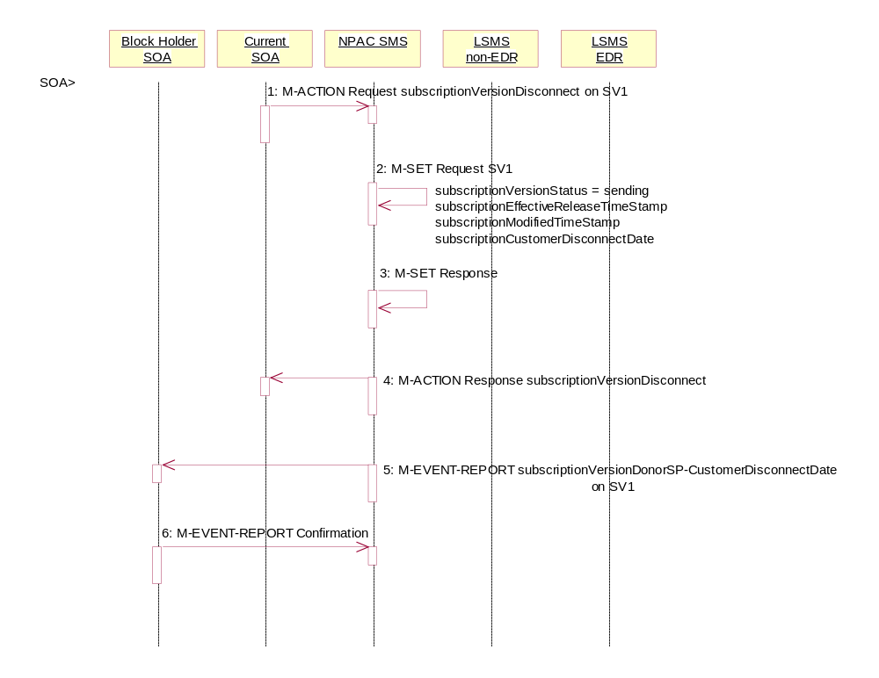
In this scenario, a future dated request is submitted to disconnect an active subscription version that will return to the block holder.

- Current service provider SOA personnel take action to disconnect a subscription version.
- Current service provider SOA issues an M-ACTION request to disconnect the lnpSubscriptions object. The M-ACTION specifies either the subscriptionVersionId, or subscriptionTN, or range of TNs, and also has future dated the subscriptionEffectiveReleaseDate and the subscriptionCustomerDisconnectDate. The subscription version status must be active and no pending, failed, conflict, conflict-pending, or cancel-pending versions can exist.
- NPAC SMS issues an M-SET to set the status to disconnect-pending, and set the subscriptionEffectiveReleaseDate, subscriptionCustomerDisconnectDate and the subscriptionModifiedTimeStamp of the existing subscriptionVersionNPAC.
- NPAC SMS responds to M-SET.
- NPAC SMS responds to M-ACTION. If the action fails, no modifications are applied and the processing stops.
- NPAC SMS sends the subscriptionVersionStatusAttributeValueChange M-EVENT-REPORT to the current service provider SOA.
- The current service provider SOA issues the M-EVENT-REPORT confirmation.
- The NPAC SMS waits for the subscriptionEffectiveReleaseDate date to arrive.

Subscription Version Disconnect of a Ported Pooled TN After Block Activation: Failure to Local
This scenario shows the broadcast of a disconnect subscription after block activation that fails to all of the Local SMSs. In this scenario:
- SV1 is the currently active Subscription Version.
- SV2 is the pool reinstatement Subscription Version with LNP type = pool that reinstates default routing to the block holder.

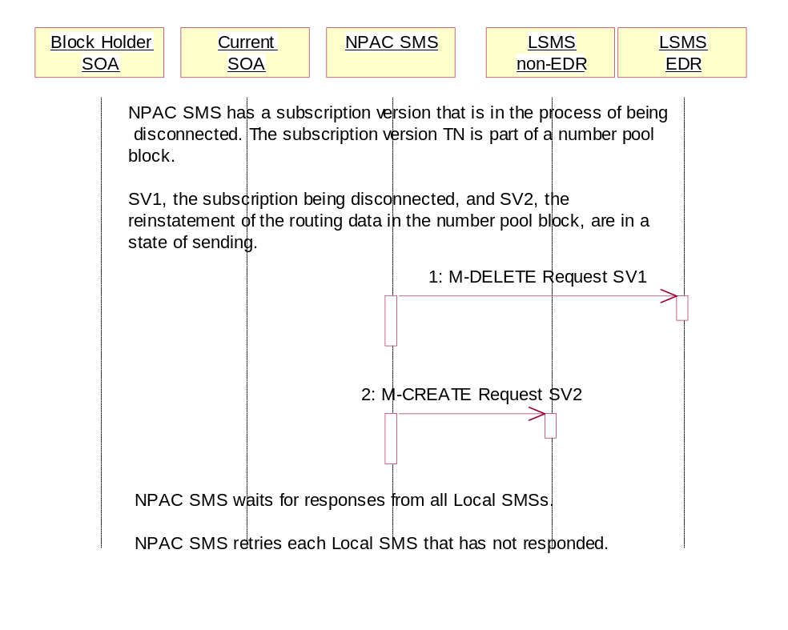
Subscription Version Disconnect NPAC SMS Failure Broadcast to Local SMS

NPAC SMS has a subscription version that is in the process of being disconnected. The subscription version TN is part of a number pool block. SV1, the subscription being disconnected, and SV2, the reinstatement of the routing data in the number pool block, are in a state of ‘sending’.

- NPAC SMS sends the M-DELETE request to the EDR Local SMS for SV1.
- At the same time as step 1, the NPAC SMS sends the M-CREATE request to the non-EDR Local SMS for SV2.

NPAC SMS waits for responses from all Local SMSs.

NPAC SMS retries each Local SMS that has not responded.

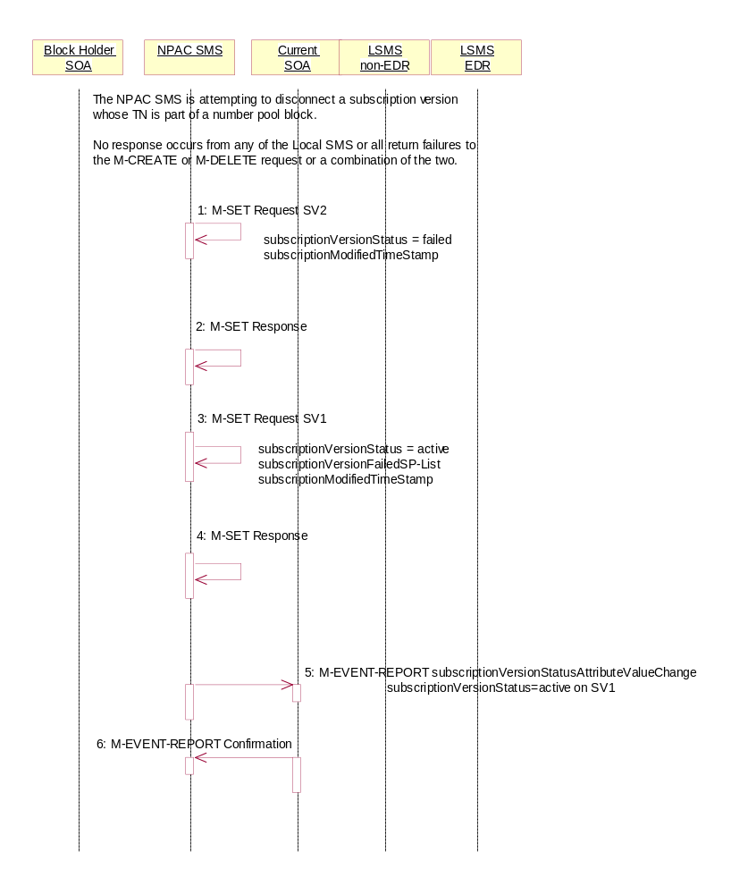
Subscription Version Disconnect Broadcast Failure NPAC SMS Updates

NPAC SMS is attempting to disconnect a subscription version whose TN is a part of a number pool block. It has broadcasted the data to the LSMSs.

No response occurs from any of the Local SMS, or all return failures to the M-CREATE or M-DELETE request, or a combination of the two.

- NPAC SMS issues the M-SET to update the SV2 subscriptionVersionStatus from “sending” to “failed”. The subscriptionModifiedTimeStamp is also set.
- NPAC SMS responds to the M-SET.
- NPAC SMS issues the M-SET to update the SV2 subscriptionVersionStatus from “sending” to “active”. It also updates the subscriptionFailed-SP-List with the service provider ID and name of all the Local SMSs. The subscriptionModifiedTimeStamp is also set.
- NPAC SMS responds to the M-SET.
- NPAC SMS sends the subscriptionVersionStatusAttributeValueChange M-EVENT-REPORT to the current service provider SOA with the current status for SV1 along with the subscriptionFailed-SP-List.
- Current service provider SOA issues the M-EVENT-REPORT confirmation.

Subscription Version Disconnect of a Ported Pooled TN: Partial Failure to Local SMS

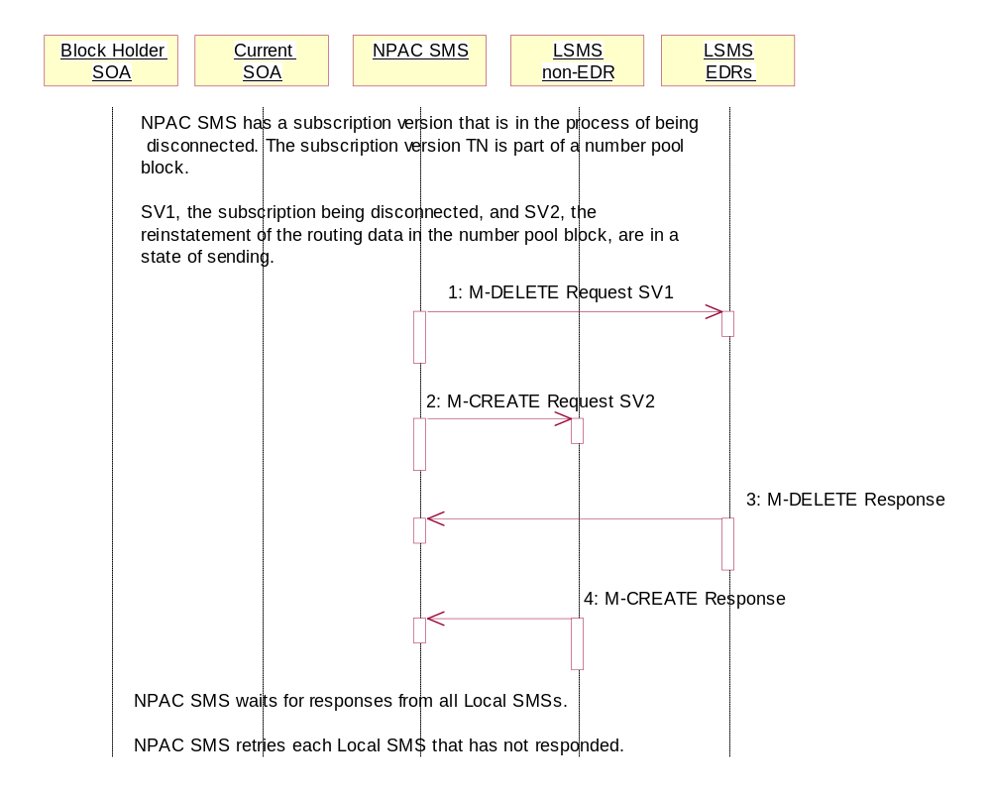
This scenario shows the broadcast of a disconnect subscription version after the number pool block activation that fails to one or more, but not all, Local SMSs. In this scenario:
- SV1 is the currently active Subscription Version.
- SV2 is the pool reinstatement Subscription Version with LNP type = pool that reinstates default routing to the block holder.

Subscription Version Disconnect Partial-Failure Broadcast
NPAC SMS has a subscription version that is in the process of being disconnected. The subscription version TN is part of a number pool block. SV1, the subscription being disconnected, and SV2, the reinstatement of the routing data in the number pool block, are in a state of ‘sending’.

- NPAC SMS sends the M-DELETE request to the EDR Local SMS for SV1.
- At the same time as step 1, the NPAC SMS sends the M-CREATE request to the non-EDR Local SMS for SV2.
- The EDR Local SMS responds to the M-DELETE.
- The non-EDR Local SMS responds to the M-CREATE.

NPAC SMS waits for responses from all Local SMSs.

NPAC SMS retries each Local SMS that has not responded.

Subscription Version Disconnect of a Ported Pooled TN Partial Failure Broadcast NPAC SMS Updates

NPAC SMS is attempting to disconnect a subscription version whose TN is a part of a number pool block.

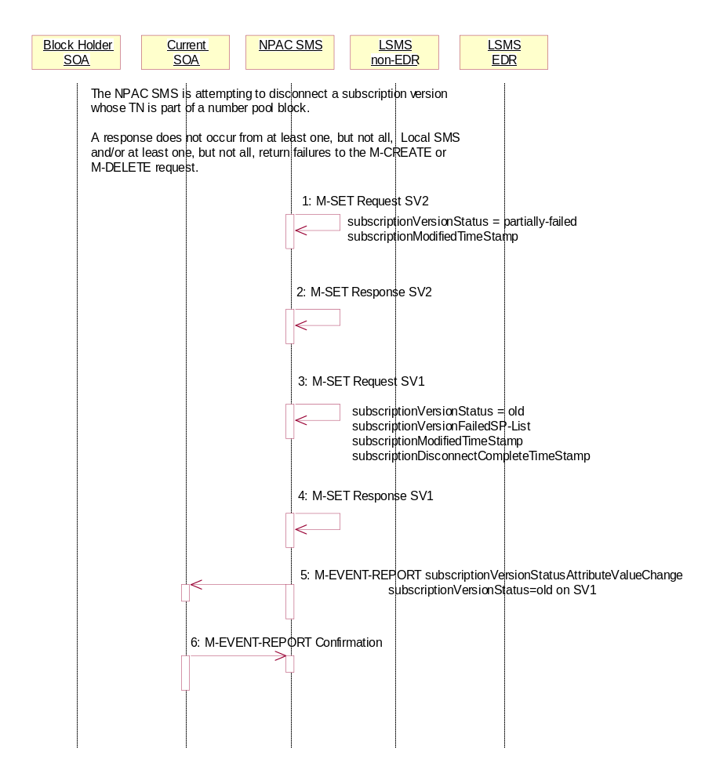
A response does not occur from at least one, but not all Local SMSs and/or at least one, but not all, Local SMSs respond with an error to the M-DELETE or M-CREATE request.

- NPAC SMS issues the M-SET to update the SV2 subscriptionVersionStatus from “sending” to “partially-failed”. The subscriptionModifiedTimeStamp and subscriptionActivationTimeStamp are also set.
- NPAC SMS responds to the M-SET.
- NPAC SMS issues the M-SET to update the SV1 subscriptionVersionStatus from “sending” to “old”. It also updates the subscriptionFailed-SP-List with the service provider ID and name of all the non-EDR and EDR Local SMSs that failed the broadcast. The subscriptionModifiedTimeStamp and subscriptionDisconnectCompleteTimeStamp are also set.
- NPAC SMS responds to the M-SET.
- NPAC SMS sends the subscriptionVersionStatusAttributeValueChange M-EVENT-REPORT to the current service provider SOA with the status of ‘old’ for SV1 along with the subscriptionFailed-SP-List.
- Current service provider SOA issues the M-EVENT-REPORT confirmation.

Subscription Version Disconnect of a Ported Pooled TN: Resend Successful to Local SMS
This scenario shows a successful resend of a disconnect for a subscription that fails to one or more of the Local SMSs. The resend of a failed disconnect can only be performed by authorized NPAC personnel. In this scenario:
- SV1 is the currently active Subscription Version.
- SV2 is the pool reinstatement Subscription Version with LNP type = pool that reinstates default routing to the block holder.

Subscription Version Disconnect of a Ported Pooled TN NPAC SMS Broadcast Successful Resend
NPAC Personnel take action to resend a failed disconnect for a subscription version (SV1) that took place after the activation of the number pool block.

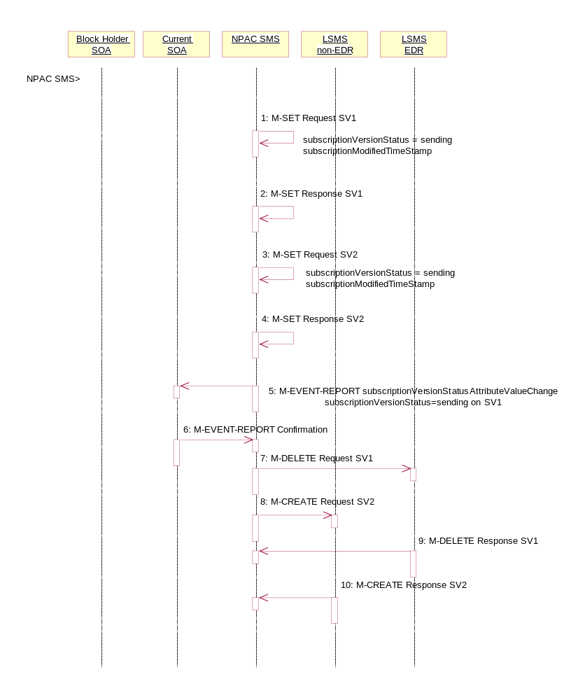
- NPAC SMS issues an M-SET to the existing subscriptionVersionNPAC object to set the status to “sending” for SV1 and set the subscriptionModifiedTimeStamp.
- NPAC SMS responds to the M-SET.
- NPAC SMS issues an M-SET to update the subscriptionVersionNPAC object for SV2. The subscriptionVersionStatus is set to “sending” for SV2 and the subscriptionModifiedTimeStamp is updated.
- NPAC SMS responds to the M-SET.
- NPAC SMS issues an M-EVENT-REPORT to the current service provider SOA of status change to “sending” for SV1.
- Current service provider confirms the M-EVENT-REPORT.
- NPAC SMS issues an M-DELETE on the subscriptionVersion SV1 to all previously failed EDR Local SMSs that are accepting downloads for the NPA-NXX of the subscriptionVersion SV1 TN.
- At the same time as step 7, the NPAC SMS issues an M-CREATE on the subscription version SV2 to all non-EDR Local SMSs that are accepting downloads for the NPA-NXX and had previously failed.
- EDR Local SMS responds successfully to the M-DELETE on SV1.
- Each non-EDR Local SMS responds successfully to the M-CREATE on SV2.

Subscription Version Disconnect of a Ported Pooled TN Resend Successful NPAC SMS Updates

All non-EDR Local SMSs have responded successfully to the M-CREATE for SV2 and all EDR Local SMSs have responded successfully to the M-DELETE for SV1.

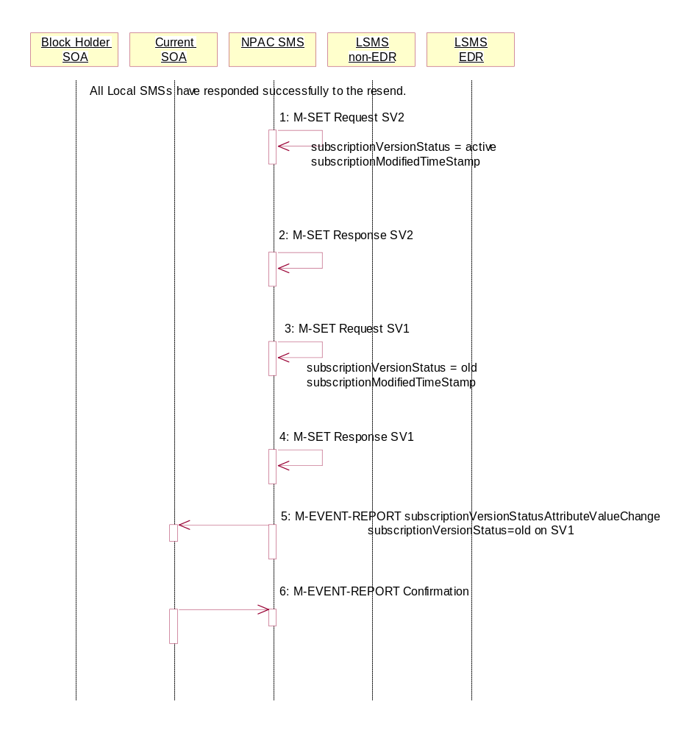
- NPAC SMS issues M-SET updating the subscriptionVersionStatus to ‘active’ for SV2. The subscriptionModifiedTimeStamp is also set.
- NPAC SMS responds to M-SET.
- NPAC SMS issues M-SET updating the subscriptionVersionStatus to ‘old’ for SV1. The subscriptionModifiedTimeStamp is also set.
- NPAC SMS responds to M-SET.
- NPAC SMS issues the M-EVENT-REPORT subscriptionVersionStatusAttributeValueChange to the current service provider for SV1 with the subscriptionVersionStatus set to ‘old’.
- Current service provider confirms the M-EVENT-REPORT.

Subscription Version Disconnect of a Ported Pooled TN: Resend Failure to Local SMS
This scenario shows an unsuccessful resend of a disconnect for a subscription that fails to one or more of the Local SMSs. the resend of a failed disconnect can only be performed by NPAC personnel. In this scenario:
- SV1 is the currently active Subscription Version.
- SV2 is the pool reinstatement Subscription Version with LNP type = pool that reinstates default routing to the block holder with a status of failed.

Subscription Version Disconnect Failed Resend Broadcast

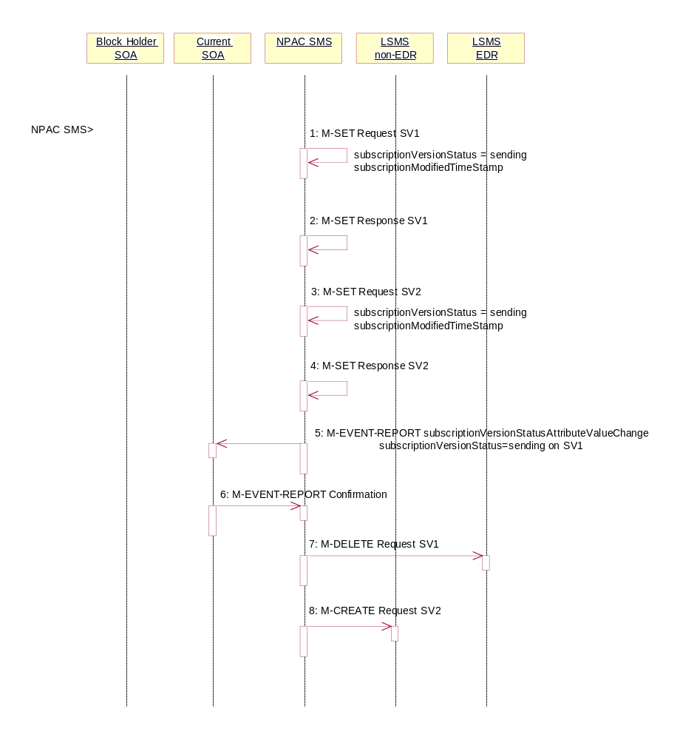
NPAC Personnel take action to resend a failed disconnect for a subscription version (SV1). This rebroadcast will result in failure again.

- NPAC SMS issues an M-SET to the existing subscriptionVersionNPAC object to set the status to “sending” for SV1 and set the subscriptionModifiedTimeStamp.
- NPAC SMS responds to the M-SET.
- NPAC SMS issues an M-SET to the existing subscriptionVersionNPAC object to set the status to “sending” for SV2 and the subscriptionModifiedTimeStamp.
- NPAC SMS responds to the M-SET.
- NPAC SMS issues an M-EVENT-REPORT to the current service provider SOA of status change to “sending” for SV1.
- Current service provider confirms the M-EVENT-REPORT.
- NPAC SMS issues an M-DELETE on the subscriptionVersion SV1 to all previously failed EDR Local SMSs that are accepting downloads for the NPA-NXX of the subscriptionVersion SV1 TN.
- At the same time as step 7, the NPAC SMS issues an M-CREATE on the subscriptionVersion SV2 to all previously failed non-EDR Local SMSs that are accepting downloads for the NPA-NXX of the subscriptionVersion SV2 TN.

NPAC SMS waits for responses from all Local SMSs.

NPAC SMS retries each Local SMS that has not responded.

Subscription Version Disconnect of a Ported Pooled TN Resend Failure NPAC SMS Updates

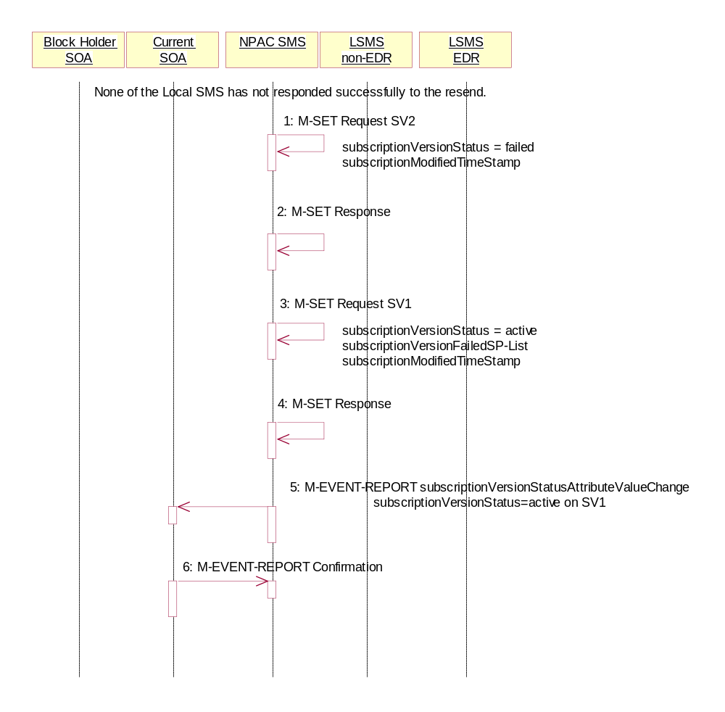
None of the non-EDR Local SMSs has responded successfully to the M-CREATE and none of the EDR Local SMSs responded successfully to the M-DELETE.

- NPAC SMS issues M-SET updating the subscriptionVersionStatus to failed for SV2. The subscriptionModifiedTimeStamp is also set.
- NPAC SMS responds to M-SET.
- NPAC SMS issues M-SET updating the subscriptionVersionStatus to active for SV1. The subscriptionFailed-SP-List and subscriptionModifiedTimeStamp is also set.
- NPAC SMS responds to M-SET.
- NPAC SMS issues the M-EVENT-REPORT subscriptionVersionAttributeValueChange to the current service provider for SV1 with the subscriptionVersionStatus set to ‘active’ and the subscriptionFailed-SP-List.
- Current service provider confirms the M-EVENT-REPORT.

Subscription Version Disconnect of a Ported Pooled TN: Resend Partial Failure to Local SMS
This scenario shows an unsuccessful resend of a disconnect for a subscription that fails to one or more of the Local SMSs. the resend of a failed disconnect can only be performed by NPAC personnel. In this scenario:
- SV1 is the previously active Subscription Version now with a status of old.
- SV2 is the pool reinstatement Subscription Version with LNP type = pool that reinstates default routing to the block holder with a status of partially failed.

NPAC SMS Initiates Resend of a Partially Failed Disconnect of a Ported Pooled TN
The NPAC SMS is initiating the resend of a previously partially failed disconnect of a ported, pooled TN for a number pool block that was active at the time of the initial broadcast.

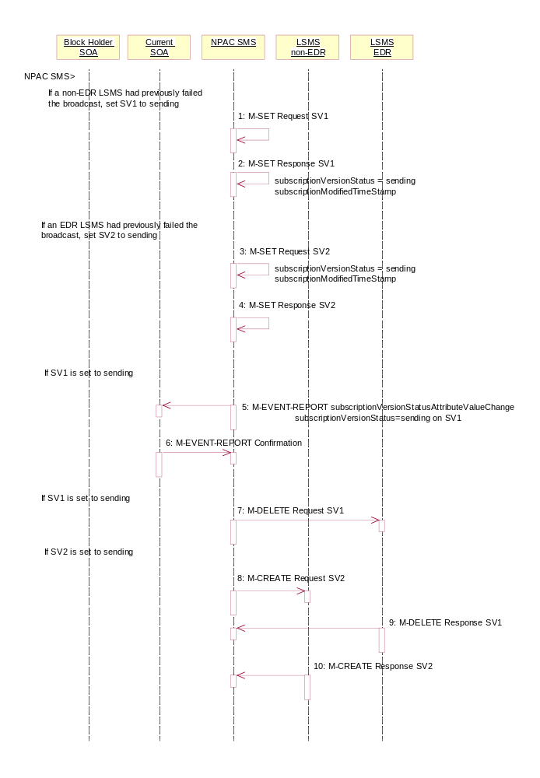

- If a non-EDR Local SMS failed the broadcast, the NPAC SMS issues an M-SET to the existing subscriptionVersionNPAC object to set the status to “sending” for SV1 and set the subscriptionModifiedTimeStamp.
- NPAC SMS responds to the M-SET.
- If an EDR Local SMS failed the broadcast, the NPAC SMS issues an M-SET to the existing subscriptionVersionNPAC object to set the status to “sending” for SV2 and the subscriptionModifiedTimeStamp.
- NPAC SMS responds to the M-SET.
- If the status of SV1 is set to sending, the NPAC SMS issues an M-EVENT-REPORT to the current service provider SOA of status change to “sending” for SV1.
- Current service provider confirms the M-EVENT-REPORT.
- If the status of SV1 is set to sending, the NPAC SMS issues an M-DELETE on the subscriptionVersion SV1 to all previously failed EDR Local SMSs that are accepting downloads for the NPA-NXX of the subscriptionVersion SV1 TN.
- At the same time as step 7 and if the status of SV2 is set to sending, the NPAC SMS issues an M-CREATE on the subscriptionVersion SV2 to all previously failed non-EDR Local SMSs that are accepting downloads for the NPA-NXX of the subscriptionVersion SV2 TN.
- The EDR Local SMS responds to the M-DELETE request.
- The non-EDR Local SMS responds to the M-CREATE request.

NPAC SMS waits for responses from all Local SMSs.

NPAC SMS retries each Local SMS that has not responded.

Subscription Version Disconnect Resend Partial Failure Broadcast NPAC SMS Updates

At least one of the non-EDR Local SMSs has not responded successfully to the M-CREATE and/or at least one of the EDR Local SMSs has not responded successfully to the M-DELETE.

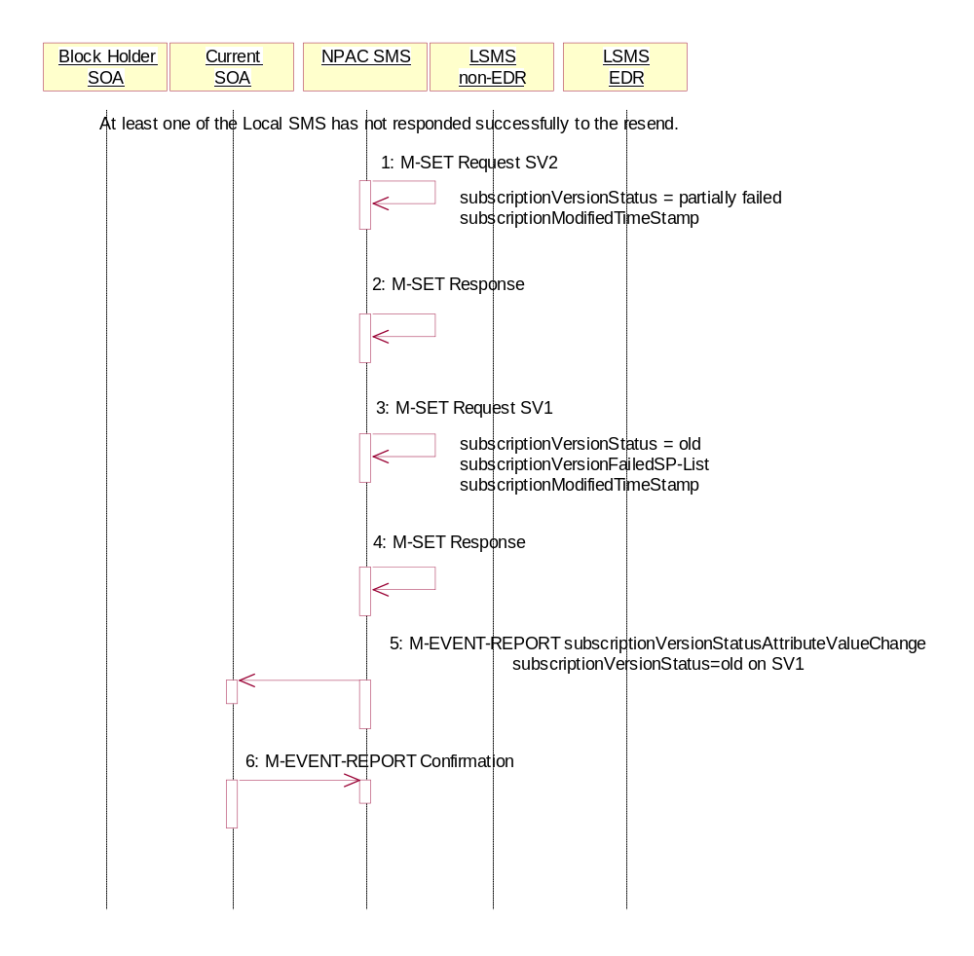
- NPAC SMS issues M-SET updating the subscriptionVersionStatus to partially-failed for SV2. The subscriptionModifiedTimeStamp is also set.
- NPAC SMS responds to M-SET.
- NPAC SMS issues M-SET updating the subscriptionVersionStatus to old for SV1. The subscriptionFailed-SP-List and subscriptionModifiedTimeStamp is also set.
- NPAC SMS responds to M-SET.
- NPAC SMS issues the M-EVENT-REPORT subscriptionVersionAttributeValueChange to the current service provider for SV1 with the subscriptionVersionStatus set to ‘old’ along with the subscriptionFailed-SP-List.
- Current service provider confirms the M-EVENT-REPORT.

Subscription Version Immediate Disconnect of a Contaminated Pooled TN Prior to Block Activation (after Effective Date)
In this scenario, the current service provider disconnects an active subscription version that will return to the block holder. However, the number pool block is past the effective date, but has not yet been activated.

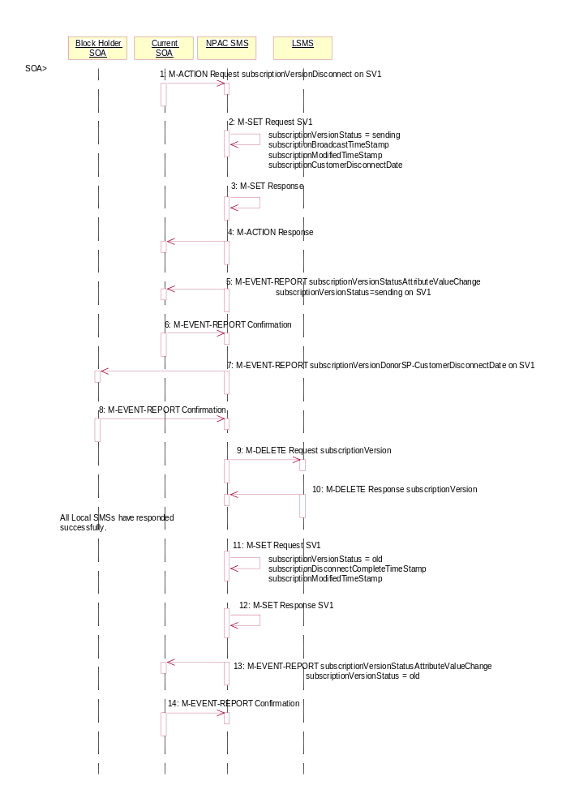
- Current service provider SOA personnel take action to disconnect a subscription version.
- Service provider SOA issues an M-ACTION request to disconnect to the lnpSubscriptions object. The M-ACTION specifies either the subscriptionVersionId, or subscriptionTN or range of TNs, and also has NOT future dated (i.e., used the current date) the subscriptionEffectiveReleaseDate and the subscriptionCustomerDisconnectDate. The subscription version status must be active and no pending, failed, conflict or cancel-pending versions can exist.
- NPAC SMS issues an M-SET to set the subscriptionCustomerDisconnectDate according to the disconnect action for SV1. The subscriptionVersionStatus for SV1 goes to “sending ”. The subscriptionModifiedTimeStamp and subscriptionBroadcastTimeStamp are set accordingly.
- NPAC SMS responds to whether M-SET was successful.
- NPAC SMS responds to the M-ACTION. If the action failed, an error will be returned and processing will stop on this flow.
- NPAC SMS notifies service provider SOA of status change to “sending” for SV1.
- Service provider SOA confirms the M-EVENT-REPORT.
- NPAC SMS sends the Donor service provider SOA notification that the subscription version is being disconnected with the customer disconnect date. This SOA is the block holder SOA.
- The donor service provider SOA confirms the M-EVENT-REPORT.
- NPAC SMS sends the M-DELETE request to the Local SMS to delete the existing subscription version.
- Local SMS sends its M-DELETE reply.
- All Local SMSs have responded successfully.
- NPAC SMS sets the subscriptionVersionStatus to ‘old’ and sets the subscriptionModifiedTimeStamp. The subscriptionDisconnectCompleteTimeStamp is set when the first successful response is received.
- NPAC SMS responds to the M-SET.
- NPAC SMS sends the subscriptionVersionStatusAttributeValueChange notification to the current SOA with the subscriptionVersionStatus set to ‘old’.
- Service provider SOA confirms the M-EVENT-REPORT.

Resynchronization
This section shows the flows related to resynchronization.

Sequencing of Events on Initialization/Resynchronization of EDR Local SMS
This scenario demonstrates how an EDR Local SMS resynchronizes itself with the NPAC SMS.

These scenarios demonstrate the recovery of additions, deletions and modifications of network, subscription version and number pool block data. The recovery of this data can cause status attribute value changes and serviceProvNPA-NXX-X deletions.

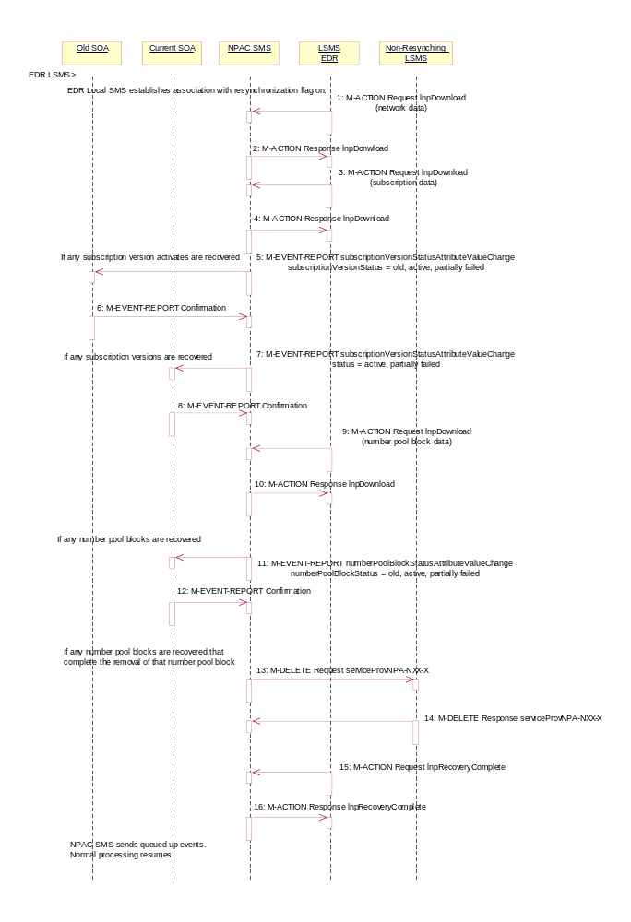
The EDR Local SMS establishes an association to the NPAC SMS with the resynchronization flag on. The NPAC SMS will queue all current activity on the NPAC SMS until the service Local SMS sends in the lnpRecoveryComplete action.
- EDR Local SMS sends lnpDownload M-ACTION to start network data download. The Local SMS specifies the start time. If the “all-network-data” is selected, the NPAC SMS sends the serviceProvNPA-NXX-X updates (creates, modifies, deletes) if the Local SMS’s “NPAC Customer LSMS NPA-NXX-X Indicator” in their service provider profile on the NPAC SMS states it supports the object.
- NPAC SMS responds to M-ACTION with updates.
- EDR Local SMS sends the lnpDownload M-ACTION to start subscription data download. The Local SMS specifies the start time.
- NPAC SMS responds to M-ACTION with updates. All creates, modifies and deletes are received, a single record for each subscription version. (i.e. no ranges) The EDR Local SMS will not receive any activity on subscription versions with LNP type of ‘pool’.
- If any corrections were issued to the resyncing Local SMS that involved the activation of a subscription version with the LNP type not equal to ‘pool’, the NPAC SMS will send the M-EVENT-REPORT to the old service provider SOA with the current subscriptionVersionStatus and a list of failed Local SMSs (minus the resyncing Local SMS that no longer contains a discrepancy).
- The old service provider SOA confirms the M-EVENT-REPORT.
- If any corrections were issued to the resyncing Local SMS that involved a subscription version with the LNP type not equal to ‘pool’, the NPAC SMS will send the M-EVENT-REPORT to the current service provider SOA with the current subscriptionVersionStatus and a list of failed Local SMSs (minus the resyncing Local SMS that no longer contains a discrepancy).
- The current service provider SOA confirms the M-EVENT-REPORT.
- EDR Local SMS sends the lnpDownload M-ACTION to start number pool block data download. The Local SMS specifies the start time.
- NPAC SMS responds to M-ACTION with updates.
- NPAC SMS sends the M-EVENT-REPORTs to the block holder SOAs for any number pool block with the SOA-Origination indicator set to true whose numberPoolBlockFailed-SP-List and possibly numberPoolBlockStatus were just updated due to the number pool block download.
- Block holder SOA confirms to the M-EVENT-REPORT.
- If deletes were sent for any number pool blocks that completed the broadcast of the M-DELETEs of a number pool block and corresponding subscription versions, then the NPAC SMS will send to all other Local SMSs the M-DELETE for the serviceProvNPA-NXX-X object. The NPAC SMS will queue up the M-DELETE request for the recovering Local SMS and send it at the completion of recovery mode.
- Local SMS responds the M-DELETE.
- EDR Local SMS sends M-ACTION, lnpRecoveryComplete, to set the resynchronization flag off.
- NPAC SMS replies to the M-ACTION.
Any activity that the NPAC SMS had queued up during the recovery period will now be sent.
Normal processing resumes.

Sequencing of Events on Initialization/Resynchronization of Non-EDR Local SMS
This scenario demonstrates how a non-EDR Local SMS resynchronizes itself with the NPAC SMS.
This scenario demonstrates the recovery of additions, deletions and modifications of network and subscription version data. The recovery of this data can cause status attribute value changes and serviceProvNPA-NXX-X deletions.

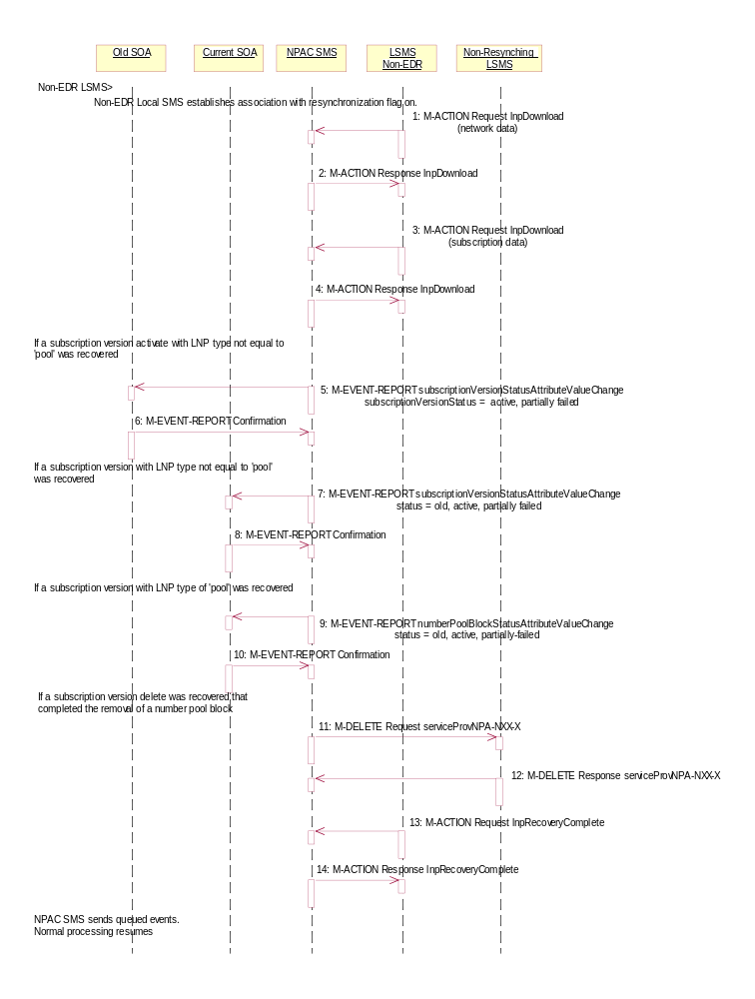
Local SMS personnel take action to resynchronize their Local SMS with the NPAC SMS.
The EDR Local SMS establishes an association to the NPAC SMS with the resynchronization flag on. The NPAC SMS will queue all current activity on the NPAC SMS until the service Local SMS sends in the lnpRecoveryComplete action.
- Non-EDR Local SMS sends the lnpDownload M-ACTION to start network data download. The Local SMS specifies the start time. If the “all-network-data” is selected, the NPAC SMS sends the serviceProvNPA-NXX-X updates (creates, modifies, deletes) if the Local SMS’s “NPAC Customer LSMS NPA-NXX-X Indicator” in their service provider profile on the NPAC SMS states it supports the object.
- NPAC SMS responds to the M-ACTION with updates.
- Non-EDR Local SMS sends the lnpDownload M-ACTION to start subscription data download. The Local SMS specifies the start time.
- NPAC SMS responds to the M-ACTION with updates. All creates, modifies and deletes are received, a single record for each subscription version. (i.e. no ranges) The Non-EDR Local SMS will receive all the activity on subscription versions with a LNP type of ‘pool’.
- If any corrections were issued to the resyncing Local SMS, the NPAC SMS will send the M-EVENT-REPORT to the old service provider SOA of the subscriptionVersionStatus change and a list of failed Local SMSs (minus the resyncing Local SMS that no longer contains a discrepancy).
- The old service provider SOA confirms the M-EVENT-REPORT.
- If any corrections were issued to the resyncing Local SMS, the NPAC SMS will send the M-EVENT-REPORT to the current service provider SOA of the status change and a list of failed Local SMSs (minus the resyncing Local SMS that no longer contains a discrepancy).
- The current service provider SOA confirms the M-EVENT-REPORT.
- If any corrections were issued to the resyncing Local SMS for subscription versions with LNP type equal to ‘pool’, the NPAC SMS will send the numberPoolBlockStatusAttributeValueChange to the current block holder SOA, if the numberPoolBlockSOA-Origination indicator is TRUE, with the current number pool block status and a list of failed Local SMSs (minus the resyncing Local SMS that no longer contains the discrepancy).
- The block holder SOA confirms the M-EVENT-REPORT.
- If deletes were sent for any subscription versions with LNP type equal to ‘pool’ that completed the broadcast of the M-DELETEs for a number pool block and corresponding subscription versions, then the NPAC SMS will send to all other Local SMSs. who support the serviceProvNPA-NXX-X object, the M-DELETE for the serviceProvNPA-NXX-X object.
- Local SMS responds to the M-DELETE.
- Non-EDR Local SMS sends M-ACTION, lnpRecoveryComplete, to set the resynchronization flag off.
- NPAC SMS replies to the M-ACTION.
Any activity that the NPAC SMS had queued up during the recovery period will now be sent.
Normal processing resumes.

Audits

SOA Audit Create for Subscription Versions within a Number Pool Block
In this scenario, the SOA initiates the audit of one or more subscription versions that are within the range of a number pool block. For non-EDR Local SMSs, this involves the subscription version objects. For EDR Local SMSs, this involves both subscription version objects and number pool block objects.
If discrepancies are found, the NPAC SMS will create, modify or delete subscription version and number pool objects, as necessary. The NPAC SMS will report to the SOA the discrepancies with subscription version identifiers. Thus, if a numberPoolBlock object is in error, the discrepancy will be reported as all TNs within the audit range that were also within the block range. Subscription version discrepancies will be reported as usual.

SOA Creates and NPAC SMS Starts Audit

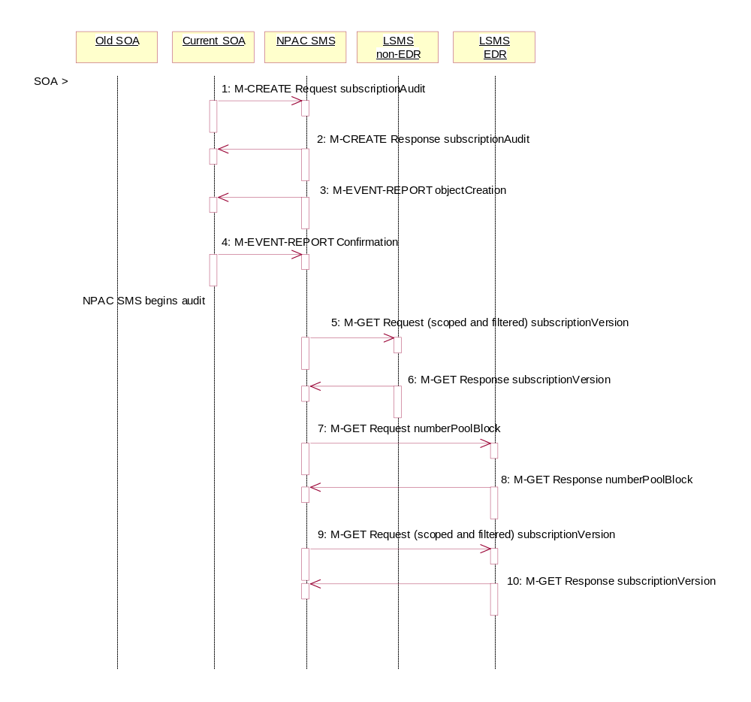
Action is taken by SOA personnel to start an audit due to suspected network discrepancies.
- The SOA sends an M-CREATE request to the NPAC SMS requesting an audit. The SOA must specify the following attributes in the request:
subscriptionAuditName – English audit name
subscriptionAuditRequestingSP – the service provider requesting the audit
subscriptionAuditServiceProvIdRange – which service provider or all service providers for audit
subscriptionAuditTN-Range – TNs to be audited
If these attributes are not specified, then the create will fail with a missingAttributeValue error. The SOA may also specify the following attributes in the request:
subscriptionAuditAttributeList – subscription version attributes to be audited
subscriptionAuditTN-ActivationRange – time range of activation for subscription versions to be audited.
The subscriptionAuditId and the subscriptionAuditStatus will be determined by the NPAC SMS. If any values are deemed invalid, an invalidArgumentValue error will be returned. NOTE: The subscriptionAuditTN-Range will be limited based on the maximum range size specified in the NPAC SMS. If the limit specified is exceeded, the create request will fail with an invalidAttributeValue error.
- Once the NPAC SMS creates the audit request object, it sends an M-CREATE response back to the SOA that initiated the request.
- NPAC SMS sends M-EVENT-REPORT to the service provider SOA for the subscriptionAudit creation.
- The service provider SOA confirms the M-EVENT-REPORT.
- NPAC SMS begins audit.
- The NPAC SMS sends an M-GET request to the non-EDR Local SMS to retrieve the subscription data for audit processing. The request uses the CMIP scoping and filtering options to retrieve only the subscriptionVersion objects to be audited.
- The non-EDR Local SMS responds to the M-GET request by returning the subscription version objects that satisfy the scope and filter data.
- The NPAC SMS sends an M-GET request to the EDR Local SMS to retrieve the number pool block for audit processing.
- The EDR Local SMS responds to the M-GET request by returning the number pool object block requested.
- The NPAC SMS sends an M-GET request to the EDR Local SMS to retrieve the subscription version objects for audit processing. The request uses the CMIP scoping and filtering options to retrieve only the subscriptionVersion objects to be audited. No subscription versions with a LNP type of ‘pool’ should exist.
- The EDR Local SMS responds to the M-GET request by returning the subscription version objects that satisfy the scope and filter criteria.

NPAC SMS Performs Audit Comparisons
The SOA has sent in the audit request and the NPAC SMS had queried for the necessary data. The NPAC SMS now performs the necessary comparisons.

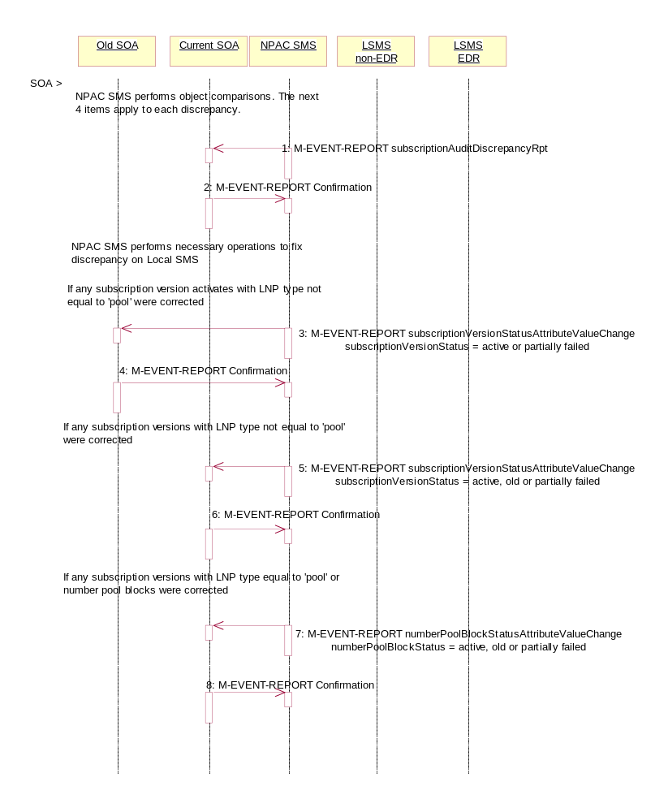
The NPAC SMS performs object comparisons. The next 4 items apply to each discrepancy.
- If a discrepancy is found, NPAC SMS issues a subscriptionAuditDiscrepancyRpt M-EVENT-REPORT.
- Service provider SOA confirms the M-EVENT-REPORT.
- NPAC SMS performs necessary operations to fix each discrepancy on Local SMS. If any subscription versions with a LNP type of ‘pool’ are returned by the EDR Local SMS, they will be deleted and discrepancies reported.
- If any corrections were issued to any Local SMSs that changed the status or subscriptionFailed-SP-List of an activated subscription version, the NPAC SMS will send M-EVENT-REPORT to the old service provider SOA of the subscriptionVersionStatus and a list of failed Local SMSs (minus any updated Local SMSs that no longer contains a discrepancy).
- The old service provider SOA confirms the M-EVENT-REPORT.
- If any corrections were issued to any Local SMSs that changed the status or subscriptionFailed-SP-List of a subscription version, the NPAC SMS will send M-EVENT-REPORT to the current service provider SOA with the status and a list of failed Local SMSs (minus any updated Local SMSs that no longer contains a discrepancy).
- The current service provider SOA confirms the M-EVENT-REPORT.
- If any corrections were issued to any Local SMSs that changed the status or numberPoolBlockFailed-SP-List of a number pool block, either by correcting a number pool block or subscription version with LNP type equal to ‘pool’, the numberPoolBlockStatusAttributeValueChange will be sent to the block holder SOA if the numberPoolBlockSOA-Origination indicator is set to “TRUE”. The M-EVENT-REPORT will contain the numberPoolBlockStatus and numberPoolBlockFailed-SP-List.
- The block holder service provider confirms the M-EVENT-REPORT.

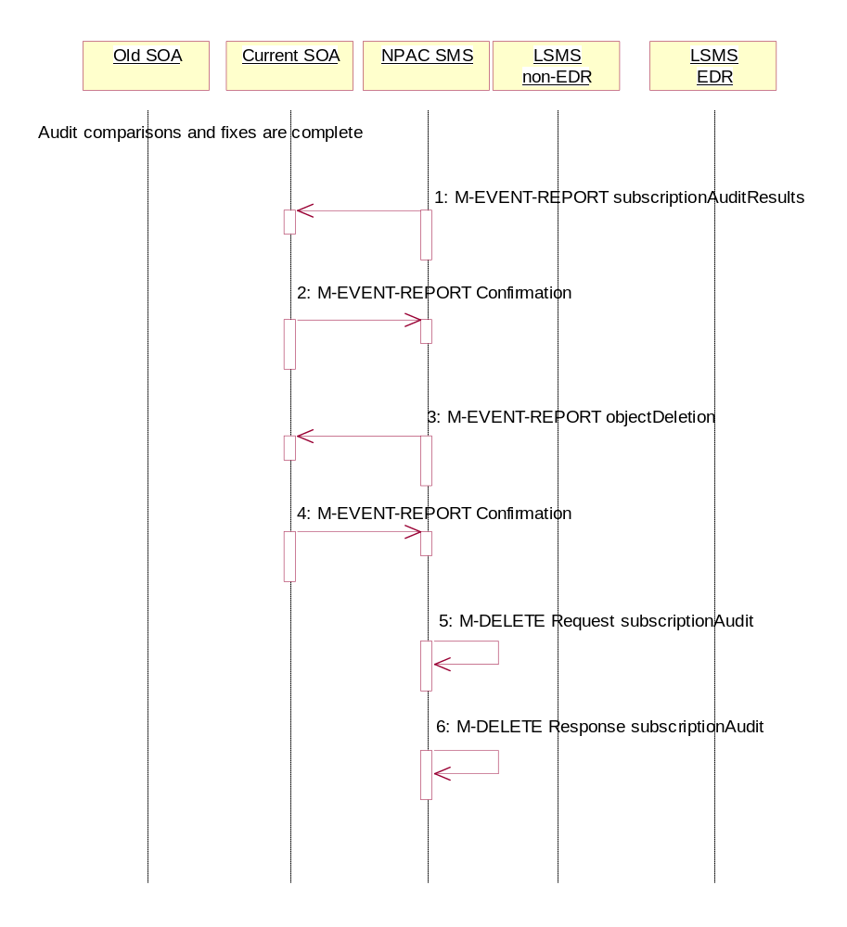
NPAC SMS Reports Audit Results
The NPAC SMS has completed the audit. It has reported and fixed all discrepancies found. It now sends the final results to the SOA.

Audit comparisons and fixes are complete.
- NPAC SMS issues the subscriptionAuditResults M-EVENT-REPORT to the service provider SOA.
- The service provider SOA confirms the M-EVENT-REPORT.
- The NPAC SMS then sends an objectDeletion M-EVENT-REPORT to the SOA for the subscriptionAudit object.
- The service provider SOA confirms the M-EVENT-REPORT.
- The NPAC SMS issues a local M-DELETE request for the subscriptionAudit object to/from the NPAC SMS. This will attempt to delete the subscriptionAudit object on the NPAC SMS.
- The M-DELETE response is received on the NPAC SMS indicating whether the subscriptionAudit object was deleted successfully.

NPAC SMS Audit Create
In this scenario, the NPAC SMS initiates an audit due to suspected subscriber data discrepancies. For non-EDR Local SMSs, this involves the subscription version objects. For EDR Local SMSs, this involves both subscription version objects and number pool block objects.
If discrepancies are found, the NPAC SMS will create, modify or delete subscription version and number pool objects, as necessary.

NPAC SMS Creates and Starts Audit

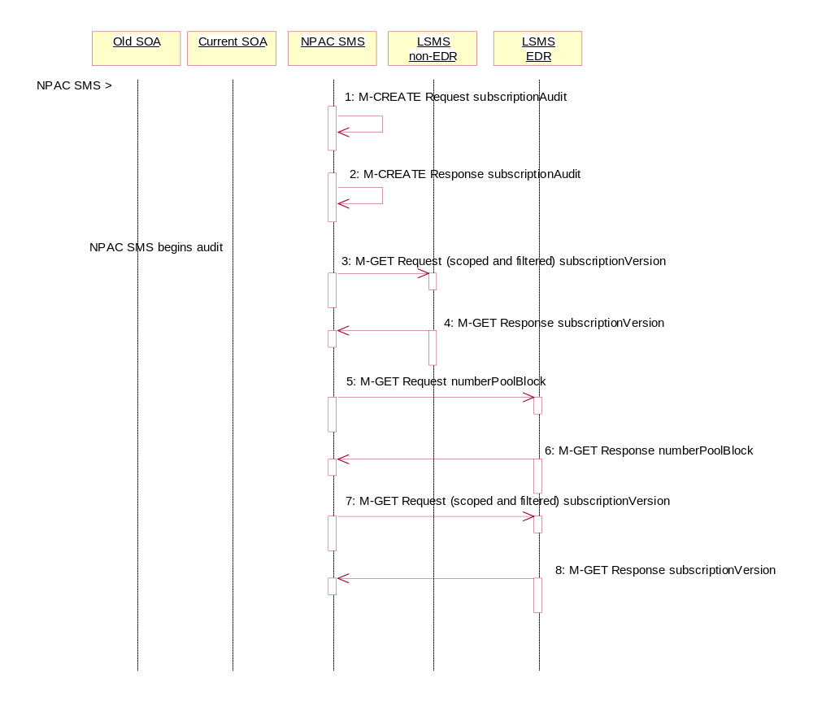
Action is taken by NPAC personnel to start an audit due to suspected network discrepancies.
- The NPAC SMS does a Local M-CREATE request for the subscriptionAudit object.
- The NPAC SMS responds with an M-CREATE response indicating that the subscriptionAudit was created successfully.
NPAC SMS begins audit.
- The NPAC SMS sends an M-GET request to the non-EDR Local SMS to retrieve the subscription data for audit processing. The request uses the CMIP scoping and filtering options to retrieve only the subscriptionVersion objects to be audited.
- The non-EDR Local SMS responds to the M-GET request by returning the subscription version objects that satisfy the scope and filter data.
- The NPAC SMS sends an M-GET request to the EDR Local SMS to retrieve the number pool block for audit processing.
- The EDR Local SMS responds to the M-GET request by returning the number pool object block requested.
- The NPAC SMS sends an M-GET request to the EDR Local SMS to retrieve the subscription version objects for audit processing. The request uses the CMIP scoping and filtering options to retrieve only the subscriptionVersion objects to be audited. No subscription versions with a LNP type of ‘pool’ should exist.
- The EDR Local SMS responds to the M-GET request by returning the subscription version objects that satisfy the scope and filter criteria.

NPAC SMS Performs Audit Comparisons

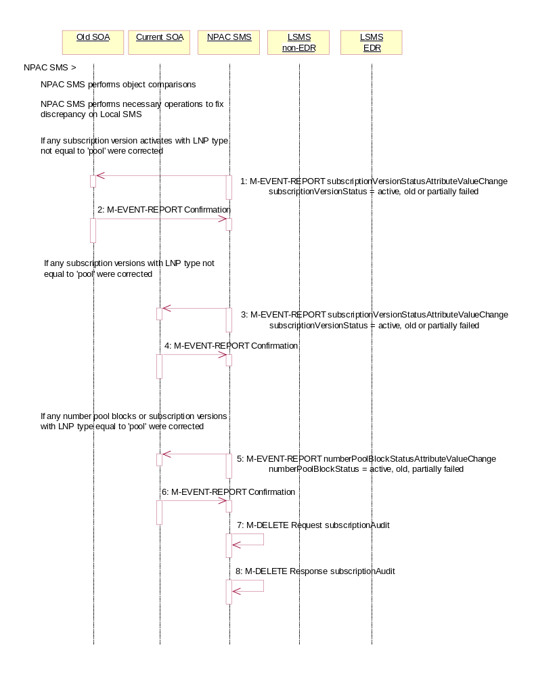
The NPAC SMS has queried for the required data and now proceeds to perform the audit comparisons.
NPAC SMS performs object comparisons.
- NPAC SMS performs necessary operations to each fix discrepancy on Local SMS. If any subscription versions with a LNP type of ‘pool’ are returned by the EDR Local SMS, they will be deleted and discrepancies reported.
- If any corrections were issued to any Local SMSs that changed the status or subscriptionFailed-SP-List of an activated subscription version, the NPAC SMS will send the M-EVENT-REPORT to the old service provider SOA with the subscriptionVersionStatus and a list of failed Local SMSs (minus any updated Local SMSs that no longer contain a discrepancy).
- The old service provider SOA confirms the M-EVENT-REPORT.
- If any corrections were issued to any Local SMSs that changed the status or subscriptionFailed-SP-List of a subscription version, the NPAC SMS will send M-EVENT-REPORT to the current service provider SOA with the subscriptionVersionStatus and a list of failed Local SMSs (minus any updated Local SMSs that no longer contain a discrepancy).
- The current service provider SOA confirms the M-EVENT-REPORT.
- If any corrections were issued to any Local SMSs that changed the status or numberPoolBlockFailed-SP-List of a number pool block, either by correcting a number pool block or subscription version with LNP type equal to ‘pool’, the numberPoolBlockStatusAttributeValueChange will be sent to the block holder SOA if the numberPoolBlockSOA-Origination indicator is set to “TRUE”. The M-EVENT-REPORT will contain the numberPoolBlockStatus and numberPoolBlockFailed-SP-List.
- The block holder service provider confirms the M-EVENT-REPORT.
- The NPAC SMS issues an M-DELETE request to remove the subscriptionAudit object from the NPAC SMS.
- The NPAC SMS response is received by the NPAC SMS indicating whether the subscriptionAudit object was deleted successfully.

NPA-NXX Split
In this scenario, the NPAC SMS personnel initiate an NPA-NXX split that contains a block of pooled TNs.

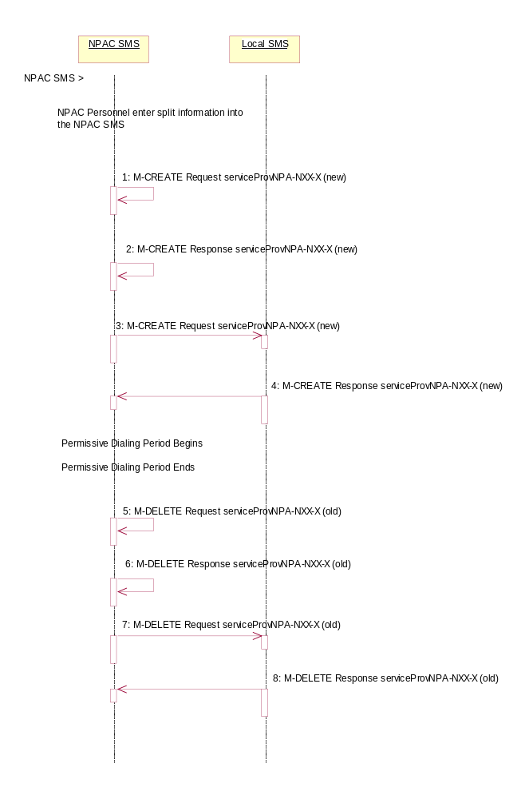

Action is taken by NPAC SMS personnel to perform an NPA-NXX split.
The old NPA-NXX and NPA-NXX-X exist and are past the effective date of the objects.
The NPA-NXX owner service provider first creates the new NPA-NXX. The effective date of the NPA-NXX should be the same as the start of permissive dialing.

The NPAC personnel enter the split information for the old and new NPA-NXX. The date for the start of permissive dialing should be the same as the effective date of the new NPA-NXX object that was just created.
- The NPAC SMS automatically creates the new serviceProvNPA-NXX-X objects with the effective date equal to the date of the start of permissive dialing.
- The NPAC SMS responds to the M-CREATE.
- The NPAC SMS broadcasts each serviceProvNPA-NXX-X M-CREATE to the Local SMSs that support the object according to their NPAC Customer LSMS NPA-NXX-X Indicator in their service provider profile on the NPAC SMS.
- The Local SMS responds to the M-CREATE request.
The NPAC SMS updates all subscription version and number pool block records in its local database that match the specified TN range. The TN or NPA-NXX-X field will be updated with the new NPA and a data field internal to the NPAC SMS will be set to the previous TN or NPA-NXX-X value (old NPA).
The permissive dialing period starts.
During the permissive dialing period, the NPAC SMS accepts requests involving the old and new NPA-NXX values according to the following rules:
- For subscription versions and number pool blocks, the NPAC SMS will accept either the new or old NPA-NXX value, but only broadcast using the new NPA-NXX value.
- The creation of a new serviceProvNPA-NXX-X object using either the old or new NPA-NXX value, but the NPAC SMS will create and broadcast both the old and new serviceProvNPA-NXX-X object creations to those service providers who support the serviceProvNPA-NXX-X object according to their NPAC Customer LSMS NPA-NXX-X Indicator in their service provider profile on the NPAC SMS.
- If a serviceProvNPA-NXX-X is to be removed (de-pooled), the NPAC SMS will broadcast the M-DELETEs for both the old and new serviceProvNPA-NXX-X objects.
- The removal of a NXX from the NPA-NXX split will cause the broadcast of the M-DELETE of the new serviceProvNPA-NXX-X object to the Local SMSs.
The permissive dialing period expires.
- NPAC SMS deletes the old serviceProvNPA-NXX-X object locally.
- NPAC SMS responds to the M-DELETE.
- The NPAC SMS sends individual M-DELETE for all the old serviceProvNPA-NXX-X objects to the Local SMSs who are supporting the object according to the NPAC Customer LSMS NPA-NXX-X Indicator in their service provider profile on the NPAC SMS.
- The Local SMS responds to the M-DELETE.
The NPAC SMS updates all subscription version and number pool block records in its local database that match the specified TN range by updating the TN or NPA-NXX-X value for each object and removing the internal field.
All Local SMS, SOA and NPAC SMS will now use the new NPA-NXX and NPA-NXX-X for all requests and the old serviceProvNPA-NXX should be removed.

Mass Update
In this scenario, the NPAC SMS personnel perform a mass update on a range of TNs that includes a number pool block object.

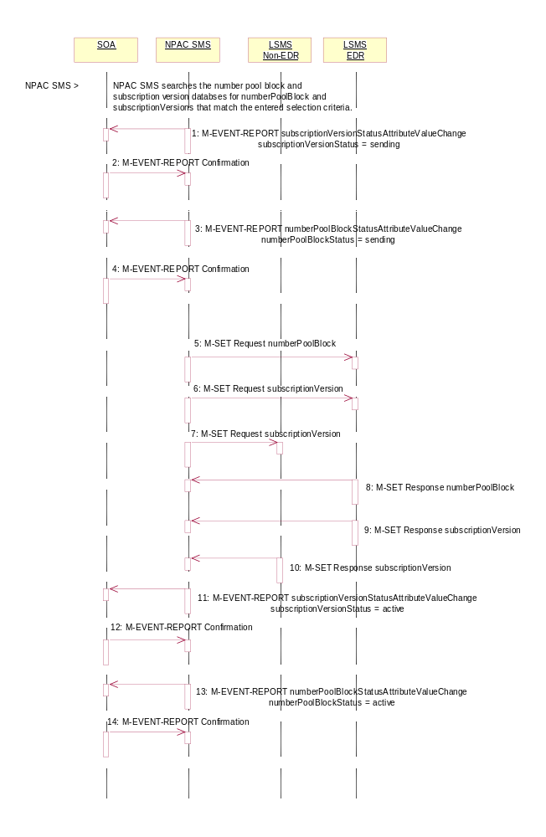
Action is taken by NPAC SMS personnel to perform a mass update.
The NPAC SMS may specify the service provider ID, LNP type and TN-Range in its selection criteria. The LNP type can be specified as LISP, LSPP, POOL, LISP and LSPP, LISP and POOL, LSPP and POOL or all three.
The NPAC SMS can update only the routing information (LRN, DPC and SSN data).
If the LNP type includes ‘pool’ TNs, the TN-Range specified must include a number pool block’s entire TN-Range.
- The NPAC SMS searches the number pool block and subscription version databases for the objects that match the selection criteria. For all objects that match the criteria, the following occurs:
- If any subscription versions, not of LNP type equal to ‘pool’ were updated to ‘sending’, the NPAC SMS sends a subscriptionVersionStatusAttributeValueChange M-EVENT-REPORT to the current service provider SOA.
- SOA confirms the M-EVENT-REPORT.
- If any number pool block objects were updated to a status of ‘sending’ and the numberPoolBlockSOA-Origination indicator is ‘TRUE’ NPAC SMS sends a numberPoolBlockStatusAttributeValueChange M-EVENT-REPORT to the block holder SOA.
- SOA confirms the M-EVENT-REPORT.
- NPAC SMS sends the M-SET for the number pool block objects to the EDR Local SMSs who are accepting updates for the NPA-NXX.
- NPAC SMS sends the M-SET, scope and filtered for the appropriate criteria, for the subscription version updates with the LNP type not equal to ‘pool’ to the EDR Local SMS who are accepting updates for the NPA-NXX.
- NPAC SMS sends the M-SET, scope and filtered for the appropriate criteria, for the subscription version updates to the non-EDR Local SMSs who are accepting updates for the NPA-NXX.
- EDR Local SMS responds to the M-SET for the number pool block object.
- EDR Local SMS responds to the M-SET for the subscription versions.
- Non-EDR Local SMS responds to the M-SET for the subscription versions.
- NPAC SMS sends the M-EVENT-REPORT subscriptionVersionStatusAttributeValueChange to the current service provider SOA for any subscription versions, not of LNP type set to ‘pool’, that were updated to a status of ‘active’.
- SOA confirms the M-EVENT-REPORT.
- NPAC SMS sends the M-EVENT-REPORT numberPoolBlockStatusAttributeValueChange for the status being set to ‘active’ to the block holder service provider SOA for any number pool block objects updated to a status of ‘active’ if the numberPoolBlockSOA-Origination indicator is ‘TRUE’.
- SOA confirms the M-EVENT-REPORT.

