**March 2016 LNPA WG meeting in Denver**

Comcast is pleased to host the March 1/2 2016 LNPA WG meeting in Denver. In addition to the main meeting room, Comcast has reserved a separate meeting room for one-off meetings.

The meeting will be held at:

Comcast Building

5800 S Quebec St

Greenwood Village, CO 80111

[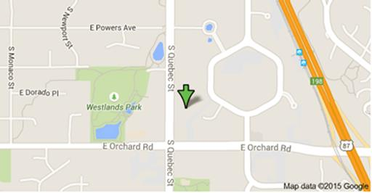](https://www.google.com/maps/place/5800+S+Quebec+St,+Greenwood+Village,+CO+80111/data=!4m2!3m1!1s0x876c86f26e26b3d5:0x22389966696eccc6?sa=X&ved=0CB0Q8gEwAGoVChMI4ajNytjvxgIVhVmICh2pOwye)

For those LNPA WG participants who plan to attend the March meeting in person, please kindly remit the following information to the attention of [Randee_Ryan@cable.comcast.com](mailto:Randee_Ryan@cable.comcast.com) no later than February 25th, 2016 as this information will be used to ensure we have sufficient accommodation for participants such as wireless internet access, electrical, seating, and facilitate participant access with building security.

Participant Name:

Company:

Email address:

Telephone number:

Comcast has negotiated rates with the following hotels.

The DoubleTree by Hilton Denver Tech Center (one block – within walking distance of the Comcast building) offers a corporate rate to all Comcast guests. To make reservations for the up-coming Comcast meeting, please call our central reservations office at 1-800-222-8733 and mention Comcast for the special rate. Reservations can also be made by visiting the website below and entering your corporate id #560055342: [www.doubletreedenvertech.com](http://www.doubletreedenvertech.com)

7801 E. Orchard Rd

Greenwood Village, CO 80111

(303) 779-6161

For the Hyatt Denver Tech Center, the following link, using corporate/group code of 98959:

<http://techcenter.hyatt.com/en/hotel/home.html>

7800 East Tufts Ave

Denver, CO 80237

For the Denver Marriott Tech Center. Reservations can be made at the following link:

[Book your corporate rate:  Comcast](http://www.marriott.com/meeting-event-hotels/group-corporate-travel/groupCorp.mi?resLinkData=Comcast%20%5EC04%60DENTC%7CDENSE%60&app=resvlink&stop_mobi=yes)

4900 S. Syracuse St.

Denver, CO 80237

Hotel: 303.779.1100

For the Courtyard Denver Tech Center. Reservations can be made at the following link:

[Book your corporate rate:  Comcast](http://www.marriott.com/meeting-event-hotels/group-corporate-travel/groupCorp.mi?resLinkData=Comcast%20%5EC04%60DENTC%7CDENSE%60&app=resvlink&stop_mobi=yes)

6565 South Boston Street

Greenwood Village, Colorado 80111 USA

(303) 721 0300

Please let me know if there are questions?

Randee Ryan 720-267-1111

Manager – Operations Compliance