November 2016 LNPA WG meeting in Atlanta

AT&T and Verizon are pleased to host the November 8/9 2016 LNPA WG meeting in Atlanta.

The meeting will be held at:

AT&T
725 W. Peachtree St (NW)
conference room C3L (third floor)
Atlanta, GA
For those LNPA WG participants who plan to attend the November meeting in person, please kindly remit the following information to the attention of Lonnie Keck, lk7516@att.com no later than October 15th, 2016 as this information will be used to ensure we have sufficient accommodation for participants such as wireless internet access, electrical, seating, and facilitate participant access with building security.

Participant Name:
Company:

Below is lodging, dining, and MARTA (public transportation) information.

The 3 “hotels nearby” at the top of the list have current contracted AT&T rates listed and are all within close proximity (walking) to the meeting location.

Transportation Nearby
MARTA

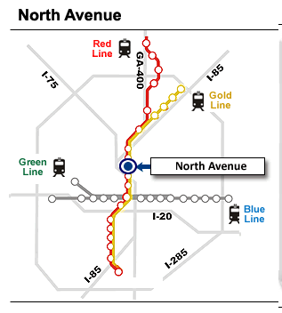 | 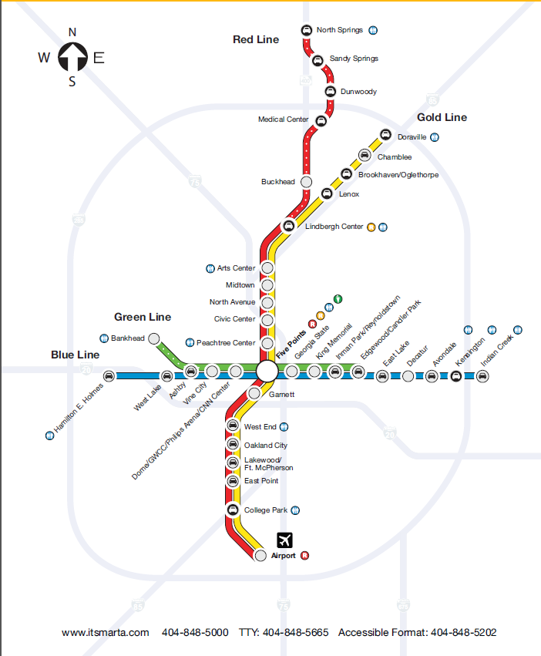

Hotels nearby
The Georgian Terrace
Hotel Indigo

Renaissance Atlanta Midtown Hotel
Other Midtown Hotels | Rail Station closest to Hotel
Days Inn - Peachtree | North Avenue
Doubletree Galleria | Midtown
Loews Atlanta Hotel | Arts Center
Quality Inn Midtown | Midtown
Regency Suites | Midtown
Residence Inn Historic Midtown | Midtown
W Atlanta - Midtown | Arts Center

Nearby restaurants
- 683 Bar & Bistro (Iocated in Hotel Indigo)
Midtown 683 Peachtree Street NE Distance of 0.0mi
- Churchill Grounds
Midtown - Italian 660 Peachtree St NE Distance of 0.0mi
- Proof and Provision (located in Georgian Terrace)
Midtown - Pub Food 659 Peachtree Street NE Distance of 0.0mi
- Cafe Mims (located in Georgian Terrace)
Midtown - Bakery, Coffee, Sandwiches/Subs 659 Peachtree Street NE Distance of 0.1mi
- Livingston Restaurant + Bar (located in Georgian Terrace)
Midtown - Modern American, Breakfast/Brunch 659 Peachtree Street NE Distance of 0.1mi
- Apache Cafe
Midtown - Southwestern 64 3rd St NE Distance of 0.1mi
- Publik Draft House (Option for Cocktails – beside Fox Theatre)
Midtown - Gastropub, American, Pub Food 654 Peachtree St NE Distance of 0.1mi
- Gina's Italian
Midtown - Italian, Pizza 710 Peachtree St NE Distance of 0.1mi
- Baraonda
Midtown - Italian, Pizza, Wine Bar 710 Peachtree St NE Distance of 0.1mi
- Quiznos
Midtown - Sandwiches/Subs 710 Peachtree St NE # 116 Distance of 0.1mi
- Landmark's Broadway Diner
Midtown - Diner 620 Peachtree St NE Distance of 0.1mi
- Coco Java Cafe
Midtown - Coffee 730 Peachtree St Distance of 0.1mi
- Pita's Republic
Midtown - Sandwiches/Subs, Middle Eastern 620 Peachtree St NE Distance of 0.1mi
- Dunkin' Donuts
Midtown - Coffee, Donuts 675 W. Peachtree St NW Distance of 0.1mi
- Broadway Diner
Old Fourth Ward - American, Diner 620 Peachtree St NE Distance of 0.1mi
- Wing Nut
Old Fourth Ward - American 120 North Ave NE Distance of 0.1mi
- Quiznos
Old Fourth Ward - Sandwiches/Subs 120 North Ave NE Distance of 0.1mi
- Carlyle's
Midtown 675 W Peachtree St NW Distance of 0.1mi
- American Deli
Midtown - Sandwiches/Subs 675 W Peachtree St NW Distance of 0.1mi
- Cafe Du Jour
Midtown 675 W Peachtree St NW Distance of 0.1mi
- Food Court
Midtown - American 675 W Peachtree St NW Distance of 0.1mi
- Model T
Midtown - Pub Food 11 Ponce De Leon Ave NE Distance of 0.1mi
- Subway
Midtown - Sandwiches/Subs 675 W Peachtree St NW Distance of 0.1mi
- The Melting Pot
Midtown - American, European, International 754 Peachtree St NE Distance of 0.1mi
- Negril Village
Old Fourth Ward - Caribbean 30 North Ave Distance of 0.2mi
- Willy's Mexicana Grill
Midtown - Mexican, California 725 W Peachtree St NW Distance of 0.2mi
- Original J R Crickets
Old Fourth Ward - American, Sandwiches/Subs, Pub Food 129 N Ave NE Distance of 0.2mi
- Gro
Old Fourth Ward 179 Ponce De Leon Ave NE Distance of 0.2mi
- Moe's Southwest Grill
Midtown - Southwestern, Tex-Mex 85 5th St NE Distance of 0.2mi
- Cafe Kia-Ora
Midtown - Greek, Breakfast/Brunch 759 W.Peachtree St Distance of 0.2mi
- Georgia Cafe
Midtown - American, Diner, Chinese 600 W Peachtree St NW Distance of 0.2mi
- Legal Bagel North Avenue
Midtown - Bagels 600 W Peachtree St NW Distance of 0.2mi
- Escorpion Tequila Bar and...
Midtown - Mexican, Tapas 800 Peachtree St NE Distance of 0.2mi
- Starbucks
Midtown - Coffee 48 5th St NE Distance of 0.2mi
- Cafe Mezo
Midtown - Mediterranean, Turkish, European 794 Juniper Street Distance of 0.2mi
- The Fifth Ivory Public House
Midtown - American, Southern/Soul 794 Juniper St Ne Distance of 0.2mi
- Ray's NY Pizza / Cedars...
Midtown - Pizza, Mediterranean, Italian 26 5th St NE Distance of 0.2mi
- Grille at 590
Midtown - American, Seafood 590 W Peachtree St NW Distance of 0.2mi
- The Original J R Crickets
Midtown - American, Sandwiches/Subs, Pub Food 631 Spring St NW Distance of 0.2mi
- Papi's Cuban & Caribbean...
Old Fourth Ward - Cuban, Caribbean, Sandwiches/Subs 216 Ponce De Leon Ave NE Distance of 0.2mi
- Atlanta's Best Chicken &...
Old Fourth Ward - American, Fast Food, Chicken 216 Ponce De Leon Ave NE Distance of 0.2mi
- Mjk
Old Fourth Ward - American 557 Peachtree St NE Distance of 0.2mi
- Biltmore Cafe and Grill
Midtown - Asian, Southern/Soul, Breakfast/Brunch 817 W Peachtree St Distance of 0.2mi
- Goodfella's Pizza & Wings
Midtown - Italian, Pizza, Sandwiches/Subs 615 Spring St. Distance of 0.3mi
- Babs
Midtown - Breakfast/Brunch, Sandwiches/Subs 814 Juniper St NE Distance of 0.3mi
- Midtown Deli
Midtown - American, Sandwiches/Subs, Diner 814 Juniper St NE Distance of 0.3mi
- Takorea
Midtown - Korean, Tacos, Mexican 818 Juniper Street Distance of 0.3mi
- Panoramia
Midtown 815 W Peachtree St NW Distance of 0.3mi
- Metro Fuxon
Old Fourth Ward - Caribbean, African 554 Piedmont Avenue NE Distance of 0.3mi
- Mu Lan
Midtown - Chinese, Asian, Thai 824 Juniper St NE Distance of 0.3mi

