LNPA Working Group Meeting Schedule
July 12-13, 2011
Hosted by Neustar
New Orleans Marriott
555 Canal Street
New Orleans, LA 70130

Agenda

LNPA Working Group Architecture Planning Team (LNPA WG APT)

Tuesday, July 12, 2011 9:00 AM – 2:00 PM (Central Time Zone)

Conference Bridge – 888-412-7808 PIN 23272#

9:00 a.m. - Introductions and APT Agenda Review – All

- Approve June 14, 2011 APT Minutes – All

- APT Test Plan Review – All
Action Item 051011-16: Neustar and Telcordia will create a list of Vendor (ITP) and Service Provider regression test cases, identify which are Vendor (ITP) and which are regression or which are both, determine which are conditional, and which apply to the following four categories:
- New Service Provider and New Vendor,
- New Service Provider and Experienced Vendor,
- Experienced Service Provider and New Vendor,
- Experienced Service Provider and Experienced Vendor.
The status of this work effort will be provided on the June 14, 2011 APT conference call and at the APT portion of the July 2011 LNPA WG meeting.

- Review of Change Order on Pending SVs - Neustar
Action Item 061411-APT-01: Regarding the attached accepted PIM, Neustar will develop a related Change Order for review and discussion during the APT portion of the July 2011 LNPA WG meeting. See related Action Item 061411-APT-02. 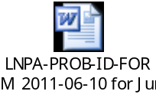

Action Item 061411-APT-02: Regarding the attached accepted PIM, Service Providers (and, in particular, non-EDR LSMS Service Providers) are to internally investigate the impact of allowing pending SVs to exist when a block is activated. The scenario being considered is only for the case where the code-owner SPID and the block-owner SPID are the same. This will be further discussed during the APT portion of the July 2011 LNPA WG meeting in conjunction with a proposed related Change Order. See related Action Item 061411-APT-01.

LNPA Working Group Meeting Schedule
July 12-13, 2011
Hosted by Neustar
New Orleans Marriott
555 Canal Street
New Orleans, LA 70130

Agenda

LNPA Working Group Architecture Planning Team (LNPA WG APT)
CONTINUED

Tuesday, July 12, 2011 9:00 AM – 2:00 PM (Central Time Zone)

Conference Bridge – 888-412-7808 PIN 23272#

11:30 – 1:00 - Lunch

1:00 p.m. - Continuation of APT Agenda (until 2p.m. local time) – All

- APT Action Items Not Previously Discussed in Agenda – All
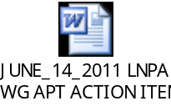

LNPA Working Group (LNPA WG)

Tuesday, July 12, 2011 2:00 PM – 5:00 PM (Central Time Zone)

Conference Bridge – 888-412-7808 PIN 23272#

2:00 p.m. - Introductions and LNPA WG Agenda Review – All

- Approve May 10-11, 2011 & June 14, 2011 LNPA WG Minutes – All

- Report of FCC 09-41 Non-Compliance to NANC – All

Action Item 051011-04: Neustar will determine if they can develop a list of inactive SPIDs, their associated SP Names, and the type of association, e.g., Service Bureau, etc, for use in determining any Service Providers that are not complying with the one-day porting Order. This will be discussed at the July 2011 LNPA WG meeting.

- Next Day porting Lessons Learned – All



Action Item 051011-06: Gary Sacra, LNPA WG Co-Chair, will add an item to the list of possible one-day porting lessons learned addressing the need to develop a plan of action to address Service Providers who are not compliant to future regulatory mandates.
LNPA Working Group Meeting Schedule
July 12-13, 2011
Hosted by Neustar
New Orleans Marriott
555 Canal Street
New Orleans, LA 70130

Agenda

LNPA Working Group (LNPA WG) - CONTINUED

Tuesday, July 12, 2011 2:00 PM – 5:00 PM (Central Time Zone)

Conference Bridge – 888-412-7808 PIN 23272#

Action item 051011-12: LNPA WG Participants are to come to the July 2011 LNPA WG meeting prepared to determine if we will move forward with a one-day porting (FCC 09-41 and FCC 10-85) lessons learned document, and, if so, who will participate in its drafting.

- Addition and Prioritization of Future LNPA WG Agenda Items – All


Action Item 051011-07: Gary Sacra, LNPA WG Co-Chair, will add the following to the list of possible future LNPA WG agenda items:
- Determining if and when the NPAC will move to support IPv6,
- Address the issue of future-dated pending SVs that are preventing the telephone numbers from being ported.

- Review & Update of LNPA WG Best Practices Document – All

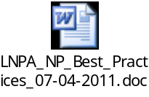

Action Item 061411-LNPAWG-01: Gary Sacra, LNPA WG Co-Chair, will incorporate the attached accepted revision to Best Practice 25 into the overall LNP Best Practices document.

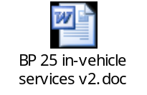

LNPA Working Group Meeting Schedule
July 12-13, 2011
Hosted by Neustar
New Orleans Marriott
555 Canal Street
New Orleans, LA 70130

Agenda

LNPA Working Group (LNPA WG) - CONTINUED

Tuesday, July 12, 2011 2:00 PM – 5:00 PM (Central Time Zone)

Conference Bridge – 888-412-7808 PIN 23272#

Action Item 051011-09: Regarding the attached revised Best Practice 32, Gary Sacra, LNPA WG Co-Chair, will shorten the Topic text to only include the 1st sentence, adding a reference to “port protection, and move the other sentences currently in the Topic section to the Decisions/Recommendations section. This will be reviewed at the July 2011 LNPA WG meeting.
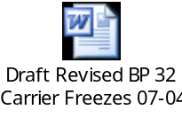

Action Item 061411-LNPAWG-02: Gary Sacra, LNPA WG Co-Chair, will revise the 3rd paragraph in the Decisions/ Recommendations section of the attached approved revision to Best Practice 37 to read as follows:
“The evidence of authorization needs to be obtained and maintained by the New Local Service provider as required by applicable federal and state regulation, as amended from time to time.”
Gary will also accept all other revisions in the attached Best Practice 37 and incorporate the revised Best Practice 37 into the overall LNP Best Practices document.
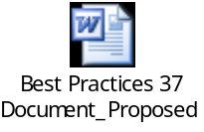

Action Item 051011-15: Service Providers are to review the attached proposed revision to Best Practice 33, which has been modified to include Service Address Number (SANO) per the discussion at the May 2011 LNPA WG meeting, and come prepared to discuss on the June 14, 2011 LNPA WG conference call.
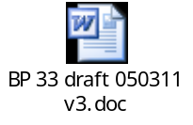
LNPA Working Group Meeting Schedule
July 12-13, 2011
Hosted by Neustar
New Orleans Marriott
555 Canal Street
New Orleans, LA 70130

Agenda

LNPA Working Group (LNPA WG) - CONTINUED

Tuesday, July 12, 2011 2:00 PM – 5:00 PM (Central Time Zone)

Conference Bridge – 888-412-7808 PIN 23272#

Action Item 051011-14: Service Providers are to review internally the attached proposed Best Practice on stolen/fraudulently acquired numbers, especially the “safe harbor” statement in the last paragraph, and come prepared on the June 14, 2011 LNPA WG conference call to determine if the Best Practice will be accepted or to suggest any revisions.
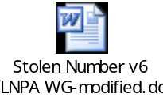

Action Item 031511-04: Paula Jordan, T-Mobile and LNPA WG Co-Chair, and Jason Lee, Verizon, and Teresa Patton, AT&T, and Tracey Guidotti, AT&T, will document in LNPA WG Best Practice 30 requirements for ICP during the permissive dialing period for NPA splits. This will be reviewed and discussed at the May 2011 LNPA WG meeting.

Action Item 061411-LNPAWG-03: Gary Sacra, Verizon, will discuss internally those additions, revisions, and questions raised on the June 14, 2011 full LNPA WG conference call regarding the attached proposed Best Practice on CSRs, and make any agreed-to changes for review and discussion at the July 2011 full LNPA WG meeting. Those suggestions include:
- Consider adding another field such as any working TN associated with the account to increase verification,
- Consider adding the date that authorization was obtained from the End User,
- How would or should there be a distinction made between CSRs requested for porting purposes vs. CSRs requested for other purposes?
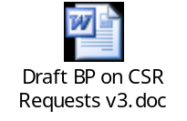

5:00 p.m. - Adjourn

LNPA Working Group Meeting Schedule
July 12-13, 2011
Hosted by Neustar
New Orleans Marriott
555 Canal Street
New Orleans, LA 70130

Agenda

LNPA Working Group (LNPA WG) - CONTINUED

Wednesday, July 13, 2011 9:00 AM – 5:00 PM (Central Time Zone)

Conference Bridge – 888-412-7808 PIN 23272#

9:00 a.m. - Issues from Other Industry Groups:
- OBF Wireless Ordering Task Force – Deb Tucker
- OBF Local Ordering Task Force – Linda Peterman
- INC Update – Dave Garner
- NANC Future of Numbering WG Update – Adam Newman
- Readout of NPAC LNPA WG Website Update – Sue Tiffany

- PIMs 51, 64, 65, 66, 80

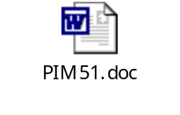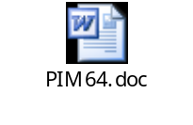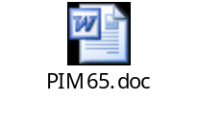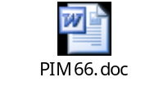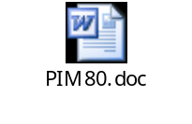
- Change Management – Neustar
(DOCUMENTS TO BE DISTRIBUTED SEPARATELY)

Action Item 051011-01: Neustar will develop a proposed Change Order related to NPAC support of IPv6, to be sponsored by AT&T Mobility.

Action Item 051011-02: Regarding the issue related to SVs with future-dated pending SVs that are preventing the telephone numbers from being ported, Neustar will send out a notice over the Cross-Regional distribution for Service Providers to verify if they have any such future-dated pending SVs that are not in the NPAC intentionally, and if so, advise that they should be deleted. See related Action Items 051011-07, 051011-08, and 051011-13.

Action Item 051011-08: Regarding the issue related to SVs with future-dated pending SVs that are preventing the telephone numbers from being ported, Gary Sacra, LNPA WG Co-Chair, will send out a notice over the LNPA WG distribution for Service Providers to verify if they have any such future-dated pending SVs that are not in the NPAC intentionally, and, if so, advise that they should be deleted. See related Action Items 051011-02, 051011-07, and 051011-13.

LNPA Working Group Meeting Schedule
July 12-13, 2011
Hosted by Neustar
New Orleans Marriott
555 Canal Street
New Orleans, LA 70130

Agenda

LNPA Working Group (LNPA WG) - CONTINUED

Wednesday, July 13, 2011 9:00 AM – 5:00 PM (Central Time Zone)

Conference Bridge – 888-412-7808 PIN 23272#

Action Item 051011-13: Regarding the issue related to SVs with future-dated pending SVs that are preventing the telephone numbers from being ported, Service Providers are to verify if they have any such future-dated pending SVs that are not in the NPAC intentionally, and, if so, delete them. See related Action Items 051011-02, 051011-07, and 051011-08.

11:30 – 1:00 - Lunch

1:00 p.m. - Continuation of Morning Agenda (IF NECESSARY) – All

- 2011 LNPA WG Meeting/Call Schedule – All
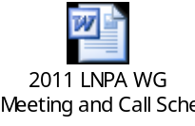

- Development of 2012 LNPA WG Meeting/Call Schedule – All

- Discussion of Need for August 9, 2011 LNPA WG Call – All

- Action Items Not Previously Discussed in Agenda – All

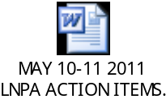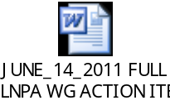

- Unfinished/New Business – All

5:00 p.m. - Adjourn

Next LNPA WG Conference Call … August 9, 2011 (If Necessary)

Next Meeting …September 13-14, 2011: Location…Overland Park, Kansas
…Hosted by Sprint Nextel

