LNPA Working Group Meeting Schedule
August 25-26, 2009
Hosted by NeuStar
Loudoun Tech Center
46000 Center Oak Plaza
Sterling, Virginia 20166
NuView Auditorium

Agenda

LNPA Working Group (LNPA WG)

Tuesday and Wednesday, August 25th and 26th, 9:00 AM – 5:00 PM (Eastern Time Zone)

Conference Bridge – 888-412-7808 PIN 23272#

9:00 a.m. - Introductions/Agenda Review

- FCC Order 09-41 Implementation – All
  - Position Paper Discussion – XO Communications
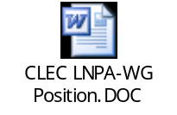
- Sub-team Updates and Discussions – Sub-team Chairs
  - One Business Day – Jan Doell, Qwest
  - Simple Port – Sue Tiffany, Sprint Nextel
  - LSR – Linda Peterman, One Communications
- NANC Flow Diagram Format Determination – All
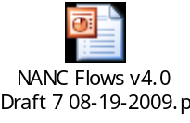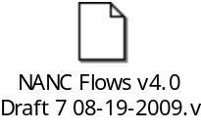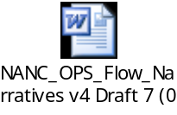
- Review of Action Items and Parking Lot items – All
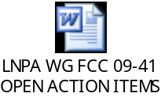
- Additional Discussion Items:
  - Time Zone Differences for Simple vs. Non-Simple Ports – Mark Lancaster, AT&T
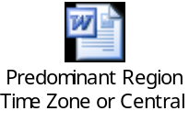
11:30 – 1:00 - Lunch

- FCC Order 09-41 Implementation (CONTINUED) – All

5:00 p.m. - Adjourn

Next Meeting …September 15-16, 2009: Location…Philadelphia, Pennsylvania
Hosted by Verizon

