LNPA WORKING GROUP
April 12, 2011 Conference Call
Final Minutes

TUESDAY 04/12/11
Tuesday, 04/12/11, Conference Call Attendance:
Name | Company | Name | Company
Renee Dillon | AT&T Mobility | Pamela Connell |  | Neustar
Ron Steen | AT&T | Mubeen Saifullah |  | Neustar Clearinghouse
Mark Lancaster | AT&T | Shannon Sevigny |  | Neustar Pooling
Teresa Patton | AT&T | Peggy Rubino |  | Paetec
Barb Hjelmaa | Brighthouse | Towanda Russell |  | RCN
Mary Retka | CenturyLink | Sue Tiffany |  | Sprint Nextel
Jan Doell | CenturyLink | Carol Frike |  | Sprint Nextel
Vicki Goth | CenturyLink | Suzanne Addington |  | Sprint Nextel
Karin Fahrenbruch | CenturyLink | Karen Taylor |  | Sprint Nextel
Linda Birchem | Comcast | Nancy Conant |  | Synchronoss
Tim Kagele | Comcast | Bob Bruce |  | Syniverse
Jennifer Hutton | Cox | Pat White |  | Telcordia
Joan Bridgeman | Cricket | Lisa Marie Maxson |  | Telcordia
Dena Hunter | Cricket | Joel Zamlong |  | Telcordia
Linda Peterman | Earthlink | Kayla Sharbaugh |  | Telcordia
Jay Hjellum | Evolving Systems | Steve Koch |  | Telcordia
Greg Council | Evolving Systems | George Tsacnaris |  | Telcordia
Bonnie Johnson | Integra | Stacy Hannah |  | Time Warner Cable
Bridget Alexander | JSI | Shelly Pedersen |  | Time Warner Telecom
Angie Mackey | JSI | Paula Jordan |  | T-Mobile
Lynette Khirallah | NetNumber | Gary Sacra |  | Verizon
Paul LaGattuta | Neustar | Jason Lee |  | Verizon
John Nakamura | Neustar | Deb Tucker |  | Verizon Wireless
Jim Rooks | Neustar | Traci Brunner |  | Windstream
Stephen Addicks | Neustar | Dawn Lawrence |  | XO Communications
Dave Garner | Neustar

NOTE: ALL ACTION ITEMS REFERENCED IN THE MINUTES BELOW HAVE BEEN CAPTURED IN THE “APRIL_12_2011 LNPA ACTION ITEMS” FILE ISSUED IN A SEPARATE E-MAIL FROM THESE MINUTES AND ATTACHED BELOW.

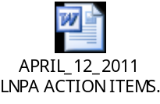

APRIL 12, 2011 CONFERENCE CALL MINUTES:

Proposed Best Practices on “Stolen” Numbers – Sue Tiffany, Sprint Nextel:

Action Item 031511-12: Sue Tiffany, Sprint Nextel, will revise the proposed Best Practice on “stolen” telephone numbers based on the discussion at the March 2011 LNPA WG meeting for review and discussion on the April 12, 2011 LNPA WG conference call.

Action Item 031511-16: LNPA WG Participants are to come to the April 12, 2011 LNPA WG conference call prepared to discuss and finalize the attached proposed Best Practice on “stolen” numbers.

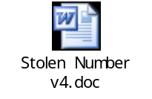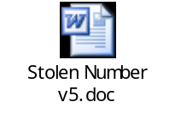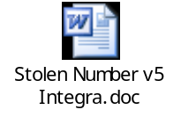

- Sue Tiffany, Sprint Nextel, teed up the discussion of the version of the proposed Best Practice on stolen numbers entitled “Stolen Number v5 Integra, embedded above.

- The group agreed to remove “to another customer” from the first sentence of the first paragraph in the Best Practice. This was done to clarify that telephone numbers can be stolen without necessarily selling them to another customer.

- A discussion then ensued on the sharing of billing records and concerns with CPNI. The Best Practice is written to require the customer’s approval to share billing records in order to address this concern.

- It was agreed that, with the change above, v6 of this document will become Best Practice 68.

- Action Items 031511-12 and 031511-16 were closed.

Review of Draft Revision to NANC 397 Engineering Assumption – Renee Dillon, AT&T Mobility:

Action Item 031511-03: Renee Dillon, AT&T Mobility, will revise the NANC 397 “engineering assumption” based on the discussion at the March 2011 LNPA WG meeting for review and discussion on the April 12, 2011 LNPA WG conference call.

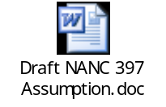

- The proposed draft NANC 397 Assumption embedded above was discussed by Renee Dillon, AT&T Mobility. She stated that it is intended to replace the current assumption in NANC Change Order 397 in its entirety.

- A Service Provider asked if the 1st paragraph in the “Service Provider” assumption is really meant to refer to a minimum or is it a maximum. It was stated that the NPAC must support at least 7 transactions per second if the load is offered and Service Providers are expected to meet this at a minimum if the load is offered.

- The proposed assumption was approved with a change in wording in the last line in the 3rd paragraph -- change “to” to “with.”

- Neustar will review where this approved revised assumption will be documented and let the Co-Chairs know. It will then be sent out over the distro for approval.

- Action Item 031115-03 was closed.

Request for Additional SPID Migration Blackout Dates – Neustar:

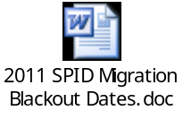

- Neustar reviewed a request for additional SPID migration blackout dates in 2011 to perform technology refreshes.

- The requested additional dates are as follows:
  - May 15, 2011 – Midwest Region only – Request for Technology Refresh
  - June 12, 2011 – Northeast and Southwest regions only – Request for Technology Refresh
  - June 19, 2011 – West Coast and Western regions only – Request for Technology Refresh

- The requested additional SPID migration blackout dates were approved as requested.

- Gary Sacra, LNPA WG Co-Chair, will distribute the attached revised list of 2011 SPID Migration Blackout dates, which was approved on the April 12, 2011 LNPA WG conference call.

Review of Proposed Best Practice on CSRs – Gary Sacra, Verizon:

Action Item 031511-10: Gary Sacra, Verizon will revise the attached proposed Best Practice on CSRs and distribute to the LNPA WG for review and discussion on the April 12, 2011 LNPA WG conference call.

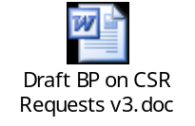

- Due to insufficient time remaining on the conference call, it was agreed to defer discussion of the attached proposed Beat Practice until the May 2011 LNPA WG meeting.

2011 Meeting/Call Schedule – All:

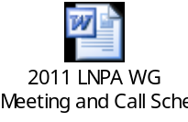

- The group reviewed the attached remaining schedule for 2011 LNPA WG meetings and conference calls and made no changes.

New Business – All:

- Barb Hjelmaa, Brighthouse, stated that they are having an issue with a particular Service Provider that considers a line with DSL on it to be a complex port. She was advised to research the earlier FCC Order related to porting with DSL on the line to see if that addresses her issue.

Next Meeting …May 10-11, 2011: Location…Banff, Canada
Hosted by Canadian LNP Consortium

