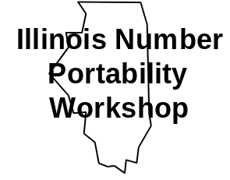
Illinois Non-Proprietary
Functional Requirements Specification
Number Portability Administration Center (NPAC)
Service Management System (SMS)
Version 1.5
April 7, 1997

- Related Publications
NPAC SMS Interoperable Interface Specification (IIS), NANC Version 1.0, April 7, 1997.
Illinois Commerce Commission Number Portability Administration Center and Service Management System Request for Proposal (ICC NPAC/SMS RFP), February 6, 1996.
Generic Requirements for SCP Application and GTT Function for Number Portability, ICC LNP Workshop SCP Generic Requirements Subcommittee.
Generic Switching and Signaling Requirements for Number Portability, version 1.03, ICC LNP Workshop Switch Generic Requirements Subcommittee, September 4, 1996.
Report on Local Number Portability, Industry Numbering Committee (INC).
FCC 96-286 First Report And Order, CC Docket No. 95-116, July 2, 1996.
© COPYRIGHT 1997 LOCKHEED MARTIN IMS
The Work may be freely redistributed subject to the terms of the GNU General Public License (the “GPL”), a copy of which may be found at ftp://prep.ai.mit.edu/pub/gnu/GPL, or requested by writing to FSF, Inc., 675 Mass Ave, Cambridge, MA 02139, USA. Any use of this Work is subject to the terms of the GPL. The “Work” covered by the GPL by operation of this notice and license is this document and any and all modifications to or derivatives of this document. Where the words “Program,” “software,” “source code,” “code,” or “files” are used in the GPL, users understand and agree that the “Work” as defined here is substituted for purposes of this notice and license.

The purpose of the Lockheed Martin IMS copyright and GNU General Public License on this Work is to insure that this Work and any subsequent derivations thereof remain non-proprietary.
Table of Contents
0. Preface
0.1 Document Structure
0.2 Abbreviations and Notations
0.3 Document Language
1. Introduction
1.1 NPAC SMS Platform Overview
1.2 NPAC SMS Functional Overview
1.2.1 Provisioning Service Functionality
1.2.2 Disconnect Service Functionality
1.2.3 Repair Service Functionality
1.2.4 Conflict Resolution Functionality
1.2.5 Disaster Recovery and Backup Functionality
1.2.6 Order Cancellation Functionality
1.2.7 Audit Request Functionality
1.2.8 Report Request Functionality
1.2.9 Data Management Functionality
1.2.9.1 NPAC Network Data
1.2.9.2 Service Provider Data
1.2.9.3 Subscription Version Data
1.2.10 NPA-NXX Split Processing
1.3 Background
1.4 Objective
1.5 Assumptions
1.6 Constraints
1.7 Related Publications
2. Business Process Flows
2.1 Provision Service Process
2.1.1 Service provider-to-service provider activities
2.1.2 Subscription version creation process
2.1.2.1 Create Subscription Version
2.1.2.2 Request missing/late notification
2.1.3 Service providers perform physical changes
2.1.4 NPAC SMS "activate and data download" process
2.1.4.1 New Service Provider sends activation to NPAC SMS
2.1.4.2 NPAC SMS broadcasts network data to appropriate Service Providers
2.1.4.3 Failure - notify NPAC
2.1.4.4 Initiate repair procedures
2.1.5 Service providers perform network updates
2.2 Disconnect Process
2.2.1 Customer notification, Service Provider initial disconnect service order activities
2.2.2 NPAC waits for effective release date
2.2.3 NPAC donor notification
2.2.4 NPAC performs broadcast download of disconnect data
2.3 Repair Service Process
2.3.2 Service provider analyzes the problem
2.3.3 Service provider performs repairs
2.3.4 Request broadcast of subscription data
2.3.5 Broadcast repaired subscription data
2.4 Conflict Process
2.4.1 Subscription version in conflict
2.4.1.1 Cancel-Pending Acknowledgment missing from new Service Provider
2.4.1.2 Old Service Provider requests conflict status
2.4.1.3 Change of status upon problem notification
2.4.1.4 Change of status upon Old Service Provider non-concurrence
2.4.1.5 Change of status upon New Service Provider non-concurrence
2.4.2 New Service Provider coordinates conflict resolution activities
2.4.2.1 Cancel pending notification
2.4.3 Subscription version cancellation
2.4.4 Conflict resolved
2.5 Disaster Recovery and Backup Process
2.5.1 NPAC personnel determine downtime requirement
2.5.2 NPAC notifies Service Providers of switch to backup NPAC and start of cutover quiet period
2.5.3 Service providers connect to backup NPAC
2.5.4 Backup NPAC notifies Service Providers of application availability and end of cutover quiet period
2.5.5 Service providers conduct business using backup NPAC
2.5.6 Backup NPAC notifies Service Providers of switch to primary NPAC and start of cutover quiet period
2.5.7 Service providers reconnect to primary NPAC
2.5.8 Primary NPAC notifies Service Providers of availability and end of cutover quiet period
2.6 Service Order Cancellation Process
2.6.1 Service Provider issues service order cancellation
2.6.2 Service provider cancels an un-concurred Subscription Version
2.6.3 NPAC requests missing acknowledgment from Service Provider
2.6.4 NPAC cancels the Subscription Version and notifies both Service Providers
2.7 Audit Request Process
2.7.1 Service provider requests audit
2.7.2 NPAC SMS issues queries to appropriate Service Providers
2.7.3 NPAC SMS compares Subscription Version data
2.7.4 NPAC SMS updates appropriate Local SMS databases
2.7.5 NPAC SMS sends report of audit discrepancies to requesting SOA
2.7.6 NPAC SMS sends report of audit results to requesting SOA
2.8 Report Request Process
2.8.1 Service provider requests report
2.8.2 NPAC SMS generates report
2.8.3 Report delivered via on-line Interface, Email, electronic file, fax, printer
2.9 Data Administration Requests
2.9.1 Service provider requests administration of data by NPAC personnel
2.9.2 NPAC SMS personnel confirms user’s privileges
2.9.3 NPAC SMS personnel inputs user’s request
2.9.4 NPAC SMS performs user’s request
2.9.5 NPAC SMS personnel logs request denial if user’s privileges are not validated
3. NPAC Data Administration
3.1 Overview
3.1.1 Data Type Legend
3.1.2 NPAC Customer Data
3.1.3 Subscription Version Data
3.1.4 Network Data
3.2 NPAC Personnel Functionality
3.3 System Functionality
3.4 Additional Requirements
3.5 Requirements Defined in Post-Award Activities
3.6 Requirements Defined in Change Orders
4. Service Provider Data Administration
4.1 Service Provider Data Administration and Management
4.1.1 User Functionality
4.1.2 System Functionality
4.1.2.1 Service Provider Data Creation
4.1.2.2 Service Provider Data Modification
4.1.2.3 Delete Service Provider Data
4.1.3 Service Provider Queries
4.1.3.1 User Functionality
4.1.3.2 System Functionality
4.2 Additional Requirements
5. Subscription Management
5.1 Subscription Version Management
5.1.1 Subscription Version Management
5.1.1.1 Version Status
5.1.2 Subscription Administration Requirements
5.1.2.1 User Functionality
5.1.2.2 System Functionality
5.1.3 Subscription Queries
5.1.3.1 User Functionality
5.1.3.2 System Functionality
6. NPAC SMS Interfaces
6.1 SOA to NPAC SMS Interface
6.1.1 Request Administration
6.1.2 Subscription Administration
6.1.3 Audit Requests
6.1.4 Notifications
6.2 NPAC SMS to Local SMS Interface
6.2.1 Transaction Administration
6.2.2 Network Subscription Administration
6.3 Interface Transactions
6.4 Interface and Protocol Requirements
6.4.1 Protocol Requirements
6.4.2 Interface Performance Requirements
6.4.3 Interface Performance Requirements
6.4.4 Request Restraints
7. Security
7.1 Overview
7.2 Identification
7.3 Authentication
7.3.1 Password Requirements
7.4 Access Control
7.4.1 System Access
7.4.2 Resource Access
7.5 Data and System Integrity
7.6 Audit
7.6.1 Audit Log Generation
7.6.2 Reporting and Intrusion Detection
7.7 Continuity of Service
7.8 Software Vendor
7.9 OSI Security Environment
7.9.1 Threats
7.9.2 Security Services
7.9.3 Security Mechanisms
7.9.3.1 Encryption
7.9.3.2 Authentication
7.9.3.3 Data Origin Authentication
7.9.3.4 Integrity and Non-repudiation
7.9.3.5 Access Control
7.9.3.6 Audit Trail
7.9.3.7 Key Exchange
8. Audit Administration
8.1 Overview
8.2 Service Provider User Functionality
8.3 NPAC User Functionality
8.4 System Functionality
8.5 Audit Report Management
8.6 Additional Requirements
8.7 Database Integrity Sampling
9. Reports
9.1 Overview
9.2 User Functionality
9.3 System Functionality
10. Performance and Reliability
10.1 Availability and Reliability
10.2 Capacity and Performance
10.3 Requirements in RFP Not Given a Unique ID
11. Billing
11.1 User Functionality
11.2 System Functionality

Appendix A. Business Process Flows A-1
Appendix B. Glossary B-1
Appendix C. System Tunables C-1

List of Figures
Figure 3-1 Entity Relationship Model
Figure 5-1 Version Status Interaction Diagram
Figure 11-1 NPAC Business Process Flows Legend
Figure 11-2 Flow 2.1 NPAC SMS Provision Service Process
Figure 11-3 Flow 2.1.2 NPAC SMS Subscription Version Creation Process
Figure 11-4 Flow 2.1.4 NPAC SMS Activate and Data Download Process
Figure 11-5 Flow 2.2 NPAC SMS Disconnect Process
Figure 11-6 Flow 2.3 NPAC SMS Repair Process
Figure 11-7 Flow 2.4.1 Conflict Process
Figure 11-8 Flow 2.5 NPAC SMS Disaster Recovery Process
Figure 11-9 Flow 2.6 Cancellation Process
Figure 11-10 Flow 2.7 Audit Process
Figure 11-11 Flow 2.8 Report Process

List of Tables
Table 0-1 Notation Key
Table 0-2 Language Key
Table 3-1 Data Type Legend
Table 3-2 NPAC Customer Data Model
Table 3-3 NPAC Customer Contact Data Model
Table 3-4 NPAC Customer Network Address Data Model
Table 3-5 Subscription Version Data Model
Table 3-6 Portable NPA-NXX Data Model
Table 3-7 LRN Data Model
Table 3-8 LSMS Filtered NPA-NXX Data Model
Table 5-1 Version Status Interaction Descriptions
Table 6-1 Interface Protocol Stack
Table 11-1 Subscription Tunables
Table 11-2 Communications Tunables
Table 11-3 Audit Tunables
Table 11-4 Logs Tunables
Table 11-5 Keys Tunables

Preface
This section describes the organization and typographical conventions used within the document.

Document Structure
This document is organized into sections as defined below:
Preface This section describes the document structure, conventions, and references used to develop this document.
Section 1 Introduction - This section introduces the project and describes its scope and objectives, constraints, associated assumptions, and related references.
Section 2 Business Process Flows - This section provides the high level processing flows for the NPAC SMS.
Section 3 NPAC Data Administration - This section provides the high level functional requirements related to the NPAC SMS data relationships.
Section 4 Service Provider Data Administration - This section contains the functional requirements for managing service provider information on the NPAC SMS.
Section 5 Subscription Administration - This section contains the functional requirements associated with managing service provider subscriptions for ported numbers on the NPAC SMS.
Section 6 NPAC SMS Interfaces - This section contains the functional requirements associated with the NPAC SMS external interfaces.
Section 7 Security - This section contains the functional requirements for the NPAC SMS system security.
Section 8 Audit Administration - This section contains the functional requirements for NPAC SMS audit administration.
Section 9 Reports - This section contains the functional requirements for NPAC SMS reporting capabilities.
Section 10 Performance and Reliability - This section contains the functional requirements for NPAC SMS system performance and reliability.
Section 11 Billing - This section contains the functional requirements for NPAC SMS usage recording for usage billing.
Appendix A This section contains the flow diagrams depicting the NPAC SMS process flows.
Appendix B Glossary - This section provides a description of all acronyms and terms used in this document.
Appendix C System Tunables - This section provides a list of all system tunables and their default values.

Abbreviations and Notations
To uniquely identify requirements, this document follows a naming convention where the first character is always a letter denoting whether the item is an assumption (A), a constraint (C) or a requirement (R).
In order to identify all NPAC SMS functional requirements this document incorporates information from three sources: the Illinois NPAC SMS RFP, Lockheed Martin’s response to the RFP and requirements definition activities performed with the Illinois Number Portability SMS Subcommittee.
If the second character is the letter “N”, the item is a requirement, assumption or a constraint that was stated in the narrative portion of the RFP and not assigned a number. The number following this character identifies the item’s section in the RFP/requirements document.
If the second character is the letter “X”, the item is a requirement, assumption or a constraint that was added upon award, and not in the RFP. These items represent clarifications or enhancements to the RFP. The number following this character identifies the item’s section in the RFP/requirements document.
If the second character is the letter “R”, the item is a requirement, assumption or a constraint that was identified during requirements analysis and verification activities subsequent to award. These items represent clarifications or enhancements to the RFP. The number following this character identifies the item’s section in the RFP/requirements document.
The following labels are used to identify assumptions, constraints, and requirements within the document. Each label begins with the letter A, C, or R followed either by a number or letter illustrated below:

A-<nnn> | Is a label for each assumption in the document. Assumptions are conditions that are expected to be true during the design and implementation phases of the project. This is an assumption that was a numbered assumption in the RFP.
AN-<nnn> | This is an assumption that was contained in the narrative text in the RFP.
AP-<nnn> | This is an assumption that was added upon award.
AR-<nnn> | This is an assumption that was identified as a new assumption for the system, during post-award meetings with the Illinois LCC.
C-<nnn> | Is a label for each constraint within the document. Constraints are conditions that restrict the design and implementation scope of the project. This is a constraint that was a numbered constraint in the RFP.
CN-<nnn> | This is a constraint that was contained in the narrative text in the RFP.
CP-<nnn> | This is a constraint that was added upon award.
CR-<nnn> | This is a constraint that was identified as a new constraint for the system, during post-award meetings with the Illinois LCC.
R-<nnn> | Is a label for each requirement in the document. Requirements define the functionality expected of the design and implementation. This is a requirement that was a numbered requirement in the RFP.
RN-<nnn> | This is a requirement that was contained in the narrative text in the RFP.
RX-<nnn> | This is a requirement that was added upon award.
RR-<nnn> | This is a requirement that was identified as a new requirement for the system, during post-award meetings with the Illinois LCC.
Table 0-1 Notation Key

Document Language
Specific language is used in the document to denote whether a statement is informative or required. The following words have these connotations when used to describe actions or items:

shall | The use of the term “shall” in this document is intended to precede a required statement. Compliance with “shall” must be demonstrated during design review and system acceptance testing.
is,  will,  should | Use of the terms “is,” “will,” or “should” in this document is intended to identify guidance or preference. Statements annotated in this manner are to be treated as informative or preference, but not required. Statements following the words “is,” “will,” or “should” are not a mandatory deliverable for the final system.
Table 0-2 Language Key

Introduction
This document defines the functional requirements of the Number Portability Administration Center Service Management System (NPAC SMS) enabling Service Provider Portability in Illinois LATA 358.
This introduction gives readers a brief overview of NPAC SMS functionality. It is intended to prepare you for the detailed sections that follow. If you need more information on any particular area, please consult the applicable detailed sections in the remainder of this document or the NPAC SMS Interoperable Interface Specification.
This introduction is also meant to convey the basic course of events that give the best understanding of the system. Alternate courses of events (variants of the basic course or error paths) are described in the detailed sections later in this document and in the NPAC SMS Interoperable Interface Specification.

NPAC SMS Platform Overview
The Number Portability Administration Center Service Management System (NPAC SMS) is a hardware and software platform which contains the database of information required to effect the porting of telephone numbers. In general, the NPAC SMS can receive customer information from both the old and new Service Providers (including the new Location Routing Number), validates the information received, and downloads the new routing information when an "activate" message is received indicating that the customer has been physically connected to the new Service Provider's network. The NPAC SMS also contains a record of all ported numbers and a history file of all transactions relating to the porting of a number. The NPAC SMS shall also provide audit functionality and the ability to transmit LNP routing information to Service Providers to maintain synchronization of Service Provider’s network elements that support LNP.

NPAC SMS Functional Overview

Provisioning Service Functionality
The new Service Provider will obtain authorization to port the customer and notify the old Service Provider according to processes internal to the Service Providers. Both the old and new Service Providers can send a notification to the NPAC SMS from their Service Order Administration Systems (SOA). When the NPAC SMS receives the notification(s), it will perform certain validation checks, and attempt to match the notification received from the new Service Provider with a concurring notification that may be sent from the old Service Provider. Assuming the notifications are valid, the two Service Providers will complete any physical changes required. When the new Service Provider due date is reached, the new Service Provider can send an activation notice to the NPAC SMS. The NPAC SMS will broadcast the update out in real time to each local SMS. Upon receiving the update from the NPAC SMS, all Service Providers will update their networks. The NPAC SMS will record any transmission failures and take the appropriate action.
In the case where either the old or new Service Providers did not send a notification to the NPAC SMS, the NPAC SMS will notify the Service Provider from which it did not receive a notification that it is expecting a notification. If it then receives the missing notification and the notifications indicate agreement among the Service Providers, the process proceeds as normal. If it still does not receive a notification and if it is the old Service Provider that failed to respond, the NPAC SMS will log the failure to respond and allow the new Service Provider to proceed with activation when the new Service Provider due date is reached. If it was the new Service Provider that failed to respond, the NPAC will log the failure to respond, cancel the notification, and notify both Service Providers of the cancellation. If there is disagreement among the Service Providers as to who will be providing service for the telephone number, the conflict resolution procedures will be implemented (see Section 1.2.4). Processes for obtaining authorization from the customer to port a number are defined by the Service Providers. The NPAC is not involved in obtaining or verifying customer approval to port a TN.

Disconnect Service Functionality
When a ported number is being disconnected, the customer and Service Provider will agree on a date. The current Service Provider will send an update indicating the disconnect to the NPAC SMS. The NPAC SMS will broadcast the update to all Service Providers based on the disconnect effective date and remove the telephone number from its database of ported numbers. Upon receiving the update, all Service Providers will remove the telephone number from their LNP databases. The NPAC SMS will log the update in history. Calls to the telephone number will be routed as a non-ported number.

Repair Service Functionality
A problem will be detected either by a Service Provider or by a customer contacting a Service Provider.
There will be audit capabilities in the NPAC SMS to aid in isolating problems. If an inaccuracy is found, the NPAC SMS will supply the correct data to any local SMS requesting updates.

Conflict Resolution Functionality
If Service Providers disagree on who will serve a particular line number, the NPAC SMS will place the request in the "conflict" state and notify both Service Providers of the conflict status and the Status Change Cause Code. The Service Providers will determine who will serve the customer via internal processes. When a resolution is reached, the NPAC will be notified and will remove the request from the "conflict" state by the new Service Provider. The new Service Provider can cancel the Subscription Version.

Disaster Recovery and Backup Functionality
If there is unplanned downtime, the NPAC will assess how long the primary machine will be down. The NPAC will notify all of the Service Providers of the situation and planned action by electronic notification and telephone calls to the Service Providers' contact numbers. The Service Providers will attempt to switch to the backup NPAC.

Order Cancellation Functionality
If a Create Subscription has been sent by only the new Service Provider, the new Service Provider may send a message to the NPAC SMS to cancel the Subscription Version. If a Create Subscription has been sent by only the old Service Provider, the old Service Provider may send a message to the NPAC SMS to cancel the Subscription Version. If both Service Providers have sent a Create Subscription, either may send a message to the NPAC SMS to cancel the Subscription Version. If both Service Providers concur with the cancellation, the NPAC SMS will set the Subscription Version to canceled and notify both Service Providers that the Subscription Version has been canceled. If cancellation concurrence is not provided by the new Service Provider the Subscription Version is placed in conflict by the NPAC SMS. If cancellation concurrence is not provided by the old Service Provider, the Subscription Version is set to cancel by the NPAC SMS.

Audit Request Functionality
An audit function will be necessary for troubleshooting customer problems and also as a maintenance process to ensure Subscription Version data integrity across the entire LNP network. Audits will be concerned with the process of comparing the NPAC SMS view of the LNP network’s Subscription Version data with one or more of the Service Provider’s views of its network. In the case of “on demand” audits, audits may be initiated by any Service Provider who has reason to believe a problem may exist in another Service Provider’s network. These audits are executed via queries to the appropriate Service Provider’s network, and corrected via downloads to those same networks.
In addition, Local Service Providers will be responsible for comparing database extracts of Subscription data written to an FTP site by the NPAC SMS with their own versions of the same Subscription data.
In a third scenario, the NPAC SMS will select a random sample of active Subscription Versions from its own database, then compare those samples to the representation of that same data in the various Local SMS databases. All three of the methods outlined above are designed to help ensure data integrity across the LNP network.

Report Request Functionality
The NPAC SMS supports report generation for pre-defined and ad-hoc reports. The report generation function creates output report files according to specified format definitions, and distributes reports to output devices as requested. The report distribution service supports distribution to electronic files local/remote printers, e-mail and FAX machines.

Data Management Functionality
The NPAC SMS will support functionality to manage network, Service Provider, and Subscription Version data.

NPAC Network Data
The NPAC SMS contains data which defines the configuration of the LNP service and network. This includes such data as: participating Service Providers, NPA-NXXs that are portable, and LRNs associated with each Service Provider.

Service Provider Data
The Service Provider data indicates who the LNP Service Providers are and includes location, contact name, security, routing, and network interface information.

Subscription Version Data
The subscription data indicates how local number portability should operate to meet subscribers' needs.

NPA-NXX Split Processing
For an impending NPA split, there is no communication between each SOA and the NPAC via an electronic interface (SOA, LSMS, or NPAC interface) other than providing the NPAC with the new network data (LRNs and NPA-NXXs), if applicable. The NPAC inputs via the interface the information for the NPAC split (the current NPA, the new NPA, and the affected NXXs) plus the beginning and end date of the permissive dialing period. This function of the interface is only available to NPAC Operations personnel. A process will be documented in the M&P document that will define how the NPAC is notified of an impending split. This process should be similar to how the Service Providers are notified of a split today.
- Split information input will not be allowed if there are any partially failed or sending subscription versions associated with the old NPA-NXXs.
The NPAC modifies all of the subscription versions associated with the split to associate the new TN with the subscription version to support the permissive dialing period. No updates or information is sent over the SOA interface or LSMS interface to indicate that a split is occurring.
During the permissive dialing period the NPAC will accept messages with either old or new NPA but broadcasts/downloads with the new NPA only. In addition, all notifications and responses to the SOA system will contain the new NPA only, once the permissive dialing period begins, regardless of whether the SOA system is using the old or new NPA in its requests to the NPAC SMS. If a delete request is received, it is broadcast with the new NPA. The subscription version ID that the NPAC SMS is aware of for the TN is used in the messages.
- The subscription version ID does not change during a split.
The NPAC will update its subscription version records when permissive dialing ends to the new NPA. Existing records to the old NPA will be modified so that the NPA is set to the new NPA and the field that held the new NPA during the permissive dialing period is deleted. Any records involved in the split will have any references to the old NPA removed. There are no old or new versions created. An NPA split causes a shift of the data, not creation of a new entity. By definition, NPAC SMS will change identity information for the TN when the NPA is changed. This type of a change would require use of the version ID to find the TN and should not be problematic because the NPAC uses the version ID, not the TN to track subscriptions relative to logs and audit data.
It is incumbent on the LSMS's to recognize that a request for data that is log-related may show TN information that was in effect when the log entry was made (if it was copied into the log, most entries are made by reference to subscription version ID, so this should not be problematic). In essence, the NPAC SMS is performing a modification when doing an NPA split that is a special case because:
- It is a change to what users consider identity information.
- The modification occurs over the permissive dialing period.
- NPAC SMS will recognize both identifiers during the permissive period.
- NPAC SMS will recognize only the new NPA "shortly" after the end of the permissive period (on the day after the end date, NPAC SMS will perform the operation soon after midnight GMT time).
Based on information from the LERG, the service providers will update their networks/LSMS to accommodate the permissive dialing period and will update the data in their networks/LSMS after permissive dialing ends. There is no communication from the NPAC to cause these updates to occur. No assumptions are made about what the LSMS does during the permissive period to track the NPA-NXX split for a subscription version.
After permissive dialing ends, the service providers can remove any old network data that is no longer valid due to the split (LRNs, NPA-NXXs), if any, via an electronic interface (SOA, LSMS, or NPAC interface).

Background
An industry task force was formed in Illinois in April 1995, pursuant to the Illinois Commerce Commission (ICC) Order on Customers First Plan (Docket 94-0096 dated April 7, 1995), to develop a permanent number portability solution for Illinois. During the year, this task force has made significant progress in defining and resolving the issues related to implementing number portability.

Objective
The target date for LRN implementation is second quarter 1997.
The objective of this document is to uniquely identify the baseline end-user, functional requirements that define the LNP SMS supporting number portability in LATA 358.

Assumptions
A1-1 Proportional Billing
The Service Providers will be billed in proportion to their usage of the services provided by the NPAC SMS.
AR1-1 Service Provider ID
All NPAC Customers will obtain a unique Service Provider ID from a proper source.
A1-2 Resource Accounting
The resource accounting measurements will not cause degradation in the performance of the basic functions of the NPAC SMS.
AR3-1 Greenwich Mean Time
Specific time of day references in the Functional Requirements Specification are assumed to be in Greenwich Mean Time (GMT).
AR4-1.1 Service Provider ID
All NPAC Customers will obtain a unique Service Provider ID from a proper source.
AR5-1 Active Status
“Active” status refers to Subscription Versions with either an Active or Disconnect Pending status.
AR5-2 Conflict Resolution Tunable due date value
The time used for the conflict restriction tunable calculation relies on the time value specified in the New Service Provider due date.
AR6-1 Range Activations
A range activate will contain an average of 20 TNs.
AR6-2 Percent of Range Activations
20% of all downloads as specified in R6-28.1, R6-28.2, R6-29.1 and R6-29.2 will be processed via range activations.
A8-1 Service Provider Audits Issued Immediately
NPAC SMS will process audit requests from service providers immediately.
AR10-1 Scheduled Downtime
NPAC initiated downtime as defined in R10-5 does not include downtime needed for software release updates initiated by or collectively agreed to by the Service Providers.
A10-1 Initial Turn-up Number of Service Providers
On initial turn-up, there will be 10 Service Providers each having one SOA to NPAC SMS interface and one NPAC SMS to Local SMS interface.
A10-2 Unknown Number of Updates
The number of updates due to mass changes, the number of audit requests and the number of report requests is not known at this time.
A10-3 Churn of Accumulated Records
It is assumed that there will be thirty percent churn of accumulated records.
A11-2 Accounting Measurements Will Not Degrade the Basic System Performance
The resource accounting measurements will not cause degradation in the performance of the basic functions of the NPAC.

Constraints
The following constraints shall be adhered to during the development of the software associated with the requirements within this document.
C1-1 Real Time Call Processing
The NPAC SMS is not involved in real time call processing.
C1-2 Service Provider Activity Tracking
The NPAC SMS is not involved in facilitating or tracking Service Provider-to-Service Provider activities.
CN1-1 Service Provider Portability
Initially, only wireline Service Provider portability within Illinois LATA 358 will be implemented.
CN2-1.1.1 Interactions between Service Providers are beyond the scope of the NPAC SMS
Processes for obtaining authorization from the customer to port a number are defined by the Service Providers. The NPAC is not involved in obtaining or verifying customer authorization. Details of steps in those processes do not involve the NPAC or NPAC SMS, and are beyond the scope of the NPAC SMS functionality.
CN2-1.3.1. Service provider network change activities are beyond the scope of the NPAC SMS
Details of steps in the processes that do not involve the NPAC or NPAC SMS, such as physical changes performed in the Service Provider’s networks, are beyond the scope of the NPAC SMS functionality.
CN2-1.4.1 Service provider’s internal activities are beyond the scope of this document
Details of steps in the processes that do not involve the NPAC or NPAC SMS, such as physical changes performed in the Service Provider’s networks are beyond the scope of this document.
CN2.1.5.1. Service Provider’s Network Change Validation Activities Are Beyond The Scope Of The NPAC SMS
Network testing performed by the Service Providers, such as testing of call processing and testing of Service Provider network elements, is beyond the scope of the NPAC SMS.
CN2-1.6.1 Service provider’s internal activities are beyond the scope of this document
Details of steps in the processes that do not involve the NPAC or NPAC SMS, such as updates to data performed in the Service Providers network elements are beyond the scope of this document.
CN2-3.3.1 Service provider’s repair activities are beyond the scope of the NPAC SMS
Details of steps in the repair processes that do not involve the NPAC or NPAC SMS, such as the customer’s notification of problems, the Service Provider’s analysis/troubleshooting activities and the Service Provider’s repair activities are beyond the scope of the NPAC SMS functionality.
CN2.4.2.1. Service provider’s conflict resolution activities are beyond the scope of the SMS NPAC
Details of steps in the processes that do not involve the NPAC or NPAC SMS, such as conflict resolution escalation and arbitration activities are beyond the scope of this document.
CN2-6.1.1 Interactions between Service Providers are beyond the scope of this document
Processes for obtaining authorization from the customer to port a number are defined by the Service Providers. The NPAC is not involved in obtaining or verifying customer authorization. Details of steps in those processes do not involve the NPAC or NPAC SMS, and are beyond the scope of this document.

Related Publications
NPAC SMS Interoperable Interface Specification, Version 1.4, February 1, 1997.

Business Process Flows
The following process flows indicate how the NPAC SMS is used by the Service Providers in business processes associated with number portability. Specific requirements generated by the process flows are included in the appropriate sections later in the document.
The process flows supported by the NPAC SMS are:
- Service Provisioning
- Service Disconnection
- Service Repair
- Conflict and Conflict Resolution
- Disaster Recovery and Backup
- Service Order Cancellation
- Audit Requests
- Report Requests
- Data Administration Requests

Provision Service Process
This process flow defines the provisioning flow in which a customer ports a telephone number to a new Service Provider. The service provisioning flow activities are shown in Appendix A, Flow 2.1 NPAC SMS Provision Service Process, on page 3.

Service provider-to-service provider activities
The new Service Provider will notify the old Service Provider according to processes internal to the Service Providers.
CN2-1.1.1 Interactions between Service Providers are beyond the scope of the NPAC SMS
Processes for obtaining authorization from the customer to port a number are defined by the Service Providers. The NPAC is not involved in obtaining or verifying customer authorization. Details of steps in those processes do not involve the NPAC or NPAC SMS, and are beyond the scope of the NPAC SMS functionality.

Subscription version creation process
The Subscription Version creation flow activities are shown in Appendix A, Flow 2.1.2 NPAC SMS Subscription Version Creation Process, on page 4.

Create Subscription Version
When a number is ported, both the old and new Service Providers can send a notification to the NPAC SMS. The NPAC validates the data for each notification and attempts to match the notification with a concurring notification from the other Service Provider. If a notification is missing from either provider after a tunable time period, the NPAC sends a request for the missing notification. If the data provided with the notification is valid, the NPAC SMS creates a pending Subscription Version and awaits the concurring notification. If the data is invalid, the NPAC SMS reports a specific error to the sender of the data and discards the request.

Request missing/late notification
If concurring notification or explicit non-concurrence from the old Service Provider is not received, the process flows to process 2.1.3, as illustrated in Appendix A, Flow 2.1 NPAC SMS Provision Service Process, on page 3. If concurring notification or explicit non-concurrence from the new Service Provider is not received, the process flows to 2.6 (Cancel).

Service providers perform physical changes
The two Service Providers involved in the number port will coordinate and perform the physical changes to their respective networks.
CN2-1.3.1. Service provider network change activities are beyond the scope of the NPAC SMS
Details of steps in the processes that do not involve the NPAC or NPAC SMS, such as physical changes performed in the Service Provider’s networks, are beyond the scope of the NPAC SMS functionality.

NPAC SMS "activate and data download" process
The NPAC network data broadcast download flow is shown in Appendix A, Flow 2.1.4 NPAC SMS Activate and Data Download Process, on page 5.

New Service Provider sends activation to NPAC SMS
The new Service Provider sends an activate notification to the NPAC SMS. If the current date is greater than or equal to the new Service Provider due date, the flow continues. Otherwise, broadcast of the activation is rejected.

NPAC SMS broadcasts network data to appropriate Service Providers
Upon receipt of the activation notification, the NPAC SMS broadcasts the network update data in real time to the appropriate Service Providers' Local SMSs.

Failure - notify NPAC
If the NPAC SMS does not receive positive acknowledgment of the broadcast from all Service Providers, the NPAC SMS will rebroadcast the network data download to the Service Providers that did not acknowledge the original broadcast. The NPAC SMS will perform the rebroadcast a tunable number of times within a tunable time frame.

Initiate repair procedures
If the tunable rebroadcast parameters have been exceeded, the NPAC staff will initiate repair processes with the appropriate Service Providers. The NPAC SMS will send the list of Service Providers associated with each failed or partial failure subscription version to the old and new Service Providers.

Service providers perform network updates
Upon receiving the network data download broadcast from the NPAC SMS, all Service Providers’ local SMSs will confirm the receipt of the download broadcast, and update their network elements. The Service Providers may also test their network changes.
CN2-1.5.1. Service Provider’s Network Change Validation Activities Are Beyond The Scope Of The NPAC SMS
Network testing performed by the Service Providers, such as testing of call processing and testing of Service Provider network elements, is beyond the scope of the NPAC SMS.

Disconnect Process
This process flow defines the activities associated with the discontinuance of service for a ported number. The NPAC Disconnect Service flow is shown in Appendix A, Flow 2.2 NPAC SMS Disconnect Process, on page 6.

Customer notification, Service Provider initial disconnect service order activities
When a ported number is being disconnected, the customer and Service Provider will agree on a date. The Service Provider will send a notification to the NPAC SMS indicating the date of the physical disconnect of the number and, optionally, the date that the disconnect information is to be broadcast to all Local SMSs (the ‘effective release date’).

NPAC waits for effective release date
The NPAC SMS will send delete actions containing the disconnect information based on the effective release date specified by the Service Provider. If no effective release date is specified on the disconnect request, the NPAC SMS processes the request immediately.

NPAC donor notification
The NPAC SMS will broadcast the effective release date and disconnect date to the donor SOA.

NPAC performs broadcast download of disconnect data
The NPAC SMS will broadcast the disconnect information to all Service Providers. If the broadcast is not acknowledged, the disconnect information will be resent a tunable number of times within a tunable time frame. If the tunable parameters for the collection of responses have been exceeded, the NPAC staff will initiate repair processes with the appropriate Service Providers (Flow 2.3), and send a list of failed Service Providers to the current Service Provider.

Repair Service Process
This process flow defines the activities performed when a problem is detected either by the NPAC SMS, a Service Provider, or by a customer who contacts a Service Provider. The repair service flow is shown in Appendix A, Flow 2.3 NPAC SMS Repair Process, on page 7.

- 2.3.1-A Service provider receives problem notification from customer
- 2.3.1-B Service provider receives problem notification from another Service Provider
- 2.3.1-C Service provider receives problem notification from NPAC SMS

Service provider analyzes the problem
If NPAC SMS intervention is needed to resolve the problem, up to three repair actions may be required before repairs can be initiated.
- 2.3.2-A Subscription data query required
If a Subscription data query is required to initiate the repair, a query is launched to the Local Service Providers.
- 2.3.2-B Subscription data audit required
If a Subscription data audit is required before the repair can be initiated, an audit is initiated with the local Service Providers.
- 2.3.2-C Network synchronization required
If network synchronization is required, the process flows to 2.3.5, Request broadcast of subscription data.

Service provider performs repairs
There will be audit capabilities in the NPAC SMS to aid in isolating problems.
CN2-3.3.1 Service provider’s repair activities are beyond the scope of the NPAC SMS
Details of steps in the repair processes that do not involve the NPAC or NPAC SMS, such as the customer’s notification of problems, the Service Provider’s analysis/troubleshooting activities and the Service Provider’s repair activities are beyond the scope of the NPAC SMS functionality.

Request broadcast of subscription data
There will be audit capabilities in the NPAC SMS to aid in isolating problems. A Service Provider may request a download of subscription data to assist in the repair process, if necessary.

Broadcast repaired subscription data
If inaccurate routing data is found, the NPAC SMS will broadcast the correct subscription data to any involved Service Provider’s networks to correct inaccuracies.

Conflict Process
This process flow defines the activities performed when Service Providers disagree on who will serve a particular customer. The conflict flow is shown in Appendix A, Flow 2.4.1 Conflict Process, on page 8.

Subscription version in conflict
A Subscription Version may be put into a conflict state either by the old Service Provider (assuming certain conditions are true), or as a result of a failure to acknowledge a Subscription Version in Cancel-Pending state by the new Service Provider (see Figure 11-7 in Appendix A). Subscription Versions set to either conflict or cancel initiate the creation of an entry in the Subscription Cause Code field identifying the cause of the status change.

Cancel-Pending Acknowledgment missing from new Service Provider
If the new Service Provider has not yet acknowledged a Subscription Version in Cancel-Pending state, the Subscription Version is put into Conflict, and the Cause Code is updated accordingly.

Old Service Provider requests conflict status
If the old Service Provider requests that a Subscription Version be put in conflict, it must be the first time the request has been made (a request to put a Subscription Version in conflict can only be made once by the old Service Provider), and the request must be received in the NPAC a tunable number of hours prior to 12:00 A.M. of the new Service Provider due date. If either one of these conditions has not been satisfied by the old Service Provider, the Subscription Version cannot be put into conflict.

Change of status upon problem notification
Subscription version’s conflict status “on” is achieved when a Service Provider notifies NPAC SMS personnel of a disagreement between the new and old Service Providers as to whether or not a TN may be ported. The old Service Provider can only place a “pending” Subscription Version in “conflict” one time.

Change of status upon Old Service Provider non-concurrence
A Subscription Version creation with authorization set to “False” from the Old Service Provider causes the NPAC SMS to place the Subscription Version in conflict during the “Create Version” process (2.1.2).

Change of status upon New Service Provider non-concurrence
Non-concurrence from the New Service Provider causes the NPAC SMS to cancel the Subscription Version during the “Create Version” process (2.1.2).

New Service Provider coordinates conflict resolution activities
The New and Old Service Providers use internal and inter-company processes to resolve the conflict. If the conflict is resolved, the new Service Provider sets the Subscription Version status to pending. If the conflict is not resolved with the tunable maximum number of days, the NPAC SMS cancels the Subscription Version, and sets the Cause Code for the Subscription Version.

Cancel pending notification
The new Service Provider may also cancel the Subscription Version, effectively taking it out of the conflict state. If the Subscription Version was previously in a cancel-pending state AND the Service Provider requesting the cancellation did NOT provide concurrence for that cancellation request, then that request will be accepted and the Subscription Version will be placed in cancel-pending. Otherwise, the request will be rejected.
CN2.4.2.1. Service provider’s conflict resolution activities are beyond the scope of the SMS NPAC
Details of steps in the processes that do not involve the NPAC or NPAC SMS, such as conflict resolution escalation and arbitration activities are beyond the scope of this document.

Subscription version cancellation
If the Subscription Version status has been set to conflict “on” for 30 days [tunable parameter] and no resolution has occurred, the NPAC SMS will cancel the Subscription Version, set the Cause Code for the Subscription Version, and notify both the old and new Service Providers of the cancellation.

Conflict resolved
When both Service Providers agree to resolve the conflict, the new Service Provider will send a request to the NPAC SMS to change the Subscription Version status to pending.

Disaster Recovery and Backup Process
This process flow defines the backup and restore activities performed by the NPAC and the Service Providers. The disaster recovery flow is shown in Appendix A, Flow 2.5 NPAC SMS Disaster Recovery Process, on page 9.

NPAC personnel determine downtime requirement
If there is planned downtime for the NPAC SMS, the NPAC SMS will send an electronic notification to the Service Providers’ SOAs that includes information on when the downtime will start, how long it will be, and if they will be required to switch to the backup or disaster recovery machine. Downtime is considered planned when the NPAC can provide notification to the Service Providers at least 24 hours in advance.
If there is unplanned downtime, the NPAC will assess how long the primary machine will be down. The NPAC will notify all of the Service Providers by electronic notification and telephone calls to the Service Providers' contact numbers. The notification will describe the situation and the planned action. The Service Providers will attempt to switch to the backup NPAC.

NPAC notifies Service Providers of switch to backup NPAC and start of cutover quiet period
The NPAC Service Providers will switch to the backup or disaster recovery machine as indicated in the notification.

Service providers connect to backup NPAC
The Service Providers must use an alternate connection route to the backup NPAC and establish associations with the backup NPAC application.

Backup NPAC notifies Service Providers of application availability and end of cutover quiet period
When the backup NPAC application and database are on-line, processes will proceed as normal. The backup NPAC application will be at the same version level as the primary NPAC application. The NPAC SMS database will also contain the same routing information as the primary database.

Service providers conduct business using backup NPAC
The Service Provider should continue to process as normal when connected to the backup NPAC. If a Service Provider does use internal processes to request updates to SCPs while waiting to be able to send them to the backup machine, the Service Provider will still resend the updates when the backup NPAC can begin processing them in order to ensure that every Service Provider and the NPAC SMS receive the update.

Backup NPAC notifies Service Providers of switch to primary NPAC and start of cutover quiet period
When the primary machine is brought back up, the backup NPAC will advise the Service Providers of the timing of their switch back to the primary machine. At this time the backup NPAC will stop taking updates.

Service providers reconnect to primary NPAC
The Service Providers re-establish associations with the primary NPAC application using their normal connections.

Primary NPAC notifies Service Providers of availability and end of cutover quiet period
When the primary NPAC is available, NPAC personnel will notify Service Providers of the end of the cutover quiet period.

Service Order Cancellation Process
This flow defines the process performed when a Service Provider cancels a service order. The service order cancellation flow is shown in Appendix A, Flow 2.6 Cancellation Process, on page 10.

Service Provider issues service order cancellation
From the time both Service Providers have sent a valid notification of a new Subscription Version to the time the Subscription Version is activated, either Service Provider may send a message to the NPAC SMS to cancel the Subscription Version. If this occurs, the NPAC SMS will notify both Service Providers that the Subscription Version is in a cancel-pending state.

Service provider cancels an un-concurred Subscription Version
If a Service Provider issues a cancel on a Subscription Version that was created by that Service Provider and not concurred to by the other Service Provider involved in that port, or if the Subscription Version was initiated, then subsequently canceled by the NPAC, the Subscription Version will be canceled immediately and a notification will be sent to both Service Providers.

NPAC requests missing acknowledgment from Service Provider
When notified that a Subscription Version has been set to cancel-pending, both Service Providers must concur by returning a cancel-pending acknowledgment to the NPAC SMS within 18 hours [tunable parameter]. If the NPAC does not receive acknowledgment in the allowable time from one of the Service Providers, a request is sent to that Service Provider for a cancel-pending-acknowledgment. If the missing cancel-pending-acknowledgment is not received within a tunable time frame, the Subscription Version status is set to “conflict” if it is the new Service Provider that failed to acknowledge, but is set to cancel if the old Service Provider failed to acknowledge. In either case, the Cause Code is then set for the Subscription Version, and both Service Providers are then notified of the Subscription Version status change.

NPAC cancels the Subscription Version and notifies both Service Providers
When acknowledgment is received from both Service Providers, within the allowed time frame the NPAC SMS will set the Subscription Version to canceled in its database, update the Cause Code for the Subscription Version, and notify both Service Providers that the Subscription Version has been canceled. All canceled Subscription Versions are purged from the NPAC database after a tunable period.

Audit Request Process
This process flow defines the activities performed by the NPAC when Service Providers request audits of LNP data. The audit request flow is shown in Appendix A, Flow 2.7 Audit Process, on page 11.

Service provider requests audit
Any Service Provider can request an audit of another Service Provider’s LSMS.

NPAC SMS issues queries to appropriate Service Providers
Upon receipt of an audit request, the NPAC SMS queries the appropriate Service Provider’s Local SMS databases.

NPAC SMS compares Subscription Version data
The NPAC SMS compares its own Subscription Version data to the data it finds in the targeted Local SMS Subscription Version databases.

NPAC SMS updates appropriate Local SMS databases
The NPAC SMS updates Subscription Version information in the appropriate Local SMS databases.

NPAC SMS sends report of audit discrepancies to requesting SOA

NPAC SMS sends report of audit results to requesting SOA

Report Request Process
This process flow defines the activities performed by the NPAC when the Service Providers request report generation and delivery. The report request flow is shown in Appendix A, Flow 2.8 Report Process, on page 12.

Service provider requests report

NPAC SMS generates report

Report delivered via on-line Interface, Email, electronic file, fax, printer

Data Administration Requests
This section defines the activities performed by the NPAC when Service Providers make a manual request for data administration.

Service provider requests administration of data by NPAC personnel
Service provider personnel are able to contact NPAC personnel to request data administration activities.

NPAC SMS personnel confirms user’s privileges
Before NPAC personnel fulfill the data administration request, they will confirm the user’s privileges and validate the request.

NPAC SMS personnel inputs user’s request
Upon validation of the request, NPAC personnel will input the request.

NPAC SMS performs user’s request
The NPAC SMS processes the request.

NPAC SMS personnel logs request denial if user’s privileges are not validated
If the user’s privileges are not confirmed, or the request cannot be validated, the NPAC personnel log the activity and end the process.

NPAC Data Administration

Overview
The NPAC SMS manages the ported TN information associated with Service Provider portability for the LNP service. This section describes the high level requirements associated with managing ported telephone numbers from an operations perspective. Figure 3-1 illustrates the logical data model associated with the data elements for the NPAC SMS, and the relationship between NPAC Customer data and other data tracked or created by the system.
AR3-1 Greenwich Mean Time
Specific time of day references in the Functional Requirements Specification are assumed to be in Greenwich Mean Time (GMT).
Figure 3-1 Entity Relationship Model
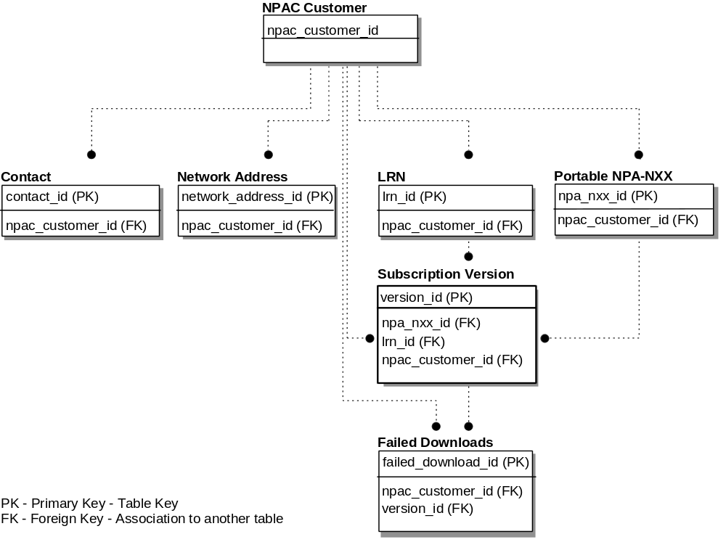

Data Type Legend
The following table describes the data types used in the data models.
DATA TYPE LEGEND
Data Type | Description
Address | Network Address: raw binary data stored as unformatted bytes.
B | Boolean (True or False) indicator.
C | Character or Alphanumeric strings.
E | Enumeration.
M | Bit Mask comprised of one or more bytes.
N | Numeric data (up to 32 bit integer, numeric data that can be arithmetically manipulated).
N(x) | Character string of “x” digits only.
T | Timestamp: month, day, year, hour, minute, and seconds.
TN | Telephone Number: 3-digit NPA, 3-digit NXX, 4-digit Station Number.
Table 3-1 Data Type Legend

NPAC Customer Data
NPAC Customer Data contains information about NPAC customers participating in the LNP service. The data items that need to be administered by NPAC Customer Data Management are represented in Table 3-2, Table 3.3, and Table 3-4.
- A check in the “Required” column means that this attribute must exist in the record before the record is considered useable.
NPAC CUSTOMER DATA MODEL
Attribute Name | Type (Size) | Required | Description
NPAC Customer ID | C (4) | √ | An alphanumeric code which uniquely identifies an NPAC Customer.
NPAC Customer Name | C (40) | √ | A unique NPAC Customer Name.
NPAC Customer Allowable Functions | M | √ | Each bit in the mask represents a boolean indicator for the following functional options:  - SOA Management  - SOA Network Data Management  - LSMS Network Data Management  - LSMS Data Download  - LSMS Queries/Audits
Table 3-2 NPAC Customer Data Model
NPAC CUSTOMER CONTACT DATA MODEL
Attribute Name | Type (Size) | Required | Description
NPAC Customer Contact ID | N | √ | A unique sequential number assigned upon creation of the Contact record.
NPAC Customer ID | C (4) | √ | An alphanumeric code which uniquely identifies an NPAC Customer.
Contact Type | C (2) | √ | The type of NPAC Customer Contact Organization. Valid values are:  - BI - Billing  - CF - Conflict Resolution Interface  - LI - Local SMS Interface  - NC - NPAC Customer  - NF - Network and Communications  Facilities Interface  - OP - Operations  - RE - Repair Center Contact  Organization  - SE - Security  - SI - SOA System Interface  - UA - User Administration  - WI - Web Interface
- Contact | C (40) | √ | Name of NPAC Customer Contact Organization.
Contact Address Line 1 | C (40) | √ | Contact Organization address Line 1.
Contact Address Line 2 | C (40) | √ | Contact Organization address Line 2.
Contact City | C (20) | √ | Contact Organization city.
Contact State | C (2) | √ | Contact Organization state.
Contact Zip | C (9) | √ | Contact Organization zip code or postal code.
Contact Country | C (2) | √ | Contact Organization country.
Contact Province | C (2) |  | Contact Organization province.
Contact Phone | TN | √ | Contact Organization phone number.
Contact Fax | TN |  | Contact Organization Fax phone number.
Contact Pager | TN |  | Contact Organization Pager phone number.
Contact Pager PIN | C (10) |  | Contact Organization Pager Personal Identification Number (PIN).
Contact Email | C (60) |  | Contact Organization E-mail address.
Table 3-3 NPAC Customer Contact Data Model
npac customer Network Address DATA MODEL
Attribute Name | Type (Size) | Required | Description
NPAC Customer Network Address ID | N | √ | A unique sequential number assigned upon creation of the Network Address record.
NPAC Customer ID | C (4) | √ | An alphanumeric code which uniquely identifies an NPAC Customer.
Network Address Type | C (1) | √ | Type of Network Address. Valid values are:  - S - SOA interface  - L - Local SMS interface
- NSAP Address | Address (20) | √ | OSI Network Service Access Point Address
TSAP Address | Address (4) |  | OSI Transport Service Access Point Address.
SSAP Address | Address (4) | √ | OSI Session Service Access Point Address.
PSAP Address | Address (4) | √ | OSI Presentation Service Access Point Address.
Internet Address | Address (12) |  | Internet address of the Service Provider Web interface.
Table 3-4 NPAC Customer Network Address Data Model

Subscription Version Data
Subscription Version Data consists of information about the ported TNs. The data items that need to be administered by Subscription Version Data Management functions are identified in Table 3-5:
SubscriPTION VERSION Data MODEL
Attribute Name | Type (Size) | Required | Description
Version ID | N | √ | A unique sequential number assigned upon creation of the Subscription Version.
LRN | TN | √ | The LRN is an identifier for the switch on which portable NPA-NXXs reside.
Old Service Provider ID | C (4) | √ | Old Service Provider ID.
New Service Provider ID | C (4) | √ | New Service Provider ID.
TN | TN | √ | Subscription Version telephone number.
Local Number Portability Type | E | √ | Number Portability Type. Valid enumerated values are:  - LSSP - Local Service Provider Portability (0)  - LISP - Local Intra-Service Provider Portability (1)
- Status | E | √ | Status of the Subscription Version.  The default value is P for Pending.  Valid enumerated values are:  - X - Conflict (0)  - A - Active (1)  - P - Pending (2)  - S - Sending (3)  - F - Failed (4)  - PF - Partial Failure (5)  - DP - Disconnect Pending (6)  - O - Old (7)  - C - Canceled (8)  - CP - Cancel Pending (9)
- CLASS DPC | N (9) | √ | DPC for 10-digit GTT for CLASS features.
CLASS SSN | N (3) | √ | CLASS SSN for the Subscription Version.
LIDB DPC | N (9) | √ | DPC for 10-digit GTT for LIDB features.
LIDB SSN | N (3) | √ | LIDB SSN for the Subscription Version.
CNAM DPC | N (9) | √ | DPC for 10-digit GTT for CNAM features.
CNAM SSN | N (3) | √ | CNAM SSN for the Subscription Version.
ISVM DPC | N (9) | √ | DPC for 10-digit GTT for ISVM features.
ISVM SSN | N (3) | √ | ISVM SSN for the Subscription Version.
New Service Provider Due Date | T | √ | The due date planned by the new Service Provider for Subscription Version Transfer.
Old Service Provider Due Date | T | √ | The due date planned by the old Service Provider for Subscription Version Transfer.
Old Service Provider Authorization | B |  | A boolean indicator set by the old Service Provider to indicate authorization or denial of Transfer of Service for the Subscription Version to the new Service Provider.
New Service Provider Create Time Stamp | T |  | The date and time that the New Service Provider authorized Transfer of Service of the Subscription Version.
Old Service Provider Authorization Time Stamp | T |  | The date and time that the old Service Provider authorized Transfer of Service for the Subscription Version.
Activation Request Time Stamp | T |  | The date and time that the Subscription Version activation request was made by the new Service Provider.
Activation Broadcast Date | T |  | The date and time that broadcasting began to all local SMS systems for the activation of the Subscription Version.
Activation Broadcast Complete Time Stamp | T |  | The date and time that at least one Local SMS system successfully acknowledged the broadcast or the retries were exhausted for the activate.
Disconnect Request Time Stamp | T |  | The date and time that the Subscription Version disconnect request was made by the local Service Provider.
Disconnect Broadcast Time Stamp | T |  | The date and time that broadcasting began to all local SMS systems for the disconnect of the Subscription Version.
Disconnect Broadcast Complete Time Stamp | T |  | The date and time that at least one Local SMS system successfully acknowledged the broadcast or the retries were exhausted for the disconnect.
Effective Release Date | T |  | The date that the Subscription Version is to be deleted from all Local SMS systems.
Customer Disconnect Date | T |  | The date that the Customer’s service was disconnected.
Pre-Cancellation Status | E |  | Status of the Subscription Version prior to cancellation. Valid enumerated values are:  - X - Conflict (0)  - P - Pending (2)  - DP - Disconnect Pending (6)
- Old Service Provider Cancellation Time Stamp | T |  | The date and time that the Old Service Provider acknowledged that the Subscription Version be canceled.
New Service Provider Cancellation Time Stamp | T |  | The date and time that the New Service Provider acknowledged that the Subscription Version be canceled.
Cancellation Time Stamp | T |  | The date and time that the Subscription Version became canceled.
Old Time Stamp | T |  | The date and time that the Subscription Version became old.
Conflict Time Stamp | T |  | The date and time that the Subscription Version was last placed in conflict.
Conflict Resolution Time Stamp | T |  | The date and time that the resolution of a Subscription Version in conflict is acknowledged.
Create Time Stamp | T | √ | The date and time that this Subscription Version record was created.
Modified Time Stamp | T | √ | The date and time that this Subscription Version record was last modified.  The default value is the Create Time Stamp.
Porting to Original | B | √ | A boolean that indicates whether the Subscription Version created is to be ported back to the original Service Provider.  The default value is False.
End User Location Value | C (12) |  | For future use.
End User Location Value Type | C (2) |  | For future use.
Modify Request Timestamp | T |  | The date and time that the Subscription Version Modify request was made.
Modify Broadcast Timestamp | T |  | The date and time that broadcasting began to all local SMS systems for the modification of the Subscription Version.
Modify Broadcast Complete Timestamp | T |  | The date and time that all local SMS systems successfully acknowledged or the retries were exhausted for the modification of the Subscription Version
Billing ID | C (4) |  | For future use.  The default value is the Facilities Based Service Provider ID.
Status Change Cause Code | N (2) |  | Used to specify reason for conflict when old Service Provider Authorization is set to False, or to indicate NPAC SMS initiated cancellation. Valid values are:  - No value  - General Conflict  - LSR Not Received  - FOC Not Issued  - Due Date Mismatch  - Vacant Number Port  - NPAC SMS Automatic Conflict from Cancellation  - NPAC SMS Automatic Cancellation
Table 3-5 Subscription Version Data Model

Network Data
The network data represents the attributes associated with network topology and routing data with respect to local number portability. This information is used by the respective network elements to route ported numbers to the new termination points. The data items that need to be administered by Network Data Administration functions are identified in Table 3-6, Table 3-7, and Table 3-8:
Portable NPA-NXX DATA MODEL
Attribute Name | Type (Size) | Required | Description
NPA-NXX Id | N | √ | A unique sequential number assigned upon creation of the NPA-NXX record.
NPA-NXX | C (6) | √ | The NPA-NXX open for porting.
NPAC Customer ID | C (4) |  | An alphanumeric code which uniquely identifies an NPAC customer.
NPA-NXX Effective Date | T | √ | The date that the NPA-NXX is available for LNP in the NPAC Customer networks.
Split new NPA | C (6) |  | The new NPA-NXX for an NPA split.
Split Activation Date | T |  | The date that the new NPA-NXX becomes available for use in an NPA split. This date represents the beginning of the permissive dialing period.
Split Disconnect Date | T |  | The data that the old NPA-NXX becomes unavailable for use in an NPA split. This date represents the end of the permissive dialing period.
NPA-NXX has been Ported | B | √ | A boolean that indicates if any TN within this NPA-NXX has been ported.  The default value is false, indicating that no TN within this NPA-NXX has yet been ported.
Table 3-6 Portable NPA-NXX Data Model
LRN Data MODEL
Attribute Name | Type (Size) | Required | Description
LRN ID | N | √ | A unique sequential number assigned upon creation of the LRN record.
LRN | TN | √ | The LRN is the unique identifier for the switch on which the portable NPA-NXXs reside.
NPAC Customer ID | C (4) | √ | An alphanumeric code which uniquely identifies an NPAC Customer.
Table 3-7 LRN Data Model
LSMS Filtered npa-nxx data model
Attribute Name | Type (Size) | Required | Description
LSMS Filter NPA-NXX ID | N | √ | A unique sequential number assigned upon creation of the LSMS Filtered NPA-NXX record.
NPAC Customer ID | C (4) | √ | An alphanumeric code that uniquely identifies the LSMS NPAC Customer who is filtering subscription version broadcasts.
NPA-NXX | C (6) | √ | The NPA-NXX for which the LSMS is filtering subscription version broadcasts.
Creation Timestamp | T | √ | Date the filtered NPA-NXX was created.
Table 3-8 LSMS Filtered NPA-NXX Data Model

NPAC Personnel Functionality
The following requirements describe the functionality required by the NPAC SMS to support the daily operation of the Regional LNP SMS support staff. These requirements define the high level functionality required by the system with the specifics of each requirement defined in more detail in sections 4 and 5.
R3-l
DELETE
R3-2
DELETE
R3-3 Create NPA-NXX data for a Service Provider
NPAC SMS shall allow NPAC personnel to create a new LNP NPA-NXX for a Service Provider.
R3-4.1
(Duplicate - refer to R4-1)
R3-4.2
(Duplicate - refer to R4-3)
R3-5
(Duplicate - refer to R4-2)
R3-6 Administer mass changes for NPA splits, LRN changes, LIDB changes, CLASS, ISVM and CNAM
NPAC SMS shall allow NPAC personnel to perform NPA splits, LRN, LIDB, CLASS, ISVM and CNAM mass changes that affect multiple Subscription Versions, with version statuses of active, pending, conflict, cancel pending, deferred disconnect or failed.
R3-7.1 Administer mass changes for one or more Subscription Versions
NPAC SMS shall allow NPAC personnel to select Subscription Versions which match a user defined TN and specify a mass update action to be applied against all Subscription Versions selected (except for Subscription Versions with a status of old, partial failure, sending, or canceled).
R3-7.2 Administer mass changes for one or more Subscription Versions for a TN range
NPAC SMS shall allow NPAC personnel to select Subscription Versions which match a TN range, and specify a mass update action to be applied against all Subscription Versions selected (except for Subscription Versions with a status of old, partial failure, sending, or canceled).

System Functionality
R3-8 Off-line batch updates for Local SMS Disaster Recovery
NPAC SMS shall support an off-line batch download (via 4mm DAT tape and FTP file download) to mass update Local SMSs with Subscription Versions and Service Provider Network data.
The contents of the batch download are:
- Subscriber data:
- Version ID
- TN
- LRN
- New Current Service Provider ID
- Activation Request Timestamp
- Version Status
- CLASS DPC
- CLASS SSN
- LIDB DPC
- LIDB SSN
- ISVM DPC
- ISVM SSN
- CNAM DPC
- CNAM SSN
- End User Location - Value
- End User Location - Type
- Billing ID
- LNP Type
- Download Reason
- Network data:
- NPAC Customer ID
- NPAC Customer name
- NPA-NXX-Download Data:
- NPA-NXX ID
- NPA-NXX Value
- NPAC Customer ID
- Effective TimeStamp
- Download Reason
- LRN-Download Data:
- LRN ID
- LRN Value
- Download Reason
R3-9 NPAC SMS download of network data to the Local SMS
NPAC SMS shall be able to communicate creation or deletion of NPA-NXX data and LRN data for a Service Provider to Local SMSs.
The contents of the network download are:
- Network data:
- NPAC Customer ID
- NPAC Customer Name

- NPA-NXX-Download Data:
- NPA-NXX ID
- NPA-NXX Value
- Effective TimeStamp
- Download Reason
- LRN-Download Data:
- LRN ID
- LRN Value
- Download Reason
R3-10 NPAC SMS notification of NPA-NXX availability to the Service Providers
NPAC SMS shall inform all Service Providers about the availability of the NPA-NXXs for porting via the NPAC SMS to Local SMS interface or the Web bulletin board. The NPA-NXX data fields sent via the NPAC SMS to Local SMS interface are:
- NPAC Customer ID
- NPAC Customer Name
- NPA-NXX ID
- NPA -NXX Value
- Effective Date
- Download Reason
The NPA-NXX data fields sent to the WEB bulletin board are:
- NPAC Customer ID
- NPAC Customer Name
- NPA-NXX Value
- Effective Date
R3-11 NPAC SMS notification of LRNs and Service Provider data by Service Provider
NPAC SMS shall inform all Service Providers about a new Service Provider and the associated LRNs. NPAC SMS shall post the new Service Providers and/or new LRNs on the Web bulletin board.
The Service Provider data fields sent to the WEB bulletin board are:
- NPAC Customer ID
- NPAC Customer Name
- NPAC Customer Type
- Contact Type
- Contact Name
- Contact Address 1
- Contact Address 2
- Contact City
- Contact State
- Contact Zip
- Contact Province
- Contact Country
- Contact Phone
- Contact Fax
- Contact Pager
- Contact Pager PIN
- Contact Email
The LRN data fields sent to the WEB bulletin board are:
- NPAC Customer ID
- NPAC Customer Name
- LRN Value
R3-12
(Duplicate - refer to R5-18)
R3-13 NPAC SMS mass change update capability to the Local SMS
NPAC SMS shall have the capability to identify all Subscription Versions affected by mass changes, (such as NPA splits), and automatically carry out the required updates to modified data in the Local SMSs.

Additional Requirements
RX3-1.1 Service Provider NPA-NXX Data Addition
NPAC SMS shall allow Service Providers to add their NPA-NXX data via the NPAC SMS to Local SMS interface or the SOA to NPAC SMS interface.
RX3-1.2 Service Provider LRN Data Addition
NPAC SMS shall allow Service Providers to add their LRN data via the NPAC SMS to Local SMS interface or the SOA to NPAC SMS interface.
RX3-2
DELETE
RX3-3.1 Service Provider NPA-NXX Data Deletion
NPAC SMS shall allow Service Providers to delete their NPA- NXX data via the NPAC SMS to Local SMS interface or the SOA to NPAC SMS interface provided the changes do not cause any updates to the Subscription Versions.
RX3-3.2 Service Provider LRN Data Deletion
NPAC SMS shall allow Service Providers to delete their LRN data via the NPAC SMS to Local SMS interface or the SOA to NPAC SMS interface provided the changes do not cause any updates to the Subscription Versions.

Requirements Defined in Post-Award Activities
RN3-1 NPA Split Permissive Dialing
NPAC SMS shall support a permissive dialing period, during which dialing of both NPAs is allowed during NPA splits.
RN3-2 NPA split
NPAC SMS shall accept both the old and new NPAs during the permissive dialing period, but will only respond and download with the new NPA.
RN3-3 NPA Split Permissive Dialing Cleanup
NPAC SMS shall perform an update to remove NPAC SMS mapping and deactivate Subscription Versions associated with an NPA split after the expiration date of the permissive dialing period.
RR3-1 Service Provider Download Indicator
NPAC SMS shall provide a mechanism for the Service Provider to indicate whether or not they want NPA-NXX data and LRN data downloaded to their Local SMS via the NPAC SMS to Local SMS Interface.
RR3-2 Service Provider Download Indicator Default
NPAC SMS shall download NPA-NXX data and LRN data via the NPAC SMS to Local SMS Interface if the indicator is ON.
R3-14 Bulk Database Extracts
NPAC SMS shall periodically perform NPAC SMS database extracts of active Subscription Versions on an NPA-NXX basis to an ASCII file.
R3-15 FTP Site for Database Extracts
NPAC SMS shall store database extract files at the NPAC SMS FTP site for Local SMS file retrieval.
R3-16 Database Extract File Creation
NPAC SMS shall allow NPAC personnel to specify database extract file creation on a weekly, monthly, or quarterly basis.
R3-17 Scope of Database Extract File Creation
NPAC SMS shall allow NPAC personnel to specify an NPA-NXX for database extract file creation.
RR3-3 NPAC SMS Input Restrictions
NPAC SMS shall prevent the entry of pipe characters (|) as part of text strings.
RR3-4 Create LRN data for a Service Provider
NPAC SMS shall allow NPAC personnel to create a new LRN for a service provider.

Requirements Defined in Change Orders
RR3-5 Create Filtered NPA-NXX for a Local SMS
NPAC SMS shall allow a Service Provider to create a filtered NPA-NXX for a given Local SMS, via the NPAC SMS to Local SMS interface and the SOA to NPAC SMS interface, which results in the SMS broadcasting subscriptions with the filtered NPA-NXX to the Local SMS.
RR3-6 Delete Filtered NPA-NXX for a Local SMS
NPAC SMS shall allow a Service Provider to delete a filtered NPA-NXX for a given Local SMS, via the NPAC SMS to Local SMS interface and the SOA to NPAC SMS interface, which results in the SMS NOT broadcasting subscriptions with the filtered NPA-NXX to the given Local SMS.
RR3-7 Query Filtered NPA-NXXs for a Local SMS
NPAC SMS shall allow a Service Provider to query filtered NPA-NXXs for a given Local SMS via the NPAC SMS to Local SMS interface and the SOA to NPAC SMS interface.
RR3-8 Query Filtered NPA-NXXs - NPA-NXX Not Provided
NPAC SMS shall return to the requesting Service Provider all filtered NPA-NXXs for a given Local SMS when the NPA-NXX is not input upon a Filter NPA-NXX Query via the NPAC SMS to Local SMS interface and the SOA to NPAC SMS interface.
RR3-9 Query Filtered NPA-NXXs - NPA-NXX Provided
NPAC SMS shall return to the requesting Service Provider a single NPA-NXX for a given Local SMS when the NPA-NXX is input upon a filtered NPA-NXX Query via the NPAC SMS to Local SMS interface and the SOA to NPAC SMS interface.
RR3-10 Business Hours and Days
NPAC SMS shall support definition and processing of business hours and days for operations involving business time calculation.
RR3-11 Business Day Definition
NPAC SMS business days shall be Monday through Friday excluding NPAC operations-defined holidays.
RR3-12.1 Business Day Duration - Tunable Parameter
NPAC SMS shall provide a Business Day Duration tunable parameter, which is defined as the number of hours from the tunable business day start time.
RR3-12.2 Business Day Duration - Tunable Parameter Modification
NPAC SMS shall allow the NPAC SMS Administrator to modify the Business Day Duration tunable parameter.
RR3-12.3 Business Day Duration - Tunable Parameter Default
NPAC SMS shall default the Business Day Duration tunable parameter to 12 hours.
RR3-13.1 Business Day Start Time - Tunable Parameter
NPAC SMS shall provide a Business Day Start Time tunable parameter, which is defined as the start of the business day in Central Standard Time.
RR3-13.2 Business Day Start Time - Tunable Parameter Modification
NPAC SMS shall allow the NPAC SMS Administrator to modify the Business Day Start Time tunable parameter.
RR3-13.3 Business Day Start Time - Tunable Parameter Default
NPAC SMS shall default the Business Day Start Time tunable parameter to 7:00 AM, Central Standard Time.
RR3-14 Business Holidays
NPAC SMS shall allow NPAC operations personnel to add/delete business holidays.

Service Provider Data Administration

Service Provider Data Administration and Management
Service Provider Data Administration functions allow NPAC personnel to receive and record data needed to identify authorized LNP Service Providers. The Service Provider data indicates who the LNP Service Providers are and includes location, contact name, security, routing, and network interface information.
Service Provider Administration supports functionality to manage Service Provider data. There can be only one instance of Service Provider data for a specific LNP Service Provider.
AR1-1 Service Provider ID
All NPAC Customers will obtain a unique Service Provider ID from a proper source.

User Functionality
R4-1 Create Service Providers
The NPAC SMS shall allow NPAC Personnel to add a Service Provider.
R4-2 Modify Service Providers
NPAC SMS shall allow modification of Service Provider data via the NPAC SMS to Local SMS interface or the SOA to NPAC SMS interface. Service Providers can only modify their own data.
R4-3 Delete Service Providers
NPAC SMS shall allow NPAC personnel to delete a Service Provider.
R4-4 View of Service Provider Data
NPAC SMS shall allow NPAC personnel to view Service Provider data.
R4-5.1 View List of Service Provider Subscriptions
NPAC SMS shall allow NPAC personnel to view a list of Subscription Versions associated with the Service Provider.
R4-5.2 Authorized Service Providers View Their Own Data
NPAC SMS shall allow authorized Service Provider personnel to view their own Service Provider data via the SOA to NPAC SMS interface, the NPAC SMS to Local SMS interface, and the NPAC Operations interface.
RX4-2 Authorized Service Providers Modify Their Own Data
NPAC SMS shall allow authorized Service Provider personnel to modify their own Service Provider data.
RR4-4.1 Broadcast NPAC Customer Names
NPAC SMS shall broadcast all additions, modifications, and deletions of NPAC Customer names via the NPAC SMS to Local SMS interface.

System Functionality
This section describes NPAC SMS functionality required to support the NPAC personnel requests described in the above section. The following specifies user requests and lists the NPAC SMS functionality needed to support those requests.

Service Provider Data Creation
NPAC personnel can request that Service Provider data be created in the NPAC SMS. The functionality described below enables a new instance of Service Provider data for a Service Provider to be created, provided that no other Service Provider data exists for the Service Provider.
R4-6 New Service Provider ID
NPAC SMS shall require the following to be entered to identify the Service Provider, when NPAC personnel are creating a new Service Provider:
Service Provider ID - the alphanumeric identifier of the Service Provider. This ID must be unique.
R4-7.1 Examine for Duplicate Service Provider ID
NPAC SMS shall check to see if there is an existing Service Provider with the same Service Provider ID.
R4-7.2 Error notification of Duplicate Service Provider
NPAC SMS shall inform the user that the Service Provider data already exists for the Service Provider, if it does exist, and that the new Service Provider data cannot be created.
R4-8 Service Provider Data Elements
NPAC SMS shall require the following data if there is no existing Service Provider data:
- Service Provider name, address, phone number, and contact organization.
- NPAC customer type.
- Service Provider allowable functions.
- Service Provider Network Address of NPAC SMS to Local SMS interface.
- Service Provider Network Address of NPAC SMS to SOA interface.
- Service Provider Security Contact. Contact data is security data when Contact Type is “SE.”
- Service Provider Repair contact name and phone number. The default Service Provider Repair Contact and phone number shall be the same as the Service Provider contact and phone number, if the Service Provider Repair Contact information is left blank.
- Service Provider billing name, address, phone number, and billing contact for NPAC SMS billing. The default for the Service Provider Billing data shall be the same as the Service Provider data, if the Service Provider Billing information is left blank.
- Service Provider Download Indicator
- Service Provider Maximum Query
The following data is optional:
- Service Provider Contact Type: SOA Contact, Local SMS, Web, Network Communications, Conflict Resolution, Operations, and User Administration Contact Address Information.
R4-9 Service Provider data validation
NPAC SMS shall validate that all required Service Provider data has been received, after the Service Provider data has been collected.
R4-10 Notification of successful add for new Service Provider
NPAC SMS shall notify NPAC personnel upon successful creation of the new Service Provider.
R4-11 Failure notification of Service Provider creation
NPAC SMS shall issue an appropriate error message upon unsuccessful creation of the new Service Provider.

Service Provider Data Modification
NPAC personnel and the SOA to NPAC SMS interface and the NPAC to Local SMS interface can request that Service Provider data be modified in the NPAC SMS. The functionality described below enables the user to modify data for the Service Provider.
R4-12
(Duplicate - refer to R4-2)
R4-13 Service Provider Key selection for modifying Service Provider data
NPAC SMS shall require one of the following data items to identify the Service Provider data to be modified:
Service Provider ID
or
Service Provider Name
The Service Provider ID is required over the SOA to NPAC SMS interface and the NPAC SMS to Local SMS interface.
R4-14 Error notification of invalid Service Provider ID or Name during Modify
NPAC SMS shall issue an appropriate error message to the user if the Service Provider data to be modified does not exist.
R4-15.1 Modify restrictions on Service Provider data - Service Providers
NPAC SMS shall allow Service Provider data to be modified or added to the Service Provider data with the exception of the data listed in Table 3-2.
R4-15.2 Modify restrictions on Service Provider data - NPAC Operations Personnel
NPAC SMS shall allow NPAC Operations personnel to modify the data in Table 3-2, with the exception of the NPAC Customer ID.
R4-16 Re-validation of Service Provider data after Modify
NPAC SMS shall revalidate that all required Service Provider data is present when a user attempts to submit modified Service Provider data.
R4-17 Modify Validation Error Message
NPAC SMS shall issue an appropriate error message to the user if the Service Provider data fails validation on a modify.
R4-18.1
DELETE
R4-18.2
DELETE
R4-18.3
DELETE

Delete Service Provider Data
NPAC personnel can request that the Service Provider data be deleted. Deleted Service Provider data will be written to a history file. The functionality described below enables a user to delete data for the Service Provider.
R4-19
(Duplicate - refer to R4-3)
R4-20 Service Provider key for delete
NPAC SMS shall require the Service Provider ID and/or Service Provider name from the user to identify the Service Provider data to be deleted.
R4-21 Error Message for Delete key search
NPAC SMS shall generate an error message and send it to the request originator, if the Service Provider data does not exist, or if is has already been deleted and exists only in a history file. NPAC SMS will not proceed further with the deletion request.
R4-22.1 No Subscription Versions during Service Provider Delete
NPAC SMS shall perform the deletion of the Service Provider data, notify the user that the deletion request was successful, if there are no affected Subscription Versions, and write the Service Provider data to a history file.
R4-22.2 Subscription during Service Provider Delete
NPAC SMS shall notify the user that the request to delete the Service Provider data cannot be completed until the affected individual Subscription Versions are modified, if affected Subscription Versions are found.
R4-22.3 Service Provider subscription restrictions during Network Data Delete.
NPAC SMS shall determine if there are any Subscription Versions being affected by the NPA-NXX and/or LRN data being deleted.

Service Provider Queries
The query functionality discussed in this section will give users the ability to view Service Provider and Subscription data. A user may not be able to modify a particular data item because they do not have the proper security permissions, therefore the data is made available via NPAC SMS for read-only purposes.

User Functionality
R4-23
(Duplicate - refer to R4-5.2)
R4-24.1 Display of Service Provider ID and related subscription data
NPAC SMS shall allow NPAC personnel to view all Subscription Versions associated with a Service Provider ID and/or Service Provider Name.
R4-24.2 Display of LRN and related subscription data
NPAC SMS shall allow NPAC personnel to view all Subscription Versions associated with an LRN.
R4-24.3 Display of NPA-NXX and related subscription data
NPAC SMS shall allow NPAC personnel to view all Subscription Versions associated with an NPA-NXX.

System Functionality
The following specifies NPAC SMS functionality needed to support the user requests described above.

Service Provider Query
R4-25 Service Provider as Key for queries
NPAC SMS shall require the Service Provider ID and/or the Service Provider Name for queries regarding Service Provider data.
R4-26.1 Error message for unknown Service Provider during a query
NPAC SMS shall provide the request originator with a message indicating that there was no data in the NPAC SMS that matched the search keys for a Service Provider query, if no match was found.
R4-26.2 Results returned to Service Provider during a query
NPAC SMS shall return all Service Provider data associated with the Service Provider ID and/or Service Provider Name, as listed in Tables 3-1, 3-2, and 3-3, if the Service Provider data matches the query criteria. Service Providers are only allowed to query their own data.
R4-27 Service Provider Query Types
NPAC SMS shall receive the Service Provider ID, a request to view subscription data, and optionally the subscription data status types to be returned (e.g., active only, active or pending) for queries regarding subscription data for a specific Service Provider.
R4-28 Service Provider Information Message during query
NPAC SMS shall provide the request originator with a message indicating that there was no data in NPAC SMS that matched the search keys, if NPAC SMS does not have subscription data as specified by the request originator.

Subscription List Query
R4-29 Service Provider subscription query options
NPAC SMS shall receive the attributes to be searched on for queries regarding Subscription Versions associated with the Service Provider. Allowable attributes are the following data elements from Table 3-5 Subscription Version Data Model:
- Subscription Version ID
- Subscription Version Status
- Local Number Portability Type
- Ported Telephone Number
- Old facilities-based Service Provider Due Date
- New facilities-based Service Provider Due Date
- New facilities-based Service Provider ID
- Authorization from old facilities-based Service Provider
- Local Routing Number (LRN)
- Class DPC
- Class SSN
- LIDB DPC
- LIDB SSN
- CNAM DPC
- CNAM SSN
- ISVM DPC
- ISVM SSN
- Billing Service Provider ID
- End User Location Value
- End User Location Type
- Customer Disconnect Date
- Effective Release Date
- Disconnect Broadcast Complete Time Stamp
- Conflict Time Stamp
- Activation Time Stamp
- Cancellation Time Stamp (Status Modified to Cancel Time Stamp)
- New Service Provider Creation Time Stamp
- Old Service Provider Authorization Time Stamp
- Pre-cancellation Status
- Old Service Provider Cancellation Time Stamp
- New Service Provider Cancellation Time Stamp
- Old Time Stamp (Status Modified to Old Time Stamp)
- New Service Provider Conflict Resolution Time Stamp
- Create Time Stamp
- Modify Time Stamp
- Porting To Original
- Status Change Cause Code
R4-30.1 Service Provider subscription query
NPAC SMS shall return all active Subscription Versions associated with the Service Provider which satisfy the selection criteria, up to a tunable parameter number of Subscription Versions for queries initiated via the NPAC SMS to Local SMS interface.
R4-30.2 NPAC SMS shall return all Subscription Versions
NPAC SMS shall return all Subscription Versions regardless of Subscription Version status for queries initiated via the NPAC Operations interface.
R4-30.3
DELETE
R4-30.4
DELETE
R4-30.5
DELETE
R4-30.6 Count of subscription information during a query
NPAC SMS shall return an “out of range” error and the count of subscription records returned by a query, if more than a tunable parameter number of Subscription Versions are found.
R4-30.7
DELETE
R4-30.8 Error Message for Service Provider subscription query
NPAC SMS shall provide the request originator with a message indicating that there was no data in NPAC SMS that matched the search keys, if NPAC SMS does not have Subscription Versions as specified by the request originator.

Additional Requirements
RN4-1 Service Provider Network Data Addition/Deletion
NPAC SMS shall allow Service Providers to add/delete the NPA-NXX and/or LRN data via the NPAC SMS to Local SMS interface and SOA to NPAC SMS interface provided the changes do not cause mass updates to the Subscription Versions.
RR4-1 Removal of Service Provider with Respect to LRNs
NPAC SMS shall allow removal of a Service Provider by NPAC personnel only if all associated LRNs are removed, and no Subscription Versions are associated with the LRN.
RR4-2 Removal of Service Provider with Respect to NPA-NXXs
NPAC SMS shall allow removal of a Service Provider by NPAC personnel only if all associated NPA-NXXs are removed, and no Subscription Versions are associated with the NPA-NXX.
RR4-3 Removal of NPA-NXX
NPAC SMS shall allow removal of an NPA-NXX by NPAC personnel only if no Subscription Versions, except Old or Canceled Subscription Versions, are associated with the NPA-NXX.
RR4-4.2 Removal of LRN
NPAC SMS shall allow removal of an LRN by NPAC personnel only if no Subscription Versions, except Old or Canceled Subscription Versions, are associated with the LRN.

Subscription Management

Subscription Version Management
Subscription Management functions allow NPAC personnel and SOA to NPAC SMS interface users to specify data needed for ported numbers. The subscription data indicates how local number portability should operate to meet subscribers' needs. These functions will be accessible to authorized service providers via an interface (i.e., the SOA to NPAC SMS interface) from their operations systems to the NPAC SMS and will also be accessible to (and performed by) NPAC personnel.
Subscription Management supports functionality to manage multiple versions of subscription data. See Section 5.1.1, Subscription Version Management, for more details on the different states of a version.
RN5-1 Subscription Version Status - Only One Per Subscription
NPAC SMS shall allow only one pending, cancel pending, conflict, disconnect pending, failed or partial failure Subscription Version per subscription.
RN5-2 Subscription Version Status - Only One Active Version
NPAC SMS shall allow only one active Subscription Version per subscription.
RN5-3 Subscription Version Status - Multiple Old/Canceled
NPAC SMS shall allow multiple old and/or canceled Subscription Versions per subscription.

Subscription Version Management
Subscription Version management provides functionality to manage multiple time-sensitive views of subscription data. This section addresses version management for LNP and the user and system functionality needed for subscription administration. In this context a version may be defined as time-sensitive subscription data.
At any given time, a Subscription Version in the SMS can have one of several statuses (e.g., active, old) and may change status depending on results of different SMS processes (e.g., modification, activation). This section describes the different statuses that a version can have and the SMS processes that can change the status. This section also discusses functionality and data that is needed for Subscription Management.

Version Status
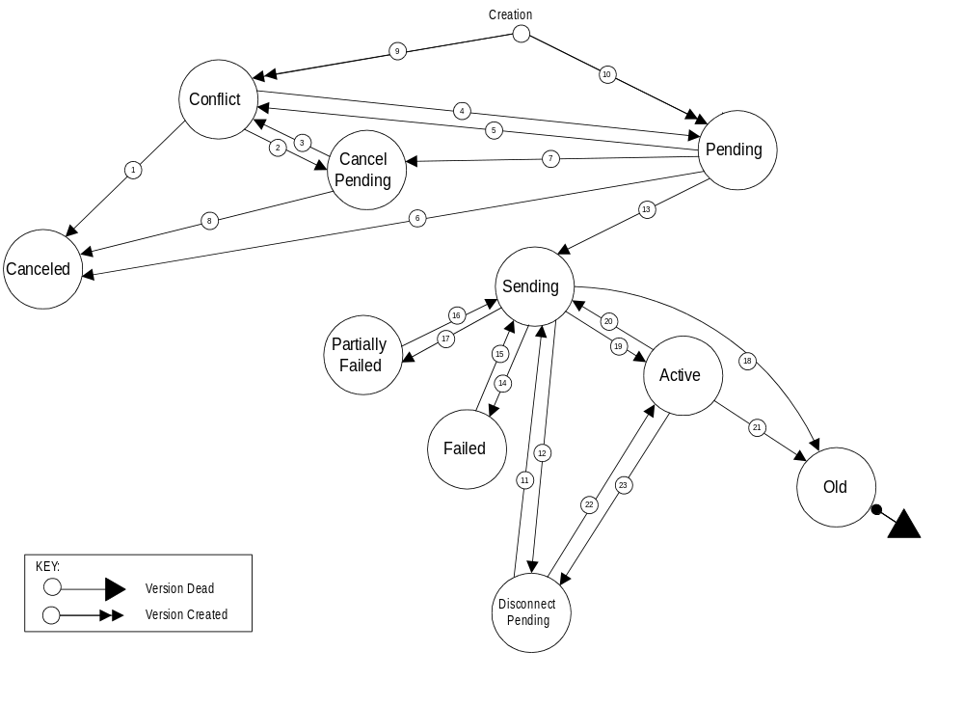
Figure 5-1 Version Status Interaction Diagram
Version Status Interaction Descriptions
# | Interaction Name | Type | Description
1 | Conflict to  Canceled | NPAC SMS Internal | NPAC SMS automatically sets a Subscription Version in conflict directly to canceled after it has been in conflict for a tunable number of calendar days.
 |  | SOA to NPAC SMS Interface or NPAC Operations Interface - NPAC Personnel | Service Provider User (or NPAC personnel acting on behalf of the Service Provider) sends a cancellation request for a Subscription Version created by that Service Provider with a status of Conflict that has not been concurred by the other Service Provider.
2 | Conflict to  Cancel Pending | NPAC Operations Interface - NPAC Personnel | User cancels a Subscription Version in conflict or cancels a Subscription Version that was created by or concurred to by both Service Providers.
 |  | SOA to NPAC SMS Interface | User sends a cancellation request for a Subscription Version with a status of conflict or cancels a Subscription Version that was created by or concurred to by both Service Providers.
3 | Cancel Pending to  Conflict | NPAC Operations Interface - NPAC Personnel | User sets a Subscription Version with a status of cancel pending to conflict.
 |  | NPAC SMS Internal | NPAC SMS automatically sets a Subscription Version with a status of cancel pending to conflict if cancel pending acknowledgment has not been received from the new Service Provider within a tunable timeframe.
4 | Conflict to  Pending | NPAC Operations Interface - NPAC Personnel and SOA to NPAC SMS Interface - Old Service Provider | User removes a Subscription Version from conflict.
 |  | SOA to NPAC SMS Interface - New Service Provider | New Service Provider User removes a Subscription Version from conflict. This action can only occur if a tunable number of hours have elapsed since the Subscription Version was placed in conflict.
5 | Pending to  Conflict | NPAC Operations Interface - NPAC Personnel | - User sets a Subscription Version with a status of pending to conflict.  - User creates a Subscription Version for an existing pending Subscription Version for the old Service Provider and does not provide authorization for the transfer of service.
 |  | SOA to NPAC SMS Interface - Old Service Provider | Old Service Provider sends a Subscription Version creation or modification request for a Subscription Version with a status of pending, which revokes the old Service Provider’s authorization for transfer of service. This action can only be taken once, and must be taken a tunable number of hours prior to the new Service Provider due date.
6 | Pending to  Canceled | NPAC Operations Interface - NPAC Personnel | User cancels a Subscription Version with a status of pending that has not been concurred by both service providers.
 |  | SOA to NPAC SMS Interface | Service Provider User sends a cancellation request for a Subscription Version created by that Service Provider with a status of pending that has not been concurred by the other Service Provider.
 |  | NPAC SMS Internal | - NPAC SMS automatically sets a pending Subscription Version to cancel after authorization for the transfer of service has not been received from the new Service Provider within a tunable timeframe.  - NPAC SMS automatically sets a pending Subscription Version to canceled if an activation request is not received a tunable amount of time after new Service Provider due date.
- 7 | Pending to  Cancel Pending | NPAC Operations Interface - NPAC Personnel | User cancels a Subscription Version with a status of pending that has been created/concurred by both Service Providers.
 |  | SOA to NPAC SMS Interface | Service Provider User sends a cancellation request for a Subscription Version with a status of pending that has been concurred by the other Service Provider.
8 | Cancel Pending to Canceled | NPAC SMS Internal | NPAC SMS automatically sets a cancel pending Subscription Version to canceled after receiving cancel pending acknowledgment from the concurring Service Provider, or the final cancellation concurrence window has expired without cancel concurrence from the old Service Provider.
9 | Creation -  Set to Conflict | NPAC Operations Interface - NPAC Personnel | User creates a Subscription Version for the old Service Provider and does not provide authorization for the transfer of service.
 |  | SOA to NPAC SMS Interface - Old Service Provider | User sends an old Service Provider Subscription Version creation request and does not provide authorization for the transfer of service.
10 | Creation -  Set to Pending | NPAC Operations Interface - NPAC Personnel | User creates a Subscription Version for either the new or old Service Provider. If the create is for the old Service Provider and authorization for the transfer of service is not provided, refer to # 9, Creation - Set to Conflict, NPAC Operations Interface.
 |  | SOA to NPAC SMS Interface | User sends a Subscription Version creation request for either the new or old Service Provider. If the create is for the old Service Provider, and authorization for the transfer of service is not provided, refer to # 9, Creation - Set to Conflict, SOA to NPAC SMS Interface.
11 | Disconnect Pending to Sending | NPAC SMS Internal | NPAC SMS automatically sets a deferred disconnect pending Subscription Version to sending after the effective release date is reached.
12 | Sending to  Disconnect Pending | NPAC SMS Internal | NPAC SMS automatically sets a Subscription Version from sending to disconnect pending when the broadcast of the disconnect pending fails completely.
13 | Pending to  Sending | NPAC Operations Interface - NPAC Personnel | User activates a pending Subscription Version for a Subscription Version with a new Service Provider due date less than or equal to today.
 |  | SOA to NPAC SMS Interface - New Service Provider | New Service Provider User sends an activation message for a pending Subscription Version for a Subscription Version with a new Service Provider due date less than or equal to today.
14 | Sending to  Failed | NPAC SMS Internal | NPAC SMS automatically sets a Subscription Version from sending to failed after all Local SMSs fail Subscription Version activation after the tunable retry period expires.
15 | Failed to  Sending | NPAC Operations Interface - NPAC Personnel | User re-sends a failed Subscription Version.
16 | Partially Failed to Sending | NPAC Operations Interface - NPAC Personnel | User re-sends a partial failure Subscription Version.
17 | Sending to  Partially Failed | NPAC SMS Internal | NPAC SMS automatically sets a Subscription Version from sending to partial failure after one or more, but not all, of the Local SMSs fail the Subscription Version activation after the tunable retry period expires.
18 | Sending to  Old | NPAC SMS Internal | NPAC SMS automatically sets a sending Subscription Version to old after a disconnect or “porting to original” port to all Local SMS successfully completes.
19 | Sending to  Active | NPAC SMS Internal | - NPAC SMS automatically sets a sending Subscription Version to active after the Subscription Version activation is successful in all of the Local SMSs.  - NPAC SMS automatically sets a sending Subscription Version to active after the Subscription Version modification is successfully broadcast to any of the Local SMSs.
20 | Active to  Sending | NPAC Operations Interface - NPAC Personnel | User disconnects an active Subscription Version and does not supply an effective release date, or User modifies an active Subscription Version.
 |  | SOA to NPAC SMS Interface - Current Service Provider | User sends a disconnect request for an active Subscription Version and does not supply an effective release date, or User modifies an active Subscription Version.
21 | Active to  Old | NPAC SMS Internal | NPAC SMS automatically sets the currently active Subscription Version to old once a Subscription Version activation or disconnect is successful in all Local SMSs.
22 | Disconnect Pending to Active | NPAC Operations Interface - NPAC Personnel | User cancels a Subscription Version with a disconnect pending status.
 |  | SOA to NPAC SMS Interface - New Service Provider | User sends a cancellation request for a disconnect pending Subscription Version.
23 | Active to  Disconnect Pending | NPAC Operations Interface - NPAC Personnel | User disconnects an active Subscription Version and supplies a future effective release date.
 |  | SOA to NPAC SMS Interface - Current Service Provider | User sends a disconnect request for an active Subscription Version and supplies a future effective release date.
Table 5-1 Version Status Interaction Descriptions
R5-1.1 Subscription Version Statuses
NPAC SMS Subscription Version instances shall at any given time have one of the following statuses:
- Active - Version is currently active in the network.
- There may be another pre- active version in the system that will eventually supersede this version.
Examples: 1) Pending version for the active subscription exists 2) Sending version for the active subscription exists.
- Canceled - A pending, conflict, or disconnect pending version was canceled prior to activation in the network.
- Cancel Pending - Version is awaiting cancellation acknowledgment from the concurring Service Providers, at which time the version will be set to canceled.
- Conflict - Version is in conflict (i.e., a dispute exists between the two Service Providers), awaiting resolution.
- Disconnect Pending - Version is awaiting the effective release date, at which time the version will be set to sending and the disconnect request will be sent to all Local SMSs.
- Failed - Version failed activation in ALL of the Local SMSs in the network.
- Old - Version was previously active in the network and either was superseded by another active version or was disconnected.
- Partial Failure - Version failed activation in one or more, but not all, Local SMSs in the network.
- Pending - Version is either pending activation (approval had been received from both Service Providers) or pending creation/approval from one or the other Service Provider.
- Sending - Version is currently being sent to all of the Local SMSs in the network.
R5-1.2
(Duplicate - refer to R5-20.3)
(Duplicate - refer to R5-30.2)
(Duplicate - refer to R5-53)
(Duplicate - refer to R5-54)
(Moved - refer to R5-54.2)
R5-2.1 Old Subscription Retention - Tunable Parameter
NPAC SMS shall provide an Old Subscription Retention tunable parameter which is defined as the length of time that old Subscription Versions shall be retained and accessible through a query request.
R5-2.2 Old Subscription Retention - Tunable Parameter Modification
NPAC SMS shall allow the NPAC SMS Administrator to modify the Old Subscription Retention tunable.
R5-2.3 Old Subscription Retention - Tunable Parameter Default
NPAC SMS shall default the Old Subscription Retention tunable parameter to 18 calendar months.
R5-3.1 Cancel-Pending Subscription Retention - Tunable Parameter
NPAC SMS shall provide a Cancel-Pending Subscription Retention tunable parameter which is defined as the length of time that canceled Subscription Versions with a pre-cancellation status of pending shall be retained and accessible through a query request.
R5-3.2 Cancel-Pending Subscription Retention - Tunable Parameter Modification
NPAC SMS shall allow the NPAC SMS Administrator to modify the Cancel-Pending Subscription Retention tunable parameter.
R5-3.3 Cancel-Pending Subscription Retention - Tunable Parameter Default
NPAC SMS shall default the Cancel-Pending Subscription Retention tunable parameter to 90 calendar days.
R5-3.4 Cancel-Conflict Subscription Retention - Tunable Parameter
NPAC SMS shall provide a Cancel-Conflict Subscription Retention tunable parameter which is defined as the length of time that canceled Subscription Versions with a pre-cancellation status of conflict shall be retained and accessible through a query request.
R5-3.5 Cancel-Conflict Subscription Retention - Tunable Parameter Modification
NPAC SMS shall allow the NPAC SMS Administrator to modify the Cancel-Conflict Subscription Retention tunable parameter.
R5-3.6 Cancel-Conflict Subscription Retention - Tunable Parameter Default
NPAC SMS shall default the Cancel-Conflict Subscription Retention tunable parameter to 30 calendar days.
R5-3.7
DELETE
R5-3.8
DELETE
R5-3.9
DELETE
R5-3.10 Cancel-Disconnect Pending Retention - Tunable Parameter
NPAC SMS shall provide a Cancel-Disconnect Pending Retention tunable parameter which is defined as the length of time that canceled Subscription Versions with a pre-cancellation status of disconnect pending shall be retained and accessible through a query request.
R5-3.11 Cancel-Disconnect Pending Retention - Tunable Parameter Modification
NPAC SMS shall allow the NPAC SMS Administrator to modify the Cancel-Disconnect Pending Retention tunable parameter.
R5-3.12 Cancel-Disconnect Pending Retention - Tunable Parameter Default
NPAC SMS shall default the Cancel-Disconnect Pending Retention tunable parameter to 90 calendar days.
RR5-1.1 Pending Subscription Retention - Tunable Parameter
NPAC SMS shall provide a Pending Subscription Retention tunable parameter, which is defined as the length of time that a pending Subscription Version shall remain in the system prior to cancellation.
RR5-1.2 Pending Subscription Retention - Tunable Parameter Modification
NPAC SMS shall allow the NPAC SMS Administrator to modify the Pending Subscription Retention tunable parameter.
RR5-1.3 Pending Subscription Retention - Tunable Parameter Default
NPAC SMS shall default the Pending Subscription Retention tunable parameter to 90 calendar days.
RR5-1.4 Pending Subscription Retention - Tunable Parameter Expiration
NPAC SMS shall cancel a Subscription Version by setting the subscription version to cancel after a pending Subscription Version has existed in the system for a Pending Subscription Retention number of calendar days subsequent to new Service Provider Due Date.
R5-4
(Duplicate - Refer to RN5-1)
R5-5 Subscription Versions Creation for TN Ranges
NPAC SMS shall create individual Subscription Versions when a Subscription Version creation request is received for a TN range.
R5-6 Subscription Administration Transaction Logging
NPAC SMS shall log all subscription administration transactions. The log entries shall include:
- Activity Type: create, modify, activate, query, all status types, and all acknowledgments.
- Service Provider ID
- Initial Version Status
- New Version Status (if applicable)
- User ID and/or Login
- Local Number Portability Type
- Date
- Time
- Ported Telephone Number
- Status Flag - successful or failed
- Subscription Version ID (when assigned)

Subscription Administration Requirements

User Functionality
Authorized users can invoke the following functionality in the NPAC SMS to administer subscription data:
R5-7 Creating a Subscription Version
NPAC SMS shall allow NPAC personnel and the SOA to NPAC SMS interface to create a Subscription Version.
R5-8.1 Modifying a Subscription Version
NPAC SMS shall allow NPAC personnel and the SOA to NPAC SMS interface to modify a Subscription Version.
R5-8.2
(Duplicate - refer to R5-25)
R5-9 Activating a Subscription version
NPAC SMS shall allow NPAC personnel and the SOA to NPAC SMS interface to activate a Subscription Version.
RN5-9
DELETE
R5-10.1 Setting a Subscription Version to Conflict
NPAC SMS shall allow NPAC personnel to set a Subscription Version to conflict.
R5-10.2 Subscription Version Conflict Status Rule
NPAC SMS shall prohibit a Subscription Version in conflict from being activated.
R5-11 Disconnecting a Subscription Version
NPAC SMS shall allow NPAC personnel and the SOA to NPAC SMS interface to disconnect a Subscription Version.
R5-12 Canceling a Subscription Version
NPAC SMS shall allow NPAC personnel and the SOA to NPAC SMS interface to cancel a Subscription Version.
R5-13 Querying a Subscription Version
NPAC SMS shall allow NPAC personnel, Local SMS/ SOA to NPAC SMS interface to query for a Subscription Version.

System Functionality
This section describes NPAC SMS functionality required to support NPAC personnel and SOA to NPAC SMS interface user requests defined in the above section.
Additionally, NPAC SMS functionality will perform operations which are not invoked by a direct user request. Some examples of this are: monitor a Subscription Version to determine whether the old and the new facilities-based Service Providers have authorized the transfer of service for a ported number, issue appropriate notifications to Service Providers, and change the status of a Subscription Version based on tunable parameters.

Subscription Version Creation
This section provides the requirements for the Subscription Version Create functionality, which is executed upon the user requesting to create a Subscription Version.
RR5-3 Create Subscription Version - Notify NPA-NXX First Usage
NPAC SMS shall notify all accepting Local SMSs and SOAs of the NPA-NXX, effective date, and owning Service Provider when an NPA-NXX is being ported for the first time immediately after creation validation of a Subscription Version.

Subscription Version Creation - Inter-Service Provider Ports
This section provides the Subscription Version Creation requirements for performing an Inter-Service Provider port of a TN. There are two types of Inter-Service Provider ports: A port of a TN to a new Service Provider from the Old, or a “porting to original” port. A “porting to original” port implies that all porting data will be removed from the Local SMSs and the TN will revert to the default routing, which ultimately results in the TN returning to the original “donor” Service Provider.
The primary differences in functionality between these two types of Inter-Service Provider ports is that for a “porting to original” port, the routing data is not supplied and upon activation, a delete request is broadcast to the Local SMSs instead of a create request.
Both port types of Inter-Service Provider ports require authorization for the transfer of service from the new Service Provider.
R5-14 Create Subscription Version - Old Service Provider Input Data
NPAC SMS shall accept the following data from the NPAC personnel or old Service Provider upon Subscription Version creation for an Inter-Service Provider port:
- Local Number Portability Type -Port Type.
- Ported Telephone Number(s) - this entry can be a single TN or a continuous range of TNs that identifies a subscription or a group of Subscription Versions that share the same attributes.
- Due Date - date on which transfer of service from old facilities-based Service Provider to new facilities-based Service Provider is initially planned to occur.
- New facilities-based Service Provider ID - the identifier of the new facilities-based Service Provider.
- Old facilities-based Service Provider ID - the identifier of the old facilities-based Service Provider.
- Authorization from old facilities-based Service Provider - indication that the transfer of service is authorized by the ported-from Service Provider.
- Status Change Cause Code - indication of reason for denial of authorized by the Old Service Provider.
R5-15.1 Create “Inter-Service Provider Port” Subscription Version - New Service Provider Input Data
NPAC SMS shall require the following data from NPAC personnel or the new Service Provider upon Subscription Version creation for an Inter-Service Provider port when NOT “porting to original”:
- Local Number Portability Type - Port Type. This field must be set to “LSPP” for Inter-Service Provider ports.
- Ported Telephone Number(s) - this entry can be a single TN or a continuous range of TNs that identifies a subscription or a group of Subscription Versions that share the same attributes.
- Due Date - date on which transfer of service from old facilities-based Service Provider to new facilities-based Service Provider is initially planned to occur.
- New Facilities-based Service Provider ID - the identifier of the new facilities-based Service Provider.
- Old Facilities-based Service Provider ID - the identifier of the old facilities-based Service Provider.
- Location Routing Number (LRN) - the identifier of the ported-to switch.
- Class DPC
- Class SSN
- LIDB DPC
- LIDB SSN
- CNAM DPC
- CNAM SSN
- ISVM DPC
- ISVM SSN
- Porting to Original - flag indicating whether or not this is a “porting to original” port. This flag must be set to “FALSE” for this type of Inter-Service Provider port.
R5-15.2 Create “porting to original” Subscription Version - New Service Provider Input Data
NPAC SMS shall require the following data from NPAC personnel or the new Service Provider upon Subscription Version creation for an Inter-Service Provider “porting to original” port:
- Local Number Portability Type - Port Type. This field must be set to “LSPP” for “porting to original” ports.
- Ported Telephone Number(s) - this entry can be a single TN or a continuous range of TNs that identifies a subscription or a group of Subscription Versions that share the same attributes.
- Due Date - date on which transfer of service from old facilities-based Service Provider to new facilities-based Service Provider is initially planned to occur.
- New Facilities-based Service Provider ID - the identifier of the new facilities-based Service Provider.
- Old Facilities-based Service Provider ID - the identifier of the old facilities-based Service Provider.
- Porting to original - flag indicating whether or not this is a “porting to original” port. This flag must be set to “TRUE” for “porting to original” port.
R5-16 Create Subscription Version - New Service Provider Optional input data
NPAC SMS shall accept the following optional fields from NPAC personnel or the new Service Provider upon Subscription Version creation for an Inter-Service Provider port:
- Billing Service Provider ID
- End-User Location - Value
- End-User Location - Type
R5-17.1
(Duplicate - Refer to R5-18.7 and R5-20.1)
R5-17.2
(Duplicate - Refer to R5-18.8 and R5-20.1)
R5-18.1 Create Subscription Version - Field-level Data Validation
NPAC SMS shall perform field-level data validations to ensure that the value formats for the following input data, if supplied, is valid according to the formats specified in Table 3-5 upon Subscription Version creation for an Inter-Service Provider port:
- LNP Type
- Ported TN(s)
- Old Service Provider Due Date
- New Service Provider Due Date
- Old Service Provider ID
- New Service Provider ID
- Authorization from old facilities-based Service Provider
- Status Change Cause Code
- LRN
- Class DPC
- Class SSN
- LIDB DPC
- LIDB SSN
- CNAM DPC
- CNAM SSN
- ISVM DPC
- ISVM SSN
- Porting to Original
- Billing Service Provider ID
- End-User Location - Value
- End-User Location - Type
R5-18.2 Create Subscription Version - Due Date Consistency Validation
NPAC SMS shall verify the old and new Service Provider due dates are the same upon initial Subscription Version creation for an Inter-Service Provider port.
R5-18.3 Create Subscription Version - Due Date Validation
NPAC SMS shall verify that the due date is the current or a future date upon Subscription Version creation for an Inter-Service Provider port.
R5-18.4 Create Subscription Version - Ported TN NPA-NXX Validation
NPAC SMS shall verify that the NPA-NXX to be ported exists as an NPA-NXX in the NPAC SMS system upon Subscription Version creation for an Inter-Service Provider port.
R5-18.5 Create Subscription Version - Service Provider ID Validation
NPAC SMS shall verify that the old and new Service Provider IDs exist in the NPAC SMS system upon Subscription Version creation for an Inter-Service Provider port.
R5-18.6 Create Subscription Version - LRN Validation
NPAC SMS shall verify that an input LRN is associated with the new Service Provider in the NPAC SMS system upon Subscription Version creation for an Inter-Service Provider port.
R5-18.7 Create Subscription Version - Originating Service Provider Validation
NPAC SMS shall verify that the originating user is identified as the new or old Service Provider on the incoming Subscription Version upon Subscription Version creation for an Inter-Service Provider port.
R5-18.8 Create Subscription Version - Duplicate Authorization Validation
NPAC SMS shall verify that authorization for transfer of service for a given Service Provider does not already exist when a Service Provider creates a Subscription Version for an Inter-Service Provider port.
R5-18.9 Create Subscription Version - Service Provider ID Validation
NPAC SMS shall verify that the incoming New and Old Service Provider IDs match the IDs in the current pending version, if one exists, upon Subscription Version creation for an Inter-Service Provider port.
R5-18.10 Create Subscription Version - Status Change Cause Code Validation
NPAC SMS shall require and only allow the Status Change Cause Code to be set when the Old Service Provider authorization is set to false.
R5-19 Create Subscription Version - Old Service Provider ID Validation
NPAC SMS shall verify that the old Service Provider ID on the version being created is equal to the new Service Provider ID on the active Subscription Version, if an active version exists upon Subscription Version creation for an Inter-Service Provider port.
R5-20.1 Create Subscription Version - Validation Failure Notification
NPAC SMS shall send an appropriate error message to the originating NPAC personnel or SOA to NPAC SMS interface user if any of the validations fail upon Subscription Version creation for an Inter-Service Provider port.
R5-20.2 Create Subscription Version - Validation Failure - No Update
NPAC SMS shall not apply the incoming data to an existing subscription if any of the validations fail upon Subscription Version creation for an Inter-Service Provider port.
R5-20.3 Create Subscription Version - Validation Failure - No Create
NPAC SMS shall not create a new Subscription Version, if a version does not exist, if any of the validations fail upon Subscription Version creation for an Inter-Service Provider port.
R5-20.4 Create Subscription Version - Validation Success - Update Existing
NPAC SMS shall apply the incoming data to an existing Subscription Version if all validations pass upon Subscription Version creation for an Inter-Service Provider or port.
R5-20.5 Create Subscription Version - Validation Success - Create New
NPAC SMS shall create a new Subscription Version, if a version does not already exist, if all validations pass at the time of Subscription Version creation for an Inter-Service Provider port.
R5-21.1 Initial Concurrence Window - Tunable Parameter
NPAC SMS shall provide an Initial Concurrence Window tunable parameter which is defined as the number of business hours subsequent to the time the Subscription Version was initially created by which both Service Providers can authorize transfer of service if this is an Inter-Service Provider port.
R5-21.2 Initial Concurrence Window - Tunable Parameter Modification
NPAC SMS shall allow the NPAC SMS Administrator to modify the Initial Concurrence Window date tunable parameter.
R5-21.3 Initial Concurrence Window - Tunable Parameter Default
NPAC SMS shall default the Initial Concurrence Window date tunable parameter to 9 business hours.
R5-21.4
(Duplicate - Refer to R5-21.1)
R5-21.5
(Duplicate - Refer to R5-21.1)
R5-21.6 Create Subscription Version - Set to Pending
NPAC SMS shall set a Subscription Version to pending upon successful subscription creation and the Old Service Provider has authorized transfer of service if this is an Old Service Provider create request for an Inter-Service Provider port.
R5-21.7 Create Subscription Version - Notify User Success
NPAC SMS shall notify the old and new Service Providers when a Subscription Version is set to pending upon successful subscription creation for an Inter-Service Provider port.
RR5-2.1 Create Subscription Version - Set to Conflict
NPAC SMS shall set a Subscription Version directly to conflict and set the cause code, if the Subscription Version passed validations, but this is a create request from the Old Service Provider and the Old Service Provider did not authorize transfer of service for an Inter-Service Provider port and specified a cause code.
RR5-2.2 Create Subscription Version - Set Conflict Timestamp
NPAC SMS shall set the conflict timestamp to the current time when a Subscription Version is set to conflict at the time of subscription version creation for an Inter-Service Provider port.
RR5-2.3 Create Subscription Version - Conflict Notification
NPAC SMS shall notify the Old and New Service Provider when a Subscription Version is set to conflict at the time of Subscription Version creation for an Inter-Service Provider or port.
RR5-2.4 Cause Code in Conflict Notification - Creation
NPAC SMS shall include the cause code in the conflict notification to the Old and New Service Provider when the Old Service Provider did not authorize transfer of service for an Inter-Service Provider port on creation.
R5-22 Create Subscription Version - Initial Concurrence Window Tunable Parameter Expiration
NPAC SMS shall send a notification to the Service Provider (old or new) who has not yet authorized the transfer of service, when the Initial Concurrence Window tunable parameter for a pending Subscription Version has expired.
R5-23.1 Final Concurrence Window - Tunable Parameter
NPAC SMS shall provide a Final Concurrence Window tunable parameter which is defined as the number of business hours after the concurrence request is sent by the NPAC SMS by which time both Service Providers can authorize transfer of subscription service for an Inter-Service Provider port.
R5-23.2 Final Concurrence Window Tunable - Tunable Parameter Modification
NPAC SMS shall allow the NPAC SMS Administrator to modify the Final Concurrence Window tunable parameter.
R5-23.3 Final Concurrence Window Tunable - Tunable Parameter Default
NPAC SMS shall default the Final Concurrence Window tunable parameter to 9 business hours.
R5-23.4 New Service Provider Fails to Authorize Transfer of Service
NPAC SMS shall set the Subscription Version status to cancel when the Final Concurrence Window tunable parameter expires and a new Service Provider has not sent authorization for the transfer of service.
R5-23.5 Activation without Old Service Provider Authorization
NPAC SMS shall allow a pending Subscription Version to be activated without an old Service Provider authorization for transfer of service.
R5-23.6 Activation without Old Service Provider Authorization - Time restriction
NPAC SMS shall allow activation without Old Service Provider concurrence only after the final concurrence window timer has expired.
RR5-43 Activation with Old Service Provider Authorization
DELETE

Subscription Version Creation - Intra-Service Provider Port
This section provides the Subscription Version Creation requirements for performing an Intra-Service Provider port of a TN. An Intra-Service Provider port of a TN is when a TN is ported to a new location within the current Service Provider network (i.e., the routing data is modified, but the Service Provider remains the same). A “port to original” port for an Intra-Service Provider port should be handled by a requesting user via submission of a Disconnect request to the NPAC SMS.
RR5-4 Create “Intra-Service Provider Port” Subscription Version - Current Service Provider Input Data
NPAC SMS shall require the following data from the NPAC personnel or the Current (New) Service Provider at the time of Subscription Version Creation for an Intra-Service Provider port:
- LNP Type - port type This field must be set to “LISP for Intra-Service Provider support.
- Ported Telephone Number(s) - this entry can be a single TN or a continuous range of TNs that identifies a subscription or group of Subscription Versions that share the same attributes.
- Due Date - date on which Intra-Service Provider port is planned to occur.
- New facilities-based Service Provider ID - current Service Provider within which the Intra-Service Provider port will occur.
- Old facilities-based Service Provider ID - current Service Provider within which the Intra-Service Provider port will occur.
- Location Routing Number (LRN) - identifier of the ported-to switch
- Class DPC
- Class SSN
- LIDB DPC
- LIDB SSN
- CNAM DPC
- CNAM SSN
- ISVM DPC
- ISVM SSN
RR5-5 Create “Intra-Service Provider Port” Subscription Version - Current Service Provider Optional Input Data
NPAC SMS shall accept the following optional fields from the NPAC personnel or the Current Service Provider upon a Subscription Version Creation for an Intra-Service Provider port:
- Billing Service Provider ID
- End-User Location - Value
- End-User Location - Type
RR5-6.1 Create “Intra-Service Provider Port” Subscription Version - Field-level Data Validation
NPAC SMS shall perform field-level data validations to ensure that the value formats for the following input data, if supplied, is valid according to the formats specified in Table 3-4 upon Subscription Version creation for an Intra-Service Provider port:
- LNP Type
- Ported TN(s)
- Current Service Provider Due Date
- Old Service Provider ID
- New Service Provider ID
- LRN
- Class DPC
- Class SSN
- LIDB DPC
- LIDB SSN
- CNAM DPC
- CNAM SSN
- ISVM DPC
- ISVM SSN
- Billing Service Provider ID
- End-User Location - Value
- End-User Location - Type
RR5-6.2 Create “Intra-Service Provider Port” Subscription Version - New and Old Service Provider ID Match
NPAC SMS shall validate that the new and old Service Provider IDs are identical to the ID of the requesting user at the time of Subscription Version creation for an Intra-Service Provider port.
RR5-6.3 Create “Intra-Service Provider Port” Subscription Version - Due Date Validation
NPAC SMS shall verify that the input due date is the current or a future due date upon Subscription Version creation for an Intra-Service Provider port.
RR5-6.4 Create “Intra-Service Provider Port” Subscription Version - Ported TN NPA-NXX Validation
NPAC SMS shall verify that the NPA-NXX for the TN to be ported exists as an NPA-NXX in the NPAC SMS system upon Subscription Version creation for an Intra-Service Provider port.
RR5-6.5 Create “Intra-Service Provider Port” Subscription Version - LRN Validation
NPAC SMS shall verify that the LRN is associated with the new Service Provider in the NPAC SMS system upon Subscription Version creation for an Intra-Service Provider port.
RR5-6.6 Create “Intra-Service Provider Port” Subscription Version - Duplicate Authorization Validation
NPAC SMS shall verify that the authorization for transfer of service for a given Service Provider does not already exist when a Service Provider creates a Subscription Version for an Intra-Service Provider port.
RR5-6.7 Create “Intra-Service Provider Port” Subscription Version - Old Service Provider ID Validation
NPAC SMS shall verify that the old Service Provider ID on the version being created is equal to the new Service Provider ID on the active Subscription Version, if an active version exists, upon Subscription Version creation for an Intra-Service Provider port.
RR5-6.8 Create “Intra-Service Provider Port” Subscription Version - No Active Version
NPAC SMS shall allow an Intra-Service Provider port to occur for a telephone number not associated with a current active version.
RR5-7.1 Create “Intra-Service Provider Port” Subscription Version - Validation Failure Notification
NPAC SMS shall send an appropriate error message to the originating NPAC personnel or SOA to NPAC SMS Interface if any of the validations fail at the time of Subscription Version creation for an Intra-Service Provider port.
RR5-7.2 Create “Intra-Service Provider Port” Subscription version - Validation Failure - No Create
NPAC SMS shall not create a new Subscription Version if any of the validations fail at the time of Subscription Version creation for an Intra-Service Provider port.
RR5-8 Create “Intra-Service Provider Port” Subscription version - Set to Pending
NPAC SMS shall set a Subscription Version to pending upon successful creation of a Subscription Version for an Intra-Service Provider port.
RR5-9 Create “Intra-Service Provider Port” Subscription version - Notify User of Creation
NPAC SMS shall notify the current Service Provider when a Subscription Version is set to pending upon a successful creation of a Subscription Version for an Intra-Service Provider port.

Subscription Version Modification
This section provides the requirements for the Subscription Version Modification functionality, which is executed upon the user requesting modify Subscription Version.

Modification of a Pending or Conflict Subscription Version
R5-24.1
(Duplicate - refer to R5-27 and R5-28)
R5-24.2
(Duplicate - refer to R5-27 and R5-28)
R5-24.3
(Duplicate - refer to R5-27 and R5-28)
R5-25 Modify Subscription Version - Invalid Version Status Notification
NPAC SMS shall return an error to the originating NPAC personnel or SOA to NPAC SMS interface user if the version status is sending, failed, partial failure, canceled, cancel pending, old or disconnect pending upon Subscription Version modification.
R5-26 Modify Subscription Version - Version Identification
NPAC SMS shall receive the following data from the originating NPAC personnel or SOA to NPAC SMS interface user to identify a pending or conflict Subscription Version to be modified:
Ported Telephone Number and status
or
Subscription Version ID
R5-27.1 Modify Subscription Version - New Service Provider Data Values
NPAC SMS shall allow the following data to be modified in a pending or conflict Subscription Version for an Inter-Service Provider or Intra-Service Provider port by the new/current Service Provider or NPAC personnel:
- Location Routing Number (LRN) - the identifier of the ported to switch.
- Due Date - date on which transfer of service from old facilities-based Service Provider to new facilities-based Service Provider is planned to occur.
- Class DPC
- Class SSN
- LIDB DPC
- LIDB SSN
- CNAM DPC
- CNAM SSN
- ISVM DPC
- ISVM SSN
R5-27.2 Modify “porting to original” Subscription Version - New Service Provider Data Values
NPAC SMS shall allow the following data to be modified in a pending, or conflict Subscription Version for a “porting to original” port by the new Service Provider or NPAC personnel:
- Due Date - New Service Provider date on which “port to original” is planned to occur.
R5-27.3 Modify Subscription Version - Old Service Provider Data Values
NPAC SMS shall allow the following data to be modified in a pending or conflict Subscription Version for an Inter-Service Provider port by the old Service Provider or NPAC personnel:
- Due Date - date on which transfer of service from old facilities-based Service Provider to new Service Provider is planned to occur.
- Old Service Provider Authorization
- Status Change Cause Code
R5-27.4 Old Service Provider authorization Flag Modification to False
NPAC SMS shall allow the old Service Provider to modify the old Service Provider authorization flag to false and set the cause code. As a result the NPAC SMS will set the Subscription Version status to conflict provided the version has not previously been set into conflict by the Old Service Provider for reasons other than cancellation.
R5-27.5 Old Service Provider Conflict Restriction
(Duplicate - refer to RR5-42.1)
R5-28 Modify Subscription Version - New Service Provider Optional input data.
NPAC SMS shall accept the following optional fields from the NPAC personnel or the new Service Provider upon modification of a pending or conflict Subscription version:
- Billing Service Provider ID
- End-User Location - Value
- End-User Location - Type
R5-29.1 Modify Subscription Version - Field-level Data Validation
NPAC SMS shall perform field-level data validations to ensure that the value formats for the following input data, if supplied, is valid according to the formats specified in Table 3-4 upon Subscription Version modification.
- LNP Type
- Ported TN(s)
- Old Service Provider Due Date
- New Service Provider Due Date
- Old Service Provider Authorization
- Status Change Cause Code
- Old Service Provider ID
- New Service Provider ID
- LRN
- Class DPC
- Class SSN
- LIDB DPC
- LIDB SSN
- CNAM DPC
- CNAM SSN
- ISVM DPC
- ISVM SSN
- Billing Service Provider ID
- End-User Location - Value
- End-User Location - Type
R5-29.2 Modify Subscription Version - Due Date Validation
NPAC SMS shall verify that an input due date is the current or future date upon Subscription Version modification.
R5-29.3 Modify Subscription Version - LRN Validation
NPAC SMS shall verify that an input LRN is associated with the new Service Provider in the NPAC SMS system upon Subscription Version modification.
R5-29.4 Modify Subscription Version - Originating Service Provider Validation
NPAC SMS shall verify that the originating user is identified as the new or old Service Provider on the current Subscription Version, if one exists, upon Subscription Version modification.
R5-29.5 Modify Subscription Version - Status Change Cause Code Validation
NPAC SMS shall require and only allow the Status Change Cause Code to be set when the Old Service Provider authorization is set to false.
R5-30.1 Modify Subscription Version - Validation Failure Notification
NPAC SMS shall send an error message to the originating user if the modified pending or conflict Subscription Version fails validations.
R5-30.2 Modify Subscription Version - Validation Error Processing
NPAC SMS shall leave the original version intact upon validation failure of a modified pending or conflict Subscription Version.
R5-31.1
DELETE
R5-31.2
DELETE
R5-31.3 Modify Subscription Version - Successful Modification Notification
NPAC SMS shall send an appropriate message to the old and new Service Providers upon successful modification of a Subscription Version.
R5-32
(Duplicate - refer to R5-31.3)
RR5-10.1 Modify Subscription Version - Set Conflict Timestamp
NPAC SMS shall set the conflict timestamp to the current time when a Subscription Version is set to conflict upon Subscription Version modification.
RR5-10.2 Modify Subscription Version - Conflict Notification
NPAC SMS shall notify the Old and New Service Provider when a Subscription Version is set to conflict upon Subscription Version modification.
RR5-10.3 Modify Subscription Version - Cause Code in Notification
NPAC SMS shall include the cause code for conflict in the conflict notification to the Old and New Service Provider when a Subscription Version is set to conflict upon Subscription Version modification.
RR5-10.4
DELETE
RR5-10.5
DELETE

Modification of an Active Subscription Version
R5-33
(Duplicate - refer to R5-35 and R5-36)
AR5-1 Active Status
“Active” status refers to Subscription Versions with either an Active or Disconnect Pending status.
RR5-11 Modify Active Subscription Version - Service Provider Owned
NPAC SMS shall allow only NPAC personnel and the current Service Provider to modify their own active Subscription Versions.
R5-34
DELETE
R5-35 Modify Active Subscription Version - Version Identification
NPAC SMS shall require the following data from NPAC personnel or SOA to NPAC SMS interface users to identify the active Subscription Version to be modified:
Ported Telephone Numbers and status of Active
or
Subscription Version ID
R5-36 Modify Active Subscription Version - Input Data
NPAC SMS shall allow the following data to be modified for an active Subscription Version:
- Location Routing Number (LRN) - the identifier of the ported to switch
- Class DPC
- Class SSN
- LIDB DPC
- LIDB SSN
- CNAM DPC
- CNAM SSN
- ISVM DPC
- ISVM SSN
R5-37 Active Subscription Version - New Service Provider Optional input data.
NPAC SMS shall accept the following optional fields from the new Service Provider or NPAC personnel for an active Subscription Version to be modified:
- Billing Service Provider ID
- End-User Location - Value
- End-User Location - Type
R5-38.1 Modify Active Subscription Version - Field-level Data Validation
NPAC SMS shall perform field-level data validations to ensure that the value formats for the following input data, if supplied, is valid according to the formats specified in Table 3-4 upon Subscription Version modification of an active version:
- LRN
- Class DPC
- Class SSN
- LIDB DPC
- LIDB SSN
- CNAM DPC
- CNAM SSN
- ISVM DPC
- ISVM SSN
- Billing Service Provider ID
- End-User Location - Value
- End-User Location - Type
R5-38.2 Modify Active Subscription Version - LRN Validation
NPAC SMS shall verify that an input LRN is associated with the new Service Provider in the NPAC SMS system upon Subscription Version modification of an active version.
R5-39.1 Modify Active Subscription Version - Validation Failure Notification
NPAC SMS shall send an appropriate error message to the originating user if the modified active Subscription Version fails validations.
R5-39.2 Modify Active Subscription Version - Validation Error Processing
NPAC SMS shall leave the original version intact upon validation failure of a modified active Subscription Version.
R5-40.1 Modify Active Subscription Version - Broadcast Date/Time Stamp
NPAC SMS shall record the current date and time as the broadcast date and time stamp upon initiation of broadcasting of the modified active Subscription Version.
R5-40.2
(Duplicate - refer to R5-34)
R5-40.3 Modify Active Subscription Version - Modification Success User Notification
NPAC SMS shall notify the originating user indicating successful modification of an active Subscription Version.
R5-40.4 Modify Active Subscription Version - Broadcast complete Time Stamp
NPAC SMS shall record the current date and time as the Broadcast Complete Date and Time Stamp, after one Local SMS has successfully acknowledged modifying the new Subscription Version.
R5-41 Activation Of A Modified Subscription Version
NPAC SMS shall proceed with the broadcast modified active subscription process upon successful modification of an active Subscription Version.
RR5-41.1 Broadcast Modified Active Subscription - Local SMS Identification
NPAC SMS shall determine which Local SMSs to send the Subscription Version to by identifying all Local SMSs that are accepting Subscription version data downloads for the given NPA-NXX.
RR5-41.2 Broadcast Modified Active Subscription - Send to Local SMSs
NPAC SMS shall send the modified Subscription version via the NPAC SMS to Local SMS Interface to the Local SMSs
RR5-41.3 Broadcast Modified Active Subscription - Set to Sending
NPAC SMS shall set the Subscription Version status to sending upon sending the Subscription version to the Local SMSs.
RR5-41.4 Modify Active Subscription Version - Return Status
NPAC SMS shall upon completion of the broadcast (failed or successful) return the status of the modified active subscription to it’s previous state.
RR5-41.5 Modify Active Subscription Activation Retry Attempts - Tunable Parameter
NPAC SMS shall use the Subscription Activation Retry Attempts tunable parameter which defines the number of times a new Subscription Version will be sent to a Local SMS which has not acknowledged receipt of the modify request.
RR5-41.6 Modify Active Subscription Activation Retry Interval - Tunable Parameter
NPAC SMS shall use the Subscription Activation Retry Interval tunable parameter, which defines the delay between sending new Subscription Versions to a Local SMS that has not acknowledged receipt of the modify request.
RR5-41.7 Modify Active Subscription Version Failure Retry
NPAC SMS shall resend the modified Subscription Version a Subscription Activation Retry Attempts tunable parameter number of times to a Local SMS that has not acknowledged the receipt of the modification request once the Subscription Activation Retry Interval tunable parameter expires.
RR5-41.8 Modify Active Subscription Version Failure - Status Sending
NPAC SMS shall retain the status for the Subscription Version being modified as sending until the earlier of the Subscription Version retry period has expired for all Local SMSs, or until all Local SMSs have acknowledged the activation.
RR5-41.9 Modify Active Subscription Version Failure - Local SMS Identification
NPAC SMS shall notify the NPAC SMS Administrator of all Local SMSs where a modify has failed, once each Local SMS has successfully responded or failed to respond during the activation retry period.
RR5-41.10 Subscription Version Activation - Resend to Failed Local SMSs
NPAC SMS shall provide NPAC SMS personnel with the functionality to re-send modify active Subscription Version requests to all failed Local SMSs.
RR5-41.11 Modify Active Subscription Version - Failed Local SMS Notification Current Service Provider
NPAC SMS shall send a list to the Current Service Provider of all Local SMSs that failed activation when a Subscription Version modify active fails.

Subscription Version Conflict
This section provides the requirements for the functionality to place a Subscription Version in to conflict and remove it from conflict.
- An old Service Provider can place a subscription version in conflict by setting the authorization flag to “False”, as noted in requirement R5-27.4

Placing a Subscription Version in Conflict
R5-42 Conflict Subscription Version - Version Identification
NPAC SMS shall require the following data from NPAC personnel to identify the Subscription Version to be placed in conflict:
Ported Telephone Number
or
Subscription Version ID
R5-43.1 Conflict Subscription Version - Invalid Status Notification
NPAC SMS shall send an error message to the requesting NPAC personnel or old Service Provider SOA to NPAC SMS interface if the version status is not pending or cancel pending upon attempting to set the Subscription Version to conflict.
R5-43.2 Conflict Subscription Version - No Cause Code Notification
NPAC SMS shall send an error message to the SOA if the cause code is not specified upon setting the Subscription Version to conflict.
RN5-11
(Duplicate - Refer to R5-42 and R5-43)
RR5-42.1 Conflict Subscription Version - Old Service Provider Number Restriction
NPAC SMS shall only allow a subscription version to be placed into conflict by the Old Service provider one time.
RR5-42.2 Conflict Subscription Version - Conflict Restriction Window
NPAC SMS shall provide a Conflict Restriction Tunable which is defined as the number of calendar hours prior to the New Service Provider due date (prior to 00:00 hours of the due date regardless of the due date time specified) that a pending Subscription version cannot be placed into conflict state by the old Service Provider.
AR5-2 Conflict Restriction Window Tunable due date value
The date used for the Conflict Restriction Window Tunable calculation relies on the date value specified in the New Service Provider due date.
RR5-42.3 Conflict Subscription Version - Conflict Restriction Window Tunable
NPAC SMS shall allow the NPAC SMS Administrator to modify the Conflict Restriction Window Tunable parameter.
RR5-42.4 Conflict Subscription Version - Conflict Restriction Window Tunable Default
NPAC SMS shall default the Conflict Restriction Window Tunable parameter to 12 business hours.
R5-44.1 Conflict Subscription Version - Set Status to Conflict
NPAC SMS shall, upon placing a Subscription Version into conflict, set the version status to conflict.
R5-44.2 Conflict Subscription Version - Set Conflict Date and Time
NPAC SMS shall, upon placing a Subscription Version into conflict, record the current date and time as the conflict date and time stamp.
R5-44.3 Conflict Subscription Version - Successful Completion Message
NPAC SMS shall issue an appropriate message to the originating user and the Old and New Service Providers indicating successful completion of the process to place a subscription in conflict.
R5-45.1 Conflict Expiration Window - Tunable Parameter
NPAC SMS shall provide a Conflict Expiration Window tunable parameter which is defined as a number of calendar days a Subscription Version will remain in conflict prior to cancellation.
R5-45.2 Conflict Expiration Window - Tunable Parameter Default
NPAC SMS shall default the Conflict Expiration Window tunable parameter to 30 calendar days.
R5-45.3 Conflict Expiration Window - Tunable Parameter Modification
NPAC SMS shall allow the NPAC SMS Administration to modify the Conflict Expiration Window tunable parameter.
R5-45.4 Conflict Subscription Version - Set to Cancel
NPAC SMS shall set the status of the Subscription Version to cancel after a Subscription Version has been in conflict for a Conflict Expiration Window tunable parameter number of calendar days.
R5-45.5 Conflict Subscription Version - Set Cancellation Date Timestamp
NPAC SMS shall set a Subscription Version cancellation date timestamp to the current time upon setting a conflict Subscription Version to cancel.
R5-45.6 Conflict Subscription Version - Inform Service Providers of Cancel Status
NPAC SMS shall notify both Service Providers after a Subscription Version status is set to cancel from conflict.

Removing a Subscription Version from Conflict
R5-46 Conflict Resolution Subscription Version - Version Identification
NPAC SMS shall require the following data from the NPAC personnel user, new, or old Service Provider to identify the Subscription Version to be set from conflict to pending:
Ported Telephone Number
or
Subscription Version ID
R5-47 Conflict Resolution Subscription Version - Invalid Status Notification
NPAC SMS shall send an error message to the originating user if the Subscription Version status is not in conflict upon attempting to set the Subscription Version to pending.
R5-48
DELETE
R5-49.1
DELETE
R5-49.2
DELETE
R5-50.1 Conflict Resolution Subscription Version - Set Status
NPAC SMS shall set the version status to pending if the Subscription Version is in conflict upon a request from NPAC personnel, new, or old service providers to set a Subscription Version to pending.
R5-50.2 Conflict Resolution Subscription Version - Status Message
NPAC SMS shall send an appropriate message to the originating user indicating successful completion of the process to set a subscription to pending.
RR5-12.1 Conflict Resolution Subscription Version - Inform Both Service Providers of Pending Status
NPAC SMS shall inform both Service Providers when the status of a Subscription Version is set to pending for an Inter-Service Provider port.
RR5-12.2
DELETE
RR5-12.3 Conflict Resolution New Service Provider Restriction Tunable Parameter
NPAC SMS shall provide a Conflict Resolution New Service Provider Restriction tunable parameter which is defined as a number of business hours after the subscription version is put into conflict that the NPAC SMS will prevent it from being removed from conflict by the New Service Provider.
RR5-12.4 Conflict Resolution New Service Provider Restriction - Tunable Parameter Default
NPAC SMS shall default the Conflict Resolution New Service Provider Restriction tunable parameter to 6 business hours.
RR5-12.5 Conflict Resolution New Service Provider Restriction Tunable Parameter Modification
NPAC SMS shall allow the NPAC SMS Administration to modify the Conflict Resolution New Service Provider Restriction tunable parameter.
RR5-13.1
DELETE
RR5-13.2
DELETE
RR5-14 Conflict Resolution Acknowledgment - Update Conflict Resolution Date and Time Stamp
NPAC SMS shall update the conflict resolution date and time stamp with the current date and time and set the old Service Provider Authorization flag to true when conflict is resolved.
RR5-15.1
DELETE
RR5-15.2
DELETE
RR5-16.1
DELETE
RR5-16.2
DELETE
RR5-17.1
DELETE
RR5-17.2
DELETE
RR5-17.3
DELETE
RR5-17.4
DELETE
RR5-18.1
DELETE
RR5-18.2
DELETE
RR5-18.3
DELETE
RR5-19
DELETE
RR5-20
DELETE

Subscription Version Activation
This section provides the requirements for the Subscription Version Activation functionality, which is executed upon the NPAC personnel or SOA to NPAC SMS interface user requesting to activate a Subscription Version. Requirements related to activation are contained in requirement R5-23.
R5-51.1 Activate Subscription Version - Version Identification
NPAC SMS shall require the following data from the NPAC personnel or new service provider to identify the Subscription Version to be activated:
Ported Telephone Number
or
Subscription Version ID
R5-51.2 Activate Subscription Version - Broadcast Complete Date and Time Stamp
NPAC SMS shall record the current date and time as the Activation Broadcast Complete Date and Time Stamp, as soon as one Local SMS has successfully acknowledged activating the new Subscription Version.
RR5-21 Activate “porting to original” Subscription Version
NPAC SMS shall proceed with the “immediate” disconnect processing when a “porting to original” Subscription Version is activated.
RR5-22 Activate Subscription Version - Set Activation Received Timestamp
NPAC SMS shall set the activation received timestamp to the current date and time upon receiving a Subscription Version activation request.
R5-52 Activate Subscription Version - Invalid Status Notification
NPAC SMS shall send an error message to the originating user if the version status is not pending upon Subscription Version activation.
R5-53.1 Activate Subscription Version - Validation
NPAC SMS shall verify that a Subscription Version is in a valid pending state by checking that a new Service Provider time stamp exists and that the effective date of the NPA-NXX has been reached.
R5-53.2 Activate Subscription Version Validation Error Message
NPAC SMS shall send an error message to the originating user if the Subscription validation fails.
R5-53.3 Activate Subscription Version - Validate Due Date
NPAC SMS shall verify that a pending Subscription Version is eligible for activation by ensuring that the new Service Provider due date is less than or equal to the current date.
R5-54.1
DELETE
R5-54.2
DELETE
R5-55 Activate Subscription Version - Local SMS Identification
NPAC SMS shall determine which Local SMSs to send the Subscription Version to by identifying all Local SMS that are accepting Subscription Version data downloads for the given NPA-NXX.
R5-56
(Duplicate - refer to R5-57.1)
R5-57.1 Activate Subscription Version - Send to Local SMSs
NPAC SMS shall send the activated Subscription Version for an activated Inter or Intra-Service Provider port via the NPAC SMS to Local SMS Interface to the Local SMSs.
R5-57.2 Activate Subscription Version - Set to Sending
NPAC SMS shall set the subscription status to sending upon sending the activated Subscription Version to the Local SMSs.
R5-57.3 Activate Subscription Version - Date and Time Stamp
NPAC SMS shall record the current date and time as the broadcast date and time stamp upon initiating sending the activated subscription to the Local SMSs.
R5-58.1 Local SMS Activation message logging
NPAC SMS shall log the activation responses resulting from the activation requests sent to the Local SMSs.
R5-58.2 Local SMS Activation Log Retention Period - Tunable Parameter
NPAC SMS shall provide a Local SMS Activation Log Retention Period tunable parameter which is defined as the number of calendar days Local SMS activation responses will remain in the log.
R5-58.3 Local SMS Activation Log Retention Period - Tunable Parameter Modification
NPAC SMS shall allow the NPAC SMS Administrator to modify the Local SMS Activation Log Retention Period tunable parameter.
R5-58.4 Local SMS Activation Log Retention Period - Tunable Parameter Default
NPAC SMS shall default the Local SMS Activation Log Retention Period tunable parameter to 90 calendar days.
R5-58.5 Local SMS Activation Message Log - Viewing
NPAC SMS shall allow NPAC personnel to view the Local SMS Activation Message log.
R5-59.1 Activate Subscription Version - Set Status of Current to Active
NPAC SMS shall, upon receiving successful activation acknowledgment from all involved Local SMSs, set the sending Subscription Version status to active.
R5-59.2 Activate Subscription Version - Set Status of Previous to Old
NPAC SMS shall upon receiving successful activation acknowledgment from any involved Local SMSs, set the previous active Subscription Version status to old.
R5-60.1 Subscription Activation Retry Attempts - Tunable Parameter
NPAC SMS shall provide a Subscription Activation Retry Attempts tunable parameter which defines the number of times a new Subscription Version will be sent to a Local SMS which has not acknowledged receipt of the activation request.
R5-60.2 Subscription Activation Retry Interval - Tunable Parameter
NPAC SMS shall provide a Subscription Activation Retry Interval tunable parameter, which defines the delay between sending new Subscription Versions to a Local SMS that has not acknowledged receipt of the activation request.
R5-60.3 Subscription Activation Retry Attempts - Tunable Parameter Modification
NPAC SMS shall allow the NPAC SMS Administrator to modify the Subscription Activation Retry Attempts tunable parameter.
R5-60.4 Subscription Activation Retry Interval - Tunable Parameter Modification
NPAC SMS shall allow the NPAC SMS Administrator to modify the Subscription Activation Retry Interval tunable parameter.
R5-60.5 Subscription Activation Retry Attempts - Tunable Parameter Default
NPAC SMS shall default the Subscription Activation Retry Attempts tunable parameter to 3 times.
R5-60.6 Subscription Activation Retry Interval - Tunable Parameter Default
NPAC SMS shall default the Subscription Activation Retry Interval tunable parameter to 2 minutes.
R5-60.7 Subscription Version Activation Failure Retry
NPAC SMS shall resend the activated Subscription Version a Subscription Activation Retry Attempts tunable parameter number of times to a Local SMS that has not acknowledged the receipt of the activation request once the Subscription Activation Retry Interval tunable parameter expires.
R5-60.8 Subscription Version Activation Failure - After Retries
NPAC SMS shall consider the Subscription Version activation for a given Local SMS failed once the applicable Activation Retry tunable parameter number of retries has been exhausted for that Local SMS.
R5-60.9 Subscription Version Activation Failure - Status Sending
NPAC SMS shall retain the status for the Subscription Version being activated as sending until the Subscription Version retry period expires for all Local SMSs, or until all Local SMSs have acknowledged the activation.
R5-60.10 Subscription Version Activation Failure - Local SMS Identification
NPAC SMS shall notify the NPAC SMS Administrator of all Local SMSs where new activation failed, once each Local SMS has successfully responded or failed to respond during the activation retry period.
R5-60.11 Subscription Version Activation Failure - Set Status to Partial Failure
NPAC SMS shall set the Subscription Version status to partial failure if the activation resulting from an subscription version activation request failed in one or more, but not all, of the Local SMSs.
R5-60.12 Subscription Version Partial Activation Failure - Set Status of Previous to Old
NPAC SMS shall set the status of a previous active version to old when a Subscription Version activation succeeds for at least one of the Local SMSs.
R5-61.1 Subscription Version Activation - Set Status to Failure
NPAC SMS shall set the status of the Subscription Version to failed if the Subscription Version fails activation resulting from an subscription version activation request in all the Local SMSs to which it was sent.
R5-61.2 Subscription Version Activation Subscription Version - Failure Notification
NPAC SMS shall notify the NPAC System Administrator when a Subscription Version fails activation at all of the Local SMSs.
R5-61.3 Subscription Version Activation - Resend to Failed Local SMSs
NPAC SMS shall provide NPAC SMS personnel with the functionality to re-send activate Subscription Version requests to all failed Local SMSs.
RR5-22.1 Subscription Version Activation - Failed Local SMS Notification - Both Service Providers
NPAC SMS shall send a list to the Old and New Service Providers of all Local SMSs that failed activation when a Subscription Version is set to failed or partial failure subsequent to Subscription Version activation for an Inter-Service Provider port.
RR5-22.2 Subscription Version Activation - Failed Local SMS Notification - Current Service Provider
NPAC SMS shall send a list to the current Service Provider of all Local SMSs that failed activation when a Subscription Version is set to failed or partial failure subsequent to Subscription Version activation for an Intra-Service Provider port.

Subscription Version Disconnect
This section provides the requirements for the Subscription Version Disconnect functionality, which is executed upon the NPAC personnel or SOA to NPAC SMS interface user requesting to have a Subscription Version disconnected.
R5-62 Disconnect Subscription Version - Version Identification
NPAC SMS shall receive the following data from the NPAC personnel or current Service Provider to identify an active Subscription Version to be disconnected:
Ported Telephone Numbers
or
Subscription Version ID
RR5-23.1 Disconnect Subscription Version - Required Input Data
NPAC SMS shall require the following input data upon a Subscription Version disconnect:
- Customer Disconnect Date - Date upon which the customer’s service is disconnected.
RR5-23.2 Disconnect Subscription Version - Optional Input Data
NPAC SMS shall accept the following optional input data upon a Subscription Version disconnect:
- Effective Release Date - Future date upon which the disconnect should be broadcast to all Local SMSs.
RN5-10 Disconnect Subscription Version - Invocation by Current Service Provider
NPAC SMS shall allow only NPAC personnel or the Current Service Provider to invoke the functionality to disconnect a Subscription Version.
R5-63 Disconnect Subscription Version - Invalid Status Notification
NPAC SMS shall send an appropriate error message to the originating user that the Subscription Version is not active in the network and cannot be disconnected or set to disconnect pending if there is no Subscription Version with a status of active.
R5-64.1 Disconnect Subscription Version - Cancel Other Version Notification
NPAC SMS shall notify the originating user that the active Subscription Version cannot be disconnected if a version of that subscription version with a status other than canceled or old exists.
R5-64.2
DELETE
R5-64.3
DELETE
R5-64.4
DELETE
R5-64.5
DELETE
R5-64.6
DELETE
R5-64.7
DELETE
RR5-24 Disconnect Subscription Version -Set to Disconnect Pending
NPAC SMS shall set the status of a Subscription Version to disconnect pending upon a Subscription Version disconnect request when an effective release date is specified.
RR5-25.1 Disconnect Subscription Version - Disconnect Pending Status Notification
NPAC SMS shall inform the current Service Provider when the status of a Subscription Version is set to Disconnect Pending.
RR5-25.2 Disconnect Subscription Version - Customer Disconnect Date Notification
NPAC SMS shall notify the new Service Provider (donor) of the Subscription Version Customer Disconnect Date and Effective Release Date immediately prior to broadcasting a Subscription Version disconnect.
R5-65.1 Disconnect Subscription Version -Immediate Broadcast
NPAC SMS shall immediately proceed with the broadcasting of the disconnect after the Customer Disconnect Date notification is sent if no Effective Release Date was specified with the request.
R5-65.2 Disconnect Subscription Version - Deferred Broadcast
NPAC SMS shall proceed with the broadcasting of the disconnect when the specified Effective Release Date is reached if an Effective Release Date was specified with the request.
R5-65.3
DELETE
R5-65.4 Disconnect Subscription Version - Broadcast Interface Message to Local SMSs
NPAC SMS shall broadcast the disconnect Subscription Version message to the Local SMSs that are accepting Subscription Version data downloads for the given NPA-NXX via the NPAC SMS to Local SMS Interface.
R5-65.5 Disconnect Subscription Version - Disconnect Broadcast Date and Time Stamp
NPAC SMS shall record the current date and time as the disconnect broadcast date and time stamp upon sending of disconnect messages to the Local SMSs.
R5-65.6 Disconnect Subscription Version - Set to Sending
NPAC SMS shall set a Subscription Version status to sending upon sending the disconnect messages to the Local SMSs.
R5-66.1
DELETE
R5-66.2 Disconnect Subscription Version Complete - Set Disconnect Broadcast Complete Date
NPAC SMS shall set the Disconnect Broadcast Complete timestamp to the current date in the previously active, now old, Subscription Version upon a successful disconnect from one Local SMS.
R5-66.3 Disconnect Subscription Version Complete - Set Disconnect to Old
NPAC SMS shall set the sending disconnect Subscription Version to old upon a successful disconnect in all Local SMSs.
R5-67.1 Disconnect Subscription Version - Set Status to Active
NPAC SMS shall set the status of the disconnect Subscription Version to active if the disconnect fails in all the Local SMSs to which it was sent.
R5-67.2 Disconnect Pending Subscription Version - Failure Notification
NPAC SMS shall notify the NPAC SMS System Administrator when a disconnect Subscription Version fails in all of the Local SMSs.
R5-67.3 Disconnect Subscription Version - Resend Disconnect Requests to All Local SMSs
NPAC SMS shall provide authorized NPAC SMS personnel with the functionality to resend all failed disconnect requests to the Local SMSs.
R5-68.1 Disconnect Subscription Version - Subscription Disconnect Retry Attempts - Tunable Parameter
NPAC SMS shall allow the NPAC SMS Administrator to modify the Subscription Disconnect Retry Attempts tunable parameter, which is defined as the number of times the NPAC SMS will resend a disconnect message to an unresponsive Local SMS.
R5-68.2 Disconnect Pending Subscription Version - Subscription Disconnect Retry Attempts - Tunable Parameter Default
NPAC SMS shall default the Subscription Disconnect Retry Attempts tunable parameter to 3 times.
R5-68.3 Disconnect Subscription Version - Subscription Disconnect Retry Interval - Tunable Parameter
NPAC SMS shall allow the NPAC SMS Administrator to modify the Subscription Disconnect Retry Interval tunable parameter, which is defined as the amount of time that shall elapse between disconnect retries.
R5-68.4 Disconnect Subscription Version - Subscription Disconnect Retry Interval - Tunable Parameter Default
NPAC SMS shall default the Subscription Disconnect Retry Interval tunable parameter to 2 minutes.
R5-68.5 Disconnect Subscription Version - Retry Processing
NPAC SMS shall resend a Subscription Version disconnect message a Subscription Disconnect Retry Attempts tunable parameter number of times to a Local SMS that has not acknowledged the receipt of a disconnect once the Subscription Disconnect Retry Interval tunable parameter expires.
R5-68.6 Disconnect Subscription Version - Sending Status during Retries
NPAC SMS shall retain the status for the Subscription Version being disconnected as sending until the Subscription Disconnect Retry Attempts tunable parameter period expires for all Local SMSs, or until all Local SMSs have acknowledged the disconnect.
R5-68.7 Disconnect Subscription Version - Retry Failed
NPAC SMS shall consider the disconnect Subscription Version request to have failed at a specific Local SMS after the Subscription Disconnect Retry Attempts tunable parameter count for the specific Local SMS has been exhausted.
R5-68.8 Disconnect Subscription Version - Failure Notification after Retries Complete
NPAC SMS shall send a list of the Local SMSs where the disconnect request failed to the NPAC SMS System Administrator after every local SMS has either succeeded or failed with the disconnect.
R5-68.9 Disconnect Subscription Version - Set to Old
NPAC SMS shall set the disconnect Subscription Version status to old if the disconnect request failed at one or more, but not all, of the Local SMSs.
R5-68.10 Disconnect Subscription Version - Resend Disconnect Requests to Failed Local SMSs
NPAC SMS shall provide authorized NPAC SMS personnel with the functionality to resend disconnect requests to all Local SMSs that failed to register the disconnect request.

Subscription Version Cancellation
This section provides the requirements for the Subscription Version Cancellation functionality, which is executed upon the NPAC personnel or SOA to NPAC SMS interface user requesting to cancel a Subscription Version.
RR5-26.1 Cancel Subscription Version - Inform Both Service Providers of Cancel Pending Status
NPAC SMS shall inform both old and new Service Providers when the status of a Subscription Version is set to cancel pending for an Inter-Service Provider port.
RR5-26.2
DELETE
R5-69 Cancel Subscription Version - Version Identification
NPAC SMS shall receive the following data from the NPAC personnel to identify a Subscription Version to be canceled:
Ported Telephone Number
or
Subscription Version ID
R5-70 Cancel Subscription Version - Invalid Status Notification
NPAC SMS shall send an appropriate error message to the originating user if the status is not pending, conflict, or disconnect pending.
RR5-27 Cancel Subscription Version - Validate Service Provider
NPAC SMS shall send an appropriate error message to the originating user if the originating user is neither the New nor the Old Service Provider in the existing Subscription Version upon Subscription Version cancellation.
R5-71.1 Cancel Subscription Version - Set to Canceled.
(Superseded - refer to RR5-28)
R5-71.2 Cancel Subscription Version - Set Cancellation Date and Time Stamp
NPAC SMS shall set the Subscription Version cancellation date and time to current upon setting the Subscription Version status to canceled.
R5-71.3 Cancel Subscription Version- Set to Cancel Old Service Provider only
NPAC SMS shall set the subscription version status to cancel upon receiving a cancellation from the old Service Provider if the New Service Provider has not sent a subscription version create.
R5-71.4 Cancel Subscription Version- Set to Cancel New Service Provider only
NPAC SMS shall set the subscription version status to cancel upon receiving a cancellation from the New Service Provider if the Old Service Provider has not sent an subscription version create.
R5-71.5 Cancel Subscription version- Error on Cancellation
NPAC SMS shall return an error if a Service Provider sends a cancellation for a subscription version that has not been created by that Service Provider.
R5-71.6 Cancel Subscription Version- Set Pending subscription version to Cancel Pending Status Inter-Service Provider port
NPAC SMS shall set the subscription version status to Cancel Pending upon receiving a cancellation from either the Old or New Service Provider for a subscription version with a pending status (both Service Providers have done a create) for an Inter-Service Provider or Port to original port.
R5-71.7
DELETE
R5-71.8 Cancel Subscription Version- Set Conflict Subscription to Cancel New Service Provider only
NPAC SMS shall set the subscription version status to cancel upon receiving a cancellation from the new Service Provider on a subscription in conflict that was previously in cancel pending and for which only the old service provider has sent a cancellation acknowledgment.
R5-71.9 Cancel Subscription Version - Rejection of Old Service Provider Conflict Cancellation
NPAC SMS shall return an error to the Old Service Provider if they attempt to cancel a Subscription Version that is in conflict due to lack of New Service Provider cancellation concurrence on a subscription version that was previously in cancel pending state.
R5-71.10 Cancel Subscription Version- Set Disconnect Pending subscription version to Active
NPAC SMS shall set the subscription version status to Active upon receiving a cancellation for a subscription version with a status of disconnect pending.
R5-71.11 Cancel Subscription Version- Set to Cancel Status - Intra-Service Provider port
NPAC SMS shall set the subscription version status to cancel upon receiving a cancellation from the current Service Provider for an Intra-Service Provider port.
RR5-28.1 Cancel Subscription Version - Set to Cancel After Service Provider Acknowledge
NPAC SMS shall set the Subscription Version status to cancel upon receiving cancellation pending acknowledgment from the Service Provider that did not initiate the cancellation for an Inter-Service Provider port.
RR5-28.2
DELETE
RR5-29.1 Cancel Subscription Version - Inform Both Service Providers of Cancel Status
NPAC SMS shall notify both old and new Service Providers after a Subscription Version’s status is set to canceled for an Inter-Service Provider port.
RR5-29.2 Cancel Subscription Version - Inform Current Service Provider of Cancel Status
NPAC SMS shall notify the current Service Provider after a Subscription Version’s status is set to canceled for an Intra-Service Provider port.
RR5-30 Cancel Subscription Version Acknowledgment - Update Old Service Provider Date and Time Stamp
NPAC SMS shall update the old Service Provider cancellation date and time stamp with the current date and time when the cancellation acknowledgment is received from the old Service Provider.
RR5-31 Cancel Subscription Version Acknowledgment - Update New Service Provider Date and Time Stamp
NPAC SMS shall update the new Service Provider cancellation date and time stamp with the current date and time when the cancellation acknowledgment is received from the new Service Provider.
RR5-32.1 Cancellation-Initial Concurrence Window - Tunable Parameter
NPAC SMS shall provide a Cancellation-Initial Concurrence Window tunable parameter, which is defined as the number of business hours after the version is set to Cancel Pending by which the non-originating Service Provider is expected to acknowledge the pending cancellation.
RR5-32.2 Cancellation-Initial Concurrence Window - Tunable Parameter Modification
NPAC SMS shall allow the NPAC SMS Administrator to modify the Cancellation-Initial Concurrence Window tunable parameter.
RR5-32.3 Cancellation-Initial Concurrence Window - Tunable Parameter Default
NPAC SMS shall default the Cancellation-Initial Concurrence Window tunable parameter to 9 business hours.
RR5-33.1 Cancellation-Final Concurrence Window - Tunable Parameter
NPAC SMS shall provide a Cancellation-Final Concurrence Window tunable parameter which is defined as the number of business hours after the second cancel pending notification is sent by which both Service Providers are expected to acknowledge the pending cancellation.
RR5-33.2 Cancellation-Final Concurrence Window Tunable Parameter Modification
NPAC SMS shall allow the NPAC SMS Administrator to modify the Cancellation-Final Concurrence Window tunable parameter.
RR5-33.3 Cancellation-Final Concurrence Window - Tunable Parameter Default
NPAC SMS shall default the Cancellation-Final Concurrence Window tunable parameter to 9 business hours.
RR5-34 Cancellation-Initial Concurrence Window - Tunable Parameter Expiration
NPAC SMS shall send a notification to the Service Provider (new or old) who has not yet acknowledged the cancel pending status when the Cancellation-Initial Concurrence Window tunable parameter expires.
RR5-35.1 Cancellation-Final Concurrence Window - Tunable Parameter Expiration New Service Provider
NPAC SMS shall set the Subscription Version status to conflict when the NPAC SMS has not received the cancellation acknowledgment from the new Service Provider and the Cancellation-Final Concurrence Window tunable parameter has expired.
RR5-35.2 Cancellation-Final Concurrence Window - Tunable Parameter Expiration Old Service Provider
NPAC SMS shall set the Subscription Version status to cancel and set the cause code to “NPAC SMS automatic cancellation” when the NPAC SMS has not received the cancellation acknowledgment from the Old Service Provider and the Cancellation-Final Concurrence Window tunable parameter has expired.
RR5-36 Cancel Subscription Version - Inform Service Providers of Conflict Status
NPAC SMS shall notify the old and new Service Providers upon setting a Subscription Version to conflict.

Subscription Version Resend
This section provides the requirements for the Subscription Version resend functionality, which is executed upon the NPAC personnel requesting to resend a Subscription Version.
RR5-38.1 Resend Subscription Version - Identify Subscription Version
NPAC SMS shall receive the following data from NPAC personnel to identify a failed or partial failure version to be resent:
Ported Telephone Number
or
Subscription Version ID
RR5-38.2 Resend Subscription Version - Input Data
NPAC SMS shall require the following input data from NPAC personnel upon a Subscription Version resend:
- List of “failed” Local SMSs to resend to.
RR5-38.3 Resend Subscription Version - Error Message
NPAC SMS shall send an error message to the originating user upon Subscription Version resend if the version does not have a list of failed LSMSs associated with the subscription’s last operation.
RR5-38.4 Resend Subscription Version - Activation Request
NPAC SMS shall resend a Subscription Version activation request, if either the Subscription Version previously failed activation or an active Subscription Version previously failed modification, to the designated list of failed Local SMSs via the NPAC SMS to Local SMS Interface upon a Subscription Version resend request.
RR5-38.5 Resend Subscription Version - Disconnect Request
NPAC SMS shall resend a Subscription Version disconnect request, if the Subscription Version failed disconnect, to the designated list of failed Local SMSs upon a Subscription Version resend request.
RR5-38.6 Resend Subscription Version - Failed or Partial Failure
NPAC SMS shall set a failed or partial failure Subscription Version to sending subsequent to resending to the Local SMSs.
RR5-38.7 Resend Subscription Version - Standard Activation Processing
NPAC SMS shall proceed with the standard activation processing subsequent to resending a Subscription Version activation request to the Local SMSs.
RR5-38.8 Resend Subscription Version - Standard Disconnect Processing
NPAC SMS shall proceed with the standard disconnect processing subsequent to resending a Subscription Version disconnect request to the Local SMSs.

Subscription Queries
This section provides the requirements for the Subscription Version Query functionality, which is executed upon the user requesting a query of a Subscription Version (R5-13).

User Functionality
R5-72 Query Subscription Version - Request
NPAC SMS shall allow NPAC personnel, SOA to NPAC SMS interface users, and NPAC SMS to Local SMS interface users to query data maintained by the NPAC SMS for a Subscription and all its Versions.

System Functionality
The following requirements specify the NPAC SMS query functionality defined above.
R5-73 Query Subscription Version - Version Identification
NPAC SMS shall receive the following data to identify a Subscription Version to be queried:
Ported Telephone Numbers and status (optional)
or
Subscription Version ID
R5-74.1 Query Subscription Version - Status Supplied
NPAC SMS shall only retrieve Subscription Versions with a specific status when the user supplies a specific Subscription Version status as part of the query criteria.
R5-74.2 Query Subscription Version - Return All Subscription Versions for Ported TN
NPAC SMS shall return all Subscription Versions associated with a ported TN that the requester is eligible to view if the originating user has not provided a Subscription Version status as part of the query criteria.
R5-74.3 Query Subscription Version - Output Data
NPAC SMS shall return the following output data for a Subscription Version query request initiated by NPAC personnel or a SOA to NPAC SMS interface user:
- Subscription Version ID
- Subscription Version Status
- Local Number Portability Type
- Ported Telephone Number
- Old facilities-based Service Provider Due Date
- New facilities-based Service Provider Due Date
- New facilities-based Service Provider ID
- Old facilities-based Service Provider ID
- Authorization from old facilities-based Service Provider
- Status Change Cause Code
- Location Routing Number (LRN)
- Class DPC
- Class SSN
- LIDB DPC
- LIDB SSN
- CNAM DPC
- CNAM SSN
- ISVM DPC
- ISVM SSN
- Billing Service Provider ID
- End-User Location Value
- End User Location Type
- Customer Disconnect Date
- Effective Release Date
- Disconnect Broadcast Complete Time Stamp
- Conflict Time Stamp
- Activation Time Stamp
- Cancellation Time Stamp (Status Modified to Canceled Time Stamp)
- New Service Provider Creation Time Stamp
- Old Service Provider Authorization Time Stamp
- Pre-cancellation Status
- Old Service Provider Cancellation Time Stamp
- New Service Provider Cancellation Time Stamp
- Old Time Stamp (Status Modified to Old Time Stamp)
- New Service Provider Conflict Resolution Time Stamp
- Create Time Stamp
- Modified Time Stamp
- Porting to Original
- List of all Local SMSs that failed activation, modification, or disconnect.
R5-74.4 Query Subscription Version - Output Data
NPAC SMS shall return the following output data for a Subscription Version query request initiated over the NPAC SMS to Local SMS interface:
- Subscription Version ID
- Ported Telephone Number
- Location Routing Number (LRN)
- New facilities-based Service Provider ID
- Activation Time Stamp
- Customer Disconnect Date
- Class DPC
- Class SSN
- LIDB DPC
- LIDB SSN
- CNAM DPC
- CNAM SSN
- ISVM DPC
- ISVM SSN
- End-User Location Value
- End-User Location Type
- Billing Service Provider ID
- Local Number Portability Type
R5-75 Query Subscription Version -No Data Found
NPAC SMS shall send the originating user an appropriate message indicating that there was no data found if no Subscription Versions were found for a query.
RN5-4 Query Subscription Version - Retrieve Data, Modification Not Allowed
NPAC SMS shall allow NPAC personnel or SOA to NPAC SMS interface users to retrieve subscription data that they cannot modify.
RN5-5 Query Subscription Version - Retrieve Data Based on Single Ported TN Only
NPAC SMS shall allow authorized NPAC personnel, SOA to NPAC SMS interface users, or NPAC SMS to Local SMS interface users to submit query requests for Subscription Version data based on a single ported TN only.
RN5-6 Query Subscription Version - View for Any Ported TN
NPAC SMS shall allow old and new Service Providers or NPAC personnel to view a Subscription Version for any ported TN.
RR5-39 Query Subscription Version - View Old or Active Only
NPAC SMS shall allow NPAC Customers who are neither the old nor the new Service Provider to view only those Subscription Versions for a ported TN with a status of active, canceled, or old.
RR5-40 Query Subscription Version - Online Records Only
NPAC SMS shall only allow Subscription Version queries of online subscription Versions that have not been archived.

NPAC SMS Interfaces
Two CMIP-based, mechanized interfaces to the NPAC SMS were defined in the Illinois NPAC RSMS RFP. One interface supports the Service Provider’s Service Order Administration (SOA) systems. This interface is referred to as the SOA to NPAC SMS interface. The second interface supports the Service Providers Local Service Management System (LSMS). This interface is referred to as the NPAC SMS to LSMS interface. Both of the interfaces support two-way communications.

SOA to NPAC SMS Interface
The SOA to NPAC SMS Interface could be used by a variety of local Service Provider systems for retrieving and updating subscription data in an NPAC SMS. The types of systems that are expected to use this interface are Service Provisioning OSs and/or Gateway Systems. The interface will require security features to ensure that data is not corrupted by unauthorized access. Security management is covered in Section 7.

Request Administration
R6-1
DELETE
R6-2.1
DELETE
R6-2.2
DELETE
R6-3
DELETE

Subscription Administration
Subscription Administration provides functionality in creating or modifying subscriptions and activating or deleting them from the networks.
R6-4.1
DELETE
R6-4.2
DELETE
R6-4.3
DELETE
R6-5.1
DELETE
R6-5.2
DELETE
R6-6.1
DELETE
R6-6.2
DELETE

Audit Requests
Audit Request functionality enables users of the SOA to NPAC SMS interface to obtain audits of a specific subscription or range of subscriptions for all Service Providers or selected Service Providers.
R6-7.1
DELETE
R6-7.2
DELETE
R6-8.1
DELETE
R6-8.2
DELETE
R6-9.1
DELETE
R6-9.2
DELETE
R6-9.3
DELETE
R6-10.1
DELETE
R6-10.2
DELETE
R6-10.3
DELETE

Notifications
R6-11
DELETE
R6-12
DELETE

NPAC SMS to Local SMS Interface
The NPAC SMS to Local SMS Interface could be used to send subscription data and audit requests to a variety of Service Provider systems. The types of systems that are expected to use this interface are Local SMSs (or SMS-like functionality at LNP SCPs) and/or Gateway Systems. The interface will require security features to ensure that data is not corrupted by unauthorized access. Security management is covered in Section 7.

Transaction Administration
R6-13
DELETE
R6-14.1 Support for multiple subscription-versions data-download transactions
The NPAC SMS to Local SMS interface shall be capable of supporting aggregated data download transactions.
R6-14.2 Failed Data Download Transactions
The NPAC SMS to Local SMS interface shall not allow one failed item in a download request to cause other items in the request to fail.
R6-15.1 NPAC SMS to Local SMS interface support of subscription-data-download response transactions from Local SMSs
NPAC SMS shall receive subscription-data-download transaction responses from Local SMSs via the NPAC SMS to Local SMS interface. A minimum of one response will be received.
R6-15.2 NPAC SMS to Local SMS interface support of subscription-data-download response transactions positive acknowledgment
NPAC SMS shall receive a positive subscription-data-download transaction response from Local SMSs via the NPAC SMS to Local SMS interface when the download was successful.
R6-15.3 NPAC SMS to Local SMS interface support of subscription-data-download response transactions negative acknowledgment
NPAC SMS shall receive a negative subscription-data-download transaction response from Local SMSs via the NPAC SMS to Local SMS interface when the download was not successful.
R6-16.1 Subscription requests for a single Subscription Version transaction
NPAC SMS shall send requests over the NPAC SMS to Local SMS interface for a single Subscription Version.
R6-16.2 Subscription requests for a range of Subscription Versions transactions
NPAC SMS shall send requests over the NPAC SMS to Local SMS interface for a range of contiguous Subscription Versions.
R6-17.1 Receipt of subscription request response acknowledgments
NPAC SMS to Local SMS interface shall receive subscription request response acknowledgment transactions from the Local SMS.
R6-17.2
DELETE
R6-17.3
DELETE
R6-18.1 Receipt of Local SMS Subscription Versions resend requests (single TN)
NPAC SMS to Local SMS interface shall receive requests from the Local SMS for download of Subscription Versions data based on a single TN.
R6-18.2 Receipt of Local SMS Subscription Versions resend requests (range of TNs)
NPAC SMS to Local SMS interface shall receive requests from the Local SMS for download of Subscription Versions data based on a range of TNs.
R6-18.3 Receipt of Local SMS Subscription Versions resend requests (range of time)
NPAC SMS to Local SMS interface shall receive requests from the Local SMS for download of Subscription Versions data based on a range of time.
R6-19 Network data download responses
NPAC SMS shall receive one response transaction from the Local SMS for each network data download.

Network Subscription Administration
Network Subscription Administration provides functionality in activating, modifying, or deleting subscription data from the network and in supporting audits.
R6-20.1 Add new Subscription Versions data via the NPAC SMS to Local SMS
NPAC SMS shall generate a request to the Local SMS to add new Subscription Versions data via NPAC to Local SMS interface.
R6-20.2 Modify specific Subscription Versions data via the NPAC SMS to Local SMS
NPAC SMS shall generate a request to the Local SMS to modify specific Subscription Versions data via NPAC to Local SMS interface.
R6-20.3 Delete specific Subscription Versions data via the NPAC SMS to Local SMS
NPAC SMS shall generate a request to the Local SMS to delete specific Subscription Versions data via NPAC to Local SMS interface.
R6-21
DELETE

Interface Transactions
The CMIP protocol provides for six types of transactions over the interface (Reference: ISO 9595 and 9596). They are:
- Create
- Delete
- Set
- Get
- M-Action
- Event Report
R6-22 Manager-agent relationship of interface transactions
NPAC SMS Interoperable Interface shall be designed in terms of CMIP transactions in a manager-agent relationship.

Interface and Protocol Requirements
While it is expected that dedicated links will be used for the interfaces, switched connections should also be supported. Reliability and availability of the links will be essential and high capacity performance will be needed.
R6-23 Open interfaces
The SOA to NPAC SMS Interface and the NPAC SMS to Local SMS Interface shall be open, non-proprietary interfaces and will not become the property of any entity.

Protocol Requirements
R6-24 Interface protocol stack
Both of the NPAC SMS interfaces, as defined above, shall be implemented via the following protocol stack:
Interface Protocol Stack
Application | CMISE, ACSE, ROSE
Presentation | ANSI T1.224
Session: | ANSI T1.224
Transport: | TCP, RFC1006
Network: | IP
Link | PPP, MAC, Frame Relay, ATM (IEEE 802.3)
Physical | DS1, DS-0 x n , V.34
Table 6-1 Interface Protocol Stack
R6-25 Multiple application associations
NPAC SMS shall support multiple application associations per Service Provider.

Interface Performance Requirements
R6-26 Interface availability
Both the SOA to NPAC SMS and the NPAC SMS to Local SMS interfaces shall be available on a 24 by 7 basis, consistent with other availability requirements in this specification.
R6-27 Interface reliability
A 99.9 % reliability rate shall be maintained for both the SOA to NPAC SMS and NPAC SMS to Local SMS interfaces.
AR6-1 Range Activations
A range activate will contain an average of 20 TNs.
AR6-2 Percent of Range Activations
20% of all downloads as specified in R6-28.1, R6-28.2, R6-29.1 and R6-29.2 will be processed via range activations.
R6-28.1 SOA to NPAC SMS interface transaction rates - sustained
A transaction rate of 2 CMIP transactions (sustained) per second shall be supported by each SOA to NPAC SMS interface association.
R6-28.2 SOA to NPAC SMS interface transaction rates - peak
NPAC SMS shall support a rate of 5.2 CMIP operations per second (peak) over a single SOA to NPAC SMS interface association.
R6-29.1 NPAC SMS to Local SMS interface transaction rates
A transaction rate of 25 TN downloads per second shall be supported by each NPAC SMS to Local SMS interface.
R6-29.2 NPAC SMS to Local SMS interface transaction rates - sustainable
NPAC SMS shall, given a transaction rate of 25 TN downloads per second and the assumptions concerning range activations expressed above, support a rate of 5.2 CMIP operations per second (sustainable for 5 minutes) over each NPAC SMS to Local SMS interface association.

Interface Performance Requirements
R6-30.1 Interface specification
NOT A SYSTEM REQUIREMENT-CANNOT BE TESTED
The interoperable interface model defining both the NPAC to Local SMS and the SOA to NPAC SMS shall be specified in terms of ISO 10165-4, "Guideline for the Definition of Managed Objects (GDMO)”.
R6-30.2 Interface specification identification
NOT A SYSTEM REQUIREMENT-CANNOT BE TESTED
The interface specification shall be referred to as the “NPAC SMS Interoperable Interface Specification” (NPAC SMS IIS).
R6-30.3
NOT A SYSTEM REQUIREMENT-CANNOT BE TESTED
DELETE
R6-31
NOT A SYSTEM REQUIREMENT-CANNOT BE TESTED
DELETE
R6-32
NOT A SYSTEM REQUIREMENT-CANNOT BE TESTED
DELETE
R6-33
NOT A SYSTEM REQUIREMENT-CANNOT BE TESTED
DELETE
R6-34
NOT A SYSTEM REQUIREMENT-CANNOT BE TESTED
DELETE
R6-35 NPAC SMS Interoperable Interface Specification extensibility
NOT A SYSTEM REQUIREMENT-CANNOT BE TESTED
The interface specified shall be capable of extension to account for evolution of the interface requirements.
RR6-1 Acknowledgment of a Cancel Pending for a Subscription Version
NPAC SMS shall acknowledge receiving a cancel pending request for a Subscription Version via the SOA to NPAC SMS Interface.
RR6-2 Acknowledgment of a Conflict Resolution for a Subscription Version
NPAC SMS shall acknowledge receiving a conflict resolution request for a Subscription Version via the SOA to NPAC SMS Interface.
RR6-3 Deferred Disconnect of a Subscription Version
NPAC SMS shall allow a specific Subscription Version to be placed into a deferred disconnect status by having the effective date in the future via the SOA to NPAC SMS Interface.
RR6-4 Cancel Request Notification
NPAC SMS shall notify a Service Provider of a request for a Subscription Version status to be changed to cancel via the SOA to NPAC SMS Interface.
RR6-5 Conflict Resolution Request Notification
NPAC SMS shall notify a Service Provider of a request for a Subscription Version status to be changed to conflict resolution via the SOA to NPAC SMS Interface.
RR6-6
(Duplicate - refer to R10-10.1)
RR6-7
(Duplicate - refer to R10-10.1)

Request Restraints
RR6-8 Tunable Parameter Number of Aggregated Download Records
NPAC SMS shall allow NPAC System Administrators to specify a tunable parameter value for the maximum number of download records.
RR6-9 Download Time Tunable Parameter to Restricted Time Range
NPAC SMS shall allow NPAC System Administrators to specify a tunable parameter value for the maximum time range for a download.
RR6-10
DELETE
RR6-11
(Duplicate - refer to RX6-2.5)
RR6-12
DELETE (moved to RX6-2.6)
RR6-13 Queries Constrained by NPA-NXX
NPAC SMS shall constrain all queries on the NPAC SMS to Local SMS Interface to one NPA-NXX plus additional filter criteria.

Security

Overview
In addition to the general security requirements based on the user interface paradigm in Section 7.2 through , there are requirements for the security on an OSI application to application interface (such as the one specified in Section 6, NPAC SMS Interfaces, for the SMS to SMS and SMS to SOA interfaces).

Identification
The NPAC will accept only authorized NPAC customers through interface connections, and among NPAC customers, the NPAC will make appropriate limitations on their actions (for example, letting only old or new Service Providers view a pending record). The NPAC will only accept authorized customer user IDs. However, the NPAC will make no distinction among an NPAC customer’s employees; individual NPAC customer employee actions must be controlled by the NPAC customer and their systems.
A user identification is a unique, auditable representation of the user's identity within the system. The NPAC SMS requires all system users, both individuals and remote machines, to be uniquely identified to support individual accountability over the NPAC Operations interface.
R7-l Unique User Identification Codes - Individuals
NPAC SMS shall require unique user identification codes (userids) to identify all NPAC and Service Provider personnel.
R7-2 Assigned Userid Identification
NPAC SMS shall require NPAC and Service Provider personnel to identify themselves with their assigned userId before performing any actions.
R7-3 Current Active User List Maintenance
NPAC SMS shall maintain internally the identity of all NPAC and Service Provider personnel logged on to the NPAC SMS.
R7-4 User Invoked Processes
NPAC SMS shall have for every process running an associated userId of the invoking user (or the userId associated with the invoking process).
R7-5.1 Userids, Unused - Disabling
NPAC SMS shall disable userids after a period of time during which the userId has not been used.
R7-5.2 Unused Userid Disable Period - Tunable Parameter
NPAC SMS shall provide an Unused Userid Disable Period tunable parameter which is defined as the number of days for which the userId has not been used.
R7-5.3 Unused Userid Disable Period - Tunable Parameter Modification
NPAC SMS shall allow the NPAC SMS administrator to modify the Unused Userid Disable Period tunable parameter time period.
R7-5.4 Unused Userid Disable Period - Tunable Parameter Default
NPAC SMS shall default the Unused Userid Disable Period tunable parameter to 60 days.
R7-6.1 Userids, Disabled - Reinstatement
NPAC SMS shall provide a complementary mechanism or procedure for the re-instatement disabled userids.
R7-6.2 Userids - Deletion
NPAC SMS shall provide a procedure for the deletion of userids.
R7-7 Userids - Temporary Disabling
NPAC SMS shall support the temporary disabling of userids.
R7-8 Userids, Disabled - Automatic Reactivation
NPAC SMS shall provide an option for automatic reactivation of disabled userids.
R7-9.1 Userids - One Active Login
NPAC SMS shall control and limit simultaneous active usage of the same userids by allowing only one active login.
R7-9.2 Second Login Attempt
NPAC SMS shall present the NPAC or Service Provider personnel with an option of disconnecting the first login and continuing the second login or terminating the second login, when a second login is entered.

Authentication
The identity of all NPAC SMS system users, both individuals and remote machines, must be verified or authenticated to enter the system, and to access restricted data or transactions over the NPAC Operations Interface.
R7-10 User Authentication
NPAC SMS shall authenticate the identity of all NPAC and Service Provider users of the NPAC Operations interface prior to their initially gaining access to NPAC SMS.
R7-11
(Duplicate - refer to R7-10)
R7-12 Authentication Data Protection
NPAC SMS shall protect all internal storage of authentication data so that it can only be accessed by an NPAC Security Administrator user.

Password Requirements
R7-13 Passwords - Non-shared
NPAC SMS shall require a single password entry for each userId.
R7-14 Passwords - Userid Unique
NPAC SMS shall allow a user to define a password that is already associated with another userId.
R7-15 Passwords - One-Way Encrypted
NPAC SMS shall store passwords in a one-way encrypted form.
R7-16 Passwords, Encrypted - Privileged Users Access Control
NPAC SMS shall only allow access to encrypted passwords by authorized users.
R7-17
(Duplicate - refer to R7-15)
R7-18 Passwords, Entry - Automatic Clear Text Suppression
NPAC SMS shall automatically suppress or fully blot out the clear-text representation of the password on the data entry device.
R7-19 Passwords - Network Transmission Clear Text Suppression
NPAC SMS shall ensure that passwords sent over public or external shared data networks are encrypted.
R7-20 Passwords - Non-Null
NPAC SMS shall require non-null passwords.
R7-21 Passwords - User-Changeable
NPAC SMS shall provide a mechanism to allow passwords to be user-changeable. This mechanism shall require re-authentication of the user identity.
R7-22 Passwords - Reset Capability
The NPAC SMS shall have a mechanism to reset passwords.
R7-23.1 Passwords - Aging Enforcement
NPAC SMS shall enforce password aging.
R7-23.2 Password Aging Default
NPAC SMS shall default the system password aging to 90 days.
R7-24.1 Passwords - Expiration Notification
NPAC SMS shall notify users a NPAC-specifiable period of time prior to their password expiring. The system supplied default shall be seven days.
R7-24.2 Passwords - Expiration Notification Default
NPAC SMS shall default the password expiration notification time period to seven days
R7-24.3 Passwords - Require User to Enter New Password
NPAC SMS shall require any user whose password has expired to enter a new password before allowing that user access to the system.
R7-25.1 Passwords - Non-Reusable
NPAC SMS shall ensure that a password can not be reused by the same individual for specifiable period of time.
R7-25.2 Password Reuse Default
NPAC SMS shall default the time period in which a password can not be reused to six months.
R7-26.1 Passwords - Minimum Structure Standard #1
Passwords shall contain a combination of at least six case-sensitive alphanumeric characters including at least one alphabetic and one numeric or punctuation character.
R7-26.2 Passwords - Associated Userid
NPAC SMS shall ensure that passwords do not contain the associated userId.
R7-27.1 Password Generator
NPAC SMS shall provide a password generator.
R7-27.2 Passwords, System Generated - Attack Resistant
NPAC SMS shall ensure that generated passwords are "reasonably" resistant to brute-force password guessing attacks.
R7-27.3 Passwords, System Generated - Random
NPAC SMS shall ensure that the generated sequence of passwords have the property of randomness.

Access Control
Access to the NPAC SMS and other resources will be limited to those users that have been authorized for that specific access right.

System Access
R7-28.1 System Access - Individuals
NPAC SMS shall allow access to authorized individual users.
R7-28.2 System Access - Remote Machines
NPAC SMS shall allow access to authorized remote systems.
R7-29.1 System Access, User Information - Entry
NPAC SMS shall provide a facility for the initial entry of authorized user and associated authentication information.
R7-29.2 System Access, User Information - Modification
NPAC SMS shall provide a facility for the modification of authorized user and associated authentication information.
R7-30
(Duplicate - refer to R7-10)
R7-31 System Access, Login - Trusted Communication
NPAC SMS's login procedure shall be able to be reliably initiated by the user, i.e., a trusted communications path should exist between NPAC SMS and the user during the login procedure.
R7-32.1 System Access - Disconnect User
NPAC SMS shall disconnect end users after a period of non-use.
R7-32.2 Non-use Disconnect Tunable Parameter
NPAC SMS shall default the Non-use Disconnect tunable parameter to 60 minutes.
R7-33.1 System Access - User Authentication Failure
NPAC SMS shall exit and end the session if the user authentication procedure is incorrectly performed a specifiable number of times.
R7-33.2 Incorrect Login Exit Default
NPAC SMS shall default the number of allowable incorrect login attempts to 3.
R7-34 System Access, User Authentication Failure - Notification
NPAC SMS shall provide a mechanism to immediately notify the NPAC SMS system administrator when the threshold in R7-33.1 is exceeded.
R7-35.1 System Access - Login Process I/O Port Restart
NPAC SMS shall restart the login process when the threshold in R7-33.1 has been exceeded and a specified interval of time has passed.
R7-35.2 Login Process Restart Default
NPAC SMS shall default the time interval to restart the login process to 60 seconds.
R7-36 System Access, User Authentication Failure - Userid Non-Suspension
NPAC SMS shall not suspend the userId upon exceeding the threshold in R7-33.1.
R7-37 System Access, User Authentication Procedure - Entry
NPAC SMS shall perform the entire user authentication procedure even if the userId that was entered was not valid.
R7-38 System Access, User Authentication Procedure Entry - Error Feedback
NPAC SMS shall only provide error feedback of "invalid".
R7-39 System Access, User Authentication Procedure Entry - Time Parameters
NPAC SMS shall provide a mechanism to restrict user login based on time-of-day, day-of-week, calendar date.
R7-40.1 System Access, User Authentication Procedure Entry - Method
NPAC SMS shall provide a mechanism to restrict user login based on method of entry.
R7-40.2 System Access, User Authentication Procedure Entry - Location
NPAC SMS shall provide a mechanism to restrict user login based on user system location.
R7-41 System Access, User Authentication Procedure Entry - Dial-Up Limitations
NPAC SMS shall provide a mechanism to limit the users authorized to access the system via dial-up facilities.
R7-42.1 System Access - Network Basis
NPAC SMS shall provide a mechanism to limit system entry for privileged NPAC SMS users on a specifiable network access.
R7-42.2 System Access - Per-Port Basis
NPAC SMS shall provide a mechanism to limit system entry for privileged NPAC SMS users on a specifiable per-port basis.
R7-43.1 System Access, Network Authentication
NPAC SMS shall provide a strong authentication mechanism for network access.
R7-43.2 Internet Access
NPAC SMS shall use authentication of public encryption keys for users accessing the NPAC SMS over the Internet.
R7-43.3 Dial-in Access
NPAC SMS shall use smart cards to authenticate users accessing the NPAC SMS via dial-up.
R7-44 System Access - Secure Logoff Procedures
NPAC SMS shall provide a mechanism to end the session through secure logoff procedures.
R7-45
(Duplicate - refer to R7-47)
R7-46 System Access, Unauthorized Use Message - Specifiable
NPAC SMS shall ensure that the message is NPAC SMS-specifiable to meet their own requirements, and any applicable laws.
R7-47.1 System Access, Unauthorized Use Message - Specifiable
NPAC SMS shall be able to display an advisory warning message of up to 20 lines in length prior to login.
R7-47.2 Advisory Warning Message Default
NPAC SMS shall default the pre-login advisory warning message to the following:
NOTICE: This is a private computer system.
Unauthorized access or use may lead to prosecution.
R7-48.1 System Access - User’s Last Successful Access
NPAC SMS shall display the date and time of the user's last successful system access upon successful login.
R7-48.2 System Access - User’s Unsuccessful Access Attempts
NPAC SMS shall display the number of unsuccessful attempts by that userId to access the system, since the last successful access by that userId upon successful login.
R7-49.1 System Access, Security Administration - Authorize Users
NPAC SMS shall only allow the NPAC Security Administrator to authorize users.
R7-49.2 System Access, Security Administration - Revoke Users
NPAC SMS shall only allow the NPAC Security Administrator to revoke users.
R7-50.1 System Access, Security Administration -Adding Users
NOT A SYSTEM REQUIREMENT-CANNOT BE TESTED
NPAC SMS shall provide security documentation that defines and describes procedures for adding users.
R7-50.2 System Access, Security Administration -Deleting Users
NOT A SYSTEM REQUIREMENT- CANNOT BE TESTED
NPAC SMS shall provide security documentation that defines and describes procedures for deleting users.

Resource Access
R7-51 Data Access for Authorized Users
NPAC SMS shall allow only authorized users to access the data that is part of or controlled by the SMS system.
R7-52 Service Provider Data Protected
NPAC SMS shall protect service provider data from access by unauthorized users.
R7-53.1 Authorized User Access to Software
NPAC SMS shall ensure that only NPAC system administrators can access the software files that constitutes the NPAC SMS.
R7-53.2 Authorized User Access to Transactions
NPAC SMS shall ensure that only authorized users can access the transactions that constitute the NPAC SMS.
R7-53.3 Authorized User Access to Data
NPAC SMS shall ensure that only authorized NPAC Operations interface users can access the data generated by the transactions that constitutes the SMS.
R7-54.1 Access Control of Executable Software
NPAC SMS shall ensure that the executable and loadable software is access controlled for overwrite and update, as well as execution rights.
R7-55 Access Control of Resources
NPAC SMS shall ensure that control of access to resources is based on authenticated user identification.
R7-56 Use of Encryption
NPAC SMS shall ensure that userId and password is used as a primary access control for direct login and system ID is used for primary access control to the SOA to NPAC SMS interface and the NPAC SMS to Local SMS interface.
R7-57 Resource Access to Users
NPAC SMS shall ensure that for software resources controlled by NPAC SMS, it must be possible to grant access rights to a single user or a group of users.
R7-58 Resource Access Denied to Users
NPAC SMS shall ensure that for software resources controlled by NPAC SMS, it must be possible to deny access rights to a single user or a group of users.
R7-59
(Duplicate - refer to R7-53.3)
R7-60 Only NPAC Personnel Can Modify User Access
NPAC SMS shall allow only NPAC personnel to modify access rights to a resource.
R7-61 Removal of User Access Rights
NPAC SMS shall provide a mechanism to remove access rights to all software resources for a user or a group of users.
R7-62.1
(Duplicate - refer to R7-12)
R7-62.2
(Duplicate - refer to R7-12)

Data and System Integrity
R7-63 Identify Originator of System Resources
NPAC SMS shall identify the originator of any accessible system resources.
R7-64 Identify Originator of Information Received Across Communication Channels
NPAC SMS shall be able to identify the originator of any information received across communication channels.
R7-65.1 Monitor System Resources
NPAC SMS NMS shall use SNMP to monitor the system resources.
R7-65.2 Detect Error Conditions
NPAC SMS NMS shall use SNMP to detect error conditions.
R7-65.3 Detect Communication Errors
NPAC SMS NMS shall use SNMP to detect communication errors.
R7-65.4 Detect Link Outages
NPAC SMS NMS shall use SNMP to detect link outages.
R7-66.1 Rule Checking on Update
NPAC SMS shall ensure proper rule checking on data update.
R7-66.2 Handling of Duplicate Inputs
NPAC SMS shall handle duplicate/multiple inputs.
R7-66.3 Check Return Status
NPAC SMS shall check return status.
R7-66.4 Validate Inputs
NPAC SMS shall validate inputs for reasonable values.
R7-66.5 Transaction Serialization
NPAC SMS shall ensure proper serialization of update transactions.
R7-67 Database Integrity Checking
NPAC SMS shall include database integrity checking utilities for the NPAC SMS database.

Audit

Audit Log Generation
R7-68.1 Security Audit Log for After the Fact Investigation
NPAC SMS shall generate a security audit log that contains information sufficient for after the fact investigation of loss or impropriety for appropriate response, including pursuit of legal remedies.
R7-68.2 Security Audit Data Availability
NPAC SMS shall ensure that the security audit data is available on-line for a minimum of 90 days.
R7-68.3 Security Audit Data Archived
NPAC SMS shall archive the security audit data off-line for a minimum of two years.
R7-69 User Identification Retained
NPAC SMS shall ensure that the user-identification associated with any NPAC SMS request or activity is maintained, so that the initiating user can be traceable.
R7-70 Protection of Security Audit Log Access
NPAC SMS shall protect the security audit log from unauthorized access.
R7-71.1
DELETE
R7-71.2 NPAC Personnel Delete Security Audit Log
NPAC SMS shall ensure that only authorized NPAC personnel can archive and delete any or all of the security audit log(s) as part of the archival process.
R7-72 Security Audit Control Protected
NPAC SMS shall ensure that the security audit control mechanisms are protected from unauthorized access.
R7-73.1 Log Invalid User Authentication Attempts
NPAC SMS shall write a record to the security audit log for each invalid user authentication attempt.
R7-73.2 Log NPAC SMS End User Logins
NPAC SMS shall write a record to the security audit log for logins of NPAC users.
R7-73.3 Log NPAC Personnel Activities
NPAC SMS shall write a record to the security audit log for security controlled activities of NPAC users.
R7-73.4 Log Unauthorized Data Access
NPAC SMS shall write a record to the security audit log for unauthorized data access attempts.
R7-73.5 Log Unauthorized Transaction Access
NPAC SMS shall write a record to the security audit log for unauthorized NPAC SMS transaction functionality access attempts.
R7-74 No Disable of Security Auditing
NPAC SMS shall ensure that NPAC audit capability cannot be disabled.
R7-75 Security Audit Record Contents
NPAC SMS shall ensure that for each recorded event, the audit log contains the following:
- Date and time of the event
- User identification including relevant connection information
- Type of event
- Name of resources accessed or function performed
- Success or failure of the event
R7-76.1 Recorded Login Attempts
NPAC SMS shall record actual or attempted logins in audit logs after an NPAC-tunable parameter threshold of consecutive login failures.

Reporting and Intrusion Detection
R7-77.1 Exception Reports on Data Items
NPAC SMS shall provide post-collection audit analysis tools that can produce exception reports on items relating to system intrusions.
R7-77.2 Exception Reports on Users
NPAC SMS shall provide post-collection audit analysis tools that can produce exception reports on users relating to system intrusions.
R7-77.3 Exception Reports on Communication Failures
NPAC SMS shall provide post-collection audit analysis tools that can produce exception reports on communication failures relating to system intrusions.
R7-77.4 Summary Reports on Data Items
NPAC SMS shall provide post-collection audit analysis tools that can produce summary reports on data items relating to system intrusions.
R7-77.5 Summary Reports on Users
NPAC SMS shall provide post-collection audit analysis tools that can produce summary reports on users relating to system intrusions.
R7-77.6 Summary Reports on Communication Failures
NPAC SMS shall provide post-collection audit analysis tools that can produce summary reports on communication failures relating to system intrusions.
R7-77.7 Detailed Reports on Data Items
NPAC SMS shall provide post-collection audit analysis tools that can produce detailed reports on data items relating to system intrusions.
R7-77.8 Detailed Reports on Users
NPAC SMS shall provide post-collection audit analysis tools that can produce detailed reports on users relating to system intrusions.
R7-77.9 Detailed Reports on Communication Failures
NPAC SMS shall provide post-collection audit analysis tools that can produce detailed reports on communication failures relating to system intrusions.
R7-78 Review User Actions
NPAC SMS shall provide a capability to review a summary of the actions of any one or more users, including other NPAC users, based on individual user identity.
R7-79.1 Monitor Network Address
NPAC SMS shall provide tools for the NPAC to monitor the message passing activities to and from a specific network address as they occur.
R7-80.1 Real-time Security Monitor
NPAC SMS NMS shall provide a real-time mechanism to monitor the occurrence or accumulation of security auditable events. Where possible, NPAC SMS shall determine and execute the least disruptive action to terminate the event.
R7-80.2 Security Event Notification
NPAC SMS NMS shall notify the NPAC personnel immediately when security event thresholds are exceeded through the SNMP agent.

Continuity of Service
R7-81 System Made Unavailable by Service Provider
NPAC SMS shall ensure that no service provider action, either deliberate or accidental, should cause the system to be unavailable to other users.
R7-82 Detect Service Degrading Conditions
NPAC SMS shall report conditions that would degrade service below a pre-specified minimum, including high memory, CPU, network traffic, and disk space utilization.
R7-83 System Recovery After Failure
NPAC SMS shall provide procedures or mechanisms to allow recovery after a system failure without a security compromise.
R7-84.1 Software Backup Procedures
NPAC SMS shall have documented procedures for software backup.
R7-84.2 Data Backup Procedures
NPAC SMS shall have documented procedures for data backup.
R7-84.3 Software Restoration Procedures
NPAC SMS shall have documented procedures for software restoration.
R7-84.4 Data Restoration Procedures
NPAC SMS shall have documented procedures for data restoration.
R7-85.1 Software Version Number
NPAC SMS shall record the exact revision number of the latest software installed.
R7-85.2 Software Version Number
NPAC SMS shall display for viewing the exact revision number of the latest software via a Web bulletin board, and also through the NPAC Operations interface upon completion of the user login sequence.

Software Vendor
R7-86 Software Development Methodology
NPAC SMS shall be developed using a corporate policy governing the development of software.
R7-87 Bypass of Security
NOT A SYSTEM REQUIREMENT - CANNOT BE TESTED
NPAC SMS shall not support any mode of entry into NPAC SMS for maintenance, support, or operations that would violate or bypass any security procedures.
R7-88 Documented Entry
NPAC SMS shall document any mode of entry into the SMS for maintenance, support, or operations.

OSI Security Environment

Threats
Attacks against the NPAC SMS may be perpetrated in order to achieve any of the following:
- Denial of service to a customer by placing wrong translation information in the SMS
- Denial of service to a customer by preventing a valid message from reaching the SMS
- Disrupting a carrier’s operations by having numerous spurious calls (to users who are not clients of that carrier) directed to that carrier
- Switching customers to various carriers without their consent
- Disrupting the functioning of the NPAC SMS by swamping it with spurious messages

Security Services
R7-89 Authentication
SOA to NPAC SMS interface and the NPAC SMS to Local SMS interface shall support Authentication (at association setup).
R7-90 Data Origin Authentication
SOA to NPAC SMS interface and the NPAC SMS to Local SMS interface shall support data origin authentication for each incoming message.
R7-91.1 Detection of Message Replay
SOA to NPAC SMS interface and the NPAC SMS to Local SMS interface shall support detection of replay.
R7-91.2 Deletion of a Message
SOA to NPAC SMS interface and the NPAC SMS to Local SMS interface shall support detection of message deletion.
R7-91.3 Modification of a Message
SOA to NPAC SMS interface and the NPAC SMS to Local SMS interface shall support detection of message modification.
R7-91.4 Delay of a Message
SOA to NPAC SMS interface and the NPAC SMS to Local SMS interface shall support detection of message delay.
R7-92 Non-repudiation of Origin
SOA to NPAC SMS interface and the NPAC SMS to Local SMS interface shall support non-repudiation of origin.
R7-93 Access Control
SOA to NPAC SMS interface and the NPAC SMS to Local SMS interface shall allow only authorized parties (i.e., carriers serving a given customer) to cause changes in the NPAC SMS database.

Security Mechanisms
This section outlines the requirements to specify security mechanisms.

Encryption
R7-94.1 Public Key Crypto System (PKCS)
SOA to NPAC SMS interface and the NPAC SMS to Local SMS interface shall use a public key crypto system (PKCS) to provide digital signatures. Since there is no requirement for confidentiality service there is no need for any additional encryption algorithms.
R7-94.2 Digital Signature Algorithms
NPAC SMS shall support one of the digital signature algorithms listed in the OIW Stable Implementation Agreement, Part 12, 1995.
R7-95 RSA Encryption Modulus Size
SOA to NPAC SMS interface and the NPAC SMS to Local SMS interface shall require the size of the modulus of each key to be at least 600 bits for RSA encryption.

Authentication
R7-96 Digital Signature Algorithm
SOA to NPAC SMS interface and the NPAC SMS to Local SMS interface shall apply the digital signature algorithm to the fields specified below without any separators between those fields or any other additional characters.
- The unique identity of the sender
- The Generalized Time, corresponding to the issuance of the message
- A sequence number
- A key identifier
- Key list ID
R7-97 Authenticator Contents
SOA to NPAC SMS interface and the NPAC SMS to Local SMS interface shall provide authentication consisting of the following:
- The unique identity of the sender
- The Generalized Time, corresponding to the issuance of the message
- A sequence number
- A key identifier
- The digital signature of the sender’s identity, Generalized Time and sequence number listed above
- Key list ID
R7-98 Authenticator in Access Control Field
SOA to NPAC SMS interface and the NPAC SMS to Local SMS interface shall convey the authenticator in the CMIP access control field.

Data Origin Authentication
R7-99.1 Subsequent Messages Contain Access Control Field
SOA to NPAC SMS interface and the NPAC SMS to Local SMS interface shall ensure that every subsequent CMIP message that contains the access control field carries the authenticator.
R7-99.2 Separate Counter for Association Sequence Numbers
SOA to NPAC SMS interface and the NPAC SMS to Local SMS interface shall verify that each party maintains a separate sequence number counter for each association it uses to send messages.
R7-99.3 Increment Sequence Numbers
SOA to NPAC SMS interface and the NPAC SMS to Local SMS interface shall verify that every time the authenticator is used the value of the sequence number will be incremented by one.

Integrity and Non-repudiation
R7-100.1 Security Field
SOA to NPAC SMS interface and the NPAC SMS to Local SMS interface shall ensure that all the notifications defined for the number portability application contain a security field.
R7-100.2 Security Field Syntax
SOA to NPAC SMS interface and the NPAC SMS to Local SMS interface shall ensure that the syntax of the security field used for the notification corresponds to the authenticator.
R7-101.1
DELETE
R7-101.2
(Duplicate - refer to R7-91.1)
R7-101.3
(Duplicate - refer to R7-91.2)
R7-101.4
(Duplicate - refer to R7-91.3)
R7-101.5
(Duplicate - refer to R7-91.4)
R7-102 Notifications in Confirmed Mode
NPAC SMS shall ensure that all the notifications are sent in the confirmed mode.
R7-103
MISSING in RFP

Access Control
R7-104 Responsible for Access Control
NPAC SMS shall be responsible for access control on the SOA to NPAC SMS interface and the NPAC SMS to Local SMS interface.
R7-105.1
(Duplicate - refer to R7-97 and R7-98)
R7-105.2 Generalized Time
SOA to NPAC SMS interface and the NPAC SMS to Local SMS interface shall ensure that external messages received have a generalized time in the access control information within 5 minutes of the NPAC SMS system clock.

Audit Trail
R7-106 Log Contents
SOA to NPAC SMS interface and the NPAC SMS to Local SMS interface shall keep a log of all of the following:
- Incoming messages that result in the setup or termination of associations
- All invalid messages (invalid signature, sequence number out of order, Generalized Time out of scope, sender not authorized for the implied request)
- All incoming messages that may cause changes to the NPAC SMS database

Key Exchange
R7-107.1 Lists of Keys
NPAC SMS shall ensure that during a security key exchange, each party provide the other with a list of keys.
R7-107.2 Keys in Electronic Form
NPAC SMS shall provide the list of keys in a secure electronic form.
R7-107.3 Paper copy of MD5 Hashes of the Keys
NOT A SYSTEM REQUIREMENT- CANNOT BE TESTED
The originator of the list of keys shall also provide the receiver with signed (in ink) paper copy of the MD5 hashes of the keys in the list.
R7-107.4 Key List Exchange
NPAC SMS shall support exchange of the list of keys in person or remotely.
R7-107.5 Remote Key List Exchange
NPAC SMS shall convey the lists via two different channels, diskette sent via certified mail, and a file sent via Email or FTP using encryption mechanisms if the keys are exchanged remotely.
R7-108.1 Remote Reception Acknowledgment
NPAC SMS shall support the Service Providers’ acknowledgment via 2 secure electronic forms, Email or FTP using encryption mechanisms.
R7-108.2 Acknowledgment Contents
NPAC SMS shall support the acknowledgment consisting of the MD5 hash of each one of the keys in the list.
R7-108.3 Phone Confirmation
NOT A SYSTEM REQUIREMENT- CANNOT BE TESTED
The recipient shall call the sender by phone for further confirmation and provide the sender with the MD5 hash of the whole list.
R7-109.1 Periodic Paper List of Public Keys NPAC Uses
NPAC SMS shall generate a paper list to each Service Provider of the MD5 hashes of all the public keys used by a Service Provider once a month.
R7-109.2 Acknowledgment of Paper List of Public Keys
NPAC SMS shall verify the identity of the Service Provider to whom the MD5 hashes of the public keys was sent.
R7-110.1 List Encryption Keys
NPAC SMS shall provide each Service Provider with a numbered list of encryption keys, numbered from 1 to 1000.
R7-110.2
(Duplicate - refer to R7-107.2)
R7-110.3 List Encryption Keys
NPAC SMS shall ensure unique numbering of the keys.
R7-111.1 New Encryption Key Can Be Chosen
NPAC SMS shall allow a new encryption key to be chosen with every message that contains a key identifier.
R7-111.2 Keys Not Reused
NPAC SMS shall reject messages that use a key whose usage has stopped.
R7-111.3 Compromised Keys
NPAC SMS shall allow authorized NPAC SMS personnel to initiate a new key for messages.
R7-111.4 Key Change Once Per Year
NPAC SMS shall change the key used between the NPAC SMS and Service Provider after one year of usage.
R7-111.5 Key Size Increase Per Year
NPAC SMS shall allow NPAC SMS personnel to change key sizes for Service Providers as needed to ensure secure communications between the NPAC SMS and the Service Providers.
R7-111.6 Per Service Provider Basis
NPAC SMS shall expect new key initiation to be requested on a per Service Provider basis.
RR7-1 Load Key List
NPAC SMS shall be able to load a new key list in 15 minutes or less.
RN7-1 Authenticator Contents - Individual System Clock Accuracy
NPAC SMS shall be responsible for ensuring that the system clock is accurate to within two minutes of GMT.
RN7-2 Authenticator Contents - Zero Sequence Number
A sequence number equal to zero shall be required for association request and association response messages.
RR7-2 Modifying User Name
NPAC SMS shall provide a mechanism for authorized NPAC personnel to change a user name in the NPAC SMS.

Audit Administration

Overview
An audit function will be necessary for troubleshooting a customer problem and also as a maintenance process to ensure data integrity across the entire LNP network. Audit will be concerned with the process of comparing the NPAC view of the LNP network with one or more of the Service Provider’s view of its network. In the case of “on demand” audits, audits may be initiated by any Service Provider who has reason to believe a problem may exist in another Service Provider’s network. Such audits are executed via queries to the appropriate Service Provider’s network, and corrected via downloads to those same networks. Requirements pertaining to these requirements are given in Sections 8.2 through 8.6.
With audits, two different scenarios are supported, one designed to “sync up” the information contained in the various Local SMS databases with the content of the NPAC SMS database, the other for the NPAC to perform random integrity checks of its own database.
The local SMS will be responsible for comparing database extracts written to an FTP site by the NPAC SMS with its own version of that same data. Note that the Service Provider network may contain several network nodes designated for local number portability and may also choose to keep its own copy in its respective SMS. In the second scenario, the NPAC SMS will select a random sample of active Subscription Versions from its own database, then compare those samples to the representation of that same data in the various Local SMS databases. Requirements pertaining to periodic audits are given in Section 8.7.
A8-1 Service Provider Audits Issued Immediately
NPAC SMS will process audit requests from service providers immediately.

Service Provider User Functionality
R8-1 Service Providers Audit Request - Single TN
NPAC SMS shall receive an audit request on a single telephone number from the Service Providers.
R8-2.1 Service Providers Audit Request - Range of TNs
NPAC SMS shall receive an audit request for a range of telephone numbers from the Service Providers.
R8-2.2
DELETE
R8-3 Service Providers Specify Audit Scope
NPAC SMS shall allow Service Providers to specify the scope of an audit by specifying one or more of the following parameters:
- Specific Service provider network or ALL Service Providers networks
- Full audit for all LNP attributes or a partial audit where the Service Provider can specify one or more of the following LNP attributes:
- LIDB data
- CLASS data
- LRN data
- CNAM data
- ISVM data
Default: Full audit

NPAC User Functionality
R8-4 NPAC Personnel Audit Request - Single TN
NPAC SMS shall allow NPAC personnel to issue an audit request on a single telephone number.
R8-5.1 NPAC Personnel Audit Request - Range of TNs
NPAC SMS shall allow NPAC personnel to issue an audit request for a range of telephone numbers.
R8-5.2
DELETE
R8-6.1 Specify an Immediate Audit Request
NPAC SMS shall provide NPAC personnel and users of the SOA to NPAC SMS interface the capability to issue an audit request to be executed immediately.
R8-6.2
DELETE
R8-7.1
DELETE
R8-7.2
DELETE
R8-7.3
DELETE
R8-8
DELETE
R8-9 NPAC Personnel Specify Audit Scope
NPAC SMS shall allow NPAC SMS Personnel to specify the scope of an audit by specifying one or more of the following parameters:
- Specific Service Provider network or ALL Service Providers networks.
- Full audit for all LNP attributes or a partial audit where the Service Provider can specify one or more of the following LNP attributes:
- LIDB data
- CLASS data
- LRN data
- CNAM data
- ISVM data
Default: Full audit
Specify an activation Date/Time stamp range, i.e., only audit records activated between a specific time window.
R8-10 NPAC Personnel Status of Audit Request
NPAC SMS shall allow NPAC personnel to obtain the final results of an audit request.
R8-11 Audit Progress Indicators
NPAC SMS shall indicate the progress of an audit as the percentage of records audited, when supplying the status of an audit request.
R8-12 NPAC Personnel Cancel of an Audit
NPAC SMS shall allow NPAC personnel to cancel an audit request.
R8-13
DELETE
R8-14.1
DELETE
R8-14.2
DELETE

System Functionality
R8-15.1 NPAC Personnel View of ALL Audit Requests
NPAC SMS shall allow NPAC Personnel to view ALL audit requests including requests issued by the Service Providers.
R8-15.2 Mechanized SOA Interface Obtain Audit Requests
NPAC SMS shall allow the mechanized SOA interface to obtain all audit requests issued from that particular mechanized SOA interface.
R8-15.3 Send Audit Results to Originating SOA
NPAC SMS shall send audit results to the originating SOA.
R8-16.1 Flow of Audit Execution
NPAC SMS shall send the query resulting from the audit request to the local Service Providers' networks that are accepting Subscription Version data downloads for the given NPA-NXX via the NPAC SMS to Local SMS interface, as described in the NPAC SMS Interoperable Interface Specification.
R8-16.2
DELETE
R8-16.3
DELETE
R8-16.4
DELETE
R8-17.1 Compare NPAC SMS Subscription Versions to Service Provider Subscription Versions
NPAC SMS shall conduct a comparison of the Subscription Versions belonging to the Service Provider to its own Subscription Versions.
R8-17.2 Add TNs to Service Provider Subscription Versions
NPAC SMS shall, following the comparison of its own Subscription Versions to the Service Provider’s Subscription Versions, add any TN found to be absent back into the Service Provider’s Subscription Version database.
R8-17.3 Modify Erroneous TNs
NPAC SMS shall, following the comparison of its own Subscription Versions to the Service Provider’s Subscription Versions, modify any TN found to be in error.
R8-17.4 Delete Discrepant TNs from Service Provider Subscription Versions
NPAC SMS shall, following the comparison of its own Subscription Versions to the Service Provider’s Subscription Versions, delete any discrepant TNs from the Service Provider’s Subscription Version database.
R8-18
(Duplicate - refer to R8-7.3)
R8-19 Record Audit Results in an Audit Log
NPAC SMS shall record all audit results in an audit log.

Audit Report Management
R8-20 Service Providers Audit Retrieval
NPAC SMS shall allow NPAC personnel and Service Provider personnel to retrieve an audit report for a specific audit request.
R8-21.1 Generate an Audit Report
NPAC SMS shall be capable of generating an audit report for each audit request that has been requested.
R8-21.2 Audit Report Contents
NPAC SMS shall generate an audit report containing the following information:
- Audit request parameters which identified the scope of the audit.
- Date and Time of Audit.
- Progress indication.
- Service Provider network which contains database conflict.
A difference indicator which indicates one of the following:
- Mismatch between the NPAC SMS and local SMS
- Record missing in local SMS
- An audit failure
- No discrepancies found
R8-22 NPAC Personnel Generate and View an Audit Report
NPAC SMS shall allow NPAC and Service Provider personnel to generate and view an audit report on-line.
R8-23.1 NPAC Personnel View an In-progress Audit Report
NPAC SMS shall allow NPAC personnel to view an audit report while the audit is in progress so the current audit results can be viewed on-line up to this point.
R8-23.2 Service Providers View Results of Audits They Have Requested
NPAC SMS shall ensure that Service Providers can only view the results of those audits which they have requested.
R8-24
(Duplicate - refer to R9-2)
R8-25 NPAC Personnel Specify Time Audit Results Retained
NPAC SMS shall allow NPAC personnel to specify the length of time audit results will be retained in the audit log.

Additional Requirements
RX8-1 Valid Audit Statuses
NPAC SMS shall support the following valid audit statuses:
- In-progress
- Canceled
- Complete

Database Integrity Sampling
RR8-1 Random Sampling of Active Subscription Versions
NPAC SMS shall select a random sample of active Subscription Versions to query over the NPAC SMS to Local SMS interface to monitor NPAC SMS data integrity.
RR8-2.1 Data Integrity Sample Size - Tunable Parameter
NPAC SMS shall provide a Data Integrity Sample Size tunable parameter which is defined as the number of active Subscription Versions in the sample to monitor NPAC SMS data integrity.
RR8-2.2 Data Integrity Sample Size - Tunable Parameter Modification
NPAC SMS shall allow the NPAC SMS Administrator to modify the Data Integrity Sample Size tunable parameter.
RR8-2.3 Data Integrity Sample Size - Tunable Parameter Default
NPAC SMS shall default the Data Integrity Sample Size tunable parameter to 1000.
RR8-3.1 Data Integrity Frequency - Tunable Parameter
NPAC SMS shall provide a Data Integrity Frequency tunable parameter which is defined as the frequency in days that the data integrity sampling is performed.
RR8-3.2 Data Integrity Frequency - Tunable Parameter Modification
NPAC SMS shall allow the NPAC SMS Administrator to modify the Data Integrity Frequency tunable parameter.
RR8-3.3 Data Integrity Frequency - Tunable Parameter Default
NPAC SMS shall default the Data Integrity Frequency tunable parameter to seven days. The allowable range is between one and ninety (1-90) days.

Reports

Overview
The NPAC SMS must support scheduled and ad hoc report generation for selectable reports. The report generation service shall create output report files according to specified format definitions, and distribute reports to output devices as requested. A report distribution service is used to distribute report files to selected output devices. Authorized NPAC personnel can request reports from active database, history logs, error logs, traffic measurements, usage measurements, and performance reports.

User Functionality
R9-1 NPAC Personnel Report Selection
NPAC SMS shall allow NPAC personnel using the NPAC Operations interface to select the type of report required.
R9-2 NPAC Personnel Selection of Output Destination
NPAC SMS shall allow NPAC personnel using the NPAC Operations interface to select the predefined report output destination. Destinations are printer, file system, email, display or FAX.
R9-3 NPAC Personnel Re-print of Reports
NPAC SMS shall allow NPAC personnel using the NPAC Operations interface to re-print reports from previously saved report outputs.
R9-4 NPAC Personnel Create Customized Reports
NPAC SMS shall allow NPAC personnel to create customized reports through an ad-hoc facility.
R9-5 NPAC Personnel Define Scope and Filtering
NPAC SMS shall allow NPAC personnel to define scope and filtering for items to be included in the customized reports.
R9-6 Service Providers Receive Reports on Their Activities
NPAC SMS shall allow Service Provider personnel to receive reports on information related to their activities.
R9-7
DELETE
RX9-1 Service and Network Data Reports
NPAC SMS shall support the following service and network data reports for NPAC personnel and Service Provider personnel using the NPAC Operations interface:
- 1. NPAC Service Tunable Parameters Report
- 2. List of Service Provider’s LRNs
- 3. Open NPA-NXXs List
RX9-2 Service Provider Reports
NPAC SMS shall support the following Service Provider reports for NPAC and Service Provider personnel using the NPAC Operations interface:
- 4. Service Provider Profile (Service Provider’s own data only)
- 5. Service Provider’s Subscription List by Status (Service Provider’s own data only)
RX9-3 Subscription Data Reports
NPAC SMS shall support the following subscription data reports for NPAC and Service Provider personnel using the NPAC Operations interface:
- 6. Subscriptions Listed by Status
- 7. Subscriptions Listed by Service Provider by Status
RX9-4 System Reports
NPAC SMS shall support the following system reports for NPAC system administration personnel using the NPAC Operations interface:
- 8. Overall CPU System Utilization
- 9. Storage Utilization
- 10. NPAC SMS Application Performance (SOA/LSMS Downloads per Second)
- 11. NPAC SMS Application Performance (SOA/LSMS Subscription Activation Time)
- 12. NPAC SMS-SOA Link Utilization
- 13. NPAC SMS-LSMS Link Utilization
- 14. NPAC SMS Application Performance (SOA/LSMS Response Time)
- 15. NPAC SMS Application Performance (Interface Transaction Rate)
- 16. NPAC SMS Application Performance (Provider SMS Database Sampling)
RX9-5 Security Reports
NPAC SMS shall support the following security reports for NPAC security administration personnel using the NPAC Operations interface:
- 17. Access Privileges Matrix
- 18. Authorized Users List
- 19. Security Log
- 20. Invalid Access Attempts
- 21. Encryption Keys List
RX9-6 Log File Reports
NPAC SMS shall support the following log file reports for NPAC personnel using the NPAC Operations interface:
- 22. History Report
- 23. Error Report
- 24. Service Provider Notification Report
- 25. Subscription Transaction Report
- 26. Service Provider Administration Report
- 27. Subscription Administration Report
RX9-7 Audit Reports
NPAC SMS shall support an Audit Results Report.
RX9-8 Regularly Scheduled Reports
NPAC SMS shall support the generation of regularly scheduled standard or ad hoc reports, to be provided at the request of a Service Provider.
RR9-1 Data Integrity Report
NPAC SMS shall generate an NPAC SMS data integrity report.

System Functionality
R9-8
(Duplicate - refer to R9-2)
R9-9 Verification of User Privileges
NPAC SMS shall verify whether the user requesting the report has the proper viewing privileges for the selected data.
R9-10 Support of On-line File Transfer
NPAC SMS shall support on-line file transfer capabilities to transfer report files.
R9-11 Transaction History Log
NPAC SMS shall maintain a History Log to keep track of transactions processed.
R9-12.1 Error Log - Transaction Errors
NPAC SMS shall maintain an Error Log to keep track of transaction errors.
R9-12.2 Error Log - Transmission Errors
NPAC SMS shall maintain an Error Log to keep track of transmission errors.
R9-12.3
(Duplicate - refer to RX9-5 number 20)
R9-13
(Duplicate - refer to R9-2)

Performance and Reliability
This section defines the reliability, availability, performance and capacity requirements for the NPAC SMS. The NPAC SMS will be designed for high reliability, including fault tolerance and data integrity features, symmetrical multi-processing capability, and allow for economical and efficient system expansion.
Note that throughout this section, “downtime” refers to the unavailability of the NPAC service. This is to be distinguished from cases where users can still switch to a backup machine.
The following are the availability, reliability, performance and capacity requirements for the NPAC SMS system.

Availability and Reliability
R10-1 System Availability
NPAC SMS shall be available 24 hours a day, 7 days a week with the exception of scheduled downtime and unscheduled downtime within the time frame defined in R10-3 and R10-5.
R10-2 System Reliability
NPAC SMS shall be 99.9 percent reliable. This applies to functionality and data integrity.
R10-3 Unscheduled Downtime
NPAC SMS shall have unscheduled downtime per year less than or equal to 9 hours.
R10-4 Mean Time to Repair for Unscheduled Downtime
NPAC SMS shall support a mean time to repair of less than or equal to 1 hour, for unscheduled downtime.
R10-5 Scheduled Downtime
NPAC SMS shall have NPAC initiated, scheduled downtime of less than or equal to 24 hours per year.
AR10-1 Scheduled Downtime
NPAC initiated downtime as defined in R10-5 does not include downtime needed for software release updates initiated by or collectively agreed to by the Service Providers.
R10-6.1 Communication Link Monitoring
NPAC shall be capable of monitoring the status of all of its communication links.
R10-6.2 Detecting Communication Link Failures
NPAC shall be capable of detecting and reporting all communication link failures.
R10-7 Detecting Single Bit Data Transmission Errors
NPAC SMS shall be capable of detecting and correcting single bit errors during data transmission between hardware components (both internal and external).
R10-8 Continue Transaction Processing After Downtime
NPAC SMS shall complete processing of all sending transactions at the time of system failure when the NPAC SMS resumes processing.
R10-9.1 Self Checking Logic
NPAC SMS shall support functional components with on board automatic self checking logic for immediate fault locating.
R10-9.2 Continuous Hardware Checking
NPAC SMS shall support continuous hardware checking without any performance penalty or service degradation.
R10-9.3 Duplexing of Hardware
NPAC SMS shall support duplexing of all major hardware components for continuous operation in the event of a system hardware failure.
R10-9.4 Transparent Hardware Fault Tolerance
NPAC SMS shall support hardware fault tolerance that is transparent to the Service Providers.
R10-10.1 Service Provider Notification of System Unavailability
NPAC SMS shall notify Service Providers of the system unavailability via both the NPAC SMS to Local SMS interface and the SOA to NPAC SMS interface if the system becomes unavailable for normal operations due to any reason, including both scheduled and unscheduled maintenance.
R10-10.2 System Availability Notification Method
NPAC SMS shall notify Service Providers via their contact numbers if electronic communication is not possible.
R10-10.3 System Availability Notification Contents
NPAC SMS shall include the following information in the notification:
- The reason for the downtime
- When the down time will start
- When the down time will stop
- An NPAC contact number
R10-11 Updates Highest Priority
NPAC SMS shall ensure the capability of receiving, processing and broadcasting updates will be given the highest priority during any maintenance, if resources allow only partial functionality.
R10-12.1 Tolerance to Communication Link Outages
NPAC SMS shall provide tolerance to communication link outages and offer alternate routing for such outages.
R10-12.2 Alternate routing
NPAC SMS shall offer alternate routing during communication link outages.
R10-13.1 Switch to Backup or Disaster Recovery Machine
NPAC SMS shall, in cases where Service Providers have been switched to a backup or disaster recovery machine, adhere to a maximum time to repair of 4 hours for the primary machine.
R10-13.2 Time to Switch Machines
NPAC SMS shall ensure that the time to switch the Service Providers to another machine and provide full functionality must not exceed the mean time to repair.
R10-13.3 Total Disaster Recovery
NPAC SMS shall restore the capability of receiving, processing and broadcasting updates within 24 hours in the event of a disaster that limits the ability of both the NPAC and NPAC SMS to function.
R10-13.4 Full Functionality Restored
NPAC SMS shall restore full functionality within 48 hours, in the event of a disaster that limits both the NPAC and NPAC SMS ability to function.
R10-14 Reports on Reliability
NPAC shall provide reliability reports documenting the following:
- Schedule down time
- Unscheduled down time
- Mean time to repair
- System availability on a monthly basis to the Service Provider

Capacity and Performance
R10-15 Number of Service Providers
NPAC SMS shall allow for a minimum of 30 Service Providers each having one SOA to NPAC SMS interface and one NPAC SMS to Local SMS interface.
A10-1 Initial Turn-up Number of Service Providers
On initial turn-up, there will be 10 Service Providers each having one SOA to NPAC SMS interface and one NPAC SMS to Local SMS interface.
R10-16 Capacity
NPAC SMS will have the capacity to support a user group in the NPAC sized for 30 Service Providers.
R10-17 Number of Ported Numbers Supported
NPAC SMS shall be capable of initially handling 200,000 ported numbers.
A10-2 Unknown Number of Updates
The number of updates due to mass changes, the number of audit requests and the number of report requests is not known at this time.
R10-18 History File Data Storage
NPAC SMS shall ensure that the data storage of the History file must keep track of all transactions made for a tunable parameter period of time (default of one year).
A10-3 Churn of Accumulated Records
It is assumed that there will be thirty percent churn of accumulated records.
R10-19 Broadcast Update Response Time
NPAC SMS shall ensure that from the time an activation notice, modification or deletion request is received from a Service Provider until the time the broadcast of the update is started to all Service Provider local SMS will be less than 60 seconds.
R10-20 Request/Transaction Response Time
NPAC SMS, under normal operating conditions, shall ensure that the response time from when a request or transaction is received in the system to the time an acknowledgment is returned will be less than 3 seconds for 95% of all transactions. This does not include the transmission time across the interface to the Service Providers’ SOA or Local SMS.
R10-21 Future System Growth
NPAC SMS shall be expandable to handle future growth due to circumstances described as follows:
- Added areas of portability
- Added Service Providers

Requirements in RFP Not Given a Unique ID
RN10-1 Allowable Connection to Backup
NPAC SMS shall ensure that Service Providers cannot connect to the backup machine if the primary machine is available.
RN10-2 Return to the Primary Machine SOA Notification
NPAC SMS shall send an electronic notification to the Service Provider’s SOA indicating the time the NPAC will switch them back to the primary machine.
RN10-3 Return to the Primary Machine Local SMS Notification
NPAC SMS shall send an electronic notification to the Service Provider’s Local SMS indicating the time the NPAC will switch them back to the primary machine.
RN10-4 Database Sync After Return to the Primary Machine
NPAC SMS shall sync up the database in its primary SMS with any updates sent to the backup or disaster recovery machine during the downtime.

Billing
A11-1
DELETE
A11-2 Accounting Measurements Will Not Degrade the Basic System Performance
The resource accounting measurements will not cause degradation in the performance of the basic functions of the NPAC.

User Functionality
R11-1 Toggling the Generation of Usage Measurements
NPAC SMS shall allow the NPAC administrator to turn on and off the recording of Service Provider usage statistics for the service elements.

System Functionality
R11-2 Generating Usage Measurements for NPAC Resources
NPAC SMS shall measure and record the usage of NPAC resources on a per Service Provider basis.
R11-3 Generating Usage Measurements for Allocated Connections
NPAC SMS shall generate usage measurements for allocated connections for each Service Provider.
R11-4 Generating Usage Measurements for Allocated Mass Storage
NPAC SMS shall generate usage measurements for the allocated mass storage (number of records stored) for each Service Provider.
R11-5 Generating Usage Measurements for the Number of Messages Processed by type
NPAC SMS shall measure the number of messages processed by type for each Service Provider.
R11-6 Generating Usage Measurements for the Number of Messages Downloaded
NPAC SMS shall measure the number of messages downloaded to each Service Provider.
R11-7
(Duplicate - refer to RX11-5)
R11-8 Generating Detailed Usage Measurement Reports
NPAC shall produce detailed NPAC usage reports for the contracting entity.
R11-9 Billing Report Types
NPAC SMS shall be capable of creating the following billing reports:
- Login Session Per Service Provider
- Allocated Mass Storage
- Messages Processed by type (to include download data and data resent by request)
- Audits Requested and Processed
- Requested Report Generation
- Service Establishment (to include Service Provider establishment, user login ID addition to the NPAC SMS, and mechanized Interface Activation)
R11-10 Full Billing Report
The NPAC SMS shall be capable of creating a full billing report, with all of the report types in R11-9 included.
R11-11 Billing Report Creation by NPAC Personnel
NPAC SMS shall allow NPAC personnel to create billing reports for all Service Provider usage. For all report types in R11-9 and R11-10, the NPAC personnel will be able to specify whether the report is an aggregation/summary of stored data or a detailed report containing every item stored for the report type.
R11-12 Billing Report Creation by Service Provider
NPAC SMS shall allow Service Providers to gather billing report data on only their NPAC SMS usage. Service Providers will not be able to create reports on any other Service Provider’s usage. For all report types in R11-9 and R11-10, the NPAC SMS shall create an aggregation/summary of stored data for the report type.
R11-13 NPAC Personnel Billing Report Destination
NPAC SMS shall allow NPAC personnel to determine the output destination of the billing report. The destinations will include: on-line (on screen), printer, file, or FAX. The default selection is on-line.
R11-14 Service Provider Billing Report Destination
NPAC SMS shall allow Service Provider users to determine the output destination of the billing report. The destinations will include: on-line (on screen) or file. The default selection is on-line.
R11-15 NPAC Personnel Only Can Access Billing System
The NPAC billing system shall be accessible only to NPAC personnel.

Business Process Flow Diagrams
This appendix contains pictorial representations of the business process flows discussed in Section 2, Business Process Flows, on page 1.

Figure 11-1 NPAC Business Process Flows Legend
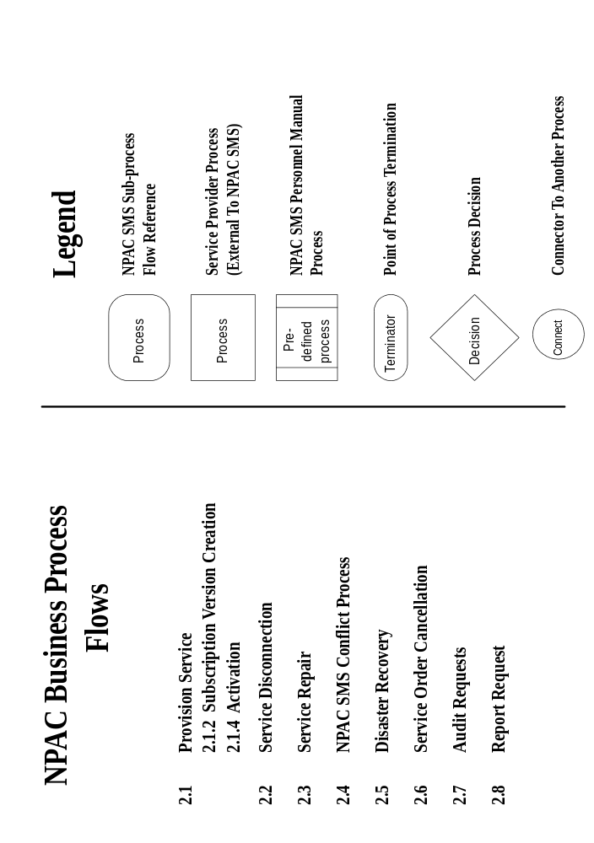
Figure 11-2 Flow 2.1 NPAC SMS Provision Service Process
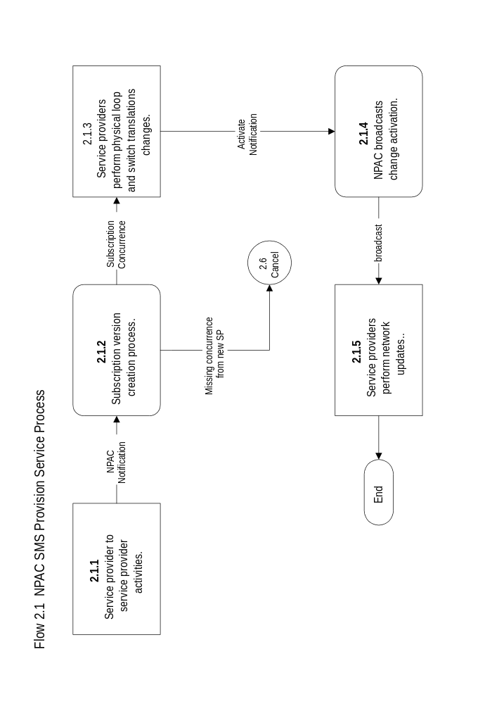
Figure 11-3 Flow 2.1.2 NPAC SMS Subscription Version Creation Process
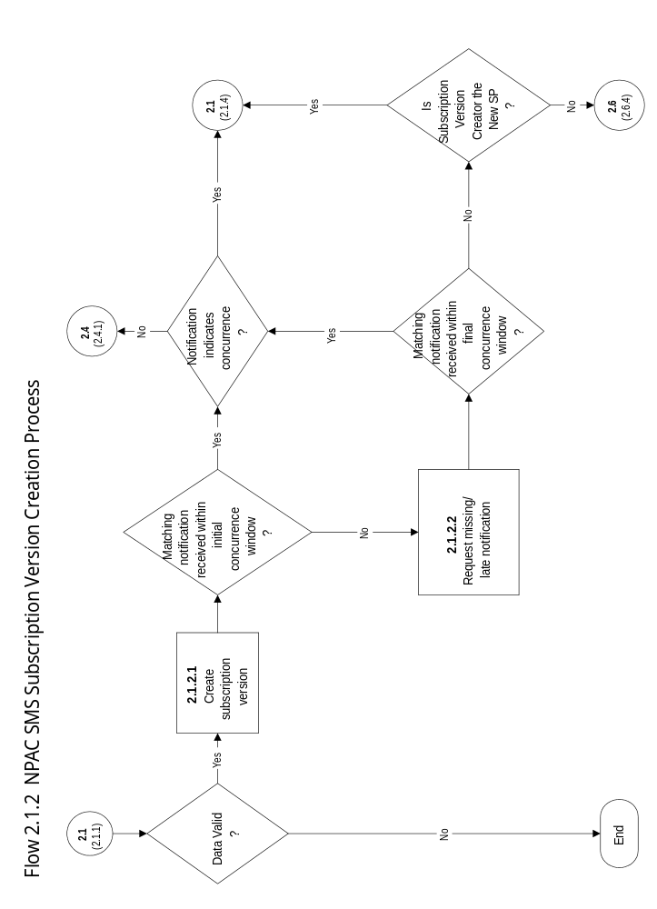
Figure 11-4 Flow 2.1.4 NPAC SMS Activate and Data Download Process
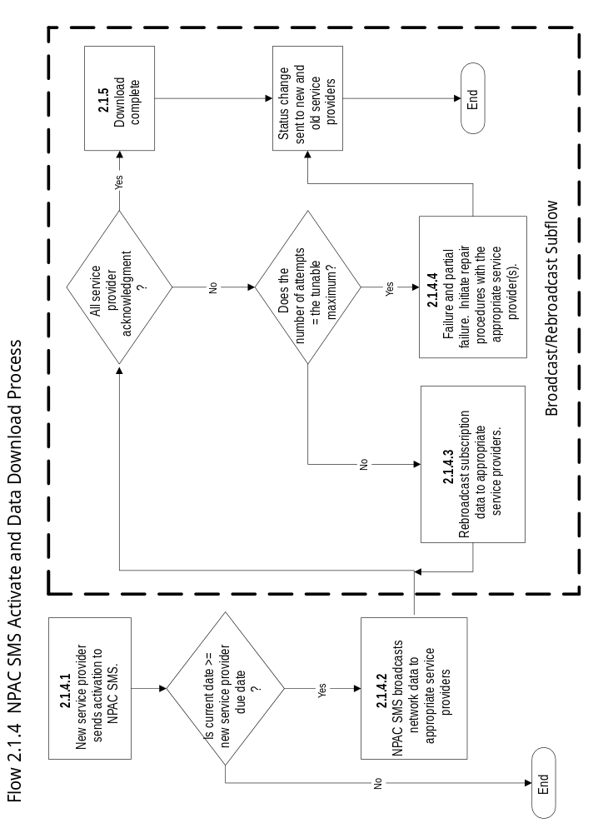
Figure 11-5 Flow 2.2 NPAC SMS Disconnect Process
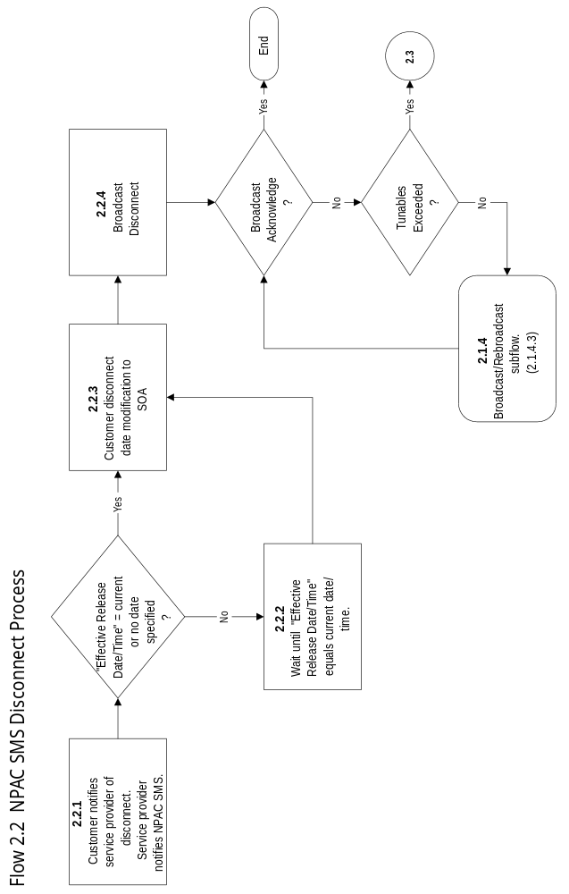
Figure 11-6 Flow 2.3 NPAC SMS Repair Process
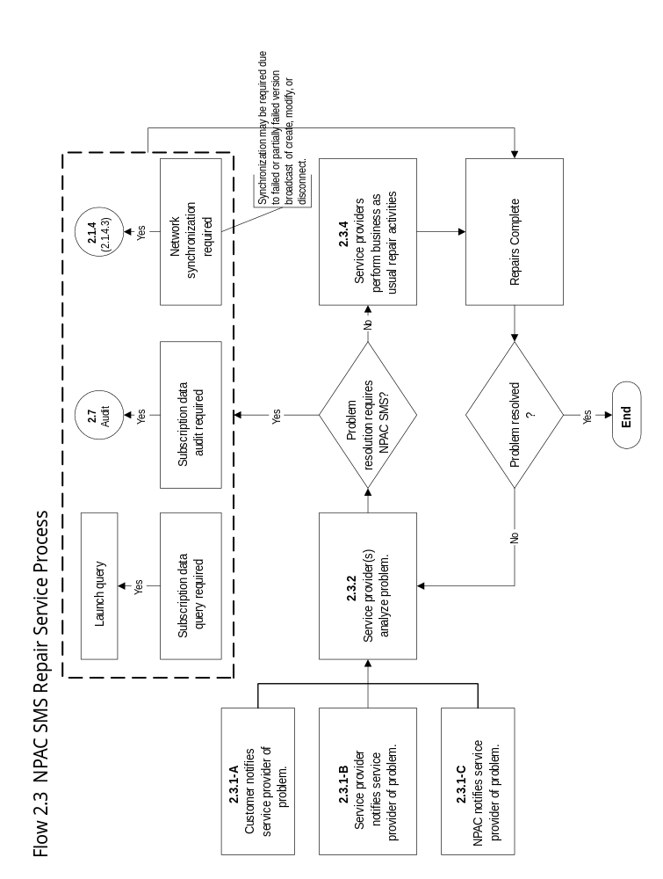
Figure 11-7 Flow 2.4.1 Conflict Process
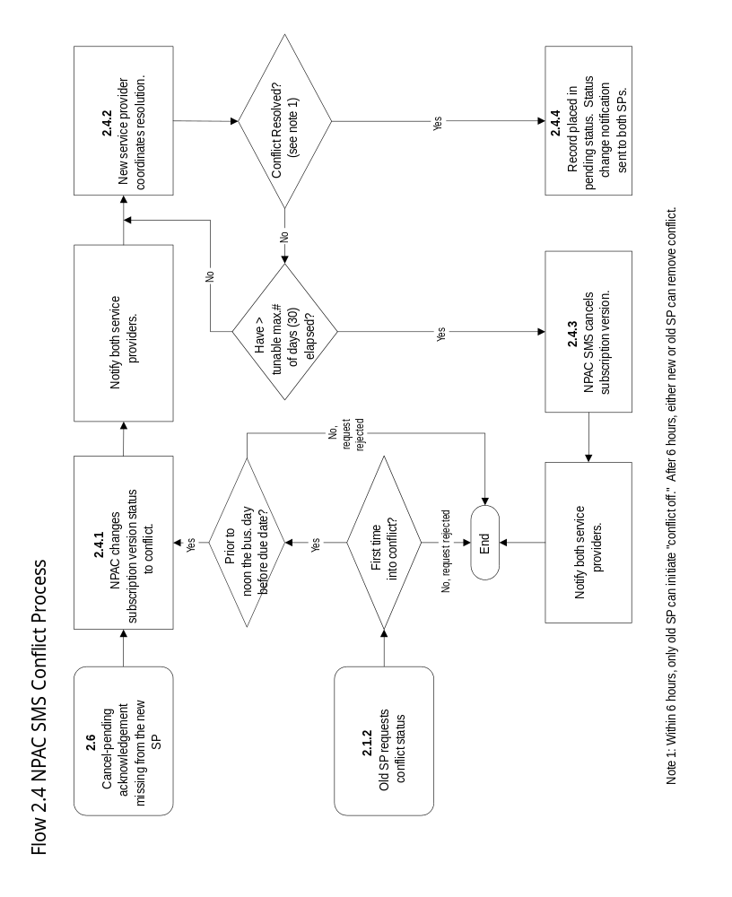
Figure 11-8 Flow 2.5 NPAC SMS Disaster Recovery Process
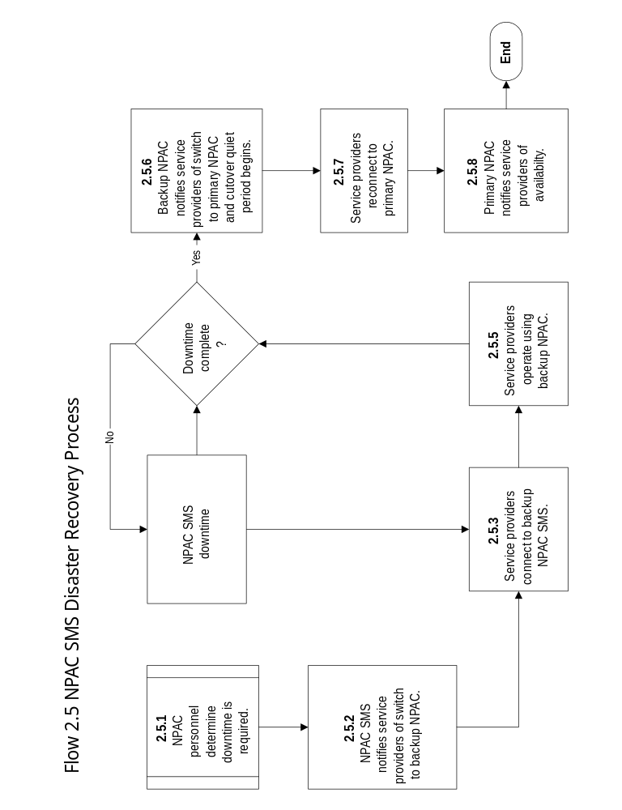
Figure 11-9 Flow 2.6 Cancellation Process
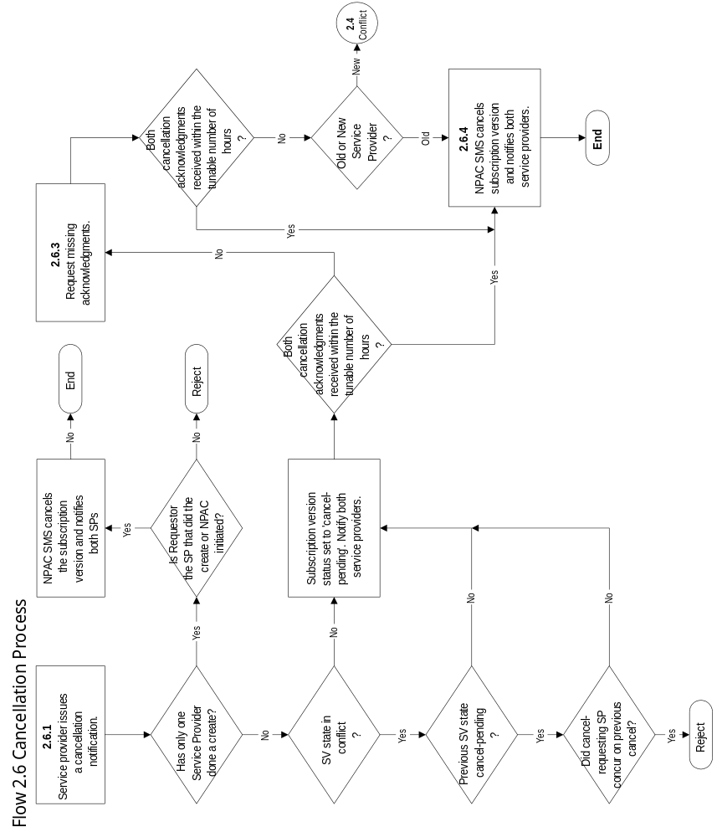
Figure 11-10 Flow 2.7 Audit Process
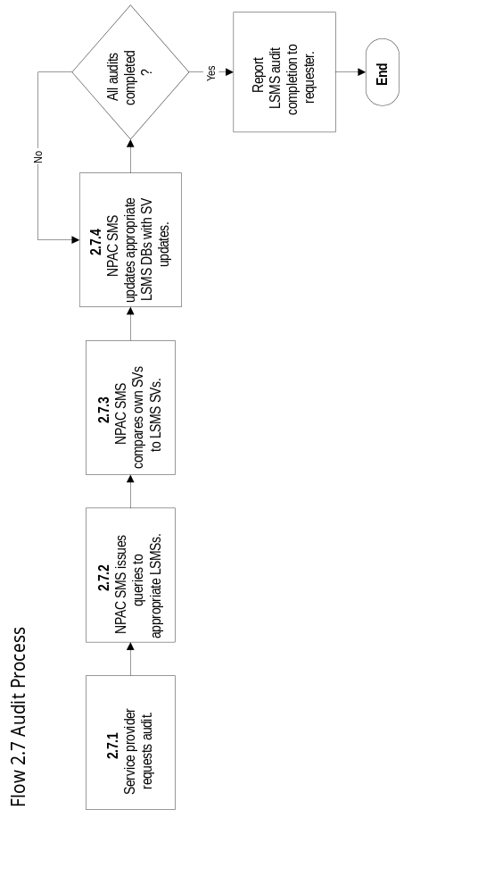
Figure 11-11 Flow 2.8 Report Process
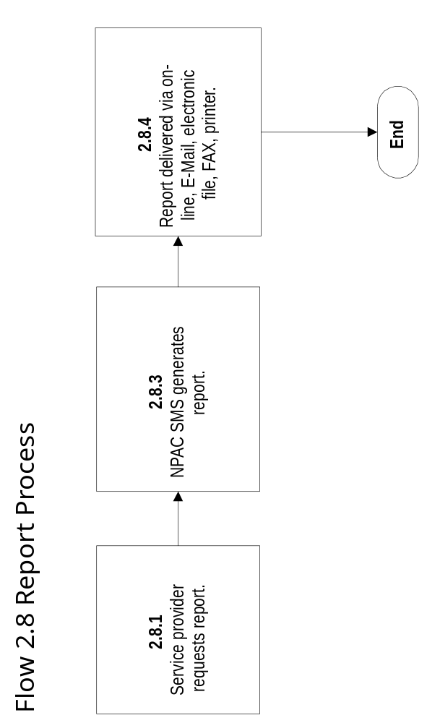

Glossary
This glossary provides a comprehensive list of definitions and acronyms that apply to NPAC SMS.
CLASS | Custom Local Area Signaling Services. Premium local service features, such as call forwarding or automatic callback.
CMIP | Common Management Information Protocol
CMISE | Common Management Information Service Element
CNAM | Caller Id with Name
DPC | Destination Point Code
FR | Frame Relay
GDMO | Guideline for the Definitions of Managed Objects
GMT | Greenwich Mean Time
GTT | Global Title Translation
ICC | Illinois Commerce Commission
ISO | International Organization of Standardization
ISVM | Inter-Switch Voice Mail
LERG | Location Exchange Routing Guide
LIDB | Line Information Database
LNP | Local Number Portability
LRN | Location Routing Number. A routing number in the same form as a TN used to identify the TN’s serving switch when the TN is a ported number.
LSMS | Local Service Management System
LISP | Local Intra-Service Provider Portability. Movement of end-user TN from one switch to another, but within the same Service Provider’s Network.
LSPP | Local Service Provider Portability. Movement of end user TN from one Service Provider to another Service Provider.
MAC | Media Access Control
MD5 | Message Digest (Version 5)
NANP | North American Numbering Plan. A 10-digit numbering scheme used in North America to uniquely identify a directory number.
NPA | An NPA code is the first three digits of the 10-digit destination number for all inter-NPA calls within the North America Numbering Plan Area.
NPAC Customer | Any customer of the NPAC SMS.
NPAC SMS | Number Portability Administration Center and Service Management System
NSAP | Network Layer Service Access Point
NXX | A code normally used as a central office code. It may also be used as an NPA code or special NPA code.
OCN | Operating Company Number
OSI | Open Systems Interconnect
PKCS | Public Key Crypto System
Ported TN | A TN ported to a switch that is not the NANP-assigned switch.
PPP | Point-To-Point Protocol
PSAP | Presentation Layer Service Access Point
RFP | Request for Proposal
RSA | A popular encryption algorithm whose name is derived from the initials of its inventors: Rivest, Shamir, and Adelman.
SCP | Service Control Point
SMS | Service Management System
SOA | Service Order Activation
SP | Service Provider. Generally refers to a facilities-based user of the NPAC SMS.
SSAP | Session Layer Service Access Point
SSN | Subsystem Number
TN | Telephone Number
TSAP | Transport Layer Service Access Point
Version | Time-sensitive or status-sensitive instance of a subscription.

System Tunables
This appendix provides a comprehensive list of tunables identified throughout the FRS and their default values.
Subscription Tunables
Tunable Name | Tunable Variable Name | Default Value | Units | Valid Range
Initial Concurrence Window | SP_Initial_Concurrence_Window | 18 | business hours | 1-72
The hours subsequent to the time the subscription version was initially created by which both Service Providers are expected to authorize transfer of service if this is an Inter-Service Provider port.
Final Concurrence Window | SP_Final_Concurrence_Window | 18 | business hours | 1-72
The number of hours after the concurrence request is sent by the NPAC SMS by which time both Service Providers are expected to authorize transfer of subscription service for an Inter-Service Provider port.
Conflict Expiration Window | SV_Conflict_Cancellation_Window | 30 | calendar days | 1-180
The length of time conflict subscriptions will remain in the conflict state before cancellation.
Maximum Subscriber Query | Max_Subscriber_Query | 50 | records | 10-150
The maximum number of active subscription versions returned by a query to the NPAC.
Pending Subscription Retention | Pending_SV_Cancellation | 90 | calendar days | 1-180
The length of time pending subscriptions will remain in the pending state before cancellation.
Conflict Restriction Window | Conflict_Restriction_Window | 12 | calendar hours | 1-72
The number of hours prior to the New Service Provider Due Date that a subscription version is prevented from being set to conflict by the Old Service Provider.
Conflict Resolution New Service Service Provider Restriction | New_SP_Conflict_Resolution_Restriction | 6 | business hours | 1-72
The number of business hours after the subscription version is put into conflict that the NPAC SMS will prevent it from being removed from conflict by the new Service Provider.
Cancellation-Initial Concurrence Window | Cancellation_Initial_Ack_Window | 9 | business hours | 1-72
The numbers of hours after the version is set to cancel pending by which both Service Providers are expected to acknowledge the pending cancellation.
Cancellation-Final Concurrence Window | Cancellation_Final_Ack_Window | 9 | business hours | 1-72
The number of hours after the second cancel pending notification is sent by which both Service Providers are expected to acknowledge the pending cancellation.
Old Subscription Retention | Purge_Old_SV | 18 | calendar months | 1-36
The length of time old subscriptions will be retained.
Cancel-Pending Subscription Retention | Purge_Canceled_Pending_SV | 90 | calendar days | 1-360
The length of time canceled subscriptions, with last status of pending, will be retained.
Cancel-Conflict Subscription Retention | Purge_Canceled_Conflict_SV | 30 | calendar days | 1-360
The length of time canceled subscriptions, with last status of conflict, will be retained.
Cancel-Disconnect Pending Retention | Purge_Canceled_Disconnect_Pending_SV | 90 | calendar days | 1-360
The length of time canceled subscriptions, with last status of disconnect pending, will be retained.
Business Day Duration | Business_Day_Duration | 12 | calendar hours | 1-24
The number of hours from the tunable business day start time.
Business Day Start Time | Business_Day_Start | 07:00 CST | hh:mm | 00:00 - 24:00
The start of the business day in Central Standard Time.
Table 11-1 Subscription Tunables

Communciations Tunables
Tunable Name | Tunable Variable Name | Default Value | Units | Valid Range
Subscription Activation Retry Attempts | Subscription_Version_Activation_Retry | 3 | attempts | 1-10
The number of times a new subscription version will be sent to a Local SMS which has not acknowledged receipt of the activation request.
Subscription Activation Retry Interval | Subscription_Version_Activation_Retry  _Interval | 2 | minutes | 1-60
The delay between sending new Subscription Versions to a Local SMS that has not acknowledged receipt of the activation request.
Subscription Modification Retry Attempts | Subscription_Version_Modification_Retry | 3 | attempts | 1-10
The number of times a modified active subscription version will be sent to a Local SMS which has not acknowledged receipt of the modification request.
Subscription Modification Retry Interval | Subscription_Version_Modification_Retry  _Interval | 2 | minutes | 1-60
The delay between sending modified active subscription versions to a Local SMS that has not acknowledged receipt of the modification request.
Subscription Disconnect Retry Attempts | Subscription_Version_Disconnect_Retry | 3 | attempts | 1-10
The number of times the NPAC SMS will resend a subscription disconnect message to an unresponsive Local SMS.
Subscription Disconnect Retry Interval | Subscription_Version_Disconnect_Retry  _Interval | 2 | minutes | 1-60
The amount of time that shall elapse between subscription disconnect retries.
Local SMS Retry Attempts | LSMS_Retry_Attempts | 3 | attempts | 1-10
The default number of times the NPAC SMS will resend a message to an unresponsive Local SMS.
Local SMS Retry Interval | LSMS_Retry_Interval | 2 | minutes | 1-60
The default delay between sending messages to an unresponsive Local SMS.
SOA Retry Attempts | SOA_Retry_Attempts | 3 | attempts | 1-10
The default number of times the NPAC SMS will resend a message to an unresponsive SOA.
SOA Retry Interval | SOA_Retry_Interval | 2 | minutes | 1-60
The default delay between sending messages to an unresponsive SOA.
Failed Login Attempts | Failed_Login_Attempts | 3 | attempts | 0-10
The number of allowable incorrect logon attempts
Failed Login Shutdown Period | Failed_Login_Shutdown_Period | 60 | seconds | 0-300
The amount of time the NPAC SMS will wait to restart the logon process after a user has exceeded the Failed_Login_Attempts tunable.
Unused User Id Disable Period | Unused_User_Id_Disable_Period | 60 | days | 1-360
The number of days for which a userId has not been used before the NPAC SMS disables that userId.
Password Age Limit | Password_Age_Limit | 90 | days | 1-360
The amount of time for password aging.
Password Expiration Notice | Password_Expiration_Notice | 7 | days | 1-30
The amount of time prior to a password expiring that the NPAC SMS will notify a user.
Post Expiration Logins | Post_Expiration_Logins | 2 | logins | 0-10
The number of logins a user is permitted after the user’s password has expired.
Password Reuse Limit | Password_Reuse_Limit | 6 | months | 1-36
The amount of time in which a password cannot be reused.
Record Logons After Failure | Record_Logons_After_Failure | 10 | attempts | 0-100
The threshold for consecutive failed logon attempts after which logon attempts will be recorded in the audit log.
Non-Use Disconnect | Non_Use_Disconnect | 60 | minutes | 1-1440
The amount of idle (non-use) time before the NPAC SMS will disconnect a user’s logon session.
Maximum Number of Download Records | Maximum_Number_Download_Records | 10000 | records | 1-200000
The maximum number of records for a single data download.
Maximum Download Duration | Maximum_Download_Duration | 60 | minutes | 1-1440
The maximum time range allowed for a data download.
Table 11-2 Communications Tunables

Audit Tunables
Tunable Name | Tunable Variable Name | Default Value | Units | Valid Range
Canceled Audit Retention Period | Canceled_Audit_Retention_Period | 30 | days | 1-360
The length of time canceled audits will be retained.
Data Integrity Sample Size | Data_Integrity_Sample_Size | 1000 | SVs | 1-5000
The number of active Subscription Versions in a sample to be monitored by the NPAC SMS.
Data Integrity Sample Frequency | Data_Integrity_Sample _Frequency | 7 | Days | 1-90
The interval in days between Data Integrity Samples conducted by the NPAC SMS.
Subscription Query Record Limit | Subscription_Query_Record_Limit | 50 | Subscriptions | 1-5000
The maximum number of records that can be returned from a query.
Table 11-3 Audit Tunables

Logs Tunables
Tunable Name | Tunable Variable Name | Default Value | Units | Valid Range
Local SMS Activation Log Retention Period | Local_SMS_Activation_Log_Duration | 90 | days | 1-360
The number of days Local SMS activation responses will remain in the log.
Audit Log Retention Period | Audit_Log_Retention_Period | 90 | days | 1-360
The length of time audit logs will be retained.
Error Log Retention Period | Error_Log_Retention_Period | 90 | days | 1-360
The length of time system error logs will be retained.
History File Data Storage | History_File_Data_Storage | 365 | days | 1-365
The length of time history logs will be retained.
Usage Log Retention | Usage_Log_Retention | 90 | days | 1-360
The length of time usage logs will be retained.
Table 11-4 Logs Tunables

Keys Tunables
Tunable Name | Tunable Variable Name | Default Value | Units | Valid Range
Key Change Interval | Key_Change_Interval | 7 | days | 1-365
How often the key is changed automatically.
Table 11-5 Keys Tunables

