NPAC SMS

Interoperable Interface Specification

NANC Version 1.10

Prepared for:
The North American Numbering Council (NANC)
July 8, 1998

© 1998 LOCKHEED MARTIN IMS CORPORATION

The Work is subject to the terms of the GNU General Public License (the “GPL”), a copy of which may be found at
ftp://prep.ai.mit.edu/pub/gnu/GPL. Any use of this Work is subject to the terms of the GPL. The “Work” covered by the GPL by
operation of this notice and license is this document and any and all modifications to or derivatives of this document.
Where the words “Program,” “software,” “source code,” “code,” or “files” are used in the GPL, users understand and agree that
the “Work” as defined here is substituted for purposes of this notice and license.

Table Of Contents
1 Introduction 1
1.1 Document Overview 1
1.2 How To Use This Document 1
1.3 Document Version History 2
1.4 References 2
1.4.1 Standards 2
1.4.2 Related Publications 4
1.5 Abbreviations/Definitions 4
2 Interface Overview 7
2.1 Overview 7
2.2 OSI Protocol Support 7
2.3 SOA to NPAC SMS Interface 8
2.3.1 Subscription Administration 8
2.3.2 Audit Requests 8
2.3.3 Notifications 8
2.3.4 Service Provider Data Administration 9
2.4 NPAC SMS to Local SMS Interface 9
2.4.1 Subscription Version and Network Data Download 9
2.4.2 Service Provider Data Administration 9
2.4.3 Notifications 10
3 Hierarchy Diagrams 11
3.1 Overview 11
3.1.1 Managed Object Model Inheritance Hierarchy 11
3.1.2 Log Record Managed Object Hierarchy 13
3.1.3 NPAC SMS to Local SMS Naming Hierarchy for the NPAC SMS 14
3.1.4 NPAC SMS to Local SMS Naming Hierarchy for the Local SMS 15
SOA to NPAC SMS Naming Hierarchy for the NPAC SMS 16
4 Interface Functionality to CMIP Definition Mapping 17
4.1 Overview 17
4.1.1 Primary NPAC Mechanized Interface Operations 17
4.1.2 Managed Object Interface Functionality 20
4.1.3 Attribute Interface Functionality 22
4.1.4 Action Interface Functionality 33
4.1.5 Notification Interface Functionality 34
4.2 Scoping and Filtering Support 36
4.2.1 Scoping 36
4.2.2 Filtering 36
4.2.3 Action Scoping and Filtering Support 37
4.3 lnpLocal-SMS-Name and lnpNPAC-SMS-Name Values 37
4.4 OID Usage Information 38
4.4.1 OIDs Used for Bind Requests 38
4.4.2 Other OIDs of Interest 38
4.5 Naming Attributes 38
4.6 Subscription Version M_DELETE Messages 38
5 Secure Association Establishment 39
5.1 Overview 39
5.2 Security 39
5.2.1 Authentication and Access Control Information 40
5.2.1.1 System Id 41
5.2.1.2 System Type 41
5.2.1.3 User Id 41
5.2.1.4 List Id 41
5.2.1.5 Key Id 41
5.2.1.6 CMIP Departure Time 42
5.2.1.7 Sequence Number 42
5.2.1.8 Association Functions 43
5.2.1.9 Recovery Mode 44
5.2.1.10 Signature 44
5.2.2 Association Establishment 44
5.2.3 Data Origination Authentication 46
5.2.4 Audit Trail 48
5.3 Association Management and Recovery 48
5.3.1 Establishing Associations 48
5.3.1.1 NpacAssociationUserInfo 48
5.3.1.2 Unbind Requests and Responses 49
5.3.1.3 Aborts 49
5.3.1.4 NPAC SMS Behavior 49
5.3.1.5 Service Provider SOA and Local SMS Procedures 50
5.3.2 Releasing or Aborting Associations 51
5.3.3 Error Handling 51
5.3.3.1 NPAC SMS Error Handling 51
5.3.3.2 Processing Failure Error 52
5.3.4 Resynchronization 52
5.3.4.1 Local SMS Resynchronization 52
5.3.4.2 SOA Resynchronization 53
6 Message Flow Diagrams 55
6.1 Overview 55
6.2 Audit Scenarios 56
6.2.1 SOA Initiated Audit 56
6.2.2 SOA Initiated Audit Cancellation by the SOA 59
6.2.3 SOA Initiated Audit Cancellation by the NPAC 60
6.2.4 NPAC Initiated Audit 61
6.2.5 NPAC Initiated Audit Cancellation by the NPAC 63
6.2.6 Audit Query on the NPAC 64
6.3 Service Provider Scenarios 65
6.3.1 Service Provider Creation by the NPAC 65
6.3.2 Service Provider Deletion by the NPAC 66
6.3.3 Service Provider Modification by the NPAC 68
6.3.4 Service Provider Modification by the Local SMS 69
6.3.5 Service Provider Modification by the SOA 70
6.3.6 Service Provider Query by the Local SMS 71
6.3.7 Service Provider Query by the SOA 72
6.4 Service Provider Network Data Scenarios 73
6.4.1 NPA-NXX Scenarios 73
6.4.1.1 NPA-NXX Creation by the NPAC 73
6.4.1.2 NPA-NXX Deletion by the NPAC 74
6.4.1.3 NPA-NXX Creation by the Local SMS 75
6.4.1.4 NPA-NXX Creation by the SOA 76
6.4.1.5 NPA-NXX Deletion by the Local SMS 77
6.4.1.6 NPA-NXX Deletion by the SOA 78
6.4.1.7 NPA-NXX Query by the Local SMS 79
6.4.1.8 NPA-NXX Query by the SOA 80
6.4.2 LRN Scenarios 81
6.4.2.1 LRN Creation by the NPAC 81
6.4.2.2 LRN Creation by the SOA 82
6.4.2.3 LRN Deletion by the SOA 83
6.4.2.4 LRN Query by the SOA 84
6.4.2.5 LRN Deletion by the NPAC 85
6.4.2.6 LRN Creation by the Local SMS 86
6.4.2.7 LRN Deletion by the Local SMS 87
6.4.2.8 LRN Query by the Local SMS 88
6.4.2.9 Network Data Download 89
6.4.2.10 Scoped/Filtered GET of Network Data 90
6.4.2.11 Scoped/Filtered GET of Network Data from SOA 91
6.5 SubscriptionVersion Flow Scenarios 92
6.5.1 SubscriptionVersion Create Scenarios 92
6.5.1.1 SubscriptionVersion Create by the Initial SOA (Old Service Provider) 93
6.5.1.2 SubscriptionVersion Create by the Initial SOA (New Service Provider) 96
6.5.1.3 SubscriptionVersion Create by Second SOA (New Service Provider) 99
6.5.1.4 SubscriptionVersion Create by Second SOA (Old Service Provider) 101
SubscriptionVersion Activated by New Service Provider SOA 103
6.5.1.6 Active SubscriptionVersion Create on Local SMS 105
6.5.1.7 SubscriptionVersionCreate M-CREATE Failure to Local SMS 112
6.5.1.8 SubscriptionVersion M-CREATE: Partial Failure to Local SMS 114
6.5.1.9 Create Subscription Version: Resend Successful to Local SMS Action 116
6.5.1.10 Subscription Version: Resend Failure to Local SMS 118
6.5.1.11 SubscriptionVersion Create for Intra-Service Provider Port 120
6.5.1.12 SubscriptionVersion Port-to-Original: Successful 122
6.5.1.13 SubscriptionVersion Port-to-Original: All LSMSs Fail 126
6.5.1.14 SubscriptionVersion Port-to-Original: Partial Failure 130
6.5.1.15 SubscriptionVersion Port-to-Original: Resend 134
6.5.1.16 SubscriptionVersion Port-to-Original: Resend Failure to Local SMS 138
6.5.2 Modify Scenarios 142
6.5.2.1 SubscriptionVersion Modify Active Version Using M-ACTION by a Service Provider SOA 142
6.5.2.2 SubscriptionVersion Modify Active: Failure to Local SMS 145
6.5.2.3 SubscriptionVersion Modify Prior to Activate Using M-ACTION 147
6.5.2.4 SubscriptionVersion Modify Prior to Activate Using M-SET 149
6.5.2.5 Subscription Version Modify Active: Resend Successful to Local SMS 151
6.5.2.6 Subscription Version Modify Active: Resend Failure to Local SMS 153
6.5.3 Cancel Scenarios 155
6.5.3.1 SubscriptionVersion Cancel by Service Provider SOA After Both Service Provider SOAs Have Concurred 155
6.5.3.2 SubscriptionVersionCancel: No Acknowledgment from a SOA 157
6.5.3.3 Subscription Version Cancels With Only One Create Action Received 159
6.5.4 Disconnect Scenarios 161
6.5.4.1 SubscriptionVersion Immediate Disconnect 161
6.5.4.2 SubscriptionVersion Disconnect With Effective Release Date 164
6.5.4.3 SubscriptionVersion Disconnect: Failure to Local SMS 166
6.5.4.4 SubscriptionVersion Disconnect: Partial Failure to Local SMS 168
6.5.4.5 Subscription Version Disconnect: Resend Successful to Local SMS 170
6.5.4.6 Subscription Version Disconnect: Resend Failure to Local SMS 172
6.5.5 Conflict Scenarios 174
6.5.5.1 SubscriptionVersion Conflict and Conflict Resolution by the NPAC SMS 174
6.5.5.2 Subscription Version Conflict Removal by the New Service Provider SOA 177
6.5.5.3 SubscriptionVersion Conflict: No Conflict Resolution 179
6.5.5.4 Subscription Version Conflict by Old Service Provider Explicitly Not Authorizing (First Create) 181
6.5.6 SubscriptionVersion Query 183
6.5.6.1 Subscription Data Download 185
6.6 LSMS Filter NPA-NXX Scenarios 186
6.6.1 lsmsFilterNPA-NXX Creation by the Local SMS 186
6.6.2 lsmsFilterNPA-NXX Deletion by the Local SMS 187
6.6.3 lsmsFilterNPA-NXX Query by the Local SMS 188
6.6.4 lsmsFilterNPA-NXX Creation by the SOA 189
6.6.5 lsmsFilterNPA-NXX Deletion by the SOA 190
6.6.6 lsmsFilterNPA-NXX Query by the SOA 191
6.7 Miscellaneous 192
6.7.1 Sequencing of Events on Initialization/Resynchronization of Local SMS 192
6.7.2 SOA/Local SMS Notification of Scheduled NPAC Downtime 194
6.7.3 NPA-NXX Split 195
6.7.4 Mass Update 196
7 GDMO Definitions 199
7.1 Overview 199
7.2 Object Definitions 199
7.3 Name Binding Definitions 224
7.4 Attribute Definitions 227
7.5 Package Definitions 254
7.6 Parameter Definitions 259
7.7 Action Definitions 260
7.8 Notification Definitions 271
8 General ASN.1 Definitions 279
8.1 Overview 279
8.2 LNP ASN.1 Object Identifier Definitions 279
8.3 LNP General ASN.1 Definitions 280
9 Managed Object Conformance Statements 295
9.1 Overview 295
9.2 alarmRecord Tables 295
9.3 AttributeValueChangeRecord Tables 298
9.4 eventLogRecord Tables 299
9.5 lnpAudits Tables 301
9.6 lnpLocalSMS Tables 302
9.7 lnpLogAudit-DiscrepancyRptRecord Tables 303
9.8 lnpLogAuditResultsRecord Tables 305
9.9 lnpLogCancellationAcknowledgeRequestRecord Tables 307
9.10 lnpLogDonorSP-CustomerDisconnectDateRecord Tables 308
9.11 lnpLogLocalSMS-ActionResultsRecord Tables 310
9.12 lnpLogNewNPA-NXXRecord Tables 311
9.13 lnpLogNewSP-CreateRequestRecord Tables 313
9.14 lnpLogOldSP-ConcurrenceRequestRecord Tables 315
9.15 lnpLogOldSPFinalConcurrenceWindowExpirationRecord Tables 316
9.16 lnpLogOperational-InformationRecord Tables 318
9.17 lnpLogStatusAttributeValueChangeRecord Tables 319
9.18 lnpNPAC-SMS Tables 321
9.19 lnpNetwork Tables 322
9.20 lnpServiceProvs Tables 323
9.21 lnpSubscriptions Tables 324
9.22 logRecord Tables 326
9.23 logSMI Tables 327
9.24 lsmsFilterNPA-NXX Tables 329
9.25 objectCreationRecord Tables 330
9.26 objectDeletionRecord Tables 332
9.27 root Tables 334
9.28 securityAlarmReportRecord Tables 335
9.29 serviceProv Tables 336
9.30 serviceProvLRN Tables 338
9.31 serviceProvNPA-NXX Tables 340
9.32 serviceProvNetwork Tables 341
9.33 stateChangeRecord Tables 342
9.34 subscriptionAudit Tables 344
9.35 subscriptionVersion Tables 345
9.36 subscriptionVersionNPAC Tables 347
9.37 top Tables 350
10 Subscription Version Status 353
Appendix A: Errors 351

1 Introduction
1

1.1 Document Overview
The NPAC SMS Interoperable Interface Specification contains the information model for the Number Portability Administration Center and Service Management System (NPAC SMS) mechanized interfaces. Both Service Order Activation (SOA) and Local Service Management System (LSMS or Local SMS) interfaces to the NPAC SMS are described in this document.

1.2 How To Use This Document
The NPAC SMS Interoperable Interface Specification contains the following chapters:
Chapter 1 Introduction -- This chapter describes the conventions and organization of this document. It also lists related documentation.
Chapter 2Interface Overview -- This chapter contains an overview of protocol requirements and a brief description of the functionality provided in each interface.
Chapter 3 Hierarchy Diagrams -- This chapter contains the class hierarchy diagrams for all managed objects defined in the interoperable interface.
Chapter 4 Interface Functionality to CMOP Definition Mapping -- This chapter contains the mapping of the interface functionality to the managed objects, attributes, actions, and notifications.
Chapter 5 Secure Association Establishment-- This chapter contains information on secure association establishment.
Chapter 6 Message Flow Diagrams -- This chapter contains the message flow diagrams.
Chapter 7 GDMO Definitions -- This chapter contains the GDMO interface definitions supporting the SOA to NPAC SMS interface and the NPAC SMS to Local SMS interface
Chapter 8 General ASN.1 Definitions -- This chapter contains the ASN.1 definitions that support the GDMO definitions in Chapter 7.
Chapter 9 Managed Object Conformance Statements -- This chapter contains the Managed Object Conformance tables.
Chapter 10 Subscription Version Status -- This chapter contains a Subscription Version Status diagram, which illustrates the transition from one subscription version state to another.
Appendix A Errors -- This appendix contains the valid errors associated with CMISE confirmed primitives used in the interoperable interface definitions.

1.3 Document Version History
NANC Version 1.0, released on 04/07/97, contains changes from the ICC Subcommittee IIS Version 1.1.5.
NANC Version 1.1, released on 05/08/97, contains changes from the NANC IIS Version 1.0.
NANC Version 1.2, released on 05/25/97, contains changes from the NANC IIS Version 1.1.
NANC Version 1.3, released on 07/09/97, contains changes from the NANC IIS Version 1.2.
NANC Version 1.4, released on 08/08/97, contains changes from the NANC IIS Version 1.3.
NANC Version 1.5, released on 09/09/97, contains changes from the NANC IIS Version 1.4.
NANC Version 1.6, released on 11/12/97, contains changes from the NANC IIS Version 1.5.
NANC Version 1.7, released on 12/12/97, contains changes from the NANC IIS Version 1.6.
NANC Version 1.8, released on 2/11/98, contains changes from the NANC IIS Version 1.7.
NANC Version 1.9, released on 5/13/98, contains changes from the NANC IIS Version 1.8.

NANC Version 1.10, released on 7/8/98, contains the following changes from the NANC IIS Version 1.9:
- Change Order NANC 133 – Audit Object Definition
- Change Order NANC 197 – IIS Clarification for Congestion Handling
- Change Order NANC 211 – Flow Modification for Failed SP List Updates
- Change Order NANC 215 – Immediate Disconnects – Section 6.5.4 of IIS

1.4 References

1.4.1 Standards
ANSI T1.224-1992, Operations, Administration, Maintenance, and Provisioning (OAM&P) - Protocols for Interfaces between Operations Systems in Different Jurisdictions.
ANSI T1.243-1995, Telecommunications, Operations, Administration, Maintenance and Provisioning (OAM&P) - Baseline Security Requirements for the Telecommunications Management Network (TMN).
ANSI T1.246, Operations, Administration, Maintenance and Provisioning (OAM&P) - Information Model and Services for Interfaces between Operations Systems across Jurisdictional Boundaries to Support Configuration Management - Customer Account Record Exchange (CARE).
Bellcore TA- 1253, Generic Requirements for Operations Interfaces Using OSI Tools: Network Element Security Administration.
Committee T1 Technical Report No, 40, Security Requirements for Electronic Bonding Between Two TMNs.
ISO/IEC 11183-1:1992, Information Technology - International Standardized Profiles AOM ln OSI Management - Management Communications - Part 1 Specification of ACSE, Presentation and Session Protocols for the use by ROSE and CMISE.
ISO/IEC 11183-2:1992, Information Technology - International Standardized Profiles AOM ln OSI Management - Management Communications - Part 2: CMISE/ROSE for AOM12 - Enhanced Management Communications.
ISO/IEC 11183-3:1992, Information Technology - International Standardized Profiles AOM ln OSI Management - Management Communications - Part 3: CMISE/ROSE for AOM12 - Basic Management Communications.
ITU X.509, Information Technology - Open Systems Interconnection - The Directory Authentication Framework.
ITU X.690/ISO IS 8825-1 Annex D, ASNI/BER Encoding of Digital Signatures and Encrypted Cyphertext.
ITU X.741, OSI Systems Management, Objects and Attributes for Access Control
ITU X.803, Upper Layers Security Model.
NMF Forum 016, Issue 1.0, 1992, OMNIPoint 1 Specifications and Technical Reports, Application Services Security of Management.
OIW Stable Implementation Agreement, Part 12, 1995.
Rec. M.3100:1992 & 1995 draft, Generic Network Information Model.
Rec. X.701 | ISO/IEC 10040:1992, Information Technology - Open System Interconnection - Common Management Overview.
Rec. X.710 | ISO/IEC 9595:1990, Information Technology - Open System Interconnection - Common Management Information Service Definitions.
Rec. X.711 | ISO/IEC 9596-1:1991, Information Technology - Open System Interconnection - Common Management Information Protocol - Part 1: Specification.
Rec. X.720 | ISO/IEC 10165-1:1991, Information Technology - Open System Interconnection - Structure of Management Information - Part 1 Management Information Model.
Rec. X.721 | ISO/IEC 10165-2:1992, Information Technology - Open System Interconnection - Structure of Management Information: Guidelines for the Definition of Managed Objects.
Rec. X.722 | ISO/IEC 10165-4:1992, Information Technology - Open System Interconnection - Structure of Management Information: Guidelines for the Definition of Managed Objects.
Rec. X.730 | ISO/10164-1:1992, Information Technology - Open System Interconnection - System Management - Part 1: Object Management Function.
Rec. X.734 | ISO/10164-5:1992, Information Technology - Open System Interconnection - System Management - Part 5: Event Report Management Function.
Rec. X.735 | ISO/10164-6:1992, Information Technology - Open System Interconnection - System Management - Part 6: Log Control Function.
Rec. X.209: 1988, Specification for Basic Encoding Rules for Abstract Syntax Notation One (ANS.1).
Rec. X.690: 1994, ASN.1 Encoding Rules: Specification of Basic Encoding Rules (BER), Canonical Encoding Rules (CER), and Distinguished Encoding Rules (DER).
Rec. X.208: 1988, Specification of Abstract Syntax Notation One (ASN.1).
Rec. X.680 | ISO/IEC 8824-1: 1994, Information Technology - Abstract Syntax Notation One (ASN.1) - Specification of Basic Notation.
Rec. X.680 Amd.1 | ISO/IEC 8824-1 Amd.1, Information Technology - Abstract Syntax Notation One (ASN.1) - Specification of Basic Notation 1 Amendment 1: Rules of Extensibility.
ITU-T Recommendations are available from the US Department of Commerce, National Technical Information Service, 5285 Port Royal Road, Springfield, VA 22161. ISO standard are available from the American National Standards Institute, 11 West 42nd Street, New York, NY 10036.

1.4.2 Related Publications
Illinois Commerce Commission Number Portability Administration Center and Service Management System Request for Proposal (ICC NPAC/SMS RFP), February 6, 1996.
Lockheed Martin Team Response to the Illinois Commerce Commission Number Portability Administration Center and Management System Request for Proposal, March 18, 1996.
Scoggins, Sophia and Tang, Adrian 1992. Open networking with OSI. Englewood Cliffs, NJ, Prentice-Hall.
Stallings, William 1993. SNMP, SNMPv2, and CMIP, The Practical Guide to Network-Management Standards, Reading Massachusetts, Addison-Wesley.
North American Number Council (NANC) Functional Requirements Specification, Number Portability Administration Center (NPAC), Service Management System (SMS), Version 1.10, July 8, 1998.

1.5 Abbreviations/Definitions
A-PDU | Application Protocol Data Unit
ASN.1 | Abstract Syntax Notation 1
BER | Basic Encoding Rules
CARE | Customer Account Record Exchange
CER | Canonical Encoding Rules
CLASS  CME | Custom Local Area Signaling Services  Conformance Management Entity
CMIP | Common Management Information Protocol
CMISE | Common Management Information Service Element
CNAM | Caller Id with Name
GDMO | Generalized Definitions of Managed Objects
DER | Distinguished Encoding Rules
DES | Data Encryption Standard
FR | Frame Relay
IEC | International Electrotechnical Commission
ISO | International Organization of Standardization
ISVM | Inter-Switch Voice Mail
LIDB | Line Information Database
LNP | Local Number Portability
LRN | Location Routing Number
LSMS | Local Service Management System
LSPP | Local Service Provider Portability
MAC | Media Access Control
MD5 | Message Digest (Version 5)
NE | Network Element
NMF | Network Management Forum
NPAC SMS | Number Portability Administration Center and Service Management System
NPA | Numbering Plan Area
NXX | Exchange
OCN  OSI | Operating Company Number  Open Systems Interconnect
PPP | Point-To-Point Protocol
RFP | Request for Proposal
RSA | Encryption Scheme
SOA | Service Order Activation
TMN | Telecommunications Management Network
SMS | Service Management System
TN | Telephone Number

2 Interface Overview

2.1 Overview
2
This specification defines the interfaces between the NPAC SMS and the service providers’ Service Order Entry System and Local SMS. The interfaces, defined using the CMIP protocol, are referred to as the SOA to NPAC SMS interface and the NPAC SMS to Local SMS interface respectively. CMISE M-CREATE, M-DELETE, M-SET, M-GET, M-EVENT-REPORT, and M-ACTION primitives are fully supported in a confirmed mode. The relationship from the SOA to the NPAC SMS is a manager to agent relationship. The relationship between the Local SMS to NPAC SMS is a manager to agent or an agent to manager relationship depending on the function being performed. The SOA and Local SMS interfaces are defined by Association Functions. These functions allow each association to define the services it supports. Association establishment from the SOAs and Local SMSs to the NPAC SMS, Association Function and security for each of these interfaces is discussed in Chapter 5, 5 Secure Association Establishment.
Note: The M-CANCEL-GET primitive may not be supported in some NPAC SMS implementations due to the fact that this functionality was not determined necessary for the interface defined.
The sections that follow provide an overview of protocol requirements and a brief description of the functionality provided in each interface. Complete functional descriptions for the interfaces are provided in the process flow diagrams in Chapter 6, Message Flow Diagrams, as well as the behavior for the managed objects.

2.2 OSI Protocol Support
The SOA to NPAC SMS and NPAC SMS to Local SMS interfaces must be implemented over the protocol stack shown in Exhibit 1.
Exhibit 1. NPAC/SMS Primary Network Protocol Stacks
Layer | Mechanized Interface | Function
 | CMIP Agent Server | User
7 | CMISE, ACSE, ROSE | Application
6 | ANSI T1.224 | Presentation
5 | ANSI T1.224 | Session
4 | TCP, RFC1006, TPO | Transport
3 | IP | Network
2 | PPP, MAC, FRAME Relay, ATM (IEEE 802.3) | Link
1 | DS-1, DS-0 x n, ISDN, V.34 | Physical
Multiple associations per service provider to the NPAC SMS can be supported. The secure association establishment is described in Chapter .

2.3 SOA to NPAC SMS Interface
The SOA to NPAC SMS interface, which allows communication between a service provider’s Service Provisioning Operating Systems and/or Gateway systems and the NPAC SMS, supports the retrieval and update of subscription, service provider, and network information. The following transactions occur to support local number portability functionality:
- SOA requests for subscription administration to the NPAC SMS and responses from the NPAC SMS to the SOA.
- Audit requests from the SOA to the NPAC SMS and responses from the NPAC SMS to the SOA.
- Notifications from the NPAC SMS to the SOA of subscription version data changes, need for concurrence or authorization for number porting, conflict-resolution, cancellation, outage information, or customer disconnect dates.
- Service provider data administration from the SOA to the NPAC SMS.
Mapping of this functionality into the CMIP Definitions is provided in Chapter (see Exhibit 7.)

2.3.1 Subscription Administration
Service provider subscription administration functionality includes the capability to:
- Create a subscription version
- Cancel a subscription version
- Acknowledge cancellation of a subscription version
- Modify a subscription version or range of versions
- Retrieve a specific subscription version or range of versions
- Activate a version or range of versions
- Disconnect a subscription version or range of versions
- Remove a subscription version from conflict

2.3.2 Audit Requests
Audit functionality allows the SOAs to request audits for a subscription version or group of subscription versions based on a Telephone Number (TN) for a specified service provider or all service provider networks. The action SOA receives discrepancy reports as they are found in the network. Upon audit completion it receives a notification of the success or failure of the audit and the total number of discrepancies found.

2.3.3 Notifications
SOAs are sent notifications to ensure that they are fully informed of relevant events for their subscriptions. Notification of creation, deletion, or data value changes for subscription versions will be sent to the SOA as they occur. Notification will be sent to the SOA if the service provider has not authorized transfer of service for a TN in the amount of time specified in the “Service Provider Concurrence Interval” defined on the NPAC. This notification will indicate to the service provider that authorization is needed for the pending subscription version. If the service provider has not acknowledged version cancellation within a timeframe specified by the NPAC SMS, notifications will be sent requesting cancellation acknowledgment. The donor service provider SOA is notified of the customer’s disconnect date. SOA systems are also sent notifications to insure they are aware of planned down time in the NPAC SMS.

2.3.4 Service Provider Data Administration
Service providers can use, read, and update their own service provider information on the NPAC SMS using the SOA to NPAC SMS interface. Service providers can update information in their service provider profile as well as add and delete their own network data. Changes to network data that result in mass updates are prevented by the NPAC SMS to SOA interface. Mass changes must be initiated by the service provider contacting the NPAC personnel directly.

2.4 NPAC SMS to Local SMS Interface
The NPAC SMS to Local SMS interface is used for communications between a service provider’s Local SMS and the NPAC SMS for support of LNP network element provisioning. The following transactions occur to support Local Number Portability:
- Subscription version and network data download from the NPAC SMS to the Local SMS.
- Service provider data administration from the Local SMS to the NPAC SMS.
- Notifications from the NPAC SMS to the Local SMS of planned NPAC SMS outages and the first use of a new NPA-NXX.
Mapping of this functionality into the CMIP Definitions is provided in Chapter (see Exhibit 7.)

2.4.1 Subscription Version and Network Data Download
When new network (new switches, NPA-NXX, or LRN data for service providers) or subscription data is created or existing network or subscription data is modified on the NPAC SMS, the data is automatically downloaded from the NPAC SMS to the Local SMS. The Local SMS may request that data be downloaded using a download request that is sent from the Local SMS to the NPAC SMS. The Local SMS then receives the data to be downloaded in the request response. Subscriber data to be downloaded can be requested based on time range, a TN, or a TN range and an optional local number portability type. Network data to be downloaded can be requested based on a time range, service provider or all service providers, an NPA-NXX range or all NPA-NXX data, an LRN range or all LRN data, or all network data can be requested.
Service providers can also directly read data they wish to download from the NPAC SMS MIB.

2.4.2 Service Provider Data Administration
Service providers can use, read, and update their own service provider information on the NPAC SMS using the Local SMS to NPAC SMS interface. Service providers can update information in their service provider profile as well as add and delete their own network data. Changes to network data that result in mass updates are prevented by the NPAC SMS to Local SMS interface. Mass changes must be initiated by the service provider contacting the NPAC personnel directly.

2.4.3 Notifications
Local SMS are sent notifications to insure they are aware of planned down time in the NPAC SMS. Local SMS are also sent notifications when a new NPA-NXX is to be used for the first time in a subscription version.

3 Hierarchy Diagrams

3.1 Overview
3
The following five exhibits show the class hierarchy diagram for all managed objects (Exhibit 2), Log Record Objects (Exhibit 3), the Local SMS (Exhibit 4), the NPAC SMS naming hierarchies for the Local SMS (Exhibit 5) and the SOA (Exhibit 6.) These exhibits will help the user gain a better understanding of the structure of the interface definitions provided.

3.1.1 Managed Object Model Inheritance Hierarchy
The Managed Object Model Inheritance Hierarchy shows the inheritance hierarchy used for object definitions in the NPAC SMS to Local SMS and the SOA to NPAC SMS interfaces.
Exhibit 2. The Managed Object Model Inheritance Hierarchy
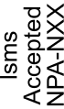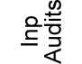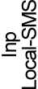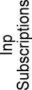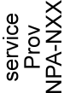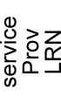

3.1.2

Log Record Managed Object Hierarchy
The Log Record Managed Object Hierarchy shows the inheritance hierarchy of the log records used in the NPAC SMS to Local SMS and SOA to NPAC SMS interfaces.
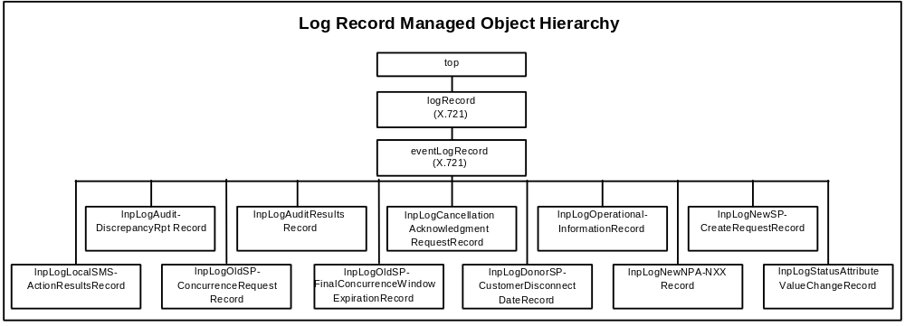
Exhibit 3 . Log Record Managed Object Hierarchy

3.1.3

NPAC SMS to Local SMS Naming Hierarchy for the NPAC SMS
The NPAC SMS to Local SMS Naming Hierarchy for the NPAC SMS shows the naming hierarchy used in the NPAC SMS to instantiate objects defined in the NPAC SMS to Local SMS interface.
Shaded objects are instantiated at NPAC SMS start-up and are not created via M-CREATE or M-DELETE requests. All other objects are created at start-up from a persistent object store on the NPAC SMS or from actions taken while the NPAC SMS is running.
Each object class belongs to one or more Association Functions.
Refer to Section , 5.2.1.8 Association Functions.
Exhibit 4. The NPAC SMS to Local SMS Naming Hierarchy for the NPAC SMS.

root
NPAC SMS TO LOCAL SMS
NAMING HIERARCHY FOR THE NPAC SMS
InpNPAC-SMS
InpServiceProvs
serviceProv
InpSubscriptions
subscriptionVersionNPAC
InpNetwork
serviceProvNetwork
serviceProvNPA-NXX
serviceProvLRN
lsmsFilterNPA-NXX

3.1.4 NPAC SMS to Local SMS Naming Hierarchy for the Local SMS
The NPAC SMS to Local SMS Naming Hierarchy for Local SMS shows the naming hierarchy used in the Local SMS to instantiate objects defined in the NPAC SMS to Local SMS interface.
Shaded objects are instantiated at Local SMS start-up and are not created via M-CREATE or M-DELETE requests. All other objects are created at start-up from a persistent object store on the Local SMS or from actions taken while the Local SMS is running.
Each object class belongs to one or more Association Functions.
Refer to Section , 5.2.1.8 Association Functions.
Exhibit 5. The NPAC SMS to Local SMS Naming Hierarchy for the Local SMS.

NPAC SMS TO LOCAL SMS
NAMING HIERARCHY FOR THE LOCAL SMS
root
InpLocalSMS
InpSubscriptions
subscriptionVersion
InpNetwork
serviceProvNetwork
serviceProvNPA-NXX
serviceProvLRN

3.1.5

SOA to NPAC SMS Naming Hierarchy for the NPAC SMS
The SOA to NPAC SMS Naming Hierarchy for the NPAC SMS shows the naming hierarchy used in the NPAC SMS to instantiate objects defined in the SOA to NPAC SMS interface.
Shaded objects are instantiated at NPAC SMS start-up and are not created via M-CREATE or M-DELETE requests. All other objects are created at start-up from a persistent object store on the NPAC SMS or from actions taken while the NPAC SMS is running.
Each object class belongs to one or more Association Functions.
Refer to Section , 5.2.1.8 Association Functions.
Exhibit 6. The SOA to NPAC SMS Naming Hierarchy for the NPAC SMS.

root
SOA TO NPAC SMS
NAMING HIERARCHY FOR THE NPAC SMS
InpNPAC-SMS
InpAudits
subscriptionAudit
InpSubscriptions
subscriptionVersionNPAC
serviceProv
lnpServiceProvs
serviceProvNPA-NXX
serviceProvLRN
lnpNetwork
serviceProvNetwork
lsmsFilterNPA-NXX

4 Interface Functionality to CMIP Definition Mapping
4

4.1 Overview
The following tables, Exhibits 7-11, contain the mapping of the interface functionality to managed objects, attributes, actions, and notifications.

4.1.1 Primary NPAC Mechanized Interface Operations
The primary interface functions in support of the NPAC requirements are described in the table below, as well as their corresponding Common Management Information Exchange (CMISE) operation and referenced object type for that operation. This table does not include miscellaneous operations, such as service provider network data querying or downloading, etc. These functions are described in the object behaviors in the GDMO source below.
Exhibit 7. Primary NPAC Mechanized Interface Operations Table
Function | Direction  (To/From) | CMIP Operation | Referenced  Object Type
Abort/Cancel Audit Request | from SOA | M-DELETE | subscriptionAudit
Audit Complete | to SOA | M-EVENT-REPORT:  subscriptionAuditResults | subscriptionAudit
Audit Discrepancy | to SOA | M-EVENT-REPORT:  subscriptionAuditDiscrepancyRpt | subscriptionAudit
Audit Query | from SOA | M-GET | subscriptionAudit
Audit Request SOA | from SOA | M-CREATE | subscriptionAudit
Cancellation Acknowledge-ment | from SOA (new service provider) | M-ACTION:  subscriptionVersionNewSP-  CancellationAcknowledge | lnpSubscriptions
Cancellation Acknowledg-ment | from SOA (old service provider) | M-ACTION:  subscriptionVersionOldSP-CancellationAcknowledge | lnpSubscriptions
Conflict Removal | from SOA (new service provider) | M-ACTION:  subscriptionVersionRemoveFromConflict | lnpSubscriptions
Customer Disconnect Date | to SOA | M-EVENT-REPORT:  subscriptionVersionDonorSP-CustomerDisconnectDate | subscriptionVersionNPAC
Final Request for Version Create | to SOA  (old service provider) | M-EVENT-REPORT:  subscriptionVersionOldSP-FinalConcurrenceWindowExpiration | subscriptionVersionNPAC
LSMS Filter NPA-NXX Create | from LOCAL SMS | M-CREATE | lsmsFilterNPA-NXX
LSMS Filter NPA-NXX Delete | from LOCAL SMS | M-DELETE | lsmsFilterNPA-NXX
LSMS Filter NPA-NXX Query | from LOCAL SMS | M-GET | lsmsFilterNPA-NXX
Network Data Download | from LOCAL SMS | M-ACTION:  lnpDownload  or  M-GET:  scoped and filtered for intended serviceProvLRN, serviceProvNPA-NXX  service provider attributes | lnpNetwork
Network Data Update | from LOCAL SMS  or  from SOA | M-CREATE:  or  M-SET:  on relevant  serviceProvLRN, serviceProvNPA-NXX  service provider attributes | serviceProvLRN,  serviceProvNPA-NXX
New NPA-NXX | to LOCAL SMS | M-EVENT-REPORT:  subscriptionVersionNewNPA-NXX | subscriptionVersionNPAC
Recovery Complete | from LOCAL SMS | M-ACTION:  lnpRecoveryComplete | lnpNPAC-SMS
Request for Cancellation Acknowledg-ment | to SOA | M-EVENT-REPORT:  subscription VersionCancellationAcknowledgment  Request | subscriptionVersionNPAC
Request for Version Create | to SOA  (new service provider) | M-EVENT-REPORT:  subscriptionVersionNewSPCreate  Request | subscriptionVersionNPAC
Request for Version Create | to SOA  (old service provider) | M-EVENT-REPORT:  subscriptionVersionOldSPConcurrence  Request | subscriptionVersionNPAC
Service Provider Network Creation | to LOCAL SMS | M-CREATE | serviceProvNetwork
Service Provider Network Deletion | to LOCAL SMS | M-DELETE | serviceProvNetwork
Service Provider Network Service Provider Name Change | to LOCAL SMS | M-SET:  serviceProvName | serviceProvNetwork
Subscription Version Activate | from SOA | M-ACTION:  subscriptionVersionActivate | lnpSubscriptions
Subscription Version Cancel | from SOA | M-ACTION  subscriptionVersionCancel | lnpSubscriptions
Subscription Version Change Notification | to SOA | M-EVENT-REPORT:  attributeValueChangeNotification or  subscriptionVersionStatusAttributeValue  Change | subscriptionVersionNPAC
Subscription  Version Conflict | from SOA (old service provider) | M-ACTION:  subscriptionVersionOldSP-Create  setting subscriptionOldSP-Authoriztion = FALSE  Note: This is an enhancement based on the current IIS, superseding RFP narrative 5.1.2.2 for manual-only conflict on/off | subscriptionVersion
Subscription  Version Create | to LOCAL SMS | M-ACTION:  subscriptionVersionLocalSMS-Create  for multiple creates (i.e., range operations) where the data in the subscription versions is the same  M-CREATE:  for an individual subscriptionVersion | lnpSubscriptions  subscriptionVersion
Subscription  Version Create | from SOA | M-ACTION:  subscriptionVersionOldSP-Create or subscriptionVersionNewSP-Create | lnpSubscriptions
Subscription  Version Delete | to LOCAL SMS | M-DELETE:  scoped and filtered for intended  subscriptionVersion criteria | subscriptionVersion
Subscription Version Disconnect | from SOA | M-ACTION:  subscriptionVersionDisconnect | lnpSubscriptions
Subscription  Version Download | to LOCAL SMS | M-ACTION:  subscriptionVersionLocalSMS-Create  or  M-CREATE:  for an individual subscriptionVersion | lnpSubscriptions
Subscription  Version  Download Request | from LOCAL SMS | M-ACTION:  lnpDownload  or  M-GET:  scoped and filtered for intended subscriptionVersionNPAC criteria | lnpSubscriptions
Subscription Version Modify | from SOA | M-ACTION: subscriptionVersion Modify  or  M-SET:  on relevant subscriptionVersionNPAC attributes for pending, active, and conflict versions | lnpSubscriptions
Subscription Version Modify | to LOCAL SMS | M-SET:  scoped and filtered for intended subscriptionVersion criteria setting relevant attributes | lnpSubscriptions
Subscription Version Query | from SOA  from LOCAL SMS | M-GET:  scoped and filtered for intended subscriptionVersionNPAC criteria setting relevant attributes | lnpSubscriptions
Subscription Version Query | to LOCAL SMS | M-GET:  scoped and filtered for intended subscriptionVersion criteria | lnpSubscriptions

4.1.2 Managed Object Interface Functionality
The table below contains the mapping of the SOA to NPAC SMS and the Local SMS to NPAC SMS managed objects to the interface functionality described in the RFP.
Exhibit 8. Managed Object Interface Functionality Table

Managed Object Name | Interface Functionality Mapping
lnpAudits | Container object used to contain all subscription audit objects on the NPAC SMS and the Local SMS. It is used in the SOA to NPAC SMS interface to support audit functionality.
lnpLocal SMS | Container object used to contain all objects on a Local SMS. It is used in the NPAC SMS to Local SMS interface to support NPAC SMS communication to the service provider Local SMS system.
lnpLogAudit-DiscrepancyRptRecord | Object used to log information from a  subscriptionAudit-DiscrepancyRpt notification.
lnpLogAuditResultsRecord | Object used to log information from a  subscriptionAuditResults notification.
lnpLogCancellation AcknowledgeRequest Record | Object used to log information from a  subscriptionVersionCancellationAcknowledgeRequest notification.
lnpLogDonorSP-CustomerDisconnectDate  Record | Object used to log information from a  subscriptionVersionDonorSP-CustomerDisconnectDate notification.
lnpLogLocalSMS-ActionResultsRecord | Object used to log information from a  subscriptionVersionLocalSMS-ActionResults notification.
lnpLogNewNPA-NXXRecord | Object used to log information from a  subscriptionVersionNewNPA-NXX notification.
lnpLogNewSP-CreateRequestRecord | Object used to log information from a  subscriptionVersionNewSP-CreateRequest notification.
lnpLogOldSP-ConcurrenceRequestRecord | Object used to log information from a  subscriptionVersionOldSP-ConcurrenceRequest notification.
lnpLogOldSP-  FinalConcurrenceWindow-  Expiration | Object used to log information from a  subscriptionVersionOldSP-FinalConcurrenceWindowExpiration notification
lnpLogOperational-InformationRecord | Object used to log information from a  lnpNPAC-SMS-Operational-Information notification.
lnpLogStatusAttributeValueChangeRecord | Object used to log information from a  subscriptionVersionStatusAttributeValueChange notification.
lnpNetwork | Container object used to contain all service provider network data on the NPAC SMS and the Local SMS It is used in the NPAC SMS to Local SMS interface to support downloading of network data to the Local SMS and the functionality that allows service providers to create/delete their network data on the NPAC SMS.
lnpNPAC-SMS | Container object used to contain all objects on a NPAC SMS. It is used in the NPAC SMS to Local SMS interface to support NPAC SMS communication from the service provider Local SMS and the SOA systems.
lnpServiceProvs | Container object used to contain all service provider data on the NPAC SMS. It is used in the NPAC SMS to Local SMS interface to support retrieving of service provider data from the Local SMS and the functionality that allows service providers to update their service provider data on the NPAC SMS. Service providers can only retrieve their own service provider data.
lnpSubscriptions | Container object used to contain all subscription versions on the NPAC SMS and the Local SMS. It is used in the NPAC SMS to Local SMS interface to support query of subscription data on the NPAC SMS and downloading of subscription data to the Local SMS.
lsmsFilterNPA-NXX | Object used to represent the NPA-NXX values for which a service provider does not want to be informed of subscription version broadcasts.
serviceProv | Object used to represent a service provider and its associated data on the NPAC SMS. These objects are used in the NPAC SMS to Local SMS interface to support retrieving of service provider data from the Local SMS and the functionality that allows service providers to update their service provider data on the NPAC SMS except serviceProvId and serviceProvType. Service providers can only retrieve their own service provider data.
serviceProvLRN | Object used to represent an LRN associated with a service provider on the NPAC SMS or the Local SMS. These objects are used to support downloading of network LRN data to the Local SMS and the functionality that allows service providers to create/delete their own network LRN data. The service provider will have to add a new object and delete the old one to modify the data.
serviceProvNetwork | Container object used to contain network data for a service provider on the NPAC SMS and the Local SMS. It is used in the NPAC SMS to Local SMS interface to support downloading of network data to the Local SMS and the functionality that allows service providers to update their network data on the NPAC SMS.
serviceProvNPA-NXX | Object used to represent an NPA-NXX associated with a service provider on the NPAC SMS or the Local SMS. These objects are used to support downloading of network NPA-NXX data to the Local SMS and the functionality that allows service providers to create/delete their own network NPA-NXX data. NPA splits are supported only through direct contact with NPAC personnel.
subscriptionAudit | Object used to represent a subscription audit request on the NPAC SMS. These objects are used to support subscription audit requests from the SOA to the NPAC SMS using the SOA to NPAC SMS interface. The object supports notifications for audit discrepancies found and audit completion results.
subscriptionVersion | Object used to represent a subscription version on the Local SMS. These objects are used to support subscription version download from the NPAC SMS to the Local SMS using the NPAC SMS to Local SMS interface
subscriptionVersionNPAC | Object used to represent a subscription version on the NPAC SMS. These objects are used to support subscription administration from the SOA using the SOA to NPAC SMS interface. Capability is provided for version creation, activation, modification, cancellation, and disconnect.

4.1.3 Attribute Interface Functionality
The table below contains the mapping of the SOA to NPAC SMS and the Local SMS to NPAC SMS attributes to the interface functionality described in the RFP.
Exhibit 9. Attribute Interface Functionality Table
Attribute Name | Interface Requirements Mapping
accessControl | This attribute is used to define access control information for security. It is used in the NPAC SMS to Local SMS and SOA to NPAC SMS interfaces.
actionResultsStatus | This attribute is used to store the status of an action that sends back an asynchronous notification with the results.
additionalDownTimeInformation | This attribute is used to provide additional information about a planned NPAC SMS outage. It is used to support the notification of operational outages to the service provider SOA and Local SMS systems using the SOA to NPAC SMS interface and the NPAC SMS to Local SMS interface.
auditDiscrepancyFailureReason | This attribute is used to specify the failure reason for a discrepancy in the lnpLogAudit-DiscrepancyRptRecord.
auditDiscrepancyLSMS-SP-Id | This attribute is used to specify the service provider Id of the Local SMS on which a discrepancy was found in the lnpLogAudit-DiscrepancyRptRecord.
auditDiscrepancyTn | This attribute is used to specify the TN for which a discrepancy was found in the lnpLogAudit-DiscrepancyRptRecord.
auditDiscrepancyVersionId | This attribute is used to specify the version Id for which a discrepancy was found in the lnpLogAudit-DiscrepancyRptRecord.
auditResultCompletionTime | This attribute is used to specify the completion time of an audit in the lnpLogAuditResultsRecord.
auditResultFailed-SP-List | This attribute is used to specify the list of failed service provider Local SMSs for a failed audit. It is used to support the audit functionality from the service provider SOA using the SOA to NPAC SMS interface.
auditResultNumberDiscrepancies | This attribute is used to specify the number of discrepancies found in an audit in the lnpLogAuditResultsRecord.
auditResultStatus | This attribute is used to specify the final status of an audit in the lnpLogAuditResultsRecord.
downTime | This attribute is used to specify the down time in the lnpLogOperational-InformationRecord.
failedTN-List | This attribute is used to indicate the TN(s) and errors for a failed action in the return asynchronous notification.
lnpAuditsName | This attribute is used to specify the name of the audit container. It is used to support audit functionality in the NPAC SMS using the SOA to NPAC SMS interface.
lnpLocal-SMS-Name | This attribute is used to specify the name of the Local SMS data container. It is used to support the NPAC SMS to Local SMS interface.
lnpNetworkName | This attribute is used to specify the name of the network data container. It is used to support download functionality to the Local SMS in the NPAC SMS to Local SMS interface.
lnpNPAC-SMS-Name | This attribute is used to specify the name of the NPAC SMS data container. It is used to support the NPAC SMS to Local SMS interface.
lnpServiceProvsName | This attribute is used to specify the name of the service provider data container. It is used to support service provider data query and the Lockheed Martin functionality for service provider data update in the NPAC SMS using the Local SMS to NPAC SMS or SOA to NPAC SMS interface.
lnpSpecificInfo | This attribute is used to pass specific error information in the case of a cmip processing failure error.
lnpSubscriptionsName | This attribute is used to specify the name of the subscription container. It is used to support subscription download functionality to the service provider Local SMS systems and subscription administration functionality for the SOA systems using the SOA to NPAC SMS and Local SMS to NPAC SMS interfaces.
lsmsFilterNPA-NXX-Id | This attribute is used to specify the LSMS Filter NPA-NXX unique identifier. It supports the broadcast of subscription versions.
lsmsFilterNPA-NXX-Value | This attribute is used to specify the service provider NPA-NXX value. It supports the broadcast of subscription versions.
npacContactNumber | This attribute is used to indicate the NPAC contact number to be called concerning an NPAC SMS outage. It is used to support the notification of operational outages to the service provider SOA and Local SMS systems using the SOA to NPAC SMS interface and the NPAC SMS to Local SMS interface.
npacCustomerAllowableFunctions | This attribute is used to specify what functions a service provider can perform on the SOA to NPAC SMS and NPAC SMS to Local SMS interfaces.
resultsCompletionTime | This attribute is used to store the completion time of the action in the action results notification.
serviceProvAddress | This attribute is used to specify the service provider address data. It is used to support service provider data query and the Lockheed Martin functionality for service provider data update in the NPAC SMS using the Local SMS to NPAC SMS or SOA to NPAC SMS interface.
serviceProvBillingAddress | This attribute is used to specify the service provider billing address data. It is used to support service provider data query and the Lockheed Martin functionality for service provider data update in the NPAC SMS using the Local SMS to NPAC SMS or SOA to NPAC SMS interface.
serviceProvConflictAddress | This attribute is used to specify the service provider conflict address data. It is used to support service provider data query and the Lockheed Martin functionality for service provider data update in the NPAC SMS using the Local SMS to NPAC SMS or SOA to NPAC SMS interface.
serviceProvDownloadReason | This attribute is used to specify the reason for download in the serviceProvLRN and serviceProvNPA-NXX objects. It is used in the NPAC SMS to Local SMS Interface.
serviceProvID | This attribute is used to specify the service provider Id to uniquely identify a service provider object. It is used to support service provider data query and the Lockheed Martin functionality for service provider data update in the NPAC SMS using the Local SMS to NPAC SMS or SOA to NPAC SMS interface.
serviceProvLRN-ID | This attribute is used to specify the service provider LRN unique identifier. It is used to support downloading of network LRN data to the Local SMS and the functionality that allows service providers to update their own network LRN data.
serviceProvLRN-CreationTimeStamp | This attribute is used to specify the last date and time the serviceProvLRN object was created on the NPAC SMS. It is used in the NPAC SMS to Local SMS Interface.
serviceProvLRN-Value | This attribute is used to specify the value for a service provider LRN associated with an NPA-NXX.
serviceProvLSMS-Address | This attribute is used to specify the service provider Local SMS contact address data. It is used to support service provider data query and the Lockheed Martin functionality for service provider data update in the NPAC SMS using the Local SMS to NPAC SMS or SOA to NPAC SMS interface.
serviceProvName | This attribute is used to specify the service provider English name. It is used to support service provider data query and the Lockheed Martin functionality for service provider data update in the NPAC SMS using the Local SMS to NPAC SMS or SOA to NPAC SMS interface.
serviceProvNetAddress | This attribute is used to specify the service provider Network operations contact address data. It is used to support service provider data query and the Lockheed Martin functionality for service provider data update in the NPAC SMS using the Local SMS to NPAC SMS or SOA to NPAC SMS interface.
serviceProvNPA-NXX-EffectiveTimeStamp | This attribute is used to specify the effective date on which the service provider NPA-NXX is available for LNP. It is used in the NPAC SMS to Local SMS interface.
serviceProvNPA-NXX-ID | This attribute is used to specify the service provider NPA-NXX unique identifier. It is used to support downloading of network NPA-NXX data to the Local SMS and the functionality that allows service providers to update their own network NPA-NXX data.
serviceProvNPA-NXX-CreationTimeStamp | This attribute is used to specify the date and time the serviceProvNPA-NXX object was created. It is used in the NPAC SMS to Local SMS Interface.
serviceProvNPA-NXX-Value | This attribute is used to specify the service provider NPA-NXX value. It is used to support downloading of network NPA-NXX data to the Local SMS.
serviceProvOperationsAddress | This attribute is used to specify the service provider operations contact address data. It is used to support service provider data query and the Lockheed Martin functionality for service provider data update in the NPAC SMS using the Local SMS to NPAC SMS or SOA to NPAC SMS interface.
serviceProvRepairCenterInfo | This attribute is used to specify the repair center information for a service provider.
serviceProvSOA-Address | This attribute is used to specify the service provider SOA contact address data. It is used to support service provider data query and the Lockheed Martin functionality for service provider data update in the NPAC SMS using the Local SMS to NPAC SMS or SOA to NPAC SMS interface.
serviceProvSysLinkInfo | This attribute is used to specify the service provider network address connectivity data. It is used to support service provider data query and the Lockheed Martin functionality for service provider data update in the NPAC SMS using the Local SMS to NPAC SMS interface and the SOA to NPAC SMS interface.
ServiceProvUserAdminAddress | This attribute is used to specify the service provider user administration contact address data. It is used to support service provider data query and the Lockheed Martin functionality for service provider data update in the NPAC SMS using the Local SMS to NPAC SMS or SOA to NPAC SMS interface.
ServiceProvWebAddress | This attribute is used to specify the service provider web contact address data. It is used to support service provider data query and the Lockheed Martin functionality for service provider data update in the NPAC SMS using the Local SMS to NPAC SMS or SOA to NPAC SMS interface.
SubscriptionActivationTimeStamp | This attribute is used to specify the date and time that the new service provider activation request was received by the NPAC SMS. It is used to support service provider data administration in NPAC SMS using the SOA to NPAC SMS interface and subscription version download from the NPAC SMS to the Local SMS using the Local SMS to NPAC SMS interface.
SubscriptionAuditAttributeList | This attribute is used to specify a list of attributes in a subscription version that are to be audited. It is used to support audit functionality from the SOA to the NPAC SMS using the SOA to NPAC SMS interface.
SubscriptionAuditId | This attribute is used to uniquely identify an audit request. It is used to support audit functionality from the SOA to the NPAC SMS using the SOA to NPAC SMS interface.
subscriptionAuditName | This attribute is used to give an English name to an audit request. It is used to support audit functionality from the SOA to the NPAC SMS using the SOA to NPAC SMS.
subscriptionAuditNonPortedTNs | This attribute is used to specify if non-ported TNs should be audited in an audit request. It is used to support audit functionality from the SOA to the NPAC SMS using the SOA to NPAC SMS interface.
subscriptionAuditNumberOfTNs | This attribute is used to specify the number of TNs being audited in an audit request. It is used to support audit functionality from the SOA to the NPAC SMS using the SOA to NPAC SMS interface.
subscriptionAuditNumberOfTNsComplete | This attribute is used to specify the number of TNs that have been successfully audited in a complete or in progress audit request. It is used to support audit functionality from the SOA to the NPAC SMS using the SOA to NPAC SMS interface.
subscriptionAuditRequestingSP | This attribute is used to specify the service provider Id that requested the audit.
subscriptionAuditServiceProvIdRange | This attribute is used to identify a specific service provider or if all service providers should be audited in an audit request. It is used to support audit functionality from the SOA to the NPAC SMS using the SOA to NPAC SMS interface.
subscriptionAuditStatus | This attribute is used to specify the status of an audit request. It is used to support audit functionality from the SOA to the NPAC SMS using the SOA to NPAC SMS interface.
subscriptionAuditTN-ActivationRange | This attribute is used to specify the activation date and time range for TNs to be audited in an audit request. It is used to support audit functionality from the SOA to the NPAC SMS using the SOA to NPAC SMS interface.
subscriptionAuditTN-AtSuspend | This attribute is used to specify the last TN that was audited when an audit request was suspended in the network. It is used to support audit functionality from the SOA to the NPAC SMS using the SOA to NPAC SMS interface.
subscriptionAuditTN-NotificationNumber | This attribute is used to specify the number of TNs that have completed audit before the number of subscriptionAuditNumberOfTNsComplete gets incremented in an audit request. It is used to support audit functionality from the SOA to the NPAC SMS using the SOA to NPAC SMS interface.
subscriptionAuditTN-Range | This attribute is used specify the range of TNs to be audited in an audit request. It is used to support audit functionality from the SOA to the NPAC SMS using the SOA to NPAC SMS interface.
subscriptionBillingId | This attribute is used to specify the subscription version service provider billing Id. It is used to support service provider data administration in the NPAC SMS using the SOA to NPAC SMS interface and subscription version download from the NPAC SMS to the Local SMS using the Local SMS to NPAC SMS interface.
subscriptionBroadcastTimeStamp | This attribute is used to specify the subscription version’s broadcast from the NPAC SMS to the Local SMS systems time stamp. It is used to support service provider data administration in the NPAC SMS using the SOA to NPAC SMS interface and subscription version download from the NPAC SMS to the Local SMS using the Local SMS to NPAC SMS interface.
subscriptionCancellationTimeStamp | This attribute is used to specify the subscription version cancellation time stamp. It is used to support service provider data administration in the NPAC SMS using the SOA to NPAC SMS interface and subscription version download from the NPAC SMS to the Local SMS using the Local SMS to NPAC SMS interface.
subscriptionCLASS-DPC | This attribute is used to specify the subscription version CLASS DPC Type. It is used to support service provider data administration in the NPAC SMS using the SOA to NPAC SMS interface and subscription version download from the NPAC SMS to the Local SMS using the Local SMS to NPAC SMS interface.
subscriptionCLASS-SSN | This attribute is used to specify the subscription version CLASS SSN. It is used to support service provider data administration in the NPAC SMS using the SOA to NPAC SMS interface and subscription version download from the NPAC SMS to the Local SMS using the Local SMS to NPAC SMS interface.
subscriptionCNAM-DPC | This attribute is used to specify the CNAM DPC in the subscriptionVersion object. It is used in the both the NPAC SMS to Local SMS Interface and the SOA to NPAC SMS Interface.
subscriptionCNAM-SSN | This attribute is used to specify the CNAM SSN in the subscriptionVersion object. It is used in the both the NPAC SMS to Local SMS Interface and the SOA to NPAC SMS Interface.
subscriptionConflictTimeStamp | This attribute is used to specify the subscription conflict time stamp. It is used to support service provider data administration in the NPAC SMS using the SOA to NPAC SMS interface and subscription version download from the NPAC SMS to the Local SMS using the Local SMS to NPAC SMS interface.
subscriptionCreationTimeStamp | This attribute is used to specify the subscription version creation time stamp. It is used to support service provider data administration in the NPAC SMS using the SOA to NPAC SMS interface and subscription version download from the NPAC SMS to the Local SMS using the Local SMS to NPAC SMS interface.
subscriptionCustomerDisconnectDate | This attribute is used to specify the timestamp of when the customer was disconnected.
subscriptionDisconnectCompleteTimestamp | This attribute is used to specify the timestamp of when the subscription version was disconnect. It is used to support service provider data administration in the NPAC SMS using the SOA to NPAC SMS interface and subscription version download from the NPAC SMS to the Local SMS using the Local SMS to the NPAC SMS interface.
subscriptionDownloadReason | This attribute is used to specify the reason for download in the subscriptionVersion objects. It is used in the NPAC SMS to Local SMS Interface.
subscriptionEffectiveReleaseDate | This attribute is used to specify the subscription version disconnect date. It is used to support service provider data administration in the NPAC SMS using the SOA to NPAC SMS interface and subscription version download from the NPAC SMS to the Local SMS using the Local SMS to NPAC SMS interface.
subscriptionEndUserLocationType | This attribute is used to specify the subscription version end user location type. It is used to support service provider data administration in the NPAC SMS using the SOA to NPAC SMS interface and subscription version download from the NPAC SMS to the Local SMS using the Local SMS to NPAC SMS interface.
subscriptionEndUserLocationValue | This attribute is used to specify the subscription version end user location value. It is used to support service provider data administration in the NPAC SMS using the SOA to NPAC SMS interface and subscription version download from the NPAC SMS to the Local SMS using the Local SMS to NPAC SMS interface.
subscriptionFailed -SP-List | This attribute is used to store the failed service providers after a subscription version broadcast results in a failed or partially-failed subscription version status.
subscriptionISVM-DPC | This attribute is used to specify the ISVM DPC in the subscriptionVersion object. It is used in both the NPAC SMS to Local SMS Interface and the SOA to NPAC SMS Interface.
subscriptionISVM-SSN | This attribute is used to specify the ISVM SSN in the subscriptionVersion object. It is used in both the NPAC SMS to Local SMS Interface and the SOA to NPAC SMS Interface.
subscriptionLIDB-DPC | This attribute is used to specify the subscription version LIDB DPC. It is used to support service provider data administration in the NPAC SMS using the SOA to NPAC SMS interface and subscription version download from the NPAC SMS to the Local SMS using the Local SMS to NPAC SMS interface.
subscriptionLIDB-SSN | This attribute is used to specify the LIDB SSN in the subscriptionVersion object. It is used in both the NPAC SMS to Local SMS Interface and the SOA to NPAC SMS Interface.
subscriptionLNPType | This attribute is used to specify the subscription version LNP Type. It is used to support service provider data administration in the NPAC SMS using the SOA to NPAC SMS interface and subscription version download from the NPAC SMS to the Local SMS using the Local SMS to NPAC SMS interface.
subscriptionLRN | This attribute is used to specify the LRN data for the subscription version. It is used to support service provider data administration in the NPAC SMS using the SOA to NPAC SMS interface and subscription version download from the NPAC SMS to the Local SMS using the Local SMS to NPAC SMS interface.
subscriptionModifiedTimeStamp | This attribute is used to specify the timestamp of any modifications to the subscription version. It is used to support service provider data administration in the NPAC SMS using the SOA to NPAC SMS interface and subscription version download from the NPAC SMS to the Local SMS using the Local SMS to NPAC SMS interface.
subscriptionNewCurrentSP | This attribute is used to specify the current or new service provider for the subscription version. It is used to support service provider data administration in the NPAC SMS using the SOA to NPAC SMS interface and subscription version download from the NPAC SMS to the Local SMS using the Local SMS to NPAC SMS interface.
subscriptionNewSP-CreationTimeStamp | This attribute is used to specify the subscription version new service provider creation time stamp. It is used to support service provider data administration in the NPAC SMS using the SOA to NPAC SMS interface and subscription version download from the NPAC SMS to the Local SMS using the Local SMS to NPAC SMS interface.
subscriptionNewSP-CancellationTimeStamp | This attribute is used to specify the time stamp of the subscription version cancellation pending acknowledgment by the new service provider. It is used to support service provider data administration in the NPAC SMS using the SOA to NPAC SMS interface and subscription version download from the NPAC SMS to the Local SMS using the Local SMS to the NPAC SMS interface.
subscriptionNewSP-ConflictResolutionTimeStamp | This attribute is used to specify the time stamp of when the subscription version was removed from conflict by the new service provider. It is used to support service provider data administration in the NPAC SMS using the SOA to NPAC SMS interface and subscription version download from the NPAC SMS to the Local SMS using the Local SMS to the NPAC SMS interface.
subscriptionNewSP-DueDate | This attribute is used to specify the new service provider activation date and time for the subscription version. It is used to support service provider data administration in the NPAC SMS using the SOA to NPAC SMS interface and subscription version download from the NPAC SMS to the Local SMS using the Local SMS to NPAC SMS interface.
subscriptionOldSP | This attribute is used to specify the old SP for the subscription version. It is used to support service provider data administration in the NPAC SMS using the SOA to NPAC SMS interface and subscription version download from the NPAC SMS to the Local SMS using the Local SMS to NPAC SMS interface.
subscriptionOldSP-Authorization | This attribute is used to specify the subscription version old service provider authorization indication. It is used to support service provider data administration in the NPAC SMS using the SOA to NPAC SMS interface and subscription version download from the NPAC SMS to the Local SMS using the Local SMS to NPAC SMS interface.
subscriptionOldSP-AuthorizationTimeStamp | This attribute is used to specify the subscription version old service provider authorization time stamp. It is used to support service provider data administration in the NPAC SMS using the SOA to NPAC SMS interface and subscription version download from the NPAC SMS to the Local SMS using the Local SMS to NPAC SMS interface.
subscriptionOldSP-CancellationTimeStamp | This attribute is used to specify the time stamp of the subscription version cancellation pending acknowledgment by the old service provider. It is used to support service provider data administration in the NPAC SMS using the SOA to NPAC SMS interface and subscription version download from the NPAC SMS to the Local SMS using the Local SMS to the NPAC SMS interface.
subscriptionOldSP-ConflictResolutionTimeStamp | This attribute is used to specify the time stamp of when the subscription version was removed from conflict by the old service provider. It is used to support service provider data administration in the NPAC SMS using the SOA to NPAC SMS interface and subscription version download from the NPAC SMS to the Local SMS using the Local SMS to the NPAC SMS interface.
subscriptionOldSP-DueDate | This attribute is used to specify the subscription version cutover time stamp to the new service provider. It is used to support service provider data administration in NPAC SMS using the SOA to NPAC SMS interface and subscription version download from the NPAC SMS to the Local SMS using the Local SMS to NPAC SMS interface.
subscriptionOldTimeStamp | This attribute is used to specify the subscription version time stamp when the version became old. It is used to support service provider data administration in the NPAC SMS using the SOA to NPAC SMS interface and subscription version download from the NPAC SMS to the Local SMS using the Local SMS to NPAC SMS interface.
subscriptionPortingToOriginal-SPSwitch | This attribute is used to specify that subscription version is being ported back to the original service provider. It is used to support service provider data administration in the NPAC SMS using the SOA to NPAC SMS interface and subscription version download from the NPAC SMS to the Local SMS using the Local SMS to the NPAC SMS interface.
subscriptionPreCancellationStatus | This attribute is used to specify the previous status of a cancel-pending subscription version. Valid values are pending, conflict, sending, active, failed, failed partial, and disconnect-pending.
subscriptionStatusChangeCauseCode | This attribute is used to specify the reason a subscription version went into conflict.
subscriptionTN | This attribute is used to specify the subscription version TN for a subscription version. It is used to support service provider data administration using the SOA to NPAC SMS interface and the NPAC SMS to Local SMS interface.
subscriptionVersionAttributeValueChangeInfo | This attribute is used to specify the attribute value change information in the lnpLogVersionAttributeValueChangeRecord.
subscriptionVersionId | This attribute is used to specify the unique version id for the subscription version in the NPAC SMS. It is used to support service provider data administration in the NPAC SMS using the SOA to NPAC SMS interface and subscription version download from the NPAC SMS to the Local SMS using the Local SMS to NPAC SMS interface.
subscriptionVersionStatus | This attribute is used to specify the subscription version status. It is used to support service provider data administration in the NPAC SMS using the SOA to NPAC SMS interface and subscription version download from the NPAC SMS to the Local SMS using the Local SMS to NPAC SMS interface.

4.1.4 Action Interface Functionality
The table below contains the mapping of the SOA to NPAC SMS and the Local SMS to NPAC SMS actions to the interface functionality described in the RFP.
Exhibit 10. The Action Interface Functionality Table
Action Name | Interface Requirements Mapping
LnpDownload | This action is used to support the downloading of subscription and network data to the Local SMS from the NPAC via the NPAC SMS to Local SMS interface.
LnpRecoveryComplete | This action is used to specify the system has recovered from down time and the transactions performed since the association establishment can now be sent to the Local SMS from the NPAC SMS using the Local SMS to NPAC SMS interface.
SubscriptionVersionActivate | This action is used to support subscription version activation by the new service provider from the SOA to the NPAC SMS using the SOA to NPAC SMS interface.
SubscriptionVersionCancel | This action is used to support subscription version cancellation by a service provider from the SOA to the NPAC SMS using the SOA to NPAC SMS interface.
SubscriptionVersionDisconnect | This action is used to support subscription version disconnection by the current service provider from the SOA to the NPAC SMS using the SOA to NPAC SMS interface.
SubscriptionVersionLocalSMS-Create | This action can be used by the NPAC SMS to create multiple subscription versions via the Local SMS to NPAC SMS interface.
SubscriptionVersionModify | This action is used to support subscription version modification by a service provider from the SOA to the NPAC SMS using the SOA to NPAC SMS interface.
SubscriptionVersionNewSP-CancellationAcknowledge | This action is used to support the acknowledgment of subscription versions with a status of cancel-pending by the old service from the SOA to the NPAC SMS using the SOA to NPAC SMS interface.
SubscriptionVersionNewSP-Create | This action is used to support subscription version creation by the new service provider from the SOA to the NPAC SMS using the SOA to NPAC SMS interface.
SubscriptionVersionOldSP-CancellationAcknowledge | This action is used to support the acknowledgment of subscription versions with a status of cancel-pending by the old service from the SOA to the NPAC SMS using the SOA to NPAC SMS interface.
SubscriptionVersionOldSP-Create | This action is used to support subscription version creation by the old service provider from the SOA to the NPAC SMS using the SOA to NPAC SMS interface.
SubscriptionVersion  RemoveFromConflict | This action is used on the NPAC SMS via the SOA to NPAC SMS interface to set the subscription version status from conflict to pending.

4.1.5 Notification Interface Functionality
The table below contains the mapping of the SOA to NPAC SMS and the Local SMS to NPAC SMS notifications to the interface functionality described in the RFP.

Exhibit 11. The Notification Interface Functionality Table
Notification Name | Interface Requirements Mapping
lnpNPAC-SMS-Operational-Information | This notification is used to support the reporting of NPAC SMS scheduled down time. This notification can be issued from the lnpNPAC-SMS object on the NPAC SMS to a SOA via the SOA to NPAC SMS interface or from the NPAC SMS to the Local SMS via the NPAC SMS to Local SMS interface.
subscriptionAudit-DiscrepancyRpt | This notification is used to support the reporting of audit discrepancies found during audit processing. This notification can be issued from an audit object on the NPAC SMS to a SOA via the SOA to NPAC SMS interface.
subscriptionAudit-Results | This notification is used to support the reporting of audit processing results. This notification can be issued from an audit object on the NPAC SMS to a SOA via the SOA to NPAC SMS interface.
subscriptionVersionCancellationAcknowledgeRequest | This notification is issued to new and old service providers to request that a cancellation acknowledgment be sent for a subscriber version in a cancel-pending state. This notification is issued via the SOA to NPAC SMS interface from the NPAC subscription version object if the service provider fails to acknowledge the cancellation after a tunable amount of time specified in the NPAC SMS service data table.
subscriptionVersionDonorSP-CustomerDisconnectDate | This notification informs the donor service provider SOA that a subscription version is being disconnected. This notification is issued from a subscription version object on the NPAC SMS to a SOA via the SOA to NPAC SMS interface.
subscriptionVersionLocalSMS-ActionResults | This notification contains the results of a subscriptionVersionLocalSMS-Create action once all the create requests have been attempted. It is issued from the Local SMS to the NPAC SMS via the NPAC SMS to Local SMS interface.
subscriptionVersionNew-NPA-NXX | This notification informs the Local SMS of a pending subscription version involving a new NPA-NXX.
SubscriptionVersionNewSP-CreateRequest | This notification is issued to the new service provider to request that a create request be sent for the subscriber version created by the old service provider to provide authorization and/or porting information. This notification is issued via the SOA to NPAC SMS interface from the NPAC subscription version object if the new service provider failed to authorize porting of a number after a tunable amount of time specified in the NPAC SMS service data table.
SubscriptionVersionOldSP-ConcurrenceRequest | This notification is issued to the old service provider to request that a create request be sent for the subscriber version created by the new service provider to provide concurrence for porting. This notification is issued via the SOA to NPAC SMS interface from the NPAC subscription version object if the old service provider failed to authorize porting of a number after a tunable amount of time specified in the NPAC SMS service data table.
subscriptionVersionStatusAttributeValueChange | This notification is issued when the subscription version status is modified. This notification is issued from both the NPAC SMS to Local SMS interface and the SOA to NPAC SMS interface from the subscriptionVersionNPAC object.

4.2

Scoping and Filtering Support
The following section defines the scoping and filtering support for both the SOA to NPAC SMS interface and LSMS to NPAC SMS interface.

4.2.1 Scoping
The LSMS to NPAC SMS interface does not support scoping of CMIP operations of any type by the LSMS for the following objects:
- root
- lnpLocal-SMS
- lnpNetwork
- any object with an “empty” filter
NPAC SMS is not required to support Scope other than baseObject Scope for CMIP operations that specify baseManangedObjectClass of one of the following:
- lnpNPAC-SMS
- lnpServiceProvs
Scoped operations for subscriptionVersions to the LSMS must be supported on the baseObject (level 0) or from the lnpSubscriptions object with a non-empty filter.
The limit in scoping and functionality prevents both the NPAC and the LSMS systems from having to implement functionality or respond to large requests that are not necessary to support LNP over the mechanized interfaces.

4.2.2 Filtering
Filtering on the NPAC SMS is supported as defined in the GDMO. The NPAC SMS requires the Local SMS to support at a minimum the filter criterias specified below.
Limitations:
- OR and NOT filter support is not required for the Local SMS.
- NOT filter support is not required for the NPAC SMS.
- Filtering requests with a scope will not be issued to the Local SMS by the NPAC SMS for any object other than the subscriptionVersion object.
- All authorization rules apply to scoped and filtered operations. For example, a query for data that a service provider is not authorized to view will be failed with a reason of access denied.
- CMISSync is not supported for any scoped/filtered CMIP operation.
The following table shows the CMISE primitive filtering support required of the Local SMS by the NPAC SMS for the subscriptionVersion object.

Exhibit 12 - CMISE Primitive Filtering Support
CMISE Primitives | Filter Supported | Notes
M-ACTION | N | No actions are defined for the subscriptionVersion object.
M-GET | Y | TN Range with greatOrEqual, lessOrEqual, equality must be supported for auditing.
M-SET | Y | TN Range with greatOrEqual, lessOrEqual, equality must be supported for Mass Update or TN range modify requests.
M-DELETE | Y | TN Range with greatOrEqual, lessOrEqual, equality will be supported for range disconnect or port to original requests.

4.2.3 Action Scoping and Filtering Support
For messages sent to any object, the scope and filter will be checked to insure it is appropriate for that object class.
- All M-Actions that relate to subscriptions are targeted to lnpsubscriptions.
- The ONLY filters allowed by the GDMO for lnpSubscriptions are "equality" and "present" for the single attribute lnpSubscriptionsName.
- If any one of the above M-Actions is sent to a subscriptionVerisonNPAC object you will get a "no such action" error response from that object.
- If you send a scoped/filters M-Action that whose scope includes objects of class subscriptionVersionNPAC, you will receive an error "no such action" from each object specified by the filter. This could mean 1 for EVERY subscriptionVersion in the NPAC.

4.3 lnpLocal-SMS-Name and lnpNPAC-SMS-Name Values
The following table (Exhibit 13) shows the values to be used for all currently identified NPAC regions for lnpNPAC-SMS-Name in the lnpNPAC-SMS object. The lnpLocal-SMS-Name for the lnpLocal-SMS object will be the service provider ID followed by a dash and the lnpNPA-SMS Name (e.g., 9999-Midwest Regional NPAC SMS).
Exhibit 13 - Defined lnpLocal-SMS-Name and lnpNPAC-SMS-Name Values
NPAC SMS Region | lnpNPAC-SMS-Name | NPAC Customer IDs
Mid-Atlantic | Mid-Atlantic Regional NPAC SMS | 0001
Midwest | Midwest Regional NPAC SMS | 0000
Northeast | Northeast Regional NPAC SMS | 0002
Southeast | Southeast Regional NPAC SMS | 0003
Southwest | Southwest Regional NPAC SMS | 0004
Western | West Regional NPAC SMS | 0005
West Coast | West Coast Regional NPAC SMS | 0006

4.4 OID Usage Information

4.4.1 OIDs Used for Bind Requests
Value | OID
CMIPUserInfo | 2:1:1 (per standards and pp.49 IIS1.5)
CMIPAbortInfo | 2:1:1 (per standards and pp.51 IIS1.5)
LnpAccessControl | {lnp-attribute 1} = 1:3:6:1:4:1:103:7:0:0:2:1
UserInfo (NpacAssociationInfo) | 1:3:6:1:4:1:103:7:0:0:2:105
Application context | 2:9:0:0:2 (per standards)

4.4.2 Other OIDs of Interest
Value | OID
AccessControl OID as part of a SMI notification | 1:3:6:1:4:1:103:7:0:0:8:1
AccessControl as part of LNP notifications | {lnp-attribute 1} = 1:3:6:1:4:1:103:7:0:0:2:1

4.5 Naming Attributes
Non-zero values are not supported in the auto-instance naming attributes for Local Number Portability objects defined in the IIS.

4.6 Subscription Version M_DELETE Messages
M_DELETE commands are not sent for subscription versions set to old as a result of subsequent porting activity. M_DELETES for subscription versions are only sent as a result of disconnect or port to original processing. Local SMS systems are responsible for deletion of the subscription versions in their Local SMS database due to the fact that some LSMS implementations may choose to retain old subscription versions in their database.

5 Secure Association Establishment
5

5.1 Overview
This chapter describes the security, the association management and recovery procedures for the service provider SOAs and Local SMSs to follow, and how error information will be passed between interfaces.
The first section describes the security and authentication procedures used in the NPAC SMS interface. The second section describes the NPAC SMS's behavior and error handling and suggests how a service provider SOA or Local SMS should proceed when establishing an association.

5.2 Security
This section describes the security processes and procedures necessary for service provider SOA systems and Local SMSs to establish a secure association and maintain secure communication with the NPAC SMS. Security threats to the NPAC SMS include:
- Spoofing - An intruder may masquerade as either the SOA, Local SMS, or NPAC SMS to falsely report information.
- Message Tampering - An intruder may modify, delete, or create messages passed.
- Denial or Disruption of Service - An intruder may cause denial or disruption of service by generating or modifying messages.
- Diversion of Resources - An intruder may generate or modify messages that cause resources to be diverted to unnecessary tasks.
- Slamming - An intruder may generate or modify messages that cause customer’s service to be moved between service providers.
Security threats are prevented in the NPAC SMS by use of the following methods:
- strong two way authentication at association.
- insuring data integrity by detection of replay, deletion, or modification to a message.
- insuring non-repudiation of data by guaranteeing integrity and supporting data origination authentication for each incoming message.
- implementation of access control and application level security that allows only authorized parties to cause changes to the NPAC SMS database.

5.2.1 Authentication and Access Control Information
The following access control information definition will be used in the AccessControl field of the association and CMIP PDUs to insure a secure communication for both the SOA to NPAC SMS interface and the NPAC SMS to Local SMS interface:
Exhibit 14 Access Control

LnpAccessControl ::= SEQUENCE {
systemId [0] SystemID,
systemType [1] SystemType,
userId [2] GraphicString60 OPTIONAL,
listId [3] INTEGER,
keyId [4] INTEGER,
cmipDepartureTime [5] GeneralizedTime,
sequenceNumber [6] INTEGER (0...4294967295),
function [7] AssociationFunction,
recoveryMode [8] BOOLEAN
signature [9] BIT STRING

}

ServiceProvId ::= GraphicString4

SystemID ::= CHOICE {
serviceProvID [0] ServiceProvId,
npac-sms [1] GraphicString60
}

SystemType ::= ENUMERATED {
soa(0),
local-sms(1),
soa-and-local-sms(2), -- value will not be supported initially by some NPAC SMS implementations; value will be removed in the next major release of the IIS
npac-sms(3) --value is only valid for AccessControl definition
}

AssociationFunction ::= SEQUENCE {
soaUnits [0] SoaUnits,
lsmsUnits [1] LSMSUnits
}
SoaUnits ::= SEQUENCE {
soaMgmt [0] NULL OPTIONAL,
networkDataMgmt [1] NULL OPTIONAL
}

LSMSUnits ::= SEQUENCE {
dataDownload [0] NULL OPTIONAL,
networkDataMgmt [1] NULL OPTIONAL,
query [2] NULL OPTIONAL
}

5.2.1.1 System Id
The system Id is the unique Id for the system using an interoperable interface and must be specified in the systemId field. For a service provider using the SOA and/or Local SMS interfaces, this is the Service Provider ID. For the NPAC SMS, it is the unique identifier for the regional SMS.

5.2.1.2 System Type
The system type that indicates the type of system using the interoperable interface must be specified in the systemType field. The valid types are SOA and/or Local SMS and NPAC SMS.

5.2.1.3 User Id
The user Id of the user of the interface can optionally be specified in the userId field for the SOA interface. This is the 60 character graphics string user identifier for a user on a SOA system. It is not validated on the NPAC SMS, however, it is used for logging purposes.

5.2.1.4 List Id
The list Id must be specified as an integer in the listId field to identify a key list. This key list is one of the key lists exchanged outside of the interface process that is known to both the NPAC SMS and the Local SMS or SOA system it is communicating with.
NPAC key lists and service provider key lists are to be managed based upon service provider id and presentations layer address (P-selector) of the service provider’s SOA system and/or Local SMS system. Also, a given service provider id and P-selector value exist for one or more Network Service Access Points (NSAP).
The NPAC SMS must generate and maintain NPAC key lists based upon the service provider’s service provider id and P-selector value of the system(s) that support its SOA and LSMS interfaces. In addition, service providers(SOA systems and Local SMS systems) must also manage the NPAC’s key lists. Each side of the interface must support multiple NPAC key lists per service provider id and P-selector value.
Service providers(SOA system and Local SMS system) must generate and maintain key lists based upon the service provider’s service provider id and P-selector value of the system(s) that support its SOA and LSMS interfaces. Furthermore, the NPAC SMS must also manage the service provider’s key lists. Each side of the interface must support multiple service provider(SOA system and Local SMS) key lists per service provider id and P-selector value.

5.2.1.5 Key Id
The key Id of a key in the key list must be specified as an integer in the keyId field. This uniquely identifies the key in the key list used to create the digital signature. The size of the modulus for the key is variable between 600 and 2048 bits.
Since key lists are to be managed based upon service provider id and the P-selector value of a service provider’s SOA system and/or Local SMS system, keys are to be treated independently at the presentation layer for an association. By using presentation layer support of a key list, SOA and Local SMS systems can have one key or unique keys to support the SOA and LSMS interfaces. The following situations are supported:
- If a service provider has one process supporting the SOA and LSMS interface, then the process has one P-selector value supporting both interfaces. The SOA/Local SMS system would use the same key list and the same key for all associations created for the both the SOA and LSMS interface. The NPAC SMS would in turn have one NPAC key list and key to support both interfaces.
- If a service provider has two processes supporting the SOA and LSMS interface, then each process would have different P-selector values. The SOA and Local SMS systems would use separate key lists and keys per interface. In detail, the SOA system would use a key list and key for all associations involving the SOA interface and the Local SMS system would use a different key list and key for all associations involving the LSMS interface. The NPAC SMS would also manage separate key lists and keys per the SOA and LSMS interface. Furthermore, the NPAC SMS would use the same key list and key for all associations within a given interface.
- If a service provider has an SOA system or a Local SMS system that consists of multiple processes, then each processes would have different P-selector values. Therefore, each process would manage separate key lists and separate keys per process. The NPAC SMS would also manage separate key lists/keys per process. For example, if a Local SMS system consists of 2 processes (one process supporting subscription data and the other supporting network/query data), the processes would have separate P-selector values and use separate key lists/keys per association. The NPAC SMS would also manage separate key lists and keys per process within the LSMS interface.
If the service provider determines their key is compromised they should change their own private key and list. If the NPAC determines that their key is compromised then they should change their own private key and list. The NPAC should not invalidate a service providers key and vice versa. However, should either side of the industry interfaces (SOA and Local SMS interface) change keys, the remote side is expected to mark the previously used key as used (key expiration). Previously used keys (ListId/KeyId combinations) are considered expired and result in a security violation across the industry interface when re-used.

5.2.1.6 CMIP Departure Time
The CMIP departure time must be specified in GeneralizedTime in the cmipDepartureTime field as the time the PDU departed the sending system. The universal time format (YYYYMMDDHHMMSS.0Z) is used. In order to insure data integrity and no-repudiation the NPAC SMS system must be synchronized to within five minutes of the Local SMS and SOA systems that it communicates.

5.2.1.7 Sequence Number
The sequence number is a 32 bit integer that must be specified in the sequenceNumber field. It should be specified as zero at association time and incremented by one for every message sent over the association. Once the sequence number reaches 4294967295 the counter will be reset to one for the association. Please note that each sender independently keeps its own counter for the sequence number of messages sent and received. For example, after association is established, a Local SMS could send three messages to the NPAC SMS with sequence numbers 1, 2, and 3 respectively. The NPAC SMS when sending it's first message to the Local SMS would use sequence number 1 not sequence number 4.

5.2.1.8 Association Functions
The Association Function(s) must be specified on the initial association request (AARQ PDU). The following table lists the possible Association Functions that can be specified for each of the Association Request Initiators:
Exhibit 15 Association Functions
Association Request Initiator  Association Function | SOA | Local SMS
SOA Management (Audit and Subscription Version)  Classes:  lnpSubscriptions  subscriptionAudit  subscriptionVersion  subscriptionVersionNPAC | X
Service Provider and Network Data Management  Classes:  lnpNetwork  lnpNPAC-SMS  lnpServiceProvs  lsmsFilterNPA-NXX  serviceProv  serviceProvLRN  serviceProvNetwork  serviceProv-NPA-NXX | X | X
Network and Subscription Data Download  Classes:  lnpNetwork  lnpSubscriptions |  | X
Query  Classes:  All |  | X

The association functions specified upon association are stored. Then all subsequent operations performed by that associations are then validated against that data to verify that they are 'legal'. All outbound messages from the NPAC are also validated against the association functions and if a service provider does not have the correct masking set, they will not receive the transmission. Note that the multiple Association Functions can be specified for an association. For example, a Local SMS can establish an association for both the process audit and network and subscription data download association functions.

5.2.1.9 Recovery Mode
The recovery mode flag is set to TRUE when a Local SMS is establishing a connection after a downtime. This flag indicates to the NPAC SMS to hold all current transactions until the Local SMS sends the Recovery Complete action. Once an association is established in recovery mode, the Local SMS should request subscription and network downloads. After these steps are complete, the Local SMS should submit the Recovery Complete action. The NPAC SMS will respond with all updates since association establishment and then normal processing will resume. See Chapter , Section , 6.7.1 Sequencing of Events on Initialization/Resynchronization of Local SMS.
The recovery mode flag applies only to the Network and Subscription Data Download Association Function.

5.2.1.10 Signature
The signature field contains the MD5 hashed and encrypted systemId, the system type, the userId, the cmipDepartureTime, and sequenceNumber without separators between those fields or other additional characters. Before hashing and encryptions, character fields are ASCII format and integer fields are 32 bit big endian. Encryption is done using RSA encryption using the key from the key list specified. Validation of this field insures data integrity and non-repudiation of data. The following is additional information about how the information should be represented for digital signature encoding:

Field | Format | Contents
systemID | ASCII
systemType | Integer | e.g. local-sms = 1
userId | ASCII
cmipDepartureTime | ASCII | "YYYYMMDDHHMMSS.OZ" format
sequenceNumber | ASCII

5.2.2 Association Establishment
Strong two way authentication at association is done for both the SOA to NPAC SMS interface and the NPAC SMS to Local SMS interface. This secure association establishment is done at the application level using the access control field described above. The access control information used during association set-up is sent in the association control messages. Association establishment can be done by the SOA to NPAC SMS or Local SMS to NPAC SMS. The NPAC SMS cannot initiate an association. The initiator of the association specifies its information in the AARQ PDU message and the responder in the AARE PDU.
When the SOA or LSMS initiate an association with the NPAC the NSAP and P-selector values will be edited to insure that they are valid for the service provider initiating the association. The following is an example of the information exchanged in the AARQ and AARE PDUs and the processing involved. Assume for the example:
- A Local SMS is making an association with the NPAC SMS.
- The Local SMS systemId is “9999.”
- The NPAC SMS systemId is “NPAC SMS User Id.”
- the listId for the key list is 1.
- the keyId is 32.
- The key in listId 1 with a keyId of 32 is “ABC123.”
- The sequence number is 0 (as required).
The Local SMS initiates the association request by creating and sending an AARQ PDU to the NPAC SMS. This AARQ PDU contains the following access control information in the syntax described above:
- the systemId of “9999.”
- the listId of 1.
- the keyId of 32.
- the current Local SMS GMT time in the cmipDepartureTime.
- a sequence number of 0.
- the signature contains MD5 hashed and encrypted systemId, systemType, userId, cmipDepartureTime, and the sequenceNumber using the encryption key “ABC123” as found in key list 1 with key id 32.
- and all BOOLEAN items are set to FALSE in the functional groups field, except for the LSMSUnit of Query item which is set to TRUE.
Once the AARQ PDU is sent, the sender (in this case the Local SMS), starts a tunable timer (with a default value of 2 minutes). If the timer expires before the AARE PDU is received then the Local SMS will terminate the association attempt.
When the NPAC SMS receives the association request it validates the data received. The data is validated as follows:
- insure the systemId is present and valid for the association.
- insure the sequence number is 0.
- insure the cmipDepartureTime is within 5 minutes of the current NPAC SMS GMT time.
- find the key specified and decrypt the signature insuring that the systemId, systemType, userId, cmipDepartureTime, and sequenceNumber are the same as those specified in the PDU.
- The functional groups requested are valid for the system type that requested the association. In this example, the system type must be “local-sms(1)” {“soa-andlocal-sms(2)” value is to be removed from a future version of the IIS}.
If validation of the AARQ PDU fails then an A-ABORT will be issued by the NPAC SMS with an error of access denied. If the validation of the AARQ PDU is successful then an AARE PDU would be sent back to the Local SMS. This AARE PDU contains the following access control information in the syntax described above:
- the systemId of “NPAC SMS User Id.”
- the listId of 1.
- the keyId of 32.
- the current NPAC SMS GMT time in the cmipDepartureTime.
- a sequence number of 0.
- and the signature contains MD5 hashed and encrypted systemId, systemType, userId, cmipDepartureTime, and the sequenceNumber using the encryption key “ABC123” as found in key list 1 with key id 32.
The NPAC SMS may choose to optionally specify a new listId and keyId if for any reason it wants to make a key change. Should either side of the interface change its listId/keyId values, both sides of the interface must mark the previously used keyId as used.
When the Local SMS receives the association response it validates the data received. The data is validated as follows:
- insure the systemId is present and valid for the association. (Note: the userId field is not required for Local SMS and NPAC SMS associations).
- insure the sequence number is 0.
- insure the cmipDepartureTime is within 5 minutes of the current Local SMS GMT time.
- find the key specified and decrypt the signature insuring that the systemId, systemType, userId, cmipDepartureTime, and sequenceNumber are the same as those specified in the PDU.
If validation of the AARE PDU fails then an A-ABORT will be issued by the Local SMS. If validation is successful then an secure association has been established.

5.2.3 Data Origination Authentication
For M-GET, M-SET, M-CREATE, M-DELETE, and M-ACTION, the access control field described above is used for data origination authentication. Please note that any of the messages sent between manager and agent must be sent in confirmed mode. The following is an example of the information exchanged in the CMIP PDUs and the processing involved. Assume for the example:
- A Local SMS is making an association with the NPAC SMS.
- The Local SMS systemId is “9999.”
- The NPAC SMS systemId is “NPAC SMS User Id.”
- the listId for the key list is 1.
- the keyId is 32.
- The key in listId 1 with a keyId of 32 is “ABC123.”
- The sequence number is 1.
The Local SMS sends an M-GET to the NPAC SMS. The M-GET PDU contains the following access control information in the syntax described above:
- the systemId of “9999.”
- the listId of 1.
- the keyId of 32.
- the current Local SMS GMT time in the cmipDepartureTime.
- a sequence number of 1.
- and the signature contains MD5 hashed and encrypted systemId, systemType, userId, cmipDepartureTime, and the sequenceNumber using the encryption key “ABC123” as found in key list 1 with key Id 32.
Once the M-GET is sent, the sender (in this case the Local SMS), starts a tunable timer (with a default value of 2 minutes). If the timer expires before the M-GET CMISE service response is received then the Local SMS will regenerate the sequenceNumber, cmipDepartureTime and signature and resend the request. The Local SMS should resend 3 times and abort the association if no response is received. If a response is received after the timeout period, it should be discarded. If an error message is received on a retry request, it should be evaluated to see if the request was processed or the error was received for other reasons. For example, an error of “duplicateObjectInstance” for an M-CREATE request most likely indicates a successful create.
When the NPAC SMS receives the M-GET request it validates the data received. The data is validated as follows:
- insure the systemId is present and valid for the association. (Note: the userId field is not required for Local SMS and NPAC SMS associations).
- insure the sequence number is the next sequence number expected. (In this case 1).
- insure the cmipDepartureTime is within 5 minutes of the current NPAC SMS time.
- find the key specified and decrypt the signature, insuring that the systemId, systemType, userId, cmipDepartureTime, and sequenceNumber are the same as those specified in the PDU.
If validation of the M-GET PDU fails then an A-ABORT will be issued by the NPAC SMS without any additional information to prevent tampering and unauthorized use of network resources by intruders. If the validation of the M-GET PDU is successful then the NPAC SMS would get the data requested and send an M-GET Response would be sent back to the Local SMS.
Since CMIP notifications (M-EVENT-REPORT) do not have access control fields, all notifications defined contain the access control information in the notification definition. ObjectCreation, ObjectDeletion, and AttributeValueChange should use the “information” attribute (i.e., sub-index 6.1.7.3, 7.1.6.3, and 8.1.6.3 in section 9.21.5, subscriptionVersionNPACNotifications, Exhibit 83), which is an ANY DEFINED BY to contain the access control field. The values and authentication for the notification access control fields are the same as above.

5.2.4 Audit Trail
Audit trails will be maintained in logs on the NPAC SMS for the following association information:
- Association set-up messages.
- Association termination messages.
- Invalid messages:
- invalid digital signature.
- sequence number out of order.
- generalized time out of range.
- Invalid origination address.
- All incoming messages regardless of whether or not they cause changes to data stored in the NPAC SMS.
This information will be made available for report generation on the NPAC SMS system. It will not be made available through the NPAC SMS Interoperable Interface.

5.3 Association Management and Recovery

5.3.1 Establishing Associations

5.3.1.1 NpacAssociationUserInfo
The following structure will be used to report the status of a login attempt or the current state of the NPAC SMS:

NpacAssociationUserInfo ::= SEQUENCE {
error-code [0] IMPLICIT ErrorCode,
error-text [1] IMPLICIT GraphicString(SIZE(1..80))
}

ErrorCode ::= ENUMERATED
{
success (0),
access-denied (1)
retry-same-host (2)
try-other-host (3)
}
Bind Requests and Responses
For AARQ (M-Bind requests) the NPAC SMS will be ignoring the CMIPUserInfo userInfo field. The SMASEUserInfo will be ignored by the NPAC SMS.
In order to validate a successful login, the AARE (M-Bind response) from the NPAC SMS will contain the NpacAssociationUserInfo as the “userInfo” field of the CMIPUserInfo that is contained on the AARE. The ErrorCode will be set to “success”.
The following structure will be used for CMIPUserInfo:

CMIPUserInfo ::= 2:9:1:1:4
--{joint-iso-ccitt(2) ms(9) cmip(1) cmip-pci(1)
abstractSyntax(4)}

CMIPUserInfo ::= SEQUENCE {
protocolVersion [0] IMPLICIT ProtocolVersion
DEFAULT {version1-cmip-assoc},
functionalUnits [1] IMPLICIT FunctionalUnits DEFAULT {},
accessControl [2] EXTERNAL OPTIONAL
userInfo [3] EXTERNAL OPTIONAL
}

5.3.1.2 Unbind Requests and Responses
The NPAC SMS will never be issuing the RLRQ (M-Unbind request), but will respond to them from the SOA or Local SMS.

5.3.1.3 Aborts
For unsuccessful logon attempts or situations where the NPAC SMS application must abort all associations, the ABRT CMIPAbortInfo structure’s “userInfo” will contain the NpacAssociationUserInfo structure. The ErrorCode will be set to one of the enumeration values.
The following structure will be used for CMIPAbortInfo:

CMIPAbortInfo ::= 2:9:1:1:4
--{joint-iso-ccitt(2) ms(9) cmip(1) cmip-pci(1)
abstractSyntax(4)}

CMIPAbortInfo ::= SEQUENCE {
abortSource [0] IMPLICIT CMIPAbortSource,
userInfo [1] EXTERNAL OPTIONAL
}

5.3.1.4 NPAC SMS Behavior
Under normal conditions, the primary NPAC SMS will be responding by accepting association requests while the secondary NPAC SMS will be responding by denying association requests with an ABRT and error code of TRY_OTHER_HOST.
When the primary NPAC SMS needs to go down for a short period of time (secondary will not take over), the primary NPAC SMS will either not be responding (if down) or be denying association requests with an error code of RETRY _SAME_HOST (if partially up). The secondary NPAC SMS will be responding by denying association requests with an ABRT and error code of TRY_OTHER_HOST.
When the primary NPAC SMS goes down (scheduled or unscheduled) and the secondary NPAC SMS is re-synchronizing to become active, the primary NPAC SMS will be denying association requests with an ABRT and error code of TRY_OTHER_HOST. The secondary NPAC SMS will be responding by denying association requests with an ABRT and error code of RETRY_SAME_HOST. Once the secondary NPAC SMS is done re-synchronizing, it will then start accepting association requests.

5.3.1.5 Service Provider SOA and Local SMS Procedures
The following is an algorithm that can be used by a service provider SOA or Local SMS when trying to establish an association with the NPAC SMS:
try to establish an association on the primary NPAC SMS if a response was obtained
{
if the response was an ABRT and the ABRT is from the NPAC
Application
{
switch (error code)
{
case ACCESS_DENIED
find out what is causing the error and fix it
retry the association on the primary NPAC SMS
case RETRY_SAME_HOST
wait X seconds
retry the association on the primary NPAC SMS
case TRY_OTHER_HOST
wait X seconds
execute this algorithm again substituting
"secondary" for "primary"
}
}
else
{
if the response was an ABRT and from the PROVIDER
(not application)
find out what is causing the error and fix it
retry the association on either the primary or
secondary NPAC SMS
}
else
{
# timeout - some type of network error has occurred
# a number of different things can be done:
#
# wait X seconds
# retry primary
#
# or
#
# find out what is causing the error and fix it
# retry the association on the primary NPAC SMS
#
# or
#
# wait X seconds
# execute this algorithm again substituting
# "secondary" for "primary"
}

5.3.2 Releasing or Aborting Associations
Any of the systems, NPAC SMS, service provider SOA or Local SMS can abort an association at any time. Only the SOA and Local SMS can perform an RLRQ request. Once a scheduled outage has arrived, the NPAC SMS will abort associations (error code of “Try Other Host” or “Retry Same Host” depending on the type of outage).

5.3.3 Error Handling

5.3.3.1 NPAC SMS Error Handling
The NPAC SMS will issue errors to the Local SMS and SOA interfaces based upon the definitions and mappings in Appendix A. The NPAC SMS expects the SOA and Local SMS to support the same error definitions when both issuing and receiving error responses for the operations each interface supports.
The NPAC SMS will attempt to interpret an error returned from a SOA or Local SMS. The NPAC SMS will either retry a tunable number of times or the error will be logged. If the request is not resent and the error response was returned from a Local SMS and related to a subscription version broadcast (M-CREATE or Create Action, M-DELETE, M-SET), a broadcast failure will be noted for the service provider on the subscription version. If a service provider does not have an active Local SMS association at the time of a broadcast, the broadcast will be automatically failed for the service provider.
The Local SMS and SOA are expected to re-synchronize themselves with the NPAC SMS when their association is reestablished. Thus it is the responsibility of the Local SMS and SOA to request the necessary data to rectify the failed transmission of M-EVENT-REPORTs, network data updates and non-broadcast oriented subscription version updates. Subscription version broadcast updates to the Local SMS can be re-transmitted.
If the NPAC SMS sends a request to a Local SMS or SOA and receives no response from the CMISE service within the tunable period, the NPAC SMS will resend the message according to the tunable retry periods for the specific message type. If a response is received after the timeout period, it will be discarded. If the NPAC SMS receives no response, the NPAC SMS will assume the association is down and abort the connection. The Local SMS and SOA systems should assume the same behavior with the NPAC SMS.

5.3.3.2 Processing Failure Error
In addition to the standard CMIP error reporting mechanisms, the following attribute will be passed in the SpecificErrorInfo structure on CMIP errors that return a PROCESSING FAILURE error. This structure will be used to detail errors not covered by the standard CMIP error codes.
GDMO Definition
lnpSpecificInfo ATTRIBUTE
WITH ATTRIBUTE SYNTAX LNP-ASN1.LnpSpecificInfo;
MATCHES FOR EQUALITY;
BEHAVIOUR lnpSpecificInfoBehavior;
REGISTERED AS {lnp-attribute 8};

lnpSpecificInfoBehavior BEHAVIOUR
DEFINED AS !
This attribute is used to return more detailed error text information upon a CMIP Processing Failure error.
!;
ASN.1 Definition
LnpSpecificInfo ::= GraphicString(SIZE(1..256))

5.3.4 Resynchronization
The SOA and Local SMS associations are viewed to be permanent connections by the NPAC SMS. Thus when the association is broken for any reason, the system connecting to the NPAC SMS must assume responsibility to resynchronize themselves with the NPAC SMS. One association should be established for recovery and no other associations should be established in normal mode until recovery is complete.

5.3.4.1 Local SMS Resynchronization
To resynchronize itself, the Local SMS starts by setting the recoveryMode flag of the access control parameter. This flag signals the NPAC SMS to hold all data updates to this Local SMS. The Local SMS should then request the downloads it needs. Once this is complete, the Local SMS should issue the lnpRecoveryComplete action to turn off the recoveryMode flag and receive back any other updates that have occurred since the association was established.

5.3.4.2 SOA Resynchronization
The SOA interface resynchronizes itself by issuing the necessary queries that inform it of updates made to objects it is concerned with since it last had an association with the NPAC SMS. For subscription objects, a query should be launched based upon the new or old service provider equal to the SOA service provider and the subscriptionModifiedTimeStamp to be greater than the time when the association was lost.
Audit results may only be viewed from the NPAC SMS GUI and are not available on the mechanized interface.

5.4 Congestion Handling
The following sections define NPAC SMS behavior when in congestion and the NPAC handling of Local SMS and SOA congestion. The recommendation for Congestion Control follows the “Flow Control” mechanism and is described in OSI Communication Reference Model (ISO/IEC 7498). The two types of flow control defined are:
- Peer Flow Control
- Inter-Layer Flow Control
Peer Flow Control can be used when two peer layers of the OSI Stack talk to each either. The most common form of Peer Flow Control is the sliding window protocol. This protocol is implemented by TCP. This is the flow control approach used by the NPAC SMS.

5.4.1 NPAC SMS Congestion
Once the number of incoming messages to be queued to the NPAC SMS is exceeded at the transport layer, TCP/IP, an indication will be sent to the sender from the transport layer, TCP/IP, that congestion is occurring. Upon clearing of the congestion situation, the transport layer, TCP/IP will indicate to the sender that congestion has been cleared. As the receiver, the NPAC SMS application will not be aware that it is congested. The NPAC SMS application will be continually processing the information being sent as quickly as possible. Only the sender will be aware that it the NPAC SMS is congested due to the fact that it can not send any more information to the NPAC SMS via the transport layer, TCP/IP. Implementation of functionality to handle NPAC congestion situations is at the discretion of SOA and LSMS vendors.

5.4.2 NPAC Handling of Local SMS and SOA Congestion
The NPAC SMS application must be able to handle a service provider returning congestion when attempting to send out a message to a SOA or LSMS system. When receiving indications of congestion via the transport layer from a SOA or LSMS the NPAC SMS application stops dispatching messages for the SPID and SOA or LSMS interface that returned congestion. Note: If a SOA system returns congestion it will not affect the LSMS for the same service provider and vise versa. When the NPAC SMS stops dispatching messages to a congested SOA or LSMS, the retry attempts and retry timer values and the behavior associated with them apply to the messages not dispatched. The NPAC will abort the SOA or LSMS association once the retry attempts are exhausted. Any outstanding unacknowledged messages at the NPAC SMS application layer will be handled as failures as they are when an association is aborted today, for example, security reasons.
Once the NPAC SMS gets an indication via the transport layer that a SOA or LSMS system that was previously congested is ready to receive information, the NPAC SMS resumes sending of messages to that system. Note that the NPAC SMS will use the sequence number for the message it sends first that was the sequence number on the message that was sent when congestion indication was received. This is done since the SOA or LSMS system did not receive this message. If the sequence number were incremented this would cause the SOA or LSMS to abort the association due to the sequence number value being larger than expected. SOA and LSMSs should use the same sequence number as well when communicating with the NPAC to prevent the NPAC from aborting the association due to the sequence number value being larger than expected.

6 Message Flow Diagrams
6

6.1 Overview
This chapter defines the message flow scenarios for the SOA to NPAC and the NPAC SMS to Local SMS interfaces. Each of these definitions consists of a message flow diagram and a textual description of the diagram.
NOTE: The order of messages in the message flows must be followed by the NPAC SMS, SOA, and LSMS systems with the exception of the return of the M-EVENT-REPORT confirmations.
The following is an example message flow diagram and legend for elements shown in the diagram.
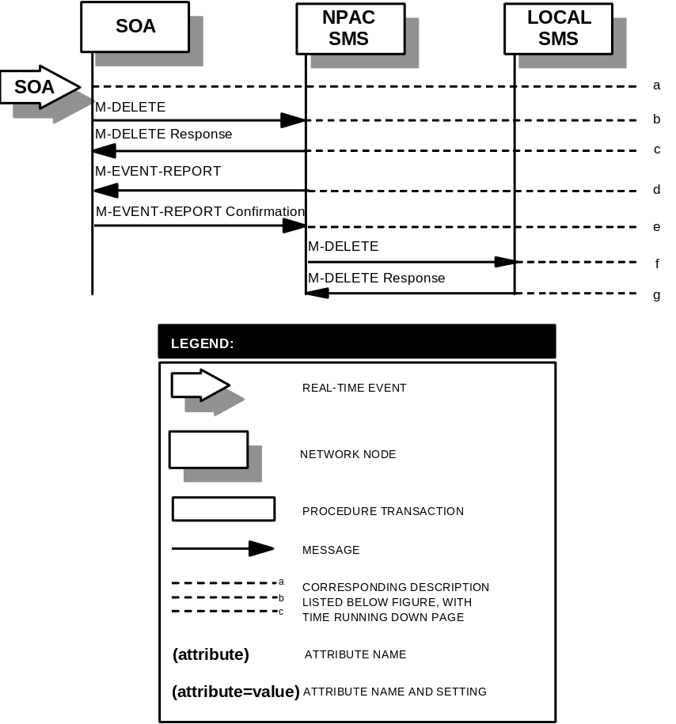

6.2

Audit Scenarios

6.2.1 SOA Initiated Audit
In this scenario, the SOA initiates an audit to the NPAC SMS due to suspected subscription version discrepancies.
- Action is taken by SOA personnel to start an audit due to suspected network discrepancies.
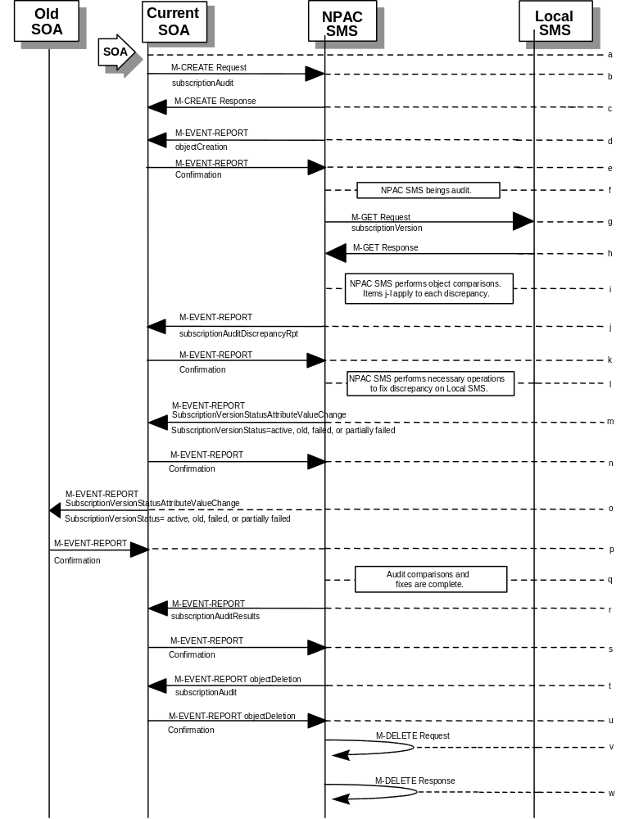
- The SOA sends a M-CREATE request to the NPAC SMS, requesting an audit. The SOA must specify the following attributes in the request:
subscriptionAuditName - English audit name
subscriptionAuditRequestingSP - the service provider requesting the audit
subscriptionAuditServiceProvIdRange - which service provider or all service providers for audit
subscriptionAuditTN-Range - TNs to be audited
- If these attributes are not specified, then the create will fail with a missingAttributesValue error. The SOA may also specify the following attributes in the request:
subscriptionAuditAttributeList - subscription version attributes to be audited
subscriptionAuditTN-ActivationRange - time range of activation for subscription versions to be audited
- The subscriptionAuditId and the subscriptionAuditStatus will be determined by the NPAC SMS. If any values are deemed invalid, an invalidArgumentValue error will be returned. NOTE: The subscriptionAuditTN-Range will be limited based on the maximum range size specified in the NPAC SMS. If the limit specified is exceeded, the create request will fail with an invalidAttributeValue error.
- Once the NPAC SMS creates the audit request object, it sends an M-CREATE response back to the SOA that initiated the request.
- NPAC SMS sends M-EVENT-REPORT to the service provider SOA for the subscriptionAudit creation.
- The service provider SOA confirms the M-EVENT-REPORT.
- NPAC SMS begins audit.
- NPAC SMS issues a scoped and filtered M-GET for the subscription versions in the audit, to all LSMS’s accepting downloads for the NPA-NXX of the subscription version.
- Local SMS returns M-GET query data.
- NPAC SMS performs the necessary comparisons of each subscription version object.
- If a discrepancy is found, NPAC SMS issues a subscriptionAuditDiscrepancyRpt M-EVENT-REPORT.
- Service provider SOA confirms the M-EVENT-REPORT.
- If a discrepancy is found, NPAC SMS issues the necessary operation to the Local SMS to correct the discrepancy (M-CREATE, M-DELETE, or
M-SET).
- If any corrections were issued to any Local SMSs, the NPAC SMS will send M-EVENT-REPORT to the service provider SOA of the subscriptionVersionStatus change and a list of failed Local SMSs (minus any recently updated Local SMSs that no longer contains a discrepancy).
- The service provider SOA confirms the M-EVENT-REPORT.
- If any corrections were issued to any Local SMSs, the NPAC SMS will send M-EVENT-REPORT to the old service provider SOA of the subscriptionVersionStatus change and a list of failed Local SMSs (minus any recently updated Local SMSs that no longer contains a discrepancy).
- The old service provider SOA confirms the M-EVENT-REPORT.
- NPAC SMS has completed the audit comparisons and corrections.

- NPAC SMS issues the subscriptionAuditResults M-EVENT-REPORT to the service provider SOA.
- The Service provider SOA confirms the M-EVENT-REPORT.
- The NPAC SMS then sends an objectDeletion M-EVENT-REPORT to the SOA for the subscriptionAudit object.
- The service provider SOA confirms the M-EVENT-REPORT.
- The NPAC SMS issues a local M-DELETE request for the subscriptionAudit object to/from the NPAC SMS. This will attempt to delete the subscriptionAudit object on the NPAC SMS.
- The M-DELETE response is received on the NPAC SMS indicating whether the subscriptionAudit object was deleted successfully.

6.2.2

SOA Initiated Audit Cancellation by the SOA
The SOA cancels an audit that it initiated.
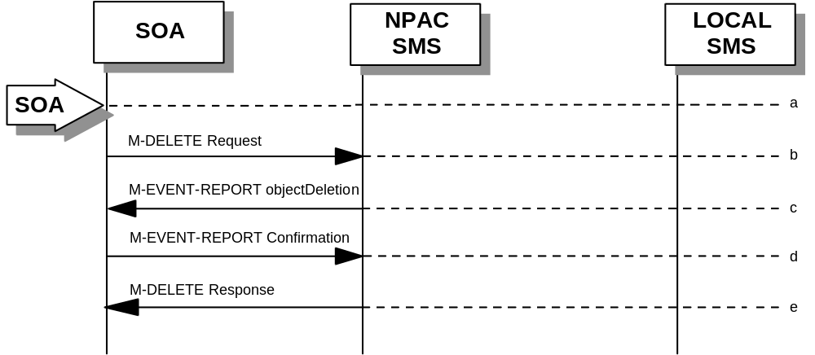
- Action is taken by SOA personnel to cancel an audit previously initiated by the SOA.
- The SOA sends an M-DELETE request for the subscriptionAudit object to the NPAC SMS, requesting cancellation of an audit. If the audit was not initiated by the SOA requesting cancellation, then the request will be rejected with an accessDenied error.
- The NPAC SMS will respond by sending an objectDeletion M-EVENT-REPORT.
- The SOA confirms the M-EVENT-REPORT.
- The NPAC SMS sends an M-DELETE response to the SOA.

6.2.3

SOA Initiated Audit Cancellation by the NPAC
The NPAC cancels an audit that was initiated by an SOA.
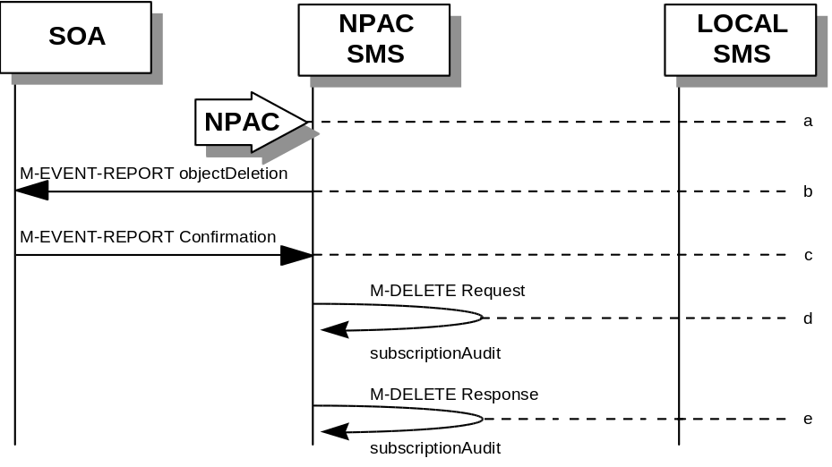
- Action is taken by NPAC personnel to cancel an audit previously initiated by an SOA.
- The NPAC SMS sends an objectDeletion M-EVENT-REPORT to the SOA that initiated the audit request.
- The SOA confirms the M-EVENT-REPORT
- The NPAC SMS issues a local M-DELETE request to/from the NPAC SMS. This will attempt to delete the subscriptionAudit object on the NPAC SMS.
- The M-DELETE response is received on the NPAC SMS indicating whether the subscriptionAudit object was deleted successfully.

6.2.4

NPAC Initiated Audit
In this scenario, the NPAC SMS initiates an audit due to suspected subscription version discrepancies.
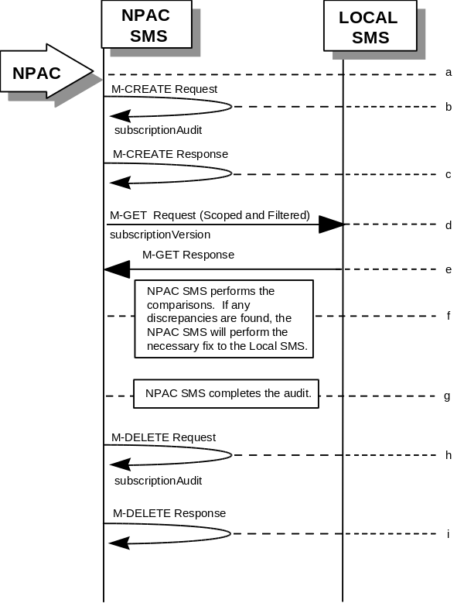
- Action is taken by NPAC personnel to start an audit due to suspected network discrepancies.
- The NPAC SMS does a Local M-CREATE request to itself for the subscriptionAudit object requesting an audit.
- The NPAC SMS responds with an M-CREATE response indicating that the subscriptionAudit object was created successfully.
- The NPAC SMS sends an M-GET request to the Local SMSs to retrieve the subscription data to use for audit processing. The request uses the CMIP scoping and filtering options to retrieve only the subscriptionVersion objects to be audited.
- The Local SMS responds to the M-GET request by returning the subscription data that satisfies the scope and filter data.
- NPAC SMS performs the comparisons. If any discrepancies are found, the NPAC SMS will perform the necessary fix to the Local SMS.
- NPAC SMS completes the audit.
- Issue a local M-DELETE request for the subscriptionAudit object to/from the NPAC SMS. This will attempt to delete the subscriptionAudit object on the NPAC SMS.
- The M-DELETE response is received on the NPAC SMS indicating whether the subscriptionAudit object was deleted successfully.

6.2.5

NPAC Initiated Audit Cancellation by the NPAC
The NPAC SMS cancels an audit that it initiated.
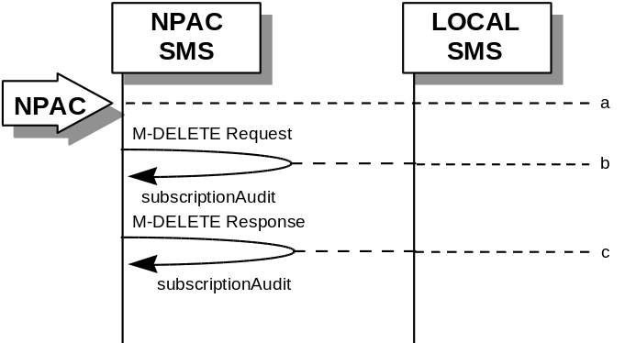
- Action is taken by NPAC personnel to cancel an audit previously initiated by the NPAC SMS.
- Issue a local M-DELETE request to/from the NPAC SMS. This will attempt to delete the subscriptionAudit object on the NPAC SMS.
- The M-DELETE response is received on the NPAC SMS indicating whether the subscriptionAudit object was deleted successfully.

6.2.6

Audit Query on the NPAC
This scenario shows a service provider query on an existing audit that it initiated.
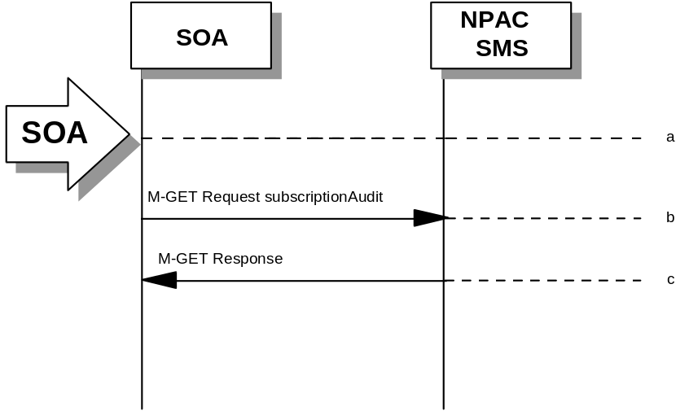
- The service provider SOA takes action to query an audit that it initiated.
- Service provider SOA sends an M-GET request for a subscriptionAudit on the NPAC SMS.
- NPAC SMS responds to an M-GET with the audit data or a failure and reason for failure. An accessDenied error will be returned to the service provider if they did not originate the audit queried.

6.3

Service Provider Scenarios

6.3.1 Service Provider Creation by the NPAC
In this scenario, the NPAC SMS creates data for a new LNP service provider. The addition of NPA-NXX and LRN data for a new service provider will be shown in flows that follow.
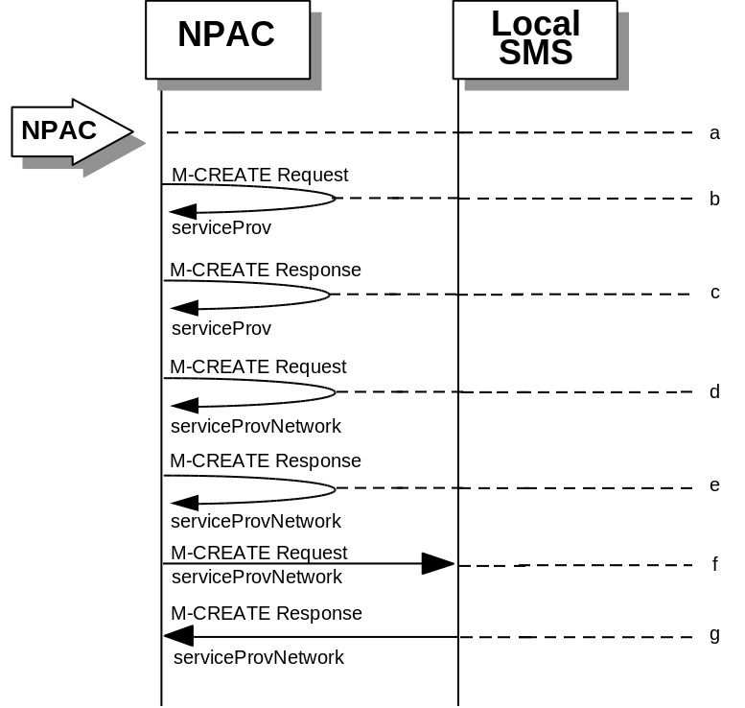
- Action is taken by NPAC SMS personnel to create a new service provider.
- Issue a local M-CREATE request for the serviceProv object to/from the NPAC SMS. This will attempt to create the serviceProv object on the NPAC SMS. If the M-CREATE fails, the appropriate error will be returned.
- The M-CREATE response is received on the NPAC SMS indicating whether the serviceProv object was created successfully. If a failure occurs, processing will stop.
- Issue a local M-CREATE request for the serviceProvNetwork object to/from the NPAC SMS. This will attempt to create the serviceProvNetwork object on the NPAC SMS. If the M-CREATE fails, the appropriate error will be returned.
- The M-CREATE response is received on the NPAC SMS indicating whether the serviceProvNetwork object was created successfully. If the object cannot be created, the serviceProv object is deleted and an error is returned.
- The NPAC SMS sends an M-CREATE request for the serviceProvNetwork object to each of the Local SMSs.
- The Local SMS(s) will respond by sending an M-CREATE response back to the NPAC SMS.

6.3.2

Service Provider Deletion by the NPAC
In this scenario, the NPAC SMS deletes data for an LNP service provider with no network data.
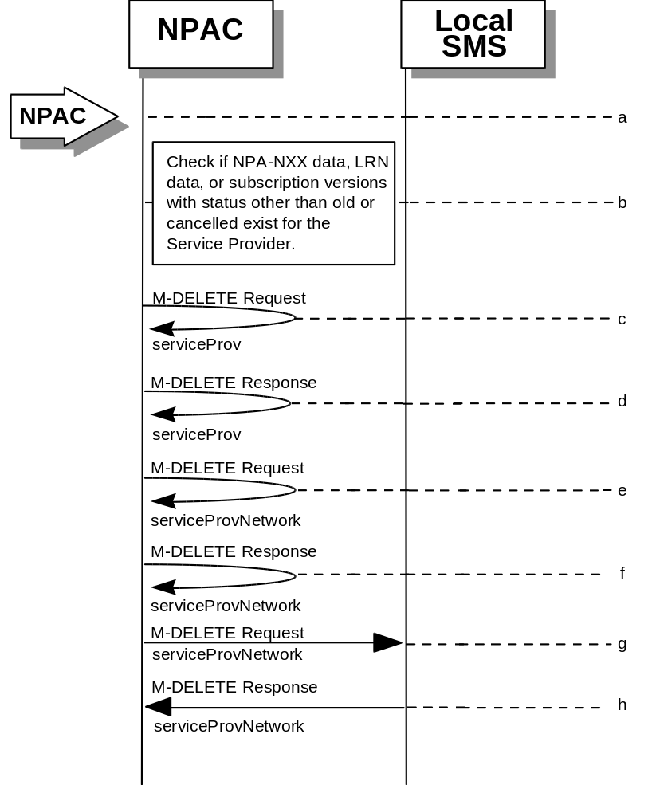
- Action is taken by NPAC SMS personnel to delete an existing service provider.
- Check the database to see if the service provider has associated with it NPA-NXX data, LRN data, or subscription versions with status other than old or canceled. If so, deny the request.
- Issue a local M-DELETE request for the serviceProv object to/from the NPAC SMS. This will attempt to delete the serviceProv object on the NPAC SMS.
- The M-Delete response is received on the NPAC SMS indicating whether the serviceProv object was deleted successfully.
- If the serviceProv object was deleted, issue a local M-DELETE request for the serviceProvNetwork object to/from the NPAC SMS. This will attempt to delete the serviceProvNetwork object on the NPAC SMS.
- The M-DELETE response is received on the NPAC SMS indicating whether the serviceProvNetwork object was deleted successfully.
- If the serviceProvNetwork object was deleted, the NPAC SMS sends an M-DELETE request for the serviceProvNetwork object to each of the Local SMS(s).
- The Local SMS(s) will respond by sending an M-DELETE response back to the NPAC SMS.

6.3.3

Service Provider Modification by the NPAC
In this scenario, the NPAC SMS modifies the LNP service provider data.
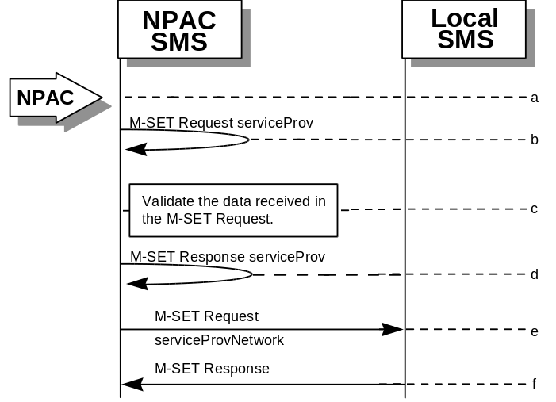
- Action is taken by the NPAC personnel to modify data for an existing service provider.
- Issue a local M-SET request for the serviceProv object to/from the NPAC SMS. This will attempt to set the specified information on the NPAC SMS.
- Validate the data to be set in the M-SET request. An M-SET Error Response of invalidArgumentValue is returned if any data is deemed invalid.
- The M-SET response is received on the NPAC SMS indicating whether the serviceProv object was modified successfully.
- NPAC SMS performs an M-SET to all the Local SMSs if the service provider name changed.
- The Local SMSs respond.

6.3.4

Service Provider Modification by the Local SMS
In this scenario, the Local SMS modifies its own service provider data.
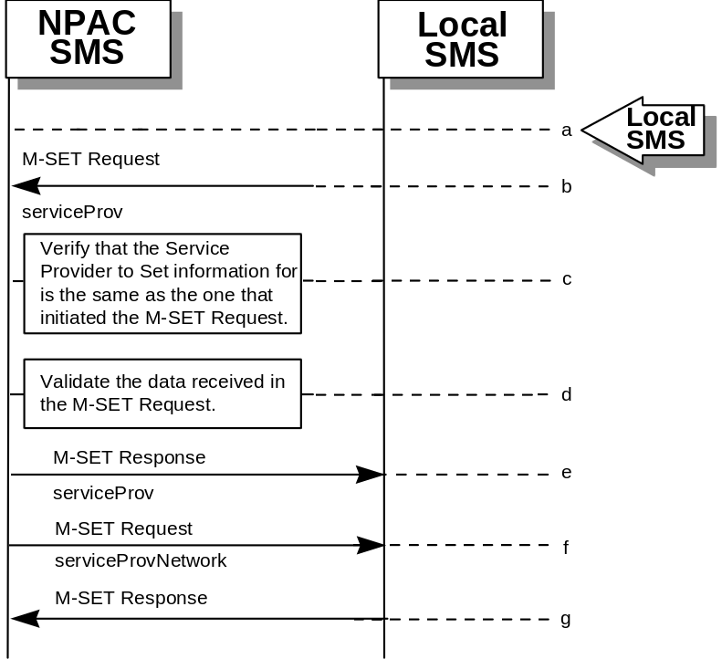
- Action is taken by the Local SMS personnel to modify their own service provider data.
- The Local SMS sends an M-SET request to the NPAC SMS to modify their service provider information.
- The NPAC SMS verifies that the service provider to be modified is owned by the service provider that initiated the request. If not, an access denied M-SET Error Response of invalidArgumentValue is returned.
- Validate the data to be set in the M-SET request. An invalidArgumentValue M-SET Error Response is returned if any data is deemed invalid.
- The NPAC SMS sends an M-SET response back to the Local SMS that initiated the request.
- NPAC SMS performs an M-SET to all Local SMSs if the service provider name changed.
- The Local SMSs respond.

6.3.5

Service Provider Modification by the SOA
In this scenario, the SOA modifies its own service provider data.
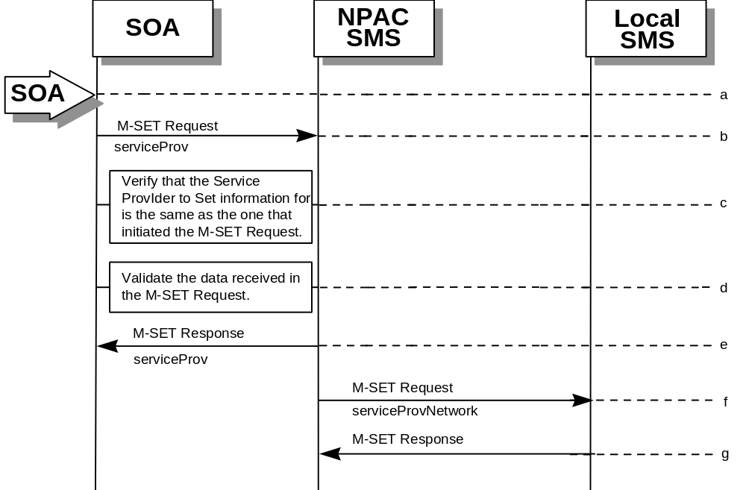
- Action is taken by the SOA to modify their own service provider data.
- The SOA sends an M-SET request to the NPAC SMS to modify their service provider information.
- The NPAC SMS verifies that the service provider to be modified is owned by the service provider that initiated the request. If not, an access denied M-SET Error Response is returned.
- Validate the data to be set in the M-SET request. An invalidArgumentValue M-SET Error Response is returned if any data is deemed invalid.
- The NPAC SMS sends an M-SET response back to the SOA that initiated the request.
- NPAC SMS performs an M-SET to all Local SMSs if the service provider name changed.
- The Local SMSs respond.

6.3.6

Service Provider Query by the Local SMS
In this scenario, the Local SMS queries their own service provider data.
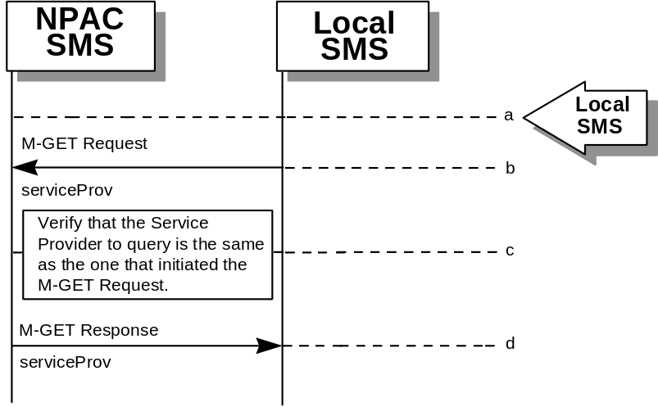
- Action is taken by the Local SMS personnel to query their own service provider data.
- The Local SMS sends an M-GET request to the NPAC SMS requesting their own service provider information.
- The NPAC SMS verifies that the service provider information to be retrieved is owned by the service provider that initiated the request. If not, an M-GET Error Response of accessDenied is returned if the two service providers do not match.
- The NPAC SMS sends an M-GET response containing the requested service provider information back to the Local SMS or SOA that initiated the request.

6.3.7

Service Provider Query by the SOA
In this scenario, the SOA queries their own service provider data.
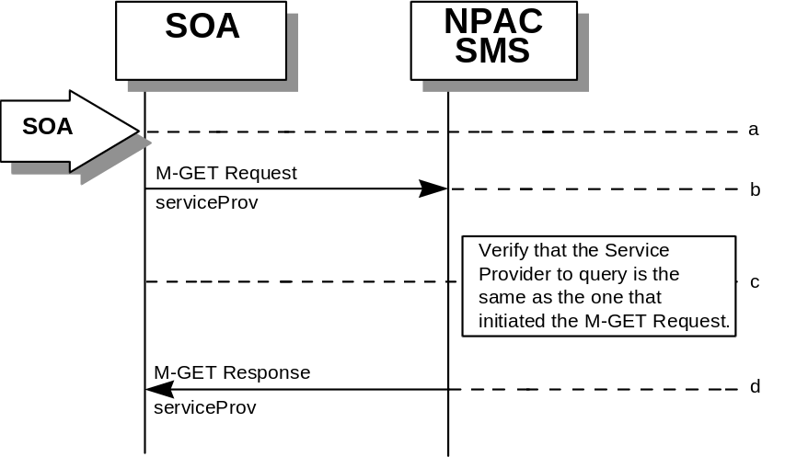
- Action is taken by the SOA or SOA personnel to query their own service provider data.
- The SOA sends an M-GET request to the NPAC SMS requesting their own service provider information.
- The NPAC SMS verifies that the service provider information to be retrieved is owned by the service provider that initiated the request. If not, an M-GET error response of accessDenied is returned if the two service providers do not match.
- The NPAC SMS sends an M-GET response containing the requested service provider information back to the SOA that initiated the request.

6.4

Service Provider Network Data Scenarios

6.4.1 NPA-NXX Scenarios

6.4.1.1 NPA-NXX Creation by the NPAC
In this scenario, NPAC SMS creates new NPA-NXX data for an LNP service provider.
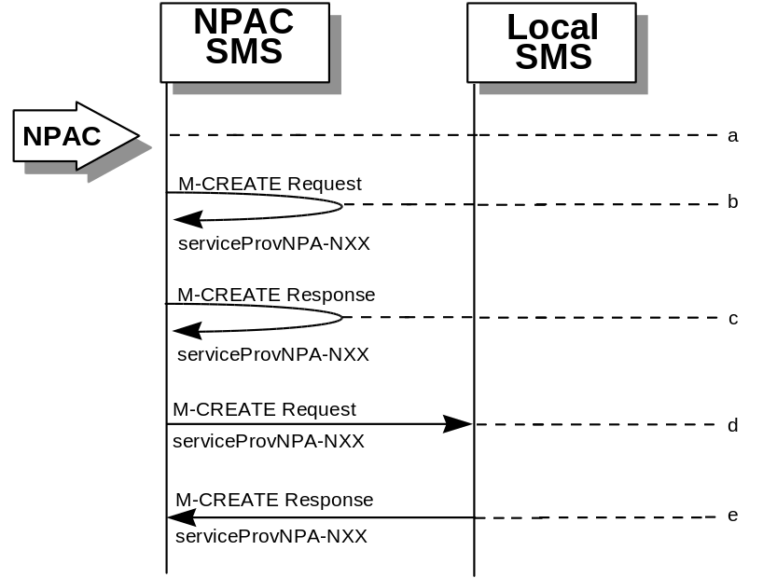
- Action is taken by the NPAC Personnel to create an NPA-NXX for a specified service provider.
- The NPAC SMS sends an M-CREATE request to itself in order to create a local serviceProvNPA-NXX object.
- The NPAC SMS receives the M-CREATE response indicating whether the serviceProvNPA-NXX object was created successfully.
- If the serviceProvNPA-NXX object was created, the NPAC SMS sends an M-CREATE request to all Local SMS(s) for the serviceProvNPA-NXX object.
- The Local SMS(s) respond by sending an M-CREATE response indicating whether the serviceProvNPA-NXX object was created successfully.

6.4.1.2

NPA-NXX Deletion by the NPAC
In this scenario, NPAC SMS deletes an NPA-NXX for an LNP service provider.
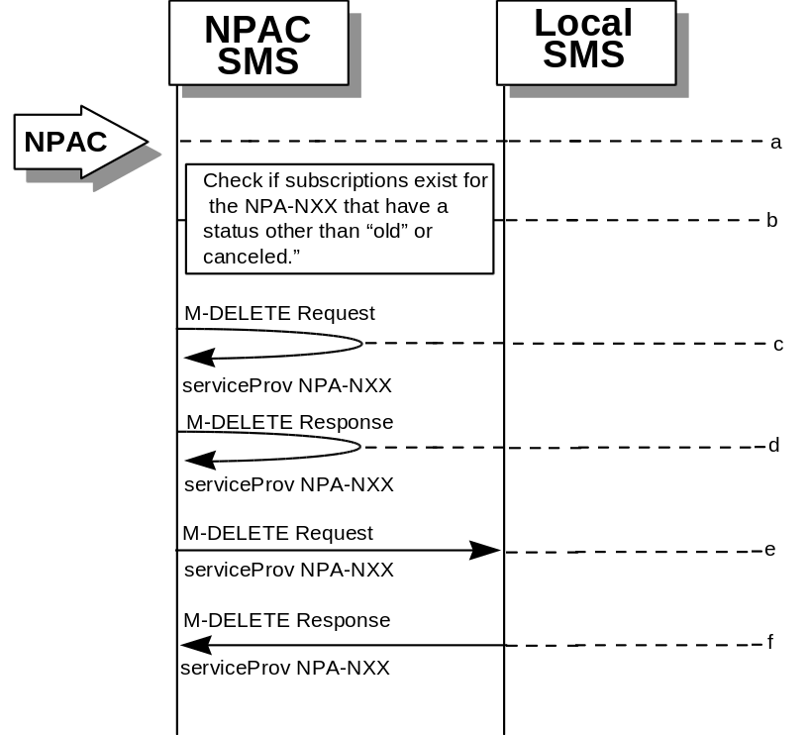
- Action is taken by NPAC SMS personnel to delete an NPA-NXX for a specified service provider.
- Check the subscriptions database to see if subscriptions exist with this NPa-NXX that have a status other than “old” or “canceled.” If so, terminate processing at this point.
- The NPAC SMS sends an M-DELETE request to itself in order to delete the local serviceProvNPA-NXX object.
- The NPAC SMS receives the M-DELETE response indicating whether the serviceProvNPA-NXX object was deleted successfully.
- If the serviceProvNPA-NXX object was deleted, the NPAC SMS sends an M-DELETE request to all Local SMS(s) for the serviceProvNPA-NXX object.
- The Local SMS(s) responds by sending an M-DELETE response to the NPAC SMS indicating whether the serviceProvNPA-NXX object was deleted successfully.

6.4.1.3

NPA-NXX Creation by the Local SMS
In this scenario, the Local SMS creates a new NPA-NXX for its own service provider network data.
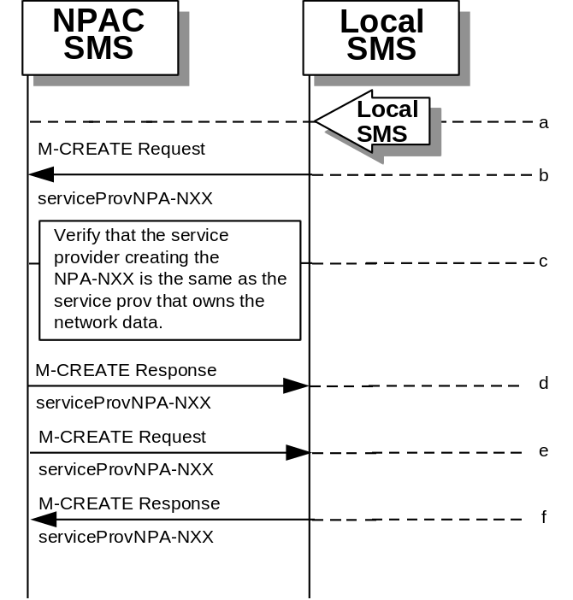
- Action is taken by the Local SMS personnel to create an NPA-NXX available for porting in their own service provider network.
- The Local SMS sends an M-CREATE request to the NPAC requesting that an NPA-NXX object be created for their own service provider network.
- The NPAC SMS verifies that the service provider creating the NPA-NXX information is the same as the service provider that owns the network data. If not, then an access denied M-CREATE accessDenied Error Response is returned.
- The NPAC SMS responds by sending an M-CREATE response to the Local SMS that initiated the request indicating whether the serviceProvNPA-NXX object was created successfully.
- If the serviceProvNPA-NXX object was created, the NPAC SMS sends an M-CREATE request to all Local SMS(s) for the serviceProvNPA-NXX object.
- The Local SMS(s) responds by sending an M-CREATE Response indicating whether the serviceProvNPA-NXX object was created successfully.

6.4.1.4

NPA-NXX Creation by the SOA
In this scenario, the SOA creates a new NPA-NXX for its own service provider network data.
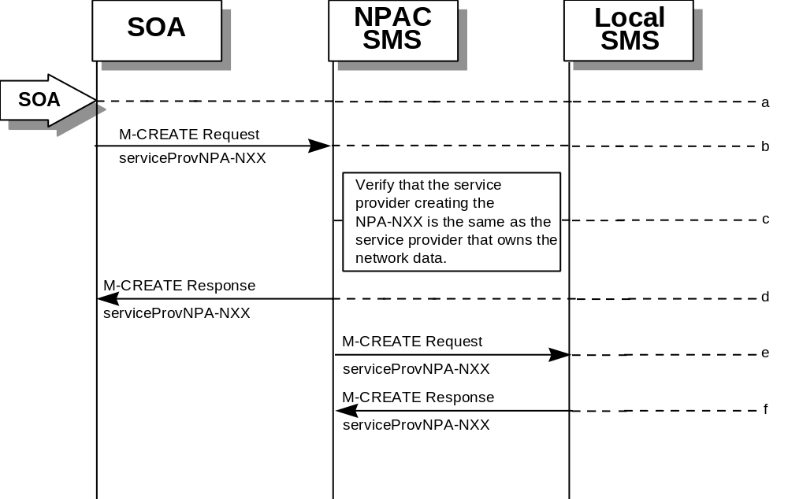
- Action is taken by the SOA personnel to create an NPA-NXX available for porting in their own service provider network.
- The SOA sends an M-CREATE request to the NPAC requesting that an NPA-NXX object be created for their own service provider network.
- The NPAC SMS verifies that the service provider creating the NPA-NXX information is the same as the service provider that owns the network data. If not, then an access denied M-CREATE response is returned to the SOA that initiated the request.
- The NPAC SMS sends an M-CREATE response back to the SOA for the serviceProvNPA-NXX object.
- The NPAC SMS sends an M-CREATE request to all Local SMS(s) for the serviceProvNPA-NXX object.
- The Local SMS(s) responds by sending an M-CREATE response indicating whether the serviceProvNPA-NXX object was created successfully.

6.4.1.5

NPA-NXX Deletion by the Local SMS
In this scenario, the Local SMS deletes an NPA-NXX in its own service provider network data.
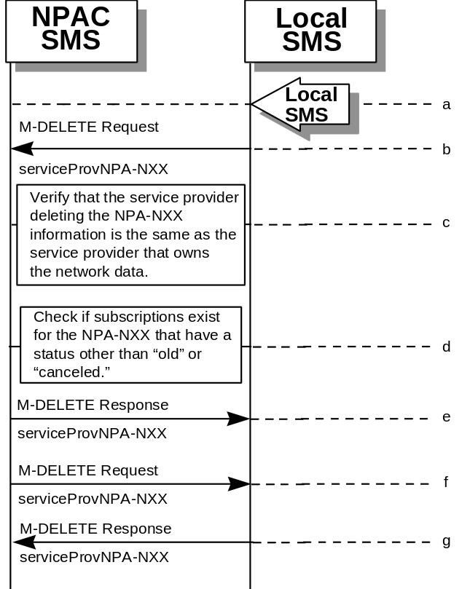
- Action is taken by the Local SMS personnel to delete an NPA-NXX for their own service provider network data.
- The SMS sends an M-DELETE request to the NPAC SMS requesting that an NPA-NXX object be deleted for their own service provider.
- The NPAC SMS verifies that the service provider that owns the NPAC-NXX information to be deleted is the same as the service provider that owns the network data. If not, then an M-DELETE accessDenied error response is returned.
- Check the subscriptions database to see if subscriptions exist with this LRN that have a status other than “old” or canceled.” If so, terminate processing at this point.
- The NPAC SMS responds by sending an M-DELETE response indicating whether the serviceProvNPA-NXX object was deleted successfully.
- If the serviceProvNPA-NXX object was deleted, the NPAC SMS sends an M-DELETE request to all Local SMS(s) for the serviceProvNPA-NXX object.
- The Local SMS(s) responds by sending an M-DELETE response indicating whether the serviceProvNPA-NXX object was deleted successfully.

6.4.1.6 NPA-NXX Deletion by the SOA
In this scenario, the SOA deletes a new NPA-NXX for its own service provider network data.
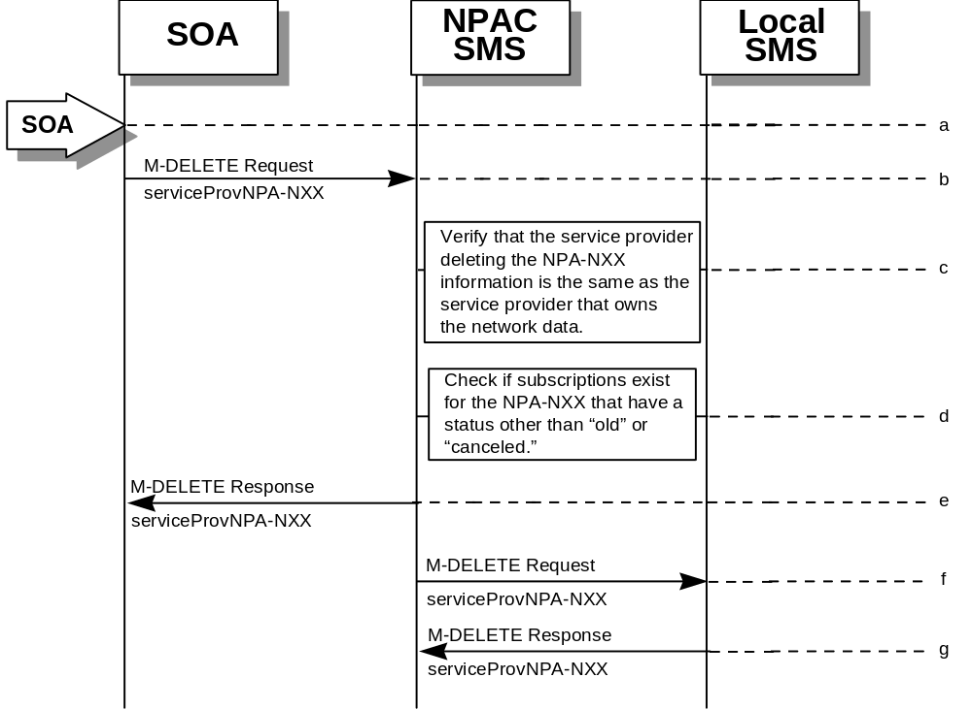
- Action is taken by the SOA personnel to delete an NPA-NXX for their own service provider network data.
- The SOA sends an M-DELETE request to the NPAC SMS requesting that an NPA-NXX object be deleted for their own service provider.
- The NPAC SMS verifies that the service provider that owns the NPA-NXX information to be deleted is the same as the service provider that owns the network data. If not, then an M-DELETE accessDenied Error Response is returned.
- Check the subscriptions database to see if subscriptions exist with this NPA-NXX that have a status other than “old” or “canceled.” If so, terminate processing at this point.
- The NPAC SMS responds by sending an M-DELETE response indicating whether the serviceProvNPA-NXX object was deleted successfully.
- The NPAC SMS sends an M-DELETE request to all Local SMS(s) for the serviceProvNPA-NXX object.
- The Local SMS(s) respond by sending an M-DELETE response indicating whether the serviceProvNPA-NXX object was deleted successfully.

6.4.1.7

NPA-NXX Query by the Local SMS
In this scenario, the Local SMS queries for NPA-NXX data.
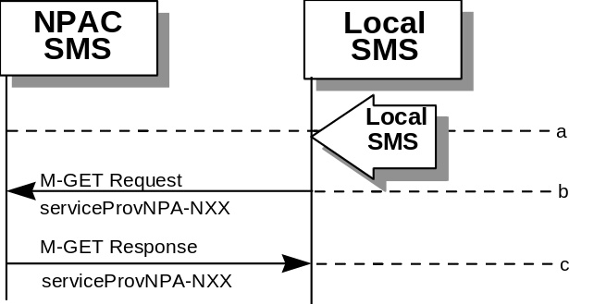
- Action is taken by Local SMS personnel to query for a serviceProvNPA-NXX.
- The Local SMS sends an M-GET request to the NPAC SMS for the serviceProvNPA-NXX object.
- The NPAC SMS responds by sending an M-GET response containing the NPA-NXX data back to the Local SMS.

6.4.1.8

NPA-NXX Query by the SOA
In this scenario, the SOA queries for NPA-NXX updates.
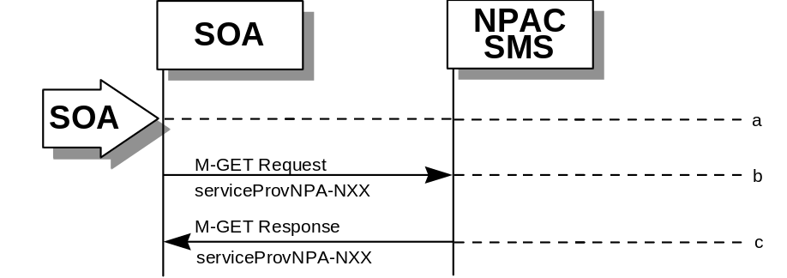
- Action is taken by SOA personnel to query for a serviceProvNPA-NXX.
- The SOA sends an M-GET request to the NPAC SMS for the serviceProvNPA-NXX object.
- The NPAC SMS responds by sending an M-GET response containing the NPA-NXX data back to the SOA.

6.4.2

LRN Scenarios

6.4.2.1 LRN Creation by the NPAC
In this scenario, the NPAC SMS creates an LRN for an LNP serviceProvNPA-NXX.
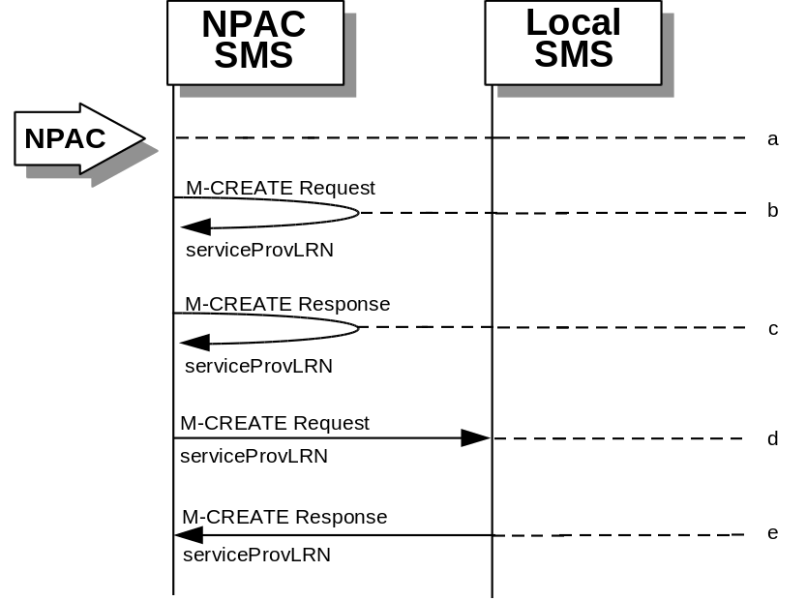
- Action is taken by the NPAC personnel to create an LRN for an existing service provider.
- The NPAC SMS sends an M-CREATE request to itself in order to create a local serviceProvLRN object.
- The NPAC SMS receives the M-CREATE response indicating whether the serviceProvLRN object was created successfully.
- If the serviceProvLRN object was created, the NPAC SMS sends an M-CREATE request to all Local SMS(s) for the serviceProvLRN object.
- The Local SMS(s) responds by sending an M-CREATE response indicating whether the serviceProvLRN object was created successfully.

6.4.2.2

LRN Creation by the SOA
In this scenario, the SOA creates an LRN for its own service provider network data.
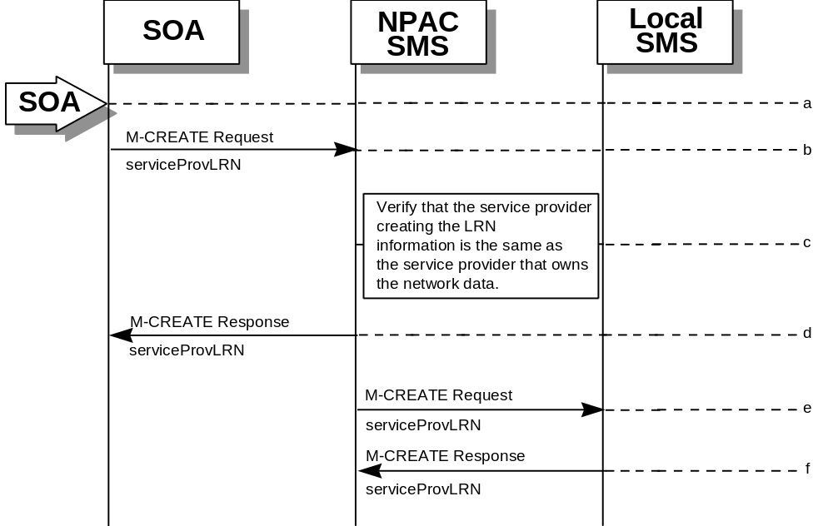
- Action is taken by the SOA personnel to create an LRN for their own network data.
- The SOA sends an M-CREATE request to the NPAC SMS requesting that an LRN object be created for their own network data.
- The NPAC SMS verifies that the service provider creating the LRN information is the same as the service provider that owns the service provider network data. If not, then an accessDenied M-CREATE Error Response is returned.
- The NPAC SMS responds by sending an M-CREATE response back to the SOA that initiated the request, indicating whether the serviceProvLRN object was created successfully.
- The NPAC SMS sends an M-CREATE request to all Local SMS(s) for the serviceProvLRN object.
- The Local SMS(s) respond by sending an M-CREATE response indicating whether the service provider LRN object was created successfully.

6.4.2.3

LRN Deletion by the SOA
In this scenario, the SOA deletes an LRN for their own service provider network data.
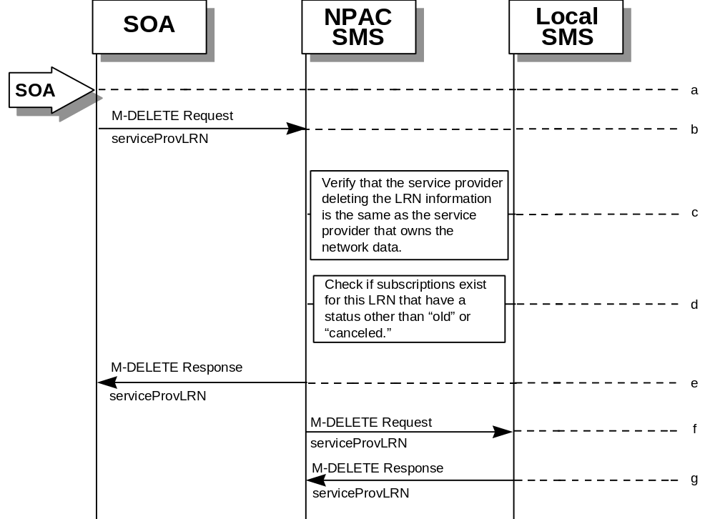
- Action is taken by the SOA personnel to delete an LRN for their own network data.
- The SOA sends an M-DELETE request to the NPA requesting that an LRN object be deleted.
- The NPAC SMS verifies that the service provider deleting the LRN information is the same as the service provider that is associated with the network data. If not, then an accessDenied M-DELETE error response is returned.
- Check the subscriptions database to see if subscriptions exist with this LRN that have a status other than “old” or “canceled.” If so, an M-SET error response complexity limitation is returned.
- The NPAC SMS responds by sending an M-DELETE response indicating whether the serviceProvLRN object was deleted successfully.
- The NPAC SMS sends an M-DELETE request to all Local SMS(s) for the serviceProvLRN object.
- The Local SMS(s) responds by sending a message indicating whether the serviceProvLRN object was deleted successfully.

6.4.2.4

LRN Query by the SOA
In this scenario, the SOA queries LRN data.
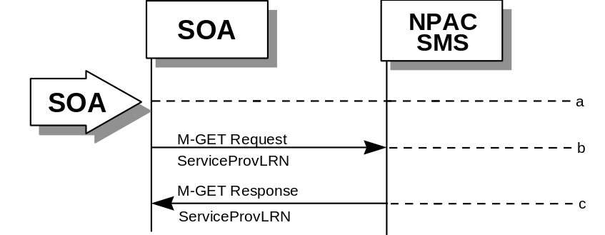
- Action is taken by SOA personnel to an LRN for a specified service provider.
- The SOA sends an M-GET request to the NPAC SMS for the serviceProvLRN object.
- The NPAC SMS responds by sending an M-GET response containing the data back to the SOA.

6.4.2.5

LRN Deletion by the NPAC
In this scenario, the NPAC SMS deletes an LRN for an LNP serviceProvNPA-NXX.
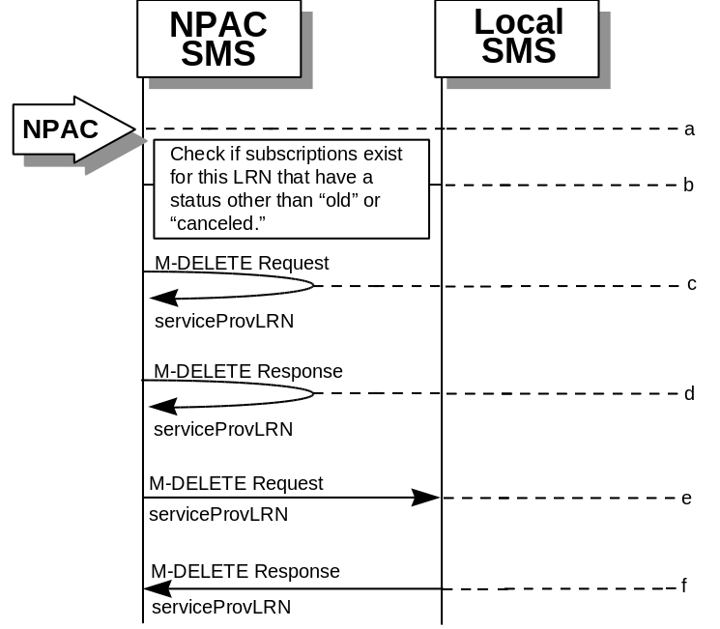
- Action is taken by the NPAC SMS personnel to delete an LRN for a service provider.
- Check the subscriptions database to see if subscriptions exist with this LRN that have a status other than “old” or “canceled.” If so, terminate processing at this point.
- The NPAC SMS sends an M-DELETE request to itself in order to delete the local serviceProvLRN object.
- The NPAC SMS receives the M-Delete response indicating whether the serviceProvLRN object was deleted successfully.
- If the serviceProvLRN object was deleted, the NPAC SMS sends an M-DELETE request to all Local SMS(s) for the serviceProvLRN object.
- The Local SMS(s) responds by sending an M-Delete response indicating whether the serviceProvLRN object was deleted successfully.

6.4.2.6 LRN Creation by the Local SMS
In this scenario, the Local SMS creates an LRN for its own service provider network data.
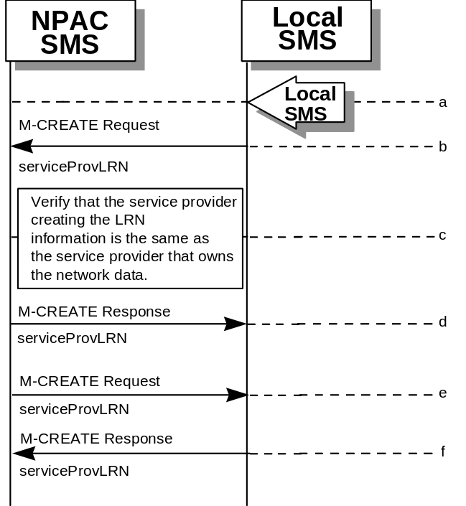
- Action is taken by the Local SMS personnel to create an LRN for their own network data.
- The SMS sends an M-CREATE request to the NPAC requesting that an LRN object be created for their own network data.
- The NPAC verifies that the service provider creating the LRN information is the same as the service provider that owns the service provider network data. If not, then an accessDenied M-CREATE error response is returned.
- The NPAC SMS responds by sending an M-CREATE response back to the Local SMS that initiated the request, indicating whether the serviceProvLRN object was created successfully.
- If the serviceProvLRN object was created, the NPAC SMS sends an M-CREATE request to all Local SMS(s) for the serviceProvLRN object.
- The Local SMS(s) responds by sending an M-CREATE response indicating whether the serviceProvLRN object was created successfully.

6.4.2.7

LRN Deletion by the Local SMS
In this scenario, the Local SMS deletes an LRN for their own service provider network data.
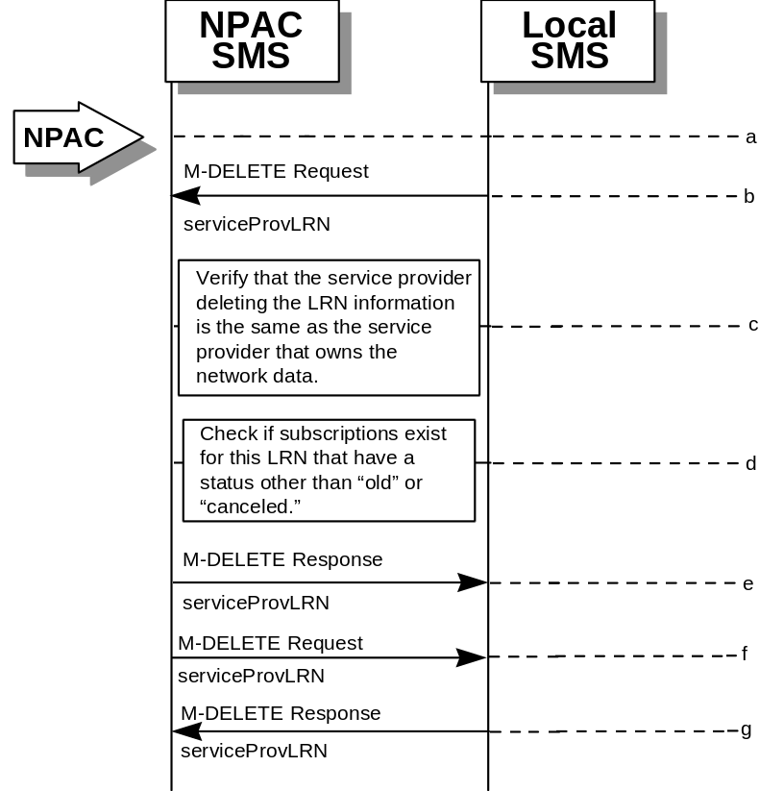
- Action is taken by the Local SMS personnel to delete an LRN for their own network data.
- The Local SMS sends an M-DELETE request to the NPAC requesting that an LRN object be deleted.
- The NPAC SMS verifies that the service provider deleting the LRN information is the same as the service provider that is associated with the network data. If not, then an accessDenied M-DELETE Error Response is returned.
- Check the subscriptions database to see if subscriptions exist with this LRN that have a status other than “old” or “canceled.” If so, an M-SET Error Response complexity limitation is returned.
- The NPAC SMS responds by sending an M-DELETE response indicating whether the serviceProvLRN object was deleted successfully.
- If the serviceProvLRN object was deleted, the NPAC SMS sends an M-DELETE request to all Local SMS(s) for the serviceProvLRN object.
- The Local SMS(s) responds by sending a message indicating whether the serviceProvLRN object was deleted successfully.

6.4.2.8 LRN Query by the Local SMS
In this scenario, the Local SMS queries LRN data.
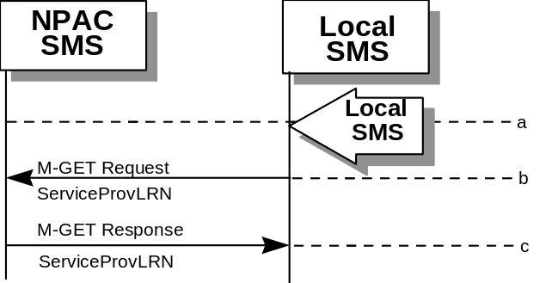
- Action is taken by Local SMS personnel to query an LRN for a specified service provider.
- The Local SMS sends an M-GET request to the NPAC SMS for the serviceProvLRN object.
- The NPAC SMS responds by sending an M-GET response containing the data back to the Local SMS.

6.4.2.9

Network Data Download
This scenario shows a Local SMS request for network data download in order to update their view of this data.
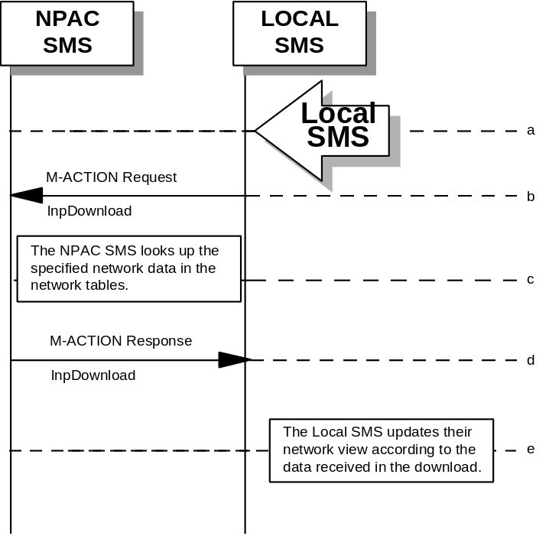
- Action is taken by the Local SMS personnel to request a network data download. The criteria to decide which network data is to be downloaded is specified by the Local SMS personnel.
- The Local SMS sends an M-ACTION request to the NPAC SMS lnpNetwork object requesting a network data download.
- The NPAC SMS looks up the network data in the network database as specified by the criteria in the M-ACTION request.
- The NPAC SMS responds by sending an M-ACTION response to the Local SMS that initiated the request. The response includes the success/failure of the request along with the requested network data.
- The Local SMS must take appropriate action to update their view of the data.

6.4.2.10

Scoped/Filtered GET of Network Data
This scenario shows a request for network data via a scoped/filtered M-GET. In this case, scoping is done from the lnpNetwork object. However, scoping and filtering can be done from serviceProvNetwork and serviceProvNPA-NXX objects.
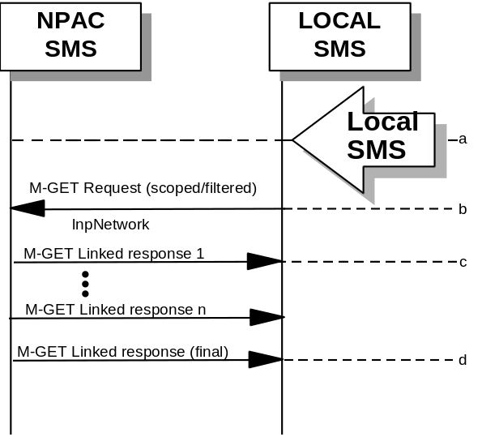
- Action is taken by the Local SMS personnel to request network data via a scoped/filtered M-GET request.
- The Local SMS sends a scoped/filtered M-GET request to the NPAC SMS.
- The NPAC SMS sends network data objects (serviceProvNetwork, serviceProvNPA-NXX, serviceProvLRN) that pass the scope/filter criteria to the Local SMS that initiated the request.
- A final M-GET response is sent to the Local SMS that initiated the request once all scoped/filtered network objects have been returned.

6.4.2.11

Scoped/Filtered GET of Network Data from SOA
This scenario shows a request for network data via a scoped/filtered M-GET. Scoping and filtering is done from serviceProvNetwork.
- Action is taken by the SOA personnel to request network data via a scoped/filtered M-GET request.
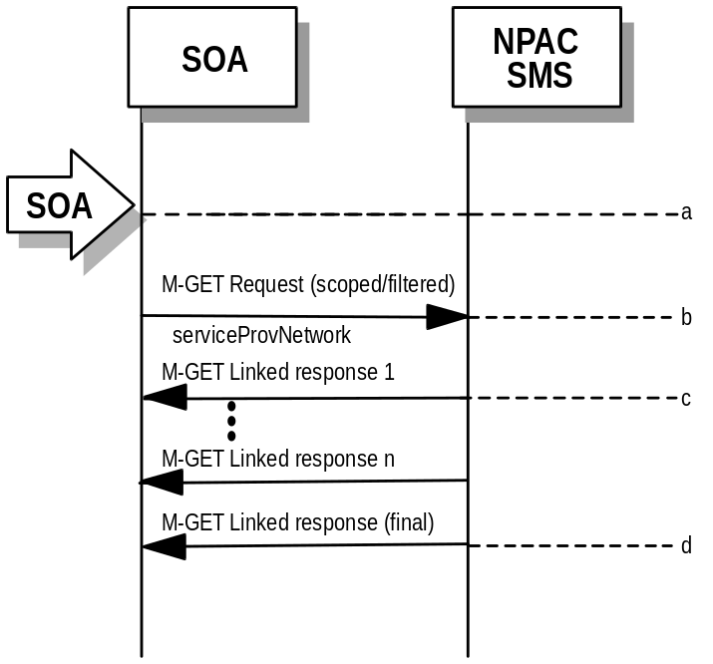

- The SOA sends a scoped/filtered M-GET request to the NPAC SMS.
- The NPAC SMS sends network data objects (serviceProvNetwork, serviceProvNPA-NXX, serviceProvLRN) that pass the scope/filter criteria to the SOA that initiated the request.
- A final M-GET response is sent to the SOA that initiated the request once all scoped/filtered network objects have been returned.

6.5

SubscriptionVersion Flow Scenarios
Note: All actions for subscription versions in the flows that follow are atomic. If the operation fails for one TN in a range it fails for all TNs in the range.

6.5.1 SubscriptionVersion Create Scenarios
The subscriptionVersionNPAC object is created by either the new or old service provider SOA issuing their M-ACTION to create the subscription version. If the new service provider SOA issues its subscriptionVersionNewSP-Create action first, the old service provider SOA has the option of sending in the subscriptionVersionOldSP-Create action or not. If they do send in the subscriptionVersionOldSP-Create, the old service provider explicitly states their concurrence or non-concurrence to the port by the value set within the subscriptionOldSP-Authorization field. If the old service provider does not send in their create request within the concurrence window, this implies concurrence to the port. However, the old service provider can send in their create request after the concurrence window before activation of the subscription version and the NPAC SMS will accept the data if valid.
If the old service provider SOA issues its subscriptionVersionOldSP-Create action first, then the new service provider SOA must issue its subscriptionVersionNewSP-Create action.

6.5.1.1 SubscriptionVersion Create by the Initial SOA (Old Service Provider)
In this scenario, the old service provider is the first to send the M-ACTION to create the subscriptionVersion object.
- Action is taken by the old service provider SOA to create a new version of a subscriber.
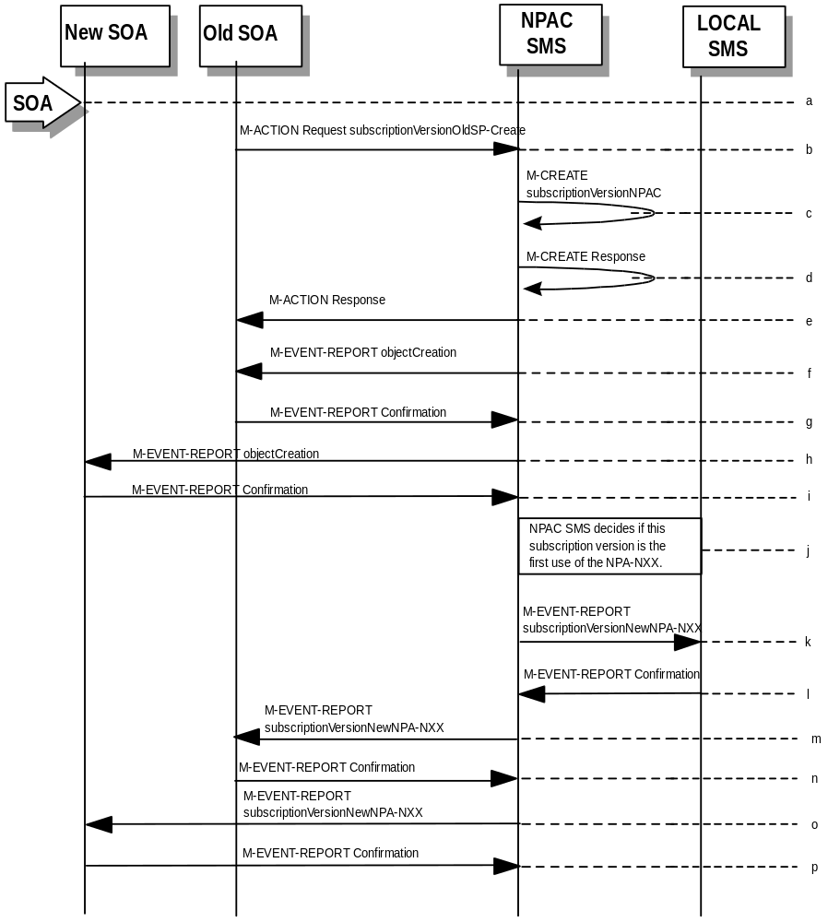
- Old service provider SOA sends M-ACTION subscriptionVersionOldSP-Create to the NPAC SMS lnpSubscriptions object to create a new subscriptionVersionNPAC. The old service provider SOA must specify the following valid attributes:
subscriptionTN or a valid subscriptionVersionTN-Range
subscriptionNewCurrentSP
subscriptionOldSP
subscriptionOldSP-DueDate
subscriptionOldSP-Authorization
subscriptionLNPType
If the service provider were to give a range of TNs, this would result in an M-CREATE and M-EVENT-REPORT for each TN.
If an attribute value is invalid, an invalidArgumentValue will be returned, indicating invalid data values. Other appropriate errors will also be returned.
- If the request is valid, the NPAC SMS will create the subscriptionVersionNPAC object. The status will be set to “pending” and the subscriptionOldSP-AuthorizationTimeStamp and subscriptionModifiedTimeStamp will be set.
- NPAC SMS responds to M-CREATE.
- NPAC SMS sends action reply with success or failure and reasons for failure.
- If the M-ACTION was successful, the NPAC SMS issues an M-EVENT-REPORT containing the following attributes to old service provider SOA of subscriptionVersionNPAC creation.
- subscriptionTN
- subscriptionOldSP
- subscriptionNewCurrentSP
- subscriptionOldSp-DueDate
- subscriptionOldSP-Authorization
- subscriptionOldSP-AuthorizationTimeStamp
- subscriptionStatusChangeCauseCode
- (if subscriptionOldSP-Authorization set to false)
- subscriptionVersionStatus
- Old service provider SOA responds by sending an M-EVENT-REPORT confirmation back to the NPAC SMS.
- If the M-ACTION was successful, the NPAC SMS issues an M- EVENT-REPORT to new service provider SOA of subscriptionVersionNPAC creation.
- New service provider SOA issues an M-EVENT-REPORT confirmation to NPAC SMS.
- NPAC SMS decides if this subscription version is the first use or the NPA-NXX.
- If this is the first use of the NPA-NXX, the NPAC SMS sends the subscriptionVersionNewNPA-NXX M-EVENT-REPORT to inform the accepting Local SMSs.
- The Local SMS confirms the M-EVENT-REPORT.
- The NPAC SMS sends the subscriptionVersionNew NPA-NXX M-EVENT-REPORT to inform the Old SOA.
- The Old SOA confirms the M-EVENT-REPORT.
- The NPAC SMS sends the subscriptionVersionNew NPA-NXX M-EVENT-REPORT to inform the New SOA.
- The New SOA confirms the M-EVENT-REPORT.
- The next scenario would be “SubscriptionVersion Create by the Second SOA (New Service Provider).”

6.5.1.2

SubscriptionVersion Create by the Initial SOA (New Service Provider)
In this scenario, the new service provider is the first to send the M-ACTION to create the subscriptionVersion object.
- Action is taken by the new service provider SOA to create a new version of a subscriber.
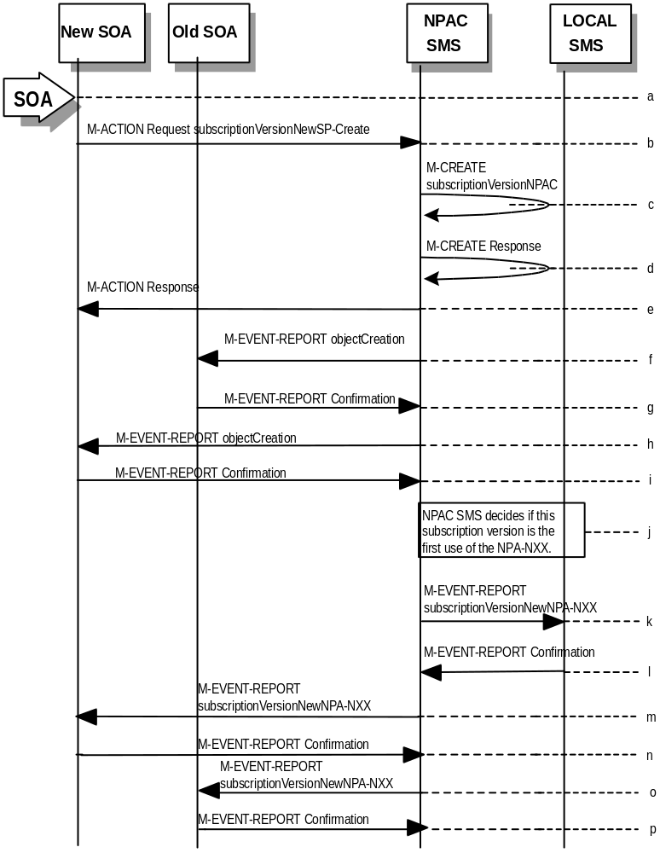

- New service provider SOA sends M-ACTION subscriptionVersionNewSP-Create to the NPAC SMS lnpSubscriptions object to create a new subscriptionVersionNPAC. The new service provider SOA must specify the following valid attributes:
subscriptionTN or a valid subscriptionVersionTN-Range
subscriptionNewCurrentSP
subscriptionOldSP
subscriptionNewSP-DueDate
subscriptionLNPType
subscriptionPortingToOriginal-SP Switch
The following items must be provided unless subscriptionPortingToOriginal-SP is true:
subscriptionLRN
subscriptionCLASS-DPC
subscriptionCLASS-SSN
subscriptionLIDB-DPC
subscriptionLIDB-SSN
subscriptionCNAM-DPC
subscriptionCNAM-SSN
subscriptionISVM-DPC
subscriptionISVM-SSN
The following attributes are optional:
subscriptionEndUserLocationValue
subscriptionEndUserLocationType
subscriptionBillingId
If the service provider were to give a range of TNs, this would result in an M-CREATE and M-EVENT-REPORT for each TN.
If any attribute is invalid, an action failure will be returned, indicating invalidArgumentValue. Other appropriate errors will also be returned.
- If the request is valid, the NPAC SMS will create the subscriptionVersionNPAC object. The status will be set to “pending” and the subscriptionModifiedTimeStamp and subscriptionCreationTimeStamp will be set.
- NPAC SMS responds to M-CREATE.
- NPAC SMS sends action reply with success or failure and reasons for failure.
- If the M-ACTION was successful, NPAC SMS issues an M-EVENT-REPORT containing the following attributes to old service provider SOA of subscriptionVersionNPAC creation.
- subscriptionTN
- subscriptionOldSP
- subscriptionNewCurrentSP
- subscriptionNewSP-CreationTimeStamp
- subscriptionVersionStatus
- subscriptionNewSP-DueDate
- Old service provider SOA responds by sending an M-EVENT-REPORT confirmation back to the NPAC SMS.
- If the M-ACTION was successful, NPAC SMS issues an M-EVENT-REPORT to new service provider SOA of subscriptionVersionNPAC creation.
- New service provider SOA issues an M-EVENT-REPORT confirmation to NPAC SMS.
- NPAC SMS decides if this subscription version is the first use or the NPA-NXX.
- If this is the first use of the NPA-NXX, the NPAC SMS sends the subscriptionVersionNewNPA-NXX M-EVENT-REPORT to inform the accepting Local SMSs.
- The Local SMS confirms the M-EVENT-REPORT.
- The NPAC SMS sends the subscriptionVersionNew NPA-NXX M-EVENT-REPORT to inform the Old SOA.
- The Old SOA confirms the M-EVENT-REPORT.
- The NPAC SMS sends the subscriptionVersionNew NPA-NXX M-EVENT-REPORT to inform the New SOA.
- The New SOA confirms the M-EVENT-REPORT.
- The next scenario is either “SubscriptionVersion Create by the Second SOA (Old Service Provider).” or “SubscriptionVersion Activated by New Service Provider SOA”.

6.5.1.3

SubscriptionVersion Create by Second SOA (New Service Provider)
In this scenario, the old service provider has already issued its request causing the subscriptionVersionNPAC to be created. The new service provider is now following with its own create action.
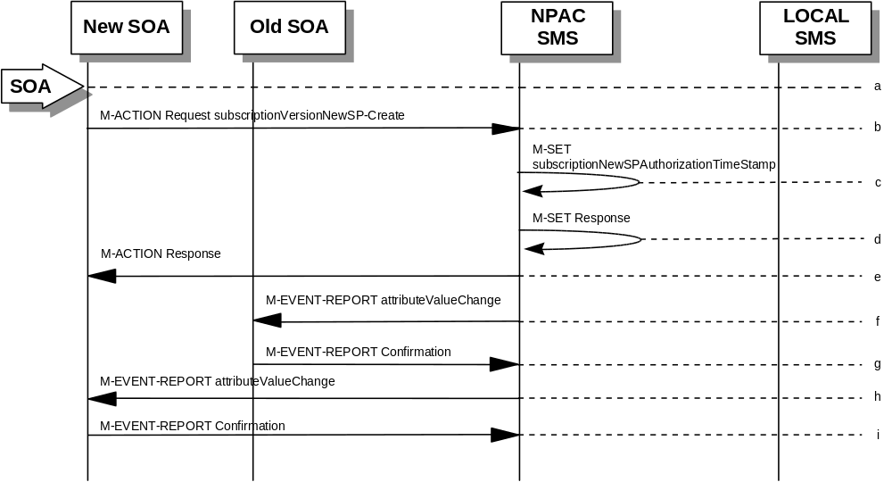
- New service provider SOA personnel take action to create a new subscription version.
- New service provider SOA sends M-ACTION subscriptionVersionNewSP-Create to NPAC SMS lnpSubscriptions object to create a new subscriptionVersionNPAC. The new service provider SOA must specify the following valid attributes:
subscriptionTN or a valid subscriptionVersionTN-Range
subscriptionNewCurrentSP
subscriptionOldSP
subscriptionNewSP-DueDate
subscriptionLNPType
subscriptionPortingToOriginal-SP Switch
The following items must be provided unless subscriptionPortingToOriginal-SP is true:
subscriptionLRN
subscriptionCLASS-DPC
subscriptionCLASS-SSN
subscriptionLIDB-DPC
subscriptionLIDB-SSN
subscriptionCNAM-DPC
subscriptionCNAM-SSN
subscriptionISVM-DPC
subscriptionISVM-SSN
The following attributes are optional:
subscriptionEndUserLocationValue
subscriptionEndUserLocationType
subscriptionBillingId
If a TN range is specified in the request, it would result in an M-SET request and M-EVENT-REPORT for each TN.
If the new service provider is not the new service provider specified in the initial create by the old service provider, an accessDenied error will be returned.
If any attribute is invalid, an action failure will be returned, indicating invalidArgumentValue. Other appropriate errors will be returned.
- If successful, the NPAC SMS sets the subscriptionModifiedTimeStamp, subscriptionCreationTimeStamp, and all data specified in the M-ACTION.
- NPAC SMS responds to M-SET.
- NPAC SMS sends M-ACTION reply with success or failure and reasons for failure.
- NPAC SMS issues the M-EVENT-REPORT with the following attributes to the old service provider when the subscriptionNewSP-DueDate changes value.
- subscriptionNewSP-DueDate
- subscriptionNewSP-CreationTimeStamp
- Old service provider SOA issues M-EVENT-REPORT confirmation.
- If the M-ACTION was successful, the NPAC SMS issues M-EVENT-REPORT to the new service provider for all attributes updated from the preceding list of modifiable attributes in addition to the following:
- subscriptionNewSP-DueDate
- subscriptionNewSP-CreationTimeStamp
- New service provider SOA issues M-EVENT-REPORT confirmation.

6.5.1.4

SubscriptionVersion Create by Second SOA (Old Service Provider)
- In this scenario, the new service provider has already issued its request causing the subscriptionVersionNPAC to be created. The old service provider is now following with its own create action.
Note: This is an optional step.
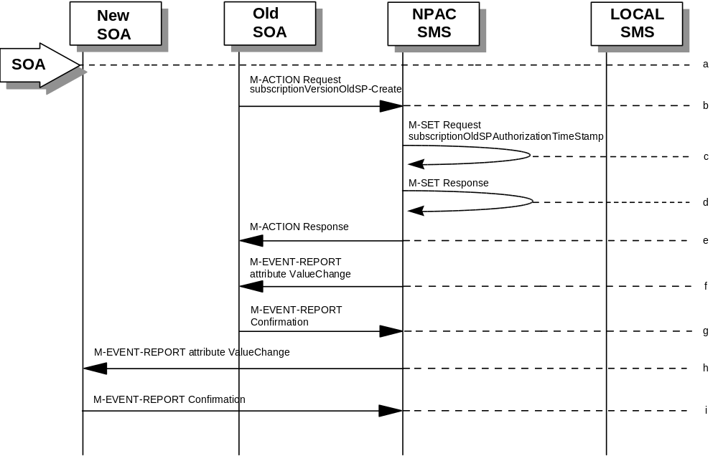
- Old service provider SOA personnel take action to create a old subscription version.
- Old service provider SOA sends M-ACTION subscriptionVersionOldSP-Create to NPAC SMS lnpSubscriptions object to create an old subscriptionVersionNPAC. The old service provider SOA must specify the following valid attributes:
subscriptionTN or a valid subscriptionVersionTN-Range
subscriptionNewCurrentSP
subscriptionOldSP
subscriptionOldSP-Authorization
subscriptionOldSP-DueDate
subscriptionLNPType
If a TN range is specified in the request, it would result in an M-SET request and M-EVENT-REPORT for each TN.
If the old service provider is not the old service provider specified in the initial create request by the new service provider, an accessDenied error will be returned.
If any attribute is invalid, an invalidArgumentValue will be returned, indicating invalid data values. Other appropriate errors will also be returned.
- If the data is valid, the NPAC SMS sets the subscriptionOldSP-AuthorizationTimeStamp, subscriptionModifiedTimeStamp and all data specified in the M-ACTION.
- NPAC SMS responds to M-SET.
- NPAC SMS sends M-ACTION reply with success or failure and reasons for failure.
- If the M-ACTION was successful, the NPAC SMS issues M-EVENT-REPORT attribute value change to the old service provider for all attributes updated from the following list:
subscriptionOldSP-DueDate
subscriptionOldSP-Authorization
- subscriptionOldSP-AuthoriztionTimeStamp
- Old service provider SOA issues M-EVENT-REPORT confirmation.
- If the M-ACTION was successful, the NPAC SMS issues M-EVENT-REPORT attribute value change to the new service provider for all attributes updated from the preceding list. The following attributes are sent in the attributeValueChangeNotification:
- subscriptionOldSP-DueDate
- subscriptionOldSP-Authorization
- subscriptionOldSP-AuthoriztionTimeStamp
- New service provider issues M-EVENT-REPORT confirmation.
- The next scenario would be “SubscriptionVersion Activated by New Service Provider SOA.”

6.5.1.5

SubscriptionVersion Activated by New Service Provider SOA
In this scenario, either both service providers have sent their create data updates for a new subscription version to the NPAC SMS or the concurrence window has expired for receiving the subscriptionVersionOldSP-Create action. The new service provider can now activate the subscription version.

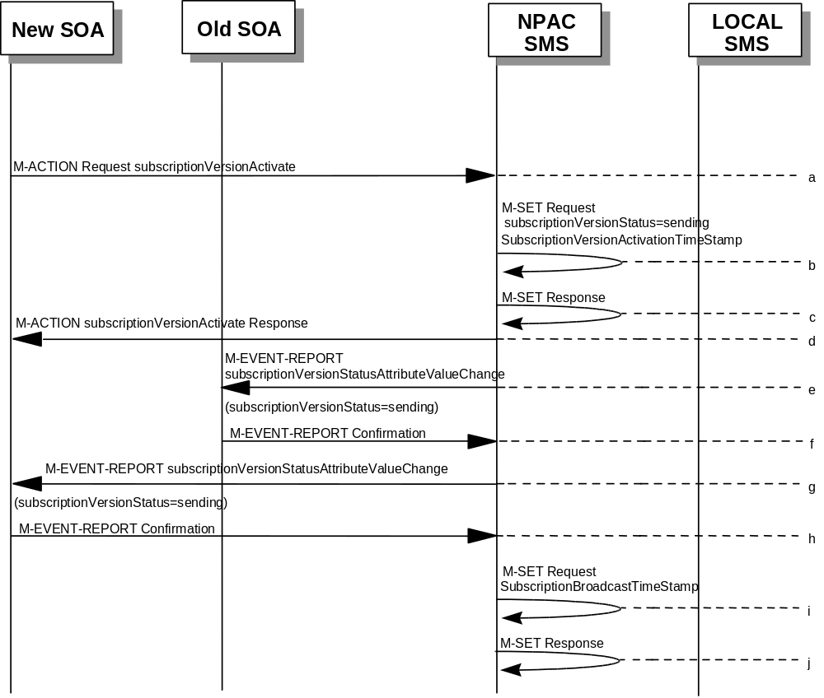
- The new service provider SOA issues a subscriptionVersionActivate
M-ACTION to the NPAC SMS lnpSubscriptions object to activate the pending subscription version by specifying the subscription version ID, subscription version TN, or a range of subscription version TNs.
- NPAC SMS issues an M-SET request setting the subscriptionVersionStatus to “sending,” subscriptionVersionActivationTimeStamp and subscriptionModifiedTimeStamp on the subscriptionVersionNPAC object.
- NPAC SMS responds to the M-SET.
- The NPAC SMS responds with the M-ACTION response. An error will be returned if the service provider is not the new service provider (accessDenied) or if there is no version to be activated (invalidArgumentValue) or if any other failures occur.
- If the M-ACTION was successful, the NPAC SMS sends to the old SOA a subscriptionVersionStatusAttributeValueChange for the subscriptionVersionStatus being set to “sending”.
- The old service provider SOA returns an M-EVENT-REPORT confirmation to the NPAC SMS.
- If the M-ACTION was successful, the NPAC SMS sends to the new service provider SOA a subscriptionVersionStatusAttributeValueChange for the subscriptionVersionStatus being set to “sending.”
- The new service provider SOA returns an M-EVENT-REPORT confirmation to the NPAC SMS.
- NPAC SMS issues an M-SET request setting the subscriptionVersionStatus to “sending,” subscriptionBroadcastTimeStamp on the subscriptionVersionNPAC object.
- NPAC SMS responds to the M-SET.
- For subscription versions that are not being ported to the original service provider’s switch, processing continues in the “Active SubscriptionVersion Create on Local SMSs” flow.
- For ports to the original service provider’s switch, the flow follows an immediate disconnect scenario. The NPAC SMS sets the broadcast timestamp, notifies the service provider SOA of the status change and proceeds to issue M-DELETEs for the subscriptionVersion to the Local SMS.

6.5.1.6

Active SubscriptionVersion Create on Local SMS
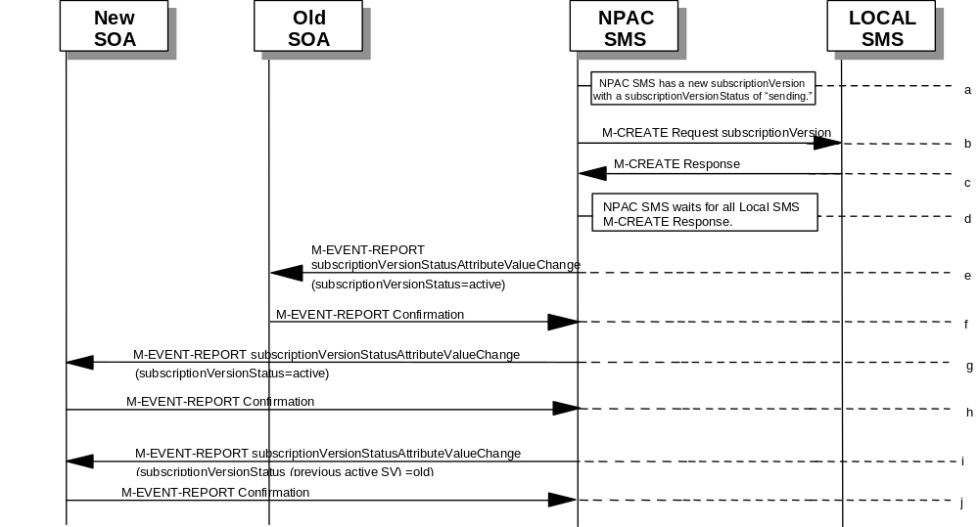This scenario and associated error scenarios reflect the message flow for all new object create requests from the NPAC SMS to the Local SMSs.

- NPAC SMS has a new subscriptionVersion with a status of “sending.”
- The NPAC SMS issues an M-CREATE for the subscriptionVersion to each of the Local SMSs, that is accepting downloads for the NPA-NXX of the subscriptionVersion.
- Each Local SMS will reply to the M-Create.
- NPAC SMS waits for Local SMSs to report successful objectCreation.
- If the subscriptionVersion NPAC object was modified, the NPAC SMS will issue M-EVENT-REPORT notifications to the old service provider SOA of the status change using an M-EVENT-REPORT subscriptionVersionStatusAttributeValueChange.
- The old service provider SOA returns an M-EVENT-REPORT confirmation to the NPAC SMS.
- If the subscriptionVersion NPAC object was modified, the NPAC SMS will issue M-EVENT-REPORT notifications to the new service provider SOA of the status change using an M-EVENT-REPORT subscriptionVersionStatusAttributeValueChange.
- The new service provider SOA returns an M-EVENT-REPORT confirmation to the NPAC SMS.
- If this TN has been previously ported (i.e., a previously active subscriptionVersion NPAC object exists), the NPAC SMS will issue an M-EVENT-REPORT notification to the current service provider SOA for the previously active subscriptionVersion NPAC object of the status change using an M-EVENT-REPORT subscriptionVersionStatusAttributeValueChange.
- The current service provider SOA for the previously active subscriptionVersion NPAC object returns an M-EVENT-REPORT confirmation to the NPAC SMS.

6.5.1.6.1

Active Subscription Version Create on Local SMS Using Create Action
This scenario reflects the message flow for all new object create requests from the NPAC SMS to the Local SMS Using Create Action. This action is used to create a group of subscription versions with the same routing information.
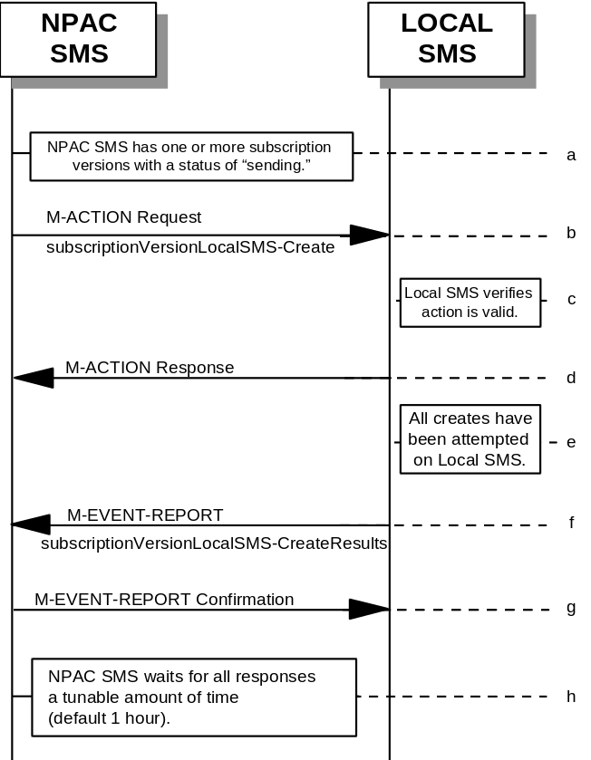
- NPAC SMS has one or more subscription versions with a status of “sending ” that have been activated by the new service provider.
- NPAC SMS issues the subscriptionVersionLocalSMS-Create action to the Local SMS, if it is accepting downloads for the NPA-NXX of the subscriptionVersion. This action contains all data necessary to create the subscription version.
- The Local SMS verifies the action is valid, but does not attempt to create the subscription version(s).
- The Local SMS responds to the M-ACTION.
- The Local SMS proceeds to execute all the creates specified by the action.
- The Local SMS sends to the NPAC SMS the M-EVENT-REPORT specifying the success or failure of the creates.
- NPAC SMS confirms the M-EVENT-REPORT.
- NPAC SMS waits for all responses a tunable amount of time. The default is 1 hour.

6.5.1.6.2

SubscriptionVersion Create: No Create Action from the Old Service Provider SOA After Concurrence Window
This scenario shows no response within “Service Provider Concurrence Window” by the old service provider SOA.
In this case, the new service provider SOA issued the create request. The NPAC SMS has issued the ObjectCreation M-EVENT-REPORT back to both the old and new service provider SOAs. No response has yet been received by the old service provider SOA.
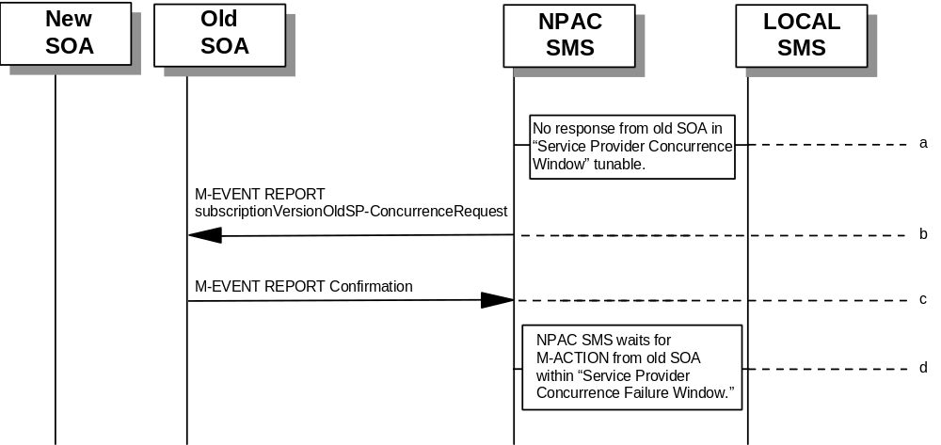
- NPAC SMS does not receive a response from the old service provider SOA within “Service Provider Concurrence Window” for the pending subscriptionVersionNPAC created by the new service provider SOA.
- NPAC SMS sends the old service provider an M-EVENT-REPORT subscriptionVersionOldSP-ConcurrenceRequest.
- The old service provider SOA returns an M-EVENT-REPORT confirmation to the NPAC SMS.
- Old service provider has up to “Service Provider Concurrence Failure Window” to respond to the request.
- If the old service provider SOA responds with a valid M-ACTION or M-SET, processing resumes as a successful create.

6.5.1.6.3

SubscriptionVersion Create: No Create Action from the Old Service Provider SOA After Final Concurrence Window
This scenario shows no response within “Service Provider Final Concurrence Window” by the old service provider SOA.
In this case, the new service provider SOA issued the create request. The NPAC SMS has issued the ObjectCreation M-EVENT-REPORT back to both the old and new service provider SOAs as well as a subsciptionVersionOldSP-ConcurrenceRequest
M-EVENT-REPORT to the old service provider SOA. No response has yet been received by the old service provider SOA.
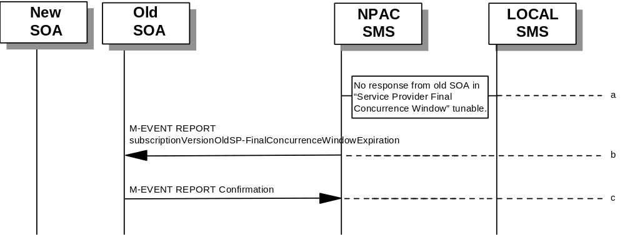
- NPAC SMS does not receive a response from the old service provider SOA within “Service Provider Final Concurrence Window” for the pending subscriptionVersionNPAC created by the new service provider SOA.
- NPAC SMS sends the old service provider an
M-EVENT-REPORT subscriptionVersionOldSP-Final ConcurrenceWindowExpiration.
- The old service provider SOA returns an M-EVENT-REPORT confirmation to the NPAC SMS.
- If the old service provider SOA responds with a valid
M-ACTION or M-SET prior to activation by the new service provider, the subscription version will be updated.

6.5.1.6.4

Subscription Version Create: Failure to Receive Response from New SOA
This scenario shows action taken by the NPAC SMS after not receiving any concurrence from the new service provider after the “Service Provider Concurrence Failure Window.”
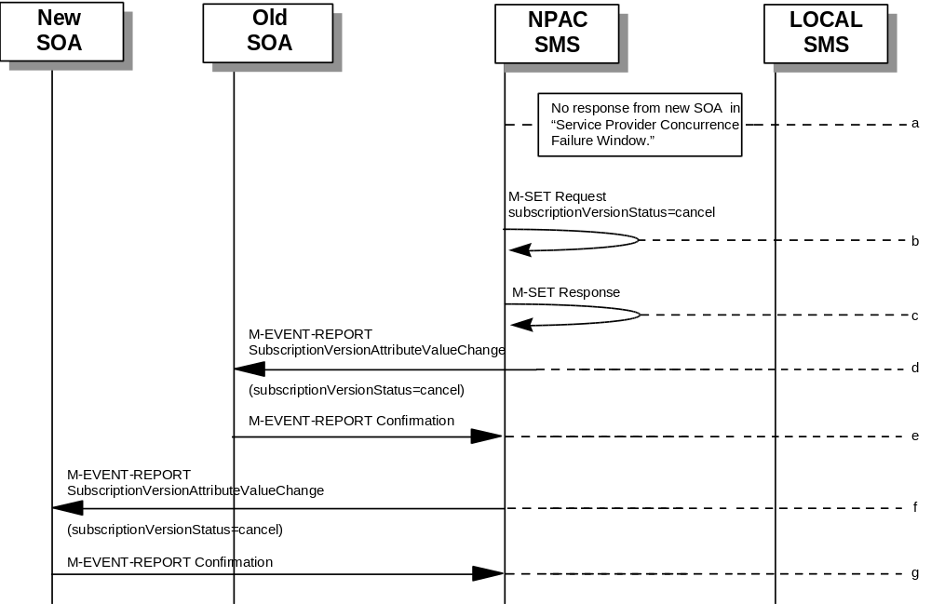
- NPAC SMS receives no occurrence from the new service provider SOA in “Service Provider Concurrence Failure Window” for the pending subscriptionVersionNPAC created by the old service provider SOA.
- NPAC SMS issues M-SET for subscriptionVersionStatus to set it to “cancel” and the subscriptionModifiedTimeStamp in the subscriptionVersionNPAC object.
- NPAC SMS responds to M-SET.
- If the subscriptionVersionNPAC object was modified, the NPAC SMS notifies the old service provider of the status change.
- The old service provider SOA returns an M-EVENT-REPORT confirmation to the NPAC SMS.
- If the subscriptionVersionNPAC object was modified, the NPAC SMS notifies new service provider SOA of the status change.
- The new service provider SOA returns an M-EVENT-REPORT confirmation to the NPAC SMS.

6.5.1.7

SubscriptionVersionCreate M-CREATE Failure to Local SMS
This scenario shows a failure to all of the Local SMS on M-CREATE.
- The new service provider SOA has activated the pending subscription.
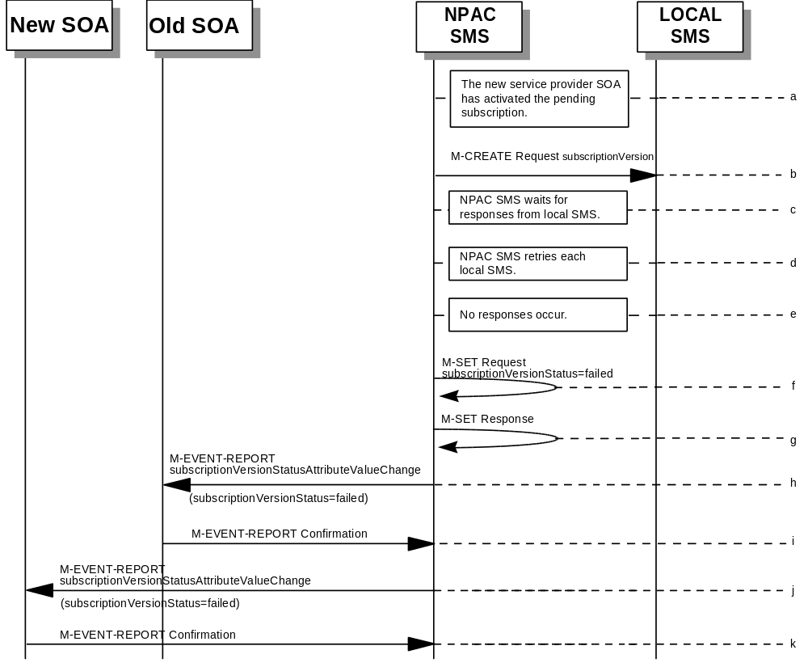
- The NPAC SMS issues an M-CREATE for the subscriptionVersion to each of the Local SMSs, that is accepting downloads for the NPA-NXX of the subscriptionVersion.
- NPAC SMS waits for responses from each Local SMS.
- NPAC SMS resends to each Local SMS up to a tunable number of retries at a tunable interval.
- No responses occur from any Local SMS or all Local SMSs report a failure response to the M-CREATE.
- NPAC SMS issues M-SET to update the subscriptionVersionStatus to “failed” in the subscriptionVersionNPAC object, the subscriptionFailed-SP-List, and the subscriptionModifiedTimeStamp.
- NPAC SMS issues M-SET response.
- If the subscriptionVersionNPAC was modified, the NPAC SMS will send M-EVENT-REPORT to the old service provider SOA of the subscriptionVersionStatus change.
- The old service provider SOA returns an M-EVENT-REPORT confirmation to the NPAC SMS.
- If the subscriptionVersionNPAC was modified, the NPAC SMS will send M-EVENT-REPORT to the new service provider SOA of the subscriptionVersionStatus change.
- The new service provider SOA returns an M-EVENT-REPORT confirmation to the NPAC SMS.

6.5.1.8

SubscriptionVersion M-CREATE: Partial Failure to Local SMS
This scenario shows a partial failure to a Local SMS on an M-CREATE.
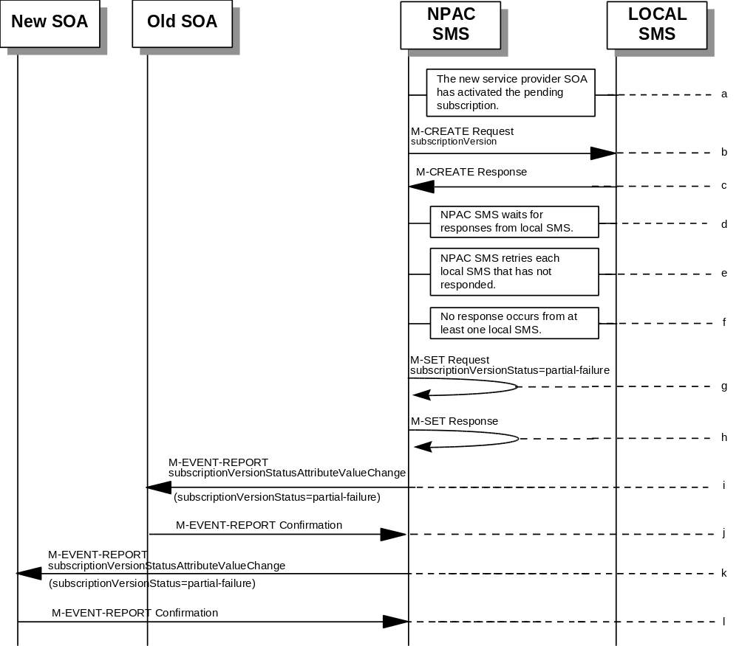
- The new service provider SOA has activated the pending subscription.
- The NPAC SMS issues an M-CREATE for the subscriptionVersion to each of the Local SMSs, that is accepting downloads for the NPA-NXX of the subscriptionVersion.
- One or more Local SMSs respond to the M-CREATE.
- NPAC SMS waits for responses from each Local SMS.
- NPAC SMS resends, to each unresponsive Local SMS, up to a tunable number of retries at a tunable interval.
- No responses occur from at least one Local SMS, or a Local SMS returns an M-CREATE failure.
- NPAC SMS issues M-SET to the subscriptionVersionStatus to “partial-failure” in the subscriptionVersionNPAC object, subscriptionFailed-SP-List, and the subscriptionModifiedTimeStamp.
- NPAC SMS issues M-SET response.
- If the subscriptionVersionNPAC was modified, the NPAC SMS will send M-EVENT-REPORT to the old service provider SOA of the subscriptionVersionStatus change and a list of failed Local SMSs.
- The old service provider SOA returns an M-EVENT-REPORT confirmation to the NPAC SMS.
- If the subscriptionVersionNPAC was modified, the NPAC SMS will send M-EVENT-REPORT to the new service provider SOA of the subscriptionVersionStatus change and a list of failed Local SMSs.
- The new service provider SOA returns an M-EVENT-REPORT confirmation to the NPAC SMS.

6.5.1.9

Create Subscription Version: Resend Successful to Local SMS Action
This scenario shows the successful resend of a subscription version create. The resend of a failed subscription version create can only be performed by authorized NPAC personnel.

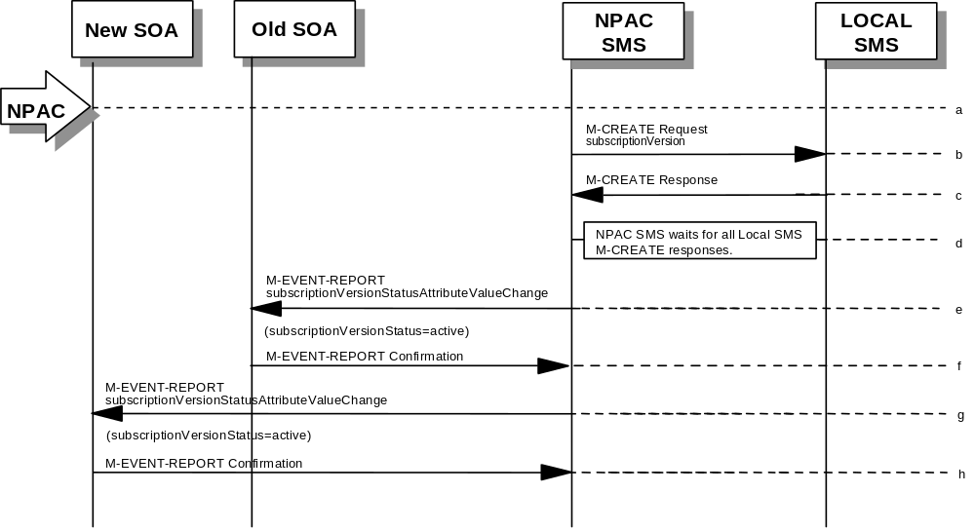
- NPAC personnel take action to resend a failed subscriptionVersion create.
- The NPAC SMS issues an M-CREATE for the subscriptionVersion to each of the Local SMSs that previously failed, and is accepting downloads for the NPA-NXX of the subscriptionVersion.
- Each Local SMS will reply to the M-Create.
- NPAC SMS waits for all Local SMSs to report successful subscription version creation.
- If the subscriptionVersion NPAC object was modified, the NPAC SMS will issue M-EVENT-REPORT notifications to the old service provider SOA of the status change using an M-EVENT-REPORT subscriptionVersionStatusAttributeValueChange.
- The old service provider SOA returns an M-EVENT-REPORT confirmation to the NPAC SMS.
- If the subscriptionVersion NPAC object was modified, the NPAC SMS will issue M-EVENT-REPORT notifications to the new service provider SOA of the status change using an M-EVENT-REPORT subscriptionVersionStatusAttributeValueChange.
- The new service provider SOA returns an M-EVENT-REPORT confirmation to the NPAC SMS.

6.5.1.10

Subscription Version: Resend Failure to Local SMS
This scenario shows a failure on a resend of a Subscription Version M-CREATE a Local SMS. The resend of a failed modified active version can only be performed by authorized NPAC SMS personnel.
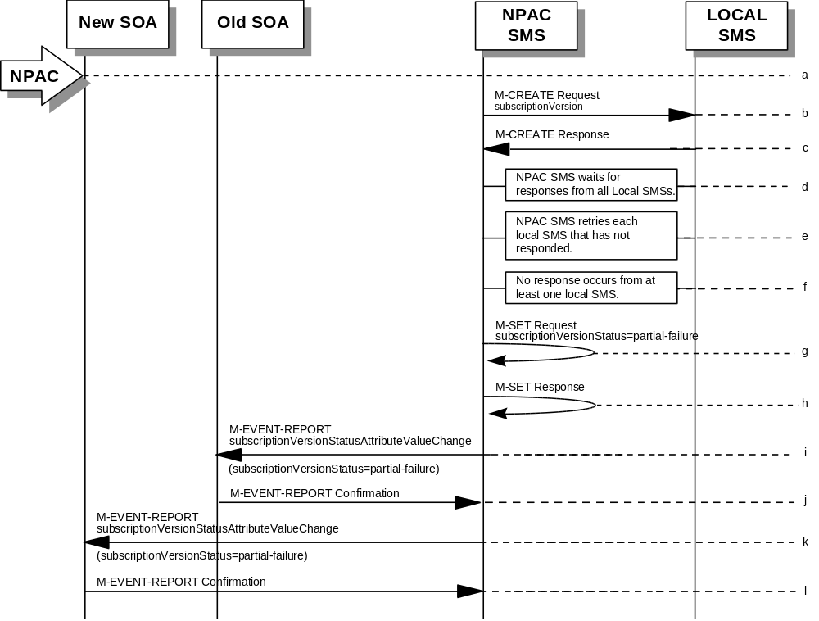
- The NPAC personnel issues a resend for the failed or partially failed subscriptionVersion.
- The NPAC SMS issues an M-CREATE for the subscriptionVersion to each of the Local SMSs for which the M-CREATE previously failed, and is accepting downloads for the NPA-NXX of the subscriptionVersion.
- One or more Local SMSs respond to the M-CREATE.
- NPAC SMS waits for responses from each Local SMS.
- NPAC SMS resends, to each unresponsive Local SMS, up to a tunable number of retries at a tunable interval.
- No responses occur from at least one or all Local SMSs, or one or all Local SMSs return an M-CREATE failure.
- NPAC SMS issues M-SET to the subscriptionVersionStatus to “partial-failure” or “failed” in the subscriptionVersionNPAC object, subscriptionFailed-SP-List, and the subscriptionModifiedTimeStamp.
- NPAC SMS issues M-SET response.
- If the subscriptionVersionNPAC was modified, the NPAC SMS will send M-EVENT-REPORT to the old service provider SOA of the subscriptionVersionStatus change and a list of failed Local SMSs.
- The old service provider SOA returns an M-EVENT-REPORT confirmation to the NPAC SMS.
- If the subscriptionVersionNPAC was modified, the NPAC SMS will send M-EVENT-REPORT to the new service provider SOA of the subscriptionVersionStatus change and a list of failed Local SMSs.
- The new service provider SOA returns an M-EVENT-REPORT confirmation to the NPAC SMS.

6.5.1.11

SubscriptionVersion Create for Intra-Service Provider Port
This scenario shows how an intra-service port is processed.
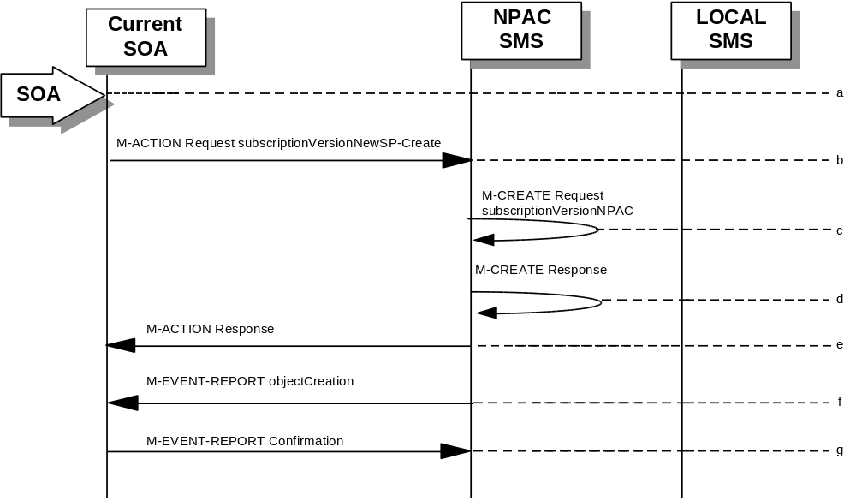
- Action is taken by the current provider SOA to create a new version of a subscriber.
- Current provider SOA sends M-ACTION subscriptionVersionNewSP-Create to the NPAC SMS lnpSubscriptions object to create a new subscriptionVersionNPAC. The SOA must specify the following valid attributes:
subscriptionTN or a valid subscriptionVersionTN-Range
subscriptionNewCurrentSP
subscriptionOldSP
subscriptionNewSP-DueDate
subscriptionPortingToOriginal-SPSwitch
subscriptionLRN
subscriptionCLASS-DPC
subscriptionCLASS-SSN
subscriptionLIDB-DPC
subscriptionLIDB-SSN
subscriptionCNAM-DPC
subscriptionCNAM-SSN
subscriptionISVM-DPC
subscriptionISVM-SSN
subscriptionLNPType
The subscriptionNewCurrentServiceProv must be equal to the subscriptionOldServiceProv.
The following attributes are optional:
subscriptionEndUserLocationValue
subscriptionEndUserLocationType
subscriptionBillingId
- If the request is valid, the NPAC SMS will M-CREATE the subscriptionVersionNPAC object. The status will be set to “pending.” Also the subscriptionCreationTimeStamp, the subscriptionNewSP-AuthorizationTimeStamp, subscriptionOldSP-AuthorizationTimeStamp, and the subscriptionModifiedTimeStamp will be set.
- NPAC SMS responds to M-CREATE.
- NPAC SMS sends an action reply with success or failure and reasons for failure. If the action fails, no modifications are applied and processing stops for this scenario.
- NPAC SMS notifies intra-service provider SOA of subscriptionVersionNPAC creation.
- Service provider SOA sends M-EVENT-REPORT confirmation to NPAC SMS.
- The intra-service subscriptionVersion now follows the same flow as an inter-service subscriptionVersionCreation to activate the subscriptionVersion on the NPAC SMS and create the subscriptionVersion on the Local SMSs.
- The only difference is the M-EVENT-REPORT for the subscriptionVersionStatusAttributeValueChange is only sent to the new provider.

6.5.1.12

SubscriptionVersion Port-to-Original: Successful
This scenario shows how a port-to-original (successful) port is processed.
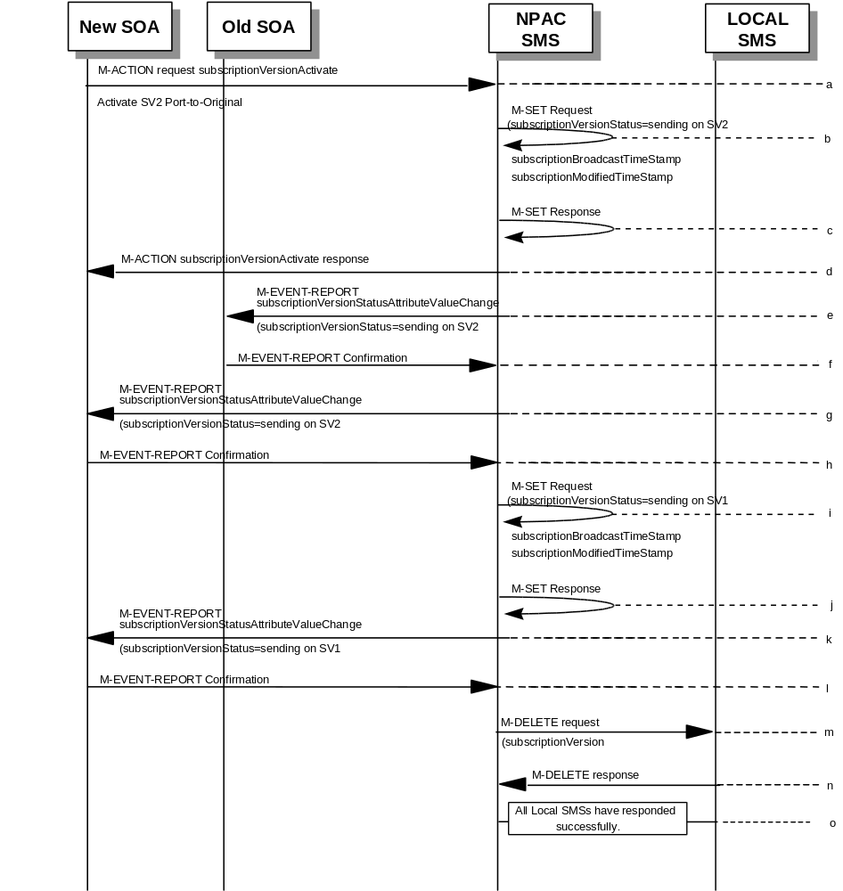

(continued on next page)

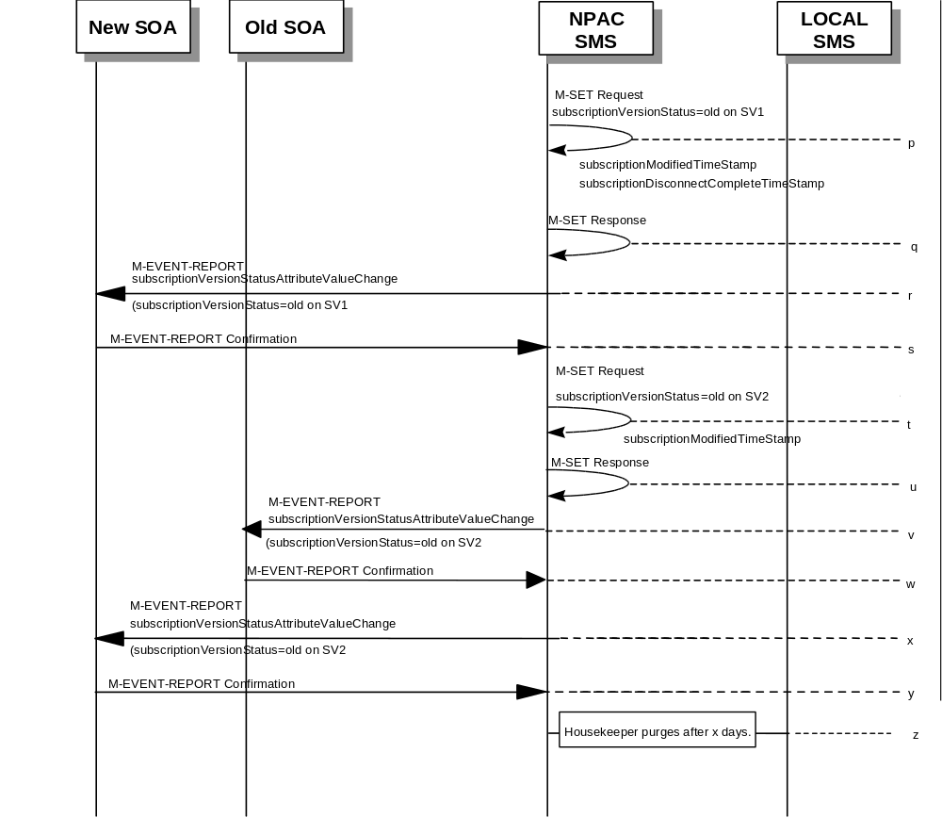

SV 1 is the currently active Subscription Version.
SV 2 is the current pending Subscription Version.
- The new service provider SOA issues a subscriptionVersionActivate M-ACTION to the NPAC SMS lnpSubscriptions object to activate the pending subscription version SV2 by specifying the subscription version ID, subscription version TN, or a range of subscription version TNs.
- The NPAC SMS issues an M-SET request setting the subscriptionVersionStatus to “sending”, subscriptionBroadcastTimeStamp and subscriptionModifiedTimeStamp on the subscriptionVersionNPAC on SV2.
- NPAC SMS response to the M-SET.
- The NPAC SMS responds with the M-ACTION response. An error will be returned if the service provider is not the new service provider (accessDenied) or if there is no version to be activated (invalidArgumentValue) or if any other failures occur.
- If the M-ACTION was successful, the NPAC SMS sends to the old service provider SOA a subscriptionVersionStatusAttributeValueChange for the subscriptionVersionStatus being set to sending on SV2.
- The old service provider SOA returns an M-EVENT-REPORT confirmation to the NPAC SMS.
- If the M-ACTION was successful, the NPAC SMS sends to the new service provider SOA a subscriptionVersionStatusAttributeValueChange for the subscriptionVersionStatus being set to sending on SV2.
- The new service provider SOA returns an M-EVENT-REPORT confirmation to the NPAC SMS.
- The NPAC SMS sets the subscriptionVersionStatus to sending and sets the subscriptionBroadcastTimeStamp and subscriptionModifiedTimeStamp on the subscriptionVersionNPAC on SV1.
- NPAC SMS response to the M-SET.
- The NPAC SMS sends to the current/new service provider SOA a subscriptionVersionStatusAttributeValueChange for the subscriptionVersionStatus being set to sending on SV1.
- The current/new service provider SOA returns an M-EVENT-REPORT confirmation to the NPAC SMS.
- NPAC SMS sends out an M-DELETE on the subscription Version SV1 to all Local SMSs, that are accepting downloads for the NPA-NXX of subscription Version SV1. If the M-DELETE is for multiple subscription versions, a scoped and filtered operation will be sent.
- Each Local SMS responds with a successful M-DELETE reply.
- All Local SMSs respond successfully.
- NPAC SMS issues an M-SET updating the subscriptionVersionStatus of SV1 to old. It also sets the subscriptionModifiedTimeStamp and subscriptionDisconnectCompleteTimeStamp.
- NPAC SMS responds to the M-SET.
- The NPAC SMS sends to the current/new service provider SOA a subscriptionVersionStatusAttributeValueChange for the subscriptionVersionStatus being set to old on SV1.
- The current/new service provider SOA returns an M-EVENT-REPORT confirmation to the NPAC SMS.
- NPAC SMS issues an M-SET updating the subscriptionVersionStatus of SV2 to old. It also sets the subscriptionModifiedTimeStamp.
- NPAC SMS responds to the M-SET.
- The NPAC SMS sends to the old service provider SOA a subscriptionVersionStatusAttributeValueChange for the subscriptionVersionStatus being set to old on SV2.
- The old service provider SOA returns an M-EVENT-REPORT confirmation to the NPAC SMS.
- The NPAC SMS sends to the new service provider SOA a subscriptionVersionStatusAttributeValueChange for the subscriptionVersionStatus being set to old on SV2.
- The new service provider SOA returns an M-EVENT-REPORT confirmation to the NPAC SMS.
- After a tunable amount of days, the subscription versions SV1 and SV2 are purged by the NPAC SMS housekeeping process.

6.5.1.13

SubscriptionVersion Port-to-Original: All LSMSs Fail
This scenario shows how a port-to-original (all fail) port is processed.
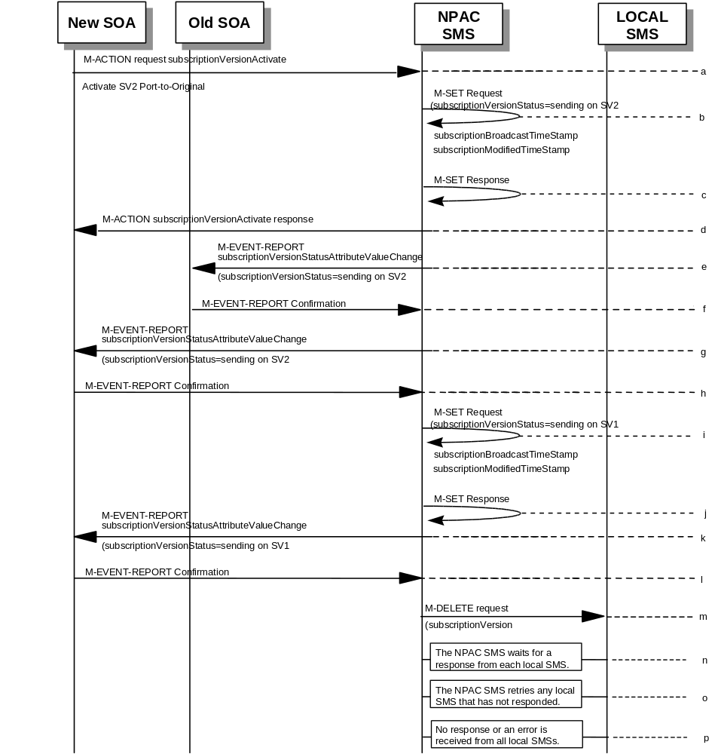

(continued on next page)

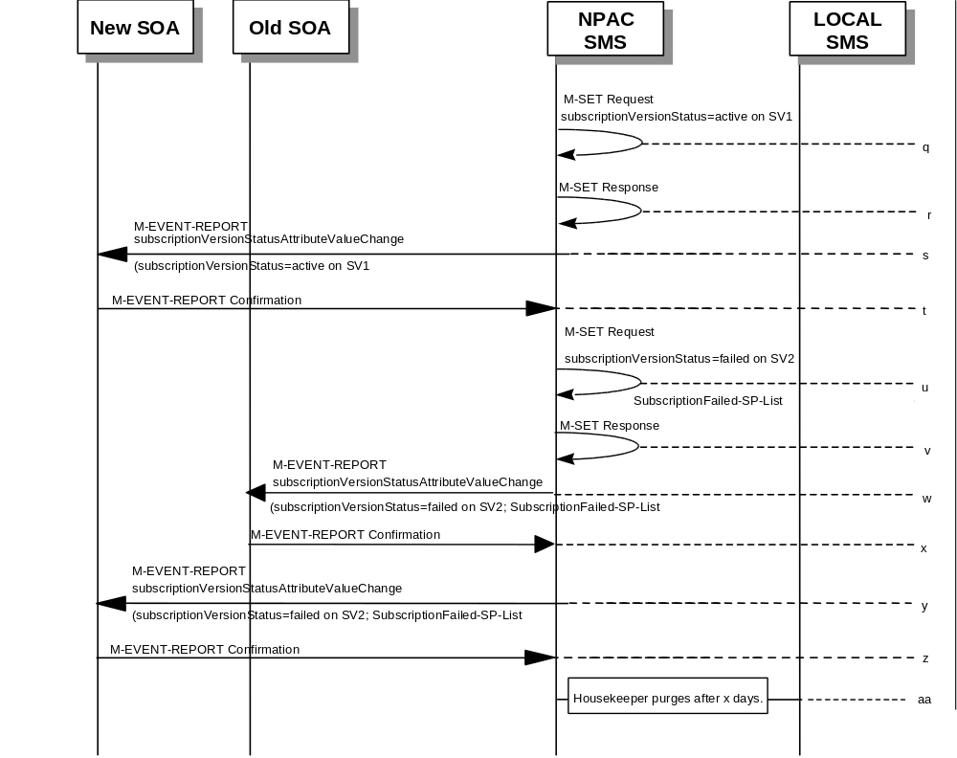

SV 1 is the currently active Subscription Version.
SV 2 is the current pending Subscription Version.
- The new service provider SOA issues a subscriptionVersionActivate M-ACTION to the NPAC SMS lnpSubscriptions object to activate the pending subscription version SV2 by specifying the subscription version ID, subscription version TN, or a range of subscription version TNs.
- The NPAC SMS issues an M-SET request setting the subscriptionVersionStatus to “sending”, subscriptionBroadcastTimeStamp and subscriptionModifiedTimeStamp on the subscriptionVersionNPAC on SV2.
- NPAC SMS response to the M-SET.
- The NPAC SMS responds with the M-ACTION response. An error will be returned if the service provider is not the new service provider (accessDenied) or if there is no version to be activated (invalidArgumentValue) or if any other failures occur.
- If the M-ACTION was successful, the NPAC SMS sends to the old service provider SOA a subscriptionVersionStatusAttributeValueChange for the subscriptionVersionStatus being set to sending on SV2.
- The old service provider SOA returns an M-EVENT-REPORT confirmation to the NPAC SMS.
- If the M-ACTION was successful, the NPAC SMS sends to the new service provider SOA a subscriptionVersionStatusAttributeValueChange for the subscriptionVersionStatus being set to sending on SV2.
- The new service provider SOA returns an M-EVENT-REPORT confirmation to the NPAC SMS.
- The NPAC SMS sets the subscriptionVersionStatus to sending and sets the subscriptionBroadcastTimeStamp and subscriptionModifiedTimeStamp on the subscriptionVersionNPAC on SV1.
- NPAC SMS response to the M-SET.
- The NPAC SMS sends to the current/new service provider SOA a subscriptionVersionStatusAttributeValueChange for the subscriptionVersionStatus being set to sending on SV1.
- The current/new service provider SOA returns an M-EVENT-REPORT confirmation to the NPAC SMS.
- NPAC SMS sends out an M-DELETE on the subscription Version SV1 to all Local SMSs, that are accepting downloads for the NPA-NXX of subscription Version SV1. If the M-DELETE is for multiple subscription versions, a scoped and filtered operation will be sent.
- NPAC SMS waits for a response from each Local SMS.
- NPAC SMS retries any Local SMS that has not responded.
- No response or an error is received from all Local SMSs.
- NPAC SMS issues an M-SET updating the subscriptionVersionStatus of SV1 to active.
- NPAC SMS responds to the M-SET.
- The NPAC SMS sends to the current/new service provider SOA a subscriptionVersionStatusAttributeValueChange for the subscriptionVersionStatus being set to active on SV1.
- The current/new service provider SOA returns an M-EVENT-REPORT confirmation to the NPAC SMS.
- NPAC SMS issues an M-SET updating the subscriptionVersionStatus of SV2 to failed. It also sets the subscriptionFailed-SP-List.
- NPAC SMS responds to the M-SET.
- The NPAC SMS sends to the old service provider SOA a subscriptionVersionStatusAttributeValueChange for the subscriptionVersionStatus being set to failed on SV2, along with the subscriptionFailed-SP-List.
- The old service provider SOA returns an M-EVENT-REPORT confirmation to the NPAC SMS.
- The NPAC SMS sends to the new service provider SOA a subscriptionVersionStatusAttributeValueChange for the subscriptionVersionStatus being set to failed on SV2, along with the subscriptionFailed-SP-List.
- The new service provider SOA returns an M-EVENT-REPORT confirmation to the NPAC SMS.
- After a tunable amount of days, the subscription versions SV1 and SV2 are purged by the NPAC SMS housekeeping process.
- NOTE: SV1 may exist as an old SV that may be associated with SV2 that is in a “partially failed” state for a port to original port. In this case, the housekeeping process should not purge SV1 unless SV2 is also being purged.
- NOTE: SV1 and SV2 should be updated to the NPA-NXX for a NPA Split if SV2 is in a “failed” or “partially failed” state.

6.5.1.14

SubscriptionVersion Port-to-Original: Partial Failure
This scenario shows how a port-to-original (partial fail) port is processed.
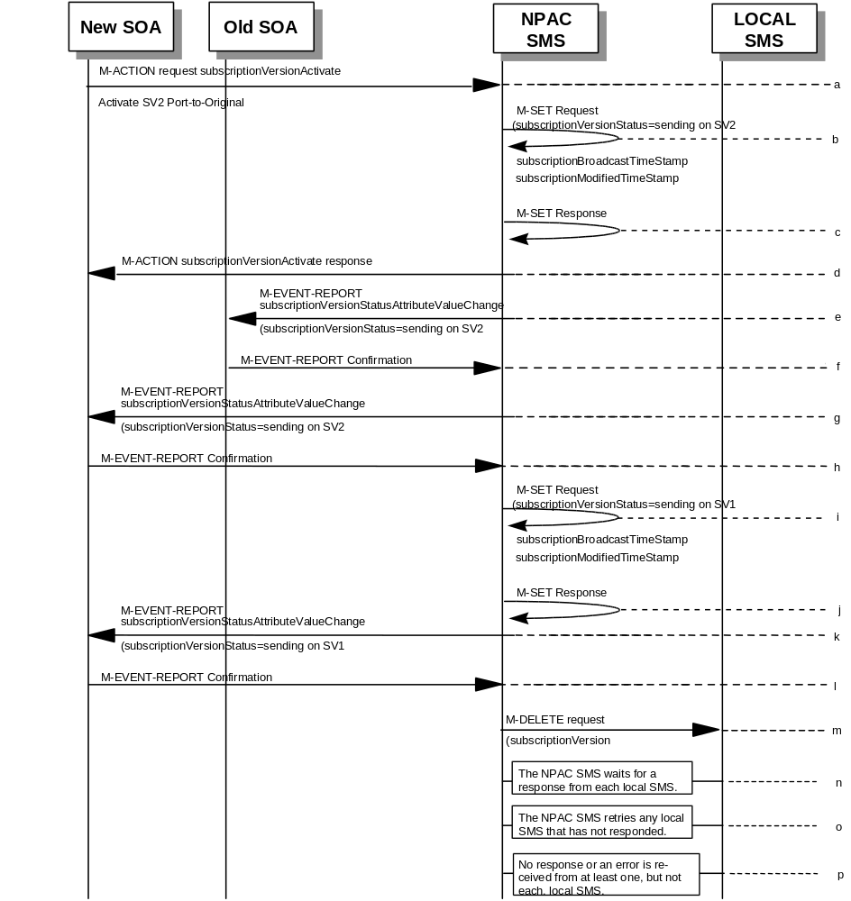

(continued on next page)

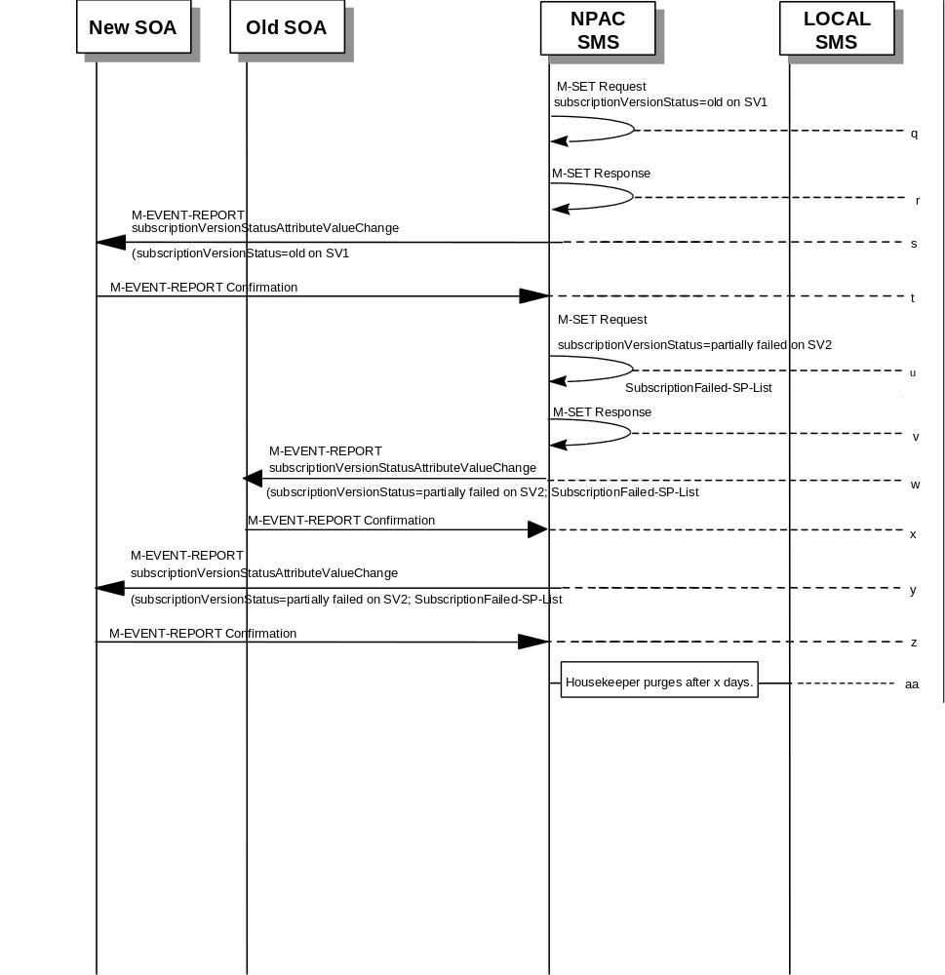

SV 1 is the currently active Subscription Version.
SV 2 is the current pending Subscription Version.
- The new service provider SOA issues a subscriptionVersionActivate M-ACTION to the NPAC SMS lnpSubscriptions object to activate the pending subscription version SV2 by specifying the subscription version ID, subscription version TN, or a range of subscription version TNs.
- The NPAC SMS issues an M-SET request setting the subscriptionVersionStatus to “sending”, subscriptionBroadcastTimeStamp and subscriptionModifiedTimeStamp on the subscriptionVersionNPAC on SV2.
- NPAC SMS response to the M-SET.
- The NPAC SMS responds with the M-ACTION response. An error will be returned if the service provider is not the new service provider (accessDenied) or if there is no version to be activated (invalidArgumentValue) or if any other failures occur.
- If the M-ACTION was successful, the NPAC SMS sends to the old service provider SOA a subscriptionVersionStatusAttributeValueChange for the subscriptionVersionStatus being set to sending on SV2.
- The old service provider SOA returns an M-EVENT-REPORT confirmation to the NPAC SMS.
- If the M-ACTION was successful, the NPAC SMS sends to the new service provider SOA a subscriptionVersionStatusAttributeValueChange for the subscriptionVersionStatus being set to sending on SV2.
- The new service provider SOA returns an M-EVENT-REPORT confirmation to the NPAC SMS.
- The NPAC SMS sets the subscriptionVersionStatus to sending and sets the subscriptionBroadcastTimeStamp and subscriptionModifiedTimeStamp on the subscriptionVersionNPAC on SV1.
- NPAC SMS response to the M-SET.
- The NPAC SMS sends to the current/new service provider SOA a subscriptionVersionStatusAttributeValueChange for the subscriptionVersionStatus being set to sending on SV1.
- The current/new service provider SOA returns an M-EVENT-REPORT confirmation to the NPAC SMS.
- NPAC SMS sends out an M-DELETE on the subscription Version SV1 to all Local SMSs, that are accepting downloads for the NPA-NXX of subscription Version SV1. If the M-DELETE is for multiple subscription versions, a scoped and filtered operation will be sent.
- NPAC SMS waits for a response from each Local SMS.
- NPAC SMS retries any Local SMS that has not responded.
- No response or an error is received from at least one, but not each, Local SMS.
- NPAC SMS issues an M-SET updating the subscriptionVersionStatus of SV1 to old.
- NPAC SMS responds to the M-SET.
- The NPAC SMS sends to the current/new service provider SOA a subscriptionVersionStatusAttributeValueChange for the subscriptionVersionStatus being set to old on SV1.
- The current/new service provider SOA returns an M-EVENT-REPORT confirmation to the NPAC SMS.
- NPAC SMS issues an M-SET updating the subscriptionVersionStatus of SV2 to partially failed. It also sets the subscriptionFailed-SP-List.
- NPAC SMS responds to the M-SET.
- The NPAC SMS sends to the old service provider SOA a subscriptionVersionStatusAttributeValueChange for the subscriptionVersionStatus being set to partially failed on SV2, along with the subscriptionFailed-SP-List.
- The old service provider SOA returns an M-EVENT-REPORT confirmation to the NPAC SMS.
- The NPAC SMS sends to the new service provider SOA a subscriptionVersionStatusAttributeValueChange for the subscriptionVersionStatus being set to partially failed on SV2, along with the subscriptionFailed-SP-List.
- The new service provider SOA returns an M-EVENT-REPORT confirmation to the NPAC SMS.
- After a tunable amount of days, the subscription versions SV1 and SV2 are purged by the NPAC SMS housekeeping process.
- NOTE: SV1 may exist as an old SV that may be associated with SV2 that is in a “partially failed” state for a port to original port. In this case, the housekeeping process should not purge SV1 unless SV2 is also being purged.
- NOTE: SV1 and SV2 should be updated to the NPA-NXX for a NPA Split if SV2 is in a “failed” or “partially failed” state.

6.5.1.15

SubscriptionVersion Port-to-Original: Resend
This scenario shows how a port-to-original (resend) port is processed.
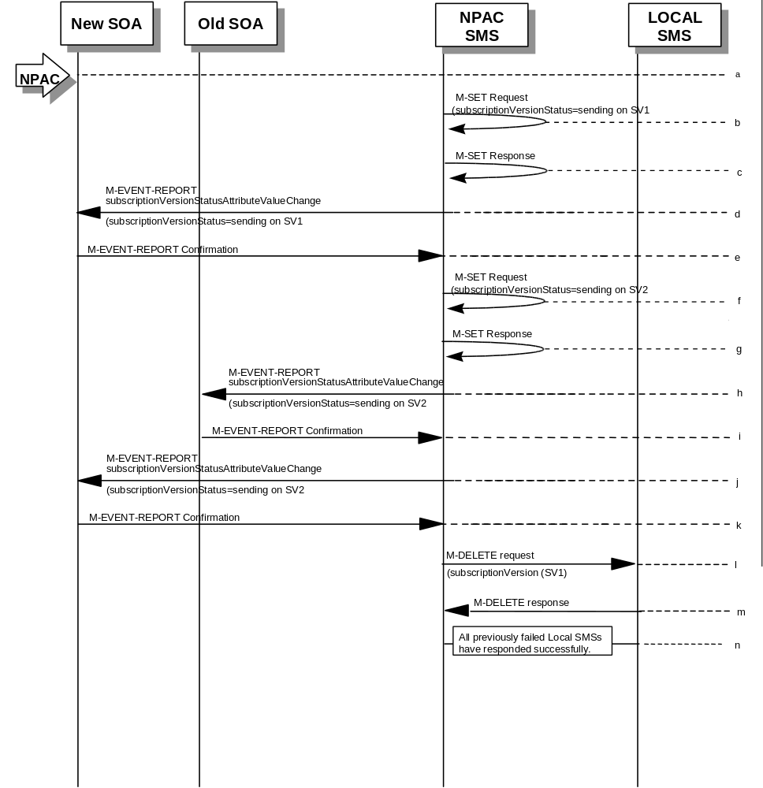

(continued on next page)

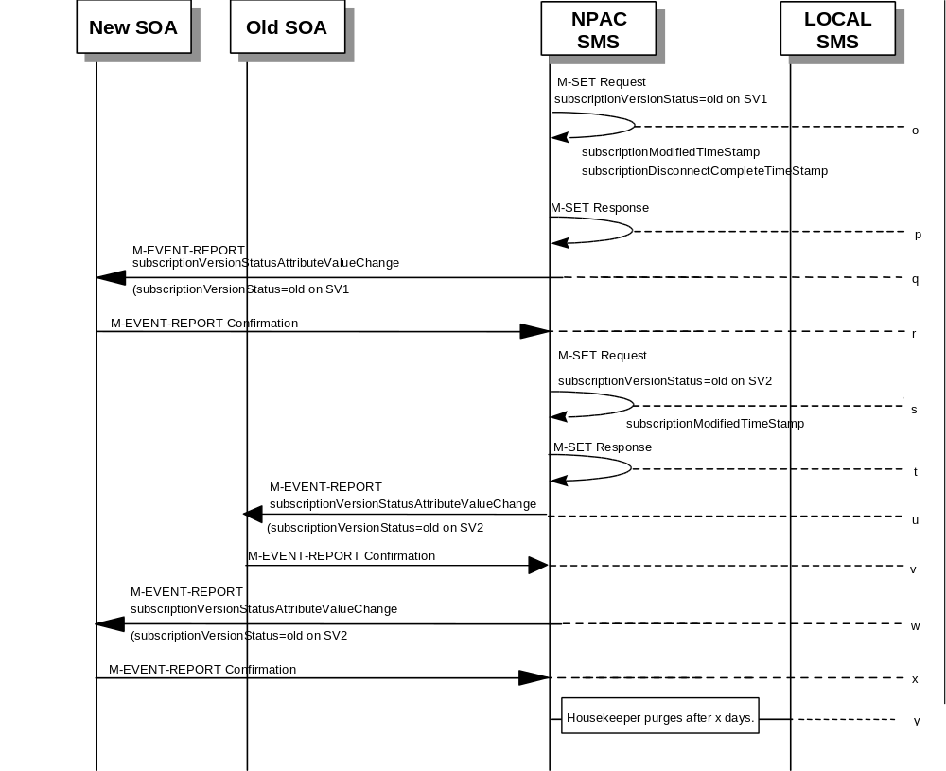

SV 1 is the currently active Subscription Version.
SV 2 is the current pending Subscription Version.
- NPAC personnel take action to resend a failed port-to-original for a subscription version.
- The NPAC SMS issues an M-SET request setting the subscriptionVersionStatus to “sending”, subscriptionBroadcastTimeStamp and subscriptionModifiedTimeStamp on the subscriptionVersionNPAC on SV1.
- NPAC SMS response to the M-SET.
- The NPAC SMS sends to the new/current service provider SOA a subscriptionVersionStatusAttributeValueChange for the subscriptionVersionStatus being set to sending on SV1.
- The new/current service provider SOA returns an M-EVENT-REPORT confirmation to the NPAC SMS.
- The NPAC SMS sets the subscriptionVersionStatus to sending on the subscriptionVersionNPAC on SV2.
- NPAC SMS response to the M-SET.
- The NPAC SMS sends to the old service provider SOA a subscriptionVersionStatusAttributeValueChange for the subscriptionVersionStatus being set to sending on SV2.
- The old service provider SOA returns an M-EVENT-REPORT confirmation to the NPAC SMS.
- The NPAC SMS sends to the new service provider SOA a subscriptionVersionStatusAttributeValueChange for the subscriptionVersionStatus being set to sending on SV2.
- The new service provider SOA returns an M-EVENT-REPORT confirmation to the NPAC SMS.
- NPAC SMS sends out an M-DELETE on the subscription Version SV1 to all Local SMSs that previously failed, that are accepting downloads for the NPA-NXX of the subscription Version SV1. If the M-DELETE is for multiple subscription versions, a scoped and filtered operation may be sent.
- Each previously failed Local SMS responds with a successful M-DELETE reply.
- All previously failed Local SMSs respond successfully.
- NPAC SMS issues an M-SET updating the subscriptionVersionStatus of SV1 to old. It also sets the subscriptionModifiedTimeStamp and subscriptionDisconnectCompleteTimeStamp.
- NPAC SMS responds to the M-SET.
- The NPAC SMS sends to the current/new service provider SOA a subscriptionVersionStatusAttributeValueChange for the subscriptionVersionStatus being set to old on SV1.
- The current/new service provider SOA returns an M-EVENT-REPORT confirmation to the NPAC SMS.
- NPAC SMS issues an M-SET updating the subscriptionVersionStatus of SV2 to old. It also sets the subscriptionModifiedTimeStamp.
- NPAC SMS responds to the M-SET.
- The NPAC SMS sends to the old service provider SOA a subscriptionVersionStatusAttributeValueChange for the subscriptionVersionStatus being set to old on SV2.
- The old service provider SOA returns an M-EVENT-REPORT confirmation to the NPAC SMS.
- The NPAC SMS sends to the new service provider SOA a subscriptionVersionStatusAttributeValueChange for the subscriptionVersionStatus being set to old on SV2.
- The new service provider SOA returns an M-EVENT-REPORT confirmation to the NPAC SMS.
- After a tunable amount of days, the subscription versions SV1 and SV2 are purged by the NPAC SMS housekeeping process.

6.5.1.16

SubscriptionVersion Port-to-Original: Resend Failure to Local SMS
This scenario shows a failure on a resend of a subscription port-to-original that failed previously to one or more of the Local SMSs. The resend of a failed port-to-original for a subscription can only be performed by authorized NPAC personnel.
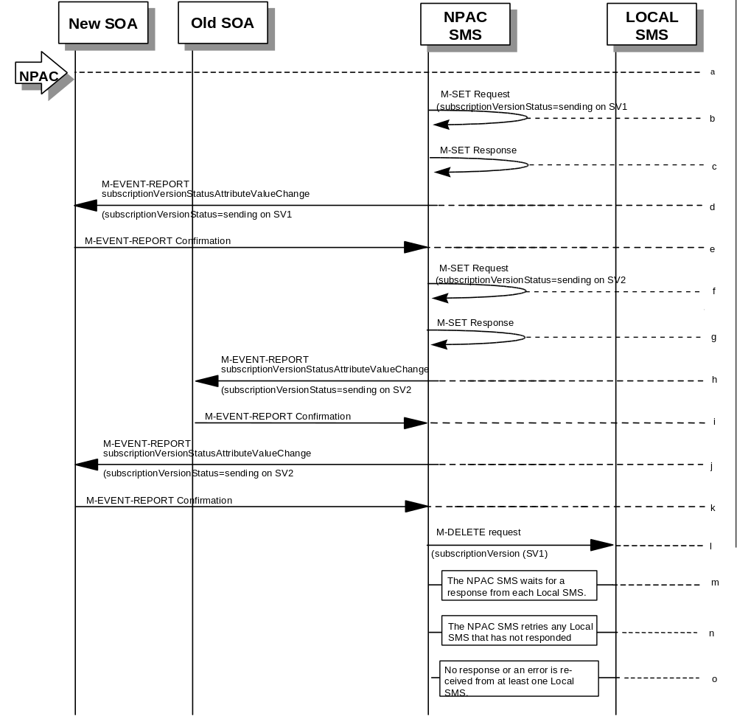

(continued on next page)

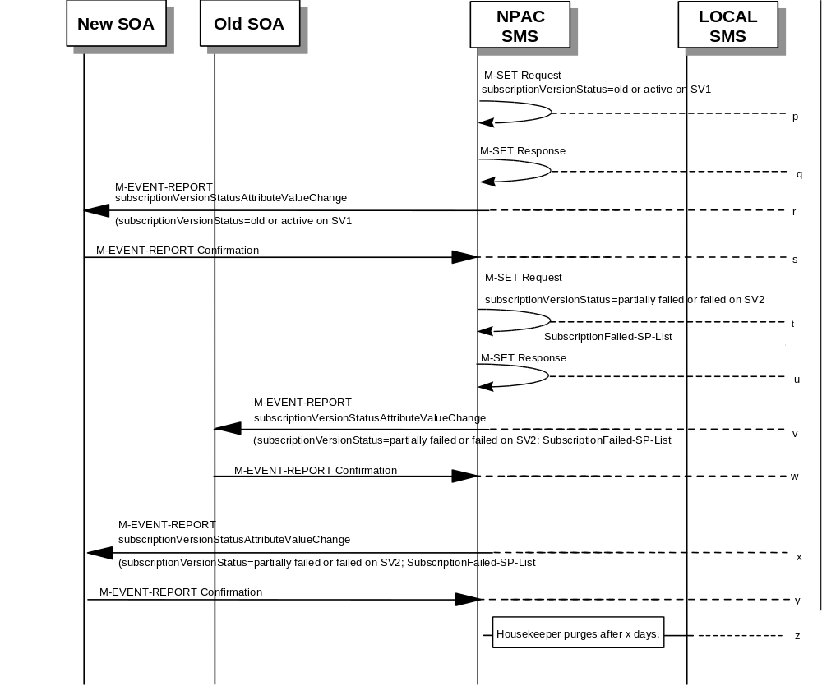

SV 1 is the currently active Subscription Version.
SV 2 is the current pending Subscription Version.
- NPAC personnel take action to resend a failed port-to-original for a subscription version.
- The NPAC SMS issues an M-SET request setting the subscriptionVersionStatus to “sending”, subscriptionBroadcastTimeStamp and subscriptionModifiedTimeStamp on the subscriptionVersionNPAC on SV1.
- NPAC SMS response to the M-SET.
- The NPAC SMS sends to the new/current service provider SOA a subscriptionVersionStatusAttributeValueChange for the subscriptionVersionStatus being set to sending on SV1.
- The new/current service provider SOA returns an M-EVENT-REPORT confirmation to the NPAC SMS.
- The NPAC SMS sets the subscriptionVersionStatus to sending on the subscriptionVersionNPAC on SV2.
- NPAC SMS response to the M-SET.
- The NPAC SMS sends to the old service provider SOA a subscriptionVersionStatusAttributeValueChange for the subscriptionVersionStatus being set to sending on SV2.
- The old service provider SOA returns an M-EVENT-REPORT confirmation to the NPAC SMS.
- The NPAC SMS sends to the new service provider SOA a subscriptionVersionStatusAttributeValueChange for the subscriptionVersionStatus being set to sending on SV2.
- The new service provider SOA returns an M-EVENT-REPORT confirmation to the NPAC SMS.
- NPAC SMS sends out an M-DELETE on the subscription Version SV1 to all Local SMSs that previously failed, that are accepting downloads for the NPA-NXX of the subscription Version SV1. If the M-DELETE is for multiple subscription versions, a scoped and filtered operation may be sent.
- NPAC SMS waits for a response from each Local SMS.
- NPAC SMS retries any Local SMS that has not responded.
- No response or an error is received from at least one Local SMS.
- NPAC SMS issues an M-SET updating the subscriptionVersionStatus of SV1 to “old” or “active” (if all Local SMSs accepting download for the NPA-NXX failed) from “sending”. It will also update the subscriptionFailed-SP-List with the service provider ID and name of the Local SMSs that failed to successfully receive the broadcast.
- NPAC SMS responds to the M-SET.
- The NPAC SMS sends to the current/new service provider SOA a subscriptionVersionStatusAttributeValueChange for the subscriptionVersionStatus being set to “old” or “active” on SV1.
- The current/new service provider SOA returns an M-EVENT-REPORT confirmation to the NPAC SMS.
- NPAC SMS issues an M-SET updating the subscriptionVersionStatus of SV2 to partially failed. It also sets the subscriptionFailed-SP-List.
- NPAC SMS responds to the M-SET.
- The NPAC SMS sends to the old service provider SOA a subscriptionVersionStatusAttributeValueChange for the subscriptionVersionStatus being set to “partially failed” or “failed” on SV2, along with the subscriptionFailed-SP-List.
- The old service provider SOA returns an M-EVENT-REPORT confirmation to the NPAC SMS.
- The NPAC SMS sends to the current/new service provider SOA a subscriptionVersionStatusAttributeValueChange for the subscriptionVersionStatus being set to “partially failed” or “failed” on SV2, along with the subscriptionFailed-SP-List.
- The current/new service provider SOA returns an M-EVENT-REPORT confirmation to the NPAC SMS.
- After a tunable amount of days, the subscription versions SV1 and SV2 are purged by the NPAC SMS housekeeping process.
- NOTE: SV1 may exist as an old SV that may be associated with SV2 that is in a “partially failed” state for a port to original port. In this case, the housekeeping process should not purge SV1 unless SV2 is also being purged.
- NOTE: SV1 and SV2 should be updated to the NPA-NXX for a NPA Split if SV2 is in a “failed” or “partially failed” state.

6.5.2

Modify Scenarios

6.5.2.1 SubscriptionVersion Modify Active Version Using M-ACTION by a Service Provider SOA
This scenario shows the modification of an active subscription. The modification of an active subscription version can only be performed by the current service provider SOA using M-ACTion.
- Action is taken by current service provider to modify an active subscription version by specifying the TN, TN range, and the version status, or by specifying the version ID of the subscription version to be modified; and the data to be modified.
The current service provider can only modify the following attributes:
subscriptionLRN
subscriptionCLASS-DPC
subscriptionCLASS-SSN
subscriptionLIDB-DPC
subscriptionLIDB-SSN
subscriptionCNAM-DPC
subscriptionCNAM-SSN
subscriptionISVM-DPC
subscriptionISVM-SSN
subscriptionEndUserLocationValue
subscriptionEndUserLocationType
subscriptionBillingId
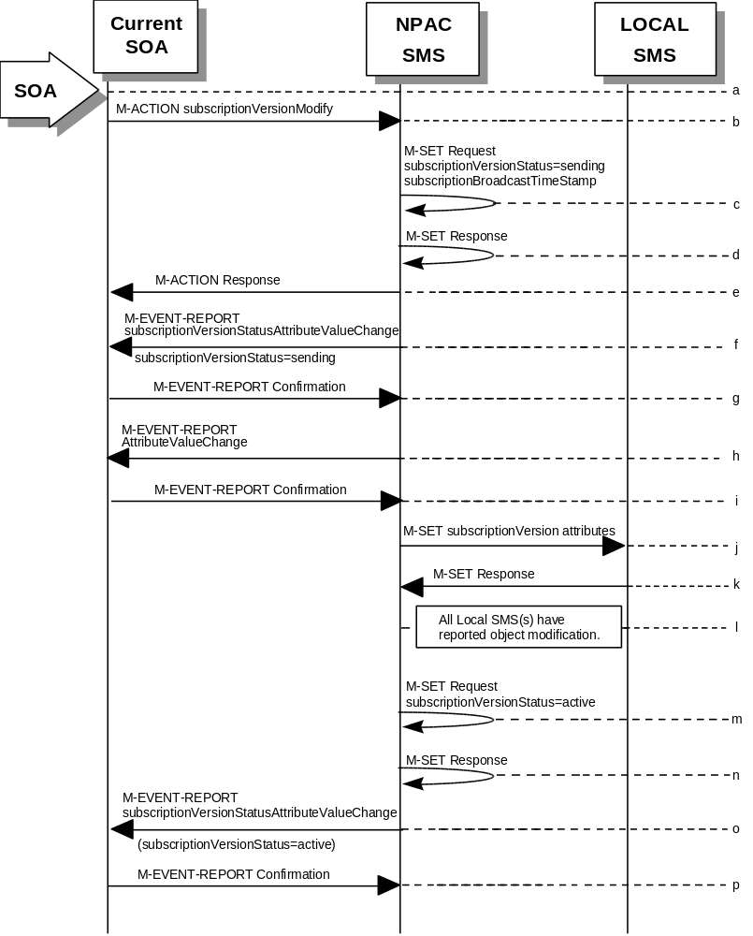
- Current service provider SOA issues M-ACTION ModifySubscriptionVersion to the NPAC SMS lnpSubscriptions object to update the active version. The NPAC SMS validates the data.
- If the M-ACTION data validates, NPAC SMS issues M-SET to the subscriptionVersionNPAC. The subscriptionVersionStatus is updated to “sending,” the subscriptionBroadcastTimeStamp and subscriptionModifiedTimeStamp are set, and any other modified attributes are updated.
- NPAC SMS issues M-SET response indicating success or failure.
- NPAC SMS replies to the M-ACTION with success or failure and reasons for failure to the service provider SOA. If the action fails, no modifications are applied and processing stops. Failure reasons include accessDenied (not the current service provider) and invalidArgumentValue (validation problems).
- NPAC SMS issues M-EVENT- REPORT subscriptionVersionStatusAttributeValueChange for the status change to “sending.”
- Current service provider SOA responds with M-EVENT-REPORT confirmation.
- NPAC SMS issues M-EVENT-REPORT for the rest of the modified attributes.
- Current service provider SOA responds with M-EVENT-REPORT confirmation.
- NPAC SMS issues M-SET to all Local SMSs for the updated attributes, that are accepting downloads for the NPA-NXX of the subscriptionVersion. If the update involves multiple subscription version objects, a scoped and filtered request will be sent.
- Local SMSs reply to M-SET.
- All Local SMSs have reported the object modification.
Failure scenarios for this modification follow the same rules for an objectCreation failure to the Local SMS. However, upon failure the version status is updated to “active” and the subscriptionFailedSP-List is updated to contain the name of the service providers for which the download fails.
- NPAC SMS issues M-SET to update the current subscriptionVersionNPAC object subscriptionVersionStatus to “active.”
- NPAC SMS responds to M-SET.
- NPAC SMS sends M-EVENT-REPORT to the current provider of the subscriptionVersionStatus update.
- Service provider SOA issues M-EVENT-REPORT confirmation.

6.5.2.2

SubscriptionVersion Modify Active: Failure to Local SMS
This scenario shows the broadcast of a modified active subscription that fails to one or more of the Local SMSs.
- The NPAC SMS has an active subscription version that has been successfully modified by the current service provider. The subscription version now has a status of “sending”.
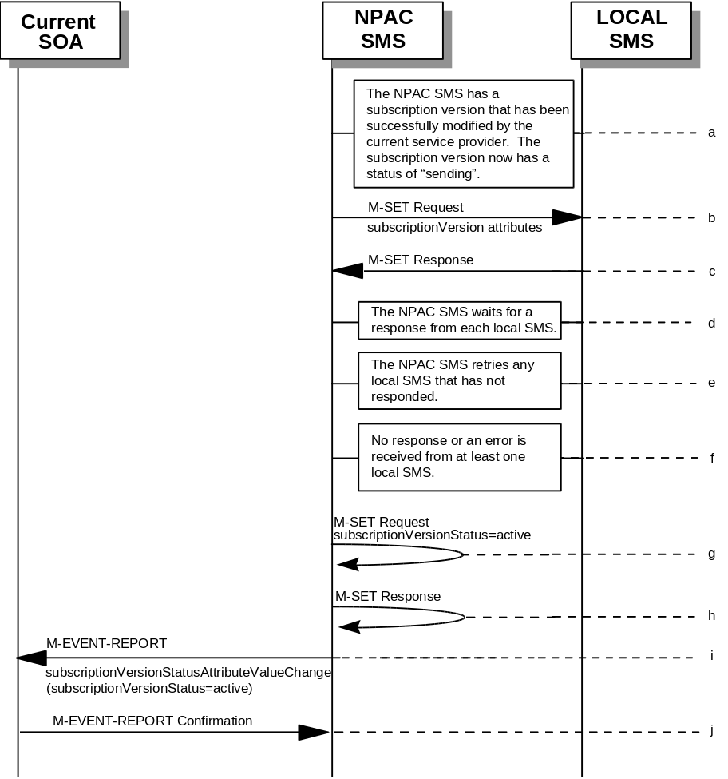
- The NPAC SMS issues M-SET to all Local SMSs for the updated attributes, that are accepting downloads for the NPA-NXX of the subscriptionVersion.
- Local SMSs should respond successfully to the M-SET.
- NPAC SMS waits for responses from each Local SMS.
- NPAC SMS retries any Local SMS that has not responded.
- No response or an error is received from at least one Local SMS.
- NPAC SMS issues the M-SET to update the current subscriptionVersionNPAC object’s subscriptionVersionStatus to “active” from “sending”. It will also update the subscriptionFailed-SP-List with the service provider ID and name of the Local SMS that failed to successfully receive the broadcast.
- NPAC SMS responds to the M-SET.
- NPAC SMS sends the subscriptionVersionStatusAttributeValueChange M-EVENT-REPORT to the current service provider SOA with the current status and failedSP-List.
- The current service provider SOA issues the M-EVENT-REPORT confirmation.

6.5.2.3

SubscriptionVersion Modify Prior to Activate Using M-ACTION
This scenario can only be performed when the subscriptionVersionStatus is conflict or pending.
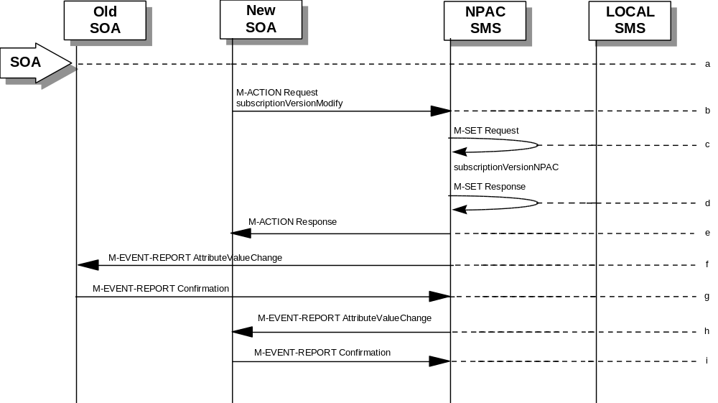
- Action is taken by a service provider to modify a subscriptionVersion by specifying the TN, TN range, and the version status, or by specifying the version ID of the subscription version to be modified; and the data to be modified.
The old service provider can only update the following attributes:
subscriptionOldSP-DueDate
subscriptionOldSP-Authorization
subscriptionStatusChangeCauseCode
NOTE: The subscriptionStatusChangeCauseCode can only be modified when the subscriptionOldSP-Authorization is set to FALSE
The new service provider can only update the attributes:
subscriptionLRN
subscriptionNewSP-DueDate
subscriptionCLASS-DPC
subscriptionCLASS-SSN
subscriptionLIDB-DPC
subscriptionLIDB-SSN
subscriptionCNAM-DPC
subscriptionCNAM-SSN
subscriptionISVM-DPC
subscriptionISVM-SSN
subscriptionEndUserLocationValue
subscriptionEndUserLocationType
subscriptionBillingId
- Service provider SOA issues M-ACTION subscriptionVersionModify to the NPAC SMS lnpSubscriptions object to update the version. The NPAC SMS validates the data.
- If validation is successful, NPAC SMS will M-SET the attributes modified in the subscriptionVersionNPAC object and set the subscriptionModifiedTimeStamp.
- The NPAC SMS will issue an M-SET response.
- NPAC SMS replies to the M-ACTION with success or failure and reasons for failure.
Note: If the old service provider was the initiator of the M-ACTION that caused the subscription version status to change, the NPAC SMS would issue a subscriptionVersionStatusAttributeValueChange M-EVENT-REPORT to the old and new service provider SOAs.
- NPAC SMS issues M-EVENT-REPORT attributeValueChange to the old service provider SOA.
- The old service provider SOA returns M-EVENT-REPORT confirmation to the NPAC SMS.
- NPAC SMS issues M-EVENT-REPORT attributeValueChange to the new service provider SOA.
- The new service provider SOA returns M-EVENT-REPORT confirmation to the NPAC SMS.

6.5.2.4

SubscriptionVersion Modify Prior to Activate Using M-SET
This scenario shows a modify using an M-SET. The M-SET can only be performed when the subscriptionVersionStatus is conflict or pending.
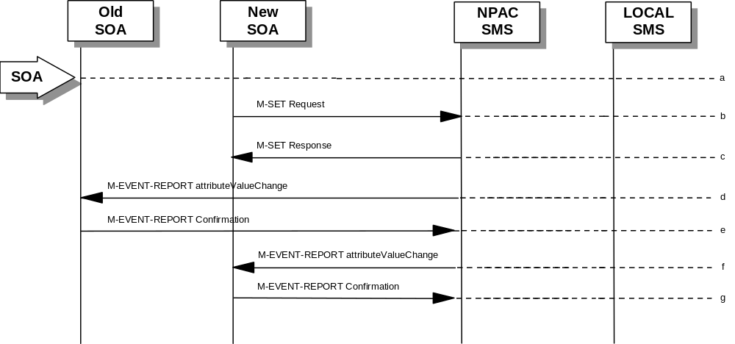
- Action is taken by a service provider to modify the subscriptionVersion. The old service provider can only update the following attributes:
subscriptionOldSP-DueDate
subscriptionOldSP-Authorization
subscriptionStatusChangeCauseCode
NOTE: The subscriptionStatusChangeCauseCode can only be modified when the subscriptionOldSP-Authorization is set to FALSE
The new service provider can only update the attributes:
subscriptionLRN
subscriptionNewSP-DueDate
subscriptionCLASS-DPC
subscriptionCLASS-SSN
subscriptionLIDB-DPC
subscriptionLIDB-SSN
subscriptionCNAM-DPC
subscriptionCNAM-SSN
subscriptionISVM-DPC
subscriptionISVM-SSN
subscriptionEndUserLocationValue
subscriptionEndUserLocationType
subscriptionBillingId
- The new or old service provider SOA will issue an M-SET request for the attributes to be updated in the subscriptionVersionNPAC object. The request will be validated for an authorized service provider and validation of the attributes and values.
- The NPAC SMS will issue an M-SET response indicating success or failure and reasons for failure.
Note: If the old service provider was the initiator of the M-SET that caused the subscription version status to change, the NPAC SMS would issue a subscriptionVersionStatusAttributeValueChange M-EVENT-REPORT to the old and new service provider SOAs
- NPAC SMS issues M-EVENT-REPORT attributeValueChange to the old service provider SOA.
- The old service provider SOA returns M-EVENT-REPORT confirmation to the NPAC SMS.
- NPAC SMS issues M-EVENT-REPORT attributeValueChange to the new service provider SOA.
- The new service provider SOA returns M-EVENT-REPORT confirmation to the NPAC SMS.

6.5.2.5

Subscription Version Modify Active: Resend Successful to Local SMS
This scenario shows the successful resend of a modification of an active subscription. The resend of a failed modified active version can only be performed by authorized NPAC personnel.
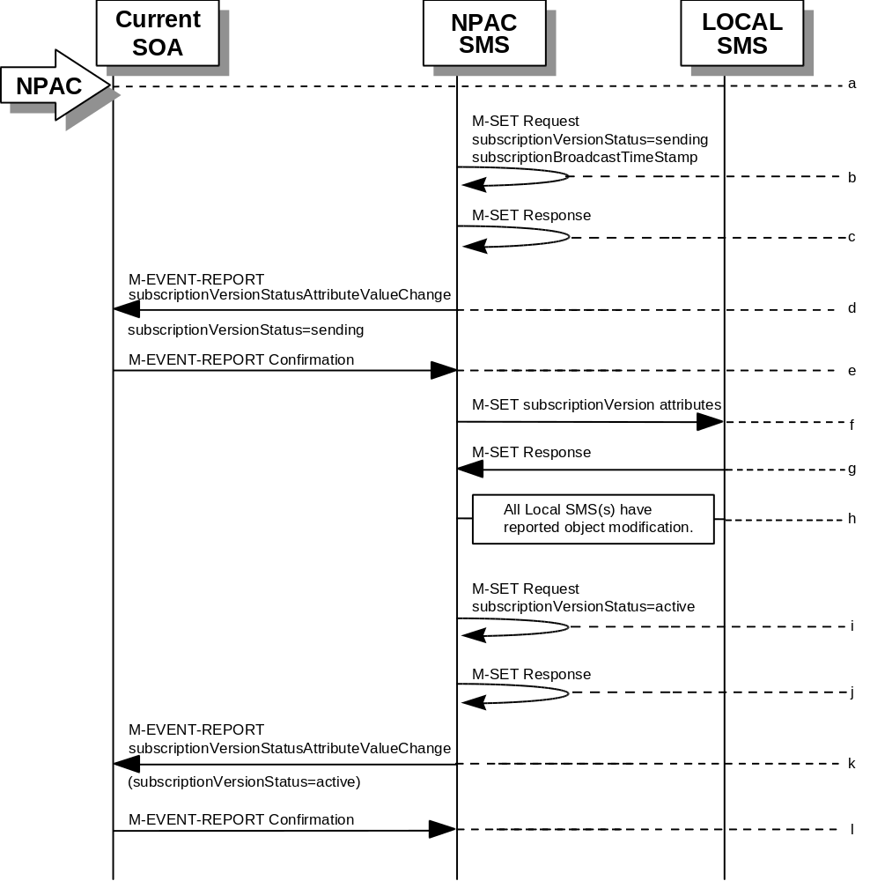
- Action is taken by NPAC personnel to resend the failed modified active version.
- NPAC SMS issues M-SET to the subscriptionVersionNPAC. The subscriptionVersionStatus is updated to “sending”.
- NPAC SMS issues M-SET response indicating success or failure.
- NPAC SMS issues M-EVENT- REPORT subscriptionVersionStatusAttributeValueChange for the status change to “sending.”
- Current service provider SOA responds with M-EVENT-REPORT confirmation.
- NPAC SMS issues M-SET to all Local SMSs that previously failed for the updated attributes, and are accepting downloads for the NPA-NXX of the subscriptionVersion.
- Local SMSs reply to M-SET.
- All Local SMSs have reported the object modification.
- NPAC SMS issues M-SET to update the current subscriptionVersionNPAC object subscriptionVersionStatus to “active.”
- NPAC SMS responds to M-SET.
- NPAC SMS sends M-EVENT-REPORT to the current provider of the subscriptionVersionStatus update.
- Service provider SOA issues M-EVENT-REPORT confirmation.

6.5.2.6

Subscription Version Modify Active: Resend Failure to Local SMS
This scenario shows a failure on a resend of a modified active subscription that failed previously to one or more of the Local SMSs. The resend of a failed modified active version can only be performed by authorized NPAC personnel.
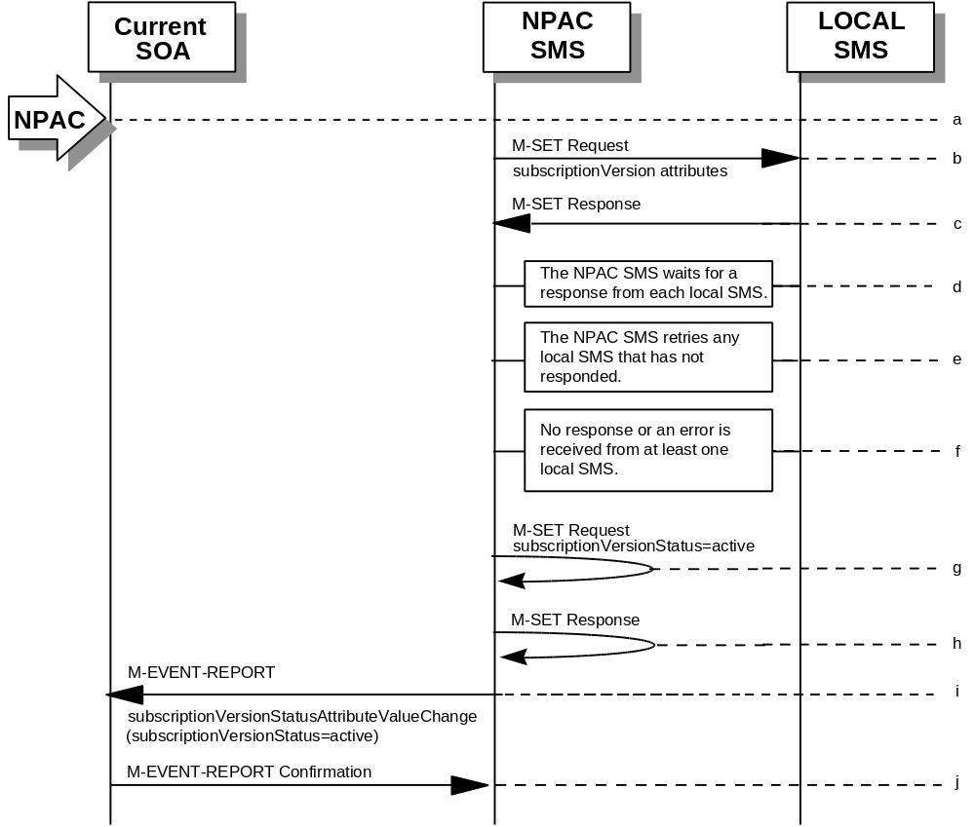
- The NPAC SMS has an active subscription version that has been unsuccessfully modified by the current service provider. The NPAC personnel issues a resend for the failed modified version and the subscription version now has a status of “sending”.
- The NPAC SMS issues M-SET to all Local SMSs that previously failed for the updated attributes, and are accepting downloads for the NPA-NXX of the subscriptionVersion.
- Local SMSs should respond successfully to the M-SET.
- NPAC SMS waits for responses from each Local SMS.
- NPAC SMS retries any Local SMS that has not responded.
- No response or an error is received from at least one or all Local SMSs.
- NPAC SMS issues the M-SET to update the current subscriptionVersionNPAC object’s subscriptionVersionStatus to “active” from “sending”. It will also update the subscriptionFailed-SP-List with the service provider ID and name of the Local SMSs that failed to successfully receive the broadcast.
- NPAC SMS responds to the M-SET.
- NPAC SMS sends the subscriptionVersionStatusAttributeValueChange M-EVENT-REPORT to the current service provider SOA with the current status and failedSP-List.
- The current service provider SOA issues the M-EVENT-REPORT confirmation.

6.5.3

Cancel Scenarios

6.5.3.1 SubscriptionVersion Cancel by Service Provider SOA After Both Service Provider SOAs Have Concurred
A subscription version can be canceled when the current status is conflict, disconnect-pending, or pending.
In this scenario, the old service provider initiates the cancel after both the old and new service provider SOAs have issued their create actions. Once the new service provider SOA’s cancellation acknowledgment is received, the version status is set to “canceled”. Since the old service provider SOA initiated the cancel, its cancellation acknowledgment is optional.
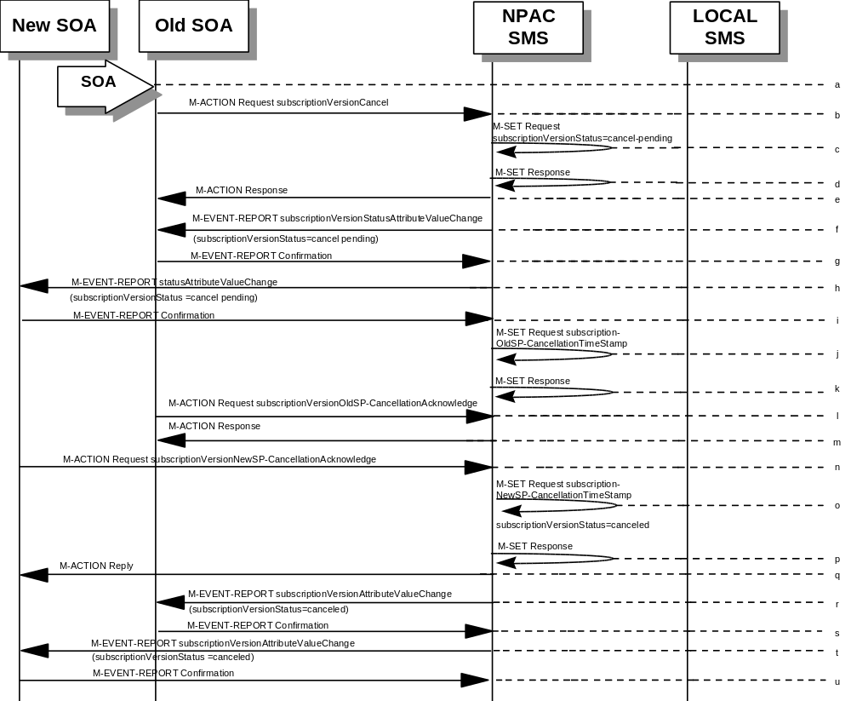
- Action is initiated by the old or new service provider SOA to cancel a subscription version by specifying the TN, TN range, or version ID of the subscription version to be canceled.
- Service provider SOA issues an M-ACTION subscriptionVersionCancel to the NPAC SMS to the lnpSubscriptions object.
- NPAC SMS issues M-SET to update subscriptionVersionStatus to “cancel-pending” in the subscriptionVersionNPAC object and the subscriptionModifiedTimeStamp.
- NPAC SMS issues M-SET response.
- NPAC SMS returns the M-ACTION reply. This either reflects a success or failure. Failure reasons are version in wrong state, no version to cancel, and authorization service provider. If successful, the subscriptionPre-CancellationStatus is set to the current subscriptionVersionStatus and then the subscriptionVersionStatus is set to “cancel-pending.” If the action fails, no modifications are applied and processing stops.
- An M-EVENT-REPORT for the subscriptionVersionStatus change is sent from the NPAC SMS to the old service provider SOA.
- The old service provider SOA returns an M-EVENT-REPORT confirmation to the NPAC SMS.
- An M-EVENT-REPORT for the subscriptionVersionStatus change is sent from the NPAC SMS to the new service provider SOA.
- The new service provider SOA returns an M-EVENT-REPORT confirmation to the NPAC SMS.
- The NPAC SMS issues M-SET for the subscriptionOldSP-CancellationTimeStamp in the subscriptionVersionNPAC object and subscriptionModifiedTimeStamp.
- NPAC SMS issues an M-SET response.
- The old service provider SOA sends an M-ACTion subscriptionVersionOldSP-CancellationAcknowledge to the NPAC SMS lnpSubscription object. This acknowledges the cancellation of the subscriptionVersionNPAC with a status of cancel-pending.
- NPAC SMS responds to the M-ACTION with either a success or failure and failure reasons. If the action fails, no modifications are applied.
- The new service provider SOA sends an M-ACTION subscriptionVersionNewSP-CancellationAcknowledge to the NPAC SMS lnpSubscriptions object.
- The NPAC SMS issues M-SET for the subscriptionNewSP-CancellationTimeStamp, subscriptionModifiedTimeStamp, subscriptionCancellationTimeStamp, and subscriptionVersionStatus to “canceled.”
- NPAC SMS issues M-SET response.
- NPAC SMS replies to M-ACTION with success or failure and reasons for failure. If the action fails, no modifications are applied.
- If the last M-ACTION was successful, the NPAC SMS sends the M-EVENT-REPORT for the subscriptionVersionStatus update to canceled to the old service provider SOA.
- If the last M-ACTION was successful, the old service provider SOA returns an M-EVENT-REPORT confirmation to the NPAC SMS.
- NPAC SMS sends the M-EVENT-REPORT for the subscriptionVersionStatus update to canceled to the new service provider SOA.
- The new service provider SOA returns an M-EVENT-REPORT confirmation to the NPAC SMS.

6.5.3.2

SubscriptionVersionCancel: No Acknowledgment from a SOA
The NPAC SMS has set the status of the subscription version to “cancel-pending” upon request of the old SOA. It is now waiting for the acknowledgments from both service provider SOAs. Acknowledgment from the old SOA is optional. In this scenario the new service provider does not respond.
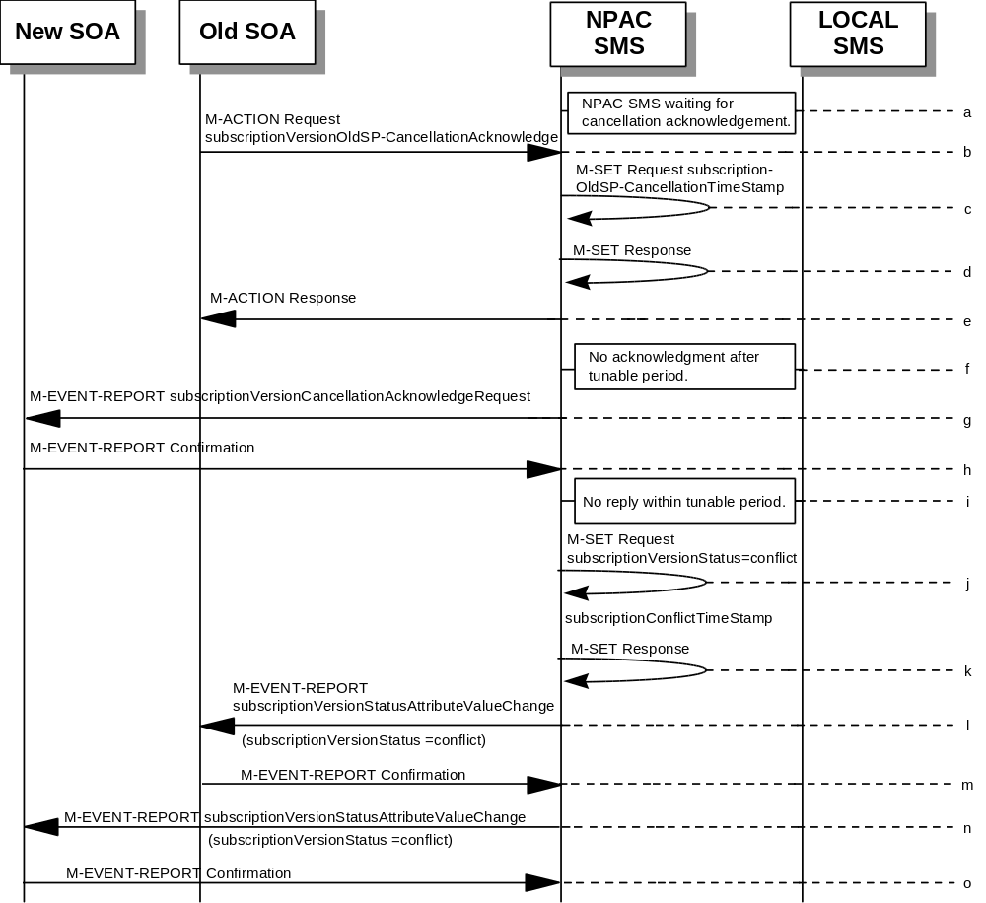
- NPAC SMS is waiting for the cancellation acknowledgments from both service provider SOAs.
- The old service provider SOA sends a subscriptionVersionOldSP-CancellationAcknowledge M-ACTION to the NPAC SMS lnpSubscriptions object. This acknowledges the cancellation of the subscriptionVersionNPAC with a status of cancel-pending.
- NPAC SMS issues M-SET for the subscriptionOldSP-CancellationTimeStamp and subscriptionModifiedTimeStamp in the subscriptionVersionNPAC object.
- NPAC SMS responds to M-SET.
- NPAC SMS replies to the M-ACTION with either a success or failure and failure reasons. If the action fails, no modifications are applied and processing stops.
- The NPAC SMS waits for the cancellation acknowledgment from the new service provider SOA. No reply is received after a tunable period.
- NPAC SMS issues M-EVENT-REPORT subscriptionVersionCancellationAcknowledgeRequest to the unresponsive new service provider SOA.
- The new service provider SOA returns an M-EVENT-REPORT confirmation to the NPAC SMS.
- The “Service Provider Concurrence Cancellation Window” has expired and still no cancellation acknowledgment is received from the new service provider.
- NPAC SMS issues M-SET to update the subscriptionVersionStatus to conflict and the subscriptionConflictTimeStamp and subscriptionModifiedTimeStamp are set.
- NPAC SMS issues M-SET response.
- The NPAC SMS issues M-EVENT-REPORT, subscriptionVersionStatusAttributeValueChange, to the old service provider SOA.
- The old service provider SOA returns an M-EVENT-REPORT confirmation to the NPAC SMS.
- The NPAC SMS issues M-EVENT-REPORT, subscriptionVersionStatusAttributeValueChange, to the new service provider SOA.
- The new service provider SOA returns an M-EVENT-REPORT confirmation to the NPAC SMS.
- At this point, the flow follows the conflict resolution scenarios.

6.5.3.3

Subscription Version Cancels With Only One Create Action Received
Once one of the subscriptionVersionNewSP-Create or subscriptionVersionOldSP-Create actions has been received, the subscription version can be canceled by the same service provider who created the subscription version. In this case, the subscription version status is set to “canceled”, not “cancel-pending”, and no further acknowledgments are necessary by either the old or new service provider.
If the new service provider SOA creates the pending subscription version and the old service provider attempts to cancel it (or vice-versa), an error is returned to the service provider who requested the cancel.
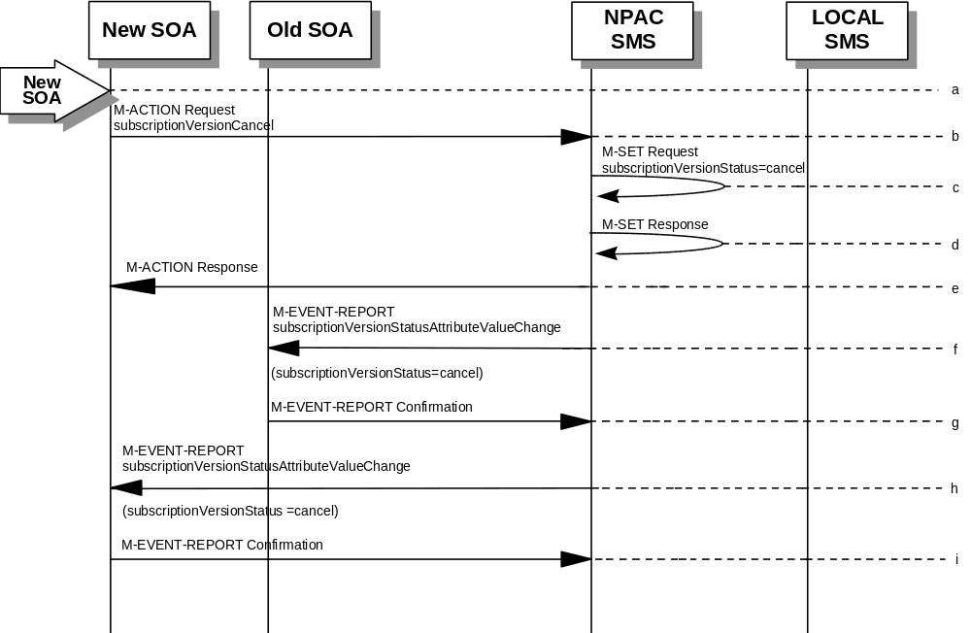
In this scenario, the new service provider SOA has already successfully issued the subscriptionVersionNewSP-Create action. The old service provider has not issued it’s subscriptionVersionOldSP-Create action. Now, the new service provider needs to cancel the pending subscription version.
- Action is taken by the new service provider to cancel a subscription version they created.
- The new service provider SOA sends M-ACTION subscriptionVersionCancel to the NPAC SMS lnpSubscriptions object to cancel a pending subscriptionVersionNPAC.
- NPAC SMS issues M-SET to update the subscriptionVersionStatus to “canceled” and update the subscriptionModifiedTimeStamp in the subscriptionVersionNPAC object.
- NPAC SMS issues M-SET response.
- NPAC SMS returns the M-ACTION reply. This either reflects a success or failure. Failure reasons are version in wrong state, no version to cancel, and service provider not authorized.
If successful, the subscriptionPreCancellationStatus is set to the current subscriptionVersionStatus, and then the subscriptionVersionStatus is set to “canceled”. If the action fails, no modifications are applied and processing stops.
- The subscriptionVersionStatusAttributeValueChange M-EVENT-REPORT is sent to the old service provider SOA.
- The old service provider confirms the M-EVENT-REPORT.
- The subscriptionVersionStatusAttributeValueChange M-EVENT-REPORT is sent to the new service provider SOA.
- The new service provider confirms the M-EVENT-REPORT.

6.5.4

Disconnect Scenarios

6.5.4.1 SubscriptionVersion Immediate Disconnect
The current service provider can disconnect an active subscription version. In this scenario, the disconnect is immediate.
- Current service provider SOA personnel take action to disconnect a subscription version.
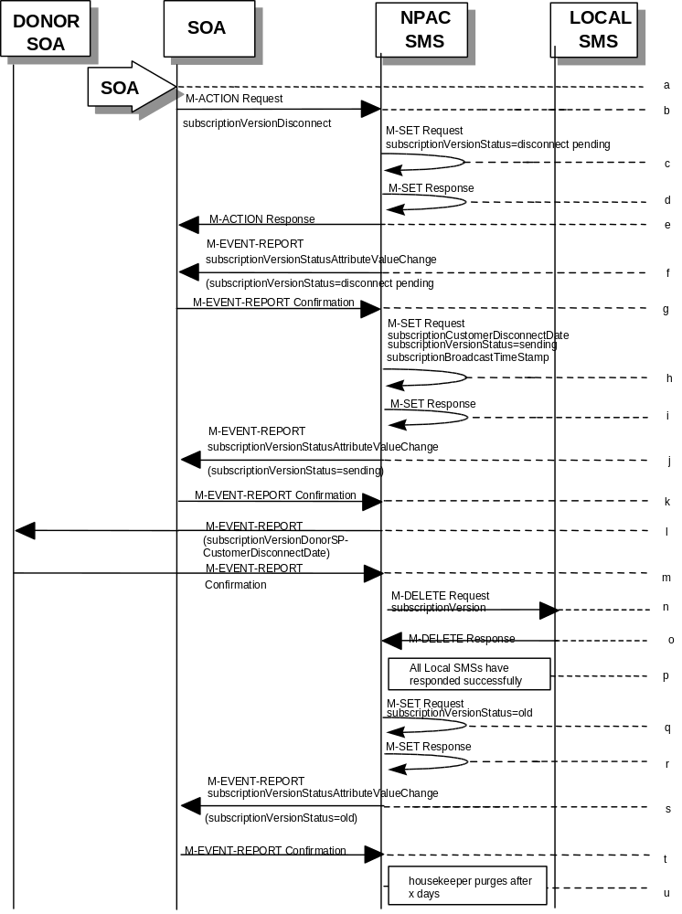
- Service provider SOA issues an M-ACTION request to disconnect to the lnpSubscriptions object. The M-ACTION specifies either the subscriptionVersionId, or subscriptionTN or range of TNs, and also has future dated the subscriptionEffectiveReleaseDate and the subscriptionCustomerDisconnectDate. The subscription version status must be active and no pending, failed, conflict or cancel-pending versions can exist.
- NPAC SMS issues an M-SET to set the subscriptionCustomerDisconnectDate according to the disconnect action. The subscriptionVersionStatus goes to “disconnect pending ”.
- NPAC SMS responds to whether M-SET was successful.
- NPAC SMS responds to the M-ACTION. If the action failed, an error will be returned and processing will stop on this flow.
- NPAC SMS notifies service provider SOA of status change to “disconnect pending.”
- Service provider SOA confirms event report.
- NPAC SMS issues an M-SET to set the subscriptionCustomerDisconnectDate according to the disconnect action. The subscriptionVersionStatus goes to “sending ” and the subscriptionModifiedTimeStamp and the subscriptionBroadcastTimeStamp are both set accordingly.
- NPAC SMS responds to whether M-SET was successful.

- NPAC SMS notifies service provider SOA of status change to “sending.”
- Service provider SOA confirms event report.
- NPAC SMS sends the donor service provider SOA notification that the subscription version is being disconnected with the customer disconnect date.
- The donor service provider SOA confirms the M-EVENT-REPORT.
- NPAC SMS sends out an M-DELETE on the subscriptionVersion to all Local SMSs, that are accepting downloads for the NPA-NXX of the subscriptionVersion. If the M-DELETE is for multiple subscription versions, a scoped and filtered operation will be sent.
- Each Local SMS responds with a successful M-DELETE reply.
- All Local SMSs respond successfully.
- NPAC SMS issues M-SET updating the subscriptionVersionStatus to old for subscriptionVersionNPAC objects. It also sets the subscriptionModifiedTimeStamp and subscriptionDisconnectCompleteTimeStamp.
- NPAC SMS responds to M-SET.
- NPAC SMS issues an M-EVENT-REPORT for the subscriptionVersionStatus equal to “old.”
- Service provider SOA responds to M-EVENT-REPORT.
- After a tunable amount of days, the subscription version is purged by the NPAC SMS housekeeping process.

6.5.4.2

SubscriptionVersion Disconnect With Effective Release Date
In this scenario, a future dated request is submitted to disconnect an active subscriptionVersion.
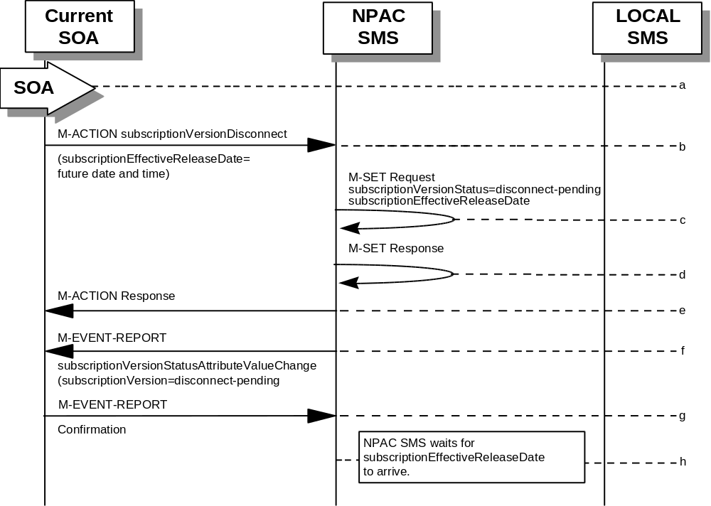
- Service provider SOA personnel take action to disconnect a subscription version.
- Service provider SOA issues an M-ACTION request to disconnect to the lnpSubscriptions object. The M-ACTION specifies either the subscriptionVersionId, or subscriptionTN or range of TNs, and also has future dated the subscriptionEffectiveReleaseDate and the subscriptionCustomerDisconnectDate. The subscription version status must be active and no pending, failed, conflict, conflict-pending, cancel or cancel-pending versions can exist.
- NPAC SMS M-SETs the status to disconnect-pending, and sets the subscriptionEffectiveReleaseDate of the existing subscriptionVersionNPAC and also the subscriptionModifiedTimeStamp.
- NPAC SMS responds to M-SET.
- NPAC SMS responds to M-ACTION. If the action fails, no modifications are applied and the processing stops.
- NPAC SMS sends the subscriptionVersionStatusAttributeValueChange
M-EVENT-REPORT to the current service provider SOA.
- The current service provider SOA issues the M-EVENT-REPORT confirmation.
- The NPAC SMS waits for the subscriptionEffectiveReleaseDate date to arrive.
- At this point, the flow follows an immediate disconnect scenario. First the donor service provider’s Local SMS is notified of the impending disconnect. The NPAC SMS sets the subscriptionVersionStatus to sending the broadcast timestamp, notifies the service provider SOA of the status change, and proceeds to issue M-DELETEs for the subscriptionVersion to the Local SMS.

6.5.4.3

SubscriptionVersion Disconnect: Failure to Local SMS
This scenario shows the broadcast of a disconnected subscription that fails to all of the Local SMSs.
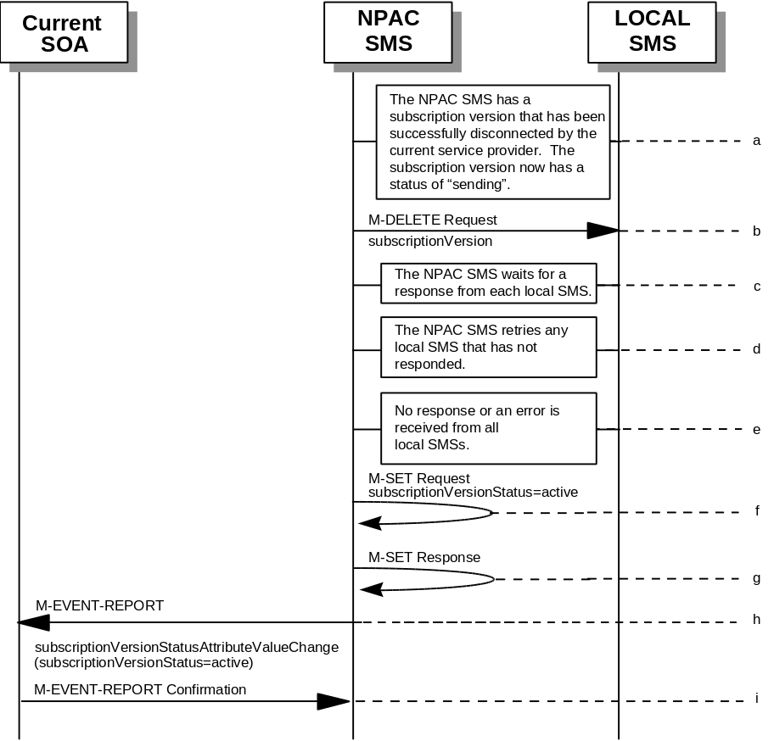
- The NPAC SMS has an active subscription version that has been successfully disconnected by the current service provider using the subscriptionVersionDisconnect action. The subscription version now has a status of “sending”.
- NPAC SMS issues the M-DELETE to all Local SMSs for the subscriptionVersion, that are accepting downloads for the NPA-NXX of the subscriptionVersion.
- NPAC SMS waits for a response from each Local SMS.
- NPAC SMS retries any Local SMS that has not responded.
- No response or an error is received from all Local SMSs.
- NPAC SMS issues the M-SET to update the current subscriptionVersionNPAC object’s subscriptionVersionStatus to “active” from “sending”. It will also update the subscriptionFailed-SP-List with the service provider ID and name of all the Local SMSs.
- NPAC SMS responds to the M-SET.
- NPAC SMS sends the subscriptionVersionStatusAttributeValueChange
M-EVENT-REPORT to the current service provider SOA with the current status and failedSP-List.
- Current service provider SOA issues the M-EVENT-REPORT confirmation.

6.5.4.4

SubscriptionVersion Disconnect: Partial Failure to Local SMS
This scenario shows the broadcast of a disconnected subscription that fails to one or more, but not all, of the Local SMSs.
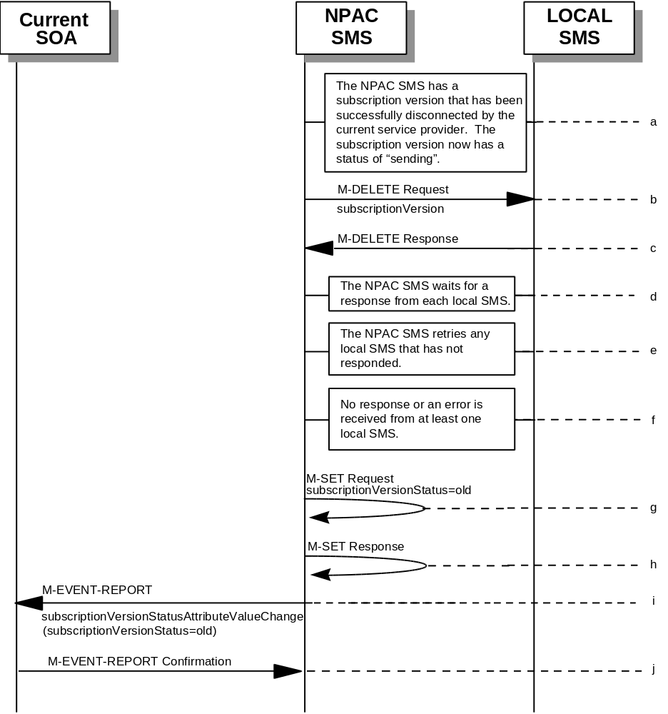
- The NPAC SMS has an active subscription version that has been successfully disconnected by the current service provider using the subscriptionVersionDisconnect action. The subscription version now has a status of “sending”.
- NPAC SMS issues the M-DELETE to all Local SMSs for the subscriptionVersion, that are accepting downloads for the NPA-NXX of the subscriptionVersion.
- Local SMSs should respond successfully to the M-DELETE.
- NPAC SMS waits for a response from each Local SMS.
- NPAC SMS retries any Local SMS that has not responded.
- No response or an error is received from at least one Local SMS.
- NPAC SMS issues the M-SET to update the current subscriptionVersionNPAC object’s subscriptionVersionStatus to “old” from “sending”. It will also update the subscriptionFailed-SP-List with the service provider ID and name of the Local SMSs that failed to successfully receive the broadcast.
- NPAC SMS responds to the M-SET.
- NPAC SMS sends the subscriptionVersionStatusAttributeValueChange
M-EVENT-REPORT to the current service provider SOA with the current status and failedSP-List.
- Current service provider SOA issues the M-EVENT-REPORT confirmation.

6.5.4.5

Subscription Version Disconnect: Resend Successful to Local SMS
This scenario shows a successful resend of a disconnect for a subscription that fails to one or more of the Local SMSs. The resend of a failed disconnect can only be performed by authorized NPAC personnel.
- NPAC personnel take action to resend a failed disconnect for a subscription version.
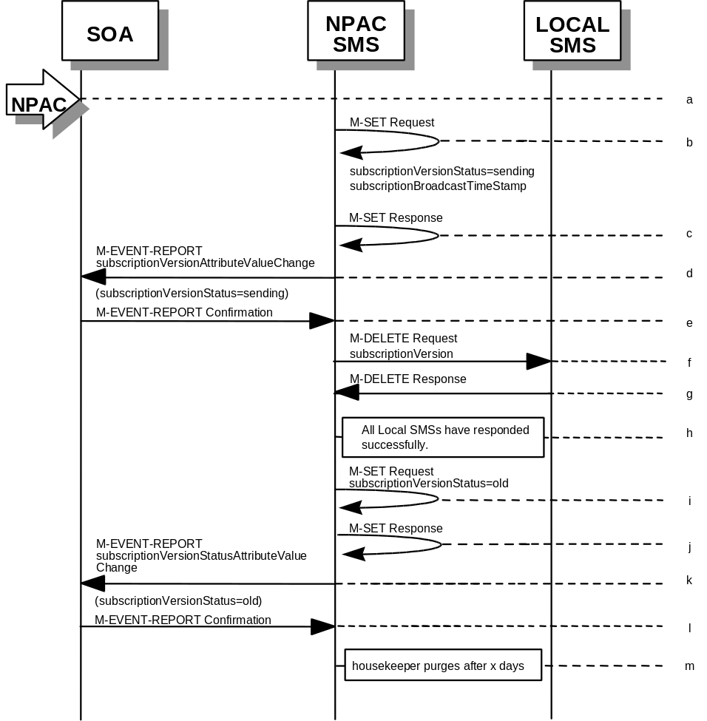
- NPAC SMS issues an M-SET to the existing subscriptionVersionNPAC object to set the status to “sending”.
- NPAC SMS responds to whether M-SET was successful.
- NPAC SMS notifies service provider SOA of status change to “sending.”
- Service provider SOA confirms event report.
- NPAC SMS sends out an M-DELETE on the subscriptionVersion to all previously failed Local SMSs, that are accepting downloads for the NPA-NXX of the subscriptionVersion.
- Each Local SMS responds with a successful M-DELETE reply.
- All Local SMSs respond successfully.
- NPAC SMS issues M-SET updating the subscriptionVersionStatus to old for subscriptionVersionNPAC objects. It also sets the subscriptionModifiedTimeStamp and subscriptionDisconnectCompleteTimeStamp.
- NPAC SMS responds to M-SET.
- NPAC SMS issues an M-EVENT-REPORT for the subscriptionVersionStatus equal to “old.”
- Service provider SOA responds to M-EVENT-REPORT.
- After a tunable amount of days, the subscription version is purged by the NPAC SMS housekeeping process.

6.5.4.6

Subscription Version Disconnect: Resend Failure to Local SMS
This scenario shows a failure on a resend of a subscription disconnect that failed previously to one or more of the Local SMSs. The resend of a failed disconnect for a subscription can only be performed by authorized NPAC personnel.
- NPAC personnel take action to resend a failed disconnect for a subscription version.
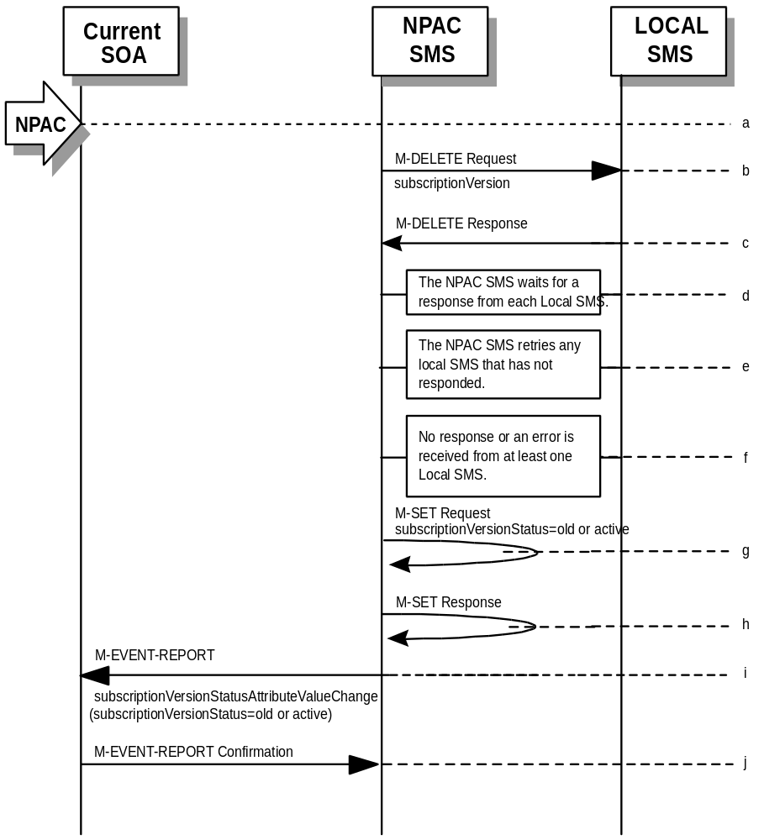
- NPAC SMS issues the M-DELETE to all Local SMSs for which the disconnect previously failed for the subscriptionVersion, and are accepting downloads for the NPA-NXX of the subscriptionVersion.
- Local SMSs should respond successfully to the M-DELETE.
- NPAC SMS waits for a response from each Local SMS.
- NPAC SMS retries any Local SMS that has not responded.
- No response or an error is received from at least one or all Local SMSs.
- NPAC SMS issues the M-SET to update the current subscriptionVersionNPAC object’s subscriptionVersionStatus to “old” or “active” (if all Local SMSs failed) from “sending”. It will also update the subscriptionFailed-SP-List with the service provider ID and name of the Local SMSs that failed to successfully receive the broadcast.
- NPAC SMS responds to the M-SET.
- NPAC SMS sends the subscriptionVersionStatusAttributeValueChange
M-EVENT-REPORT to the current service provider SOA with the current status and failedSP-List.
- Current service provider SOA issues the M-EVENT-REPORT confirmation.

6.5.5

Conflict Scenarios
A situation has arisen which causes the NPAC SMS or NPAC personnel to place the subscriptionVersion into conflict.
A subscription version can be removed from conflict by the NPAC personnel or the new service provider SOA.

6.5.5.1 SubscriptionVersion Conflict and Conflict Resolution by the NPAC SMS
This scenario shows a version being placed into conflict and removed from conflict by the NPAC personnel.
- NPAC personnel or NPAC SMS take action to set the status of a subscription to “conflict.”
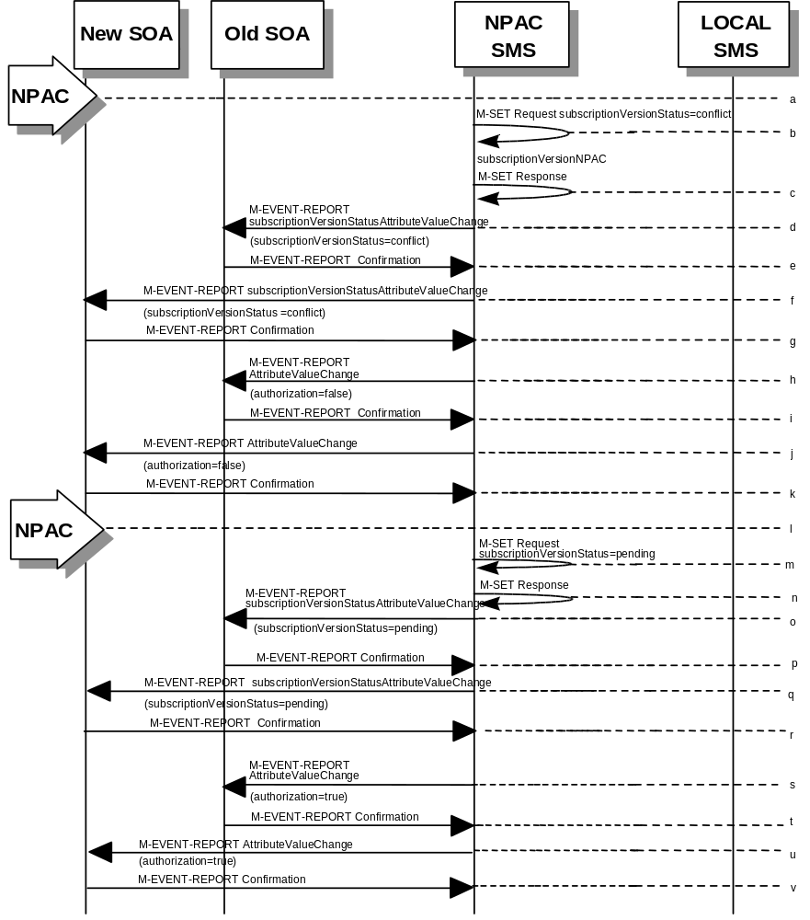
- NPAC SMS issues M-SET request to update subscriptionVersionStatus to “conflict,” subscriptionConflictTimeStamp, and subscriptionModifiedTimeStamp in the subscriptionVersionNPAC object.
- NPAC SMS issues an M-SET response. If the M-SET fails, processing for this scenario stops.
- NPAC SMS issues an M-EVENT-REPORT subscriptionVersionStatusAttributeValueChange to old service provider SOA.
- The old service provider SOA returns an M-EVENT-REPORT confirmation to the NPAC SMS.
- NPAC SMS issues subscriptionVersionStatusAttributeValueChange for status to new service provider SOA.
- The new service provider SOA returns an M-EVENT-REPORT confirmation to the NPAC SMS.
- NPAC SMS sends a subscriptionVersionStatusAttributeValueChange to set the old service provider’s authorization to “FALSE”.
- The old service provider SOA returns an M-EVENT-REPORT confirmation to the NPAC SMS.
- NPAC SMS sends an AttributeValueChange to set the new service provider authorization to “FALSE”.
- The new service provider SOA returns an M-EVENT-REPORT confirmation to the NPAC SMS.
- Once the conflict is resolved, NPAC personnel take action to remove the subscriptionVersion from conflict.
- NPAC SMS issues an M-SET request to update the subscriptionModifiedTimeStamp and the subscriptionVersionStatus to “pending.”
- NPAC SMS issues an M-SET response. If the M-SET fails, processing for this scenario stops.
- NPAC SMS issues subscriptionVersionStatusAttributeValueChange for the new status to the old service provider SOA.
- The old service provider SOA returns an M-EVENT-REPORT confirmation to the NPAC SMS.
- NPAC SMS issues subscriptionVersionStatusAttributeValueChange for the new status to the new service provider SOA.
- The new service provider SOA returns an M-EVENT-REPORT confirmation to the NPAC SMS.
- NPAC SMS sends a subscriptionVersionStatusAttributeValueChange to set the old service provider’s authorization to “TRUE”.
- The old service provider SOA returns an M-EVENT-REPORT confirmation to the NPAC SMS.
- NPAC SMS sends an AttributeValueChange to set the new service provider authorization to “TRUE”.
- The new service provider SOA returns an M-EVENT-REPORT confirmation to the NPAC SMS.

6.5.5.2

Subscription Version Conflict Removal by the New Service Provider SOA
In this scenario, the new service provider elects to remove the subscription version from conflict.
- A subscription version exists on the NPAC SMS with a status of conflict.
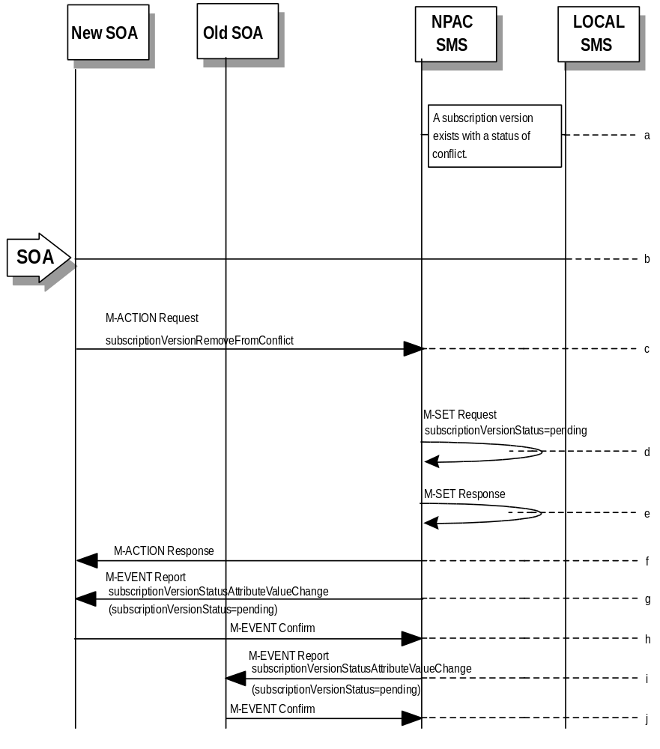
- The new service provider SOA personnel take action to remove the subscription version from conflict.
- The new service provider SOA sends the M-ACTION subscriptionVersionNewSP-RemoveFromConflict specifying the subscription version TN or subscription version ID of the subscription version in conflict.
- If the request is valid, the NPAC SMS will set the status to “pending”.
The request will be denied and an error returned if the subscriptionOldSP-Authorization was set to conflict by the old service provider and the conflict restriction window has not expired.
- The NPAC SMS responds to its own M-SET.
- The NPAC SMS responds to the M-ACTION with success or failure and reason for failure.
- The NPAC SMS sends the M-EVENT-REPORT subscriptionVersionStatusAttributeValueChange to the New SOA.
- The New SOA sends the M-EVENT-REPORT confirmation.
- The NPAC SMS sends the M-EVENT-REPORT subscriptionVersionStatusAttributeValueChange to the Old SOA.
- The Old SOA sends the M-EVENT-REPORT confirmation.

6.5.5.3

SubscriptionVersion Conflict: No Conflict Resolution
This scenario shows the action taken at the NPAC SMS when service providers do not reach a conflict resolution.
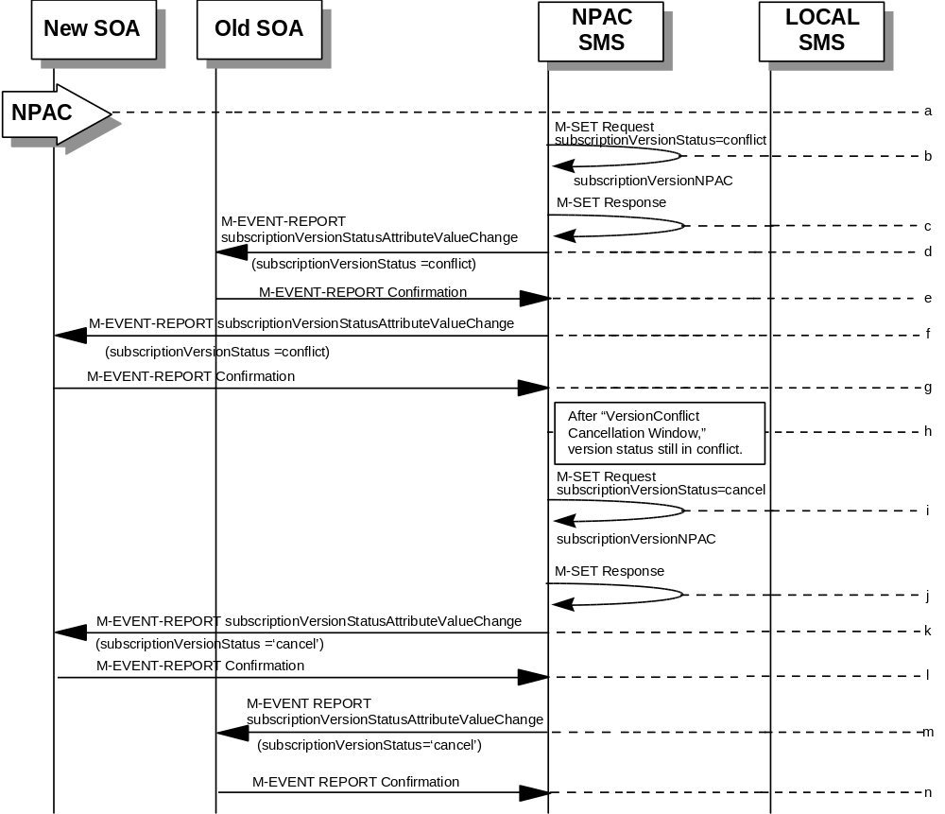
- NPAC personnel or NPAC SMS take action to set a subscriptionVersionStatus to “conflict.”
- NPAC SMS issues an M-SET request to set the subscriptionVersionStatus to “conflict,” the subscriptionConflictTimeStamp, and the subscriptionModifiedTimeStamp in the subscriptionVersionNPAC object.
- NPAC SMS responds to M-SET. If the M-SET fails, processing stops for this scenario until the M-SET completes successfully.
- NPAC SMS issues subscriptionVersionStatusAttributeValueChange to old service provider SOA for the new “conflict” status.
- The old service provider SOA returns an M-EVENT-REPORT confirmation to the NPAC SMS.
- NPAC SMS issues subscriptionVersionStatusAttributeValueChange to new service provider SOA for the “conflict” status.
- The new service provider SOA returns an M-EVENT-REPORT confirmation to the NPAC SMS.
- “Version Conflict Cancellation Window” expires without conflict resolution.
- NPAC SMS issues an M-SET request to set the subscriptionVersionStatus to “cancel” in the subscriptionVersionNPAC object and sets the subscriptionCancellationTimeStamp and subscriptionModifiedTimeStamp.
- NPAC SMS responds to M-SET. If the M-SET fails, processing stops for this scenario until the M-SET is successfully completed.
- NPAC SMS issues attribute value change for status to new service provider SOA for the “cancel” status.
- The new service provider SOA returns an M-EVENT-REPORT confirmation to the NPAC SMS.
- NPAC SMS issues attribute value change for status to old service provider SOA for the “cancel” status.
- The old service provider SOA returns an M-EVENT-REPORT confirmation to the NPAC SMS.

6.5.5.4

Subscription Version Conflict by Old Service Provider Explicitly Not Authorizing (First Create)
The old service provider SOA can put a pending subscription version into conflict by setting its authorization flag to off. This can be done on the subscriptionVersionOldSP-Create action, subscriptionVersionModify action, or M-SET of the attribute on the subscription version object.
This scenario shows the old service provider putting a new pending subscription version into conflict by turning the authorization flag off on the subscriptionVersionOldSP-Create. In this case, the old service provider’s create action is the first sent to the NPAC SMS.
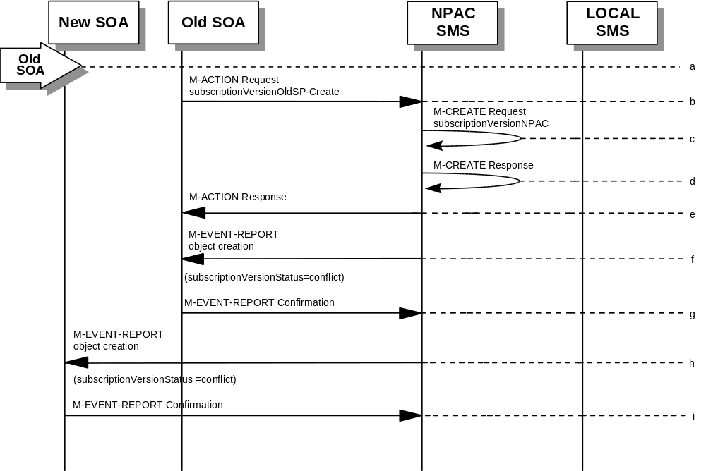
- Action is taken by the old service provider to set a subscription version to conflict using the subscriptionVersionOldSP-Create action.
- The old service provider SOA sends M-ACTION subscriptionVersionOldSP-Create to the NPAC SMS lnpSubscriptions object to create a new subscriptionVersionNPAC with the status of “conflict”.
The old service provider SOA specifies the following valid attributes:
subscriptionTN or valid subscriptionVersionTN-Range
subscriptionNewCurrentSP
subscriptionOldSP
subscriptionOldSP-DueDate
subscriptionOldSP-Authorization
subscriptionLNPType
In this case, the subscriptionOldSP-Authorization is set to NO.
- NPAC SMS issues M-CREATE to create the subscriptionVersionNPAC with a status of “conflict” and sets all the other attribute values from the subscriptionVersionOldSP-Create action.
- NPAC SMS issues M-CREATE response.
- NPAC SMS returns M-ACTION reply. This either reflects a success or failure and reasons for the failure.
- If the action was successful, the NPAC SMS issues the M-EVENT-REPORT to the old service provider SOA notifying them of the object creation.
- The old service provider SOA confirms the M-EVENT-REPORT.
- If the action was successful, the NPAC SMS issues the M-EVENT-REPORT to the new service provider SOA notifying them of the object creation.
- The new service provider SOA confirms the M-EVENT-REPORT.

6.5.6

SubscriptionVersion Query
This scenario shows subscriptionVersion query from service provider systems to the NPAC SMS.
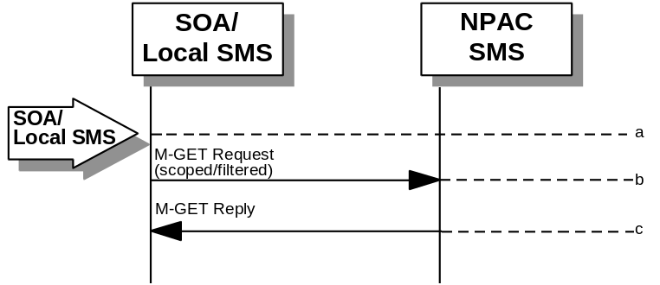
- Action is taken by either a service provider SOA or Local SMS for retrieving one or more versions of a subscription.
- The service provider SOA or Local SMS issues a scoped filtered M-GET from the lnpSubscriptions object to retrieve a specific version for a subscription version TN or can request all subscription versions. However, the service provider SOA is limited by a scope and filter in their search capabilities. The filter will currently support all the attributes on the subscriptionVersionNPAC.
- The NPAC SMS replies with the requested subscriptionVersion data if the requested number of records is less than or equal to “Max SubscriberQuery” specified in the NPAC SMS. Otherwise a complexityLimitation error will be returned.
- The query return data includes:
subscriptionTN
subscriptionLRN
subscriptionNewCurrentSP
subscriptionOldSP
subscriptionNewSP-DueDate
subscriptionNewSP-CreationTimeStamp
subscriptionOldSP-DueDate
subscriptionOldSP-Authorization
subscriptionOldSP-AuthorizationTimeStamp
subscriptionActivationTimeStamp
subscriptionBroadcastTimeStamp
subscriptionConflictTimeStamp
subscriptionCustomerDisconnectDate
subscriptionDisconnectCompleteTimeStamp
subscriptionEffectiveReleaseDate
subscriptionVersionStatus
subscriptionCLASS-DPC
subscriptionCLASS-SSN
subscriptionLIDB-DPC
subscriptionLIDB-SSN
subscriptionCNAM-DPC
subscriptionCNAM-SSN
subscriptionISVM-DPC
subscriptionISVM-SSN
subscriptionEndUserLocationValue
subscriptionEndUserLocationType
subscriptionBillingId
subscriptionLNPType
subscriptionPreCancellationStatus
subscriptionCancellationTimeStamp
subscriptionOldTimeStamp
subscriptionModifiedTimeStamp
subscriptionCreationTimeStamp
subscriptionOldSP-CancellationTimeStamp
subscriptionNewSP-CancellationTimeStamp
subscriptionOldSP-ConflictResolutionTimeStamp
subscriptionNewSP-ConflictResolutionTimeStamp
subscriptionPortingToOriginal-SPSwitch
subscriptionFailedSP-List
subscriptionDownloadReason

6.5.6.1

Subscription Data Download
This scenario shows a Local SMS request for subscription data download in order to update their view of this data.
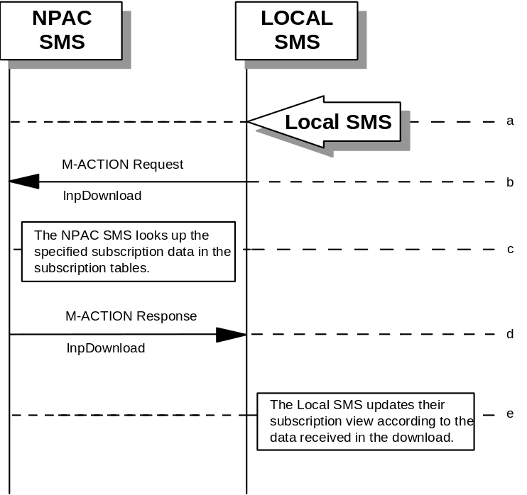
- Action is taken by the Local SMS personnel to request a subscription data download. The criteria to decide which subscription data is to be downloaded is specified by the Local SMS personnel.
- The Local SMS sends an M-ACTION request to the NPAC SMS lnpSubscription object requesting a subscription data download.
- The NPAC SMS looks up the subscription data in the subscription database as specified by the criteria in the M-ACTION request.
- The NPAC SMS responds by sending an M-ACTION response to the Local SMS that initiated the request. The response includes the success/failure of the request along with the requested subscription data.
- The Local SMS must take appropriate action to update their view of the data.

6.6

LSMS Filter NPA-NXX Scenarios

6.6.1 lsmsFilterNPA-NXX Creation by the Local SMS
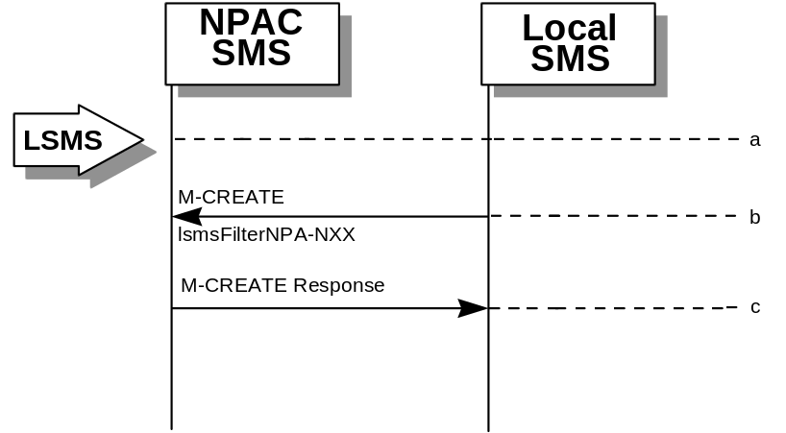
- Action is taken by the Local SMS personnel to create an lsmsFilterNPA-NXX object.
- The Local SMS sends the M-CREATE request to the NPAC for the lsmsFilterNPA-NXX object to be created.
- The NPAC SMS attempts to create the object. If successful, the M-CREATE response is returned. Otherwise, an error is returned.

6.6.2

lsmsFilterNPA-NXX Deletion by the Local SMS
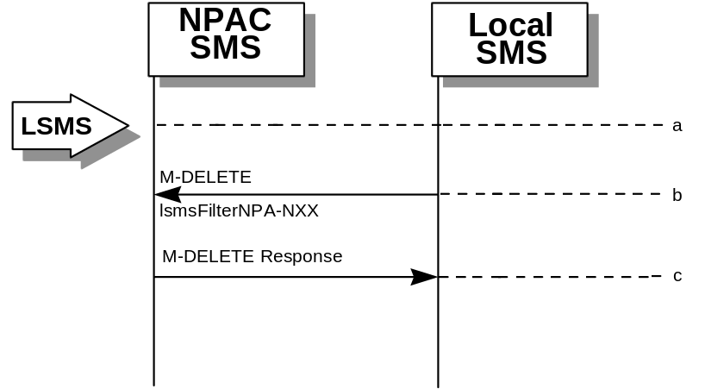
- Action is taken by the Local SMS personnel to delete an lsmsFilterNPA-NXX object.
- The Local SMS sends the M-DELETE request to the NPAC for the lsmsFilterNPA-NXX object to be removed.
- The NPAC SMS attempts to delete the object. If successful, the M-DELETE response is returned. Otherwise, an error is returned.

6.6.3

lsmsFilterNPA-NXX Query by the Local SMS
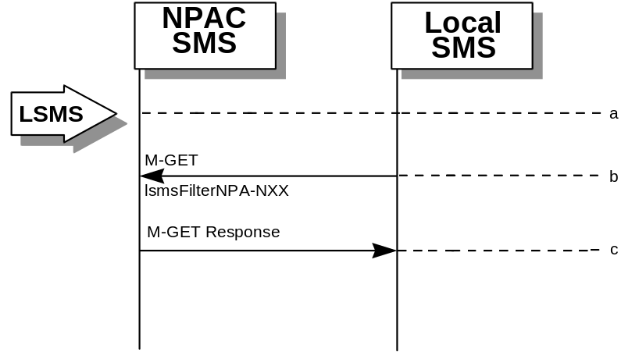
- Action is taken by the Local SMS personnel to query for one or all lsmsFilterNPA-NXX object(s).
- The Local SMS sends the M-GET request to the NPAC for the lsmsFilterNPA-NXX object(s).
- If the Service Provider ID was specified, all lsmsFilterNPA-NXX objects for that Service Provider are returned. If only one object was requested, that object is returned.

6.6.4

lsmsFilterNPA-NXX Creation by the SOA
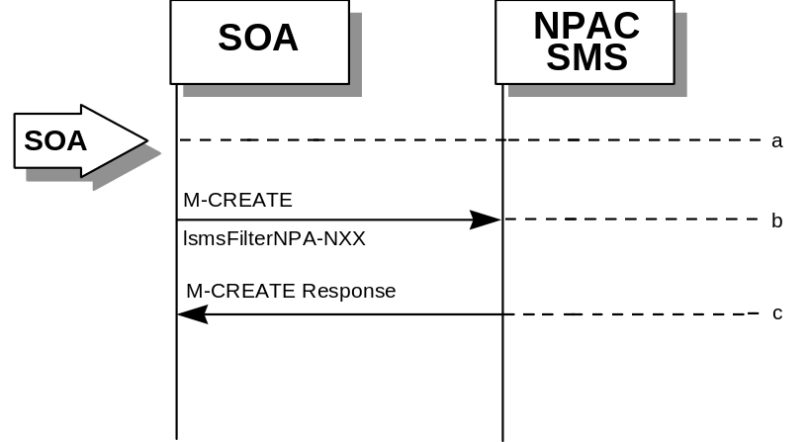
- Action is taken by the SOA personnel to create an lsmsFilterNPA-NXX object.
- The SOA sends the M-CREATE request to the NPAC for the lsmsFilterNPA-NXX object to be created.
- The NPAC SMS attempts to create the object. If successful, the M-CREATE response is returned. Otherwise, an error is returned.

6.6.5

lsmsFilterNPA-NXX Deletion by the SOA
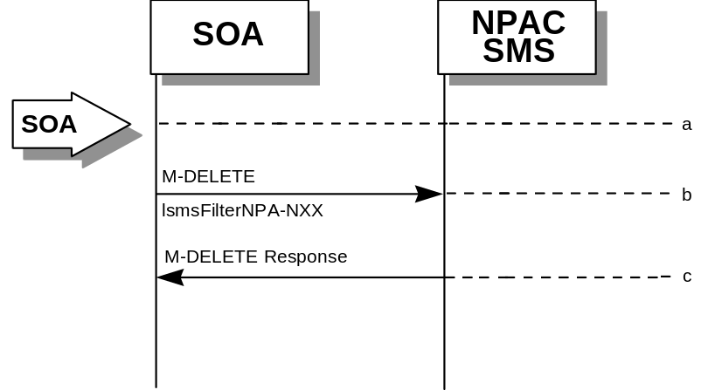
- Action is taken by the SOA personnel to delete an lsmsFilterNPA-NXX object.
- The SOA sends the M-DELETE request to the NPAC for the lsmsFilterNPA-NXX object to be removed.
- The NPAC SMS attempts to delete the object. If successful, the M-DELETE response is returned. Otherwise, an error is returned.

6.6.6

lsmsFilterNPA-NXX Query by the SOA
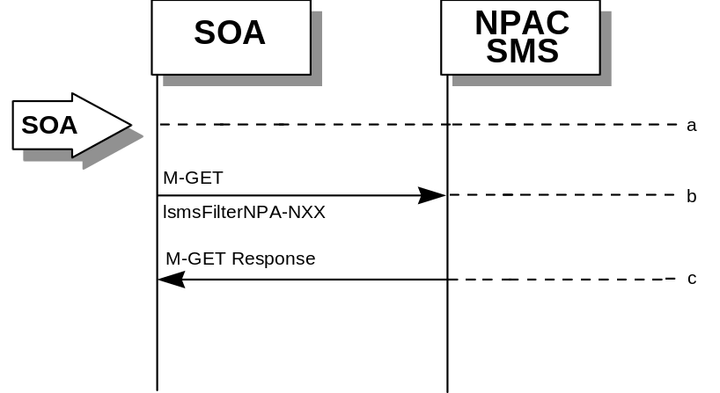
- Action is taken by the SOA personnel to query for one or all lsmsFilterNPA-NXX object(s).
- The SOA sends the M-GET request to the NPAC for the lsmsFilterNPA-NXX object(s).
- If the Service Provider ID was specified, all lsmsFilterNPA-NXX objects for that Service Provider are returned. If only one object was requested, that object is returned.

6.7

Miscellaneous

6.7.1 Sequencing of Events on Initialization/Resynchronization of Local SMS
If the resynchronization flag is TRUE upon association establishment, the NPAC SMS will hold updates to the Local SMS until the flag is turned off. At that time all updates issued since the association establishment will be sent.
If any of the requests in this scenario fail, the Local SMS must correct the problem - retry the action instead of continuing.
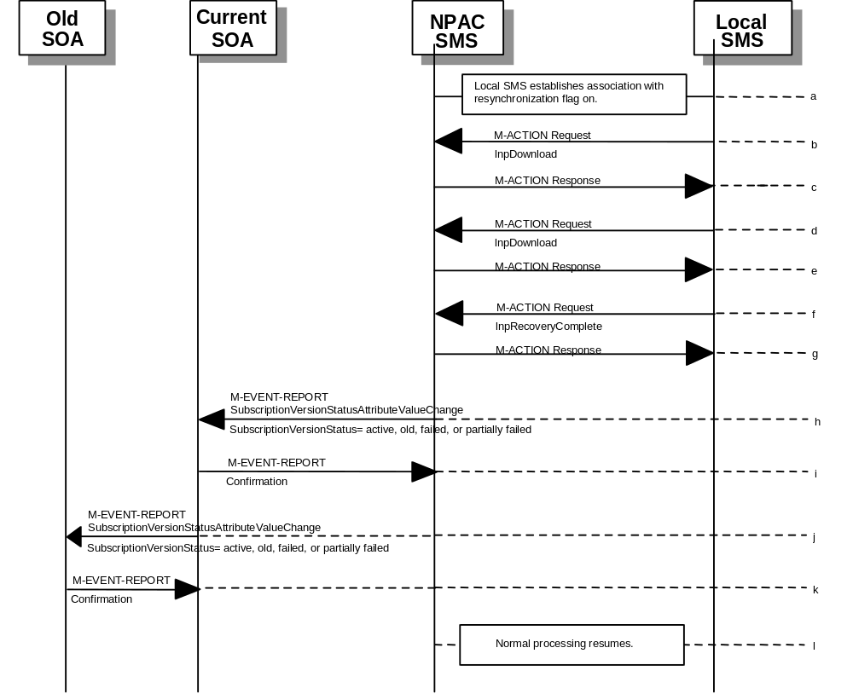
- Local SMS establishes association with resynchronization flag on.
- Local SMS sends M-ACTION to start network data download. The Local SMS specifies the start time.
- NPAC SMS responds to M-ACTION with updates.
- Local SMS sends M-ACTION to start subscription data download. The Local SMS specifies the start time.
- NPAC SMS responds to M-ACTION with subscription version updates.
- Local SMS sends M-ACTION to set resynchronization flag off.
- NPAC SMS replies with data updates since association establishment.
- If any corrections were issued to the resyncing Local SMS, the NPAC SMS will send M-EVENT-REPORT to the service provider SOA of the subscriptionVersionStatus change and a list of failed Local SMSs (minus the resyncing Local SMS that no longer contains a discrepancy).
- The service provider SOA confirms the M-EVENT-REPORT.
- If any corrections were issued to the resyncing Local SMS, the NPAC SMS will send M-EVENT-REPORT to the old service provider SOA of the subscriptionVersionStatus change and a list of failed Local SMSs (minus the resyncing Local SMS that no longer contains a discrepancy).
- The old service provider SOA confirms the M-EVENT-REPORT.
- Normal processing resumes.

6.7.2

SOA/Local SMS Notification of Scheduled NPAC Downtime
This scenario shows SOA/Local SMS notification of scheduled NPAC downtime.
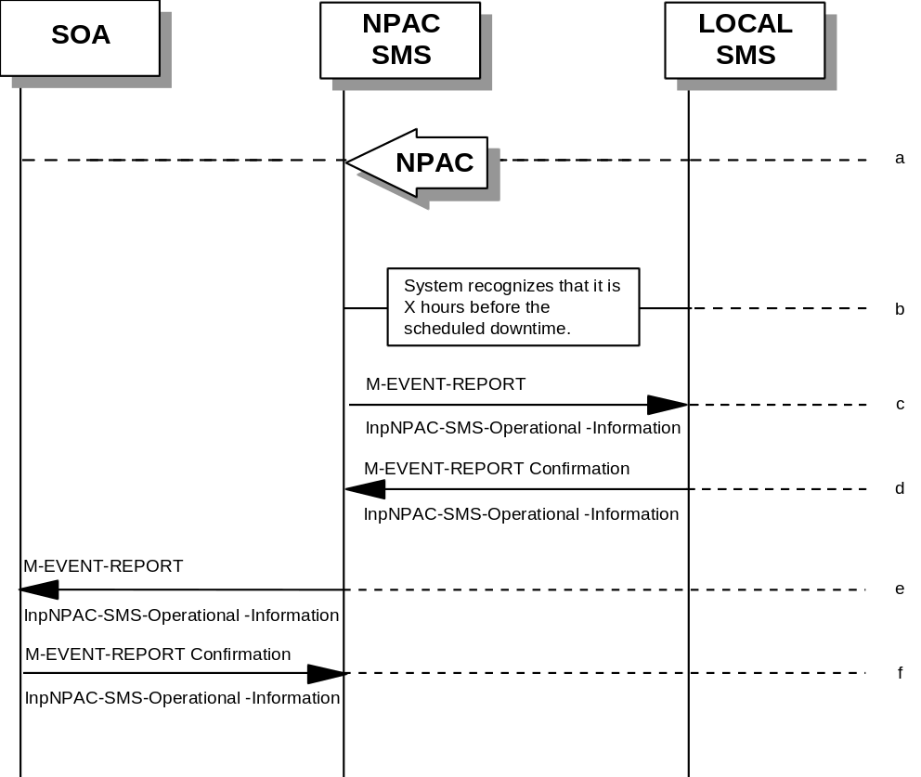
- Action is taken by NPAC SMS personnel to schedule downtime for the NPAC SMS system.
- The NPAC SMS system recognizes that it is some tunable amount of time before a scheduled outage.
- The NPAC SMS sends an lnpNPAC-SMS-Operational-Information M-EVENT-REPORT to the Local SMSs.
- The Local SMSs respond by sending an lnpNPAC-SMS-Operational-Information M-EVENT-REPORT confirmation back to the NPAC SMS.
- The NPAC SMS sends an lnpNPAC-SMS-Operational-Information M-EVENT-REPORT to all SOAs.
- The SOA(s) respond by sending an lnpNPAC-SMS-Operational-Information M-EVENT-REPORT confirmation back to the NPAC SMS.

6.7.3

NPA-NXX Split
This scenario shows NPAC SMS personnel initiation of an NPA-NXX split.
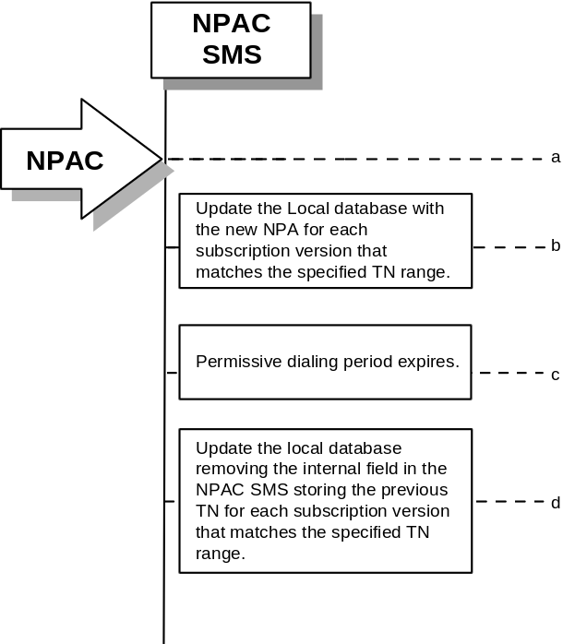
- Action is taken by the NPAC SMS personnel to cause an NPA-NXX split.
- The NPAC SMS updates all subscription version records in its local database that match the specified TN range. The TN field will be updated with the new NPA, and a data field internal to the NPAC SMS will be set to the previous TN (old NPA).
- The permissive dialing period expires.
- The NPAC SMS updates all subscription version records in its local database that match the specified TN range. The internal field in the NPAC SMS storing the previous TN will be set to Null.

6.7.4

Mass Update
NPAC SMS personnel can perform a mass update on subscription data.
- Action is taken by the NPAC SMS personnel to request that a mass update be performed on active subscription data.
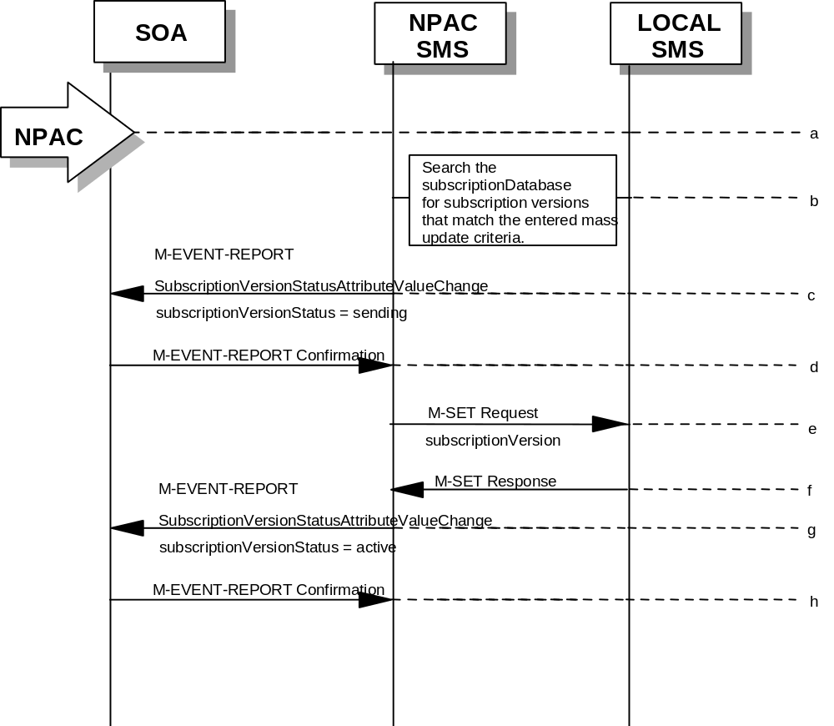
- Search the subscription database for subscription versions that match the specified mass update criteria. Perform steps c-through-h for the allowable range of subscription versions.
- The NPAC SMS sends a statusAttributeValueChange M-EVENT-REPORT to the current service provider SOA.
- The service provider SOA sends a confirmation to the M-EVENT-REPORT.
- The NPAC SMS sends an M-SET on the subscription versions to the Local SMS, that is accepting downloads for the NPA-NXX of the subscription versions.
- The Local SMS replies to the M-SET.
- The NPAC SMS sends a statusAttributeValueChange M-EVENT-REPORT to the current service provider SOA.
- The service provider SOA sends a confirmation to the M-EVENT-REPORT.

7 GDMO Definitions
7

7.1 Overview
The GDMO interface definitions provided below support the SOA to NPAC SMS interface and the NPAC SMS to Local SMS interface. Included in this chapter of the interface specification are object name bindings, attribute, package, action, and notification definitions.

7.2 Object Definitions

-- 1.0 LNP Audits Managed Object

lnpAudits MANAGED OBJECT CLASS
DERIVED FROM "CCITT Rec. X.721 (1992) | ISO/IEC 10165-2 : 1992":top;
CHARACTERIZED BY
lnpAuditsPkg;
REGISTERED AS {LNP-OIDS.lnp-objectClass 1};

lnpAuditsPkg PACKAGE
BEHAVIOUR
lnpAuditsDefinition,
lnpAuditsBehavior;
ATTRIBUTES
lnpAuditsName GET;
;

lnpAuditsDefinition BEHAVIOUR
DEFINED AS !
The lnpAudits class is the managed object that is used as
the container object for the subscriptionAudit objects on the
NPAC SMS. This object has been created for scoping efficiency.
!;

lnpAuditsBehavior BEHAVIOUR
DEFINED AS !
NPAC SMS Managed Object for the SOA to NPAC SMS interface.

The service provider SOA can M-GET any lnpAudits object on the
NPAC SMS. (SOA Management Association Function).
The Local SMS can not M-GET any lnpAudits object on the NPAC SMS.

The lnpAuditsName attribute is read only and can not
be changed via the Local SMS or SOA Interface once the object has
been created. The value of lnpAuditsName will always be "lnpAudits".

Only one of these objects will exist per agent and it will only be
created at startup of the CMIP agent software on the NPAC SMS.

!;

-- 2.0 LNP Local SMS Managed Object Class

lnpLocalSMS MANAGED OBJECT CLASS
DERIVED FROM "CCITT Rec. X.721 (1992) | ISO/IEC 10165-2 : 1992":top;
CHARACTERIZED BY
lnpLocalSMS-Pkg;
REGISTERED AS {LNP-OIDS.lnp-objectClass 2};

lnpLocalSMS-Pkg PACKAGE
BEHAVIOUR
lnpLocalSMS-Definition,
lnpLocalSMS-Behavior;
ATTRIBUTES
lnpLocal-SMS-Name GET;
;

lnpLocalSMS-Definition BEHAVIOUR
DEFINED AS !
The lnpLocalSMS class is the managed object that is used as the
container object for all Local SMS data in the NPAC SMS to
Local SMS Interface.
!;

lnpLocalSMS-Behavior BEHAVIOUR
DEFINED AS !
Local SMS Managed Object.

The NPAC SMS can M-GET any lnpLocalSMS object (Data Download
Association Function).
The lnp-LocalSMS-Name attribute is read only and can not
be changed via the Local SMS Interface once the object has
been created. The value of lnpLocal-SMS-Name will always be
a unique identifier for the Local SMS for the NPAC SMS to
Local SMS Interface.

Only one of these objects will exist and it will only be
created at startup of the CMIP agent software on the Local
SMS.
!;

-- 3.0 LNP Log Record for the Subscription Audit Local SMS Discrepancy Report

lnpLogAudit-DiscrepancyRptRecord MANAGED OBJECT CLASS
DERIVED FROM "CCITT Rec. X.721 (1992) | ISO/IEC 10165-2 :
1992":eventLogRecord;
CHARACTERIZED BY
lnpLogAudit-DiscrepancyRptPkg;
REGISTERED AS {LNP-OIDS.lnp-objectClass 3};

lnpLogAudit-DiscrepancyRptPkg PACKAGE
BEHAVIOUR
lnpLogAudit-DiscrepancyRptDefinition,
lnpLogAudit-DiscrepancyRptBehavior;
ATTRIBUTES
auditDiscrepancyTn GET,
auditDiscrepancyVersionId GET,
auditDiscrepancyLSMS-SP-Id GET,
auditDiscrepancyFailureReason GET,
accessControl GET;
;

lnpLogAudit-DiscrepancyRptDefinition BEHAVIOUR
DEFINED AS !
The lnpLogAudit-DiscrepancyRptRecord class is the managed
object that is used to create log records for the
subscriptionAudit-DiscrepancyRpt Notification.
!;

lnpLogAudit-DiscrepancyRptBehavior BEHAVIOUR
DEFINED AS !
This log record can be used by any CME wanting to log the
subscriptionAudit-DiscrepancyRpt Notification.
!;

-- 4.0 LNP Log Record for the Subscription Audit Results

lnpLogAuditResultsRecord MANAGED OBJECT CLASS
DERIVED FROM "CCITT Rec. X.721 (1992) | ISO/IEC 10165-2 :
1992":eventLogRecord;
CHARACTERIZED BY
lnpLogAuditResultsPkg;
REGISTERED AS {LNP-OIDS.lnp-objectClass 4};

lnpLogAuditResultsPkg PACKAGE
BEHAVIOUR
lnpLogAuditResultsDefinition,
lnpLogAuditResultsBehavior;
ATTRIBUTES
auditResultStatus GET,
auditResultFailed-SP-List GET,
auditResultNumberDiscrepancies GET,
auditResultCompletionTime GET,
accessControl GET;
;

lnpLogAuditResultsDefinition BEHAVIOUR
DEFINED AS !
The lnpLogAuditResultsRecord class is the managed object
that is used to create log records for the
subscriptionAuditResults Notification.
!;

lnpLogAuditResultsBehavior BEHAVIOUR
DEFINED AS !
This log record can be used by any CME wanting to log the
subscriptionAuditResults Notification.
!;

-- 5.0 LNP Log Record for the Subscription Version Cancellation
-- Acknowledge Request Notification

lnpLogCancellationAcknowledgeRequestRecord MANAGED OBJECT CLASS
DERIVED FROM "CCITT Rec. X.721 (1992) | ISO/IEC 10165-2 :
1992":eventLogRecord;
CHARACTERIZED BY
lnpLogCancellationAcknowledgeRequestPkg;
REGISTERED AS {LNP-OIDS.lnp-objectClass 5};

lnpLogCancellationAcknowledgeRequestPkg PACKAGE
BEHAVIOUR
lnpLogCancellationAcknowledgeRequestDefinition,
lnpLogCancellationAcknowledgeRequestBehavior;
ATTRIBUTES
subscriptionTN GET,
subscriptionVersionId GET,
accessControl GET;
;

lnpLogCancellationAcknowledgeRequestDefinition BEHAVIOUR
DEFINED AS !
The lnpLogCancellationAcknowledgeRequestRecord class is
the managed object that is used to create log records for the
subscriptionVersionCancellationAcknowledgeRequest
Notification.
!;

lnpLogCancellationAcknowledgeRequestBehavior BEHAVIOUR
DEFINED AS !
This log record can be used by any CME wanting to log the
subscriptionVersionCancellationAcknowledgeRequest
Notification.
!;

-- 7.0 LNP Log Record for the Subscription Version New SP Create Request
-- Notification

lnpLogNewSP-CreateRequestRecord MANAGED OBJECT CLASS
DERIVED FROM "CCITT Rec. X.721 (1992) | ISO/IEC 10165-2 :
1992":eventLogRecord;
CHARACTERIZED BY
lnpLogNewSP-CreateRequestPkg;
REGISTERED AS {LNP-OIDS.lnp-objectClass 7};

lnpLogNewSP-CreateRequestPkg PACKAGE
BEHAVIOUR
lnpLogNewSP-CreateRequestDefinition,
lnpLogNewSP-CreateRequestBehavior;
ATTRIBUTES
subscriptionTN GET,
subscriptionVersionId GET,
subscriptionOldSP GET,
subscriptionOldSP-DueDate GET,
subscriptionOldSP-Authorization GET,
subscriptionOldSP-AuthorizationTimeStamp GET,
subscriptionStatusChangeCauseCode GET,
accessControl GET;
;

lnpLogNewSP-CreateRequestDefinition BEHAVIOUR
DEFINED AS !
The lnpLogNewSP-CreateRequestRecord class is the managed
object that is used to create log records for the
subscriptionVersionNewSP-CreateRequest Notification.
!;

lnpLogNewSP-CreateRequestBehavior BEHAVIOUR
DEFINED AS !
This log record can be used by any CME wanting to log the
subscriptionVersionNewSP-CreateRequest Notification.
!;

-- 8.0 LNP Log Record for the Subscription Version Old SP Concurrence Request
-- Notification

lnpLogOldSP-ConcurrenceRequestRecord MANAGED OBJECT CLASS
DERIVED FROM "CCITT Rec. X.721 (1992) | ISO/IEC 10165-2 :
1992":eventLogRecord;
CHARACTERIZED BY
lnpLogOldSP-ConcurrenceRequestPkg;
REGISTERED AS {LNP-OIDS.lnp-objectClass 8};

lnpLogOldSP-ConcurrenceRequestPkg PACKAGE
BEHAVIOUR
lnpLogOldSP-ConcurrenceRequestDefinition,
lnpLogOldSP-ConcurrenceRequestBehavior;
ATTRIBUTES
subscriptionTN GET,
subscriptionVersionId GET,
subscriptionNewCurrentSP GET,
subscriptionNewSP-DueDate GET,
subscriptionNewSP-CreationTimeStamp GET,
accessControl GET;
;

lnpLogOldSP-ConcurrenceRequestDefinition BEHAVIOUR
DEFINED AS !
The lnpLogOldSP-ConcurrenceRequestRecord class is the managed
object that is used to create log records for the
subscriptionVersionOldSP-ConcurrenceRequest Notification.
!;

lnpLogOldSP-ConcurrenceRequestBehavior BEHAVIOUR
DEFINED AS !
This log record can be used by any CME wanting to log the
subscriptionVersionOldSP-ConcurrenceRequest Notification.
!;

-- 9.0 LNP Log Record for the NPAC SMS Operational Information Notification

lnpLogOperational-InformationRecord MANAGED OBJECT CLASS
DERIVED FROM "CCITT Rec. X.721 (1992) | ISO/IEC 10165-2 :
1992":eventLogRecord;
CHARACTERIZED BY
lnpLogOperational-InformationPkg;
REGISTERED AS {LNP-OIDS.lnp-objectClass 9};

lnpLogOperational-InformationPkg PACKAGE
BEHAVIOUR
lnpLogOperational-InformationDefinition,
lnpLogOperational-InformationBehavior;
ATTRIBUTES
downTime GET,
npacContactNumber GET,
additionalDownTimeInformation GET,
accessControl GET;
;

lnpLogOperational-InformationDefinition BEHAVIOUR
DEFINED AS !
The lnpLogOperational-InformationRecord class is the managed object
that is used to create log records for the
lnpNPAC-SMS-Operational-Information Notification.
!;

lnpLogOperational-InformationBehavior BEHAVIOUR
DEFINED AS !
This log record can be used by any CME wanting to log the
lnpNPAC-SMS-Operational-Information Notification.
!;

-- 10.0 LNP Log Record for the Subscription Version Status Attribute Value
-- Change Notification

lnpLogStatusAttributeValueChangeRecord MANAGED OBJECT CLASS
DERIVED FROM "CCITT Rec. X.721 (1992) | ISO/IEC 10165-2 :
1992":eventLogRecord;
CHARACTERIZED BY
lnpLogStatusAttributeValueChangePkg;
CONDITIONAL PACKAGES
subscriptionVersionAttributeValueChangeFailed-SP-ListPkg PRESENT IF
!the version status is failed or partially failed!,
subscriptionStatusChangeCauseCodePkg PRESENT IF
!the version status is set to conflict by the old service
provider!;
REGISTERED AS {LNP-OIDS.lnp-objectClass 10};

lnpLogStatusAttributeValueChangePkg PACKAGE
BEHAVIOUR
lnpLogStatusAttributeValueChangeDefinition,
lnpLogStatusAttributeValueChangeBehavior;
ATTRIBUTES
subscriptionVersionAttributeValueChangeInfo GET,
accessControl GET;
;

lnpLogStatusAttributeValueChangeDefinition BEHAVIOUR
DEFINED AS !
The lnpLogStatusAttributeValueChangeRecord class is the managed
object that is used to create log records for the
subscriptionVersionStatusAttributeValueChange Notification.
!;

lnpLogStatusAttributeValueChangeBehavior BEHAVIOUR
DEFINED AS !
This log record can be used by any CME wanting to log the
subscriptionVersionStatusAttributeValueChange Notification.
!;

-- 11.0 LNP Network Managed Object Class

lnpNetwork MANAGED OBJECT CLASS
DERIVED FROM "CCITT Rec. X.721 (1992) | ISO/IEC 10165-2 : 1992":top;
CHARACTERIZED BY
lnpNetworkPkg;
CONDITIONAL PACKAGES
lnpDownloadPkg PRESENT IF
!the object is instantiated on the NPAC SMS!;
REGISTERED AS {LNP-OIDS.lnp-objectClass 11};

lnpNetworkPkg PACKAGE
BEHAVIOUR
lnpNetworkDefinition,
lnpNetworkBehavior;
ATTRIBUTES
lnpNetworkName GET;
;

lnpNetworkDefinition BEHAVIOUR
DEFINED AS !
The lnpNetwork class is the managed object that is used as the
container object for the serviceProvNetwork objects.
This object has been created primarily for scoping efficiency.

The lnpDownloadPkg will only be used for lnpNetwork object
instantiated on the NPAC SMS (Data Download Association Function).
This package is used for initiating from the Local SMS downloading
of serviceProvNetwork, serviceProvNPA-NXX, and serviceProvLRN object
creation or deletion to the Local SMS from the NPAC SMS.
!;

lnpNetworkBehavior BEHAVIOUR
DEFINED AS !
Local SMS and NPAC SMS Managed Object used for the Local SMS to
NPAC SMS interface.

The Local SMS and the NPAC SMS can M-GET any lnpNetwork
object (Data Download Association Function). The lnpNetworkName
attribute is read only and can not be changed via the NPAC SMS
to Local SMS Interface once the object has been created. The
value of lnpNetworkName will always be "lnpNetwork".

Only one of these objects will exist and it will only be
created at startup of the CMIP agent software on the NPAC SMS
or the Local SMS.
!;

-- 12.0 LNP NPAC SMS Managed Object Class

lnpNPAC-SMS MANAGED OBJECT CLASS
DERIVED FROM "CCITT Rec. X.721 (1992) | ISO/IEC 10165-2 : 1992":top;
CHARACTERIZED BY
lnpNPAC-SMS-Pkg,
lnpRecoveryCompletePkg;
REGISTERED AS {LNP-OIDS.lnp-objectClass 12};

lnpNPAC-SMS-Pkg PACKAGE
BEHAVIOUR
lnpNPAC-SMS-Definition,
lnpNPAC-SMS-Behavior;
ATTRIBUTES
lnpNPAC-SMS-Name GET;
NOTIFICATIONS
lnpNPAC-SMS-Operational-Information;
;

lnpNPAC-SMS-Definition BEHAVIOUR
DEFINED AS !
The lnpNPAC-SMS class is the managed object that is used as
the container object for all NPAC SMS objects in the NPAC SMS to
Local SMS Interface and the SOA to NPAC SMS interface.
!;

lnpNPAC-SMS-Behavior BEHAVIOUR
DEFINED AS !
NPAC SMS Managed Object for the SOA to NPAC SMS and the Local SMS
to NPAC SMS interface.

A Local SMS (Data Download Association Function) and service
provider SOA (SOA Management Association Function) can M-GET
any lnpNPAC-SMS object.

The lnpNPAC-SMS-Name attribute is read only and can not be
changed via either Interface once the object has been created.
The value of lnpNPAC-SMS-Name will be set to "Illinois-NPAC-SMS"
in Illinois.

The lnpRecoveryComplete-Pkg is used to used for indicating the
recovery mode for the Local SMS is complete and to return all
updates made since the recovery mode began. (Data Download Functional
Group).

Only one of these objects will exist and it will only be
created at startup of the CMIP agent software on the NPAC SMS.

The lnpNPAC-SMS-Operational-Information will be used to notify
service provider SOA and Local SMS systems of planned outages.
!;

-- 13.0 LNP Service Providers Managed Object Class

lnpServiceProvs MANAGED OBJECT CLASS
DERIVED FROM "CCITT Rec. X.721 (1992) | ISO/IEC 10165-2 : 1992":top;
CHARACTERIZED BY
lnpServiceProvsPkg;
REGISTERED AS {LNP-OIDS.lnp-objectClass 13};

lnpServiceProvsPkg PACKAGE
BEHAVIOUR
lnpServiceProvsDefinition,
lnpServiceProvsBehavior;
ATTRIBUTES
lnpServiceProvsName GET;
;

lnpServiceProvsDefinition BEHAVIOUR
DEFINED AS !
The lnpServiceProvs class is the managed object that is
used as the container object for the serviceProv
objects on the NPAC SMS. This object has been created
for scoping efficiency.
!;

lnpServiceProvsBehavior BEHAVIOUR
DEFINED AS !
NPAC SMS Managed Object used for the Local SMS to NPAC
SMS interface.

A Local SMS and service provider SOA can M-GET any
lnpServiceProvs object (Network Data Association Function).
The lnpServiceProvsName attribute is read only and can not
be changed via the Local SMS Interface once the object has
been created. The value of lnpServiceProvsName will
always be "lnpServiceProvs".

Only one of these objects will exist and it will only be created
at startup of the CMIP agent software on the NPAC SMS.
!;

-- 14.0 LNP Subscriptions Managed Object Class

lnpSubscriptions MANAGED OBJECT CLASS
DERIVED FROM "CCITT Rec. X.721 (1992) | ISO/IEC 10165-2 : 1992":top;
CHARACTERIZED BY
lnpSubscriptionsPkg,
subscriptionVersionLocalSMS-CreatePkg;
CONDITIONAL PACKAGES
lnpDownloadPkg PRESENT IF
!the object is instantiated on the NPAC SMS!,
subscriptionVersionOldSP-CreatePkg PRESENT IF
!the object is instantiated on the NPAC SMS!,
subscriptionVersionNewSP-CreatePkg PRESENT IF
!the object is instantiated on the NPAC SMS!,
subscriptionVersionDisconnectPkg PRESENT IF
!the object is instantiated on the NPAC SMS!,
subscriptionVersionModifyPkg PRESENT IF
!the object is instantiated on the NPAC SMS!,
subscriptionVersionActivatePkg PRESENT IF
!the object is instantiated on the NPAC SMS!,
subscriptionVersionCancelPkg PRESENT IF
!the object is instantiated on the NPAC SMS!,
subscriptionVersionOldSP-CancellationPkg PRESENT IF
!the object is instantiated on the NPAC SMS!,
subscriptionVersionNewSP-CancellationPkg PRESENT IF
!the object is instantiated on the NPAC SMS!,
subscriptionVersionRemoveFromConflictPkg PRESENT IF
!the object is instantiated on the NPAC SMS!;
REGISTERED AS {LNP-OIDS.lnp-objectClass 14};

lnpSubscriptionsPkg PACKAGE
BEHAVIOUR
lnpSubscriptionsDefinition,
lnpSubscriptionsBehavior;
ATTRIBUTES
lnpSubscriptionsName GET;
NOTIFICATIONS
subscriptionVersionLocalSMS-ActionResults;
;

lnpSubscriptionsDefinition BEHAVIOUR
DEFINED AS !
Local SMS and NPAC SMS Managed Object for the SOA to NPAC SMS
and the Local SMS to NPAC SMS interface.

The lnpSubscriptions class is the managed object that is used
as the container object for the subscription version objects
on the NPAC SMS and the Local SMS.

Local SMS interfaces must be able to support scope/filtered
M-SETs and M-DELETEs with a TN range as the primary filter.

!;

lnpSubscriptionsBehavior BEHAVIOUR
DEFINED AS !
Local SMS and NPAC SMS Managed Object

The Local SMS (Data Download Association Function) and the service
provider SOA (SOA Management Association Function) can M-GET any
lnpSubscriptions object. The lnpSubscriptionsName attribute
is read only and can not be changed via the Local SMS Interface
once the object has been created. The value of
lnpSubscriptionsName will always be "lnpSubscriptions".

Only one of these objects will exist and it will only be
created at startup of the CMIP agent software on the NPAC SMS
or the Local SMS.

The lnpDownloadPkg will only be used for a lnpSubscriptions
object instantiated on the NPAC SMS. This package is used to
used for initiating downloading of subscriptionVersions
object creation, deletion, or modifications to the Local
SMS (Data Download Association Function).

The subscriptionVersionOldSP-CreatePkg will only be used for a
lnpSubscriptions object instantiated on the NPAC SMS. This
package is used for creation of subscription versions for
porting TNs by the old service provider.

The subscriptionVersionNewSP-CreatePkg will only be used for a
lnpSubscriptions object instantiated on the NPAC SMS. This
package is used for creation of subscription versions for
porting TNs by the new service provider.

The subscriptionVersionDisconnectPkg will only be used for a
lnpSubscriptions object instantiated on the NPAC SMS. This
package is used for disconnection of a ported TN by the current
service provider.

The subscriptionVersionModifyPkg will only be used for a
lnpSubscriptions object instantiated on the NPAC SMS. This
package is used for modification of a ported TN by a service
provider.

The subscriptionVersionActivatePkg will only be used for a
lnpSubscriptions object instantiated on the NPAC SMS. This
package is used for activation of a ported TN by a new service
provider.

The subscriptionVersionCancelPkg will only be used for a
lnpSubscriptions object instantiated on the NPAC SMS. This
package is used for cancellation of a ported TN by a service
provider.

The subscriptionVersionOldSP-CancellationPkg will only be
used for a lnpSubscriptions object instantiated on the NPAC SMS.
This package is used for acknowledgment of subscription versions
with status values of cancel-pending. Acknowledgments
from both old and new service provider SOAs take a version from
cancel-pending and to a canceled state. This action is used by
the old service provider SOA.

The subscriptionVersionNewSP-CancellationPkg will only be
used for a lnpSubscriptions object instantiated on the NPAC SMS.
This package is used for acknowledgment of subscription versions
with status values of cancel-pending. Acknowledgments
from both old and new service provider SOAs take a version out of
cancel-pending and to a canceled state. This action is used by
the new service provider SOA.

The subscriptionVersionRemoveFromConflictPkg will only be
used for a lnpSubscriptions object instantiated on the NPAC SMS.
This package is used for setting the status of subscription versions
with status values of conflict to pending. This action is used by
either the new or old service provider SOA.
!;

-- 15.0 LNP Service Provider Managed Object Class

serviceProv MANAGED OBJECT CLASS
DERIVED FROM serviceProvNetwork;
CHARACTERIZED BY
serviceProvPkg;
CONDITIONAL PACKAGES
serviceProvBillingAddressPkg PRESENT IF
!the service provider has billing address and contact
information!,
serviceProvSOA-AddressPkg PRESENT IF
!the service provider has SOA address and contact information!,
serviceProvLSMS-AddressPkg PRESENT IF
!the service provider has LSMS address and contact information!,
serviceProvWebAddressPkg PRESENT IF
!the service provider has Web address and contact information!,
serviceProvNetAddressPkg PRESENT IF
!the service provider has network and communication facilities
address and contact information!,
serviceProvConflictAddressPkg PRESENT IF
!the service provider has conflict resolution interface
address and contact information!,
serviceProvOperationsAddressPkg PRESENT IF
!the service provider has operations address and contact
information!,
serviceProvRepairCenterInfoPkg PRESENT IF
!the service provider has repair contact information!,
serviceProvSecurityAddressPkg PRESENT IF
!the service provider has security contact information!,
serviceProvUserAdminAddressPkg PRESENT IF
!the service provider has user administration interface address
and contact information!;
REGISTERED AS {LNP-OIDS.lnp-objectClass 15};

serviceProvPkg PACKAGE
BEHAVIOUR
serviceProvDefinition,
serviceProvBehavior;
ATTRIBUTES
npacCustomerAllowableFunctions GET-REPLACE,
serviceProvAddress GET-REPLACE,
serviceProvSysLinkInfo GET-REPLACE;
;

serviceProvDefinition BEHAVIOUR
DEFINED AS !
The serviceProv class is the managed object
used on the NPAC SMS to contain the data related to each
LNP service provider.
!;

serviceProvBehavior BEHAVIOUR
DEFINED AS !
NPAC SMS Managed Object used for the Local SMS to NPAC
SMS interface.

A Local SMS and service provider SOA can M-GET their own
serviceProv object (Network Data Association Function).
Attempts to read any service provider information other
than their own will be rejected as unauthorized. All attributes
in this object, except serviceProvID and
npacCustomerAllowableFunctions can be M-SET by the Local SMS
Interface once the object has been created on the NPAC SMS.
!;

-- 16.0 LNP Service Provider LRN Managed Object Class

serviceProvLRN MANAGED OBJECT CLASS
DERIVED FROM "CCITT Rec. X.721 (1992) | ISO/IEC 10165-2 : 1992":top;
CHARACTERIZED BY
serviceProvLRN-Pkg;
REGISTERED AS {LNP-OIDS.lnp-objectClass 16};

serviceProvLRN-Pkg PACKAGE
BEHAVIOUR
serviceProvLRN-Definition,
serviceProvLRN-Behavior;
ATTRIBUTES
serviceProvLRN-ID GET,
serviceProvLRN-Value GET,
serviceProvDownloadReason GET,
serviceProvLRN-CreationTimeStamp GET;
;

serviceProvLRN-Definition BEHAVIOUR
DEFINED AS !
The serviceProvLRN class is the managed object
used to identify Service Provider LRN values open for
porting.
!;

serviceProvLRN-Behavior BEHAVIOUR
DEFINED AS !
Local SMS and NPAC SMS Managed Object used for the Local SMS to
NPAC SMS interface.

All attributes are read only. Once created, the serviceProvLRN
object can only be deleted via the Local SMS or SOA interface.

The serviceProvLRN-ID is specified by the NPAC SMS. The
serviceProvLRN-CreationTimeStamp will reflect the current system
date and time when the object is created.

NPAC SMS can M-GET, M-DELETE and M-CREATE any
serviceProvLRN object on the Local SMS (Network Data
Functional Unit). The Local SMS only creates local
copies of serviceProvLRN objects after receiving the
objects from an NPAC SMS create request, reading them from
the NPAC SMS for initial instantiation, or from a download request.

A Local SMS or SOA can M-GET any serviceProvLRN object (Network Data
Functional Unit).

The Local SMS can M-DELETE and M-CREATE any
serviceProvLRN object on the NPAC SMS for their
own service provider id (Network Data Functional Unit). Attempts
to take actions on other service provider objects will be
rejected as unauthorized.

The creation or deletion of a serviceProvLRN object will be
distributed to all Local SMSs.

The serviceProvLRN-Value attributes on the NPAC SMS can
not be modified by the Local SMS or SOA. The service
provider will have to add a new object and delete the
old one to modify the data.
!;

-- 17.0 LNP Service Provider Network Managed Object Class

serviceProvNetwork MANAGED OBJECT CLASS
DERIVED FROM "CCITT Rec. X.721 (1992) | ISO/IEC 10165-2 : 1992":top;
CHARACTERIZED BY
serviceProvNetworkPkg;
REGISTERED AS {LNP-OIDS.lnp-objectClass 17};

serviceProvNetworkPkg PACKAGE
BEHAVIOUR
serviceProvNetworkDefinition,
serviceProvNetworkBehavior;
ATTRIBUTES
serviceProvID GET,
serviceProvName GET-REPLACE;
;

serviceProvNetworkDefinition BEHAVIOUR
DEFINED AS !
The serviceProvNetwork class is the managed object
used to contain the network data for a service provider.
!;

serviceProvNetworkBehavior BEHAVIOUR
DEFINED AS !
Local SMS and NPAC SMS Managed Object used for the Local SMS to
NPAC SMS interface.

Service providers and the NPAC SMS can M-GET, M-CREATE, and M-SET
any serviceProvNetwork object (Network Data Association Function).
The serviceProvId attribute is read only and can not be
changed via the NPAC SMS to Local SMS Interface once the object
has been created on the Local SMS or NPAC SMS. The
serviceProvName can be M-SET via the NPAC SMS to Local
SMS Interface by the NPAC SMS. The Local SMS only creates
or modifies local copies of serviceProvNetwork objects
after receiving the objects from an NPAC SMS M-CREATE or M-SET
request or reading them from the NPAC SMS for initial instantiation.
!;

-- 18.0 LNP Service Provider NPA-NXX Managed Object Class

serviceProvNPA-NXX MANAGED OBJECT CLASS
DERIVED FROM "CCITT Rec. X.721 (1992) | ISO/IEC 10165-2 : 1992":top;
CHARACTERIZED BY
serviceProvNPA-NXX-Pkg;
REGISTERED AS {LNP-OIDS.lnp-objectClass 18};

serviceProvNPA-NXX-Pkg PACKAGE
BEHAVIOUR
serviceProvNPA-NXX-Definition,
serviceProvNPA-NXX-Behavior;
ATTRIBUTES
serviceProvNPA-NXX-ID GET,
serviceProvNPA-NXX-Value GET,
serviceProvNPA-NXX-EffectiveTimeStamp GET,
serviceProvDownloadReason GET,
serviceProvNPA-NXX-CreationTimeStamp GET;
;

serviceProvNPA-NXX-Definition BEHAVIOUR
DEFINED AS !
The serviceProvNPA-NXX class is the managed object
used to identify Service Provider NPA-NXX values open for
porting.
!;

serviceProvNPA-NXX-Behavior BEHAVIOUR
DEFINED AS !
Local SMS and NPAC SMS Managed Object used for the Local SMS to
NPAC SMS interface.

All attributes are read only. Once created, the serviceProvNPA-NXX
object can only be deleted via the Local SMS or SOA interface. The
serviceProvNPA-NXX-ID is specified by the NPAC SMS. The
serviceProvNPA-NXX-CreationTimeStamp will be set to the current
system date and time when the object is created.

NPAC SMS can M-GET, M-DELETE and M-CREATE any
serviceProvNPA-NXX object on the Local SMS (Network Data
Association Function). The Local SMS only creates local copies of
serviceProvNPA-NXX objects after receiving the objects from
an NPAC SMS create, after reading them from the NPAC SMS for
initial instantiation, or from a download.

Service providers can M-GET any serviceProvNPA-NXX object.

A Local SMS or SOA can M-DELETE and M-CREATE any
serviceProvNPA-NXX object on the NPAC SMS for their own service
provider id (Network Data Association Function). Attempts to
take actions on other service provider objects will be rejected
as unauthorized.

A Local SMS or SOA can not modify any of the attributes.

To cause an NPA-NXX split to occur the service provider must
contact the NPAC SMS operations personnel.
!;

-- 19.0 LNP Subscription Audit Managed Object

subscriptionAudit MANAGED OBJECT CLASS
DERIVED FROM "CCITT Rec. X.721 (1992) | ISO/IEC 10165-2 : 1992":top;
CHARACTERIZED BY
subscriptionAuditPkg;
CONDITIONAL PACKAGES
SubscriptionAuditTN-ActivationRangePkg PRESENT IF;
!the audit is being done on an activation data range!;
REGISTERED AS {LNP-OIDS.lnp-objectClass 19};

subscriptionAuditPkg PACKAGE
BEHAVIOUR
subscriptionAuditDefinition,
subscriptionAuditBehavior;
ATTRIBUTES
subscriptionAuditId GET,
subscriptionAuditName GET,
subscriptionAuditStatus GET,
subscriptionAuditAttributeList GET,
subscriptionAuditTN-Range GET,

subscriptionAuditServiceProvIdRange GET,
subscriptionAuditNumberOfTNs GET,
subscriptionAuditNumberOfTNsComplete GET,
subscriptionAuditRequestingSP GET;
NOTIFICATIONS
subscriptionAuditResults,
subscriptionAudit-DiscrepancyRpt,
"CCITT Rec. X.721 (1992) | ISO/IEC 10165-2 : 1992":attributeValueChange
accessControlParameter,
"CCITT Rec. X.721 (1992) | ISO/IEC 10165-2 : 1992":objectCreation
accessControlParameter,
"CCITT Rec. X.721 (1992) | ISO/IEC 10165-2 : 1992":objectDeletion
accessControlParameter;
;

subscriptionAuditDefinition BEHAVIOUR
DEFINED AS !
The subscriptionAudit class is the managed object that
represents a subscription audit request. This object is
only instantiated on the NPAC SMS.
!;

subscriptionAuditBehavior BEHAVIOUR
DEFINED AS !
When the subscriptionAuditStatus changes an attribute value
change will be emitted to the audit requester.

All attributes must be specified upon create with the exception
of the subscriptionAuditTN-ActivationRange, if an audit is
not being performed on an activation date range. If the
subscriptionAuditAttributeList is not specified then a full
audit is assumed. If the subscriptionAuditTN-ActivationRange is
specified then an audit of all TNs in the range specified in
subscriptionAuditTN-Range will be audited. The serviceAuditId
is determined by the NPAC SMS.

The subscriptionAuditRequestingSP is the id of the service provider
who requested the audit.

The NPAC SMS will be required to set the number of TNs that
will be audited in the subscriptionAuditNumberOfTNs attribute
based on the NPAC SMS audit request criteria.

The SOA or NPAC SMS can M-CREATE, M-GET subscriptionAudit
managed objects on the NPAC SMS (SOA Management Function).
When a subscriptionAudit object is created on the NPAC SMS the
NPAC SMS will begin the audit for the service provider specified
or all service providers. The SOA can only M-GET subscriptionAudit
that they created.

The SOA will be required to set the requesting SP with
their service provider id so that the origination of the audit
request can be tracked and notifications can be sent to the
requesting SOA.

The subscriptionAuditTN-Range will be limited based on the
maximum range size specified in the NPAC SMS. If the limit
specified is exceeded, the create request will fail with an
invalidAttributeValue error.

When this object is created and deleted, object creation and
deletion notifications will be sent to the requester. Object
deletion indicates completion of an audit. The audit results
notification will be sent before the object is deleted by the
entity performing the audit indicating how may discrepancies the
audit found and reported during execution.

If discrepancies are found during the audit, audit discrepancy
notifications will be sent to the requester at the time they
are found. When audit discrepancy notifications are sent to
the NPAC SMS by the Local SMS, create or modify requests will be
sent to the Local SMS by the NPAC SMS to correct the
discrepancies found.

Deletion of an audit object cancels an audit request.
!;

-- 20.0 LNP subscription Version Managed Object Class

subscriptionVersion MANAGED OBJECT CLASS
DERIVED FROM "CCITT Rec. X.721 (1992) | ISO/IEC 10165-2 : 1992":top;
CHARACTERIZED BY
subscriptionVersionPkg;
REGISTERED AS {LNP-OIDS.lnp-objectClass 20};

subscriptionVersionPkg PACKAGE
BEHAVIOUR
subscriptionVersionDefinition,
subscriptionVersionBehavior;
ATTRIBUTES
subscriptionVersionId GET,
subscriptionTN GET-REPLACE,
subscriptionLRN GET-REPLACE,
subscriptionNewCurrentSP GET-REPLACE,
subscriptionActivationTimeStamp GET-REPLACE,
subscriptionCLASS-DPC GET-REPLACE,
subscriptionCLASS-SSN GET-REPLACE,
subscriptionLIDB-DPC GET-REPLACE,
subscriptionLIDB-SSN GET-REPLACE,
subscriptionCNAM-DPC GET-REPLACE,
subscriptionCNAM-SSN GET-REPLACE,
subscriptionISVM-DPC GET-REPLACE,
subscriptionISVM-SSN GET-REPLACE,
subscriptionEndUserLocationValue GET-REPLACE,
subscriptionEndUserLocationType GET-REPLACE,
subscriptionBillingId GET-REPLACE,
subscriptionLNPType GET-REPLACE,
subscriptionDownloadReason GET-REPLACE;
;

subscriptionVersionDefinition BEHAVIOUR
DEFINED AS !
The subscriptionVersion class is the managed object that
represents a subscription version on the Local SMS.
!;

subscriptionVersionBehavior BEHAVIOUR
DEFINED AS !
Local SMS Managed Object

NPAC SMS can M-GET (Query Association Function), M-SET, M-DELETE
and M-CREATE (Data Download Association Function) any
subscriptionVersion object on the Local SMS (Data Download
Association Function). The Local SMS only creates local copies
of subscriptionVersion objects after receiving the objects from an
NPAC SMS create request or reading them from the NPAC SMS for
initial instantiation.

The serviceProvVersionId with subscriptionVersionId is assigned
upon creation by the NPAC SMS and is read only.

The subscriptionTN, subscriptionLRN and associated routing
information, are specified by the new service provider SOA upon
creation of a new subscription version.

The subscriptionActivationTimeStamp is set by the NPAC SMS as the
current date and time when the subscriptionVersion activation
request is received from the new service provider.

When the subscription version is downloaded to the locals, the
subscriptionDownloadReason is set to one of new, delete, modified,
or audit-discrepancy. This field is not validated in audits.

When the subscription version status is set to disconnect pending
or old, the subscriptionVersionDonorSP-CustomerDisconnectDate is
sent to the donor SOA informing the service provider of the actual
customer disconnect date.

The Local SMS can not modify any of the subscription version
data locally unless changes were downloaded via a download
request.

!;

-- 21.0 LNP NPAC Subscription Version Managed Object Class

subscriptionVersionNPAC MANAGED OBJECT CLASS
DERIVED FROM subscriptionVersion;
CHARACTERIZED BY
subscriptionVersionNPAC-Pkg;
REGISTERED AS {LNP-OIDS.lnp-objectClass 21};

subscriptionVersionNPAC-Pkg PACKAGE
BEHAVIOUR
subscriptionVersionNPAC-Definition,
subscriptionVersionNPAC-Behavior;
ATTRIBUTES
subscriptionVersionStatus GET-REPLACE,
subscriptionOldSP GET-REPLACE,
subscriptionNewSP-DueDate GET-REPLACE,
subscriptionNewSP-CreationTimeStamp GET-REPLACE,
subscriptionOldSP-DueDate GET-REPLACE,
subscriptionOldSP-Authorization GET-REPLACE,
subscriptionStatusChangeCauseCode GET-REPLACE,
subscriptionOldSP-AuthorizationTimeStamp GET-REPLACE,
subscriptionBroadcastTimeStamp GET-REPLACE,
subscriptionConflictTimeStamp GET-REPLACE,
subscriptionCustomerDisconnectDate GET-REPLACE,
subscriptionEffectiveReleaseDate GET-REPLACE,
subscriptionDisconnectCompleteTimeStamp GET-REPLACE,
subscriptionCancellationTimeStamp GET-REPLACE,
subscriptionCreationTimeStamp GET-REPLACE,
subscriptionFailed-SP-List GET-REPLACE,
subscriptionModifiedTimeStamp GET-REPLACE,
subscriptionOldTimeStamp GET-REPLACE,
subscriptionOldSP-CancellationTimeStamp GET-REPLACE,
subscriptionNewSP-CancellationTimeStamp GET-REPLACE,
subscriptionOldSP-ConflictResolutionTimeStamp GET-REPLACE,
subscriptionNewSP-ConflictResolutionTimeStamp GET-REPLACE,
subscriptionPortingToOriginal-SPSwitch GET-REPLACE,
subscriptionPreCancellationStatus GET-REPLACE;
NOTIFICATIONS
subscriptionVersionOldSP-ConcurrenceRequest,
subscriptionVersionNewSP-CreateRequest,
subscriptionVersionOldSPFinalConcurrenceWindowExpiration,
subscriptionVersionNewNPA-NXX,
subscriptionVersionCancellationAcknowledgeRequest,
subscriptionVersionDonorSP-CustomerDisconnectDate,
subscriptionVersionStatusAttributeValueChange,
"CCITT Rec. X.721 (1992) | ISO/IEC 10165-2 :
1992":attributeValueChange
accessControlParameter,
"CCITT Rec. X.721 (1992) | ISO/IEC 10165-2 : 1992":objectCreation
accessControlParameter;
;

subscriptionVersionNPAC-Definition BEHAVIOUR
DEFINED AS !
The subscriptionVersionNPAC class is the managed object
that represents a subscription version on the NPAC SMS.
!;

subscriptionVersionNPAC-Behavior BEHAVIOUR
DEFINED AS !
NPAC SMS Managed Object for the SOA to NPAC SMS and the Local SMS
to NPAC SMS interface.

A Local SMS can M-GET any subscriptionVersionNPAC objects
from the NPAC SMS via the Local SMS Interface (Data Download
Association Function).

A Service Provider SOA can M-GET any subscriptionVersionNPAC
objects from the NPAC SMS via the SOA Interface (SOA Management
Association Function).

If a Service Provider SOA or Local SMS does a scoped filtered
M-GET for subscription versions, this request will only be
successful if a the number of records to be returned is less
than or equal to the NPAC SMS tunable parameter,
"Max Subscriber Query", in the Service Data table.

When the status of an object is changed to "cancel-pending",
subscriptionPreCancellationStatus is first set to the current status.

The subscriptionCreationTimeStamp is set to the current system
time when the object is created.

When the subscription version is modified for any reason, the
subscriptionModifiedTimeStamp is updated with the current system time.

When the subscription version is broadcast to Local SMSs via
the NPAC to Local SMS interface, the subscriptionBroadcastTimeStamp
is updated with the current system time.

When the subscription version has its version status set to old,
the subscriptionOldTimeStamp is updated with the current system
time.

When the subscription version has its version status set to cancel,
the subscriptionCancellationTimeStamp is updated with the
current system time.

When the subscription version has its version status set to
conflict, the subscriptionConflictTimeStamp is updated with the
current system time.

When the subscription version is disconnected and the version
status is set to old, the subscriptionDisconnectCompleteTimeStamp
is updated with the current system time.

When the subscription version status is set to disconnect pending
the subscriptionEffectiveReleaseDate is set to the date the
disconnect should be broadcast.

When the subscription version in a cancel-pending
state is acknowledged by an old service provider SOA, the
subscriptionOldSP-CancellationTimeStamp is updated with the
current system time.

When the subscription version in a cancel-pending
state is acknowledged by a new service provider SOA, the
subscriptionNewSP-CancellationTimeStamp is updated with the
current system time.

When the subscription version in a conflict state is removed
from conflict by the old service provider SOA, the
subscriptionOldSP-ConflictResolutionTimeStamp is updated with the
current system time.

When the subscription version in a conflict state is removed
from conflict by the new service provider SOA, the
subscriptionNewSP-ConflictResolutionTimeStamp is updated with
the current system time.

When the subscription version status is failed or partially-failed,
the subscriptionFailed-SP-List is populated with a list of the
failed service providers.

The Service Provider SOA can M-GET and M-SET subscriptionVersionNPAC
objects via the SOA to NPAC SMS interface (SOA Management Association
Function). Rules for M-SET are described below.

For M-GET requests, the filter will support all attributes for
a specified ported TN.

Any service provider SOA can view any subscription version for any
ported TN (SOA Management Association Function).

Subscription versions are created on the NPAC SMS via actions over
the SOA to NPAC SMS interface to the lnpSubscriptions object (SOA
Management Association Function). New service provider SOAs must use
the subscriptionVersionNewSP-Create action and old service
provider SOAs must use the subscriptionVersionOldSP-Create action.
Creates can only be performed provided there is only one
currently active subscription version for the TN.

subscriptionPortingToOriginal-SPSwitch can only be specified as
TRUE for a TN that is currently ported and is being ported back
to the original service provider. If the value of
subscriptionPortingToOriginal-SPSwitch is TRUE, the LRN and GTT data
should not be specified. This data is not specified because
when the activate occurs for the subscription version, the Local
SMS will receive requests to delete the old subscription version
routing data in their networks and they will not receive any
new network routing data for the subscription. Concurrence from the
old service provider is required.

If the port of the subscription version is an intra-service
provider port, the new service provider SOA can use the
subscriptionVersionNewSP-Create action specifying the old service
provider equal to the new service provider. In this case, the
old service provider create action is not required and processing
proceeds after a valid pending version is created in the same
manner as it does for inter-service provider porting.

Once a version has been created that passes validation, the
subscriptionVersionNPAC object subscriptionVersionStatus will
be set to pending and an object creation notification will be sent
to both old and new service provider SOAs. If a version
previously existed, attribute value change notifications will be
sent to both old and new service provider SOAs.

If there is a pending version that does not have concurrence during
the "Service Provider Concurrence Window" specified in the Service
Data table, a subscriptionVersionNoConcurrence notification will be
sent to the service provider SOA that has not responded. The
subscriptionVersionStatus will be set to cancel-pending if the new
service provider SOA has not responded or to conflict if the old
service provider SOA has not responded after the "Service Provider
Concurrence Failure Window" specified in the Service Data table.
An attribute value change will be sent to the service provider
SOA that sent the original create request.

The Service Provider SOA can M-SET attributes associated with
pending, or conflict subscription versions (SOA Management Association
Function).

Attempts to modify an active, sending, failed, canceled, cancel-pending,
disconnect-pending or old version using M-SET will result in
an access denied error.

Modification of an active subscription can only be done by the
current/new service provider SOA using the subscriptionVersionModify
action.

The modify action can be used by both old and new service
provider SOAs to update pending or conflict subscription versions.

Old service provider SOAs can only modify the following attributes:

subscriptionOldSP-DueDate
subscriptionOldSP-Authorization
subscriptionStatusChangeCauseCode

New service provider SOAs can only modify the following attributes:

subscriptionLRN
subscriptionNewSP-DueDate
subscriptionCLASS-DPC
subscriptionCLASS-SSN
subscriptionLIDB-DPC
subscriptionLIDB-SSN
subscriptionCNAM-DPC
subscriptionCNAM-SSN
subscriptionISVM-DPC
subscriptionISVM-SSN
subscriptionEndUserLocationValue
subscriptionEndUserLocationType
subscriptionBillingId

The subscriptionOldSP-DueDate and subscriptionVewSP-DueDate must
match. Validation will be done for both old and new service
provider data that is specified on an M-SET. If validation fails,
no changes will be made and a processing failure will be returned.
If the version passes validation, the version status will be
set to pending. An error message will be returned to the service
provider if the status is not pending when they attempt to change
the version status to cancel-pending.

Once a pending version has been created, the new service provider
can activate the subscription version if authorization for the port
has been received by the old service provider within
the "Service Provider Concurrence Cancellation Window".

Once the version is activated, the version status is set to
sending, the broadcast time stamp is updated, and creates
are sent to the Local SMSs.

If the create requests are successful for all Local SMSs, the
version status will be marked as active and the previously active
subscription version will have its version status set to old.

If create requests fail for a subscription version after the
retry periods have expired, the version status will be set
to failed or partially-failed based on if the download failed
in all or some of the Local SMSs respectively.

A status version attribute value change will be sent to both old
and new service providers when the subscriptionVersionStatus is
modified. If the version status is failed or partially-failed then
a list of failed service providers is provided in the
subscriptionVersionStatus notification.

A subscription version can be put into conflict by either the NPAC
SMS or by the old service provider explicitly setting the
subscriptionOldSP-Authorization off or by not responding with the
subscriptionVersionOldSP-Create action.

If the old service provider explicitly sets the
subscriptionOldSP-Authorization off, the
subscriptionStatusChangeCauseCode must be given.

The old service provider can only put a subscription version into
conflict once and only by explicitly setting the
subscriptionOldSP-Authorization off.

A service provider should acknowledge the conflict resolution pending
state within a tunable time frame specified on the NPAC SMS
with a conflict resolution acknowledgement action.

A service provider should acknowledge the cancel pending
state within a tunable time frame specified on the NPAC SMS
with a cancel acknowledgement action.

If a service provider SOA fails to acknowledge the cancel pending
state, a subscriptionVersionCancellationAcknowledgeRequest is
sent to the service provider SOA. If they do not respond to this
acknowledgement in a tunable time frame specified on the NPAC SMS,
the version status will be set to conflict.

Attribute value change notifications will be sent to both service
provider SOAs when the following attribute values change for
a pending, cancel-pending, conflict or disconnect-pending subscription
versions:

subscriptionNewSP-DueDate
subscriptionNewSP-CreationTimeStamp
subscriptionOldSP-DueDate
subscriptionOldSP-Authorization
subscriptionOldSP-AuthorizationTimeStamp
subscriptionStatusChangeCauseCode
subscriptionVersionStatus

Object creation notifications will be sent to both old and
new service provider SOAs when a subscriptionVersionNPAC associated
with their Service Provider id is created. Object deletion
notifications will not be used. Objects will only be deleted by the
NPAC SMS as a result of housekeeping processing.

Prior to when the subscription version status is set to disconnect
pending or old, the subscriptionVersionDonorSP-CustomerDisconnectDate
is sent to the donor SOA informing the service provider of the
actual customer disconnect date.

!;

-- 22.0 LNP Log Record for the Subscription Version Donor Service Provider
-- Customer Disconnect Date Notification

lnpLogDonorSP-CustomerDisconnectDateRecord MANAGED OBJECT CLASS
DERIVED FROM "CCITT Rec. X.721 (1992) | ISO/IEC 10165-2 : 1992":eventLogRecord;
CHARACTERIZED BY
lnpLogDonorSP-CustomerDisconnectDatePkg;
REGISTERED AS {LNP-OIDS.lnp-objectClass 22};

lnpLogDonorSP-CustomerDisconnectDatePkg PACKAGE
BEHAVIOUR
lnpLogDonorSP-CustomerDisconnectDateDefinition,
lnpLogDonorSP-CustomerDisconnectDateBehavior;
ATTRIBUTES
subscriptionTN GET,
subscriptionVersionId GET,
subscriptionCustomerDisconnectDate GET,
subscriptionEffectiveReleaseDate GET,
accessControl GET;
;

lnpLogDonorSP-CustomerDisconnectDateDefinition BEHAVIOUR
DEFINED AS !
The lnpLogDonorSP-CustomerDisconnectDateRecord class is the managed
object that is used to create log records for the
subscriptionVersionDonorSP-CustomerDisconnectDate Notification.
!;

lnpLogDonorSP-CustomerDisconnectDateBehavior BEHAVIOUR
DEFINED AS !
This log record can be used by any CME wanting to log the
subscriptionVersionDonorSP-CustomerDisconnectDate Notification.
!;

-- 23.0 LNP Log Record for the Subscription Version Local SMS Action Results
-- Notification

lnpLogLocalSMS-ActionResultsRecord MANAGED OBJECT CLASS
DERIVED FROM "CCITT Rec. X.721 (1992) | ISO/IEC 10165-2 : 1992":eventLogRecord;
CHARACTERIZED BY
lnpLogLocalSMS-ActionResultsPkg;
REGISTERED AS {LNP-OIDS.lnp-objectClass 23};

lnpLogLocalSMS-ActionResultsPkg PACKAGE
BEHAVIOUR
lnpLogLocalSMS-ActionResultsDefinition,
lnpLogLocalSMS-ActionResultsBehavior;
ATTRIBUTES
actionId GET,
actionResultsStatus GET,
failedTN-List GET,
resultsCompletionTime GET,
accessControl GET;
;

lnpLogLocalSMS-ActionResultsDefinition BEHAVIOUR
DEFINED AS !
The lnpLogLocalSMS-ActionResultsRecord class is the managed
object that is used to create log records for the
subscriptionVersionLocalSMS-ActionResults Notification.
!;

lnpLogLocalSMS-ActionResultsBehavior BEHAVIOUR
DEFINED AS !
This log record can be used by any CME wanting to log the
subscriptionVersionLocalSMS-ActionResults Notification.
!;

-- 24.0 LNP Log Record for the Subscription Version New NPA-NXX Notification

lnpLogNewNPA-NXXRecord MANAGED OBJECT CLASS
DERIVED FROM "CCITT Rec. X.721 (1992) | ISO/IEC 10165-2 : 1992":eventLogRecord;
CHARACTERIZED BY
lnpLogNewNPA-NXXPkg;
REGISTERED AS {LNP-OIDS.lnp-objectClass 24};

lnpLogNewNPA-NXXPkg PACKAGE
BEHAVIOUR
lnpLogNewNPA-NXXDefinition,
lnpLogNewNPA-NXXBehavior;
ATTRIBUTES
serviceProvNPA-NXX-ID GET,
serviceProvNPA-NXX-Value GET,
serviceProvNPA-NXX-EffectiveTimeStamp GET,
serviceProvID GET,
accessControl GET;
;

lnpLogNewNPA-NXXDefinition BEHAVIOUR
DEFINED AS !
The lnpLogNewNPA-NXX class is the managed
object that is used to create log records for the
subscriptionVersionNewNPA-NXX Notification.
!;

lnpLogNewNPA-NXXBehavior BEHAVIOUR
DEFINED AS !
This log record can be used by any CME wanting to log the
subscriptionVersionNewNPA-NXX Notification.
!;

-- 25.0 LNP Service Provider NPA-NXX Managed Object Class

lsmsFilterNPA-NXX MANAGED OBJECT CLASS
DERIVED FROM "CCITT Rec. X.721 (1992) | ISO/IEC 10165-2 : 1992":top;
CHARACTERIZED BY
lsmsFilterNPA-NXX-Pkg;
REGISTERED AS {LNP-OIDS.lnp-objectClass 25};

lsmsFilterNPA-NXX-Pkg PACKAGE
BEHAVIOUR
lsmsFilterNPA-NXX-Definition,
lsmsFilterNPA-NXX-Behavior;
ATTRIBUTES
lsmsFilterNPA-NXX-ID GET,
lsmsFilterNPA-NXX-Value GET;
;

lsmsFilterNPA-NXX-Definition BEHAVIOUR
DEFINED AS !
The lsmsFilterNPA-NXX class is the managed object
used to identify the NPA-NXX values for which a service provider
does not want to be informed of subscription version broadcasts.
!;

lsmsFilterNPA-NXX-Behavior BEHAVIOUR
DEFINED AS !
NPAC SMS Managed Object used for the Local SMS to NPAC SMS interface
and the NPAC SMS to SOA interface.

All attributes are read only. Once created, the lsmsFilterNPA-NXX
object can be deleted via the Local SMS or SOA interface. The
lsmsFilterNPA-NXX-ID is specified by the NPAC SMS.

The Local SMS or SOA can M-DELETE, M-CREATE and M-GET the
lsmsFilterNPA-NXX objects on the NPAC SMS. (LSMS Network Data
Association Function).

!;

-- 26.0 LNP Log Record for the Subscription Version Final Concurrence
-- Timer Expiration

lnpLogOldSPFinalConcurrenceWindowExpirationRecord MANAGED OBJECT CLASS
DERIVED FROM "CCITT Rec. X.721 (1992) | ISO/IEC 10165-2 : 1992":eventLogRecord;
CHARACTERIZED BY
lnpLogOldSPFinalConcurrenceWindowExpirationPkg;
REGISTERED AS {LNP-OIDS.lnp-objectClass 26};

lnpLogOldSPFinalConcurrenceWindowExpirationPkg PACKAGE
BEHAVIOUR
lnpLogOldSPFinalConcurrenceWindowExpirationDefinition,
lnpLogOldSPFinalConcurrenceWindowExpirationBehavior;
ATTRIBUTES
subscriptionTN GET,
subscriptionVersionId GET,
accessControl GET;
;

lnpLogOldSPFinalConcurrenceWindowExpirationDefinition BEHAVIOUR
DEFINED AS !
The lnpLogOldSPFinalConcurrenceWindowExpirationRecord class is
the managed object that is used to create log records for the
subscriptionVersionOldSPFinalConcurrenceWindowExpiration
Notification.
!;

lnpLogOldSPFinalConcurrenceWindowExpirationBehavior BEHAVIOUR
DEFINED AS !
This log record can be used by any CME wanting to log the
subscriptionVersionOldSPFinalConcurrenceWindowExpiration
Notification.
!;

7.3 Name Binding Definitions

-- Name Binding Definitions
--

-- 1.0 LNP Audits Managed Object Name Bindings

lnpAudits-lnpNPAC-SMS NAME BINDING
SUBORDINATE OBJECT CLASS lnpAudits AND SUBCLASSES;
NAMED BY
SUPERIOR OBJECT CLASS lnpNPAC-SMS AND SUBCLASSES;
WITH ATTRIBUTE lnpAuditsName;
-- Note: Create through interface is not supported.
-- Note: Delete through interface is not supported.
REGISTERED AS {LNP-OIDS.lnp-nameBinding 1};

lnpAudits-lnpLocalSMS NAME BINDING
SUBORDINATE OBJECT CLASS lnpAudits AND SUBCLASSES;
NAMED BY
SUPERIOR OBJECT CLASS lnpLocalSMS AND SUBCLASSES;
WITH ATTRIBUTE lnpAuditsName;
-- Note: Create through interface is not supported.
-- Note: Delete through interface is not supported.
REGISTERED AS {LNP-OIDS.lnp-nameBinding 2};

-- 2.0 LNP Local SMS Managed Object Name Bindings

lnpLocalSMS-root NAME BINDING
SUBORDINATE OBJECT CLASS lnpLocalSMS AND SUBCLASSES;
NAMED BY
SUPERIOR OBJECT CLASS "CCITT Rec. X.660 (1992) | ISO/IEC 9834-1 :
1992":root;
WITH ATTRIBUTE lnpLocal-SMS-Name;
-- Note: Create through interface is not supported.
-- Note: Delete through interface is not supported.
REGISTERED AS {LNP-OIDS.lnp-nameBinding 3};

-- 3.0 LNP Network Managed Object Name Bindings

lnpNetwork-lnpNPAC-SMS NAME BINDING
SUBORDINATE OBJECT CLASS lnpNetwork AND SUBCLASSES;
NAMED BY
SUPERIOR OBJECT CLASS lnpNPAC-SMS AND SUBCLASSES;
WITH ATTRIBUTE lnpNetworkName;
-- Note: Create through interface is not supported.
-- Note: Delete through interface is not supported.
REGISTERED AS {LNP-OIDS.lnp-nameBinding 4};

lnpNetwork-lnpLocalSMS NAME BINDING
SUBORDINATE OBJECT CLASS lnpNetwork AND SUBCLASSES;
NAMED BY
SUPERIOR OBJECT CLASS lnpLocalSMS AND SUBCLASSES;
WITH ATTRIBUTE lnpNetworkName;
-- Note: Create through interface is not supported.
-- Note: Delete through interface is not supported.
REGISTERED AS {LNP-OIDS.lnp-nameBinding 5};

-- 4.0 LNP NPAC SMS Managed Object Name Bindings

lnpNPAC-SMS-root NAME BINDING
SUBORDINATE OBJECT CLASS lnpNPAC-SMS AND SUBCLASSES;
NAMED BY
SUPERIOR OBJECT CLASS "CCITT Rec. X.660 (1992) | ISO/IEC 9834-1 :
1992":root;
WITH ATTRIBUTE lnpNPAC-SMS-Name;
-- Note: Create through interface is not supported.
-- Note: Delete through interface is not supported.
REGISTERED AS {LNP-OIDS.lnp-nameBinding 6};

-- 5.0 LNP Service Providers Managed Object Name Bindings

lnpServiceProvs-lnpNPAC-SMS NAME BINDING
SUBORDINATE OBJECT CLASS lnpServiceProvs AND SUBCLASSES;
NAMED BY
SUPERIOR OBJECT CLASS lnpNPAC-SMS AND SUBCLASSES;
WITH ATTRIBUTE lnpServiceProvsName;
-- Note: Create through interface is not supported.
-- Note: Delete through interface is not supported.
REGISTERED AS {LNP-OIDS.lnp-nameBinding 7};

-- 6.0 LNP Subscriptions Managed Object Class Name Bindings

lnpSubscriptions-lnpNPAC-SMS NAME BINDING
SUBORDINATE OBJECT CLASS lnpSubscriptions AND SUBCLASSES;
NAMED BY
SUPERIOR OBJECT CLASS lnpNPAC-SMS AND SUBCLASSES;
WITH ATTRIBUTE lnpSubscriptionsName;
-- Note: Create through interface is not supported.
-- Note: Delete through interface is not supported.
REGISTERED AS {LNP-OIDS.lnp-nameBinding 8};

lnpSubscriptions-lnpLocalSMS NAME BINDING
SUBORDINATE OBJECT CLASS lnpSubscriptions AND SUBCLASSES;
NAMED BY
SUPERIOR OBJECT CLASS lnpLocalSMS AND SUBCLASSES;
WITH ATTRIBUTE lnpSubscriptionsName;
-- Note: Create through interface is not supported.
-- Note: Delete through interface is not supported.
REGISTERED AS {LNP-OIDS.lnp-nameBinding 9};

-- 7.0 LNP Service Provider Managed Object Class Name Bindings

serviceProv-lnpServiceProvs NAME BINDING
SUBORDINATE OBJECT CLASS serviceProv AND SUBCLASSES;
NAMED BY
SUPERIOR OBJECT CLASS lnpServiceProvs AND SUBCLASSES;
WITH ATTRIBUTE serviceProvID;
CREATE;
DELETE ONLY-IF-NO-CONTAINED-OBJECTS;
REGISTERED AS {LNP-OIDS.lnp-nameBinding 10};

-- 8.0 LNP Service Provider LRN Managed Object Class Name Bindings

serviceProvLRN-serviceProvNetwork NAME BINDING
SUBORDINATE OBJECT CLASS serviceProvLRN AND SUBCLASSES;
NAMED BY
SUPERIOR OBJECT CLASS serviceProvNetwork AND SUBCLASSES;
WITH ATTRIBUTE serviceProvLRN-ID;
CREATE WITH-AUTOMATIC-INSTANCE-NAMING;
DELETE ONLY-IF-NO-CONTAINED-OBJECTS;
REGISTERED AS {LNP-OIDS.lnp-nameBinding 11};

-- 9.0 LNP Service Provider Network Managed Object Class Name Bindings

serviceProvNetwork-lnpNetwork NAME BINDING
SUBORDINATE OBJECT CLASS serviceProvNetwork AND SUBCLASSES;
NAMED BY
SUPERIOR OBJECT CLASS lnpNetwork AND SUBCLASSES;
WITH ATTRIBUTE serviceProvID;
CREATE;
DELETE ONLY-IF-NO-CONTAINED-OBJECTS;
REGISTERED AS {LNP-OIDS.lnp-nameBinding 12};

-- 10.0 LNP Service Provider NPA-NXX Managed Object Class Name Bindings

serviceProvNPA-NXX-serviceProvNetwork NAME BINDING
SUBORDINATE OBJECT CLASS serviceProvNPA-NXX AND SUBCLASSES;
NAMED BY
SUPERIOR OBJECT CLASS serviceProvNetwork AND SUBCLASSES;
WITH ATTRIBUTE serviceProvNPA-NXX-ID;
CREATE WITH-AUTOMATIC-INSTANCE-NAMING;
DELETE ONLY-IF-NO-CONTAINED-OBJECTS;
REGISTERED AS {LNP-OIDS.lnp-nameBinding 13};

-- 11.0 LNP Subscription Audit for the NPAC SMS Managed Object

subscriptionAudit-lnpAudits NAME BINDING
SUBORDINATE OBJECT CLASS subscriptionAudit AND SUBCLASSES;
NAMED BY
SUPERIOR OBJECT CLASS lnpAudits AND SUBCLASSES;
WITH ATTRIBUTE subscriptionAuditId;
CREATE WITH-AUTOMATIC-INSTANCE-NAMING;
DELETE ONLY-IF-NO-CONTAINED-OBJECTS;
REGISTERED AS {LNP-OIDS.lnp-nameBinding 14};

-- 12.0 LNP Subscription Version Managed Object Class

subscriptionVersion-lnpSubscriptions NAME BINDING
SUBORDINATE OBJECT CLASS subscriptionVersion AND SUBCLASSES;
NAMED BY
SUPERIOR OBJECT CLASS lnpSubscriptions AND SUBCLASSES;
WITH ATTRIBUTE subscriptionVersionId;
CREATE WITH-AUTOMATIC-INSTANCE-NAMING;
DELETE ONLY-IF-NO-CONTAINED-OBJECTS;
REGISTERED AS {LNP-OIDS.lnp-nameBinding 15};

-- 13.0 LNP Service Provider LSMS Filter NPA-NXX Managed Object Class
-- Name Bindings

lsmsFilterNPA-NXX-serviceProv NAME BINDING
SUBORDINATE OBJECT CLASS lsmsFilterNPA-NXX AND SUBCLASSES;
NAMED BY
SUPERIOR OBJECT CLASS serviceProv AND SUBCLASSES;
WITH ATTRIBUTE lsmsFilterNPA-NXX-ID;
CREATE WITH-AUTOMATIC-INSTANCE-NAMING;
DELETE ONLY-IF-NO-CONTAINED-OBJECTS;
REGISTERED AS {LNP-OIDS.lnp-nameBinding 16};

7.4 Attribute Definitions

-- 1.0 LNP Access Control Attribute

accessControl ATTRIBUTE
WITH ATTRIBUTE SYNTAX LNP-ASN1.LnpAccessControl;
MATCHES FOR EQUALITY;
BEHAVIOUR accessControlBehavior;
REGISTERED AS {LNP-OIDS.lnp-attribute 1};

accessControlBehavior BEHAVIOUR
DEFINED AS !
This attribute is used to store/define access control
information for security.
!;

-- 2.0 LNP Action Id Attribute

actionId ATTRIBUTE
WITH ATTRIBUTE SYNTAX LNP-ASN1.Integer;
MATCHES FOR EQUALITY;
BEHAVIOUR actionIdBehavior;
REGISTERED AS {LNP-OIDS.lnp-attribute 2};

actionIdBehavior BEHAVIOUR
DEFINED AS !
This attribute is used to store the action id associated
with an action that sends back an asynchronous notification.
!;

-- 3.0 LNP Action Results Status Attribute

actionResultsStatus ATTRIBUTE
WITH ATTRIBUTE SYNTAX LNP-ASN1.ActionResultsStatus;
MATCHES FOR EQUALITY;
BEHAVIOUR actionResultsStatusBehavior;
REGISTERED AS {LNP-OIDS.lnp-attribute 3};

actionResultsStatusBehavior BEHAVIOUR
DEFINED AS !
This attribute is used to store the status of an action that
sends back an asynchronous notification with the results.
!;

-- 4.0 LNP Additional Down Time Information

additionalDownTimeInformation ATTRIBUTE
WITH ATTRIBUTE SYNTAX LNP-ASN1.GraphicString255;
MATCHES FOR EQUALITY;
BEHAVIOUR additionalDownTimeInformationBehavior;
REGISTERED AS {LNP-OIDS.lnp-attribute 4};

additionalDownTimeInformationBehavior BEHAVIOUR
DEFINED AS !
This attribute is used to provide additional information
about planned NPAC SMS down time in an NPAC operations notification
in a log record.
!;

-- 5.0 LNP Audit Discrepancy Failure Reason

auditDiscrepancyFailureReason ATTRIBUTE
WITH ATTRIBUTE SYNTAX LNP-ASN1.AuditFailureData;
MATCHES FOR EQUALITY;
BEHAVIOUR auditDiscrepancyFailureReasonBehavior;
REGISTERED AS {LNP-OIDS.lnp-attribute 5};

auditDiscrepancyFailureReasonBehavior BEHAVIOUR
DEFINED AS !
This attribute is used to store the audit discrepancy failure reason
in an audit discrepancy notification in a log record.
!;

-- 6.0 LNP Audit Discrepancy Local SMS Service Provider Id

auditDiscrepancyLSMS-SP-Id ATTRIBUTE
WITH ATTRIBUTE SYNTAX LNP-ASN1.ServiceProvId;
MATCHES FOR EQUALITY;
BEHAVIOUR auditDiscrepancyLSMS-SP-Id-Behavior;
REGISTERED AS {LNP-OIDS.lnp-attribute 6};

auditDiscrepancyLSMS-SP-Id-Behavior BEHAVIOUR
DEFINED AS !
This attribute is used to store the service provider id
associated with the Local SMS in an audit discrepancy notification
in a log record.
!;

-- 7.0 LNP Audit Discrepancy TN

auditDiscrepancyTn ATTRIBUTE
WITH ATTRIBUTE SYNTAX LNP-ASN1.PhoneNumber;
MATCHES FOR EQUALITY;
BEHAVIOUR auditDiscrepancyTnBehavior;
REGISTERED AS {LNP-OIDS.lnp-attribute 7};

auditDiscrepancyTnBehavior BEHAVIOUR
DEFINED AS !
This attribute is used to store the TN for which the discrepancy
was found in an audit discrepancy notification in a log record.
!;

-- 8.0 LNP Audit Discrepancy Version Id

auditDiscrepancyVersionId ATTRIBUTE
WITH ATTRIBUTE SYNTAX LNP-ASN1.SubscriptionVersionId;
MATCHES FOR EQUALITY;
BEHAVIOUR auditDiscrepancyVersionId-Behavior;
REGISTERED AS {LNP-OIDS.lnp-attribute 8};

auditDiscrepancyVersionId-Behavior BEHAVIOUR
DEFINED AS !
This attribute is used to store the version id for the TN for
which the discrepancy was found in an audit discrepancy
notification in a log record.
!;

-- 10.0 LNP Audit Results Audit Completion Time

auditResultCompletionTime ATTRIBUTE
WITH ATTRIBUTE SYNTAX LNP-ASN1.GeneralTime;
MATCHES FOR EQUALITY, ORDERING;
BEHAVIOUR auditResultCompletionTimeBehavior;
REGISTERED AS {LNP-OIDS.lnp-attribute 10};

auditResultCompletionTimeBehavior BEHAVIOUR
DEFINED AS !
This attribute is used to store the completion time of the audit
in an audit results notification in a log record.
!;

-- 11.0 LNP Audit Result Failed Service Provider List

auditResultFailed-SP-List ATTRIBUTE
WITH ATTRIBUTE SYNTAX LNP-ASN1.Failed-SP-List;
MATCHES FOR EQUALITY;
BEHAVIOUR auditResultFailed-SP-ListBehavior;
REGISTERED AS {LNP-OIDS.lnp-attribute 11};

auditResultFailed-SP-ListBehavior BEHAVIOUR
DEFINED AS !
This attribute is used to store, in an audit results
notification in a log record, the list of failed service
providers for an audit that failed due to failures on Local
SMSs.
!;

-- 12.0 LNP Audit Results Number of Discrepancies

auditResultNumberDiscrepancies ATTRIBUTE
WITH ATTRIBUTE SYNTAX LNP-ASN1.Integer;
MATCHES FOR EQUALITY;
BEHAVIOUR auditResultNumberDiscrepanciesBehavior;
REGISTERED AS {LNP-OIDS.lnp-attribute 12};

auditResultNumberDiscrepanciesBehavior BEHAVIOUR
DEFINED AS !
This attribute is used to store the number of discrepancies found
in an audit results notification in a log record.
!;

-- 13.0 LNP Audit Result Status

auditResultStatus ATTRIBUTE
WITH ATTRIBUTE SYNTAX LNP-ASN1.AuditResultStatus;
MATCHES FOR EQUALITY;
BEHAVIOUR auditResultStatusBehavior;
REGISTERED AS {LNP-OIDS.lnp-attribute 13};

auditResultStatusBehavior BEHAVIOUR
DEFINED AS !
This attribute is used to store the final status of the audit
in an audit results notification in a log record.
!;

-- 14.0 LNP Operational Notification Down Time

downTime ATTRIBUTE
WITH ATTRIBUTE SYNTAX LNP-ASN1.TimeRange;
MATCHES FOR EQUALITY;
BEHAVIOUR downTimeBehavior;
REGISTERED AS {LNP-OIDS.lnp-attribute 14};

downTimeBehavior BEHAVIOUR
DEFINED AS !
This attribute is used to indicate the down time in an
NPAC operations notification in a log record.
!;

-- 15.0 LNP Failed TN List

failedTN-List ATTRIBUTE
WITH ATTRIBUTE SYNTAX LNP-ASN1.FailedTN-List;
MATCHES FOR EQUALITY;
BEHAVIOUR failedTN-ListBehavior;
REGISTERED AS {LNP-OIDS.lnp-attribute 15};

failedTN-ListBehavior BEHAVIOUR
DEFINED AS !
This attribute is used to indicate the tn(s) and errors for
a failed action in the return asynchronous notification.
!;

-- 16.0 LNP Audits Name

lnpAuditsName ATTRIBUTE
WITH ATTRIBUTE SYNTAX LNP-ASN1.LnpAuditsName;
MATCHES FOR EQUALITY;
BEHAVIOUR lnpAuditsNameBehavior;
REGISTERED AS {LNP-OIDS.lnp-attribute 16};

lnpAuditsNameBehavior BEHAVIOUR
DEFINED AS !
This attribute provides an identifier for the lnpAudits managed
object. The value for this attribute is "lnpAudits".
!;

-- 17.0 LNP Local SMS Name

lnpLocal-SMS-Name ATTRIBUTE
WITH ATTRIBUTE SYNTAX LNP-ASN1.LnpSMS-Name;
MATCHES FOR EQUALITY;
BEHAVIOUR lnpLocal-SMS-NameBehavior;
REGISTERED AS {LNP-OIDS.lnp-attribute 17};

lnpLocal-SMS-NameBehavior BEHAVIOUR
DEFINED AS !
This attribute provides an identifier for the lnpNPAC-SMS
object. The valid value is the service provider id of the
Local SMS followed by a dash and then the region name of the
NPAC-SMS specified in the lnpNPAC-SMS-Name for the NPAC SMS to
Local SMS Interface. For example, if the region name is
"Midwest Regional NPAC SMS" and the service provider id is "1234",
the lnpLocal-SMS-Name would be "1234-Midwest Regional NPAC SMS".
!;

-- 18.0 LNP Network Name

lnpNetworkName ATTRIBUTE
WITH ATTRIBUTE SYNTAX LNP-ASN1.LnpNetworkName;
MATCHES FOR EQUALITY;
BEHAVIOUR lnpNetworkNameBehavior;
REGISTERED AS {LNP-OIDS.lnp-attribute 18};

lnpNetworkNameBehavior BEHAVIOUR
DEFINED AS !
This attribute provides an identifier for the lnpNetwork
object. Valid values are "lnpNetwork" for the NPAC SMS to Local
SMS Interface.
!;

-- 19.0 LNP NPAC SMS Name

lnpNPAC-SMS-Name ATTRIBUTE
WITH ATTRIBUTE SYNTAX LNP-ASN1.LnpSMS-Name;
MATCHES FOR EQUALITY;
BEHAVIOUR lnpNPAC-SMS-NameBehavior;
REGISTERED AS {LNP-OIDS.lnp-attribute 19};

lnpNPAC-SMS-NameBehavior BEHAVIOUR
DEFINED AS !
This attribute provides an identifier for the lnpNPAC-SMS
object. Valid values for NPAC SMS regional systems can be obtained
from NPAC personnel.

The lnpNPAC-SMS-Name for the Illinois NPAC will be "Midwest Regional
NPAC SMS" and will be noted in a table in the M&P.
!;

-- 20.0 LNP Service Providers Name

lnpServiceProvsName ATTRIBUTE
WITH ATTRIBUTE SYNTAX LNP-ASN1.LnpServiceProvsName;
MATCHES FOR EQUALITY;
BEHAVIOUR lnpServiceProvsNameBehavior;
REGISTERED AS {LNP-OIDS.lnp-attribute 20};

lnpServiceProvsNameBehavior BEHAVIOUR
DEFINED AS !
This attribute provides an identifier for the
lnpServiceProvs object. The value for this attribute
will be "lnpServiceProvs" in the NPAC SMS to Local SMS
Interface.
!;

-- 21.0 LNP Specific Info

lnpSpecificInfo ATTRIBUTE
WITH ATTRIBUTE SYNTAX LNP-ASN1.LnpSpecificInfo;
MATCHES FOR EQUALITY;
BEHAVIOUR lnpSpecificInfoBehavior;
REGISTERED AS {LNP-OIDS.lnp-attribute 21};

lnpSpecificInfoBehavior BEHAVIOUR
DEFINED AS !
This attribute is used to pass specific error information in the
case of a cmip processing failure error.
!;

-- 22.0 LNP Subscriptions Name

lnpSubscriptionsName ATTRIBUTE
WITH ATTRIBUTE SYNTAX LNP-ASN1.LnpSubscriptionsName;
MATCHES FOR EQUALITY;
BEHAVIOUR lnpSubscriptionsNameBehavior;
REGISTERED AS {LNP-OIDS.lnp-attribute 22};

lnpSubscriptionsNameBehavior BEHAVIOUR
DEFINED AS !
This attribute provides an identifier for the
lnpSubscriptions object. The value for this attribute
will be "lnpSubscriptions" in the NPAC SMS to Local SMS
Interface.
!;

-- 23.0 LNP NPAC Contact Number

npacContactNumber ATTRIBUTE
WITH ATTRIBUTE SYNTAX LNP-ASN1.PhoneNumber;
MATCHES FOR EQUALITY;
BEHAVIOUR npacContactNumberBehavior;
REGISTERED AS {LNP-OIDS.lnp-attribute 23};

npacContactNumberBehavior BEHAVIOUR
DEFINED AS !
This attribute is used to indicate the NPAC contact number
to be called concerning an NPAC SMS outage in an NPAC operations
notification in a log record.

!;

-- 24.0 LNP NPAC Customer Allowable Functions

npacCustomerAllowableFunctions ATTRIBUTE
WITH ATTRIBUTE SYNTAX LNP-ASN1.AssociationFunction;
MATCHES FOR EQUALITY;
BEHAVIOUR npacCustomerAllowableFunctionsBehavior;
REGISTERED AS {LNP-OIDS.lnp-attribute 24};

npacCustomerAllowableFunctionsBehavior BEHAVIOUR
DEFINED AS !
This attribute is used to specify what functions a service provider
can perform on the SOA to NPAC SMS and NPAC SMS to Local SMS
interfaces.
!;

-- 25.0 LNP Results Completion Time

resultsCompletionTime ATTRIBUTE
WITH ATTRIBUTE SYNTAX LNP-ASN1.GeneralTime;
MATCHES FOR EQUALITY, ORDERING;
BEHAVIOUR resultsCompletionTimeBehavior;
REGISTERED AS {LNP-OIDS.lnp-attribute 25};

resultsCompletionTimeBehavior BEHAVIOUR
DEFINED AS !
This attribute is used to store the completion time of the
action in the action results notification.
!;

-- 26.0 LNP Service Provider Address

serviceProvAddress ATTRIBUTE
WITH ATTRIBUTE SYNTAX LNP-ASN1.AddressInformation;
MATCHES FOR EQUALITY;
BEHAVIOUR serviceProvAddressBehavior;
REGISTERED AS {LNP-OIDS.lnp-attribute 26};

serviceProvAddressBehavior BEHAVIOUR
DEFINED AS !
This attribute is used to specify the address information
for a service provider.
!;

-- 27.0 LNP Service Provider Billing Address

serviceProvBillingAddress ATTRIBUTE
WITH ATTRIBUTE SYNTAX LNP-ASN1.AddressInformation;
MATCHES FOR EQUALITY, ORDERING;
BEHAVIOUR serviceProvBillingAddressBehavior;
REGISTERED AS {LNP-OIDS.lnp-attribute 27};

serviceProvBillingAddressBehavior BEHAVIOUR
DEFINED AS !
This attribute is used to specify the billing address information
for a service provider.
!;

-- 28.0 LNP Service Provider Conflict Resolution Contact Address

serviceProvConflictAddress ATTRIBUTE
WITH ATTRIBUTE SYNTAX LNP-ASN1.AddressInformation;
MATCHES FOR EQUALITY, ORDERING;
BEHAVIOUR serviceProvConflictAddressBehavior;
REGISTERED AS {LNP-OIDS.lnp-attribute 28};

serviceProvConflictAddressBehavior BEHAVIOUR
DEFINED AS !
This attribute is used to specify the service provider conflict
resolution contact address and contact information.
!;

-- 29.0 LNP Service Provider Data Download Reason

serviceProvDownloadReason ATTRIBUTE
WITH ATTRIBUTE SYNTAX LNP-ASN1.DownloadReason;
MATCHES FOR EQUALITY;
BEHAVIOUR serviceProvDownloadReasonBehavior;
REGISTERED AS {LNP-OIDS.lnp-attribute 29};

serviceProvDownloadReasonBehavior BEHAVIOUR
DEFINED AS !
This attribute is used to specify the reason the data was
downloaded to the Local SMS from NPAC SMS. This attribute only
has meaning in objects instantiated on the Local SMS.
!;

-- 30.0 LNP Service Provider ID

serviceProvID ATTRIBUTE
WITH ATTRIBUTE SYNTAX LNP-ASN1.ServiceProvId;
MATCHES FOR EQUALITY, ORDERING;
BEHAVIOUR serviceProvID-Behavior;
REGISTERED AS {LNP-OIDS.lnp-attribute 30};

serviceProvID-Behavior BEHAVIOUR
DEFINED AS !
This attribute provides an identifier for the
serviceProvNetwork and serviceProv objects as
well as an identifier for the service provider who has requested
an audit on the NPAC SMS. Valid values are the Facilities Id
(or OCN) of the service provider.
!;

-- 31.0 LNP Service Provider LRN Last Modified Time Stamp

serviceProvLRN-CreationTimeStamp ATTRIBUTE
WITH ATTRIBUTE SYNTAX LNP-ASN1.GeneralTime;
MATCHES FOR EQUALITY, ORDERING;
BEHAVIOUR serviceProvLRN-CreationTimeStampBehavior;
REGISTERED AS {LNP-OIDS.lnp-attribute 31};

serviceProvLRN-CreationTimeStampBehavior BEHAVIOUR
DEFINED AS !
This attribute provides the timestamp of the last time the
serviceProvLRN object was created on the NPAC SMS.
!;

-- 32.0 LNP Service Provider LRN ID

serviceProvLRN-ID ATTRIBUTE
WITH ATTRIBUTE SYNTAX LNP-ASN1.LRN-ID;
MATCHES FOR EQUALITY, ORDERING;
BEHAVIOUR serviceProvLRN-ID-Behavior;
REGISTERED AS {LNP-OIDS.lnp-attribute 32};

serviceProvLRN-ID-Behavior BEHAVIOUR
DEFINED AS !
This attribute provides an identifier for the serviceProvLRN
object. The NPAC SMS determines the value for this attribute.
!;

-- 33.0 LNP Service Provider LRN Value

serviceProvLRN-Value ATTRIBUTE
WITH ATTRIBUTE SYNTAX LNP-ASN1.LRN;
MATCHES FOR EQUALITY, ORDERING;
BEHAVIOUR serviceProvLRN-Value-Behavior;
REGISTERED AS {LNP-OIDS.lnp-attribute 33};

serviceProvLRN-Value-Behavior BEHAVIOUR
DEFINED AS !
This attribute is used to specify the value for a service
provider LRN associated with an NPA-NXX.

The data is stored as packed decimal. For example, if the octets
contained 01 23 45 67 89 then the LRN value would be displayed
as 0123456789).
!;

-- 34.0 LNP Service Provider LSMS Address

serviceProvLSMS-Address ATTRIBUTE
WITH ATTRIBUTE SYNTAX LNP-ASN1.AddressInformation;
MATCHES FOR EQUALITY, ORDERING;
BEHAVIOUR serviceProvLSMS-AddressBehavior;
REGISTERED AS {LNP-OIDS.lnp-attribute 34};

serviceProvLSMS-AddressBehavior BEHAVIOUR
DEFINED AS !
This attribute is used to specify the service provider LSMS
address and contact information.
!;

-- 35.0 LNP Service Provider Name

serviceProvName ATTRIBUTE
WITH ATTRIBUTE SYNTAX LNP-ASN1.ServiceProvName;
MATCHES FOR EQUALITY, ORDERING;
BEHAVIOUR serviceProvNameBehavior;
REGISTERED AS {LNP-OIDS.lnp-attribute 35};

serviceProvNameBehavior BEHAVIOUR
DEFINED AS !
This attribute is the English name for the service provider.
!;

-- 36.0 LNP Service Provider Network and Communications Address

serviceProvNetAddress ATTRIBUTE
WITH ATTRIBUTE SYNTAX LNP-ASN1.AddressInformation;
MATCHES FOR EQUALITY, ORDERING;
BEHAVIOUR serviceProvNetAddressBehavior;
REGISTERED AS {LNP-OIDS.lnp-attribute 36};

serviceProvNetAddressBehavior BEHAVIOUR
DEFINED AS !
This attribute is used to specify the service provider network
and communications facilities address and contact information.
!;

-- 37.0 LNP Service Provider NPA-NXX Creation Time Stamp

serviceProvNPA-NXX-CreationTimeStamp ATTRIBUTE
WITH ATTRIBUTE SYNTAX LNP-ASN1.GeneralTime;
MATCHES FOR EQUALITY, ORDERING;
BEHAVIOUR serviceProvNPA-NXX-CreationTimeStampBehavior;
REGISTERED AS {LNP-OIDS.lnp-attribute 37};

serviceProvNPA-NXX-CreationTimeStampBehavior BEHAVIOUR
DEFINED AS !
This attribute provides the timestamp of the creation of the
serviceProvNPA-NXX object on the NPAC SMS.
!;

-- 38.0 LNP Service Provider NPA-NXX Effective Time Stamp

serviceProvNPA-NXX-EffectiveTimeStamp ATTRIBUTE
WITH ATTRIBUTE SYNTAX LNP-ASN1.GeneralTime;
MATCHES FOR EQUALITY, ORDERING;
BEHAVIOUR serviceProvNPA-NXX-EffectiveTimeStampBehavior;
REGISTERED AS {LNP-OIDS.lnp-attribute 38};

serviceProvNPA-NXX-EffectiveTimeStampBehavior BEHAVIOUR
DEFINED AS !
This attribute provides a timestamp as to when the
NPA-NXX is available for LNP in the service provider networks.
!;

-- 39.0 LNP Service Provider NPA-NXX ID

serviceProvNPA-NXX-ID ATTRIBUTE
WITH ATTRIBUTE SYNTAX LNP-ASN1.NPA-NXX-ID;
MATCHES FOR EQUALITY, ORDERING;
BEHAVIOUR serviceProvNPA-NXX-ID-Behavior;
REGISTERED AS {LNP-OIDS.lnp-attribute 39};

serviceProvNPA-NXX-ID-Behavior BEHAVIOUR
DEFINED AS !
This attribute provides an identifier for the
serviceProvNPA-NXX object.
The NPAC SMS determines the value for this attribute.
!;

-- 40.0 LNP Service Provider NPA-NXX Value

serviceProvNPA-NXX-Value ATTRIBUTE
WITH ATTRIBUTE SYNTAX LNP-ASN1.NPA-NXX;
MATCHES FOR EQUALITY, ORDERING;
BEHAVIOUR serviceProvNPA-NXX-ValueBehavior;
REGISTERED AS {LNP-OIDS.lnp-attribute 40};

serviceProvNPA-NXX-ValueBehavior BEHAVIOUR
DEFINED AS !
This attribute is used to specify a portable NPA-NXX value.
!;

-- 41.0 LNP Service Provider Operations Address

serviceProvOperationsAddress ATTRIBUTE
WITH ATTRIBUTE SYNTAX LNP-ASN1.AddressInformation;
MATCHES FOR EQUALITY, ORDERING;
BEHAVIOUR serviceProvOperationsAddressBehavior;
REGISTERED AS {LNP-OIDS.lnp-attribute 41};

serviceProvOperationsAddressBehavior BEHAVIOUR
DEFINED AS !
This attribute is used to specify the service provider
operations contact address and contact information.
!;

-- 42.0 LNP Service Provider Repair Center Information

serviceProvRepairCenterInfo ATTRIBUTE
WITH ATTRIBUTE SYNTAX LNP-ASN1.AddressInformation;
MATCHES FOR EQUALITY, ORDERING;
BEHAVIOUR serviceProvRepairCenterInfoBehavior;
REGISTERED AS {LNP-OIDS.lnp-attribute 42};

serviceProvRepairCenterInfoBehavior BEHAVIOUR
DEFINED AS !
This attribute is used to specify the repair center information
for a service provider.
!;

-- 43.0 LNP Service Provider SOA Address

serviceProvSOA-Address ATTRIBUTE
WITH ATTRIBUTE SYNTAX LNP-ASN1.AddressInformation;
MATCHES FOR EQUALITY, ORDERING;
BEHAVIOUR serviceProvSOA-AddressBehavior;
REGISTERED AS {LNP-OIDS.lnp-attribute 43};

serviceProvSOA-AddressBehavior BEHAVIOUR
DEFINED AS !
This attribute is used to specify the service provider SOA address
and contact information.
!;

-- 44.0 LNP Service Provider System Link Information

serviceProvSysLinkInfo ATTRIBUTE
WITH ATTRIBUTE SYNTAX LNP-ASN1.NetworkAddressInformation;
MATCHES FOR EQUALITY;
BEHAVIOUR serviceProvSysLinkInfoBehavior;
REGISTERED AS {LNP-OIDS.lnp-attribute 44};

serviceProvSysLinkInfoBehavior BEHAVIOUR
DEFINED AS !
This attribute is used to specify the system link address
information for service provider for the SOA to NPAC SMS and
NPAC SMS to Local SMS interfaces.
!;

-- 46.0 LNP Service Provider User Administration Contact Address

serviceProvUserAdminAddress ATTRIBUTE
WITH ATTRIBUTE SYNTAX LNP-ASN1.AddressInformation;
MATCHES FOR EQUALITY, ORDERING;
BEHAVIOUR serviceProvUserAdminAddressBehavior;
REGISTERED AS {LNP-OIDS.lnp-attribute 46};

serviceProvUserAdminAddressBehavior BEHAVIOUR
DEFINED AS !
This attribute is used to specify the service provider
user administration contact address and contact information.
!;

-- 47.0 LNP Service Provider Web Address

serviceProvWebAddress ATTRIBUTE
WITH ATTRIBUTE SYNTAX LNP-ASN1.AddressInformation;
MATCHES FOR EQUALITY, ORDERING;
BEHAVIOUR serviceProvWebAddressBehavior;
REGISTERED AS {LNP-OIDS.lnp-attribute 47};

serviceProvWebAddressBehavior BEHAVIOUR
DEFINED AS !
This attribute is used to specify the service provider Web
interface address and contact information.
!;

-- 48.0 LNP Subscription Activation Time Stamp

subscriptionActivationTimeStamp ATTRIBUTE
WITH ATTRIBUTE SYNTAX LNP-ASN1.GeneralTime;
MATCHES FOR EQUALITY, ORDERING;
BEHAVIOUR subscriptionActivationTimeStampBehavior;
REGISTERED AS {LNP-OIDS.lnp-attribute 48};

subscriptionActivationTimeStampBehavior BEHAVIOUR
DEFINED AS !
This attribute is set by the NPAC SMS as the time and date
that the subscription version activation request was received from the new
service provider.
!;

-- 49.0 LNP Subscription Audit Attribute List

subscriptionAuditAttributeList ATTRIBUTE
WITH ATTRIBUTE SYNTAX LNP-ASN1.AuditAttributes;
MATCHES FOR EQUALITY;
BEHAVIOUR subscriptionAuditAttributeListBehavior;
REGISTERED AS {LNP-OIDS.lnp-attribute 49};

subscriptionAuditAttributeListBehavior BEHAVIOUR
DEFINED AS !
This attribute is used to specify the list of attributes in
a subscription version that are to be audited.
!;

-- 50.0 LNP Subscription Audit ID

subscriptionAuditId ATTRIBUTE
WITH ATTRIBUTE SYNTAX LNP-ASN1.AuditId;
MATCHES FOR EQUALITY, ORDERING;
BEHAVIOUR subscriptionAuditIdBehavior;
REGISTERED AS {LNP-OIDS.lnp-attribute 50};

subscriptionAuditIdBehavior BEHAVIOUR
DEFINED AS !
This attribute provides an identifier for the subscriptionAudit
managed objects. The value for this attribute is specified by
the NPAC SMS.
!;

-- 51.0 LNP Subscription Audit Name

subscriptionAuditName ATTRIBUTE
WITH ATTRIBUTE SYNTAX LNP-ASN1.AuditName;
MATCHES FOR EQUALITY, ORDERING, SUBSTRINGS;
BEHAVIOUR subscriptionAuditNameBehavior;
REGISTERED AS {LNP-OIDS.lnp-attribute 51};

subscriptionAuditNameBehavior BEHAVIOUR
DEFINED AS !
This attribute is used to specify the English name associated
with an audit.
!;

-- 52.0 LNP Subscription Audit Number of TNs to be Audited

subscriptionAuditNumberOfTNs ATTRIBUTE
WITH ATTRIBUTE SYNTAX LNP-ASN1.AuditNumberOfTNs;
MATCHES FOR EQUALITY;
BEHAVIOUR subscriptionAuditNumberOfTNsBehavior;
REGISTERED AS {LNP-OIDS.lnp-attribute 52};

subscriptionAuditNumberOfTNsBehavior BEHAVIOUR
DEFINED AS !
This attribute is used to specify the number of TNs that
will be audited based on the audit request criteria.
!;

-- 53.0 LNP Subscription Audit Number of TNs having Completed Audit

subscriptionAuditNumberOfTNsComplete ATTRIBUTE
WITH ATTRIBUTE SYNTAX LNP-ASN1.AuditNumberOfTNsComplete;
MATCHES FOR EQUALITY;
BEHAVIOUR subscriptionAuditNumberOfTNsCompleteBehavior;
REGISTERED AS {LNP-OIDS.lnp-attribute 53};

subscriptionAuditNumberOfTNsCompleteBehavior BEHAVIOUR
DEFINED AS !
This attribute is used to specify the number of TNs that
have completed audit.
!;

-- 54.0 LNP Subscription Audit Requesting Service Provider

subscriptionAuditRequestingSP ATTRIBUTE
WITH ATTRIBUTE SYNTAX LNP-ASN1.ServiceProvId;
MATCHES FOR EQUALITY;
BEHAVIOUR subscriptionAuditRequestingSP-Behavior;
REGISTERED AS {LNP-OIDS.lnp-attribute 54};

subscriptionAuditRequestingSP-Behavior BEHAVIOUR
DEFINED AS !
This attribute is used to specify the service provider who
requested the audit.
!;

-- 55.0 LNP Subscription Audit Service Provider Id Range

subscriptionAuditServiceProvIdRange ATTRIBUTE
WITH ATTRIBUTE SYNTAX LNP-ASN1.AuditServiceProvIdRange;
MATCHES FOR EQUALITY;
BEHAVIOUR subscriptionAuditServiceProvIdRangeBehavior;
REGISTERED AS {LNP-OIDS.lnp-attribute 55};

subscriptionAuditServiceProvIdRangeBehavior BEHAVIOUR
DEFINED AS !
This attribute is used to specify a specific service provider
or all service providers should be audited in the subscription
audit.
!;

-- 56.0 LNP Subscription Audit Status

subscriptionAuditStatus ATTRIBUTE
WITH ATTRIBUTE SYNTAX LNP-ASN1.AuditStatus;
MATCHES FOR EQUALITY;
BEHAVIOUR subscriptionAuditStatusBehavior;
REGISTERED AS {LNP-OIDS.lnp-attribute 56};

subscriptionAuditStatusBehavior BEHAVIOUR
DEFINED AS !
This attribute is used to specify the status of an audit. Valid
values are in-progress, suspended, canceled, and complete.
!;

-- 57.0 LNP Subscription Audit TN Activation Range

subscriptionAuditTN-ActivationRange ATTRIBUTE
WITH ATTRIBUTE SYNTAX LNP-ASN1.AuditTN-ActivationRange;
MATCHES FOR EQUALITY;
BEHAVIOUR subscriptionAuditTN-ActivationRangeBehavior;
REGISTERED AS {LNP-OIDS.lnp-attribute 57};

subscriptionAuditTN-ActivationRangeBehavior BEHAVIOUR
DEFINED AS !
This attribute is used to specify the activation date and time
range for which TNs should be audited in the subscription audit.
!;

-- 59.0 LNP Subscription Audit TN Range

subscriptionAuditTN-Range ATTRIBUTE
WITH ATTRIBUTE SYNTAX LNP-ASN1.TN-Range;
MATCHES FOR EQUALITY;
BEHAVIOUR subscriptionAuditTN-RangeBehavior;
REGISTERED AS {LNP-OIDS.lnp-attribute 59};

subscriptionAuditTN-RangeBehavior BEHAVIOUR
DEFINED AS !
This attribute is used to specify the TN range to be used for
the subscription audit.
!;

-- 60.0 LNP Subscription Billing Id

subscriptionBillingId ATTRIBUTE
WITH ATTRIBUTE SYNTAX LNP-ASN1.BillingId;
MATCHES FOR EQUALITY, ORDERING;
BEHAVIOUR subscriptionBillingIdBehavior;
REGISTERED AS {LNP-OIDS.lnp-attribute 60};

subscriptionBillingIdBehavior BEHAVIOUR
DEFINED AS !
This attribute is used to specify the Billing Id for the
subscription version.
!;

-- 61.0 LNP Subscription Broadcast Time Stamp

subscriptionBroadcastTimeStamp ATTRIBUTE
WITH ATTRIBUTE SYNTAX LNP-ASN1.GeneralTime;
MATCHES FOR EQUALITY, ORDERING;
BEHAVIOUR subscriptionBroadcastTimeStampBehavior;
REGISTERED AS {LNP-OIDS.lnp-attribute 61};

subscriptionBroadcastTimeStampBehavior BEHAVIOUR
DEFINED AS !
This attribute is used to specify the time stamp of when
the subscription version was broadcast to the service provider
Local SMSs.
!;

-- 62.0 LNP Subscription Cancellation Time Stamp

subscriptionCancellationTimeStamp ATTRIBUTE
WITH ATTRIBUTE SYNTAX LNP-ASN1.GeneralTime;
MATCHES FOR EQUALITY, ORDERING;
BEHAVIOUR subscriptionCancellationTimeStampBehavior;
REGISTERED AS {LNP-OIDS.lnp-attribute 62};

subscriptionCancellationTimeStampBehavior BEHAVIOUR
DEFINED AS !
This attribute is used to specify the cancellation time
stamp for the subscription version. This field is only valid
if the subscription version status is cancel.
!;

-- 63.0 LNP Subscription Version Class Destination Point Code

subscriptionCLASS-DPC ATTRIBUTE
WITH ATTRIBUTE SYNTAX LNP-ASN1.DPC;
MATCHES FOR EQUALITY, ORDERING;
BEHAVIOUR subscriptionCLASS-DPCBehavior;
REGISTERED AS {LNP-OIDS.lnp-attribute 63};

subscriptionCLASS-DPCBehavior BEHAVIOUR
DEFINED AS !
This attribute is used to specify the subscription version
CLASS Destination Point Code.

The data is stored in BCD (e.g. a value of FFF would be displayed
as 255.255.255).
!;

-- 64.0 LNP Subscription Version Class SSN

subscriptionCLASS-SSN ATTRIBUTE
WITH ATTRIBUTE SYNTAX LNP-ASN1.SSN;
MATCHES FOR EQUALITY, ORDERING;
BEHAVIOUR subscriptionCLASS-SSN-Behavior;
REGISTERED AS {LNP-OIDS.lnp-attribute 64};

subscriptionCLASS-SSN-Behavior BEHAVIOUR
DEFINED AS !
This attribute is used to specify the subscription version
CLASS SSN.
!;

-- 65.0 LNP Subscription CNAM Destination Point Code

subscriptionCNAM-DPC ATTRIBUTE
WITH ATTRIBUTE SYNTAX LNP-ASN1.DPC;
MATCHES FOR EQUALITY, ORDERING;
BEHAVIOUR subscriptionCNAM-DPC-Behavior;
REGISTERED AS {LNP-OIDS.lnp-attribute 65};

subscriptionCNAM-DPC-Behavior BEHAVIOUR
DEFINED AS !
This attribute is used to specify the CNAM Destination Point
value for the subscription version.

The data is stored in BCD (e.g. a value of FFF would be displayed
as 255.255.255).
!;

-- 66.0 LNP Subscription CNAM SSN

subscriptionCNAM-SSN ATTRIBUTE
WITH ATTRIBUTE SYNTAX LNP-ASN1.SSN;
MATCHES FOR EQUALITY, ORDERING;
BEHAVIOUR subscriptionCNAM-SSN-Behavior;
REGISTERED AS {LNP-OIDS.lnp-attribute 66};

subscriptionCNAM-SSN-Behavior BEHAVIOUR
DEFINED AS !
This attribute is used to specify the CNAM SSN
value for the subscription version.
!;

-- 67.0 LNP Subscription Conflict Time Stamp

subscriptionConflictTimeStamp ATTRIBUTE
WITH ATTRIBUTE SYNTAX LNP-ASN1.GeneralTime;
MATCHES FOR EQUALITY, ORDERING;
BEHAVIOUR subscriptionConflictTimeStampBehavior;
REGISTERED AS {LNP-OIDS.lnp-attribute 67};

subscriptionConflictTimeStampBehavior BEHAVIOUR
DEFINED AS !
This attribute is used to specify the time stamp of when
the subscription version was put into conflict.
!;

-- 68.0 LNP Subscription Creation Time Stamp

subscriptionCreationTimeStamp ATTRIBUTE
WITH ATTRIBUTE SYNTAX LNP-ASN1.GeneralTime;
MATCHES FOR EQUALITY, ORDERING;
BEHAVIOUR subscriptionCreationTimeStampBehavior;
REGISTERED AS {LNP-OIDS.lnp-attribute 68};

subscriptionCreationTimeStampBehavior BEHAVIOUR
DEFINED AS !
This attribute is used to specify the creation date for a
subscription version.
!;

-- 69.0 LNP Subscription Customer Disconnect Date

subscriptionCustomerDisconnectDate ATTRIBUTE
WITH ATTRIBUTE SYNTAX LNP-ASN1.GeneralTime;
MATCHES FOR EQUALITY, ORDERING;
BEHAVIOUR subscriptionCustomerDisconnectDateBehavior;
REGISTERED AS {LNP-OIDS.lnp-attribute 69};

subscriptionCustomerDisconnectDateBehavior BEHAVIOUR
DEFINED AS !
This attribute is used to specify the time stamp of when the
customer was disconnected.
!;

-- 70.0 LNP Subscription Disconnect Complete Date

subscriptionDisconnectCompleteTimeStamp ATTRIBUTE
WITH ATTRIBUTE SYNTAX LNP-ASN1.GeneralTime;
MATCHES FOR EQUALITY, ORDERING;
BEHAVIOUR subscriptionDisconnectCompleteTimeStampBehavior;
REGISTERED AS {LNP-OIDS.lnp-attribute 70};

subscriptionDisconnectCompleteTimeStampBehavior BEHAVIOUR
DEFINED AS !
This attribute is used to specify the time stamp of when the
subscription version was disconnected.
!;

-- 71.0 LNP Subscription Download Reason

subscriptionDownloadReason ATTRIBUTE
WITH ATTRIBUTE SYNTAX LNP-ASN1.DownloadReason;
MATCHES FOR EQUALITY;
BEHAVIOUR subscriptionDownloadReasonBehavior;
REGISTERED AS {LNP-OIDS.lnp-attribute 71};

subscriptionDownloadReasonBehavior BEHAVIOUR
DEFINED AS !
This attribute is used to specify the reason the data was
downloaded to the Local SMS from NPAC SMS. This attribute
only has meaning in objects instantiated on the Local SMS and is
not audited in subscription versions.
!;

-- 72.0 LNP Subscription Effective Release Date

subscriptionEffectiveReleaseDate ATTRIBUTE
WITH ATTRIBUTE SYNTAX LNP-ASN1.GeneralTime;
MATCHES FOR EQUALITY, ORDERING;
BEHAVIOUR subscriptionEffectiveReleaseDateBehavior;
REGISTERED AS {LNP-OIDS.lnp-attribute 72};

subscriptionEffectiveReleaseDateBehavior BEHAVIOUR
DEFINED AS !
This attribute is used to specify the time stamp of when the
subscription version is to be disconnected. The status
of the version must be disconnect pending.
!;

-- 73.0 LNP Subscription End User Location Type

subscriptionEndUserLocationType ATTRIBUTE
WITH ATTRIBUTE SYNTAX LNP-ASN1.EndUserLocationType;
MATCHES FOR EQUALITY, ORDERING;
BEHAVIOUR subscriptionEndUserLocationTypeBehavior;
REGISTERED AS {LNP-OIDS.lnp-attribute 73};

subscriptionEndUserLocationTypeBehavior BEHAVIOUR
DEFINED AS !
This attribute is used to specify the End User Location Type
for the subscription version. This field is included for
future use.
!;

-- 74.0 LNP Subscription End User Location Value

subscriptionEndUserLocationValue ATTRIBUTE
WITH ATTRIBUTE SYNTAX LNP-ASN1.EndUserLocationValue;
MATCHES FOR EQUALITY, ORDERING;
BEHAVIOUR subscriptionEndUserLocationValueBehavior;
REGISTERED AS {LNP-OIDS.lnp-attribute 74};

subscriptionEndUserLocationValueBehavior BEHAVIOUR
DEFINED AS !
This attribute is used to specify the End User Location Value
for the subscription version. This field is included for
future use.
!;

-- 75.0 LNP Subscription Failed Service Provider List

subscriptionFailed-SP-List ATTRIBUTE
WITH ATTRIBUTE SYNTAX LNP-ASN1.Failed-SP-List;
MATCHES FOR EQUALITY;
BEHAVIOUR subscriptionFailed-SP-ListBehavior;
REGISTERED AS {LNP-OIDS.lnp-attribute 75};

subscriptionFailed-SP-ListBehavior BEHAVIOUR
DEFINED AS !
This attribute is used to store the failed service providers after
a subscription version broadcast results in a failed or
partially-failed subscription version status.
!;

-- 76.0 LNP Subscription ISVM Destination Point Code

subscriptionISVM-DPC ATTRIBUTE
WITH ATTRIBUTE SYNTAX LNP-ASN1.DPC;
MATCHES FOR EQUALITY, ORDERING;
BEHAVIOUR subscriptionISVM-DPC-Behavior;
REGISTERED AS {LNP-OIDS.lnp-attribute 76};

subscriptionISVM-DPC-Behavior BEHAVIOUR
DEFINED AS !
This attribute is used to specify the ISVM Destination Point
value for the subscription version.

The data is stored in BCD (e.g. a value of FFF would be
displayed as 255.255.255).
!;

-- 77.0 LNP Subscription ISVM SSN

subscriptionISVM-SSN ATTRIBUTE
WITH ATTRIBUTE SYNTAX LNP-ASN1.SSN;
MATCHES FOR EQUALITY, ORDERING;
BEHAVIOUR subscriptionISVM-SSN-Behavior;
REGISTERED AS {LNP-OIDS.lnp-attribute 77};

subscriptionISVM-SSN-Behavior BEHAVIOUR
DEFINED AS !
This attribute is used to specify the ISVM SSN
value for the subscription version.
!;

-- 78.0 LNP Subscription LIDB Destination Point Code

subscriptionLIDB-DPC ATTRIBUTE
WITH ATTRIBUTE SYNTAX LNP-ASN1.DPC;
MATCHES FOR EQUALITY, ORDERING;
BEHAVIOUR subscriptionLIDB-DPC-Behavior;
REGISTERED AS {LNP-OIDS.lnp-attribute 78};

subscriptionLIDB-DPC-Behavior BEHAVIOUR
DEFINED AS !
This attribute is used to specify the LIDB Destination Point
value for the subscription version.

The data is stored in BCD (e.g. a value of FFF would be
displayed as 255.255.255).
!;

-- 79.0 LNP Subscription LIDB SSN

subscriptionLIDB-SSN ATTRIBUTE
WITH ATTRIBUTE SYNTAX LNP-ASN1.SSN;
MATCHES FOR EQUALITY, ORDERING;
BEHAVIOUR subscriptionLIDB-SSN-Behavior;
REGISTERED AS {LNP-OIDS.lnp-attribute 79};

subscriptionLIDB-SSN-Behavior BEHAVIOUR
DEFINED AS !
This attribute is used to specify the LIDB SSN
value for the subscription version.
!;

-- 80.0 LNP Subscription Local Number Portability Type

subscriptionLNPType ATTRIBUTE
WITH ATTRIBUTE SYNTAX LNP-ASN1.LNPType;
MATCHES FOR EQUALITY;
BEHAVIOUR subscriptionLNPTypeBehavior;
REGISTERED AS {LNP-OIDS.lnp-attribute 80};

subscriptionLNPTypeBehavior BEHAVIOUR
DEFINED AS !
This attribute is used to specify the Local Number Portability
type for the subscription version.
!;

-- 81.0 LNP Subscription LRN

subscriptionLRN ATTRIBUTE
WITH ATTRIBUTE SYNTAX LNP-ASN1.LRN;
MATCHES FOR EQUALITY, ORDERING;
BEHAVIOUR subscriptionLRNBehavior;
REGISTERED AS {LNP-OIDS.lnp-attribute 81};

subscriptionLRNBehavior BEHAVIOUR
DEFINED AS !
This attribute is used to specify the subscription LRN
for a subscription version.

The data is stored as packed decimal. For example, if the octets
contained 01 23 45 67 89 then the LRN value would be displayed
as 0123456789).
!;

-- 82.0 LNP Subscription Modified Time Stamp

subscriptionModifiedTimeStamp ATTRIBUTE
WITH ATTRIBUTE SYNTAX LNP-ASN1.GeneralTime;
MATCHES FOR EQUALITY, ORDERING;
BEHAVIOUR subscriptionModifiedTimeStampBehavior;
REGISTERED AS {LNP-OIDS.lnp-attribute 82};

subscriptionModifiedTimeStampBehavior BEHAVIOUR
DEFINED AS !
This attribute is used to specify the last modification date
for a subscription version.
!;

-- 83.0 LNP Subscription New or Current Service Provider

subscriptionNewCurrentSP ATTRIBUTE
WITH ATTRIBUTE SYNTAX LNP-ASN1.ServiceProvId;
MATCHES FOR EQUALITY, ORDERING;
BEHAVIOUR subscriptionNewCurrentSPBehavior;
REGISTERED AS {LNP-OIDS.lnp-attribute 83};

subscriptionNewCurrentSPBehavior BEHAVIOUR
DEFINED AS !
This attribute is used to specify the subscription New or Current
Service Provider for a subscription version.

This attribute is also used to store the new service provider
for an old SP concurrence request notification in a log record.
!;

-- 84.0 LNP Subscription New Service Provider Cancellation Time Stamp

subscriptionNewSP-CancellationTimeStamp ATTRIBUTE
WITH ATTRIBUTE SYNTAX LNP-ASN1.GeneralTime;
MATCHES FOR EQUALITY, ORDERING;
BEHAVIOUR subscriptionNewSP-CancellationTimeStampBehavior;
REGISTERED AS {LNP-OIDS.lnp-attribute 84};

subscriptionNewSP-CancellationTimeStampBehavior BEHAVIOUR
DEFINED AS !
This attribute is used to specify the subscription cancellation
concurrence time stamp for the subscription in a
cancel-pending state. This value is specified by the new
service provider.
!;

-- 85.0 LNP Subscription New Service Provider Conflict Resolution Time Stamp

subscriptionNewSP-ConflictResolutionTimeStamp ATTRIBUTE
WITH ATTRIBUTE SYNTAX LNP-ASN1.GeneralTime;
MATCHES FOR EQUALITY, ORDERING;
BEHAVIOUR subscriptionNewSP-ConflictResolutionTimeStampBehavior;
REGISTERED AS {LNP-OIDS.lnp-attribute 85};

subscriptionNewSP-ConflictResolutionTimeStampBehavior BEHAVIOUR
DEFINED AS !
This attribute is used to specify when the subscription
version was removed from conflict by the new service provider.
!;

-- 86.0 LNP Subscription New Service Provider Creation Time Stamp

subscriptionNewSP-CreationTimeStamp ATTRIBUTE
WITH ATTRIBUTE SYNTAX LNP-ASN1.GeneralTime;
MATCHES FOR EQUALITY, ORDERING;
BEHAVIOUR subscriptionNewSP-CreationTimeStampBehavior;
REGISTERED AS {LNP-OIDS.lnp-attribute 86};

subscriptionNewSP-CreationTimeStampBehavior BEHAVIOUR
DEFINED AS !
This attribute is used to specify the time stamp of when
the new service provider creates the cutover for the
subscription from the old service provider. This timestamp is set
by the NPAC SMS when the new service provider sends its create
request for activation.

This attribute is also used to store the new service provider
creation time stamp for an old SP concurrence request notification
in a log record.
!;

-- 87.0 LNP Subscription New Service Provider Activation Due Date

subscriptionNewSP-DueDate ATTRIBUTE
WITH ATTRIBUTE SYNTAX LNP-ASN1.GeneralTime;
MATCHES FOR EQUALITY, ORDERING;
BEHAVIOUR subscriptionNewSP-DueDateBehavior;
REGISTERED AS {LNP-OIDS.lnp-attribute 87};

subscriptionNewSP-DueDateBehavior BEHAVIOUR
DEFINED AS !
This attribute is used to specify the subscription due
date for the subscription when they are being ported to a new
service provider. This value is specified by the new service
provider.

If not specified, the time defaults to 00:00.00.
!;

-- 88.0 LNP Subscription Old Service Provider

subscriptionOldSP ATTRIBUTE
WITH ATTRIBUTE SYNTAX LNP-ASN1.ServiceProvId;
MATCHES FOR EQUALITY, ORDERING;
BEHAVIOUR subscriptionOldSPBehavior;
REGISTERED AS {LNP-OIDS.lnp-attribute 88};

subscriptionOldSPBehavior BEHAVIOUR
DEFINED AS !
This attribute is used to specify the subscription Old
Service Provider for a subscription version.

This attribute is also used to store the old service provider id
for a new service provider create request notification in a
log record.
!;

-- 89.0 LNP Subscription Old Service Provider Authorization

subscriptionOldSP-Authorization ATTRIBUTE
WITH ATTRIBUTE SYNTAX LNP-ASN1.ServiceProvAuthorization;
MATCHES FOR EQUALITY;
BEHAVIOUR subscriptionOldSP-AuthorizationBehavior;
REGISTERED AS {LNP-OIDS.lnp-attribute 89};

subscriptionOldSP-AuthorizationBehavior BEHAVIOUR
DEFINED AS !
This attribute is used to indicate the old service
provider authorization or denial of cutover for the subscription
to the new service provider.

This attribute is also used to store the old service provider
authorization for a new service provider create request
notification in a log record.
!;

-- 90.0 LNP Subscription Old Service Provider Authorization Time Stamp

subscriptionOldSP-AuthorizationTimeStamp ATTRIBUTE
WITH ATTRIBUTE SYNTAX LNP-ASN1.GeneralTime;
MATCHES FOR EQUALITY, ORDERING;
BEHAVIOUR subscriptionOldSP-AuthorizationTimeStampBehavior;
REGISTERED AS {LNP-OIDS.lnp-attribute 90};

subscriptionOldSP-AuthorizationTimeStampBehavior BEHAVIOUR
DEFINED AS !
This attribute is used to specify the time stamp of when
the old service provider authorizes or denies the cutover for the
subscription to the new service provider. This timestamp is set
by the NPAC SMS when the old service provider sends its create
request or modifies the authorization information for
activation.

This attribute is also used to store the old service provider
authorization timestamp for an old service provider concurrence
request notification in a log record.
!;

-- 91.0 LNP Subscription Old Service Provider Cancellation Time Stamp

subscriptionOldSP-CancellationTimeStamp ATTRIBUTE
WITH ATTRIBUTE SYNTAX LNP-ASN1.GeneralTime;
MATCHES FOR EQUALITY, ORDERING;
BEHAVIOUR subscriptionOldSP-CancellationTimeStampBehavior;
REGISTERED AS {LNP-OIDS.lnp-attribute 91};

subscriptionOldSP-CancellationTimeStampBehavior BEHAVIOUR
DEFINED AS !
This attribute is used to specify the subscription cancellation
concurrence time stamp for the subscription in a
cancellation-pending state. This value is specified by the
old service provider.
!;

-- 92.0 LNP Subscription Old Service Provider Conflict Resolution Time Stamp

subscriptionOldSP-ConflictResolutionTimeStamp ATTRIBUTE
WITH ATTRIBUTE SYNTAX LNP-ASN1.GeneralTime;
MATCHES FOR EQUALITY, ORDERING;
BEHAVIOUR subscriptionOldSP-ConflictResolutionTimeStampBehavior;
REGISTERED AS {LNP-OIDS.lnp-attribute 92};

subscriptionOldSP-ConflictResolutionTimeStampBehavior BEHAVIOUR
DEFINED AS !
This attribute is used to specify when the subscription
version was removed from conflict by the old service provider.
!;

-- 93.0 LNP Subscription Old Service Provider Cutover Due Date

subscriptionOldSP-DueDate ATTRIBUTE
WITH ATTRIBUTE SYNTAX LNP-ASN1.GeneralTime;
MATCHES FOR EQUALITY, ORDERING;
BEHAVIOUR subscriptionOldSP-DueDateBehavior;
REGISTERED AS {LNP-OIDS.lnp-attribute 93};

subscriptionOldSP-DueDateBehavior BEHAVIOUR
DEFINED AS !
This attribute is used to specify the subscription due
date for the subscription when they are being ported to a new
service provider from an old service provider. This value
is specified by the old service provider.

The time if not specified with the date is defaulted to 00:00.00.
!;

-- 94.0 LNP Subscription Old Time Stamp

subscriptionOldTimeStamp ATTRIBUTE
WITH ATTRIBUTE SYNTAX LNP-ASN1.GeneralTime;
MATCHES FOR EQUALITY, ORDERING;
BEHAVIOUR subscriptionOldTimeStampBehavior;
REGISTERED AS {LNP-OIDS.lnp-attribute 94};

subscriptionOldTimeStampBehavior BEHAVIOUR
DEFINED AS !
This attribute is used to specify the old time
stamp for the subscription version. This field is only valid
if the subscription version status is old.
!;

-- 95.0 LNP Subscription Porting To Original SP Switch

subscriptionPortingToOriginal-SPSwitch ATTRIBUTE
WITH ATTRIBUTE SYNTAX LNP-ASN1.SubscriptionPortingToOriginal-SPSwitch;
MATCHES FOR EQUALITY;
BEHAVIOUR subscriptionPortingToOriginal-SPSwitchBehavior;
REGISTERED AS {LNP-OIDS.lnp-attribute 95};

subscriptionPortingToOriginal-SPSwitchBehavior BEHAVIOUR
DEFINED AS !
This attribute is used to specify that the subscription version
created is to be to ported back to the original service
provider switch.
!;

-- 96.0 LNP Subscription Pre-Cancellation Status

subscriptionPreCancellationStatus ATTRIBUTE
WITH ATTRIBUTE SYNTAX LNP-ASN1.SubscriptionPreCancellationStatus;
MATCHES FOR EQUALITY;
BEHAVIOUR subscriptionPreCancellationStatusBehavior;
REGISTERED AS {LNP-OIDS.lnp-attribute 96};

subscriptionPreCancellationStatusBehavior BEHAVIOUR
DEFINED AS !
This attribute is used to specify the previous status of a
cancel-pending subscription version. Valid values are pending,
conflict, sending, active, failed, failed-partial, and
disconnect-pending.
!;

-- 97.0 LNP Subscription Version TN

subscriptionTN ATTRIBUTE
WITH ATTRIBUTE SYNTAX LNP-ASN1.PhoneNumber;
MATCHES FOR EQUALITY, ORDERING;
BEHAVIOUR subscriptionTN-Behavior;
REGISTERED AS {LNP-OIDS.lnp-attribute 97};

subscriptionTN-Behavior BEHAVIOUR
DEFINED AS !
This attribute is used to specify the subscription version TN .

This attribute is also used to store the subscription version TN
for a new SP create request and a old service provider concurrence
request notification in a log record.
!;

-- 98.0 LNP Subscription Version Attribute Value Change Information

subscriptionVersionAttributeValueChangeInfo ATTRIBUTE
WITH ATTRIBUTE SYNTAX Attribute-ASN1Module.AttributeValueChangeInfo;
MATCHES FOR EQUALITY;
BEHAVIOUR subscriptionVersionAttributeValueChangeInfoBehavior;
REGISTERED AS {LNP-OIDS.lnp-attribute 98};

subscriptionVersionAttributeValueChangeInfoBehavior BEHAVIOUR
DEFINED AS !
This attribute is used to store the attribute value change
information for a subscription version attribute value change
notification in a log record.
!;

-- 99.0 LNP Subscription Version Id

subscriptionVersionId ATTRIBUTE
WITH ATTRIBUTE SYNTAX LNP-ASN1.SubscriptionVersionId;
MATCHES FOR EQUALITY, ORDERING;
BEHAVIOUR subscriptionVersionIdBehavior;
REGISTERED AS {LNP-OIDS.lnp-attribute 99};

subscriptionVersionIdBehavior BEHAVIOUR
DEFINED AS !
This attribute provides an identifier for the
lnpSubscriptions and subscriptionVersion objects. The
NPAC SMS determines the value for this attribute.

This attribute is also used to store the subscription version Id
in notification log records.
!;

-- 100.0 LNP Subscription Version Status

subscriptionVersionStatus ATTRIBUTE
WITH ATTRIBUTE SYNTAX LNP-ASN1.VersionStatus;
MATCHES FOR EQUALITY;
BEHAVIOUR subscriptionVersionStatusBehavior;
REGISTERED AS {LNP-OIDS.lnp-attribute 100};

subscriptionVersionStatusBehavior BEHAVIOUR
DEFINED AS !
This attribute is used to specify the status of the
subscription version. Valid values are pending,
conflict, sending, active, failed, failed partial, old,
canceled, disconnect-pending, and cancel-pending.
!;

-- 101.0 LNP LSMS Filter NPA-NXX ID

lsmsFilterNPA-NXX-ID ATTRIBUTE
WITH ATTRIBUTE SYNTAX LNP-ASN1.NPA-NXX-ID;
MATCHES FOR EQUALITY;
BEHAVIOUR lsmsFilterNPA-NXX-ID-Behavior;
REGISTERED AS {LNP-OIDS.lnp-attribute 101};

lsmsFilterNPA-NXX-ID-Behavior BEHAVIOUR
DEFINED AS !
This attribute provides an identifier for the
lsmsFilterNPA-NXX object. The NPAC SMS determines the value
for this attribute.
!;

-- 102.0 LNP LSMS Filter NPA-NXX Value

lsmsFilterNPA-NXX-Value ATTRIBUTE
WITH ATTRIBUTE SYNTAX LNP-ASN1.NPA-NXX;
MATCHES FOR EQUALITY;
BEHAVIOUR lsmsFilterNPA-NXX-ValueBehavior;
REGISTERED AS {LNP-OIDS.lnp-attribute 102};

lsmsFilterNPA-NXX-ValueBehavior BEHAVIOUR
DEFINED AS !
This attribute is used to specify a portable NPA-NXX value.
!;

-- 103.0 LNP Subscription Status Change Cause Code

subscriptionStatusChangeCauseCode ATTRIBUTE
WITH ATTRIBUTE SYNTAX LNP-ASN1.SubscriptionStatusChangeCauseCode;
MATCHES FOR EQUALITY;
BEHAVIOUR subscriptionStatusChangeCauseCodeBehavior;
REGISTERED AS {LNP-OIDS.lnp-attribute 103};

subscriptionStatusChangeCauseCodeBehavior BEHAVIOUR
DEFINED AS !
This attribute is used to indicate the reason for putting a
subscription version into conflict.
!;

-- 104.0 LNP Service Provider Security Address

serviceProvSecurityAddress ATTRIBUTE
WITH ATTRIBUTE SYNTAX LNP-ASN1.AddressInformation;
MATCHES FOR EQUALITY, ORDERING;
BEHAVIOUR serviceProvSecurityAddressBehavior;
REGISTERED AS {LNP-OIDS.lnp-attribute 104};

serviceProvSecurityAddressBehavior BEHAVIOUR
DEFINED AS !
This attribute is used to specify the security contact information
for a service provider.
!;

-- 105.0 LNP NPAC Association User Info

npacAssociationUserInfo ATTRIBUTE
WITH ATTRIBUTE SYNTAX LNP-ASN1.NpacAssociationUserInfo;
MATCHES FOR EQUALITY;
BEHAVIOUR npacAssociationUserInfoBehavior;
REGISTERED AS {LNP-OIDS.lnp-attribute 105};

npacAssociationUserInfoBehavior BEHAVIOUR
DEFINED AS !
This attribute is used to report the status of a login attempt or
the current state of the NPAC SMS.
!;

7.5 Package Definitions

-- 1.0 LNP Download Package

lnpDownloadPkg PACKAGE
BEHAVIOUR lnpDownloadPkgBehavior;
ACTIONS
lnpDownload;
REGISTERED AS {LNP-OIDS.lnp-package 1};

lnpDownloadPkgBehavior BEHAVIOUR
DEFINED AS !
This package provides for conditionally including the
lnpDownload action.
!;

-- 2.0 LNP Recovery Complete Package

lnpRecoveryCompletePkg PACKAGE
BEHAVIOUR lnpRecoveryCompletePkgBehavior;
ACTIONS
lnpRecoveryComplete;
REGISTERED AS {LNP-OIDS.lnp-package 2};

lnpRecoveryCompletePkgBehavior BEHAVIOUR
DEFINED AS !
This package provides for conditionally including the
lnpRecoveryCompletePkg action.
!;

-- 3.0 LNP Service Provider Billing Address Package

serviceProvBillingAddressPkg PACKAGE
BEHAVIOUR serviceProvBillingAddressPkgBehavior;
ATTRIBUTES
serviceProvBillingAddress GET-REPLACE;
REGISTERED AS {LNP-OIDS.lnp-package 3};

serviceProvBillingAddressPkgBehavior BEHAVIOUR
DEFINED AS !
This package provides for conditionally including the
serviceProvBillingAddress attribute.
!;

-- 4.0 LNP Service Provider Conflict Address Package

serviceProvConflictAddressPkg PACKAGE
BEHAVIOUR serviceProvConflictAddressPkgBehavior;
ATTRIBUTES
serviceProvConflictAddress GET-REPLACE;
REGISTERED AS {LNP-OIDS.lnp-package 4};

serviceProvConflictAddressPkgBehavior BEHAVIOUR
DEFINED AS !
This package provides for conditionally including the
serviceProvConflictAddress attribute.
!;

-- 5.0 LNP Service Provider LSMS Address Package

serviceProvLSMS-AddressPkg PACKAGE
BEHAVIOUR serviceProvLSMS-AddressPkgBehavior;
ATTRIBUTES
serviceProvLSMS-Address GET-REPLACE;
REGISTERED AS {LNP-OIDS.lnp-package 5};

serviceProvLSMS-AddressPkgBehavior BEHAVIOUR
DEFINED AS !
This package provides for conditionally including the
serviceProvLSMS-Address attribute.
!;

-- 6.0 LNP Service Provider Net Address Package

serviceProvNetAddressPkg PACKAGE
BEHAVIOUR serviceProvNetAddressPkgBehavior;
ATTRIBUTES
serviceProvNetAddress GET-REPLACE;
REGISTERED AS {LNP-OIDS.lnp-package 6};

serviceProvNetAddressPkgBehavior BEHAVIOUR
DEFINED AS !
This package provides for conditionally including the
serviceProvNetAddress attribute.
!;

-- 7.0 LNP Service Provider Operations Address Package

serviceProvOperationsAddressPkg PACKAGE
BEHAVIOUR serviceProvOperationsAddressPkgBehavior;
ATTRIBUTES
serviceProvOperationsAddress GET-REPLACE;
REGISTERED AS {LNP-OIDS.lnp-package 7};

serviceProvOperationsAddressPkgBehavior BEHAVIOUR
DEFINED AS !
This package provides for conditionally including the
serviceProvOperationsAddress attribute.
!;

-- 8.0 LNP Service Provider Repair Center Info Package

serviceProvRepairCenterInfoPkg PACKAGE
BEHAVIOUR serviceProvRepairCenterInfoPkgBehavior;
ATTRIBUTES
serviceProvRepairCenterInfo GET-REPLACE;
REGISTERED AS {LNP-OIDS.lnp-package 8};

serviceProvRepairCenterInfoPkgBehavior BEHAVIOUR
DEFINED AS !
This package provides for conditionally including the
serviceProvRepairCenterInfo attribute.
!;

-- 9.0 LNP Service Provider SOA Address Package

serviceProvSOA-AddressPkg PACKAGE
BEHAVIOUR serviceProvSOA-AddressPkgBehavior;
ATTRIBUTES
serviceProvSOA-Address GET-REPLACE;
REGISTERED AS {LNP-OIDS.lnp-package 9};

serviceProvSOA-AddressPkgBehavior BEHAVIOUR
DEFINED AS !
This package provides for conditionally including the
serviceProvSOA-Address attribute.
!;

-- 10.0 LNP Service Provider User Administration Address Package

serviceProvUserAdminAddressPkg PACKAGE
BEHAVIOUR serviceProvUserAdminAddressPkgBehavior;
ATTRIBUTES
serviceProvUserAdminAddress GET-REPLACE;
REGISTERED AS {LNP-OIDS.lnp-package 10};

serviceProvUserAdminAddressPkgBehavior BEHAVIOUR
DEFINED AS !
This package provides for conditionally including the
serviceProvUserAdminAddress attribute.
!;

-- 11.0 LNP Service Provider Web Address Package

serviceProvWebAddressPkg PACKAGE
BEHAVIOUR serviceProvWebAddressPkgBehavior;
ATTRIBUTES
serviceProvWebAddress GET-REPLACE;
REGISTERED AS {LNP-OIDS.lnp-package 11};

serviceProvWebAddressPkgBehavior BEHAVIOUR
DEFINED AS !
This package provides for conditionally including the
serviceProvWebAddress attribute.
!;

-- 12.0 LNP Subscription Version Activate Package

subscriptionVersionActivatePkg PACKAGE
BEHAVIOUR subscriptionVersionActivatePkgBehavior;
ACTIONS
subscriptionVersionActivate;
REGISTERED AS {LNP-OIDS.lnp-package 12};

subscriptionVersionActivatePkgBehavior BEHAVIOUR
DEFINED AS !
This package provides for conditionally including the
subscriptionVersionActivate action.
!;

-- 13.0 LNP Subscription Version Attribute Value Change Failed Service
-- Providers List

subscriptionVersionAttributeValueChangeFailed-SP-ListPkg PACKAGE
BEHAVIOUR
subscriptionVersionAttributeValueChangeFailed-SP-ListPkgBehavior;
ATTRIBUTES
subscriptionFailed-SP-List GET;
REGISTERED AS {LNP-OIDS.lnp-package 13};

subscriptionVersionAttributeValueChangeFailed-SP-ListPkgBehavior BEHAVIOUR
DEFINED AS !
This package provides for conditionally including the
subscriptionVersionAttributeValueChangeFailed-SP-List
attribute.
!;

-- 14.0 LNP Subscription Version Cancel Package

subscriptionVersionCancelPkg PACKAGE
BEHAVIOUR subscriptionVersionCancelPkgBehavior;
ACTIONS
subscriptionVersionCancel;
REGISTERED AS {LNP-OIDS.lnp-package 14};

subscriptionVersionCancelPkgBehavior BEHAVIOUR
DEFINED AS !
This package provides for conditionally including the
subscriptionVersionCancel action.
!;

-- 15.0 LNP Subscription Version Disconnect Package

subscriptionVersionDisconnectPkg PACKAGE
BEHAVIOUR subscriptionVersionDisconnectPkgBehavior;
ACTIONS
subscriptionVersionDisconnect;
REGISTERED AS {LNP-OIDS.lnp-package 15};

subscriptionVersionDisconnectPkgBehavior BEHAVIOUR
DEFINED AS !
This package provides for conditionally including the
subscriptionVersionDisconnect action.
!;

-- 16.0 LNP Subscription Version Local SMS Create Package

subscriptionVersionLocalSMS-CreatePkg PACKAGE
BEHAVIOUR subscriptionVersionLocalSMS-CreatePkgBehavior;
ACTIONS
subscriptionVersionLocalSMS-Create;
REGISTERED AS {LNP-OIDS.lnp-package 16};

subscriptionVersionLocalSMS-CreatePkgBehavior BEHAVIOUR
DEFINED AS !
This package provides for including the
subscriptionVersionLocalSMS-Create action.
!;

-- 17.0 LNP Subscription Version Modify Package

subscriptionVersionModifyPkg PACKAGE
BEHAVIOUR subscriptionVersionModifyPkgBehavior;
ACTIONS
subscriptionVersionModify;
REGISTERED AS {LNP-OIDS.lnp-package 17};

subscriptionVersionModifyPkgBehavior BEHAVIOUR
DEFINED AS !
This package provides for conditionally including the
subscriptionVersionModify action.
!;

-- 18.0 LNP New Service Provider Subscription Version Cancellation
-- Acknowledge Package

subscriptionVersionNewSP-CancellationPkg PACKAGE
BEHAVIOUR subscriptionVersionNewSP-CancellationPkgBehavior;
ACTIONS
subscriptionVersionNewSP-CancellationAcknowledge;
REGISTERED AS {LNP-OIDS.lnp-package 18};

subscriptionVersionNewSP-CancellationPkgBehavior BEHAVIOUR
DEFINED AS !
This package provides for conditionally including the
subscriptionVersionNewSP-CancellationAcknowledge action.
!;

-- 20.0 LNP Subscription Version Remove From Conflict
-- Pending Package

subscriptionVersionRemoveFromConflictPkg PACKAGE
BEHAVIOUR subscriptionVersionRemoveFromConflictPkgBehavior;
ACTIONS
subscriptionVersionRemoveFromConflict;
REGISTERED AS {LNP-OIDS.lnp-package 20};

subscriptionVersionRemoveFromConflictPkgBehavior BEHAVIOUR
DEFINED AS !
This package provides for conditionally including the
subscriptionVersionRemoveFromConflict action.
!;

-- 21.0 LNP New Service Provider Subscription Version Create Package

subscriptionVersionNewSP-CreatePkg PACKAGE
BEHAVIOUR subscriptionVersionNewSP-CreatePkgBehavior;
ACTIONS
subscriptionVersionNewSP-Create;
REGISTERED AS {LNP-OIDS.lnp-package 21};

subscriptionVersionNewSP-CreatePkgBehavior BEHAVIOUR
DEFINED AS !
This package provides for conditionally including the
subscriptionVersionNewSP-Create action.
!;

-- 22.0 LNP Old Service Provider Subscription Version Cancellation
-- Acknowledge Package

subscriptionVersionOldSP-CancellationPkg PACKAGE
BEHAVIOUR subscriptionVersionOldSP-CancellationPkgBehavior;
ACTIONS
subscriptionVersionOldSP-CancellationAcknowledge;
REGISTERED AS {LNP-OIDS.lnp-package 22};

subscriptionVersionOldSP-CancellationPkgBehavior BEHAVIOUR
DEFINED AS !
This package provides for conditionally including the
subscriptionVersionOldSP-CancellationAcknowledge action.
!;

-- 24.0 LNP Old Service Provider Subscription Version Create Package

subscriptionVersionOldSP-CreatePkg PACKAGE
BEHAVIOUR subscriptionVersionOldSP-CreatePkgBehavior;
ACTIONS
subscriptionVersionOldSP-Create;
REGISTERED AS {LNP-OIDS.lnp-package 24};

subscriptionVersionOldSP-CreatePkgBehavior BEHAVIOUR
DEFINED AS !
This package provides for conditionally including the
subscriptionVersionOldSP-Create action.
!;

-- 25.0 LNP Subscription Status Change Cause Code Package

subscriptionStatusChangeCauseCodePkg PACKAGE
BEHAVIOUR subscriptionStatusChangeCauseCodePkgBehavior;
ATTRIBUTES
subscriptionStatusChangeCauseCode GET;
REGISTERED AS {LNP-OIDS.lnp-package 25};

subscriptionStatusChangeCauseCodePkgBehavior BEHAVIOUR
DEFINED AS !
This package provides for conditionally including the
subscriptionStatusChangeCauseCode attribute.
!;

-- 26.0 LNP Service Provider Security Address Package

serviceProvSecurityAddressPkg PACKAGE
BEHAVIOUR serviceProvSecurityAddressPkgBehavior;
ATTRIBUTES
serviceProvSecurityAddress GET-REPLACE;
REGISTERED AS {LNP-OIDS.lnp-package 26};

serviceProvSecurityAddressPkgBehavior BEHAVIOUR
DEFINED AS !
This package provides for conditionally including the
serviceProvSecurityAddress attribute.
!;

-- 27.0 LNP Subscription Audit TN Activation Range Package

subscriptionAuditTN-ActivationRangePkg PACKAGE
BEHAVIOUR subscriptionAuditTN-ActivationRangePkgBehavior;
ATTRIBUTES
subscriptionAuditTN-ActivationRange GET;
REGISTERED AS {LNP-OIDS.lnp-package 27};

subscriptionAuditTN-ActivationRangePkgBehavior BEHAVIOUR
DEFINED AS !
This package provides for conditionally including the
subscriptionAuditTN-ActivationRange attribute.
!;

7.6 Parameter Definitions

-- 1.0 Access Control Parameter

accessControlParameter PARAMETER
CONTEXT EVENT-INFO;
WITH SYNTAX LNP-ASN1.LnpAccessControl;
REGISTERED AS {LNP-OIDS.lnp-parameter 1};

-- 2.0 LNP Specific Info Parameter

lnpSpecificInfoParameter PARAMETER
CONTEXT SPECIFIC-ERROR;
-- ATTRIBUTE lnpSpecificInfo;
WITH SYNTAX LNP-ASN1.LnpSpecificInfo;
REGISTERED AS {LNP-OIDS.lnp-parameter 2};

7.7 Action Definitions

-- 1.0 LNP Download Action

lnpDownload ACTION
BEHAVIOUR
lnpDownloadDefinition,
lnpDownloadBehavior;
MODE CONFIRMED;
WITH INFORMATION SYNTAX LNP-ASN1.DownloadAction;
WITH REPLY SYNTAX LNP-ASN1.DownloadReply;
REGISTERED AS {LNP-OIDS.lnp-action 1};

lnpDownloadDefinition BEHAVIOUR
DEFINED AS !
The lnpDownload action is the action that is used by the Local SMS
to specify the objects to be downloaded from the NPAC SMS.
!;

lnpDownloadBehavior BEHAVIOUR
DEFINED AS !
Preconditions: This action is issued from an lnpSubscriptions
or an lnpNetwork object and all objects to be downloaded
are specified in the action request.

Postconditions: After this action has been executed by the Local
SMS specifying which objects to download, the NPAC SMS will
determine which objects satisfy the download request and return
them in the download action reply. All data for objects that have
been modified is downloaded not just the information that was
modified.

Data to be downloaded can be specified by a time range of last
modification/creation or by other criteria. Time range requests
will be limited to a tunable range specified in the NPAC SMS.
All data modified/created in the download time period, regardless
of the amount of data, will be downloaded. For download requests
not specifying a time range, the amount of data downloaded will be
limited to a tunable amount as specified in the NPAC SMS.

Criteria for a subscription download is a time range or a TN or
TN range.

Criteria for a network data download is a time range, service
provider id or all service providers, an npa-nxx range or all
npa-nxx data, an LRN range or all LRN data, or all network data.

If a download requests fails in the NPAC SMS, the failure reason
will be returned in the reply.
!;

-- 2.0 LNP Recovery Complete Action

lnpRecoveryComplete ACTION
BEHAVIOUR
lnpRecoveryCompleteDefinition,
lnpRecoveryCompleteBehavior;
MODE CONFIRMED;
WITH INFORMATION SYNTAX LNP-ASN1.RecoveryCompleteAction;
WITH REPLY SYNTAX LNP-ASN1.RecoveryCompleteReply;
REGISTERED AS {LNP-OIDS.lnp-action 2};

lnpRecoveryCompleteDefinition BEHAVIOUR
DEFINED AS !
The lnpRecoveryComplete action is used by the Local SMS to
specify the system has recovered from downtime and the
transactions performed since the association establishment can now be
sent from the NPAC SMS.
!;

lnpRecoveryCompleteBehavior BEHAVIOUR
DEFINED AS !
Preconditions: This action is issued from an lnpLocalSMS object that
specified the recovery mode flag in the access control as true at
association establishment.

Postconditions: After this action has been executed by the Local
SMS specifying recovery is complete, the NPAC SMS will
forward those updates which took place for the network and subscription
data since the association was established in the action reply.

If a recovery complete request fails in the NPAC SMS the failure reason
will be returned in the reply.
!;

-- 3.0 LNP Subscription Version Activate Action

subscriptionVersionActivate ACTION
BEHAVIOUR
subscriptionVersionActivateDefinition,
subscriptionVersionActivateBehavior;
MODE CONFIRMED;
WITH INFORMATION SYNTAX LNP-ASN1.ActivateAction;
WITH REPLY SYNTAX LNP-ASN1.ActivateReply;
REGISTERED AS {LNP-OIDS.lnp-action 3};

subscriptionVersionActivateDefinition BEHAVIOUR
DEFINED AS !
The subscriptionVersionActivate action is the action that can be
used by the SOA of the new service provider to activate a
subscription version id, tn or a range of tns via the SOA to
NPAC SMS interface.
!;

subscriptionVersionActivateBehavior BEHAVIOUR
DEFINED AS !
Preconditions: This action is issued from an lnpSubscriptions
object specifying the object or range of objects to be activated by
either subscriptionVersionId, the subscriptionTN or range of TNs.

Postconditions: The service provider has activated the subscription
version. An error will be returned to the service provider if
there is no version that can be activated at this time or if the
activation fails due to the service provider not being the
new service provider for the subscription version.

Only pending subscription versions can be activated. Attempts to
port subscription that have not been authorized by both service
providers will fail.

!;

-- 4.0 LNP Subscription Version Cancel Action

subscriptionVersionCancel ACTION
BEHAVIOUR
subscriptionVersionCancelDefinition,
subscriptionVersionCancelBehavior;
MODE CONFIRMED;
WITH INFORMATION SYNTAX LNP-ASN1.CancelAction;
WITH REPLY SYNTAX LNP-ASN1.CancelReply;
REGISTERED AS {LNP-OIDS.lnp-action 4};

subscriptionVersionCancelDefinition BEHAVIOUR
DEFINED AS !
The subscriptionVersionCancel action is the action that can be
used by the SOA to cancel a subscription version via the SOA to
NPAC SMS interface.
!;

subscriptionVersionCancelBehavior BEHAVIOUR
DEFINED AS !
Preconditions: This action is issued from an lnpSubscriptions
object specifying the object or objects to be canceled by either
the subscriptionVersionId, the subscriptionTN or a range of TNs.

Postconditions: The service provider has set the version status
to cancel-pending in the subscription version. An error will be
returned to the service provider if there is no version that can be
canceled (i.e. pending, conflict, or disconnect-pending) or if the
cancellation fails due to authorization of the service provider.
!;

-- 5.0 LNP Subscription Version Disconnect Action

subscriptionVersionDisconnect ACTION
BEHAVIOUR
subscriptionVersionDisconnectDefinition,
subscriptionVersionDisconnectBehavior;
MODE CONFIRMED;
WITH INFORMATION SYNTAX LNP-ASN1.DisconnectAction;
WITH REPLY SYNTAX LNP-ASN1.DisconnectReply;
REGISTERED AS {LNP-OIDS.lnp-action 5};

subscriptionVersionDisconnectDefinition BEHAVIOUR
DEFINED AS !
The subscriptionVersionDisconnect action is the action that is
used by the SOA to disconnect a subscription version via the SOA to
NPAC SMS interface.
!;

subscriptionVersionDisconnectBehavior BEHAVIOUR
DEFINED AS !
Preconditions: This action is issued from an lnpSubscriptions
object and specifies the object or objects to be disconnected by
either stating the subscriptionVersionId, the subscriptionTN or a
range of TNs. In addition, the customer's disconnect date is
specified. An optional effective release date can be specified for
a time deferred disconnect.

Postconditions: The current service provider can disconnect an active
subscription version. An error will be returned to the service
provider if there is no active version. If there is a pending
version and an active version, the disconnect of the active subscription
version will fail.

If the version is active, no outstanding versions exist,
and the time stamp for disconnect has not been reached, the
subscription version will be modified with a version status of
disconnect-pending and the subscriptionEffectiveReleaseDate
set to the effective release date specified in the action.

If the version is active, there are no outstanding versions, and
the time stamp for effective release has not been specified, the
subscription version will be updated with a version status of
sending.

When the new subscription version status is set to sending either
immediately or at the time the date and time specified in the
subscriptionEffectiveReleaseDate, the broadcast time stamp is
set to the current time when the disconnect version sending starts
to the Local SMSs via the NPAC SMS to Local SMS interface.

Before the broadcast of deletes begins, the
subscriptionVersionDonorSP-CustomerDisconnectDate notification
is sent to the donor SOA informing the service provider of the
actual customer disconnect date.

If the delete requests are successful for all Local SMSs, the
current active version will have its version status marked as old
and the subscriptionDisconnectCompleteTimeStamp is set to the
current system date and time.

If a delete request fails for the disconnect subscription
version after the retry periods have expired, the version
status will be set to active if all Local SMSs fail, or set to old
if one or more, but not all, Local SMSs fail.
!;

-- 6.0 LNP Subscription Version Local SMS Create Action

subscriptionVersionLocalSMS-Create ACTION
BEHAVIOUR
subscriptionVersionLocalSMS-CreateDefinition,
subscriptionVersionLocalSMS-CreateBehavior;
MODE CONFIRMED;
WITH INFORMATION SYNTAX LNP-ASN1.LocalSMS-CreateAction;
WITH REPLY SYNTAX LNP-ASN1.LocalSMS-CreateReply;
REGISTERED AS {LNP-OIDS.lnp-action 6};

subscriptionVersionLocalSMS-CreateDefinition BEHAVIOUR
DEFINED AS !
The subscriptionVersionLocalSMS-Create action is the action that can be
used by the NPAC SMS to create multiple subscription versions via the
Local SMS to NPAC SMS interface.
!;

subscriptionVersionLocalSMS-CreateBehavior BEHAVIOUR
DEFINED AS !
Preconditions: This action is issued from an lnpSubscriptions
object specifying the object(s) to be created by
the subscriptionVersionId and the subscriptionTN. All attribute
values required for creation will be supplied.

Postconditions: A successful reply indicates the Local SMS can
decipher the subscription version create action. An error will be
returned to the NPAC SMS if the Local SMS cannot recognize the
action data.

The Local SMS will attempt to create all the specified subscription
versions. It will return the subscriptionVersionActionResults
notification to the NPAC SMS informing it of the success or
failure of the creation attempts.
!;

-- 7.0 LNP Subscription Version Modify Action

subscriptionVersionModify ACTION
BEHAVIOUR
subscriptionVersionModifyDefinition,
subscriptionVersionModifyBehavior;
MODE CONFIRMED;
WITH INFORMATION SYNTAX LNP-ASN1.ModifyAction;
WITH REPLY SYNTAX LNP-ASN1.ModifyReply;
REGISTERED AS {LNP-OIDS.lnp-action 7};

subscriptionVersionModifyDefinition BEHAVIOUR
DEFINED AS !
The subscriptionVersionModify action is the action that can be
used by the SOA to modify a subscription version via the SOA to
NPAC SMS interface.
!;

subscriptionVersionModifyBehavior BEHAVIOUR
DEFINED AS !
Preconditions: This action is issued from an lnpSubscriptions
object specifying the object to be modified by either
the subscriptionVersionId, the subscriptionTN or a range of TNs and
optionally the status of the subscription version. All attribute
values to be modified shall also be specified.

Postconditions: The service provider has modified the subscription
version. An error will be returned to the service provider if
there is no version that is modifiable or if the modification fails
due to authorization of the service provider or data validation.

Service Providers can modify attributes associated with active,
pending or conflict subscription versions.

Old service providers can only modify the following attributes
for pending, cancel-pending, or conflict subscription versions:

subscriptionOldSP-DueDate
subscriptionOldSP-Authorization
subscriptionStatusChangeCauseCode

The subscriptionStatusChangeCauseCode is an optional field and is
only specified if the subscriptionOldSP-Authorization is false.

New service providers can only modify the following attributes
for pending, cancel-pending, or conflict subscription versions:

subscriptionLRN
subscriptionNewSP-DueDate
subscriptionCLASS-DPC
subscriptionCLASS-SSN
subscriptionLIDB-DPC
subscriptionLIDB-SSN
subscriptionCNAM-DPC
subscriptionCNAM-SSN
subscriptionISVM-DPC
subscriptionISVM-SSN
subscriptionEndUserLocationValue
subscriptionEndUserLocationType
subscriptionBillingId

Validation will be done for both old and new service provider
data that is specified for pending, cancel-pending, or conflict
subscription versions.

If validation fails no changes will be made and an error
will be returned. If validation passes, the version will be
modified and remain in a pending or active state.

New service providers can only modify the following attributes
for active subscription versions:

subscriptionLRN
subscriptionCLASS-DPC
subscriptionCLASS-SSN
subscriptionLIDB-DPC
subscriptionLIDB-SSN
subscriptionCNAM-DPC
subscriptionCNAM-SSN
subscriptionISVM-DPC
subscriptionISVM-SSN
subscriptionEndUserLocationValue
subscriptionEndUserLocationType
subscriptionBillingId

If the data specified passes validation, the modified version
is immediately activated. The modified subscription version will have
a status of sending and broadcasts will begin. If validation fails,
no changes will be made and an error will be returned in the action
reply.

!;

-- 8.0 LNP New Service Provider Cancellation Acknowledge Request

subscriptionVersionNewSP-CancellationAcknowledge ACTION
BEHAVIOUR
subscriptionVersionNewSP-CancellationAcknowledgeDefinition,
subscriptionVersionNewSP-CancellationAcknowledgeBehavior;
MODE CONFIRMED;
WITH INFORMATION SYNTAX LNP-ASN1.CancellationAcknowledgeAction;
WITH REPLY SYNTAX LNP-ASN1.CancellationAcknowledgeReply;
REGISTERED AS {LNP-OIDS.lnp-action 8};

subscriptionVersionNewSP-CancellationAcknowledgeDefinition BEHAVIOUR
DEFINED AS !
The subscriptionVersionNewSP-CancellationAcknowledge action
is the action that is used the on NPAC SMS via the SOA to NPAC
SMS interface by the new service provider to acknowledge
cancellation of a subscriptionVersionNPAC with a status of
cancel-pending.
!;

subscriptionVersionNewSP-CancellationAcknowledgeBehavior BEHAVIOUR
DEFINED AS !
Preconditions: This action was issued from an lnpSubscriptions
object specifying the object or objects to be acknowledged by either
the subscriptionVersionId, the subscriptionTN or a range of
subscriptionTNs.

Postconditions: The service provider has acknowledged the
subscription version. An error will be returned to the service
provider if no version exists that can have the cancellation
acknowledged or if the acknowledgement fails due to
the service provider not being authorized to perform the action.

The subscriptionNewSP-CancellationTimeStamp will be
updated to the current time if the action is successful and the
version status will be changed to cancel if the old service
provider has previously acknowledged the cancel.
!;

-- 10.0 LNP Subscription Version Remove From Conflict

subscriptionVersionRemoveFromConflict ACTION
BEHAVIOUR
subscriptionVersionRemoveFromConflictDefinition,
subscriptionVersionRemoveFromConflictBehavior;
MODE CONFIRMED;
WITH INFORMATION SYNTAX LNP-ASN1.RemoveFromConflictAction;
WITH REPLY SYNTAX LNP-ASN1.RemoveFromConflictReply;
REGISTERED AS {LNP-OIDS.lnp-action 10};

subscriptionVersionRemoveFromConflictDefinition BEHAVIOUR
DEFINED AS !
The subscriptionVersionRemoveFromConflict action
is the action that is used the on NPAC SMS via the SOA to NPAC
SMS interface by either the old or new service provider to set the
subscription version status from conflict to pending.
!;

subscriptionVersionRemoveFromConflictBehavior BEHAVIOUR
DEFINED AS !
Preconditions: This action was issued from an lnpSubscriptions
object specifying the object or objects to be updated by either
the subscriptionVersionId, the subscriptionTN or a range of
subscriptionTNs.

Postconditions: The NPAC SMS has acknowledged the
subscription version. An error will be returned to the service
provider if there is no version that can have the conflict
status removed or if the service provider is not authorized to
perform the action.

If the action is successful, either the
subscriptionNewSPConflictResolutionTimeStamp or
subscriptionOldSP-ConflictResolutionTimeStamp will be updated to
the current time, the version status will be changed from conflict
to pending, and the subscriptionOldSP-Authorization attribute
will be modified to true.

If the old service provider issues the action, the
subscriptionOldSP-AuthorizationTimeStamp is also updated to the
current date and time.
!;

-- 11.0 LNP New Service Provider Subscription Version Create

subscriptionVersionNewSP-Create ACTION
BEHAVIOUR
subscriptionVersionNewSP-CreateDefinition,
subscriptionVersionNewSP-CreateBehavior;
MODE CONFIRMED;
WITH INFORMATION SYNTAX LNP-ASN1.NewSP-CreateAction;
WITH REPLY SYNTAX LNP-ASN1.NewSP-CreateReply;
REGISTERED AS {LNP-OIDS.lnp-action 11};

subscriptionVersionNewSP-CreateDefinition BEHAVIOUR
DEFINED AS !
The subscriptionVersionNewSP-Create action is the action that is
used the on NPAC SMS via the SOA to NPAC SMS interface by the
new service provider to create a new subscriptionVersionNPAC.
!;

subscriptionVersionNewSP-CreateBehavior BEHAVIOUR
DEFINED AS !
Preconditions: This action is issued from an lnpSubscriptions
object. Creates can only be performed provided there is only one
currently active subscription or no subscription version in the
NPAC or an action failure will be returned.

The new service provider must specify valid values for the
following attributes:

subscriptionTN or a valid subscriptionVersionTN-Range
subscriptionLRN
subscriptionNewCurrentSP
subscriptionOldSP
subscriptionNewSP-DueDate
subscriptionCLASS-DPC
subscriptionCLASS-SSN
subscriptionLIDB-DPC
subscriptionLIDB-SSN
subscriptionCNAM-DPC
subscriptionCNAM-SSN
subscriptionISVM-DPC
subscriptionISVM-SSN
subscriptionLNPType
subscriptionPortingToOriginal-SPSwitch

The new service provider may specify valid values for the
following attributes:

subscriptionEndUserLocationValue
subscriptionEndUserLocationType
subscriptionBillingId

subscriptionPortingToOriginal-SPSwitch can only be specified as
TRUE for a TN that is currently ported and is being ported back
to the original service provider. If the value of
subscriptionPortingToOriginal-SPSwitch is TRUE, the LRN and GTT data
should be specified as NULL. If the variable is TRUE,
when the activate occurs for the subscription version, the Local
SMS's will receive a request to delete the old subscription version
routing data in their networks. They will not receive any
new network routing data for the subscription. Concurrence from the
old service provider is required.

If the port of the subscription version is an intra-service
provider port, the new service provider can use the
subscriptionVersionNewSP-Create action specifying the old service
provider equal to the new service provider. In this case, the
old service provider create action is not required.

Postconditions: After this action has been executed, if
the data specified passes validation, a pending subscription
version will exist in the NPAC SMS. These validations are
done as follows:

subscriptionTN or range of TNs are valid in a range open for
porting by the old service provider.

subscriptionLNPType is specified to be "LSPP" or "LISP".

subscriptionNewSP-DueDate is a future date. If not specified,
the time defaults to 00:00.00.

Old and New SP are valid service providers in the NPAC SMS.

LRN data is associated with the New Service Provider.

If a pre-existing version exists, validation will be done to insure
that the new service provider previously specified is the same
as the executor of the action.

If the validations succeed and the subscription version does not exist,
a new subscription version will be created with a status of pending.

If the validations succeed and the subscription version already
exists, the new service provider data will be applied to the
subscription version.

If the validations fail, a new subscription version will not
be created if one does not exist. If one already existed, it
will be retained.

The action success or failure and reasons for failure will be
returned in the action reply.
!;

-- 12.0 LNP Old Service Provider Cancellation Acknowledge Request

subscriptionVersionOldSP-CancellationAcknowledge ACTION
BEHAVIOUR
subscriptionVersionOldSP-CancellationAcknowledgeDefinition,
subscriptionVersionOldSP-CancellationAcknowledgeBehavior;
MODE CONFIRMED;
WITH INFORMATION SYNTAX LNP-ASN1.CancellationAcknowledgeAction;
WITH REPLY SYNTAX LNP-ASN1.CancellationAcknowledgeReply;
REGISTERED AS {LNP-OIDS.lnp-action 12};

subscriptionVersionOldSP-CancellationAcknowledgeDefinition BEHAVIOUR
DEFINED AS !
The subscriptionVersionOldSP-CancellationAcknowledge action
is the action that is used on the NPAC SMS via the SOA to NPAC
SMS interface by the old service provider to acknowledge
cancellation of a subscriptionVersionNPAC with a status of
cancel-pending.
!;

subscriptionVersionOldSP-CancellationAcknowledgeBehavior BEHAVIOUR
DEFINED AS !
Preconditions: This action was issued from an lnpSubscriptions
object specifying the object or objects to be acknowledged by either
the subscriptionVersionId, the subscriptionTN or a range of
subscriptionTNs.

Postconditions: The service provider has acknowledged the
subscription version. An error will be returned to the service
provider if there is no version that can have cancellation
acknowledged or if the acknowledgement fails due to
the service provider not being authorized to perform the action.

The subscriptionOldSP-CancellationTimeStamp will be
updated to the current time if the action is successful and the
version status will be changed to cancel if the new service
provider has previously acknowledged the cancel.
!;

-- 14.0 LNP Old Service Provider Subscription Version Create

subscriptionVersionOldSP-Create ACTION
BEHAVIOUR
subscriptionVersionOldSP-CreateDefinition,
subscriptionVersionOldSP-CreateBehavior;
MODE CONFIRMED;
WITH INFORMATION SYNTAX LNP-ASN1.OldSP-CreateAction;
WITH REPLY SYNTAX LNP-ASN1.OldSP-CreateReply;
REGISTERED AS {LNP-OIDS.lnp-action 14};

subscriptionVersionOldSP-CreateDefinition BEHAVIOUR
DEFINED AS !
The subscriptionVersionOldSP-Create action is the action that is
used the on NPAC SMS via the SOA to NPAC SMS interface by the
old service provider to create a new subscriptionVersionNPAC.
!;

subscriptionVersionOldSP-CreateBehavior BEHAVIOUR
DEFINED AS !
Preconditions: This action was issued from an lnpSubscriptions
object. Creates can be performed provided there is only one
currently active subscription or action failure will be returned.

The old service provider must specify valid values for the
following attributes:

subscriptionTN or a valid subscriptionVersionTN-Range
subscriptionNewCurrentSP
subscriptionOldSP
subscriptionOldSP-DueDate
subscriptionOldSP-Authorization
subscriptionLNPType

If the subscriptionOldSP-Authorization is false, the old service
provider must specify a subscriptionStatusChangeCauseCode.

Postconditions: After this action has been executed if
the data specified passes validation, a pending subscription
version will exist in the NPAC SMS. These validations are
done as follows:

subscriptionTN or range of TNs are valid in a range open for
porting by the old service provider.

subscriptionLNPType is specified as "LSPP" or "LISP".

subscriptionOldSP-DueDate is a future date. If not specified,
the time defaults to 00:00.00.

Old and New SP are valid service providers in the NPAC SMS and
the new service provider is not equal to the old service provider.

If a pre-existing version exists, validation will be done to insure
that the new service provider previously specified is the same
as the executor of the action.

If the validations succeed and the subscription version does not exist,
a new subscription version will be created with a status of pending.

If the validations succeed and the subscription version already
exists, the old service provider data will be applied to the
existing subscription version.

If the validations fail, a new subscription version will not
be created if one does not exist. If one already existed it
will be retained and an error returned.

The action success or failure and reasons for failure will be
returned in the action reply.
!;

7.8 Notification Definitions

-- 1.0 LNP NPAC SMS Operational Information Notification

lnpNPAC-SMS-Operational-Information NOTIFICATION
BEHAVIOUR lnpNPAC-SMS-Operational-InformationBehavior;
WITH INFORMATION SYNTAX LNP-ASN1.NPAC-SMS-Operational-Information
AND ATTRIBUTE IDS
down-time downTime,
npac-contact-number npacContactNumber,
additional-down-time-information additionalDownTimeInformation,
access-control accessControl;
REGISTERED AS {LNP-OIDS.lnp-notification 1};

lnpNPAC-SMS-Operational-InformationBehavior BEHAVIOUR
DEFINED AS !
This notification contains information about the NPAC SMS's
scheduled down time. This notification contains the start and
stop date and time for the planned down time. It is sent to both the
SOA and Local SMS systems.
!;

-- 2.0 LNP Subscription Audit Local SMS Discrepancy Report

subscriptionAudit-DiscrepancyRpt NOTIFICATION
BEHAVIOUR subscriptionAudit-DiscrepancyRptBehavior;
WITH INFORMATION SYNTAX LNP-ASN1.AuditDiscrepancyRpt
AND ATTRIBUTE IDS
tn auditDiscrepancyTn,
version-id auditDiscrepancyVersionId,
lsms-service-prov-id auditDiscrepancyLSMS-SP-Id,
failure-reason auditDiscrepancyFailureReason,
access-control accessControl;
REGISTERED AS {LNP-OIDS.lnp-notification 2};

subscriptionAudit-DiscrepancyRptBehavior BEHAVIOUR
DEFINED AS !
This notification contains a report on a discrepancy found during
an audit. The discrepancy contains the subscription TN and Version
ID for which the discrepancy was found and the error. Valid
errors are:

fields mismatched between NPAC SMS and Local SMS
record missing in Local SMS and associated Service Provider Id
record missing in NPAC SMS

If field mismatches are found then the attribute(s) for which the
mismatch and the Local SMS value(s) and the NPAC SMS value(s)
will be returned as well as the Service Provider Id associated
with the Local SMS.

When audit discrepancy notifications are sent to the NPAC SMS by
the Local SMS create or modification requests to correct the
discrepancy will be done by the NPAC SMS.
!;

-- 3.0 LNP Subscription Audit Results

subscriptionAuditResults NOTIFICATION
BEHAVIOUR subscriptionAuditResultsBehavior;
WITH INFORMATION SYNTAX LNP-ASN1.AuditResults
AND ATTRIBUTE IDS
status auditResultStatus,
failed-service-prov-list auditResultFailed-SP-List,
number-of-discrepancies auditResultNumberDiscrepancies,
time-of-completion auditResultCompletionTime,
access-control accessControl;
REGISTERED AS {LNP-OIDS.lnp-notification 3};

subscriptionAuditResultsBehavior BEHAVIOUR
DEFINED AS !
This notification contains the results of an audit. It contains
the name of the audit, the number of discrepancies found during the
audit, the success or failure of the audit, and the time of audit
completion or failure.

The audit status will be returned with the following priority
On the return values:
Highest – failed due to discrepancies
High – failed on Local SMS
Low – no audit performed
Lowest – success

A higher priority status condition will override a lower. For
example, any error will override a ‘no audit performed’, and
‘failed due to discrepancies’ will override all other status
conditions.
!;

-- 4.0 LNP Subscription Version Cancellation Resolution Request
-- Notification

subscriptionVersionCancellationAcknowledgeRequest NOTIFICATION
BEHAVIOUR subscriptionVersionCancellationAcknowledgeBehavior;
WITH INFORMATION SYNTAX
LNP-ASN1.VersionCancellationAcknowledgeRequest
AND ATTRIBUTE IDS
tn subscriptionTN,
version-id subscriptionVersionId,
access-control accessControl;
REGISTERED AS {LNP-OIDS.lnp-notification 4};

subscriptionVersionCancellationAcknowledgeBehavior BEHAVIOUR
DEFINED AS !
This notification requests that a service provider send
a cancellation acknowledgement for a subscription
version. The TN and the version id are sent.
!;

-- 6.0 LNP Subscription Version Donor Service Provider Customer
-- Disconnect Date Notification

subscriptionVersionDonorSP-CustomerDisconnectDate NOTIFICATION
BEHAVIOUR subscriptionVersionDonorSP-CustomerDisconnectDateBehavior;
WITH INFORMATION SYNTAX LNP-ASN1.VersionCustomerDisconnectDate
AND ATTRIBUTE IDS
tn subscriptionTN,
version-id subscriptionVersionId,
service-prov-customer-disconnect-date
subscriptionCustomerDisconnectDate,
service-prov-effective-release-date
subscriptionEffectiveReleaseDate,
access-control accessControl;
REGISTERED AS {LNP-OIDS.lnp-notification 6};

subscriptionVersionDonorSP-CustomerDisconnectDateBehavior BEHAVIOUR
DEFINED AS !
This notification informs the donor service provider SOA
that a subscription version is being disconnected.
The TN, the version id, customer disconnect date and
effective release date values are sent.
!;

-- 7.0 LNP Subscription Version Local SMS Action Results

subscriptionVersionLocalSMS-ActionResults NOTIFICATION
BEHAVIOUR subscriptionVersionLocalSMS-ActionResultsBehavior;
WITH INFORMATION SYNTAX LNP-ASN1.LocalSMS-ActionResults
AND ATTRIBUTE IDS
actionId actionId,
status actionResultsStatus,
failed-tn-list failedTN-List,
time-of-completion resultsCompletionTime,
accessControl accessControl;
REGISTERED AS {LNP-OIDS.lnp-notification 7};

subscriptionVersionLocalSMS-ActionResultsBehavior BEHAVIOUR
DEFINED AS !
This notification contains the reuslts of a
subscriptionVersionLocalSMS-Create action once all the create requests
have been attempted. It contains the id of the action, the success or
failure of the action, the completion time and an optional list of
failed subscriptionTNs and error codes.
!;

-- 8.0 LNP Subscription Version New NPA-NXX Notification

subscriptionVersionNewNPA-NXX NOTIFICATION
BEHAVIOUR subscriptionVersionNewNPA-NXXBehavior;
WITH INFORMATION SYNTAX
LNP-ASN1.VersionNewNPA-NXX
AND ATTRIBUTE IDS
service-prov-npa-nxx-id serviceProvNPA-NXX-ID,
service-prov-npa-nxx-value serviceProvNPA-NXX-Value,
service-prov-npa-nxx-effective-time-stamp
serviceProvNPA-NXX-EffectiveTimeStamp,
service-prov-id serviceProvID,
access-control accessControl;
REGISTERED AS {LNP-OIDS.lnp-notification 8};

subscriptionVersionNewNPA-NXXBehavior BEHAVIOUR
DEFINED AS !
This notification informs the SOA and Local SMS of a pending
subscription version involving a new NPA-NXX. The
service-prov-npa-nxx-id, service-prov-npa-nxx-value,
service-prov-npa-nxx-effective-time-stamp and service-prov-id
are sent.
!;

-- 9.0 LNP Subscription Version New SP Create Request Notification

subscriptionVersionNewSP-CreateRequest NOTIFICATION
BEHAVIOUR subscriptionVersionNewSP-CreateRequestBehavior;
WITH INFORMATION SYNTAX LNP-ASN1.VersionNewSP-CreateRequest
AND ATTRIBUTE IDS
tn subscriptionTN,
version-id subscriptionVersionId,
service-prov-id subscriptionOldSP,
service-prov-due-date subscriptionOldSP-DueDate,
service-prov-old-authorization subscriptionOldSP-Authorization,
service-prov-authorization-creation-time-stamp
subscriptionOldSP-AuthorizationTimeStamp,
status-change-cause-code subscriptionStatusChangeCauseCode,
access-control accessControl;
REGISTERED AS {LNP-OIDS.lnp-notification 9};

subscriptionVersionNewSP-CreateRequestBehavior BEHAVIOUR
DEFINED AS !
This notification requests that a new service provider send
a create request for a subscription version for which
concurrence for porting the number has not been received.
The TN, the version id and the old service provider id,
authorization flag and authorization timestamp values are sent.
!;

-- 10.0 LNP Subscription Version Old SP Concurrence Request Notification

subscriptionVersionOldSP-ConcurrenceRequest NOTIFICATION
BEHAVIOUR subscriptionVersionOldSP-ConcurrenceRequestBehavior;
WITH INFORMATION SYNTAX LNP-ASN1.VersionOldSP-ConcurrenceRequest
AND ATTRIBUTE IDS
tn subscriptionTN,
version-id subscriptionVersionId,
service-prov-id subscriptionNewCurrentSP,
service-prov-due-date subscriptionNewSP-DueDate,
service-prov-authorization-creation-time-stamp
subscriptionNewSP-CreationTimeStamp,
access-control accessControl;
REGISTERED AS {LNP-OIDS.lnp-notification 10};

subscriptionVersionOldSP-ConcurrenceRequestBehavior BEHAVIOUR
DEFINED AS !
This notification requests that a old service provider send
a create request for a subscription version for which
concurrence for porting the number has not been received.
The TN, the version id, and the new service provider id,
authorization flag and creation timestamp values are sent.
!;

-- 11.0 LNP Subscription Version Status Attribute Value Change Notification

subscriptionVersionStatusAttributeValueChange NOTIFICATION
BEHAVIOUR subscriptionVersionStatusAttributeValueChangeBehavior;
WITH INFORMATION SYNTAX LNP-ASN1.VersionStatusAttributeValueChange
AND ATTRIBUTE IDS
value-change-info subscriptionVersionAttributeValueChangeInfo,
failed-service-provs subscriptionFailed-SP-List,
status-change-cause-code subscriptionStatusChangeCauseCode,
access-control accessControl;
REGISTERED AS {LNP-OIDS.lnp-notification 11};

subscriptionVersionStatusAttributeValueChangeBehavior BEHAVIOUR
DEFINED AS !
This notification type is used to report changes to the
subscriptionVersionStatus field. It is identical to an
attribute value change notification as defined in M.3100
except for the addition of the list of failed service
providers in cases where the version status is active, failed or
partially failed and the subscriptionStatusChangeCauseCode if
it is set.

Failed lists will also be potentially sent for subscription versions
with statuses of disconnect-pending and old.
!;

-- 12.0 LNP Subscription Version Final Concurrence Timer Expiration
-- Notification

subscriptionVersionOldSPFinalConcurrenceWindowExpiration NOTIFICATION
BEHAVIOUR
subscriptionVersionOldSPFinalConcurrenceWindowExpirationBehavior;
WITH INFORMATION SYNTAX
LNP-ASN1.VersionOldSPFinalConcurrenceWindowExpiration
AND ATTRIBUTE IDS
tn subscriptionTN,
version-id subscriptionVersionId,
access-control accessControl;
REGISTERED AS {LNP-OIDS.lnp-notification 12};

subscriptionVersionOldSPFinalConcurrenceWindowExpirationBehavior BEHAVIOUR
DEFINED AS !
This notification will be sent by the NPAC SMS upon expiration of
the Final Concurrence Timer to the old service provider via the SOA
to NPAC SMS interface to inform them of the timer expiration.
!;

8 General ASN.1 Definitions
8

8.1 Overview
The ASN.1 definitions provided below support the GDMO definitions in Chapter 5. Included below are the ASN.1 object identifier definitions and the syntax definitions for the interface attributes, notifications, and actions.
Note: The exact lengths must be specified for ASN.1 data send across the interface. This will prevent trailing null characters that may not be accepted by some CMIP vendor products.

8.2 LNP ASN.1 Object Identifier Definitions
--#include "smi.asn"

LNP-OIDS
{iso(1) org(3) dod(6) internet(1) private(4) enterprises(1)
lockheedMartin(103) cis(7) npac(0) iis(0) oids(0)}

DEFINITIONS ::=

BEGIN

-- EXPORTS all definitions
lnp-npac OBJECT IDENTIFIER ::=
{iso(1) org(3) dod(6) internet(1) private(4) enterprises(1)
lockheedMartin(103) cis(7) npac(0)}

lnp-npac-iis OBJECT IDENTIFIER ::=
{lnp-npac iis(0)}

-- If additional MIB specializations are needed (e.g. regional or vendor
-- specific implementations) object identifiers can be added at the npac level (e.g.
-- {lnp-npac special(1)}, etc.)

-- LNP NPAC SMS categories of Interoperable Interface Specification (IIS)
-- information objects

lnp-attribute OBJECT IDENTIFIER ::= {lnp-npac-iis attribute(2) }
lnp-objectClass OBJECT IDENTIFIER ::= {lnp-npac-iis objectClass(3) }
lnp-nameBinding OBJECT IDENTIFIER ::= {lnp-npac-iis nameBinding(4) }
lnp-notification OBJECT IDENTIFIER ::= {lnp-npac-iis notification(5) }
lnp-action OBJECT IDENTIFIER ::= {lnp-npac-iis action(6) }
lnp-package OBJECT IDENTIFIER ::= {lnp-npac-iis package(7) }
lnp-parameter OBJECT IDENTIFIER ::= {lnp-npac-iis parameter(8) }

END -- LNP-OIDS

8.3 LNP General ASN.1 Definitions

LNP-ASN1
{iso(1) org(3) dod(6) internet(1) private(4) enterprises(1)
lockheed(103) cis(7) npac(0) iis(0) asn1(1)}

DEFINITIONS IMPLICIT TAGS ::= BEGIN

-- EXPORTS everything

IMPORTS

-- CMIP
ObjectClass, ObjectInstance
FROM CMIP-1 {joint-iso-ccitt ms(9) cmip(1) modules(0) protocol(3)}

-- DMI

AttributeValueChangeInfo
FROM Notification-ASN1Module {joint-iso-ccitt ms(9) smi(3) part2(2)
asn1Module(2) 2};

ActivateAction ::= SubscriptionVersionAction

ActionResultsStatus ::= ResultsStatus

ActivateReply ::= SubscriptionVersionActionReply

AddressInformation ::= SEQUENCE {
line1 GraphicString40,
line2 GraphicString40,
city GraphicString20,
state GraphicString(SIZE(2)),
zip GraphicString(SIZE(9)),
province GraphicString(SIZE(2)),
country GraphicString20,
contactPhone PhoneNumber,
contact GraphicString40,
contactFax PhoneNumber,
contactPager PhoneNumber,
contactPagerPIN DigitString,
contactE-mail GraphicString60
}

AssociationFunction ::= SEQUENCE {
soaUnits SoaUnits,
lsmsUnits LSMSUnits
}

AuditAttributes ::= CHOICE {
specific-audit [0] SEQUENCE {
lidb-data BOOLEAN,
class-data BOOLEAN,
cnam-data BOOLEAN,
isvm-data BOOLEAN,
lrn-data BOOLEAN
},
all-data [1] NULL
}

AuditDiscrepancyRpt ::= SEQUENCE {
tn PhoneNumber,
version-id SubscriptionVersionId,
lsms-service-prov-id ServiceProvId,
failure-reason AuditFailureData,
access-control LnpAccessControl
}

AuditFailureData ::= CHOICE {
tn-version-missing-NPAC [0] NULL,
tn-version-missing-LSMS [1] NULL,
mismatch-data [2] MismatchAttributes
}

AuditId ::= LnpKey

AuditName ::= GraphicString40

AuditNumberOfTNs ::= INTEGER

AuditNumberOfTNsComplete ::= INTEGER

AuditResults ::= SEQUENCE {
status [0] AuditResultStatus,
failed-service-prov-list [1] Failed-SP-List OPTIONAL,
number-of-discrepancies [2] INTEGER,
time-of-completion [3] GeneralizedTime,
access-control [4] LnpAccessControl
}

AuditResultStatus ::= ENUMERATED {
success (0),
failed-due-to-discrepancies (1),
failed-on-local-sms (2),
no-audit-performed (3)
}

AuditServiceProvIdRange ::= CHOICE {
allServiceProvs [0] NULL,
serviceProv [1] ServiceProvName
}

AuditStatus ::= ENUMERATED {
in-progress (0),
suspended (1),

complete (2)
}

AuditTN-ActivationRange ::= TimeRange

BillingId ::= CHOICE {
value [0] GraphicString4,
no-value-needed [1] NULL
}

Boolean ::= BOOLEAN

CancellationAcknowledgeAction ::= SubscriptionVersionAction

CancellationAcknowledgeReply ::= SubscriptionVersionActionReply

CancelAction::= SubscriptionVersionAction

CancelReply ::= SubscriptionVersionActionReply

DPC ::= CHOICE {
dpc-value [0] OCTET STRING (SIZE(3)),
no-value-needed [1] NULL
}

DigitString ::= GraphicString (FROM ("0" | "1" | "2" | "3" | "4" | "5" |
"6" | "7" | "8" | "9" | "*" | "#" ))

DisconnectAction::= SEQUENCE {
subscription-version-action [0] EXPLICIT SubscriptionVersionAction,
customer-disconnect-date [1] GeneralizedTime,
effective-release-date [2] GeneralizedTime OPTIONAL
}

DisconnectReply ::= SEQUENCE {
status SubscriptionVersionActionReply,
version-id SET OF SubscriptionVersionId OPTIONAL
}

DownloadAction ::= CHOICE {
subscriber-download [0] EXPLICIT SubscriptionDownloadCriteria,
network-download [1] NetworkDownloadCriteria
}

DownloadReason ::= ENUMERATED {
new1 (0),
delete1(1),
modified (2),
audit-discrepancy (3)
}

DownloadReply ::= SEQUENCE {
status ENUMERATED {
success (0),
failed (1),
time-range-invalid (2),
criteria-to-large (3),
no-data-selected (4)
},
downloaddata CHOICE {
subscriber-data [0] SubscriptionDownloadData,
network-data [1] NetworkDownloadData
} OPTIONAL
}

EndUserLocationType ::= CHOICE {
value [0] NumberString(SIZE(2)),
no-value-needed [1] NULL
}

EndUserLocationValue ::= CHOICE {
value [0] NumberString(SIZE(1..12)),
no-value-needed [1] NULL
}

Failed-SP-List ::= SET OF SEQUENCE {
service-prov-id ServiceProvId,
service-prov-name ServiceProvName
}

CMIPErrorCode ::= ENUMERATED {
noSuchObjectClassEr (0),
noSuchObjectInstanceEr (1),
accessDeniedEr (2),
syncNotSupportedEr (3),
invalidFilterEr (4),
noSuchAttributeEr (5),
invalidAttributeValueEr (6),
getListErrorEr (7),
setListErorrEr (8),
noSuchActionEr (9),
processingFailureEr (10),
duplicateManagedObjectInstanceEr (11),
noSuchReferenceObjectEr (12),
noSuchEventTypeEr (13),
noSuchArgumentEr (14),
invalidArgumentValueEr (15),
invalidScopeEr (16),
invalidObjectInstanceEr (17),
missingattributeValueEr (18),
classInstanceConflictEr (19),
complexityLimitationEr (20),
mistypedOperationEr (21),
noSuchInvokeIdEr (22),
operationCancelledEr (23)
}

FailedTN-List ::= SET OF SEQUENCE {
subscriptionVersionId SubscriptionVersionId,
tn PhoneNumber,
errorId CMIPErrorCode
}

GeneralTime ::= GeneralizedTime

GraphicStringBase ::= GraphicString

GraphicString4 ::= GraphicStringBase(SIZE(1..4))

GraphicString16 ::= GraphicStringBase(SIZE(1..16))

GraphicString20 ::= GraphicStringBase(SIZE(1..20))

GraphicString25 ::= GraphicStringBase(SIZE(1..25))

GraphicString28 ::= GraphicStringBase(SIZE(1..28))

GraphicString40 ::= GraphicStringBase(SIZE(1..40))

GraphicString60 ::= GraphicStringBase(SIZE(1..60))

GraphicString255 ::= GraphicStringBase(SIZE(1..255))

Integer ::= INTEGER

LnpAccessControl ::= [0] SEQUENCE {
systemId [0] EXPLICIT SystemID,
systemType [1] SystemType,
userId [2] GraphicString60 OPTIONAL,
listId [3] INTEGER,
keyId [4] INTEGER,
cmipDepartureTime [5] GeneralizedTime,
sequenceNumber [6] INTEGER(0..4294967295),
function [7] AssociationFunction,
recoveryMode [8] BOOLEAN,
signature [9] BIT STRING
}

LnpAuditsName ::= GraphicString ("lnpAudits")

LnpKey ::= INTEGER

LnpNetworkName ::= GraphicString ("lnpNetwork")

LnpSMS-Name ::= GraphicString40

LnpServiceProvsName ::= GraphicString ("lnpServiceProvs")

LnpSubscriptionsName ::= GraphicString ("lnpSubscriptions")

LnpSpecificInfo ::= GraphicString255

LNPType ::= ENUMERATED {
lspp (0),
lisp (1)
}

LocalSMS-ActionResults ::= SEQUENCE {
actionId [0] INTEGER,
status [1] ActionResultsStatus,
failed-tn-list [2] FailedTN-List OPTIONAL,
time-of-completion [3] GeneralizedTime,
accessControl [4] LnpAccessControl
}

LocalSMS-CreateAction ::= SEQUENCE {
actionId INTEGER,
subscriptionVersionObjects SET OF SubscriptionVersionObject
}

LocalSMS-CreateReply ::= ResultsStatus

LRN ::= CHOICE {
value [0] OCTET STRING (SIZE(5)),
no-value-needed [1] NULL
}

LRN-ID ::= LnpKey

LRN-DownloadData ::= SET OF SEQUENCE {
service-prov-lrn-id LRN-ID,
service-prov-lrn-value LRN,
service-prov-download-reason DownloadReason,
service-prov-lrn-creation-timestamp GeneralizedTime OPTIONAL
}

LRN-Range ::= SEQUENCE {
start-lrn LRN,
stop-lrn LRN
}

LSMSUnits ::= SEQUENCE {
dataDownload [0] NULL OPTIONAL,
networkDataMgmt [1] NULL OPTIONAL,
query [2] NULL OPTIONAL
}

MismatchAttributes ::= SEQUENCE {
seq0 [0] SEQUENCE {
lsms-subscriptionLRN LRN,
npac-subscriptionLRN LRN
} OPTIONAL,
seq1 [1] SEQUENCE {
lsms-subscriptionNewCurrentSP ServiceProvId,
npac-subscriptionNewCurrentSP ServiceProvId
} OPTIONAL,
seq2 [2] SEQUENCE {
lsms-subscriptionActivationTimeStamp GeneralizedTime,
npac-subscriptionActivationTimeStamp GeneralizedTime
} OPTIONAL,
seq3 [3] SEQUENCE {
lsms-subscriptionCLASS-DPC DPC,
npac-subscriptionCLASS-DPC DPC
} OPTIONAL,
seq4 [4] SEQUENCE {
lsms-subscriptionCLASS-SSN SSN,
npac-subscriptionCLASS-SSN SSN
} OPTIONAL,
seq5 [5] SEQUENCE {
lsms-subscriptionLIDB-DPC DPC,
npac-subscriptionLIDB-DPC DPC
} OPTIONAL,
seq6 [6] SEQUENCE {
lsms-subscriptionLIDB-SSN SSN,
npac-subscriptionLIDB-SSN SSN
} OPTIONAL,
seq7 [7] SEQUENCE {
lsms-subscriptionISVM-DPC DPC,
npac-subscriptionISVM-DPC DPC
} OPTIONAL,
seq8 [8] SEQUENCE {
lsms-subscriptionISVM-SSN SSN,
npac-subscriptionISVM-SSN SSN
} OPTIONAL,
seq9 [9] SEQUENCE {
lsms-subscriptionCNAM-DPC DPC,
npac-subscriptionCNAM-DPC DPC
} OPTIONAL,
seq10 [10] SEQUENCE {
lsms-subscriptionCNAM-SSN SSN,
npac-subscriptionCNAM-SSN SSN
} OPTIONAL,
seq11 [11] SEQUENCE {
lsms-subscriptionEndUserLocationValue EndUserLocationValue,
npac-subscriptionEndUserLocationValue EndUserLocationValue
} OPTIONAL,
seq12 [12] SEQUENCE {
lsms-subscriptionEndUserLocationType EndUserLocationType,
npac-subscriptionEndUserLocationType EndUserLocationType
} OPTIONAL,
seq13 [13] SEQUENCE {
lsms-subscriptionBillingId BillingId,
npac-subscriptionBillingId BillingId
} OPTIONAL,
seq14 [14] SEQUENCE {
lsms-subscriptionLNPType LNPType,
npac-subscriptionLNPType LNPType
} OPTIONAL
}

ModifyAction::= SEQUENCE {
subscription-version-action [0] EXPLICIT SubscriptionVersionAction,
version-status [1] VersionStatus OPTIONAL,
data-to-modify [2] SubscriptionModifyData
}

ModifyReply ::= SEQUENCE {
status SubscriptionVersionActionReply,
invalid-data SubscriptionModifyInvalidData OPTIONAL
}

NetworkAddressInformation ::= SET OF SEQUENCE {
interfaceAddress OSI-Address,
systemType SystemType
}

NetworkDownloadCriteria ::= SEQUENCE {
time-range [0] TimeRange OPTIONAL,
chc1 [1] EXPLICIT CHOICE {
service-prov [0] ServiceProvId,
all-service-provs [1] NULL
},
chc2 [2] EXPLICIT CHOICE {-- A decision was made by
-- NANC to leave this structure a CHOICE of
-- CHOICEs instead of using one CHOICE to
-- simplify tagging
npa-nxx-data [0] EXPLICIT CHOICE {
npa-nxx-range [0] NPA-NXX-Range,

all-npa-nxx [1] NULL
},
lrn-data [1] EXPLICIT CHOICE {
lrn-range [0] LRN-Range,
all-lrn [1] NULL
},
all-network-data [2] NULL
}
}

NetworkDownloadData ::= SET OF SEQUENCE {
service-prov-data [0] SEQUENCE {
service-prov-id ServiceProvId,
service-prov-name ServiceProvName OPTIONAL
},
service-prov-npa-nxx-data [1] NPA-NXX-DownloadData OPTIONAL,
service-prov-lrn-data [2] LRN-DownloadData OPTIONAL
}

NewSP-CreateAction ::= NewSP-CreateData

NewSP-CreateData ::= SEQUENCE {
chc1 [0] EXPLICIT CHOICE {
subscription-version-tn [0] PhoneNumber,
subscription-version-tn-range [1] TN-Range
},
subscription-lrn [1] LRN OPTIONAL,
subscription-new-current-sp [2] ServiceProvId,
subscription-old-sp [3] ServiceProvId,
subscription-new-sp-due-date [4] GeneralizedTime,
subscription-class-dpc [6] EXPLICIT DPC OPTIONAL,
subscription-class-ssn [7] EXPLICIT SSN OPTIONAL,
subscription-lidb-dpc [8] EXPLICIT DPC OPTIONAL,
subscription-lidb-ssn [9] EXPLICIT SSN OPTIONAL,
subscription-isvm-dpc [10] EXPLICIT DPC OPTIONAL,
subscription-isvm-ssn [11] EXPLICIT SSN OPTIONAL,
subscription-cnam-dpc [12] EXPLICIT DPC OPTIONAL,
subscription-cnam-ssn [13] EXPLICIT SSN OPTIONAL,
subscription-end-user-location-value [14]
EndUserLocationValue OPTIONAL,
subscription-end-user-location-type [15] EndUserLocationType OPTIONAL,
subscription-billing-id [16] BillingId OPTIONAL,
subscription-lnp-type [17] LNPType,
subscription-porting-to-original-sp-switch [18]
SubscriptionPortingToOriginal-SPSwitch
}

NewSP-CreateReply ::= SEQUENCE {
status [0] SubscriptionVersionActionReply,
invalid-data [1] NewSP-CreateInvalidData OPTIONAL
}

NewSP-CreateInvalidData ::= CHOICE {
subscription-version-tn [0] EXPLICIT PhoneNumber,
subscription-version-tn-range [1] EXPLICIT TN-Range,
subscription-lrn [2] EXPLICIT LRN,
subscription-new-current-sp [3] EXPLICIT ServiceProvId,
subscription-old-sp [4] EXPLICIT ServiceProvId,
subscription-new-sp-due-date [5] EXPLICIT GeneralizedTime,
subscription-class-dpc [6] EXPLICIT DPC,
subscription-class-ssn [7] EXPLICIT SSN,
subscription-lidb-dpc [8] EXPLICIT DPC,
subscription-lidb-ssn [9] EXPLICIT SSN,
subscription-isvm-dpc [10] EXPLICIT DPC,
subscription-isvm-ssn [11] EXPLICIT SSN,
subscription-cnam-dpc [12] EXPLICIT DPC,
subscription-cnam-ssn [13] EXPLICIT SSN,
subscription-end-user-location-value [14] EXPLICIT EndUserLocationValue,
subscription-end-user-location-type [15] EXPLICIT EndUserLocationType,
subscription-billing-id [16] EXPLICIT BillingId,
subscription-lnp-type [17] EXPLICIT LNPType,
subscription-porting-to-original-sp-switch [18]
EXPLICIT subscriptionPortingToOriginal-SPSwitch
}

NpacAssociationUserInfo ::= SEQUENCE {
error-code [0] IMPLICIT ErrorCode,
error-text [1] IMPLICIT GraphicString(SIZE(1..80))
}

ErrorCode ::= ENUMERATED {
success (0),
access-denied (1),
retry-same-host (2),
try-other-host (3)
}

NPA ::= NumberString(SIZE(3))

NPA-NXX ::= SEQUENCE {
npa-value NPA,
nxx-value NumberString(SIZE(3))
}

NPA-NXX-DownloadData ::= SET OF SEQUENCE {
service-prov-npa-nxx-id NPA-NXX-ID,
service-prov-npa-nxx-value NPA-NXX OPTIONAL,
service-prov-npa-nxx-effective-timestamp GeneralizedTime OPTIONAL,
service-prov-download-reason DownloadReason,
service-prov-npa-nxx-creation-timestamp GeneralizedTime OPTIONAL
}

NPA-NXX-ID ::= LnpKey

NPA-NXX-Range ::= SEQUENCE {
start-npa-nxx NPA-NXX,
stop-npa-nxx NPA-NXX
}

NPAC-SMS-Operational-Information ::= SEQUENCE {
down-time TimeRange,
npac-contact-number PhoneNumber,
additional-down-time-information GraphicString255,
access-control LnpAccessControl
}

NumberString ::= GraphicString (FROM ("0" | "1" | "2" | "3" | "4" | "5" |
"6" | "7" | "8" | "9"))

OldSP-CreateAction ::= OldSP-CreateData

OldSP-CreateData ::= SEQUENCE {
chc1 [0] EXPLICIT CHOICE {
subscription-version-tn [0] PhoneNumber,
subscription-version-tn-range [1] TN-Range
},
subscription-new-current-sp [1] ServiceProvId,
subscription-old-sp [2] ServiceProvId,
subscription-old-sp-due-date [3] GeneralizedTime,
subscription-old-sp-authorization [4] ServiceProvAuthorization,
subscription-status-change-cause-code [5] SubscriptionStatusChangeCauseCode,
subscription-lnp-type [6] LNPType
}

OldSP-CreateReply ::= SEQUENCE {
status SubscriptionVersionActionReply,
invalid-data OldSP-CreateInvalidData OPTIONAL
}

OldSP-CreateInvalidData ::= CHOICE {
subscription-version-tn [0] EXPLICIT PhoneNumber,
subscription-version-tn-range [1] EXPLICIT TN-Range,
subscription-new-current-sp [2] EXPLICIT ServiceProvId,
subscription-old-sp [3] EXPLICIT ServiceProvId,
subscription-old-sp-due-date [4] EXPLICIT GeneralizedTime,
subscription-old-sp-authorization [5] EXPLICIT ServiceProvAuthorization,
subscription-status-change-cause-code [6]
EXPLICIT subscriptionStatusChangeCauseCode,
subscription-lnp-type [7] EXPLICIT LNPType
}

OSI-Address ::= SEQUENCE {
nsap OCTET STRING(SIZE(20)),
tsap OCTET STRING(SIZE(1..4)),
ssap OCTET STRING(SIZE(1..4)),
psap OCTET STRING(SIZE(1..4))
}

PhoneNumber ::= NumberString(SIZE(10))

RecoveryCompleteAction ::= NULL

RecoveryCompleteReply ::= SEQUENCE {
status ResultsStatus,
subscriber-data [1] SubscriptionDownloadData OPTIONAL,
network-data [2] NetworkDownloadData OPTIONAL
}

RemoveFromConflictAction ::= SubscriptionVersionAction

RemoveFromConflictReply ::= SubscriptionVersionActionReply

ServiceProvAuthorization ::= BOOLEAN

ServiceProvId ::= GraphicString4

ServiceProvName ::= GraphicString40

SoaUnits ::= SEQUENCE {
soaMgmt [0] NULL OPTIONAL,
networkDataMgmt [1] NULL OPTIONAL
}

ResultsStatus ::= ENUMERATED {
success(0),
failure(1)
}

SSN ::= CHOICE {
ssn-value [0] INTEGER(0..255),
no-value-needed [1] NULL
}

SubscriptionData ::= SEQUENCE {
subscription-lrn [1] LRN OPTIONAL,
subscription-new-current-sp [2] ServiceProvId OPTIONAL,
subscription-activation-timestamp [3] GeneralizedTime OPTIONAL,
subscription-class-dpc [4] EXPLICIT DPC,
subscription-class-ssn [5] EXPLICIT SSN,
subscription-lidb-dpc [6] EXPLICIT DPC,
subscription-lidb-ssn [7] EXPLICIT SSN,
subscription-isvm-dpc [8] EXPLICIT DPC,
subscription-isvm-ssn [9] EXPLICIT SSN,
subscription-cnam-dpc [10] EXPLICIT DPC,
subscription-cnam-ssn [11] EXPLICIT SSN,
subscription-end-user-location-value [12]
EndUserLocationValue OPTIONAL,
subscription-end-user-location-type [13] EndUserLocationType OPTIONAL,
subscription-billing-id [14] BillingId OPTIONAL,
subscription-lnp-type [15] LNPType,
subscription-download-reason [16] DownloadReason
}

SubscriptionDownloadCriteria ::= CHOICE {
time-range [0] TimeRange,
tn [1] PhoneNumber,
tn-range [2] TN-Range
}

SubscriptionDownloadData ::= SET OF SEQUENCE {
subscription-version-id [0] SubscriptionVersionId OPTIONAL,
subscription-version-tn [1] PhoneNumber OPTIONAL,
subscription-data SubscriptionData
}

SubscriptionModifyData ::= SEQUENCE {
subscription-lrn [0] LRN OPTIONAL,
subscription-new-sp-due-date [1] GeneralizedTime OPTIONAL,
subscription-old-sp-due-date [2] GeneralizedTime OPTIONAL,
subscription-old-sp-authorization [3] ServiceProvAuthorization OPTIONAL,
subscription-class-dpc [4] EXPLICIT DPC OPTIONAL,
subscription-class-ssn [5] EXPLICIT SSN OPTIONAL,
subscription-lidb-dpc [6] EXPLICIT DPC OPTIONAL,
subscription-lidb-ssn [7] EXPLICIT SSN OPTIONAL,
subscription-isvm-dpc [8] EXPLICIT DPC OPTIONAL,
subscription-isvm-ssn [9] EXPLICIT SSN OPTIONAL,
subscription-cnam-dpc [10] EXPLICIT DPC OPTIONAL,
subscription-cnam-ssn [11] EXPLICIT SSN OPTIONAL,
subscription-end-user-location-value [12] EndUserLocationValue OPTIONAL,
subscription-end-user-location-type [13] EndUserLocationType OPTIONAL,
subscription-billing-id [14] BillingId OPTIONAL,
subscription-status-change-cause-code [15]
SubscriptionStatusChangeCauseCode OPTIONAL
}

SubscriptionModifyInvalidData ::= CHOICE {
subscription-lrn [0] EXPLICIT LRN,
subscription-new-sp-due-date [1] EXPLICIT GeneralizedTime,
subscription-old-sp-due-date [2] EXPLICIT GeneralizedTime,
subscription-old-sp-authorization [3] EXPLICIT ServiceProvAuthorization,
subscription-class-dpc [4] EXPLICIT DPC,
subscription-class-ssn [5] EXPLICIT SSN,
subscription-lidb-dpc [6] EXPLICIT DPC,
subscription-lidb-ssn [7] EXPLICIT SSN,
subscription-isvm-dpc [8] EXPLICIT DPC,
subscription-isvm-ssn [9] EXPLICIT SSN,
subscription-cnam-dpc [10] EXPLICIT DPC,
subscription-cnam-ssn [11] EXPLICIT SSN,
subscription-end-user-location-value [12] EXPLICIT EndUserLocationValue,
subscription-end-user-location-type [13] EXPLICIT EndUserLocationType,
subscription-billing-id [14] EXPLICIT BillingId,
subscription-status-change-cause-code [15]
EXPLICIT subscriptionStatusChangeCauseCode
}

SubscriptionPortingToOriginal-SPSwitch ::= BOOLEAN

SubscriptionPreCancellationStatus ::= ENUMERATED {
conflict (0),
pending (2),
disconnect-pending (6)
}

SubscriptionStatusChangeCauseCode ::= CHOICE {
value [0] INTEGER,
no-value-needed [1] NULL
}

SubscriptionVersionAction ::= CHOICE {
subscription-version-action-key [0] EXPLICIT SubscriptionVersionActionKey,
subscription-version-tn-range [1] TN-Range
}

SubscriptionVersionActionKey ::= CHOICE {
version-id [0] SubscriptionVersionId,
tn [1] PhoneNumber
}

SubscriptionVersionActionReply ::= ENUMERATED {
success (0),
failed (1),
soa-not-authorized (2),
no-version-found (3),
invalid-data-values (4),
version-create-already-exists (5)
}

SubscriptionVersionId ::= LnpKey

SubscriptionVersionObject ::= SEQUENCE {
tn-version-id SET OF TN-VersionId,
subscription-data SubscriptionData
}

TimeRange ::= SEQUENCE {
startTime [0] GeneralizedTime OPTIONAL,
stopTime [1] GeneralizedTime OPTIONAL
}

SystemID ::= CHOICE {
serviceProvId [0] ServiceProvId,
npac-sms [1] GraphicString60
}

SystemType ::= ENUMERATED {
soa(0),
local-sms(1),
soa-and-local-sms(2), -- value will not be supported initially
-- by some NPAC SMS implementations;
-- value will be removed in the next major
-- release of the IIS
npac-sms(3) -- value is only valid for AccessControl definition
}

TN-Range ::= SEQUENCE {
tn-start NumberString(SIZE(10)),
tn-stop NumberString(SIZE(4))
}

TN-VersionId ::= SEQUENCE {
tn PhoneNumber,
version-id SubscriptionVersionId
}

VersionCancellationAcknowledgeRequest ::= SEQUENCE {
tn PhoneNumber,
version-id LnpKey,
access-control LnpAccessControl
}

VersionCreateConcurrenceRequest ::= SEQUENCE {
tn PhoneNumber,
version-id LnpKey,
service-prov-id ServiceProvId,
service-prov-due-date GeneralizedTime,
service-prov-authorization-creation-time-stamp GeneralizedTime,
access-control LnpAccessControl
}

VersionCustomerDisconnectDate ::= SEQUENCE {
tn PhoneNumber,
version-id LnpKey,
service-prov-customer-disconnect-date GeneralizedTime,
service-prov-effective-release-date GeneralizedTime OPTIONAL,
access-control LnpAccessControl
}

VersionNewNPA-NXX ::= SEQUENCE {
service-prov-npa-nxx-id NPA-NXX-ID,
service-prov-npa-nxx-value NPA-NXX OPTIONAL,
service-prov-npa-nxx-effective-time-stamp GeneralizedTime,
service-prov-id ServiceProvId,
access-control LnpAccessControl
}

VersionNewSP-CreateRequest ::= SEQUENCE {
version-create-request [0] VersionCreateConcurrenceRequest,
service-prov-old-authorization [1] ServiceProvAuthorization,
subscription-status-change-cause-code [2] SubscriptionStatusChangeCauseCode
}

VersionOldSP-ConcurrenceRequest ::= VersionCreateConcurrenceRequest

VersionOldSPFinalConcurrenceWindowExpiration ::= SEQUENCE {
tn PhoneNumber,
version-id LnpKey,
access-control LnpAccessControl
}

VersionStatus ::= ENUMERATED {
conflict (0),
active (1),
pending (2),
sending (3),
download-failed (4),
download-failed-partial (5),
disconnect-pending (6),
old (7),
canceled (8),
cancel-pending (9)
}

VersionStatusAttributeValueChange ::= SEQUENCE {
value-change-info [0] AttributeValueChangeInfo,
failed-service-provs [1] Failed-SP-List OPTIONAL,
subscription-status-change-cause-code [2] SubscriptionStatusChangeCauseCode
OPTIONAL,
access-control [3] LnpAccessControl
}

END -- LNP-ASN1

9 Managed Object Conformance Statements

9.1 Overview
9
The Managed Object Conformance Statement (MOCS) that follow should be used by an implementation to identify which features and properties of each managed object class are supported. These tables have been prepared without regard to whether they are instantiated on the NPAC SMS, Local SMS, or the SOA.
The Base Status headings identify the requirements, as stated in the GDMO template. The valid values in the status columns will be as follows:
m | for characteristics contained in mandatory packages or in conditional packages if the GDMO condition is always true
o | for characteristics of conditional packages with GDMO conditions that indicate static optionality (e.g., “if an instance supports it”)
c | for a conditional status expresson
x | for characteristics explicitly prohibited in the definition
- | for characteristics that are not mentions in the definition

9.2 alarmRecord Tables
Exhibit 1: Managed object class support
Index | Managed object class template label | Value of object identifier for the managed object class | Support of all mandatory features  (Y/N) | Is the actual class the same as the managed object class to which conformance is claimed?  (Y/N)
1 | alarmRecord | 2 9 3 2 3 1 | N | Y

Exhibit 2: Package support
Index | Package template label | Value of object identifier for package | Constraints and values | Status | Support | Additional information
1 | packagesPackage | 2 9 3 2 4 16 |  | c | N
2 | allomorphicPackage | 2 9 3 2 4 17 |  | c | N
3 | eventTimePackage | 2 9 3 2 4 11 |  | c | N
4 | notificationIdentifierPackage | 2 9 3 2 4 24 |  | c | N
5 | correlatedNotificationsPackage | 2 9 3 2 4 23 |  | c | N
6 | additionalTextPackage | 2 9 3 2 4 19 |  | c | N
7 | additionalInformationPackage | 2 9 3 2 4 18 |  | c | N
8 | specificProblemsPackage | 2 9 3 2 4 1 | PRESENT IF "the Specific  problems parameter is present in the alarm notification or event  report corresponding to the instance of alarm record" | c | N
9 | backedUpStatusPackage | 2 9 3 2 4 2 | PRESENT IF "the  backedUpStatus attribute has a value TRUE and the Backed up  status parameter is present in the alarm notification or event report  corresponding to the instance of alarm record" | c | N
10 | backUpObjectPackage | 2 9 3 2 4 3 | PRESENT IF "Backup  object parameter is present in the alarm notification or event  report corresponding to the instance of alarm record" | c | N
11 | trendIndicationPackage | 2 9 3 2 4 4 | PRESENT IF "the Trend  indication parameter is present in the alarm notification or event  report corresponding to the instance of alarm record" | c | N
12 | thresholdInfoPackage | 2 9 3 2 4 5 | PRESENT IF "the value  for probableCause attribute is thresholdCrossed" | c | Y
13 | stateChangeDefinitionPackage | 2 9 3 2 4 6 | PRESENT IF "there is a  state transition for the states defined in State Management  Function, corresponding to the alarm type specified in the alarm  record" | c | N
14 | monitoredAttributesPackage | 2 9 3 2 4 7 | PRESENT IF "the  monitoredAttributes parameter is present in the alarm notification  or event report corresponding to the instance of alarm record" | c | Y
15 | proposedRepairActionsPackage | 2 9 3 2 4 8 | PRESENT IF "the  proposedRepairActions parameter is present in the alarm alarm  notification or event report corresponding to the instance of alarm  record" | c | N

Exhibit 3: Attribute support
Index | Attribute template label | Value of object identifier for attribute | Constraints and values | Set by create |  |  | Get |  |  | Replace
 |  |  |  | Status | Support | Status | Support | Status | Support
1 | objectClass | 2 9 3 2 7 65 |  | - |  | m |  | -
2 | nameBinding | 2 9 3 2 7 63 |  | - |  | m |  | -
3 | packages | 2 9 3 2 7 66 |  | - |  | o |  | -
4 | allomorphs | 2 9 3 2 7 50 |  | - |  | o |  | -
5 | logRecordId | 2 9 3 2 7 3 |  | - |  | m |  | -
6 | loggingTime | 2 9 3 2 7 59 |  | - |  | m |  | -
7 | managedObjectClass | 2 9 3 2 7 60 |  | - |  | m |  | -
8 | managedObjectInstance | 2 9 3 2 7 61 |  | - |  | m |  | -
9 | eventType | 2 9 3 2 7 14 |  | - |  | m |  | -
10 | eventTime | 2 9 3 2 7 13 |  | - |  | o |  | -
11 | notificationIdentifier | 2 9 3 2 7 16 |  | - |  | o |  | -
12 | correlatedNotifications | 2 9 3 2 7 12 |  | - |  | o |  | -
13 | additionalText | 2 9 3 2 7 7 |  | - |  | o |  | -
14 | additionalInformation | 2 9 3 2 7 6 |  | - |  | o |  | -
15 | probableCause | 2 9 3 2 7 18 |  | - |  | m |  | -
16 | perceivedSeverity | 2 9 3 2 7 17 |  | - |  | m |  | -
17 | specificProblems | 2 9 3 2 7 27 |  | - |  | o |  | -
18 | backedUpStatus | 2 9 3 2 7 11 |  | - |  | o |  | -
19 | backUpObject | 2 9 3 2 7 40 |  | - |  | o |  | -
20 | trendIndication | 2 9 3 2 7 30 |  | - |  | o |  | -
21 | thresholdInfo | 2 9 3 2 7 29 |  | - |  | o |  | -
22 | stateChangeDefinition | 2 9 3 2 7 28 |  | - |  | o |  | -
23 | monitoredAttributes | 2 9 3 2 7 15 |  | - |  | o |  | -
24 | proposedRepairActions | 2 9 3 2 7 19 |  | - |  | o |  | -

Exhibit 4: (concluded) - Attribute support
Index | Add |  |  | Remove |  |  | Set to default |  |  | Additional information
 | Status | Support | Status | Support | Status | Support
1 | - |  | - |  | -
2 | - |  | - |  | -
3 | - |  | - |  | -
4 | - |  | - |  | -
5 | - |  | - |  | -
6 | - |  | - |  | -
7 | - |  | - |  | -
8 | - |  | - |  | -
9 | - |  | - |  | -
10 | - |  | - |  | -
11 | - |  | - |  | -
12 | - |  | - |  | -
13 | - |  | - |  | -
14 | - |  | - |  | -
15 | - |  | - |  | -
16 | - |  | - |  | -
17 | - |  | - |  | -
18 | - |  | - |  | -
19 | - |  | - |  | -
20 | - |  | - |  | -
21 | - |  | - |  | -
22 | - |  | - |  | -
23 | - |  | - |  | -
24 | - |  | - |  | -

Exhibit 5: Attribute group support
Index | Attribute group template label | Value of object identifier for attribute group | Constraintsand values | Get |  |  | Set to default |  |  | Additional information
 |  |  |  | Status | Support | Status | Support

Exhibit 6: Action support
Index | Action type template label | Value of object identifier for action type | Constraints and values | Status | Support | Additional information

Exhibit 7: Notification support
Index | Notification type template label | Value of object identifier for notification type | Constraints and values | Status | Support |  |  | Additional information
 |  |  |  |  | Confirmed | Non-confirmed

Exhibit 8: Parameter support
Index | Parameter template label | Value of object identifier for parameter | Constraints and values | Status | Support | Additional information

9.3 AttributeValueChangeRecord Tables
Exhibit 9: Managed object class support
Index | Managed object class template label | Value of object identifier for the managed object class | Support of all mandatory features  (Y/N) | Is the actual class the same as the managed object class to which conformance is claimed?  (Y/N)
1 | attributeValueChangeRecord | 2 9 3 2 3 2 | N | Y

Exhibit 10: Package support
Index | Package template label | Value of object identifier for package | Constraints and values | Status | Support | Additional information
1 | packagesPackage | 2 9 3 2 4 16 |  | c | N
2 | allomorphicPackage | 2 9 3 2 4 17 |  | c | N
3 | eventTimePackage | 2 9 3 2 4 11 |  | c | N
4 | notificationIdentifierPackage | 2 9 3 2 4 24 |  | c | N
5 | correlatedNotificationsPackage | 2 9 3 2 4 23 |  | c | N
6 | additionalTextPackage | 2 9 3 2 4 19 |  | c | N
7 | additionalInformationPackage | 2 9 3 2 4 18 |  | c | N
8 | sourceIndicatorPackage | 2 9 3 2 4 28 | PRESENT IF "the sourceIndicator  parameter is present in the attributeValueChange notification or  event report corresponding to the instance of attribute value  change record" | c | Y
9 | attributeIdentifierListPackage | 2 9 3 2 4 20 | PRESENT IF "the  attributeIdentifierList parameter is present in the  attributeValueChange notification or event report corresponding to  the instance of attribute value change record" | c | N

Exhibit 11: Attribute support
Index | Attribute template label | Value of object identifier for attribute | Constraints and values | Set by create |  |  | Get |  |  | Replace
 |  |  |  | Status | Support | Status | Support | Status | Support
1 | objectClass | 2 9 3 2 7 65 |  | - |  | m |  | -
2 | nameBinding | 2 9 3 2 7 63 |  | - |  | m |  | -
3 | packages | 2 9 3 2 7 66 |  | - |  | o |  | -
4 | allomorphs | 2 9 3 2 7 50 |  | - |  | o |  | -
5 | logRecordId | 2 9 3 2 7 3 |  | - |  | m |  | -
6 | loggingTime | 2 9 3 2 7 59 |  | - |  | m |  | -
7 | managedObjectClass | 2 9 3 2 7 60 |  | - |  | m |  | -
8 | managedObjectInstance | 2 9 3 2 7 61 |  | - |  | m |  | -
9 | eventType | 2 9 3 2 7 14 |  | - |  | m |  | -
10 | eventTime | 2 9 3 2 7 13 |  | - |  | o |  | -
11 | notificationIdentifier | 2 9 3 2 7 16 |  | - |  | o |  | -
12 | correlatedNotifications | 2 9 3 2 7 12 |  | - |  | o |  | -
13 | additionalText | 2 9 3 2 7 7 |  | - |  | o |  | -
14 | additionalInformation | 2 9 3 2 7 6 |  | - |  | o |  | -
15 | attributeValueChangeDefinition | 2 9 3 2 7 10 |  | - |  | m |  | -
16 | sourceIndicator | 2 9 3 2 7 26 |  | - |  | o |  | -
17 | attributeIdentifierList | 2 9 3 2 7 8 |  | - |  | o |  | -

Exhibit 12: (concluded) - Attribute support
Index | Add |  |  | Remove |  |  | Set to default |  |  | Additional information
 | Status | Support | Status | Support | Status | Support
1 | - |  | - |  | -
2 | - |  | - |  | -
3 | - |  | - |  | -
4 | - |  | - |  | -
5 | - |  | - |  | -
6 | - |  | - |  | -
7 | - |  | - |  | -
8 | - |  | - |  | -
9 | - |  | - |  | -
10 | - |  | - |  | -
11 | - |  | - |  | -
12 | - |  | - |  | -
13 | - |  | - |  | -
14 | - |  | - |  | -
15 | - |  | - |  | -
16 | - |  | - |  | -
17 | - |  | - |  | -

Exhibit 13: Attribute group support
Index | Attribute group template label | Value of object identifier for attribute group | Constraintsand values | Get |  |  | Set to default |  |  | Additional information
 |  |  |  | Status | Support | Status | Support

Exhibit 14: Action support
Index | Action type template label | Value of object identifier for action type | Constraints and values | Status | Support | Additional information

Exhibit 15: Notification support
Index | Notification type template label | Value of object identifier for notification type | Constraints and values | Status | Support |  |  | Additional information
 |  |  |  |  | Confirmed | Non-confirmed

Exhibit 16: Parameter support
Index | Parameter template label | Value of object identifier for parameter | Constraints and values | Status | Support | Additional information

9.4 eventLogRecord Tables
Exhibit 17: Managed object class support
Index | Managed object class template label | Value of object identifier for the managed object class | Support of all mandatory features  (Y/N) | Is the actual class the same as the managed object class to which conformance is claimed?  (Y/N)
1 | eventLogRecord | 2 9 3 2 3 5 | N | Y

Exhibit 18: Package support
Index | Package template label | Value of object identifier for package | Constraints and values | Status | Support | Additional information
1 | packagesPackage | 2 9 3 2 4 16 |  | c | N
2 | allomorphicPackage | 2 9 3 2 4 17 |  | c | N
3 | eventTimePackage | 2 9 3 2 4 11 | PRESENT IF "the event  time parameter was present in the received event report" | c | N
4 | notificationIdentifierPackage | 2 9 3 2 4 24 | PRESENT IF "the notification  Identifier parameter is present in the notification or event report  corresponding to the instance of an event record or an instance of its  subclasses" | c | N
5 | correlatedNotificationsPackage | 2 9 3 2 4 23 | PRESENT IF "the  correlatedNotifications parameter is present in the notification or  event report corresponding to the instance of an event record or an  instance of its subclasses " | c | N
6 | additionalTextPackage | 2 9 3 2 4 19 | PRESENT IF "the Additional text  parameter is present in the notification or report corresponding to  the instance of event record or an instance of its subclasses" | c | N
7 | additionalInformationPackage | 2 9 3 2 4 18 | PRESENT IF "the Additional  information parameter is present in the notification or report  corresponding to the instance of event record or an instance of its  subclasses" | c | N

Exhibit 19: Attribute support
Index | Attribute template label | Value of object identifier for attribute | Constraints and values | Set by create |  |  | Get |  |  | Replace
 |  |  |  | Status | Support | Status | Support | Status | Support
1 | objectClass | 2 9 3 2 7 65 |  | - |  | m |  | -
2 | nameBinding | 2 9 3 2 7 63 |  | - |  | m |  | -
3 | packages | 2 9 3 2 7 66 |  | - |  | o |  | -
4 | allomorphs | 2 9 3 2 7 50 |  | - |  | o |  | -
5 | logRecordId | 2 9 3 2 7 3 |  | - |  | m |  | -
6 | loggingTime | 2 9 3 2 7 59 |  | - |  | m |  | -
7 | managedObjectClass | 2 9 3 2 7 60 |  | - |  | m |  | -
8 | managedObjectInstance | 2 9 3 2 7 61 |  | - |  | m |  | -
9 | eventType | 2 9 3 2 7 14 |  | - |  | m |  | -
10 | eventTime | 2 9 3 2 7 13 |  | - |  | o |  | -
11 | notificationIdentifier | 2 9 3 2 7 16 |  | - |  | o |  | -
12 | correlatedNotifications | 2 9 3 2 7 12 |  | - |  | o |  | -
13 | additionalText | 2 9 3 2 7 7 |  | - |  | o |  | -
14 | additionalInformation | 2 9 3 2 7 6 |  | - |  | o |  | -

Exhibit 20: (concluded) - Attribute support
Index | Add |  |  | Remove |  |  | Set to default |  |  | Additional information
 | Status | Support | Status | Support | Status | Support
1 | - |  | - |  | -
2 | - |  | - |  | -
3 | - |  | - |  | -
4 | - |  | - |  | -
5 | - |  | - |  | -
6 | - |  | - |  | -
7 | - |  | - |  | -
8 | - |  | - |  | -
9 | - |  | - |  | -
10 | - |  | - |  | -
11 | - |  | - |  | -
12 | - |  | - |  | -
13 | - |  | - |  | -
14 | - |  | - |  | -

Exhibit 21: Attribute group support
Index | Attribute group template label | Value of object identifier for attribute group | Constraintsand values | Get |  |  | Set to default |  |  | Additional information
 |  |  |  | Status | Support | Status | Support

Exhibit 22: Action support
Index | Action type template label | Value of object identifier for action type | Constraints and values | Status | Support | Additional information

Exhibit 23: Notification support
Index | Notification type template label | Value of object identifier for notification type | Constraints and values | Status | Support |  |  | Additional information
 |  |  |  |  | Confirmed | Non-confirmed

Exhibit 24: Parameter support
Index | Parameter template label | Value of object identifier for parameter | Constraints and values | Status | Support | Additional information

9.5 lnpAudits Tables
Exhibit 25: Managed object class support
Index | Managed object class template label | Value of object identifier for the managed object class | Support of all mandatory features  (Y/N) | Is the actual class the same as the managed object class to which conformance is claimed?  (Y/N)
1 | lnpAudits | 1 3 6 1 4 1 103 7 0 0 3 1 | N | Y

Exhibit 26: Package support
Index | Package template label | Value of object identifier for package | Constraints and values | Status | Support | Additional information
1 | packagesPackage | 2 9 3 2 4 16 |  | c | N
2 | allomorphicPackage | 2 9 3 2 4 17 |  | c | N

Exhibit 27: Attribute support
Index | Attribute template label | Value of object identifier for attribute | Constraints and values | Set by create |  |  | Get |  |  | Replace
 |  |  |  | Status | Support | Status | Support | Status | Support
1 | objectClass | 2 9 3 2 7 65 |  | - |  | m |  | -
2 | nameBinding | 2 9 3 2 7 63 |  | - |  | m |  | -
3 | packages | 2 9 3 2 7 66 |  | - |  | o |  | -
4 | allomorphs | 2 9 3 2 7 50 |  | - |  | o |  | -
5 | lnpAuditsName | 1 3 6 1 4 1 103 7 0 0 2 16 |  | - |  | m |  | -

Exhibit 28: (concluded) - Attribute support
Index | Add |  |  | Remove |  |  | Set to default |  |  | Additional information
 | Status | Support | Status | Support | Status | Support
1 | - |  | - |  | -
2 | - |  | - |  | -
3 | - |  | - |  | -
4 | - |  | - |  | -
5 | - |  | - |  | -

Exhibit 29: Attribute group support
Index | Attribute group template label | Value of object identifier for attribute group | Constraintsand values | Get |  |  | Set to default |  |  | Additional information
 |  |  |  | Status | Support | Status | Support

Exhibit 30: Action support
Index | Action type template label | Value of object identifier for action type | Constraints and values | Status | Support | Additional information

Exhibit 31: Notification support
Index | Notification type template label | Value of object identifier for notification type | Constraints and values | Status | Support |  |  | Additional information
 |  |  |  |  | Confirmed | Non-confirmed

Exhibit 32: Parameter support
Index | Parameter template label | Value of object identifier for parameter | Constraints and values | Status | Support | Additional information

9.6 lnpLocalSMS Tables
Exhibit 33: Managed object class support
Index | Managed object class template label | Value of object identifier for the managed object class | Support of all mandatory features  (Y/N) | Is the actual class the same as the managed object class to which conformance is claimed?  (Y/N)
1 | lnpLocalSMS | 1 3 6 1 4 1 103 7 0 0 3 2 | N | Y

Exhibit 34: Package support
Index | Package template label | Value of object identifier for package | Constraints and values | Status | Support | Additional information
1 | packagesPackage | 2 9 3 2 4 16 |  | c | N
2 | allomorphicPackage | 2 9 3 2 4 17 |  | c | N

Exhibit 35: Attribute support
Index | Attribute template label | Value of object identifier for attribute | Constraints and values | Set by create |  |  | Get |  |  | Replace
 |  |  |  | Status | Support | Status | Support | Status | Support
1 | objectClass | 2 9 3 2 7 65 |  | - |  | m |  | -
2 | nameBinding | 2 9 3 2 7 63 |  | - |  | m |  | -
3 | packages | 2 9 3 2 7 66 |  | - |  | o |  | -
4 | allomorphs | 2 9 3 2 7 50 |  | - |  | o |  | -
5 | lnpLocal-SMS-Name | 1 3 6 1 4 1 103 7 0 0 2 17 |  | - |  | m |  | -

Exhibit 36: (concluded) - Attribute support
Index | Add |  |  | Remove |  |  | Set to default |  |  | Additional information
 | Status | Support | Status | Support | Status | Support
1 | - |  | - |  | -
2 | - |  | - |  | -
3 | - |  | - |  | -
4 | - |  | - |  | -
5 | - |  | - |  | -

Exhibit 37: Attribute group support
Index | Attribute group template label | Value of object identifier for attribute group | Constraintsand values | Get |  |  | Set to default |  |  | Additional information
 |  |  |  | Status | Support | Status | Support

Exhibit 38: Action support
Index | Action type template label | Value of object identifier for action type | Constraints and values | Status | Support | Additional information

Exhibit 39: Notification support
Index | Notification type template label | Value of object identifier for notification type | Constraints and values | Status | Support |  |  | Additional information
 |  |  |  |  | Confirmed | Non-confirmed

Exhibit 40: Parameter support
Index | Parameter template label | Value of object identifier for parameter | Constraints and values | Status | Support | Additional information

9.7 lnpLogAudit-DiscrepancyRptRecord Tables
Exhibit 41: Managed object class support
Index | Managed object class template label | Value of object identifier for the managed object class | Support of all mandatory features  (Y/N) | Is the actual class the same as the managed object class to which conformance is claimed?  (Y/N)
1 | lnpLogAudit-DiscrepancyRptRecord | 1 3 6 1 4 1 103 7 0 0 3 3 | N | Y

Exhibit 42: Package support
Index | Package template label | Value of object identifier for package | Constraints and values | Status | Support | Additional information
1 | packagesPackage | 2 9 3 2 4 16 |  | c | N
2 | allomorphicPackage | 2 9 3 2 4 17 |  | c | N
3 | eventTimePackage | 2 9 3 2 4 11 |  | c | N
4 | notificationIdentifierPackage | 2 9 3 2 4 24 |  | c | N
5 | correlatedNotificationsPackage | 2 9 3 2 4 23 |  | c | N
6 | additionalTextPackage | 2 9 3 2 4 19 |  | c | N
7 | additionalInformationPackage | 2 9 3 2 4 18 |  | c | N

Exhibit 43: Attribute support
Index | Attribute template label | Value of object identifier for attribute | Constraints and values | Set by create |  |  | Get |  |  | Replace
 |  |  |  | Status | Support | Status | Support | Status | Support
1 | objectClass | 2 9 3 2 7 65 |  | - |  | m |  | -
2 | nameBinding | 2 9 3 2 7 63 |  | - |  | m |  | -
3 | packages | 2 9 3 2 7 66 |  | - |  | o |  | -
4 | allomorphs | 2 9 3 2 7 50 |  | - |  | o |  | -
5 | logRecordId | 2 9 3 2 7 3 |  | - |  | m |  | -
6 | loggingTime | 2 9 3 2 7 59 |  | - |  | m |  | -
7 | managedObjectClass | 2 9 3 2 7 60 |  | - |  | m |  | -
8 | managedObjectInstance | 2 9 3 2 7 61 |  | - |  | m |  | -
9 | eventType | 2 9 3 2 7 14 |  | - |  | m |  | -
10 | eventTime | 2 9 3 2 7 13 |  | - |  | o |  | -
11 | notificationIdentifier | 2 9 3 2 7 16 |  | - |  | o |  | -
12 | correlatedNotifications | 2 9 3 2 7 12 |  | - |  | o |  | -
13 | additionalText | 2 9 3 2 7 7 |  | - |  | o |  | -
14 | additionalInformation | 2 9 3 2 7 6 |  | - |  | o |  | -
15 | auditDiscrepancyTn | 1 3 6 1 4 1 103 7 0 0 2 7 |  | - |  | m |  | -
16 | auditDiscrepancyVersionId | 1 3 6 1 4 1 103 7 0 0 2 8 |  | - |  | m |  | -
17 | auditDiscrepancyLSMS-SP-Id | 1 3 6 1 4 1 103 7 0 0 2 6 |  | - |  | m |  | -
18 | auditDiscrepancyFailureReason | 1 3 6 1 4 1 103 7 0 0 2 5 |  | - |  | m |  | -
19 | accessControl | 1 3 6 1 4 1 103 7 0 0 2 1 |  | - |  | m |  | -

Exhibit 44: (concluded) - Attribute support
Index | Add |  |  | Remove |  |  | Set to default |  |  | Additional information
 | Status | Support | Status | Support | Status | Support
1 | - |  | - |  | -
2 | - |  | - |  | -
3 | - |  | - |  | -
4 | - |  | - |  | -
5 | - |  | - |  | -
6 | - |  | - |  | -
7 | - |  | - |  | -
8 | - |  | - |  | -
9 | - |  | - |  | -
10 | - |  | - |  | -
11 | - |  | - |  | -
12 | - |  | - |  | -
13 | - |  | - |  | -
14 | - |  | - |  | -
15 | - |  | - |  | -
16 | - |  | - |  | -
17 | - |  | - |  | -
18 | - |  | - |  | -
19 | - |  | - |  | -

Exhibit 45: Attribute group support
Index | Attribute group template label | Value of object identifier for attribute group | Constraintsand values | Get |  |  | Set to default |  |  | Additional information
 |  |  |  | Status | Support | Status | Support

Exhibit 46: Action support
Index | Action type template label | Value of object identifier for action type | Constraints and values | Status | Support | Additional information

Exhibit 47: Notification support
Index | Notification type template label | Value of object identifier for notification type | Constraints and values | Status | Support |  |  | Additional information
 |  |  |  |  | Confirmed | Non-confirmed

Exhibit 48: Parameter support
Index | Parameter template label | Value of object identifier for parameter | Constraints and values | Status | Support | Additional information

9.8 lnpLogAuditResultsRecord Tables
Exhibit 49: Managed object class support
Index | Managed object class template label | Value of object identifier for the managed object class | Support of all mandatory features  (Y/N) | Is the actual class the same as the managed object class to which conformance is claimed?  (Y/N)
1 | lnpLogAuditResultsRecord | 1 3 6 1 4 1 103 7 0 0 3 4 | N | Y

Exhibit 50: Package support
Index | Package template label | Value of object identifier for package | Constraints and values | Status | Support | Additional information
1 | packagesPackage | 2 9 3 2 4 16 |  | c | N
2 | allomorphicPackage | 2 9 3 2 4 17 |  | c | N
3 | eventTimePackage | 2 9 3 2 4 11 |  | c | N
4 | notificationIdentifierPackage | 2 9 3 2 4 24 |  | c | N
5 | correlatedNotificationsPackage | 2 9 3 2 4 23 |  | c | N
6 | additionalTextPackage | 2 9 3 2 4 19 |  | c | N
7 | additionalInformationPackage | 2 9 3 2 4 18 |  | c | N

Exhibit 51: Attribute support
Index | Attribute template label | Value of object identifier for attribute | Constraints and values | Set by create |  |  | Get |  |  | Replace
 |  |  |  | Status | Support | Status | Support | Status | Support
1 | objectClass | 2 9 3 2 7 65 |  | - |  | m |  | -
2 | nameBinding | 2 9 3 2 7 63 |  | - |  | m |  | -
3 | packages | 2 9 3 2 7 66 |  | - |  | o |  | -
4 | allomorphs | 2 9 3 2 7 50 |  | - |  | o |  | -
5 | logRecordId | 2 9 3 2 7 3 |  | - |  | m |  | -
6 | loggingTime | 2 9 3 2 7 59 |  | - |  | m |  | -
7 | managedObjectClass | 2 9 3 2 7 60 |  | - |  | m |  | -
8 | managedObjectInstance | 2 9 3 2 7 61 |  | - |  | m |  | -
9 | eventType | 2 9 3 2 7 14 |  | - |  | m |  | -
10 | eventTime | 2 9 3 2 7 13 |  | - |  | o |  | -
11 | notificationIdentifier | 2 9 3 2 7 16 |  | - |  | o |  | -
12 | correlatedNotifications | 2 9 3 2 7 12 |  | - |  | o |  | -
13 | additionalText | 2 9 3 2 7 7 |  | - |  | o |  | -
14 | additionalInformation | 2 9 3 2 7 6 |  | - |  | o |  | -
15 | auditResultStatus | 1 3 6 1 4 1 103 7 0 0 2 13 |  | - |  | m |  | -
16 | auditResultFailed-SP-List | 1 3 6 1 4 1 103 7 0 0 2 11 |  | - |  | m |  | -
17 | auditResultNumberDiscrepancies | 1 3 6 1 4 1 103 7 0 0 2 12 |  | - |  | m |  | -
18 | auditResultCompletionTime | 1 3 6 1 4 1 103 7 0 0 2 10 |  | - |  | m |  | -
19 | accessControl | 1 3 6 1 4 1 103 7 0 0 2 1 |  | - |  | m |  | -

Exhibit 52: (concluded) - Attribute support
Index | Add |  |  | Remove |  |  | Set to default |  |  | Additional information
 | Status | Support | Status | Support | Status | Support
1 | - |  | - |  | -
2 | - |  | - |  | -
3 | - |  | - |  | -
4 | - |  | - |  | -
5 | - |  | - |  | -
6 | - |  | - |  | -
7 | - |  | - |  | -
8 | - |  | - |  | -
9 | - |  | - |  | -
10 | - |  | - |  | -
11 | - |  | - |  | -
12 | - |  | - |  | -
13 | - |  | - |  | -
14 | - |  | - |  | -
15 | - |  | - |  | -
16 | - |  | - |  | -
17 | - |  | - |  | -
18 | - |  | - |  | -
19 | - |  | - |  | -

Exhibit 53: Attribute group support
Index | Attribute group template label | Value of object identifier for attribute group | Constraintsand values | Get |  |  | Set to default |  |  | Additional information
 |  |  |  | Status | Support | Status | Support

Exhibit 54: Action support
Index | Action type template label | Value of object identifier for action type | Constraints and values | Status | Support | Additional information

Exhibit 55: Notification support
Index | Notification type template label | Value of object identifier for notification type | Constraints and values | Status | Support |  |  | Additional information
 |  |  |  |  | Confirmed | Non-confirmed

Exhibit 56: Parameter support
Index | Parameter template label | Value of object identifier for parameter | Constraints and values | Status | Support | Additional information

9.9 lnpLogCancellationAcknowledgeRequestRecord Tables
Exhibit 57: Managed object class support
Index | Managed object class template label | Value of object identifier for the managed object class | Support of all mandatory features  (Y/N) | Is the actual class the same as the managed object class to which conformance is claimed?  (Y/N)
1 | lnpLogCancellationAcknowledgeRequestRecord | 1 3 6 1 4 1 103 7 0 0 3 5 | N | Y

Exhibit 58: Package support
Index | Package template label | Value of object identifier for package | Constraints and values | Status | Support | Additional information
1 | packagesPackage | 2 9 3 2 4 16 |  | c | N
2 | allomorphicPackage | 2 9 3 2 4 17 |  | c | N
3 | eventTimePackage | 2 9 3 2 4 11 |  | c | N
4 | notificationIdentifierPackage | 2 9 3 2 4 24 |  | c | N
5 | correlatedNotificationsPackage | 2 9 3 2 4 23 |  | c | N
6 | additionalTextPackage | 2 9 3 2 4 19 |  | c | N
7 | additionalInformationPackage | 2 9 3 2 4 18 |  | c | N

Exhibit 59: Attribute support
Index | Attribute template label | Value of object identifier for attribute | Constraints and values | Set by create |  |  | Get |  |  | Replace
 |  |  |  | Status | Support | Status | Support | Status | Support
1 | objectClass | 2 9 3 2 7 65 |  | - |  | m |  | -
2 | nameBinding | 2 9 3 2 7 63 |  | - |  | m |  | -
3 | packages | 2 9 3 2 7 66 |  | - |  | o |  | -
4 | allomorphs | 2 9 3 2 7 50 |  | - |  | o |  | -
5 | logRecordId | 2 9 3 2 7 3 |  | - |  | m |  | -
6 | loggingTime | 2 9 3 2 7 59 |  | - |  | m |  | -
7 | managedObjectClass | 2 9 3 2 7 60 |  | - |  | m |  | -
8 | managedObjectInstance | 2 9 3 2 7 61 |  | - |  | m |  | -
9 | eventType | 2 9 3 2 7 14 |  | - |  | m |  | -
10 | eventTime | 2 9 3 2 7 13 |  | - |  | o |  | -
11 | notificationIdentifier | 2 9 3 2 7 16 |  | - |  | o |  | -
12 | correlatedNotifications | 2 9 3 2 7 12 |  | - |  | o |  | -
13 | additionalText | 2 9 3 2 7 7 |  | - |  | o |  | -
14 | additionalInformation | 2 9 3 2 7 6 |  | - |  | o |  | -
15 | subscriptionTN | 1 3 6 1 4 1 103 7 0 0 2 97 |  | - |  | m |  | -
16 | subscriptionVersionId | 1 3 6 1 4 1 103 7 0 0 2 99 |  | - |  | m |  | -
17 | accessControl | 1 3 6 1 4 1 103 7 0 0 2 1 |  | - |  | m |  | -

Exhibit 60: (concluded) - Attribute support
Index | Add |  |  | Remove |  |  | Set to default |  |  | Additional information
 | Status | Support | Status | Support | Status | Support
1 | - |  | - |  | -
2 | - |  | - |  | -
3 | - |  | - |  | -
4 | - |  | - |  | -
5 | - |  | - |  | -
6 | - |  | - |  | -
7 | - |  | - |  | -
8 | - |  | - |  | -
9 | - |  | - |  | -
10 | - |  | - |  | -
11 | - |  | - |  | -
12 | - |  | - |  | -
13 | - |  | - |  | -
14 | - |  | - |  | -
15 | - |  | - |  | -
16 | - |  | - |  | -
17 | - |  | - |  | -

Exhibit 61: Attribute group support
Index | Attribute group template label | Value of object identifier for attribute group | Constraintsand values | Get |  |  | Set to default |  |  | Additional information
 |  |  |  | Status | Support | Status | Support

Exhibit 62: Action support
Index | Action type template label | Value of object identifier for action type | Constraints and values | Status | Support | Additional information

Exhibit 63: Notification support
Index | Notification type template label | Value of object identifier for notification type | Constraints and values | Status | Support |  |  | Additional information
 |  |  |  |  | Confirmed | Non-confirmed

Exhibit 64: Parameter support
Index | Parameter template label | Value of object identifier for parameter | Constraints and values | Status | Support | Additional information

9.10 lnpLogDonorSP-CustomerDisconnectDateRecord Tables
Exhibit 65: Managed object class support
Index | Managed object class template label | Value of object identifier for the managed object class | Support of all mandatory features  (Y/N) | Is the actual class the same as the managed object class to which conformance is claimed?  (Y/N)
1 | lnpLogDonorSP-CustomerDisconnectDateRecord | 1 3 6 1 4 1 103 7 0 0 3 22 | N | Y

Exhibit 66: Package support
Index | Package template label | Value of object identifier for package | Constraints and values | Status | Support | Additional information
1 | packagesPackage | 2 9 3 2 4 16 |  | c | N
2 | allomorphicPackage | 2 9 3 2 4 17 |  | c | N
3 | eventTimePackage | 2 9 3 2 4 11 |  | c | N
4 | notificationIdentifierPackage | 2 9 3 2 4 24 |  | c | N
5 | correlatedNotificationsPackage | 2 9 3 2 4 23 |  | c | N
6 | additionalTextPackage | 2 9 3 2 4 19 |  | c | N
7 | additionalInformationPackage | 2 9 3 2 4 18 |  | c | N

Exhibit 67: Attribute support
Index | Attribute template label | Value of object identifier for attribute | Constraints and values | Set by create |  |  | Get |  |  | Replace
 |  |  |  | Status | Support | Status | Support | Status | Support
1 | objectClass | 2 9 3 2 7 65 |  | - |  | m |  | -
2 | nameBinding | 2 9 3 2 7 63 |  | - |  | m |  | -
3 | packages | 2 9 3 2 7 66 |  | - |  | o |  | -
4 | allomorphs | 2 9 3 2 7 50 |  | - |  | o |  | -
5 | logRecordId | 2 9 3 2 7 3 |  | - |  | m |  | -
6 | loggingTime | 2 9 3 2 7 59 |  | - |  | m |  | -
7 | managedObjectClass | 2 9 3 2 7 60 |  | - |  | m |  | -
8 | managedObjectInstance | 2 9 3 2 7 61 |  | - |  | m |  | -
9 | eventType | 2 9 3 2 7 14 |  | - |  | m |  | -
10 | eventTime | 2 9 3 2 7 13 |  | - |  | o |  | -
11 | notificationIdentifier | 2 9 3 2 7 16 |  | - |  | o |  | -
12 | correlatedNotifications | 2 9 3 2 7 12 |  | - |  | o |  | -
13 | additionalText | 2 9 3 2 7 7 |  | - |  | o |  | -
14 | additionalInformation | 2 9 3 2 7 6 |  | - |  | o |  | -
15 | subscriptionTN | 1 3 6 1 4 1 103 7 0 0 2 97 |  | - |  | m |  | -
16 | subscriptionVersionId | 1 3 6 1 4 1 103 7 0 0 2 99 |  | - |  | m |  | -
17 | subscriptionCustomerDisconnectDate | 1 3 6 1 4 1 103 7 0 0 2 69 |  | - |  | m |  | -
18 | subscriptionEffectiveReleaseDate | 1 3 6 1 4 1 103 7 0 0 2 72 |  | - |  | m |  | -
19 | accessControl | 1 3 6 1 4 1 103 7 0 0 2 1 |  | - |  | m |  | -

Exhibit 68: (concluded) - Attribute support
Index | Add |  |  | Remove |  |  | Set to default |  |  | Additional information
 | Status | Support | Status | Support | Status | Support
1 | - |  | - |  | -
2 | - |  | - |  | -
3 | - |  | - |  | -
4 | - |  | - |  | -
5 | - |  | - |  | -
6 | - |  | - |  | -
7 | - |  | - |  | -
8 | - |  | - |  | -
9 | - |  | - |  | -
10 | - |  | - |  | -
11 | - |  | - |  | -
12 | - |  | - |  | -
13 | - |  | - |  | -
14 | - |  | - |  | -
15 | - |  | - |  | -
16 | - |  | - |  | -
17 | - |  | - |  | -
18 | - |  | - |  | -
19 | - |  | - |  | -

Exhibit 69: Attribute group support
Index | Attribute group template label | Value of object identifier for attribute group | Constraintsand values | Get |  |  | Set to default |  |  | Additional information
 |  |  |  | Status | Support | Status | Support

Exhibit 70: Action support
Index | Action type template label | Value of object identifier for action type | Constraints and values | Status | Support | Additional information

Exhibit 71: Notification support
Index | Notification type template label | Value of object identifier for notification type | Constraints and values | Status | Support |  |  | Additional information
 |  |  |  |  | Confirmed | Non-confirmed

Exhibit 72: Parameter support
Index | Parameter template label | Value of object identifier for parameter | Constraints and values | Status | Support | Additional information

9.11 lnpLogLocalSMS-ActionResultsRecord Tables
Exhibit 73: Managed object class support
Index | Managed object class template label | Value of object identifier for the managed object class | Support of all mandatory features  (Y/N) | Is the actual class the same as the managed object class to which conformance is claimed?  (Y/N)
1 | lnpLogLocalSMS-ActionResultsRecord | 1 3 6 1 4 1 103 7 0 0 3 23 | N | Y

Exhibit 74: Package support
Index | Package template label | Value of object identifier for package | Constraints and values | Status | Support | Additional information
1 | packagesPackage | 2 9 3 2 4 16 |  | c | N
2 | allomorphicPackage | 2 9 3 2 4 17 |  | c | N
3 | eventTimePackage | 2 9 3 2 4 11 |  | c | N
4 | notificationIdentifierPackage | 2 9 3 2 4 24 |  | c | N
5 | correlatedNotificationsPackage | 2 9 3 2 4 23 |  | c | N
6 | additionalTextPackage | 2 9 3 2 4 19 |  | c | N
7 | additionalInformationPackage | 2 9 3 2 4 18 |  | c | N

Exhibit 75: Attribute support
Index | Attribute template label | Value of object identifier for attribute | Constraints and values | Set by create |  |  | Get |  |  | Replace
 |  |  |  | Status | Support | Status | Support | Status | Support
1 | objectClass | 2 9 3 2 7 65 |  | - |  | m |  | -
2 | nameBinding | 2 9 3 2 7 63 |  | - |  | m |  | -
3 | packages | 2 9 3 2 7 66 |  | - |  | o |  | -
4 | allomorphs | 2 9 3 2 7 50 |  | - |  | o |  | -
5 | logRecordId | 2 9 3 2 7 3 |  | - |  | m |  | -
6 | loggingTime | 2 9 3 2 7 59 |  | - |  | m |  | -
7 | managedObjectClass | 2 9 3 2 7 60 |  | - |  | m |  | -
8 | managedObjectInstance | 2 9 3 2 7 61 |  | - |  | m |  | -
9 | eventType | 2 9 3 2 7 14 |  | - |  | m |  | -
10 | eventTime | 2 9 3 2 7 13 |  | - |  | o |  | -
11 | notificationIdentifier | 2 9 3 2 7 16 |  | - |  | o |  | -
12 | correlatedNotifications | 2 9 3 2 7 12 |  | - |  | o |  | -
13 | additionalText | 2 9 3 2 7 7 |  | - |  | o |  | -
14 | additionalInformation | 2 9 3 2 7 6 |  | - |  | o |  | -
15 | actionId | 1 3 6 1 4 1 103 7 0 0 2 2 |  | - |  | m |  | -
16 | actionResultsStatus | 1 3 6 1 4 1 103 7 0 0 2 3 |  | - |  | m |  | -
17 | failedTN-List | 1 3 6 1 4 1 103 7 0 0 2 15 |  | - |  | m |  | -
18 | resultsCompletionTime | 1 3 6 1 4 1 103 7 0 0 2 25 |  | - |  | m |  | -
19 | accessControl | 1 3 6 1 4 1 103 7 0 0 2 1 |  | - |  | m |  | -

Exhibit 76: (concluded) - Attribute support
Index | Add |  |  | Remove |  |  | Set to default |  |  | Additional information
 | Status | Support | Status | Support | Status | Support
1 | - |  | - |  | -
2 | - |  | - |  | -
3 | - |  | - |  | -
4 | - |  | - |  | -
5 | - |  | - |  | -
6 | - |  | - |  | -
7 | - |  | - |  | -
8 | - |  | - |  | -
9 | - |  | - |  | -
10 | - |  | - |  | -
11 | - |  | - |  | -
12 | - |  | - |  | -
13 | - |  | - |  | -
14 | - |  | - |  | -
15 | - |  | - |  | -
16 | - |  | - |  | -
17 | - |  | - |  | -
18 | - |  | - |  | -
19 | - |  | - |  | -

Exhibit 77: Attribute group support
Index | Attribute group template label | Value of object identifier for attribute group | Constraintsand values | Get |  |  | Set to default |  |  | Additional information
 |  |  |  | Status | Support | Status | Support

Exhibit 78: Action support
Index | Action type template label | Value of object identifier for action type | Constraints and values | Status | Support | Additional information

Exhibit 79: Notification support
Index | Notification type template label | Value of object identifier for notification type | Constraints and values | Status | Support |  |  | Additional information
 |  |  |  |  | Confirmed | Non-confirmed

Exhibit 80: Parameter support
Index | Parameter template label | Value of object identifier for parameter | Constraints and values | Status | Support | Additional information

9.12 lnpLogNewNPA-NXXRecord Tables
Exhibit 81: Managed object class support
Index | Managed object class template label | Value of object identifier for the managed object class | Support of all mandatory features  (Y/N) | Is the actual class the same as the managed object class to which conformance is claimed?  (Y/N)
1 | lnpLogNewNPA-NXXRecord | 1 3 6 1 4 1 103 7 0 0 3 24 | N | Y

Exhibit 82: Package support
Index | Package template label | Value of object identifier for package | Constraints and values | Status | Support | Additional information
1 | packagesPackage | 2 9 3 2 4 16 |  | c | N
2 | allomorphicPackage | 2 9 3 2 4 17 |  | c | N
3 | eventTimePackage | 2 9 3 2 4 11 |  | c | N
4 | notificationIdentifierPackage | 2 9 3 2 4 24 |  | c | N
5 | correlatedNotificationsPackage | 2 9 3 2 4 23 |  | c | N
6 | additionalTextPackage | 2 9 3 2 4 19 |  | c | N
7 | additionalInformationPackage | 2 9 3 2 4 18 |  | c | N

Exhibit 83: Attribute support
Index | Attribute template label | Value of object identifier for attribute | Constraints and values | Set by create |  |  | Get |  |  | Replace
 |  |  |  | Status | Support | Status | Support | Status | Support
1 | objectClass | 2 9 3 2 7 65 |  | - |  | m |  | -
2 | nameBinding | 2 9 3 2 7 63 |  | - |  | m |  | -
3 | packages | 2 9 3 2 7 66 |  | - |  | o |  | -
4 | allomorphs | 2 9 3 2 7 50 |  | - |  | o |  | -
5 | logRecordId | 2 9 3 2 7 3 |  | - |  | m |  | -
6 | loggingTime | 2 9 3 2 7 59 |  | - |  | m |  | -
7 | managedObjectClass | 2 9 3 2 7 60 |  | - |  | m |  | -
8 | managedObjectInstance | 2 9 3 2 7 61 |  | - |  | m |  | -
9 | eventType | 2 9 3 2 7 14 |  | - |  | m |  | -
10 | eventTime | 2 9 3 2 7 13 |  | - |  | o |  | -
11 | notificationIdentifier | 2 9 3 2 7 16 |  | - |  | o |  | -
12 | correlatedNotifications | 2 9 3 2 7 12 |  | - |  | o |  | -
13 | additionalText | 2 9 3 2 7 7 |  | - |  | o |  | -
14 | additionalInformation | 2 9 3 2 7 6 |  | - |  | o |  | -
15 | serviceProvNPA-NXX-ID | 1 3 6 1 4 1 103 7 0 0 2 39 |  | - |  | m |  | -
16 | serviceProvNPA-NXX-Value | 1 3 6 1 4 1 103 7 0 0 2 40 |  | - |  | m |  | -
17 | serviceProvNPA-NXX-EffectiveTimeStamp | 1 3 6 1 4 1 103 7 0 0 2 38 |  | - |  | m |  | -
18 | serviceProvID | 1 3 6 1 4 1 103 7 0 0 2 30 |  | - |  | m |  | -
19 | accessControl | 1 3 6 1 4 1 103 7 0 0 2 1 |  | - |  | m |  | -

Exhibit 84: (concluded) - Attribute support
Index | Add |  |  | Remove |  |  | Set to default |  |  | Additional information
 | Status | Support | Status | Support | Status | Support
1 | - |  | - |  | -
2 | - |  | - |  | -
3 | - |  | - |  | -
4 | - |  | - |  | -
5 | - |  | - |  | -
6 | - |  | - |  | -
7 | - |  | - |  | -
8 | - |  | - |  | -
9 | - |  | - |  | -
10 | - |  | - |  | -
11 | - |  | - |  | -
12 | - |  | - |  | -
13 | - |  | - |  | -
14 | - |  | - |  | -
15 | - |  | - |  | -
16 | - |  | - |  | -
17 | - |  | - |  | -
18 | - |  | - |  | -
19 | - |  | - |  | -

Exhibit 85: Attribute group support
Index | Attribute group template label | Value of object identifier for attribute group | Constraintsand values | Get |  |  | Set to default |  |  | Additional information
 |  |  |  | Status | Support | Status | Support

Exhibit 86: Action support
Index | Action type template label | Value of object identifier for action type | Constraints and values | Status | Support | Additional information

Exhibit 87: Notification support
Index | Notification type template label | Value of object identifier for notification type | Constraints and values | Status | Support |  |  | Additional information
 |  |  |  |  | Confirmed | Non-confirmed

Exhibit 88: Parameter support
Index | Parameter template label | Value of object identifier for parameter | Constraints and values | Status | Support | Additional information

9.13 lnpLogNewSP-CreateRequestRecord Tables
Exhibit 89: Managed object class support
Index | Managed object class template label | Value of object identifier for the managed object class | Support of all mandatory features  (Y/N) | Is the actual class the same as the managed object class to which conformance is claimed?  (Y/N)
1 | lnpLogNewSP-CreateRequestRecord | 1 3 6 1 4 1 103 7 0 0 3 7 | N | Y

Exhibit 90: Package support
Index | Package template label | Value of object identifier for package | Constraints and values | Status | Support | Additional information
1 | packagesPackage | 2 9 3 2 4 16 |  | c | N
2 | allomorphicPackage | 2 9 3 2 4 17 |  | c | N
3 | eventTimePackage | 2 9 3 2 4 11 |  | c | N
4 | notificationIdentifierPackage | 2 9 3 2 4 24 |  | c | N
5 | correlatedNotificationsPackage | 2 9 3 2 4 23 |  | c | N
6 | additionalTextPackage | 2 9 3 2 4 19 |  | c | N
7 | additionalInformationPackage | 2 9 3 2 4 18 |  | c | N

Exhibit 91: Attribute support
Index | Attribute template label | Value of object identifier for attribute | Constraints and values | Set by create |  |  | Get |  |  | Replace
 |  |  |  | Status | Support | Status | Support | Status | Support
1 | objectClass | 2 9 3 2 7 65 |  | - |  | m |  | -
2 | nameBinding | 2 9 3 2 7 63 |  | - |  | m |  | -
3 | packages | 2 9 3 2 7 66 |  | - |  | o |  | -
4 | allomorphs | 2 9 3 2 7 50 |  | - |  | o |  | -
5 | logRecordId | 2 9 3 2 7 3 |  | - |  | m |  | -
6 | loggingTime | 2 9 3 2 7 59 |  | - |  | m |  | -
7 | managedObjectClass | 2 9 3 2 7 60 |  | - |  | m |  | -
8 | managedObjectInstance | 2 9 3 2 7 61 |  | - |  | m |  | -
9 | eventType | 2 9 3 2 7 14 |  | - |  | m |  | -
10 | eventTime | 2 9 3 2 7 13 |  | - |  | o |  | -
11 | notificationIdentifier | 2 9 3 2 7 16 |  | - |  | o |  | -
12 | correlatedNotifications | 2 9 3 2 7 12 |  | - |  | o |  | -
13 | additionalText | 2 9 3 2 7 7 |  | - |  | o |  | -
14 | additionalInformation | 2 9 3 2 7 6 |  | - |  | o |  | -
15 | subscriptionTN | 1 3 6 1 4 1 103 7 0 0 2 97 |  | - |  | m |  | -
16 | subscriptionVersionId | 1 3 6 1 4 1 103 7 0 0 2 99 |  | - |  | m |  | -
17 | subscriptionOldSP | 1 3 6 1 4 1 103 7 0 0 2 88 |  | - |  | m |  | -
18 | subscriptionOldSP-DueDate | 1 3 6 1 4 1 103 7 0 0 2 93 |  | - |  | m |  | -
19 | subscriptionOldSP-Authorization | 1 3 6 1 4 1 103 7 0 0 2 89 |  | - |  | m |  | -
20 | subscriptionOldSP-AuthorizationTimeStamp | 1 3 6 1 4 1 103 7 0 0 2 90 |  | - |  | m |  | -
21 | subscriptionStatusChangeCauseCode | 1 3 6 1 4 1 103 7 0 0 2 103 |  | - |  | m |  | -
22 | accessControl | 1 3 6 1 4 1 103 7 0 0 2 1 |  | - |  | m |  | -

Exhibit 92: (concluded) - Attribute support
Index | Add |  |  | Remove |  |  | Set to default |  |  | Additional information
 | Status | Support | Status | Support | Status | Support
1 | - |  | - |  | -
2 | - |  | - |  | -
3 | - |  | - |  | -
4 | - |  | - |  | -
5 | - |  | - |  | -
6 | - |  | - |  | -
7 | - |  | - |  | -
8 | - |  | - |  | -
9 | - |  | - |  | -
10 | - |  | - |  | -
11 | - |  | - |  | -
12 | - |  | - |  | -
13 | - |  | - |  | -
14 | - |  | - |  | -
15 | - |  | - |  | -
16 | - |  | - |  | -
17 | - |  | - |  | -
18 | - |  | - |  | -
19 | - |  | - |  | -
20 | - |  | - |  | -
21 | - |  | - |  | -
22 | - |  | - |  | -

Exhibit 93: Attribute group support
Index | Attribute group template label | Value of object identifier for attribute group | Constraintsand values | Get |  |  | Set to default |  |  | Additional information
 |  |  |  | Status | Support | Status | Support

Exhibit 94: Action support
Index | Action type template label | Value of object identifier for action type | Constraints and values | Status | Support | Additional information

Exhibit 95: Notification support
Index | Notification type template label | Value of object identifier for notification type | Constraints and values | Status | Support |  |  | Additional information
 |  |  |  |  | Confirmed | Non-confirmed

Exhibit 96: Parameter support
Index | Parameter template label | Value of object identifier for parameter | Constraints and values | Status | Support | Additional information

9.14 lnpLogOldSP-ConcurrenceRequestRecord Tables
Exhibit 97: Managed object class support
Index | Managed object class template label | Value of object identifier for the managed object class | Support of all mandatory features  (Y/N) | Is the actual class the same as the managed object class to which conformance is claimed?  (Y/N)
1 | lnpLogOldSP-ConcurrenceRequestRecord | 1 3 6 1 4 1 103 7 0 0 3 8 | N | Y

Exhibit 98: Package support
Index | Package template label | Value of object identifier for package | Constraints and values | Status | Support | Additional information
1 | packagesPackage | 2 9 3 2 4 16 |  | c | N
2 | allomorphicPackage | 2 9 3 2 4 17 |  | c | N
3 | eventTimePackage | 2 9 3 2 4 11 |  | c | N
4 | notificationIdentifierPackage | 2 9 3 2 4 24 |  | c | N
5 | correlatedNotificationsPackage | 2 9 3 2 4 23 |  | c | N
6 | additionalTextPackage | 2 9 3 2 4 19 |  | c | N
7 | additionalInformationPackage | 2 9 3 2 4 18 |  | c | N

Exhibit 99: Attribute support
Index | Attribute template label | Value of object identifier for attribute | Constraints and values | Set by create |  |  | Get |  |  | Replace
 |  |  |  | Status | Support | Status | Support | Status | Support
1 | objectClass | 2 9 3 2 7 65 |  | - |  | m |  | -
2 | nameBinding | 2 9 3 2 7 63 |  | - |  | m |  | -
3 | packages | 2 9 3 2 7 66 |  | - |  | o |  | -
4 | allomorphs | 2 9 3 2 7 50 |  | - |  | o |  | -
5 | logRecordId | 2 9 3 2 7 3 |  | - |  | m |  | -
6 | loggingTime | 2 9 3 2 7 59 |  | - |  | m |  | -
7 | managedObjectClass | 2 9 3 2 7 60 |  | - |  | m |  | -
8 | managedObjectInstance | 2 9 3 2 7 61 |  | - |  | m |  | -
9 | eventType | 2 9 3 2 7 14 |  | - |  | m |  | -
10 | eventTime | 2 9 3 2 7 13 |  | - |  | o |  | -
11 | notificationIdentifier | 2 9 3 2 7 16 |  | - |  | o |  | -
12 | correlatedNotifications | 2 9 3 2 7 12 |  | - |  | o |  | -
13 | additionalText | 2 9 3 2 7 7 |  | - |  | o |  | -
14 | additionalInformation | 2 9 3 2 7 6 |  | - |  | o |  | -
15 | subscriptionTN | 1 3 6 1 4 1 103 7 0 0 2 97 |  | - |  | m |  | -
16 | subscriptionVersionId | 1 3 6 1 4 1 103 7 0 0 2 99 |  | - |  | m |  | -
17 | subscriptionNewCurrentSP | 1 3 6 1 4 1 103 7 0 0 2 83 |  | - |  | m |  | -
18 | subscriptionNewSP-DueDate | 1 3 6 1 4 1 103 7 0 0 2 87 |  | - |  | m |  | -
19 | subscriptionNewSP-CreationTimeStamp | 1 3 6 1 4 1 103 7 0 0 2 86 |  | - |  | m |  | -
20 | accessControl | 1 3 6 1 4 1 103 7 0 0 2 1 |  | - |  | m |  | -

Exhibit 100: (concluded) - Attribute support
Index | Add |  |  | Remove |  |  | Set to default |  |  | Additional information
 | Status | Support | Status | Support | Status | Support
1 | - |  | - |  | -
2 | - |  | - |  | -
3 | - |  | - |  | -
4 | - |  | - |  | -
5 | - |  | - |  | -
6 | - |  | - |  | -
7 | - |  | - |  | -
8 | - |  | - |  | -
9 | - |  | - |  | -
10 | - |  | - |  | -
11 | - |  | - |  | -
12 | - |  | - |  | -
13 | - |  | - |  | -
14 | - |  | - |  | -
15 | - |  | - |  | -
16 | - |  | - |  | -
17 | - |  | - |  | -
18 | - |  | - |  | -
19 | - |  | - |  | -
20 | - |  | - |  | -

Exhibit 101: Attribute group support
Index | Attribute group template label | Value of object identifier for attribute group | Constraintsand values | Get |  |  | Set to default |  |  | Additional information
 |  |  |  | Status | Support | Status | Support

Exhibit 102: Action support
Index | Action type template label | Value of object identifier for action type | Constraints and values | Status | Support | Additional information

Exhibit 103: Notification support
Index | Notification type template label | Value of object identifier for notification type | Constraints and values | Status | Support |  |  | Additional information
 |  |  |  |  | Confirmed | Non-confirmed

Exhibit 104: Parameter support
Index | Parameter template label | Value of object identifier for parameter | Constraints and values | Status | Support | Additional information

9.15 lnpLogOldSPFinalConcurrenceWindowExpirationRecord Tables
Exhibit 105: Managed object class support
Index | Managed object class template label | Value of object identifier for the managed object class | Support of all mandatory features  (Y/N) | Is the actual class the same as the managed object class to which conformance is claimed?  (Y/N)
1 | lnpLogOldSPFinalConcurrenceWindowExpirationRecord | 1 3 6 1 4 1 103 7 0 0 3 26 | N | Y

Exhibit 106: Package support
Index | Package template label | Value of object identifier for package | Constraints and values | Status | Support | Additional information
1 | packagesPackage | 2 9 3 2 4 16 |  | c | N
2 | allomorphicPackage | 2 9 3 2 4 17 |  | c | N
3 | eventTimePackage | 2 9 3 2 4 11 |  | c | N
4 | notificationIdentifierPackage | 2 9 3 2 4 24 |  | c | N
5 | correlatedNotificationsPackage | 2 9 3 2 4 23 |  | c | N
6 | additionalTextPackage | 2 9 3 2 4 19 |  | c | N
7 | additionalInformationPackage | 2 9 3 2 4 18 |  | c | N

Exhibit 107: Attribute support
Index | Attribute template label | Value of object identifier for attribute | Constraints and values | Set by create |  |  | Get |  |  | Replace
 |  |  |  | Status | Support | Status | Support | Status | Support
1 | objectClass | 2 9 3 2 7 65 |  | - |  | m |  | -
2 | nameBinding | 2 9 3 2 7 63 |  | - |  | m |  | -
3 | packages | 2 9 3 2 7 66 |  | - |  | o |  | -
4 | allomorphs | 2 9 3 2 7 50 |  | - |  | o |  | -
5 | logRecordId | 2 9 3 2 7 3 |  | - |  | m |  | -
6 | loggingTime | 2 9 3 2 7 59 |  | - |  | m |  | -
7 | managedObjectClass | 2 9 3 2 7 60 |  | - |  | m |  | -
8 | managedObjectInstance | 2 9 3 2 7 61 |  | - |  | m |  | -
9 | eventType | 2 9 3 2 7 14 |  | - |  | m |  | -
10 | eventTime | 2 9 3 2 7 13 |  | - |  | o |  | -
11 | notificationIdentifier | 2 9 3 2 7 16 |  | - |  | o |  | -
12 | correlatedNotifications | 2 9 3 2 7 12 |  | - |  | o |  | -
13 | additionalText | 2 9 3 2 7 7 |  | - |  | o |  | -
14 | additionalInformation | 2 9 3 2 7 6 |  | - |  | o |  | -
15 | subscriptionTN | 1 3 6 1 4 1 103 7 0 0 2 97 |  | - |  | m |  | -
16 | subscriptionVersionId | 1 3 6 1 4 1 103 7 0 0 2 99 |  | - |  | m |  | -
17 | accessControl | 1 3 6 1 4 1 103 7 0 0 2 1 |  | - |  | m |  | -

Exhibit 108: (concluded) - Attribute support
Index | Add |  |  | Remove |  |  | Set to default |  |  | Additional information
 | Status | Support | Status | Support | Status | Support
1 | - |  | - |  | -
2 | - |  | - |  | -
3 | - |  | - |  | -
4 | - |  | - |  | -
5 | - |  | - |  | -
6 | - |  | - |  | -
7 | - |  | - |  | -
8 | - |  | - |  | -
9 | - |  | - |  | -
10 | - |  | - |  | -
11 | - |  | - |  | -
12 | - |  | - |  | -
13 | - |  | - |  | -
14 | - |  | - |  | -
15 | - |  | - |  | -
16 | - |  | - |  | -
17 | - |  | - |  | -

Exhibit 109: Attribute group support
Index | Attribute group template label | Value of object identifier for attribute group | Constraintsand values | Get |  |  | Set to default |  |  | Additional information
 |  |  |  | Status | Support | Status | Support

Exhibit 110: Action support
Index | Action type template label | Value of object identifier for action type | Constraints and values | Status | Support | Additional information

Exhibit 111: Notification support
Index | Notification type template label | Value of object identifier for notification type | Constraints and values | Status | Support |  |  | Additional information
 |  |  |  |  | Confirmed | Non-confirmed

Exhibit 112: Parameter support
Index | Parameter template label | Value of object identifier for parameter | Constraints and values | Status | Support | Additional information

9.16 lnpLogOperational-InformationRecord Tables
Exhibit 113: Managed object class support
Index | Managed object class template label | Value of object identifier for the managed object class | Support of all mandatory features  (Y/N) | Is the actual class the same as the managed object class to which conformance is claimed?  (Y/N)
1 | lnpLogOperational-InformationRecord | 1 3 6 1 4 1 103 7 0 0 3 9 | N | Y

Exhibit 114: Package support
Index | Package template label | Value of object identifier for package | Constraints and values | Status | Support | Additional information
1 | packagesPackage | 2 9 3 2 4 16 |  | c | N
2 | allomorphicPackage | 2 9 3 2 4 17 |  | c | N
3 | eventTimePackage | 2 9 3 2 4 11 |  | c | N
4 | notificationIdentifierPackage | 2 9 3 2 4 24 |  | c | N
5 | correlatedNotificationsPackage | 2 9 3 2 4 23 |  | c | N
6 | additionalTextPackage | 2 9 3 2 4 19 |  | c | N
7 | additionalInformationPackage | 2 9 3 2 4 18 |  | c | N

Exhibit 115: Attribute support
Index | Attribute template label | Value of object identifier for attribute | Constraints and values | Set by create |  |  | Get |  |  | Replace
 |  |  |  | Status | Support | Status | Support | Status | Support
1 | objectClass | 2 9 3 2 7 65 |  | - |  | m |  | -
2 | nameBinding | 2 9 3 2 7 63 |  | - |  | m |  | -
3 | packages | 2 9 3 2 7 66 |  | - |  | o |  | -
4 | allomorphs | 2 9 3 2 7 50 |  | - |  | o |  | -
5 | logRecordId | 2 9 3 2 7 3 |  | - |  | m |  | -
6 | loggingTime | 2 9 3 2 7 59 |  | - |  | m |  | -
7 | managedObjectClass | 2 9 3 2 7 60 |  | - |  | m |  | -
8 | managedObjectInstance | 2 9 3 2 7 61 |  | - |  | m |  | -
9 | eventType | 2 9 3 2 7 14 |  | - |  | m |  | -
10 | eventTime | 2 9 3 2 7 13 |  | - |  | o |  | -
11 | notificationIdentifier | 2 9 3 2 7 16 |  | - |  | o |  | -
12 | correlatedNotifications | 2 9 3 2 7 12 |  | - |  | o |  | -
13 | additionalText | 2 9 3 2 7 7 |  | - |  | o |  | -
14 | additionalInformation | 2 9 3 2 7 6 |  | - |  | o |  | -
15 | downTime | 1 3 6 1 4 1 103 7 0 0 2 14 |  | - |  | m |  | -
16 | npacContactNumber | 1 3 6 1 4 1 103 7 0 0 2 23 |  | - |  | m |  | -
17 | additionalDownTimeInformation | 1 3 6 1 4 1 103 7 0 0 2 4 |  | - |  | m |  | -
18 | accessControl | 1 3 6 1 4 1 103 7 0 0 2 1 |  | - |  | m |  | -

Exhibit 116: (concluded) - Attribute support
Index | Add |  |  | Remove |  |  | Set to default |  |  | Additional information
 | Status | Support | Status | Support | Status | Support
1 | - |  | - |  | -
2 | - |  | - |  | -
3 | - |  | - |  | -
4 | - |  | - |  | -
5 | - |  | - |  | -
6 | - |  | - |  | -
7 | - |  | - |  | -
8 | - |  | - |  | -
9 | - |  | - |  | -
10 | - |  | - |  | -
11 | - |  | - |  | -
12 | - |  | - |  | -
13 | - |  | - |  | -
14 | - |  | - |  | -
15 | - |  | - |  | -
16 | - |  | - |  | -
17 | - |  | - |  | -
18 | - |  | - |  | -

Exhibit 117: Attribute group support
Index | Attribute group template label | Value of object identifier for attribute group | Constraintsand values | Get |  |  | Set to default |  |  | Additional information
 |  |  |  | Status | Support | Status | Support

Exhibit 118: Action support
Index | Action type template label | Value of object identifier for action type | Constraints and values | Status | Support | Additional information

Exhibit 119: Notification support
Index | Notification type template label | Value of object identifier for notification type | Constraints and values | Status | Support |  |  | Additional information
 |  |  |  |  | Confirmed | Non-confirmed

Exhibit 120: Parameter support
Index | Parameter template label | Value of object identifier for parameter | Constraints and values | Status | Support | Additional information

9.17 lnpLogStatusAttributeValueChangeRecord Tables
Exhibit 121: Managed object class support
Index | Managed object class template label | Value of object identifier for the managed object class | Support of all mandatory features  (Y/N) | Is the actual class the same as the managed object class to which conformance is claimed?  (Y/N)
1 | lnpLogStatusAttributeValueChangeRecord | 1 3 6 1 4 1 103 7 0 0 3 10 | N | Y

Exhibit 122: Package support
Index | Package template label | Value of object identifier for package | Constraints and values | Status | Support | Additional information
1 | packagesPackage | 2 9 3 2 4 16 |  | c | N
2 | allomorphicPackage | 2 9 3 2 4 17 |  | c | N
3 | eventTimePackage | 2 9 3 2 4 11 |  | c | N
4 | notificationIdentifierPackage | 2 9 3 2 4 24 |  | c | N
5 | correlatedNotificationsPackage | 2 9 3 2 4 23 |  | c | N
6 | additionalTextPackage | 2 9 3 2 4 19 |  | c | N
7 | additionalInformationPackage | 2 9 3 2 4 18 |  | c | N
8 | subscriptionVersionAttributeValueChangeFailed-SP-ListPkg | 1 3 6 1 4 1 103 7 0 0 7 13 | PRESENT IF !the version status is failed or partially failed! | c | N
9 | subscriptionStatusChangeCauseCodePkg | 1 3 6 1 4 1 103 7 0 0 7 25 | PRESENT IF !the the version status is set to conflict by the old service  provider! | c | N

Exhibit 123: Attribute support
Index | Attribute template label | Value of object identifier for attribute | Constraints and values | Set by create |  |  | Get |  |  | Replace
 |  |  |  | Status | Support | Status | Support | Status | Support
1 | objectClass | 2 9 3 2 7 65 |  | - |  | m |  | -
2 | nameBinding | 2 9 3 2 7 63 |  | - |  | m |  | -
3 | packages | 2 9 3 2 7 66 |  | - |  | o |  | -
4 | allomorphs | 2 9 3 2 7 50 |  | - |  | o |  | -
5 | logRecordId | 2 9 3 2 7 3 |  | - |  | m |  | -
6 | loggingTime | 2 9 3 2 7 59 |  | - |  | m |  | -
7 | managedObjectClass | 2 9 3 2 7 60 |  | - |  | m |  | -
8 | managedObjectInstance | 2 9 3 2 7 61 |  | - |  | m |  | -
9 | eventType | 2 9 3 2 7 14 |  | - |  | m |  | -
10 | eventTime | 2 9 3 2 7 13 |  | - |  | o |  | -
11 | notificationIdentifier | 2 9 3 2 7 16 |  | - |  | o |  | -
12 | correlatedNotifications | 2 9 3 2 7 12 |  | - |  | o |  | -
13 | additionalText | 2 9 3 2 7 7 |  | - |  | o |  | -
14 | additionalInformation | 2 9 3 2 7 6 |  | - |  | o |  | -
15 | subscriptionVersionAttributeValueChangeInfo | 1 3 6 1 4 1 103 7 0 0 2 98 |  | - |  | m |  | -
16 | accessControl | 1 3 6 1 4 1 103 7 0 0 2 1 |  | - |  | m |  | -
17 | subscriptionFailed-SP-List | 1 3 6 1 4 1 103 7 0 0 2 75 |  | - |  | o |  | -
18 | subscriptionStatusChangeCauseCode | 1 3 6 1 4 1 103 7 0 0 2 103 |  | - |  | o |  | -

Exhibit 124: (concluded) - Attribute support
Index | Add |  |  | Remove |  |  | Set to default |  |  | Additional information
 | Status | Support | Status | Support | Status | Support
1 | - |  | - |  | -
2 | - |  | - |  | -
3 | - |  | - |  | -
4 | - |  | - |  | -
5 | - |  | - |  | -
6 | - |  | - |  | -
7 | - |  | - |  | -
8 | - |  | - |  | -
9 | - |  | - |  | -
10 | - |  | - |  | -
11 | - |  | - |  | -
12 | - |  | - |  | -
13 | - |  | - |  | -
14 | - |  | - |  | -
15 | - |  | - |  | -
16 | - |  | - |  | -
17 | - |  | - |  | -
18 | - |  | - |  | -

Exhibit 125: Attribute group support
Index | Attribute group template label | Value of object identifier for attribute group | Constraintsand values | Get |  |  | Set to default |  |  | Additional information
 |  |  |  | Status | Support | Status | Support

Exhibit 126: Action support
Index | Action type template label | Value of object identifier for action type | Constraints and values | Status | Support | Additional information

Exhibit 127: Notification support
Index | Notification type template label | Value of object identifier for notification type | Constraints and values | Status | Support |  |  | Additional information
 |  |  |  |  | Confirmed | Non-confirmed

Exhibit 128: Parameter support
Index | Parameter template label | Value of object identifier for parameter | Constraints and values | Status | Support | Additional information

9.18 lnpNPAC-SMS Tables
Exhibit 129: Managed object class support
Index | Managed object class template label | Value of object identifier for the managed object class | Support of all mandatory features  (Y/N) | Is the actual class the same as the managed object class to which conformance is claimed?  (Y/N)
1 | lnpNPAC-SMS | 1 3 6 1 4 1 103 7 0 0 3 12 | N | Y

Exhibit 130: Package support
Index | Package template label | Value of object identifier for package | Constraints and values | Status | Support | Additional information
1 | packagesPackage | 2 9 3 2 4 16 |  | c | N
2 | allomorphicPackage | 2 9 3 2 4 17 |  | c | N

Exhibit 131: Attribute support
Index | Attribute template label | Value of object identifier for attribute | Constraints and values | Set by create |  |  | Get |  |  | Replace
 |  |  |  | Status | Support | Status | Support | Status | Support
1 | objectClass | 2 9 3 2 7 65 |  | - |  | m |  | -
2 | nameBinding | 2 9 3 2 7 63 |  | - |  | m |  | -
3 | packages | 2 9 3 2 7 66 |  | - |  | o |  | -
4 | allomorphs | 2 9 3 2 7 50 |  | - |  | o |  | -
5 | lnpNPAC-SMS-Name | 1 3 6 1 4 1 103 7 0 0 2 19 |  | - |  | m |  | -

Exhibit 132: (concluded) - Attribute support
Index | Add |  |  | Remove |  |  | Set to default |  |  | Additional information
 | Status | Support | Status | Support | Status | Support
1 | - |  | - |  | -
2 | - |  | - |  | -
3 | - |  | - |  | -
4 | - |  | - |  | -
5 | - |  | - |  | -

Exhibit 133: Attribute group support
Index | Attribute group template label | Value of object identifier for attribute group | Constraintsand values | Get |  |  | Set to default |  |  | Additional information
 |  |  |  | Status | Support | Status | Support

Exhibit 134: Action support
Index | Action type template label | Value of object identifier for action type | Constraints and values | Status | Support | Additional information
1 | lnpRecoveryComplete | 1 3 6 1 4 1 103 7 0 0 6 2 |  | m

Exhibit 135: Notification support
Index | Notification type template label | Value of object identifier for notification type | Constraints and values | Status | Support |  |  | Additional information
 |  |  |  |  | Confirmed | Non-confirmed
1 | lnpNPAC-SMS-Operational-Information | 1 3 6 1 4 1 103 7 0 0 5 1 |  | m

Exhibit 136: Parameter support
Index | Parameter template label | Value of object identifier for parameter | Constraints and values | Status | Support | Additional information

9.19 lnpNetwork Tables
Exhibit 137: Managed object class support
Index | Managed object class template label | Value of object identifier for the managed object class | Support of all mandatory features  (Y/N) | Is the actual class the same as the managed object class to which conformance is claimed?  (Y/N)
1 | lnpNetwork | 1 3 6 1 4 1 103 7 0 0 3 11 | N | Y

Exhibit 138: Package support
Index | Package template label | Value of object identifier for package | Constraints and values | Status | Support | Additional information
1 | packagesPackage | 2 9 3 2 4 16 |  | c | N
2 | allomorphicPackage | 2 9 3 2 4 17 |  | c | N
3 | lnpDownloadPkg | 1 3 6 1 4 1 103 7 0 0 7 1 | PRESENT IF !the object is instantiated on the NPAC SMS! | c | N

Exhibit 139: Attribute support
Index | Attribute template label | Value of object identifier for attribute | Constraints and values | Set by create |  |  | Get |  |  | Replace
 |  |  |  | Status | Support | Status | Support | Status | Support
1 | objectClass | 2 9 3 2 7 65 |  | - |  | m |  | -
2 | nameBinding | 2 9 3 2 7 63 |  | - |  | m |  | -
3 | packages | 2 9 3 2 7 66 |  | - |  | o |  | -
4 | allomorphs | 2 9 3 2 7 50 |  | - |  | o |  | -
5 | lnpNetworkName | 1 3 6 1 4 1 103 7 0 0 2 18 |  | - |  | m |  | -

Exhibit 140: (concluded) - Attribute support
Index | Add |  |  | Remove |  |  | Set to default |  |  | Additional information
 | Status | Support | Status | Support | Status | Support
1 | - |  | - |  | -
2 | - |  | - |  | -
3 | - |  | - |  | -
4 | - |  | - |  | -
5 | - |  | - |  | -

Exhibit 141: Attribute group support
Index | Attribute group template label | Value of object identifier for attribute group | Constraintsand values | Get |  |  | Set to default |  |  | Additional information
 |  |  |  | Status | Support | Status | Support

Exhibit 142: Action support
Index | Action type template label | Value of object identifier for action type | Constraints and values | Status | Support | Additional information
1 | lnpDownload | 1 3 6 1 4 1 103 7 0 0 6 1 |  | o

Exhibit 143: Notification support
Index | Notification type template label | Value of object identifier for notification type | Constraints and values | Status | Support |  |  | Additional information
 |  |  |  |  | Confirmed | Non-confirmed

Exhibit 144: Parameter support
Index | Parameter template label | Value of object identifier for parameter | Constraints and values | Status | Support | Additional information

9.20 lnpServiceProvs Tables
Exhibit 145: Managed object class support
Index | Managed object class template label | Value of object identifier for the managed object class | Support of all mandatory features  (Y/N) | Is the actual class the same as the managed object class to which conformance is claimed?  (Y/N)
1 | lnpServiceProvs | 1 3 6 1 4 1 103 7 0 0 3 13 | N | Y

Exhibit 146: Package support
Index | Package template label | Value of object identifier for package | Constraints and values | Status | Support | Additional information
1 | packagesPackage | 2 9 3 2 4 16 |  | c | N
2 | allomorphicPackage | 2 9 3 2 4 17 |  | c | N

Exhibit 147: Attribute support
Index | Attribute template label | Value of object identifier for attribute | Constraints and values | Set by create |  |  | Get |  |  | Replace
 |  |  |  | Status | Support | Status | Support | Status | Support
1 | objectClass | 2 9 3 2 7 65 |  | - |  | m |  | -
2 | nameBinding | 2 9 3 2 7 63 |  | - |  | m |  | -
3 | packages | 2 9 3 2 7 66 |  | - |  | o |  | -
4 | allomorphs | 2 9 3 2 7 50 |  | - |  | o |  | -
5 | lnpServiceProvsName | 1 3 6 1 4 1 103 7 0 0 2 20 |  | - |  | m |  | -

Exhibit 148: (concluded) - Attribute support
Index | Add |  |  | Remove |  |  | Set to default |  |  | Additional information
 | Status | Support | Status | Support | Status | Support
1 | - |  | - |  | -
2 | - |  | - |  | -
3 | - |  | - |  | -
4 | - |  | - |  | -
5 | - |  | - |  | -

Exhibit 149: Attribute group support
Index | Attribute group template label | Value of object identifier for attribute group | Constraintsand values | Get |  |  | Set to default |  |  | Additional information
 |  |  |  | Status | Support | Status | Support

Exhibit 150: Action support
Index | Action type template label | Value of object identifier for action type | Constraints and values | Status | Support | Additional information

Exhibit 151: Notification support
Index | Notification type template label | Value of object identifier for notification type | Constraints and values | Status | Support |  |  | Additional information
 |  |  |  |  | Confirmed | Non-confirmed

Exhibit 152: Parameter support
Index | Parameter template label | Value of object identifier for parameter | Constraints and values | Status | Support | Additional information

9.21 lnpSubscriptions Tables
Exhibit 153: Managed object class support
Index | Managed object class template label | Value of object identifier for the managed object class | Support of all mandatory features  (Y/N) | Is the actual class the same as the managed object class to which conformance is claimed?  (Y/N)
1 | lnpSubscriptions | 1 3 6 1 4 1 103 7 0 0 3 14 | N | Y

Exhibit 154: Package support
Index | Package template label | Value of object identifier for package | Constraints and values | Status | Support | Additional information
1 | packagesPackage | 2 9 3 2 4 16 |  | c | N
2 | allomorphicPackage | 2 9 3 2 4 17 |  | c | N
3 | lnpDownloadPkg | 1 3 6 1 4 1 103 7 0 0 7 1 | PRESENT IF !the object is instantiated on the NPAC SMS! | c | N
4 | subscriptionVersionOldSP-CreatePkg | 1 3 6 1 4 1 103 7 0 0 7 24 | PRESENT IF !the object is instantiated on the NPAC SMS! | c | N
5 | subscriptionVersionNewSP-CreatePkg | 1 3 6 1 4 1 103 7 0 0 7 21 | PRESENT IF !the object is instantiated on the NPAC SMS! | c | N
6 | subscriptionVersionDisconnectPkg | 1 3 6 1 4 1 103 7 0 0 7 15 | PRESENT IF !the object is instantiated on the NPAC SMS! | c | N
7 | subscriptionVersionModifyPkg | 1 3 6 1 4 1 103 7 0 0 7 17 | PRESENT IF !the object is instantiated on the NPAC SMS! | c | N
8 | subscriptionVersionActivatePkg | 1 3 6 1 4 1 103 7 0 0 7 12 | PRESENT IF !the object is instantiated on the NPAC SMS! | c | N
9 | subscriptionVersionCancelPkg | 1 3 6 1 4 1 103 7 0 0 7 14 | PRESENT IF !the object is instantiated on the NPAC SMS! | c | N
10 | subscriptionVersionOldSP-CancellationPkg | 1 3 6 1 4 1 103 7 0 0 7 22 | PRESENT IF !the object is instantiated on the NPAC SMS! | c | N
11 | subscriptionVersionNewSP-CancellationPkg | 1 3 6 1 4 1 103 7 0 0 7 18 | PRESENT IF !the object is instantiated on the NPAC SMS! | c | N
12 | subscriptionVersionRemoveFromConflictPkg | 1 3 6 1 4 1 103 7 0 0 7 20 | PRESENT IF !the object is instantiated on the NPAC SMS! | c | N

Exhibit 155: Attribute support
Index | Attribute template label | Value of object identifier for attribute | Constraints and values | Set by create |  |  | Get |  |  | Replace
 |  |  |  | Status | Support | Status | Support | Status | Support
1 | objectClass | 2 9 3 2 7 65 |  | - |  | m |  | -
2 | nameBinding | 2 9 3 2 7 63 |  | - |  | m |  | -
3 | packages | 2 9 3 2 7 66 |  | - |  | o |  | -
4 | allomorphs | 2 9 3 2 7 50 |  | - |  | o |  | -
5 | lnpSubscriptionsName | 1 3 6 1 4 1 103 7 0 0 2 22 |  | - |  | m |  | -

Exhibit 156: (concluded) - Attribute support
Index | Add |  |  | Remove |  |  | Set to default |  |  | Additional information
 | Status | Support | Status | Support | Status | Support
1 | - |  | - |  | -
2 | - |  | - |  | -
3 | - |  | - |  | -
4 | - |  | - |  | -
5 | - |  | - |  | -

Exhibit 157: Attribute group support
Index | Attribute group template label | Value of object identifier for attribute group | Constraintsand values | Get |  |  | Set to default |  |  | Additional information
 |  |  |  | Status | Support | Status | Support

Exhibit 158: Action support
Index | Action type template label | Value of object identifier for action type | Constraints and values | Status | Support | Additional information
1 | subscriptionVersionLocalSMS-Create | 1 3 6 1 4 1 103 7 0 0 6 6 |  | m
2 | lnpDownload | 1 3 6 1 4 1 103 7 0 0 6 1 |  | o
3 | subscriptionVersionOldSP-Create | 1 3 6 1 4 1 103 7 0 0 6 14 |  | o
4 | subscriptionVersionNewSP-Create | 1 3 6 1 4 1 103 7 0 0 6 11 |  | o
5 | subscriptionVersionDisconnect | 1 3 6 1 4 1 103 7 0 0 6 5 |  | o
6 | subscriptionVersionModify | 1 3 6 1 4 1 103 7 0 0 6 7 |  | o
7 | subscriptionVersionActivate | 1 3 6 1 4 1 103 7 0 0 6 3 |  | o
8 | subscriptionVersionCancel | 1 3 6 1 4 1 103 7 0 0 6 4 |  | o
9 | subscriptionVersionOldSP-CancellationAcknowledge | 1 3 6 1 4 1 103 7 0 0 6 12 |  | o
10 | subscriptionVersionNewSP-CancellationAcknowledge | 1 3 6 1 4 1 103 7 0 0 6 8 |  | o
11 | subscriptionVersionRemoveFromConflict | 1 3 6 1 4 1 103 7 0 0 6 10 |  | o

Exhibit 159: Notification support
Index | Notification type template label | Value of object identifier for notification type | Constraints and values | Status | Support |  |  | Additional information
 |  |  |  |  | Confirmed | Non-confirmed
1 | subscriptionVersionLocalSMS-ActionResults | 1 3 6 1 4 1 103 7 0 0 5 7 |  | m

Exhibit 160: Parameter support
Index | Parameter template label | Value of object identifier for parameter | Constraints and values | Status | Support | Additional information

9.22 logRecord Tables
Exhibit 161: Managed object class support
Index | Managed object class template label | Value of object identifier for the managed object class | Support of all mandatory features  (Y/N) | Is the actual class the same as the managed object class to which conformance is claimed?  (Y/N)
1 | logRecord | 2 9 3 2 3 7 | N | Y

Exhibit 162: Package support
Index | Package template label | Value of object identifier for package | Constraints and values | Status | Support | Additional information
1 | packagesPackage | 2 9 3 2 4 16 |  | c | N
2 | allomorphicPackage | 2 9 3 2 4 17 |  | c | N

Exhibit 163: Attribute support
Index | Attribute template label | Value of object identifier for attribute | Constraints and values | Set by create |  |  | Get |  |  | Replace
 |  |  |  | Status | Support | Status | Support | Status | Support
1 | objectClass | 2 9 3 2 7 65 |  | - |  | m |  | -
2 | nameBinding | 2 9 3 2 7 63 |  | - |  | m |  | -
3 | packages | 2 9 3 2 7 66 |  | - |  | o |  | -
4 | allomorphs | 2 9 3 2 7 50 |  | - |  | o |  | -
5 | logRecordId | 2 9 3 2 7 3 |  | - |  | m |  | -
6 | loggingTime | 2 9 3 2 7 59 |  | - |  | m |  | -

Exhibit 164: (concluded) - Attribute support
Index | Add |  |  | Remove |  |  | Set to default |  |  | Additional information
 | Status | Support | Status | Support | Status | Support
1 | - |  | - |  | -
2 | - |  | - |  | -
3 | - |  | - |  | -
4 | - |  | - |  | -
5 | - |  | - |  | -
6 | - |  | - |  | -

Exhibit 165: Attribute group support
Index | Attribute group template label | Value of object identifier for attribute group | Constraintsand values | Get |  |  | Set to default |  |  | Additional information
 |  |  |  | Status | Support | Status | Support

Exhibit 166: Action support
Index | Action type template label | Value of object identifier for action type | Constraints and values | Status | Support | Additional information

Exhibit 167: Notification support
Index | Notification type template label | Value of object identifier for notification type | Constraints and values | Status | Support |  |  | Additional information
 |  |  |  |  | Confirmed | Non-confirmed

Exhibit 168: Parameter support
Index | Parameter template label | Value of object identifier for parameter | Constraints and values | Status | Support | Additional information

9.23 logSMI Tables
Exhibit 169: Managed object class support
Index | Managed object class template label | Value of object identifier for the managed object class | Support of all mandatory features  (Y/N) | Is the actual class the same as the managed object class to which conformance is claimed?  (Y/N)
1 | logSMI | 2 9 3 2 3 6 | N | Y

Exhibit 170: Package support
Index | Package template label | Value of object identifier for package | Constraints and values | Status | Support | Additional information
1 | packagesPackage | 2 9 3 2 4 16 |  | c | N
2 | allomorphicPackage | 2 9 3 2 4 17 |  | c | N
3 | finiteLogSizePackage | 2 9 3 2 4 12 | PRESENT IF "an  instance supports it" | c | Y
4 | logAlarmPackage | 2 9 3 2 4 13 | PRESENT IF "a log is of  finite size and halts logging when the availability status has the  log full value." | c | Y
5 | availabilityStatusPackage | 2 9 3 2 4 22 | PRESENT IF "any of the  scheduling packages, ( duration, weekly scheduling, external)  are present. The presence of this package makes available the off-duty  value of the available status attribute to the object." | c | Y
6 | duration | 2 9 3 2 4 26 | PRESENT IF "the logging function is scheduled to  start at a specified time and stop at either a specified time or  function continuously ." | c | Y
7 | dailyScheduling | 2 9 3 2 4 25 | PRESENT IF "both the weekly scheduling  package and external scheduler packages are not present in an  instance and daily scheduling is supported by that instance " | c | Y
8 | weeklyScheduling | 2 9 3 2 4 29 | PRESENT IF "both the daily scheduling package and external  scheduler packages are not present in an instance and weekly  scheduling is supported by that instance." | c | N
9 | externalScheduler | 2 9 3 2 4 27 | PRESENT IF "both the daily scheduling package and weekly  scheduling packages are not present in an instance and external  scheduling is supported by that instance." | c | N

Exhibit 171: Attribute support
Index | Attribute template label | Value of object identifier for attribute | Constraints and values | Set by create |  |  | Get |  |  | Replace
 |  |  |  | Status | Support | Status | Support | Status | Support
1 | objectClass | 2 9 3 2 7 65 |  | - |  | m |  | -
2 | nameBinding | 2 9 3 2 7 63 |  | - |  | m |  | -
3 | packages | 2 9 3 2 7 66 |  | - |  | o |  | -
4 | allomorphs | 2 9 3 2 7 50 |  | - |  | o |  | -
5 | logId | 2 9 3 2 7 2 |  | - |  | m |  | -
6 | discriminatorConstruct | 2 9 3 2 7 56 |  | - |  | m |  | m
7 | administrativeState | 2 9 3 2 7 31 |  | - |  | m |  | m
8 | operationalState | 2 9 3 2 7 35 |  | - |  | m |  | -
9 | availabilityStatus | 2 9 3 2 7 33 |  | - |  | m |  | -
10 | logFullAction | 2 9 3 2 7 58 |  | - |  | m |  | m
11 | maxLogSize | 2 9 3 2 7 62 |  | - |  | o |  | o
12 | currentLogSize | 2 9 3 2 7 54 |  | - |  | o |  | -
13 | numberOfRecords | 2 9 3 2 7 64 |  | - |  | o |  | -
14 | capacityAlarmThreshold | 2 9 3 2 7 52 |  | - |  | o |  | o
15 | startTime | 2 9 3 2 7 68 |  | - |  | o |  | o
16 | stopTime | 2 9 3 2 7 69 |  | - |  | o |  | o
17 | intervalsOfDay | 2 9 3 2 7 57 |  | - |  | o |  | o
18 | weekMask | 2 9 3 2 7 71 |  | - |  | o |  | o
19 | schedulerName | 2 9 3 2 7 67 |  | - |  | o |  | -

Exhibit 172: (concluded) - Attribute support
Index | Add |  |  | Remove |  |  | Set to default |  |  | Additional information
 | Status | Support | Status | Support | Status | Support
1 | - |  | - |  | -
2 | - |  | - |  | -
3 | - |  | - |  | -
4 | - |  | - |  | -
5 | - |  | - |  | -
6 | - |  | - |  | -
7 | - |  | - |  | -
8 | - |  | - |  | -
9 | - |  | - |  | -
10 | - |  | - |  | -
11 | - |  | - |  | -
12 | - |  | - |  | -
13 | - |  | - |  | -
14 | o |  | o |  | -
15 | - |  | - |  | -
16 | - |  | - |  | o
17 | o |  | o |  | o
18 | o |  | o |  | o
19 | - |  | - |  | -

Exhibit 173: Attribute group support
Index | Attribute group template label | Value of object identifier for attribute group | Constraintsand values | Get |  |  | Set to default |  |  | Additional information
 |  |  |  | Status | Support | Status | Support

Exhibit 174: Action support
Index | Action type template label | Value of object identifier for action type | Constraints and values | Status | Support | Additional information

Exhibit 175: Notification support
Index | Notification type template label | Value of object identifier for notification type | Constraints and values | Status | Support |  |  | Additional information
 |  |  |  |  | Confirmed | Non-confirmed
1 | objectCreation | 2 9 3 2 10 6 |  | m
2 | objectDeletion | 2 9 3 2 10 7 |  | m
3 | attributeValueChange | 2 9 3 2 10 1 |  | m
4 | stateChange | 2 9 3 2 10 14 |  | m
5 | processingErrorAlarm | 2 9 3 2 10 10 |  | m

Exhibit 176: Parameter support
Index | Parameter template label | Value of object identifier for parameter | Constraints and values | Status | Support | Additional information

9.24 lsmsFilterNPA-NXX Tables
Exhibit 177: Managed object class support
Index | Managed object class template label | Value of object identifier for the managed object class | Support of all mandatory features  (Y/N) | Is the actual class the same as the managed object class to which conformance is claimed?  (Y/N)
1 | lsmsFilterNPA-NXX | 1 3 6 1 4 1 103 7 0 0 3 25 | N | Y

Exhibit 178: Package support
Index | Package template label | Value of object identifier for package | Constraints and values | Status | Support | Additional information
1 | packagesPackage | 2 9 3 2 4 16 |  | c | N
2 | allomorphicPackage | 2 9 3 2 4 17 |  | c | N

Exhibit 179: Attribute support
Index | Attribute template label | Value of object identifier for attribute | Constraints and values | Set by create |  |  | Get |  |  | Replace
 |  |  |  | Status | Support | Status | Support | Status | Support
1 | objectClass | 2 9 3 2 7 65 |  | - |  | m |  | -
2 | nameBinding | 2 9 3 2 7 63 |  | - |  | m |  | -
3 | packages | 2 9 3 2 7 66 |  | - |  | o |  | -
4 | allomorphs | 2 9 3 2 7 50 |  | - |  | o |  | -
5 | lsmsFilterNPA-NXX-ID | 1 3 6 1 4 1 103 7 0 0 2 101 |  | - |  | m |  | -
6 | lsmsFilterNPA-NXX-Value | 1 3 6 1 4 1 103 7 0 0 2 102 |  | - |  | m |  | -

Exhibit 180: (concluded) - Attribute support
Index | Add |  |  | Remove |  |  | Set to default |  |  | Additional information
 | Status | Support | Status | Support | Status | Support
1 | - |  | - |  | -
2 | - |  | - |  | -
3 | - |  | - |  | -
4 | - |  | - |  | -
5 | - |  | - |  | -
6 | - |  | - |  | -

Exhibit 181: Attribute group support
Index | Attribute group template label | Value of object identifier for attribute group | Constraintsand values | Get |  |  | Set to default |  |  | Additional information
 |  |  |  | Status | Support | Status | Support

Exhibit 182: Action support
Index | Action type template label | Value of object identifier for action type | Constraints and values | Status | Support | Additional information

Exhibit 183: Notification support
Index | Notification type template label | Value of object identifier for notification type | Constraints and values | Status | Support |  |  | Additional information
 |  |  |  |  | Confirmed | Non-confirmed

Exhibit 184: Parameter support
Index | Parameter template label | Value of object identifier for parameter | Constraints and values | Status | Support | Additional information

9.25 objectCreationRecord Tables
Exhibit 185: Managed object class support
Index | Managed object class template label | Value of object identifier for the managed object class | Support of all mandatory features  (Y/N) | Is the actual class the same as the managed object class to which conformance is claimed?  (Y/N)
1 | objectCreationRecord | 2 9 3 2 3 8 | N | Y

Exhibit 186: Package support
Index | Package template label | Value of object identifier for package | Constraints and values | Status | Support | Additional information
1 | packagesPackage | 2 9 3 2 4 16 |  | c | N
2 | allomorphicPackage | 2 9 3 2 4 17 |  | c | N
3 | eventTimePackage | 2 9 3 2 4 11 |  | c | N
4 | notificationIdentifierPackage | 2 9 3 2 4 24 |  | c | N
5 | correlatedNotificationsPackage | 2 9 3 2 4 23 |  | c | N
6 | additionalTextPackage | 2 9 3 2 4 19 |  | c | N
7 | additionalInformationPackage | 2 9 3 2 4 18 |  | c | N
8 | sourceIndicatorPackage | 2 9 3 2 4 28 | PRESENT IF "the sourceIndicator  parameter is present in the object creation notification or  event report corresponding to the instance of object creation record" | c | Y
9 | attributeListPackage | 2 9 3 2 4 21 | PRESENT IF "the attributeList  parameter is present in the object creation notification or event  report corresponding to the instance of object creation record" | c | Y

Exhibit 187: Attribute support
Index | Attribute template label | Value of object identifier for attribute | Constraints and values | Set by create |  |  | Get |  |  | Replace
 |  |  |  | Status | Support | Status | Support | Status | Support
1 | objectClass | 2 9 3 2 7 65 |  | - |  | m |  | -
2 | nameBinding | 2 9 3 2 7 63 |  | - |  | m |  | -
3 | packages | 2 9 3 2 7 66 |  | - |  | o |  | -
4 | allomorphs | 2 9 3 2 7 50 |  | - |  | o |  | -
5 | logRecordId | 2 9 3 2 7 3 |  | - |  | m |  | -
6 | loggingTime | 2 9 3 2 7 59 |  | - |  | m |  | -
7 | managedObjectClass | 2 9 3 2 7 60 |  | - |  | m |  | -
8 | managedObjectInstance | 2 9 3 2 7 61 |  | - |  | m |  | -
9 | eventType | 2 9 3 2 7 14 |  | - |  | m |  | -
10 | eventTime | 2 9 3 2 7 13 |  | - |  | o |  | -
11 | notificationIdentifier | 2 9 3 2 7 16 |  | - |  | o |  | -
12 | correlatedNotifications | 2 9 3 2 7 12 |  | - |  | o |  | -
13 | additionalText | 2 9 3 2 7 7 |  | - |  | o |  | -
14 | additionalInformation | 2 9 3 2 7 6 |  | - |  | o |  | -
15 | sourceIndicator | 2 9 3 2 7 26 |  | - |  | o |  | -
16 | attributeList | 2 9 3 2 7 9 |  | - |  | o |  | -

Exhibit 188: (concluded) - Attribute support
Index | Add |  |  | Remove |  |  | Set to default |  |  | Additional information
 | Status | Support | Status | Support | Status | Support
1 | - |  | - |  | -
2 | - |  | - |  | -
3 | - |  | - |  | -
4 | - |  | - |  | -
5 | - |  | - |  | -
6 | - |  | - |  | -
7 | - |  | - |  | -
8 | - |  | - |  | -
9 | - |  | - |  | -
10 | - |  | - |  | -
11 | - |  | - |  | -
12 | - |  | - |  | -
13 | - |  | - |  | -
14 | - |  | - |  | -
15 | - |  | - |  | -
16 | - |  | - |  | -

Exhibit 189: Attribute group support
Index | Attribute group template label | Value of object identifier for attribute group | Constraintsand values | Get |  |  | Set to default |  |  | Additional information
 |  |  |  | Status | Support | Status | Support

Exhibit 190: Action support
Index | Action type template label | Value of object identifier for action type | Constraints and values | Status | Support | Additional information

Exhibit 191: Notification support
Index | Notification type template label | Value of object identifier for notification type | Constraints and values | Status | Support |  |  | Additional information
 |  |  |  |  | Confirmed | Non-confirmed

Exhibit 192: Parameter support
Index | Parameter template label | Value of object identifier for parameter | Constraints and values | Status | Support | Additional information

9.26 objectDeletionRecord Tables
Exhibit 193: Managed object class support
Index | Managed object class template label | Value of object identifier for the managed object class | Support of all mandatory features  (Y/N) | Is the actual class the same as the managed object class to which conformance is claimed?  (Y/N)
1 | objectDeletionRecord | 2 9 3 2 3 9 | N | Y

Exhibit 194: Package support
Index | Package template label | Value of object identifier for package | Constraints and values | Status | Support | Additional information
1 | packagesPackage | 2 9 3 2 4 16 |  | c | N
2 | allomorphicPackage | 2 9 3 2 4 17 |  | c | N
3 | eventTimePackage | 2 9 3 2 4 11 |  | c | N
4 | notificationIdentifierPackage | 2 9 3 2 4 24 |  | c | N
5 | correlatedNotificationsPackage | 2 9 3 2 4 23 |  | c | N
6 | additionalTextPackage | 2 9 3 2 4 19 |  | c | N
7 | additionalInformationPackage | 2 9 3 2 4 18 |  | c | N
8 | sourceIndicatorPackage | 2 9 3 2 4 28 | PRESENT IF "the sourceIndicator  parameter is present in the object deletion notification or  event report corresponding to the instance of object deletion record" | c | Y
9 | attributeListPackage | 2 9 3 2 4 21 | PRESENT IF "the attributeList  parameter is present in the object deletion notification or event  report corresponding to the instance of object deletion record" | c | Y

Exhibit 195: Attribute support
Index | Attribute template label | Value of object identifier for attribute | Constraints and values | Set by create |  |  | Get |  |  | Replace
 |  |  |  | Status | Support | Status | Support | Status | Support
1 | objectClass | 2 9 3 2 7 65 |  | - |  | m |  | -
2 | nameBinding | 2 9 3 2 7 63 |  | - |  | m |  | -
3 | packages | 2 9 3 2 7 66 |  | - |  | o |  | -
4 | allomorphs | 2 9 3 2 7 50 |  | - |  | o |  | -
5 | logRecordId | 2 9 3 2 7 3 |  | - |  | m |  | -
6 | loggingTime | 2 9 3 2 7 59 |  | - |  | m |  | -
7 | managedObjectClass | 2 9 3 2 7 60 |  | - |  | m |  | -
8 | managedObjectInstance | 2 9 3 2 7 61 |  | - |  | m |  | -
9 | eventType | 2 9 3 2 7 14 |  | - |  | m |  | -
10 | eventTime | 2 9 3 2 7 13 |  | - |  | o |  | -
11 | notificationIdentifier | 2 9 3 2 7 16 |  | - |  | o |  | -
12 | correlatedNotifications | 2 9 3 2 7 12 |  | - |  | o |  | -
13 | additionalText | 2 9 3 2 7 7 |  | - |  | o |  | -
14 | additionalInformation | 2 9 3 2 7 6 |  | - |  | o |  | -
15 | sourceIndicator | 2 9 3 2 7 26 |  | - |  | o |  | -
16 | attributeList | 2 9 3 2 7 9 |  | - |  | o |  | -

Exhibit 196: (concluded) - Attribute support
Index | Add |  |  | Remove |  |  | Set to default |  |  | Additional information
 | Status | Support | Status | Support | Status | Support
1 | - |  | - |  | -
2 | - |  | - |  | -
3 | - |  | - |  | -
4 | - |  | - |  | -
5 | - |  | - |  | -
6 | - |  | - |  | -
7 | - |  | - |  | -
8 | - |  | - |  | -
9 | - |  | - |  | -
10 | - |  | - |  | -
11 | - |  | - |  | -
12 | - |  | - |  | -
13 | - |  | - |  | -
14 | - |  | - |  | -
15 | - |  | - |  | -
16 | - |  | - |  | -

Exhibit 197: Attribute group support
Index | Attribute group template label | Value of object identifier for attribute group | Constraintsand values | Get |  |  | Set to default |  |  | Additional information
 |  |  |  | Status | Support | Status | Support

Exhibit 198: Action support
Index | Action type template label | Value of object identifier for action type | Constraints and values | Status | Support | Additional information

Exhibit 199: Notification support
Index | Notification type template label | Value of object identifier for notification type | Constraints and values | Status | Support |  |  | Additional information
 |  |  |  |  | Confirmed | Non-confirmed

Exhibit 200: Parameter support
Index | Parameter template label | Value of object identifier for parameter | Constraints and values | Status | Support | Additional information

9.27 root Tables
Exhibit 201: Managed object class support
Index | Managed object class template label | Value of object identifier for the managed object class | Support of all mandatory features  (Y/N) | Is the actual class the same as the managed object class to which conformance is claimed?  (Y/N)
1 | root | 2 9 3 2 3 9999 | N | Y

Exhibit 202: Package support
Index | Package template label | Value of object identifier for package | Constraints and values | Status | Support | Additional information
1 | packagesPackage | 2 9 3 2 4 16 |  | c | N
2 | allomorphicPackage | 2 9 3 2 4 17 |  | c | N

Exhibit 203: Attribute support
Index | Attribute template label | Value of object identifier for attribute | Constraints and values | Set by create |  |  | Get |  |  | Replace
 |  |  |  | Status | Support | Status | Support | Status | Support
1 | objectClass | 2 9 3 2 7 65 |  | - |  | m |  | -
2 | nameBinding | 2 9 3 2 7 63 |  | - |  | m |  | -
3 | packages | 2 9 3 2 7 66 |  | - |  | o |  | -
4 | allomorphs | 2 9 3 2 7 50 |  | - |  | o |  | -

Exhibit 204: (concluded) - Attribute support
Index | Add |  |  | Remove |  |  | Set to default |  |  | Additional information
 | Status | Support | Status | Support | Status | Support
1 | - |  | - |  | -
2 | - |  | - |  | -
3 | - |  | - |  | -
4 | - |  | - |  | -

Exhibit 205: Attribute group support
Index | Attribute group template label | Value of object identifier for attribute group | Constraintsand values | Get |  |  | Set to default |  |  | Additional information
 |  |  |  | Status | Support | Status | Support

Exhibit 206: Action support
Index | Action type template label | Value of object identifier for action type | Constraints and values | Status | Support | Additional information

Exhibit 207: Notification support
Index | Notification type template label | Value of object identifier for notification type | Constraints and values | Status | Support |  |  | Additional information
 |  |  |  |  | Confirmed | Non-confirmed

Exhibit 208: Parameter support
Index | Parameter template label | Value of object identifier for parameter | Constraints and values | Status | Support | Additional information

9.28 securityAlarmReportRecord Tables
Exhibit 209: Managed object class support
Index | Managed object class template label | Value of object identifier for the managed object class | Support of all mandatory features  (Y/N) | Is the actual class the same as the managed object class to which conformance is claimed?  (Y/N)
1 | securityAlarmReportRecord | 2 9 3 2 3 11 | N | Y

Exhibit 210: Package support
Index | Package template label | Value of object identifier for package | Constraints and values | Status | Support | Additional information
1 | packagesPackage | 2 9 3 2 4 16 |  | c | N
2 | allomorphicPackage | 2 9 3 2 4 17 |  | c | N
3 | eventTimePackage | 2 9 3 2 4 11 |  | c | N
4 | notificationIdentifierPackage | 2 9 3 2 4 24 |  | c | N
5 | correlatedNotificationsPackage | 2 9 3 2 4 23 |  | c | N
6 | additionalTextPackage | 2 9 3 2 4 19 |  | c | N
7 | additionalInformationPackage | 2 9 3 2 4 18 |  | c | N

Exhibit 211: Attribute support
Index | Attribute template label | Value of object identifier for attribute | Constraints and values | Set by create |  |  | Get |  |  | Replace
 |  |  |  | Status | Support | Status | Support | Status | Support
1 | objectClass | 2 9 3 2 7 65 |  | - |  | m |  | -
2 | nameBinding | 2 9 3 2 7 63 |  | - |  | m |  | -
3 | packages | 2 9 3 2 7 66 |  | - |  | o |  | -
4 | allomorphs | 2 9 3 2 7 50 |  | - |  | o |  | -
5 | logRecordId | 2 9 3 2 7 3 |  | - |  | m |  | -
6 | loggingTime | 2 9 3 2 7 59 |  | - |  | m |  | -
7 | managedObjectClass | 2 9 3 2 7 60 |  | - |  | m |  | -
8 | managedObjectInstance | 2 9 3 2 7 61 |  | - |  | m |  | -
9 | eventType | 2 9 3 2 7 14 |  | - |  | m |  | -
10 | eventTime | 2 9 3 2 7 13 |  | - |  | o |  | -
11 | notificationIdentifier | 2 9 3 2 7 16 |  | - |  | o |  | -
12 | correlatedNotifications | 2 9 3 2 7 12 |  | - |  | o |  | -
13 | additionalText | 2 9 3 2 7 7 |  | - |  | o |  | -
14 | additionalInformation | 2 9 3 2 7 6 |  | - |  | o |  | -
15 | securityAlarmCause | 2 9 3 2 7 21 |  | - |  | m |  | -
16 | securityAlarmSeverity | 2 9 3 2 7 23 |  | - |  | m |  | -
17 | securityAlarmDetector | 2 9 3 2 7 22 |  | - |  | m |  | -
18 | serviceUser | 2 9 3 2 7 25 |  | - |  | m |  | -
19 | serviceProvider | 2 9 3 2 7 24 |  | - |  | m |  | -

Exhibit 212: (concluded) - Attribute support
Index | Add |  |  | Remove |  |  | Set to default |  |  | Additional information
 | Status | Support | Status | Support | Status | Support
1 | - |  | - |  | -
2 | - |  | - |  | -
3 | - |  | - |  | -
4 | - |  | - |  | -
5 | - |  | - |  | -
6 | - |  | - |  | -
7 | - |  | - |  | -
8 | - |  | - |  | -
9 | - |  | - |  | -
10 | - |  | - |  | -
11 | - |  | - |  | -
12 | - |  | - |  | -
13 | - |  | - |  | -
14 | - |  | - |  | -
15 | - |  | - |  | -
16 | - |  | - |  | -
17 | - |  | - |  | -
18 | - |  | - |  | -
19 | - |  | - |  | -

Exhibit 213: Attribute group support
Index | Attribute group template label | Value of object identifier for attribute group | Constraintsand values | Get |  |  | Set to default |  |  | Additional information
 |  |  |  | Status | Support | Status | Support

Exhibit 214: Action support
Index | Action type template label | Value of object identifier for action type | Constraints and values | Status | Support | Additional information

Exhibit 215: Notification support
Index | Notification type template label | Value of object identifier for notification type | Constraints and values | Status | Support |  |  | Additional information
 |  |  |  |  | Confirmed | Non-confirmed

Exhibit 216: Parameter support
Index | Parameter template label | Value of object identifier for parameter | Constraints and values | Status | Support | Additional information

9.29 serviceProv Tables
Exhibit 217: Managed object class support
Index | Managed object class template label | Value of object identifier for the managed object class | Support of all mandatory features  (Y/N) | Is the actual class the same as the managed object class to which conformance is claimed?  (Y/N)
1 | serviceProv | 1 3 6 1 4 1 103 7 0 0 3 15 | N | Y

Exhibit 218: Package support
Index | Package template label | Value of object identifier for package | Constraints and values | Status | Support | Additional information
1 | packagesPackage | 2 9 3 2 4 16 |  | c | N
2 | allomorphicPackage | 2 9 3 2 4 17 |  | c | N
3 | serviceProvBillingAddressPkg | 1 3 6 1 4 1 103 7 0 0 7 3 | PRESENT IF !the service provider has billing address and contact  information! | c | N
4 | serviceProvSOA-AddressPkg | 1 3 6 1 4 1 103 7 0 0 7 9 | PRESENT IF !the service provider has SOA address and contact information! | c | N
5 | serviceProvLSMS-AddressPkg | 1 3 6 1 4 1 103 7 0 0 7 5 | PRESENT IF !the service provider has LSMS address and contact information! | c | N
6 | serviceProvWebAddressPkg | 1 3 6 1 4 1 103 7 0 0 7 11 | PRESENT IF !the service provider has Web address and contact information! | c | N
7 | serviceProvNetAddressPkg | 1 3 6 1 4 1 103 7 0 0 7 6 | PRESENT IF !the service provider has network and communication facilities  address and contact information! | c | N
8 | serviceProvConflictAddressPkg | 1 3 6 1 4 1 103 7 0 0 7 4 | PRESENT IF !the service provider has conflict resolution interface  address and contact information! | c | N
9 | serviceProvOperationsAddressPkg | 1 3 6 1 4 1 103 7 0 0 7 7 | PRESENT IF !the service provider has operations address and contact  information! | c | N
10 | serviceProvRepairCenterInfoPkg | 1 3 6 1 4 1 103 7 0 0 7 8 | PRESENT IF !the service provider has repair contact information! | c | N
11 | serviceProvSecurityAddressPkg | 1 3 6 1 4 1 103 7 0 0 7 26 | PRESENT IF !the service provider has security contact information! | c | N
12 | serviceProvUserAdminAddressPkg | 1 3 6 1 4 1 103 7 0 0 7 10 | PRESENT IF !the service provider has user administration interface address  and contact information! | c | N

Exhibit 219: Attribute support
Index | Attribute template label | Value of object identifier for attribute | Constraints and values | Set by create |  |  | Get |  |  | Replace
 |  |  |  | Status | Support | Status | Support | Status | Support
1 | objectClass | 2 9 3 2 7 65 |  | - |  | m |  | -
2 | nameBinding | 2 9 3 2 7 63 |  | - |  | m |  | -
3 | packages | 2 9 3 2 7 66 |  | - |  | o |  | -
4 | allomorphs | 2 9 3 2 7 50 |  | - |  | o |  | -
5 | serviceProvID | 1 3 6 1 4 1 103 7 0 0 2 30 |  | - |  | m |  | -
6 | serviceProvName | 1 3 6 1 4 1 103 7 0 0 2 35 |  | - |  | m |  | m
7 | npacCustomerAllowableFunctions | 1 3 6 1 4 1 103 7 0 0 2 24 |  | - |  | m |  | m
8 | serviceProvAddress | 1 3 6 1 4 1 103 7 0 0 2 26 |  | - |  | m |  | m
9 | serviceProvSysLinkInfo | 1 3 6 1 4 1 103 7 0 0 2 44 |  | - |  | m |  | m
10 | serviceProvBillingAddress | 1 3 6 1 4 1 103 7 0 0 2 27 |  | - |  | o |  | o
11 | serviceProvSOA-Address | 1 3 6 1 4 1 103 7 0 0 2 43 |  | - |  | o |  | o
12 | serviceProvLSMS-Address | 1 3 6 1 4 1 103 7 0 0 2 34 |  | - |  | o |  | o
13 | serviceProvWebAddress | 1 3 6 1 4 1 103 7 0 0 2 47 |  | - |  | o |  | o
14 | serviceProvNetAddress | 1 3 6 1 4 1 103 7 0 0 2 36 |  | - |  | o |  | o
15 | serviceProvConflictAddress | 1 3 6 1 4 1 103 7 0 0 2 28 |  | - |  | o |  | o
16 | serviceProvOperationsAddress | 1 3 6 1 4 1 103 7 0 0 2 41 |  | - |  | o |  | o
17 | serviceProvRepairCenterInfo | 1 3 6 1 4 1 103 7 0 0 2 42 |  | - |  | o |  | o
18 | serviceProvSecurityAddress | 1 3 6 1 4 1 103 7 0 0 2 104 |  | - |  | o |  | o
19 | serviceProvUserAdminAddress | 1 3 6 1 4 1 103 7 0 0 2 46 |  | - |  | o |  | o

Exhibit 220: (concluded) - Attribute support
Index | Add |  |  | Remove |  |  | Set to default |  |  | Additional information
 | Status | Support | Status | Support | Status | Support
1 | - |  | - |  | -
2 | - |  | - |  | -
3 | - |  | - |  | -
4 | - |  | - |  | -
5 | - |  | - |  | -
6 | - |  | - |  | -
7 | - |  | - |  | -
8 | - |  | - |  | -
9 | - |  | - |  | -
10 | - |  | - |  | -
11 | - |  | - |  | -
12 | - |  | - |  | -
13 | - |  | - |  | -
14 | - |  | - |  | -
15 | - |  | - |  | -
16 | - |  | - |  | -
17 | - |  | - |  | -
18 | - |  | - |  | -
19 | - |  | - |  | -

Exhibit 221: Attribute group support
Index | Attribute group template label | Value of object identifier for attribute group | Constraintsand values | Get |  |  | Set to default |  |  | Additional information
 |  |  |  | Status | Support | Status | Support

Exhibit 222: Action support
Index | Action type template label | Value of object identifier for action type | Constraints and values | Status | Support | Additional information

Exhibit 223: Notification support
Index | Notification type template label | Value of object identifier for notification type | Constraints and values | Status | Support |  |  | Additional information
 |  |  |  |  | Confirmed | Non-confirmed

Exhibit 224: Parameter support
Index | Parameter template label | Value of object identifier for parameter | Constraints and values | Status | Support | Additional information

9.30 serviceProvLRN Tables
Exhibit 225: Managed object class support
Index | Managed object class template label | Value of object identifier for the managed object class | Support of all mandatory features  (Y/N) | Is the actual class the same as the managed object class to which conformance is claimed?  (Y/N)
1 | serviceProvLRN | 1 3 6 1 4 1 103 7 0 0 3 16 | N | Y

Exhibit 226: Package support
Index | Package template label | Value of object identifier for package | Constraints and values | Status | Support | Additional information
1 | packagesPackage | 2 9 3 2 4 16 |  | c | N
2 | allomorphicPackage | 2 9 3 2 4 17 |  | c | N

Exhibit 227: Attribute support
Index | Attribute template label | Value of object identifier for attribute | Constraints and values | Set by create |  |  | Get |  |  | Replace
 |  |  |  | Status | Support | Status | Support | Status | Support
1 | objectClass | 2 9 3 2 7 65 |  | - |  | m |  | -
2 | nameBinding | 2 9 3 2 7 63 |  | - |  | m |  | -
3 | packages | 2 9 3 2 7 66 |  | - |  | o |  | -
4 | allomorphs | 2 9 3 2 7 50 |  | - |  | o |  | -
5 | serviceProvLRN-ID | 1 3 6 1 4 1 103 7 0 0 2 32 |  | - |  | m |  | -
6 | serviceProvLRN-Value | 1 3 6 1 4 1 103 7 0 0 2 33 |  | - |  | m |  | -
7 | serviceProvDownloadReason | 1 3 6 1 4 1 103 7 0 0 2 29 |  | - |  | m |  | -
8 | serviceProvLRN-CreationTimeStamp | 1 3 6 1 4 1 103 7 0 0 2 31 |  | - |  | m |  | -

Exhibit 228: (concluded) - Attribute support
Index | Add |  |  | Remove |  |  | Set to default |  |  | Additional information
 | Status | Support | Status | Support | Status | Support
1 | - |  | - |  | -
2 | - |  | - |  | -
3 | - |  | - |  | -
4 | - |  | - |  | -
5 | - |  | - |  | -
6 | - |  | - |  | -
7 | - |  | - |  | -
8 | - |  | - |  | -

Exhibit 229: Attribute group support
Index | Attribute group template label | Value of object identifier for attribute group | Constraintsand values | Get |  |  | Set to default |  |  | Additional information
 |  |  |  | Status | Support | Status | Support

Exhibit 230: Action support
Index | Action type template label | Value of object identifier for action type | Constraints and values | Status | Support | Additional information

Exhibit 231: Notification support
Index | Notification type template label | Value of object identifier for notification type | Constraints and values | Status | Support |  |  | Additional information
 |  |  |  |  | Confirmed | Non-confirmed

Exhibit 232: Parameter support
Index | Parameter template label | Value of object identifier for parameter | Constraints and values | Status | Support | Additional information

9.31 serviceProvNPA-NXX Tables
Exhibit 233: Managed object class support
Index | Managed object class template label | Value of object identifier for the managed object class | Support of all mandatory features  (Y/N) | Is the actual class the same as the managed object class to which conformance is claimed?  (Y/N)
1 | serviceProvNPA-NXX | 1 3 6 1 4 1 103 7 0 0 3 18 | N | Y

Exhibit 234: Package support
Index | Package template label | Value of object identifier for package | Constraints and values | Status | Support | Additional information
1 | packagesPackage | 2 9 3 2 4 16 |  | c | N
2 | allomorphicPackage | 2 9 3 2 4 17 |  | c | N

Exhibit 235: Attribute support
Index | Attribute template label | Value of object identifier for attribute | Constraints and values | Set by create |  |  | Get |  |  | Replace
 |  |  |  | Status | Support | Status | Support | Status | Support
1 | objectClass | 2 9 3 2 7 65 |  | - |  | m |  | -
2 | nameBinding | 2 9 3 2 7 63 |  | - |  | m |  | -
3 | packages | 2 9 3 2 7 66 |  | - |  | o |  | -
4 | allomorphs | 2 9 3 2 7 50 |  | - |  | o |  | -
5 | serviceProvNPA-NXX-ID | 1 3 6 1 4 1 103 7 0 0 2 39 |  | - |  | m |  | -
6 | serviceProvNPA-NXX-Value | 1 3 6 1 4 1 103 7 0 0 2 40 |  | - |  | m |  | -
7 | serviceProvNPA-NXX-EffectiveTimeStamp | 1 3 6 1 4 1 103 7 0 0 2 38 |  | - |  | m |  | -
8 | serviceProvDownloadReason | 1 3 6 1 4 1 103 7 0 0 2 29 |  | - |  | m |  | -
9 | serviceProvNPA-NXX-CreationTimeStamp | 1 3 6 1 4 1 103 7 0 0 2 37 |  | - |  | m |  | -

Exhibit 236: (concluded) - Attribute support
Index | Add |  |  | Remove |  |  | Set to default |  |  | Additional information
 | Status | Support | Status | Support | Status | Support
1 | - |  | - |  | -
2 | - |  | - |  | -
3 | - |  | - |  | -
4 | - |  | - |  | -
5 | - |  | - |  | -
6 | - |  | - |  | -
7 | - |  | - |  | -
8 | - |  | - |  | -
9 | - |  | - |  | -

Exhibit 237: Attribute group support
Index | Attribute group template label | Value of object identifier for attribute group | Constraintsand values | Get |  |  | Set to default |  |  | Additional information
 |  |  |  | Status | Support | Status | Support

Exhibit 238: Action support
Index | Action type template label | Value of object identifier for action type | Constraints and values | Status | Support | Additional information

Exhibit 239: Notification support
Index | Notification type template label | Value of object identifier for notification type | Constraints and values | Status | Support |  |  | Additional information
 |  |  |  |  | Confirmed | Non-confirmed

Exhibit 240: Parameter support
Index | Parameter template label | Value of object identifier for parameter | Constraints and values | Status | Support | Additional information

9.32 serviceProvNetwork Tables
Exhibit 241: Managed object class support
Index | Managed object class template label | Value of object identifier for the managed object class | Support of all mandatory features  (Y/N) | Is the actual class the same as the managed object class to which conformance is claimed?  (Y/N)
1 | serviceProvNetwork | 1 3 6 1 4 1 103 7 0 0 3 17 | N | Y

Exhibit 242: Package support
Index | Package template label | Value of object identifier for package | Constraints and values | Status | Support | Additional information
1 | packagesPackage | 2 9 3 2 4 16 |  | c | N
2 | allomorphicPackage | 2 9 3 2 4 17 |  | c | N

Exhibit 243: Attribute support
Index | Attribute template label | Value of object identifier for attribute | Constraints and values | Set by create |  |  | Get |  |  | Replace
 |  |  |  | Status | Support | Status | Support | Status | Support
1 | objectClass | 2 9 3 2 7 65 |  | - |  | m |  | -
2 | nameBinding | 2 9 3 2 7 63 |  | - |  | m |  | -
3 | packages | 2 9 3 2 7 66 |  | - |  | o |  | -
4 | allomorphs | 2 9 3 2 7 50 |  | - |  | o |  | -
5 | serviceProvID | 1 3 6 1 4 1 103 7 0 0 2 30 |  | - |  | m |  | -
6 | serviceProvName | 1 3 6 1 4 1 103 7 0 0 2 35 |  | - |  | m |  | m

Exhibit 244: (concluded) - Attribute support
Index | Add |  |  | Remove |  |  | Set to default |  |  | Additional information
 | Status | Support | Status | Support | Status | Support
1 | - |  | - |  | -
2 | - |  | - |  | -
3 | - |  | - |  | -
4 | - |  | - |  | -
5 | - |  | - |  | -
6 | - |  | - |  | -

Exhibit 245: Attribute group support
Index | Attribute group template label | Value of object identifier for attribute group | Constraintsand values | Get |  |  | Set to default |  |  | Additional information
 |  |  |  | Status | Support | Status | Support

Exhibit 246: Action support
Index | Action type template label | Value of object identifier for action type | Constraints and values | Status | Support | Additional information

Exhibit 247: Notification support
Index | Notification type template label | Value of object identifier for notification type | Constraints and values | Status | Support |  |  | Additional information
 |  |  |  |  | Confirmed | Non-confirmed

Exhibit 248: Parameter support
Index | Parameter template label | Value of object identifier for parameter | Constraints and values | Status | Support | Additional information

9.33 stateChangeRecord Tables
Exhibit 249: Managed object class support
Index | Managed object class template label | Value of object identifier for the managed object class | Support of all mandatory features  (Y/N) | Is the actual class the same as the managed object class to which conformance is claimed?  (Y/N)
1 | stateChangeRecord | 2 9 3 2 3 12 | N | Y

Exhibit 250: Package support
Index | Package template label | Value of object identifier for package | Constraints and values | Status | Support | Additional information
1 | packagesPackage | 2 9 3 2 4 16 |  | c | N
2 | allomorphicPackage | 2 9 3 2 4 17 |  | c | N
3 | eventTimePackage | 2 9 3 2 4 11 |  | c | N
4 | notificationIdentifierPackage | 2 9 3 2 4 24 |  | c | N
5 | correlatedNotificationsPackage | 2 9 3 2 4 23 |  | c | N
6 | additionalTextPackage | 2 9 3 2 4 19 |  | c | N
7 | additionalInformationPackage | 2 9 3 2 4 18 |  | c | N
8 | sourceIndicatorPackage | 2 9 3 2 4 28 | PRESENT IF "the Source indicator  parameter is present in the stateChange notification or event report  corresponding to the instance of state change record" | c | Y
9 | attributeIdentifierListPackage | 2 9 3 2 4 20 | PRESENT IF "the Attribute  identifierList parameter is present in the stateChange notification  or event report corresponding to the instance of state change  record" | c | N

Exhibit 251: Attribute support
Index | Attribute template label | Value of object identifier for attribute | Constraints and values | Set by create |  |  | Get |  |  | Replace
 |  |  |  | Status | Support | Status | Support | Status | Support
1 | objectClass | 2 9 3 2 7 65 |  | - |  | m |  | -
2 | nameBinding | 2 9 3 2 7 63 |  | - |  | m |  | -
3 | packages | 2 9 3 2 7 66 |  | - |  | o |  | -
4 | allomorphs | 2 9 3 2 7 50 |  | - |  | o |  | -
5 | logRecordId | 2 9 3 2 7 3 |  | - |  | m |  | -
6 | loggingTime | 2 9 3 2 7 59 |  | - |  | m |  | -
7 | managedObjectClass | 2 9 3 2 7 60 |  | - |  | m |  | -
8 | managedObjectInstance | 2 9 3 2 7 61 |  | - |  | m |  | -
9 | eventType | 2 9 3 2 7 14 |  | - |  | m |  | -
10 | eventTime | 2 9 3 2 7 13 |  | - |  | o |  | -
11 | notificationIdentifier | 2 9 3 2 7 16 |  | - |  | o |  | -
12 | correlatedNotifications | 2 9 3 2 7 12 |  | - |  | o |  | -
13 | additionalText | 2 9 3 2 7 7 |  | - |  | o |  | -
14 | additionalInformation | 2 9 3 2 7 6 |  | - |  | o |  | -
15 | stateChangeDefinition | 2 9 3 2 7 28 |  | - |  | m |  | -
16 | sourceIndicator | 2 9 3 2 7 26 |  | - |  | o |  | -
17 | attributeIdentifierList | 2 9 3 2 7 8 |  | - |  | o |  | -

Exhibit 252: (concluded) - Attribute support
Index | Add |  |  | Remove |  |  | Set to default |  |  | Additional information
 | Status | Support | Status | Support | Status | Support
1 | - |  | - |  | -
2 | - |  | - |  | -
3 | - |  | - |  | -
4 | - |  | - |  | -
5 | - |  | - |  | -
6 | - |  | - |  | -
7 | - |  | - |  | -
8 | - |  | - |  | -
9 | - |  | - |  | -
10 | - |  | - |  | -
11 | - |  | - |  | -
12 | - |  | - |  | -
13 | - |  | - |  | -
14 | - |  | - |  | -
15 | - |  | - |  | -
16 | - |  | - |  | -
17 | - |  | - |  | -

Exhibit 253: Attribute group support
Index | Attribute group template label | Value of object identifier for attribute group | Constraintsand values | Get |  |  | Set to default |  |  | Additional information
 |  |  |  | Status | Support | Status | Support

Exhibit 254: Action support
Index | Action type template label | Value of object identifier for action type | Constraints and values | Status | Support | Additional information

Exhibit 255: Notification support
Index | Notification type template label | Value of object identifier for notification type | Constraints and values | Status | Support |  |  | Additional information
 |  |  |  |  | Confirmed | Non-confirmed

Exhibit 256: Parameter support
Index | Parameter template label | Value of object identifier for parameter | Constraints and values | Status | Support | Additional information

9.34 subscriptionAudit Tables
Exhibit 257: Managed object class support
Index | Managed object class template label | Value of object identifier for the managed object class | Support of all mandatory features  (Y/N) | Is the actual class the same as the managed object class to which conformance is claimed?  (Y/N)
1 | subscriptionAudit | 1 3 6 1 4 1 103 7 0 0 3 19 | N | Y

Exhibit 258: Package support
Index | Package template label | Value of object identifier for package | Constraints and values | Status | Support | Additional information
1 | packagesPackage | 2 9 3 2 4 16 |  | c | N
2 | allomorphicPackage | 2 9 3 2 4 17 |  | c | N
3 | SubscriptionAuditTN-ActivationRangePkg | 1 3 6 1 4 1 103 7 0 0 7 27 | PRESENT IF “the audit is being done on an activation date range” | c | N

Exhibit 259: Attribute support
Index | Attribute template label | Value of object identifier for attribute | Constraints and values | Set by create |  |  | Get |  |  | Replace
 |  |  |  | Status | Support | Status | Support | Status | Support
1 | objectClass | 2 9 3 2 7 65 |  | - |  | m |  | -
2 | nameBinding | 2 9 3 2 7 63 |  | - |  | m |  | -
3 | packages | 2 9 3 2 7 66 |  | - |  | o |  | -
4 | allomorphs | 2 9 3 2 7 50 |  | - |  | o |  | -
5 | subscriptionAuditId | 1 3 6 1 4 1 103 7 0 0 2 50 |  | - |  | m |  | -
6 | subscriptionAuditName | 1 3 6 1 4 1 103 7 0 0 2 51 |  | - |  | m |  | -
7 | subscriptionAuditStatus | 1 3 6 1 4 1 103 7 0 0 2 56 |  | - |  | m |  | -
8 | subscriptionAuditAttributeList | 1 3 6 1 4 1 103 7 0 0 2 49 |  | - |  | m |  | -
9 | subscriptionAuditTN-Range | 1 3 6 1 4 1 103 7 0 0 2 59 |  | - |  | m |  | -
10 | subscriptionAuditTN-ActivationRange | 1 3 6 1 4 1 103 7 0 0 2 57 |  | - |  | c |  | -
11 | subscriptionAuditServiceProvIdRange | 1 3 6 1 4 1 103 7 0 0 2 55 |  | - |  | m |  | -
12 | subscriptionAuditNumberOfTNs | 1 3 6 1 4 1 103 7 0 0 2 52 |  | - |  | m |  | -
13 | subscriptionAuditNumberOfTNsComplete | 1 3 6 1 4 1 103 7 0 0 2 53 |  | - |  | m |  | -
14 | subscriptionAuditRequestingSP | 1 3 6 1 4 1 103 7 0 0 2 54 |  | - |  | m |  | -

Exhibit 260: (concluded) - Attribute support
Index | Add |  |  | Remove |  |  | Set to default |  |  | Additional information
 | Status | Support | Status | Support | Status | Support
1 | - |  | - |  | -
2 | - |  | - |  | -
3 | - |  | - |  | -
4 | - |  | - |  | -
5 | - |  | - |  | -
6 | - |  | - |  | -
7 | - |  | - |  | -
8 | - |  | - |  | -
9 | - |  | - |  | -
10 | - |  | - |  | -
11 | - |  | - |  | -
12 | - |  | - |  | -
13 | - |  | - |  | -
14 | - |  | - |  | -

Exhibit 261: Attribute group support
Index | Attribute group template label | Value of object identifier for attribute group | Constraintsand values | Get |  |  | Set to default |  |  | Additional information
 |  |  |  | Status | Support | Status | Support

Exhibit 262: Action support
Index | Action type template label | Value of object identifier for action type | Constraints and values | Status | Support | Additional information

Exhibit 263: Notification support
Index | Notification type template label | Value of object identifier for notification type | Constraints and values | Status | Support |  |  | Additional information
 |  |  |  |  | Confirmed | Non-confirmed
1 | subscriptionAuditResults | 1 3 6 1 4 1 103 7 0 0 5 3 |  | m
2 | subscriptionAudit-DiscrepancyRpt | 1 3 6 1 4 1 103 7 0 0 5 2 |  | m
3 | attributeValueChange | 2 9 3 2 10 1 |  | m
4 | objectCreation | 2 9 3 2 10 6 |  | m
5 | objectDeletion | 2 9 3 2 10 7 |  | m

Exhibit 264: Parameter support
Index | Parameter template label | Value of object identifier for parameter | Constraints and values | Status | Support | Additional information
1 | accessControlParameter | 1 3 6 1 4 1 103 7 0 0 8 1 |  | m

9.35 subscriptionVersion Tables
Exhibit 265: Managed object class support
Index | Managed object class template label | Value of object identifier for the managed object class | Support of all mandatory features  (Y/N) | Is the actual class the same as the managed object class to which conformance is claimed?  (Y/N)
1 | subscriptionVersion | 1 3 6 1 4 1 103 7 0 0 3 20 | N | Y

Exhibit 266: Package support
Index | Package template label | Value of object identifier for package | Constraints and values | Status | Support | Additional information
1 | packagesPackage | 2 9 3 2 4 16 |  | c | N
2 | allomorphicPackage | 2 9 3 2 4 17 |  | c | N

Exhibit 267: Attribute support
Index | Attribute template label | Value of object identifier for attribute | Constraints and values | Set by create |  |  | Get |  |  | Replace
 |  |  |  | Status | Support | Status | Support | Status | Support
1 | objectClass | 2 9 3 2 7 65 |  | - |  | m |  | -
2 | nameBinding | 2 9 3 2 7 63 |  | - |  | m |  | -
3 | packages | 2 9 3 2 7 66 |  | - |  | o |  | -
4 | allomorphs | 2 9 3 2 7 50 |  | - |  | o |  | -
5 | subscriptionVersionId | 1 3 6 1 4 1 103 7 0 0 2 99 |  | - |  | m |  | -
6 | subscriptionTN | 1 3 6 1 4 1 103 7 0 0 2 97 |  | - |  | m |  | m
7 | subscriptionLRN | 1 3 6 1 4 1 103 7 0 0 2 81 |  | - |  | m |  | m
8 | subscriptionNewCurrentSP | 1 3 6 1 4 1 103 7 0 0 2 83 |  | - |  | m |  | m
9 | subscriptionActivationTimeStamp | 1 3 6 1 4 1 103 7 0 0 2 48 |  | - |  | m |  | m
10 | subscriptionCLASS-DPC | 1 3 6 1 4 1 103 7 0 0 2 63 |  | - |  | m |  | m
11 | subscriptionCLASS-SSN | 1 3 6 1 4 1 103 7 0 0 2 64 |  | - |  | m |  | m
12 | subscriptionLIDB-DPC | 1 3 6 1 4 1 103 7 0 0 2 78 |  | - |  | m |  | m
13 | subscriptionLIDB-SSN | 1 3 6 1 4 1 103 7 0 0 2 79 |  | - |  | m |  | m
14 | subscriptionCNAM-DPC | 1 3 6 1 4 1 103 7 0 0 2 65 |  | - |  | m |  | m
15 | subscriptionCNAM-SSN | 1 3 6 1 4 1 103 7 0 0 2 66 |  | - |  | m |  | m
16 | subscriptionISVM-DPC | 1 3 6 1 4 1 103 7 0 0 2 76 |  | - |  | m |  | m
17 | subscriptionISVM-SSN | 1 3 6 1 4 1 103 7 0 0 2 77 |  | - |  | m |  | m
18 | subscriptionEndUserLocationValue | 1 3 6 1 4 1 103 7 0 0 2 74 |  | - |  | m |  | m
19 | subscriptionEndUserLocationType | 1 3 6 1 4 1 103 7 0 0 2 73 |  | - |  | m |  | m
20 | subscriptionBillingId | 1 3 6 1 4 1 103 7 0 0 2 60 |  | - |  | m |  | m
21 | subscriptionLNPType | 1 3 6 1 4 1 103 7 0 0 2 80 |  | - |  | m |  | m
22 | subscriptionDownloadReason | 1 3 6 1 4 1 103 7 0 0 2 71 |  | - |  | m |  | m

Exhibit 268: (concluded) - Attribute support
Index | Add |  |  | Remove |  |  | Set to default |  |  | Additional information
 | Status | Support | Status | Support | Status | Support
1 | - |  | - |  | -
2 | - |  | - |  | -
3 | - |  | - |  | -
4 | - |  | - |  | -
5 | - |  | - |  | -
6 | - |  | - |  | -
7 | - |  | - |  | -
8 | - |  | - |  | -
9 | - |  | - |  | -
10 | - |  | - |  | -
11 | - |  | - |  | -
12 | - |  | - |  | -
13 | - |  | - |  | -
14 | - |  | - |  | -
15 | - |  | - |  | -
16 | - |  | - |  | -
17 | - |  | - |  | -
18 | - |  | - |  | -
19 | - |  | - |  | -
20 | - |  | - |  | -
21 | - |  | - |  | -
22 | - |  | - |  | -

Exhibit 269: Attribute group support
Index | Attribute group template label | Value of object identifier for attribute group | Constraintsand values | Get |  |  | Set to default |  |  | Additional information
 |  |  |  | Status | Support | Status | Support

Exhibit 270: Action support
Index | Action type template label | Value of object identifier for action type | Constraints and values | Status | Support | Additional information

Exhibit 271: Notification support
Index | Notification type template label | Value of object identifier for notification type | Constraints and values | Status | Support |  |  | Additional information
 |  |  |  |  | Confirmed | Non-confirmed

Exhibit 272: Parameter support
Index | Parameter template label | Value of object identifier for parameter | Constraints and values | Status | Support | Additional information

9.36 subscriptionVersionNPAC Tables
Exhibit 273: Managed object class support
Index | Managed object class template label | Value of object identifier for the managed object class | Support of all mandatory features  (Y/N) | Is the actual class the same as the managed object class to which conformance is claimed?  (Y/N)
1 | subscriptionVersionNPAC | 1 3 6 1 4 1 103 7 0 0 3 21 | N | Y

Exhibit 274: Package support
Index | Package template label | Value of object identifier for package | Constraints and values | Status | Support | Additional information
1 | packagesPackage | 2 9 3 2 4 16 |  | c | N
2 | allomorphicPackage | 2 9 3 2 4 17 |  | c | N

Exhibit 275: Attribute support
Index | Attribute template label | Value of object identifier for attribute | Constraints and values | Set by create |  |  | Get |  |  | Replace
 |  |  |  | Status | Support | Status | Support | Status | Support
1 | objectClass | 2 9 3 2 7 65 |  | - |  | m |  | -
2 | nameBinding | 2 9 3 2 7 63 |  | - |  | m |  | -
3 | packages | 2 9 3 2 7 66 |  | - |  | o |  | -
4 | allomorphs | 2 9 3 2 7 50 |  | - |  | o |  | -
5 | subscriptionVersionId | 1 3 6 1 4 1 103 7 0 0 2 99 |  | - |  | m |  | -
6 | subscriptionTN | 1 3 6 1 4 1 103 7 0 0 2 97 |  | - |  | m |  | m
7 | subscriptionLRN | 1 3 6 1 4 1 103 7 0 0 2 81 |  | - |  | m |  | m
8 | subscriptionNewCurrentSP | 1 3 6 1 4 1 103 7 0 0 2 83 |  | - |  | m |  | m
9 | subscriptionActivationTimeStamp | 1 3 6 1 4 1 103 7 0 0 2 48 |  | - |  | m |  | m
10 | subscriptionCLASS-DPC | 1 3 6 1 4 1 103 7 0 0 2 63 |  | - |  | m |  | m
11 | subscriptionCLASS-SSN | 1 3 6 1 4 1 103 7 0 0 2 64 |  | - |  | m |  | m
12 | subscriptionLIDB-DPC | 1 3 6 1 4 1 103 7 0 0 2 78 |  | - |  | m |  | m
13 | subscriptionLIDB-SSN | 1 3 6 1 4 1 103 7 0 0 2 79 |  | - |  | m |  | m
14 | subscriptionCNAM-DPC | 1 3 6 1 4 1 103 7 0 0 2 65 |  | - |  | m |  | m
15 | subscriptionCNAM-SSN | 1 3 6 1 4 1 103 7 0 0 2 66 |  | - |  | m |  | m
16 | subscriptionISVM-DPC | 1 3 6 1 4 1 103 7 0 0 2 76 |  | - |  | m |  | m
17 | subscriptionISVM-SSN | 1 3 6 1 4 1 103 7 0 0 2 77 |  | - |  | m |  | m
18 | subscriptionEndUserLocationValue | 1 3 6 1 4 1 103 7 0 0 2 74 |  | - |  | m |  | m
19 | subscriptionEndUserLocationType | 1 3 6 1 4 1 103 7 0 0 2 73 |  | - |  | m |  | m
20 | subscriptionBillingId | 1 3 6 1 4 1 103 7 0 0 2 60 |  | - |  | m |  | m
21 | subscriptionLNPType | 1 3 6 1 4 1 103 7 0 0 2 80 |  | - |  | m |  | m
22 | subscriptionDownloadReason | 1 3 6 1 4 1 103 7 0 0 2 71 |  | - |  | m |  | m
23 | subscriptionVersionStatus | 1 3 6 1 4 1 103 7 0 0 2 100 |  | - |  | m |  | m
24 | subscriptionOldSP | 1 3 6 1 4 1 103 7 0 0 2 88 |  | - |  | m |  | m
25 | subscriptionNewSP-DueDate | 1 3 6 1 4 1 103 7 0 0 2 87 |  | - |  | m |  | m
26 | subscriptionNewSP-CreationTimeStamp | 1 3 6 1 4 1 103 7 0 0 2 86 |  | - |  | m |  | m
27 | subscriptionOldSP-DueDate | 1 3 6 1 4 1 103 7 0 0 2 93 |  | - |  | m |  | m
28 | subscriptionOldSP-Authorization | 1 3 6 1 4 1 103 7 0 0 2 89 |  | - |  | m |  | m
29 | subscriptionStatusChangeCauseCode | 1 3 6 1 4 1 103 7 0 0 2 103 |  | - |  | m |  | m
30 | subscriptionOldSP-AuthorizationTimeStamp | 1 3 6 1 4 1 103 7 0 0 2 90 |  | - |  | m |  | m
31 | subscriptionBroadcastTimeStamp | 1 3 6 1 4 1 103 7 0 0 2 61 |  | - |  | m |  | m
32 | subscriptionConflictTimeStamp | 1 3 6 1 4 1 103 7 0 0 2 67 |  | - |  | m |  | m
33 | subscriptionCustomerDisconnectDate | 1 3 6 1 4 1 103 7 0 0 2 69 |  | - |  | m |  | m
34 | subscriptionEffectiveReleaseDate | 1 3 6 1 4 1 103 7 0 0 2 72 |  | - |  | m |  | m
35 | subscriptionDisconnectCompleteTimeStamp | 1 3 6 1 4 1 103 7 0 0 2 70 |  | - |  | m |  | m
36 | subscriptionCancellationTimeStamp | 1 3 6 1 4 1 103 7 0 0 2 62 |  | - |  | m |  | m
37 | subscriptionCreationTimeStamp | 1 3 6 1 4 1 103 7 0 0 2 68 |  | - |  | m |  | m
38 | subscriptionFailed-SP-List | 1 3 6 1 4 1 103 7 0 0 2 75 |  | - |  | m |  | m
39 | subscriptionModifiedTimeStamp | 1 3 6 1 4 1 103 7 0 0 2 82 |  | - |  | m |  | m
40 | subscriptionOldTimeStamp | 1 3 6 1 4 1 103 7 0 0 2 94 |  | - |  | m |  | m
41 | subscriptionOldSP-CancellationTimeStamp | 1 3 6 1 4 1 103 7 0 0 2 91 |  | - |  | m |  | m
42 | subscriptionNewSP-CancellationTimeStamp | 1 3 6 1 4 1 103 7 0 0 2 84 |  | - |  | m |  | m
43 | subscriptionOldSP-ConflictResolutionTimeStamp | 1 3 6 1 4 1 103 7 0 0 2 92 |  | - |  | m |  | m
44 | subscriptionNewSP-ConflictResolutionTimeStamp | 1 3 6 1 4 1 103 7 0 0 2 85 |  | - |  | m |  | m
45 | subscriptionPortingToOriginal-SPSwitch | 1 3 6 1 4 1 103 7 0 0 2 95 |  | - |  | m |  | m
46 | subscriptionPreCancellationStatus | 1 3 6 1 4 1 103 7 0 0 2 96 |  | - |  | m |  | m

Exhibit 276: (concluded) - Attribute support
Index | Add |  |  | Remove |  |  | Set to default |  |  | Additional information
 | Status | Support | Status | Support | Status | Support
1 | - |  | - |  | -
2 | - |  | - |  | -
3 | - |  | - |  | -
4 | - |  | - |  | -
5 | - |  | - |  | -
6 | - |  | - |  | -
7 | - |  | - |  | -
8 | - |  | - |  | -
9 | - |  | - |  | -
10 | - |  | - |  | -
11 | - |  | - |  | -
12 | - |  | - |  | -
13 | - |  | - |  | -
14 | - |  | - |  | -
15 | - |  | - |  | -
16 | - |  | - |  | -
17 | - |  | - |  | -
18 | - |  | - |  | -
19 | - |  | - |  | -
20 | - |  | - |  | -
21 | - |  | - |  | -
22 | - |  | - |  | -
23 | - |  | - |  | -
24 | - |  | - |  | -
25 | - |  | - |  | -
26 | - |  | - |  | -
27 | - |  | - |  | -
28 | - |  | - |  | -
29 | - |  | - |  | -
30 | - |  | - |  | -
31 | - |  | - |  | -
32 | - |  | - |  | -
33 | - |  | - |  | -
34 | - |  | - |  | -
35 | - |  | - |  | -
36 | - |  | - |  | -
37 | - |  | - |  | -
38 | - |  | - |  | -
39 | - |  | - |  | -
40 | - |  | - |  | -
41 | - |  | - |  | -
42 | - |  | - |  | -
43 | - |  | - |  | -
44 | - |  | - |  | -
45 | - |  | - |  | -
46 | - |  | - |  | -

Exhibit 277: Attribute group support
Index | Attribute group template label | Value of object identifier for attribute group | Constraintsand values | Get |  |  | Set to default |  |  | Additional information
 |  |  |  | Status | Support | Status | Support

Exhibit 278: Action support
Index | Action type template label | Value of object identifier for action type | Constraints and values | Status | Support | Additional information

Exhibit 279: Notification support
Index | Notification type template label | Value of object identifier for notification type | Constraints and values | Status | Support |  |  | Additional information
 |  |  |  |  | Confirmed | Non-confirmed
1 | subscriptionVersionOldSP-ConcurrenceRequest | 1 3 6 1 4 1 103 7 0 0 5 10 |  | m
2 | subscriptionVersionNewSP-CreateRequest | 1 3 6 1 4 1 103 7 0 0 5 9 |  | m
3 | subscriptionVersionOldSPFinalConcurrenceWindowExpiration | 1 3 6 1 4 1 103 7 0 0 5 12 |  | m
4 | subscriptionVersionNewNPA-NXX | 1 3 6 1 4 1 103 7 0 0 5 8 |  | m
5 | subscriptionVersionCancellationAcknowledgeRequest | 1 3 6 1 4 1 103 7 0 0 5 4 |  | m
6 | subscriptionVersionDonorSP-CustomerDisconnectDate | 1 3 6 1 4 1 103 7 0 0 5 6 |  | m
7 | subscriptionVersionStatusAttributeValueChange | 1 3 6 1 4 1 103 7 0 0 5 11 |  | m
8 | attributeValueChange | 2 9 3 2 10 1 |  | m
9 | objectCreation | 2 9 3 2 10 6 |  | m

Exhibit 280: Parameter support
Index | Parameter template label | Value of object identifier for parameter | Constraints and values | Status | Support | Additional information
1 | accessControlParameter | 1 3 6 1 4 1 103 7 0 0 8 1 |  | m

9.37 top Tables
Exhibit 281: Managed object class support
Index | Managed object class template label | Value of object identifier for the managed object class | Support of all mandatory features  (Y/N) | Is the actual class the same as the managed object class to which conformance is claimed?  (Y/N)
1 | top | 2 9 3 2 3 14 | N | Y

Exhibit 282: Package support
Index | Package template label | Value of object identifier for package | Constraints and values | Status | Support | Additional information
1 | packagesPackage | 2 9 3 2 4 16 | PRESENT IF "any registered package, other than this package  has been instantiated" | c | N
2 | allomorphicPackage | 2 9 3 2 4 17 | PRESENT IF " if an object supports allomorphism" | c | N

Exhibit 283: Attribute support
Index | Attribute template label | Value of object identifier for attribute | Constraints and values | Set by create |  |  | Get |  |  | Replace
 |  |  |  | Status | Support | Status | Support | Status | Support
1 | objectClass | 2 9 3 2 7 65 |  | - |  | m |  | -
2 | nameBinding | 2 9 3 2 7 63 |  | - |  | m |  | -
3 | packages | 2 9 3 2 7 66 |  | - |  | o |  | -
4 | allomorphs | 2 9 3 2 7 50 |  | - |  | o |  | -

Exhibit 284: (concluded) - Attribute support
Index | Add |  |  | Remove |  |  | Set to default |  |  | Additional information
 | Status | Support | Status | Support | Status | Support
1 | - |  | - |  | -
2 | - |  | - |  | -
3 | - |  | - |  | -
4 | - |  | - |  | -

Exhibit 285: Attribute group support
Index | Attribute group template label | Value of object identifier for attribute group | Constraintsand values | Get |  |  | Set to default |  |  | Additional information
 |  |  |  | Status | Support | Status | Support

Exhibit 286: Action support
Index | Action type template label | Value of object identifier for action type | Constraints and values | Status | Support | Additional information

Exhibit 287: Notification support
Index | Notification type template label | Value of object identifier for notification type | Constraints and values | Status | Support |  |  | Additional information
 |  |  |  |  | Confirmed | Non-confirmed

Exhibit 288: Parameter support
Index | Parameter template label | Value of object identifier for parameter | Constraints and values | Status | Support | Additional information

10 Subscription Version Status
10
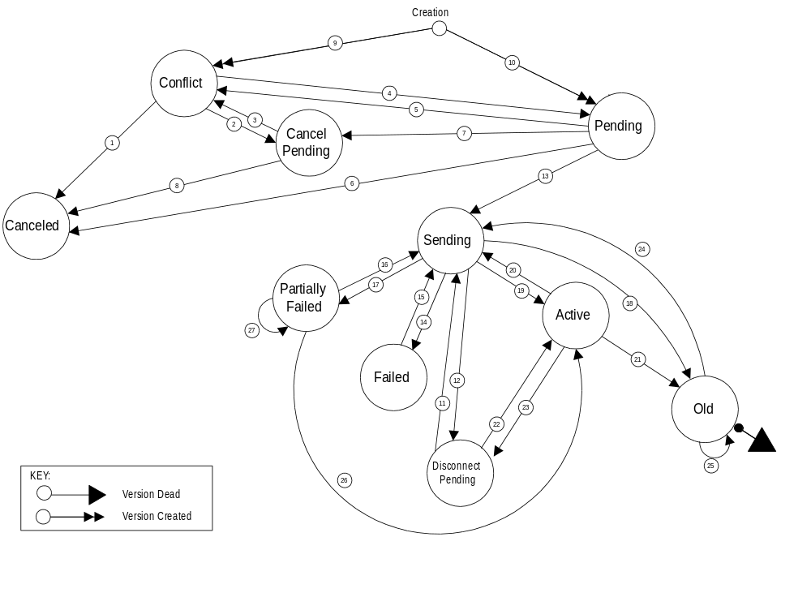

Version Status Interaction Descriptions
# | Interaction Name | Type | Description
1 | Conflict to  Canceled | NPAC SMS Internal | NPAC SMS automatically sets a Subscription Version in conflict directly to canceled after it has been in conflict for a tunable number of calendar days.
 |  | SOA to NPAC SMS Interface or NPAC Operations Interface - NPAC Personnel | The old Service Provider User (or NPAC personnel acting on behalf of the Service Provider) sends a cancellation requestfor a Subscription Version created by that Service Provider with a status of conflict that has not been concurred by the other new Service Provider.
2 | Conflict to  Cancel Pending | NPAC Operations Interface - NPAC Personnel | User cancels a Subscription Version in conflict or cancels a Subscription Version that was created by or concurred to by both Service Providers.
 |  | SOA to NPAC SMS Interface | User sends a cancellation request for a Subscription Version that was created by or concurred to by both Service Providers.
3 | Cancel Pending to  Conflict | NPAC Operations Interface - NPAC Personnel | User sets a Subscription Version with a status of cancel pending to conflict.
 |  | NPAC SMS Internal | NPAC SMS automatically sets a Subscription Version with a status of cancel pending to conflict if cancel pending acknowledgment has not been received from the new Service Provider within a tunable timeframe.
4 | Conflict to  Pending | NPAC Operations Interface - NPAC Personnel and SOA to NPAC SMS Interface - Old Service Provider | User removes a Subscription Version from conflict.
 |  | SOA to NPAC SMS Interface - New Service Provider | New Service Provider User removes a Subscription Version from conflict. This action can only occur if a tunable number of hours have elapsed since the Subscription Version was placed in conflict.
5 | Pending to  Conflict | NPAC Operations Interface - NPAC Personnel | - User sets a Subscription Version with a status of pending to conflict.  - User creates a Subscription Version for an existing pending Subscription Version for the old Service Provider and does not provide authorization for the transfer of service.
 |  | SOA to NPAC SMS Interface - Old Service Provider | Old Service Provider sends a Subscription Version creation or modification request for a Subscription Version with a status of pending, which revokes the old Service Provider’s authorization for transfer of service. This action can only be taken once, and must be taken a tunable number of hours prior to the new Service Provider due date.
6 | Pending to  Canceled | NPAC Operations Interface - NPAC Personnel | User cancels a Subscription Version with a status of pending that has not been concurred by both service providers.
 |  | SOA to NPAC SMS Interface | Service Provider User sends a cancellation request for a Subscription Version created by that Service Provider with a status of pending that has not been concurred by the other Service Provider.
 |  | NPAC SMS Internal | - NPAC SMS automatically sets a pending Subscription Version to canceled after authorization for the transfer of service has not been received from the new Service Provider within a tunable timeframe.  - NPAC SMS automatically sets a pending Subscription Version to canceled if an activation request is not received a tunable amount of time after new Service Provider due date.
- 7 | Pending to  Cancel Pending | NPAC Operations Interface - NPAC Personnel | User cancels a Subscription Version with a status of pending that has been created/concurred by both Service Providers.
 |  | SOA to NPAC SMS Interface | Service Provider User sends a cancellation request for a Subscription Version with a status of pending that has been concurred by the other Service Provider.
8 | Cancel Pending to Canceled | NPAC SMS Internal | NPAC SMS automatically sets a cancel pending Subscription Version to canceled after receiving cancel pending acknowledgment from the concurring Service Provider, or the final cancellation concurrence window has expired without cancel concurrence from the old Service Provider.
9 | Creation -  Set to Conflict | NPAC Operations Interface - NPAC Personnel | User creates a Subscription Version for the old Service Provider and does not provide authorization for the transfer of service.
 |  | SOA to NPAC SMS Interface - Old Service Provider | User sends an old Service Provider Subscription Version creation request and does not provide authorization for the transfer of service.
10 | Creation -  Set to Pending | NPAC Operations Interface - NPAC Personnel | User creates a Subscription Version for either the new or old Service Provider. If the create is for the old Service Provider and authorization for the transfer of service is not provided, refer to # 9, Creation - Set to Conflict, NPAC Operations Interface.
 |  | SOA to NPAC SMS Interface | User sends a Subscription Version creation request for either the new or old Service Provider. If the create is for the old Service Provider, and authorization for the transfer of service is not provided, refer to # 9, Creation - Set to Conflict, SOA to NPAC SMS Interface.
11 | Disconnect Pending to Sending | NPAC SMS Internal | NPAC SMS automatically sets a deferred disconnect pending Subscription Version to sending after the effective release date is reached.
12 | Sending to  Disconnect Pending | NPAC SMS Internal | NPAC SMS automatically sets a Subscription Version from sending to disconnect pending when the broadcast of the disconnect pending fails completely.
13 | Pending to  Sending | NPAC Operations Interface - NPAC Personnel | User activates a pending Subscription Version for a Subscription Version with a new Service Provider due date less than or equal to today.
 |  | SOA to NPAC SMS Interface - New Service Provider | New Service Provider User sends an activation message for a pending Subscription Version for a Subscription Version with a new Service Provider due date less than or equal to today.
14 | Sending to  Failed | NPAC SMS Internal | NPAC SMS automatically sets a Subscription Version from sending to failed after all Local SMSs fail Subscription Version activation after the tunable retry period expires.
15 | Failed to  Sending | NPAC Operations Interface - NPAC Personnel | User re-sends a failed Subscription Version.
16 | Partially Failed to Sending | NPAC Operations Interface - NPAC Personnel | User re-sends a partial failure Subscription Version.
17 | Sending to  Partially Failed | NPAC SMS Internal | NPAC SMS automatically sets a Subscription Version from sending to partial failure after one or more, but not all, of the Local SMSs fail the Subscription Version activation after the tunable retry period expires.
18 | Sending to  Old | NPAC SMS Internal | NPAC SMS automatically sets a sending Subscription Version to old after a disconnect or “porting to original” port to all Local SMSs successfully completes. Disconnects that fail on one or more, but not all, Local SMSs will also be set to old.
19 | Sending to  Active | NPAC SMS Internal | - NPAC SMS automatically sets a sending Subscription Version to active after the Subscription Version activation is successful in all of the Local SMSs.  - NPAC SMS automatically sets a sending Subscription Version to active after the Subscription Version modification is successfully broadcast to any of the Local SMSs.  - NPAC SMS automatically sets a sending Subscription Version to active after a failure to all Local SMSs on a disconnect.
20 | Active to  Sending | NPAC Operations Interface - NPAC Personnel | User disconnects an active Subscription Version and does not supply an effective release date, or User modifies an active Subscription Version.
 |  | SOA to NPAC SMS Interface - Current Service Provider | User sends a disconnect request for an active Subscription Version and does not supply an effective release date, or User modifies an active Subscription Version.
21 | Active to  Old | NPAC SMS Internal | NPAC SMS automatically sets the currently active Subscription Version to old once a currently active subscription version is superceded by a pending subscription version, due to the fact that the current version is set to old when an activate occurs. The new pending version is set to sending and then to active, partially failed, or old. On a disconnect the sending state accurs before the old.
22 | Disconnect Pending to Active | NPAC Operations Interface - NPAC Personnel | User cancels a Subscription Version with a disconnect pending status.
 |  | SOA to NPAC SMS Interface - New Service Provider | User sends a cancellation request for a disconnect pending Subscription Version.
23 | Active to  Disconnect Pending | NPAC Operations Interface - NPAC Personnel | User disconnects an active Subscription Version and supplies a future effective release date.
 |  | SOA to NPAC SMS Interface - Current Service Provider | User sends a disconnect request for an active Subscription Version and supplies a future effective release date.
24 | Old to Sending | NPA Operations Interface – NPAC Personnel | User re-sends a partial failure or failure port-to-original Subscription Version.
25 | Old to Old | NPAC SMS Internal | NPAC SMS automatically sets a Subscription Version from old to old after one or more previously failed Local SMSs successfully disconnect a Subscription Version, as a result of an audit or LSMS resync. The Failed_SP_List is updated to reflect the updates to the previously failed SPs.
26 | Partially Failed to Active | NPAC SMS Internal | NPAC SMS automatically sets a Subscription Version from partial failure to active after all previously failed Local SMSs successfully activate a Subscription Version, as a result of an audit or LSMS resync. The Failed_SP_List is updated to reflect the updates to the previously failed SPs.
27 | Partially Failed to Partially Failed | NPAC SMS Internal | NPAC SMS automatically sets a Subscription Version from partial failure to partial failure after one or more, but not all previously failed Local SMSs successfully activate a Subscription Version, as a result of an audit or LSMS resync. The Failed_SP_List is updated to reflect the updates to the previously failed SPs.

- Errors
CMISE Primitive Errors
A
The following exhibit contains the valid errors associated with CMISE confirmed primitives used in the interoperable interfaces definitions. The situations under which these errors occur are documented in the message flow diagrams in Chapter 6.
Exhibit 16. Valid Errors Associated with CMISE-Confirmed Primitives Used by the NPAC SMS
CMISE PRIMITIVE ERRORS
CMISE Primitive | Errors
M-EVENT-REPORT | invalidArgumentValue, noSuchArgument, noSuchObjectClass, noSuchObjectInstance, processingFailure
M-GET | accessDenied, classInstanceConflict, complexityLimitation, getListError, invalidFilter, invalidScope, noSuchObjectClass, noSuchObject-Instance, processingFailure, syncNotSupported
M-SET | accessDenied, class-InstanceConflict, complexityLimitation, invalidAttributeValue, invalidFilter, invalidScope, noSuchAttribute, noSuchObjectClass, noSuchObject-Instance, processingFailure, syncNotSupported
M-ACTION | accessDenied, class-InstanceConflict, complexityLimitation, invalidArgumentValue, invalidFilter, invalidScope, noSuchAction, noSuchArgument, noSuchObjectClass, noSuchObject-Instance, processingFailure, syncNotSupported
M-CREATE | accessDenied, class-InstanceConflict, duplicateManaged-ObjectInstance, invalidAttributeValue, invalidObjectInstance, missingAttributeValue, noSuchAttribute, noSuchObjectClass, noSuchObject-Instance, processingFailure
M-DELETE | accessDenied, class-InstanceConflict, complexityLimitation, invalidFilter, invalidScope, noSuchObjectClass, noSuchObject-Instance, processingFailure, syncNotSupported

CMISE Primitive Error Descriptions

accessDenied
The service provider does not have the authorization to do this operation.
Examples:
- The service provider is not authorized to perform this type of operation.
- The service provider is not the old or new service provider for the subscription version.
- The modify of the subscription version will cause a mass update.
- The version selected for a disconnect is not active.

duplicateManagedObjectInstance
For create operations, the requested object already exists.
Examples:
- Pending subscription version, NPA-NXX or LRN already exist on NPAC SMS.

classInstanceConflict
The object specified is not a member of the specified class.

complexityLimitation
A parameter was too complex to complete the operation.

invalidArgumentValue
A specified argument is not valid.
Examples:
- An argument value does not pass validation for an action or event report.
- A required parameter is missing for an action or event report.
- An argument value does not exist.

invalidAttributeValue
A specified attribute is not valid.

invalidFilter
A filter specified is not valid.

invalidScope
The scope specified is not valid.

noSuchAction
A specified action is not recognized.

noSuchArgument
A specified argument is not recognized.

noSuchAttribute
A specified attribute is not recognized.

noSuchObjectClass
A specified object class is not recognized.

noSuchObjectInstance
The requested object does not exist.
Examples:
- A query fails based on the search criteria.
- The referenced object (subscription version, NPA-NXX, LRN, etc.) does not exist.

processingFailure
A general failure has occurred in processing the operation or notification A text string is needed to qualify the error message.

Exhibit 17. processingFailure Errors
processingFailure Errors
Error ID |  | Description
0 | lnpSpecificInfo (GraphicString) | Number of records in query response, <#records>, exceeds the number of records that can be returned (<tunable>).

resourceLimitation
The operation was not processed due to a resource limitation.

synchronizationNotSupported
The type of synchronization specified is not supported.
CMIP Error Mapping to the External Design Specification
The following exhibit provides a mapping of CMIP errors to the errors defined in the External Design Specification. Errors reflected are defined as follows:
accessDenied
Implies the service provider cannot perform the given task.
duplicateObjectInstance
The object already exists.
invalidArgumentValue
Represents invalidArgumentValue for an M-ACTION response, and invalidAttributeValue for
M-CREATE and M-SET responses.
noSuchObjectInstance
The requested object does not exist.
processingFailure
The processing failed for the reason given.
Exhibit 18 CMIP Error Mapping to the External Design Specification
CMIP Error | Functional Area | Message Text
invalidArgument  Value | Subscription Version Management | Required data for TN field(s) missing.
invalidArgument  Value | Subscription Version Management | Required due date entry missing from the subscription version.
invalidArgument  Value | Subscription Version Management | Required Customer Disconnect Date missing from the subscription version.
invalidArgument  Value | Subscription Version Management | Required New Service Provider ID missing from the subscription version.
invalidArgument  Value | Subscription Version Management | Required Old Service Provider ID missing from the subscription version.
invalidArgument  Value | Subscription Version Management | Required LRN missing.
invalidArgument  Value | Subscription Version Management | Required CLASS DPC missing.
invalidArgument  Value | Subscription Version Management | Required CLASS SSN missing.
invalidArgument  Value | Subscription Version Management | Required CNAM DPC missing.
invalidArgument  Value | Subscription Version Management | Required CNAM SSN missing.
invalidArgument  Value | Subscription Version Management | Required ISVM DPC missing.
invalidArgument  Value | Subscription Version Management | Required ISVM SSN missing.
invalidArgument  Value | Subscription Version Management | Required LIDB DPC missing.
invalidArgument  Value | Subscription Version Management | Required LIDB SSN missing.
invalidArgument  Value | Network Management | Required value for Date is missing from Network Data.
invalidArgument  Value | Network Management | Required value for Time is missing from Network Data.
invalidArgument  Value | NPAC Customer Management | Required value for NPAC Customer Type is missing from NPAC Customer.
invalidArgument  Value | NPAC Customer Management | Required value for Contact Name is missing from NPAC Customer.
invalidArgument  Value | NPAC Customer Management | Required value for Address Line 1 is missing from NPAC Customer.
invalidArgument  Value | NPAC Customer Management | Required value for NPAC Customer City is missing from NPAC Customer.
invalidArgument  Value | NPAC Customer Management | Required value for Repair Center City is missing from NPAC Customer.
invalidArgument  Value | NPAC Customer Management | Required value for NPAC Customer State is missing from NPAC Customer.
invalidArgument  Value | NPAC Customer Management | Required value for Repair Center State is missing from NPAC Customer.
invalidArgument  Value | NPAC Customer Management | Required value for NPAC Customer Zip Code is missing from NPAC Customer.
invalidArgument  Value | NPAC Customer Management | Required value for Repair Center Zip Code is missing from NPAC Customer.
invalidArgument  Value | NPAC Customer Management | Required value for Pager is missing from NPAC Customer.
invalidArgument  Value | NPAC Customer Management | Required value for Pager PIN is missing from NPAC Customer.
invalidArgument  Value | NPAC Customer Management | Required value for Fax is missing from NPAC Customer.
invalidArgument  Value | NPAC Customer Management | Required value for Email is missing from NPAC Customer.
invalidArgument  Value | NPAC Customer Management | Required value for NSAP is missing from NPAC Customer.
invalidArgument  Value | NPAC Customer Management | Required value for TSAP is missing from NPAC Customer.
invalidArgument  Value | NPAC Customer Management | Required value for SSAP is missing from NPAC Customer.
invalidArgument  Value | NPAC Customer Management | Required value for PSAP is missing from NPAC Customer.
invalidArgument  Value | NPAC Customer Management | Required value for IP is missing from NPAC Customer.
invalidArgument  Value | Subscription Version Management | Invalid value for CLASS DPC entered.
invalidArgument  Value | Subscription Version Management | Invalid value for CLASS SSN entered.
invalidArgument  Value | Subscription Version Management | Invalid value for CNAM DPC entered.
invalidArgument  Value | Subscription Version Management | Invalid value for CNAM SSN entered.
invalidArgument  Value | Subscription Version Management | Invalid value for ISVM DPC entered.
invalidArgument  Value | Subscription Version Management | Invalid value for ISVM SSN entered.
invalidArgument  Value | Subscription Version Management | Invalid value for LIDB DPC entered.
invalidArgument  Value | Subscription Version Management | Invalid value for LIDB SSN entered.
invalidArgument  Value | Subscription Version Management | TN NPA contains invalid data.
invalidArgument  Value | Subscription Version Management | TN NXX contains invalid data.
invalidArgument  Value | Subscription Version Management | TN extension field contains invalid data.
invalidArgument  Value | Subscription Version Management | Month field contains invalid data.
invalidArgument  Value | Subscription Version Management | Day field contains invalid data.
invalidArgument  Value | Subscription Version Management | Year field contains invalid data.
invalidArgument  Value | Subscription Version Management | TN range `through' field (ending extension value) contains invalid data.
invalidArgument  Value | Subscription Version Management | The entered due date must be greater than or equal to today's date.
invalidArgument  Value | Subscription Version Management | Billing Service Provider ID contains invalid data.
invalidArgument  Value | Subscription Version Management | End-User Location Value contains invalid data.
invalidArgument  Value | Subscription Version Management | End-User Location Type contains invalid data.
invalidArgument  Value | NPAC Customer Management | Invalid value for Time entered.
invalidArgument  Value | NPAC Customer Management | Invalid value for NPAC Customer Name entered.
invalidArgument  Value | NPAC Customer Management | Invalid value for NPAC Customer Id entered.
invalidArgument  Value | Subscription Version Management | Invalid value for LRN entered.
invalidArgument  Value | NPAC Customer Management | Invalid value for NPAC Customer Type entered.
invalidArgument  Value | NPAC Customer Management | Invalid value for Allowable Functions entered.
invalidArgument  Value | NPAC Customer Management | Invalid value for Download entered.
invalidArgument  Value | NPAC Customer Management | Invalid value for Contact Name entered.
invalidArgument  Value | NPAC Customer Management | Invalid value for Address Line 1 entered.
invalidArgument  Value | NPAC Customer Management | Invalid value for Address Line 2 entered.
invalidArgument  Value | NPAC Customer Management | Invalid value for City entered.
invalidArgument  Value | NPAC Customer Management | Invalid value for State entered.
invalidArgument  Value | NPAC Customer Management | Invalid value for Zip Code entered.
invalidArgument  Value | NPAC Customer Management | Invalid value for Pager entered.
invalidArgument  Value | NPAC Customer Management | Invalid value for Pager PIN entered.
invalidArgument  Value | NPAC Customer Management | Invalid value for Fax entered.
invalidArgument  Value | NPAC Customer Management | Invalid value for Email entered.
invalidArgument  Value | NPAC Customer Management | Invalid value for NSAP entered.
invalidArgument  Value | NPAC Customer Management | Invalid value for TSAP entered.
invalidArgument  Value | NPAC Customer Management | Invalid value for SSAP entered.
invalidArgument  Value | NPAC Customer Management | Invalid value for PSAP entered.
invalidArgument  Value | NPAC Customer Management | Invalid value for IP entered.
duplicateObject  Instance | Network Data Management | Item being added already exists in the database.
accessDenied | Network Data Management | Subscriptions in either partial failed or sending state are associated with the change. Change/Delete is denied.
invalidArgument  Value | Network Data Management | GTT data is not equivalent across TN range specified. Modify the TN range.
duplicateObject  Instance | NPAC Customer Management | Item being added already exists in the database.
accessDenied | NPAC Customer Management | One or more subscriptions will be affected by change. Change is denied.
invalidArgument  Value | NPAC Customer Management | The NPAC Customer Id cannot be modified.
noSuchObject  Instance | NPAC Customer Management | The NPAC Customer being modified does not exist in the database.
noSuchObject  Instance | NPAC Customer Management | The NPAC Customer being deleted does not exist in the database, or has already been deleted.
invalidArgument  Value | Subscription Version Management | The NPA-NXX of the TN to be ported does not exist in the NPAC SMS system.
invalidArgument  Value | Subscription Version Management | Service Provider ID does not exist in the NPAC SMS system.
accessDenied | Subscription Version Management | The Service Provider issuing this subscription version request is not the Service Provider identified as the New Service Provider ID or the Old Service Provider ID on the subscription version.
duplicateObject  Instance | Subscription Version Management | A pending subscription version with authorization from this Service Provider already exists.
invalidArgument  Value | Subscription Version Management | The entered LRN is not associated with the New Service Provider in the NPAC SMS system.
invalidArgument  Value | Subscription Version Management | The Old Service Provider ID in the subscription version does not match the current Service Provider ID on an existing active subscription version for this TN.
invalidArgument  Value | Subscription Version Management | The New Service Provider ID in the subscription version to be created does not match the new Service Provider ID in an existing pending subscription version for this TN.
invalidArgument  Value | Subscription Version Management | The Old Service Provider ID in the subscription version to be created does not match the Old Service Provider ID in an existing pending subscription version for this TN.
accessDenied | Subscription Version Management | Releasing a subscription version for an Intra-Service Provider port does not apply.
invalidArgument  Value | Subscription Version Management | The Old Service Provider ID must match the New Service Provider ID for an Intra-Service Port.
invalidArgument  Value | Subscription Version Management | The New and Old Service Provider Due Dates must match.
accessDenied | Subscription Version Management | An active subscription version must exist for an Intra-SP port.
accessDenied | Subscription Version Management | A subscription version with sending status cannot be modified.
accessDenied | Subscription Version Management | A subscription version with failed status cannot be modified.
accessDenied | Subscription Version Management | A subscription version with partial failure status cannot be modified.
accessDenied | Subscription Version Management | A subscription version with canceled status cannot be modified.
accessDenied | Subscription Version Management | A subscription version with old status cannot be modified.
accessDenied | Subscription Version Management | A subscription version with disconnect pending status cannot be modified.
accessDenied | Subscription Version Management | A subscription version with cancel pending status cannot be modified.
accessDenied | Subscription Version Management | A subscription version must be in pending status to be activated.
invalidArgument  Value | Subscription Version Management | The Old Service Provider Id is not equal to the New Service Provider ID on the active subscription version, as required for an Intra-Service Provider port.
accessDenied | Subscription Version Management | The Service Provider originating the modification request is not the current Service Provider.
accessDenied | Subscription Version Management | The subscription version cannot be put in conflict because its current status is not pending or cancel pending.
accessDenied | Subscription Version Management | The subscription version cannot be set to pending because its current status is not conflict.
accessDenied | Subscription Version Management | The subscription version cannot be disconnected because there is no current subscription version in active status.
accessDenied | Subscription Version Management | This active subscription version cannot be disconnected until a sending subscription version successfully completes.
accessDenied | Subscription Version Management | This active subscription version cannot be disconnected until a failed or partial failure subscription version is re-sent and successfully completes.
accessDenied | Subscription Version Management | The subscription version cannot be canceled because its current status is not pending, conflict or disconnect pending.
accessDenied | Subscription Version Management | Active subscription version may not be modified because a related subscription version for this TN has been activated.
accessDenied | Subscription Version Management | Pending subscription version may not be activated until a related subscription version in sending status becomes active.
accessDenied | Subscription Version Management | Deferred disconnect request is not allowed because a pending subscription version exists for this TN.
accessDenied | Subscription Version Management | This subscription version may not be activated because authorization for transfer of service has not been received from both SPs.
accessDenied | Subscription Version Management | This immediate disconnect request is denied because a pending subscription version for the TN exists, and the Old Service Provider has authorized transfer of service for the pending subscription version.
invalidArgument  Value | Audit Administration | Invalid date entered.
invalidArgument  Value | Audit Administration | Invalid time entered.
invalidArgument  Value | Audit Administration | Audit Profile name too long.
invalidArgument  Value | Audit Administration | Invalid TN data entered.
invalidArgument  Value | Audit Administration | Audit Profile name is not unique.

Exhibit 19 CMIP Warning Mapping to the External Design Specification
CMIP Error | Functional Area | Message Text
invalidArgument  Value | Subscription Version Management | The entered due date differs from the due date entered by the other Service Provider.
invalidArgument  Value | Audit Administration | NPA does not exist in the NPAC SMS data.
invalidArgument  Value | Audit Administration | NPA-NXX combination does not exist in the NPAC SMS data.
noSuchObject  Instance | Audit Administration | No audits match the entered criteria.

Exhibit 20 CMIP Informational Mapping to the External Design Specification
CMIP Error | Functional Area | Message Text
noSuchObject  Instance | Network Data Management | No match found in the database for the search criteria.
noSuchObject  Instance | NPAC Customer Management | No match found in the database for the search criteria.
processingFailure | NPAC Customer Management | <x> Subscriptions found: exceed maximum query limit.
noSuchObject  Instance | NPAC Customer Management | No subscription versions found for the given input search criteria.
noSuchObject  Instance | Subscription Version Management | No subscription versions found for the given input search criteria.
processingFailure | Subscription Version Management | Subscriptions found exceed maximum query limit.
invalidArgument  Value | Audit Administration | No TNs found within the range entered.

