NPAC SMS

Interoperable Interface Specification

APPENDICES A and B

NANC Version 3.0.0

Prepared for:
The North American Numbering Council (NANC)
February 14, 2000

Release 3.0: © 1997, 1998, 1999, 2000 NeuStar, Inc.

The Work is subject to the terms of the GNU General Public License (the “GPL”), a copy of which may be found at
ftp://prep.ai.mit.edu/pub/gnu/GPL. Any use of this Work is subject to the terms of the GPL. The “Work” covered by the GPL by
operation of this notice and license is this document and any and all modifications to or derivatives of this document.
Where the words “Program,” “software,” “source code,” “code,” or “files” are used in the GPL, users understand and agree that
the “Work” as defined here is substituted for purposes of this notice and license.

Table Of Contents
Introduction v
A.1 CMISE Primitive Errors 1
A.2 CMISE Primitive Error Descriptions 1
A.3 CMIP Error Mapping to the External Design Specification 3
B.1 Overview 1
B.2 Audit Scenarios 3
B.2.1 SOA Initiated Audit 3
B.2.2 SOA Initiated Audit Cancellation by the SOA 6
B.2.3 SOA Initiated Audit Cancellation by the NPAC 7
B.2.4 NPAC Initiated Audit 8
B.2.5 NPAC Initiated Audit Cancellation by the NPAC 11
B.2.6 Audit Query on the NPAC 12
B.2.7 SOA Audit Create for Subscription Versions within a Number Pool Block (previously NNP flow 6.1) 13
B.2.8 NPAC SMS Audit Create for Subscription Versions Within a Number Pool Block (previously NNP flow 6.2) 20
B.3 Service Provider Scenarios 24
B.3.1 Service Provider Creation by the NPAC 24
B.3.2 Service Provider Deletion by the NPAC 26
B.3.3 Service Provider Modification by the NPAC 28
B.3.4 Service Provider Modification by the Local SMS 29
B.3.5 Service Provider Modification by the SOA 30
B.3.6 Service Provider Query by the Local SMS 31
B.3.7 Service Provider Query by the SOA 32
B.4 Service Provider Network Data Scenarios 33
B.4.1 NPA-NXX Scenarios 33
B.4.2 LRN Scenarios 47
B.4.3 Service Provider NPA-NXX-X 61
B.4.4 Number Pool Block 70
B.5 SubscriptionVersion Flow Scenarios 140
B.5.1 SubscriptionVersion Create Scenarios 140
B.5.2 Modify Scenarios 216
B.5.3 Cancel Scenarios 228
B.5.4 Disconnect Scenarios 234
B.5.5 Conflict Scenarios 276
B.5.6 SubscriptionVersion Query 286
B.6 LSMS Filter NPA-NXX Scenarios 290
B.6.1 lsmsFilterNPA-NXX Creation by the Local SMS 290
B.6.2 lsmsFilterNPA-NXX Deletion by the Local SMS 291
B.6.3 lsmsFilterNPA-NXX Query by the Local SMS 292
B.6.4 lsmsFilterNPA-NXX Creation by the SOA 293
B.6.5 lsmsFilterNPA-NXX Deletion by the SOA 294
B.6.6 lsmsFilterNPA-NXX Query by the SOA 295
B.7 Local SMS and SOA Recovery 296
B.7.2 Sequencing of Events on Initialization/Resynchronization of SOA 306
B.8 Miscellaneous 308
B.8.1 SOA/Local SMS Notification of Scheduled NPAC Downtime 308
B.8.2 NPA-NXX Split 310
B.8.3 Mass Update 317

Introduction

This document contains the appendices for the IIS document. The appendices are in a separate document from the body of the IIS due to the large size of the document.
With the publication of the Release 3.0 version of the appendices, the message flows specific to National Number Pooling have been integrated into this document. These new flows were developed using Rational Rose’s Object Model Tool. The numbering functionality in Rose only allowed the steps to be numbered, and did not allow the steps to be lettered. Therefore, the styles in MS-Word for the description of the steps were set up to use numbers as well. When the Number Pooling message flows and description steps were integrated into the 2.0.2 version of the IIS, the existing steps were automatically changed from letters to numbers. The long-term plan is to replace all of the existing message flow diagrams with new Rose diagrams (keeping the same functionality). However, for this version of the document, there are known inconsistencies with the existing message flows (i.e., the diagrams use letters, and the text steps use numbers). In order to assist the reader with the letter-to-number coordination for the existing flows, the following table is provided:
A=1 | E=5 | I=9 | M=13 | Q=17 | U=21 | Y=25
B=2 | F=6 | J=10 | N=14 | R=18 | V=22 | Z=26
C=3 | G=7 | K=11 | O=15 | S=19 | W=23 | AA=27
D=4 | H=8 | L=12 | P=16 | T=20 | X=24 | BB=28

- Errors

CMISE Primitive Errors
A
The following exhibit contains the valid errors associated with CMISE confirmed primitives used in the interoperable interfaces definitions. The situations under which these errors occur are documented in the message flow diagrams in Appendix B.
Exhibit 1. Valid Errors Associated with CMISE-Confirmed Primitives Used by the NPAC SMS
CMISE PRIMITIVE ERRORS
CMISE Primitive | Errors
M-EVENT-REPORT | invalidArgumentValue, noSuchArgument, noSuchObjectClass, noSuchObjectInstance, processingFailure, noSuchEventType
M-GET | accessDenied, classInstanceConflict, complexityLimitation, getListError, invalidFilter, invalidScope, noSuchObjectClass, noSuchObject-Instance, processingFailure, syncNotSupported
M-SET | accessDenied, class-InstanceConflict, complexityLimitation, invalidFilter, invalidScope, noSuchObjectClass, noSuchObject-Instance, processingFailure, syncNotSupported, setListError
M-ACTION | accessDenied, class-InstanceConflict, complexityLimitation, invalidArgumentValue, invalidFilter, invalidScope, noSuchAction, noSuchArgument, noSuchObjectClass, noSuchObject-Instance, processingFailure, syncNotSupported
M-CREATE | accessDenied, class-InstanceConflict, duplicateManaged-ObjectInstance, invalidAttributeValue, invalidObjectInstance, missingAttributeValue, noSuchAttribute, noSuchObjectClass, noSuchObject-Instance, processingFailure, noSuchReferenceObject
M-DELETE | accessDenied, class-InstanceConflict, complexityLimitation, invalidFilter, invalidScope, noSuchObjectClass, noSuchObject-Instance, processingFailure, syncNotSupported

CMISE Primitive Error Descriptions

accessDenied
The service provider does not have the authorization to do this operation.
Examples:
- The service provider is not authorized to perform this type of operation.
- The service provider is not the old or new service provider for the subscription version.
- The modify of the subscription version will cause a mass update.
- The version selected for a disconnect is not active.

duplicateManagedObjectInstance
For create operations, the requested object already exists.
Examples:
- Pending subscription version, NPA-NXX or LRN already exist on NPAC SMS.

classInstanceConflict
The object specified is not a member of the specified class.

complexityLimitation
A parameter was too complex to complete the operation.

invalidArgumentValue
A specified argument is not valid.
Examples:
- An argument value does not pass validation for an action or event report.
- A required parameter is missing for an action or event report.
- An argument value does not exist.

invalidAttributeValue
A specified attribute is not valid.

invalidFilter
A filter specified is not valid.

invalidScope
The scope specified is not valid.

noSuchAction
A specified action is not recognized.

noSuchArgument
A specified argument is not recognized.

noSuchAttribute
A specified attribute is not recognized.

noSuchObjectClass
A specified object class is not recognized.

noSuchObjectInstance
The requested object does not exist.
Examples:
- A query fails based on the search criteria.
- The referenced object (subscription version, NPA-NXX, LRN, etc.) does not exist.

processingFailure
A general failure has occurred in processing the operation or notification A text string is needed to qualify the error message.

Exhibit 2. processingFailure Errors
processingFailure Errors
Error ID |  | Description
0 | lnpSpecificInfo (GraphicString) | Invalid CLASS DPC value.

resourceLimitation
The operation was not processed due to a resource limitation.

synchronizationNotSupported
The type of synchronization specified is not supported.

CMIP Error Mapping to the External Design Specification
The following exhibit provides a mapping of CMIP errors to the errors defined in the External Design Specification. Errors reflected are defined as follows:
accessDenied
Implies the service provider cannot perform the given task.
duplicateObjectInstance
The object already exists.
invalidArgumentValue
Represents invalidArgumentValue for an M-ACTION response, and invalidAttributeValue for
M-CREATE and M-SET responses.
noSuchObjectInstance
The requested object does not exist.
processingFailure
The processing failed for the reason given.
Exhibit 3 CMIP Error Mapping to the External Design Specification
CMIP Error | Functional Area | Message Text
invalidArgument  Value | Subscription Version Management | Required data for TN field(s) missing.
invalidArgument  Value | Subscription Version Management | Required due date entry missing from the subscription version.
invalidArgument  Value | Subscription Version Management | Required Customer Disconnect Date missing from the subscription version.
invalidArgument  Value | Subscription Version Management | Required New Service Provider ID missing from the subscription version.
invalidArgument  Value | Subscription Version Management | Required Old Service Provider ID missing from the subscription version.
invalidArgument  Value | Subscription Version Management | Required LRN missing.
invalidArgument  Value | Subscription Version Management | Required CLASS DPC missing.
invalidArgument  Value | Subscription Version Management | Required CLASS SSN missing.
invalidArgument  Value | Subscription Version Management | Required CNAM DPC missing.
invalidArgument  Value | Subscription Version Management | Required CNAM SSN missing.
invalidArgument  Value | Subscription Version Management | Required ISVM DPC missing.
invalidArgument  Value | Subscription Version Management | Required ISVM SSN missing.
invalidArgument  Value | Subscription Version Management | Required LIDB DPC missing.
invalidArgument  Value | Subscription Version Management | Required LIDB SSN missing.
invalidArgument  Value | Subscription Version Management | Required WSMSC DPC missing.
invalidArgument  Value | Subscription Version Management | Required WSMSC SSN missing.
invalidArgument  Value | Network Management | Required value for Date is missing from Network Data.
invalidArgument  Value | Network Management | Required value for Time is missing from Network Data.
invalidArgument  Value | NPAC Customer Management | Required value for NPAC Customer Type is missing from NPAC Customer.
invalidArgument  Value | NPAC Customer Management | Required value for Contact Name is missing from NPAC Customer.
invalidArgument  Value | NPAC Customer Management | Required value for Address Line 1 is missing from NPAC Customer.
invalidArgument  Value | NPAC Customer Management | Required value for NPAC Customer City is missing from NPAC Customer.
invalidArgument  Value | NPAC Customer Management | Required value for Repair Center City is missing from NPAC Customer.
invalidArgument  Value | NPAC Customer Management | Required value for NPAC Customer State is missing from NPAC Customer.
invalidArgument  Value | NPAC Customer Management | Required value for Repair Center State is missing from NPAC Customer.
invalidArgument  Value | NPAC Customer Management | Required value for NPAC Customer Zip Code is missing from NPAC Customer.
invalidArgument  Value | NPAC Customer Management | Required value for Repair Center Zip Code is missing from NPAC Customer.
invalidArgument  Value | NPAC Customer Management | Required value for Pager is missing from NPAC Customer.
invalidArgument  Value | NPAC Customer Management | Required value for Pager PIN is missing from NPAC Customer.
invalidArgument  Value | NPAC Customer Management | Required value for Fax is missing from NPAC Customer.
invalidArgument  Value | NPAC Customer Management | Required value for Email is missing from NPAC Customer.
invalidArgument  Value | NPAC Customer Management | Required value for NSAP is missing from NPAC Customer.
invalidArgument  Value | NPAC Customer Management | Required value for TSAP is missing from NPAC Customer.
invalidArgument  Value | NPAC Customer Management | Required value for SSAP is missing from NPAC Customer.
invalidArgument  Value | NPAC Customer Management | Required value for PSAP is missing from NPAC Customer.
invalidArgument  Value | NPAC Customer Management | Required value for IP is missing from NPAC Customer.
invalidArgument  Value | Subscription Version Management | Invalid value for CLASS DPC entered.
invalidArgument  Value | Subscription Version Management | Invalid value for CLASS SSN entered.
invalidArgument  Value | Subscription Version Management | Invalid value for CNAM DPC entered.
invalidArgument  Value | Subscription Version Management | Invalid value for CNAM SSN entered.
invalidArgument  Value | Subscription Version Management | Invalid value for ISVM DPC entered.
invalidArgument  Value | Subscription Version Management | Invalid value for ISVM SSN entered.
invalidArgument  Value | Subscription Version Management | Invalid value for LIDB DPC entered.
invalidArgument  Value | Subscription Version Management | Invalid value for LIDB SSN entered.
invalidArgument  Value | Subscription Version Management | Invalid value for WSMSC DPC entered.
invalidArgument  Value | Subscription Version Management | Invalid value for WSMSC SSN entered.
invalidArgument  Value | Subscription Version Management | TN NPA contains invalid data.
invalidArgument  Value | Subscription Version Management | TN NXX contains invalid data.
invalidArgument  Value | Subscription Version Management | TN extension field contains invalid data.
invalidArgument  Value | Subscription Version Management | Month field contains invalid data.
invalidArgument  Value | Subscription Version Management | Day field contains invalid data.
invalidArgument  Value | Subscription Version Management | Year field contains invalid data.
invalidArgument  Value | Subscription Version Management | TN range `through' field (ending extension value) contains invalid data.
invalidArgument  Value | Subscription Version Management | The entered due date must be greater than or equal to today's date.
invalidArgument  Value | Subscription Version Management | Billing Service Provider ID contains invalid data.
invalidArgument  Value | Subscription Version Management | End-User Location Value contains invalid data.
invalidArgument  Value | Subscription Version Management | End-User Location Type contains invalid data.
invalidArgument  Value | NPAC Customer Management | Invalid value for Time entered.
invalidArgument  Value | NPAC Customer Management | Invalid value for NPAC Customer Name entered.
invalidArgument  Value | NPAC Customer Management | Invalid value for NPAC Customer Id entered.
invalidArgument  Value | Subscription Version Management | Invalid value for LRN entered.
invalidArgument  Value | NPAC Customer Management | Invalid value for NPAC Customer Type entered.
invalidArgument  Value | NPAC Customer Management | Invalid value for Allowable Functions entered.
invalidArgument  Value | NPAC Customer Management | Invalid value for Download entered.
invalidArgument  Value | NPAC Customer Management | Invalid value for Contact Name entered.
invalidArgument  Value | NPAC Customer Management | Invalid value for Address Line 1 entered.
invalidArgument  Value | NPAC Customer Management | Invalid value for Address Line 2 entered.
invalidArgument  Value | NPAC Customer Management | Invalid value for City entered.
invalidArgument  Value | NPAC Customer Management | Invalid value for State entered.
invalidArgument  Value | NPAC Customer Management | Invalid value for Zip Code entered.
invalidArgument  Value | NPAC Customer Management | Invalid value for Pager entered.
invalidArgument  Value | NPAC Customer Management | Invalid value for Pager PIN entered.
invalidArgument  Value | NPAC Customer Management | Invalid value for Fax entered.
invalidArgument  Value | NPAC Customer Management | Invalid value for Email entered.
invalidArgument  Value | NPAC Customer Management | Invalid value for NSAP entered.
invalidArgument  Value | NPAC Customer Management | Invalid value for TSAP entered.
invalidArgument  Value | NPAC Customer Management | Invalid value for SSAP entered.
invalidArgument  Value | NPAC Customer Management | Invalid value for PSAP entered.
invalidArgument  Value | NPAC Customer Management | Invalid value for IP entered.
duplicateObject  Instance | Network Data Management | Item being added already exists in the database.
accessDenied | Network Data Management | Subscriptions in either partial failed or sending state are associated with the change. Change/Delete is denied.
invalidArgument  Value | Network Data Management | GTT data is not equivalent across TN range specified. Modify the TN range.
duplicateObject  Instance | NPAC Customer Management | Item being added already exists in the database.
accessDenied | NPAC Customer Management | One or more subscriptions will be affected by change. Change is denied.
invalidArgument  Value | NPAC Customer Management | The NPAC Customer Id cannot be modified.
noSuchObject  Instance | NPAC Customer Management | The NPAC Customer being modified does not exist in the database.
noSuchObject  Instance | NPAC Customer Management | The NPAC Customer being deleted does not exist in the database, or has already been deleted.
invalidArgument  Value | Subscription Version Management | The NPA-NXX of the TN to be ported does not exist in the NPAC SMS system.
invalidArgument  Value | Subscription Version Management | Service Provider ID does not exist in the NPAC SMS system.
accessDenied | Subscription Version Management | The Service Provider issuing this subscription version request is not the Service Provider identified as the New Service Provider ID or the Old Service Provider ID on the subscription version.
duplicateObject  Instance | Subscription Version Management | A pending subscription version with authorization from this Service Provider already exists.
invalidArgument  Value | Subscription Version Management | The entered LRN is not associated with the New Service Provider in the NPAC SMS system.
invalidArgument  Value | Subscription Version Management | The Old Service Provider ID in the subscription version does not match the current Service Provider ID on an existing active subscription version for this TN.
invalidArgument  Value | Subscription Version Management | The New Service Provider ID in the subscription version to be created does not match the new Service Provider ID in an existing pending subscription version for this TN.
invalidArgument  Value | Subscription Version Management | The Old Service Provider ID in the subscription version to be created does not match the Old Service Provider ID in an existing pending subscription version for this TN.
accessDenied | Subscription Version Management | Releasing a subscription version for an Intra-Service Provider port does not apply.
invalidArgument  Value | Subscription Version Management | The Old Service Provider ID must match the New Service Provider ID for an Intra-Service Port.
invalidArgument  Value | Subscription Version Management | The New and Old Service Provider Due Dates must match.
accessDenied | Subscription Version Management | An active subscription version must exist for an Intra-SP port.
accessDenied | Subscription Version Management | A subscription version with sending status cannot be modified.
accessDenied | Subscription Version Management | A subscription version with failed status cannot be modified.
accessDenied | Subscription Version Management | A subscription version with partial failure status cannot be modified.
accessDenied | Subscription Version Management | A subscription version with canceled status cannot be modified.
accessDenied | Subscription Version Management | A subscription version with old status cannot be modified.
accessDenied | Subscription Version Management | A subscription version with disconnect pending status cannot be modified.
accessDenied | Subscription Version Management | A subscription version with cancel pending status cannot be modified.
accessDenied | Subscription Version Management | A subscription version must be in pending status to be activated.
invalidArgument  Value | Subscription Version Management | The Old Service Provider Id is not equal to the New Service Provider ID on the active subscription version, as required for an Intra-Service Provider port.
accessDenied | Subscription Version Management | The Service Provider originating the modification request is not the current Service Provider.
accessDenied | Subscription Version Management | The subscription version cannot be put in conflict because its current status is not pending or cancel pending.
accessDenied | Subscription Version Management | The subscription version cannot be set to pending because its current status is not conflict.
accessDenied | Subscription Version Management | The subscription version cannot be disconnected because there is no current subscription version in active status.
accessDenied | Subscription Version Management | This active subscription version cannot be disconnected until a sending subscription version successfully completes.
accessDenied | Subscription Version Management | This active subscription version cannot be disconnected until a failed or partial failure subscription version is re-sent and successfully completes.
accessDenied | Subscription Version Management | The subscription version cannot be canceled because its current status is not pending, conflict or disconnect pending.
accessDenied | Subscription Version Management | Active subscription version may not be modified because a related subscription version for this TN has been activated.
accessDenied | Subscription Version Management | Pending subscription version may not be activated until a related subscription version in sending status becomes active.
accessDenied | Subscription Version Management | Deferred disconnect request is not allowed because a pending subscription version exists for this TN.
accessDenied | Subscription Version Management | This subscription version may not be activated because authorization for transfer of service has not been received from both SPs.
accessDenied | Subscription Version Management | This immediate disconnect request is denied because a pending subscription version for the TN exists, and the Old Service Provider has authorized transfer of service for the pending subscription version.
invalidArgument  Value | Audit Administration | Invalid date entered.
invalidArgument  Value | Audit Administration | Invalid time entered.
invalidArgument  Value | Audit Administration | Audit Profile name too long.
invalidArgument  Value | Audit Administration | Invalid TN data entered.
invalidArgument  Value | Audit Administration | Audit Profile name is not unique.

Exhibit 4 CMIP Warning Mapping to the External Design Specification
CMIP Error | Functional Area | Message Text
invalidArgument  Value | Subscription Version Management | The entered due date differs from the due date entered by the other Service Provider.
invalidArgument  Value | Audit Administration | NPA does not exist in the NPAC SMS data.
invalidArgument  Value | Audit Administration | NPA-NXX combination does not exist in the NPAC SMS data.
noSuchObject  Instance | Audit Administration | No audits match the entered criteria.

Exhibit 5 CMIP Informational Mapping to the External Design Specification
CMIP Error | Functional Area | Message Text
NoSuchObject  Instance | Network Data Management | No match found in the database for the search criteria.
noSuchObject  Instance | NPAC Customer Management | No match found in the database for the search criteria.
processingFailure | NPAC Customer Management | <x> Subscriptions found: exceed maximum query limit.
noSuchObject  Instance | NPAC Customer Management | No subscription versions found for the given input search criteria.
noSuchObject  Instance | Subscription Version Management | No subscription versions found for the given input search criteria.
processingFailure | Subscription Version Management | Subscriptions found exceed maximum query limit.
invalidArgument  Value | Audit Administration | No TNs found within the range entered.

- Flow Diagrams
B

Overview
This appendix defines the message flow scenarios for the SOA to NPAC and the NPAC SMS to Local SMS interfaces. Each of these definitions consists of a message flow diagram and a textual description of the diagram.
IMPORTANT NOTES
The order of messages in the message flows must be followed by the NPAC SMS SOA and LSMS systems with the exception of the return of the M-EVENT-REPORT confirmations.
The following is an example message flow diagram and legend for elements shown in the diagram.
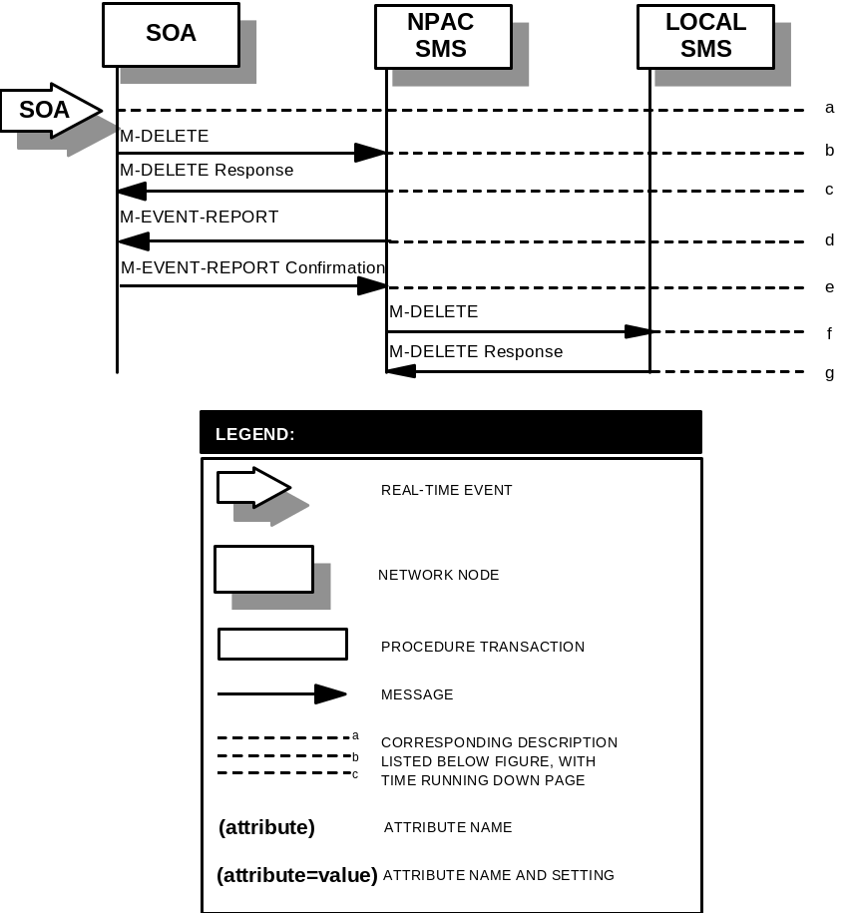

Audit Scenarios

SOA Initiated Audit
In this scenario, the SOA initiates an audit to the NPAC SMS due to suspected subscription version discrepancies. This scenario applies to non-pooled subscription versions only.
- Action is taken by SOA personnel to start an audit due to suspected network discrepancies.
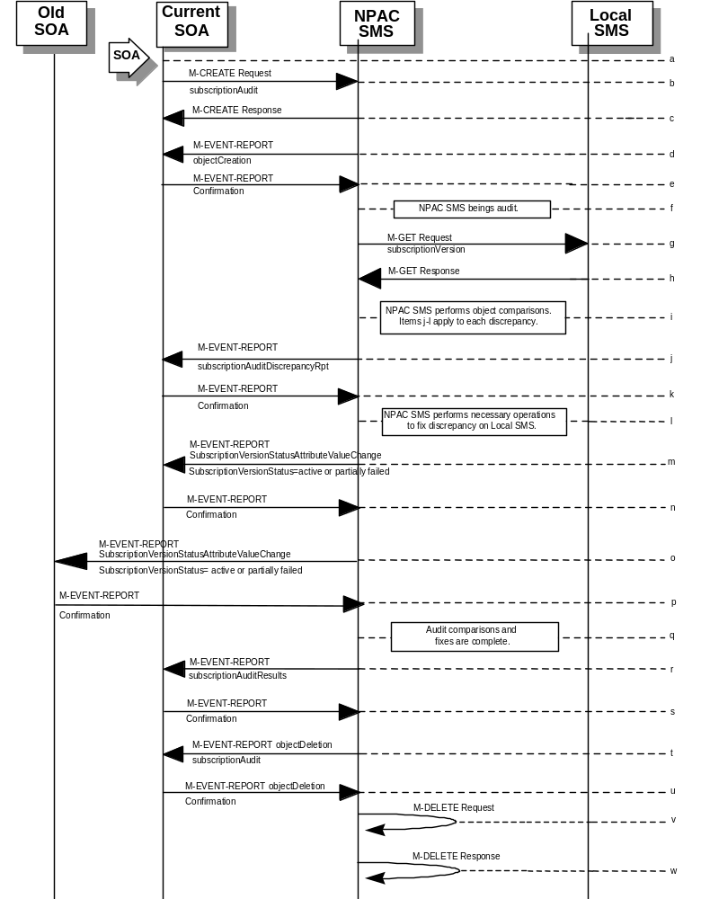
- The SOA sends a M-CREATE request to the NPAC SMS, requesting an audit. The SOA must specify the following attributes in the request:
subscriptionAuditName - English audit name
subscriptionAuditRequestingSP - the service provider requesting the audit
subscriptionAuditServiceProvIdRange - which service provider or all service providers for audit
subscriptionAuditTN-Range - TNs to be audited. If only a single TN is to be audited, specify the ending TN station equal to the starting TN station.
If these attributes are not specified, then the create will fail with a missingAttributesValue error. The SOA may also specify the following attributes in the request:
subscriptionAuditAttributeList - subscription version attributes to be audited
subscriptionAuditTN-ActivationRange - time range of activation for subscription versions to be audited
The subscriptionAuditId and the subscriptionAuditStatus will be determined by the NPAC SMS. If any values are deemed invalid, an invalidArgumentValue error will be returned. Once the NPAC SMS creates the audit request object, it sends an M-CREATE response back to the SOA that initiated the request.
- NPAC SMS responds to M-CREATE.
- NPAC SMS sends M-EVENT-REPORT to the service provider SOA for the subscriptionAudit creation.
- The service provider SOA confirms the M-EVENT-REPORT.
- NPAC SMS begins audit.
- NPAC SMS issues a scoped and filtered M-GET for the subscription versions in the audit, to all LSMSs accepting downloads for the NPA-NXX of the subscription version.
- Local SMS returns M-GET query data.
- NPAC SMS performs the necessary comparisons of each subscription version object.
- If a discrepancy is found, NPAC SMS issues a subscriptionAuditDiscrepancyRpt M-EVENT-REPORT.
- Service provider SOA confirms the M-EVENT-REPORT.
- If a discrepancy is found, NPAC SMS issues the necessary operation to the Local SMS to correct the discrepancy (M-CREATE, M-DELETE, or
M-SET).
- If any corrections were issued to any Local SMSs, the NPAC SMS will send M-EVENT-REPORT to the service provider SOA of the subscriptionVersionStatus change and a list of failed Local SMSs (minus any recently updated Local SMSs that no longer contains a discrepancy).
- The service provider SOA confirms the M-EVENT-REPORT.
- If any corrections were issued to any Local SMSs, the NPAC SMS will send M-EVENT-REPORT to the old service provider SOA of the subscriptionVersionStatus change and a list of failed Local SMSs (minus any recently updated Local SMSs that no longer contains a discrepancy).
- The old service provider SOA confirms the M-EVENT-REPORT.
- NPAC SMS has completed the audit comparisons and corrections.
- NPAC SMS issues the subscriptionAuditResults M-EVENT-REPORT to the service provider SOA.
- The Service provider SOA confirms the M-EVENT-REPORT.
- The NPAC SMS then sends an objectDeletion M-EVENT-REPORT to the SOA for the subscriptionAudit object.
- The service provider SOA confirms the M-EVENT-REPORT.
- The NPAC SMS issues a local M-DELETE request for the subscriptionAudit object to/from the NPAC SMS. This will attempt to delete the subscriptionAudit object on the NPAC SMS. The M-DELETE does not occur until after the “Audit Log Retention Period” which defaults to 90 days.
- The M-DELETE response is received on the NPAC SMS indicating whether the subscriptionAudit object was deleted successfully.

SOA Initiated Audit Cancellation by the SOA
The SOA cancels an audit that it initiated.
- 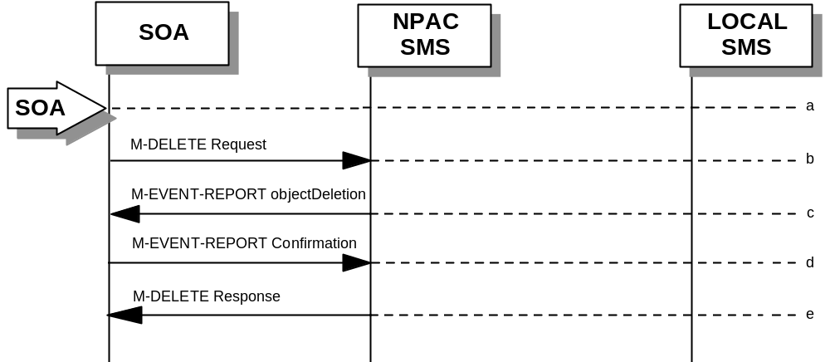Action is taken by SOA personnel to cancel an audit previously initiated by the SOA.
- The SOA sends an M-DELETE request for the subscriptionAudit object to the NPAC SMS, requesting cancellation of an audit. If the audit was not initiated by the SOA requesting cancellation, then the request will be rejected with an accessDenied error.
- The NPAC SMS will respond by sending an objectDeletion M-EVENT-REPORT.
- The SOA confirms the M-EVENT-REPORT.
- The NPAC SMS sends an M-DELETE response to the SOA.

SOA Initiated Audit Cancellation by the NPAC
The NPAC cancels an audit that was initiated by an SOA.
- Action is taken by NPAC personnel to cancel an audit previously initiated by an SOA.
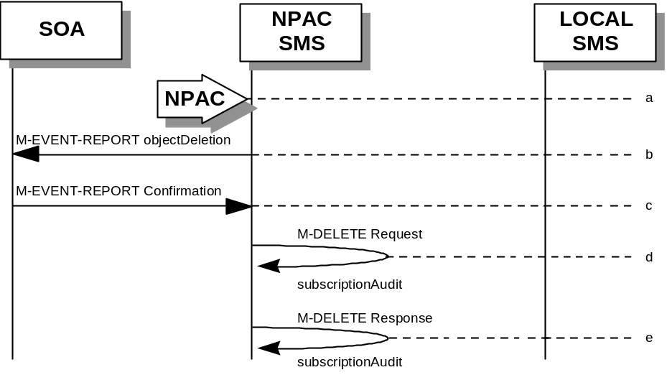
- The NPAC SMS sends an objectDeletion M-EVENT-REPORT to the SOA that initiated the audit request.
- The SOA confirms the M-EVENT-REPORT
- The NPAC SMS issues a local M-DELETE request to/from the NPAC SMS. This will attempt to delete the subscriptionAudit object on the NPAC SMS.
- The M-DELETE response is received on the NPAC SMS indicating whether the subscriptionAudit object was deleted successfully.

NPAC Initiated Audit
In this scenario, the NPAC SMS initiates an audit due to suspected subscription version discrepancies. This scenario applies to non-pooled subscription versions only.
- Action is taken by NPAC personnel to start an audit due to suspected network discrepancies.
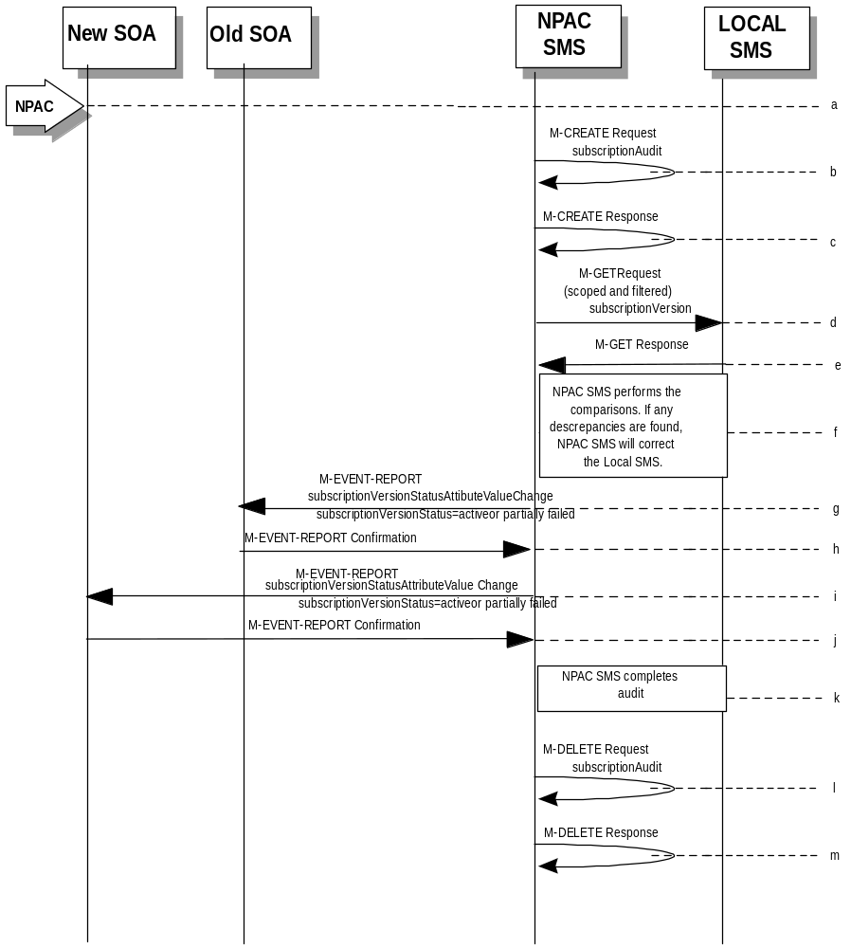
- The NPAC SMS does a Local M-CREATE request to itself for the subscriptionAudit object requesting an audit.
- The NPAC SMS responds with an M-CREATE response indicating that the subscriptionAudit object was created successfully.
- The NPAC SMS sends an M-GET request to the Local SMSs to retrieve the subscription data to use for audit processing. The request uses the CMIP scoping and filtering options to retrieve only the subscriptionVersion objects to be audited.
- The Local SMS responds to the M-GET request by returning the subscription data that satisfies the scope and filter data.
- NPAC SMS performs the comparisons. If any discrepancies are found, the NPAC SMS will perform the necessary fix to the Local SMS.
- If any corrections were issued to any Local SMSs, the NPAC SMS will send M-EVENT-REPORT to the old service provider SOA of the subscriptionVersionStatus change and a list of failed Local SMSs (minus any recently updated Local SMSs that no longer contains a discrepancy).
- The old service provider SOA confirms the M-EVENT-REPORT.
- If any corrections were issued to any Local SMSs, the NPAC SMS will send M-EVENT-REPORT to the new service provider SOA of the subscriptionVersionStatus change and a list of failed Local SMSs (minus any recently updated Local SMSs that no longer contains a discrepancy).
- The new service provider SOA confirms the M-EVENT-REPORT.
- NPAC SMS completes the audit.
- Issue a local M-DELETE request for the subscriptionAudit object to/from the NPAC SMS. This will attempt to delete the subscriptionAudit object on the NPAC SMS. The M-DELETE does not occur until after the “Audit Log Retention Period” which defaults to 90 days.
- The M-DELETE response is received on the NPAC SMS indicating whether the subscriptionAudit object was deleted successfully.

NPAC Initiated Audit Cancellation by the NPAC
The NPAC SMS cancels an audit that it initiated.
- 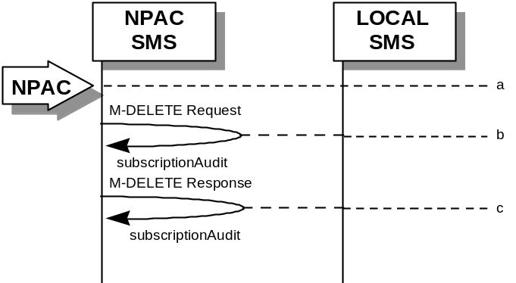Action is taken by NPAC personnel to cancel an audit previously initiated by the NPAC SMS.
- Issue a local M-DELETE request to/from the NPAC SMS. This will attempt to delete the subscriptionAudit object on the NPAC SMS.
- The M-DELETE response is received on the NPAC SMS indicating whether the subscriptionAudit object was deleted successfully.

Audit Query on the NPAC
This scenario shows a service provider query on an existing audit that it initiated.
- 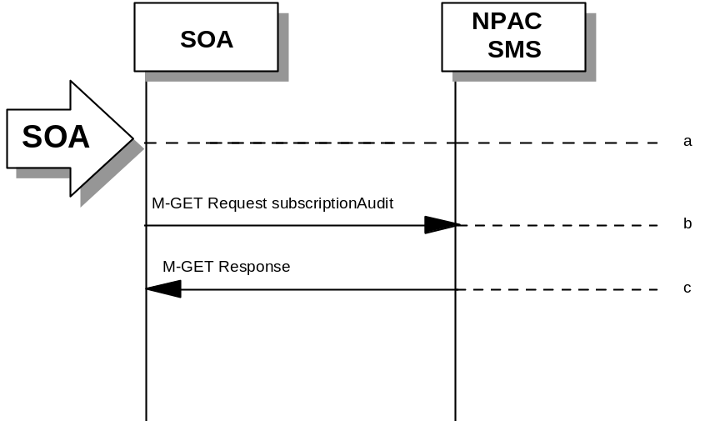The service provider SOA takes action to query an audit that it initiated.
- Service provider SOA sends an M-GET request for a subscriptionAudit on the NPAC SMS.
- NPAC SMS responds to an M-GET with the audit data or a failure and reason for failure. An accessDenied error will be returned to the service provider if they did not originate the audit queried.

SOA Audit Create for Subscription Versions within a Number Pool Block (previously NNP flow 6.1)
In this scenario, the SOA initiates the audit of one or more subscription versions that are within the range of a number pool block. For non-EDR Local SMSs, this involves the subscription version objects. For EDR Local SMSs, this involves both subscription version objects and number pool block objects.
If discrepancies are found, the NPAC SMS will create, modify or delete subscription version and number pool objects, as necessary. The NPAC SMS will report to the SOA the discrepancies with subscription version identifiers. Thus, if a numberPoolBlock object is in error, the discrepancy will be reported as all TNs within the audit range that were also within the block range. Subscription version discrepancies will be reported as usual.

SOA Creates and NPAC SMS Starts Audit (previously NNP flow 6.1.1)

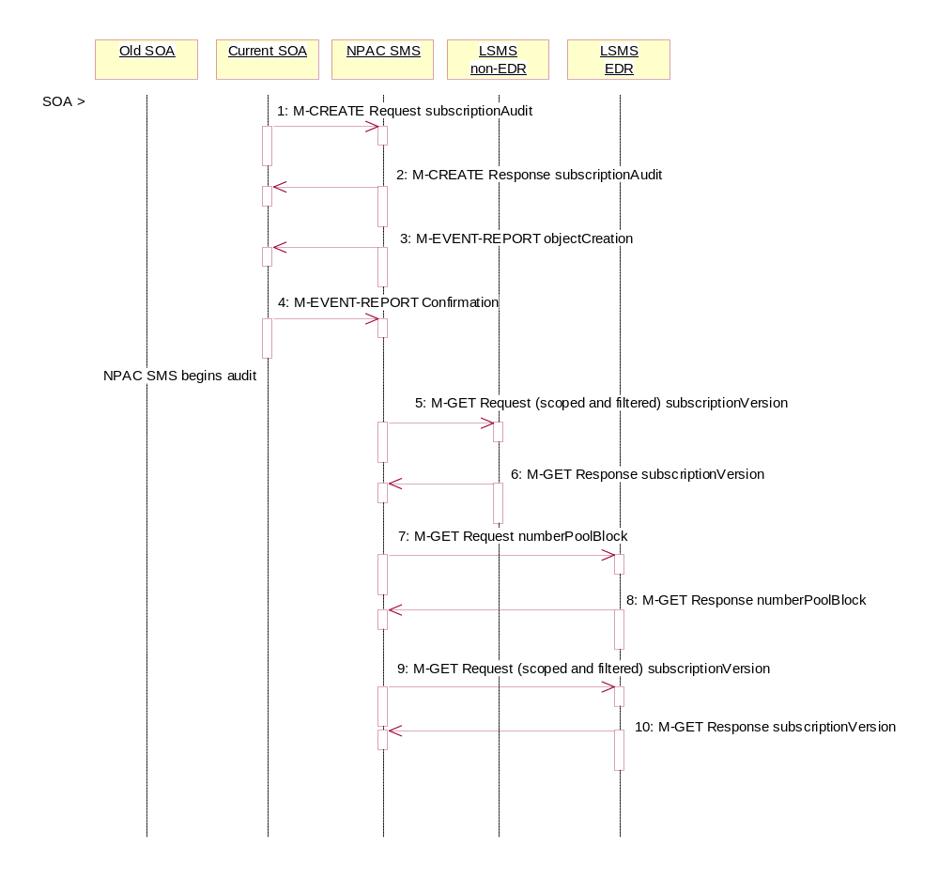
Action is taken by SOA personnel to start an audit due to suspected network discrepancies.
- The SOA sends an M-CREATE request to the NPAC SMS requesting an audit. The SOA must specify the following attributes in the request:
subscriptionAuditName – English audit name
subscriptionAuditRequestingSP – the service provider requesting the audit
subscriptionAuditServiceProvIdRange – which service provider or all service providers for audit
subscriptionAuditTN-Range – TNs to be audited. If only a single TN is to be audited, specify the ending TN station equal to the starting TN station.
If these attributes are not specified, then the create will fail with a missingAttributeValue error. The SOA may also specify the following attributes in the request:
subscriptionAuditAttributeList – subscription version attributes to be audited
subscriptionAuditTN-ActivationRange – time range of activation for subscription versions to be audited.
The subscriptionAuditId and the subscriptionAuditStatus will be determined by the NPAC SMS. If any values are deemed invalid, an invalidArgumentValue error will be returned.
- Once the NPAC SMS creates the audit request object, it sends an M-CREATE response back to the SOA that initiated the request.
- NPAC SMS sends M-EVENT-REPORT to the service provider SOA for the subscriptionAudit creation.
- The service provider SOA confirms the M-EVENT-REPORT.
NPAC SMS begins audit.
- The NPAC SMS sends an M-GET request to the non-EDR Local SMS to retrieve the subscription data for audit processing. The request uses the CMIP scoping and filtering options to retrieve only the subscriptionVersion objects to be audited.
- The non-EDR Local SMS responds to the M-GET request by returning the subscription version objects that satisfy the scope and filter data.
- The NPAC SMS sends an M-GET request to the EDR Local SMS to retrieve the number pool block for audit processing. The request uses the CMIP scoping and filtering options to retrieve only the numberPoolBlock objects to be audited.
- The EDR Local SMS responds to the M-GET request by returning the number pool object block requested.
- The NPAC SMS sends an M-GET request to the EDR Local SMS to retrieve the subscription version objects for audit processing. The request uses the CMIP scoping and filtering options to retrieve only the subscriptionVersion objects to be audited. No subscription versions with a LNP type of ‘pool’ should exist.
- The EDR Local SMS responds to the M-GET request by returning the subscription version objects that satisfy the scope and filter criteria.

NPAC SMS Performs Audit Comparisons for a SOA initiated Audit including a Number Pool Block (previously NNP flow 6.1.2)
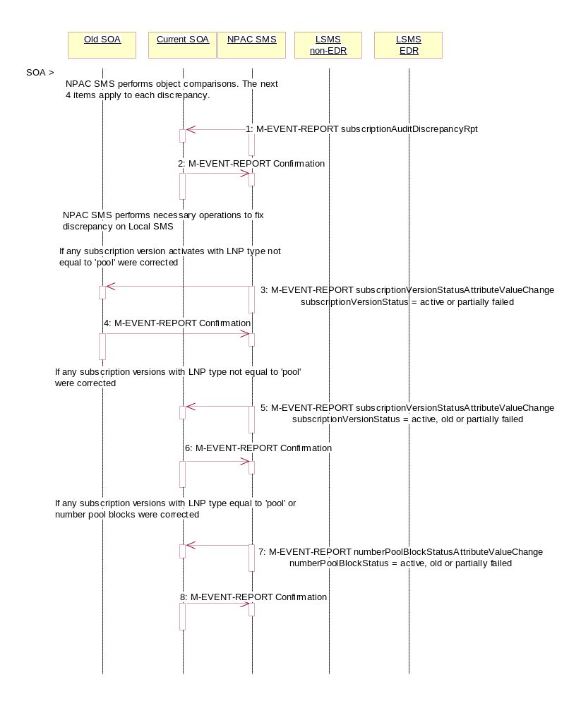
The SOA has sent in the audit request and the NPAC SMS had queried for the necessary data. The NPAC SMS now performs the necessary comparisons.
The NPAC SMS performs object comparisons. The next 4 items apply to each discrepancy.
- If a discrepancy is found, NPAC SMS issues a subscriptionAuditDiscrepancyRpt M-EVENT-REPORT.
- Service provider SOA confirms the M-EVENT-REPORT.
NPAC SMS performs necessary operations to fix each discrepancy on Local SMS. If any subscription versions with a LNP type of ‘pool’ are returned by the EDR Local SMS, they will be deleted and discrepancies reported.
- If any corrections were issued to any Local SMSs that changed the status or subscriptionFailed-SP-List of an activated subscription version, the NPAC SMS will send M-EVENT-REPORT to the old service provider SOA of the subscriptionVersionStatus and a list of failed Local SMSs (minus any updated Local SMSs that no longer contains a discrepancy).
- The old service provider SOA confirms the M-EVENT-REPORT.
- If any corrections were issued to any Local SMSs that changed the status or subscriptionFailed-SP-List of a subscription version, the NPAC SMS will send M-EVENT-REPORT to the current service provider SOA with the status and a list of failed Local SMSs (minus any updated Local SMSs that no longer contains a discrepancy).
- The current service provider SOA confirms the M-EVENT-REPORT.
- If any corrections were issued to any Local SMSs that changed the status or numberPoolBlockFailed-SP-List of a number pool block, either by correcting a number pool block or subscription version with LNP type equal to ‘pool’, the numberPoolBlockStatusAttributeValueChange will be sent to the block holder SOA if the numberPoolBlockSOA-Origination indicator is set to “TRUE”. The M-EVENT-REPORT will contain the numberPoolBlockStatus and numberPoolBlockFailed-SP-List.
- The block holder service provider confirms the M-EVENT-REPORT.

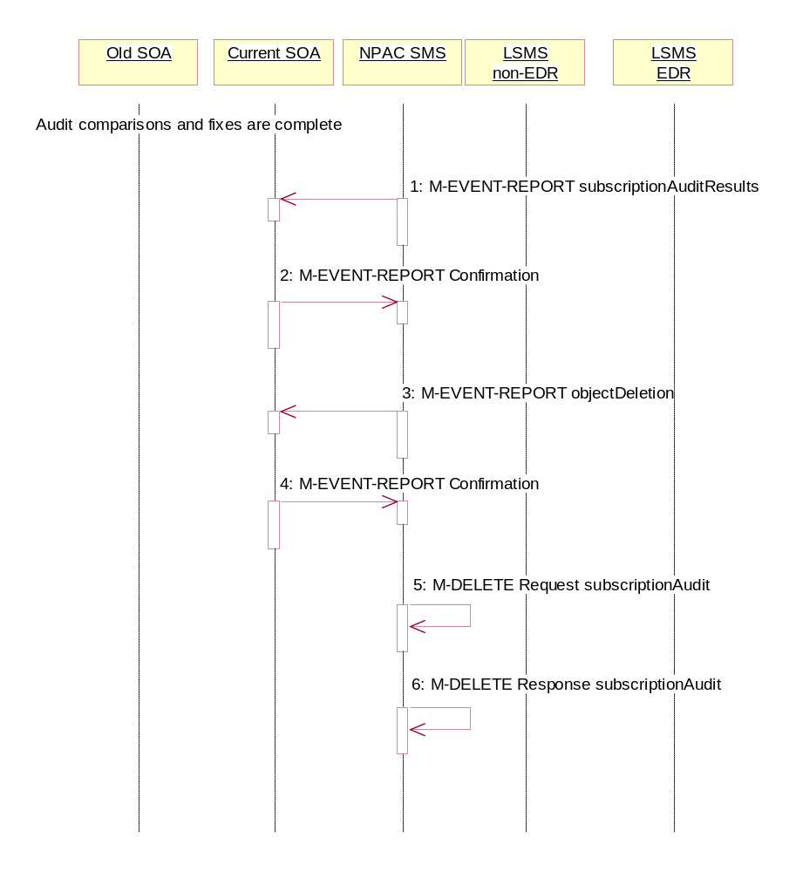
NPAC SMS Reports Audit Results (previously NNP flow 6.1.3)
The NPAC SMS has completed the audit. It has reported and fixed all discrepancies found. It now sends the final results to the SOA.
Audit comparisons and fixes are complete.
- NPAC SMS issues the subscriptionAuditResults M-EVENT-REPORT to the service provider SOA.
- The service provider SOA confirms the M-EVENT-REPORT.
- The NPAC SMS then sends an objectDeletion M-EVENT-REPORT to the SOA for the subscriptionAudit object.
- The service provider SOA confirms the M-EVENT-REPORT.
- The NPAC SMS issues a local M-DELETE request for the subscriptionAudit object to/from the NPAC SMS. This will attempt to delete the subscriptionAudit object on the NPAC SMS.
- The M-DELETE response is received on the NPAC SMS indicating whether the subscriptionAudit object was deleted successfully.

NPAC SMS Audit Create for Subscription Versions Within a Number Pool Block (previously NNP flow 6.2)
In this scenario, the NPAC SMS initiates an audit due to suspected subscriber data discrepancies. For non-EDR Local SMSs, this involves the subscription version objects. For EDR Local SMSs, this involves both subscription version objects and number pool block objects.
If discrepancies are found, the NPAC SMS will create, modify or delete subscription version and number pool objects, as necessary.

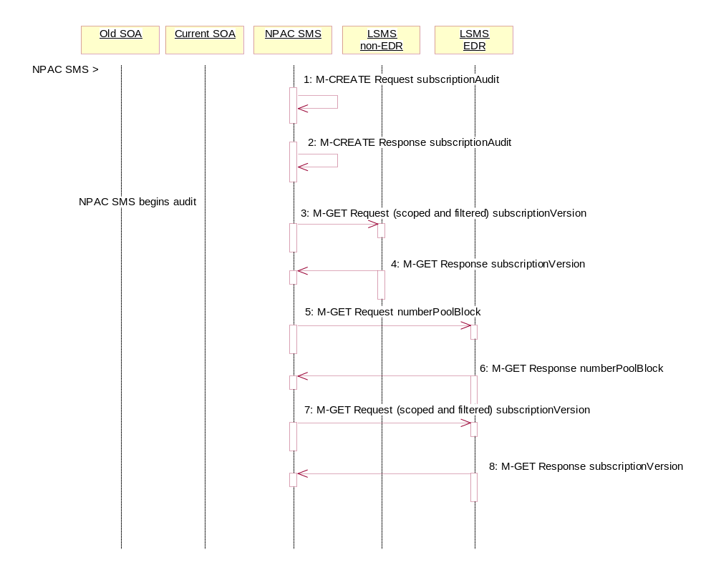
NPAC SMS Creates and Starts Audit (previously NNP flow 6.2.1)
- Action is taken by NPAC personnel to start an audit due to suspected network discrepancies.
- The NPAC SMS does a Local M-CREATE request for the subscriptionAudit object.
- The NPAC SMS responds with an M-CREATE response indicating that the subscriptionAudit was created successfully.
NPAC SMS begins audit.
- The NPAC SMS sends an M-GET request to the non-EDR Local SMS to retrieve the subscription data for audit processing. The request uses the CMIP scoping and filtering options to retrieve only the subscriptionVersion objects to be audited.
- The non-EDR Local SMS responds to the M-GET request by returning the subscription version objects that satisfy the scope and filter data.
- The NPAC SMS sends an M-GET request to the EDR Local SMS to retrieve the number pool block for audit processing.
- The EDR Local SMS responds to the M-GET request by returning the number pool object block requested.
- The NPAC SMS sends an M-GET request to the EDR Local SMS to retrieve the subscription version objects for audit processing. The request uses the CMIP scoping and filtering options to retrieve only the subscriptionVersion objects to be audited. No subscription versions with a LNP type of ‘pool’ should exist.
- The EDR Local SMS responds to the M-GET request by returning the subscription version objects that satisfy the scope and filter criteria.

NPAC SMS Performs Audit Comparisons for NPAC initiated Audit including a Number Pool Block (previously NNP flow 6.2.2)
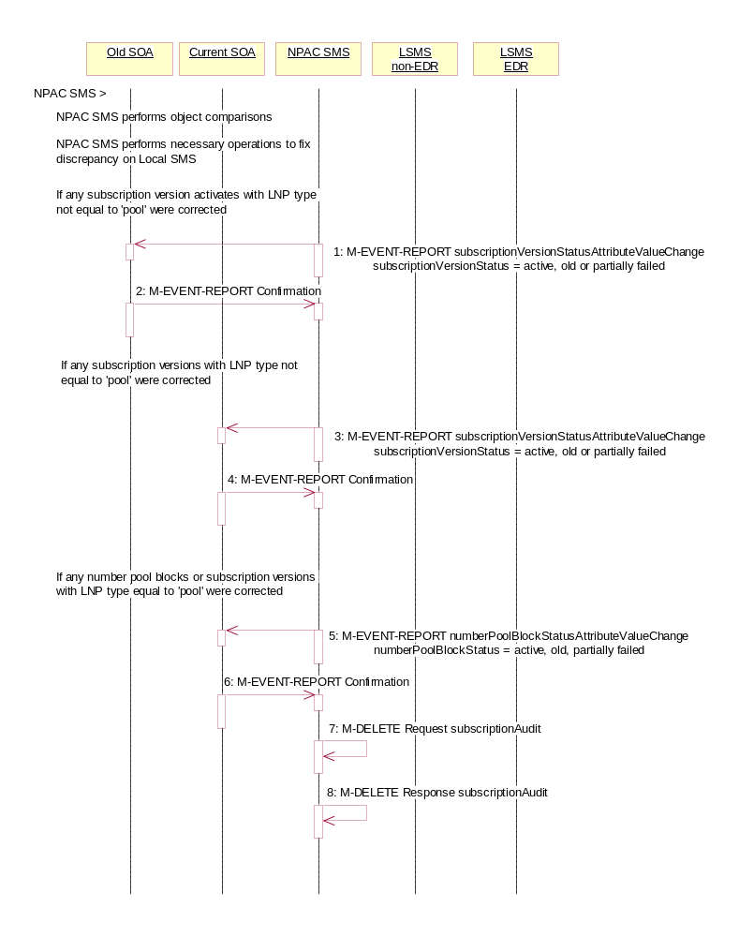
The NPAC SMS has queried for the required data and now proceeds to perform the audit comparisons.
NPAC SMS performs object comparisons.
NPAC SMS performs necessary operations to each fix discrepancy on Local SMS. If any subscription versions with a LNP type of ‘pool’ are returned by the EDR Local SMS, they will be deleted and discrepancies reported.
- If any corrections were issued to any Local SMSs that changed the status or subscriptionFailed-SP-List of an activated subscription version, the NPAC SMS will send the M-EVENT-REPORT to the old service provider SOA with the subscriptionVersionStatus and a list of failed Local SMSs (minus any updated Local SMSs that no longer contain a discrepancy).
- The old service provider SOA confirms the M-EVENT-REPORT.
- If any corrections were issued to any Local SMSs that changed the status or subscriptionFailed-SP-List of a subscription version, the NPAC SMS will send M-EVENT-REPORT to the current service provider SOA with the subscriptionVersionStatus and a list of failed Local SMSs (minus any updated Local SMSs that no longer contain a discrepancy).
- The current service provider SOA confirms the M-EVENT-REPORT.
- If any corrections were issued to any Local SMSs that changed the status or numberPoolBlockFailed-SP-List of a number pool block, either by correcting a number pool block or subscription version with LNP type equal to ‘pool’, the numberPoolBlockStatusAttributeValueChange will be sent to the block holder SOA if the numberPoolBlockSOA-Origination indicator is set to “TRUE”. The M-EVENT-REPORT will contain the numberPoolBlockStatus and numberPoolBlockFailed-SP-List.
- The block holder service provider confirms the M-EVENT-REPORT.
- The NPAC SMS issues an M-DELETE request to remove the subscriptionAudit object from the NPAC SMS.
- The NPAC SMS response is received by the NPAC SMS indicating whether the subscriptionAudit object was deleted successfully.

Service Provider Scenarios

Service Provider Creation by the NPAC
In this scenario, the NPAC SMS creates data for a new LNP service provider. The addition of NPA-NXX and LRN data for a new service provider will be shown in flows that follow.
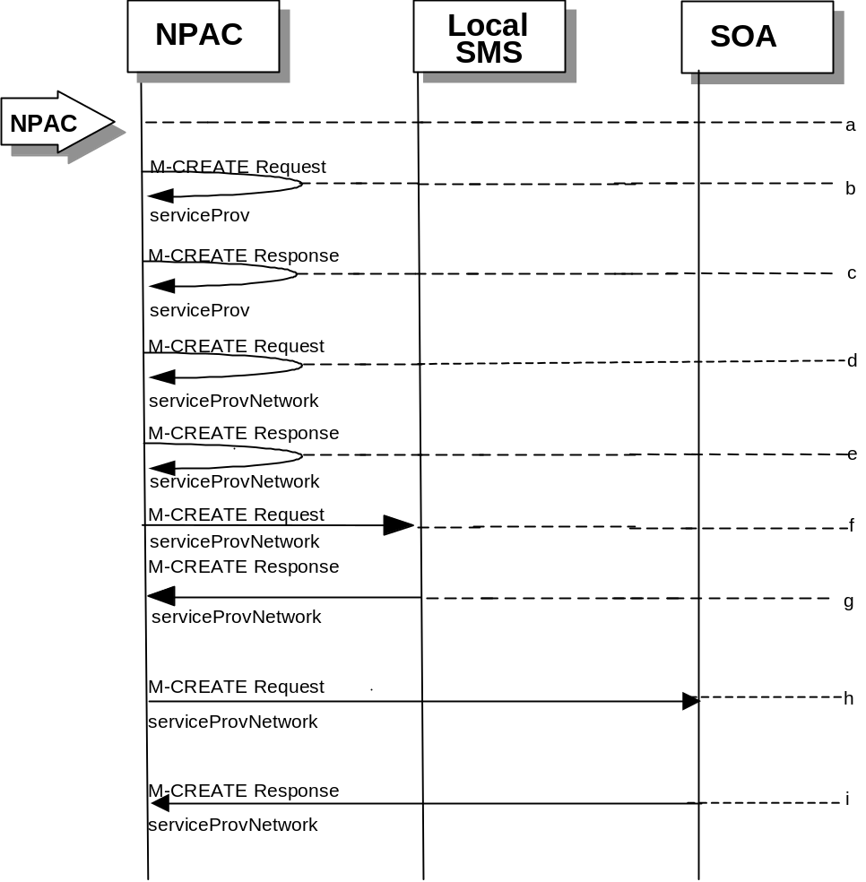
- Action is taken by NPAC SMS personnel to create a new service provider.
- Issue a local M-CREATE request for the serviceProv object to/from the NPAC SMS. This will attempt to create the serviceProv object on the NPAC SMS. If the M-CREATE fails, the appropriate error will be returned.
- The M-CREATE response is received on the NPAC SMS indicating whether the serviceProv object was created successfully. If a failure occurs, processing will stop.
- Issue a local M-CREATE request for the serviceProvNetwork object to/from the NPAC SMS. This will attempt to create the serviceProvNetwork object on the NPAC SMS. If the M-CREATE fails, the appropriate error will be returned.
- The M-CREATE response is received on the NPAC SMS indicating whether the serviceProvNetwork object was created successfully. If the object cannot be created, the serviceProv object is deleted and an error is returned.
- The NPAC SMS sends an M-CREATE request for the serviceProvNetwork object to each of the Local SMS(s).
- The Local SMS(s) will respond by sending an M-CREATE response back to the NPAC SMS.
- The NPAC SMS sends an M-CREATE request for the serviceProvNetwork object to each of the SOA(s).
- The SOA(s) will respond by sending an M-CREATE response back to the NPAC SMS.

Service Provider Deletion by the NPAC
In this scenario, the NPAC SMS deletes data for an LNP service provider with no network data.
- Action is taken by NPAC SMS personnel to delete an existing service provider.
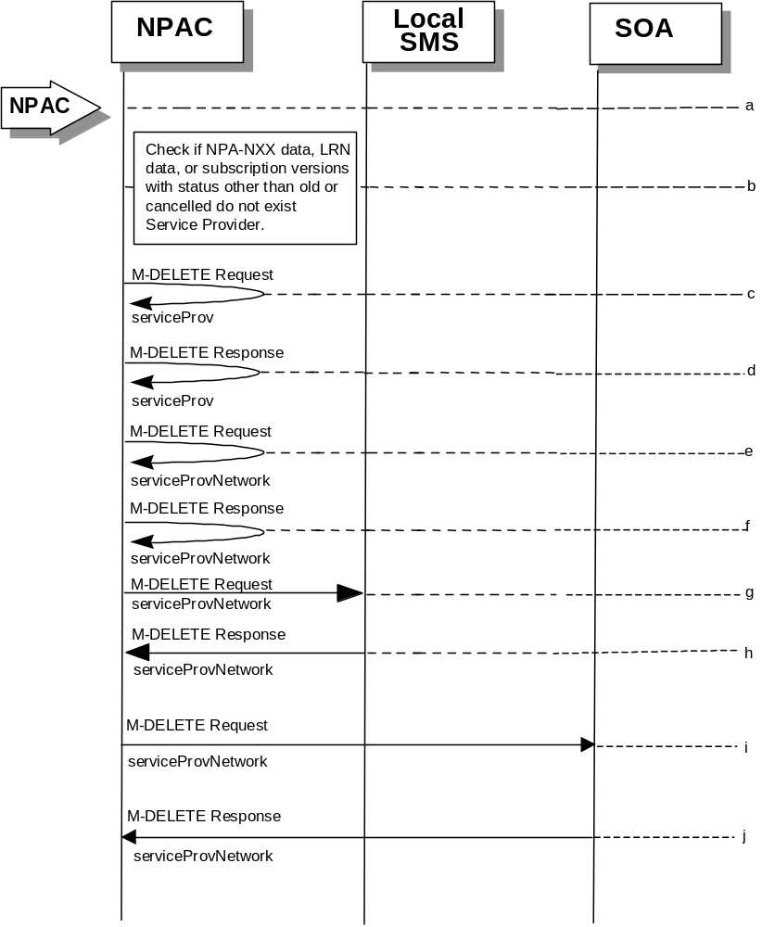
- Check the database to see if the service provider has associated with it NPA-NXX data, LRN data, or subscription versions with status other than old or canceled. If so, deny the request.
- Issue a local M-DELETE request for the serviceProv object to/from the NPAC SMS. This will attempt to delete the serviceProv object on the NPAC SMS.
- The M-Delete response is received on the NPAC SMS indicating whether the serviceProv object was deleted successfully.
- If the serviceProv object was deleted, issue a local M-DELETE request for the serviceProvNetwork object to/from the NPAC SMS. This will attempt to delete the serviceProvNetwork object on the NPAC SMS.
- The M-DELETE response is received on the NPAC SMS indicating whether the serviceProvNetwork object was deleted successfully.
- If the serviceProvNetwork object was deleted, the NPAC SMS sends an M-DELETE request for the serviceProvNetwork object to each of the Local SMS(s).
- The Local SMS(s) will respond by sending an M-DELETE response back to the NPAC SMS.
- If the serviceProvNetwork object was deleted, the NPAC SMS sends an M-DELETE request for the serviceProvNetwork object to each of the SOA(s).
- The SOA(s) will respond by sending an M-DELETE response back to the NPAC SMS.

Service Provider Modification by the NPAC
In this scenario, the NPAC SMS modifies the LNP service provider data.
- Action is taken by the NPAC personnel to modify data for an existing service provider.
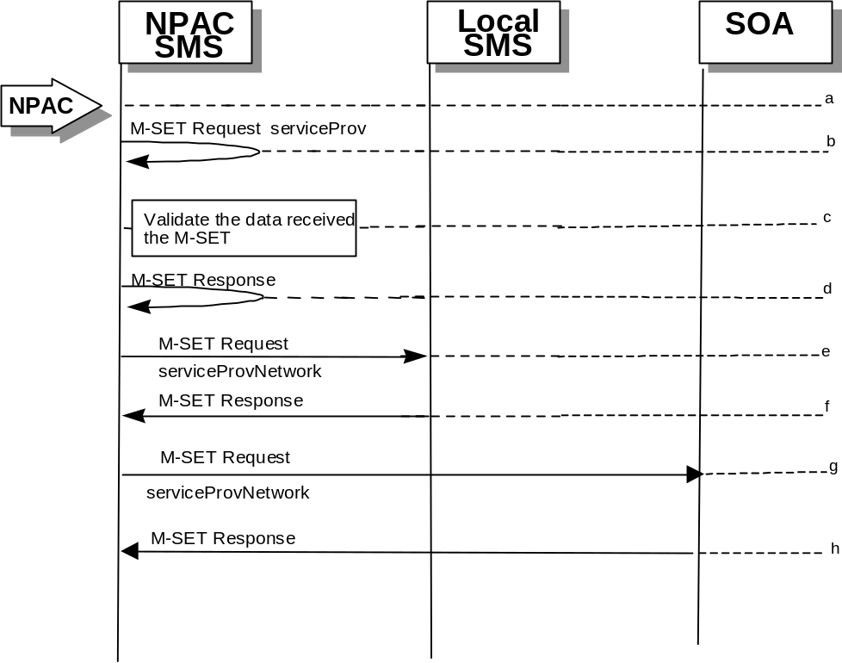
- Issue a local M-SET request for the serviceProv object to/from the NPAC SMS. This will attempt to set the specified information on the NPAC SMS.
- Validate the data to be set in the M-SET request. An M-SET Error Response of invalidArgumentValue is returned if any data is deemed invalid.
- The M-SET response is received on the NPAC SMS indicating whether the serviceProv object was modified successfully.
- NPAC SMS performs an M-SET for the serviceProvNetwork to all the Local SMS(s) if the service provider name changed.
- The Local SMS(s) respond.
- NPAC SMS performs an M-SET for the service ProvNetwork to all the SOA(s) if the service provider name changed.
- The SOA(s) respond.

Service Provider Modification by the Local SMS
In this scenario, the Local SMS modifies its own service provider data.

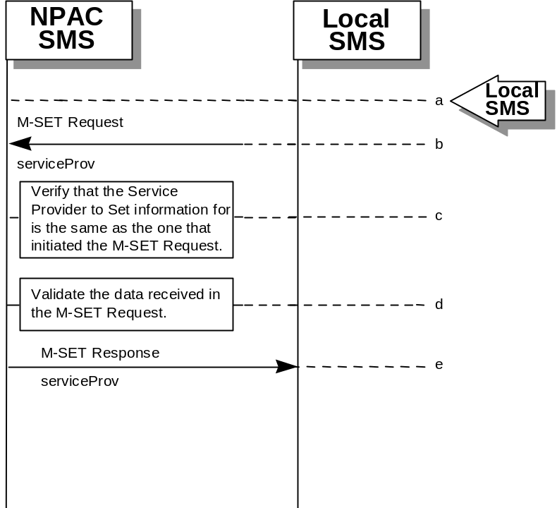
- Action is taken by the Local SMS personnel to modify their own service provider data.
- The Local SMS sends an M-SET request to the NPAC SMS to modify their service provider information.
- The NPAC SMS verifies that the service provider to be modified is owned by the service provider that initiated the request. If not, an access denied M-SET Error Response of invalidArgumentValue is returned.
- Validate the data to be set in the M-SET request. An invalidArgumentValue M-SET Error Response is returned if any data is deemed invalid.
- The NPAC SMS sends an M-SET response back to the Local SMS that initiated the request

Service Provider Modification by the SOA

In this scenario, the SOA modifies its own service provider data.
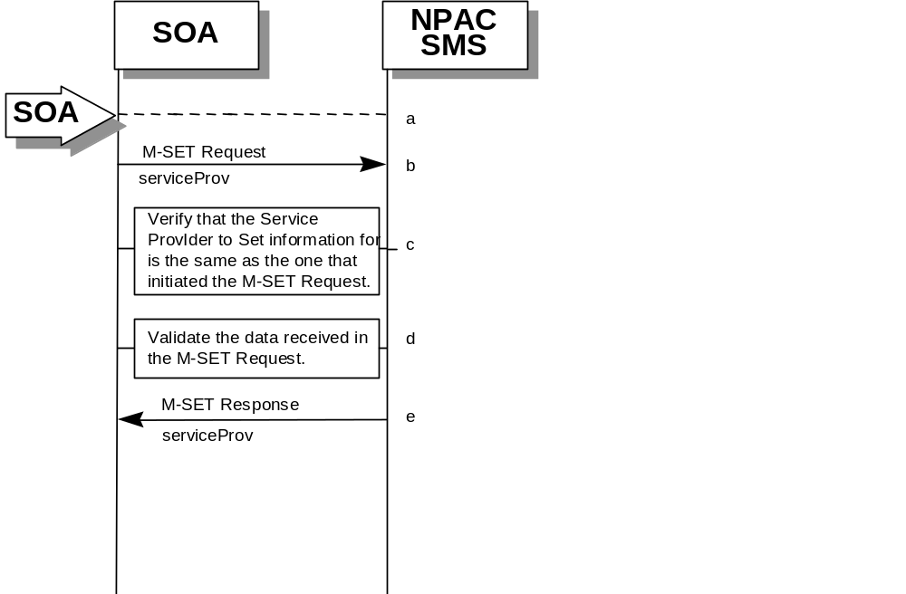

- Action is taken by the SOA to modify their own service provider data.
- The SOA sends an M-SET request to the NPAC SMS to modify their service provider information.
- The NPAC SMS verifies that the service provider to be modified is owned by the service provider that initiated the request. If not, an access denied M-SET Error Response is returned.
- Validate the data to be set in the M-SET request. An invalidArgumentValue M-SET Error Response is returned if any data is deemed invalid.
- The NPAC SMS sends an M-SET response back to the SOA that initiated the request.

Service Provider Query by the Local SMS
In this scenario, the Local SMS queries their own service provider data.
- 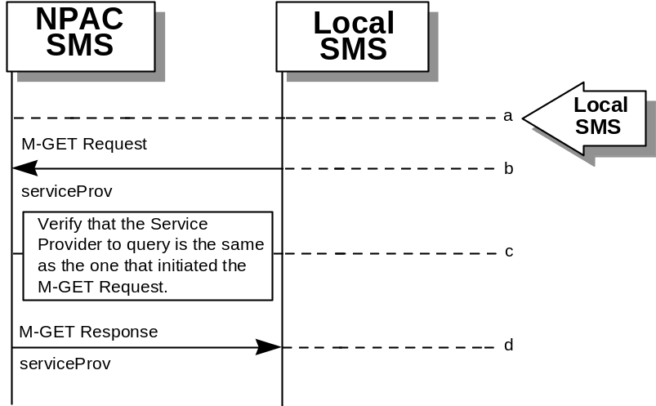Action is taken by the Local SMS personnel to query their own service provider data.
- The Local SMS sends an M-GET request to the NPAC SMS requesting their own service provider information.
- The NPAC SMS verifies that the service provider information to be retrieved is owned by the service provider that initiated the request. If not, an M-GET Error Response of accessDenied is returned if the two service providers do not match.
- The NPAC SMS sends an M-GET response containing the requested service provider information back to the Local SMS or SOA that initiated the request.

Service Provider Query by the SOA
In this scenario, the SOA queries their own service provider data.
- 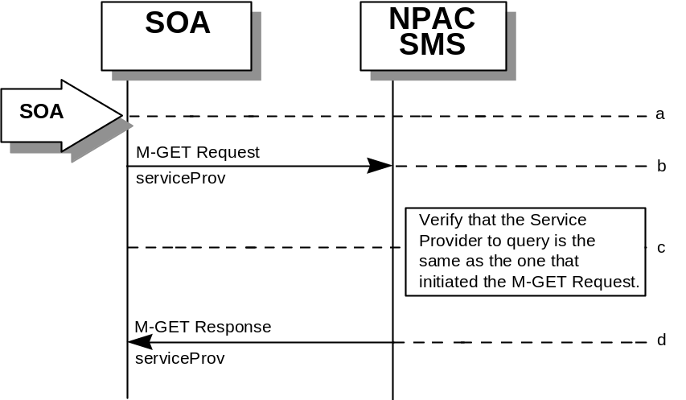Action is taken by the SOA or SOA personnel to query their own service provider data.
- The SOA sends an M-GET request to the NPAC SMS requesting their own service provider information.
- The NPAC SMS verifies that the service provider information to be retrieved is owned by the service provider that initiated the request. If not, an M-GET error response of accessDenied is returned if the two service providers do not match.
- The NPAC SMS sends an M-GET response containing the requested service provider information back to the SOA that initiated the request.

Service Provider Network Data Scenarios

NPA-NXX Scenarios

NPA-NXX Creation by the NPAC
In this scenario, NPAC SMS creates new NPA-NXX data for an LNP service provider.
- Action is taken by the NPAC Personnel to create an NPA-NXX for a specified service provider.
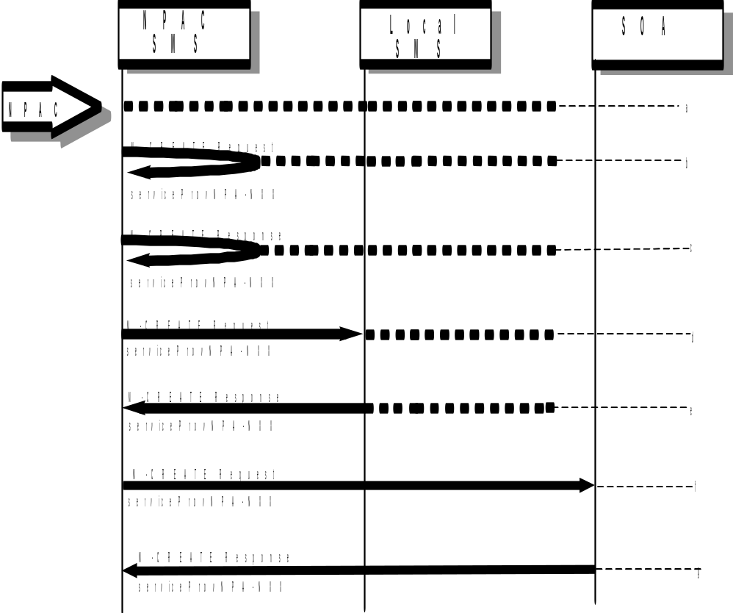
- The NPAC SMS sends an M-CREATE request to itself in order to create a local serviceProvNPA-NXX object.
- The NPAC SMS receives the M-CREATE response indicating whether the serviceProvNPA-NXX object was created successfully.
- If the serviceProvNPA-NXX object was created, the NPAC SMS sends an M-CREATE request to all Local SMS(s) accepting downloads for the NPA-NXX for the serviceProvNPA-NXX object.
- The Local SMS(s) respond by sending an M-CREATE response indicating whether the serviceProvNPA-NXX object was created successfully.
- If the serviceProvNPA-NXX object was created, the NPAC SMS sends an M-CREATE request to all SOA(s) accepting downloads for the NPA-NXX for the serviceProvNPA-NXX object.
- The SOA(s) respond by sending an M-CREATE response indicating whether the serviceProvNPA-NXX object was created successfully.

NPA-NXX Deletion by the NPAC
In this scenario, NPAC SMS deletes an NPA-NXX for an LNP service provider.
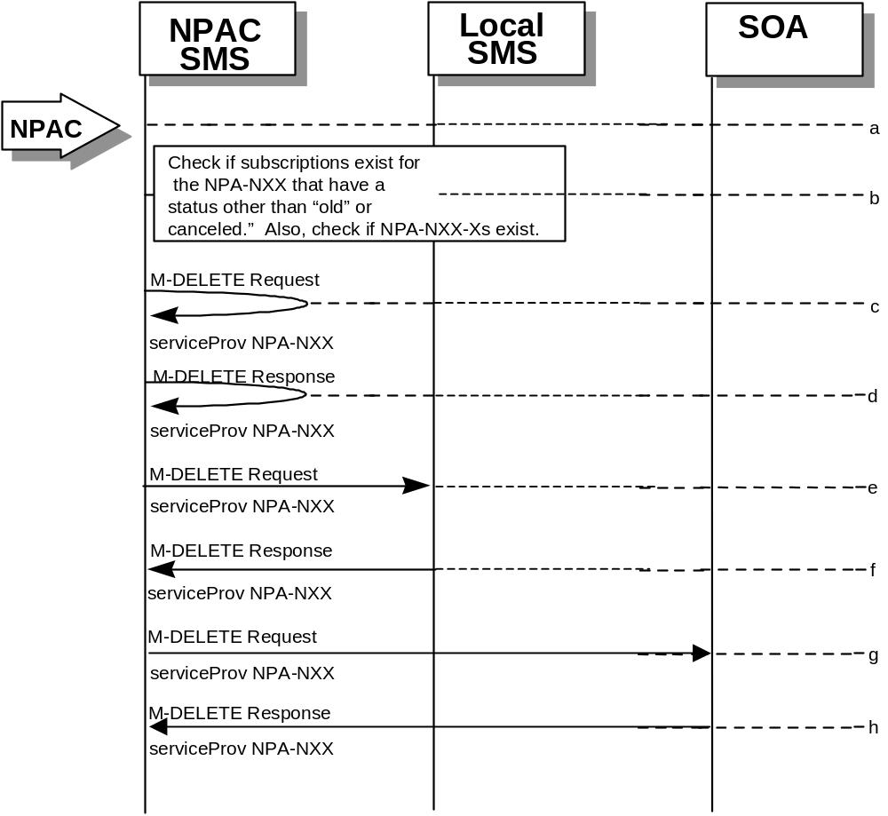
- Action is taken by NPAC SMS personnel to delete an NPA-NXX for a specified service provider.
- Check the subscriptions database to see if subscriptions exist with this NPa-NXX that have a status other than “old” or “canceled.” Also, check if any NPA-NXX-Xs exist with this NPA-NXX. If so, terminate processing at this point.
- The NPAC SMS sends an M-DELETE request to itself in order to delete the local serviceProvNPA-NXX object.
- The NPAC SMS receives the M-DELETE response indicating whether the serviceProvNPA-NXX object was deleted successfully.
- If the serviceProvNPA-NXX object was deleted, the NPAC SMS sends an M-DELETE request to all Local SMS(s) accepting downloads for the NPA-NXX for the serviceProvNPA-NXX object.
- The Local SMS(s) responds by sending an M-DELETE response to the NPAC SMS indicating whether the serviceProvNPA-NXX object was deleted successfully.
- If the serviceProvNPA-NXX object was deleted, the NPAC SMS sends an M-DELETE request to all SOA(s) accepting downloads for the NPA-NXX for the serviceProvNPA-NXX object.
- The SOA(s) responds by sending an M-DELETE response to the NPAC SMS indicating whether the serviceProvNPA-NXX object was deleted successfully.

NPA-NXX Creation by the Local SMS
In this scenario, the Local SMS creates a new NPA-NXX for its own service provider network data.
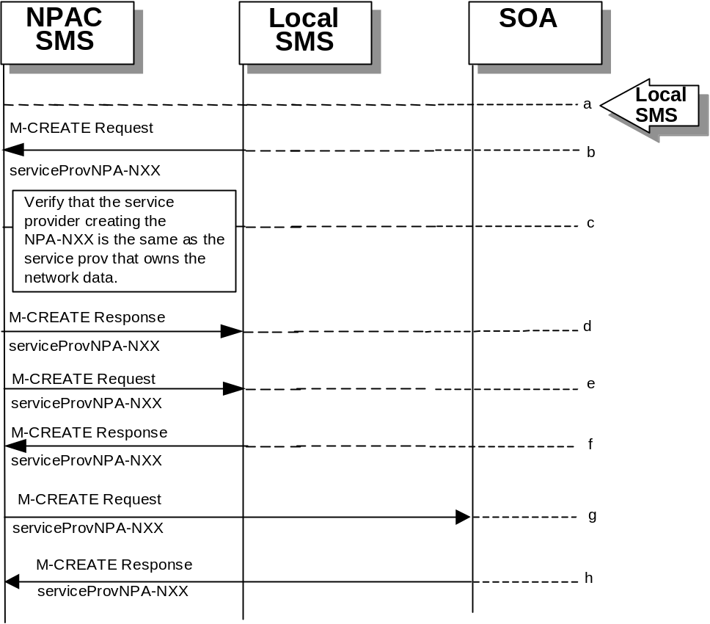
- Action is taken by the Local SMS personnel to create an NPA-NXX available for porting in their own service provider network.
- The Local SMS sends an M-CREATE request to the NPAC requesting that an NPA-NXX object be created for their own service provider network.
- The NPAC SMS verifies that the service provider creating the NPA-NXX information is the same as the service provider that owns the network data. If not, then an access denied M-CREATE accessDenied Error Response is returned.
- The NPAC SMS responds by sending an M-CREATE response to the Local SMS that initiated the request indicating whether the serviceProvNPA-NXX object was created successfully.
- If the serviceProvNPA-NXX object was created, the NPAC SMS sends an M-CREATE request to all Local SMS(s) accepting downloads for the NPA-NXX for the serviceProvNPA-NXX object.
- The Local SMS(s) responds by sending an M-CREATE Response indicating whether the serviceProvNPA-NXX object was created successfully.
- If the serviceProvNPA-NXX object was created, the NPAC SMS sends an M-CREATE request to all SOA(s) accepting downloads for the NPA-NXX for the serviceProvNPA-NXX object.
- The SOA(s) responds by sending an M-CREATE Response indicating whether the serviceProvNPA-NXX object was created successfully.

NPA-NXX Creation by the SOA
In this scenario, the SOA creates a new NPA-NXX for its own service provider network data.
- Action is taken by the SOA personnel to create an NPA-NXX available for porting in their own service provider network.
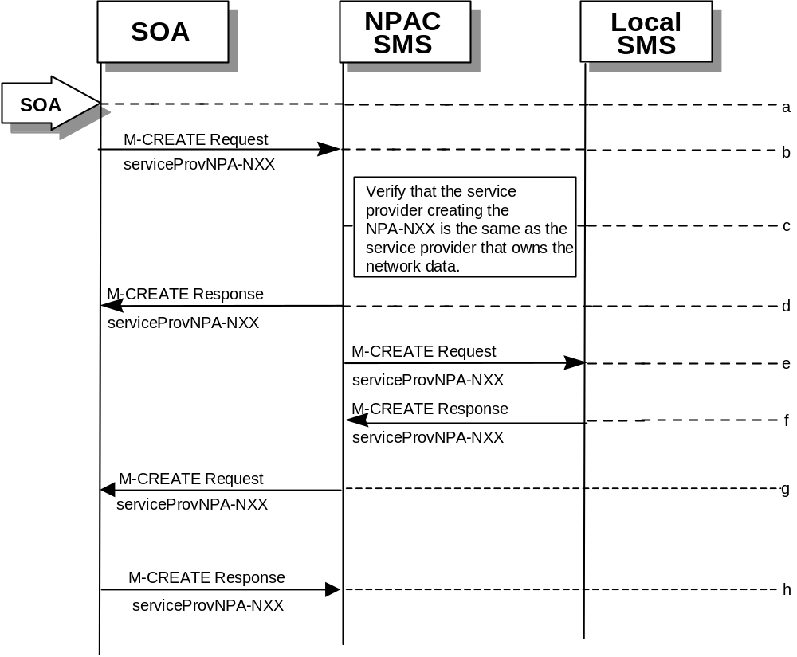
- The SOA sends an M-CREATE request to the NPAC requesting that an NPA-NXX object be created for their own service provider network.
- The NPAC SMS verifies that the service provider creating the NPA-NXX information is the same as the service provider that owns the network data. If not, then an access denied M-CREATE response is returned to the SOA that initiated the request.
- The NPAC SMS sends an M-CREATE response back to the SOA for the serviceProvNPA-NXX object.
- The NPAC SMS sends an M-CREATE request to all Local SMS(s) accepting downloads for the NPA-NXX for the serviceProvNPA-NXX object.
- The Local SMS(s) responds by sending an M-CREATE response indicating whether the serviceProvNPA-NXX object was created successfully.
- The NPAC SMS sends an M-CREATE request to all SOA(s) accepting downloads for the NPA-NXX for the serviceProvNPA-NXX object.
- The SOA(s) responds by sending an M-CREATE response indicating whether the serviceProvNPA-NXX object was created successfully.

NPA-NXX Deletion by the Local SMS
In this scenario, the Local SMS deletes an NPA-NXX in its own service provider network data.
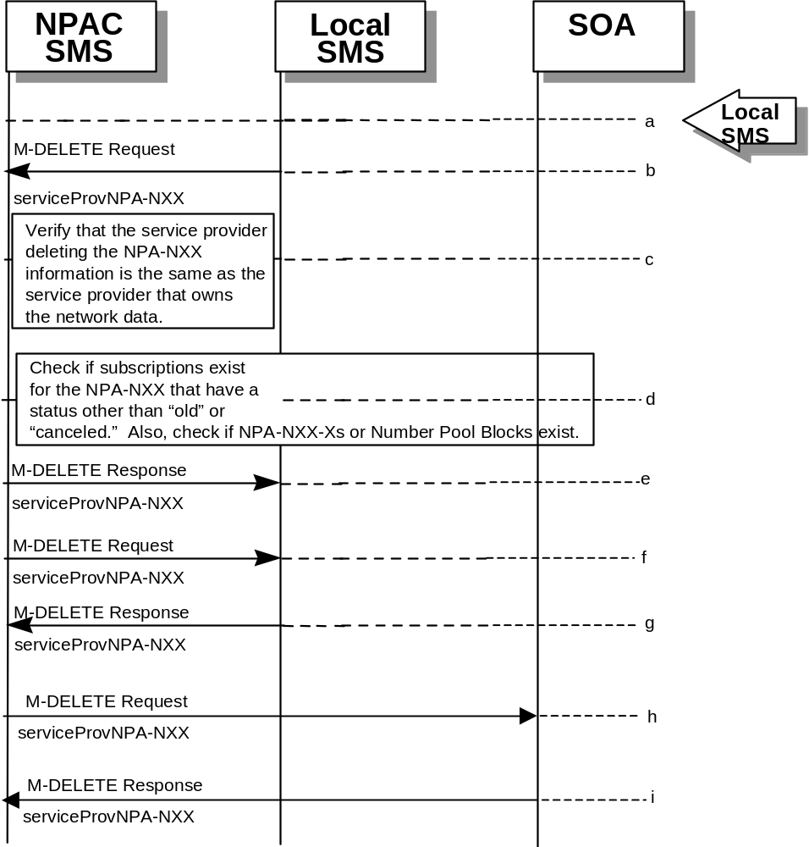
- Action is taken by the Local SMS personnel to delete an NPA-NXX for their own service provider network data.
- The SMS sends an M-DELETE request to the NPAC SMS requesting that an NPA-NXX object be deleted for their own service provider.
- The NPAC SMS verifies that the service provider that owns the NPAC-NXX information to be deleted is the same as the service provider that owns the network data. If not, then an M-DELETE accessDenied error response is returned.
- Check the subscriptions database to see if subscriptions exist with this NPA-NXX that have a status other than “old” or canceled.” Also, check if any NPA-NXX-Xs or Number Pool Blocks exist with this NPA-NXX. If so, terminate processing at this point.
- The NPAC SMS responds by sending an M-DELETE response indicating whether the serviceProvNPA-NXX object was deleted successfully.
- If the serviceProvNPA-NXX object was deleted, the NPAC SMS sends an M-DELETE request to all Local SMS(s) accepting downloads for the NPA-NXX for the serviceProvNPA-NXX object.
- The Local SMS(s) responds by sending an M-DELETE response indicating whether the serviceProvNPA-NXX object was deleted successfully.
- If the serviceProvNPA-NXX object was deleted, the NPAC SMS sends an M-DELETE request to all SOA(s) accepting downloads for the NPA-NXX for the serviceProvNPA-NXX object.
- The SOA(s) responds by sending an M-DELETE response indicating whether the serviceProvNPA-NXX object was deleted successfully.

NPA-NXX Deletion by SOA
In this scenario, the SOA deletes a new NPA-NXX for its own service provider network data.
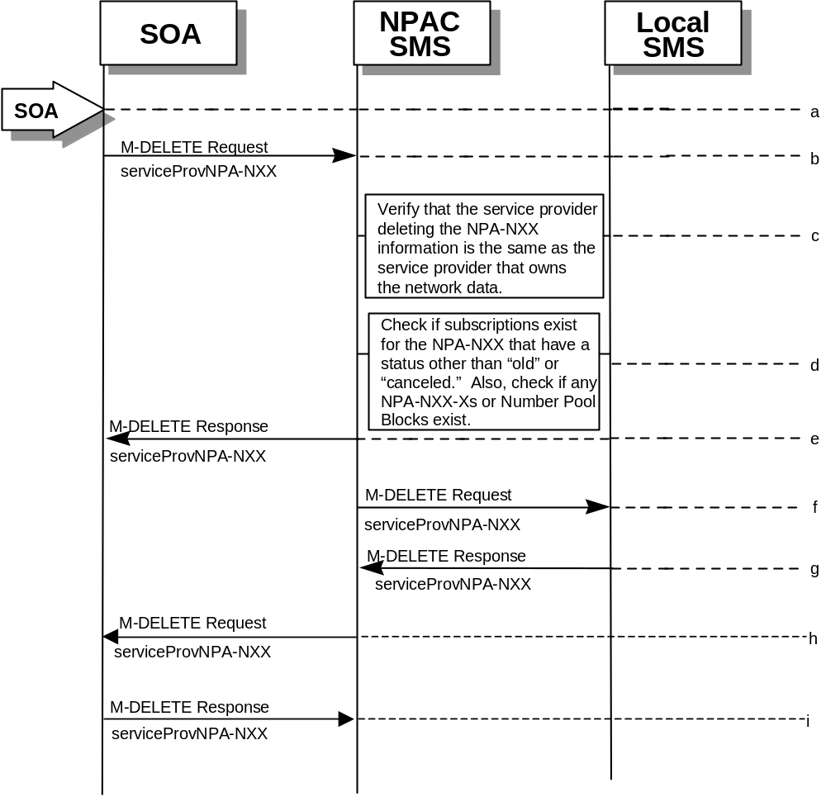
- Action is taken by the SOA personnel to delete an NPA-NXX for their own service provider network data.
- The SOA sends an M-DELETE request to the NPAC SMS requesting that an NPA-NXX object be deleted for their own service provider.
- The NPAC SMS verifies that the service provider that owns the NPA-NXX information to be deleted is the same as the service provider that owns the network data. If not, then an M-DELETE accessDenied Error Response is returned.
- Check the subscriptions database to see if subscriptions exist with this NPA-NXX that have a status other than “old” or “canceled.” Also, check if any NPA-NXX-Xs or Number Pool Blocks exist with this NPA-NXX. If so, terminate processing at this point.
- The NPAC SMS responds by sending an M-DELETE response indicating whether the serviceProvNPA-NXX object was deleted successfully.
- The NPAC SMS sends an M-DELETE request to all Local SMS(s) accepting downloads for the NPA-NXX for the serviceProvNPA-NXX object.
- The Local SMS(s) respond by sending an M-DELETE response indicating whether the serviceProvNPA-NXX object was deleted successfully.
- The NPAC SMS sends an M-DELETE request to all SOA(s) accepting downloads for the NPA-NXX for the serviceProvNPA-NXX object.
- The SOA(s) respond by sending an M-DELETE response indicating whether the serviceProvNPA-NXX object was deleted successfully

NPA-NXX Query by the Local SMS
In this scenario, the Local SMS queries for NPA-NXX data.
- 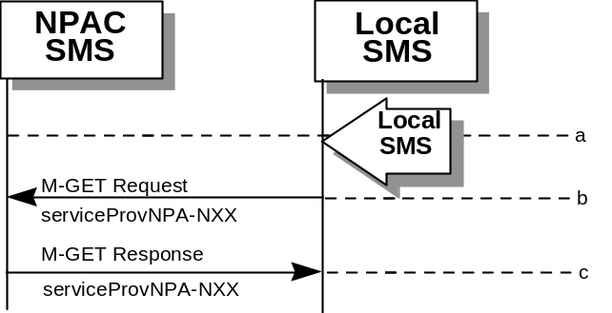Action is taken by Local SMS personnel to query for a serviceProvNPA-NXX.
- The Local SMS sends an M-GET request to the NPAC SMS for the serviceProvNPA-NXX object.
- The NPAC SMS responds by sending an M-GET response containing the NPA-NXX data back to the Local SMS.

NPA-NXX Query by the SOA
In this scenario, the SOA queries for NPA-NXX updates.
- 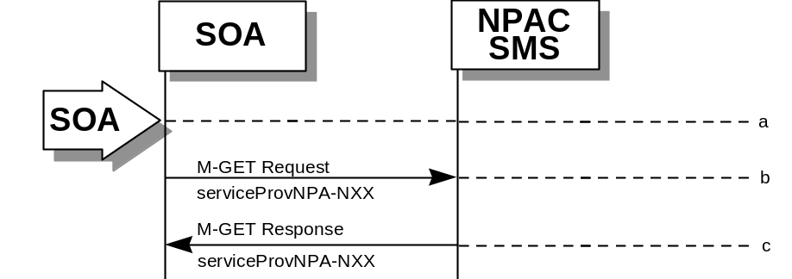Action is taken by SOA personnel to query for a serviceProvNPA-NXX.
- The SOA sends an M-GET request to the NPAC SMS for the serviceProvNPA-NXX object.
- The NPAC SMS responds by sending an M-GET response containing the NPA-NXX data back to the SOA.

LRN Scenarios

LRN Creation by the NPAC
In this scenario, the NPAC SMS creates an LRN.
- Action is taken by the NPAC personnel to create an LRN for an existing service provider.
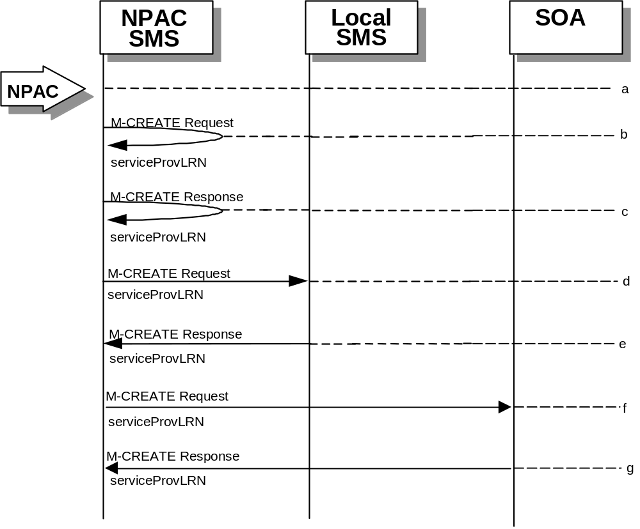
- The NPAC SMS sends an M-CREATE request to itself in order to create a local serviceProvLRN object.
- The NPAC SMS receives the M-CREATE response indicating whether the serviceProvLRN object was created successfully.
- If the serviceProvLRN object was created, the NPAC SMS sends an M-CREATE request to all Local SMS(s) for the serviceProvLRN object.
- The Local SMS(s) responds by sending an M-CREATE response indicating whether the serviceProvLRN object was created successfully.
- If the serviceProvLRN object was created, the NPAC SMS sends an M-CREATE request to all SOA(s) for the serviceProvLRN object.
- The SOA(s) responds by sending an M-CREATE response indicating whether the serviceProvLRN object was created successfully.

LRN Creation by the SOA
In this scenario, the SOA creates an LRN for its own service provider network data.
- Action is taken by the SOA personnel to create an LRN for their own network data.
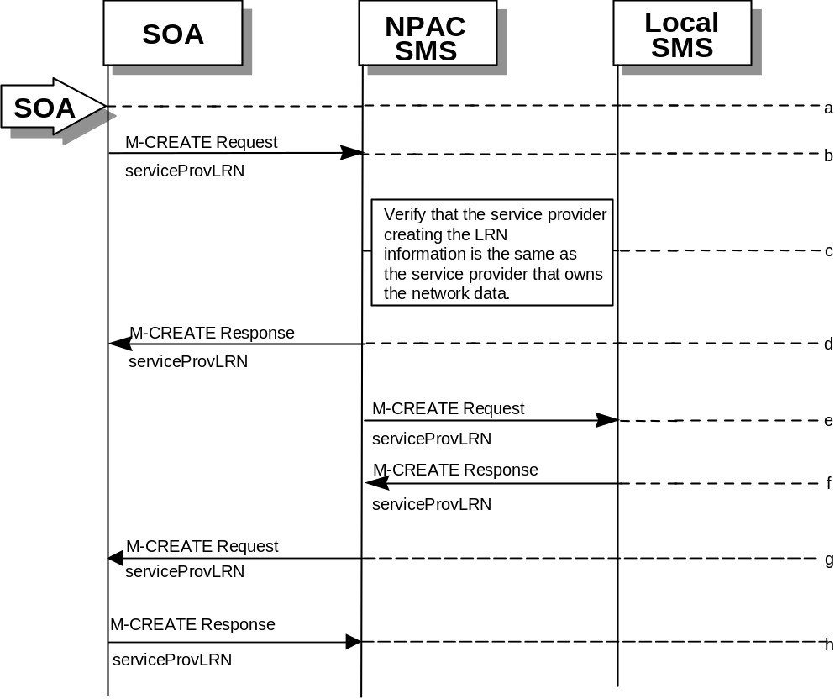
- The SOA sends an M-CREATE request to the NPAC SMS requesting that an LRN object be created for their own network data.
- The NPAC SMS verifies that the service provider creating the LRN information is the same as the service provider that owns the service provider network data. If not, then an accessDenied M-CREATE Error Response is returned.
- The NPAC SMS responds by sending an M-CREATE response back to the SOA that initiated the request, indicating whether the serviceProvLRN object was created successfully.
- The NPAC SMS sends an M-CREATE request to all Local SMS(s) for the serviceProvLRN object.
- The Local SMS(s) respond by sending an M-CREATE response indicating whether the service provider LRN object was created successfully.
- The NPAC SMS sends an M-CREATE request to all SOA(s) for the serviceProvLRN object.
- The SOA(s) respond by sending an M-CREATE response indicating whether the service provider LRN object was created successfully.

LRN Deletion by the SOA
In this scenario, the SOA deletes an LRN for their own service provider network data.
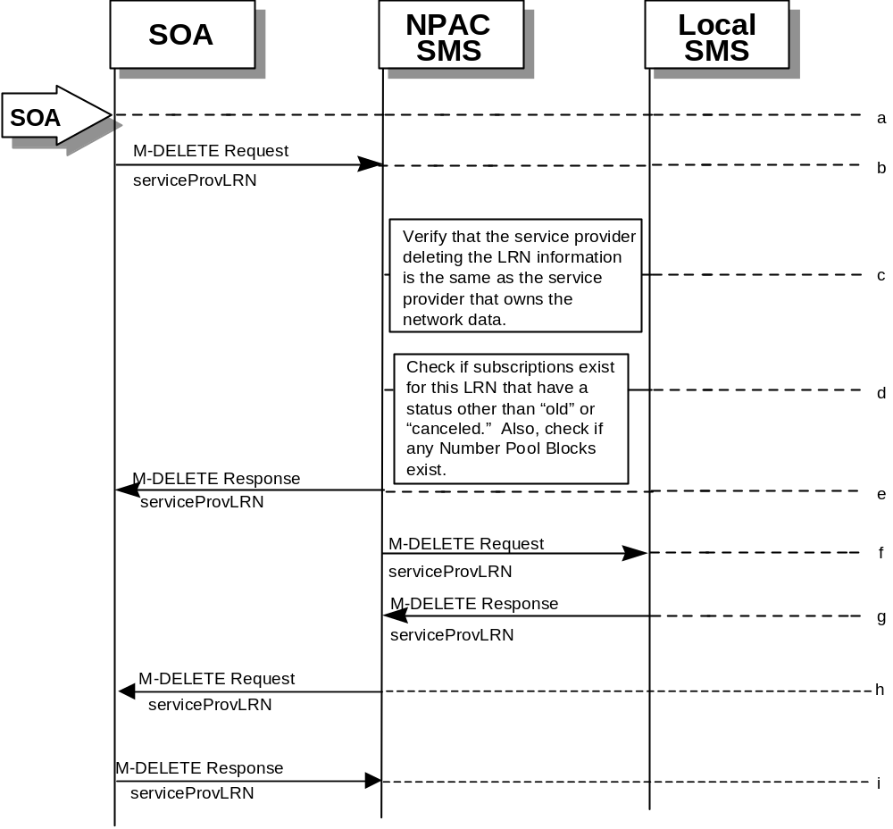
- Action is taken by the SOA personnel to delete an LRN for their own network data.
- The SOA sends an M-DELETE request to the NPA requesting that an LRN object be deleted.
- The NPAC SMS verifies that the service provider deleting the LRN information is the same as the service provider that is associated with the network data. If not, then an accessDenied M-DELETE error response is returned.
- Check the subscriptions database to see if subscriptions exist with this LRN that have a status other than “old” or “canceled.” Also, check if any Number Pool Blocks exist with this NPA-NXX. If so, an M-SET error response complexity limitation is returned.
- The NPAC SMS responds by sending an M-DELETE response indicating whether the serviceProvLRN object was deleted successfully.
- The NPAC SMS sends an M-DELETE request to all Local SMS(s) for the serviceProvLRN object.
- The Local SMS(s) responds by sending a message indicating whether the serviceProvLRN object was deleted successfully.
- The NPAC SMS sends an M-DELETE request to all SOA(s) for the serviceProvLRN object.
- The SOA(s) responds by sending a message indicating whether the serviceProvLRN object was deleted successfully.

LRN Query by the SOA
In this scenario, the SOA queries LRN data.
- 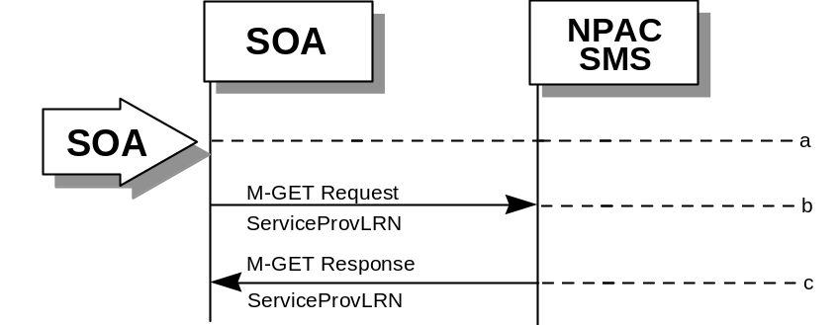Action is taken by SOA personnel to an LRN for a specified service provider.
- The SOA sends an M-GET request to the NPAC SMS for the serviceProvLRN object.
- The NPAC SMS responds by sending an M-GET response containing the data back to the SOA.

LRN Deletion by the NPAC
In this scenario, the NPAC SMS deletes an LRN.
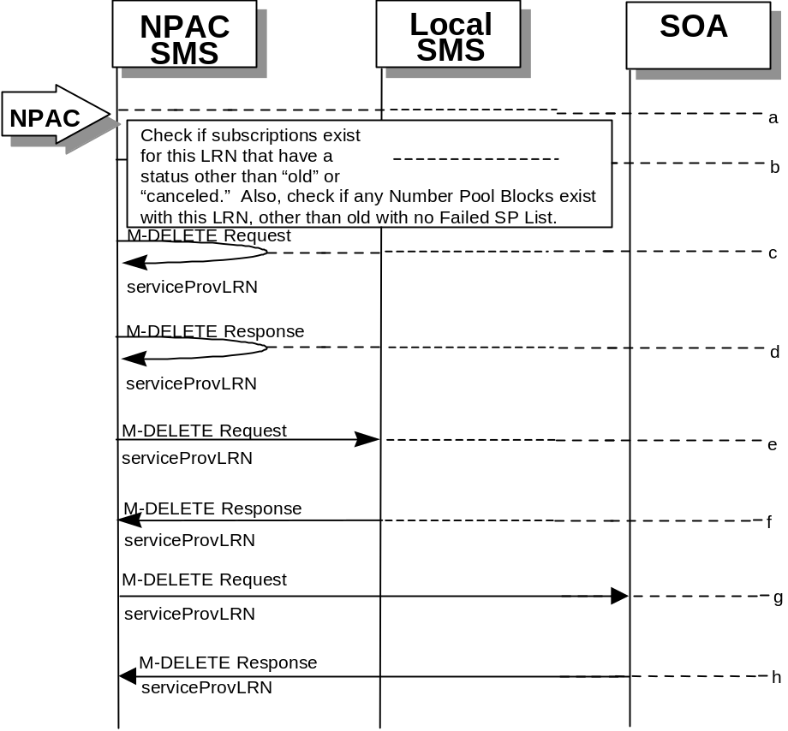
- Action is taken by the NPAC SMS personnel to delete an LRN for a service provider.
- Check the subscriptions database to see if subscriptions exist with this LRN that have a status other than “old” or “canceled.” Also, check if any Number Pool Blocks exist with this LRN. If so, terminate processing at this point.
- The NPAC SMS sends an M-DELETE request to itself in order to delete the local serviceProvLRN object.
- The NPAC SMS receives the M-Delete response indicating whether the serviceProvLRN object was deleted successfully.
- If the serviceProvLRN object was deleted, the NPAC SMS sends an M-DELETE request to all Local SMS(s) for the serviceProvLRN object.
- The Local SMS(s) responds by sending an M-Delete response indicating whether the serviceProvLRN object was deleted successfully.
- If the serviceProvLRN object was deleted, the NPAC SMS sends an M-DELETE request to all SOA(s) for the serviceProvLRN object.
- The SOA(s) responds by sending an M-Delete response indicating whether the serviceProvLRN object was deleted successfully.

LRN Creation by the Local SMS
In this scenario, the Local SMS creates an LRN for its own service provider network data.
- Action is taken by the Local SMS personnel to create an LRN for their own network data.
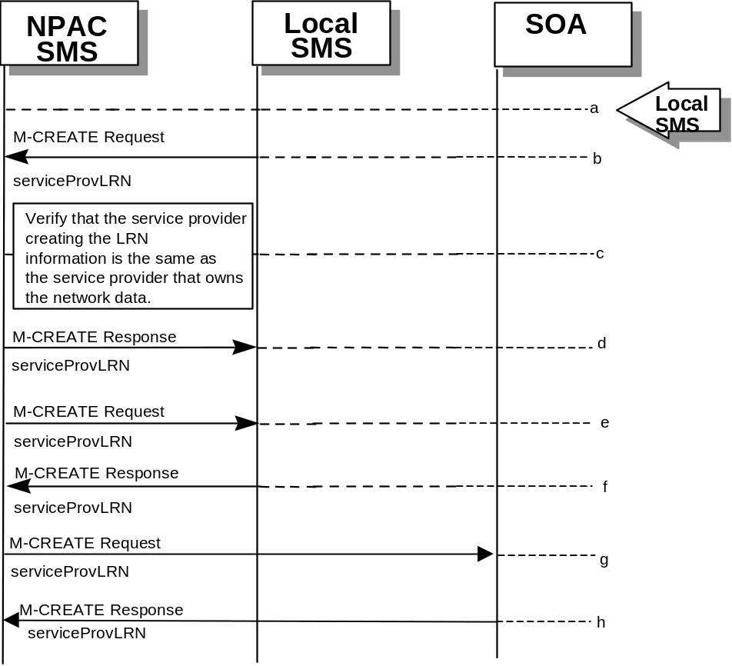
- The SMS sends an M-CREATE request to the NPAC requesting that an LRN object be created for their own network data.
- The NPAC verifies that the service provider creating the LRN information is the same as the service provider that owns the service provider network data. If not, then an accessDenied M-CREATE error response is returned.
- The NPAC SMS responds by sending an M-CREATE response back to the Local SMS that initiated the request, indicating whether the serviceProvLRN object was created successfully.
- If the serviceProvLRN object was created, the NPAC SMS sends an M-CREATE request to all Local SMS(s) for the serviceProvLRN object.
- The Local SMS(s) responds by sending an M-CREATE response indicating whether the serviceProvLRN object was created successfully.
- If the serviceProvLRN object was created, the NPAC SMS sends an M-CREATE request to all SOA(s) for the serviceProvLRN object.
- The SOA(s) responds by sending an M-CREATE response indicating whether the serviceProvLRN object was created successfully.

LRN Deletion by the Local SMS
In this scenario, the Local SMS deletes an LRN for their own service provider network data.
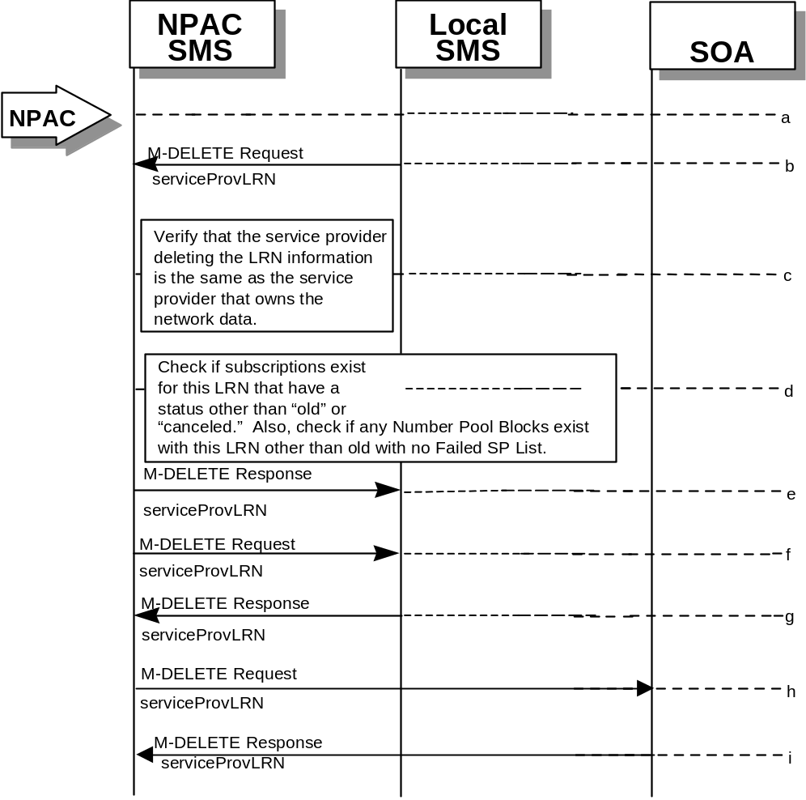
- Action is taken by the Local SMS personnel to delete an LRN for their own network data.
- The Local SMS sends an M-DELETE request to the NPAC requesting that an LRN object be deleted.
- The NPAC SMS verifies that the service provider deleting the LRN information is the same as the service provider that is associated with the network data. If not, then an accessDenied M-DELETE Error Response is returned.
- Check the subscriptions database to see if subscriptions exist with this LRN that have a status other than “old” or “canceled.” Also, check if any Number Pool Blocks exist with this LRN. If so, an M-SET Error Response complexity limitation is returned.
- The NPAC SMS responds by sending an M-DELETE response indicating whether the serviceProvLRN object was deleted successfully.
- If the serviceProvLRN object was deleted, the NPAC SMS sends an M-DELETE request to all Local SMS(s) for the serviceProvLRN object.
- The Local SMS(s) responds by sending a message indicating whether the serviceProvLRN object was deleted successfully.
- If the serviceProvLRN object was deleted, the NPAC SMS sends an M-DELETE request to all SOA(s) for the serviceProvLRN object.
- The SOA(s) responds by sending a message indicating whether the serviceProvLRN object was deleted successfully.

LRN Query by the Local SMS
In this scenario, the Local SMS queries LRN data.
- 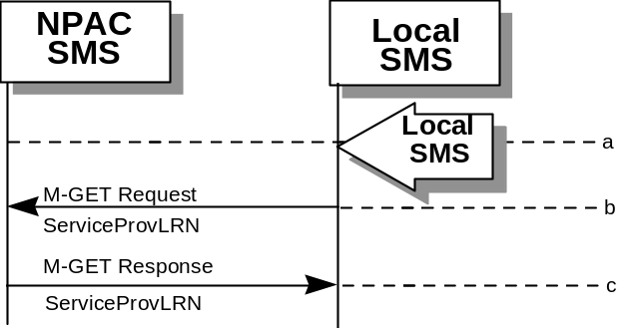Action is taken by Local SMS personnel to query an LRN for a specified service provider.
- The Local SMS sends an M-GET request to the NPAC SMS for the serviceProvLRN object.
- The NPAC SMS responds by sending an M-GET response containing the data back to the Local SMS.

Network Data Download
This scenario shows a Local SMS request for network data download in order to update their view of this data.
- Action is taken by the Local SMS personnel to request a network data download. The criterion to decide which network data is to be recovered is specified in the network data recovery request.
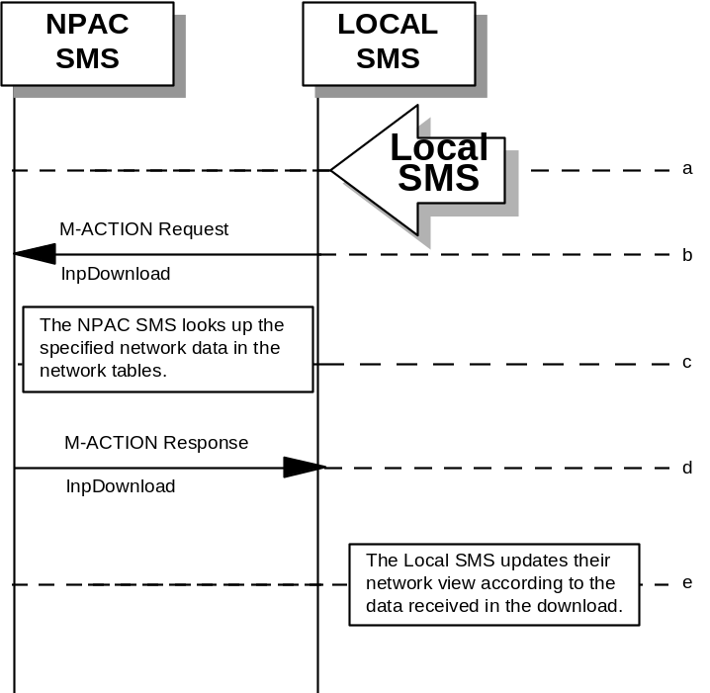
- The Local SMS sends an M-ACTION request to the NPAC SMS lnpNetwork object requesting a network data download.
- The NPAC SMS looks up the network data in the network database as specified by the criteria in the M-ACTION request.
- The NPAC SMS responds by sending an M-ACTION response to the Local SMS that initiated the request. The response includes the success/failure of the request along with the requested network data.
- The Local SMS must take appropriate action to update their view of the data.

Scoped/Filtered GET of Network Data
This scenario shows a request for network data via a scoped/filtered M-GET. In this case, scoping is done from the lnpNetwork object. However, scoping and filtering can be done from serviceProvNetwork, serviceProvLRN, and serviceProvNPA-NXX objects.
- 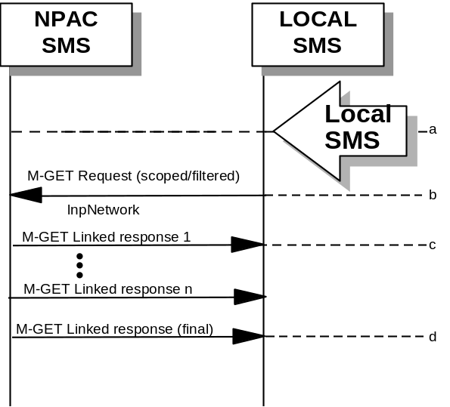Action is taken by the Local SMS personnel to request network data via a scoped/filtered M-GET request.
- The Local SMS sends a scoped/filtered M-GET request to the NPAC SMS.
- The NPAC SMS sends network data objects (serviceProvNetwork, serviceProvNPA-NXX, serviceProvLRN) that pass the scope/filter criteria to the Local SMS that initiated the request.
- A final M-GET response is sent to the Local SMS that initiated the request once all scoped/filtered network objects have been returned, and will contain no data.

Scoped/Filtered GET of Network Data from SOA
This scenario shows a request for network data via a scoped/filtered M-GET. Scoping and filtering is done from serviceProvNetwork.
- Action is taken by the SOA personnel to request network data via a scoped/filtered M-GET request.
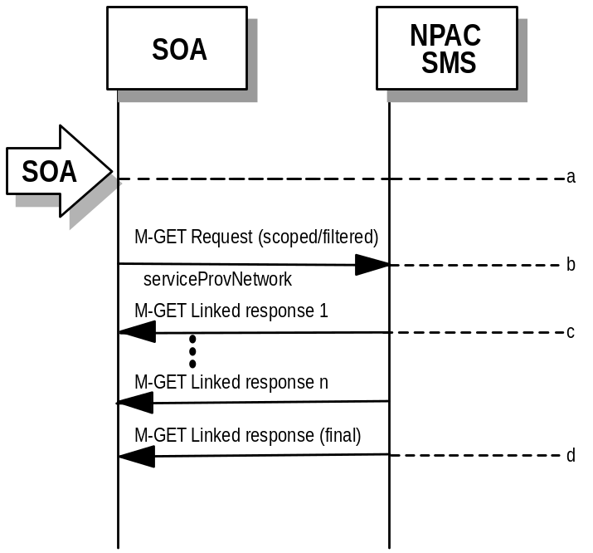

- The SOA sends a scoped/filtered M-GET request to the NPAC SMS.
- The NPAC SMS sends network data objects (serviceProvNetwork, serviceProvNPA-NXX, serviceProvLRN, serviceProvNPA-NXX-X) that pass the scope/filter criteria to the SOA that initiated the request.
- A final M-GET response is sent to the SOA that initiated the request once all scoped/filtered network objects have been returned, and will contain no data.

Service Provider NPA-NXX-X
This section contains the flows that demonstrate service provider NPA-NXX-X creation, modification, deletion and query.

Service Provider NPA-NXX-X Create by NPAC SMS (previously NNP flow 1.1)
In this scenario, the NPAC SMS creates the serviceProvNPA-NXX-X object at the request of the number pool administrator.
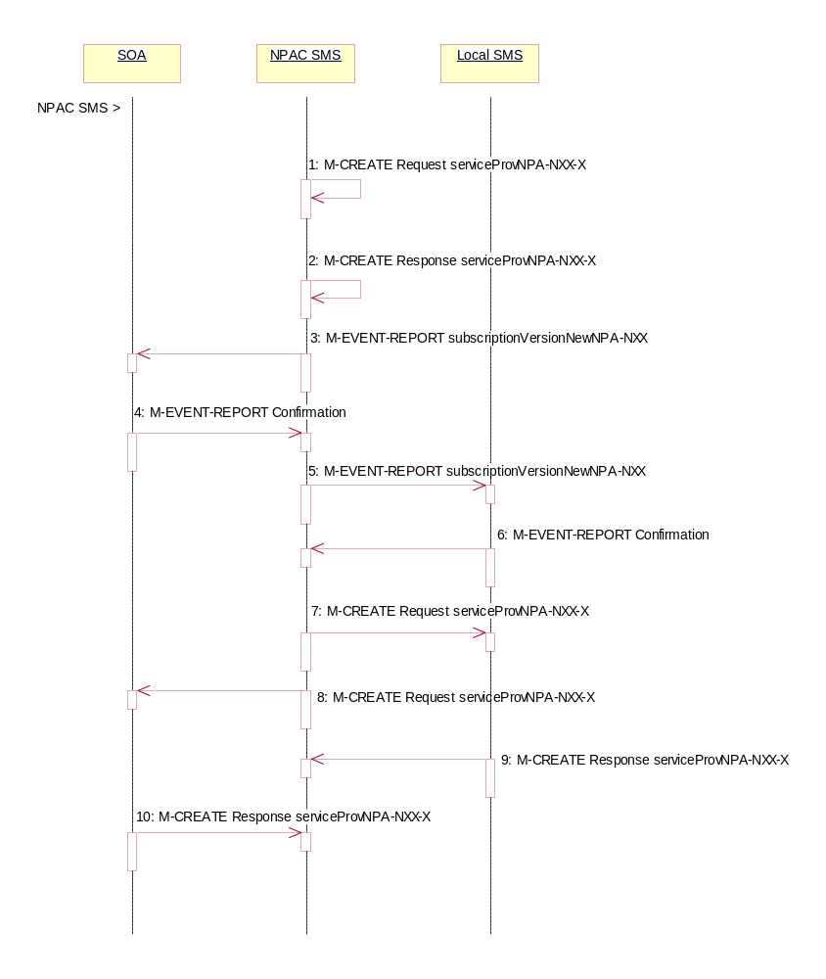
Action is taken by NPAC SMS personnel to create the serviceProvNPA-NXX-X object.
- The NPAC SMS sends an M-CREATE request to itself in order to create a local serviceProvNPA-NXX-X object. The NPAC SMS provides the following attributes:
serviceProvNPA-NXX-X-Value
serviceProvNPA-NXX-X-EffectiveTimeStamp
serviceProvID

The NPAC SMS validates the following:
- NPA-NXX of the serviceProvNPA-NXX-X-value is an existing NPA-NXX.
- The effective date is greater than or equal to the effective date of the serviceProvNPA-NXX.
- The effective date is greater than or equal to the current date plus the effective date tunable number of days.
- Verify no serviceProvNPA-NXX-X object exists with this NPA-NXX-X value.
- The service provider ID is an existing service provider.

The NPAC SMS rejects the request if any subscriptionVersionNPAC objects exist with a status of pending, conflict, cancel-pending or failed for a TN specified by the serviceProvNPA-NXX-X-value and an active subscriptionVersionNPAC object does not exist for that TN or the subscription version is a Port-To-Original request.
- The NPAC SMS receives the M-CREATE request and sets the serviceProvNPA-NXX-X-ID, serviceProvNPA-NXX-X-CreationTimeStamp and serviceProvNPA-NXX-X-ModifiedTimeStamp. The NPAC SMS then issues a response indicating whether the serviceProvNPA-NXX-X object was successfully created.
- If the serviceProvNPA-NXX-X object was successfully created and this is the first usage of the NPA-NXX, the NPAC SMS sends the subscriptionVersionNewNPA-NXX notification to all SOAs.
- The SOAs confirm the subscriptionVersionNewNPA-NXX M-EVENT-REPORT.
- If the serviceProvNPA-NXX-X object was successfully created and this is the first usage of the NPA-NXX, the NPAC SMS sends the subscriptionVersionNewNPA-NXX notification to all Local SMSs.
- The Local SMSs confirm the subscriptionVersionNewNPA-NXX M-EVENT-REPORT.
- The NPAC SMS sends an M-CREATE request for the serviceProvNPA-NXX-X object to all Local SMSs who support the object according to the “NPAC Customer LSMS NPA-NXX-X Indicator” in their service provider profile on the NPAC SMS and are receiving data for the NPA-NXX. The following attributes are sent in the M-CREATE:
serviceProvNPA-NXX-X-ID
serviceProvNPA-NXX-X-Value
serviceProvNPA-NXX-X-CreationTimeStamp
serviceProvNPA-NXX-X-EffectiveTimeStamp
serviceProvNPA-NXX-X-ModifiedTimeStamp
serviceProvNPA-NXX-X-DownloadReason
- At the same time as step 7, the NPAC SMS sends an M-CREATE request for the serviceProvNPA-NXX-X object to all SOAs who support the object according to the “NPAC Customer SOA NPA-NXX-X Indicator” in their service provider profile on the NPAC SMS and are receiving data for the NPA-NXX. The following attributes are sent in the M-CREATE:
serviceProvNPA-NXX-X-ID
serviceProvNPA-NXX-X-Value
serviceProvNPA-NXX-X-CreationTimeStamp
serviceProvNPA-NXX-X-EffectiveTimeStamp
serviceProvNPA-NXX-X-ModifiedTimeStamp
serviceProvNPA-NXX-X-DownloadReason
- The Local SMS responds by sending the M-CREATE response indicating whether the serviceProvNPA-NXX-X object was created successfully.
- The SOA responds by sending the M-CREATE response indicating whether the serviceProvNPA-NXX-X object was created successfully.

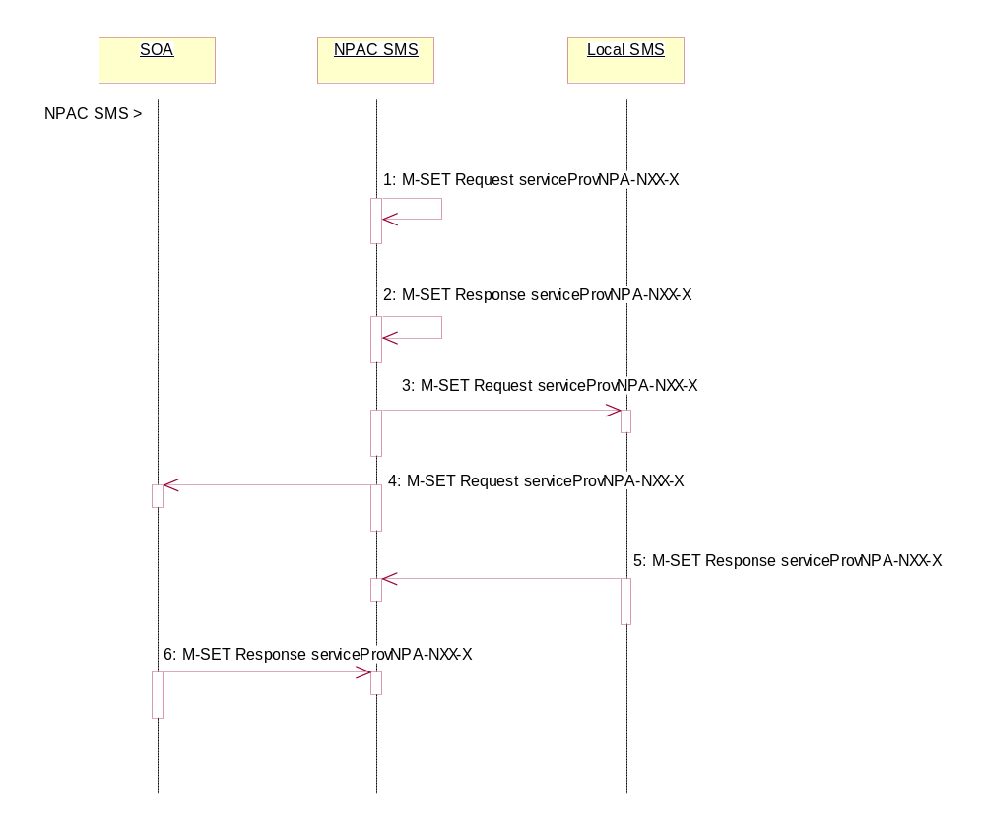
Service Provider NPA-NXX-X Modification by NPAC SMS (previously NNP flow 1.2)
In this scenario, the NPAC SMS modifies the serviceProvNPA-NXX-X object at the request of the number pool administrator.

Action is taken by NPAC SMS personnel to initiate a modification to the serviceProvNPA-NXX-X object.
- NPAC SMS sends the M-SET request to itself to update the following attributes:
serviceProvNPA-NXX-X-EffectiveTimeStamp
serviceProvNPA-NXX-X-ModifiedTimeStamp
- NPAC SMS responds indicating whether the modification was successful. The update request will fail if the effective timestamp is within the Block Holder Effective Date Window’s tunable number of days to the creation timestamp of the object or if the current date is greater than or equal to the object’s current effective timestamp.
- NPAC SMS sends the M-SET request to update the serviceProvNPA-NXX-X to all Local SMS that support the object according to the “NPAC Customer LSMS NPA-NXX-X Indicator” in their service provider profile on the NPAC SMS and are receiving data for the NPA-NXX.
- At the same time as step 3, NPAC SMS sends the M-SET request to update the serviceProvNPA-NXX-X to all SOAs that support the object according to the “NPAC Customer SOA NPA-NXX-X Indicator” in their service provider profile on the NPAC SMS and are receiving data for the NPA-NXX.
- Local SMS respond to the M-SET indicating whether the modification was successful.
- SOA respond to the M-SET indicating whether the modification was successful.

Service Provider NPA-NXX-X Deletion by NPAC SMS Prior to Number Pool Block Existence (previously NNP flow 1.3)
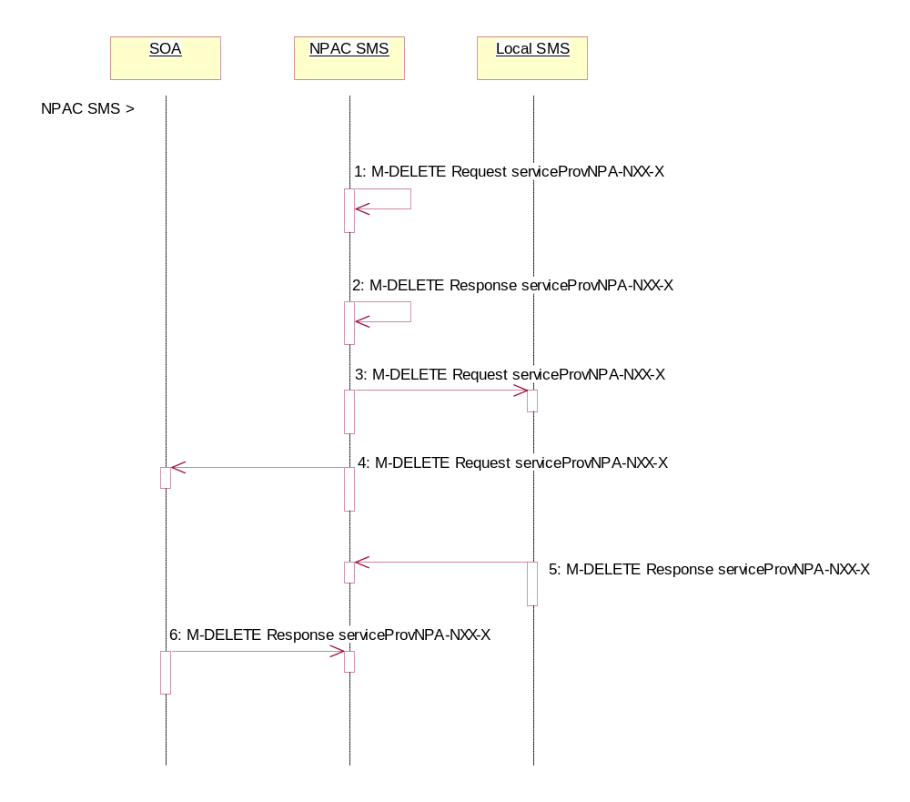
In this scenario, the NPAC SMS deletes the serviceProvNPA-NXX-X object at the request of the number pool administrator. This deletion takes place prior to the effective date or after the effective date, but prior to the number pool block object being created for the NPA-NXX-X value.

Action is taken by NPAC SMS personnel to delete a serviceProvNPA-NXX-X object.
- The NPAC SMS sends an M-DELETE request to itself in order to delete the local serviceProvNPA-NXX-X object.
- The NPAC SMS receives the M-DELETE response indicating whether the serviceProvNPA-NXX-X object was successfully deleted.
- The NPAC SMS sends the M-DELETE request to all Local SMS for the serviceProvNPA-NXX-X object who support the object according to the “NPAC Customer LSMS NPA-NXX-X Indicator” in their service provider profile on the NPAC SMS and are receiving data for the NPA-NXX.
- At the same time as step 3, the NPAC SMS sends the M-DELETE request to all SOAs for the serviceProvNPA-NXX-X object who support the object according to the “NPAC Customer SOA NPA-NXX-X Indicator” in their service provider profile on the NPAC SMS and are receiving data for the NPA-NXX.
- The Local SMS responds by sending the M-DELETE response indicating whether the serviceProvNPA-NXX-X object was deleted successfully.
- The SOA responds by sending the M-DELETE response indicating whether the serviceProvNPA-NXX-X object was deleted successfully.

Service Provider NPA-NXX-X Query by SOA or LSMS (previously NNP flow1.4)
In this scenario, the service provider queries the NPAC SMS for one or more serviceProvNPA-NXX-X objects from the SOA or Local SMS.

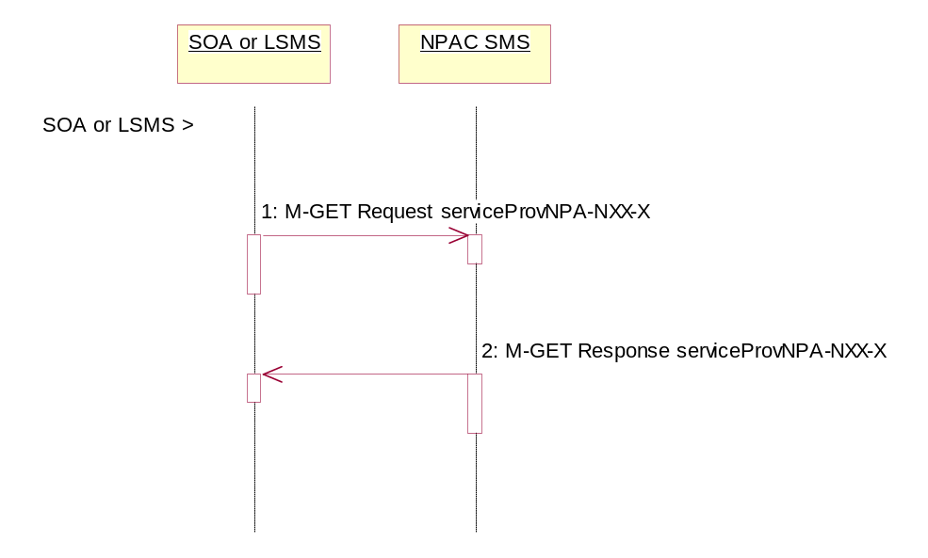
Service provider personnel take action to query the NPAC SMS for one or more serviceProvNPA-NXX-X objects.
- SOA or Local SMS sends an M-GET for a single serviceProvNPA-NXX-X object by serviceProvNPA-NXX-X-ID or a scope and filtered M-GET for one or more serviceProvNPA-NXX-X objects.
- If the NPAC SMS finds one or more serviceProvNPA-NXX-X objects that match the input criteria, the NPAC SMS responds with the single or linked reply of serviceProvNPA-NXX-X object(s). Otherwise it returns an empty result.

Number Pool Block

This section contains the flows that demonstrate number pool block creation, modification and deletion.

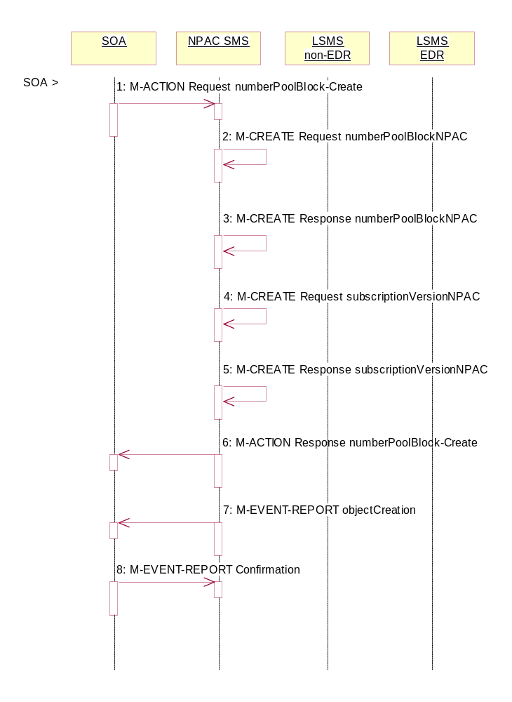
Number Pool Block Create/Activate by SOA (previously NNP flow 2.1)
In this scenario, the block holder service provider sends in the M-ACTION for the number pool block to be created.

Action is taken by the block holder service provider SOA to create a number pool block.

- The block holder service provider SOA sends the M-ACTION numberPoolBlock-Create to the NPAC SMS. The block holder service provider must provide the following attributes:

numberPoolBlockNPA-NXX-X
numberPoolBlockLRN
numberPoolBlockSPID
numberPoolBlockCLASS-DPC
numberPoolBlockCLASS-SSN
numberPoolBlockCNAM-DPC
numberPoolBlockCNAM-SSN
numberPoolBlockISVM-DPC
numberPoolBlockISVM-SSN
numberPoolBlockLIDB-DPC
numberPoolBlockLIDB-SSN

If the “SOA WSMSC DPC SSN Data Indicator” is set in the service provider’s profile on the NPAC SMS, the following attributes must be included:

numberPoolBlockWSMSC-DPC
numberPoolBlockWSMSC-SSN

If the indicator is not set in the service provider’s profile, the WSMSC data cannot be included.

The NPAC SMS verifies the following and returns the indicated error if the condition fails:
- The serviceProvNPA-NXX-X object exists for the given numberPoolBlockNPA-NXX-X. If the condition fails, error returned is ‘no-npa-nxx-x-found’.
- The service provider associated with the SOA is equal to the numberPoolBlockSPID and is owner of the corresponding serviceProvNPA-NXX-X object. If the condition fails, error returned is ‘soa-not-authorized’.
- All attributes are valid. If the condition fails, error returned is ‘invalid-data-values’.
- A numberPoolBlockNPAC object does not already exist or one exists with a status of ‘old’ with an empty list of failed service providers for the given numberPoolBlockNPA-NXX-X. If the condition fails, error returned is ‘number-pool-block-already-exists’.
- The current date is greater than or equal to the serviceProvNPA-NXX-X-EffectiveTimeStamp of the corresponding serviceProvNPA-NXX-X object. If the condition fails, error returned is ‘prior-to-effective-date’.
- There are no subscription version objects within the given TN range with a status of pending, conflict, cancel-pending or failed (“pending-like”) and no active subscription version for that TN. If the condition fails, error returned is ‘invalid-subscription-versions’.

Any other error will be returned as “failed”. If an error is found, the NPAC SMS returns the M-ACTION reply with the error. No further processing occurs.

- If the request is valid, the NPAC SMS creates the numberPoolBlockNPAC object. The numberPoolBlockSOA-Origination indicator is set to TRUE. The numberPoolBlockActivationTimeStamp, numberPoolBlockCreationTimeStamp, numberPoolBlockBroadcastTimeStamp and numberPoolBlockModifiedTimeStamp are set. The numberPoolBlockStatus is set to “sending”.

- The NPAC SMS responds to the M-CREATE.

- If the request is valid, the NPAC SMS will create the corresponding subscriptionVersionNPAC object(s). If an active, partial-failure, sending or disconnect-pending (“active-like”) subscription version exists within the block’s TN range, no new subscription version will be created for that TN. For the subscription versions created, the subscriptionLNPType will be set to ‘pool’, subscriptionVersionStatus will be set to “sending” and the subscriptionModifiedTimeStamp, subscriptionActivationTimeStamp, subscriptionBroadcastTimeStamp and subscriptionCreationTimeStamp will be set.

- The NPAC SMS will respond with the M-CREATE response.

- NPAC SMS responds to the M-ACTION.

- NPAC SMS sends the M-EVENT-REPORT objectCreation for the numberPoolBlockNPAC to the SOA. The following attributes will be sent in the objectCreation notification:

numberPoolBlockId
numberPoolBlockSOA-Origination
numberPoolBlockCreationTimeStamp
numberPoolBlockStatus
numberPoolBlockNPA-NXX-X
numberPoolBlockSPID
numberPoolBlockLRN
numberPoolBlockCLASS-DPC
numberPoolBlockCLASS-SSN
numberPoolBlockCNAM-DPC
numberPoolBlockCNAM-SSN
numberPoolBlockISVM-DPC
numberPoolBlockISVM-SSN
numberPoolBlockLIDB-DPC
numberPoolBlockLIDB-SSN

If the “SOA WSMSC DPC SSN Data Indicator” is set in the service provider’s profile on the NPAC SMS, the following attributes will be included:

numberPoolBlockWSMSC-DPC
numberPoolBlockWSMSC-SSN

- The block holder SOA confirms the M-EVENT-REPORT.

Number Pool Block Create by NPAC SMS (previously NNP flow 2.2)
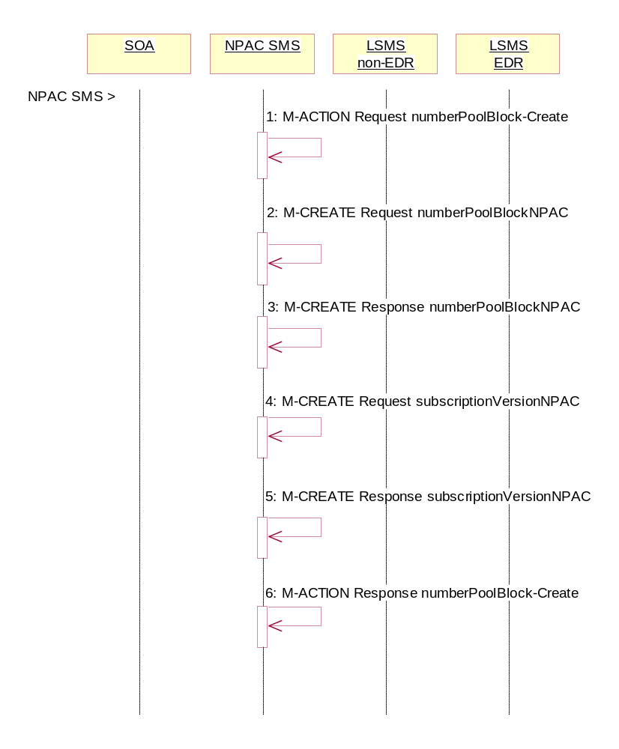
In this scenario, the NPAC SMS creates the number pool block on or after the effective date of the serviceProvNPA-NXX-X object. Since the SOA does not send in the creation request, all notifications (M-EVENT-REPORTs) to the SOA will be suppressed.
Action is taken by the NPAC SMS to create a number pool block.

- NPAC SMS personnel create the numberPoolBlockNPAC on the NPAC SMS for a service provider block holder using the M-ACTION, numberPoolBlock-Create. The following attributes are required:
numberPoolBlockNPA-NXX-X
numberPoolBlockSPID
numberPoolBlockLRN
numberPoolBlockCLASS-DPC
numberPoolBlockCLASS-SSN
numberPoolBlockCNAM-DPC
numberPoolBlockCNAM-SSN
numberPoolBlockISVM-DPC
numberPoolBlockISVM-SSN
numberPoolBlockLIDB-DPC
numberPoolBlockLIDB-SSN

If the “SOA WSMSC DPC SSN Data Indicator” is set in the service provider’s profile, the following attributes must be provided:

numberPoolBlockWSMSC-DPC
numberPoolBlockWSMSC-SSN

If the indicator is not set, the request will be rejected.

The NPAC SMS verifies the following and returns the indicated error if the condition fails:
- The serviceProvNPA-NXX-X object exists for the given numberPoolBlockNPA-NXX-X. If the condition fails, error returned is no-npa-nxx-x-found.
- All attributes are valid. If the condition fails, error returned is invalid-data-values.
- A numberPoolBlockNPAC object does not already exist or one exists with a status of ‘old’ with an empty list of failed service providers for the given numberPoolBlockNPA-NXX-X. If the condition fails, error returned is number-pool-block-already-exists.
- The current date is greater than or equal to the serviceProvNPA-NXX-X-EffectiveTimeStamp of the corresponding serviceProvNPA-NXX-X object. If the condition fails, error returned is prior-to-effective-date.
- There are no subscription version objects within the given TN range with a status of pending, conflict, cancel-pending or failed (“pending-like”) and no active subscription version for that TN. If the condition fails, error returned is invalid-subscription-versions.

Any other error will be returned as “failed”. If an error is found, the NPAC SMS returns the M-ACTION reply with the error. No further processing occurs.

- The NPAC SMS creates the numberPoolBlockNPAC object. The numberPoolBlockSOA-Origination indicator is set to FALSE. The numberPoolBlockCreationTimeStamp, numberPoolBlockActivationTimeStamp, numberPoolBlockBroadcastTimeStamp and numberPoolBlockModifiedTimeStamp are set. The numberPoolBlockStatus is set to “sending”.

- NPAC SMS responds to the M-CREATE.

- The NPAC SMS creates the corresponding subscriptionVersionNPAC object.(s). If an active, partial-failure, sending or disconnect-pending (“active-like”) subscription version exists within the block’s TN range, no new subscription version will be created for that TN. For the subscription version created, the subscriptionLNPType will be set to ‘pool’, the subscriptionVersionStatus will be set to “sending” and the subscriptionModifiedTimeStamp, subscriptionActivationTimeStamp, subscriptionBroadcastTimeStamp and subscriptionCreationTimeStamp will be set.

- NPAC SMS responds to the M-CREATE.

- NPAC SMS responds to the M-ACTION.

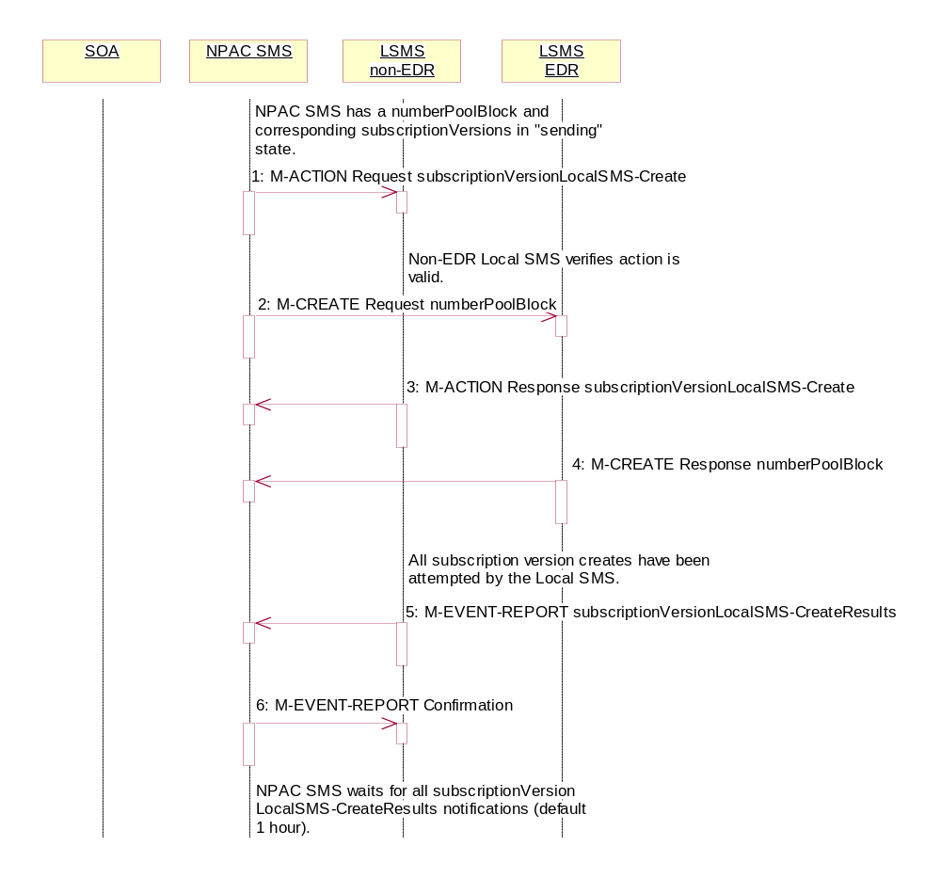
Number Pool Block Create Broadcast Successful to Local SMS (previously NNP flow 2.3.1)
In this scenario, the number pool block and corresponding subscription versions have been created on the NPAC SMS. The NPAC SMS now begins to broadcast the subscriptionVersions and numberPoolBlock data to the Local SMSs.

- NPAC SMS issues the subscriptionVersionLocalSMS-Create action to the non-EDR Local SMS, if it is accepting downloads for the NPA-NXX of the subscription versions. This action contains all data required to create the subscription versions with the subscriptionLNPType of ‘pool’.
- At the same time as step 1, the NPAC SMS sends the M-CREATE for the numberPoolBlock to the EDR Local SMS.
- The non-EDR Local SMS verifies the action is valid and returns the M-ACTION reply. If the non-EDR Local SMS does not respond to the M-ACTION request, the NPAC SMS will retry the request a tunable amount of times.
- The EDR Local SMS sends to the NPAC SMS the results of the M-CREATE. If the EDR Local SMS fails to respond, the NPAC SMS will retry the M-CREATE request a tunable amount of times.
- The non-EDR Local SMS proceeds to execute all the creates specified by the action. The non-EDR Local SMS sends to the NPAC SMS the M-EVENT-REPORT specifying the success or failure of the subscription version creates.
- NPAC SMS confirms the M-EVENT-REPORT.
The NPAC SMS now waits for all the subscriptionVersionLocalSMS-CreateResults M-EVENT-REPORTs a tunable amount of time (default 1 hour).

Number Pool Block Create: Successful Broadcast (previously NNP flow 2.3.2)
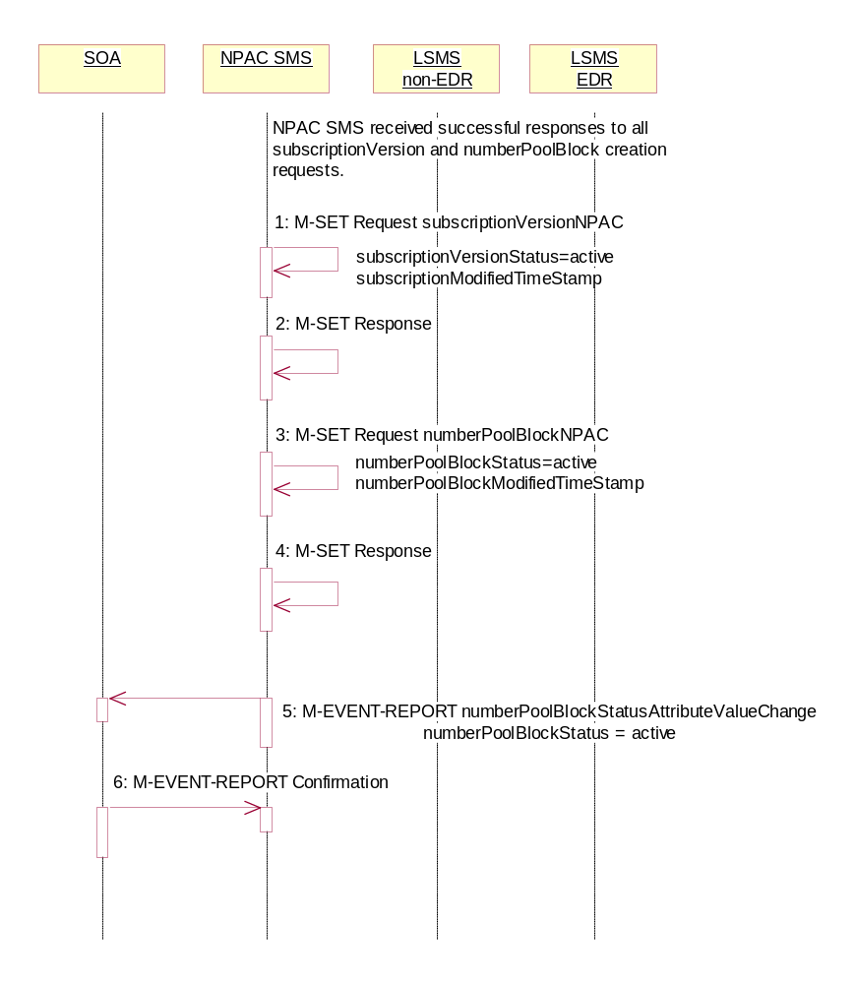
In this scenario, the NPAC SMS has just completed the successful broadcast of a numberPoolBlock and corresponding subscriptionVersions.
- NPAC SMS updates all the subscriptionVersionNPACs that were broadcasted by setting the subscriptionVersionStatus to ‘active’ and setting the subscriptionModifiedTimeStamp to the current date and time.
- NPAC SMS responds to the M-SET.
- NPAC SMS updates the numberPoolBlock by setting the numberPoolBlockStatus to ‘active’ and setting the numberPoolBlockModifiedTimeStamp to the current date and time.
- NPAC SMS responds to the M-SET.
- If the numberPoolBlockSOA-Origination indicator is set to TRUE, the NPAC SMS sends the M-EVENT-REPORT, numberPoolBlockStatusAttributeValueChange, to the block holder SOA for the number pool block. The status attribute value change would contain the numberPoolBlockStatus set to ‘active’.
- Block holder SOA confirms the M-EVENT-REPORT.

Number Pool Block Create Broadcast to Local SMS: Failure (previously NNP flow 2.4)
In this scenario, the NPAC SMS has a numberPoolBlock and corresponding subscriptionVersions in ‘sending’ state for creation to the Local SMSs and no Local SMS will respond successfully to the broadcast.
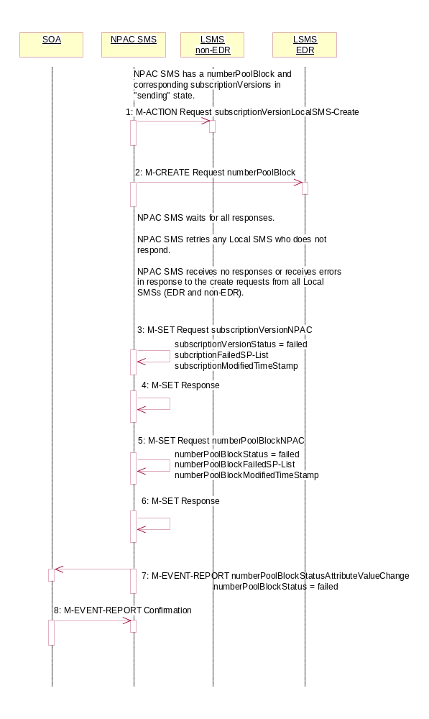

- NPAC SMS sends the M-ACTION subscriptionVersionLocalSMS-Create request to all the non-EDR Local SMSs.
- At the same time as step 1, NPAC SMS sends the M-CREATE numberPoolBlock request to all the EDR Local SMSs.

NPAC SMS waits for all the responses.
NPAC SMS retries any Local SMS who does not respond.
NPAC SMS receives no responses or receives errors in response to the create requests from all Local SMSs (EDR and non-EDR).

- NPAC SMS sets each subscriptionVersionNPAC’s subscriptionVersionStatus to ‘failed’. The subscriptionFailed-SP-List gets updated with the failed service providers and the subscriptionModifiedTimeStamp gets set.
- NPAC SMS responds to the M-SET.
- NPAC SMS sets the numberPoolBlock’s numberPoolBlockStatus to ‘failed’. The numberPoolBlockFailed-SP-List gets updated with the failed service providers, both EDR and non-EDR, and the subscriptionModifiedTimeStamp gets set.
- NPAC SMS responds to the M-SET.
- If the numberPoolBlock’s SOA Origination indicator is set to ‘true’, the NPAC SMS sends the M-EVENT-REPORT, numberPoolBlockStatusAttributeValueChange, for the numberPoolBlock with the numberPoolBlockStatus set to ‘failed’ and the numberPoolBlockFailed-SP-List to the block holder SOA.
- The SOA confirms the M-EVENT-REPORT.

Number Pool Block Create Broadcast to Local SMS: Partial Failure (previously NNP flow 2.5.1)
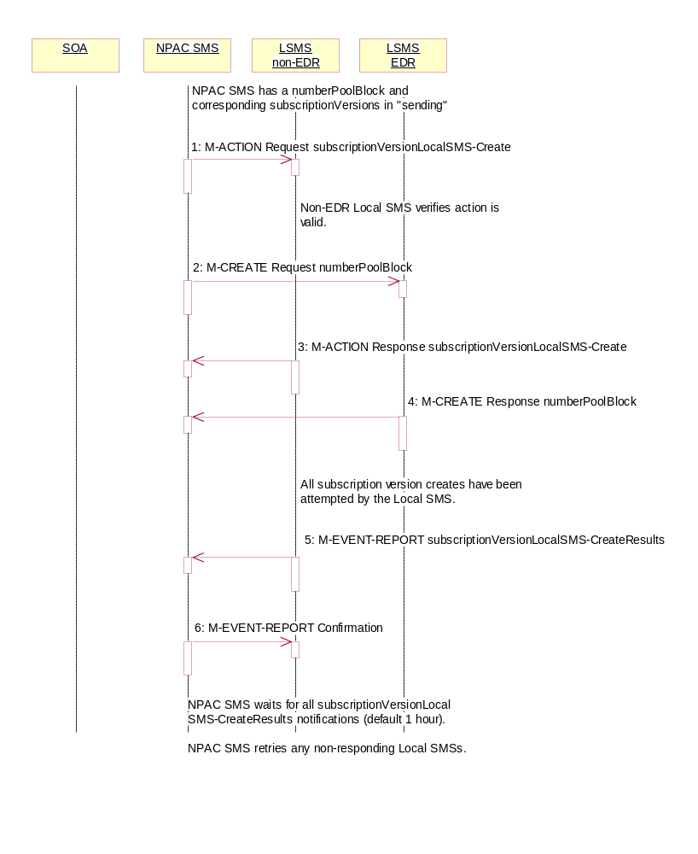
In this scenario, the NPAC SMS has a numberPoolBlock and corresponding subscriptionVersions in ‘sending’ state for creation to the Local SMSs and some but not all Local SMS will respond successfully to the broadcast resulting in a state of “partial-failure” for one or more of the subscription versions and the number pool block.

- NPAC SMS issues the subscriptionVersionLocalSMS-Create action to the non-EDR Local SMS, if it is accepting downloads for the NPA-NXX of the subscription versions. This action contains all data required to create the subscription versions with the subscriptionLNPType of ‘pool’.
- At the same time as step 1, NPAC SMS sends the M-CREATE for the numberPoolBlock to the EDR Local SMS.
- The non-EDR Local SMS verifies the action is valid and returns an acknowledgment. If the non-EDR Local SMS fails to respond, the NPAC SMS will retry the M-ACTION request a tunable amount of times.
- The EDR Local SMS sends to the NPAC SMS the results of the M-CREATE. If the EDR Local SMS fails to respond, the NPAC SMS will retry the M-CREATE request a tunable amount of times.
- The non-EDR Local SMS proceeds to execute all the creates specified by the action. The non-EDR Local SMS sends to the NPAC SMS the M-EVENT-REPORT specifying the success or failure of the creates.
- NPAC SMS confirms the M-EVENT-REPORT.

The NPAC SMS now waits for all the subscriptionVersionLocalSMS-CreateResults M-EVENT-REPORTs responses a tunable amount of time (default 1 hour).

Number Pool Block Create Broadcast Partially Failed NPAC SMS Updates (previously NNP flow2.5.2)
All retries have been exhausted and the time for the subscriptionVersionLocalSMS-CreateResults to be received has expired for a broadcast of a number pool block create.

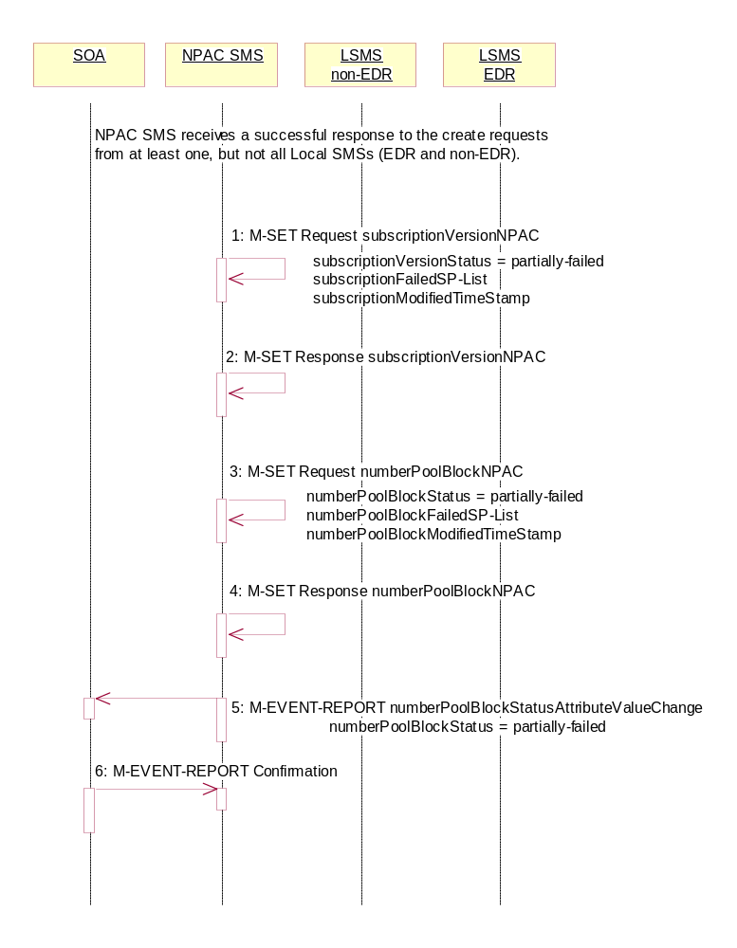
NPAC SMS receives a successful response to the create request from at least one, but not all, Local SMSs (EDR and non-EDR).

The NPAC SMS must now set the numberPoolBlock to partial-failure and subscriptionVersion objects to partial-failure or active depending upon which Local SMSs failed the request. If an EDR Local SMS failed, the numberPoolBlock and ALL subscriptionVersions broadcast will be set to partial-failure. If a non-EDR Local SMS failed all the creates, the numberPoolBlock and ALL subscriptionVersion broadcast will be set to partial-failure. If a non-EDR Local SMS fails only some of the subscriptionVersion creates, the numberPoolBlock will be set to partial-failure along with the subscriptionVersions the non-EDR Local SMS failed. The other subscription versions may be set to ‘active’ if all EDR Local SMSs were successful and all other non-EDR Local SMSs were successful for those subscription versions.

The numberPoolBlockFailed-SP-List on the number pool block object contains all the service providers who failed to receive either the number pool block or any of the subscription versions. The subscriptionFailed-SP-List on each subscription version object contains only those service providers who failed to receive that subscription version or the number pool block object.

The partial-failure status will be removed from both objects when all subscriptionVersions and numberPoolBlocks are successfully resent or recovered.

- NPAC SMS issues an M-SET to the subscriptionVersionNPAC(s) setting the subscriptionVersionStatus to ‘partially-failed’ or ‘active’ and setting the subscriptionFailed-SP-List to the list of failed service providers. The subscriptionModifiedTimeStamp is also set.
- NPAC SMS responds to the M-SET.
- NPAC SMS issues an M-SET to the numberPoolBlockNPAC setting the numberPoolBlockStatus to ‘partially-failed’ and setting the numberPoolBlockFailed-SP-List to the list of failed service providers. The numberPoolBlockModifiedTimeStamp is also set.
- NPAC SMS responds to the M-SET.
- If the numberPoolBlockSOA-Origination indicator is set to ‘true’, the NPAC SMS sends the block holder SOA the M-EVENT-REPORT, numberPoolBlockStatusAttributeValueChange, with the numberPoolBlockStatus set to ‘partially-failed’ and the numberPoolBlockFailed-SP-List.
- The block holder SOA confirms the M-EVENT-REPORT.

Number Pool Block Create Resend Broadcast (previously NNP flow 2.6)
In this scenario, the NPAC SMS has a number pool block and corresponding subscription versions with LNP type of ‘pool’ in a failed or partially-failed state. The NPAC SMS will resend the requests to the Local SMSs.
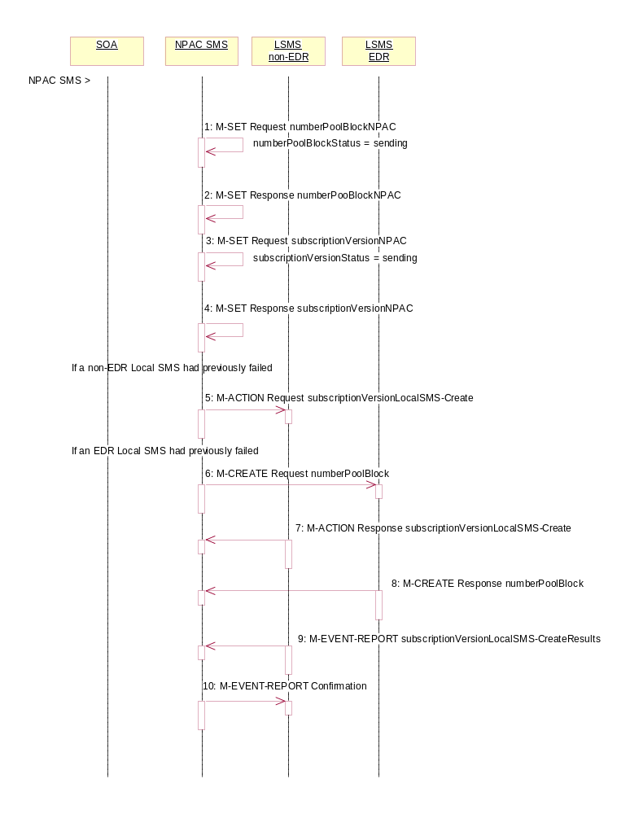
Action is taken by the NPAC SMS personnel to resend a previously failed activation of a number pool block and corresponding subscription versions.
- NPAC SMS issues the M-SET to modify the numberPoolBlockStatus to ‘sending’ on the number pool block object. The numberPoolBlockModifiedTimeStamp and numberPoolBlockBroadcastTimeStamp also get set.
- NPAC SMS responds to the M-SET.
- NPAC SMS issues the M-SET to modify the subscriptionVersionStatus to ‘sending’ on the subscription version object. The subscriptionModifiedTimeStamp and subscriptionBroadcastTimeStamp also get set.
- NPAC SMS responds to the M-SET.
- NPAC SMS issues the subscriptionVersionLocalSMS-Create action to the non-EDR Local SMS if it had previously failed the create request. This action contains all data to create the subscription versions with LNP type of ‘pool’. If the create is for a single subscription version, the M-CREATE will be sent. A mixture of both actions and single creates is possible depending upon the subscription versions that need to be created.
- At the same time as step 5, the NPAC SMS sends the M-CREATE for the numberPoolBlock to the EDR Local SMS if it had previously failed the create request.
- The non-EDR Local SMS verifies the action is valid and returns the M-ACTION reply. If the non-EDR Local SMS does not respond to the M-ACTION request, the NPAC SMS will retry the request a tunable number of times.
- The EDR Local SMS sends to the NPAC SMS the results of the M-CREATE. If the EDR Local SMS fails to respond, the NPAC SMS will retry the M-CREATE request a tunable amount of times.
- The non-EDR Local SMS proceeds to execute all the creates specified by the action. The non-EDR Local SMS sends to the NPAC SMS the M-EVENT-REPORT specifying the success or failure of the subscription version creates.
- NPAC SMS confirms the M-EVENT-REPORT.
The NPAC SMS now waits for all the subscriptionVersionLocalSMS-CreateResults M-EVENT-REPORTs a tunable amount of time (default 1 hour).

Number Pool Block Create Successful Resend Updates (previously NNP flow 2.7)
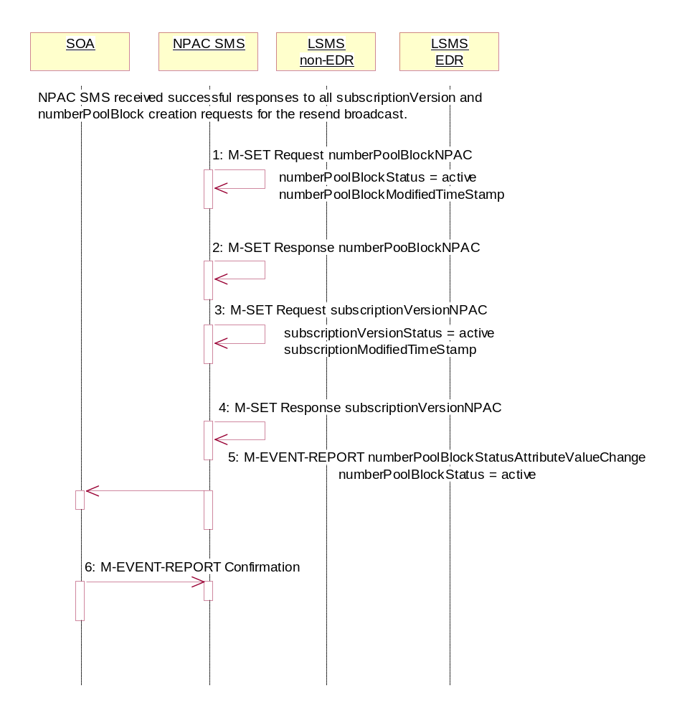
In this scenario, the NPAC SMS has successfully re-sent the creation of a number pool block and corresponding subscription versions. The NPAC SMS now updates the state of the objects on the NPAC SMS.

- NPAC SMS updates the numberPoolBlockNPAC by setting the numberPoolBlockStatus to ‘active’ and setting the numberPoolBlockModifiedTimeStamp to the current date and time.
- NPAC SMS responds to the M-SET.
- NPAC SMS updates all the subscriptionVersionNPACs that were broadcasted by setting the subscriptionVersionStatus to ‘active’ and setting the subscriptionModifiedTimeStamp to the current date and time.
- NPAC SMS responds to the M-SET.
- If the numberPoolBlockSOA-Origination indicator is set to TRUE, the NPAC SMS sends the M-EVENT-REPORT, numberPoolBlockStatusAttributeValueChange, to the block holder SOA for the number pool block. The status attribute value change would contain the numberPoolBlockStatus set to ‘active’.
- Block holder SOA confirms the M-EVENT-REPORT.

Number Pool Block Create Failed Resend NPAC SMS Updates (previously NNP flow 2.8)
In this scenario, the NPAC SMS has unsuccessfully resent the creation of a number pool block and corresponding subscription versions and the status is still failed for the objects. The NPAC SMS now updates the state of the objects on the NPAC SMS.

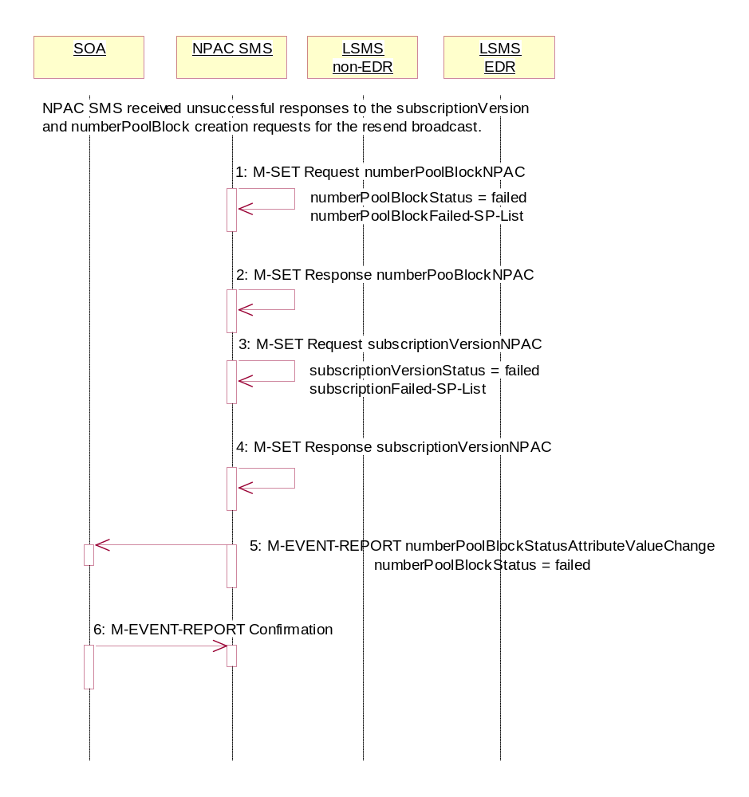
- NPAC SMS updates the numberPoolBlock by setting the numberPoolBlockStatus back to ‘failed’, updating the numberPoolBlockFailed-SP-List with the failed service providers who failed the subscription version and number pool block download and setting the numberPoolBlockModifiedTimeStamp to the current date and time.
- NPAC SMS responds to the M-SET.
- NPAC SMS updates all the subscriptionVersionNPACs that were broadcasted by setting the subscriptionVersionStatus back to ‘failed’, updating the subscriptionFailed-SP-List with the failed service providers who failed either the number pool block or subscription version create and setting the subscriptionModifiedTimeStamp to the current date and time.
- NPAC SMS responds to the M-SET.
- If the numberPoolBlockSOA-Origination indicator is set to TRUE, the NPAC SMS sends the M-EVENT-REPORT, numberPoolBlockStatusAttributeValueChange, to the block holder SOA for the number pool block. The status attribute value change would contain the numberPoolBlockStatus set to ‘failed’ and the numberPoolBlockFailed-SP-List.
- Block holder SOA confirms the M-EVENT-REPORT.

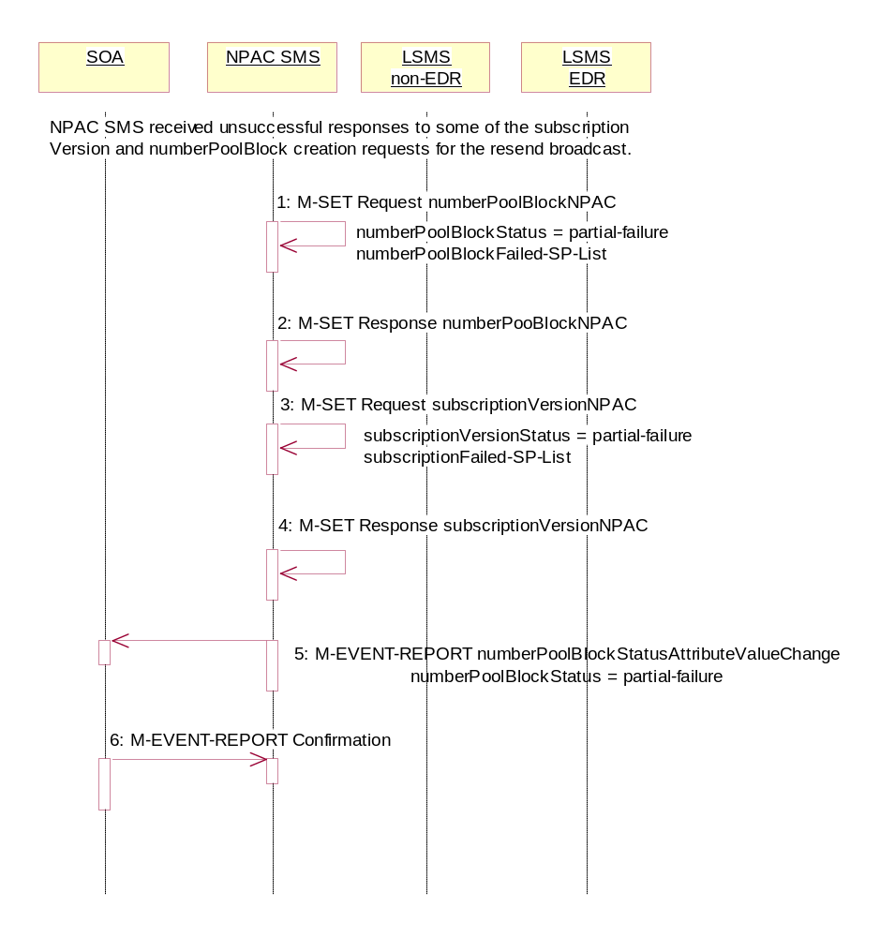
Number Pool Block Create Partial-Failure Resend NPAC SMS Updates (previously NNP flow 2.9)
In this scenario, the NPAC SMS has unsuccessfully re-sent the creation of a number pool block and corresponding subscription versions and the status is now partial-failure for the objects. The NPAC SMS now updates the state of the objects on the NPAC SMS.

- NPAC SMS updates the numberPoolBlock by setting the numberPoolBlockStatus to ‘partial-failure’, updating the numberPoolBlockFailed-SP-List with the failed service providers who failed the number pool block or subscription version create and setting the numberPoolBlockModifiedTimeStamp to the current date and time.
- NPAC SMS responds to the M-SET.
- NPAC SMS updates each of the subscriptionVersionNPAC that was broadcasted by setting the subscriptionVersionStatus to ‘partial-failure’ or ‘active’, updating the subscriptionFailed-SP-List with the failed service providers who failed the number pool block or subscription version create and setting the subscriptionModifiedTimeStamp to the current date and time.
- NPAC SMS responds to the M-SET.
- If the numberPoolBlockSOA-Origination indicator is set to TRUE, the NPAC SMS sends the M-EVENT-REPORT, numberPoolBlockStatusAttributeValueChange, to the block holder SOA for the number pool block. The status attribute value change would contain the numberPoolBlockStatus set to ‘partial-failure’ and the failed service provider list.
- Block holder SOA confirms the M-EVENT-REPORT.

Number Pool Block Modify by NPAC SMS (previously NNP flow 2.10)
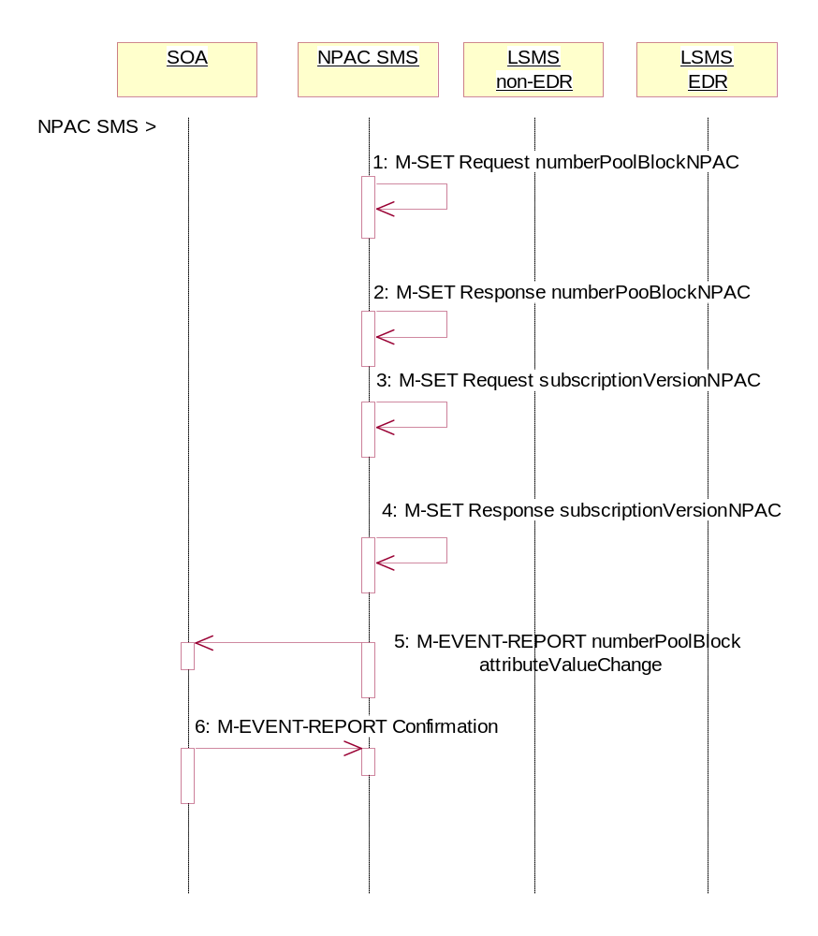
This scenario shows the modification of a number pool block object by NPAC Personnel at the request of the block holder service provider.

Action is taken by NPAC personnel to modify the data on a number pool block.
- NPAC SMS issues the M-SET to modify attribute data on a single numberPoolBlock. The following attributes can be modified:
numberPoolBlockLRN
numberPoolBlockCLASS-DPC
numberPoolBlockCLASS-SSN
numberPoolBlockCNAM-DPC
numberPoolBlockCNAM-SSN
numberPoolBlockISVM-DPC
numberPoolBlockISVM-SSN
numberPoolBlockLIDB-DPC
numberPoolBlockLIDB-SSN
numberPoolBlockSOA-Origination

If the “SOA WSMSC DPC SSN Data Indicator” is set in the service provider’s profile, the following attributes may be updated:

numberPoolBlockWSMSC-DPC
numberPoolBlockWSMSC-SSN

If the indicator is not set, the request will be rejected..

In addition, the numberPoolBlockStatus gets set to ‘sending’ and the numberPoolBlockBroadcastTimeStamp and numberPoolBlockModifiedTimeStamp get set to the current date and time.

- NPAC SMS responds to the M-SET.

- NPAC SMS issues the M-SET to modify the attribute data on the corresponding subscriptionVersionNPAC object(s). Only the following attribute can be modified:

subscriptionLRN
subscriptionCLASS-DPC
subscriptionCLASS-SSN
subscriptionCNAM-DPC
subscriptionCNAM-SSN
subscriptionISVM-DPC
subscriptionISVM-SSN
subscriptionLIDB-DPC
subscriptionLIDB-SSN
subscriptionWSMSC-DPC
subscriptionWSMSC-SSN
subscriptionSOA-Origination

In addition, the NPAC SMS sets the subscriptionVersionStatus to ‘sending’ and the subscriptionBroadcastTimeStamp and subscriptionModifiedTimeStamp get set to the current date and time.

- NPAC SMS responds to the M-SET.

- If the numberPoolBlockSOA-Origination indicator is set to TRUE, the NPAC SMS sends the M-EVENT-REPORT, attribute value change, to the block holder SOA. The attribute value change would include any of the following attributes that were updated:
numberPoolBlockLRN
numberPoolBlockCLASS-DPC
numberPoolBlockCLASS-SSN
numberPoolBlockCNAM-DPC
numberPoolBlockCNAM-SSN
numberPoolBlockISVM-DPC
numberPoolBlockISVM-SSN
numberPoolBlockLIDB-DPC
numberPoolBlockLIDB-SSN
numberPoolBlockSOA-Origination

The following attributes will be sent if they are updated and the “SOA WSMSC DPC SSN Data Indicator” is set in the service provider’s profile:

numberPoolBlockWSMSC-DPC
numberPoolBlockWSMSC-SSN

- Block holder SOA confirms the M-EVENT-REPORT.

Number Pool Block Modify by Block Holder SOA (previously NNP flow 2.11)
This scenario shows the modification of a number pool block object by the block holder SOA Personnel.
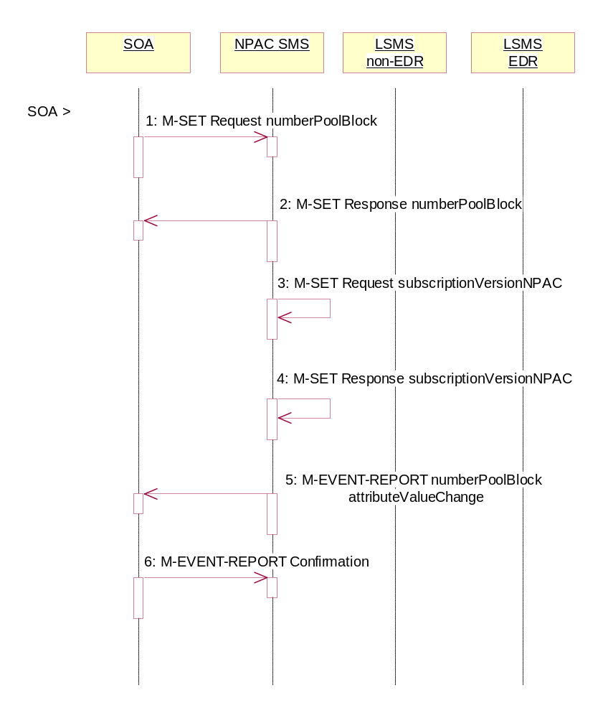
- Block holder SOA issues the M-SET by either directing the request to a specific number pool block or issuing a scope and filtered request specifying the numberPoolBlockNPA-NXX-X and numberPoolBlockStatus to modify attribute data on the numberPoolBlock. The following attributes can be modified:
numberPoolBlockLRN
numberPoolBlockCLASS-DPC
numberPoolBlockCLASS-SSN
numberPoolBlockCNAM-DPC
numberPoolBlockCNAM-SSN
numberPoolBlockISVM-DPC
numberPoolBlockISVM-SSN
numberPoolBlockLIDB-DPC
numberPoolBlockLIDB-SSN
If the “SOA WSMSC DPC SSN Data Indicator” is set in the service provider’s profile, the following attributes may be updated:

numberPoolBlockWSMSC-DPC
numberPoolBlockWSMSC-SSN

If the indicator is not set, the request will be rejected..

In addition, the numberPoolBlockStatus gets set to ‘sending’ and the numberPoolBlockBroadcastTimeStamp gets set.

- NPAC SMS responds to the M-SET.

- NPAC SMS issues the M-SET to modify the attribute data on the corresponding subscriptionVersionNPAC object(s). Only the following attribute can be modified:

subscriptionLRN
subscriptionCLASS-DPC
subscriptionCLASS-SSN
subscriptionCNAM-DPC
subscriptionCNAM-SSN
subscriptionISVM-DPC
subscriptionISVM-SSN
subscriptionLIDB-DPC
subscriptionLIDB-SSN
subscriptionWSMSC-DPC
subscriptionWSMSC-SSN

In addition, the NPAC SMS sets the subscriptionVersionStatus to ‘sending’.

- NPAC SMS responds to the M-SET.

- If the numberPoolBlockSOA-Origination indicator is set to TRUE, the NPAC SMS sends the M-EVENT-REPORT, attribute value change, to the block holder SOA. The attribute value change would include any of the following attributes that were updated:
numberPoolBlockLRN
numberPoolBlockCLASS-DPC
numberPoolBlockCLASS-SSN
numberPoolBlockCNAM-DPC
numberPoolBlockCNAM-SSN
numberPoolBlockISVM-DPC
numberPoolBlockISVM-SSN
numberPoolBlockLIDB-DPC
numberPoolBlockLIDB-SSN

If the “SOA WSMSC DPC SSN Data Indicator” is set in the service provider’s profile on the NPAC SMS, the following attributes will be sent if they were updated:

numberPoolBlockWSMSC-DPC
numberPoolBlockWSMSC-SSN

- Block holder SOA confirms the M-EVENT-REPORT.

Number Pool Block Modify Successful Broadcast to Local SMS Success (previously NNP flow 2.12.1)
In this scenario, the NPAC SMS has made a modification to a number pool block object and is about to broadcast the data to the Local SMS.

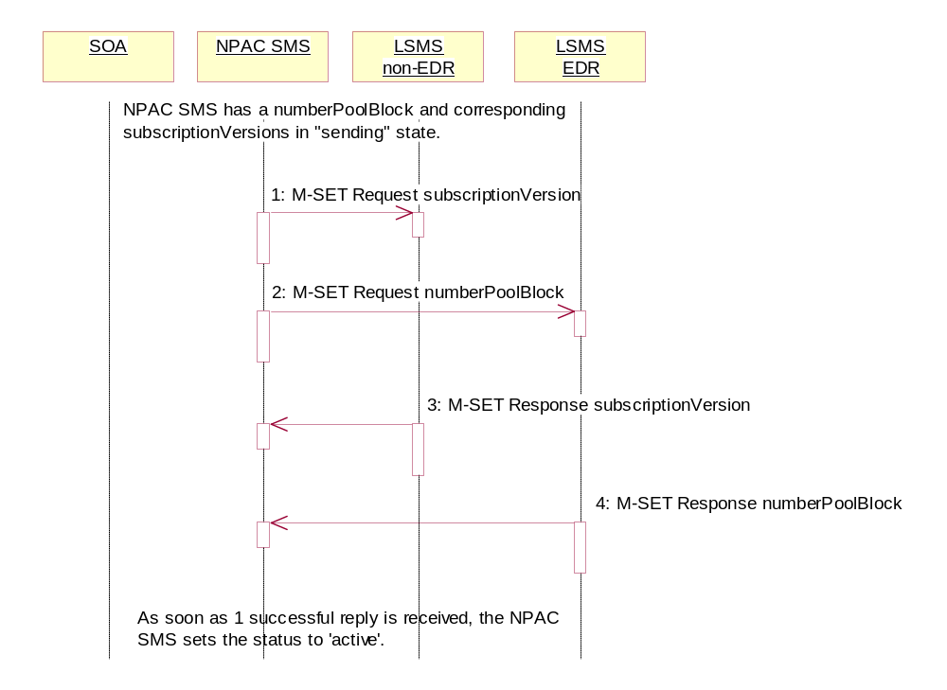
The NPAC SMS has a number pool block object and corresponding subscription version objects in a state of ‘sending’.
- NPAC SMS sends the M-SET for the updated attributes on the subscription version object(s) to the non-EDR Local SMS who are accepting downloads for the NPA-NXX.
- At the same time, the NPAC SMS sends the M-SET for the updated attributes on the number pool block object to the EDR Local SMS.
- Non-EDR Local SMS responds to the M-SET.
- EDR Local SMS responds to the M-SET.
As soon as 1 successful response is received to either M-SET, the status of the subscriptionVersionNPAC and numberPoolBlockNPAC object goes to ‘active’.

      - Number Pool Block Modify Successful Broadcast NPAC SMS Updates (previously NNP flow 2.12.2)
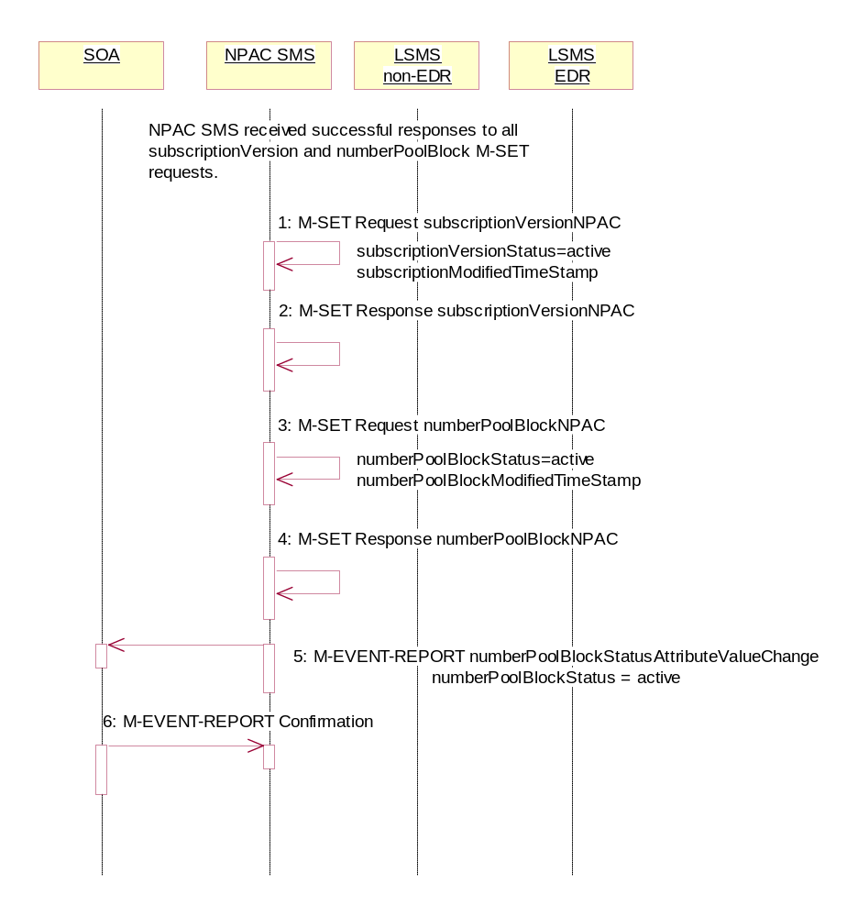
In this scenario, the NPAC SMS has received successful M-SET responses from all the Local SMS for the numberPoolBlock and corresponding subscriptionVersions.

As soon as the first successful response is received, the NPAC SMS sets the status of the subscriptionVersionNPAC objects and numberPoolBlockNPAC object to ‘active’. The numberPoolBlockStatusAttributeValueChange, however, is not sent out until all replies have been received or the retries have been exhausted.
- NPAC SMS updates all the subscriptionVersionNPACs that were broadcasted by setting the subscriptionVersionStatus to ‘active’ and setting the subscriptionModifiedTimeStamp to the current date and time.
- NPAC SMS responds to the M-SET.
- NPAC SMS updates the numberPoolBlock by setting the numberPoolBlockStatus to ‘active’ and setting the numberPoolBlockModifiedTimeStamp to the current date and time.
- NPAC SMS responds to the M-SET.
- If the numberPoolBlockSOA-Origination indicator is set to TRUE, the NPAC SMS sends the M-EVENT-REPORT, numberPoolBlockStatusAttributeValueChange, to the block holder SOA. The status attribute value change would contain the numberPoolBlockStatus set to active.
- Block holder SOA confirms the M-EVENT-REPORT.

Number Pool Block Modify Broadcast to Local SMS Failure (previously NNP flow 2.13)
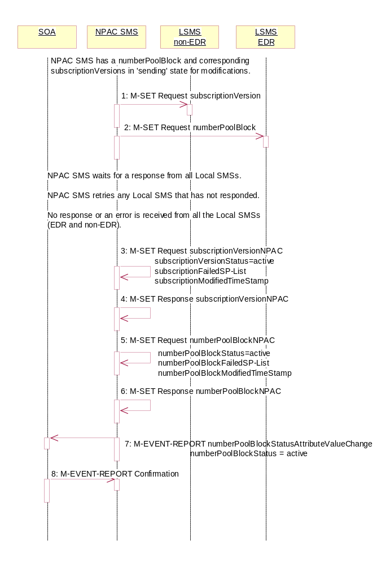
NPAC SMS has a numberPoolBlock and corresponding subscriptionVersion in ‘sending’ state for modifications. In this scenario, no Local SMSs will respond successfully to the M-SET requests.

- NPAC SMS sends the M-SET with the modifications for the subscriptionVersion to the non-EDR Local SMS.
- At the same time as step 1, NPAC SMS sends the M-SET with the modifications for the numberPoolBlock to the EDR Local SMS.
NPAC SMS waits for a response from all Local SMSs.
NPAC SMS retries any Local SMS that has not responded.
No response or an error is received from all the Local SMSs (EDR and non-EDR).
- NPAC SMS returns the subscriptionVersionStatus to ‘active’, sets the subscriptionFailed-SP-List to the list of failed service providers and sets the subscriptionModifiedTimeStamp.
- NPAC SMS responds to the M-SET.
- NPAC SMS returns the numberPoolBlockStatus to ‘active’ and sets the numberPoolBlockFailed-SP-List to the list of failed service providers. The numberPoolBlockModifiedTimeStamp also gets set.
- NPAC SMS responds to the M-SET.
- If the numberPoolBlockSOA-Origination indicator is set to ‘true’, the NPAC SMS sends the block holder SOA the M-EVENT-REPORT, numberPoolBlockStatusAttributeValueChange, with the numberPoolBlockStatus set to active and the numberPoolBlockFailed-SP-List.
- SOA confirms M-EVENT-REPORT.

Number Pool Block Modify Partial Failure Broadcast to Local SMS (previously NNP flow 2.14.1)
In this scenario, the NPAC SMS has a numberPoolBlock and corresponding subscriptionVersion object(s) in a state of ‘sending’ for a modification to the Local SMS. The broadcast, however, will result in a partial-failure state for both the numberPoolBlock and corresponding subscriptionVersions.

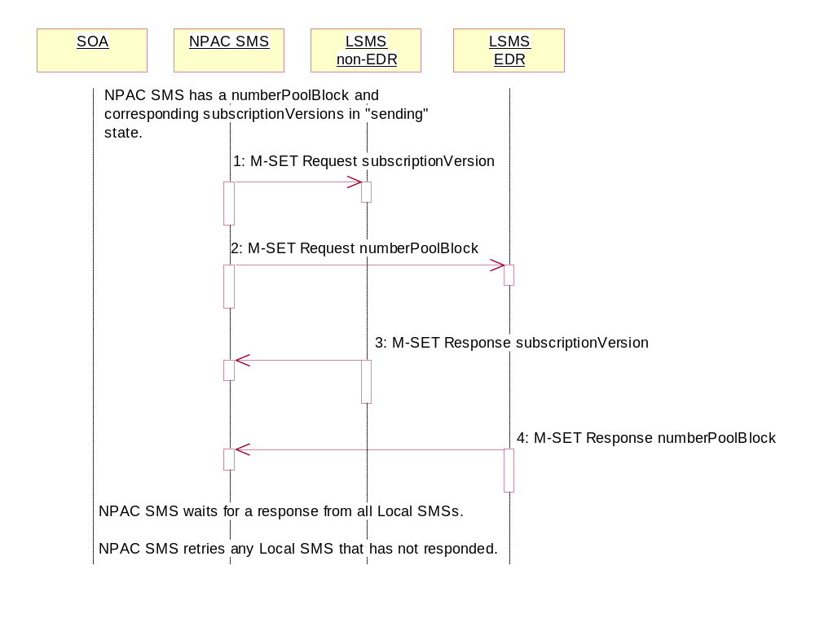
The NPAC SMS has a number pool block object and corresponding subscription version objects in a state of ‘sending’.
- NPAC SMS sends the M-SET for the updated attributes on the subscription version object(s) to the non-EDR Local SMS who are accepting downloads for the NPA-NXX.
- At the same time as step 1, NPAC SMS sends the M-SET for the updated attributes on the number pool block object to the EDR Local SMS who are accepting downloads for the NPA-NXX.
- Non-EDR Local SMS responds successfully to the M-SET.
- EDR Local SMS responds successfully to the M-SET.

NPAC SMS waits for a response from all Local SMSs.
NPAC SMS retries any Local SMS that has not responded.

Number Pool Block Modify Broadcast Partial Failure NPAC SMS Updates (previously NNP flow 2.14.2)
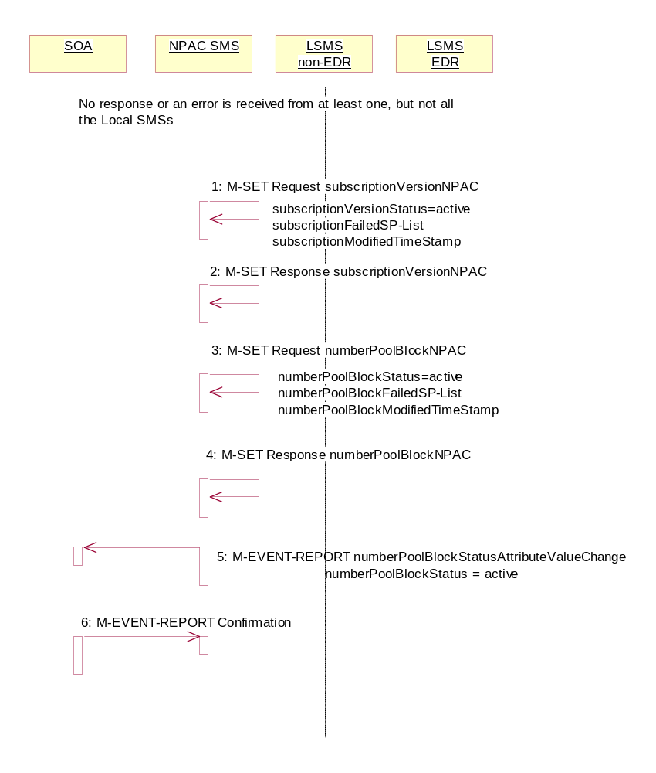
The NPAC SMS has attempted to broadcast the number pool block modification to the Local SMSs. However, at least 1, but not all Local SMSs have responded successfully to the M-SETs.

Once the first successful M-SET response is received, the NPAC SMS sets the status to ‘active’ for the numberPoolBlock and subscriptionVersion objects. Once all retries are exhausted, the NPAC SMS sets
the numberPoolBlockFailed-SP-List and sends the status attribute value change.

The numberPoolBlockSP-List on the number pool block object contains all the service providers who failed to receive either the number pool block or any of the subscription versions. The subscriptionFailed-SP-List on the subscription version object contains only those service providers who failed to receive that subscription version or the number pool block object.

- NPAC SMS updates the subscriptionVersionNPACs with a LNP type set to ‘pool’ that were broadcasted by setting the subscriptionVersionStatus to ‘active’ and updating the subscriptionFailed-SP-List to the list of failed service providers. The subscriptionModifiedTimeStamp is set to the current date and time.
- NPAC SMS responds to the M-SET.
- NPAC SMS updates the numberPoolBlock by setting the numberPoolBlockStatus to ‘active’ and setting the numberPoolBlockFailed-SP-List to the list of currently failed service providers. It also sets the numberPoolBlockModifiedTimeStamp and numberPoolBlockBroadcastTimeStamp to the current date and time.
- NPAC SMS responds to the M-SET.
- If the numberPoolBlockSOA-Origination indicator is set to TRUE, the NPAC SMS sends the M-EVENT-REPORT, numberPoolBlockStatusAttributeValueChange, to the block holder SOA. The status attribute value change would contain the numberPoolBlockStatus set to ‘active’ and the numberPoolBlockFailed-SP-List.
- Block holder SOA confirms the M-EVENT-REPORT.

Number Pool Block Modify Resend Broadcast (previously NNP flow 2.15)
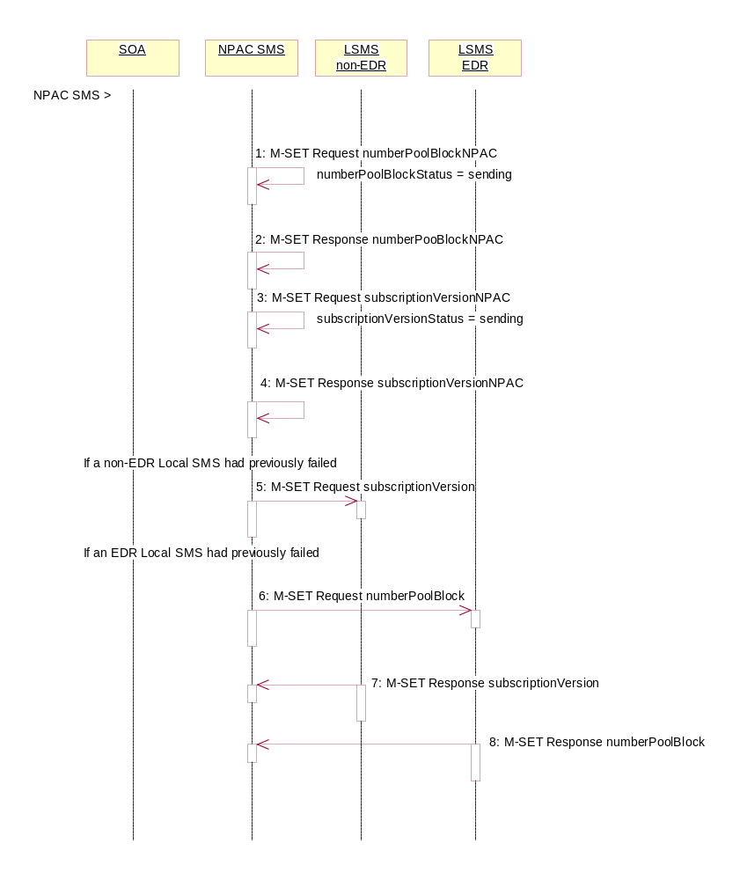
In this scenario, the NPAC SMS must resend a previously failed modification to a number pool block and corresponding subscription versions of type ‘pool’.

Action is taken by the NPAC SMS personnel to resend a previously failed modification of a number pool block and corresponding subscription versions with a LNP type of ‘pool’.
- NPAC SMS issues the M-SET to modify the numberPoolBlockStatus to ‘sending’ on the number pool block object. The numberPoolBlockModifiedTimeStamp and numberPoolBlockBroadcastTimeStamp also get set.
- NPAC SMS responds to the M-SET.
- NPAC SMS issues the M-SET to modify the subscriptionVersionStatus to ‘sending’ on the subscription version object. The subscriptionModifiedTimeStamp and subscriptionBroadcastTimeStamp also get set.
- NPAC SMS responds to the M-SET.
- NPAC SMS issues the M-SET for the subscription versions to the non-EDR Local SMS if it had previously failed the modify request and if it is accepting downloads for the NPA-NXX.
- At the same time as step 5, the NPAC SMS sends the M-SET for the numberPoolBlock to the EDR Local SMS if it had previously failed the modify request and if it is accepting downloads for the NPA-NXX.
- The non-EDR Local SMS sends to the NPAC SMS the results of the M-SET. If the non-EDR Local SMS fails to respond, the NPAC SMS will retry the M-SET request a tunable amount of times.
- The EDR Local SMS sends to the NPAC SMS the results of the M-SET. If the EDR Local SMS fails to respond, the NPAC SMS will retry the M-SET request a tunable amount of times.

Number Pool Block Modify Successful Resend Updates (previously NNP flow 2.16)
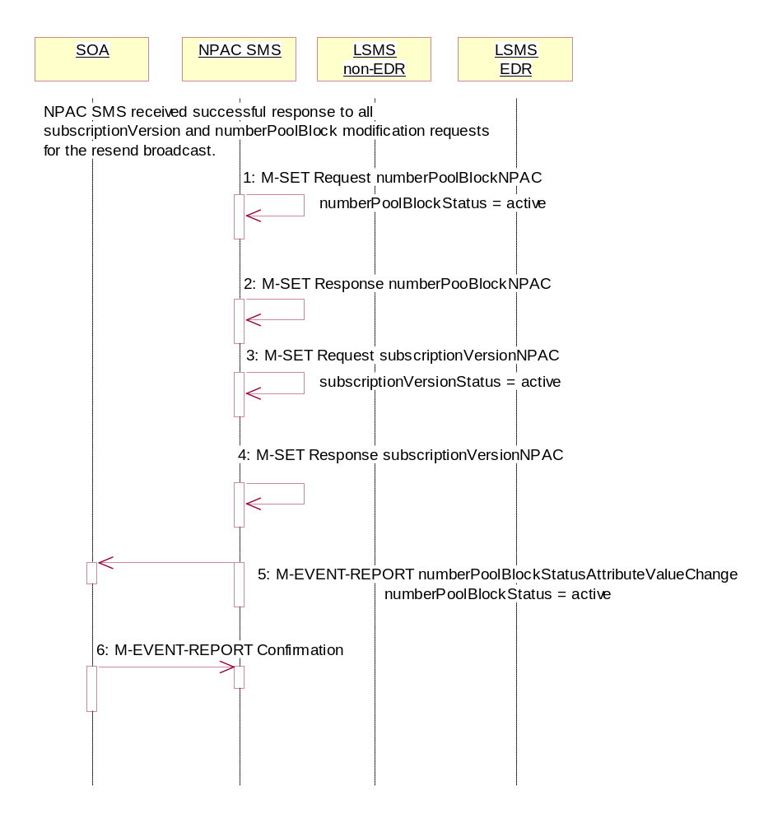
In this scenario, the NPAC SMS has received all successful responses to the modify request for a number pool block and corresponding subscription version with LNP type equal to ‘pool’.

- NPAC SMS updates the numberPoolBlockNPAC by setting the numberPoolBlockStatus to ‘active’ and setting the numberPoolBlockModifiedTimeStamp to the current date and time.
- NPAC SMS responds to the M-SET.
- NPAC SMS updates all the subscriptionVersionNPACs that were broadcasted by setting the subscriptionVersionStatus to ‘active’ and setting the subscriptionModifiedTimeStamp to the current date and time.
- NPAC SMS responds to the M-SET.
- If the numberPoolBlockSOA-Origination indicator is set to TRUE, the NPAC SMS sends the M-EVENT-REPORT, numberPoolBlockStatusAttributeValueChange, to the block holder SOA for the number pool block. The status attribute value change would contain the numberPoolBlockStatus set to ‘active’.
- Block holder SOA confirms the M-EVENT-REPORT.

Number Pool Block Modify Failure Resend Updates (previously NNP flow 2.17)
In this scenario, the NPAC SMS has not received all successful responses to the modify request for a number pool block and corresponding subscription version with LNP type equal to ‘pool’.
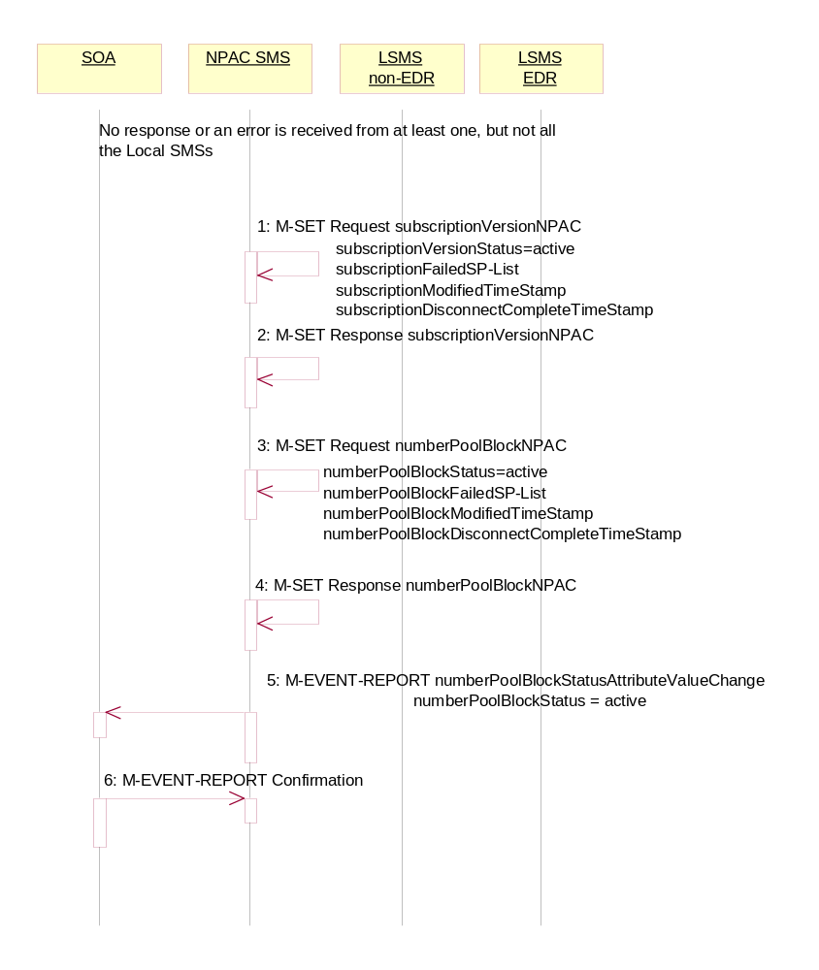
- NPAC SMS updates the numberPoolBlockNPAC by setting the numberPoolBlockStatus back to ‘active’, updating the numberPoolBlockFailed-SP-List with the failed service providers who failed the subscription version and number pool block download and setting the numberPoolBlockModifiedTimeStamp to the current date and time.
- NPAC SMS responds to the M-SET.
- NPAC SMS updates each of the subscriptionVersionNPAC that was broadcasted by setting the subscriptionVersionStatus back to ‘active’, updating the subscriptionVersionFailed-SP-List with the failed service providers who failed either the number pool block or subscription version create and setting the subscriptionModifiedTimeStamp to the current date and time.
- NPAC SMS responds to the M-SET.
- If the numberPoolBlockSOA-Origination indicator is set to TRUE, the NPAC SMS sends the M-EVENT-REPORT, numberPoolBlockStatusAttributeValueChange, to the block holder SOA for the number pool block. The status attribute value change would contain the numberPoolBlockStatus set to ‘active’ and the numberPoolBlockFailed-SP-List with any of the failed service providers who failed the subscription version and/or number pool block download.
- Block holder SOA confirms the M-EVENT-REPORT.

Number Pool Block Modification of SOA-Origination Indicator (previously NNP flow 2.18)
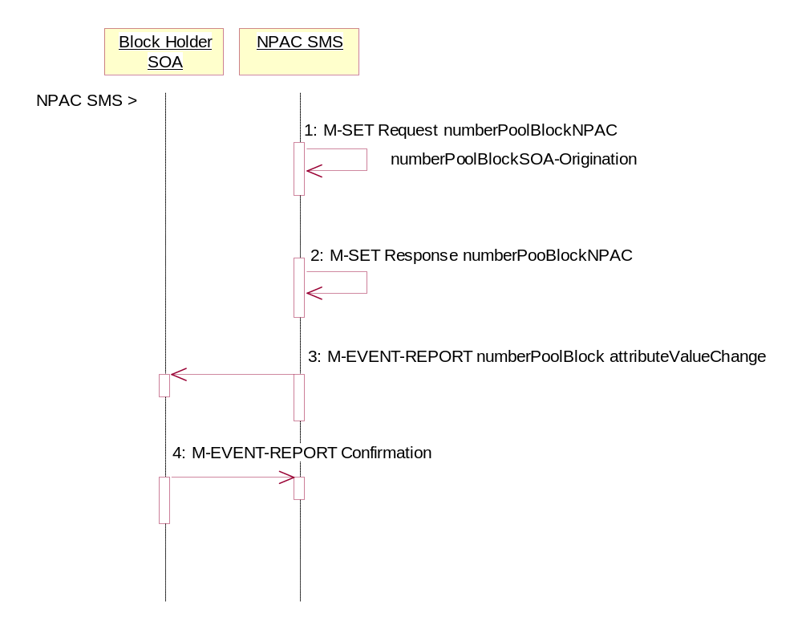
A block holder service provider has asked the NPAC SMS to change the value of the numberPoolBlockSOA-Origination indicator on a number pool block.
Action is taken by NPAC SMS personnel to modify a number pool block object.
- NPAC SMS locally M-SETs the number pool block object changing the value of the numberPoolBlockSOA-Origination indicator.
- NPAC SMS successfully responds to the M-SET.
- The NPAC SMS issues the M-EVENT-REPORT attribute value change to the block holder SOA for the number pool block that contains the numberPoolBlockSOA-Origination indicator, only when the numberPoolBlockSOA-Origination indicator is modified from FALSE to TRUE.
- The block holder SOA confirms the M-EVENT-REPORT.

Number Pool Block De-Pool by NPAC SMS (previously NNP flow 2.19)
This scenario reflects the events that occur when a block is “de-pooled” after the serviceProvNPA-NXX-X object has become effective and active. Only NPAC Personnel are allowed to remove a number pool block object at the request of the number pool block administrator.
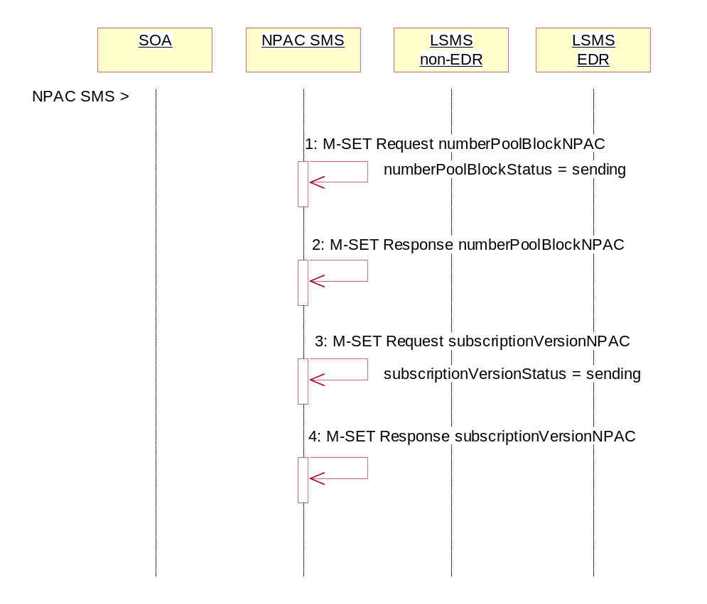
The removal of the serviceProvNPA-NXX-X object is a cascading request. First, all subscription versions with the LNP type equal to ‘pool’ must be removed from the non-EDR Local SMSs and the number pool block must be removed from all the EDR Local SMSs.

Action is taken by NPAC personnel to ‘de-pool’ a block of TNs.
- NPAC SMS issues the M-SET to update the numberPoolBlockStatus to ‘sending’ and the numberPoolBlockBroadcastTimeStamp gets set.
- NPAC SMS responds to the M-SET.
- NPAC SMS issues the M-SET to update the corresponding subscriptionVersions within the block range with LNP type equal to ‘pool’ to a status of ‘sending’ and the subscriptionModifiedTimeStamp gets set.
- NPAC SMS responds to the M-SET.

Number Pool Block De-Pool Successful Broadcast of Subscription Version and Number Pool Block Deletes (previously NNP flow 2.20.1)
In this scenario, the NPAC personnel have initiated the “de-pool” of a block of TNs. The NPAC SMS already has the numberPoolBlock and corresponding subscriptionVersions in the “sending” state.
In this scenario, the NPAC SMS will send all the M-DELETE requests for the number pool block and subscription versions to the Local SMSs and get successful replies to all the requests.

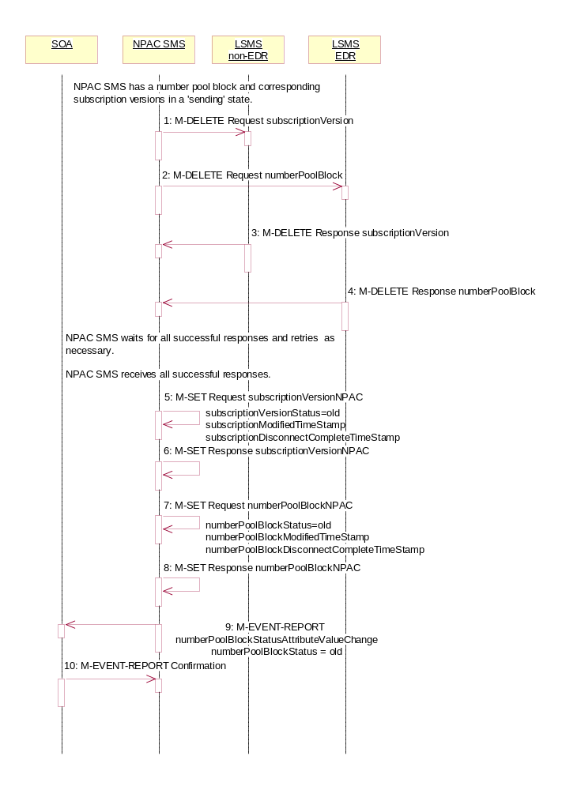
The NPAC SMS has a number pool block object and corresponding subscription version objects in a state of ‘sending’.
- NPAC SMS sends the M-DELETE for the subscription version object(s) to the non-EDR Local SMS who are accepting downloads for the NPA-NXX. The subscription version TNs are within the block range and have the LNP type set to ‘pool’.
- At the same time, NPAC SMS sends the M-DELETE for the number pool block object to the EDR Local SMS.
- Non-EDR Local SMS respond successfully to the M-DELETE.
- EDR Local SMS respond successfully to the M-DELETE.
NPAC SMS waits for all the successful responses and retries as necessary.
NPAC SMS receives all successful responses.
- NPAC SMS updates all the subscriptionVersionNPACs that were broadcasted by setting the subscriptionVersionStatus to ‘old’ and setting the subscriptionModifiedTimeStamp to the current date and time. The subscriptionDisconnectCompleteTimeStamp is set when the first successful response is received.
- NPAC SMS responds to the M-SET.
- NPAC SMS updates the numberPoolBlock by setting the numberPoolBlockStatus to ‘old’ and setting the numberPoolBlockModifiedTimeStamp to the current date and time. The numberPoolBlockDisconnectCompleteTimeStamp is set when the first successful response is received.
- NPAC SMS responds to the M-SET.
- If the numberPoolBlockSOA-Origination indicator is set to TRUE, the NPAC SMS sends the M-EVENT-REPORT for the numberPoolBlockStatusAttributeValueChange to the block holder SOA. The status attribute value change would contain the numberPoolBlockStatus set to ‘old’.
- Block holder SOA confirms the M-EVENT-REPORT.
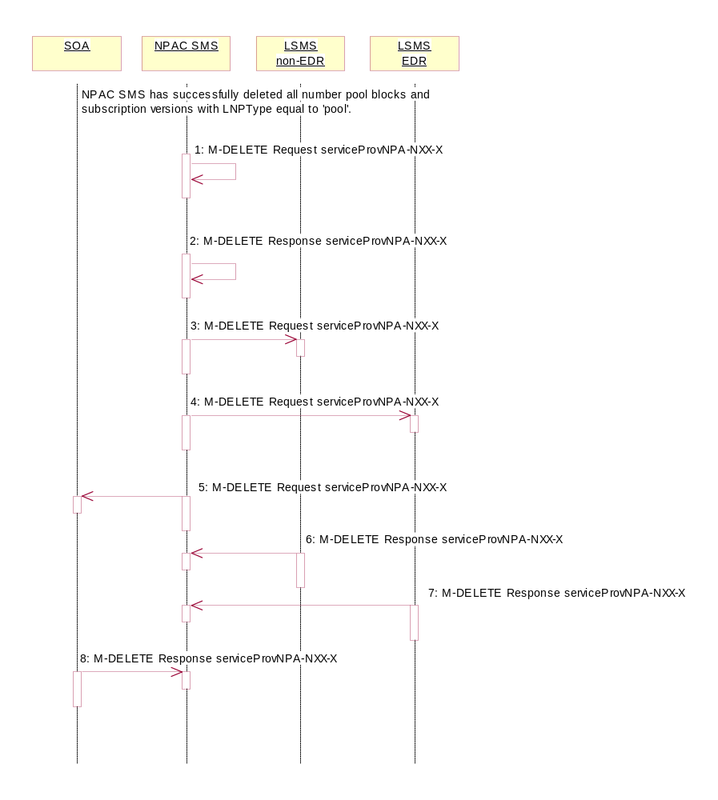

Number Pool Block De-Pool Broadcast Successful NPA-NXX-X Updates (previously NNP flow 2.20.2)
NPAC SMS has received successful responses to all numberPoolBlock and subscriptionVersion M-DELETE requests. The NPAC SMS now proceeds to delete the service provider NPA-NXX-X object.

- NPAC SMS issues the M-DELETE to remove the serviceProvNPA-NXX-X object locally.
- NPAC SMS responds successfully to the M-DELETE request for the serviceProvNPA-NXX-X object.
- The NPAC SMS sends the M-DELETE for the serviceProvNPA-NXX-X object to the non-EDR Local SMS who are supporting the object according to the “NPAC Customer LSMS NPA-NXX-X Indicator” in their service provider profile on the NPAC SMS.
- The NPAC SMS sends the M-DELETE for the serviceProvNPA-NXX-X object to the EDR Local SMS who are supporting the object according to the “NPAC Customer LSMS NPA-NXX-X Indicator” in their service provider profile on the NPAC SMS.
- At the same time as step 4, the NPAC SMS sends the M-DELETE for the serviceProvNPA-NXX-X object to the SOAs who are supporting the object according to the “NPAC Customer SOA NPA-NXX-X Indicator” in their service provider profile on the NPAC SMS.
- Non-EDR Local SMS respond successfully to the M-DELETE.
- EDR Local SMS respond successfully to the M-DELETE.
- SOA respond successfully to the M-DELETE.

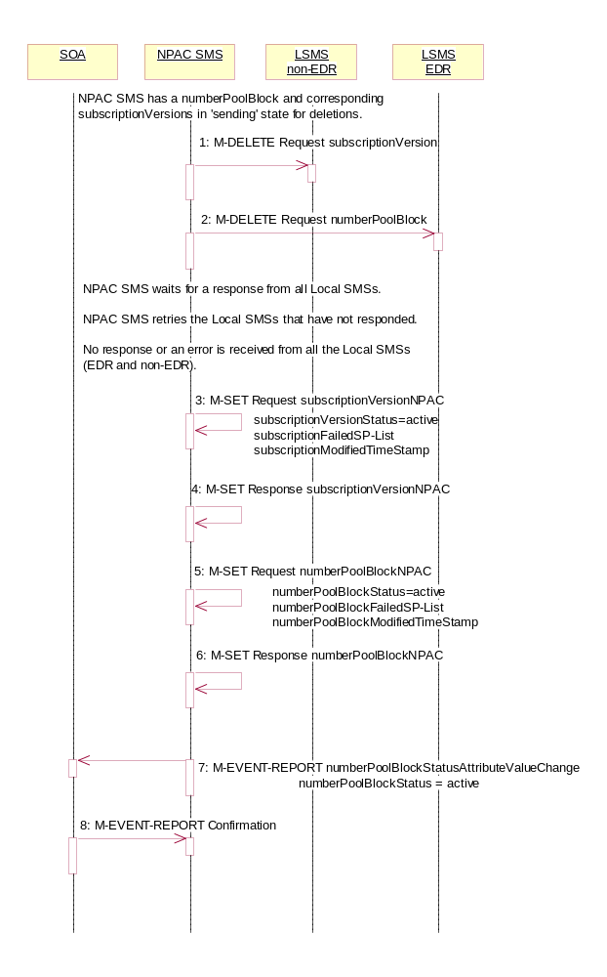
Number Pool Block De-Pool Broadcast to Local SMS Failure (previously NNP flow 2.21)
This scenario shows the failure of a broadcast for a de-pool of a number pool block. The M-DELETE has been issued on the serviceProvNPA-NXX-X object and now the NPAC SMS is attempting to broadcast the all the M-DELETEs associated with the block removal.

- NPAC SMS sends the M-DELETE for the subscriptionVersion to the non-EDR Local SMS.
- At the same time as step 1, NPAC SMS sends the M-DELETE for the numberPoolBlock to the EDR Local SMS.
NPAC SMS waits for a response from all Local SMSs.
NPAC SMS retries the Local SMSs that have not responded.
No response or an error is received from all the Local SMSs (EDR and non-EDR).
- NPAC SMS sets the subscriptionVersionStatus to ‘active’, sets the subscriptionFailed-SP-List to the list of failed service providers and sets the subscriptionModifiedTimeStamp.
- NPAC SMS responds to the M-SET.
- NPAC SMS sets the numberPoolBlockStatus to ‘active’ and sets the numberPoolBlockFailed-SP-List to the list of failed service providers. The numberPoolBlockModifiedTimeStamp also gets set.
- NPAC SMS responds to the M-SET.
- If the numberPoolBlockSOA-Origination indicator is set to ‘true’, the NPAC SMS sends the originating SOA the M-EVENT-REPORT numberPoolBlockStatusAttributeValueChange with the numberPoolBlockStatus set back to ‘active’ and numberPoolBlockFailed-SP-List.
- SOA confirms M-EVENT-REPORT.

Number Pool Block De-Pool Partial Failure Broadcast to Local SMS of Subscription Versions and Number Pool Block (previously NNP flow 2.22.1)
This scenario shows the processing of a partial-failure for the de-pool of a number pool block. The M-DELETE has been issued on the serviceProvNPA-NXX-X object on the NPAC SMS and now the NPAC SMS is attempting to broadcast all the M-DELETEs associated with the block removal to the Local SMSs.
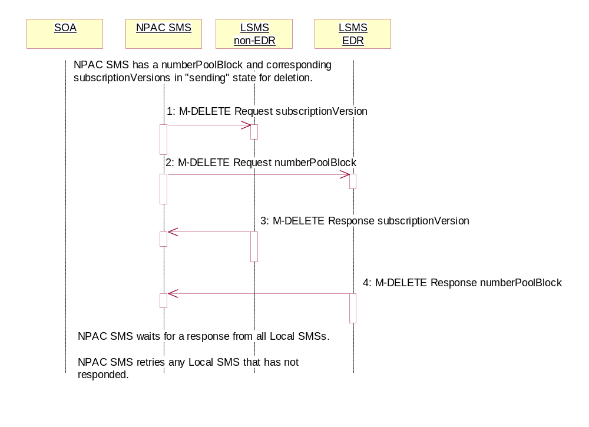
The NPAC SMS has a number pool block object and corresponding subscription version objects in a state of ‘sending’.

- NPAC SMS sends the M-DELETE for the subscription version object(s) to the non-EDR Local SMS who are accepting downloads for the NPA-NXX.
- NPAC SMS sends the M-DELETE for the number pool block object to the EDR Local SMS.
- Non-EDR Local SMS responds to the M-DELETE for the subscriptionVersion.
- EDR Local SMS responds to the M-DELETE for the numberPoolBlock.
NPAC SMS waits for a response from all Local SMSs.
NPAC SMS retries any Local SMS that has not responded.
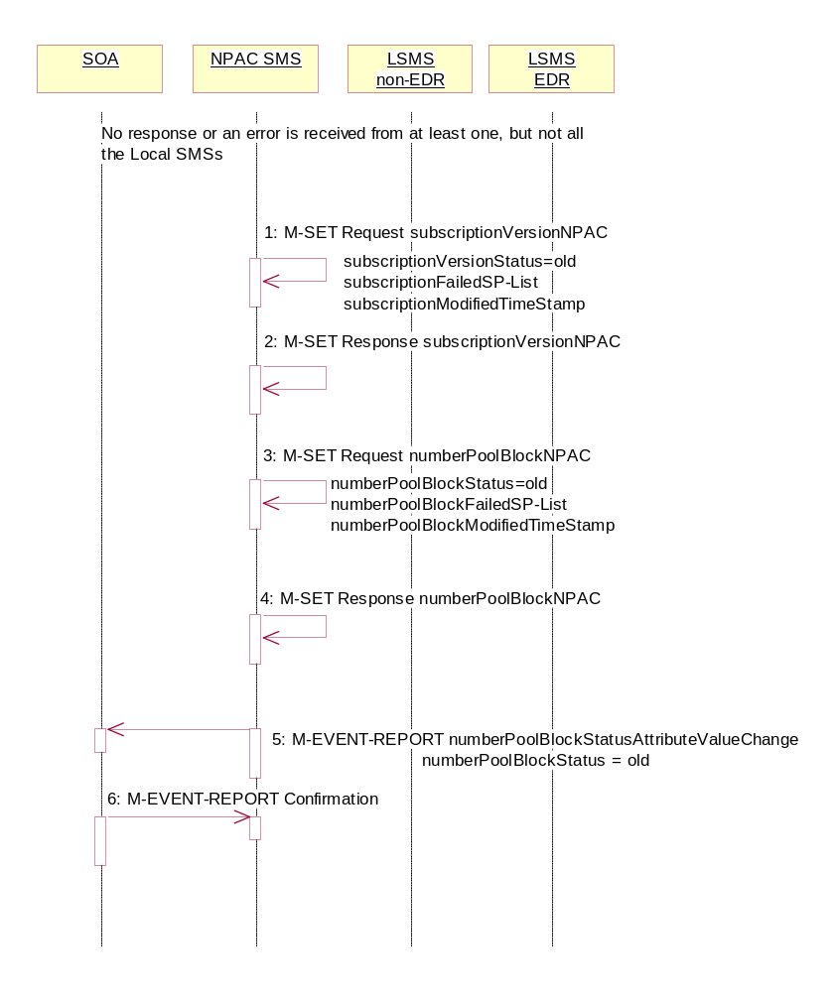

Number Pool Block De-Pool Broadcast Partial Failure NPAC SMS Updates (previously NNP flow2.22.2)
The NPAC SMS broadcast of a block deletion partially failed. The NPAC SMS now updates the states of the objects on the NPAC SMS.

No response or an error is received from at least one Local SMS.

- NPAC SMS updates each of the subscriptionVersionNPACs that was broadcasted by setting the subscriptionVersionStatus to ‘old’ and updating the subscriptionFailed-SP-List to the list of failed service providers. The subscriptionModifiedTimeStamp is set to the current date and time. The subscriptionDisconnectCompleteTimeStamp would be set with the first successful response.
The subscriptionFailed-SP-List will reflect the list of the EDR service providers that failed on the number pool block broadcast and any non-EDR service provider that failed to receive any subscription version.
- NPAC SMS responds to the M-SET.
- NPAC SMS updates the numberPoolBlock by setting the numberPoolBlockStatus to ‘old’ and setting the numberPoolBlockFailed-SP-List to the list of currently failed service providers. It also sets the numberPoolBlockModifiedTimeStamp to the current date and time. The numberPoolBlockDisconnectCompleteTimeStamp would be set with the first successful response.
The numberPoolBlockFailed-SP-List will reflect the list of the EDR service providers that failed on the number pool block broadcast and any non-EDR service provider that failed to receive any subscription versions.
- NPAC SMS responds to the M-SET.
- If the numberPoolBlockSOA-Origination indicator is set to TRUE, the NPAC SMS sends the M-EVENT-REPORT for the subscription version status attribute value change to the block holder SOA. The numberPoolBlockStatusAttributeValueChange would contain the numberPoolBlockStatus set to ‘old’ and the numberPoolBlockFailed-SP-List.
- Block holder SOA confirms the M-EVENT-REPORT.

Number Pool Block De-Pool Resend Broadcast (previously NNP flow 2.23)
In this scenario, the NPAC SMS resends the broadcast of a de-pool of a block because the first attempt did not complete successfully.
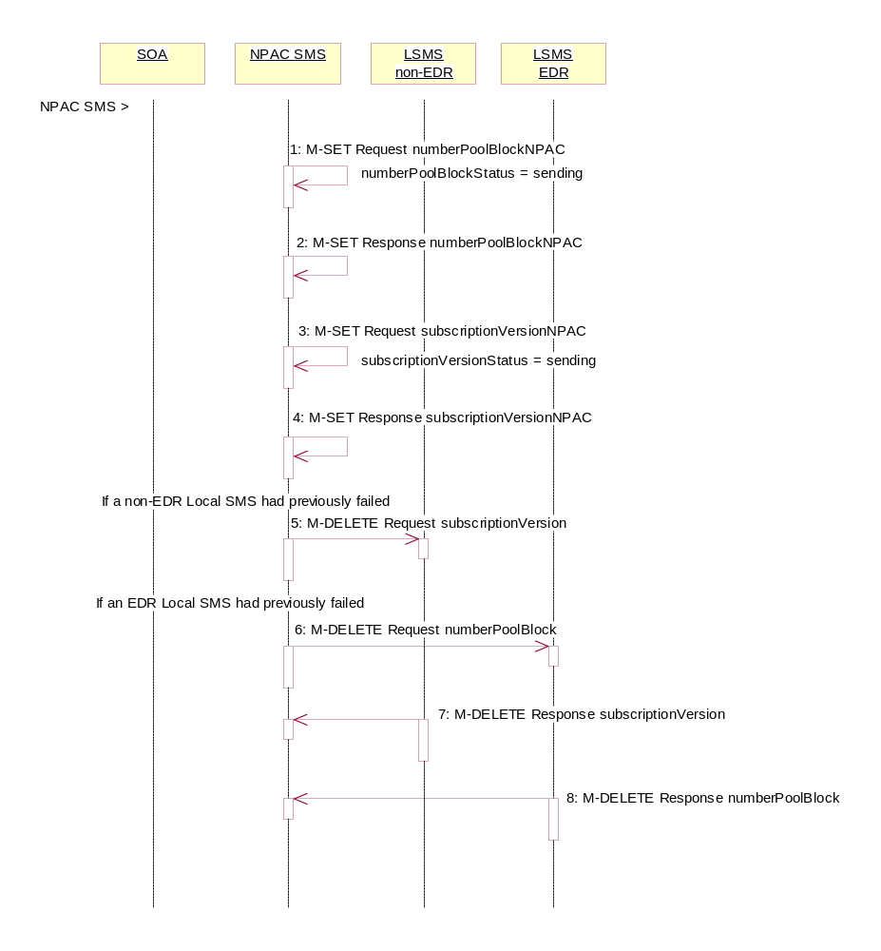
Action is taken by the NPAC SMS personnel to resend a previously failed de-pool of block data.
- NPAC SMS issues the M-SET to modify the numberPoolBlockStatus to ‘sending’ of the number pool block object. The numberPoolBlockModifiedTimeStamp and numberPoolBlockBroadcastTimeStamp also get set.
- NPAC SMS responds to the M-SET.
- NPAC SMS issues the M-SET to modify the subscriptionVersionStatus to ‘sending’ of the subscription version object. The subscriptionModifiedTimeStamp and subscriptionBroadcastTimeStamp also get set.
- NPAC SMS responds to the M-SET.
- NPAC SMS issues the M-DELETE for the subscription versions to the non-EDR Local SMS if it is accepting downloads for the NPA-NXX and had previously failed the delete request.
- At the same time as step 5, the NPAC SMS sends the M-DELETE for the numberPoolBlock to the EDR Local SMS if it is accepting downloads for the NPA-NXX and had previously failed the delete request.
- The non-EDR Local SMS sends to the NPAC SMS the results of the M-DELETE. If the non-EDR Local SMS fails to respond, the NPAC SMS will retry the M-DELETE request a tunable amount of times.
- The EDR Local SMS sends to the NPAC SMS the results of the M-DELETE. If the EDR Local SMS fails to respond, the NPAC SMS will retry the M-DELETE request a tunable amount of times.

Number Pool Block De-Pool Successful Resend Updates (previously NNP flow 2.24)
In this scenario, the NPAC SMS successfully rebroadcast the number pool block and subscription version deletes to the Local SMS. It now proceeds to update the status of the number pool block and corresponding subscription versions and then sends the NPA-NXX-X delete to the Local SMSs.

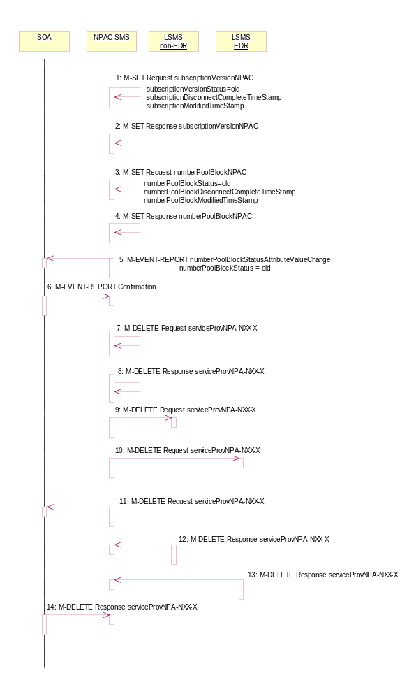
- NPAC SMS updates all the subscriptionVersionNPACs that were broadcasted by setting the subscriptionVersionStatus to ‘old’ and setting the subscriptionModifiedTimeStamp to the current date and time. The subscriptionDisconnectCompleteTimeStamp is set when the first successful response is received.
- NPAC SMS responds to the M-SET.
- NPAC SMS updates the numberPoolBlock by setting the numberPoolBlockStatus to ‘old’ and setting the numberPoolBlockModifiedTimeStamp to the current date and time. The numberPoolBlockDisconnectCompleteTimeStamp is set when the first successful response is received.
- NPAC SMS responds to the M-SET.
- If the numberPoolBlockSOA-Origination indicator is set to TRUE, the NPAC SMS sends the M-EVENT-REPORT for the numberPoolBlockStatusAttributeValueChange to the block holder SOA. The status attribute value change would contain the numberPoolBlockStatus set to ‘old’.
- Block holder SOA confirms the M-EVENT-REPORT.
- NPAC SMS issues the M-DELETE to remove the serviceProvNPA-NXX-X object locally.
- NPAC SMS responds successfully to the M-DELETE request for the serviceProvNPA-NXX-X object.
- The NPAC SMS sends the M-DELETE for the serviceProvNPA-NXX-X object to the non-EDR Local SMS that support the object according to the “NPAC Customer LSMS NPA-NXX-X Indicator” in their service provider profile on the NPAC SMS.
- The NPAC SMS sends the M-DELETE for the serviceProvNPA-NXX-X object to the EDR Local SMS that support the object according to the “NPAC Customer LSMS NPA-NXX-X Indicator” in their service provider profile on the NPAC SMS.
- At the same time as step 10, the NPAC SMS sends the M-DELETE for the serviceProvNPA-NXX-X object to the SOA that support the object according to the “NPAC Customer SOA NPA-NXX-X Indicator” in their service provider profile on the NPAC SMS.
- Non-EDR Local SMS respond successfully to the M-DELETE.
- EDR Local SMS respond successfully to the M-DELETE.
- SOA respond successfully to the M-DELETE.

Number Pool Block De-Pool Resend Failure Updates (previously NNP flow 2.25)
In this scenario, the NPAC SMS was not successful in the resend of a previously failed de-pool attempt and proceeds to update the status of the number pool block and corresponding subscription versions.
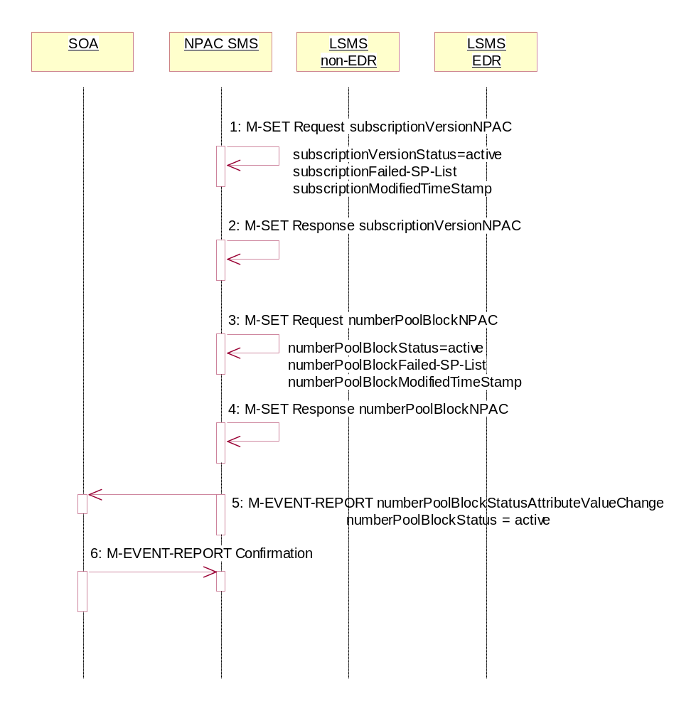
- NPAC SMS sets the subscriptionVersionStatus to ‘active’, sets the subscriptionFailed-SP-List to the list of failed service providers and sets the subscriptionModifiedTimeStamp on the subscription version objects.
- NPAC SMS responds to the M-SET.
- NPAC SMS sets the numberPoolBlockStatus to ‘active’ and sets the numberPoolBlockFailed-SP-List to the list of failed service providers on the number pool block object. The numberPoolBlockModifiedTimeStamp also gets set.
- NPAC SMS responds to the M-SET.
- If the numberPoolBlockSOA-Origination indicator is set to ‘true’, the NPAC SMS sends the originating SOA the M-EVENT-REPORT numberPoolBlockStatusAttributeValueChange with the numberPoolBlockStatus set back to ‘active’ and numberPoolBlockFailed-SP-List.
- SOA confirms M-EVENT-REPORT.

Number Pool Block De-Pool Resend Partial Failure Updates (previously NNP flow 2.26)
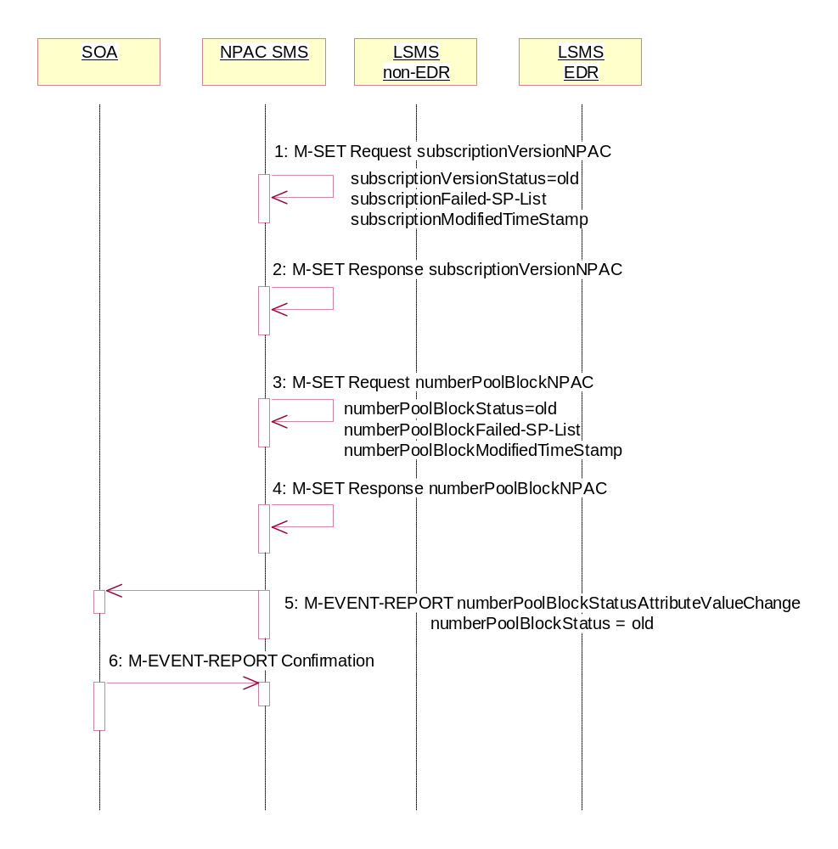
In this scenario, the NPAC SMS has attempted to resend a failed de-pool attempt and has resulted in partial-failure. The NPAC SMS proceeds to update the status of the objects locally.

- NPAC SMS sets the subscriptionVersionStatus to ‘old’, sets the subscriptionFailed-SP-List to the list of failed service providers and sets the subscriptionModifiedTimeStamp to the current date and time on the subscription version objects. The subscriptionDisconnectCompleteTimeStamp is set when the first successful response is received.
- NPAC SMS responds to the M-SET.
- NPAC SMS sets the numberPoolBlockStatus to ‘old’ and sets the numberPoolBlockFailed-SP-List to the list of failed service providers on the number pool block object. The numberPoolBlockModifiedTimeStamp also get set. The numberPoolBlockDisconnectCompleteTimeStamp is set when the first successful response is received.
- NPAC SMS responds to the M-SET.
- If the numberPoolBlockSOA-Origination indicator is set to ‘true’, the NPAC SMS sends the originating SOA the M-EVENT-REPORT numberPoolBlockStatusAttributeValueChange with the numberPoolBlockStatus set to ‘old’ and numberPoolBlockFailed-SP-List.
- SOA confirms M-EVENT-REPORT.

Number Pool Block Query by SOA or LSMS (previously NNP flow 2.27)
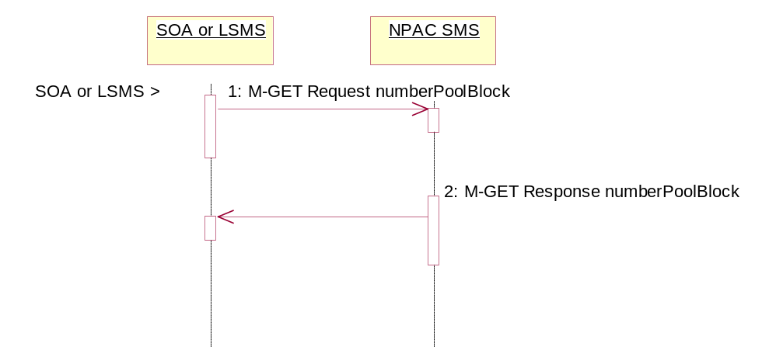
In this scenario, the service provider personnel queries for one or more number pool block objects from the SOA or Local SMS.
Action is taken by service provider personnel to query one or more numberPoolBlock objects for all attributes.
- SOA or Local SMS sends the M-GET request for either requesting a single numberPoolBlock object by numberPoolBlockId or requesting one or more numberPoolBlock objects using a scope and filtered request.
- If the requested object(s) exist, the NPAC SMS will respond with a single or linked M-GET reply. If no objects are found, the NPAC SMS will respond with an empty result. All attributes are returned in the query.

  - SubscriptionVersion Flow Scenarios
Note: All actions for subscription versions in the flows that follow are atomic. If the operation fails for one TN in a range it fails for all TNs in the range.

SubscriptionVersion Create Scenarios
The subscriptionVersionNPAC object is created by either the new or old service provider SOA issuing their M-ACTION to create the subscription version. If the new service provider SOA issues its subscriptionVersionNewSP-Create action first, the old service provider SOA has the option of sending in the subscriptionVersionOldSP-Create action or not. If they do send in the subscriptionVersionOldSP-Create, the old service provider explicitly states their concurrence or non-concurrence to the port by the value set within the subscriptionOldSP-Authorization field. If the old service provider does not send in their create request within the concurrence window, this implies concurrence to the port. However, the old service provider can send in their create request after the concurrence window before activation of the subscription version and the NPAC SMS will accept the data if valid.
If the old service provider SOA issues its subscriptionVersionOldSP-Create action first, then the new service provider SOA must issue its subscriptionVersionNewSP-Create action.

SubscriptionVersion Create by the Initial SOA (Old Service Provider)
In this scenario, the old service provider is the first to send the M-ACTION to create the subscriptionVersion object.
- Action is taken by the old service provider SOA to create a new version of a subscriber.
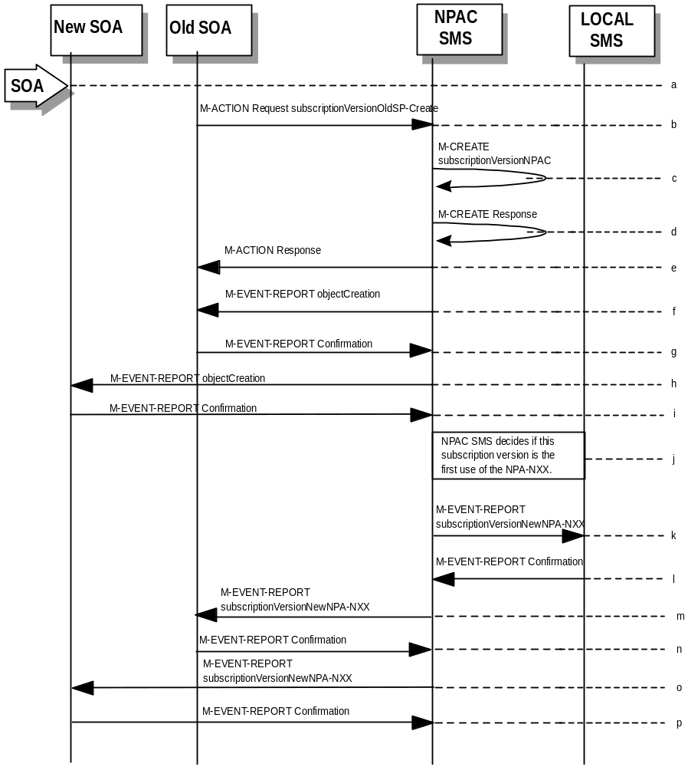
- Old service provider SOA sends M-ACTION subscriptionVersionOldSP-Create to the NPAC SMS lnpSubscriptions object to create a new subscriptionVersionNPAC. The old service provider SOA must specify the following valid attributes:
subscriptionTN or a valid subscriptionVersionTN-Range
subscriptionNewCurrentSP
subscriptionOldSP
subscriptionOldSP-DueDate (seconds set to zeros)
subscriptionOldSP-Authorization
subscriptionLNPType
If the service provider were to give a range of TNs, this would result in an M-CREATE and M-EVENT-REPORT for each TN.
If an attribute value is invalid, an invalidArgumentValue will be returned, indicating invalid data values. Other appropriate errors will also be returned.
- If the request is valid, the NPAC SMS will create the subscriptionVersionNPAC object. The status will be set to “pending” and the subscriptionOldSP-AuthorizationTimeStamp and subscriptionModifiedTimeStamp will be set.
- NPAC SMS responds to M-CREATE.
- NPAC SMS sends action reply with success or failure and reasons for failure.
- If the M-ACTION was successful, the NPAC SMS issues an M-EVENT-REPORT containing the following attributes to old service provider SOA of subscriptionVersionNPAC creation.
subscriptionTN
subscriptionOldSP
subscriptionNewCurrentSP
subscriptionOldSp-DueDate
subscriptionOldSP-Authorization
subscriptionOldSP-AuthorizationTimeStamp
subscriptionStatusChangeCauseCode
(if subscriptionOldSP-Authorization set to false)
subscriptionVersionStatus
- Old service provider SOA responds by sending an M-EVENT-REPORT confirmation back to the NPAC SMS.
- If the M-ACTION was successful, the NPAC SMS issues an M- EVENT-REPORT to new service provider SOA of subscriptionVersionNPAC creation.
- New service provider SOA issues an M-EVENT-REPORT confirmation to NPAC SMS.
- NPAC SMS decides if this subscription version is the first use or the NPA-NXX.
- If this is the first use of the NPA-NXX, the NPAC SMS sends the subscriptionVersionNewNPA-NXX M-EVENT-REPORT to inform the accepting Local SMSs.
- The Local SMS confirms the M-EVENT-REPORT.
- The NPAC SMS sends the subscriptionVersionNew NPA-NXX M-EVENT-REPORT to inform the Old SOA.
- The Old SOA confirms the M-EVENT-REPORT.
- The NPAC SMS sends the subscriptionVersionNew NPA-NXX M-EVENT-REPORT to inform the New SOA.
- The New SOA confirms the M-EVENT-REPORT.
The next scenario would be “SubscriptionVersion Create by the Second SOA (New Service Provider).”

SubscriptionVersion Create by the Initial SOA (New Service Provider)
In this scenario, the new service provider is the first to send the M-ACTION to create the subscriptionVersion object.
- Action is taken by the new service provider SOA to create a new subscription version.
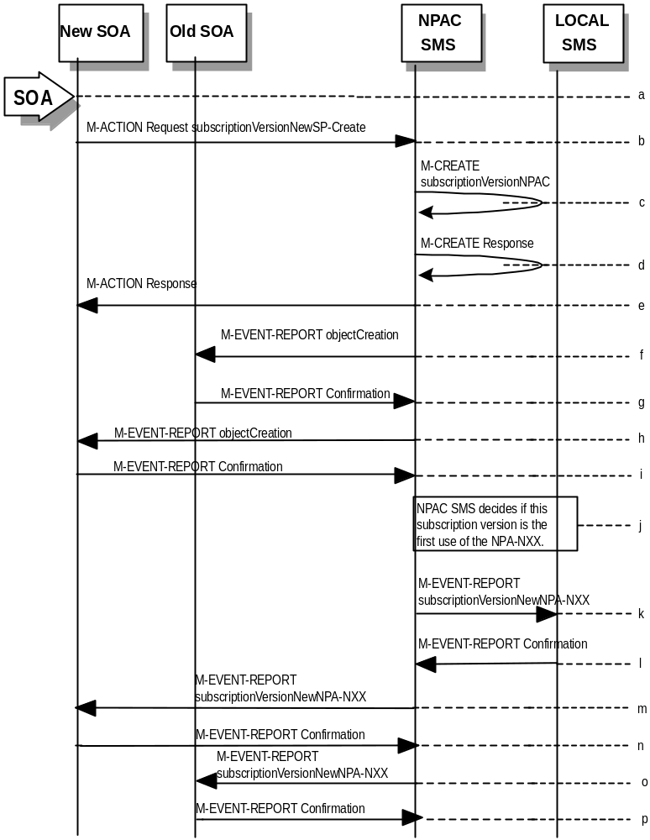

- New service provider SOA sends M-ACTION subscriptionVersionNewSP-Create to the NPAC SMS lnpSubscriptions object to create a new subscriptionVersionNPAC. The new service provider SOA must specify the following valid attributes:
subscriptionTN or a valid subscriptionVersionTN-Range
subscriptionNewCurrentSP
subscriptionOldSP
subscriptionNewSP-DueDate (seconds set to zero)
subscriptionLNPType
subscriptionPortingToOriginal-SP Switch
The following items must be provided unless subscriptionPortingToOriginal-SP is true:
subscriptionLRN
subscriptionCLASS-DPC
subscriptionCLASS-SSN
subscriptionLIDB-DPC
subscriptionLIDB-SSN
subscriptionCNAM-DPC
subscriptionCNAM-SSN
subscriptionISVM-DPC
subscriptionISVM-SSN
subscriptionWSMSC-DPC - if supported by the Service Provider SOA
subscriptionWSMSC-SSN - if supported by the Service Provider SOA
The following attributes are optional:
subscriptionEndUserLocationValue
subscriptionEndUserLocationType
subscriptionBillingId
If the service provider were to give a range of TNs, this would result in an M-CREATE and M-EVENT-REPORT for each TN.
If any attribute is invalid, an action failure will be returned, indicating invalidArgumentValue. Other appropriate errors will also be returned.
- If the request is valid, the NPAC SMS will create the subscriptionVersionNPAC object. The status will be set to “pending” and the subscriptionModifiedTimeStamp and subscriptionCreationTimeStamp will be set.
- NPAC SMS responds to M-CREATE.
- NPAC SMS sends action reply with success or failure and reasons for failure.
- If the M-ACTION was successful, NPAC SMS issues an M-EVENT-REPORT containing the following attributes to old service provider SOA of subscriptionVersionNPAC creation.
subscriptionTN
subscriptionOldSP
subscriptionNewCurrentSP
subscriptionNewSP-CreationTimeStamp
subscriptionVersionStatus
subscriptionNewSP-DueDate
- Old service provider SOA responds by sending an M-EVENT-REPORT confirmation back to the NPAC SMS.
- If the M-ACTION was successful, NPAC SMS issues an M-EVENT-REPORT to new service provider SOA of subscriptionVersionNPAC creation.
- New service provider SOA issues an M-EVENT-REPORT confirmation to NPAC SMS.
- NPAC SMS decides if this subscription version is the first use or the NPA-NXX.
- If this is the first use of the NPA-NXX, the NPAC SMS sends the subscriptionVersionNewNPA-NXX M-EVENT-REPORT to inform the accepting Local SMSs.
- The Local SMS confirms the M-EVENT-REPORT.
- The NPAC SMS sends the subscriptionVersionNew NPA-NXX M-EVENT-REPORT to inform the Old SOA.
- The Old SOA confirms the M-EVENT-REPORT.
- The NPAC SMS sends the subscriptionVersionNew NPA-NXX M-EVENT-REPORT to inform the New SOA.
- The New SOA confirms the M-EVENT-REPORT.
The next scenario is either “SubscriptionVersion Create by the Second SOA (Old Service Provider).” or “SubscriptionVersion Activated by New Service Provider SOA”.

SubscriptionVersion Create by Second SOA (New Service Provider)
In this scenario, the old service provider has already issued its request causing the subscriptionVersionNPAC to be created. The new service provider is now following with its own create action.
- New service provider SOA personnel take action to create a new subscription version.
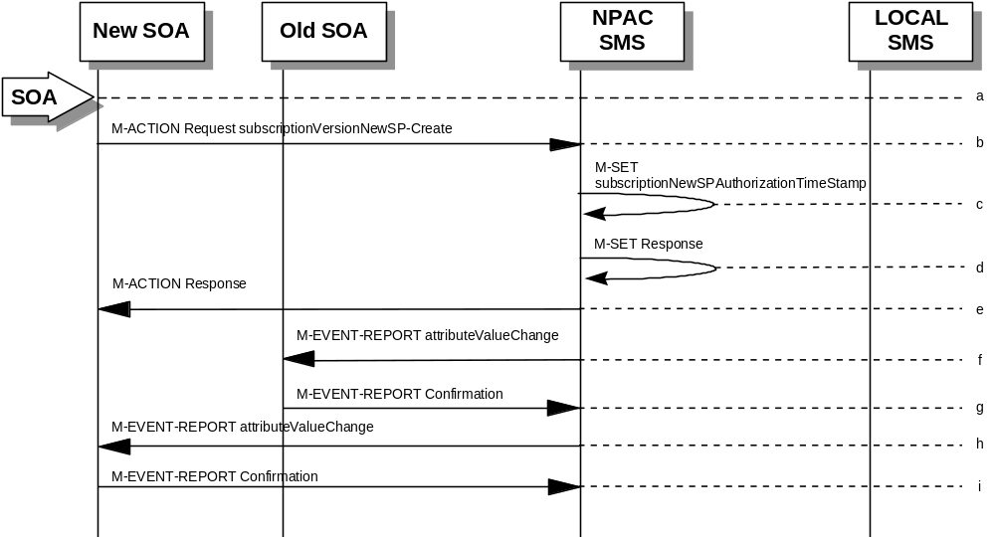
- New service provider SOA sends M-ACTION subscriptionVersionNewSP-Create to NPAC SMS lnpSubscriptions object to create a new subscriptionVersionNPAC. The new service provider SOA must specify the following valid attributes:
subscriptionTN or a valid subscriptionVersionTN-Range
subscriptionNewCurrentSP
subscriptionOldSP
subscriptionNewSP-DueDate (seconds set to zeros)
subscriptionLNPType
subscriptionPortingToOriginal-SP Switch
The following items must be provided unless subscriptionPortingToOriginal-SP is true:
subscriptionLRN
subscriptionCLASS-DPC
subscriptionCLASS-SSN
subscriptionLIDB-DPC
subscriptionLIDB-SSN
subscriptionCNAM-DPC
subscriptionCNAM-SSN
subscriptionISVM-DPC
subscriptionISVM-SSN
subscriptionWSMSC-DPC - if supported by the Service Provider SOA
subscriptionWSMSC-SSN - if supported by the Service Provider SOA
The following attributes are optional:
subscriptionEndUserLocationValue
subscriptionEndUserLocationType
subscriptionBillingId
If a TN range is specified in the request, it would result in an M-SET request and M-EVENT-REPORT for each TN.
If the new service provider is not the new service provider specified in the initial create by the old service provider, an accessDenied error will be returned.
If any attribute is invalid, an action failure will be returned, indicating invalidArgumentValue. Other appropriate errors will be returned.
- If successful, the NPAC SMS sets the subscriptionModifiedTimeStamp, subscriptionCreationTimeStamp, and all data specified in the M-ACTION.
- NPAC SMS responds to M-SET.
- NPAC SMS sends M-ACTION reply with success or failure and reasons for failure.
- NPAC SMS issues the M-EVENT-REPORT with the following attributes to the old service provider when the subscriptionNewSP-DueDate changes value.
subscriptionNewSP-DueDate
subscriptionNewSP-CreationTimeStamp
- Old service provider SOA issues M-EVENT-REPORT confirmation.
- If the M-ACTION was successful, the NPAC SMS issues M-EVENT-REPORT to the new service provider for all attributes updated from the preceding list of modifiable attributes in addition to the following:
subscriptionNewSP-DueDate
subscriptionNewSP-CreationTimeStamp
- New service provider SOA issues M-EVENT-REPORT confirmation.

SubscriptionVersion Create by Second SOA (Old Service Provider) with Authorization to Port
In this scenario, the new service provider has already issued its request causing the subscriptionVersionNPAC to be created. The old service provider is now following with its own create action authorizing the port.
Note: This is an optional step.
- Old service provider SOA personnel take action to create a old subscription version.
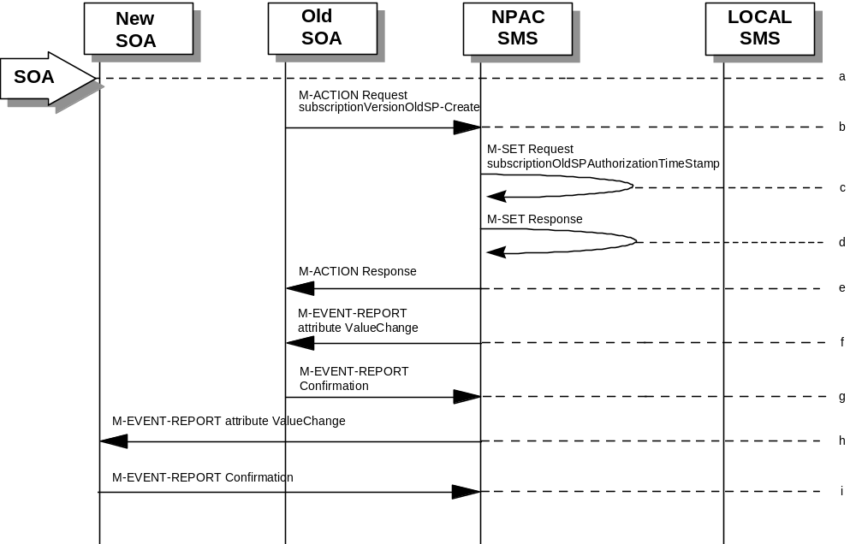
- Old service provider SOA sends M-ACTION subscriptionVersionOldSP-Create to NPAC SMS lnpSubscriptions object to create an old subscriptionVersionNPAC. The old service provider SOA must specify the following valid attributes:
subscriptionTN or a valid subscriptionVersionTN-Range
subscriptionNewCurrentSP
subscriptionOldSP
subscriptionOldSP-Authorization
subscriptionOldSP-DueDate (seconds set to zeros)
subscriptionLNPType
If a TN range is specified in the request, it would result in an M-SET request and M-EVENT-REPORT for each TN.
If the old service provider is not the old service provider specified in the initial create request by the new service provider, an accessDenied error will be returned.
If any attribute is invalid, an invalidArgumentValue will be returned, indicating invalid data values. Other appropriate errors will also be returned.
- If the data is valid, the NPAC SMS sets the subscriptionOldSP-AuthorizationTimeStamp, subscriptionModifiedTimeStamp and all data specified in the M-ACTION.
- NPAC SMS responds to M-SET.
- NPAC SMS sends M-ACTION reply with success or failure and reasons for failure.
- If the M-ACTION was successful, the NPAC SMS issues M-EVENT-REPORT attribute value change to the old service provider for all attributes updated from the following list:
subscriptionOldSP-DueDate
subscriptionOldSP-Authorization
subscriptionOldSP-AuthorizationTimeStamp
- Old service provider SOA issues M-EVENT-REPORT confirmation.
- If the M-ACTION was successful, the NPAC SMS issues M-EVENT-REPORT attribute value change to the new service provider for all attributes updated from the preceding list. The following attributes are sent in the attributeValueChangeNotification:
subscriptionOldSP-DueDate
subscriptionOldSP-Authorization
subscriptionOldSP-AuthorizationTimeStamp
- New service provider issues M-EVENT-REPORT confirmation.

SubscriptionVersion Activated by New Service Provider SOA
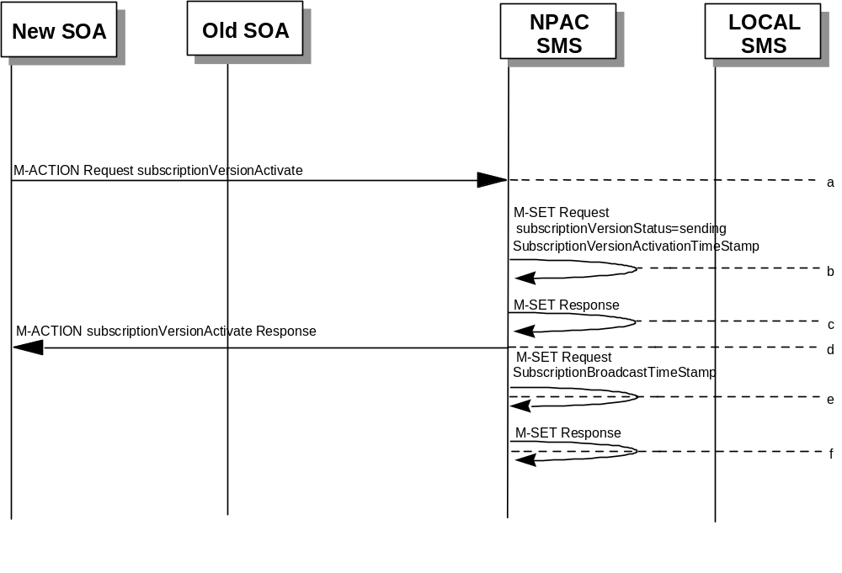In this scenario, either both service providers have sent their create data updates for a new subscription version to the NPAC SMS or the concurrence window has expired for receiving the subscriptionVersionOldSP-Create action. The new service provider can now activate the subscription version.

- The new service provider SOA issues a subscriptionVersionActivate
M-ACTION to the NPAC SMS lnpSubscriptions object to activate the pending subscription version by specifying the subscription version ID, subscription version TN, or a range of subscription version TNs.
- NPAC SMS issues an M-SET request setting the subscriptionVersionStatus to “sending,” subscriptionVersionActivationTimeStamp and subscriptionModifiedTimeStamp on the subscriptionVersionNPAC object.
- NPAC SMS responds to the M-SET.
- The NPAC SMS responds with the M-ACTION response. An error will be returned if the service provider is not the new service provider (accessDenied) or if there is no version to be activated (invalidArgumentValue) or if any other failures occur.
- NPAC SMS issues an M-SET request setting the subscriptionVersionStatus to “sending,” subscriptionBroadcastTimeStamp on the subscriptionVersionNPAC object.
- NPAC SMS responds to the M-SET.
For subscription versions that are not being ported to the original service provider’s switch, processing continues in the “Active SubscriptionVersion Create on Local SMSs” flow.
For ports to the original service provider’s switch, the flow follows an immediate disconnect scenario. The NPAC SMS sets the broadcast timestamp, notifies the service provider SOA of the status change and proceeds to issue M-DELETEs for the subscriptionVersion to the Local SMS.

Active SubscriptionVersion Create on Local SMS
This scenario and associated error scenarios reflect the message flow for all new object create requests from the NPAC SMS to the Local SMSs.
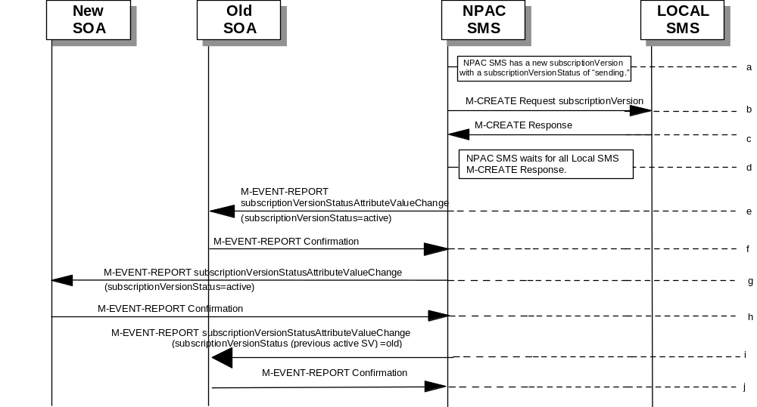
- NPAC SMS has a new subscriptionVersion with a status of “sending.”
- The NPAC SMS issues an M-CREATE for the subscriptionVersion to each of the Local SMSs, that is accepting downloads for the NPA-NXX of the subscriptionVersion.
- Each Local SMS will reply to the M-Create.
- NPAC SMS waits for Local SMSs to report successful objectCreation.
- If this TN has been previously ported (i.e., a previously active subscriptionVersion NPAC object exists), the NPAC SMS will issue an M-EVENT-REPORT notification to the current service provider SOA for the previously active subscriptionVersion NPAC object of the status change using an M-EVENT-REPORT subscriptionVersionStatusAttributeValueChange.
- The current service provider SOA for the previously active subscriptionVersion NPAC object returns an M-EVENT-REPORT confirmation to the NPAC SMS.
- If the subscriptionVersion NPAC object was modified, the NPAC SMS will issue M-EVENT-REPORT notifications to the old service provider SOA of the status change using an M-EVENT-REPORT subscriptionVersionStatusAttributeValueChange.
- The old service provider SOA returns an M-EVENT-REPORT confirmation to the NPAC SMS.
- If the subscriptionVersion NPAC object was modified, the NPAC SMS will issue M-EVENT-REPORT notifications to the new service provider SOA of the status change using an M-EVENT-REPORT subscriptionVersionStatusAttributeValueChange.
- The new service provider SOA returns an M-EVENT-REPORT confirmation to the NPAC SMS.

Active Subscription Version Create on Local SMS Using Create Action
This scenario reflects the message flow for all new object create requests from the NPAC SMS to the Local SMS Using Create Action. This action is used to create a group of subscription versions with the same routing information.
- NPAC SMS has one or more subscription versions with a status of “sending ” that have been activated by the new service provider.
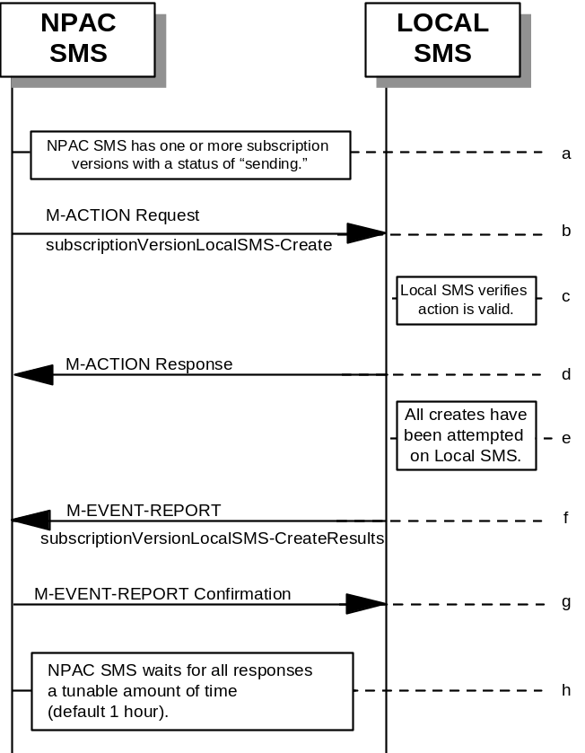
- NPAC SMS issues the subscriptionVersionLocalSMS-Create action to the Local SMS, if it is accepting downloads for the NPA-NXX of the subscriptionVersion. This action contains all data necessary to create the subscription version.
- The Local SMS verifies the action is valid, but does not attempt to create the subscription version(s).
- The Local SMS responds to the M-ACTION.
- The Local SMS proceeds to execute all the creates specified by the action.
- The Local SMS sends to the NPAC SMS the M-EVENT-REPORT specifying the success or failure of the creates.
- NPAC SMS confirms the M-EVENT-REPORT.
- NPAC SMS waits for all responses a tunable amount of time. The default is 1 hour.

SubscriptionVersion Create: No Create Action from the Old Service Provider SOA After Concurrence Window
This scenario shows no response within “Service Provider Concurrence Window” by the old service provider SOA.
In this case, the new service provider SOA issued the create request. The NPAC SMS has issued the ObjectCreation M-EVENT-REPORT back to both the old and new service provider SOAs. No response has yet been received by the old service provider SOA.
- 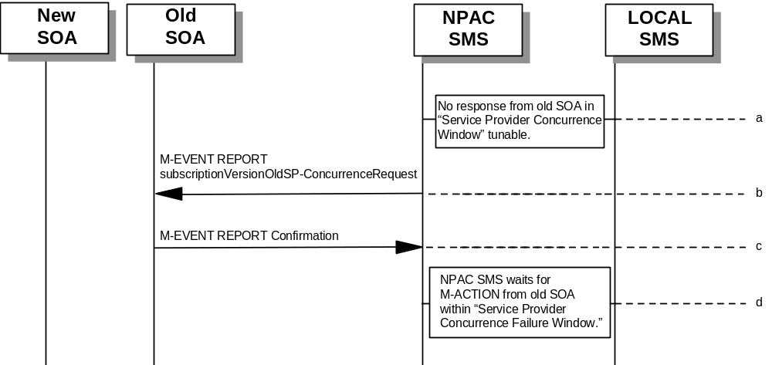NPAC SMS does not receive a response from the old service provider SOA within “Service Provider Concurrence Window” for the pending subscriptionVersionNPAC created by the new service provider SOA.
- NPAC SMS sends the old service provider an M-EVENT-REPORT subscriptionVersionOldSP-ConcurrenceRequest.
- The old service provider SOA returns an M-EVENT-REPORT confirmation to the NPAC SMS.
- Old service provider has up to “Service Provider Concurrence Failure Window” to respond to the request.
If the old service provider SOA responds with a valid M-ACTION or M-SET, processing resumes as a successful create.

SubscriptionVersion Create: No Create Action from the Old Service Provider SOA After Final Concurrence Window
This scenario shows no response within “Service Provider Final Concurrence Window” by the old service provider SOA.
In this case, the new service provider SOA issued the create request. The NPAC SMS has issued the ObjectCreation M-EVENT-REPORT back to both the old and new service provider SOAs as well as a subsciptionVersionOldSP-ConcurrenceRequest
M-EVENT-REPORT to the old service provider SOA. No response has yet been received by the old service provider SOA.
- 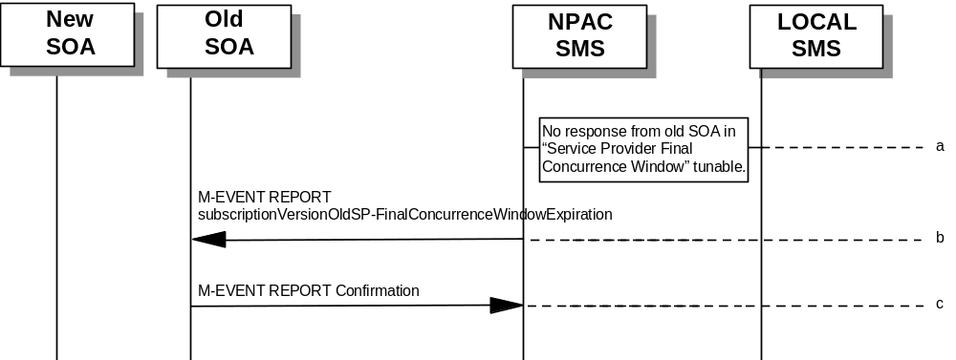NPAC SMS does not receive a response from the old service provider SOA within “Service Provider Final Concurrence Window” for the pending subscriptionVersionNPAC created by the new service provider SOA.
- NPAC SMS sends the old service provider an
M-EVENT-REPORT subscriptionVersionOldSP-Final ConcurrenceWindowExpiration.
- The old service provider SOA returns an M-EVENT-REPORT confirmation to the NPAC SMS.
If the old service provider SOA responds with a valid
M-ACTION or M-SET prior to activation by the new service provider, the subscription version will be updated.

Subscription Version Create: Failure to Receive Response from New SOA
This scenario shows action taken by the NPAC SMS after not receiving any concurrence from the new service provider after the “Final Service Provider Concurrence Failure Window.”
- 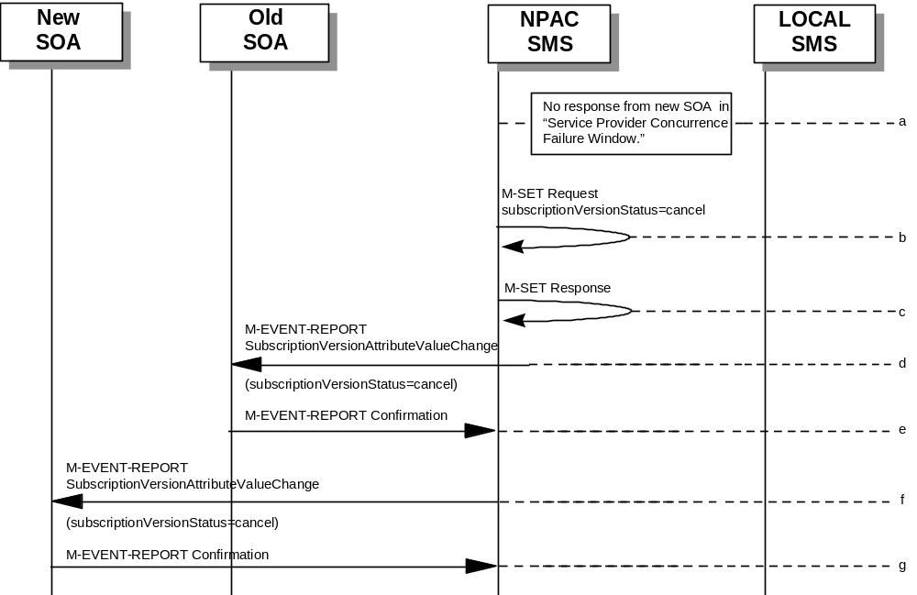NPAC SMS receives no occurrence from the new service provider SOA in “Service Provider Concurrence Failure Window” for the pending subscriptionVersionNPAC created by the old service provider SOA.
- NPAC SMS issues M-SET for subscriptionVersionStatus to set it to “cancel” and the subscriptionModifiedTimeStamp in the subscriptionVersionNPAC object.
- NPAC SMS responds to M-SET.
- If the subscriptionVersionNPAC object was modified, the NPAC SMS notifies the old service provider of the status change.
- The old service provider SOA returns an M-EVENT-REPORT confirmation to the NPAC SMS.
- If the subscriptionVersionNPAC object was modified, the NPAC SMS notifies new service provider SOA of the status change.
- The new service provider SOA returns an M-EVENT-REPORT confirmation to the NPAC SMS.

SubscriptionVersionCreate M-CREATE Failure to Local SMS
This scenario shows a failure to all of the Local SMS on M-CREATE.
- The new service provider SOA has activated the pending subscription.
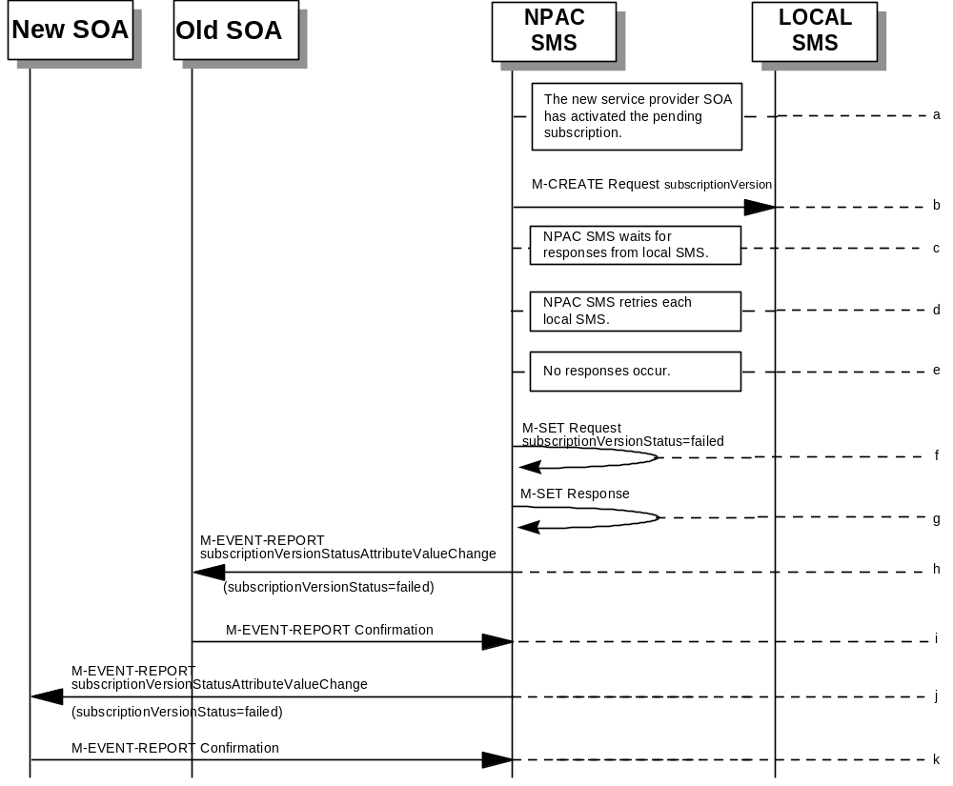
- The NPAC SMS issues an M-CREATE for the subscriptionVersion to each of the Local SMSs, that is accepting downloads for the NPA-NXX of the subscriptionVersion.
- NPAC SMS waits for responses from each Local SMS.
- NPAC SMS resends to each Local SMS up to a tunable number of retries at a tunable interval.
- No responses occur from any Local SMS or all Local SMSs report a failure response to the M-CREATE.
- NPAC SMS issues M-SET to update the subscriptionVersionStatus to “failed” in the subscriptionVersionNPAC object, the subscriptionFailed-SP-List, and the subscriptionModifiedTimeStamp.
- NPAC SMS issues M-SET response.
- If the subscriptionVersionNPAC was modified, the NPAC SMS will send M-EVENT-REPORT to the old service provider SOA of the subscriptionVersionStatus change.
- The old service provider SOA returns an M-EVENT-REPORT confirmation to the NPAC SMS.
- If the subscriptionVersionNPAC was modified, the NPAC SMS will send M-EVENT-REPORT to the new service provider SOA of the subscriptionVersionStatus change.
- The new service provider SOA returns an M-EVENT-REPORT confirmation to the NPAC SMS.

SubscriptionVersion M-CREATE: Partial Failure to Local SMS
This scenario shows a partial failure to a Local SMS on an M-CREATE.
- The new service provider SOA has activated the pending subscription.
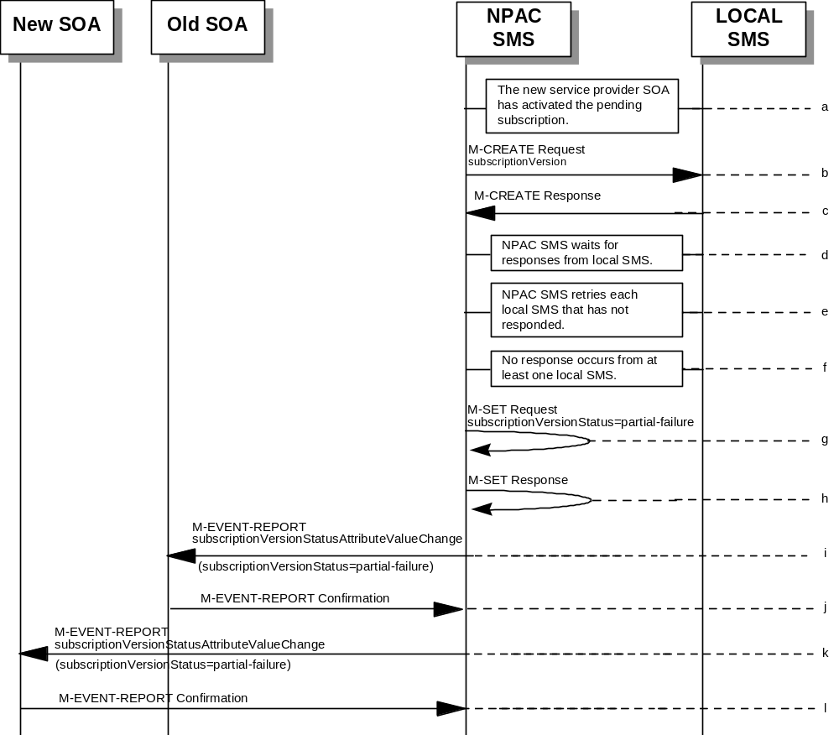
- The NPAC SMS issues an M-CREATE for the subscriptionVersion to each of the Local SMSs, that is accepting downloads for the NPA-NXX of the subscriptionVersion.
- One or more Local SMSs respond to the M-CREATE.
- NPAC SMS waits for responses from each Local SMS.
- NPAC SMS resends, to each unresponsive Local SMS, up to a tunable number of retries at a tunable interval.
- No responses occur from at least one Local SMS, or a Local SMS returns an M-CREATE failure.
- NPAC SMS issues M-SET to the subscriptionVersionStatus to “partial-failure” in the subscriptionVersionNPAC object, subscriptionFailed-SP-List, and the subscriptionModifiedTimeStamp.
- NPAC SMS issues M-SET response.
- If the subscriptionVersionNPAC was modified, the NPAC SMS will send M-EVENT-REPORT to the old service provider SOA of the subscriptionVersionStatus change and a list of failed Local SMSs.
- The old service provider SOA returns an M-EVENT-REPORT confirmation to the NPAC SMS.
- If the subscriptionVersionNPAC was modified, the NPAC SMS will send M-EVENT-REPORT to the new service provider SOA of the subscriptionVersionStatus change and a list of failed Local SMSs.
- The new service provider SOA returns an M-EVENT-REPORT confirmation to the NPAC SMS.

Create Subscription Version: Resend Successful to Local SMS Action
This scenario shows the successful resend of a subscription version create. The resend of a failed subscription version create can only be performed by authorized NPAC personnel.
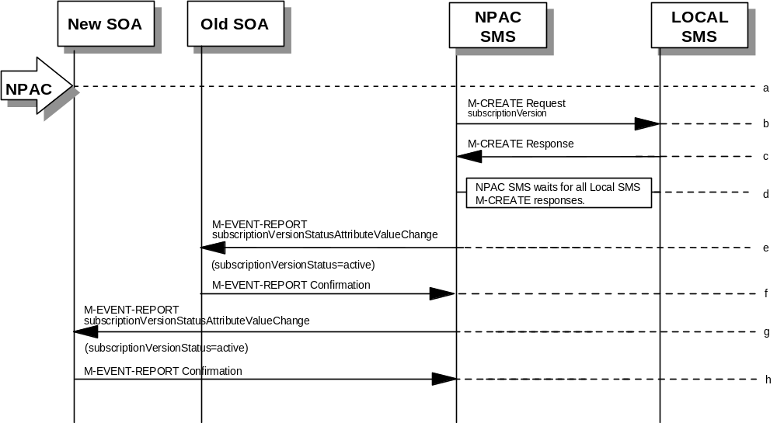
- NPAC personnel take action to resend a failed subscriptionVersion create.
- The NPAC SMS issues an M-CREATE for the subscriptionVersion to each of the Local SMSs that previously failed, and is accepting downloads for the NPA-NXX of the subscriptionVersion.
- Each Local SMS will reply to the M-Create.
- NPAC SMS waits for all Local SMSs to report successful subscription version creation.
- If the subscriptionVersion NPAC object was modified, the NPAC SMS will issue M-EVENT-REPORT notifications to the old service provider SOA of the status change using an M-EVENT-REPORT subscriptionVersionStatusAttributeValueChange.
- The old service provider SOA returns an M-EVENT-REPORT confirmation to the NPAC SMS.
- If the subscriptionVersion NPAC object was modified, the NPAC SMS will issue M-EVENT-REPORT notifications to the new service provider SOA of the status change using an M-EVENT-REPORT subscriptionVersionStatusAttributeValueChange.
- The new service provider SOA returns an M-EVENT-REPORT confirmation to the NPAC SMS.

Subscription Version: Resend Failure to Local SMS
This scenario shows a failure on a resend of a Subscription Version M-CREATE a Local SMS. The resend of a failed version can only be performed by authorized NPAC SMS personnel.
- The NPAC personnel issues a resend for the failed or partially failed subscriptionVersion.
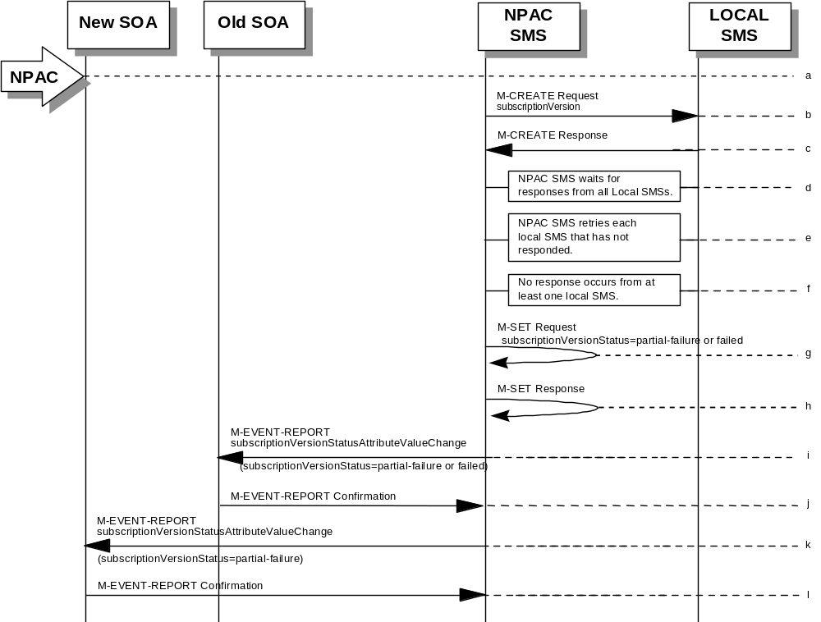
- The NPAC SMS issues an M-CREATE for the subscriptionVersion to each of the Local SMSs for which the M-CREATE previously failed, and is accepting downloads for the NPA-NXX of the subscriptionVersion.
- One or more Local SMSs respond to the M-CREATE.
- NPAC SMS waits for responses from each Local SMS.
- NPAC SMS resends, to each unresponsive Local SMS, up to a tunable number of retries at a tunable interval.
- No responses occur from at least one or all Local SMSs, or one or all Local SMSs return an M-CREATE failure.
- NPAC SMS issues M-SET to the subscriptionVersionStatus to “partial-failure” or “failed” in the subscriptionVersionNPAC object, subscriptionFailed-SP-List, and the subscriptionModifiedTimeStamp.
- NPAC SMS issues M-SET response.
- If the subscriptionVersionNPAC was modified, the NPAC SMS will send M-EVENT-REPORT to the old service provider SOA of the subscriptionVersionStatus change and a list of failed Local SMSs.
- The old service provider SOA returns an M-EVENT-REPORT confirmation to the NPAC SMS.
- If the subscriptionVersionNPAC was modified, the NPAC SMS will send M-EVENT-REPORT to the new service provider SOA of the subscriptionVersionStatus change and a list of failed Local SMSs.
- The new service provider SOA returns an M-EVENT-REPORT confirmation to the NPAC SMS.

SubscriptionVersion Create for Intra-Service Provider Port
This scenario shows how an intra-service port is processed.
- 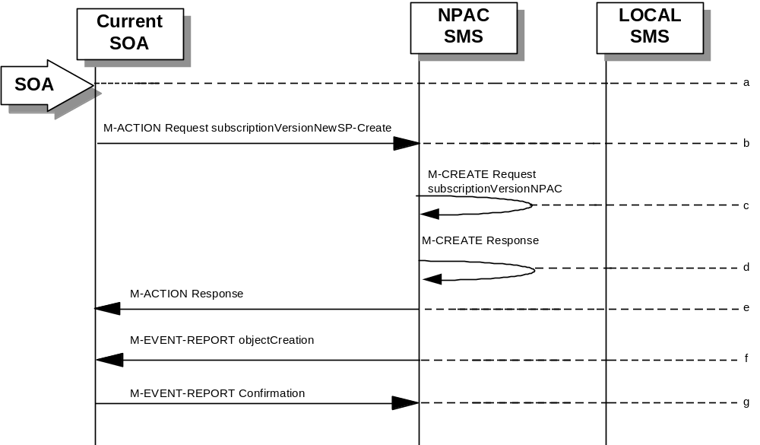Action is taken by the current provider SOA to create a new version of a subscriber.
- Current provider SOA sends M-ACTION subscriptionVersionNewSP-Create to the NPAC SMS lnpSubscriptions object to create a new subscriptionVersionNPAC. The SOA must specify the following valid attributes:
subscriptionTN or a valid subscriptionVersionTN-Range
subscriptionNewCurrentSP
subscriptionOldSP
subscriptionNewSP-DueDate (seconds set to zeros)
subscriptionPortingToOriginal-SPSwitch
subscriptionLRN
subscriptionCLASS-DPC
subscriptionCLASS-SSN
subscriptionLIDB-DPC
subscriptionLIDB-SSN
subscriptionCNAM-DPC
subscriptionCNAM-SSN
subscriptionISVM-DPC
subscriptionISVM-SSN
subscriptionLNPType
subscriptionWSMSC-DPC - if supported by the Service Provider SOA
subscriptionWSMSC-SSN - if supported by the Service Provider SOA
The subscriptionNewCurrentServiceProv must be equal to the subscriptionOldServiceProv.
The following attributes are optional:
subscriptionEndUserLocationValue
subscriptionEndUserLocationType
subscriptionBillingId
- If the request is valid, the NPAC SMS will M-CREATE the subscriptionVersionNPAC object. The status will be set to “pending.” Also the subscriptionCreationTimeStamp, the subscriptionNewSP-AuthorizationTimeStamp, subscriptionOldSP-AuthorizationTimeStamp, and the subscriptionModifiedTimeStamp will be set.
- NPAC SMS responds to M-CREATE.
- NPAC SMS sends an action reply with success or failure and reasons for failure. If the action fails, no modifications are applied and processing stops for this scenario.
- NPAC SMS notifies intra-service provider SOA of subscriptionVersionNPAC creation.
- Service provider SOA sends M-EVENT-REPORT confirmation to NPAC SMS.
The intra-service subscriptionVersion now follows the same flow as an inter-service subscriptionVersionCreation to activate the subscriptionVersion on the NPAC SMS and create the subscriptionVersion on the Local SMSs.
The only difference is the M-EVENT-REPORT for the subscriptionVersionStatusAttributeValueChange is only sent to the new provider.

SubscriptionVersion Port-to-Original: Successful
This scenario shows how a port-to-original (successful) port is processed.
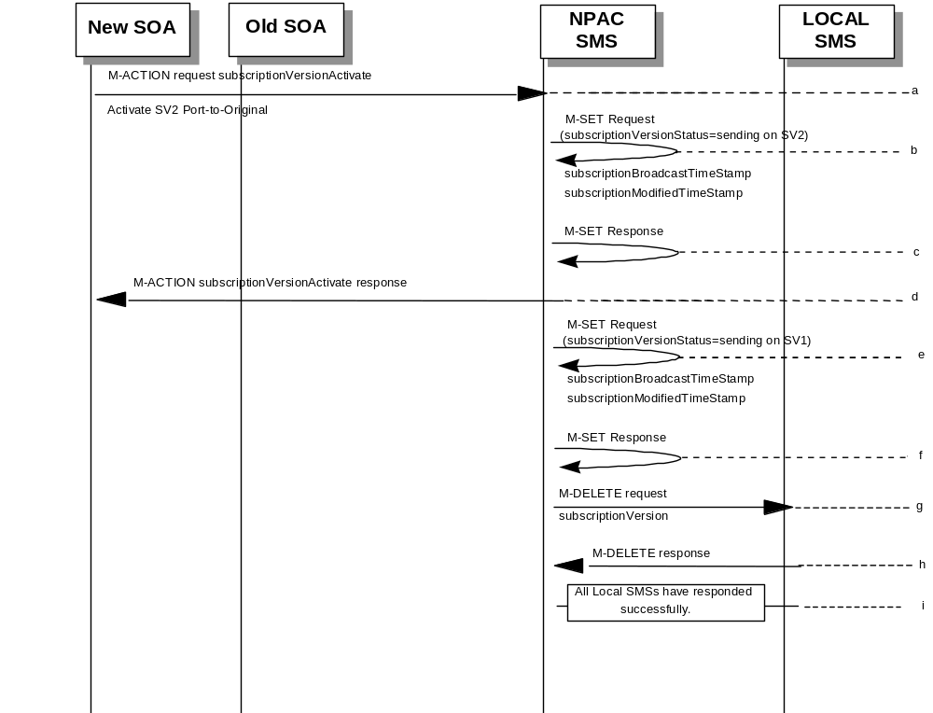

(continued on next page)

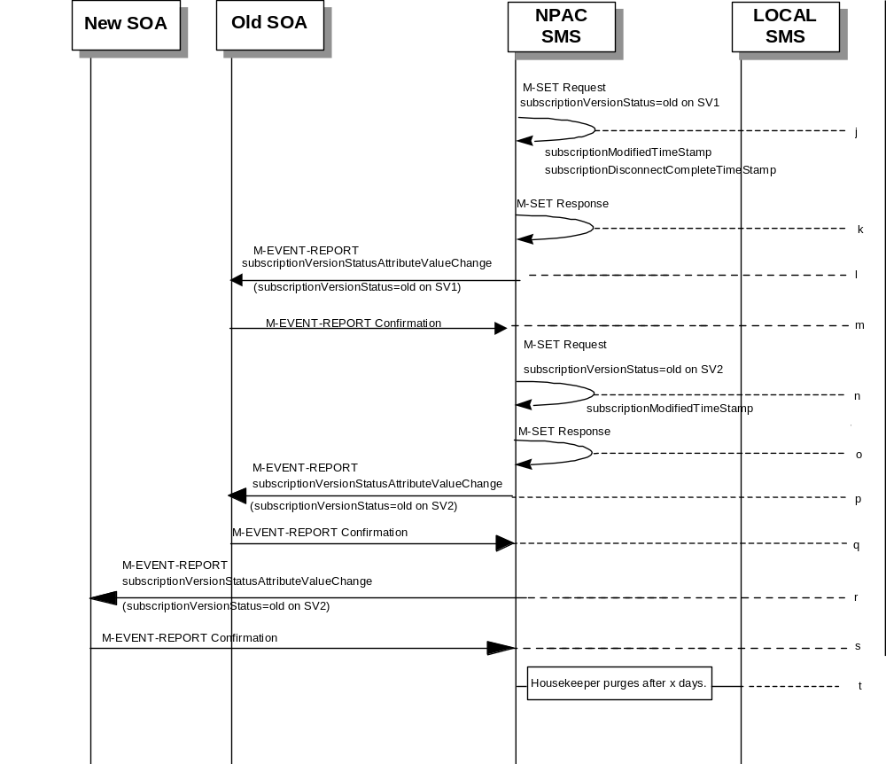

SV 1 is the currently active Subscription Version.
SV 2 is the current pending Subscription Version.
- The new service provider SOA issues a subscriptionVersionActivate M-ACTION to the NPAC SMS lnpSubscriptions object to activate the pending subscription version SV2 by specifying the subscription version ID, subscription version TN, or a range of subscription version TNs.
- The NPAC SMS issues an M-SET request setting the subscriptionVersionStatus to “sending”, subscriptionBroadcastTimeStamp and subscriptionModifiedTimeStamp on the subscriptionVersionNPAC on SV2.
- NPAC SMS response to the M-SET.
- The NPAC SMS responds with the M-ACTION response. An error will be returned if the service provider is not the new service provider (accessDenied) or if there is no version to be activated (invalidArgumentValue) or if any other failures occur.
- The NPAC SMS sets the subscriptionVersionStatus to sending and sets the subscriptionBroadcastTimeStamp and subscriptionModifiedTimeStamp on the subscriptionVersionNPAC on SV1.
- NPAC SMS response to the M-SET.
- NPAC SMS sends out an M-DELETE on the subscription Version SV1 to all Local SMSs, that are accepting downloads for the NPA-NXX of subscription Version SV1. If the M-DELETE is for multiple subscription versions, a scoped and filtered operation will be sent.
- Each Local SMS responds with a successful M-DELETE reply.
- All Local SMSs respond successfully.
- NPAC SMS issues an M-SET updating the subscriptionVersionStatus of SV1 to old. It also sets the subscriptionModifiedTimeStamp and subscriptionDisconnectCompleteTimeStamp.
- NPAC SMS responds to the M-SET.
- The NPAC SMS sends to the current/new service provider SOA a subscriptionVersionStatusAttributeValueChange for the subscriptionVersionStatus being set to old on SV1.
- The current/new service provider SOA returns an M-EVENT-REPORT confirmation to the NPAC SMS.
- NPAC SMS issues an M-SET updating the subscriptionVersionStatus of SV2 to old. It also sets the subscriptionModifiedTimeStamp.
- NPAC SMS responds to the M-SET.
- The NPAC SMS sends to the old service provider SOA a subscriptionVersionStatusAttributeValueChange for the subscriptionVersionStatus being set to old on SV2.
- The old service provider SOA returns an M-EVENT-REPORT confirmation to the NPAC SMS.
- The NPAC SMS sends to the new service provider SOA a subscriptionVersionStatusAttributeValueChange for the subscriptionVersionStatus being set to old on SV2.
- The new service provider SOA returns an M-EVENT-REPORT confirmation to the NPAC SMS.
- After a tunable amount of days, the subscription versions SV1 and SV2 are purged by the NPAC SMS housekeeping process.

SubscriptionVersion Port-to-Original: All LSMSs Fail
This scenario shows how a port-to-original (all fail) port is processed.
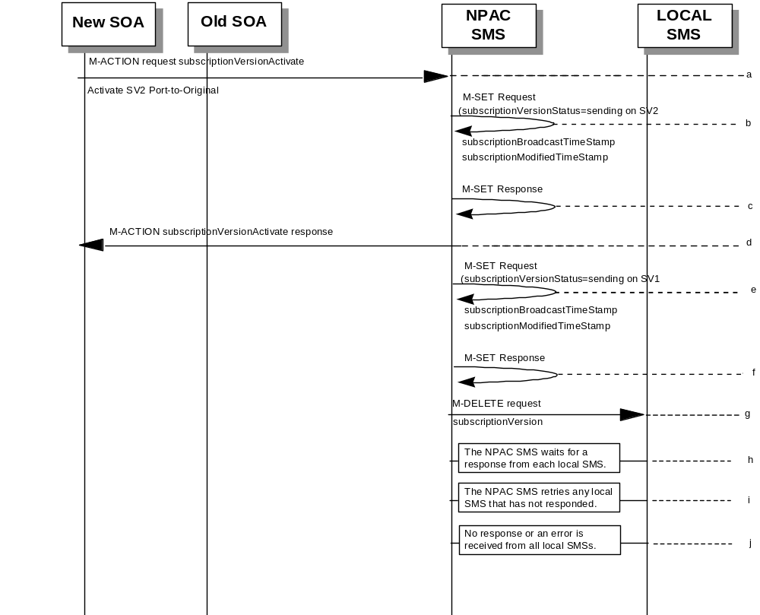

(continued on next page)

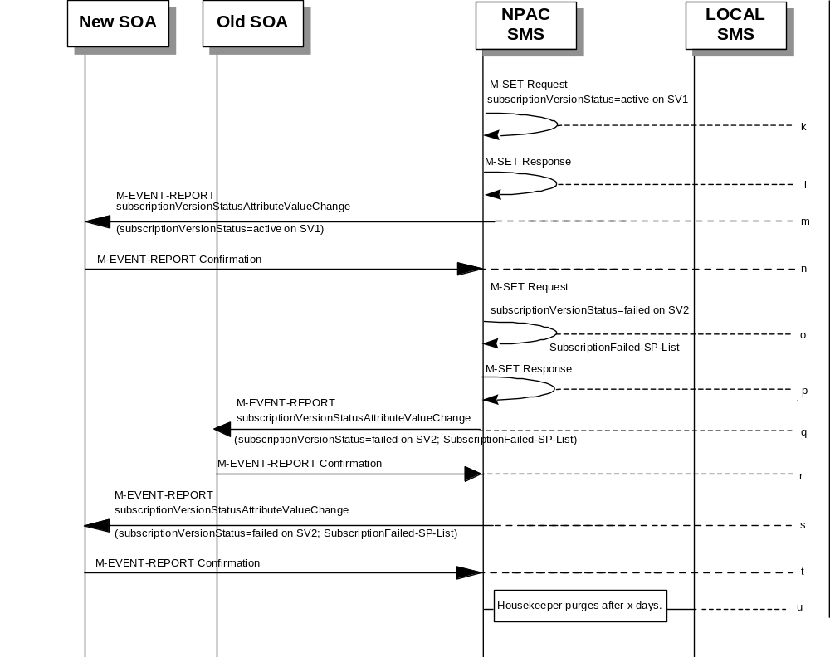

SV 1 is the currently active Subscription Version.
SV 2 is the current pending Subscription Version.
- The new service provider SOA issues a subscriptionVersionActivate M-ACTION to the NPAC SMS lnpSubscriptions object to activate the pending subscription version SV2 by specifying the subscription version ID, subscription version TN, or a range of subscription version TNs.
- The NPAC SMS issues an M-SET request setting the subscriptionVersionStatus to “sending”, subscriptionBroadcastTimeStamp and subscriptionModifiedTimeStamp on the subscriptionVersionNPAC on SV2.
- NPAC SMS response to the M-SET.
- NPAC SMS responds with the M-ACTION response. An error will be returned if the service provider is not the new service provider (accessDenied) or if there is no version to be activated (invalidArgumentValue) or if any other failures occur.
- The NPAC SMS sets the subscriptionVersionStatus to sending and sets the subscriptionBroadcastTimeStamp and subscriptionModifiedTimeStamp on the subscriptionVersionNPAC on SV1.
- NPAC SMS response to the M-SET.
- NPAC SMS sends out an M-DELETE on the subscription Version SV1 to all Local SMSs, that are accepting downloads for the NPA-NXX of subscription Version SV1. If the M-DELETE is for multiple subscription versions, a scoped and filtered operation will be sent.
- NPAC SMS waits for a response from each Local SMS.
- NPAC SMS retries any Local SMS that has not responded.
- No response or an error is received from all Local SMSs.
- NPAC SMS issues an M-SET updating the subscriptionVersionStatus of SV1 to active.
- NPAC SMS responds to the M-SET.
- The NPAC SMS sends to the current/new service provider SOA a subscriptionVersionStatusAttributeValueChange for the subscriptionVersionStatus being set to active on SV1.
- The current/new service provider SOA returns an M-EVENT-REPORT confirmation to the NPAC SMS.
- NPAC SMS issues an M-SET updating the subscriptionVersionStatus of SV2 to failed. It also sets the subscriptionFailed-SP-List.
- NPAC SMS responds to the M-SET.
- The NPAC SMS sends to the old service provider SOA a subscriptionVersionStatusAttributeValueChange for the subscriptionVersionStatus being set to failed on SV2, along with the subscriptionFailed-SP-List.
- The old service provider SOA returns an M-EVENT-REPORT confirmation to the NPAC SMS.
- The NPAC SMS sends to the new service provider SOA a subscriptionVersionStatusAttributeValueChange for the subscriptionVersionStatus being set to failed on SV2, along with the subscriptionFailed-SP-List.
- The new service provider SOA returns an M-EVENT-REPORT confirmation to the NPAC SMS.
- After a tunable amount of days, the subscription versions SV1 and SV2 are purged by the NPAC SMS housekeeping process.
NOTE: SV1 may exist as an old SV that may be associated with SV2 that is in a “partially failed” state for a port to original port. In this case, the housekeeping process should not purge SV1 unless SV2 is also being purged.
NOTE: SV1 and SV2 should be updated to the NPA-NXX for a NPA Split if SV2 is in a “failed” or “partially failed” state.

SubscriptionVersion Port-to-Original: Partial Failure
This scenario shows how a port-to-original (partial fail) port is processed.
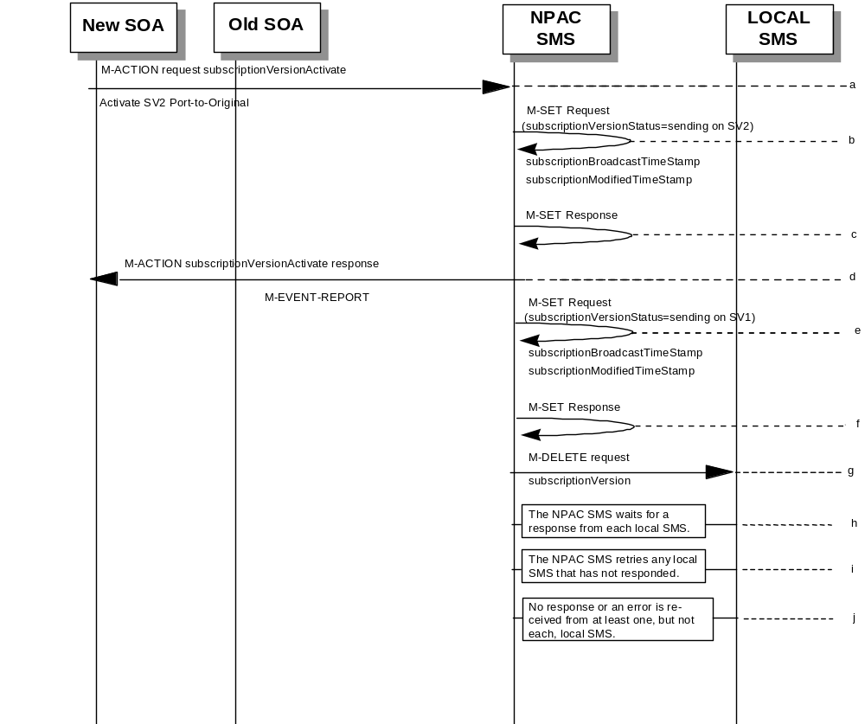

(continued on next page)

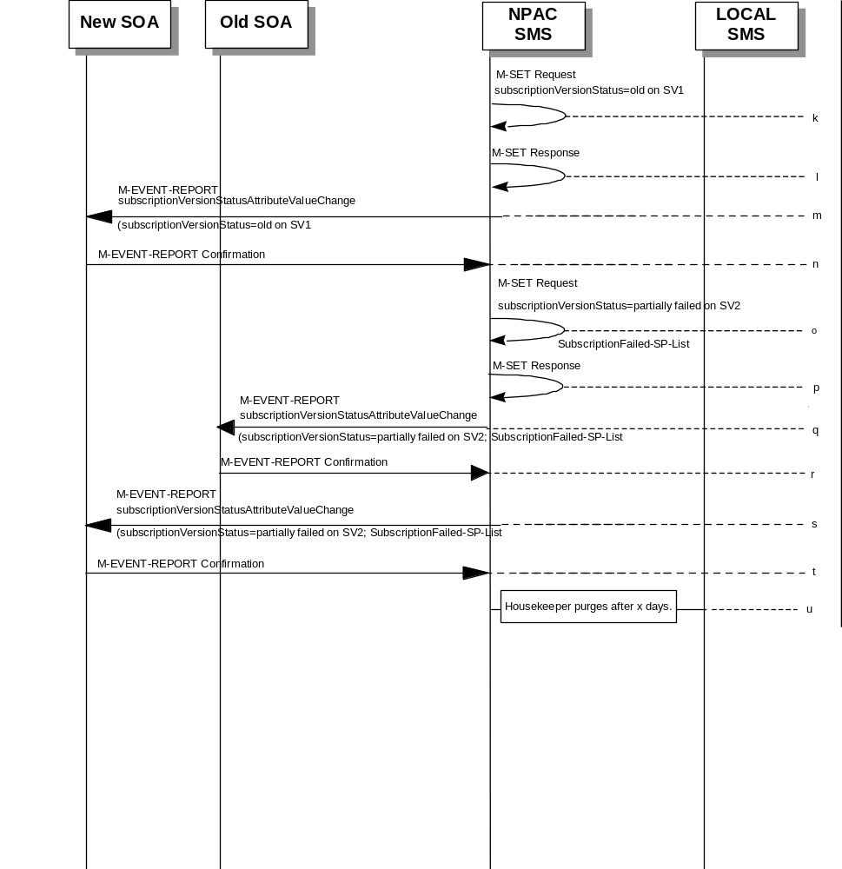

SV 1 is the currently active Subscription Version.
SV 2 is the current pending Subscription Version.
- The new service provider SOA issues a subscriptionVersionActivate M-ACTION to the NPAC SMS lnpSubscriptions object to activate the pending subscription version SV2 by specifying the subscription version ID, subscription version TN, or a range of subscription version TNs.
- The NPAC SMS issues an M-SET request setting the subscriptionVersionStatus to “sending”, subscriptionBroadcastTimeStamp and subscriptionModifiedTimeStamp on the subscriptionVersionNPAC on SV2.
- NPAC SMS response to the M-SET.
- The NPAC SMS responds with the M-ACTION response. An error will be returned if the service provider is not the new service provider (accessDenied) or if there is no version to be activated (invalidArgumentValue) or if any other failures occur.
- The NPAC SMS sets the subscriptionVersionStatus to sending and sets the subscriptionBroadcastTimeStamp and subscriptionModifiedTimeStamp on the subscriptionVersionNPAC on SV1.
- NPAC SMS response to the M-SET.
- NPAC SMS sends out an M-DELETE on the subscription Version SV1 to all Local SMSs, that are accepting downloads for the NPA-NXX of subscription Version SV1. If the M-DELETE is for multiple subscription versions, a scoped and filtered operation will be sent.
- NPAC SMS waits for a response from each Local SMS.
- NPAC SMS retries any Local SMS that has not responded.
- No response or an error is received from at least one, but not each, Local SMS.
- NPAC SMS issues an M-SET updating the subscriptionVersionStatus of SV1 to old.
- NPAC SMS responds to the M-SET.
- The NPAC SMS sends to the current/new service provider SOA a subscriptionVersionStatusAttributeValueChange for the subscriptionVersionStatus being set to old on SV1.
- The current/new service provider SOA returns an M-EVENT-REPORT confirmation to the NPAC SMS.
- NPAC SMS issues an M-SET updating the subscriptionVersionStatus of SV2 to partially failed. It also sets the subscriptionFailed-SP-List.
- NPAC SMS responds to the M-SET.
- The NPAC SMS sends to the old service provider SOA a subscriptionVersionStatusAttributeValueChange for the subscriptionVersionStatus being set to partially failed on SV2, along with the subscriptionFailed-SP-List.
- The old service provider SOA returns an M-EVENT-REPORT confirmation to the NPAC SMS.
- The NPAC SMS sends to the new service provider SOA a subscriptionVersionStatusAttributeValueChange for the subscriptionVersionStatus being set to partially failed on SV2, along with the subscriptionFailed-SP-List.
- The new service provider SOA returns an M-EVENT-REPORT confirmation to the NPAC SMS.
- After a tunable amount of days, the subscription versions SV1 and SV2 are purged by the NPAC SMS housekeeping process.
NOTE: SV1 may exist as an old SV that may be associated with SV2 that is in a “partially failed” state for a port to original port. In this case, the housekeeping process should not purge SV1 unless SV2 is also being purged.
NOTE: SV1 and SV2 should be updated to the NPA-NXX for a NPA Split if SV2 is in a “failed” or “partially failed” state.

SubscriptionVersion Port-to-Original: Resend
This scenario shows how a port-to-original (resend) port is processed.
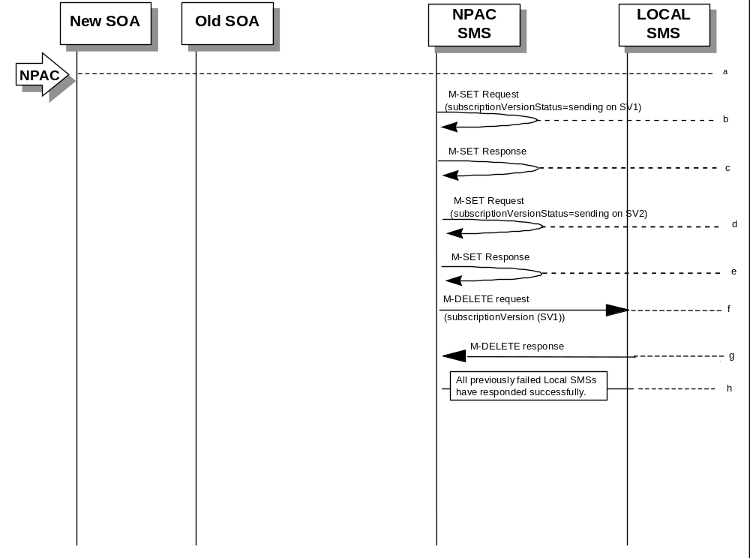

(continued on next page)

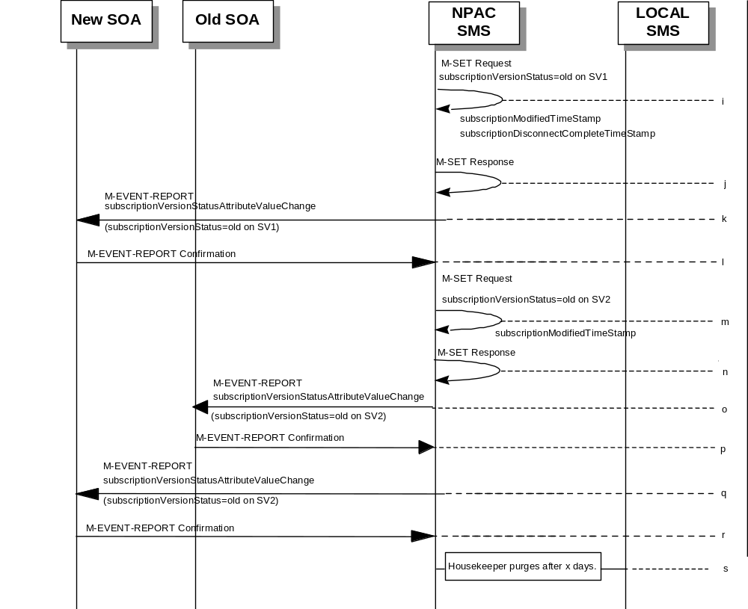

SV 1 is the currently active Subscription Version.
SV 2 is the current pending Subscription Version.
- NPAC personnel take action to resend a failed port-to-original for a subscription version.
- The NPAC SMS issues an M-SET request setting the subscriptionVersionStatus to “sending”, subscriptionBroadcastTimeStamp and subscriptionModifiedTimeStamp on the subscriptionVersionNPAC on SV1.
- NPAC SMS responds to the M-SET.
- The NPAC SMS sets the subscriptionVersionStatus to sending on the subscriptionVersionNPAC on SV2.
- NPAC SMS response to the M-SET.
- NPAC SMS sends out an M-DELETE on the subscription Version SV1 to all Local SMSs that previously failed, that are accepting downloads for the NPA-NXX of the subscription Version SV1. If the M-DELETE is for multiple subscription versions, a scoped and filtered operation may be sent.
- Each previously failed Local SMS responds with a successful M-DELETE reply.
- All previously failed Local SMSs respond successfully.
- NPAC SMS issues an M-SET updating the subscriptionVersionStatus of SV1 to old. It also sets the subscriptionModifiedTimeStamp and subscriptionDisconnectCompleteTimeStamp.
- NPAC SMS responds to the M-SET.
- The NPAC SMS sends to the current/new service provider SOA a subscriptionVersionStatusAttributeValueChange for the subscriptionVersionStatus being set to old on SV1.
- The current/new service provider SOA returns an M-EVENT-REPORT confirmation to the NPAC SMS.
- NPAC SMS issues an M-SET updating the subscriptionVersionStatus of SV2 to old. It also sets the subscriptionModifiedTimeStamp.
- NPAC SMS responds to the M-SET.
- The NPAC SMS sends to the old service provider SOA a subscriptionVersionStatusAttributeValueChange for the subscriptionVersionStatus being set to old on SV2.
- The old service provider SOA returns an M-EVENT-REPORT confirmation to the NPAC SMS.
- The NPAC SMS sends to the new service provider SOA a subscriptionVersionStatusAttributeValueChange for the subscriptionVersionStatus being set to old on SV2.
- The new service provider SOA returns an M-EVENT-REPORT confirmation to the NPAC SMS.
- After a tunable amount of days, the subscription versions SV1 and SV2 are purged by the NPAC SMS housekeeping process.

SubscriptionVersion Port-to-Original: Resend Failure to Local SMS
This scenario shows a failure on a resend of a subscription port-to-original that failed previously to one or more of the Local SMSs. The resend of a failed port-to-original for a subscription can only be performed by authorized NPAC personnel.
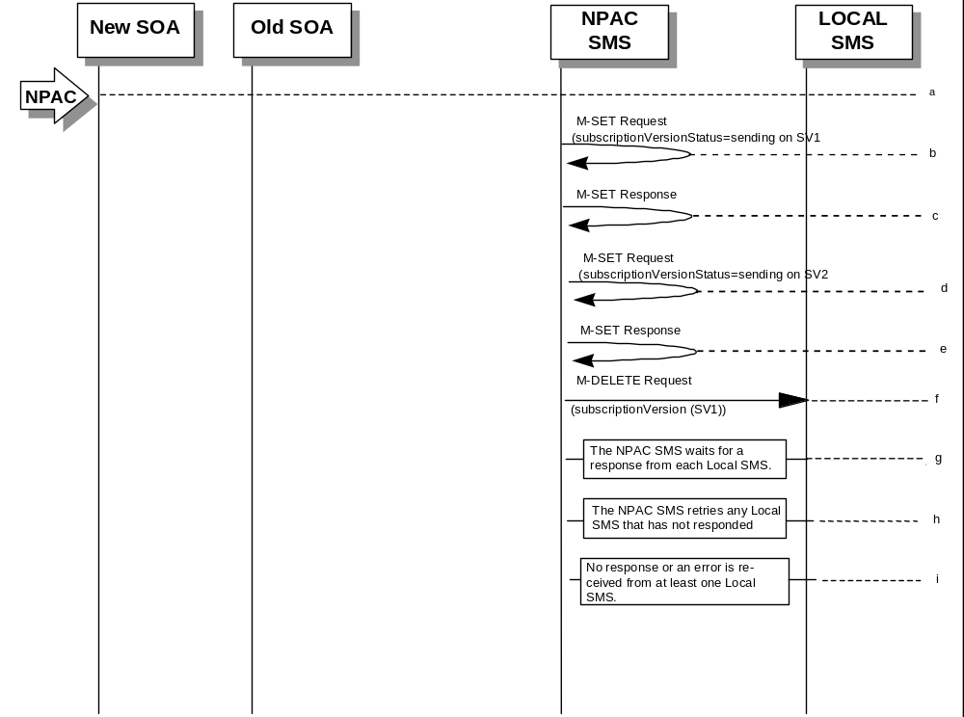

(continued on next page)

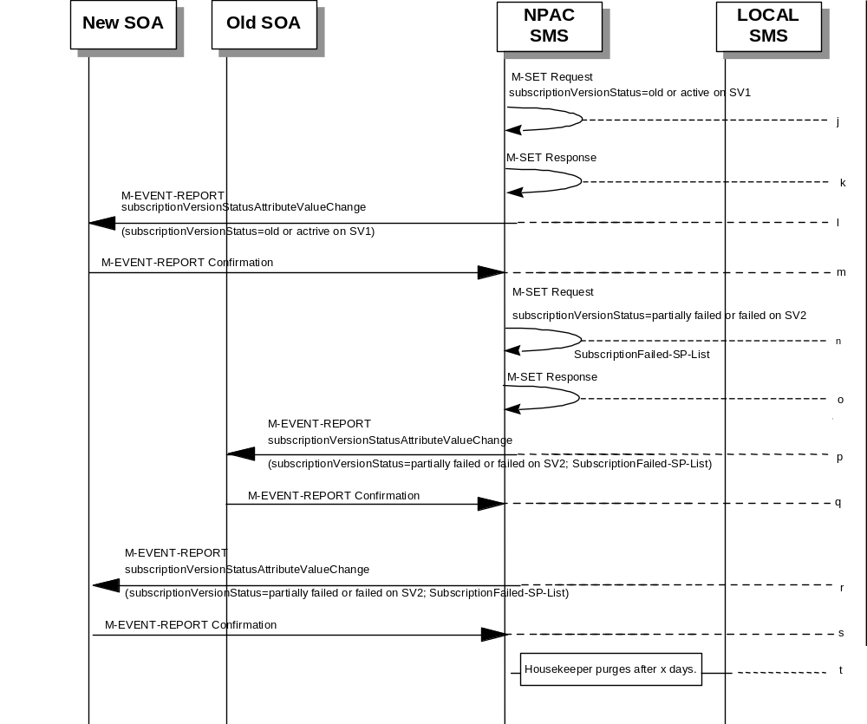

SV 1 is the currently active Subscription Version.
SV 2 is the current pending Subscription Version.
- NPAC personnel take action to resend a failed port-to-original for a subscription version.
- The NPAC SMS issues an M-SET request setting the subscriptionVersionStatus to “sending”, subscriptionBroadcastTimeStamp and subscriptionModifiedTimeStamp on the subscriptionVersionNPAC on SV1.
- NPAC SMS response to the M-SET.
- The NPAC SMS sets the subscriptionVersionStatus to sending on the subscriptionVersionNPAC on SV2.
- NPAC SMS response to the M-SET.
- NPAC SMS sends out an M-DELETE on the subscription Version SV1 to all Local SMSs that previously failed, that are accepting downloads for the NPA-NXX of the subscription Version SV1. If the M-DELETE is for multiple subscription versions, a scoped and filtered operation may be sent.
- NPAC SMS waits for a response from each Local SMS.
- NPAC SMS retries any Local SMS that has not responded.
- No response or an error is received from at least one Local SMS.
- NPAC SMS issues an M-SET updating the subscriptionVersionStatus of SV1 to “old” or “active” (if all Local SMSs accepting download for the NPA-NXX failed) from “sending”. It will also update the subscriptionFailed-SP-List with the service provider ID and name of the Local SMSs that failed to successfully receive the broadcast.
- NPAC SMS responds to the M-SET.
- The NPAC SMS sends to the current/new service provider SOA a subscriptionVersionStatusAttributeValueChange for the subscriptionVersionStatus being set to “old” or “active” on SV1.
- The current/new service provider SOA returns an M-EVENT-REPORT confirmation to the NPAC SMS.
- NPAC SMS issues an M-SET updating the subscriptionVersionStatus of SV2 to partially failed. It also sets the subscriptionFailed-SP-List.
- NPAC SMS responds to the M-SET.
- The NPAC SMS sends to the old service provider SOA a subscriptionVersionStatusAttributeValueChange for the subscriptionVersionStatus being set to “partially failed” or “failed” on SV2, along with the subscriptionFailed-SP-List.
- The old service provider SOA returns an M-EVENT-REPORT confirmation to the NPAC SMS.
- The NPAC SMS sends to the current/new service provider SOA a subscriptionVersionStatusAttributeValueChange for the subscriptionVersionStatus being set to “partially failed” or “failed” on SV2, along with the subscriptionFailed-SP-List.
- The current/new service provider SOA returns an M-EVENT-REPORT confirmation to the NPAC SMS.
- After a tunable amount of days, the subscription versions SV1 and SV2 are purged by the NPAC SMS housekeeping process.
NOTE: SV1 may exist as an old SV that may be associated with SV2 that is in a “partially failed” state for a port to original port. In this case, the housekeeping process should not purge SV1 unless SV2 is also being purged.
NOTE: SV1 and SV2 should be updated to the NPA-NXX for a NPA Split if SV2 is in a “failed” or “partially failed” state.

Port-To-Original Subscription Version Flows for Pooled TNs
This section contains Port-to-Original flows whose subscription version TNs are part of a pooled block and therefore the behavior of these scenarios is different than normal Port-to-Original subscription version processing.

Subscription Version Port-to-Original of a Ported Pool TN Activation by SOA (previously NNP flow 3.1.1)
The following scenarios show the broadcast of a Port-to-Original subscription version that is successfully sent to all of the Local SMSs. In this scenario:
- SV1 is the currently active Subscription Version.
- SV2 is the current pending Subscription Version with the Port-To-Original flag set to TRUE.
- SV3 is the pool reinstatement Subscription Version with LNP type = Pool that reinstates default routing to the block holder.
The creation of a port-to-original request will be rejected if the block holder service provider and new service provider are not the same and if the TN is part of a pooled TN range.
This scenario shows the activation by the new service provider SOA and the update to ‘sending’ of the 3 subscription versions.

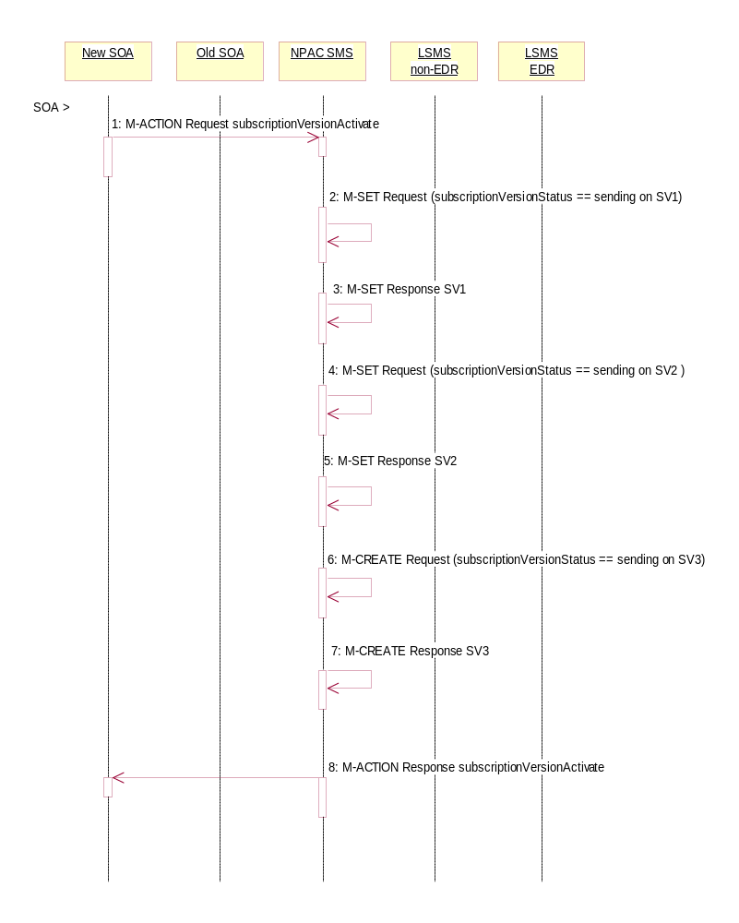

- The new, block holder service provider SOA issues a subscriptionVersionActivate M-ACTION to the NPAC SMS lnpSubscriptions object to activate the pending subscription version SV2 by specifying the subscription version ID, subscription version TN, or a range of subscription version TNs that are within the block.
- The NPAC SMS issues an M-SET request setting the subscriptionVersionStatus to “sending”, subscriptionBroadcastTimeStamp and subscriptionModifiedTimeStamp on the subscriptionVersionNPAC on SV1.
- NPAC SMS responds to the M-SET.
- The NPAC SMS issues an M-SET request setting the subscriptionVersionStatus to “sending”, subscriptionBroadcastTimeStamp and subscriptionModifiedTimeStamp on the subscriptionVersionNPAC on SV2.
- NPAC SMS responds to the M-SET.
- The NPAC SMS issues an M-CREATE request for SV3 and the subscriptionVersionStatus is set to “sending”, the subscriptionLNPType is set to ‘pool’, the subscriptionActivationTimeStamp, subscriptionCreationTimeStamp, subscriptionBroadcastTimeStamp and subscriptionModifiedTimeStamp are set to the current date and time. All routing information originates from the numberPoolBlock that exists for the specified TN(s).
- NPAC SMS responds to the M-CREATE.
- The NPAC SMS responds with the M-ACTION response. An error will be returned if the service provider is not the new service provider (soa-not-authorized) or if there is no version to be activated (no-version-found) or if any other failures occur (invalid-data-values, failed).

Successful Broadcast of Port-to-Original Activation Request for a Pooled TN (previously NNP flow 3.1.2)
The NPAC SMS has the port-to-original request of a pooled TN in sending mode. In this scenario, the broadcasts begin.

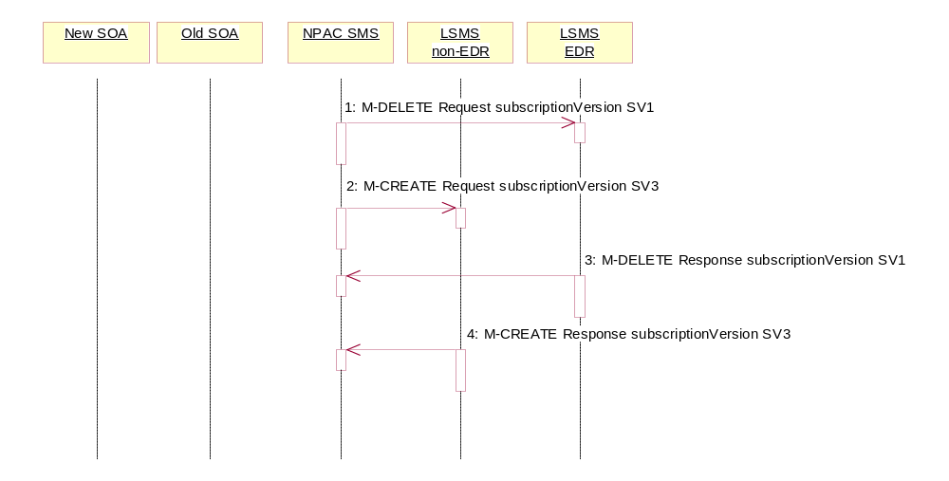
- NPAC SMS issues the M-DELETE for SV1 to the EDR Local SMS that are accepting downloads for the NPA-NXX. The EDR Local SMS will revert back to using the routing information in the number pool block object for the TN in the subscription version. If the EDR Local SMS fails to respond, the NPAC SMS will retry the M-DELETE request a tunable amount of times.
- At the same time as step 1, the NPAC SMS sends out an M-CREATE on the subscription version SV3 to all non-EDR Local SMSs that are accepting downloads for the NPA-NXX of subscription Version SV3. If the create is for multiple subscription versions, the M-ACTION subscriptionVersionLocalSMS-Create will be used instead. The SV3 created on the non-EDR Local SMS systems contains the default block routing information and has a LNP type of ‘pool’. If the non-EDR Local SMS fails to respond, the NPAC SMS will retry the M-CREATE request a tunable amount of times.
- The EDR Local SMS responds to the M-DELETE.
- Each non-EDR Local SMS responds to the M-CREATE.

Successful Broadcast Complete NPAC SMS Updates for a Port-to-Original Request for a Pooled TN (previously NNP flow 3.1.3)
In this scenario, the NPAC SMS has successfully completed the broadcast of the port-to-original of a pooled TN. The NPAC SMS now updates the status of the subscription versions on the NPAC SMS.
All Local SMSs respond successfully to the port-to-original broadcast of a pooled TN.
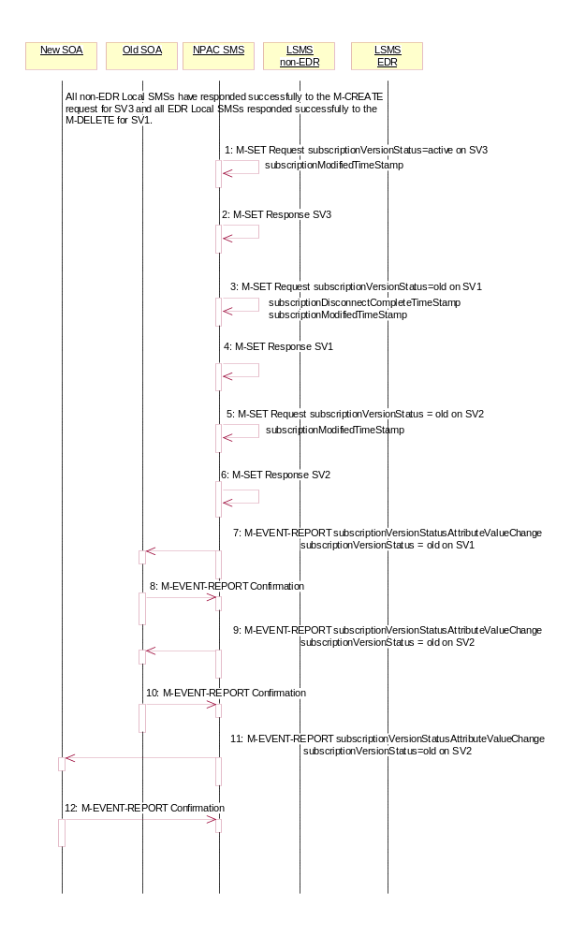
- NPAC SMS issues an M-SET updating the subscriptionVersionStatus of SV3 to active. The subscriptionModifiedTimeStamp is also set.
- NPAC SMS responds to the M-SET.
- NPAC SMS issues an M-SET updating the subscriptionVersionStatus of SV1 to old. It also sets the subscriptionDisconnectCompleteTimeStamp and subscriptionModifiedTimeStamp.
- NPAC SMS responds to the M-SET.
- NPAC SMS issues an M-SET updating the subscriptionVersionStatus of SV2 to old. It also sets the subscriptionModifiedTimeStamp.
- NPAC SMS responds to the M-SET.
- The NPAC SMS sends to the old service provider SOA, who is the current service provider on SV1, a subscriptionVersionStatusAttributeValueChange for the subscriptionVersionStatus being set to old on SV1.
- The old service provider SOA returns an M-EVENT-REPORT confirmation to the NPAC SMS.
- The NPAC SMS sends to the old service provider SOA a subscriptionVersionStatusAttributeValueChange for the subscriptionVersionStatus being set to old on SV2.
- The old service provider SOA returns an M-EVENT-REPORT confirmation to the NPAC SMS.
- The NPAC SMS sends to the current/new service provider SOA a subscriptionVersionStatusAttributeValueChange for the subscriptionVersionStatus being set to old on SV2.
- The current/new, block holder service provider SOA returns an M-EVENT-REPORT confirmation to the NPAC SMS.
After a tunable amount of days, the subscription versions SV1 and SV2 are purged by the NPAC SMS housekeeping process.

Subscription Version Create Port-to-Original of a Pool TN: Failure Broadcast to All Local SMSs (previously NNP flow 3.2.1)
This scenario shows the broadcast of a Port-to-Original subscription version that fails to all of the Local SMSs.
- SV1 is the active Subscription Version.
- SV2 is the pending Subscription Version with the Port to Original flag set to TRUE.
- SV3 is the pool reinstatement Subscription Version with LNP type = Pool that reinstates default routing to the block holder.
In this scenario, the NPAC SMS has the required subscription versions in a ‘sending’ state. The NPAC SMS begins the broadcast.

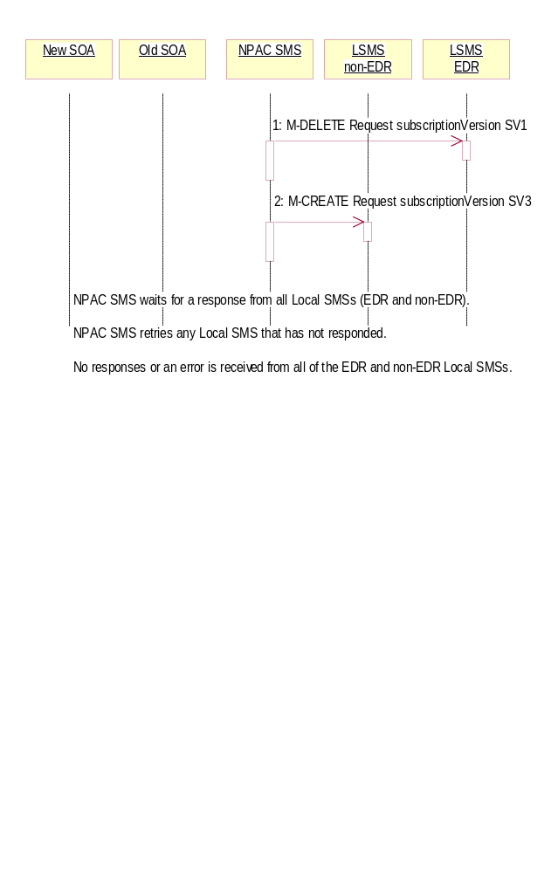
- NPAC SMS issues the M-DELETE for SV1 to the EDR Local SMS. The EDR Local SMS will revert back to using the routing information in the number pool block object for the TN in the subscription version.
- At the same time as step 1, the NPAC SMS sends out an M-CREATE on subscription version SV3 to all non-EDR Local SMSs that are accepting downloads for the NPA-NXX of subscription Version SV3. If the create is for multiple subscription versions, the M-ACTION subscriptionVersionLocalSMS-Create will be used instead. The SV3 created on the non-EDR Local SMS systems contains the default block routing information and has a LNP type of “pool”.
The NPAC SMS waits for a response from all Local SMSs (EDR and non-EDR).
The NPAC SMS retries any Local SMS that has not responded successfully.
No response or an error is received from all of the EDR and non-EDR Local SMSs.

Updates to NPAC SMS after Failure of Port-to-Original Broadcast for a Pooled TN (previously NNP flow 3.2.2)
The NPAC SMS has just completed an unsuccessful broadcast to the LSMSs of a port-to-original of a pooled TN. The NPAC SMS now proceeds to update the status on the NPAC SMS.

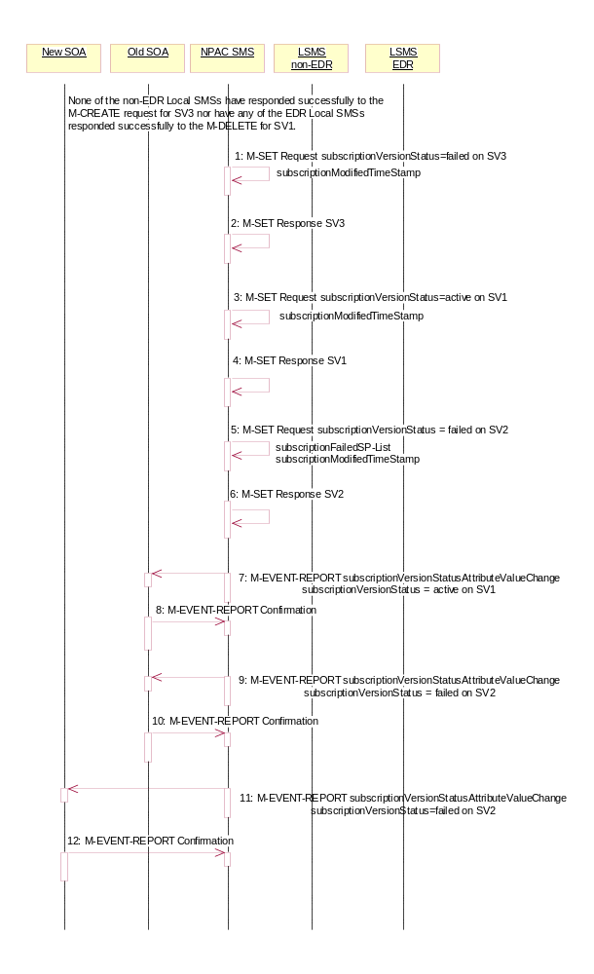
None of the non-EDR Local SMSs has responded successfully to the M-CREATE request for SV3 nor have any of the EDR Local SMSs responded successfully to the M-DELETE for SV1.

- NPAC SMS issues an M-SET updating the subscriptionVersionStatus of SV3 to failure and the subscriptionModifiedTimeStamp is also set to the current date and time.
- NPAC SMS responds to the M-SET.
- NPAC SMS issues an M-SET updating the subscriptionVersionStatus of SV1 to active. It also sets the subscriptionModifiedTimeStamp to the current date and time.
- NPAC SMS responds to the M-SET.
- NPAC SMS issues an M-SET updating the subscriptionVersionStatus of SV2 to failed. It also sets the subscriptionModifiedTimeStamp to the current date and time and sets the subscriptionFailed-SP-List. The failed SP list contains the EDR and non-EDR Local SMSs who failed to receive the broadcast of SV1 and SV3.
- NPAC SMS responds to the M-SET.
- The NPAC SMS sends to the old service provider SOA, who is the current service provider on SV1, a subscriptionVersionStatusAttributeValueChange for the subscriptionVersionStatus being set to active on SV1.
- The old service provider SOA returns an M-EVENT-REPORT confirmation to the NPAC SMS.
- The NPAC SMS sends to the old service provider SOA a subscriptionVersionStatusAttributeValueChange with the subscriptionVersionStatus being set to failed and the subscriptionFailed-SP-List for SV2.
- The old service provider SOA returns an M-EVENT-REPORT confirmation to the NPAC SMS.
- The NPAC SMS sends to the current/new, block holder service provider SOA a subscriptionVersionStatusAttributeValueChange with the subscriptionVersionStatus being set to failed and the subscriptionFailed-SP-List for SV2.
- The current/new service provider SOA returns an M-EVENT-REPORT confirmation to the NPAC SMS.

Port-to-Original Activation Partial Failure Broadcast of a Pooled TN (previously NNP flow 3.3.1)
This scenario shows the broadcast of a Port-to-Original subscription version that fails to one or more, but not all, of the Local SMSs.
SV1 is the active Subscription Version.
SV2 is the pending Subscription Version with the Port-To-Original flag set to TRUE.
SV3 is the pool reinstatement Subscription Version with LNP type = Pool that reinstates default routing to the block holder.

The NPAC SMS has the port-to-original request of a pooled TN in sending mode. In this scenario, the broadcasts begin that will result in a partial failure.

- NPAC SMS issues the M-DELETE to the EDR Local SMS for SV1. The EDR Local SMS will revert back to using the routing information in the number pool block object for the TN in the subscription version.
- NPAC SMS issues an M-CREATE on the subscription version SV3 to all non-EDR Local SMSs, that are accepting downloads for the NPA-NXX of subscription Version SV3. If the create is for multiple subscription versions, the M-ACTION subscriptionVersionLocalSMS-Create will be used instead. The SV3 created on the non-EDR Local SMS systems contains the default block routing information and has a LNP type of “pool”.
- The EDR Local SMS responds to the M-DELETE.
- Each non-EDR Local SMS responds to the M-CREATE.

Partial-Failure Broadcast Complete NPAC SMS Updates of a Port-to-Original for a Pooled TN (previously NNP flow 3.3.2)
In this scenario, the NPAC SMS has already performed the broadcast of the activation of the port-to-original activation. The broadcast resulted in a partial failure status. The NPAC SMS now updates the objects on the NPAC SMS.

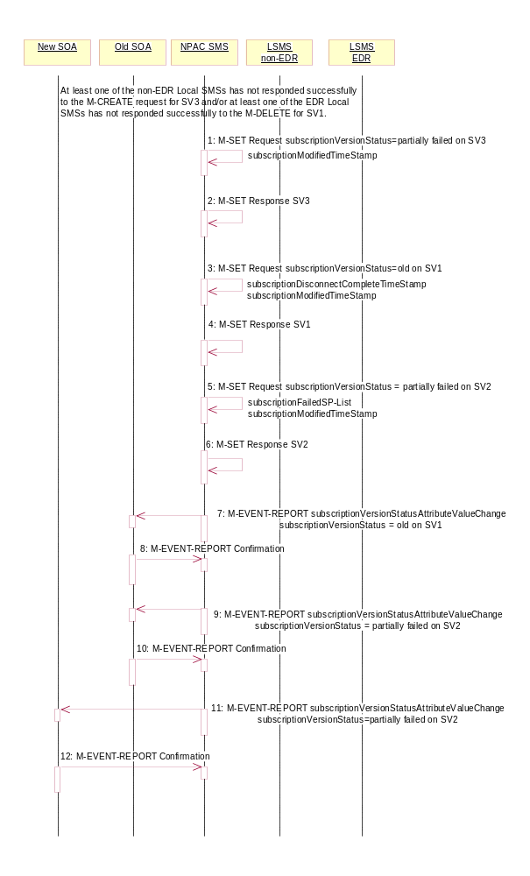
At least one of the non-EDR Local SMSs has not responded successfully to the M-CREATE for SV3 and/or at least one of the EDR Local SMSs has not responded successfully to the M-DELETE for SV1.

- NPAC SMS issues an M-SET updating the subscriptionVersionStatus of SV3 to partial failure. The subscriptionModifiedTimeStamp is also set to the current date and time.
- NPAC SMS responds to the M-SET.
- NPAC SMS issues an M-SET updating the subscriptionVersionStatus of SV1 to old. It also sets the s subscriptionDisconnectCompleteTimeStamp and subscriptionModifiedTimeStamp to the current date and time.
- NPAC SMS responds to the M-SET.
- NPAC SMS issues an M-SET updating the subscriptionVersionStatus of SV2 to partially failed. It also sets the subscriptionModifiedTimeStamp to the current date and time and sets the subscriptionFailed-SP-List. The failed list contains the both the EDR and non-EDR Local SMSs who did not complete the broadcast of SV1 and SV3 successfully.
- NPAC SMS responds to the M-SET.
- The NPAC SMS sends to the old service provider SOA, who is the current service provider on SV1, a subscriptionVersionStatusAttributeValueChange for the subscriptionVersionStatus being set to old on SV1.
- The old service provider SOA returns an M-EVENT-REPORT confirmation to the NPAC SMS.
- The NPAC SMS sends to the old service provider SOA a subscriptionVersionStatusAttributeValueChange with the subscriptionVersionStatus being set to partially failed and the subscriptionFailed-SP-List for SV2.
- The old service provider SOA returns an M-EVENT-REPORT confirmation to the NPAC SMS.
- The NPAC SMS sends to the current/new service provider SOA a subscriptionVersionStatusAttributeValueChange with the subscriptionVersionStatus being set to partially failed and the subscriptionFailed-SP-List for SV2.
- The current/new service provider SOA returns an M-EVENT-REPORT confirmation to the NPAC SMS.

Port-to-Original NPAC SMS Initiates Successful Resend for a Pooled TN (previously NNP flow 3.4.1)
This scenario shows how the successful resend of a failed port-to-original broadcast is processed. In this scenario the following subscription versions are used:

- SV1 is the active Subscription Version.
- SV2 is the partially failed or failed Subscription Version with the Port-To-Original flag set to TRUE.
- SV3 is the pool reinstatement Subscription Version with LNP type = Pool that reinstates default routing to the block holder.
In this scenario, the NPAC SMS must resend the port-to-original request. Either at least 1 EDR LSMS failed to receive the M-DELETE for SV1 or at least 1 non-EDR LSMS failed to receive the M-CREATE for SV3. The NPAC SMS will resend the necessary operations to the failed LSMSs.

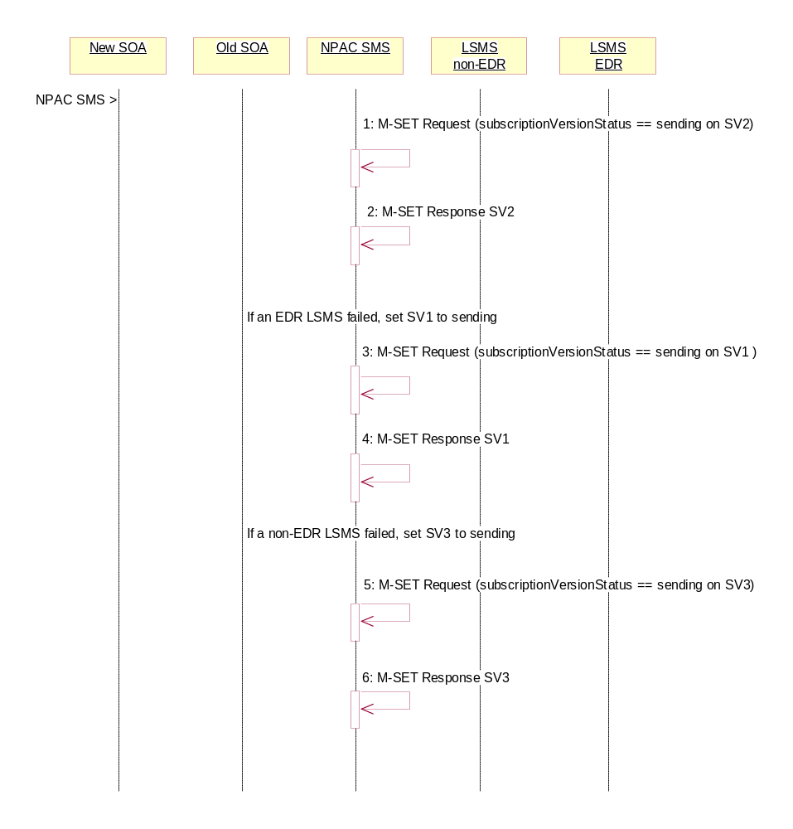
- The NPAC SMS issues an M-SET request setting the subscriptionVersionStatus to “sending”, subscriptionBroadcastTimeStamp and subscriptionModifiedTimeStamp on the subscriptionVersionNPAC on SV2.
- NPAC SMS responds to the M-SET.
- If one of the failed LSMSs is an EDR LSMS, the NPAC SMS issues an M-SET request setting the subscriptionVersionStatus to “sending”, subscriptionBroadcastTimeStamp and subscriptionModifiedTimeStamp on the subscriptionVersionNPAC on SV1.
- NPAC SMS responds to the M-SET.
- If one of the failed LSMSs is a non-EDR LSMS, the NPAC SMS issues an M-SET request setting the subscriptionVersionStatus to “sending”, the subscriptionActivationTimeStamp, subscriptionBroadcastTimeStamp and subscriptionModifiedTimeStamp on the subscriptionVersionNPAC on SV3.
- NPAC SMS responds to the M-SET.

Successful Resend Broadcast of a Port-to-Original of a Pooled TN (previously NNP flow 3.4.2)
The NPAC SMS has the necessary subscription versions in sending mode. It now broadcasts the data.

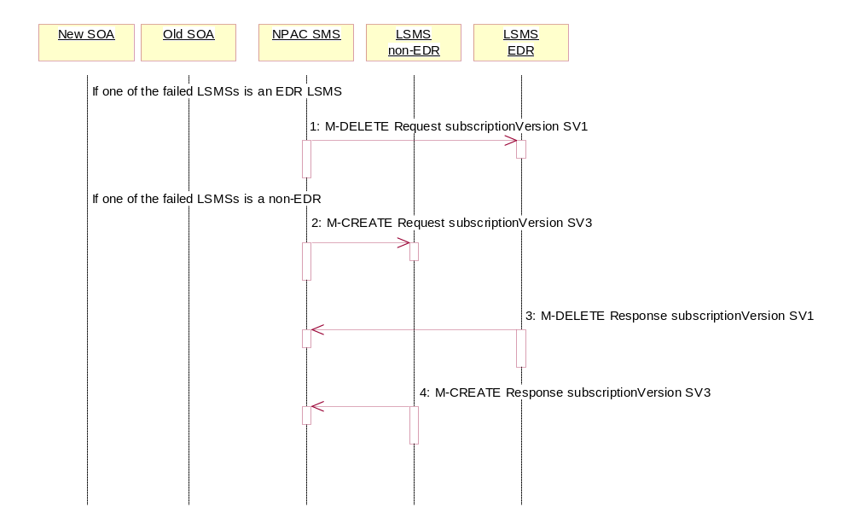
- If one of the failed Local SMSs is an EDR LSMS, the NPAC SMS issues the M-DELETE to the failed EDR Local SMS for SV1. The EDR Local SMS will revert back to using the routing information in the number pool block object for the TN in the subscription version.
- If one of the failed Local SMSs is a non-EDR LSMS, the NPAC SMS sends out an M-CREATE on the subscription version SV3 to the failed non-EDR Local SMSs that are accepting downloads for the NPA-NXX of subscription Version SV3. If the M-CREATE is for multiple subscription versions, a scoped and filtered operation will be sent. The SV3 created on the non-EDR Local SMS systems contains the default block routing information and has a LNP type of “pool”.
- If a request was sent, the EDR Local SMS responds to the M-DELETE.
- If a request was sent, the non-EDR Local SMS responds to the M-CREATE.
All previously failed Local SMSs respond successfully.

Updates to NPAC SMS after Successful Resend of Port-to-Original Request of a Pooled TN (previously NNP flow 3.4.3)

The NPAC SMS just successfully re-broadcasted the necessary updates to the Local SMS. It now updates the status of the objects on the NPAC SMS.

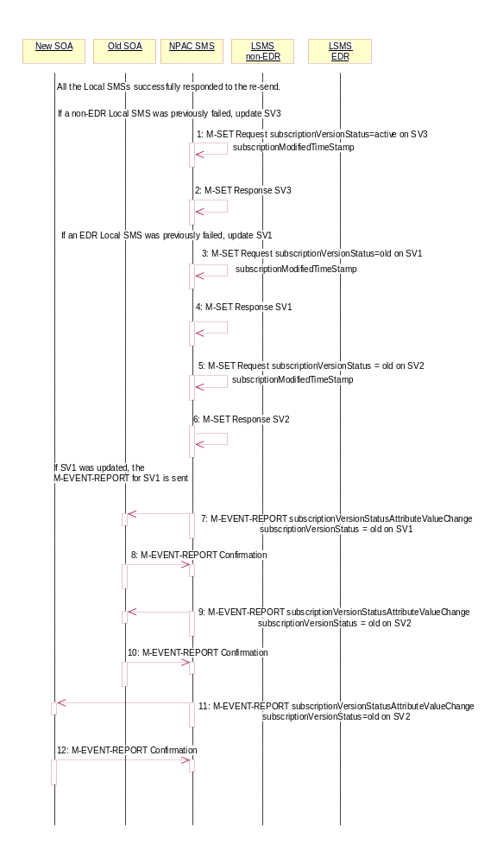
- If a resend to a non-EDR Local SMS was successful, the NPAC SMS issues an M-SET updating the subscriptionVersionStatus of SV3 to active. The subscriptionModifiedTimeStamp is also set.
- NPAC SMS responds to the M-SET.
- If a resend to a EDR Local SMS was successful, the NPAC SMS issues an M-SET updating the subscriptionVersionStatus of SV1 to old. It also sets the subscriptionModifiedTimeStamp. If the subscription status was previously set to “failed”, the subscriptionDisconnectCompleteTimeStamp is set when the first successful response is received.
- NPAC SMS responds to the M-SET.
- NPAC SMS issues an M-SET updating the subscriptionVersionStatus of SV2 to old. It also sets the subscriptionModifiedTimeStamp.
- NPAC SMS responds to the M-SET.
- The NPAC SMS sends to the old service provider SOA, who is the current service provider on SV1, a subscriptionVersionStatusAttributeValueChange for the subscriptionVersionStatus being set to old on SV1.
- The old service provider SOA returns an M-EVENT-REPORT confirmation to the NPAC SMS.
- The NPAC SMS sends to the old service provider SOA a subscriptionVersionStatusAttributeValueChange for the subscriptionVersionStatus being set to old on SV2.
- The old service provider SOA returns an M-EVENT-REPORT confirmation to the NPAC SMS.
- The NPAC SMS sends to the current/new service provider SOA a subscriptionVersionStatusAttributeValueChange for the subscriptionVersionStatus being set to old on SV2.
- The current/new service provider SOA returns an M-EVENT-REPORT confirmation to the NPAC SMS.

After a tunable amount of days, the subscription versions SV1 and SV2 are purged by the NPAC SMS housekeeping process.

Subscription Version Create Port-to-Original of a Pool TN: Resend Failure to Local SMS (previously NNP flow 3.5)
This scenario shows how the unsuccessful resend of a failed port-to-original broadcast is processed. In this scenario, the following subscription versions are used:
- SV1 is the active Subscription Version.
- SV2 is the failed Subscription Version with the Port-To-Original flag set to TRUE.
- SV3 is the pool reinstatement Subscription Version with LNP type = Pool that reinstates default routing to the block holder and its current status is failed.
In the following scenario, the NPAC SMS must resend the port-to-original request. All the EDR LSMS failed to receive the M-DELETE for SV1 and all the non-EDR LSMSs failed to receive the M-CREATE for SV3. The NPAC SMS will resend the necessary operations to the failed LSMSs, but the resend will result in total failure again. The scenario would work just as a successful resend, except for when the NPAC SMS sets the final statuses on the NPAC SMS.

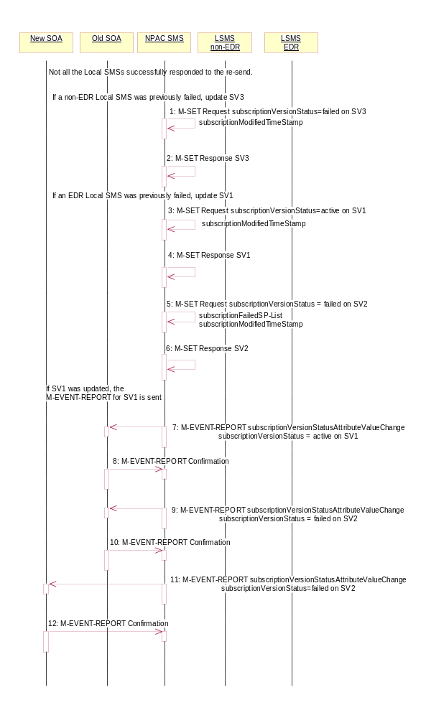
- If all non-EDR Local SMS failed the broadcast, the NPAC SMS issues an M-SET updating the subscriptionVersionStatus of SV3 to failed. The subscriptionModifiedTimeStamp is also set.
- NPAC SMS responds to the M-SET.
- If all the EDR Local SMS failed the broadcast, the NPAC SMS issues an M-SET updating the subscriptionVersionStatus of SV1 back to active. It also sets the subscriptionModifiedTimeStamp.
- NPAC SMS responds to the M-SET.
- NPAC SMS issues an M-SET updating the subscriptionVersionStatus of SV2 back to failed and setting the subscriptionFailed-SP-List to the list of all the service providers that failed to receive the broadcast successfully (EDR and non-EDR). It also sets the subscriptionModifiedTimeStamp.
- NPAC SMS responds to the M-SET.
- The NPAC SMS sends to the old service provider SOA, who is the current service provider on SV1, a subscriptionVersionStatusAttributeValueChange for the subscriptionVersionStatus being set back to active on SV1.
- The old service provider SOA returns an M-EVENT-REPORT confirmation to the NPAC SMS.
- The NPAC SMS sends to the old service provider SOA a subscriptionVersionStatusAttributeValueChange for the subscriptionVersionStatus being set to failed on SV2 with the subscriptionFailed-SP-List.
- The old service provider SOA returns an M-EVENT-REPORT confirmation to the NPAC SMS.
- The NPAC SMS sends to the current/new service provider SOA a subscriptionVersionStatusAttributeValueChange for the subscriptionVersionStatus being set to failed on SV2 with the subscriptionFailed-SP-List.
- The current/new service provider SOA returns an M-EVENT-REPORT confirmation to the NPAC SMS.

Subscription Version Create Port-to-Original of a Pool TN: Resend Partial Failure to Local SMS (previously NNP flow 3.6)
This scenario shows how the unsuccessful resend of a partially failed port-to-original broadcast is processed. In this scenario, the following subscription versions are used:
- SV1 is the old Subscription Version.
- SV2 is the partially failed Subscription Version with the Port-To-Original flag set to TRUE.
- SV3 is the pool reinstatement Subscription Version with LNP type = Pool that reinstates default routing to the block holder and its current status is partially failed.
In the following scenario, the NPAC SMS must resend the port-to-original request. At least 1 of the EDR LSMSs failed to receive the M-DELETE for SV1 and/or at least 1 of the non-EDR LSMSs failed to receive the M-CREATE for SV3. The NPAC SMS will resend the necessary operations to the failed LSMSs, but the resend will result in partial failure again. The scenario would work just as a successful resend, except for when the NPAC SMS sets the final statuses on the NPAC SMS.

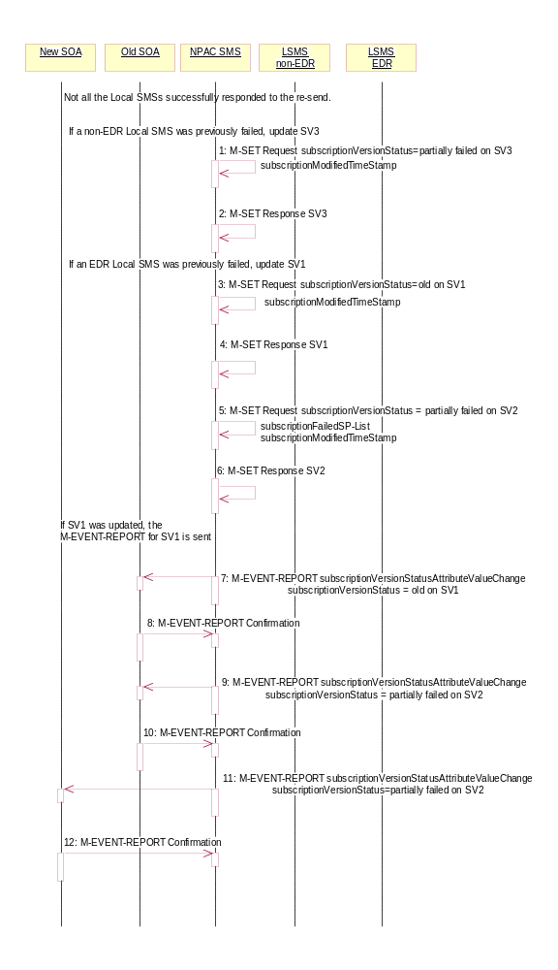
- If a resend of a non-EDR Local SMS was not successful, the NPAC SMS issues an M-SET updating the subscriptionVersionStatus of SV3 to partially failed. The subscriptionModifiedTimeStamp is also set.
- NPAC SMS responds to the M-SET.
- If a resend of an EDR Local SMS was not successful, the NPAC SMS issues an M-SET updating the subscriptionVersionStatus of SV1 back to old. It also sets the subscriptionModifiedTimeStamp.
- NPAC SMS responds to the M-SET.
- NPAC SMS issues an M-SET updating the subscriptionVersionStatus of SV2 to partially failed. It also sets the subscriptionModifiedTimeStamp and setting the subscriptionFailed-SP-List to the list of all the service providers that failed to receive the broadcast successfully (EDR and non-EDR).
- NPAC SMS responds to the M-SET.
- If SV1 was updated, the NPAC SMS sends to the old service provider SOA, who is the current service provider on SV1, a subscriptionVersionStatusAttributeValueChange for the subscriptionVersionStatus being set back to old on SV1.
- The old service provider SOA returns an M-EVENT-REPORT confirmation to the NPAC SMS.
- The NPAC SMS sends to the old service provider SOA a subscriptionVersionStatusAttributeValueChange for the subscriptionVersionStatus being set to partially failed on SV2 and the subscriptionFailed-SP-List.
- The old service provider SOA returns an M-EVENT-REPORT confirmation to the NPAC SMS.
- The NPAC SMS sends to the current/new service provider SOA a subscriptionVersionStatusAttributeValueChange for the subscriptionVersionStatus being set to partially failed on SV2 and the subscriptionFailed-SP-List.
- The current/new service provider SOA returns an M-EVENT-REPORT confirmation to the NPAC SMS.

Subscription Version Port-to-Original of a Pool TN – Creation Prior to NPA-NXX-X Effective Date (previously NNP flow 3.7)
In this scenario, the service provider SOA attempts to create a port-to-original request prior to the effective date of the corresponding serviceProvNPA-NXX-X object. The NPAC SMS will reject this request, as a port-to-original request can not be created prior to the effective date of the corresponding serviceProvNPA-NXX-X.
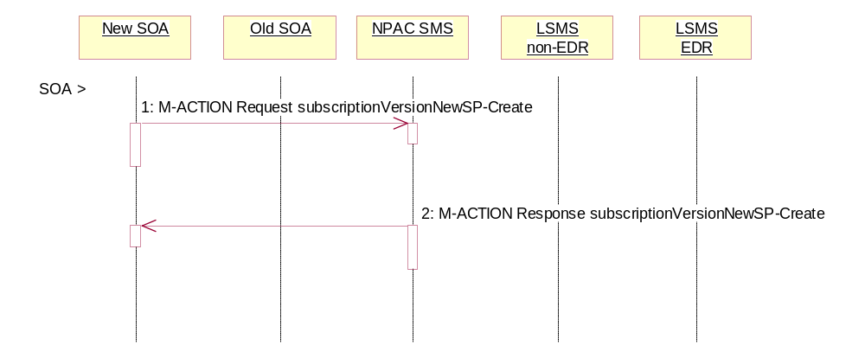
SOA personnel take action to create a port-to-original request.
- The new service provider SOA sends a valid, M-ACTION, subscriptionVersionNewSP-Create request with the subscriptionPortingToOriginal-SPSwitch set to ‘TRUE’ for a TN within a pooled block.
NPAC SMS replies with an error, ‘soa-not-authorized’.
Modify Scenarios

SubscriptionVersion Modify Active Version Using M-ACTION by a Service Provider SOA
This scenario shows the modification of an active subscription. The modification of an active subscription version can be performed using an M-ACTION only by the current service provider SOA.
- Action is taken by current service provider to modify an active subscription version by specifying the TN, TN range, and the version status, or by specifying the version ID of the subscription version to be modified; and the data to be modified.
The current service provider can only modify the following attributes:
subscriptionLRN
subscriptionCLASS-DPC
subscriptionCLASS-SSN
subscriptionLIDB-DPC
subscriptionLIDB-SSN
subscriptionCNAM-DPC
subscriptionCNAM-SSN
subscriptionISVM-DPC
subscriptionISVM-SSN
subscriptionWSMSC-DPC - if supported by the Service Provider SOA
subscriptionWSMSC-SSN - if supported by the Service Provider SOA
subscriptionEndUserLocationValue
subscriptionEndUserLocationType
subscriptionBillingId
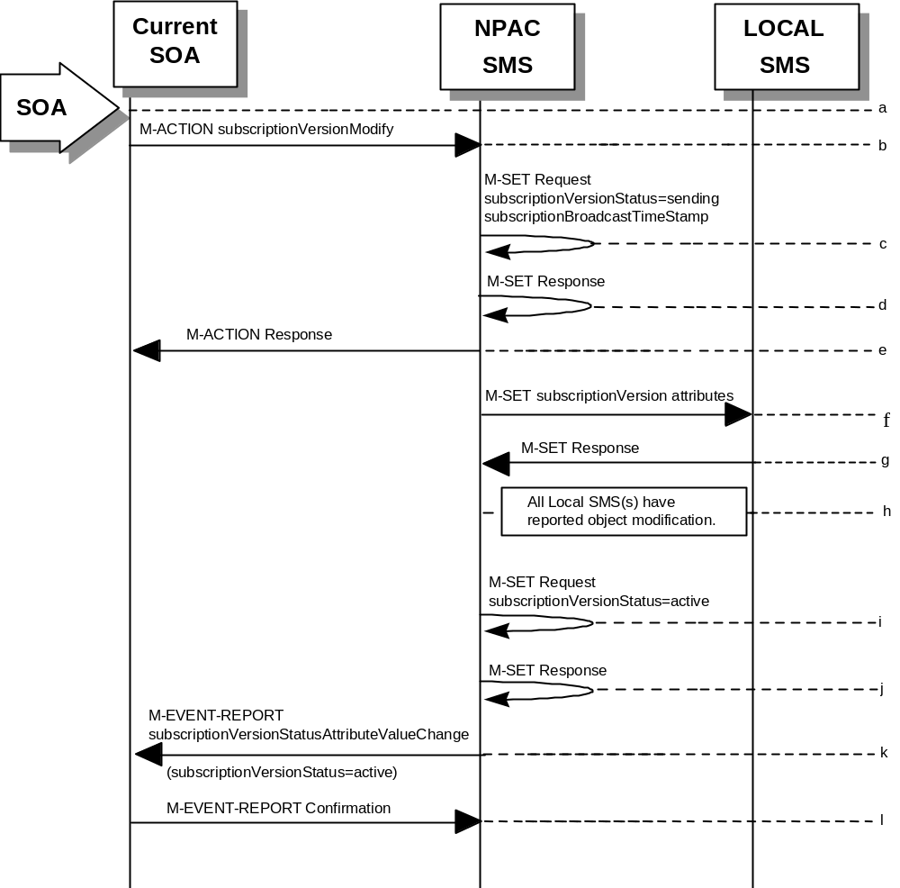
- Current service provider SOA issues M-ACTION ModifySubscriptionVersion to the NPAC SMS lnpSubscriptions object to update the active version. The NPAC SMS validates the data.
- If the M-ACTION data validates, NPAC SMS issues M-SET to the subscriptionVersionNPAC. The subscriptionVersionStatus is updated to “sending,” the subscriptionBroadcastTimeStamp and subscriptionModifiedTimeStamp are set, and any other modified attributes are updated.
- NPAC SMS issues M-SET response indicating success or failure.
- NPAC SMS replies to the M-ACTION with success or failure and reasons for failure to the service provider SOA. If the action fails, no modifications are applied and processing stops. Failure reasons include accessDenied (not the current service provider) and invalidArgumentValue (validation problems).
- NPAC SMS issues M-SET to all Local SMSs for the updated attributes, that are accepting downloads for the NPA-NXX of the subscriptionVersion. If the update involves multiple subscription version objects, a scoped and filtered request will be sent.
- Local SMSs reply to M-SET.
- All Local SMSs have reported the object modification.
Failure scenarios for this modification follow the same rules for an objectCreation failure to the Local SMS. However, upon failure the version status is updated to “active” and the subscriptionFailedSP-List is updated to contain the name of the service providers for which the download fails.
- NPAC SMS issues M-SET to update the current subscriptionVersionNPAC object subscriptionVersionStatus to “active.”
- NPAC SMS responds to M-SET.
- NPAC SMS sends M-EVENT-REPORT to the current provider of the subscriptionVersionStatus update.
- Service provider SOA issues M-EVENT-REPORT confirmation.

SubscriptionVersion Modify Active: Failure to Local SMS
This scenario shows the broadcast of a modified active subscription that fails to one or more of the Local SMSs.
- The NPAC SMS has an active subscription version that has been successfully modified by the current service provider. The subscription version now has a status of “sending”.
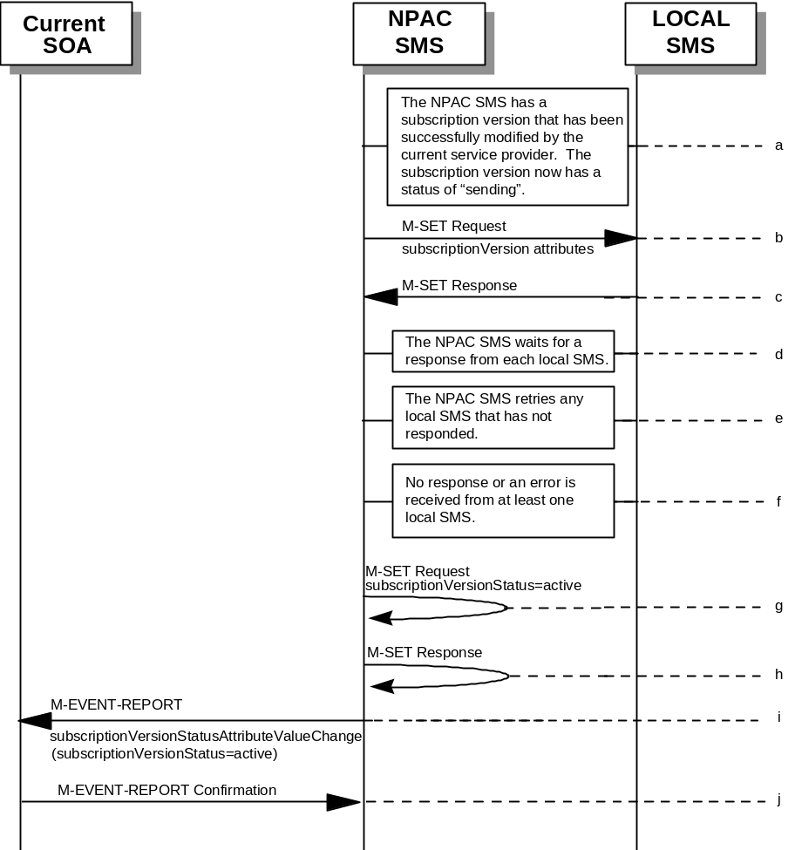
- The NPAC SMS issues M-SET to all Local SMSs for the updated attributes, that are accepting downloads for the NPA-NXX of the subscriptionVersion.
- Local SMSs should respond successfully to the M-SET.
- NPAC SMS waits for responses from each Local SMS.
- NPAC SMS retries any Local SMS that has not responded.
- No response or an error is received from at least one Local SMS.
- NPAC SMS issues the M-SET to update the current subscriptionVersionNPAC object’s subscriptionVersionStatus to “active” from “sending”. It will also update the subscriptionFailed-SP-List with the service provider ID and name of the Local SMS that failed to successfully receive the broadcast.
- NPAC SMS responds to the M-SET.
- NPAC SMS sends the subscriptionVersionStatusAttributeValueChange M-EVENT-REPORT to the current service provider SOA with the current status and failedSP-List.
- The current service provider SOA issues the M-EVENT-REPORT confirmation.

SubscriptionVersion Modify Prior to Activate Using M-ACTION
This scenario can only be performed when the subscriptionVersionStatus is conflict or pending.
- Action is taken by a service provider to modify a subscriptionVersion by specifying the TN, TN range, and the version status, or by specifying the version ID of the subscription version to be modified; and the data to be modified.
The old service provider can only update the following attributes:
subscriptionOldSP-DueDate (seconds set to zeros)
subscriptionOldSP-Authorization
subscriptionStatusChangeCauseCode
NOTE: The subscriptionStatusChangeCauseCode can only be modified when the subscriptionOldSP-Authorization is set to FALSE
The new service provider can only update the attributes:
subscriptionLRN
subscriptionNewSP-DueDate (seconds set to zeros)
subscriptionCLASS-DPC
subscriptionCLASS-SSN
subscriptionLIDB-DPC
subscriptionLIDB-SSN
subscriptionCNAM-DPC
subscriptionCNAM-SSN
subscriptionISVM-DPC
subscriptionISVM-SSN
subscriptionWSMSC-DPC - if supported by the Service Provider SOA
subscriptionWSMSC-SSN - if supported by the Service Provider SOA
subscriptionEndUserLocationValue
subscriptionEndUserLocationType
subscriptionBillingId
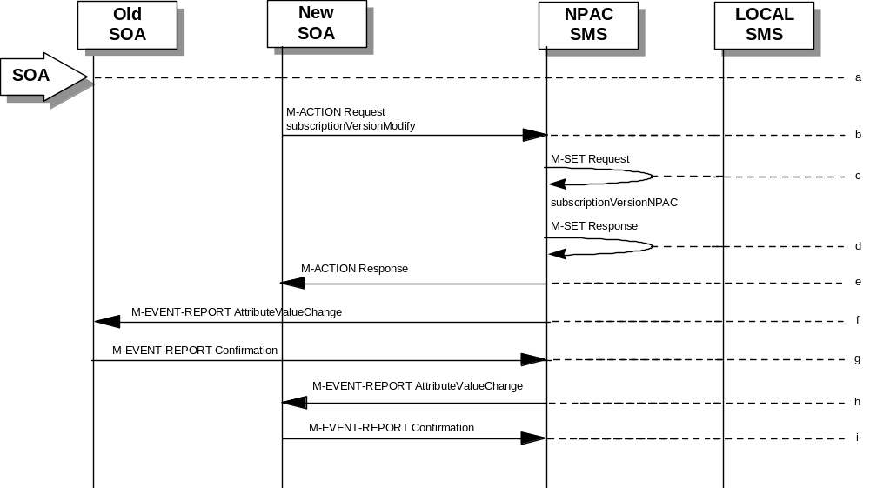
- Service provider SOA issues M-ACTION subscriptionVersionModify to the NPAC SMS lnpSubscriptions object to update the version. The NPAC SMS validates the data.
- If validation is successful, NPAC SMS will M-SET the attributes modified in the subscriptionVersionNPAC object and set the subscriptionModifiedTimeStamp.
- The NPAC SMS will issue an M-SET response.
- NPAC SMS replies to the M-ACTION with success or failure and reasons for failure.
Note: If the old service provider was the initiator of the M-ACTION that caused the subscription version status to change, the NPAC SMS would issue a subscriptionVersionStatusAttributeValueChange M-EVENT-REPORT to the old and new service provider SOAs.
- NPAC SMS issues M-EVENT-REPORT attributeValueChange to the old service provider SOA.
- The old service provider SOA returns M-EVENT-REPORT confirmation to the NPAC SMS.
- NPAC SMS issues M-EVENT-REPORT attributeValueChange to the new service provider SOA.
- The new service provider SOA returns M-EVENT-REPORT confirmation to the NPAC SMS.

SubscriptionVersion Modify Prior to Activate Using M-SET
This scenario shows a modify using an M-SET. The M-SET can only be performed when the subscriptionVersionStatus is conflict or pending.
- 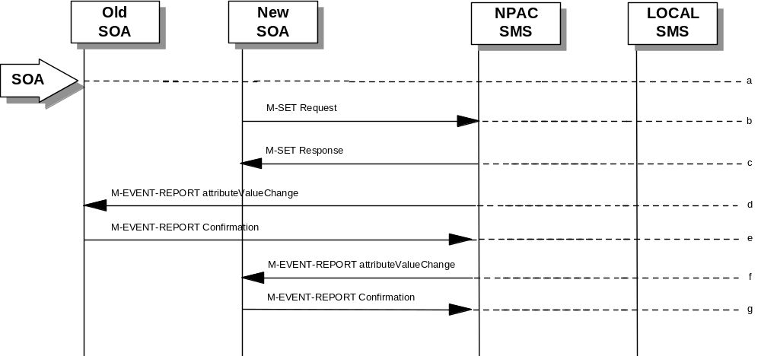Action is taken by a service provider to modify the subscriptionVersion by specifying the TN, TN range, and the version status, or by specifying the version ID of the subscription version to be modified; and the data to be modified. The old service provider can only update the following attributes:
subscriptionOldSP-DueDate (seconds set to zeros)
subscriptionOldSP-Authorization
subscriptionStatusChangeCauseCode
NOTE: The subscriptionStatusChangeCauseCode can only be modified when the subscriptionOldSP-Authorization is set to FALSE
The new service provider can only update the attributes:
subscriptionLRN
subscriptionNewSP-DueDate (seconds set to zeros)
subscriptionCLASS-DPC
subscriptionCLASS-SSN
subscriptionLIDB-DPC
subscriptionLIDB-SSN
subscriptionCNAM-DPC
subscriptionCNAM-SSN
subscriptionISVM-DPC
subscriptionISVM-SSN
subscriptionWSMSC-DPC - if supported by the Service Provider SOA
subscriptionWSMSC-SSN - if supported by the Service Provider SOA
subscriptionEndUserLocationValue
subscriptionEndUserLocationType
subscriptionBillingId
- The new or old service provider SOA will issue an M-SET request for the attributes to be updated in the subscriptionVersionNPAC object. The request will be validated for an authorized service provider and validation of the attributes and values.
- The NPAC SMS will issue an M-SET response indicating success or failure and reasons for failure.
Note: If the old service provider was the initiator of the M-SET that caused the subscription version status to change, the NPAC SMS would issue a subscriptionVersionStatusAttributeValueChange M-EVENT-REPORT to the old and new service provider SOAs
- NPAC SMS issues M-EVENT-REPORT attributeValueChange to the old service provider SOA.
- The old service provider SOA returns M-EVENT-REPORT confirmation to the NPAC SMS.
- NPAC SMS issues M-EVENT-REPORT attributeValueChange to the new service provider SOA.
- The new service provider SOA returns M-EVENT-REPORT confirmation to the NPAC SMS.

Subscription Version Modify Active: Resend Successful to Local SMS
This scenario shows the successful resend of a modification of an active subscription. The resend of a failed modified active version can only be performed by authorized NPAC personnel.
- Action is taken by NPAC personnel to resend the failed modified active version.
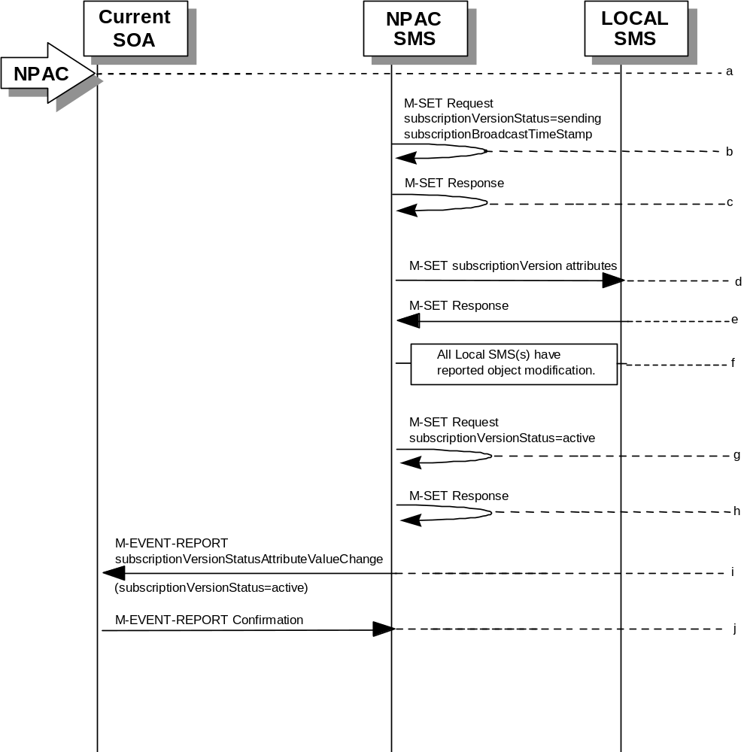
- NPAC SMS issues M-SET to the subscriptionVersionNPAC. The subscriptionVersionStatus is updated to “sending”.
- NPAC SMS issues M-SET response indicating success or failure.
- NPAC SMS issues M-SET to all Local SMSs that previously failed for the updated attributes, and are accepting downloads for the NPA-NXX of the subscriptionVersion.
- Local SMSs reply to M-SET.
- All Local SMSs have reported the object modification.
- NPAC SMS issues M-SET to update the current subscriptionVersionNPAC object subscriptionVersionStatus to “active.”
- NPAC SMS responds to M-SET.
- NPAC SMS sends M-EVENT-REPORT to the current provider of the subscriptionVersionStatus update.
- Service provider SOA issues M-EVENT-REPORT confirmation.

Subscription Version Modify Active: Resend Failure to Local SMS
This scenario shows a failure on a resend of a modified active subscription that failed previously to one or more of the Local SMSs. The resend of a failed modified active version can only be performed by authorized NPAC personnel.
- 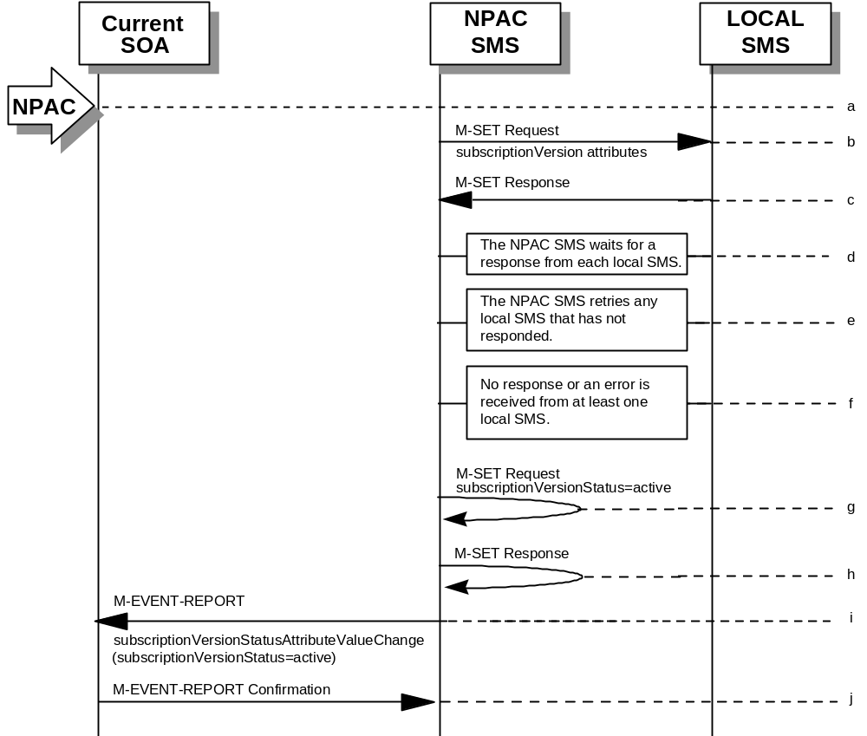The NPAC SMS has an active subscription version that has been unsuccessfully modified by the current service provider. The NPAC personnel issues a resend for the failed modified version and the subscription version now has a status of “sending”.
- The NPAC SMS issues M-SET to all Local SMSs that previously failed for the updated attributes, and are accepting downloads for the NPA-NXX of the subscriptionVersion.
- Local SMSs should respond successfully to the M-SET.
- NPAC SMS waits for responses from each Local SMS.
- NPAC SMS retries any Local SMS that has not responded.
- No response or an error is received from at least one or all Local SMSs.
- NPAC SMS issues the M-SET to update the current subscriptionVersionNPAC object’s subscriptionVersionStatus to “active” from “sending”. It will also update the subscriptionFailed-SP-List with the service provider ID and name of the Local SMSs that failed to successfully receive the broadcast.
- NPAC SMS responds to the M-SET.
- NPAC SMS sends the subscriptionVersionStatusAttributeValueChange M-EVENT-REPORT to the current service provider SOA with the current status and failedSP-List.
- The current service provider SOA issues the M-EVENT-REPORT confirmation.

Cancel Scenarios

SubscriptionVersion Cancel by Service Provider SOA After Both Service Provider SOAs Have Concurred
A subscription version can be canceled when the current status is conflict or pending.
In this scenario, the old service provider initiates the cancel after both the old and new service provider SOAs have issued their create actions. Once the new service provider SOA’s cancellation acknowledgment is received, the version status is set to “canceled”. Since the old service provider SOA initiated the cancel, its cancellation acknowledgment is optional.
- Action is initiated by the old or new service provider SOA to cancel a subscription version by specifying the TN, TN range, or version ID of the subscription version to be canceled.
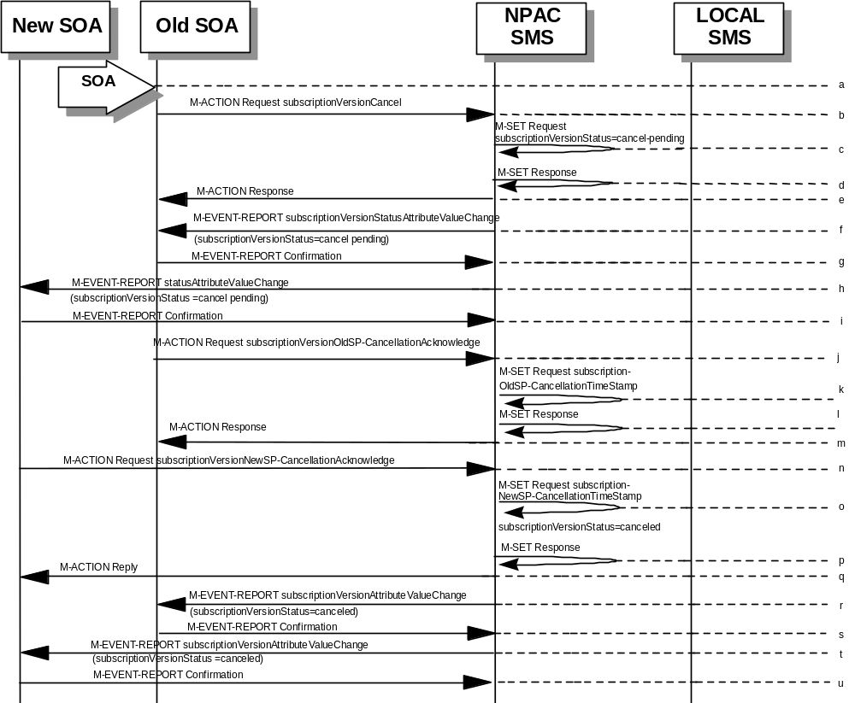
- Service provider SOA issues an M-ACTION subscriptionVersionCancel to the NPAC SMS to the lnpSubscriptions object.
- NPAC SMS issues M-SET to update subscriptionVersionStatus to “cancel-pending” in the subscriptionVersionNPAC object and the subscriptionModifiedTimeStamp.
- NPAC SMS issues M-SET response.
- NPAC SMS returns the M-ACTION reply. This either reflects a success or failure. Failure reasons are version in wrong state, no version to cancel, and authorization service provider. If successful, the subscriptionPre-CancellationStatus is set to the current subscriptionVersionStatus and then the subscriptionVersionStatus is set to “cancel-pending.” If the action fails, no modifications are applied and processing stops.
- An M-EVENT-REPORT for the subscriptionVersionStatus change is sent from the NPAC SMS to the old service provider SOA.
- The old service provider SOA returns an M-EVENT-REPORT confirmation to the NPAC SMS.
- An M-EVENT-REPORT for the subscriptionVersionStatus change is sent from the NPAC SMS to the new service provider SOA.
- The new service provider SOA returns an M-EVENT-REPORT confirmation to the NPAC SMS.

- The old service provider SOA sends an M-ACTion subscriptionVersionOldSP-CancellationAcknowledge to the NPAC SMS lnpSubscription object. This acknowledges the cancellation of the subscriptionVersionNPAC with a status of cancel-pending.
- The NPAC SMS issues M-SET for the subscriptionOldSP-CancellationTimeStamp in the subscriptionVersionNPAC object and subscriptionModifiedTimeStamp.
- NPAC SMS issues an M-SET response.
- NPAC SMS responds to the M-ACTION with either a success or failure and failure reasons. If the action fails, no modifications are applied.
- The new service provider SOA sends an M-ACTION subscriptionVersionNewSP-CancellationAcknowledge to the NPAC SMS lnpSubscriptions object.
- The NPAC SMS issues M-SET for the subscriptionNewSP-CancellationTimeStamp, subscriptionModifiedTimeStamp, subscriptionCancellationTimeStamp, and subscriptionVersionStatus to “canceled.”
- NPAC SMS issues M-SET response.
- NPAC SMS replies to M-ACTION with success or failure and reasons for failure. If the action fails, no modifications are applied.
- If the last M-ACTION was successful, the NPAC SMS sends the M-EVENT-REPORT for the subscriptionVersionStatus update to canceled to the old service provider SOA.
- If the last M-ACTION was successful, the old service provider SOA returns an M-EVENT-REPORT confirmation to the NPAC SMS.
- NPAC SMS sends the M-EVENT-REPORT for the subscriptionVersionStatus update to canceled to the new service provider SOA.
- The new service provider SOA returns an M-EVENT-REPORT confirmation to the NPAC SMS.

SubscriptionVersionCancel: No Acknowledgment from a SOA
The NPAC SMS has set the status of the subscription version to “cancel-pending” upon request of the old SOA. It is now waiting for the acknowledgments from both service provider SOAs. Acknowledgment from the old SOA is optional. In this scenario the new service provider does not respond.
- NPAC SMS is waiting for the cancellation acknowledgments from both service provider SOAs.
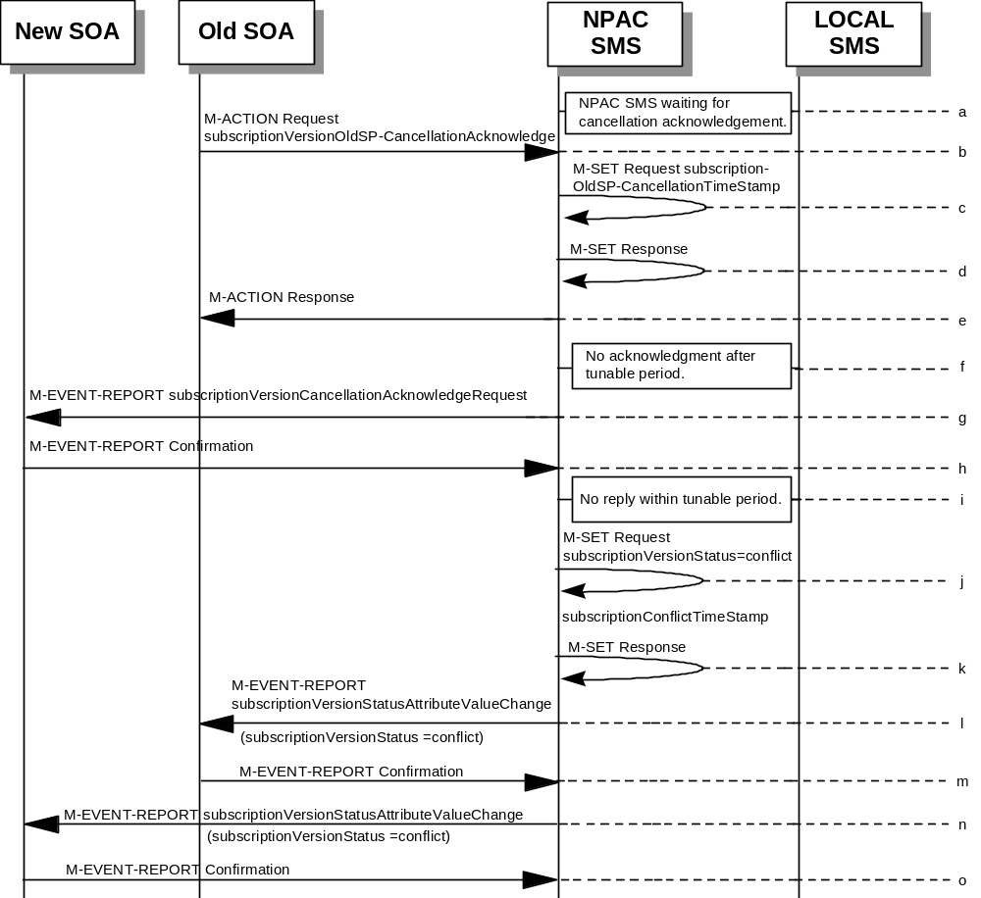
- The old service provider SOA sends a subscriptionVersionOldSP-CancellationAcknowledge M-ACTION to the NPAC SMS lnpSubscriptions object. This acknowledges the cancellation of the subscriptionVersionNPAC with a status of cancel-pending.
- NPAC SMS issues M-SET for the subscriptionOldSP-CancellationTimeStamp and subscriptionModifiedTimeStamp in the subscriptionVersionNPAC object.
- NPAC SMS responds to M-SET.
- NPAC SMS replies to the M-ACTION with either a success or failure and failure reasons. If the action fails, no modifications are applied and processing stops.
- The NPAC SMS waits for the cancellation acknowledgment from the new service provider SOA. No reply is received after a tunable period.
- NPAC SMS issues M-EVENT-REPORT subscriptionVersionCancellationAcknowledgeRequest to the unresponsive new service provider SOA.
- The new service provider SOA returns an M-EVENT-REPORT confirmation to the NPAC SMS.
- The “Service Provider Concurrence Cancellation Window” has expired and still no cancellation acknowledgment is received from the new service provider.
- NPAC SMS issues M-SET to update the subscriptionVersionStatus to conflict and the subscriptionConflictTimeStamp and subscriptionModifiedTimeStamp are set.
- NPAC SMS issues M-SET response.
- The NPAC SMS issues M-EVENT-REPORT, subscriptionVersionStatusAttributeValueChange, to the old service provider SOA.
- The old service provider SOA returns an M-EVENT-REPORT confirmation to the NPAC SMS.
- The NPAC SMS issues M-EVENT-REPORT, subscriptionVersionStatusAttributeValueChange, to the new service provider SOA.
- The new service provider SOA returns an M-EVENT-REPORT confirmation to the NPAC SMS.
At this point, the flow follows the conflict resolution scenarios.

Subscription Version Cancels With Only One Create Action Received
Once one of the subscriptionVersionNewSP-Create or subscriptionVersionOldSP-Create actions has been received, the subscription version can be canceled by the same service provider who created the subscription version. In this case, the subscription version status is set to “canceled”, not “cancel-pending”, and no further acknowledgments are necessary by either the old or new service provider.
If the new service provider SOA creates the pending subscription version and the old service provider attempts to cancel it (or vice-versa), an error is returned to the service provider who requested the cancel.
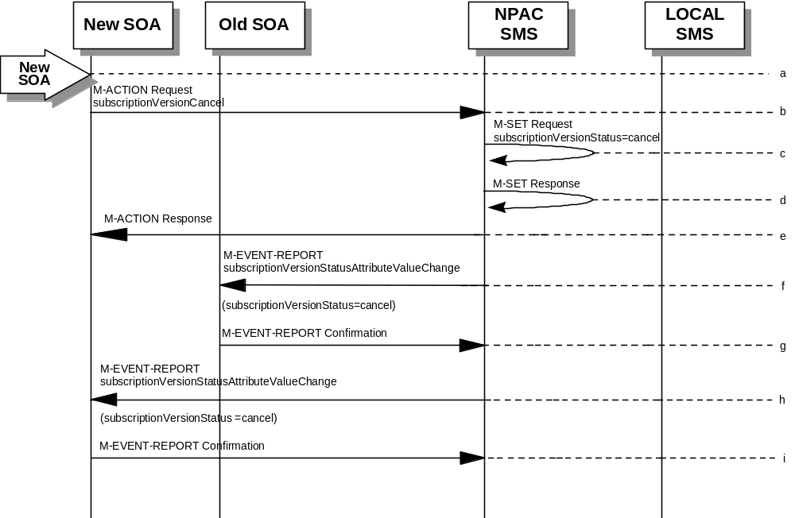In this scenario, the new service provider SOA has already successfully issued the subscriptionVersionNewSP-Create action. The old service provider has not issued its subscriptionVersionOldSP-Create action. Now, the new service provider needs to cancel the pending subscription version.
- Action is taken by the new service provider to cancel a subscription version they created.
- The new service provider SOA sends M-ACTION subscriptionVersionCancel to the NPAC SMS lnpSubscriptions object to cancel a pending subscriptionVersionNPAC.
- NPAC SMS issues M-SET to update the subscriptionVersionStatus to “canceled” and update the subscriptionModifiedTimeStamp in the subscriptionVersionNPAC object.
- NPAC SMS issues M-SET response.
- NPAC SMS returns the M-ACTION reply. This either reflects a success or failure. Failure reasons are version in wrong state, no version to cancel, and service provider not authorized.
If successful, the subscriptionPreCancellationStatus is set to the current subscriptionVersionStatus, and then the subscriptionVersionStatus is set to “canceled”. If the action fails, no modifications are applied and processing stops.
- The subscriptionVersionStatusAttributeValueChange M-EVENT-REPORT is sent to the old service provider SOA.
- The old service provider confirms the M-EVENT-REPORT.
- The subscriptionVersionStatusAttributeValueChange M-EVENT-REPORT is sent to the new service provider SOA.
- The new service provider confirms the M-EVENT-REPORT.

Disconnect Scenarios

SubscriptionVersion Immediate Disconnect
The current service provider can disconnect an active subscription version. In this scenario, the disconnect is immediate.
- Current service provider SOA personnel take action to disconnect a subscription version.
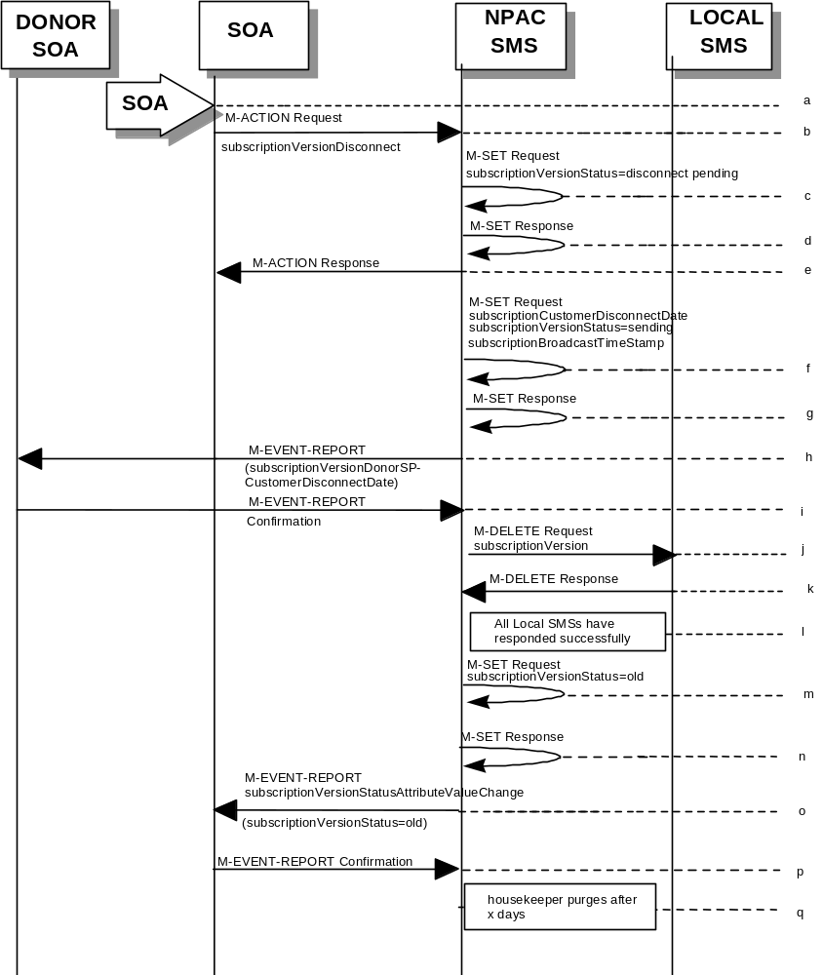
- Service provider SOA issues an M-ACTION request to disconnect to the lnpSubscriptions object. The M-ACTION specifies either the subscriptionVersionId, or subscriptionTN or range of TNs. The subscription version status must be active and no pending, failed, conflict or cancel-pending versions can exist.
- NPAC SMS issues an M-SET to set the subscriptionCustomerDisconnectDate according to the disconnect action.
- NPAC SMS responds to whether M-SET was successful.
- NPAC SMS responds to the M-ACTION. If the action failed, an error will be returned and processing will stop on this flow.
- NPAC SMS issues an M-SET to set the subscriptionCustomerDisconnectDate according to the disconnect action. The subscriptionVersionStatus goes to “sending ” and the subscriptionModifiedTimeStamp and the subscriptionBroadcastTimeStamp are both set accordingly.
- NPAC SMS responds to whether M-SET was successful.
- NPAC SMS sends the donor service provider SOA notification that the subscription version is being disconnected with the customer disconnect date.
- The donor service provider SOA confirms the M-EVENT-REPORT.
- NPAC SMS sends out an M-DELETE on the subscriptionVersion to all Local SMSs, that are accepting downloads for the NPA-NXX of the subscriptionVersion. If the M-DELETE is for multiple subscription versions, a scoped and filtered operation will be sent.
- Each Local SMS responds with a successful M-DELETE reply.
- All Local SMSs respond successfully.
- NPAC SMS issues M-SET updating the subscriptionVersionStatus to old for subscriptionVersionNPAC objects. It also sets the subscriptionModifiedTimeStamp and subscriptionDisconnectCompleteTimeStamp.
- NPAC SMS responds to M-SET.
- NPAC SMS issues an M-EVENT-REPORT for the subscriptionVersionStatus equal to “old.”
- Service provider SOA responds to M-EVENT-REPORT.
- After a tunable amount of days, the subscription version is purged by the NPAC SMS housekeeping process.

SubscriptionVersion Disconnect With Effective Release Date
In this scenario, a future dated request is submitted to disconnect an active subscriptionVersion.
- Service provider SOA personnel take action to disconnect a subscription version.
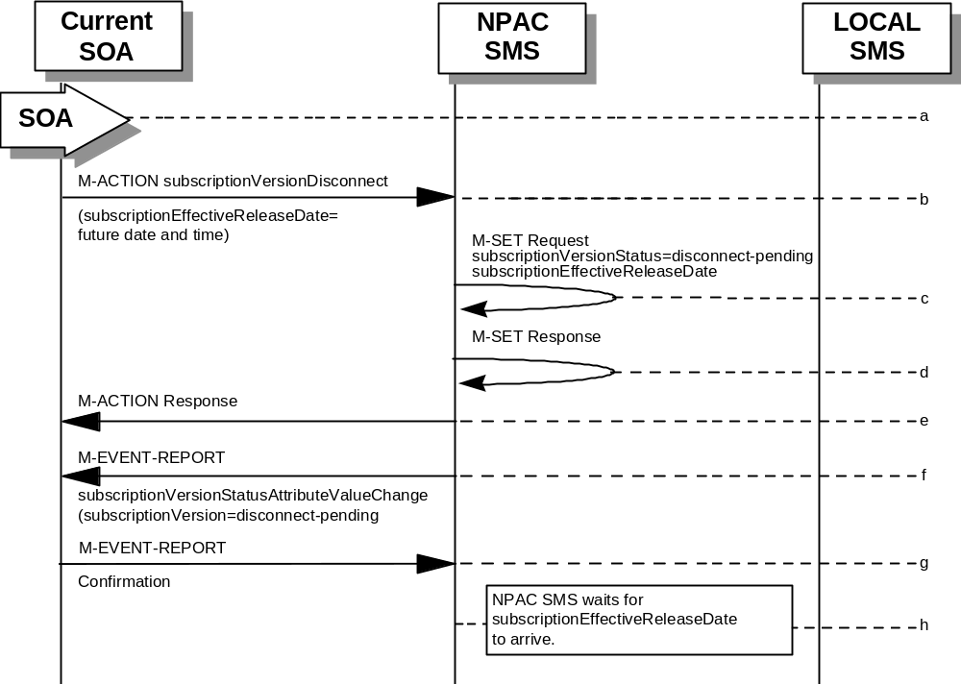
- Service provider SOA issues an M-ACTION request to disconnect to the lnpSubscriptions object. The M-ACTION specifies either the subscriptionVersionId, or subscriptionTN or range of TNs, and also has future dated the subscriptionEffectiveReleaseDate and the subscriptionCustomerDisconnectDate. The subscription version status must be active and no pending, failed, conflict, or cancel-pending versions can exist.
- NPAC SMS M-SETs the status to disconnect-pending, and sets the subscriptionEffectiveReleaseDate of the existing subscriptionVersionNPAC and also the subscriptionModifiedTimeStamp.
- NPAC SMS responds to M-SET.
- NPAC SMS responds to M-ACTION. If the action fails, no modifications are applied and the processing stops.
- NPAC SMS sends the subscriptionVersionStatusAttributeValueChange
M-EVENT-REPORT to the current service provider SOA.
- The current service provider SOA issues the M-EVENT-REPORT confirmation.
- The NPAC SMS waits for the subscriptionEffectiveReleaseDate date to arrive.
At this point, the flow follows an immediate disconnect scenario. First the donor service provider’s Local SMS is notified of the impending disconnect. The NPAC SMS sets the subscriptionVersionStatus to sending the broadcast timestamp, notifies the service provider SOA of the status change, and proceeds to issue M-DELETEs for the subscriptionVersion to the Local SMS.

SubscriptionVersion Disconnect: Failure to Local SMS
This scenario shows the broadcast of a disconnected subscription that fails to all of the Local SMSs.
- 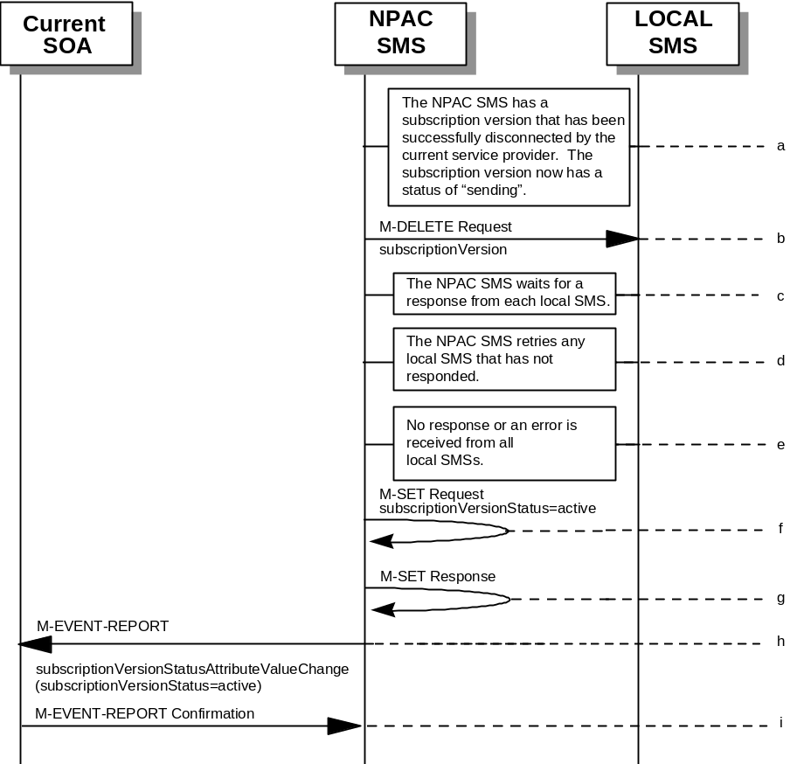The NPAC SMS has an active subscription version that has been successfully disconnected by the current service provider using the subscriptionVersionDisconnect action. The subscription version now has a status of “sending”.
- NPAC SMS issues the M-DELETE to all Local SMSs for the subscriptionVersion, that are accepting downloads for the NPA-NXX of the subscriptionVersion.
- NPAC SMS waits for a response from each Local SMS.
- NPAC SMS retries any Local SMS that has not responded.
- No response or an error is received from all Local SMSs.
- NPAC SMS issues the M-SET to update the current subscriptionVersionNPAC object’s subscriptionVersionStatus to “active” from “sending”. It will also update the subscriptionFailed-SP-List with the service provider ID and name of all the Local SMSs.
- NPAC SMS responds to the M-SET.
- NPAC SMS sends the subscriptionVersionStatusAttributeValueChange
M-EVENT-REPORT to the current service provider SOA with the current status and failedSP-List.
- Current service provider SOA issues the M-EVENT-REPORT confirmation.

SubscriptionVersion Disconnect: Partial Failure to Local SMS
This scenario shows the broadcast of a disconnected subscription that fails to one or more, but not all, of the Local SMSs.
- The NPAC SMS has an active subscription version that has been successfully disconnected by the current service provider using the subscriptionVersionDisconnect action. The subscription version now has a status of “sending”.
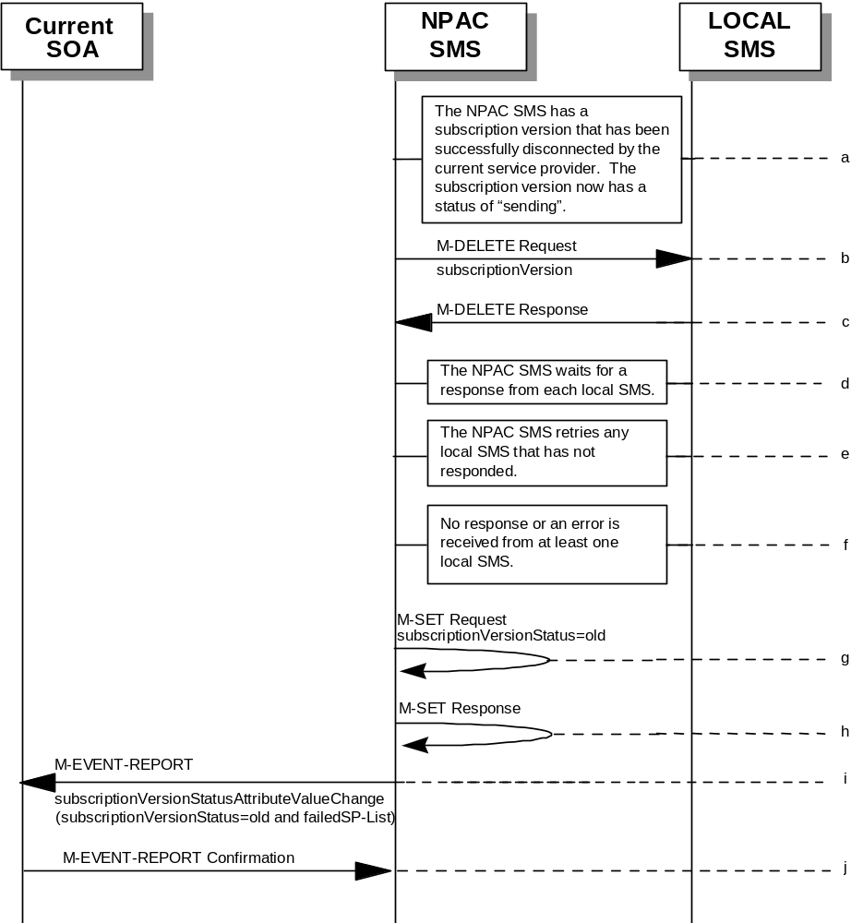
- NPAC SMS issues the M-DELETE to all Local SMSs for the subscriptionVersion, that are accepting downloads for the NPA-NXX of the subscriptionVersion.
- Local SMSs should respond successfully to the M-DELETE.
- NPAC SMS waits for a response from each Local SMS.
- NPAC SMS retries any Local SMS that has not responded.
- No response or an error is received from at least one Local SMS.
- NPAC SMS issues the M-SET to update the current subscriptionVersionNPAC object’s subscriptionVersionStatus to “old” from “sending”. It will also update the subscriptionFailed-SP-List with the service provider ID and name of the Local SMSs that failed to successfully receive the broadcast.
- NPAC SMS responds to the M-SET.
- NPAC SMS sends the subscriptionVersionStatusAttributeValueChange
M-EVENT-REPORT to the current service provider SOA with the current status and failedSP-List.
- Current service provider SOA issues the M-EVENT-REPORT confirmation.

Subscription Version Disconnect: Resend Successful to Local SMS
This scenario shows a successful resend of a disconnect for a subscription that fails to one or more of the Local SMSs. The resend of a failed disconnect can only be performed by authorized NPAC personnel.
- NPAC personnel take action to resend a failed disconnect for a subscription version.
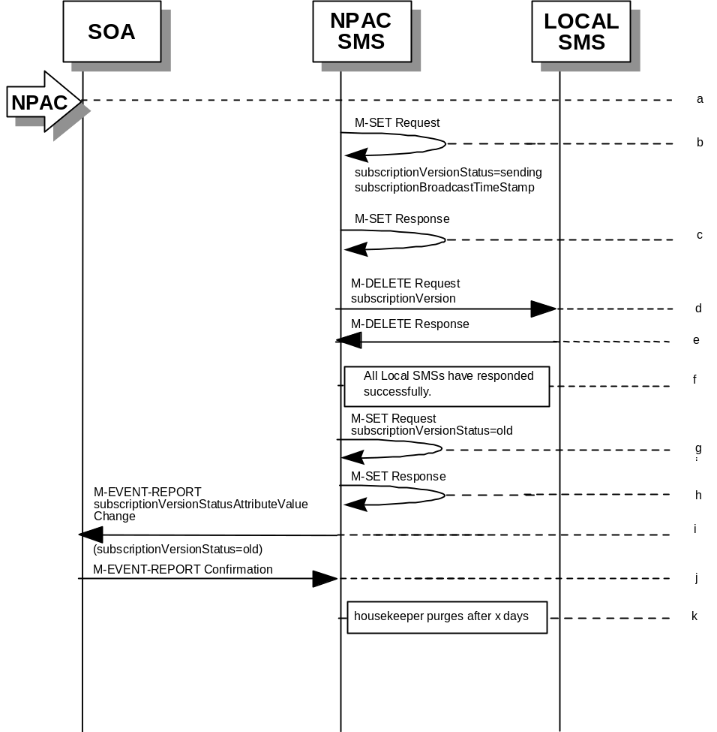
- NPAC SMS issues an M-SET to the existing subscriptionVersionNPAC object to set the status to “sending”.
- NPAC SMS responds to whether M-SET was successful.
- NPAC SMS sends out an M-DELETE on the subscriptionVersion to all previously failed Local SMSs, that are accepting downloads for the NPA-NXX of the subscriptionVersion.
- Each Local SMS responds with a successful M-DELETE reply.
- All Local SMSs respond successfully.
- NPAC SMS issues M-SET updating the subscriptionVersionStatus to old for subscriptionVersionNPAC objects. It also sets the subscriptionModifiedTimeStamp and subscriptionDisconnectCompleteTimeStamp.
- NPAC SMS responds to M-SET.
- NPAC SMS issues an M-EVENT-REPORT for the subscriptionVersionStatus equal to “old.”
- Service provider SOA responds to M-EVENT-REPORT.
- After a tunable amount of days, the subscription version is purged by the NPAC SMS housekeeping process.

Subscription Version Disconnect: Resend Failure to Local SMS
This scenario shows a failure on a resend of a subscription disconnect that failed previously to one or more of the Local SMSs. The resend of a failed disconnect for a subscription can only be performed by authorized NPAC personnel.
- NPAC personnel take action to resend a failed disconnect for a subscription version.
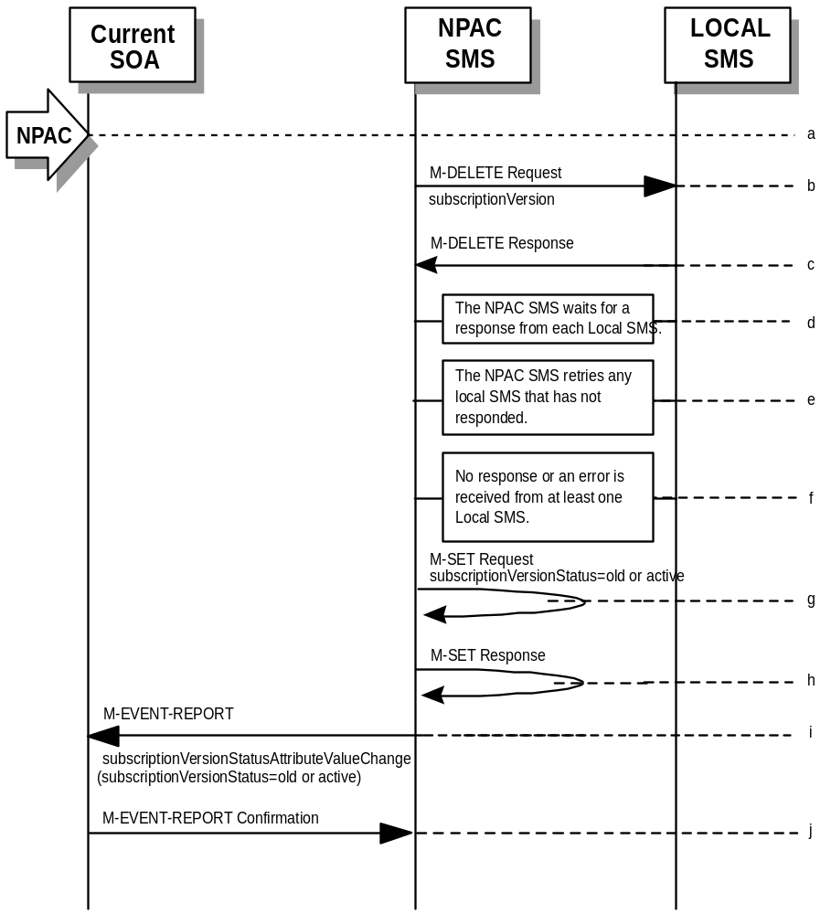
- NPAC SMS issues the M-DELETE to all Local SMSs for which the disconnect previously failed for the subscriptionVersion, and are accepting downloads for the NPA-NXX of the subscriptionVersion.
- Local SMSs should respond successfully to the M-DELETE.
- NPAC SMS waits for a response from each Local SMS.
- NPAC SMS retries any Local SMS that has not responded.
- No response or an error is received from at least one or all Local SMSs.
- NPAC SMS issues the M-SET to update the current subscriptionVersionNPAC object’s subscriptionVersionStatus to “old” or “active” (if all Local SMSs failed) from “sending”. It will also update the subscriptionFailed-SP-List with the service provider ID and name of the Local SMSs that failed to successfully receive the broadcast.
- NPAC SMS responds to the M-SET.
- NPAC SMS sends the subscriptionVersionStatusAttributeValueChange
M-EVENT-REPORT to the current service provider SOA with the current status and failedSP-List.
- Current service provider SOA issues the M-EVENT-REPORT confirmation.

Disconnect Subscription Version Scenarios for TNs that are part of a Number Pool Block

SOA Initiates Successful Disconnect Request of Ported Pooled TN (previously NNP flow 4.1.1)
The current service provider can disconnect an active subscription version that will return to the block holder after the number pool block has been activated. In this scenario, the disconnect is immediate where the TN returns to the block holder and the number pool block is active. In this scenario:
- SV1 is the currently active Subscription Version that will be disconnected.
- SV2 is the pool reinstatement Subscription Version with LNP type = pool that reinstates default routing to the block holder.
SV1 will be broadcast to the EDR Local SMSs to disconnect the ported TN and revert to the number pool block routing information. SV2 will be broadcast to the non-EDR Local SMSs with the number pool block routing information.
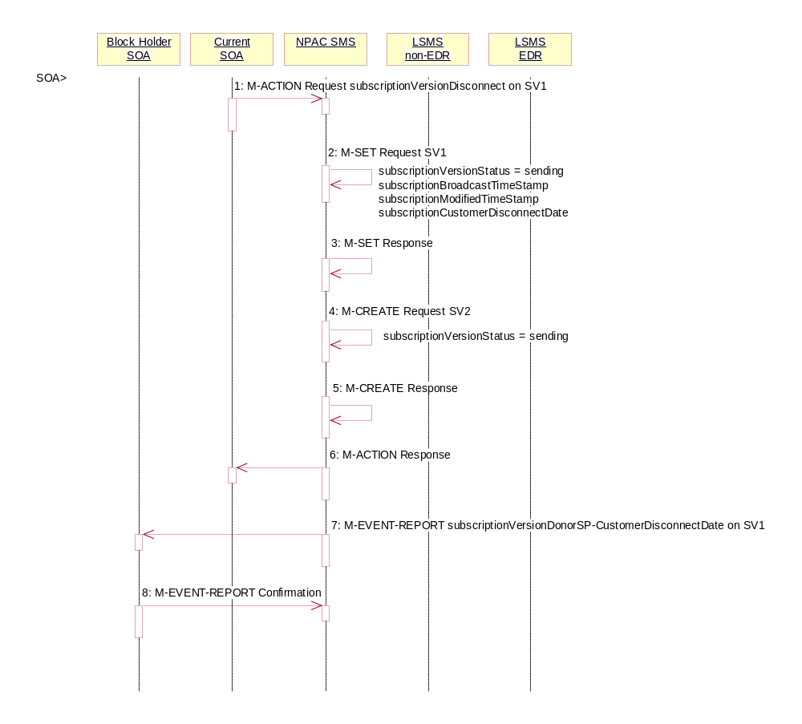
In this scenario, the SOA sends in the disconnect action to a ported, pooled TN.

Current service provider SOA personnel take action to disconnect a subscription version.
- Service provider SOA issues an M-ACTION request to disconnect to the lnpSubscriptions object. The M-ACTION specifies either the subscriptionVersionId, or subscriptionTN or range of TNs, and also has NOT future dated (i.e., used the current date) the subscriptionEffectiveReleaseDate and the subscriptionCustomerDisconnectDate. The subscription version status must be active and no pending, failed, conflict or cancel-pending versions can exist.
- NPAC SMS issues an M-SET to set the subscriptionCustomerDisconnectDate according to the disconnect action for SV1. The subscriptionVersionStatus for SV1 goes to “sending ”. The subscriptionModifiedTimeStamp and subscriptionBroadcastTimeStamp are set accordingly.
- NPAC SMS responds to the M-SET.
- NPAC SMS issues M-CREATE to create SV2. The routing information comes from the numberPoolBlock object that contains the TN. The status is set to ‘sending’. The subscriptionActivationTimeStamp, subscriptionBroadcastTimeStamp, subscriptionCreationTimeStamp and subscriptionModifiedTimeStamp are all set.
- NPAC SMS responds to M-CREATE.
- NPAC SMS responds to the M-ACTION. If the action failed, an error will be returned and processing will stop on this flow.
- NPAC SMS sends the Donor service provider SOA notification that the subscription version is being disconnected with the customer disconnect date. This SOA is the block holder SOA.
- The donor service provider SOA confirms the M-EVENT-REPORT.

Successful Broadcast of Disconnect for a Ported Pooled TN After Block Activation (previously NNP flow 4.1.2)
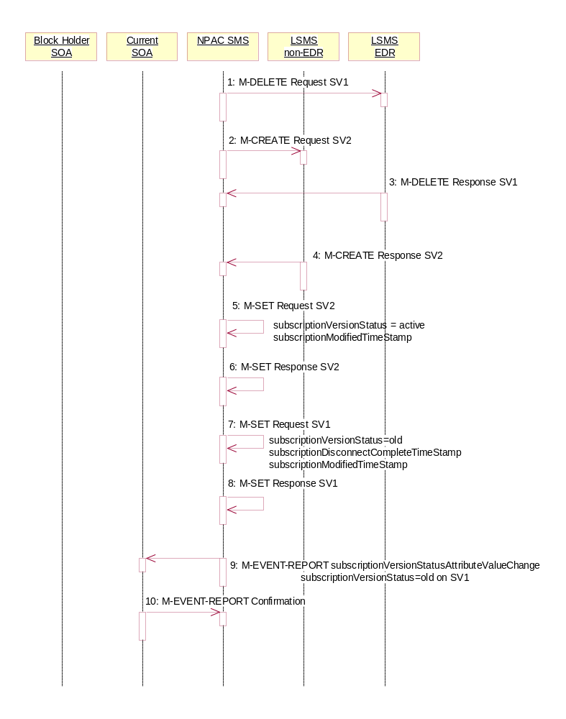
The NPAC SMS is ready to broadcast the disconnect of the ported, pooled TN.

- NPAC SMS sends the M-DELETE request to the EDR Local SMS to delete the existing subscription version and cause the routing to return to the number pool block. If a range of subscription versions is being removed, the M-DELETE will be scoped and filtered for the appropriate subscription versions by TN.
- At the same time as step 1, the NPAC SMS sends out the M-CREATE of a subscription version to all non-EDR Local SMSs that are accepting downloads for the NPA-NXX of the subscription version for SV2. If the M-CREATE is for multiple subscription versions, the subscriptionVersionLocalSMS-Create M-ACTION will be sent. The subscription version for the TN has a LNP type of ‘pool’.
- EDR Local SMS sends its successful M-DELETE reply.
- Non-EDR Local SMS responds with a successful M-CREATE reply.
- NPAC SMS issues M-SET updating the subscriptionVersionStatus to active for subscriptionVersionNPAC objects for SV2. The subscriptionModifiedTimeStamp is also set.
- NPAC SMS responds to M-SET.
- NPAC SMS issues M-SET updating the subscriptionVersionStatus to old for subscriptionVersionNPAC objects for SV1. It also sets the subscriptionModifiedTimeStamp. The subscriptionDisconnectCompleteTimeStamp is set when the first successful response is received.
- NPAC SMS responds to M-SET.
- NPAC SMS issues an M-EVENT-REPORT to current service provider SOA of subscriptionVersionStatusAttributeValueChange being set to old on SV1.
- The current service provider SOA confirms the M-EVENT-REPORT.

Subscription Version Disconnect With Effective Release Date (replace/update existing flow B.5.4.2 with this flow here – NNP flow 4.2)
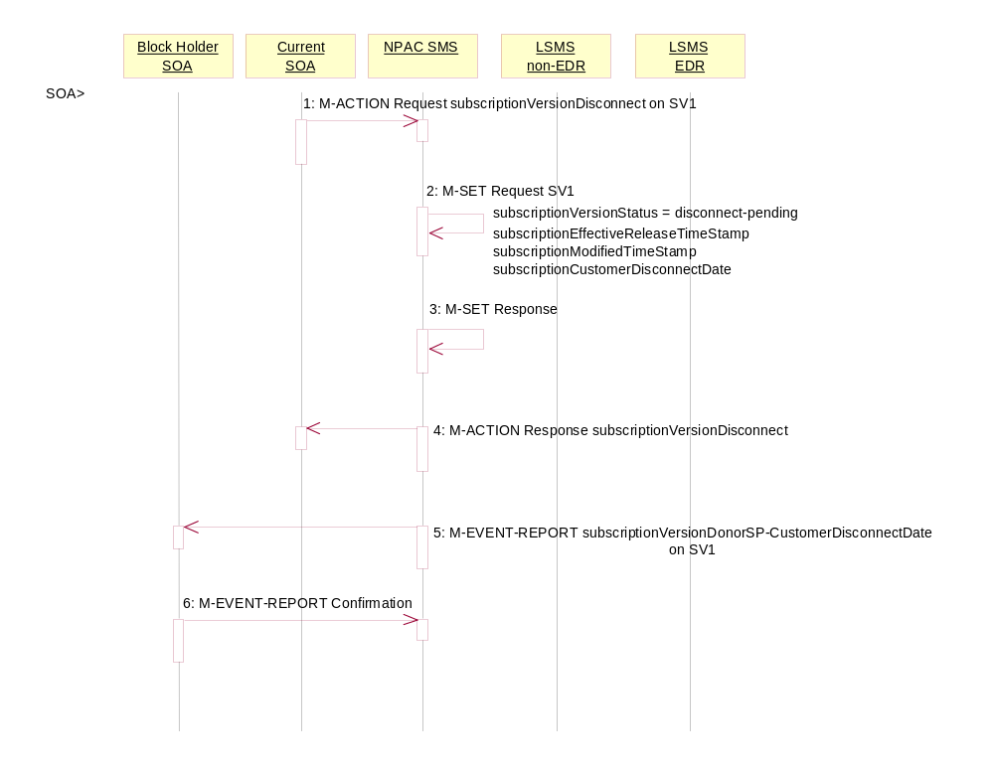In this scenario, a future dated request is submitted to disconnect an active subscription version that will return to the block holder.

Current service provider SOA personnel take action to disconnect a subscription version.
- Current service provider SOA issues an M-ACTION request to disconnect the lnpSubscriptions object. The M-ACTION specifies either the subscriptionVersionId, or subscriptionTN, or range of TNs, and also has future dated the subscriptionEffectiveReleaseDate and the subscriptionCustomerDisconnectDate. The subscription version status must be active and no pending, failed, conflict, conflict-pending, or cancel-pending versions can exist.
- NPAC SMS issues an M-SET to set the status to disconnect-pending, and set the subscriptionEffectiveReleaseDate, subscriptionCustomerDisconnectDate and the subscriptionModifiedTimeStamp of the existing subscriptionVersionNPAC.
- NPAC SMS responds to M-SET.
- NPAC SMS responds to M-ACTION. If the action fails, no modifications are applied and the processing stops.
- NPAC SMS sends the subscriptionVersionStatusAttributeValueChange M-EVENT-REPORT to the current service provider SOA.
- The current service provider SOA issues the M-EVENT-REPORT confirmation.
The NPAC SMS waits for the subscriptionEffectiveReleaseDate date to arrive.

Subscription Version Disconnect of a Ported Pooled TN After Block Activation: Failure to Local SMS (previously NNP flow 4.3.1)
This scenario shows the broadcast of a disconnect subscription after block activation that fails to all of the Local SMSs. In this scenario:
- SV1 is the currently active Subscription Version.
- SV2 is the pool reinstatement Subscription Version with LNP type = pool that reinstates default routing to the block holder.
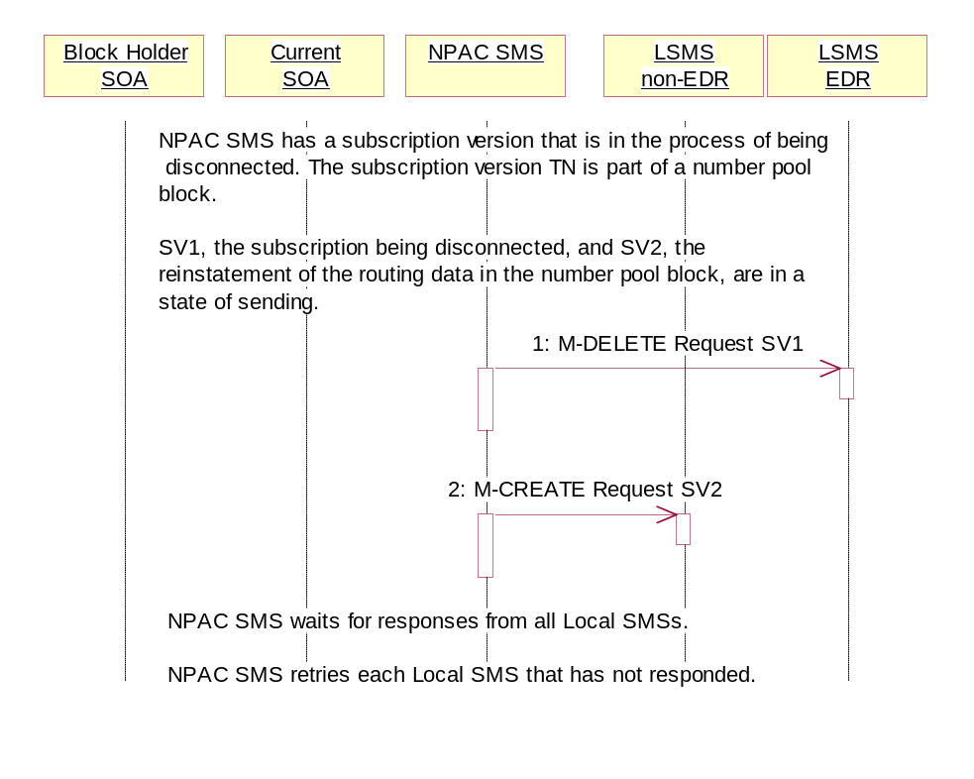
NPAC SMS has a subscription version that is in the process of being disconnected. The subscription version TN is part of a number pool block. SV1, the subscription being disconnected, and SV2, the reinstatement of the routing data in the number pool block, are in a state of ‘sending’.

- NPAC SMS sends the M-DELETE request to the EDR Local SMS for SV1.
- At the same time as step 1, the NPAC SMS sends the M-CREATE request to the non-EDR Local SMS for SV2.

NPAC SMS waits for responses from all Local SMSs.

NPAC SMS retries each Local SMS that has not responded.

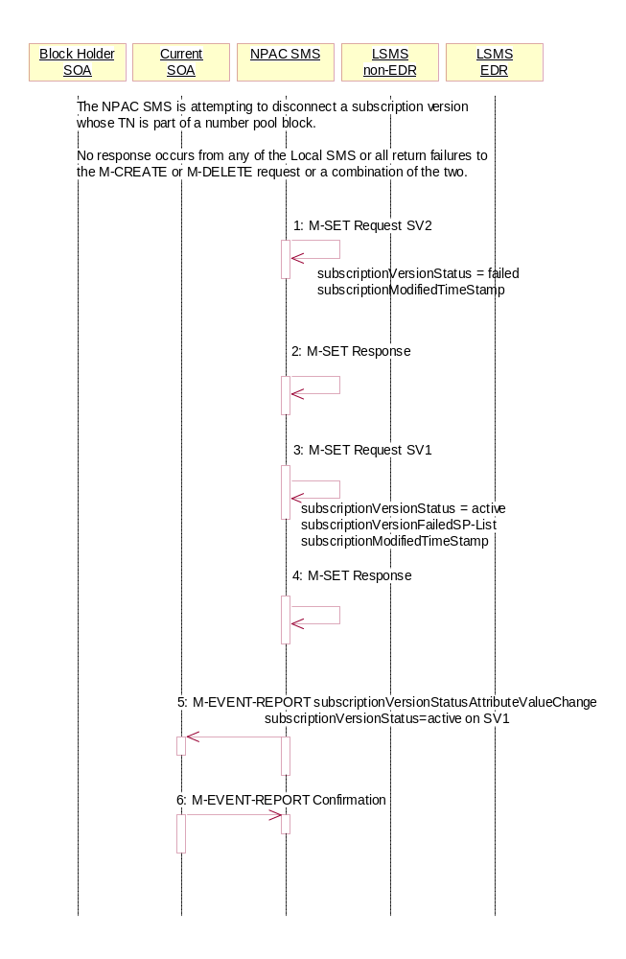
Subscription Version Disconnect for a Ported Pooled TN Broadcast Failure NPAC SMS Updates (previously NNP flow 4.3.2)

NPAC SMS is attempting to disconnect a subscription version whose TN is a part of a number pool block. It has broadcast the data to the LSMSs.

No response occurs from any of the Local SMS, or all return failures to the M-CREATE or M-DELETE request, or a combination of the two.

- NPAC SMS issues the M-SET to update the SV2 subscriptionVersionStatus from “sending” to “failed”. The subscriptionModifiedTimeStamp is also set.
- NPAC SMS responds to the M-SET.
- NPAC SMS issues the M-SET to update the SV1 subscriptionVersionStatus from “sending” to “active”. It also updates the subscriptionFailed-SP-List with the service provider ID and name of all the Local SMSs. The subscriptionModifiedTimeStamp is also set.
- NPAC SMS responds to the M-SET.
- NPAC SMS sends the subscriptionVersionStatusAttributeValueChange M-EVENT-REPORT to the current service provider SOA with the current status for SV1 along with the subscriptionFailed-SP-List.
- Current service provider SOA issues the M-EVENT-REPORT confirmation.

Subscription Version Disconnect of a Ported Pooled TN: Partial Failure to Local SMS (previously NNP flow 4.4.1)
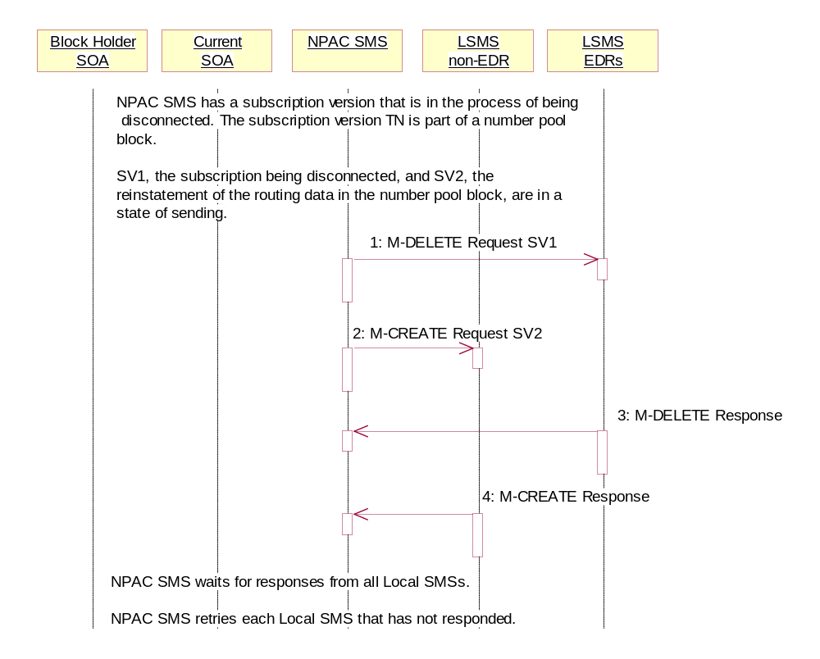
This scenario shows the broadcast of a disconnect subscription version after the number pool block activation that fails to one or more, but not all, Local SMSs. In this scenario:
- SV1 is the currently active Subscription Version.
- SV2 is the pool reinstatement Subscription Version with LNP type = pool that reinstates default routing to the block holder.
NPAC SMS has a subscription version that is in the process of being disconnected. The subscription version TN is part of a number pool block. SV1, the subscription being disconnected, and SV2, the reinstatement of the routing data in the number pool block, are in a state of ‘sending’.

- NPAC SMS sends the M-DELETE request to the EDR Local SMS for SV1.
- At the same time as step 1, the NPAC SMS sends the M-CREATE request to the non-EDR Local SMS for SV2.
- The EDR Local SMS responds to the M-DELETE.
- The non-EDR Local SMS responds to the M-CREATE.

NPAC SMS waits for responses from all Local SMSs.

NPAC SMS retries each Local SMS that has not responded.

Subscription Version Disconnect of a Ported Pooled TN Partial Failure Broadcast NPAC SMS Updates (previously NNP flow 4.4.2)

NPAC SMS is attempting to disconnect a subscription version whose TN is a part of a number pool block.

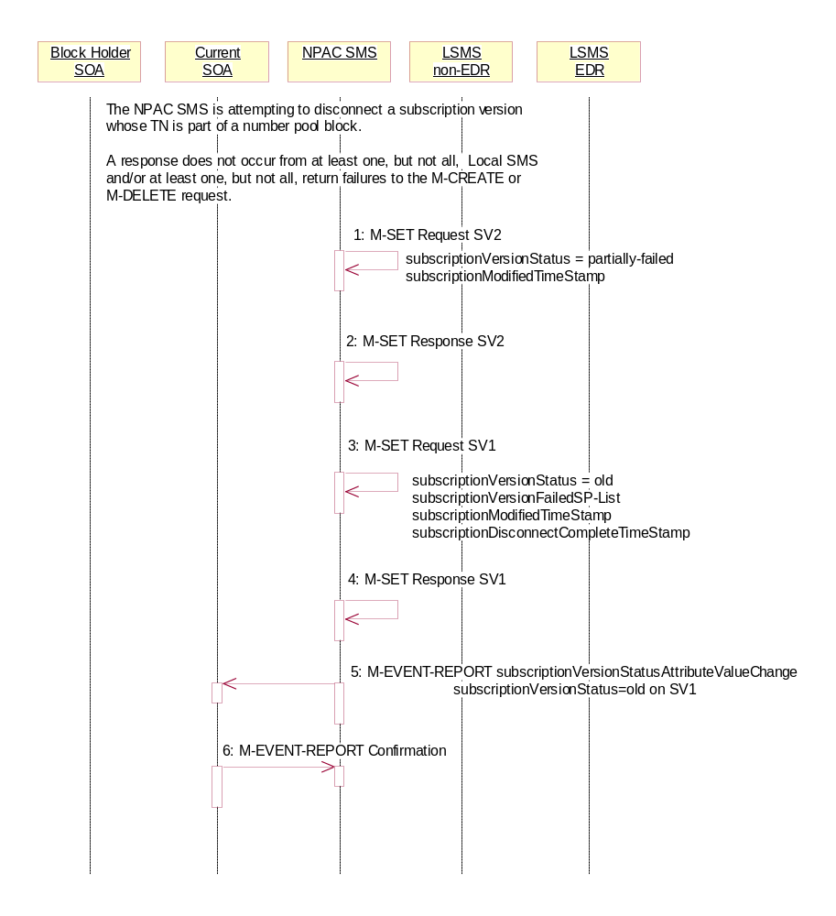
A response does not occur from at least one, but not all Local SMSs and/or at least one, but not all, Local SMSs respond with an error to the M-DELETE or M-CREATE request.

- NPAC SMS issues the M-SET to update the SV2 subscriptionVersionStatus from “sending” to “partially-failed”. The subscriptionModifiedTimeStamp and subscriptionActivationTimeStamp are also set.
- NPAC SMS responds to the M-SET.
- NPAC SMS issues the M-SET to update the SV1 subscriptionVersionStatus from “sending” to “old”. It also updates the subscriptionFailed-SP-List with the service provider ID and name of all the non-EDR and EDR Local SMSs that failed the broadcast. The subscriptionModifiedTimeStamp is also set. The subscriptionDisconnectCompleteTimeStamp is set when the first successful response is received.
- NPAC SMS responds to the M-SET.
- NPAC SMS sends the subscriptionVersionStatusAttributeValueChange M-EVENT-REPORT to the current service provider SOA with the status of ‘old’ for SV1 along with the subscriptionFailed-SP-List.
- Current service provider SOA issues the M-EVENT-REPORT confirmation.

Subscription Version Disconnect of a Ported Pooled TN: Resend Successful to Local SMS (previously NNP flow 4.5.1)
This scenario shows a successful resend of a disconnect for a subscription that fails to one or more of the Local SMSs. The resend of a failed disconnect can only be performed by authorized NPAC personnel. In this scenario:
- SV1 is the currently active Subscription Version.
- SV2 is the pool reinstatement Subscription Version with LNP type = pool that reinstates default routing to the block holder.
NPAC Personnel take action to resend a failed disconnect for a subscription version (SV1) that took place after the activation of the number pool block.

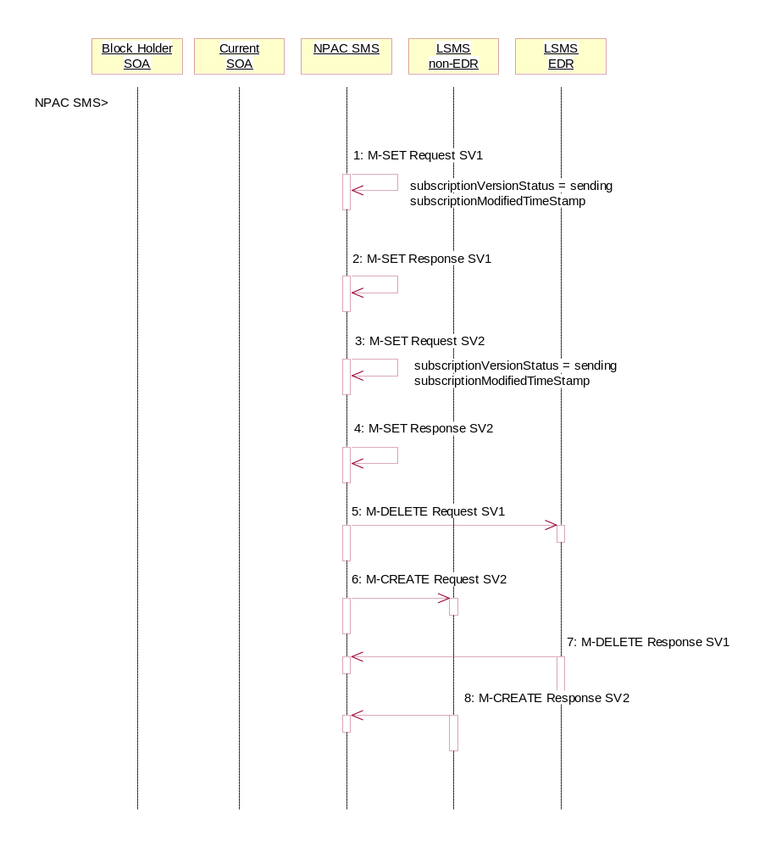

- NPAC SMS issues an M-SET to the existing subscriptionVersionNPAC object to set the status to “sending” for SV1 and set the subscriptionModifiedTimeStamp.
- NPAC SMS responds to the M-SET.
- NPAC SMS issues an M-SET to update the subscriptionVersionNPAC object for SV2. The subscriptionVersionStatus is set to “sending” for SV2 and the subscriptionModifiedTimeStamp is updated.
- NPAC SMS responds to the M-SET.
- NPAC SMS issues an M-DELETE on the subscriptionVersion SV1 to all previously failed EDR Local SMSs that are accepting downloads for the NPA-NXX of the subscriptionVersion SV1 TN.
- At the same time as step 5, the NPAC SMS issues an M-CREATE on the subscription version SV2 to all non-EDR Local SMSs that are accepting downloads for the NPA-NXX and had previously failed.
- EDR Local SMS responds successfully to the M-DELETE on SV1.
- Each non-EDR Local SMS responds successfully to the M-CREATE on SV2.

Subscription Version Disconnect of a Ported Pooled TN Resend Successful NPAC SMS Updates (previously NNP flow 4.5.2)

All non-EDR Local SMSs have responded successfully to the M-CREATE for SV2 and all EDR Local SMSs have responded successfully to the M-DELETE for SV1.

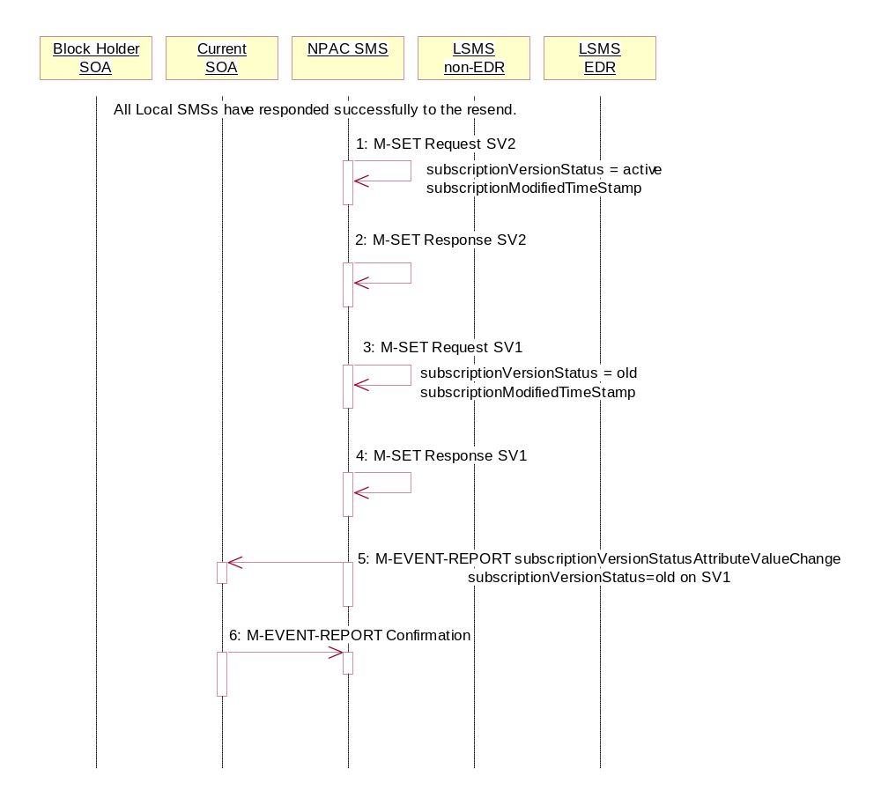
- NPAC SMS issues M-SET updating the subscriptionVersionStatus to ‘active’ for SV2. The subscriptionModifiedTimeStamp is also set.
- NPAC SMS responds to M-SET.
- NPAC SMS issues M-SET updating the subscriptionVersionStatus to ‘old’ for SV1. The subscriptionModifiedTimeStamp is also set.
- NPAC SMS responds to M-SET.
- NPAC SMS issues the M-EVENT-REPORT subscriptionVersionStatusAttributeValueChange to the current service provider for SV1 with the subscriptionVersionStatus set to ‘old’.
- Current service provider confirms the M-EVENT-REPORT.

Subscription Version Disconnect of a Ported Pooled TN: Resend Failure to Local SMS (previously NNP flow 4.6.1)
This scenario shows an unsuccessful resend of a disconnect for a subscription that fails to one or more of the Local SMSs. the resend of a failed disconnect can only be performed by NPAC personnel. In this scenario:
- SV1 is the currently active Subscription Version.
- SV2 is the pool reinstatement Subscription Version with LNP type = pool that reinstates default routing to the block holder with a status of failed.

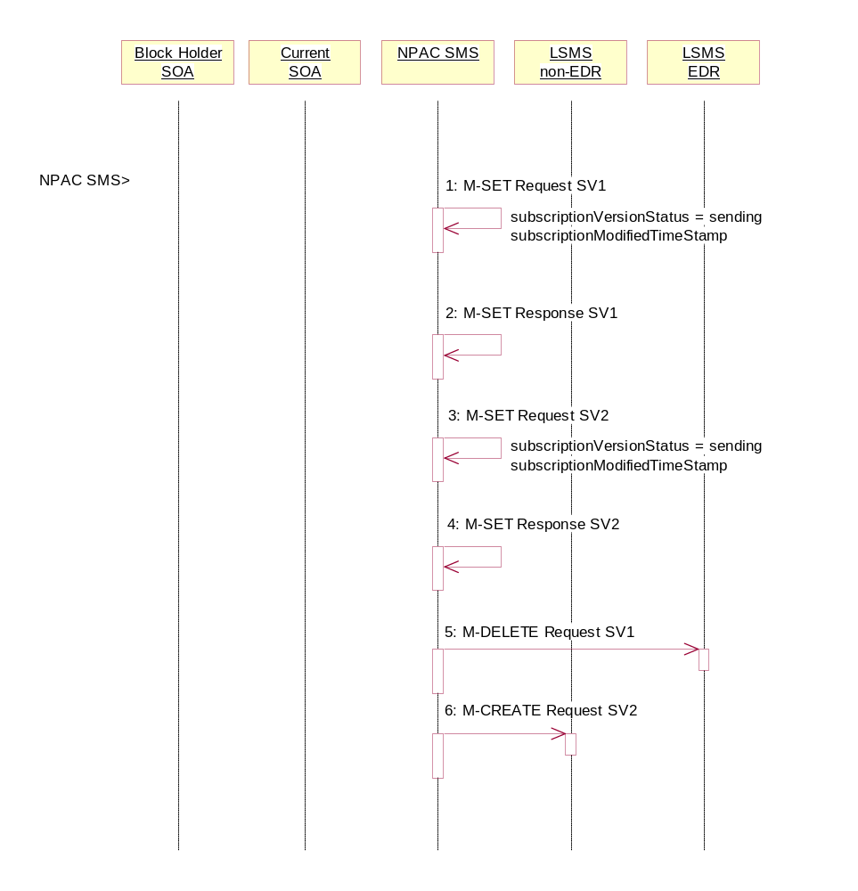
NPAC Personnel take action to resend a failed disconnect for a subscription version (SV1). This rebroadcast will result in failure again.

- NPAC SMS issues an M-SET to the existing subscriptionVersionNPAC object to set the status to “sending” for SV1 and set the subscriptionModifiedTimeStamp.
- NPAC SMS responds to the M-SET.
- NPAC SMS issues an M-SET to the existing subscriptionVersionNPAC object to set the status to “sending” for SV2 and the subscriptionModifiedTimeStamp.
- NPAC SMS responds to the M-SET.
- NPAC SMS issues an M-DELETE on the subscriptionVersion SV1 to all previously failed EDR Local SMSs that are accepting downloads for the NPA-NXX of the subscriptionVersion SV1 TN.
- At the same time as step 5, the NPAC SMS issues an M-CREATE on the subscriptionVersion SV2 to all previously failed non-EDR Local SMSs that are accepting downloads for the NPA-NXX of the subscriptionVersion SV2 TN.

NPAC SMS waits for responses from all Local SMSs.

NPAC SMS retries each Local SMS that has not responded.

Subscription Version Disconnect of a Ported Pooled TN Resend Failure NPAC SMS Updates (previously NNP flow 4.6.2)

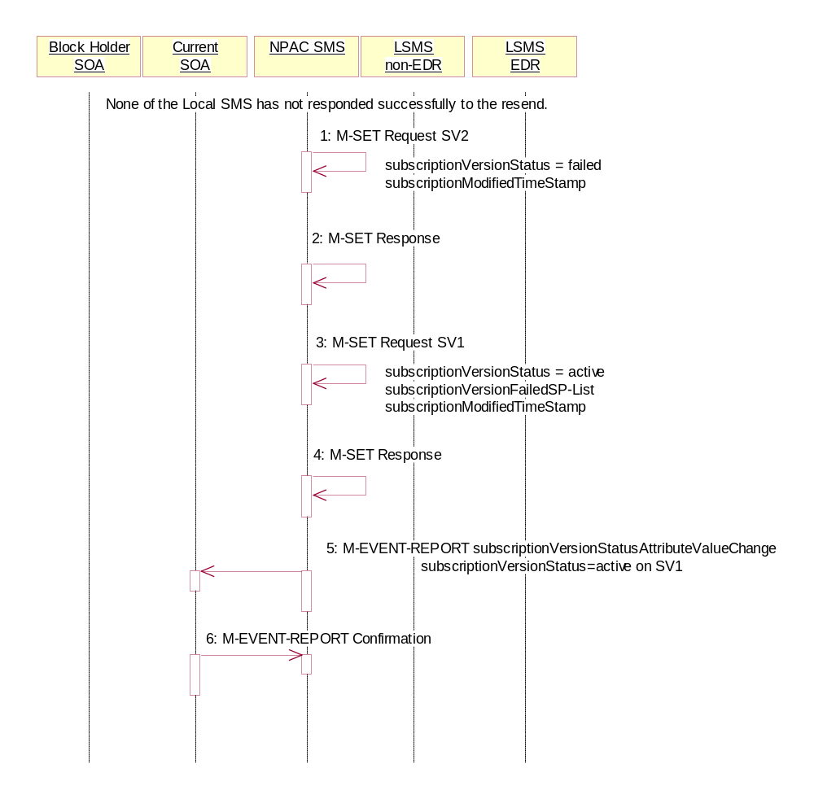
None of the non-EDR Local SMSs has responded successfully to the M-CREATE and none of the EDR Local SMSs responded successfully to the M-DELETE.

- NPAC SMS issues M-SET updating the subscriptionVersionStatus to failed for SV2. The subscriptionModifiedTimeStamp is also set.
- NPAC SMS responds to M-SET.
- NPAC SMS issues M-SET updating the subscriptionVersionStatus to active for SV1. The subscriptionFailed-SP-List and subscriptionModifiedTimeStamp is also set.
- NPAC SMS responds to M-SET.
- NPAC SMS issues the M-EVENT-REPORT subscriptionVersionAttributeValueChange to the current service provider for SV1 with the subscriptionVersionStatus set to ‘active’ and the subscriptionFailed-SP-List.
- Current service provider confirms the M-EVENT-REPORT.

Subscription Version Disconnect of a Ported Pooled TN: Resend Partial Failure to Local SMS (previously NNP flow 4.7.1)
This scenario shows an unsuccessful resend of a disconnect for a subscription that fails to one or more of the Local SMSs. the resend of a failed disconnect can only be performed by NPAC personnel. In this scenario:
- SV1 is the previously active Subscription Version now with a status of old.
- SV2 is the pool reinstatement Subscription Version with LNP type = pool that reinstates default routing to the block holder with a status of partially failed.

The NPAC SMS is initiating the resend of a previously partially failed disconnect of a ported, pooled TN for a number pool block that was active at the time of the initial broadcast
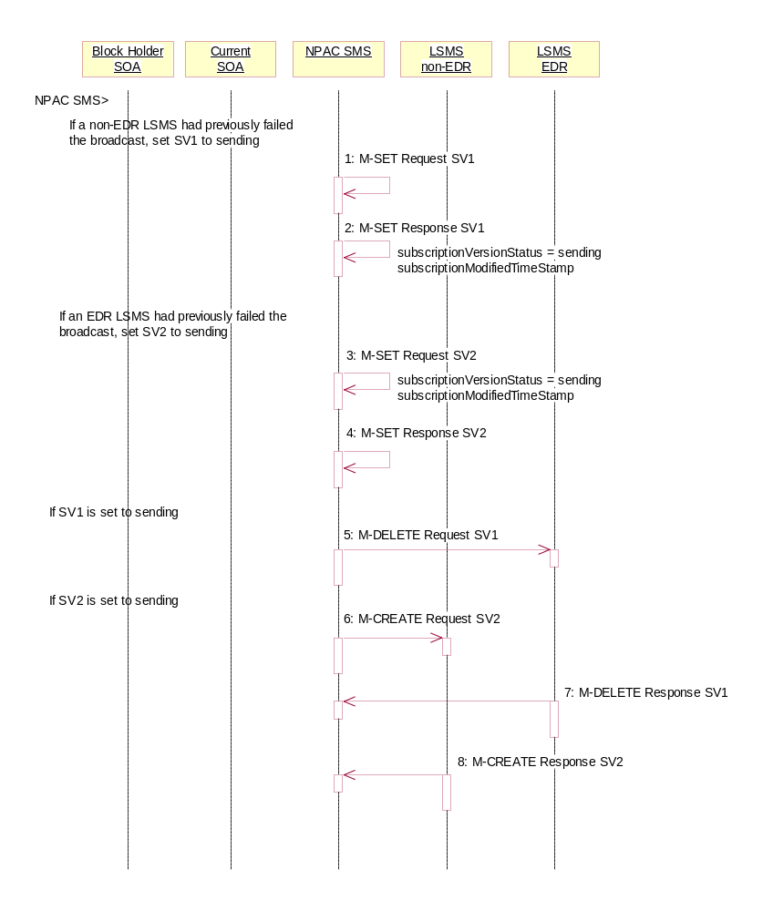

- If a non-EDR Local SMS failed the broadcast, the NPAC SMS issues an M-SET to the existing subscriptionVersionNPAC object to set the status to “sending” for SV1 and set the subscriptionModifiedTimeStamp.
- NPAC SMS responds to the M-SET.
- If an EDR Local SMS failed the broadcast, the NPAC SMS issues an M-SET to the existing subscriptionVersionNPAC object to set the status to “sending” for SV2 and the subscriptionModifiedTimeStamp.
- NPAC SMS responds to the M-SET.
- If the status of SV1 is set to sending, the NPAC SMS issues an M-DELETE on the subscriptionVersion SV1 to all previously failed EDR Local SMSs that are accepting downloads for the NPA-NXX of the subscriptionVersion SV1 TN.
- At the same time as step 5 and if the status of SV2 is set to sending, the NPAC SMS issues an M-CREATE on the subscriptionVersion SV2 to all previously failed non-EDR Local SMSs that are accepting downloads for the NPA-NXX of the subscriptionVersion SV2 TN.
- The EDR Local SMS responds to the M-DELETE request.
- The non-EDR Local SMS responds to the M-CREATE request.

NPAC SMS waits for responses from all Local SMSs.

NPAC SMS retries each Local SMS that has not responded.

Subscription Version Disconnect of a Ported Pooled TN Resend Partial Failure Broadcast NPAC SMS Updates (previously NNP flow 4.7.2)

At least one of the non-EDR Local SMSs has not responded successfully to the M-CREATE and/or at least one of the EDR Local SMSs has not responded successfully to the M-DELETE.
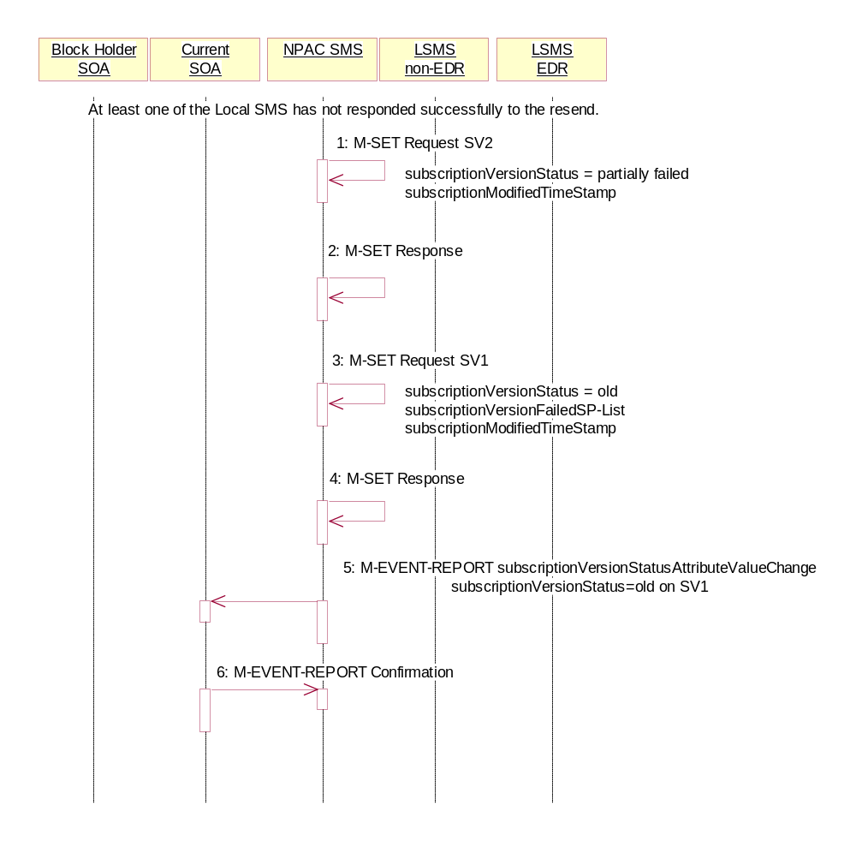
- NPAC SMS issues M-SET updating the subscriptionVersionStatus to partially-failed for SV2. The subscriptionModifiedTimeStamp is also set.
- NPAC SMS responds to M-SET.
- NPAC SMS issues M-SET updating the subscriptionVersionStatus to old for SV1. The subscriptionFailed-SP-List and subscriptionModifiedTimeStamp is also set.
- NPAC SMS responds to M-SET.
- NPAC SMS issues the M-EVENT-REPORT subscriptionVersionAttributeValueChange to the current service provider for SV1 with the subscriptionVersionStatus set to ‘old’ along with the subscriptionFailed-SP-List.
- Current service provider confirms the M-EVENT-REPORT.

Subscription Version Immediate Disconnect of a Contaminated Pooled TN Prior to Block Activation (after Effective Date) (previously NNP flow 4.8)
In this scenario, the current service provider disconnects an active subscription version that will return to the block holder. However, the number pool block is past the effective date, but has not yet been activated.
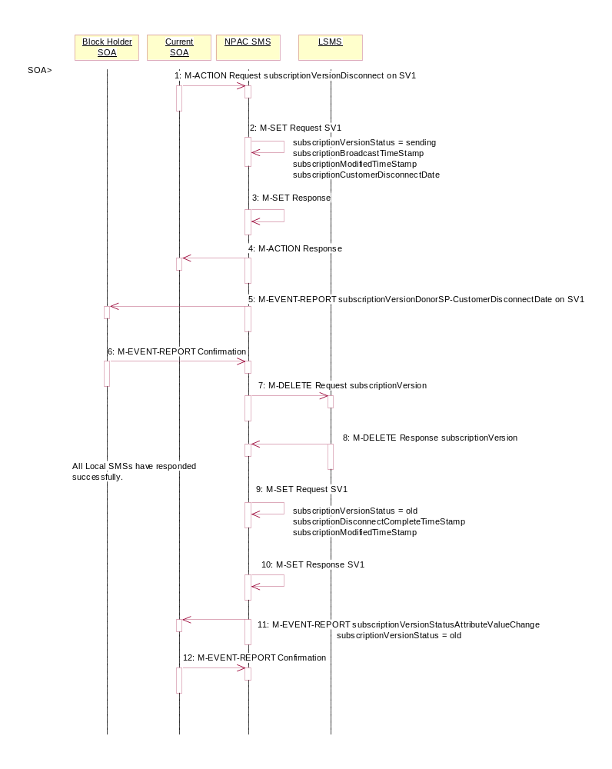
Current service provider SOA personnel take action to disconnect a subscription version.
- Service provider SOA issues an M-ACTION request to disconnect to the lnpSubscriptions object. The M-ACTION specifies either the subscriptionVersionId, or subscriptionTN or range of TNs, and also has NOT future dated (i.e., used the current date) the subscriptionEffectiveReleaseDate and the subscriptionCustomerDisconnectDate. The subscription version status must be active and no pending, failed, conflict or cancel-pending versions can exist.
- NPAC SMS issues an M-SET to set the subscriptionCustomerDisconnectDate according to the disconnect action for SV1. The subscriptionVersionStatus for SV1 goes to “sending ”. The subscriptionModifiedTimeStamp and subscriptionBroadcastTimeStamp are set accordingly.
- NPAC SMS responds to whether M-SET was successful.
- NPAC SMS responds to the M-ACTION. If the action failed, an error will be returned and processing will stop on this flow.
- NPAC SMS sends the Donor service provider SOA notification that the subscription version is being disconnected with the customer disconnect date. This SOA is the block holder SOA.
- The donor service provider SOA confirms the M-EVENT-REPORT.
- NPAC SMS sends the M-DELETE request to the Local SMS to delete the existing subscription version.
- Local SMS sends its M-DELETE reply.
All Local SMSs have responded successfully.
- NPAC SMS sets the subscriptionVersionStatus to ‘old’ and sets the subscriptionModifiedTimeStamp. The subscriptionDisconnectCompleteTimeStamp is set when the first successful response is received.
- NPAC SMS responds to the M-SET.
- NPAC SMS sends the subscriptionVersionStatusAttributeValueChange notification to the current SOA with the subscriptionVersionStatus set to ‘old’.
- Service provider SOA confirms the M-EVENT-REPORT.

Conflict Scenarios
A situation has arisen which causes the NPAC SMS or NPAC personnel to place the subscriptionVersion into conflict.
A subscription version can be removed from conflict by the NPAC personnel or the new service provider SOA.

SubscriptionVersion Conflict and Conflict Resolution by the NPAC SMS
This scenario shows a version being placed into conflict and removed from conflict by the NPAC personnel.
- NPAC personnel or NPAC SMS take action to set the status of a subscription to “conflict.”
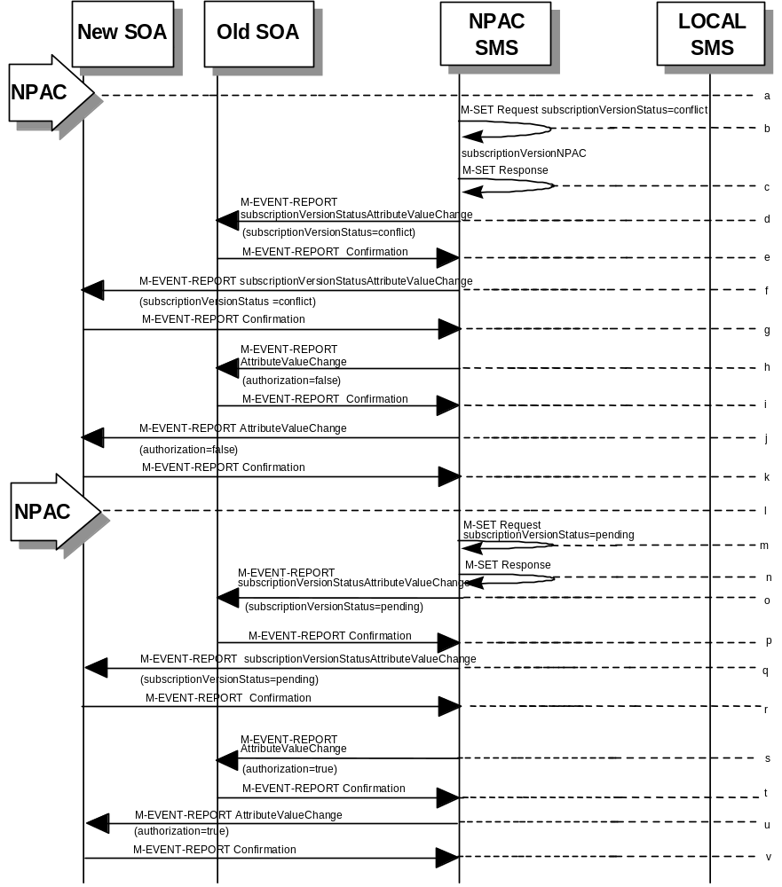
- NPAC SMS issues M-SET request to update subscriptionVersionStatus to “conflict,” subscriptionConflictTimeStamp, and subscriptionModifiedTimeStamp in the subscriptionVersionNPAC object.
- NPAC SMS issues an M-SET response. If the M-SET fails, processing for this scenario stops.
- NPAC SMS issues an M-EVENT-REPORT subscriptionVersionStatusAttributeValueChange to old service provider SOA.
- The old service provider SOA returns an M-EVENT-REPORT confirmation to the NPAC SMS.
- NPAC SMS issues subscriptionVersionStatusAttributeValueChange for status to new service provider SOA.
- The new service provider SOA returns an M-EVENT-REPORT confirmation to the NPAC SMS.
- NPAC SMS sends a subscriptionVersionStatusAttributeValueChange to set the old service provider’s authorization to “FALSE”.
- The old service provider SOA returns an M-EVENT-REPORT confirmation to the NPAC SMS.
- NPAC SMS sends an AttributeValueChange to set the new service provider authorization to “FALSE”.
- The new service provider SOA returns an M-EVENT-REPORT confirmation to the NPAC SMS.
- Once the conflict is resolved, NPAC personnel take action to remove the subscriptionVersion from conflict.
- NPAC SMS issues an M-SET request to update the subscriptionModifiedTimeStamp and the subscriptionVersionStatus to “pending.”
- NPAC SMS issues an M-SET response. If the M-SET fails, processing for this scenario stops.
- NPAC SMS issues subscriptionVersionStatusAttributeValueChange for the new status to the old service provider SOA.
- The old service provider SOA returns an M-EVENT-REPORT confirmation to the NPAC SMS.
- NPAC SMS issues subscriptionVersionStatusAttributeValueChange for the new status to the new service provider SOA.
- The new service provider SOA returns an M-EVENT-REPORT confirmation to the NPAC SMS.
- NPAC SMS sends a subscriptionVersionStatusAttributeValueChange to the old service provider’s indicating the authorization has been set to “TRUE”.
- The old service provider SOA returns an M-EVENT-REPORT confirmation to the NPAC SMS.
- NPAC SMS sends an AttributeValueChange to the new service provider indicating the authorization has been set to “TRUE”.
- The new service provider SOA returns an M-EVENT-REPORT confirmation to the NPAC SMS.

Subscription Version Conflict Removal by the New Service Provider SOA
In this scenario, the new service provider elects to remove the subscription version from conflict.
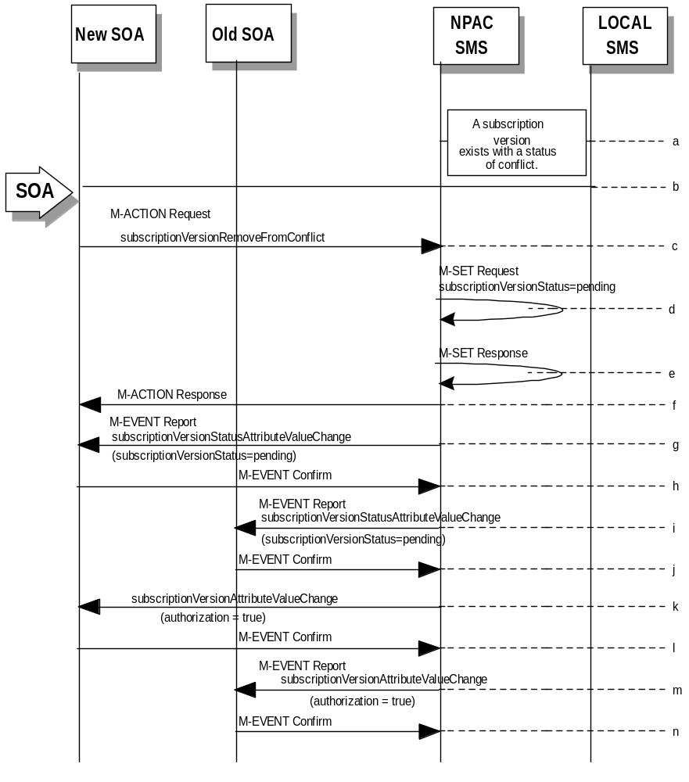
- A subscription version exists on the NPAC SMS with a status of conflict.
- The new service provider SOA personnel take action to remove the subscription version from conflict.
- The new service provider SOA sends the M-ACTION subscriptionVersionNewSP-RemoveFromConflict specifying the subscription version TN or subscription version ID of the subscription version in conflict.
- If the request is valid, the NPAC SMS will set the status to “pending”.
The request will be denied and an error returned if the subscriptionOldSP-Authorization was set to conflict by the old service provider and the conflict restriction window has not expired.
- The NPAC SMS responds to its own M-SET.
- The NPAC SMS responds to the M-ACTION with success or failure and reason for failure.
- The NPAC SMS sends the M-EVENT-REPORT subscriptionVersionStatusAttributeValueChange to the New SOA.
- The New SOA sends the M-EVENT-REPORT confirmation.
- The NPAC SMS sends the M-EVENT-REPORT subscriptionVersionStatusAttributeValueChange to the Old SOA.
- The Old SOA sends the M-EVENT-REPORT confirmation.
- NPAC SMS sends a subscriptionVersionStatusAttributeValueChange to set the old service provider’s authorization to “TRUE”.
- The old service provider SOA returns an M-EVENT-REPORT confirmation to the NPAC SMS.
- NPAC SMS sends an AttributeValueChange to the new service provider indicating the authorization has been set to “TRUE”.
- The new service provider SOA returns an M-EVENT-REPORT confirmation to the NPAC SMS.

SubscriptionVersion Conflict: No Conflict Resolution
This scenario shows the action taken at the NPAC SMS when service providers do not reach a conflict resolution.
- NPAC personnel or NPAC SMS take action to set a subscriptionVersionStatus to “conflict.”
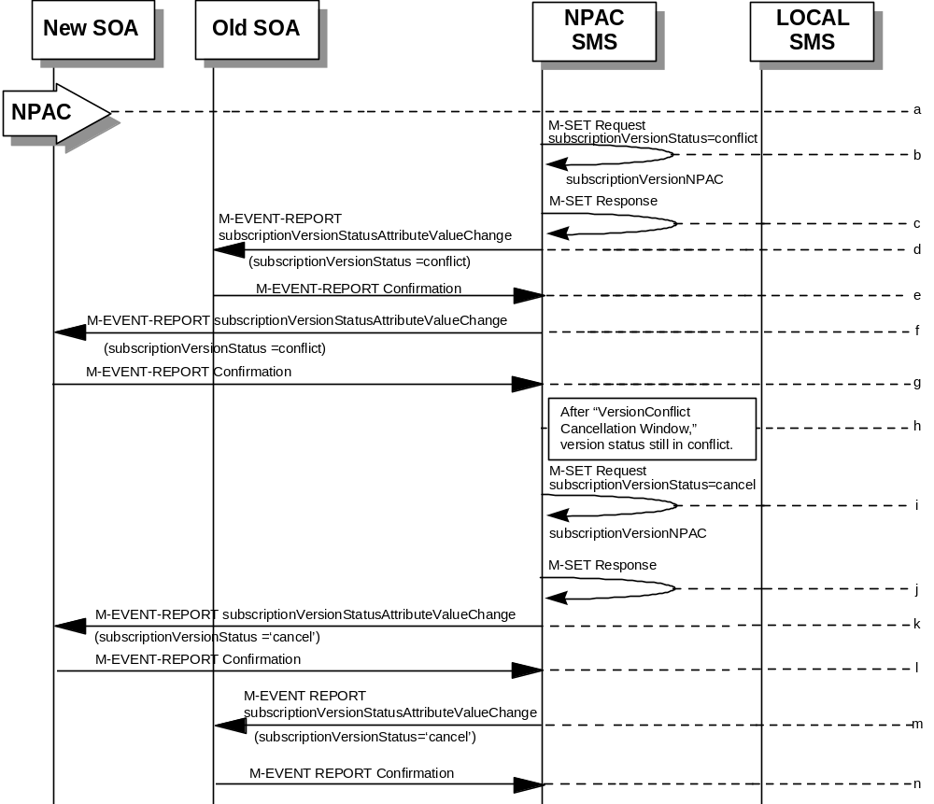
- NPAC SMS issues an M-SET request to set the subscriptionVersionStatus to “conflict,” the subscriptionConflictTimeStamp, and the subscriptionModifiedTimeStamp in the subscriptionVersionNPAC object.
- NPAC SMS responds to M-SET. If the M-SET fails, processing stops for this scenario until the M-SET completes successfully.
- NPAC SMS issues subscriptionVersionStatusAttributeValueChange to old service provider SOA for the new “conflict” status.
- The old service provider SOA returns an M-EVENT-REPORT confirmation to the NPAC SMS.
- NPAC SMS issues subscriptionVersionStatusAttributeValueChange to new service provider SOA for the “conflict” status.
- The new service provider SOA returns an M-EVENT-REPORT confirmation to the NPAC SMS.
- “Version Conflict Cancellation Window” expires without conflict resolution.
- NPAC SMS issues an M-SET request to set the subscriptionVersionStatus to “cancel” in the subscriptionVersionNPAC object and sets the subscriptionCancellationTimeStamp and subscriptionModifiedTimeStamp.
- NPAC SMS responds to M-SET. If the M-SET fails, processing stops for this scenario until the M-SET is successfully completed.
- NPAC SMS issues attribute value change for status to new service provider SOA for the “cancel” status.
- The new service provider SOA returns an M-EVENT-REPORT confirmation to the NPAC SMS.
- NPAC SMS issues attribute value change for status to old service provider SOA for the “cancel” status.
- The old service provider SOA returns an M-EVENT-REPORT confirmation to the NPAC SMS.

Subscription Version Conflict by Old Service Provider Explicitly Not Authorizing (First Create)
The old service provider SOA can put a pending subscription version into conflict by setting its authorization flag to off. This can be done on the subscriptionVersionOldSP-Create action, subscriptionVersionModify action, or M-SET of the attribute on the subscription version object.
This scenario shows the old service provider putting a new pending subscription version into conflict by turning the authorization flag off on the subscriptionVersionOldSP-Create. In this case, the old service provider’s create action is the first sent to the NPAC SMS.
- 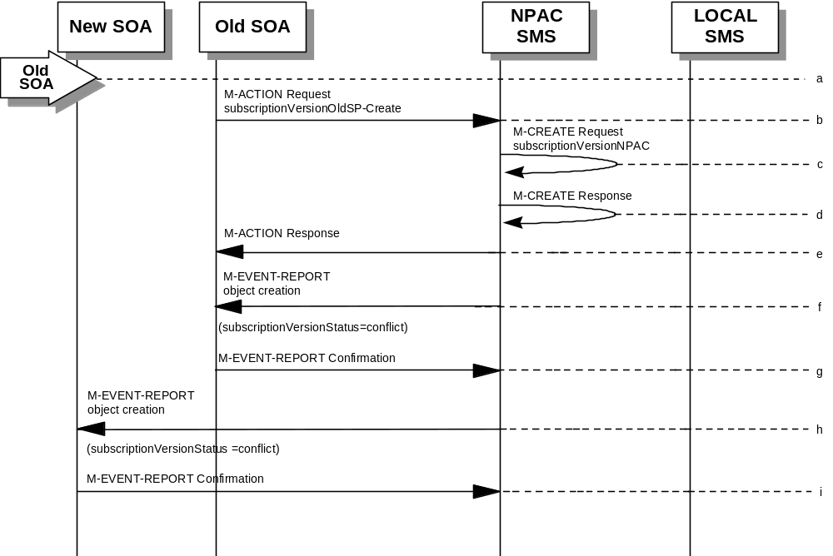Action is taken by the old service provider to set a subscription version to conflict using the subscriptionVersionOldSP-Create action.
- The old service provider SOA sends M-ACTION subscriptionVersionOldSP-Create to the NPAC SMS lnpSubscriptions object to create a new subscriptionVersionNPAC with the status of “conflict”.
The old service provider SOA specifies the following valid attributes:
subscriptionTN or valid subscriptionVersionTN-Range
subscriptionNewCurrentSP
subscriptionOldSP
subscriptionOldSP-DueDate (seconds set to zeros)
subscriptionOldSP-Authorization
subscriptionLNPType
subscriptionStatusChangeCauseCode
In this case, the subscriptionOldSP-Authorization is set to NO.
- NPAC SMS issues M-CREATE to create the subscriptionVersionNPAC with a status of “conflict” and sets all the other attribute values from the subscriptionVersionOldSP-Create action.
- NPAC SMS issues M-CREATE response.
- NPAC SMS returns M-ACTION reply. This either reflects a success or failure and reasons for the failure.
- If the action was successful, the NPAC SMS issues the M-EVENT-REPORT to the old service provider SOA notifying them of the object creation.
- The old service provider SOA confirms the M-EVENT-REPORT.
- If the action was successful, the NPAC SMS issues the M-EVENT-REPORT to the new service provider SOA notifying them of the object creation.
- The new service provider SOA confirms the M-EVENT-REPORT.

Subscription Version Conflict Removal by the Old Service Provider SOA
In this scenario, the old service provider elects to remove the subscription version from conflict.
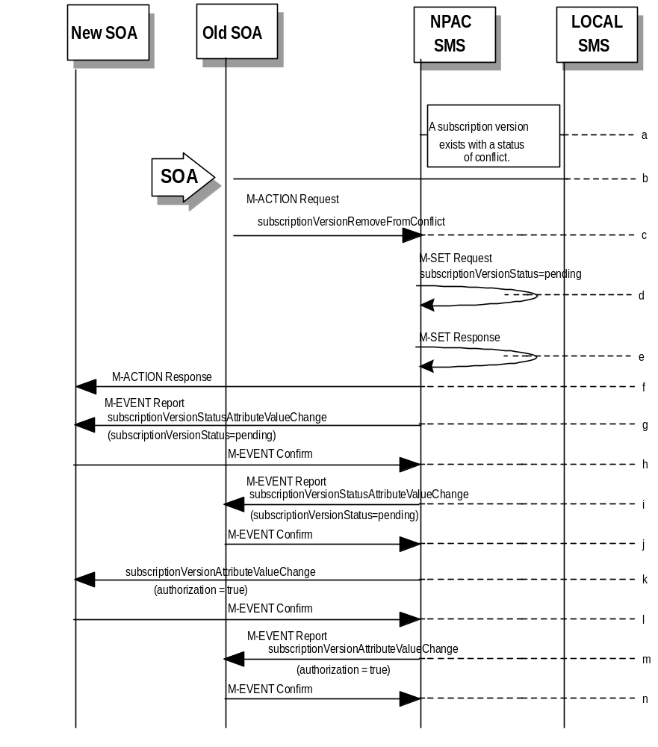
- A subscription version exists on the NPAC SMS with a status of conflict.
- The old service provider SOA personnel take action to remove the subscription version from conflict.
- The old service provider SOA sends the M-ACTION subscriptionVersionOldSP-RemoveFromConflict specifying the subscription version TN or subscription version ID of the subscription version in conflict.
- If the request is valid, the NPAC SMS will set the status to “pending”.
- The NPAC SMS responds to its own M-SET.
- The NPAC SMS responds to the M-ACTION with success or failure and reason for failure.
- The NPAC SMS sends the M-EVENT-REPORT subscriptionVersionStatusAttributeValueChange to the New SOA.
- The New SOA sends the M-EVENT-REPORT confirmation.
- The NPAC SMS sends the M-EVENT-REPORT subscriptionVersionStatusAttributeValueChange to the Old SOA.
- The Old SOA sends the M-EVENT-REPORT confirmation.
- NPAC SMS sends a subscriptionVersionAttributeValueChange to the new service provider indicating the authorization has been set to “TRUE”.
- The new service provider SOA returns an M-EVENT-REPORT confirmation to the NPAC SMS.
- NPAC SMS sends a subscriptionVersionAttributeValueChange to the old service provider indicating the authorization has been set to “TRUE”.
- The old service provider SOA returns an M-EVENT-REPORT confirmation to the NPAC SMS.

SubscriptionVersion Query
This scenario shows subscriptionVersion query from service provider systems to the NPAC SMS.
- 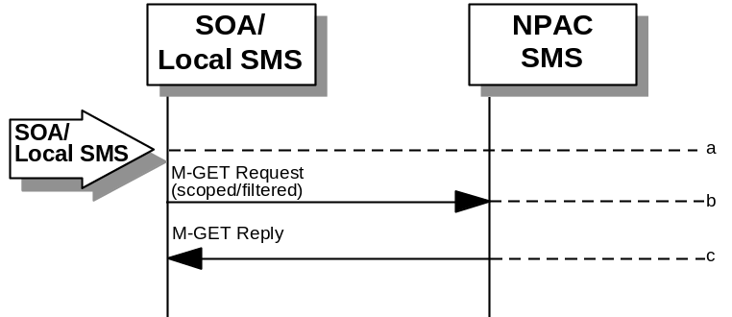Action is taken by either a service provider SOA or Local SMS for retrieving one or more versions of a subscription.
- The service provider SOA or Local SMS issues a scoped filtered M-GET from the lnpSubscriptions object to retrieve a specific version for a subscription version TN or can request all subscription versions. However, the service provider SOA is limited by a scope and filter in their search capabilities. The filter will currently support all the attributes on the subscriptionVersionNPAC.
- The NPAC SMS replies with the requested subscriptionVersion data if the requested number of records is less than or equal to “Max SubscriberQuery” specified in the NPAC SMS. Otherwise a complexityLimitation error will be returned.
The query return data includes:
subscriptionTN (SOA, LSMS)
subscriptionLRN (SOA, LSMS)
subscriptionNewCurrentSP (SOA, LSMS)
subscriptionOldSP (SOA)
subscriptionNewSP-DueDate (SOA)
subscriptionNewSP-CreationTimeStamp (SOA)
subscriptionOldSP-DueDate (SOA)
subscriptionOldSP-Authorization (SOA)
subscriptionOldSP-AuthorizationTimeStamp (SOA)
subscriptionActivationTimeStamp (SOA)
subscriptionBroadcastTimeStamp (SOA)
subscriptionConflictTimeStamp (SOA)
subscriptionCustomerDisconnectDate (SOA)
subscriptionDisconnectCompleteTimeStamp (SOA)
subscriptionEffectiveReleaseDate (SOA)
subscriptionVersionStatus (SOA, LSMS)
subscriptionCLASS-DPC (SOA, LSMS)
subscriptionCLASS-SSN (SOA, LSMS)
subscriptionLIDB-DPC (SOA,LSMS)
subscriptionLIDB-SSN (SOA, LSMS)
subscriptionCNAM-DPC (SOA, LSMS)
subscriptionCNAM-SSN (SOA, LSMS)
subscriptionISVM-DPC (SOA, LSMS)
subscriptionISVM-SSN (SOA, LSMS)
subscriptionWSMSC-DPC - if supported by the Service Provider SOA (SOA, LSMS)
subscriptionWSMSC-SSN - if supported by the Service Provider SOA (SOA, LSMS)
subscriptionEndUserLocationValue (SOA)
subscriptionEndUserLocationType (SOA)
subscriptionBillingId (SOA)
subscriptionLNPType (SOA)
subscriptionPreCancellationStatus (SOA)
subscriptionCancellationTimeStamp (SOA)
subscriptionOldTimeStamp (SOA)
subscriptionModifiedTimeStamp (SOA)
subscriptionCreationTimeStamp (SOA)
subscriptionOldSP-CancellationTimeStamp (SOA)
subscriptionNewSP-CancellationTimeStamp (SOA)
subscriptionOldSP-ConflictResolutionTimeStamp (SOA)
subscriptionNewSP-ConflictResolutionTimeStamp (SOA)
subscriptionPortingToOriginal-SPSwitch (SOA)
subscriptionFailedSP-List (SOA)
subscriptionDownloadReason (SOA)
subscriptionTimerType (SOA)
subscriptionBusinessType (SOA)

Subscription Data Download
This scenario shows a Local SMS request for subscription data download in order to update their view of this data.
- Action is taken by the Local SMS personnel to request a subscription data download. The criteria to decide which subscription data is to be downloaded is specified by the Local SMS personnel.
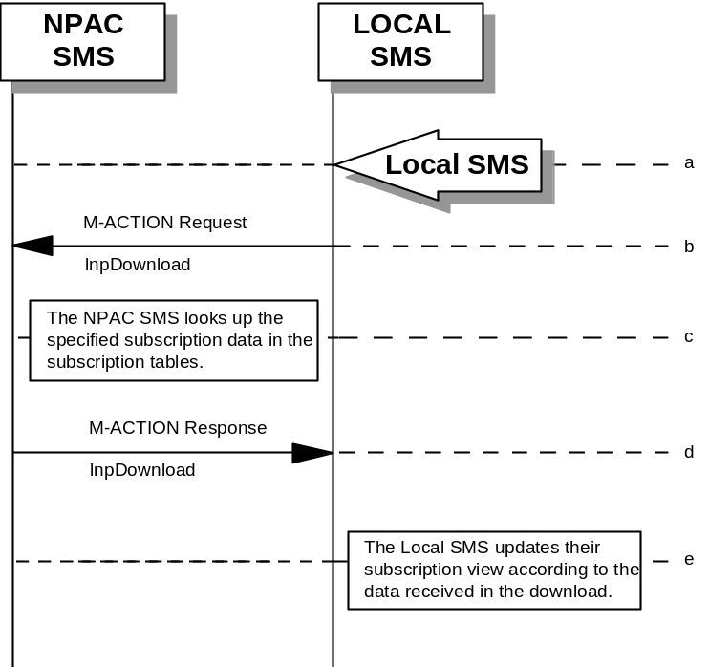
- The Local SMS sends an M-ACTION request to the NPAC SMS lnpSubscription object requesting a subscription data download.
- The NPAC SMS looks up the subscription data in the subscription database as specified by the criteria in the M-ACTION request.
- The NPAC SMS responds by sending an M-ACTION response to the Local SMS that initiated the request. The response includes the success/failure of the request along with the requested subscription data.
- The Local SMS must take appropriate action to update their view of the data.

LSMS Filter NPA-NXX Scenarios

lsmsFilterNPA-NXX Creation by the Local SMS
- 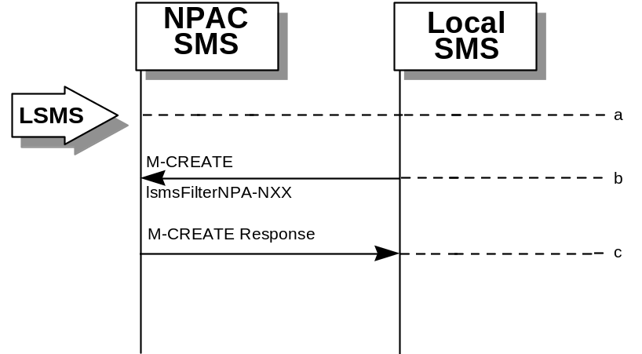Action is taken by the Local SMS personnel to create an lsmsFilterNPA-NXX object.
- The Local SMS sends the M-CREATE request to the NPAC for the lsmsFilterNPA-NXX object to be created.
- The NPAC SMS attempts to create the object. If successful, the M-CREATE response is returned. Otherwise, an error is returned.

lsmsFilterNPA-NXX Deletion by the Local SMS
- Action is taken by the Local SMS personnel to delete an lsmsFilterNPA-NXX object.
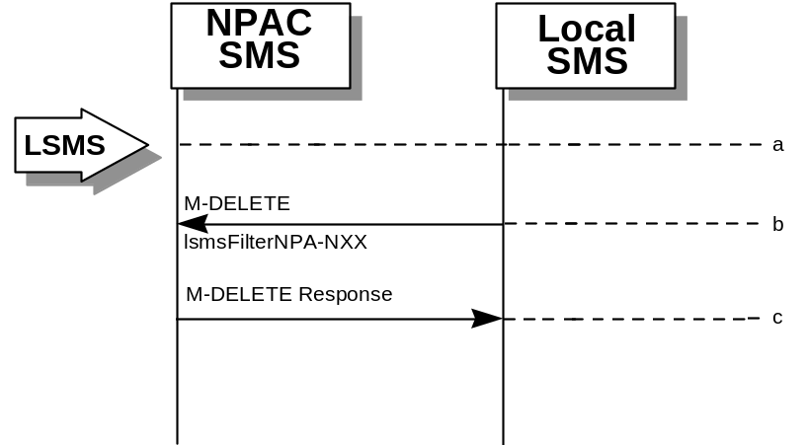
- The Local SMS sends the M-DELETE request to the NPAC for the lsmsFilterNPA-NXX object to be removed.
- The NPAC SMS attempts to delete the object. If successful, the M-DELETE response is returned. Otherwise, an error is returned.

lsmsFilterNPA-NXX Query by the Local SMS
- 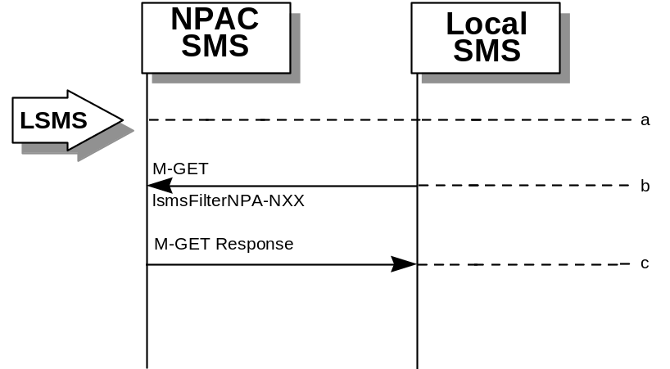Action is taken by the Local SMS personnel to query for one or all lsmsFilterNPA-NXX object(s).
- The Local SMS sends the M-GET request to the NPAC for the lsmsFilterNPA-NXX object(s).
- If the Service Provider ID was specified, all lsmsFilterNPA-NXX objects for that Service Provider are returned. If only one object was requested, that object is returned.

lsmsFilterNPA-NXX Creation by the SOA
- 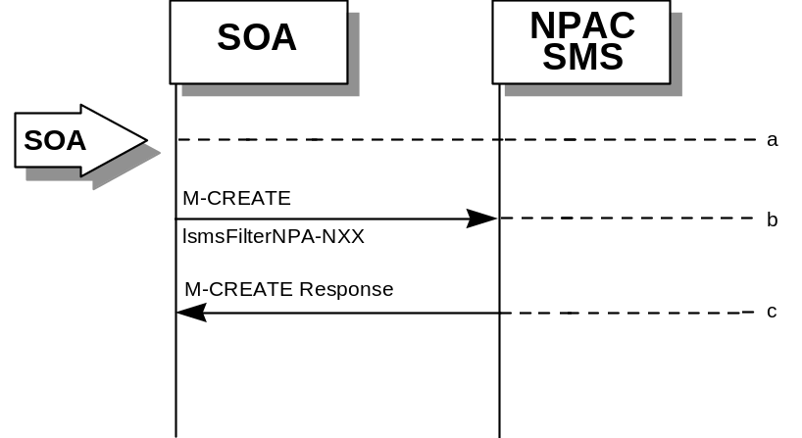Action is taken by the SOA personnel to create an lsmsFilterNPA-NXX object.
- The SOA sends the M-CREATE request to the NPAC for the lsmsFilterNPA-NXX object to be created.
- The NPAC SMS attempts to create the object. If successful, the M-CREATE response is returned. Otherwise, an error is returned.

lsmsFilterNPA-NXX Deletion by the SOA
- Action is taken by the SOA personnel to delete an lsmsFilterNPA-NXX object.
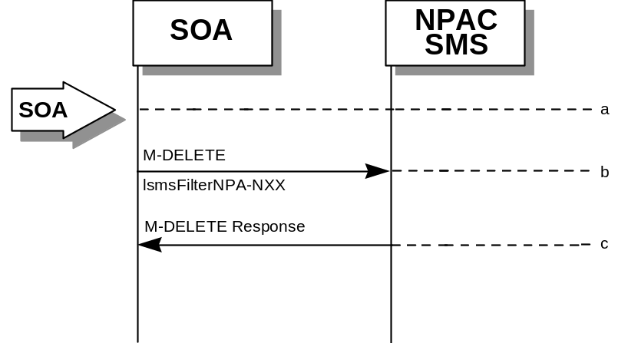
- The SOA sends the M-DELETE request to the NPAC for the lsmsFilterNPA-NXX object to be removed.
- The NPAC SMS attempts to delete the object. If successful, the M-DELETE response is returned. Otherwise, an error is returned.

lsmsFilterNPA-NXX Query by the SOA
- 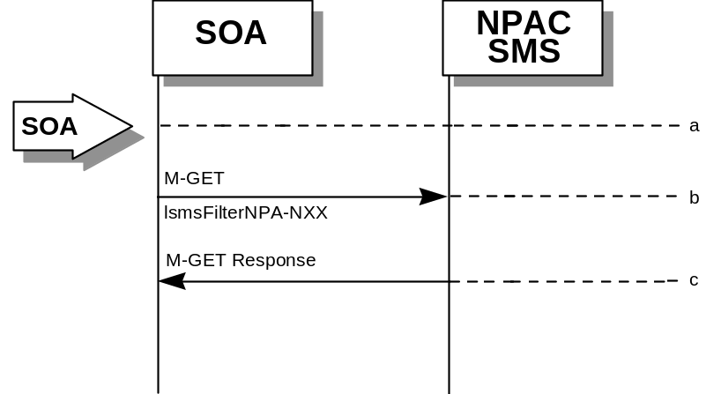Action is taken by the SOA personnel to query for one or all lsmsFilterNPA-NXX object(s).
- The SOA sends the M-GET request to the NPAC for the lsmsFilterNPA-NXX object(s).
- If the Service Provider ID was specified, all lsmsFilterNPA-NXX objects for that Service Provider are returned. If only one object was requested, that object is returned.

Local SMS and SOA Recovery
For all download requests in this section, the Local SMS or SOA should behave as follows in response to the possible download M-ACTION response from the NPAC SMS:
Success – process the data received from the NPAC SMS, continue processing.
No-data-selected – no data was found, continue processing.
Criteria-too-large (using the Maximum Number of Download Records tunable) – break up the request into a smaller time range and re-issue the request to the NPAC SMS (only applies to SV requests).
OR
Criteria-too-large (using the Maximum Number of Download Notifications tunable) – break up the request into a smaller time range and re-issue the request to the NPAC SMS (only applies to notification requests).
Time-range-invalid (using the Maximum Download Duration tunable) – break up the request into shorter time ranges and re-issue the request to the NPAC SMS.
Failed – go into retry mode. Re-issue the request configurable number of additional retry attempts with an “x” amount of delay between requests (“x” is based on a configurable amount of time after receiving the failure for each request). If a failed response is received for the final retry request, abort the association and re-start the recovery process. Note: It is recommended that the Local SMS or SOA use the same value that the NPAC SMS uses for retry interval.
For activities that specify “continue processing”, the Local SMS or SOA should send the NPAC SMS, either the next lnpDownload Action for a different type of data, or an lnpRecoveryComplete request, depending on where the response appears in the flow.
It is optional as to whether the Local SMS recovers Network Data, Subscription Data, Notification Data, or any combination of the three and if the SOA recovers the Network Data and/or Notification Data. For an Local SMS or SOA that initiates recovery, the only step that is required is the lnpRecoveryComplete message, at the end of all previous data recovery requests. This instructs the NPAC SMS to send previously queued messages, at the next scheduled retry interval, and resume normal processing.

Local SMS establishes association with resynchronization flag on.

Local SMS sends M-ACTION to start network data download. The Local SMS specifies the criteria.

NPAC SMS responds to M-ACTION with updates.

Local SMS sends M-ACTION to start subscription data download. The Local SMS specifies the criteria.

NPAC SMS responds to M-ACTION with subscription version updates.

Local SMS sends M-ACTION to recovery notifications by time range.

NPAC SMS responds to M-ACTION with notification updates.

Local SMS sends M-ACTION to set resynchronization flag off.

NPAC SMS replies to the M-ACTION.

Normal processing resumes and any activity that the NPAC SMS had queued upduring the recovery period will now be sent.

Sequencing of Events on Initialization/Resynchronization of Non-EDR Local SMS (previously NNP flow 5.2)
This scenario demonstrates how a non-EDR Local SMS resynchronizes itself with the NPAC SMS.
This scenario demonstrates the recovery of additions, deletions and modifications of network and subscription version data. The recovery of this data can cause status attribute value changes and serviceProvNPA-NXX-X deletions.
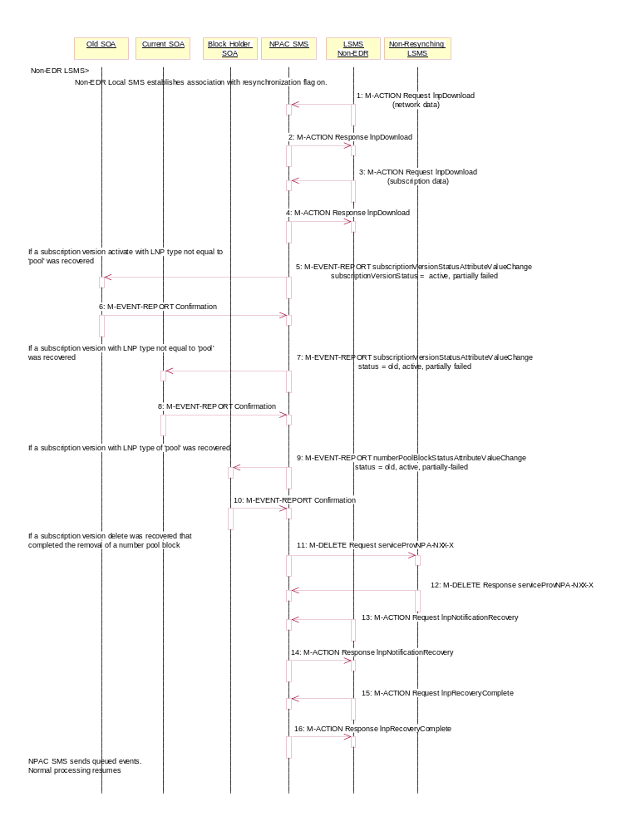
Local SMS personnel take action to resynchronize their Local SMS with the NPAC SMS.
The Non-EDR Local SMS establishes an association to the NPAC SMS with the resynchronization flag on, along with the network data management (networkDataMgmt) and data download (dataDownload) association functions set. The NPAC SMS will queue all current activity on the NPAC SMS until the service Local SMS sends in the lnpRecoveryComplete action. All updates issued since the association establishment will be sent at the next normally scheduled retry interval.

- Non-EDR Local SMS sends the lnpDownload M-ACTION to start network data download. In this case, the Local SMS specifies the start time and end time. There are criteria other than time which may be specified. If one of the following is selected (all-network-data, all NPA-NXX-X data, a range of NPA-NXX-X data, a single NPA-NXX-X), the NPAC SMS sends the serviceProvNPA-NXX-X updates (creates, modifies, deletes) if the Local SMS’s “NPAC Customer LSMS NPA-NXX-X Indicator” in their service provider profile on the NPAC SMS states it supports the object.
- NPAC SMS responds to the M-ACTION with updates.
- Non-EDR Local SMS sends the lnpDownload M-ACTION to start subscription data download. In this case, the Local SMS specifies the start time and end time. There are criteria other than time which may be specified.
- NPAC SMS responds to the M-ACTION with updates. All creates, modifies and deletes are received, a single record for each subscription version. (i.e. no ranges) The Non-EDR Local SMS will receive all the activity on subscription versions with a LNP type of ‘pool’.
- If any corrections were issued to the resyncing Local SMS, the NPAC SMS will send the M-EVENT-REPORT to the old service provider SOA of the subscriptionVersionStatus change and a list of failed Local SMSs (minus the resyncing Local SMS that no longer contains a discrepancy).
- The old service provider SOA confirms the M-EVENT-REPORT.
- If any corrections were issued to the resyncing Local SMS, the NPAC SMS will send the M-EVENT-REPORT to the current service provider SOA of the status change and a list of failed Local SMSs (minus the resyncing Local SMS that no longer contains a discrepancy).
- The current service provider SOA confirms the M-EVENT-REPORT.
- If any corrections were issued to the resyncing Local SMS for subscription versions with LNP type equal to ‘pool’, the NPAC SMS will send the numberPoolBlockStatusAttributeValueChange to the current block holder SOA, if the numberPoolBlockSOA-Origination indicator is TRUE, with the current number pool block status and a list of failed Local SMSs (minus the resyncing Local SMS that no longer contains the discrepancy).
- The block holder SOA confirms the M-EVENT-REPORT.
- If deletes were sent for any subscription versions with LNP type equal to ‘pool’ that completed the broadcast of the M-DELETEs for a number pool block and corresponding subscription versions, then the NPAC SMS will send to all other Local SMSs, who support the serviceProvNPA-NXX-X object, the M-DELETE for the serviceProvNPA-NXX-X object. The NPAC SMS will queue up the M-DELETE request for the recovering Local SMS and send it at the completion of recovery mode.
- Local SMS responds to the M-DELETE.
- Non-EDR Local SMS sends M-ACTION, lnpNotificationRecovery, to the NPAC SMS. The Non-EDR Local SMS specifies a time range.
- NPAC SMS responds to the M-ACTION with the notification updates that occurred within the given time range.
- Non-EDR Local SMS sends M-ACTION, lnpRecoveryComplete, to set the resynchronization flag off.
- NPAC SMS replies to the M-ACTION.

Normal processing resumes and any activity that the NPAC SMS had queued up during the recovery period will now be sent at the next scheduled retry interval.

Sequencing of Events on Initialization/Resynchronization of EDR Local SMS (previously NNP flow 5.1)
This scenario demonstrates how an EDR Local SMS resynchronizes itself with the NPAC SMS.

These scenarios demonstrate the recovery of additions, deletions and modifications of network, subscription version and number pool block data. The recovery of this data can cause status attribute value changes and serviceProvNPA-NXX-X deletions.

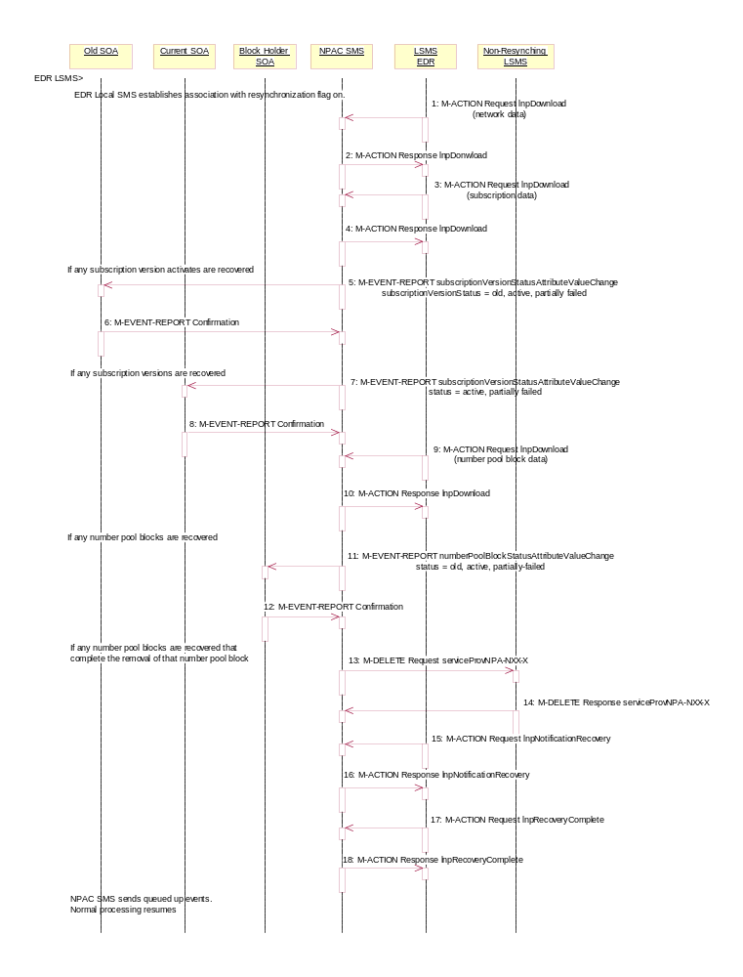
The EDR Local SMS establishes an association to the NPAC SMS with the resynchronization flag on, along with the network data management (networkDataMgmt) and data download (dataDownload) association functions set.
The NPAC SMS will queue all current activity on the NPAC SMS until the service Local SMS sends in the lnpRecoveryComplete action. All updates issued since the association establishment will be sent at the next normally scheduled retry interval.
- EDR Local SMS sends lnpDownload M-ACTION to start network data download. In this case, the Local SMS specifies the start time and end time. There are criteria other than time which may be specified. If one of the following is selected (all-network-data, all NPA-NXX-X data, a range of NPA-NXX-X data, a single NPA-NXX-X), the NPAC SMS sends the serviceProvNPA-NXX-X updates (creates, modifies, deletes) if the Local SMS’s “NPAC Customer LSMS NPA-NXX-X Indicator” in their service provider profile on the NPAC SMS states it supports the object.
- NPAC SMS responds to M-ACTION with updates.
- EDR Local SMS sends the lnpDownload M-ACTION to start subscription data download. In this case, the Local SMS specifies the start time and end time. There are criteria other than time which may be specified.
- NPAC SMS responds to M-ACTION with updates. All creates, modifies and deletes are received, a single record for each subscription version. (i.e. no ranges) The EDR Local SMS will not receive any activity on subscription versions with LNP type of ‘pool’.
- If any corrections were issued to the resyncing Local SMS that involved the activation of a subscription version with the LNP type not equal to ‘pool’, the NPAC SMS will send the M-EVENT-REPORT to the old service provider SOA with the current subscriptionVersionStatus and a list of failed Local SMSs (minus the resyncing Local SMS that no longer contains a discrepancy).
- The old service provider SOA confirms the M-EVENT-REPORT.
- If any corrections were issued to the resyncing Local SMS that involved a subscription version with the LNP type not equal to ‘pool’, the NPAC SMS will send the M-EVENT-REPORT to the current service provider SOA with the current subscriptionVersionStatus and a list of failed Local SMSs (minus the resyncing Local SMS that no longer contains a discrepancy).
- The current service provider SOA confirms the M-EVENT-REPORT.
- EDR Local SMS sends the lnpDownload M-ACTION to start number pool block data download. The Local SMS specifies the start time.
- NPAC SMS responds to M-ACTION with updates.
- NPAC SMS sends the M-EVENT-REPORTs to the block holder SOAs for any number pool block with the SOA-Origination indicator set to true whose numberPoolBlockFailed-SP-List and possibly numberPoolBlockStatus were just updated due to the number pool block download.
- Block holder SOA confirms to the M-EVENT-REPORT.
- If deletes were sent for any number pool blocks that completed the broadcast of the M-DELETEs of a number pool block and corresponding subscription versions, then the NPAC SMS will send to all other Local SMSs the M-DELETE for the serviceProvNPA-NXX-X object. The NPAC SMS will queue up the M-DELETE request for the recovering Local SMS and send it at the completion of recovery mode.
- Local SMS responds the M-DELETE.
- EDR Local SMS sends M-ACTION, lnpNotificationRecovery, to the NPAC SMS. The EDR Local SMS specifies a time range.
- NPAC SMS responds to the M-ACTION with the notification updates that occurred within the given time range.
- EDR Local SMS sends M-ACTION, lnpRecoveryComplete, to set the resynchronization flag off.
- NPAC SMS replies to the M-ACTION.

Normal processing resumes and any activity that the NPAC SMS had queued up during the recovery period will now be sent at the next scheduled retry interval.

    - Sequencing of Events on Initialization/Resynchronization of SOA

This scenario demonstrates how a SOA resynchronizes itself with the NPAC SMS. In this example, the SOA supports network data over the SOA.
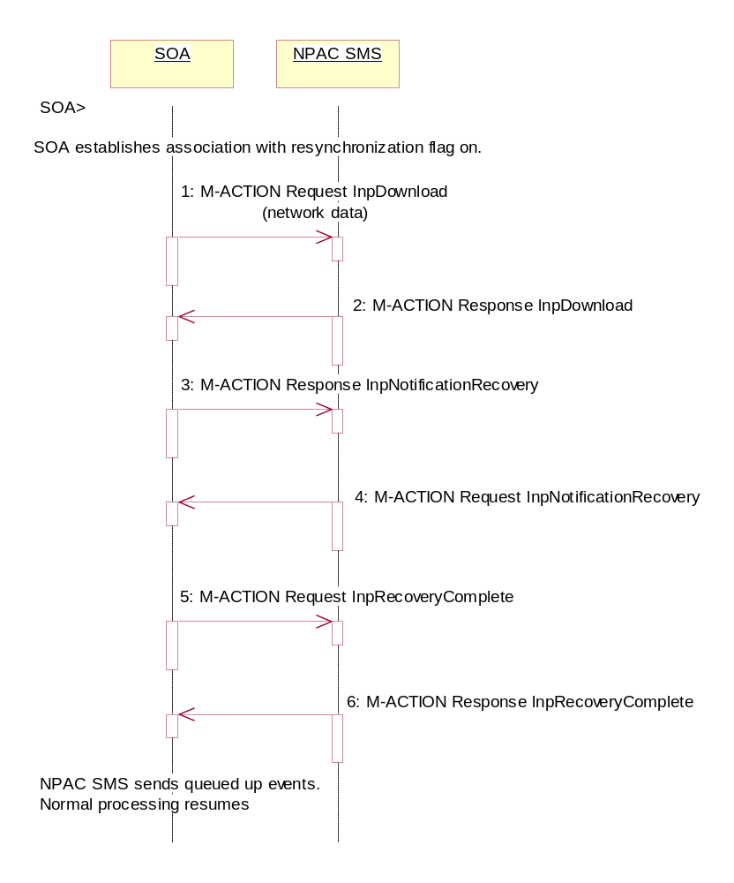
SOA takes action to resynchronize their SOA with the NPAC SMS.
The SOA establishes an association to the NPAC SMS with the resynchronization flag on, and the network data management (networkDataMgmt) association function set. The NPAC SMS will queue all current activity on the NPAC SMS until the service SOA sends in the lnpRecoveryComplete action. All updates issued since the association establishment will be sent at the next normally scheduled retry interval.
- SOA sends the lnpDownload M-ACTION to start network data download. In this case, the SOA specifies the start time and end time. There are criteria other than time which may be specified. If one of the following is selected (all-network-data, all NPA-NXX-X data, a range of NPA-NXX-X data, a single NPA-NXX-X), the NPAC SMS sends the serviceProvNPA-NXX-X updates (creates, modifies, deletes) if the SOA’s “NPAC Customer SOA NPA-NXX-X Indicator” in their service provider profile on the NPAC SMS states it supports the object.
- SOA responds to the M-ACTION with updates.
- SOA sends M-ACTION, lnpNotificationRecovery, to the NPAC SMS. The SOA specifies a time range.
- NPAC SMS responds to the M-ACTION with the notification updates that occurred within the given time range.
- SOA sends M-ACTION, lnpRecoveryComplete, to set the resynchronization flag off.
- NPAC SMS replies to the M-ACTION.
Any activity that the NPAC SMS had queued up during the recovery period will now be sent.
Normal processing resumes and any activity that the NPAC SMS had queued up during the recovery period will now be sent at the next scheduled retry interval.

- SOA establishes association with resynchronization flag on.
- Local SMS sends M-ACTION to start network data download. The Local SMS specifies the criteria.
- NPAC SMS responds to M-ACTION with updates.
- SOA sends M-ACTION to recovery notifications by time range.
- NPAC SMS responds to M-ACTION with notification updates.
- SOA sends M-ACTION to set resynchronization flag off.
- NPAC SMS replies with to the M-ACTION.
- Normal processing resumes and any activity that the NPAC SMS had queued upduring the recovery period will now be sent.

Miscellaneous

SOA/Local SMS Notification of Scheduled NPAC Downtime
This scenario shows SOA/Local SMS notification of scheduled NPAC downtime.
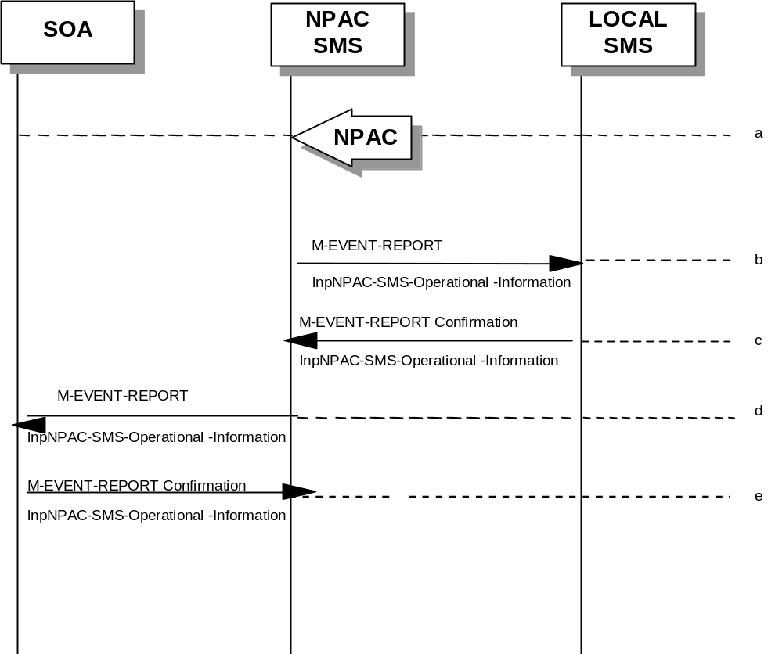
- Action is taken by NPAC SMS personnel to schedule downtime for the NPAC SMS system
- The NPAC SMS sends an lnpNPAC-SMS-Operational-Information M-EVENT-REPORT to the Local SMSs.
- The Local SMSs respond by sending an lnpNPAC-SMS-Operational-Information M-EVENT-REPORT confirmation back to the NPAC SMS.
- The NPAC SMS sends an lnpNPAC-SMS-Operational-Information M-EVENT-REPORT to all SOAs.
- The SOA(s) respond by sending an lnpNPAC-SMS-Operational-Information M-EVENT-REPORT confirmation back to the NPAC SMS.

NPA-NXX Split
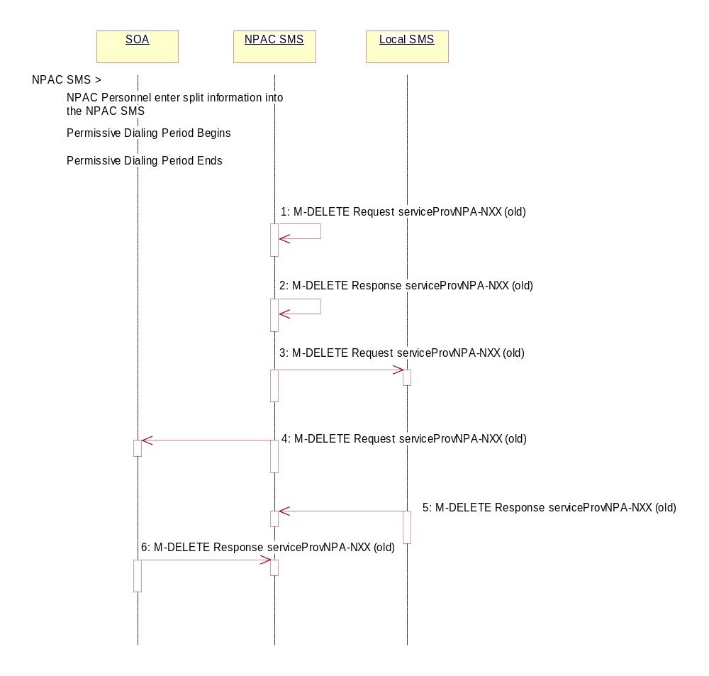
This scenario shows NPAC SMS personnel initiation of an NPA-NXX split that does not involve a Number Pool Block object.

Action is taken by the NPAC SMS personnel to create an NPA-NXX split.

- The old NPA-NXX exists and is past the effective date of the object.
The NPA-NXX owner service provider first creates the new NPA-NXX. The effective date of the NPA-NXX should be the same as the start of permissive dialing.
The NPAC personnel enter the split information for the old and new NPA-NXX. The date for the start of permissive dialing should be the same as the effective date of the new NPA-NXX object that was just created.
The permissive dialing period begins.
The NPAC SMS updates all subscription version records in its local database that are affected by the NPA-NXX Split. The TN field will be updated with the new NPA. Internal mapping between the old and new NPA-NXXs for the TNs is maintained.
The NPAC SMS accepts requests involving the old and new NPA-NXX values but only broadcasts using the new NPA-NXX value.
The permissive dialing period expires.

- NPAC SMS deletes the old serviceProvNPA-NXX object locally.
- NPAC SMS responds to the M-DELETE.
- The NPAC SMS sends individual M-DELETE for all the old serviceProvNPA-NXX objects to the Local SMSs who are accepting downloads for this NPA-NXX.
- At the same time as step 7, the NPAC SMS sends individual M-DELETE for all the old serviceProvNPA-NXX objects to the SOAs who are accepting downloads for this NPA-NXX.
- The Local SMS responds to the M-DELETE.
- The SOA responds to the M-DELETE.
The NPAC SMS updates all subscription version records in its local database that match the specified TN range by updating the TN value for each object and removing the internal field.
All Local SMS, SOA and NPAC SMS will now use the new NPA-NXX for all requests
.

NPA-NXX Split that contains a block of pooled TNs Part 1 (previously NNP flow 7)
In this scenario, the NPAC SMS personnel initiate an NPA-NXX split that contains a block of pooled TNs.

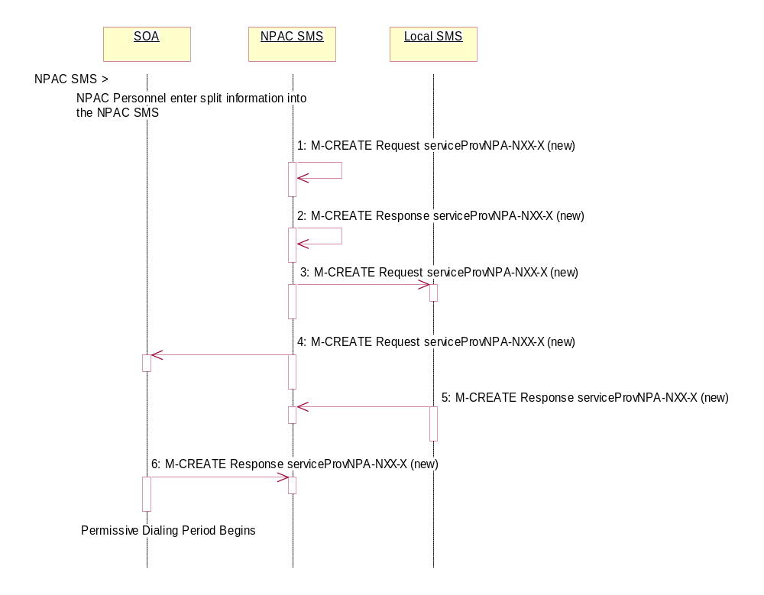
Action is taken by NPAC SMS personnel to perform an NPA-NXX split.
The old NPA-NXX and NPA-NXX-X exist and are past the effective date of the objects.
The NPA-NXX owner service provider first creates the new NPA-NXX. The effective date of the NPA-NXX should be the same as the start of permissive dialing.
The NPAC personnel enter the split information for the old and new NPA-NXX. The date for the start of permissive dialing should be the same as the effective date of the new NPA-NXX object that was just created.
- The NPAC SMS automatically creates the new serviceProvNPA-NXX-X objects with the effective date equal to the date of the start of permissive dialing.
- The NPAC SMS responds to the M-CREATE.
- The NPAC SMS broadcasts each serviceProvNPA-NXX-X M-CREATE to the Local SMSs that support the object according to their NPAC Customer LSMS NPA-NXX-X Indicator in their service provider profile on the NPAC SMS.
- At the same time as step 3, the NPAC SMS broadcasts each serviceProvNPA-NXX-X M-CREATE to the SOAs that support the object according to their NPAC Customer SOA NPA-NXX-X Indicator in their service provider profile on the NPAC SMS.
- The Local SMS responds to the M-CREATE request.
- The SOA responds to the M-CREATE request.
The NPAC SMS updates all subscription version and number pool block records in its local database that match the specified TN range. The TN or NPA-NXX-X field will be updated with the new NPA and a data field internal to the NPAC SMS will be set to the previous TN or NPA-NXX-X value (old NPA).
The permissive dialing period starts.
During the permissive dialing period, the NPAC SMS accepts requests involving the old and new NPA-NXX values according to the following rules:
- For subscription versions and number pool blocks, the NPAC SMS will accept either the new or old NPA-NXX value, but only broadcast using the new NPA-NXX value.
- The creation of a new serviceProvNPA-NXX-X object using either the old or new NPA-NXX value, but the NPAC SMS will create and broadcast both the old and new serviceProvNPA-NXX-X object creations to those service providers who support the serviceProvNPA-NXX-X object according to their NPAC Customer LSMS NPA-NXX-X Indicator in their service provider profile on the NPAC SMS.
- If a serviceProvNPA-NXX-X is to be removed (de-pooled), the NPAC SMS will broadcast the M-DELETEs for both the old and new serviceProvNPA-NXX-X objects.
- The removal of a NXX from the NPA-NXX split will cause the broadcast of the M-DELETE of the new serviceProvNPA-NXX-X object to the Local SMSs.
The permissive dialing period continues into the next flow.

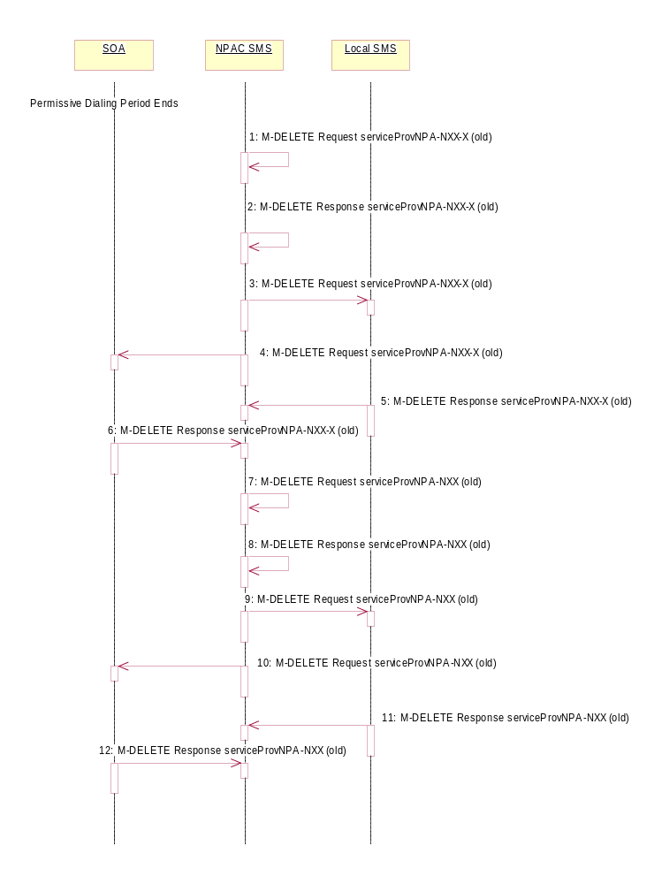
NPA-NXX Split that contains a block of pooled TNs Part 2 (previously NNP flow 7)
The Permissive Dialing Period is in progressive for an NPA-NXX split. This flow shows what occurs at the end of the Permissive Dialing Period.

The permissive dialing period expires.
- NPAC SMS deletes the old serviceProvNPA-NXX-X object locally.
- NPAC SMS responds to the M-DELETE.
- The NPAC SMS sends individual M-DELETE for all the old serviceProvNPA-NXX-X objects to the Local SMSs who are supporting the object according to the NPAC Customer LSMS NPA-NXX-X Indicator in their service provider profile on the NPAC SMS.
- At the same time as step 3, the NPAC SMS sends individual M-DELETE for all the old serviceProvNPA-NXX-X objects to the SOAs who are supporting the object according to the NPAC Customer SOA NPA-NXX-X Indicator in their service provider profile on the NPAC SMS.
- The Local SMS responds to the M-DELETE.
- The SOA responds to the M-DELETE.
- NPAC SMS deletes the old serviceProvNPA-NXX object locally.
- NPAC SMS responds to the M-DELETE.
- The NPAC SMS sends individual M-DELETE for all the old serviceProvNPA-NXX objects to the Local SMSs who are supporting downloads of the object according to their NPA-NXX filters on the NPAC SMS.
- At the same time as step 9, the NPAC SMS sends individual M-DELETE for all the old serviceProvNPA-NXX objects to the SOAs who are supporting the object according to their NPA-NXX filters on the NPAC SMS.
- The Local SMS responds to the M-DELETE.
- The SOA responds to the M-DELETE.

The NPAC SMS updates all subscription version and number pool block records in its local database that match the specified TN range by updating the TN or NPA-NXX-X value for each object and removing the internal field.
All Local SMS, SOA and NPAC SMS will now use the new NPA-NXX and NPA-NXX-X for all requests.

Mass Update
NPAC SMS personnel can perform a mass update on subscription data.
- Action is taken by the NPAC SMS personnel to request that a mass update be performed on active subscription data.
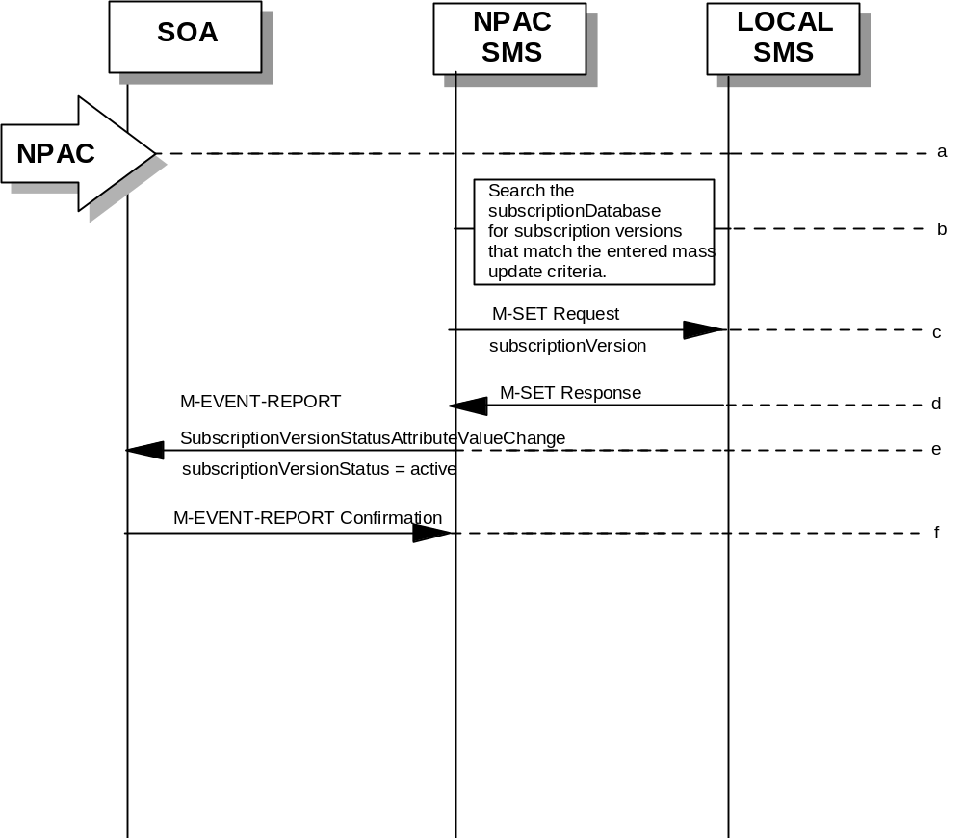
- Search the subscription database for subscription versions that match the specified mass update criteria. Perform steps c-through-f for the allowable range of subscription versions. The NPAC logs as errors subscription versions that match the mass update criteria but are in the wrong state.
- The NPAC SMS sends an M-SET on the subscription versions to the Local SMS, that is accepting downloads for the NPA-NXX of the subscription versions.
- The Local SMS replies to the M-SET.
- The NPAC SMS sends a statusAttributeValueChange M-EVENT-REPORT to the current service provider SOA.
- The service provider SOA sends a confirmation to the M-EVENT-REPORT.

Mass Update for a range of TNs that contains a Number Pool Block (previously NNP flow 8)
In this scenario, the NPAC SMS personnel perform a mass update on a range of TNs that includes a number pool block object.
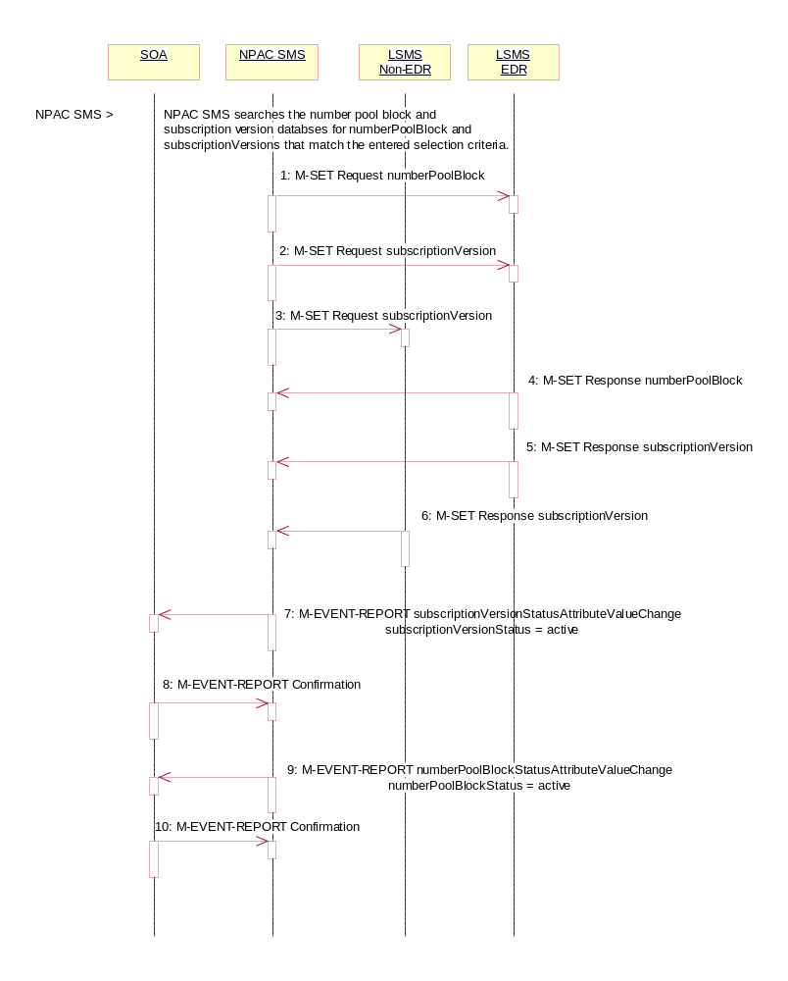

Action is taken by NPAC SMS personnel to perform a mass update.
The NPAC SMS may specify the service provider ID, LNP type and TN-Range in its selection criteria. The LNP type can be restricted as only LISP, only LSPP, only POOL, or none (which would then include all three types).
The NPAC SMS can update only the routing information (LRN, DPC and SSN data).
If the LNP type includes ‘pool’ TNs, the TN-Range specified must include a number pool block’s entire TN-Range.
The NPAC SMS searches the number pool block and subscription version databases for the objects that match the selection criteria. For all objects that match the criteria, the following occurs:
- NPAC SMS sends the M-SET for the number pool block objects to the EDR Local SMSs who are accepting updates for the NPA-NXX.
- NPAC SMS sends the M-SET, scope and filtered for the appropriate criteria, for the non-pooled subscription version updates to the EDR Local SMS who are accepting updates for the NPA-NXX.
- NPAC SMS sends the M-SET, scope and filtered for the appropriate criteria, for the subscription version updates to the non-EDR Local SMSs who are accepting updates for the NPA-NXX.
- EDR Local SMS responds to the M-SET for the number pool block object.
- EDR Local SMS responds to the M-SET for the subscription versions.
- Non-EDR Local SMS responds to the M-SET for the subscription versions.
- NPAC SMS sends the M-EVENT-REPORT subscriptionVersionStatusAttributeValueChange to the current service provider SOA for any subscription versions, not of LNP type set to ‘pool’, that were updated to a status of ‘active’.
- SOA confirms the M-EVENT-REPORT.
- NPAC SMS sends the M-EVENT-REPORT numberPoolBlockStatusAttributeValueChange for the status being set to ‘active’ to the block holder service provider SOA for any number pool block objects updated to a status of ‘active’ if the numberPoolBlockSOA-Origination indicator is ‘TRUE’.
- SOA confirms the M-EVENT-REPORT.

