Wireless Number Portability Subcommittee
Inter-carrier Test Plan

Draft

TABLE OF CONTENTS
SECTION 1 6
1.0 Introduction 6
1.1 Scope and Purpose 7
1.2 Assumptions 8
2 Internal Testing Requirements 9
2.1 Network Interconnections 9
2.2 Provisioning Guidelines for Information Exchange 10
3 Test Planning 11
3.1 Test Setup 11
3.2 TEST EXECUTION 13
3.3 Establish Test Accounts 14
3.4 Timeline 15
SECTION 4 16
4.0 Interface and Provisioning Processes 17
4.0.1 Fax Interfaces 17
4.0.2 Electronic Interfaces 18
4.0.3 Conflict Resolution Process 19
4.0.3 Cancel Order (Port in Progress) NSP Notified 20
4.0.4 Cancel Order (Port in Progress) OSP Notified 21
4.0.5 Disconnect Ported Subscribers Service 22
4.0.6 Port Wireline TN to Wireless Carrier 24
4.0.7 Port Wireless TN to Wireline Carrier 25
4.0.8 Port to Original 26
4.0.9 Notification and validations of customer information for an 27
incoming Single Line Port using WPR. 27
4.0.10 Notification and validations of customer information for an 28
incoming Single Line Port using WPR with reject. 28
4.0.11 Notification and validations of customer information for an 29
outgoing Single Line Port using WPR. 29
4.0.12 Notification and validations of customer information for an 30
outgoing Single Line Port using WPR with reject. 30
4.0.13 Notification and validations of customer information for a 31
wireless Single Line Port-in using LSR / FOC. 31
4.0.14 Notification and validations of customer information for a 32
wireless Single Line Port-in using LSR / FOC with reject. 32
4.0.15 Notification and validations of customer information for a 33
wireless Single Line Port-out using LSR / FOC. 33
4.0.16 Notification and validations of customer information for an 34
Wireless Single Line Port using LSR / FOC with reject. 34
4.1 WIRELESS / WIRELESS 35
4.1.1 Local Ported Wireless Subscriber calling another Ported Wireless Subscriber with same NETWORK PROVIDER in same LATA. (SEE APPENDIX B DRAWING E) 35
4.1.2 Local Ported Wireless Subscriber calling Non-Ported Wireless Subscriber with same NETWORK PROVIDER in same LATA. (SEE APPENDIX B DRAWING E) 36
4.1.3 Local Non-Ported Wireless Subscriber calling a Ported Wireless Subscriber with same NETWORK PROVIDER in the same LATA. (SEE APPENDIX B DRAWING E) 37
4.1.4 Local Non-Ported Wireless Subscriber calling another Non-Ported Wireless Subscriber with same NETWORK PROVIDER in same LATA. (SEE APPENDIX B DRAWING E) 38
4.1.5 Local Ported Wireless Subscriber calling another Ported Wireless Subscriber with different NETWORK PROVIDER in same LATA. (SEE APPENDIX B DRAWING E) 39
4.1.6 Local Ported Wireless Subscriber calling Non-Ported Wireless Subscriber with different NETWORK PROVIDER in same LATA. (SEE APPENDIX B DRAWING E) 40
4.1.7 Local Non-Ported Wireless Subscriber calling a Ported Wireless Subscriber with different NETWORK PROVIDER in same LATA. (SEE APPENDIX B DRAWING E) 41
4.1.8 Local Non-Ported Wireless Subscriber calling a Non-Ported Wireless Subscriber with different NETWORK PROVIDER in same LATA. (SEE APPENDIX B DRAWING E) 42
4.1.9 Local Ported Wireless Subscriber calling another Wireless Ported Subscriber with same NETWORK PROVIDER in a different LATA. (SEE APPENDIX B DRAWING F) 43
4.1.10 Local Ported Wireless Subscriber calling Non-Ported Wireless Subscriber with same NETWORK PROVIDER in a different LATA. (SEE APPENDIX B DRAWING F) 44
4.1.11 Local Non-Ported Wireless Subscriber calling a Ported Wireless Subscriber with same NETWORK PROVIDER in a different LATA. (SEE APPENDIX B DRAWING F) 45
4.1.12 Local Non-Ported Wireless Subscriber calling another Non-Ported Wireless Subscriber with same NETWORK PROVIDER in a different LATA. (SEE APPENDIX B DRAWING F) 46
4.1.13 Local Ported Wireless Subscriber calling another Ported Wireless Subscriber with different NETWORK PROVIDER in a different LATA. (SEE APPENDIX B DRAWING G) 47
4.1.14 Local Ported Wireless Subscriber calling Non-Ported Wireless Subscriber with different NETWORK PROVIDER in a different LATA. (SEE APPENDIX B DRAWING G) 48
4.1.15 Local Non-Ported Wireless Subscriber calling a Ported Wireless Subscriber with different NETWORK PROVIDER in a different LATA. (SEE APPENDIX B DRAWING G) 49
4.1.16 Local Non-Ported Wireless Subscriber calling a Non-Ported Wireless Subscriber with different NETWORK PROVIDER in a different LATA. (SEE APPENDIX B DRAWING G) 50
4.1.17 Roaming Ported Wireless Subscriber calling another Ported Wireless Subscriber with same NETWORK PROVIDER in same LATA. (SEE APPENDIX B DRAWING A) 51
4.1.18 Roaming Ported Wireless Subscriber calling Non-Ported Wireless Subscriber with same NETWORK PROVIDER in same LATA. (SEE APPENDIX B DRAWING A) 52
4.1.19 Roaming Non-Ported Wireless Subscriber calling a Ported Wireless Subscriber with same NETWORK PROVIDER in the same LATA. (SEE APPENDIX B DRAWING A) 53
4.1.20 Roaming Non-Ported Wireless Subscriber calling another Non-Ported Wireless Subscriber with same NETWORK PROVIDER in same LATA. (SEE APPENDIX B DRAWING A) 54
4.1.21 Roaming Ported Wireless Subscriber calling another Ported Wireless Subscriber with different NETWORK PROVIDER in same LATA. (SEE APPENDIX B DRAWING B) 55
4.1.22 Roaming Ported Wireless Subscriber calling Non-Ported Wireless Subscriber with different NETWORK PROVIDER in same LATA. (SEE APPENDIX B DRAWING B) 56
4.1.23 Roaming Non-Ported Wireless Subscriber calling a Ported Wireless Subscriber with different NETWORK PROVIDER in same LATA. (SEE APPENDIX B DRAWING B) 57
4.1.24 Roaming Non-Ported Wireless Subscriber calling a Non-Ported Wireless Subscriber with different NETWORK PROVIDER in same LATA. (SEE APPENDIX B DRAWING B) 58
4.1.25 Roaming Ported Wireless Subscriber calling another Ported Wireless Subscriber with same NETWORK PROVIDER in their home LATA. (SEE APPENDIX B DRAWING C) 59
4.1.26 Roaming Ported Wireless Subscriber calling Non-Ported Wireless Subscriber with same NETWORK PROVIDER in their home LATA. (SEE APPENDIX B DRAWING C) 60
4.1.27 Roaming Non-Ported Wireless Subscriber calling a Ported Wireless Subscriber with same NETWORK PROVIDER in their home LATA. (SEE APPENDIX B DRAWING C) 61
4.1.28 Roaming Non-Ported Wireless Subscriber calling another Non-Ported Wireless Subscriber with same NETWORK PROVIDER in their home LATA. (SEE APPENDIX B DRAWING C) 62
4.1.29 Roaming Ported Wireless Subscriber calling another Ported Wireless Subscriber with different NETWORK PROVIDER in their home LATA. (SEE APPENDIX B DRAWING D) 63
4.1.30 Roaming Ported Wireless Subscriber calling Non-Ported Wireless Subscriber with different NETWORK PROVIDER in their home LATA. (SEE APPENDIX B DRAWING D) 64
4.1.31 Roaming Non-Ported Wireless Subscriber calling a Ported Wireless Subscriber with different NETWORK PROVIDER in their home LATA. (SEE APPENDIX B DRAWING D) 65
4.1.32 Roaming Non-Ported Wireless Subscriber calling a Non-Ported Wireless Subscriber with different NETWORK PROVIDER in their home LATA. (SEE APPENDIX B DRAWING D) 66
4.1.33 Roaming Non Ported Wireless Subscriber calling a Roaming Ported Wireless Subscriber with same NETWORK PROVIDER in same LATA. (SEE APPENDIX B DRAWING A) 67
4.1.34 Roaming Ported Wireless Subscriber calling a Roaming Ported Wireless Subscriber with same NETWORK PROVIDER in same LATA. (SEE APPENDIX B DRAWING A) 68
4.1.35 Roaming Non Ported Wireless Subscriber calling a Roaming Non Ported Wireless Subscriber with same NETWORK PROVIDER in same LATA. (SEE APPENDIX B DRAWING A) 69
4.1.36 Roaming Ported Wireless Subscriber calling a Non Ported Wireless Subscriber with same NETWORK PROVIDER in same LATA. (SEE APPENDIX B DRAWING A) 70
4.2 WIRELESS / WIRELINE 71
4.2.1 Local Ported Wireless Subscriber calling Ported Wireline Subscriber in same LATA. (SEE APPENDIX B DRAWING E) 71
4.2.2 Local Ported Wireless Subscriber calling Wireline Non-Ported Subscriber in same LATA. (SEE APPENDIX B DRAWING E) 72
4.2.3 Local Non-Ported Wireless Subscriber calling a Ported Wireline Subscriber in same LATA. (SEE APPENDIX B DRAWING E) 73
4.2.4 Local Non-Ported Wireless Subscriber calling a Non-Ported Wireline Subscriber in same LATA. (SEE APPENDIX B DRAWING E) 74
4.2.5 Local Ported Wireless Subscriber calling Ported Wireline Subscriber in a different LATA. (SEE APPENDIX B DRAWING F) 75
4.2.6 Local Ported Wireless Subscriber calling Wireline Non-Ported Subscriber in a different LATA. (SEE APPENDIX B DRAWING F) 76
4.2.7 Local Non-Ported Wireless Subscriber calling a Ported Wireline Subscriber in a different LATA. (SEE APPENDIX B DRAWING F) 77
4.2.8 Local Non-Ported Wireless Subscriber calling a Non-Ported Wireline Subscriber in a different LATA. (SEE APPENDIX B DRAWING F) 78
4.2.9 Roaming Ported Wireless Subscriber calling Ported Wireline Subscriber in same LATA. (SEE APPENDIX B DRAWING A) 79
4.2.10 Roaming Ported Wireless Subscriber calling Wireline Non-Ported Subscriber in same LATA. (SEE APPENDIX B DRAWING A) 80
4.2.11 Roaming Non-Ported Wireless Subscriber calling a Ported Wireline Subscriber in same LATA. (SEE APPENDIX B DRAWING A) 81
4.2.12 Roaming Non-Ported Wireless Subscriber calling a Non-Ported Wireline Subscriber in same LATA. (SEE APPENDIX B DRAWING A) 82
4.2.13 Roaming Ported Wireless Subscriber calling Ported Wireline Subscriber in the roamer’s home LATA. (SEE APPENDIX B DRAWING C) 83
4.2.14 Roaming Ported Wireless Subscriber calling Wireline Non-Ported Subscriber in their home LATA. (SEE APPENDIX B DRAWING C) 84
4.2.15 Roaming Non-Ported Wireless Subscriber calling a Ported Wireline Subscriber in their home LATA. (SEE APPENDIX B DRAWING C) 85
4.2.16 Roaming Non-Ported Wireless Subscriber calling a Non-Ported Wireline Subscriber in their home LATA. (SEE APPENDIX B DRAWING C) 86
4.3 WIRELINE / WIRELESS 87
4.3.1 Ported Wireline Subscriber calling Local Ported Wireless Subscriber in same LATA. (SEE APPENDIX B DRAWING E) 87
4.3.2 Local Ported Wireline Subscriber calling Wireless Non-Ported Subscriber in same LATA. (SEE APPENDIX B DRAWING E) 88
4.3.3 Local Non-Ported Wireline Subscriber calling a Ported Wireless Subscriber in same LATA. (SEE APPENDIX B DRAWING E) 89
4.3.4 Local Non-Ported Wireline Subscriber calling a Non-Ported Wireless Subscriber in same LATA. (SEE APPENDIX B DRAWING E) 90
4.3.5 Local Ported Wireline Subscriber calling Ported Wireless Subscriber in a different LATA. (SEE APPENDIX B DRAWING F) 91
4.3.6 Local Ported Wireline Subscriber calling Wireless Non-Ported Subscriber in a different LATA. (SEE APPENDIX B DRAWING F) 92
4.3.7 Local Non-Ported Wireline Subscriber calling a Ported Wireless Subscriber in a different LATA. (SEE APPENDIX B DRAWING F) 93
4.3.8 Local Non-Ported Wireline Subscriber calling a Non-Ported Wireless Subscriber in a different LATA. (SEE APPENDIX B DRAWING F) 94
4.3.9 Roaming Ported Wireline Subscriber calling Ported Wireless Subscriber in same LATA. (SEE APPENDIX B DRAWING A) 95
4.3.10 Roaming Ported Wireline Subscriber calling Wireless Non-Ported Subscriber in same LATA. (SEE APPENDIX B DRAWING A) 96
4.3.11 Roaming Non-Ported Wireline Subscriber calling a Ported Wireless Subscriber in same LATA. (SEE APPENDIX B DRAWING A) 97
4.3.12 Roaming Non-Ported Wireline Subscriber calling a Non-Ported Wireless Subscriber in same LATA. (SEE APPENDIX B DRAWING A) 98
4.3.13 Roaming Ported Wireline Subscriber calling Ported Wireless Subscriber in the roamer’s home LATA. (SEE APPENDIX B DRAWING C) 99
4.3.14 Roaming Ported Wireline Subscriber calling Wireless Non-Ported Subscriber in their home LATA. (SEE APPENDIX B DRAWING C) 100
4.3.15 Roaming Non-Ported Wireline Subscriber calling a Ported Wireless Subscriber in their home LATA. (SEE APPENDIX B DRAWING C) 101
4.3.16 Roaming Non-Ported Wireline Subscriber calling a Non-Ported Wireless Subscriber in their home LATA. (SEE APPENDIX B DRAWING C) 102
4.4 Enhanced Services 103
4.4.1 911 Call From a Ported Wireless Number (E-911 Phase 1 and Phase 2) NOTE: 911 Calls Are Made Using A 911 Access Tandem to PSAP. However, any other existing architecture should be tested. (SEE APPENDIX B DRAWING H1 & H2) 103
4.4.2 An Operator Assisted (0- and 0+) Intra LATA Call from a Ported-In Number to a Ported-Out Number with Originating LRN obtained from LNP Database (SEE APPENDIX B DRAWING SE1) 104
4.4.3 Alternately Billed call placed from a Ported-In Number to a Ported-Out Number with Originating LRN obtained from LNP Database. (SEE APPENDIX B DRAWING SE2) 105
4.4.4 Operator service call (0+ and 0-) from a Porter number to a Ported number on Different Networks. (SEE APPENDIX B DRAWING SE6) 106
APPENDICES 107
APPENDIX A The Test Matrix 107
APPENDIX B Drawings that support each Test Script 108
APPENDIX C Checklist for Entry for use by the individual companies 120
APPENDIX D Checklist for Exit 123
APPENDIX E Test Successful Criteria, completion documents (Suggested) 124
APPENDIX F Related documents (i.e. NIIF, Interoperability Issues, status) 125
APPENDIX G Glossary of Terms 125

SECTION 1

1.0 Introduction
The Wireless Inter Carrier Test Plan was developed using inputs from participating companies to test the Location Routing Number (LRN) solution for Wireless Local Number Portability (WLNP).
The Test Plan is written to evaluate the ability of Service Providers (SPs) to implement LNP. The focus of the Test Plan is to ensure conformance of individual, proprietary networks to industry LNP standards. As well as, the compatibility of those proprietary networks with each other in the LNP environment. This includes associated support systems, business arrangements, and interface agreements. The intent of the Test Plan is to ensure that the customer does not encounter any disruption or degradation of service when porting mobile directory numbers (MDN) from one service provider to another service provider.
The Test Plan contains a series of tests cases used to ensure that the porting of mobile directory numbers to or from a wireless service provider using the LRN solution will be successful. The Test Plan includes the porting of simulated live customers between Service Providers. This is accomplished by establishing test numbers and using existing or new porting processes. Using existing or newly established porting processes for testing will ensure that each Service Provider’s internal processes and support systems will support LNP. This plan includes testing of porting between two wireless service providers as well as porting between wireline and wireless service providers. Any potentially destructive tests should be performed in a lab or another internal environment and not performed between Service Providers.

1.0.1 Intra-Company Testing
Intra-company testing should utilize the internal environment specific to each Service Provider. The internal tests must be conducted with sufficient depth to ensure that the various elements are functioning properly before testing begins between Service Providers. The internal network testing environments will allow the simulation of anticipated inter-company situations as a means of avoiding failures when actual interconnection is achieved. Adherence to currently accepted network architectures and standards for processing calls in a non-ported environment must be retained in a portability environment.
Company-specific intra-company testing should be completed prior to inter-company testing (see Section 1.0.2). Each company will confirm its completion of intra-company testing and its readiness to participate in inter-company testing by providing a written memo to their Test Coordinator.
Once the intra-company testing of affected nodes and network, and the certification testing with the Number Portability Administration Center (NPAC) is successfully completed, the Test Coordinator will schedule inter-company testing. Prior to initiating the inter-company testing, all intra-company testing must be completed by the individual Service Providers.

1.0.2 Inter-Company Testing
The inter-company testing will be organized according to the availability of the Service Provider participants and will be coordinated by their Test Coordinators. Each Service Provider will conduct a set of test scripts between itself and another service provider. Specific combinations of participants will be determined by the participants themselves, using the recommended list defined in Section 3. All selected tests should be satisfactorily completed before a Service Providers attempt to implement LNP. Participants may choose to run additional tests developed by individual Service Provider combinations that address any specific needs, architectures or business arrangements of the testing partners.
Service Providers participating in a particular location will negotiate for test partners and test selections. Their Test Coordinators will manage this process by developing a master test schedule and track the testing done in each location by each Service Provider.

1.1 Scope and Purpose
This document defines Wireless Number Portability Sub Committee’s (WNPSC) recommendations for inter-service provider LNP testing between wireless and wireless service providers, and wireless and wireline service providers. These recommendations are limited to defining the testing recommended to validate the business processes and call completion between Service Providers. The testing and validating of an individual company’s internal systems and processes is explicitly outside the scope of this document.

Vertical Services
There are vertical services that are impacted by the porting of numbers. This issue is not within the scope of this document. The responsibility for the testing of these services shall be addressed in the service level agreements made between individual service providers.
A “black box” testing approach will be used for inter-company testing. Black box testing implies that the tester is not concerned with what is inside the black box. Instead, the testing validates that the black box functions and interfaces with the outside world as specified. When applied to inter-company LNP testing, the black box approach means we will validate the interactions between SPs but not delve into the internal systems or processes of the SPs. Additionally, this test plan only addresses LNP functionality between SPs. Validation of processes that were in place prior to the implementation of LNP will only be addressed to the extent that they impact LNP or are impacted by LNP. Additionally, interactions between SPs and their vendors or third party network service providers are considered part of an SPs internal processes and are outside the scope of the inter-company test team. The test cases and validation points in this test plan are defined to address LNP systems and processes between Service Providers.
Service Provider Scope: This document addresses portability between wireless carriers and between wireline and wireless carriers. Because the issues and processes for porting between wireless and wireline carriers are significantly different than for porting between wireless carriers, this document will define them in separate sections as required.
While the focus of this test plan is on facility-based service providers, participation from resellers in testing is welcome. The participation of resellers may require the addition of new test cases or modification to existing test cases.
Third parties who provide network services for telecommunications providers are represented in this testing by the telecommunications SPs whom they support. This does not preclude third parties from participating in test planning sessions or in test execution, but the industry test team will not monitor or report on the performance of the third party directly. It is the responsibility of each telecommunications SP to get the appropriate support from any network service provider they require, to track and resolve any issues they have with their 3rd party providers. As an example, if a SP uses a third party network services provider’s LNP database, and that database is not receiving porting updates, the testing team will look to the telecommunications SP to facilitate a resolution and inform the test team when the problem is resolved.
The concept of a service provider being responsible for their 3rd party services support extends to the relationship between the NPAC and SPs or other 3rd party LNP database providers. Testing of functionality between the NPAC and companies who get LNP data directly from the NPAC is facilitated by the NPAC and managed in a separate forum.
Vendors of telecommunications equipment are specifically outside the scope of this test plan. The functioning of network elements is considered an internal issue for each company.
Business Function Scope: The following inter-service provider functions are impacted by LNP and are included in the test validations:
- Porting Order Exchange
- Service Provisioning
- Exception Processing – Order Cancellation
- Disconnected TN Snapback
- Call Flows
- 911 Call Back
- Operator Services
- Inter-Service Provider Billing

1.2 Assumptions

- Service providers are responsible for testing their internal systems and processes prior to inter-company testing. Any problems identified during internal testing should be resolved prior to external testing. (Internal system’s problems which can be overcome with workaround processes need not be resolved nor disclosed in order to participate in inter-company testing. However, companies should validate that any workaround process satisfies the external requirements.)
- Production personnel will be used for testing all porting processes.
- Prior to proceeding with the LNP capability verification the preliminary evaluation has been successfully completed on all participating nodes and equipment. This is done to ensure that nodes being placed in service have been manufactured and configured in compliance with recognized industry standards.
- The interaction between the NPAC and LSMS must allow for the transfer of all routing information furnished and required for the EOs / MSCs to process and route calls in an LNP environment.
- The interactions between Service Providers must allow for the transfer of all information via agreed upon communication channels, that is, passing the information required for directory numbers to be ported. Third party and other vendor support provided for a particular Service Provider should be transparent to the testing partner and is the responsibility of that Service Provider.
- Basic billing structures are proprietary to each company.
- Organizations must have internal processes capable of providing all administrative elements, the required data needed to port subscribers.
- Wireline carriers will not participate in wireless to wireless testing.
- Resellers are considered as another service provider. Any resellers who wish to participate in testing are welcome. It is not the responsibility of a facility-based service provider to ensure the participation of companies who resell their services.
- The test conditions contained within this document are based on the NANC process flows. All carriers participating in inter-carrier testing should have access to the NANC process flows.
- The Wireless Inter-carrier Test Plan does not include test cases specifically designed for multi-company testing
- Test Coordinators are responsible for disconnecting their test accounts upon the completion of testing.

2 Internal Testing Requirements

The purpose of the Requirements section is to provide network preparation guidelines for Service Providers. These requirements are designed to assist Service Providers and other interested parties involved in providing service to ported subscribers and in verifying compatibility with existing standards and are capable of processing LNP calls.
Testing of nodes and networks should be accomplished by individual Service Providers (SPs) on their own equipment, as their apparatus is installed into their working network. Testing in a risk free environment is recommended. All problems encountered during these conformance and interoperability tests should be corrected prior to testing with another SP.

2.0.1 Industry and Regulatory Requirements

The purpose of this section is to identify, and give a brief description, of the institutions, documents, and policies that have been established for LNP.

ATIS- ATIS provides uniformity in administrative and testing issues
ANSI requirements - ANSI provides the technical requirements accepted by the industry for telecommunications.
Local and National Regulatory requirements - This includes all requirements imposed by the governing bodies that define service requirements.
CTIA, other similar organizations and applicable wireless standards and requirements provide organizational direction and/or requirements.
NANC Wireless Wireline integration reports, NANC process flows- provide thorough discussion of integration issue.

2.1 Network Interconnections

Network Configurations Consideration
- Effect of launch point conflicts - Launch point conflicts can occur when a signaling node has more than one return route available from the node. An example is when a “full point code route” is directed by a cluster route.
- Gateway screening within various network - Screening in networks is used to provide security and customer control. If translations are not appropriate a STP may receive an unexpected point code and discard the message.
- Trunk screening tables should also be examined and translated to support NPA-NXX routing in an LNP environment.
- Each company should notify any third party vendors or system owners before entering into Inter-carrier tensting.

SSP
- The SSP (wireline EO, wireless MSC) must check for dialed number locally, or send a query via the STP for routing. The order of the sequencing is based upon an FCC ruling. This ability must also exist for the required call set up when ported numbers are encountered.
- Ability to assign appropriate Subsystem Numbers (SSN)
- Ability to respond with necessary announcement codes. - The SS7 environment has established the requirements for announcement codes and responses.
- Service and feature support should be tested for transparency to customer.

STP
- Must be capable of receiving all required messages and routing them to the proper network element, without any degradation to existing service.
- Must be capable of performing intermediate and final global title translations and routing correctly.
- Gateway screening is used in many networks as traffic control mechanism for the network. Screening tables if used must be modified as required to allow the proper routing of messages.

SCP
- Must be Capable of receiving and storing all LNP routing data.
- Must be capable of responding to all NPDB queries.
- Other network elements may perform these functions.

SOA /LSMS
- Prior to the implementation of LNP, Service Providers must either deploy or utilize a SOA, LSMS, Service Bureau or an internal solution.
- These systems facilitate the critical transaction flows to be exchanged between Service Providers and the NPAC SOA and master SMS database (NPAC/SMS).

2.2 Provisioning Guidelines for Information Exchange

The CTIA inter-carrier communications process, also known as the pre-port process, will be used to communicate a customer’s request to port from one wireless service provider to another.

The ATIS wireline ordering process, as defined by the Ordering and Provisioning committee of OBF, will be used to communicate a customer’s request to port, when a wireless and wireline carrier is involved.

Both processes include transmitting customer information from the New Service Provider (NSP) to the Old Service Provider (OSP) for validation. The OSP will be responsible for responding to the NSP, communicating the validation results (accept/deny). The NSP is responsible for communicating this response to the customer. However, differences exist within each process, such as port response intervals. For detailed background information, please refer to the NANC 2nd Wireless Wireline Integration report.

3 Test Planning

General

It is the intent that each company appoint a test coordinator who will be
the single point of contact for initiation of inter-company testing. In addition, one or more test managers may be assigned to facilitate the actual execution of the test plans. Below are specific responsibilities for each position

Company Contacts

A testing coordinator or point of contact will be maintained by each carrier. Information regarding this position will be shared in Wireless Operations team meetings and the National Number Portability Operations (NNPO) meetings.

3.1 Test Setup

Each Service Provider Wireless and Wireline Company will identify a Company Coordinator. If a Service Provider does not provide this information or is unwilling to, then it will be assumed that they do not wish to engage in this test exercise.
The Coordinator will be responsible for all LNP testing activities for their respective company. This may be done on a national basis, regional basis, or any other geographic basis of their choosing. This information along with names and contact telephone numbers should be made available in the various Operations Teams, the LNPAWG, or any other similar organization.
This is for company to company LNP testing and does not include any NPAC certification activities or any third party vendors. Third party vendors will be the responsibility of those companies to which services are provided.
Resellers will be treated as Service Providers and all support activities / business arrangements should be transparent to their respective test partners.
The Test Coordinator is responsible for initiating and negotiating intercarrier testing. Some companies may choose to appoint one or more Test Managers to oversee the execution of the test plan. The following section details the responsibilities of each position.

Testing Coordinator

Responsibilities:

- A dedicated resource to interact with other companies for LNP test matters.
- This person should be the single point of contact (SPOC) for other companies when intercompany testing is desired.
- The scope (nationally, per state, regionally, or other size) will be identified in the ‘Test Plan’. This may require a Coordinator for each area defined.
- A SPOC for all activities of planning and scheduling of intercompany testing.
- In the event that there is no designated Test Manager, the Test Coordinator would assume both roles listed.

Attributes:

- This person should be knowledgeable of the Public Switching Network, the Wireless (Cellular and PCS) networks and the LNP technology, as it has been implemented in the Wireline networks, and proposed for Wireless networks. This includes the NPAC ‘flows’ and the relationship with the NPAC provider required in order to provide the provisioning feature of LNP.
- Excellent communication skills with peers, senior executives and customers.
- Must be flexible in dealing with all activities in the execution of the ‘Test Plan’.
- Keeps a global focus on testing; sees the big picture.
- Previous experience in similar activities.

Test Manager

Responsibilities:

- Leads the Test Team in the execution of the ‘Test Plan’ by:

- Organizing and chairing the company specific Test Team
- Participating in the test selection process between test partners using past experience, the information furnished by the testing partners (vertical services, third party vendors, network architecture, special calling plans and any other consideration voiced by either partner).
- Scheduling the testing activities via the Test Coordinator, by test partners.
- Coordinating the actual testing by regular contact with their test partners. This includes, in the event of troubles, the decision to skip tests, reschedule tests, delete or modify tests, and any other activity to continue the flow of testing and to maintain a reasonable schedule.
- Providing regular status reports as required.

Attributes:

- This person should be knowledgeable of the Public Switching Network, the Wireless (Cellular and PCS) networks and the LNP technology, as it has been implemented in the Wireline networks, and proposed for Wireless networks . This includes the NPAC ‘flows’ and the relationship with the NPAC provider required in order to provide the provisioning feature of LNP.
- This person should posses the technical skills to assist in identifying and assist resolving conflicts.

Information Exchange

Companies should complete a form (See Appendix E)to be exchanged between the testing companies. This form will contain all contact names, telephone numbers for ordering, provisioning, maintenance (significance to be determined) and any other contacts to assist in facilitating the testing.

Communications Forum

Companies should agree upon a regularly scheduled forum to communicate progress and address any issues that may arise during testing. This may include face to face meetings, conference calls, or video conferencing.

Network Setup

The test network should be a subset of the actual network that will carry live LNP traffic. If nodes and switch types are included only for testing, it raises the obvious question about validity of the real network used for live LNP traffic. Therefore, all testing should be in the “live” network.

Test Matrix

Each company’s Test Coordinator or Test Manager will need to identify which tests they will execute as part of the negotiations. As a basis, the test matrix is included in Appendix “A” of this document. This matrix includes is intended to include all tests. If a desired test is not listed here, the testing companies should develop it and include it in the Test Plan and Test Matrix.

3.2 TEST EXECUTION
Each company, after reviewing their test selections, will establish working numbers that will support those tests selected. The individual pairs of testing companies should cooperatively accomplish this. Test scheduling will dictate the total number of test numbers that will be required. Each test number should be established with a pseudo name, valid address, and should be included in all support systems. To initiate the test plan the customer (pseudo name) will request that a test number will be ported.

Any specific interface-business agreements should be included in the above process. In the absence of any, standard industry agreements should be the norm. This includes any timing / intervals along with accepted “business flows”.

Logistics

The test partners should address the mechanics and processes for ordering / provisioning, contact numbers, billing concerns, etc.

The timelines for test execution shall be agreed to by the test partners prior to the commencement of testing.

Maintenance

Maintenance procedures will not be tested.

Trouble Resolution

Test partners should agree to the rules governing trouble resolution prior to the commencement of testing. It is recommended that any minor, quick fix problem be resolved as they are encountered. All others should noted and that this test(s) should be suspended and concluded at an agreed to time after the problem has been resolved.

Test Results Document

Each test partner should document all test results. Test results will be classified as follows:

- Completed – Test results match the expected results.
- Incomplete – Test results do not match expected results, or test not performed to the point of completion for any given reason.
- Not performed – Both companies agree not to perform a selected test.

3.3 Establish Test Accounts

Each company shall be responsible for establishing test accounts prior to the start of inter-carrier testing. A list of the MDN’s should be made available to all testing partners.

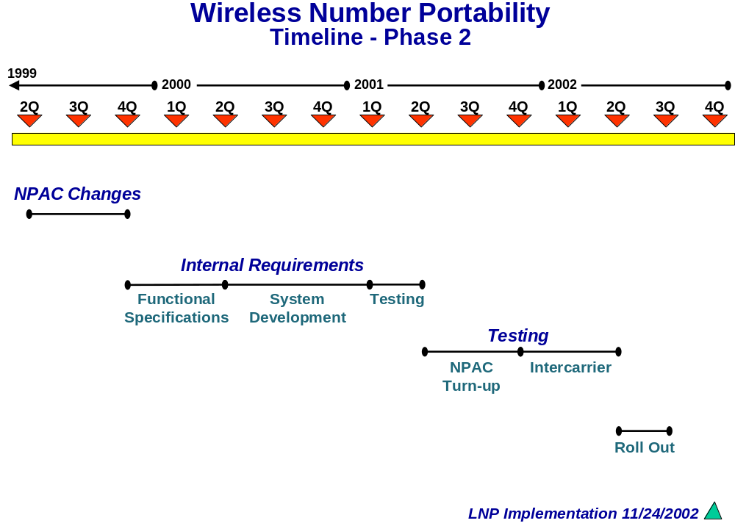
3.4 Timeline

SECTION 4
Basic Porting Processes

Basic Porting Processes Wireless and Wireline

The wireless to wireline porting tests defined in this plan are based on porting within rate centers as per the FCC First Report and Order (FCC95-116). Wireless numbers must be ported to a wireline rate center within the NPAXXX. These test cases also assume inter-carrier communications are accomplished using the current LSR (Local Service Request) requirements for porting between wireless and wireline carriers or the ICP (Intercarrier Communication Process) requirements for porting between two wireless carriers.

Wireless / Wireline and Wireless/ Wireless LNP Test Cases
Recommendations for testing to validate a wireless carrier’s ability to deliver calls to TNs that have been ported between wireline carriers are addressed in the wireline LNP testing documents. Recommendations for testing to validate wireline carriers ability to deliver calls to TNs which have been ported between wireless and wireline carriers are covered in this section.
These test cases define validation of the interfaces between carriers. Companies who wish to perform additional internal validations will manage those validations internally.
These test cases assume a bilateral testing model. That is, a wireless company A and wireline company B are testing with each other. Each pair of companies that chooses to test must negotiate the test cases and the plan to execute the test cases.

4.0 Interface and Provisioning Processes
(Service Provider – Service Provider Interfaces)
The test cases contained within this section test the communication processes between service providers, as well as the basic porting processes.

4.0.1 Fax Interfaces

Test Description:
The Test Case verifies that orders faxed to production personnel at company A and B are received at company B & A.

Test Procedure:
Production ordering personnel at company A fax a porting order to company B based on publicly available contact information. The Test Coordinator at company B informs the test coordinator at company A that the fax was received. Repeat tests from company B to company A. Document test results.

Expected Results:
- Company B Test Coordinator contacts company A test coordinator and informs them that the fax was received.
- Company A Test Coordinator contacts company B test coordinator and informs them that the fax was received.

4.0.2 Electronic Interfaces

Test Description:
Were electronic ordering interfaces exist and support porting, verify system operation. Where electronic interfaces will be used in production, they should also be used for inter-company testing.

Test Procedure:
Validation of electronic interfaces is outside the scope of this industry body. The teams responsible for the implementation and maintenance of an electronic interface should manage testing of electronic interfaces. Document test results

Expected Results:

Both test partners are able to receive and verify transactions from their respective electronic ordering interfaces.

4.0.3 Conflict Resolution Process

Test Description:
Verify that the production personnel at the OSP and the NSP understand how to use the NPAC conflict resolution process. This test models OSP placing the port into conflict for an inappropriate due date however the conflict function can be used for other types of conflict. This is a first time conflict only conflict scenario and the conflict is initiated prior to noon the business day before the Due Date. This also simulates the conflict being resolved within six (6) hours.

Test Procedure:
OSP places NSP porting request in conflict. Repeat for NSP placing OSP porting request in conflict.
- NSP sends OSP an LSR to port a TN.
- OSP sends NSP an FOC confirming the request, including the due date). (
- NSP creates an NPAC subscription version (SV) for the port.
- OSP enters a concurrence flag of “No” and designates a conflict cause code.
- NPAC changes subscription to Conflict Status and notifies both SPs.
- NSP contacts OSP to resolve the conflict. If the conflict is resolved with within six (6) business hours, the OSP only notifies the NPAC of “conflict off”. (If test scenario changes to conflict resolved after six (6) hours, either the OSP or the NSP can notify the NPAC of “conflict off”.)
- NPAC notifies both SPs of conflict off, change in subscription version status, via the interface (SOA or LTI).
- The porting process resumes as normal and the port proceeds to completion
- Document Test Results

Expected Results:
- NSP personnel contact the appropriate personnel at OSP to resolve and have the conflict status removed from the subscription version.
- OSP personnel contact the appropriate personnel at company B and have the conflict status removed from the subscription version.
- The TN is activated on the new agreed to due date.

4.0.3 Cancel Order (Port in Progress) NSP Notified

Test Description:

- Subscriber notifies NSP of desire to change carrier
- NSP processes request to port number
- Subscriber changes mind and cancels change order prior to activation only. (After activation a new port must occur.)

Test Procedure:

- Subscriber notifies NSP of desire to port to a new carrier

- NSP notifies NPAC and OSP of porting activity using provisioning process flow. Subscriber subsequently notifies NSP to cancel port request
- NSP notifies OSP of request to cancel impending port prior to activation, via LSR/FOC or ICP.
- NSP sends a cancellation request NPAC via the interface, SOA or LTI

- NPAC accepts and cancels porting request by changing subscription status to cancelled.
- Both SPs are notified of cancellation via the interface
- OSP and NSP return all translations and equipment to status prior to transaction request
- Test to determine subscriber is fully functional – can receive incoming and make outgoing calls.
- Document Test Results.

Expected Results:

- TN is fully functional and a tested non-ported number
- No trouble reports generated in switch
- Proper billing records generated

4.0.4 Cancel Order (Port in Progress) OSP Notified

Test Description:

- Subscriber notifies OSP of desire to change carrier
- NSP processes request to port number
- Subscriber changes mind and cancels change order prior to activation only. (After activation a new port must occur.)
- The OSP has obtained authority from the end-user to act as the official agent to cancel port request
- The OSP previously uploaded tot he NPAC during the subscription create

Test Procedure:

- Subscriber notifies OSP of desire to port to a new carrier

- OSP notifies NPAC and OSP of porting activity using provisioning process flow.

- Subscriber subsequently notifies OSP to cancel port request
- OSP notifies NSP of request to cancel impending port prior to activation, via LSR/FOC or ICP.
- OSP sends a cancellation request NPAC via the interface, SOA or LTI
- NPAC accepts and cancels porting request by changing subscription status to canceled.
- Both SPs are notified of cancellation via the interface
- OSP and NSP return all translations and equipment to status prior to transaction request
- Test to determine subscriber is fully functional – can receive incoming and make outgoing calls.
- Document Test Results.

Expected Results:

- TN is fully functional and a tested non-ported number
- No trouble reports generated in switch
- Proper billing records generated

4.0.5 Disconnect Ported Subscribers Service

Test Description:

- A ported subscriber notifies service provider of desire to disconnect service
- Service provider issues disconnect order to NPAC
- OSP/LSP provide necessary translations changes for disconnected number
- Service disconnected

Test Procedure:

- Ported subscriber notifies current service provider of disconnect date & negotiates intercept treatment
- Service provide arranges intercept treatment and creates & processes service order
- Service provider notifies NPAC of disconnect date via the interface and indicates effective release date (defines when broadcast occurs.) Note: If no effective release date indicated, broadcast from NPAC is immediate.
- On effective release date, NPAC notifies NPA/NXX (code) holder of the disconnected TN, effective release and disconnect dates via the SOA interface.
- On effective release date, NPAC broadcasts subscription deletion to all applicable SPs via LSMS interface.
- NPAC deletes TN from its active database on effective release date
- Service provider effects switch translations making ported TN a disconnected number, and places equipment and translations in a busy state.
- Incumbent switch provider prepares translations in switch to identify the ported TN as a disconnected number, and places all translations in a busy state
- Service provider physically prepares CO and loop facilities to disconnect ported numbers
- Service provider coordinates disconnect
- Service provider removes switch translations
- Incumbent switch provider activates translations in switch that identify NPA-NXX-XXXX as a disconnected number
- Test NPA-NXX-XXXX for vacant number announcement
- When completed testing has determined that NPA-NXX-XXXX is fully disconnected all translations, removal is finalized
- Document Test Results.

Expected Results:

- NPA-NXX-XXXX is a disconnect number
- No trouble reports generated in switch
- NPA-NXX-XXXX is treated as a non working number at the ISP’s switch
- On effective release date, the number is removed from the NPAC, and is returned to the origional code holder after ageing. For the purposes of testing the standard ageing period may need to be shortened.

4.0.6 Port Wireline TN to Wireless Carrier

Test Description:
Verify that a wireless company (NSP) can successfully port a TN from a working wireline account to a wireless account.

Test Procedure:
- Wireline OSP, sets up account to be ported.
- Wireless NSP, sends LSR to port customers service.
- Wireline OSP, validates LSR is correctly filled out.
- The NSP and (optionally) the OSP create SVs in the NPAC.
- The subscription version is activated on the due date.
- Document Test Results.

Expected Results:
- Verify customer’s wireless service is active, and can make and receive calls.
- 911 Records deleted as standards dictate.

4.0.7 Port Wireless TN to Wireline Carrier

Test Description:
Verify that wireless company B can successfully port a TN from a working wireless account to a wireline account.

Test Procedure:
- Wireline SP, company A sends LSR to port customer’s service.
- Wireless SP, company B validates LSR is correctly filled out.
- The NSP and (optionally) the OSP create SVs in the NPAC.
- The subscription version is activated on the due date.
- Document Test Results

Expected Results:
- Verify customer’s wireless service is active, and can make and receive calls.
- 911 Records Created as standards dictate.

4.0.8 Port to Original

Test Description:
This Test Case verifies the service provider owning the donor switch for a ported number can return the number to the donor switch. The key difference between porting to another switch and “Win Back” is that the NPAC porting record is deleted rather than updated with a new LRN.

Test Procedure:
- This test requires a TN ported from the LERG assigned switch for the code to another service provider. In this test the NSP is the LERG assignee, and the TN is in a ported status at the OSP.
- The NSP send the OSP an LSR requesting to port the customer.
- The OSP validates LSR is correctly filled out.
- The NSP and (optionally) the OSP create SVs in the NPAC.
- The subscription version is deleted on the due date.
- The NSP verifies the customers service is activated and that the SV has been removed from the NPAC.
- Document Test Results

Expected Results:
- The SV for the ported number is removed from the NPAC.
- 911 Records Updated.
- TN is working in the ISP’s switch

4.0.9 Notification and validations of customer information for an

incoming Single Line Port using WPR.

Test Description:

Wireless customer initiates a single-line port. Wireless NSP completes customer validation using ICP.

Test Procedure:

- Wireless NSP completes and transmits WPR to wireless OSP
- Wireless OSP receives and validates customer information and returns confirmation via WPR.
- Wireless NSP receives confirmation from wireless OSP via WPR.
- Document test results

Expected Results:

- Wireless NSP can proceed with SV Create

4.0.10 Notification and validations of customer information for an

incoming Single Line Port using WPR with reject.

Test Description:

Wireless customer initiates a single-line port. Wireless NSP resolves port
date/time conflict with OSP and completes customer validation using WPR.

Test Procedure:

- Wireless NSP completes and transmits WPR to wireless OSP
- Wireless OSP receives and validates customer information, but rejects port date and time; OSP returns rejected WPR
- Wireless NSP receives rejected WPR, changes requested port date
- and time, and re-sends WPR to OSP.
- OSP receives WPR, validates customer information and returns
- confirmation via WPR.
- Document test results.

Expected Results:

- Wireless NSP can proceed with SV Create

4.0.11 Notification and validations of customer information for an

outgoing Single Line Port using WPR.

Test Description:

Wireless customer initiates a single-line port. Wireless OSP receives WPR,
completes customer validation, and returns confirmation.

Test Procedure:

- Wireless NSP completes and transmits WPR to wireless OSP
- Wireless OSP receives and validates customer information and returns confirmation via WPR.
- Wireless NSP receives confirmation from wireless OSP via WPR.
- Document test results

Expected Results:

- Wireless OSP can proceed with matching SV Create

4.0.12 Notification and validations of customer information for an

outgoing Single Line Port using WPR with reject.

Test Description:

Wireless customer initiates a single-line port. Wireless OSP receives WPR
and rejects it based on requested port date/time; date/time conflict is resolved
and validation is completed; confirmation is returned to NSP.

Test Procedure:

- Wireless NSP completes and transmits WPR to wireless OSP
- Wireless OSP receives and validates customer information, but rejects port date and time; OSP returns rejected WPR
- Wireless NSP receives rejected WPR, changes requested port date
- and time, and re-sends WPR to OSP.
- OSP receives WPR, validates customer information and returns
- confirmation via WPR.
- Document test results.

Expected Results:

- Wireless OSP can proceed with matching SV Create

4.0.13 Notification and validations of customer information for a

wireless Single Line Port-in using LSR / FOC.

Test Description:

Wireline customer initiates a single-line port. Wireless NSP generates LSR/
EUI/NP forms and transmits to OSP; OSP validates and returns FOC.

Test Procedure:

- Wireless NSP completes and faxes LSR/EU/NP forms to wireline OSP
- Wireline OSP receives and validates customer information and returns confirmation via FOC.
- Wireless NSP receives confirmation from wireline OSP via FOC.
- Document test results

Expected Results:

- Wireless NSP can proceed with SV Create
- Wireline OSP can proceed with matching SV Create

4.0.14 Notification and validations of customer information for a

wireless Single Line Port-in using LSR / FOC with reject.

Test Description:

Wireline customer initiates a single-line port. Wireless NSP generates LSR/
EUI/NP forms and transmits to OSP; OSP rejects based on port date/time;
NSP and OSP resolve difference; OSP returns FOC to NSP.

Test Procedure:

- Wireless NSP completes and faxes LSR/EUI/NP forms to wireline OSP
- Wireline OSP receives and validates customer information, but rejects port date and time; OSP returns FOC with a reject reason.
- Wireless NSP receives rejected FOC, changes requested port date
- and time, and sends supplemental LSP/EU/NP forms to OSP.
- OSP receives LSR/EU/NP forms, validates customer information and
- returns FOC.
- Wireless NSP receives FOC from wireline OSP.
- Document test results.

Expected Results:

- Wireless NSP can proceed with SV Create

4.0.15 Notification and validations of customer information for a

wireless Single Line Port-out using LSR / FOC.

Test Description:

Wireless customer initiates a single-line port. Wireline NSP completes LSR/
EUI/NP forms and transmits them to wireless OSP; wireless OSP validates
and transmits FOC to NSP.

Test Procedure:

- Wireline NSP completes and faxes LSR/EU/NP forms to wireless OSP
- Wireless OSP receives and validates customer information and returns confirmation via FOC.
- Wireline NSP receives confirmation from wireless OSP via FOC.
- Document test results

Expected Results:

- Wireless OSP can proceed with matching SV Create

4.0.16 Notification and validations of customer information for an

Wireless Single Line Port using LSR / FOC with reject.

Test Description:

Wireless customer initiates a single-line port. Wireline NSP generates LSR/
EUI/NP forms and transmits to wireless OSP; OSP rejects based on requested
port date/time; NSP changes requested port date and time and re-transmits;
OSP completes customer validation, generates and transmits FOC.

Test Procedure:

- Wireline NSP completes and faxes LSR/EU/NP forms to wireless OSP
- Wireless OSP receives and validates customer information, but rejects port date and time; OSP returns FOC with a reject reason.
- Wireline NSP receives rejected FOC, changes requested port date
- and time, and sends supplemental LSP/EU/NP forms to OSP.
- OSP receives LSR/EU/NP forms, validates customer information and
- returns FOC.
- Wireline NSP receives FOC from wireless OSP.
- Document test results.

Expected Results:

- Wireless OSP can proceed with SV Create

4.1 WIRELESS / WIRELESS

Test cases contained within this section test call completion from a wireless phone, to a
wireless phone, in a porting environment.

4.1.1 Local Ported Wireless Subscriber calling another Ported Wireless Subscriber with same NETWORK PROVIDER in same LATA. (SEE APPENDIX B DRAWING E)

Test Description:

This will validate that a local call can be completed from a ported wireless number to another ported wireless number when both are subscribers of the same NETWORK PROVIDER and both are in the same LATA.

Test Procedure:

- From a local ported wireless number
- Call a local ported wireless number served by the same Network Provider in the same LATA
- Document Test Results

Expected Results:

- Switch performs NPDB query
- Switch routes call to destination
- Call completes to ported number
- Expected switch billing records are created

4.1.2 Local Ported Wireless Subscriber calling Non-Ported Wireless Subscriber with same NETWORK PROVIDER in same LATA. (SEE APPENDIX B DRAWING E)

Test Description:

This will validate that a local call can be completed from a ported wireless number to a non-ported wireless number when both are subscribers of the same NETWORK PROVIDER and in the same LATA.

Test Procedure:

- From a local ported wireless number
- Call a local non-ported wireless number served by the same Network Provider in the same LATA
- Document Test Results

Expected Results:

- Switch performs NPDB query
- Switch routes call to destination
- Call completes to non-ported number
- Expected switch billing records are created

4.1.3 Local Non-Ported Wireless Subscriber calling a Ported Wireless Subscriber with same NETWORK PROVIDER in the same LATA. (SEE APPENDIX B DRAWING E)

Test Description:

This will validate that a local call can be completed from a non-ported wireless number to a ported wireless number when both are subscribers of the same NETWORK PROVIDER and both are in the same LATA.

Test Procedure:

- From a local non-ported wireless number
- Call a local ported wireless number served by the same Network Provider in the same LATA
- Document Test Results

Expected Results:

- Switch performs NPDB query
- Switch routes call to destination
- Call completes to ported number
- Expected switch billing records are created

4.1.4 Local Non-Ported Wireless Subscriber calling another Non-Ported Wireless Subscriber with same NETWORK PROVIDER in same LATA. (SEE APPENDIX B DRAWING E)

Test Description:

This will validate that a local call can be completed from a non-ported wireless number to another non-ported wireless number when both are subscribers of the same NETWORK PROVIDER and both are in the same LATA.

Test Procedure:

- From a local non-ported wireless number
- Call a local non-ported wireless number served by the same Network Provider in the same LATA
- Document Test Results

Expected Results:

- Switch performs NPDB query
- Switch routes call to destination
- Call completes to non-ported number
- Expected switch billing records are created

4.1.5 Local Ported Wireless Subscriber calling another Ported Wireless Subscriber with different NETWORK PROVIDER in same LATA. (SEE APPENDIX B DRAWING E)

Test Description:

This will validate that a local call can be completed from a ported wireless number to another ported wireless number when each are subscribers of different NETWORK PROVIDERS and both are in the same LATA.

Test Procedure:

- From a local ported wireless number
- Call a local ported wireless number served by a different Network Provider in the same LATA
- Document Test Results

Expected Results:

- Switch performs NPDB query
- Switch routes call to destination
- Call completes to ported number
- Expected switch billing records are created

4.1.6 Local Ported Wireless Subscriber calling Non-Ported Wireless Subscriber with different NETWORK PROVIDER in same LATA. (SEE APPENDIX B DRAWING E)

Test Description:

This will validate that a local call can be completed from a ported wireless number to non-ported wireless number when each are subscribers of different NETWORK PROVIDERS and both are in the same LATA.

Test Procedure:

- From a local ported wireless number
- Call a local non-ported wireless number served by a different Network Provider in the same LATA
- Document Test Results

Expected Results:

- Switch performs NPDB query
- Switch routes call to destination
- Call completes to non-ported number
- Expected switch billing records are created

4.1.7 Local Non-Ported Wireless Subscriber calling a Ported Wireless Subscriber with different NETWORK PROVIDER in same LATA. (SEE APPENDIX B DRAWING E)

Test Description:

This will validate that a local call can be completed from a non-ported wireless number to ported wireless number when each are subscribers of different NETWORK PROVIDERS and both are in the same LATA.

Test Procedure:

- From a local non-ported wireless number
- Call a local ported wireless number served by a different Network Provider in the same LATA
- Document Test Results

Expected Results:

- Switch performs NPDB query
- Switch routes call to destination
- Call completes to ported number
- Expected switch billing records are created

4.1.8 Local Non-Ported Wireless Subscriber calling a Non-Ported Wireless Subscriber with different NETWORK PROVIDER in same LATA. (SEE APPENDIX B DRAWING E)

Test Description:

This will validate that a local call can be completed from a non-ported wireless number to non-ported wireless number when each are subscribers of different NETWORK PROVIDERS and both are in the same LATA.

Test Procedure:

- From a local non-ported wireless number
- Call a local non-ported wireless number served by a different Network Provider in the same LATA
- Document Test Results

Expected Results:

- Switch performs NPDB query
- Switch routes call to destination
- Call completes to non-ported number
- Expected switch billing records are created

4.1.9 Local Ported Wireless Subscriber calling another Wireless Ported Subscriber with same NETWORK PROVIDER in a different LATA. (SEE APPENDIX B DRAWING F)

Test Description:

This will validate that a call routed over an IXC can be completed from a ported wireless number to another ported wireless number when both are subscribers of the same NETWORK PROVIDER and are in different LATA’s, and on non-networked MSC’s.

Test Procedure:

- From a local ported wireless number
- Call a local ported wireless number served by the same Network Provider in a different LATA
- Document Test Results

Expected Results:

- Originating Switch routs call to N-1 carrier
- N-1 carrier performs NPDB query
- N-1 carrier routes call to terminating network
- Terminating network completes call to ported number
- Expected switch billing records are created

4.1.10 Local Ported Wireless Subscriber calling Non-Ported Wireless Subscriber with same NETWORK PROVIDER in a different LATA. (SEE APPENDIX B DRAWING F)

Test Description:

This will validate that a call can be completed over an IXC from a ported wireless number to a non-ported wireless number when both are subscribers of the same NETWORK PROVIDER and are in different LATAs, and on non-networked MSC’s.

Test Procedure:

- From a local ported wireless number
- Call a local non-ported wireless number served by the same Network Provider in a different LATA
- Document Test Results

Expected Results:

- Originating Switch routs call to N-1 carrier
- N-1 carrier performs NPDB query
- N-1 carrier routes call to terminating network
- Terminating network completes call to Non-ported number
- Expected switch billing records are created

4.1.11 Local Non-Ported Wireless Subscriber calling a Ported Wireless Subscriber with same NETWORK PROVIDER in a different LATA. (SEE APPENDIX B DRAWING F)

Test Description:

This will validate that a call can be completed over an IXC from a non-ported wireless number to a ported wireless number when both are subscribers of the same NETWORK PROVIDER and are in different LATAs, and on non-networked MSC’s.

Test Procedure:

- From a local non-ported wireless number
- Call a local ported wireless number served by the same Network Provider in a different LATA
- Document Test Results

Expected Results:

- Originating Switch routs call to N-1 carrier
- N-1 carrier performs NPDB query
- N-1 carrier routes call to terminating network
- Terminating network completes call to ported number
- Expected switch billing records are created

4.1.12 Local Non-Ported Wireless Subscriber calling another Non-Ported Wireless Subscriber with same NETWORK PROVIDER in a different LATA. (SEE APPENDIX B DRAWING F)

Test Description:

This will validate that a call can be completed over an IXC from a non-ported wireless number to another non-ported wireless number when both are subscribers of the same NETWORK PROVIDER and are in different LATAs, and on non-networked MSC’s.

Test Procedure:

- From a local non-ported wireless number
- Call a local non-ported wireless number served by the same Network Provider in a different LATA
- Document Test Results

Expected Results:

- Originating Switch routs call to N-1 carrier
- N-1 carrier performs NPDB query
- N-1 carrier routes call to terminating network
- Terminating network completes call to Non-ported number
- Expected switch billing records are created

4.1.13 Local Ported Wireless Subscriber calling another Ported Wireless Subscriber with different NETWORK PROVIDER in a different LATA. (SEE APPENDIX B DRAWING G)

Test Description:

This will validate that a call can be completed over an IXC from a ported wireless number to another ported wireless number when each are subscribers of different NETWORK PROVIDERS and are in different LATAs.

Test Procedure:

- From a local ported wireless number
- Call a local ported wireless number served by a different Network Provider in a different LATA
- Document Test Results

Expected Results:

- Originating Switch routs call to N-1 carrier
- N-1 carrier performs NPDB query
- N-1 carrier routes call to terminating network
- Terminating network completes call to ported number
- Expected switch billing records are created

4.1.14 Local Ported Wireless Subscriber calling Non-Ported Wireless Subscriber with different NETWORK PROVIDER in a different LATA. (SEE APPENDIX B DRAWING G)

Test Description:

This will validate that a call can be completed over an IXC from a ported wireless number to non-ported wireless number when each are subscribers of different NETWORK PROVIDERS and are in different LATAs.

Test Procedure:

- From a local ported wireless number
- Call a local non-ported wireless number served by a different Network Provider in a different LATA
- Document Test Results

Expected Results:

- Originating Switch routs call to N-1 carrier
- N-1 carrier performs NPDB query
- N-1 carrier routes call to terminating network
- Terminating network completes call to Non-ported number
- Expected switch billing records are created

4.1.15 Local Non-Ported Wireless Subscriber calling a Ported Wireless Subscriber with different NETWORK PROVIDER in a different LATA. (SEE APPENDIX B DRAWING G)

Test Description:

This will validate that a call can be completed over an IXC from a non-ported wireless number to ported wireless number when each are subscribers of different NETWORK PROVIDERS and are in different LATAs.

Test Procedure:

- From a local non-ported wireless number
- Call a local ported wireless number served by a different Network Provider in a different LATA
- Document Test Results

Expected Results:

- Originating Switch routs call to N-1 carrier
- N-1 carrier performs NPDB query
- N-1 carrier routes call to terminating network
- Terminating network completes call to ported number
- Expected switch billing records are created

4.1.16 Local Non-Ported Wireless Subscriber calling a Non-Ported Wireless Subscriber with different NETWORK PROVIDER in a different LATA. (SEE APPENDIX B DRAWING G)

Test Description:

This will validate that a call can be completed over an IXC from a non-ported wireless number to non-ported wireless number when each are subscribers of different NETWORK PROVIDERS and are in different LATAs.

Test Procedure:

- From a local non-ported wireless number
- Call a local non-ported wireless number served by a different Network Provider in a different LATA
- Document Test Results

Expected Results:

- Originating Switch routs call to N-1 carrier
- N-1 carrier performs NPDB query
- N-1 carrier routes call to terminating network
- Terminating network completes call to Non-ported number
- Expected switch billing records are created

4.1.17 Roaming Ported Wireless Subscriber calling another Ported Wireless Subscriber with same NETWORK PROVIDER in same LATA. (SEE APPENDIX B DRAWING A)

Test Description:

This will validate that a roaming call can be completed from a ported wireless number to another ported wireless number when both are subscribers of the same NETWORK PROVIDER and both are in the same LATA.

Test Procedure:

- From a ported wireless number that is roaming
- Call a local ported wireless number served by the same Network Provider in the same LATA
- Document Test Results

Expected Results:

- Switch performs NPDB query
- Switch routes call to destination
- Call completes to ported number
- Expected switch billing records are created

4.1.18 Roaming Ported Wireless Subscriber calling Non-Ported Wireless Subscriber with same NETWORK PROVIDER in same LATA. (SEE APPENDIX B DRAWING A)

Test Description:

This will validate that a roaming call can be completed from a ported wireless number to a non-ported wireless number when both are subscribers of the same NETWORK PROVIDER and in the same LATA.

Test Procedure:

- From a ported wireless number that is roaming
- Call a local non-ported wireless number served by the same Network Provider in the same LATA
- Document Test Results

Expected Results:

- Switch performs NPDB query
- Switch routes call to destination
- Call completes to ported number
- Expected switch billing records are created

4.1.19 Roaming Non-Ported Wireless Subscriber calling a Ported Wireless Subscriber with same NETWORK PROVIDER in the same LATA. (SEE APPENDIX B DRAWING A)

Test Description:

This will validate that a roaming call can be completed from a non-ported wireless number to a ported wireless number when both are subscribers of the same NETWORK PROVIDER and both are in the same LATA.

Test Procedure:

- From a non-ported wireless number that is roaming
- Call a local ported wireless number served by the same Network Provider in the same LATA
- Document Test Results

Expected Results:

- Switch performs NPDB query
- Switch routes call to destination
- Call completes to ported number
- Expected switch billing records are created

4.1.20 Roaming Non-Ported Wireless Subscriber calling another Non-Ported Wireless Subscriber with same NETWORK PROVIDER in same LATA. (SEE APPENDIX B DRAWING A)

Test Description:

This will validate that a roaming call can be completed from a non-ported wireless number to another non-ported wireless number when both are subscribers of the same NETWORK PROVIDER and both are in the same LATA.

Test Procedure:

- From a non-ported wireless number that is roaming
- Call a local non-ported wireless number served by the same Network Provider in the same LATA
- Document Test Results

Expected Results:

- Switch performs NPDB query
- Switch routes call to destination
- Call completes to ported number
- Expected switch billing records are created

4.1.21 Roaming Ported Wireless Subscriber calling another Ported Wireless Subscriber with different NETWORK PROVIDER in same LATA. (SEE APPENDIX B DRAWING B)

Test Description:

This will validate that a roaming call can be completed from a ported wireless number to another ported wireless number when each are subscribers of different NETWORK PROVIDERS and both are in the same LATA.

Test Procedure:

- From a ported wireless number that is roaming
- Call a local ported wireless number served by a different Network Provider in the same LATA
- Document Test Results

Expected Results:

- Switch performs NPDB query
- Switch routes call to destination
- Call completes to ported number
- Expected switch billing records are created

4.1.22 Roaming Ported Wireless Subscriber calling Non-Ported Wireless Subscriber with different NETWORK PROVIDER in same LATA. (SEE APPENDIX B DRAWING B)

Test Description:

This will validate that a roaming call can be completed from a ported wireless number to non-ported wireless number when each are subscribers of different NETWORK PROVIDERS and both are in the same LATA.

Test Procedure:

- From a ported wireless number that is roaming
- Call a local non-ported wireless number served by a different Network Provider in the same LATA
- Document Test Results

Expected Results:

- Switch performs NPDB query
- Switch routes call to destination
- Call completes to non-ported number
- Expected switch billing records are created

4.1.23 Roaming Non-Ported Wireless Subscriber calling a Ported Wireless Subscriber with different NETWORK PROVIDER in same LATA. (SEE APPENDIX B DRAWING B)

Test Description:

This will validate that a roaming call can be completed from a non-ported wireless number to ported wireless number when each are subscribers of different NETWORK PROVIDERS and both are in the same LATA.

Test Procedure:

- From a non-ported wireless number that is roaming
- Call a local ported wireless number served by a different Network Provider in the same LATA
- Document Test Results

Expected Results:

- Switch performs NPDB query
- Switch routes call to destination
- Call completes to ported number
- Expected switch billing records are created

4.1.24 Roaming Non-Ported Wireless Subscriber calling a Non-Ported Wireless Subscriber with different NETWORK PROVIDER in same LATA. (SEE APPENDIX B DRAWING B)

Test Description:

This will validate that a roaming call can be completed from a non-ported wireless number to non-ported wireless number when each are subscribers of different NETWORK PROVIDERS and both are in the same LATA.

Test Procedure:

- From a non-ported wireless number that is roaming
- Call a local non-ported wireless number served by a different Network Provider in the same LATA
- Document Test Results

Expected Results:

- Switch performs NPDB query
- Switch routes call to destination
- Call completes to non-ported number
- Expected switch billing records are created

4.1.25 Roaming Ported Wireless Subscriber calling another Ported Wireless Subscriber with same NETWORK PROVIDER in their home LATA. (SEE APPENDIX B DRAWING C)

Test Description:

This will validate that a roaming call can be completed over an IXC from a ported wireless number to another ported wireless number when both are subscribers of the same NETWORK PROVIDER and are in different LATAs.

Test Procedure:

- From a ported wireless number that is roaming
- Call a local ported wireless number served by the same Network Provider in their home LATA
- Document Test Results

Expected Results:

- Originating Switch routs call to N-1 carrier
- N-1 carrier performs NPDB query
- N-1 carrier routes call to terminating network
- Terminating network completes call to ported number
- Expected switch billing records are created

4.1.26 Roaming Ported Wireless Subscriber calling Non-Ported Wireless Subscriber with same NETWORK PROVIDER in their home LATA. (SEE APPENDIX B DRAWING C)

Test Description:

This will validate that a roaming call can be completed over an IXC from a ported wireless number to a non-ported wireless number when both are subscribers of the same NETWORK PROVIDER and are in different LATAs.

Test Procedure:

- From a ported wireless number that is roaming
- Call a local non-ported wireless number served by the same Network Provider in their home LATA
- Document Test Results

Expected Results:

- Originating Switch routs call to N-1 carrier
- N-1 carrier performs NPDB query
- N-1 carrier routes call to terminating network
- Terminating network completes call to Non-ported number
- Expected switch billing records are created

4.1.27 Roaming Non-Ported Wireless Subscriber calling a Ported Wireless Subscriber with same NETWORK PROVIDER in their home LATA. (SEE APPENDIX B DRAWING C)

Test Description:

This will validate that a roaming call can be completed over an IXC from a non-ported wireless number to a ported wireless number when both are subscribers of the same NETWORK PROVIDER and are in different LATAs.

Test Procedure:

- From a non-ported wireless number that is roaming
- Call a local ported wireless number served by the same Network Provider in their home LATA
- Document Test Results

Expected Results:

- Originating Switch routs call to N-1 carrier
- N-1 carrier performs NPDB query
- N-1 carrier routes call to terminating network
- Terminating network completes call to ported number
- Expected switch billing records are created

4.1.28 Roaming Non-Ported Wireless Subscriber calling another Non-Ported Wireless Subscriber with same NETWORK PROVIDER in their home LATA. (SEE APPENDIX B DRAWING C)

Test Description:

This will validate that a roaming call can be completed over an IXC from a non-ported wireless number to another non-ported wireless number when both are subscribers of the same NETWORK PROVIDER and are in different LATAs.

Test Procedure:

- From a non-ported wireless number that is roaming
- Call a local non-ported wireless number served by the same Network Provider in their home LATA
- Document Test Results

Expected Results:

- Originating Switch routs call to N-1 carrier
- N-1 carrier performs NPDB query
- N-1 carrier routes call to terminating network
- Terminating network completes call to Non-ported number
- Expected switch billing records are created

4.1.29 Roaming Ported Wireless Subscriber calling another Ported Wireless Subscriber with different NETWORK PROVIDER in their home LATA. (SEE APPENDIX B DRAWING D)

Test Description:

This will validate that a roaming call can be completed over an IXC from a ported wireless number to another ported wireless number when each are subscribers of different NETWORK PROVIDERS and are in different LATAs.

Test Procedure:

- From a ported wireless number that is roaming
- Call a local ported wireless number served by a different Network Provider in their home LATA
- Document Test Results

Expected Results:

- Originating Switch routs call to N-1 carrier
- N-1 carrier performs NPDB query
- N-1 carrier routes call to terminating network
- Terminating network completes call to ported number
- Expected switch billing records are created

4.1.30 Roaming Ported Wireless Subscriber calling Non-Ported Wireless Subscriber with different NETWORK PROVIDER in their home LATA. (SEE APPENDIX B DRAWING D)

Test Description:

This will validate that a roaming call can be completed over an IXC from a ported wireless number to non-ported wireless number when each are subscribers of different NETWORK PROVIDERS and are in different LATAs.

Test Procedure:

- From a ported wireless number that is roaming
- Call a local non-ported wireless number served by a different Network Provider in their home LATA
- Document Test Results

Expected Results:

- Originating Switch routs call to N-1 carrier
- N-1 carrier performs NPDB query
- N-1 carrier routes call to terminating network
- Terminating network completes call to Non-ported number
- Expected switch billing records are created

4.1.31 Roaming Non-Ported Wireless Subscriber calling a Ported Wireless Subscriber with different NETWORK PROVIDER in their home LATA. (SEE APPENDIX B DRAWING D)

Test Description:

This will validate that a roaming call can be completed over an IXC from a non-ported wireless number to ported wireless number when each are subscribers of different NETWORK PROVIDERS and are in different LATAs.

Test Procedure:

- From a non-ported wireless number that is roaming
- Call a local ported wireless number served by a different Network Provider in their home LATA
- Document Test Results

Expected Results:

- Originating Switch routs call to N-1 carrier
- N-1 carrier performs NPDB query
- N-1 carrier routes call to terminating network
- Terminating network completes call to ported number
- Expected switch billing records are created

4.1.32 Roaming Non-Ported Wireless Subscriber calling a Non-Ported Wireless Subscriber with different NETWORK PROVIDER in their home LATA. (SEE APPENDIX B DRAWING D)

Test Description:

This will validate that a roaming call can be completed over an IXC from a non-ported wireless number to non-ported wireless number when each are subscribers of different NETWORK PROVIDERS and are in different LATAs.

Test Procedure:

- From a non-ported wireless number that is roaming
- Call a local non-ported wireless number served by a different Network Provider in their home LATA
- Document Test Results

Expected Results:

- Originating Switch routs call to N-1 carrier
- N-1 carrier performs NPDB query
- N-1 carrier routes call to terminating network
- Terminating network completes call to Non-ported number
- Expected switch billing records are created

4.1.33 Roaming Non Ported Wireless Subscriber calling a Roaming Ported Wireless Subscriber with same NETWORK PROVIDER in same LATA. (SEE APPENDIX B DRAWING A)

Test Description:

This will validate that a roaming call can be completed from a non ported wireless number to a roaming ported wireless number when both are subscribers of the same NETWORK PROVIDER and both are in the same LATA.

Test Procedure:

- From a non ported wireless number that is roaming
- Call a roaming ported wireless number served by the same Network Provider in the same LATA
- Document Test Results

Expected Results:

- Switch performs NP database dip
- Call completes to ported number
- Expected switch billing records are created

4.1.34 Roaming Ported Wireless Subscriber calling a Roaming Ported Wireless Subscriber with same NETWORK PROVIDER in same LATA. (SEE APPENDIX B DRAWING A)

Test Description:

This will validate that a roaming call can be completed from a ported wireless number to a roaming ported wireless number when both are subscribers of the same NETWORK PROVIDER and both are in the same LATA.

Test Procedure:

- From a ported wireless number that is roaming
- Call a roaming ported wireless number served by the same Network Provider in the same LATA
- Document Test Results

Expected Results:

- Switch performs NP database dip
- Call completes to ported number
- Expected switch billing records are created

4.1.35 Roaming Non Ported Wireless Subscriber calling a Roaming Non Ported Wireless Subscriber with same NETWORK PROVIDER in same LATA. (SEE APPENDIX B DRAWING A)

Test Description:

This will validate that a roaming call can be completed from a non ported wireless number to a roaming non ported wireless number when both are subscribers of the same NETWORK PROVIDER and both are in the same LATA.

Test Procedure:

- From a non ported wireless number that is roaming
- Call a roaming non ported wireless number served by the same Network Provider in the same LATA
- Document Test Results

Expected Results:

- Switch performs NP database dip
- Call completes to ported number
- Expected switch billing records are created

4.1.36 Roaming Ported Wireless Subscriber calling a Non Ported Wireless Subscriber with same NETWORK PROVIDER in same LATA. (SEE APPENDIX B DRAWING A)

Test Description:

This will validate that a roaming call can be completed from a ported wireless number to a non ported wireless number when both are subscribers of the same NETWORK PROVIDER and both are in the same LATA.

Test Procedure:

- From a ported wireless number that is roaming
- Call a non ported wireless number served by the same Network Provider in the same LATA
- Document Test Results

Expected Results:

- Originating Switch routes call
- Switch performs LRN database dip
- Switch routes call to destination
- Call completes to ported number
- Expected switch billing records are created

WIRELESS / WIRELINE

Test cases contained within this section test call completion from a wireless phone, to a
wireline phone, in a porting environment.

4.2.1 Local Ported Wireless Subscriber calling Ported Wireline Subscriber in same LATA. (SEE APPENDIX B DRAWING E)

Test Description:

This will validate that a local call can be completed from a ported wireless number to a ported wireline number when both are in the same LATA.

Test Procedure:

- From a local ported wireless number
- Call a local ported wireline number in the same LATA
- Document Test Results

Expected Results:

- Switch performs NPDB query
- Switch routes call to destination
- Call completes to ported number
- Expected switch billing records are created

4.2.2 Local Ported Wireless Subscriber calling Wireline Non-Ported Subscriber in same LATA. (SEE APPENDIX B DRAWING E)

Test Description:

This will validate that a local call can be completed from a ported wireless number to a non-ported wireline number when both are in the same LATA.

Test Procedure:

- From a local ported wireless number
- Call a local non-ported wireline number in the same LATA
- Document Test Results

Expected Results:

- Switch performs NPDB query
- Switch routes call to destination
- Call completes to non-ported number
- Expected switch billing records are created

4.2.3 Local Non-Ported Wireless Subscriber calling a Ported Wireline Subscriber in same LATA. (SEE APPENDIX B DRAWING E)

Test Description:

This will validate that a local call can be completed from a non-ported wireless number to a ported wireline number when both are in the same LATA.

Test Procedure:

- From a local non-ported wireless number
- Call a local ported wireline number in the same LATA
- Document Test Results

Expected Results:

- Switch performs NPDB query
- Switch routes call to destination
- Call completes to ported number
- Expected switch billing records are created

4.2.4 Local Non-Ported Wireless Subscriber calling a Non-Ported Wireline Subscriber in same LATA. (SEE APPENDIX B DRAWING E)

Test Description:

This will validate that a local call can be completed from a non-ported wireless number to a non-ported wireline number when both are in the same LATA.

Test Procedure:

- From a local non-ported wireless number
- Call a local non-ported wireline number in the same LATA
- Document Test Results

Expected Results:

- Switch performs NPDB query
- Switch routes call to destination
- Call completes to non-ported number
- Expected switch billing records are created

4.2.5 Local Ported Wireless Subscriber calling Ported Wireline Subscriber in a different LATA. (SEE APPENDIX B DRAWING F)

Test Description:

This will validate that a call can be completed over an IXC from a ported wireless number to a ported wireline number when the second subscriber is in a different LATA than the originator of the call.

Test Procedure:

- From a local ported wireless number
- Call a local ported wireline number in a different LATA
- Document Test Results

Expected Results:

- Originating Switch routs call to N-1 carrier
- N-1 carrier performs NPDB query
- N-1 carrier routes call to terminating network
- Terminating network completes call to ported number
- Expected switch billing records are created

4.2.6 Local Ported Wireless Subscriber calling Wireline Non-Ported Subscriber in a different LATA. (SEE APPENDIX B DRAWING F)

Test Description:

This will validate that a call can be completed over an IXC from a ported wireless number to a non-ported wireline number when the second subscriber is in a different LATA than the originator of the call.

Test Procedure:

- From a local ported wireless number
- Call a local non-ported wireline number in a different LATA
- Document Test Results

Expected Results:

- Originating Switch routs call to N-1 carrier
- N-1 carrier performs NPDB query
- N-1 carrier routes call to terminating network
- Terminating network completes call to Non-ported number
- Expected switch billing records are created

4.2.7 Local Non-Ported Wireless Subscriber calling a Ported Wireline Subscriber in a different LATA. (SEE APPENDIX B DRAWING F)

Test Description:

This will validate that a call can be completed over an IXC from a non-ported wireless number to a ported wireline number when the second subscriber is in a different LATA than the originator of the call.

Test Procedure:

- From a local non-ported wireless number
- Call a local ported wireline number in a different LATA
- Document Test Results

Expected Results:

- Originating Switch routs call to N-1 carrier
- N-1 carrier performs NPDB query
- N-1 carrier routes call to terminating network
- Terminating network completes call to ported number
- Expected switch billing records are created

4.2.8 Local Non-Ported Wireless Subscriber calling a Non-Ported Wireline Subscriber in a different LATA. (SEE APPENDIX B DRAWING F)

Test Description:

This will validate that a call can be completed over an IXC from a non-ported wireless number to a non-ported wireline number when the second subscriber is in a different LATA than the originator of the call.

Test Procedure:

- From a local non-ported wireless number
- Call a local non-ported wireline number in a different LATA
- Document Test Results

Expected Results:

- Originating Switch routs call to N-1 carrier
- N-1 carrier performs NPDB query
- N-1 carrier routes call to terminating network
- Terminating network completes call to Non-ported number
- Expected switch billing records are created

4.2.9 Roaming Ported Wireless Subscriber calling Ported Wireline Subscriber in same LATA. (SEE APPENDIX B DRAWING A)

Test Description:

This will validate that a roaming call can be completed from a ported wireless number to a ported wireline number when both are in the same LATA.

Test Procedure:

- From a ported wireless number that is roaming
- Call a local ported wireline number in the same LATA
- Document Test Results

Expected Results:

- Switch performs NPDB query
- Switch routes call to destination
- Call completes to ported number
- Expected switch billing records are created

4.2.10 Roaming Ported Wireless Subscriber calling Wireline Non-Ported Subscriber in same LATA. (SEE APPENDIX B DRAWING A)

Test Description:

This will validate that a roaming call can be completed from a ported wireless number to a non-ported wireline number when both are in the same LATA.

Test Procedure:

- From a ported wireless number that is roaming
- Call a local non-ported wireline number in the same LATA
- Document Test Results

Expected Results:

- Switch performs NPDB query
- Switch routes call to destination
- Call completes to non-ported number
- Expected switch billing records are created

4.2.11 Roaming Non-Ported Wireless Subscriber calling a Ported Wireline Subscriber in same LATA. (SEE APPENDIX B DRAWING A)

Test Description:

This will validate that a roaming call can be completed from a non-ported wireless number to a ported wireline number when both are in the same LATA.

Test Procedure:

- From a non-ported wireless number that is roaming
- Call a local ported wireline number in the same LATA
- Document Test Results

Expected Results:

- Switch performs NPDB query
- Switch routes call to destination
- Call completes to ported number
- Expected switch billing records are created

4.2.12 Roaming Non-Ported Wireless Subscriber calling a Non-Ported Wireline Subscriber in same LATA. (SEE APPENDIX B DRAWING A)

Test Description:

This will validate that a roaming call can be completed from a non-ported wireless number to a non-ported wireline number when both are in the same LATA.

Test Procedure:

- From a non-ported wireless number that is roaming
- Call a local non-ported wireline number in the same LATA
- Document Test Results

Expected Results:

- Switch performs NPDB query
- Switch routes call to destination
- Call completes to non-ported number
- Expected switch billing records are created

4.2.13 Roaming Ported Wireless Subscriber calling Ported Wireline Subscriber in the roamer’s home LATA. (SEE APPENDIX B DRAWING C)

Test Description:

This will validate that a roaming call can be completed over an IXC from a ported wireless number to a ported wireline number when the second subscriber is in the roamer’s home LATA.

Test Procedure:

- From a ported wireless number that is roaming
- Call a local ported wireline number in their home LATA
- Document Test Results

Expected Results:

- Originating Switch routs call to N-1 carrier
- N-1 carrier performs NPDB query
- N-1 carrier routes call to terminating network
- Terminating network completes call to ported number
- Expected switch billing records are created

4.2.14 Roaming Ported Wireless Subscriber calling Wireline Non-Ported Subscriber in their home LATA. (SEE APPENDIX B DRAWING C)

Test Description:

This will validate that a roaming call can be completed over an IXC from a ported wireless number to a non-ported wireline number when the second subscriber is in their home LATA.

Test Procedure:

- From a ported wireless number that is roaming
- Call a local non-ported wireline number in their home LATA
- Document Test Results

Expected Results:

- Originating Switch routs call to N-1 carrier
- N-1 carrier performs NPDB query
- N-1 carrier routes call to terminating network
- Terminating network completes call to Non-ported number
- Expected switch billing records are created

4.2.15 Roaming Non-Ported Wireless Subscriber calling a Ported Wireline Subscriber in their home LATA. (SEE APPENDIX B DRAWING C)

Test Description:

This will validate that a roaming call can be completed over an IXC from a non-ported wireless number to a ported wireline number when the second subscriber is in their home LATA.

Test Procedure:

- From a non-ported wireless number that is roaming
- Call a local ported wireline number in their home LATA
- Document Test Results

Expected Results:

- Originating Switch routs call to N-1 carrier
- N-1 carrier performs NPDB query
- N-1 carrier routes call to terminating network
- Terminating network completes call to ported number
- Expected switch billing records are created

4.2.16 Roaming Non-Ported Wireless Subscriber calling a Non-Ported Wireline Subscriber in their home LATA. (SEE APPENDIX B DRAWING C)

Test Description:

This will validate that a roaming call can be completed over an IXC from a non-ported wireless number to a non-ported wireline number when the second subscriber is in their home LATA.

Test Procedure:

- From a non-ported wireless number that is roaming
- Call a local non-ported wireline number in their home LATA
- Document Test Results

Expected Results:

- Originating Switch routs call to N-1 carrier
- N-1 carrier performs NPDB query
- N-1 carrier routes call to terminating network
- Terminating network completes call to Non-ported number
- Expected switch billing records are created

WIRELINE / WIRELESS

Test cases contained within this section test call completion from a wireline phone, to a
wireless phone, in a porting environment.

4.3.1 Ported Wireline Subscriber calling Local Ported Wireless Subscriber in same LATA. (SEE APPENDIX B DRAWING E)

Test Description:

This will validate that a local call can be completed from a ported number to a ported wireless number when both are in the same LATA.

Test Procedure:

- From a local ported wireline number
- Call a local ported wireless number in the same LATA
- Document Test Results

Expected Results:

- Switch performs NPDB query
- Switch routes call to destination
- Call completes to ported number
- Expected switch billing records are created

4.3.2 Local Ported Wireline Subscriber calling Wireless Non-Ported Subscriber in same LATA. (SEE APPENDIX B DRAWING E)

Test Description:

This will validate that a local call can be completed from a ported wireline number to a non-ported wireless number when both are in the same LATA.

Test Procedure:

- From a local ported wireline number
- Call a local non-ported wireless number in the same LATA
- Document Test Results

Expected Results:

- Switch performs NPDB query
- Switch routes call to destination
- Call completes to non-ported number
- Expected switch billing records are created

4.3.3 Local Non-Ported Wireline Subscriber calling a Ported Wireless Subscriber in same LATA. (SEE APPENDIX B DRAWING E)

Test Description:

This will validate that a local call can be completed from a non-ported wireline number to a ported wireless number when both are in the same LATA.

Test Procedure:

- From a local non-ported wireline number
- Call a local ported wireless number in the same LATA
- Document Test Results

Expected Results:

- Switch performs NPDB query
- Switch routes call to destination
- Call completes to ported number
- Expected switch billing records are created

4.3.4 Local Non-Ported Wireline Subscriber calling a Non-Ported Wireless Subscriber in same LATA. (SEE APPENDIX B DRAWING E)

Test Description:

This will validate that a local call can be completed from a non-ported wireline number to a non-ported wireless number when both are in the same LATA.

Test Procedure:

- From a local non-ported wireless number
- Call a local non-ported wireline number in the same LATA
- Document Test Results

Expected Results:

- Switch performs NPDB query
- Switch routes call to destination
- Call completes to non-ported number
- Expected switch billing records are created

4.3.5 Local Ported Wireline Subscriber calling Ported Wireless Subscriber in a different LATA. (SEE APPENDIX B DRAWING F)

Test Description:

This will validate that a call can be completed over an IXC from a ported wireline number to a ported wireless number when the second subscriber is in a different LATA than the originator of the call.

Test Procedure:

- From a local ported wireline number
- Call a local ported wireless number in a different LATA
- Document Test Results

Expected Results:

- Originating Switch routs call to N-1 carrier
- N-1 carrier performs NPDB query
- N-1 carrier routes call to terminating network
- Terminating network completes call to ported number
- Expected switch billing records are created

4.3.6 Local Ported Wireline Subscriber calling Wireless Non-Ported Subscriber in a different LATA. (SEE APPENDIX B DRAWING F)

Test Description:

This will validate that a call can be completed over an IXC from a ported wireline number to a non-ported wireless number when the second subscriber is in a different LATA than the originator of the call.

Test Procedure:

- From a local ported wireline number
- Call a local non-ported wireless number in a different LATA
- Document Test Results

Expected Results:

- Originating Switch routs call to N-1 carrier
- N-1 carrier performs NPDB query
- N-1 carrier routes call to terminating network
- Terminating network completes call to Non-ported number
- Expected switch billing records are created

4.3.7 Local Non-Ported Wireline Subscriber calling a Ported Wireless Subscriber in a different LATA. (SEE APPENDIX B DRAWING F)

Test Description:

This will validate that a call can be completed over an IXC from a non-ported wireline number to a ported wireless number when the second subscriber is in a different LATA than the originator of the call.

Test Procedure:

- From a local non-ported wireline number
- Call a local ported wireless number in a different LATA
- Document Test Results

Expected Results:

- Originating Switch routs call to N-1 carrier
- N-1 carrier performs NPDB query
- N-1 carrier routes call to terminating network
- Terminating network completes call to ported number
- Expected switch billing records are created

4.3.8 Local Non-Ported Wireline Subscriber calling a Non-Ported Wireless Subscriber in a different LATA. (SEE APPENDIX B DRAWING F)

Test Description:

This will validate that a call can be completed over an IXC from a non-ported wireline number to a non-ported wireless number when the second subscriber is in a different LATA than the originator of the call.

Test Procedure:

- From a local non-ported wireline number
- Call a local non-ported wireless number in a different LATA
- Document Test Results

Expected Results:

- Originating Switch routs call to N-1 carrier
- N-1 carrier performs NPDB query
- N-1 carrier routes call to terminating network
- Terminating network completes call to Non-ported number
- Expected switch billing records are created

4.3.9 Roaming Ported Wireline Subscriber calling Ported Wireless Subscriber in same LATA. (SEE APPENDIX B DRAWING A)

Test Description:

This will validate that a roaming call can be completed from a ported wireline number to a ported wireless number when both are in the same LATA.

Test Procedure:

- From a ported wireline number that is roaming
- Call a local ported wireless number in the same LATA
- Document Test Results

Expected Results:

- Switch performs NPDB query
- Switch routes call to destination
- Call completes to ported number
- Expected switch billing records are created

4.3.10 Roaming Ported Wireline Subscriber calling Wireless Non-Ported Subscriber in same LATA. (SEE APPENDIX B DRAWING A)

Test Description:

This will validate that a roaming call can be completed from a ported wireline number to a non-ported wireless number when both are in the same LATA.

Test Procedure:

- From a ported wireline number that is roaming
- Call a local non-ported wireless number in the same LATA
- Document Test Results

Expected Results:

- Switch performs NPDB query
- Switch routes call to destination
- Call completes to non-ported number
- Expected switch billing records are created

4.3.11 Roaming Non-Ported Wireline Subscriber calling a Ported Wireless Subscriber in same LATA. (SEE APPENDIX B DRAWING A)

Test Description:

This will validate that a roaming call can be completed from a non-ported wireline number to a ported wireless number when both are in the same LATA.

Test Procedure:

- From a non-ported wireline number that is roaming
- Call a local ported wireless number in the same LATA
- Document Test Results

Expected Results:

- Switch performs NPDB query
- Switch routes call to destination
- Call completes to ported number
- Expected switch billing records are created

4.3.12 Roaming Non-Ported Wireline Subscriber calling a Non-Ported Wireless Subscriber in same LATA. (SEE APPENDIX B DRAWING A)

Test Description:

This will validate that a roaming call can be completed from a non-ported wireline number to a non-ported wireless number when both are in the same LATA.

Test Procedure:

- From a non-ported wireline number that is roaming
- Call a local non-ported wireless number in the same LATA
- Document Test Results

Expected Results:

- Switch performs NPDB query
- Switch routes call to destination
- Call completes to non-ported number
- Expected switch billing records are created

4.3.13 Roaming Ported Wireline Subscriber calling Ported Wireless Subscriber in the roamer’s home LATA. (SEE APPENDIX B DRAWING C)

Test Description:

This will validate that a roaming call can be completed over an IXC from a ported wireline number to a ported wireless number when the second subscriber is in the roamer’s home LATA.

Test Procedure:

- From a ported wireline number that is roaming
- Call a local ported wireless number in their home LATA
- Document Test Results

Expected Results:

- Originating Switch routs call to N-1 carrier
- N-1 carrier performs NPDB query
- N-1 carrier routes call to terminating network
- Terminating network completes call to ported number
- Expected switch billing records are created

4.3.14 Roaming Ported Wireline Subscriber calling Wireless Non-Ported Subscriber in their home LATA. (SEE APPENDIX B DRAWING C)

Test Description:

This will validate that a roaming call can be completed over an IXC from a ported wireline number to a non-ported wireless number when the second subscriber is in their home LATA.

Test Procedure:

- From a ported wireless number that is roaming
- Call a local non-ported wireline number in their home LATA
- Document Test Results

Expected Results:

- Originating Switch routs call to N-1 carrier
- N-1 carrier performs NPDB query
- N-1 carrier routes call to terminating network
- Terminating network completes call to Non-ported number
- Expected switch billing records are created

4.3.15 Roaming Non-Ported Wireline Subscriber calling a Ported Wireless Subscriber in their home LATA. (SEE APPENDIX B DRAWING C)

Test Description:

This will validate that a roaming call can be completed over an IXC from a non-ported wireline number to a ported wireless number when the second subscriber is in their home LATA.

Test Procedure:

- From a non-ported wireless number that is roaming
- Call a local ported wireline number in their home LATA
- Document Test Results

Expected Results:

- Originating Switch routs call to N-1 carrier
- N-1 carrier performs NPDB query
- N-1 carrier routes call to terminating network
- Terminating network completes call to ported number
- Expected switch billing records are created

4.3.16 Roaming Non-Ported Wireline Subscriber calling a Non-Ported Wireless Subscriber in their home LATA. (SEE APPENDIX B DRAWING C)

Test Description:

This will validate that a roaming call can be completed over an IXC from a non-ported wireline number to a non-ported wireless number when the second subscriber is in their home LATA.

Test Procedure:

- From a non-ported wireline number that is roaming
- Call a local non-ported wireless number in their home LATA
- Document Test Results

Expected Results:

- Originating Switch routs call to N-1 carrier
- N-1 carrier performs NPDB query
- N-1 carrier routes call to terminating network
- Terminating network completes call to Non-ported number
- Expected switch billing records are created

Enhanced Services

This test will verify that enhanced services that are common to all Wireless and Wireline SP’s, such as 911 calling and operator services, are not impacted by number portability.

4.4.1 911 Call From a Ported Wireless Number (E-911 Phase 1 and Phase 2) NOTE: 911 Calls Are Made Using A 911 Access Tandem to PSAP. However, any other existing architecture should be tested. (SEE APPENDIX B DRAWING H1 & H2)

Test Description:

This will validate that a ported Wireless number can place a 911 call to the local PSAP and provide the required information.

Test Procedure:
- Schedule with 911 Coordinator
- Call initiated by dialing 911
- Ask PSAP operator to verify the LSP, the call back Number & X,Y display information (E-911phase 2 only)

Expected Results:
- PSAP receives ANI / P-ANI. The PSAP operator will verify the LSP and call back number (E-911 Phase 1) in E-911 Phase 2 the X, Y display capability will be added.
- Call Back from PSAP operator terminates to the originating TN that initiated the 911 call
- Company ID in database shows your company abbreviation
- If architecture is different, expected test results will be decided locally

4.4.2 An Operator Assisted (0- and 0+) Intra LATA Call from a Ported-In Number to a Ported-Out Number with Originating LRN obtained from LNP Database (SEE APPENDIX B DRAWING SE1)

Test Description:

This will test that an OSS is LNP capable for completing a wireless intra-LATA call to ported number and the call can be billed to the originating number and correctly populating the AMA modules to the AMA record for recording the call. The calling party’s LRN information to be populated in the AMA record is obtained from the LNP database.

Test Procedure:

- The calling party is a ported number
- The called party is a ported number in a different network
- The calling party dials 0 and informs the operator to complete the call to a ported intra LATA number and bill the call to the calling party number

Test Results:

- Call is completed to the ported intra LATA number
- Originating LRN obtained from LNP Database.
- AMA record is correctly generated.
- The customer is not double billed.

4.4.3 Alternately Billed call placed from a Ported-In Number to a Ported-Out Number with Originating LRN obtained from LNP Database. (SEE APPENDIX B DRAWING SE2)

Test Description:

Wireless Switch completes and alternately billed call (3rd party billing, Calling card, ect.) from a ported number to a ported number billed to a ported number.

Test Procedure:

- The called party, calling party and billed number are all ported numbers on three different networks
- Caller dials 0+Ported Destination Number and requests that the live operator complete the call using a ported billing number
- Originating LRN obtained from LNP Database

Test Results:

- Originating LSP routes call to the OSS
- Call is completed to the ported intra LATA number
- Originating LRN obtained from LNP Database.
- AMA record is correctly generated.
- The customer is not double billed.

4.4.4 Operator service call (0+ and 0-) from a Porter number to a Ported number on Different Networks. (SEE APPENDIX B DRAWING SE6)

Test Description:

A customer calls an OSS from a ported number and requests that the live operator place a call to the dialed ported number and bill the dialed ported number. The two numbers involved in this call should be on different networks.

Test Procedure:

- The called party and calling party numbers are ported numbers on different networks within the Portable NPA-NXX
- Caller dials 0+Ported Destination Number and requests that the live operator complete the call and bill the dialed ported number (collect call)
- Originating LRN obtained from LNP Database

Test Results:

- Originating LSP routes call to the OSS
- Call is completed to the ported intra LATA number
- Originating LRN obtained from LNP Database.
- AMA record is correctly generated.
- The customer is not double billed.

APPENDICES

APPENDIX A - The Test Matrix

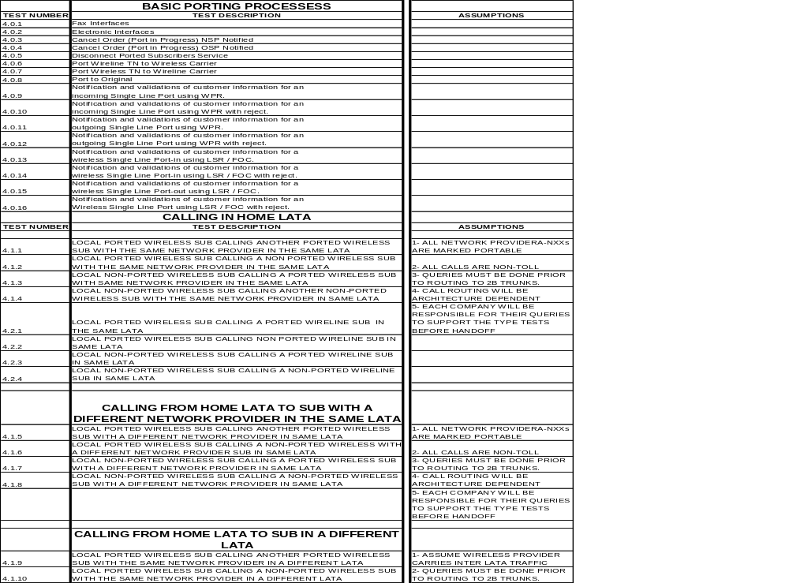

APPENDIX B Drawings that support each Test Script

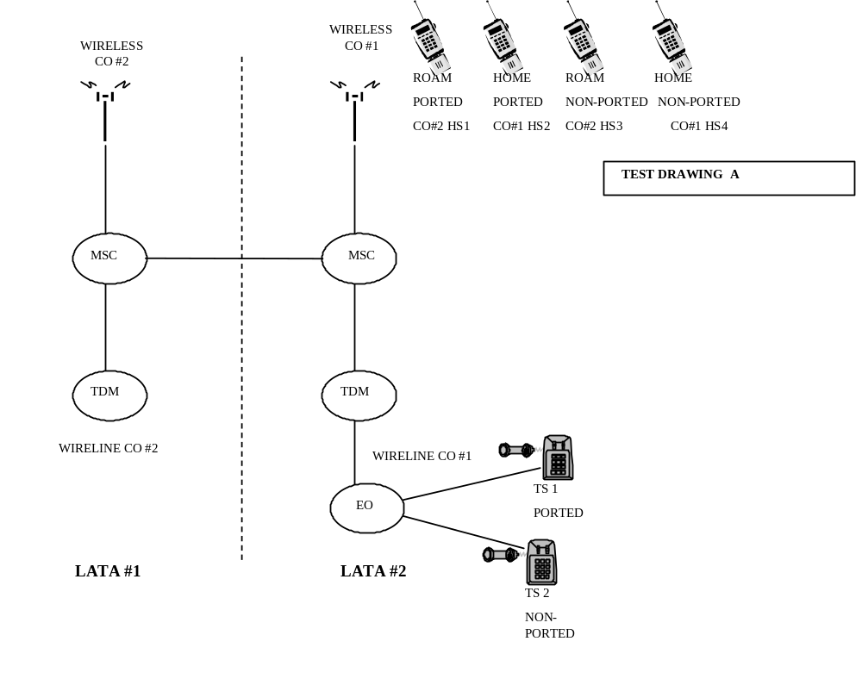

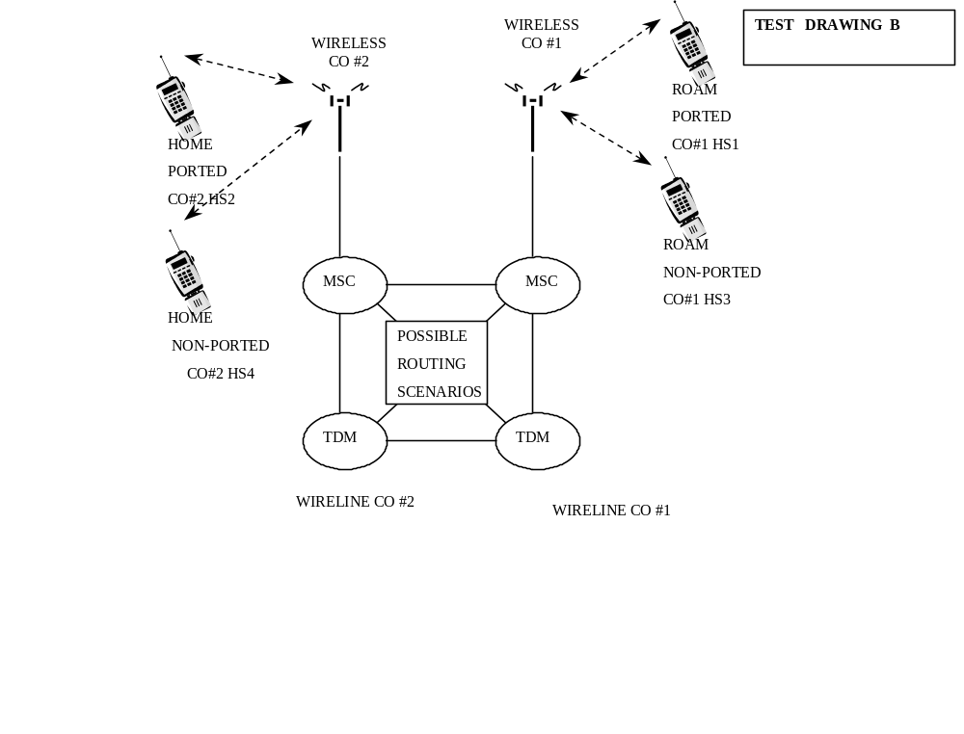

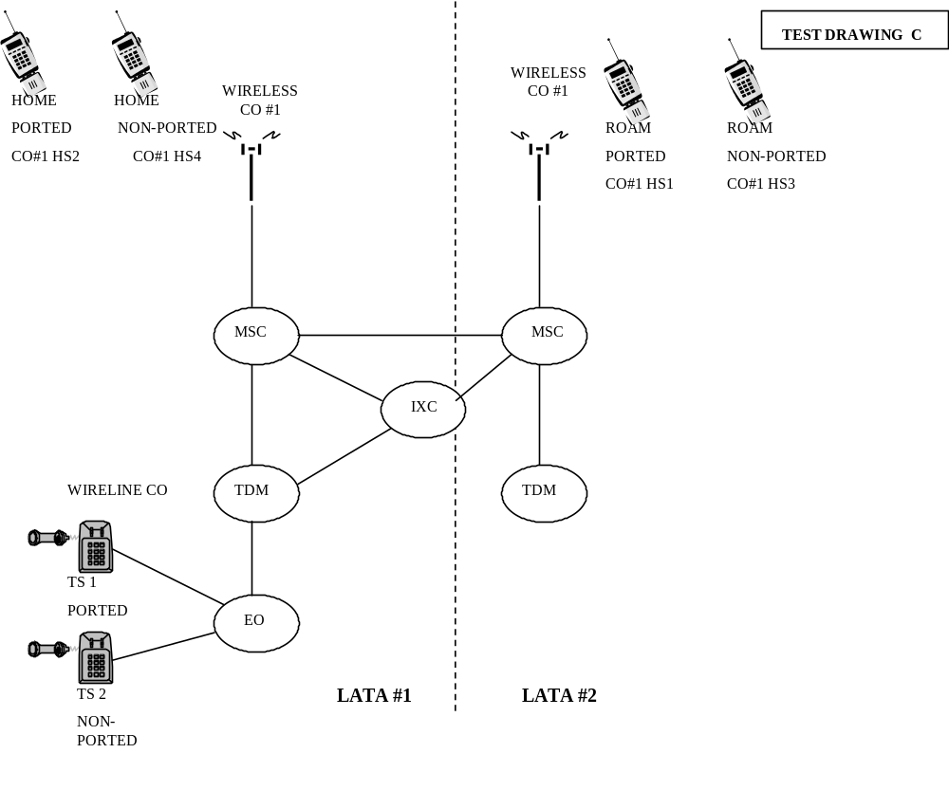

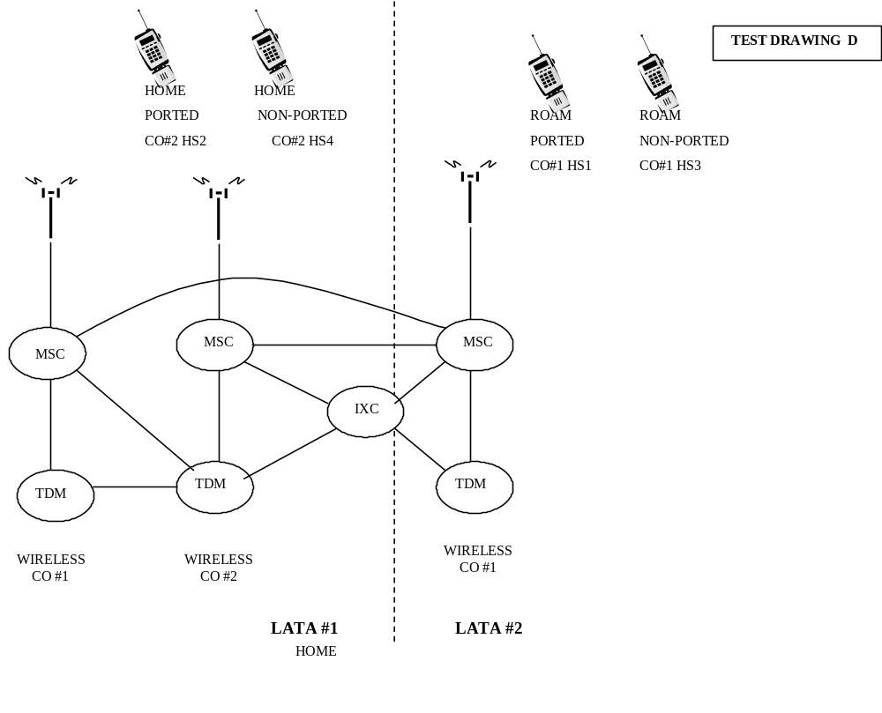

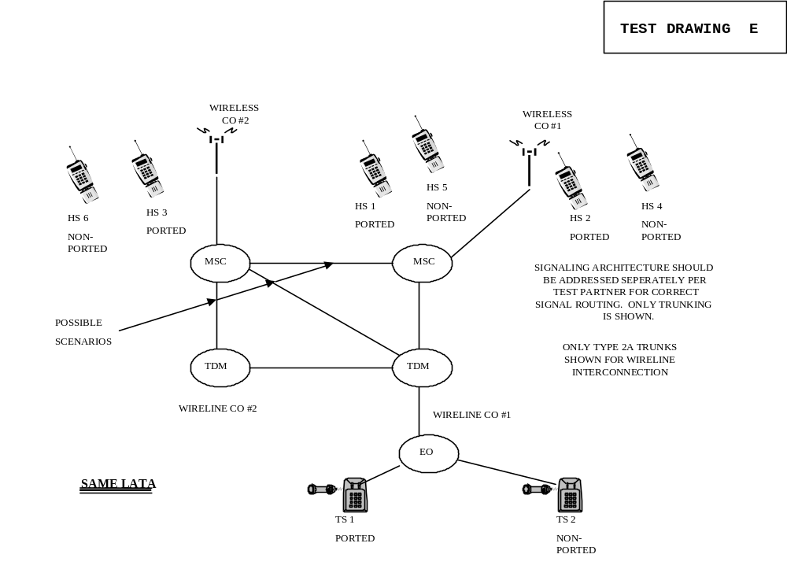

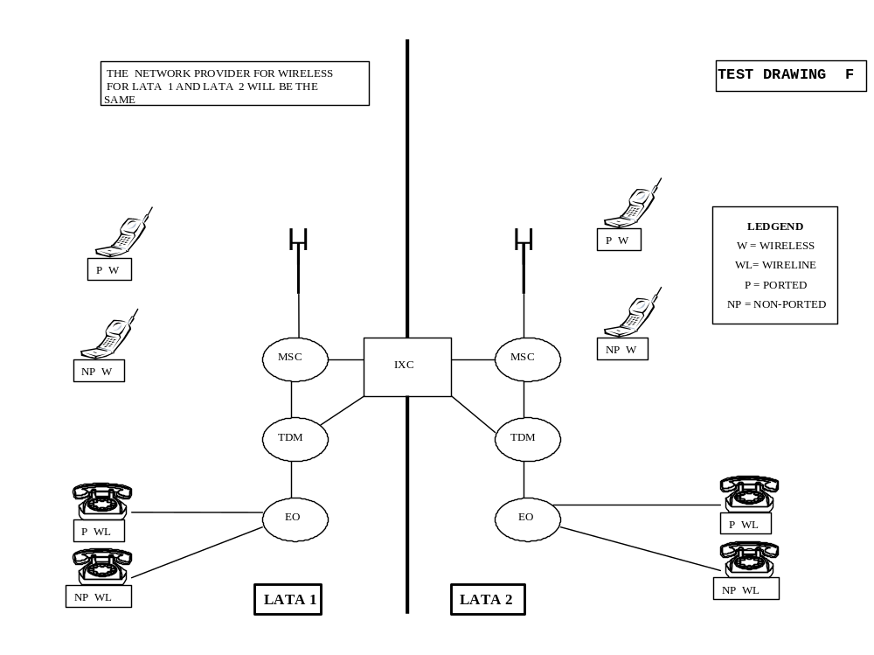

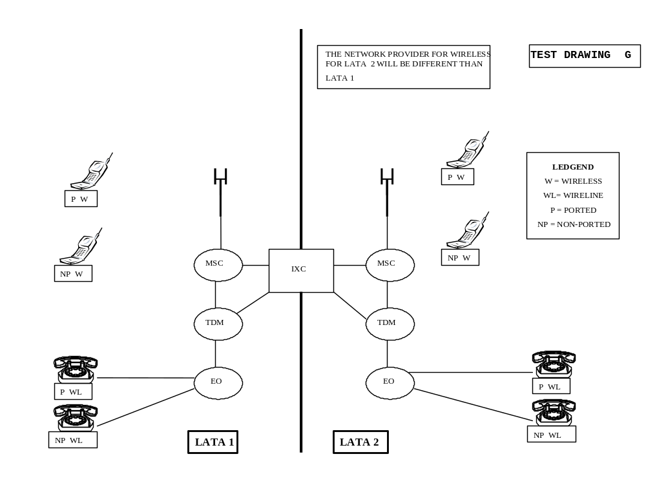

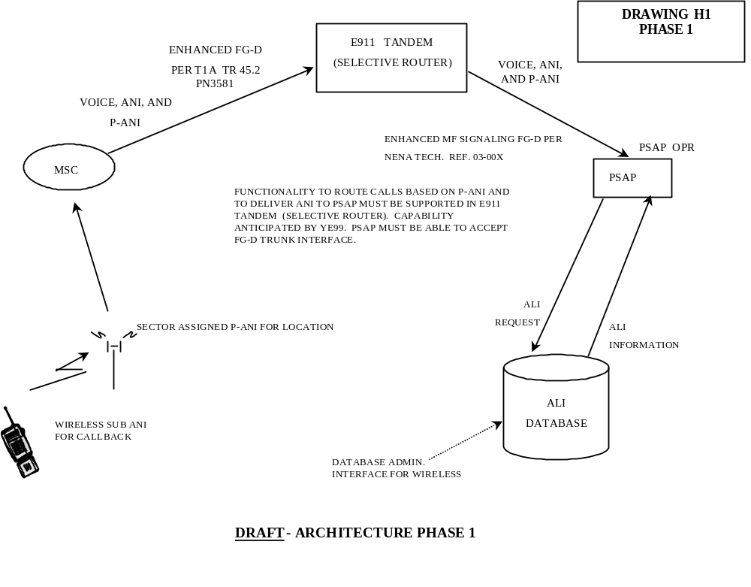

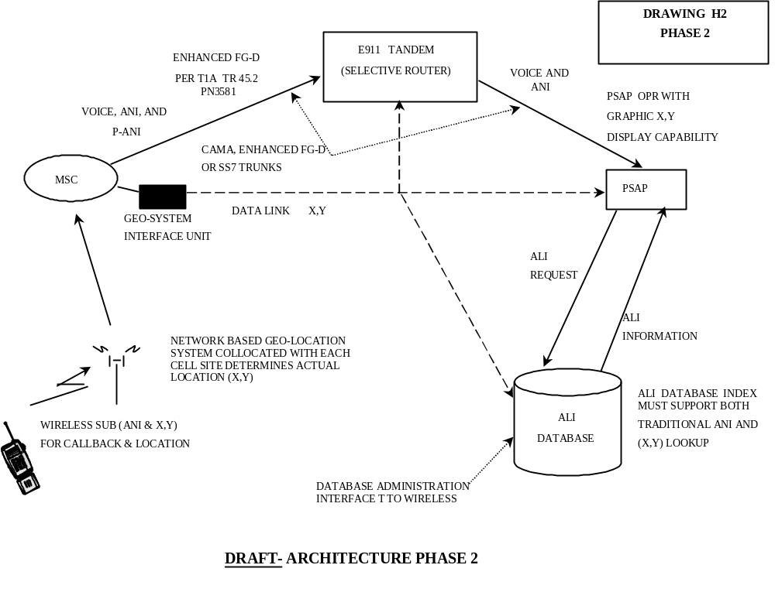

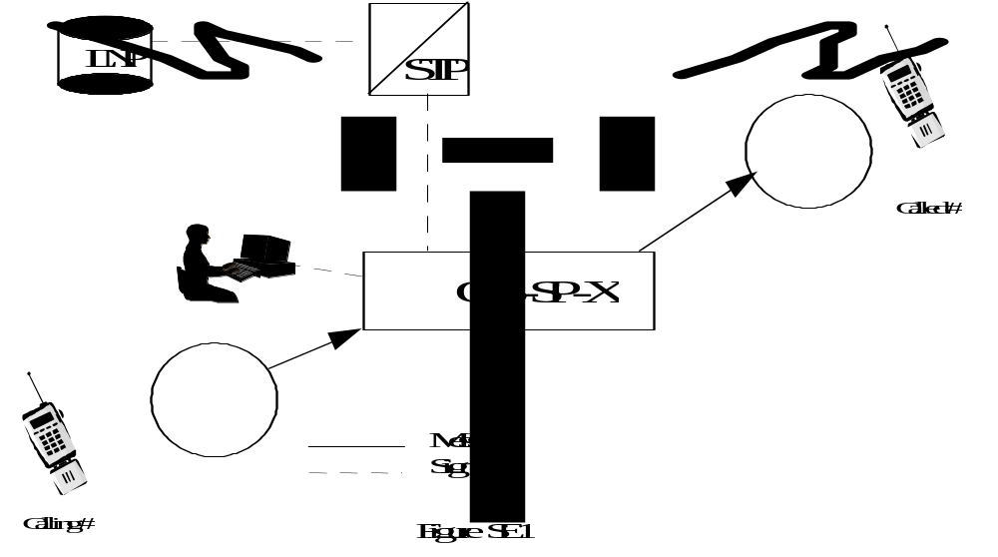

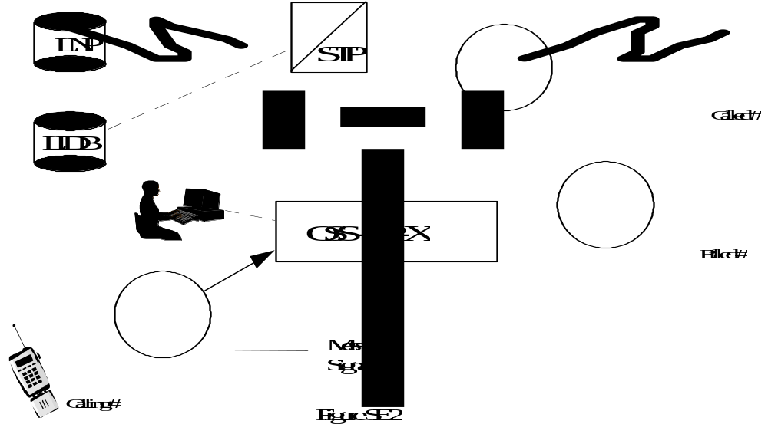

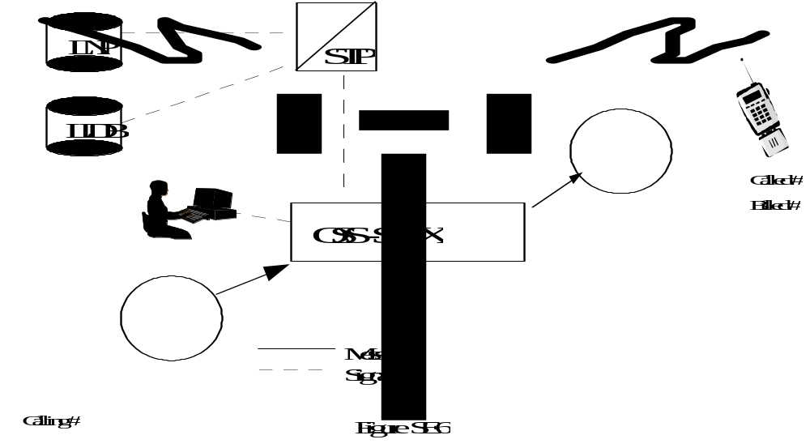

APPENDIX C Checklist for Entry for use by the individual companies

INTER-COMPANY TEST READINESS CHECKLIST

Checklist Instructions: Review checklist and enter “Y” in the Complete column once the criteria is met. If a criteria will not be met for the start of test execution or is not applicable, indicate “N” or “N/A” in the Complete column. Comments are required if criteria will not be met or are not applicable. If applicable, attach supporting documentation for each met criteria.
Checklists should be exchanged between each pair of service providers participating in a
specific iteration of the test.

# |  | Complete |  | Test Readiness Criteria |  | Comments
Logical Test Planning
1. |  |  |  | Test cases from the Wireless Number Portability Inter-Carrier Test Plan have been reviewed, selected, and agreed to by test participants.
2. |  |  |  | Any additional test scenarios or requirements have been agreed to by test participants.
3. |  |  |  | Test validation points have been identified and confirmed by test participants. These validation points will be reviewed and tracked in execution status calls.
4. |  |  |  | The following dates have been agreed to by test participants:  - Date for start of test execution  - Due date interval for test service orders (i.e. 3 day due date, same day due date, etc)  - Duration of test window (estimated maximum of 45 calendar days)
Physical Test Planning
5. |  |  |  | Following information has been completed and exchanged between test participants:  - Rate Area to be used for test. Both test participants must have at least one NPA-NXX that serves the selected Rate Area, as defined by LERG.  - NPA-NXXs to be used by both participants  - LRN of each switch (wireless MSC and wireline  end office  - OCN for each participant  - NPAC SPID for each participant
6. |  |  |  | Test account information has been exchanged between participants. Information includes:  - Test Account User/Billing Name  - Telephone Number(s)  - Service/Billing Address
7. |  |  |  | Test codes are registered in the E911 system. Embedded records have been inserted into the E911 database for all test accounts where appropriate. E911 account records must be in place before LNP unlock/migrate/delete transactions can complete for wireline service providers.
8. |  |  | Test participants have marked the NPA-NXXs to be used for test as ‘portable’ in both LERG and NPAC.
Pre-Test Preparation
9. |  |  | Each participant has fully tested and validated all modifications to internal business processes and systems. This includes, but is not limited to:  - Internal Software for SOA  - Internal Software for LSMS  - Internal Processes for SOA  - Internal Processes for LSMS  - Inter-carrier Communications software  - Inter-carrier Communications processes  - Switch Upgrades  - Network Upgrades  - Internal Software for MSID/MDN split  - Internal Processes for MSID/MDN split  - Internal Software to allow customers to  port MDNs in and out  - Internal Processes to allow customers to  port in and out  - Roaming Agreements  - Procedures for Foreign Roamers  - Reseller Agreements and Processes
10, |  |  | If applicable, other interface agreements are in place (i.e. CPCN agreements, E911 database access).
11. |  |  | Each participant understands the documented NANC and NENA processes for LNP and Local Competition.
12. |  |  | Inter-Carrier communication training for both test participants is complete.
13. |  |  | Each participant’s switch is LNP capable.
14. |  |  | Each participant has signed Service Level Agreements with the other participant(s).
15. |  |  | Each participant has SS7 access to an LRN database.
16. |  |  | Each participant has installed and completely tested their own SOA and LSMS and is certified by the appropriate regional Number Portability Administration Center (NPAC), or receives access to the appropriate regional NPAC through a certified carrier.
17. |  |  | Contact information for both carriers has been distributed to the industry for the following:  - LSR contact name, phone number, Fax  - E911 administrator name & phone number (where appropriate)  - 7x24 Network support
18. |  |  | A conference bridge has been identified for regular status reporting and inter-company communication during the test. Communication should include status relative to agreed upon inter-company validation points and any outstanding inter-company LNP issues.

Inter-Company Test Readiness Sign-Off

Once the checklist has been completed and updated with appropriate comments, contacts from both test participants should sign below indicating each carrier’s readiness to perform inter-company LNP testing.

Service Provider #1:
Testing Coordinator:
Phone #:
Signature:

Service Provider #2:
Testing Coordinator:
Phone #:
Signature:

APPENDIX D Checklist for Exit

CHECKLIST FOR EXIT

Inter-Company Test Execution Exit Checklist
Checklist Instructions: Review checklist and enter “Y” in the Met column if the criteria has been met at the end of test execution. If criteria has not be met at the end of test execution or is not applicable, indicate “N” or “N/A” in the Met column. Comments are required if criteria has not been met or is not applicable.

Sign the completed checklist and deliver to the other company(ies) participating in the Inter-Company Test.

Testing Stage: | Inter-Company Test
Your Company Name:
Test Coordinator:
Test Coordinator Signature:

# | Met | Test Execution Exit Criteria | Comments
1 |  | All required test cases have been successfully executed
2 |  | All specified conditional test cases have been successfully executed
3 |  | All mutually agreed upon optional test cases have been successfully executed
4 |  | Actual results for all Inter-company test cases are documented and match expected results
5 |  | Test planning documents updated to reflect final execution status for all test cases. (Wireless Number Portability Test Matrix appendix updated to reflect actual execution status of each test case.)
6 |  | All problems, defects, and errors from previous levels of testing have been retested and successfully validated
7 |  | Any inter-company workarounds have been documented, successfully tested and validated
8 |  | All testing metrics have been collected and are available upon request.
9 |  | Completed exit criteria checklist to be provided upon request.
10 |  | E911 readiness

Following to be completed by other company's Inter-Company Test Coordinator upon receipt and review of the completed checklist.
Your company name:
Exit Criteria Met (Y/N):
Test Coordinator:
Test Coordinator Signature:
Date of Approval:

APPENDIX E Test Successful Criteria, completion documents (Suggested)

Testing Status Logs

Complete a log entry for each test.
- Indicate test Number
- Indicate appropriate configuration

For any test that does not pass attach complete descriptions of situation.
- Test made
- Set up of all equipment involved
- Enclose test result collected
- Resolutions attempted and results
- All other pertinent information for future analysis
- Complete additional log entries for each new attempt at completing failed tests

Return copy and results to appropriate organization

Make as many additional copies of the form as needed for all tests executed

Test  No. |  | LSP  TSTR | SCNRO  DATE | GO  NoGo
COMMENTS:

Test  No. |  | LSP  TSTR | SCNRO  DATE | GO  NoGo
COMMENTS:

Test  No. |  | LSP  TSTR | SCNRO  DATE | GO  NoGo
COMMENTS:

Test  No. |  | LSP  TSTR | SCNRO  DATE | GO  NoGo
COMMENTS:

APPENDIX F Related documents (i.e. NIIF, Interoperability Issues, status)

Wireless Portability Technical Operational and implementation Documents

APPENDIX G Glossary of Terms

ANI Automatic Number Identification
ANSI American National Standard Institute
CdPN Called Party Number
CAC Carrier Access Code
CCS Common Channel Signaling
CDR Call Detail Record
CgPN Calling Party Number
CSD Circuit Switched Data
CSV Circuit Switched Voice
DN Directory Number
IC Interexchange Carrier
ICP Inter carrier Communication Process
IP Intelligent Peripheral
ISDN Integrated Services Digital Network
ISP Incumbent Service Provider
ISUP ISDN User Part
ISVM Interswitch Voice Messaging
IXC Interexchange Carrier
JIP Jurisdiction Information Parameter
LATA Local Access Transport Area
LEC Local Exchange Carrier
LERG Local Exchange Routing Guide
LIDB Line Identification Database
LNP Local Number Portability
LRN Location Routing Number
MSC Mobile Switching Center
MDN Mobile Directory Number
MIN Mobile Identification Number
NANC North American Numbering Council
NANP North American Number Plan
NPREQ Number Portability Request
NP Number Portability
NPA Numbering Plan Area
NPAC Number Portability Administration Center
NRA Network Routing Address (LRN)
NSP New Service Provider
NXX Office Code
OSP Old Service Provider
OSPS Operator Services Position System
P-ANI Pseudo Automated Number Identification
PIC Pre-subscribed Interexchange Carrier
SOA Service Order Activation
SP Service Provider
SPID Service Provider Identity
SS7 Signaling System 7
SSP Service Switching Point
TN Telephone Number

Automatic Number Information:
Telephone number associated with the access line from which a call originates.

Competitive Local Exchange Carrier (CLEC):
A telecommunications company that has obtained FCC certification to sell local exchange services in a specific geographical territory.

Conditional Trigger:

The trigger is encountered after additional criteria is satisfied.

Donor Switch:
The switch from which a DN was originally ported. More specifically, the switch that is considered the default destination for the NPA-NXX of the DN.

End-User:

Business or residential subscriber.

Global Title (GT)
A ”logical” or “virtual” address used for routing SS7 messages using the Signal Control Connection Part (SCCP) capabilities. To complete message routing, a GTA must be converted to a SS& point code and subsystem number.

Global Title Address (GTA)

The address digits contained in the GT. Examples include NPA-NXX, a DN or an LRN.

Global Title Translations(GTT):
Process by which a GT is converted either into a SS7 point code and subsystem number (final GTT) or another SS7 destination which will perform the GTT (non-final GTT or final GTT).

Incumbent Local Exchange Carrier (ILEC):

Local exchange service provider that has traditionally served a specific geographical territory.

Intermediate Switch:

A tandem switch.

LATA:
A defined geographic area where equal access switches or access tandem switches can provide carrier access to the local switch.

Local Exchange Carrier Routing:
An intra LATA route where the route does not involve an inter exchange carrier. For this case, an IXC is neither dialed nor pre-subscribed. Typically, Feature Group-C signaling is used for sending the call out of the office.

Local Exchange Routing Guide:
Contains information about he local routing data obtained from the Routing Data Base System (RDBS). This information reflects the current network configuration and scheduled network changes for all entities originating or terminating calls within the NANP.

N-1 Network:
The network in the call path just prior to the terminating network. If there are only two networks in the call path, then the N-1 network is the originating network. In the case of an inter-Lata call, the next to last network is the interexchange carrier network.

Network Element (NE):
Entities of the telecommunications network that primarily provide switching and transport network functions. For example: switching systems, AIN switching systems, digital cross-connect systems, and Signaling Transfer Points.

North American Numbering Plan:
A numbering architecture in which every station in the NANP area is identified by a unique ten-digit address consisting of a three digit NPA code, a three-digit central office code in the form of NXX, and a four-digit number in the form of XXXX..

Number Portability:
The ability of end users to retain their telephone number when they change any of the following: their location, service provider, or service.

Number Portability Data Base (NPDB):

A generic term for the network element that runs the number portability application.

Number Portability (NP) Query:
A request for call routing information sent from the switch to the NPDB when a call encounters an NP trigger. (i.e. AIN or IN or (NPREQ).

Number Portability Information:
Information associated with a ported DN used by AMA recording to identify the recipient switch (via LRN), of the ported DN to assist in billing.

Originating Switch:

The switch serving the calling party.

Portable NPA-NXX:

An NPA-NXX designated as “open” for portability. NO numbers may have actually ported.

Ported Number:
A DN in a portable NPA-NXX that resides on a switch other than the switch to which it is assigned in the LERG.

Rate Center:

A rate center denotes a geographic area used to distinguish rate boundaries for Wireline companies.

Recipient Switch:

The switch to which the DN is ported.

Terminating Switch:

The switch in which the call terminates.

Trigger:
An event in the originating switch which launches the query to the NPDB to determine if the called number is a ported number.

Exit Criteria (expected results):
Defines what the acceptable parameters to consider the test as pass or fail.

Portable Number:
A Directory Number (DN) that is part of a ported range from which one or more DN’s may have been ported.

Ported Number:
A DN that has been ported from one service provider to another. A ported number is also a portable number.

X, Y Coordinates:
New capability to identify geographic location for 911 calls

