APPENDICIES A - H

Appendix A - Wireless Inter-carrier Communications Process
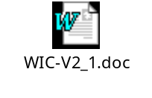

Appendix B – Wireless Number Portability Timeline Phase 2



Appendix C - Wireless Wireline Integration Report
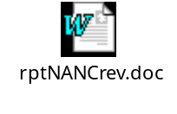
2ndWireless Wireline Integration Report


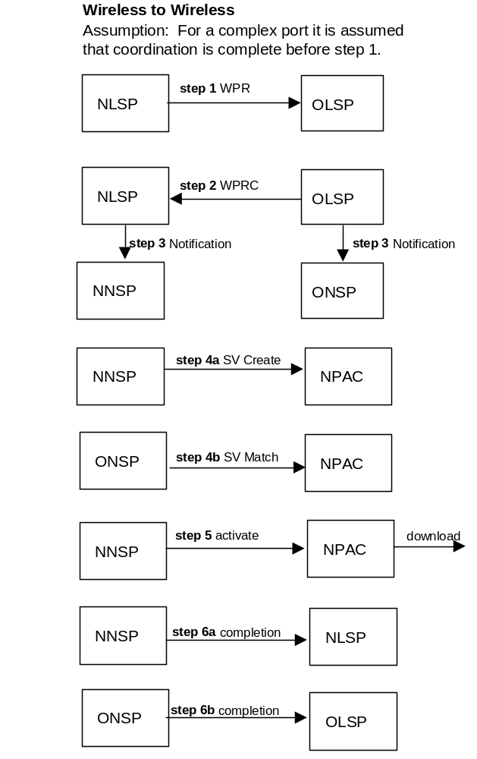
Appendix D - Reseller LNP Flows for Wireless to Wireless

Appendix E - INC LRN Assignment Guidelines


Appendix F - Code Opening Processes

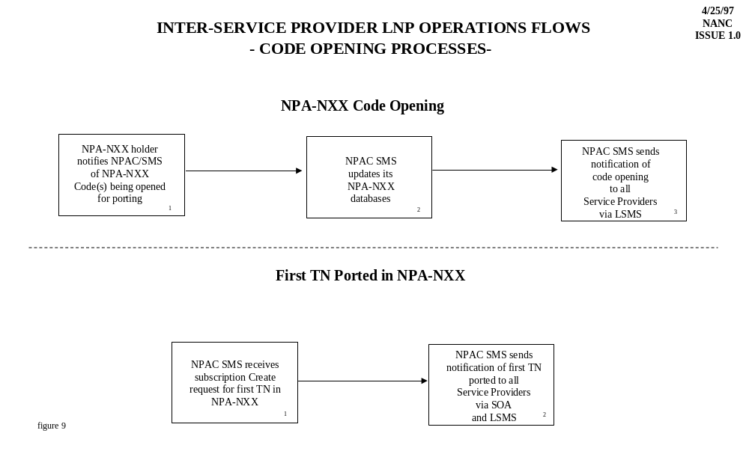

Step | Description
1. NPA-NXX holder notifies NPAC SMS of NPA-NXX Code(s) being opened for porting. | - The SP responsible for the NPA-NXX being opened must notify the NPAC SMS via the SOA or LSMS interface within a regionally agreed to time frame.
2. NPAC SMS updates its NPA-NXX databases | - NPAC SMS updates its databases to indicate that the NPA-NXX has been opened for porting.
3. NPAC SMS sends notification of code opening to all SPs via LSMS. | - The NPAC SMS provides advance notification of the scheduled opening of NPA-NXX code(s) via the LSMS interface.

First TN Ported in NPA-NXX
Step | Description
1. NPAC SMS receives subscription create request for first TN in NPA-NXX | - SP notifies NPAC SMS to create subscription for the first telephone number in an NPA-NXX.
2. NPAC SMS sends notification of first TN ported to all SPs via SOA and LSMS | - When the NPAC SMS receives the first subscription create request in an NPA-NXX, it will broadcast a “heads-up” notification to all SPs via both the LSMS and SOA interfaces. Upon receipt of the NPAC message, all SPs, within five (5) business days, will complete the opening for the NPA-NXX code for porting in all switches.

Appendix G - Companies Represented

The following is a list of companies represented at the WNPSC meetings from its creation in February, 1999, through completion of this report in July, 2000.

Airtouch | MCI
Alcatel USA | MCI/World Com
Ameritech | Metapath Software International
Ameritech Cellular | Microcell Telecommunications
AT&T | NENA
AT&T Wireless | Neustar
Bell Mobility | Nortel Networks
BellSouth | PCIA
Bellsouth Cellular Corp. | SBC
BellSouth Science & Technology | SBC Wireless
Clearnet | Sprint Corp.
Cox | Sprint PCS
DSET | Stentor
Ericsson Communications | Telcordia Technologies
Evolving Systems Inc. | Telecom Software Enterprises
GTE Corp. | Ulticom
GTE Network Services | US West
GTE Wireless | US West Wireless
Illuminet | Voicestream
Intermedia Communications Inc | Winstar
Lockheed Martin | World Com

Appendix H - Useful Web sites.
www.npac.com (NPAC Home Page)
www.global.ihs.com (Global Engineering Documents
www.t1.org/t1p1/_P1-GRID.HTM www.atis.org/atis/clc/inc/incdocs.htm (INC Documents)
www.fcc.gov/ccb/Nanc/nanchot.html (NANC Hot Topics)
www.fcc.gov/ccb/Nanc/nancordr.html (NANC Related Orders)
www.fcc.gov/ccb/Nanc (NANC Home Page)
www.ported.com
www.webproforum.com/siemens1/index.htm
www.evoiving.com
www.tsi.gte.com
www.illuminetss7.com
www.bellcore.com
www.nist.gov/ext_links/industry/industy.html
www.industry.net/c/orgindex/tia

Appendix I – WorldCom Minority Opinion on Wireless Resale

Minority Opinion Regarding the Wireless Number Portability Subcommittee's “Wireless Number Portability – Technical, Operational, and Implementation Requirements - Phase II” Report to the North American Numbering Council

Submitted by WorldCom

Some wireless resellers may need to move their customer bases from their current underlying wireless providers' networks shortly after November 24, 2002. The FCC requirement of mandatory wireless service resale expires November 24, 2002. Some underlying wireless network service providers may elect to end their resale arrangements when their resale contracts expire on or after November 24, 2002. Should a wireless network provider not renew its resale contracts, the resellers affected face the need to move their customer bases to other wireless network providers still willing to allow resale.

Moving a reseller's customers to a new underlying wireless network provider is not transparent to the reseller's customers. An end-user's move from one facility-based wireless provider to another can require both a telephone number change and an equipment ID change. The handset thus must be modified or replaced in order to accommodate these changes.

LNP allows a wireless reseller to avoid number changes for its customers when moving its customer base to a new underlying network provider. Although an equipment ID change still is required, and thus handset modifications appear unavoidable, the reseller's customers are not faced with having to notify anyone of a pending number change. Even with the use of LNP, the migration of a reseller's customer base is not transparent to the resellers' customers, but the migration's impact on them is reduced. Perhaps more significantly, the reseller's customers are not faced with making a decision about whether to change service providers (reverting to the current underlying network provider) in order to retain their numbers.

Implementation of wireless LNP may be too late to accommodate some resellers that need to move their customer base to a new underlying
wireless network provider. There is a finite window available between the arrival of wireless LNP and the expiration of wireless resale contracts. Shifting a reseller's customer base is a massive effort, requiring a phased approach. The effort required to move a reseller's customers is similar to the year-long effort required to convert landline customers with interim number portability arrangements to LNP.

WorldCom urges that accommodation be made to allow sufficient time to transfer resellers' customer bases as necessary after wireless LNP becomes available and therefore recommends that the resale requirement be extended two years beyond the November 24, 2002 wireless LNP deadline.

