Prepared By : | Mohamed Samater | Phone #: | 206-384-1669
Date Created: | 03/01/2010
Last Updated By: | Mohamed Samater | Last Updated Date: |  | 03/01/2010

Meeting Title: | Inter-carrier Testing Committee MEETING MINUTES
Meeting Date: | 02/26/2008 | Next Meeting Date: |  |  | 03/17/2010
Attendees: | Teresa Patton , Anh Nguyen, Mohamed Samater, Mubeen Saifullah, David Lund, Bridget Alexander, Carolyn Brown, Jan Doell, Lavinia Rotaru, Bob Bruce, Matt Timmerman, Jessica Walzer, Jason Lee, Tina Plaisance, Dawn Lawrence
Conducted by: | Teresa Patton, Mohamed Samater and Bridget Alexander |  | Recorded by: | Mohamed Samater

Action Required
Action # | Description | Status | Assigned To |  | Target Date | Actual Date
 | Participants are asked to come to the next meeting prepared to discuss their availability to participate in Intercarrier testing at the same time as the ITP (SOA <->NPAC) | OPEN | Carriers | 03/15/10 |  | 01/27/10
 | Participants need to determine what types of testing they will be able to support (Simple and/or complex). | OPEN | Carriers | 03/15/10 |  | 01/27/10
 | Carriers need to provide dates when they plan to support/start performing intercarrier testing | OPEN | Carriers | Ongoing |  | 01/27/10

Record significant Topics, Presenters, Decisions:

Discussions:

The committee reviewed test plan documents. Wireline to Wireline test plan as well as test cases were discussed first:

- There were inputs from participants for new test cases as well as updates to some of the current test scenarios
- As result of the review, Anh Nguyen with Sprint took the below action items to create/update the document accordingly:
  - Single line port with a Reject response, followed by a cancel, followed by a new LSR
  - Medium timer mismatch test case
  - Single line port with 2 optional fields being populated, followed by a Reject response, followed by a supplemental LSR without these 2 optional fields.
- Copy of the Wireline and Intermodal Test Plan Document is attached
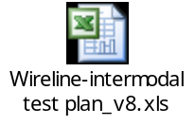
The committee reviewed the attached LNPA-WG meeting readout/update prepared to be shared at the upcoming March LNPA-WG meeting:
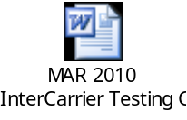

Wireless to Wireless Test Plan Document was reviewed by the ITC participants:

- The feasibility of the some of the test cases were discussed and determined changes will be made with the upcoming draft version
- The need for one of the appendix section where carriers previously used to share testing specific data was discussed. It was determined that this section will be updated or eliminated based on the feedback that will be elicited from carriers

After reviewing the Wireless Test Plan document, the committee decided to extend the March 4th meeting to the rest of the wireless participants in an effort to further work on the draft Wireless Test Plan Document. This will allow the team to assess/fix any errors found while reviewing the document:

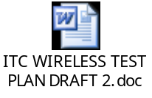

Upcoming Meeting

- Wireless to Wireless test plan document meeting is scheduled Thurs March 4, 2010 at 4PM to 5PM ET. This meeting will be held at the following conference bridge ((877) 888-4443 PASSCODE 6230424# )

- Next checkpoint meeting is scheduled for Wed March 17th 2010 at 3 to 3:30 PM ET. This meeting will be held at the following conference bridge ((877) 888-4443 PASSCODE 6230424# )

Scheduled Meetings

- Mar 30th, 2010 at 2 – 4 ET Wireline/Intermodal Test Plan Final Review
- Apr 1st, 2010 at 3 – 5PM ET Wireless Test Plan Review

Current tentatively planned Test Schedule
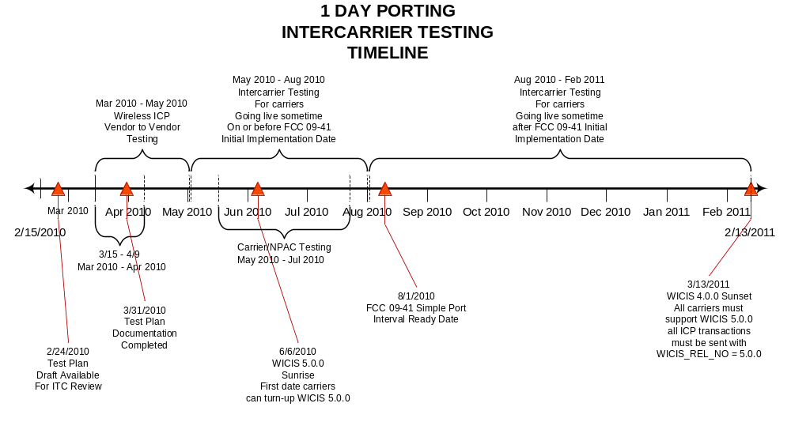

Vendor to Vendor Testing Schedule

To be published soon

