NPAC SMS

Interoperable Interface Specification

APPENDIXES A and B

NANC Version 2.0.1

Prepared for:
The North American Numbering Council (NANC)
April 6, 1999

© 1999 LOCKHEED MARTIN IMS CORPORATION

The Work is subject to the terms of the GNU General Public License (the “GPL”), a copy of which may be found at
ftp://prep.ai.mit.edu/pub/gnu/GPL. Any use of this Work is subject to the terms of the GPL. The “Work” covered by the GPL by
operation of this notice and license is this document and any and all modifications to or derivatives of this document.
Where the words “Program,” “software,” “source code,” “code,” or “files” are used in the GPL, users understand and agree that
the “Work” as defined here is substituted for purposes of this notice and license.

Table Of Contents
Introduction iv
A.1 CMISE Primitive Errors 1
A.2 CMISE Primitive Error Descriptions 1
A.3 CMIP Error Mapping to the External Design Specification 3
B.1 Overview 11
B.2 Audit Scenarios 13
B.2.1 SOA Initiated Audit 13
B.2.2 SOA Initiated Audit Cancellation by the SOA 16
B.2.3 SOA Initiated Audit Cancellation by the NPAC 17
B.2.4 NPAC Initiated Audit 18
B.2.5 NPAC Initiated Audit Cancellation by the NPAC 20
B.2.6 Audit Query on the NPAC 21
B.3 Service Provider Scenarios 22
B.3.1 Service Provider Creation by the NPAC 22
B.3.2 Service Provider Deletion by the NPAC 24
B.3.3 Service Provider Modification by the NPAC 26
B.3.4 Service Provider Modification by the Local SMS 27
B.3.5 Service Provider Modification by the SOA 28
B.3.6 Service Provider Query by the Local SMS 29
B.3.7 Service Provider Query by the SOA 30
B.4 Service Provider Network Data Scenarios 31
B.4.1 NPA-NXX Scenarios 31
B.4.2 LRN Scenarios 31
B.5 SubscriptionVersion Flow Scenarios 31
B.5.1 SubscriptionVersion Create Scenarios 31
B.5.2 Modify Scenarios 31
B.5.3 Cancel Scenarios 31
B.5.4 Disconnect Scenarios 31
B.5.5 Conflict Scenarios 31
B.5.6 SubscriptionVersion Query 31
B.6 LSMS Filter NPA-NXX Scenarios 31
B.6.1 lsmsFilterNPA-NXX Creation by the Local SMS 31
B.6.2 lsmsFilterNPA-NXX Deletion by the Local SMS 31
B.6.3 lsmsFilterNPA-NXX Query by the Local SMS 31
B.6.4 lsmsFilterNPA-NXX Creation by the SOA 31
B.6.5 lsmsFilterNPA-NXX Deletion by the SOA 31
B.6.6 lsmsFilterNPA-NXX Query by the SOA 31
B.7 Local SMS and SOA Recovery 31
B.7.1 Sequencing of Events on Initialization/Resynchronization of Local SMS 31
B.7.2 Sequencing of Events on Initialization/Resynchronization of SOA 31
B.8 Miscellaneous 31
B.8.1 SOA/Local SMS Notification of Scheduled NPAC Downtime 31
B.8.2 NPA-NXX Split 31
B.8.3 Mass Update 31

Introduction

This document contains the appendixes for the IIS document. The appendixes are in a separate document from the body of the IIS due to large size of the document.

- Errors

CMISE Primitive Errors
A
The following exhibit contains the valid errors associated with CMISE confirmed primitives used in the interoperable interfaces definitions. The situations under which these errors occur are documented in the message flow diagrams in Appendix B.
Exhibit 1. Valid Errors Associated with CMISE-Confirmed Primitives Used by the NPAC SMS
CMISE PRIMITIVE ERRORS
CMISE Primitive | Errors
M-EVENT-REPORT | invalidArgumentValue, noSuchArgument, noSuchObjectClass, noSuchObjectInstance, processingFailure, noSuchEventType
M-GET | accessDenied, classInstanceConflict, complexityLimitation, getListError, invalidFilter, invalidScope, noSuchObjectClass, noSuchObject-Instance, processingFailure, syncNotSupported
M-SET | accessDenied, class-InstanceConflict, complexityLimitation, invalidFilter, invalidScope, noSuchObjectClass, noSuchObject-Instance, processingFailure, syncNotSupported, setListError
M-ACTION | accessDenied, class-InstanceConflict, complexityLimitation, invalidArgumentValue, invalidFilter, invalidScope, noSuchAction, noSuchArgument, noSuchObjectClass, noSuchObject-Instance, processingFailure, syncNotSupported
M-CREATE | accessDenied, class-InstanceConflict, duplicateManaged-ObjectInstance, invalidAttributeValue, invalidObjectInstance, missingAttributeValue, noSuchAttribute, noSuchObjectClass, noSuchObject-Instance, processingFailure, noSuchReferenceObject
M-DELETE | accessDenied, class-InstanceConflict, complexityLimitation, invalidFilter, invalidScope, noSuchObjectClass, noSuchObject-Instance, processingFailure, syncNotSupported

CMISE Primitive Error Descriptions

accessDenied
The service provider does not have the authorization to do this operation.
Examples:
- The service provider is not authorized to perform this type of operation.
- The service provider is not the old or new service provider for the subscription version.
- The modify of the subscription version will cause a mass update.
- The version selected for a disconnect is not active.

duplicateManagedObjectInstance
For create operations, the requested object already exists.
Examples:
- Pending subscription version, NPA-NXX or LRN already exist on NPAC SMS.

classInstanceConflict
The object specified is not a member of the specified class.

complexityLimitation
A parameter was too complex to complete the operation.

invalidArgumentValue
A specified argument is not valid.
Examples:
- An argument value does not pass validation for an action or event report.
- A required parameter is missing for an action or event report.
- An argument value does not exist.

invalidAttributeValue
A specified attribute is not valid.

invalidFilter
A filter specified is not valid.

invalidScope
The scope specified is not valid.

noSuchAction
A specified action is not recognized.

noSuchArgument
A specified argument is not recognized.

noSuchAttribute
A specified attribute is not recognized.

noSuchObjectClass
A specified object class is not recognized.

noSuchObjectInstance
The requested object does not exist.
Examples:
- A query fails based on the search criteria.
- The referenced object (subscription version, NPA-NXX, LRN, etc.) does not exist.

processingFailure
A general failure has occurred in processing the operation or notification A text string is needed to qualify the error message.

Exhibit 2. processingFailure Errors
processingFailure Errors
Error ID |  | Description
0 | lnpSpecificInfo (GraphicString) | Invalid CLASS DPC value.

resourceLimitation
The operation was not processed due to a resource limitation.

synchronizationNotSupported
The type of synchronization specified is not supported.

CMIP Error Mapping to the External Design Specification
The following exhibit provides a mapping of CMIP errors to the errors defined in the External Design Specification. Errors reflected are defined as follows:
accessDenied
Implies the service provider cannot perform the given task.
duplicateObjectInstance
The object already exists.
invalidArgumentValue
Represents invalidArgumentValue for an M-ACTION response, and invalidAttributeValue for
M-CREATE and M-SET responses.
noSuchObjectInstance
The requested object does not exist.
processingFailure
The processing failed for the reason given.
Exhibit 3 CMIP Error Mapping to the External Design Specification
CMIP Error | Functional Area | Message Text
invalidArgument  Value | Subscription Version Management | Required data for TN field(s) missing.
invalidArgument  Value | Subscription Version Management | Required due date entry missing from the subscription version.
invalidArgument  Value | Subscription Version Management | Required Customer Disconnect Date missing from the subscription version.
invalidArgument  Value | Subscription Version Management | Required New Service Provider ID missing from the subscription version.
invalidArgument  Value | Subscription Version Management | Required Old Service Provider ID missing from the subscription version.
invalidArgument  Value | Subscription Version Management | Required LRN missing.
invalidArgument  Value | Subscription Version Management | Required CLASS DPC missing.
invalidArgument  Value | Subscription Version Management | Required CLASS SSN missing.
invalidArgument  Value | Subscription Version Management | Required CNAM DPC missing.
invalidArgument  Value | Subscription Version Management | Required CNAM SSN missing.
invalidArgument  Value | Subscription Version Management | Required ISVM DPC missing.
invalidArgument  Value | Subscription Version Management | Required ISVM SSN missing.
invalidArgument  Value | Subscription Version Management | Required LIDB DPC missing.
invalidArgument  Value | Subscription Version Management | Required LIDB SSN missing.
invalidArgument  Value | Subscription Version Management | Required WSMSC DPC missing.
invalidArgument  Value | Subscription Version Management | Required WSMSC SSN missing.
invalidArgument  Value | Network Management | Required value for Date is missing from Network Data.
invalidArgument  Value | Network Management | Required value for Time is missing from Network Data.
invalidArgument  Value | NPAC Customer Management | Required value for NPAC Customer Type is missing from NPAC Customer.
invalidArgument  Value | NPAC Customer Management | Required value for Contact Name is missing from NPAC Customer.
invalidArgument  Value | NPAC Customer Management | Required value for Address Line 1 is missing from NPAC Customer.
invalidArgument  Value | NPAC Customer Management | Required value for NPAC Customer City is missing from NPAC Customer.
invalidArgument  Value | NPAC Customer Management | Required value for Repair Center City is missing from NPAC Customer.
invalidArgument  Value | NPAC Customer Management | Required value for NPAC Customer State is missing from NPAC Customer.
invalidArgument  Value | NPAC Customer Management | Required value for Repair Center State is missing from NPAC Customer.
invalidArgument  Value | NPAC Customer Management | Required value for NPAC Customer Zip Code is missing from NPAC Customer.
invalidArgument  Value | NPAC Customer Management | Required value for Repair Center Zip Code is missing from NPAC Customer.
invalidArgument  Value | NPAC Customer Management | Required value for Pager is missing from NPAC Customer.
invalidArgument  Value | NPAC Customer Management | Required value for Pager PIN is missing from NPAC Customer.
invalidArgument  Value | NPAC Customer Management | Required value for Fax is missing from NPAC Customer.
invalidArgument  Value | NPAC Customer Management | Required value for Email is missing from NPAC Customer.
invalidArgument  Value | NPAC Customer Management | Required value for NSAP is missing from NPAC Customer.
invalidArgument  Value | NPAC Customer Management | Required value for TSAP is missing from NPAC Customer.
invalidArgument  Value | NPAC Customer Management | Required value for SSAP is missing from NPAC Customer.
invalidArgument  Value | NPAC Customer Management | Required value for PSAP is missing from NPAC Customer.
invalidArgument  Value | NPAC Customer Management | Required value for IP is missing from NPAC Customer.
invalidArgument  Value | Subscription Version Management | Invalid value for CLASS DPC entered.
invalidArgument  Value | Subscription Version Management | Invalid value for CLASS SSN entered.
invalidArgument  Value | Subscription Version Management | Invalid value for CNAM DPC entered.
invalidArgument  Value | Subscription Version Management | Invalid value for CNAM SSN entered.
invalidArgument  Value | Subscription Version Management | Invalid value for ISVM DPC entered.
invalidArgument  Value | Subscription Version Management | Invalid value for ISVM SSN entered.
invalidArgument  Value | Subscription Version Management | Invalid value for LIDB DPC entered.
invalidArgument  Value | Subscription Version Management | Invalid value for LIDB SSN entered.
invalidArgument  Value | Subscription Version Management | Invalid value for WSMSC DPC entered.
invalidArgument  Value | Subscription Version Management | Invalid value for WSMSC SSN entered.
invalidArgument  Value | Subscription Version Management | TN NPA contains invalid data.
invalidArgument  Value | Subscription Version Management | TN NXX contains invalid data.
invalidArgument  Value | Subscription Version Management | TN extension field contains invalid data.
invalidArgument  Value | Subscription Version Management | Month field contains invalid data.
invalidArgument  Value | Subscription Version Management | Day field contains invalid data.
invalidArgument  Value | Subscription Version Management | Year field contains invalid data.
invalidArgument  Value | Subscription Version Management | TN range `through' field (ending extension value) contains invalid data.
invalidArgument  Value | Subscription Version Management | The entered due date must be greater than or equal to today's date.
invalidArgument  Value | Subscription Version Management | Billing Service Provider ID contains invalid data.
invalidArgument  Value | Subscription Version Management | End-User Location Value contains invalid data.
invalidArgument  Value | Subscription Version Management | End-User Location Type contains invalid data.
invalidArgument  Value | NPAC Customer Management | Invalid value for Time entered.
invalidArgument  Value | NPAC Customer Management | Invalid value for NPAC Customer Name entered.
invalidArgument  Value | NPAC Customer Management | Invalid value for NPAC Customer Id entered.
invalidArgument  Value | Subscription Version Management | Invalid value for LRN entered.
invalidArgument  Value | NPAC Customer Management | Invalid value for NPAC Customer Type entered.
invalidArgument  Value | NPAC Customer Management | Invalid value for Allowable Functions entered.
invalidArgument  Value | NPAC Customer Management | Invalid value for Download entered.
invalidArgument  Value | NPAC Customer Management | Invalid value for Contact Name entered.
invalidArgument  Value | NPAC Customer Management | Invalid value for Address Line 1 entered.
invalidArgument  Value | NPAC Customer Management | Invalid value for Address Line 2 entered.
invalidArgument  Value | NPAC Customer Management | Invalid value for City entered.
invalidArgument  Value | NPAC Customer Management | Invalid value for State entered.
invalidArgument  Value | NPAC Customer Management | Invalid value for Zip Code entered.
invalidArgument  Value | NPAC Customer Management | Invalid value for Pager entered.
invalidArgument  Value | NPAC Customer Management | Invalid value for Pager PIN entered.
invalidArgument  Value | NPAC Customer Management | Invalid value for Fax entered.
invalidArgument  Value | NPAC Customer Management | Invalid value for Email entered.
invalidArgument  Value | NPAC Customer Management | Invalid value for NSAP entered.
invalidArgument  Value | NPAC Customer Management | Invalid value for TSAP entered.
invalidArgument  Value | NPAC Customer Management | Invalid value for SSAP entered.
invalidArgument  Value | NPAC Customer Management | Invalid value for PSAP entered.
invalidArgument  Value | NPAC Customer Management | Invalid value for IP entered.
duplicateObject  Instance | Network Data Management | Item being added already exists in the database.
accessDenied | Network Data Management | Subscriptions in either partial failed or sending state are associated with the change. Change/Delete is denied.
invalidArgument  Value | Network Data Management | GTT data is not equivalent across TN range specified. Modify the TN range.
duplicateObject  Instance | NPAC Customer Management | Item being added already exists in the database.
accessDenied | NPAC Customer Management | One or more subscriptions will be affected by change. Change is denied.
invalidArgument  Value | NPAC Customer Management | The NPAC Customer Id cannot be modified.
noSuchObject  Instance | NPAC Customer Management | The NPAC Customer being modified does not exist in the database.
noSuchObject  Instance | NPAC Customer Management | The NPAC Customer being deleted does not exist in the database, or has already been deleted.
invalidArgument  Value | Subscription Version Management | The NPA-NXX of the TN to be ported does not exist in the NPAC SMS system.
invalidArgument  Value | Subscription Version Management | Service Provider ID does not exist in the NPAC SMS system.
accessDenied | Subscription Version Management | The Service Provider issuing this subscription version request is not the Service Provider identified as the New Service Provider ID or the Old Service Provider ID on the subscription version.
duplicateObject  Instance | Subscription Version Management | A pending subscription version with authorization from this Service Provider already exists.
invalidArgument  Value | Subscription Version Management | The entered LRN is not associated with the New Service Provider in the NPAC SMS system.
invalidArgument  Value | Subscription Version Management | The Old Service Provider ID in the subscription version does not match the current Service Provider ID on an existing active subscription version for this TN.
invalidArgument  Value | Subscription Version Management | The New Service Provider ID in the subscription version to be created does not match the new Service Provider ID in an existing pending subscription version for this TN.
invalidArgument  Value | Subscription Version Management | The Old Service Provider ID in the subscription version to be created does not match the Old Service Provider ID in an existing pending subscription version for this TN.
accessDenied | Subscription Version Management | Releasing a subscription version for an Intra-Service Provider port does not apply.
invalidArgument  Value | Subscription Version Management | The Old Service Provider ID must match the New Service Provider ID for an Intra-Service Port.
invalidArgument  Value | Subscription Version Management | The New and Old Service Provider Due Dates must match.
accessDenied | Subscription Version Management | An active subscription version must exist for an Intra-SP port.
accessDenied | Subscription Version Management | A subscription version with sending status cannot be modified.
accessDenied | Subscription Version Management | A subscription version with failed status cannot be modified.
accessDenied | Subscription Version Management | A subscription version with partial failure status cannot be modified.
accessDenied | Subscription Version Management | A subscription version with canceled status cannot be modified.
accessDenied | Subscription Version Management | A subscription version with old status cannot be modified.
accessDenied | Subscription Version Management | A subscription version with disconnect pending status cannot be modified.
accessDenied | Subscription Version Management | A subscription version with cancel pending status cannot be modified.
accessDenied | Subscription Version Management | A subscription version must be in pending status to be activated.
invalidArgument  Value | Subscription Version Management | The Old Service Provider Id is not equal to the New Service Provider ID on the active subscription version, as required for an Intra-Service Provider port.
accessDenied | Subscription Version Management | The Service Provider originating the modification request is not the current Service Provider.
accessDenied | Subscription Version Management | The subscription version cannot be put in conflict because its current status is not pending or cancel pending.
accessDenied | Subscription Version Management | The subscription version cannot be set to pending because its current status is not conflict.
accessDenied | Subscription Version Management | The subscription version cannot be disconnected because there is no current subscription version in active status.
accessDenied | Subscription Version Management | This active subscription version cannot be disconnected until a sending subscription version successfully completes.
accessDenied | Subscription Version Management | This active subscription version cannot be disconnected until a failed or partial failure subscription version is re-sent and successfully completes.
accessDenied | Subscription Version Management | The subscription version cannot be canceled because its current status is not pending, conflict or disconnect pending.
accessDenied | Subscription Version Management | Active subscription version may not be modified because a related subscription version for this TN has been activated.
accessDenied | Subscription Version Management | Pending subscription version may not be activated until a related subscription version in sending status becomes active.
accessDenied | Subscription Version Management | Deferred disconnect request is not allowed because a pending subscription version exists for this TN.
accessDenied | Subscription Version Management | This subscription version may not be activated because authorization for transfer of service has not been received from both SPs.
accessDenied | Subscription Version Management | This immediate disconnect request is denied because a pending subscription version for the TN exists, and the Old Service Provider has authorized transfer of service for the pending subscription version.
invalidArgument  Value | Audit Administration | Invalid date entered.
invalidArgument  Value | Audit Administration | Invalid time entered.
invalidArgument  Value | Audit Administration | Audit Profile name too long.
invalidArgument  Value | Audit Administration | Invalid TN data entered.
invalidArgument  Value | Audit Administration | Audit Profile name is not unique.

Exhibit 4 CMIP Warning Mapping to the External Design Specification
CMIP Error | Functional Area | Message Text
invalidArgument  Value | Subscription Version Management | The entered due date differs from the due date entered by the other Service Provider.
invalidArgument  Value | Audit Administration | NPA does not exist in the NPAC SMS data.
invalidArgument  Value | Audit Administration | NPA-NXX combination does not exist in the NPAC SMS data.
noSuchObject  Instance | Audit Administration | No audits match the entered criteria.

Exhibit 5 CMIP Informational Mapping to the External Design Specification
CMIP Error | Functional Area | Message Text
NoSuchObject  Instance | Network Data Management | No match found in the database for the search criteria.
noSuchObject  Instance | NPAC Customer Management | No match found in the database for the search criteria.
processingFailure | NPAC Customer Management | <x> Subscriptions found: exceed maximum query limit.
noSuchObject  Instance | NPAC Customer Management | No subscription versions found for the given input search criteria.
noSuchObject  Instance | Subscription Version Management | No subscription versions found for the given input search criteria.
processingFailure | Subscription Version Management | Subscriptions found exceed maximum query limit.
invalidArgument  Value | Audit Administration | No TNs found within the range entered.

- Flow Diagrams
B

Overview
This appendix defines the message flow scenarios for the SOA to NPAC and the NPAC SMS to Local SMS interfaces. Each of these definitions consists of a message flow diagram and a textual description of the diagram.
IMPORTANT NOTES
The order of messages in the message flows must be followed by the NPAC SMS SOA and LSMS systems with the exception of the return of the M-EVENT-REPORT confirmations.
The following is an example message flow diagram and legend for elements shown in the diagram.
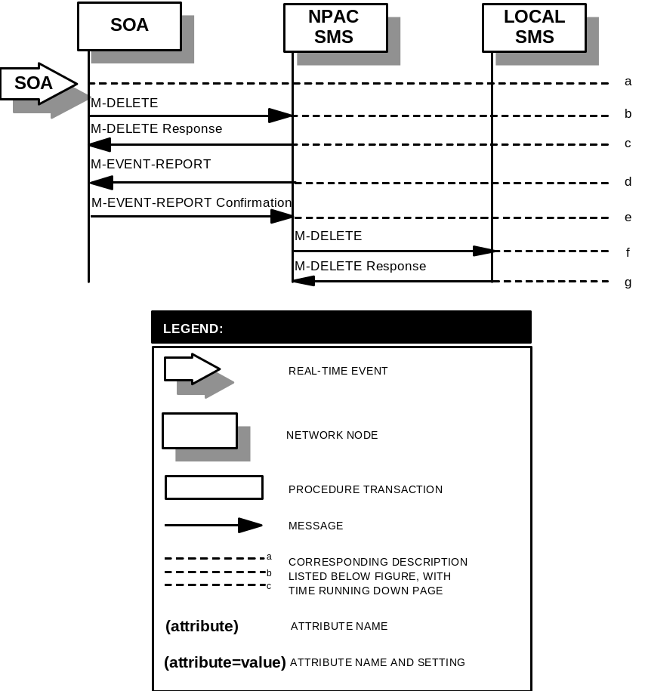

Audit Scenarios

SOA Initiated Audit
In this scenario, the SOA initiates an audit to the NPAC SMS due to suspected subscription version discrepancies.
- Action is taken by SOA personnel to start an audit due to suspected network discrepancies.
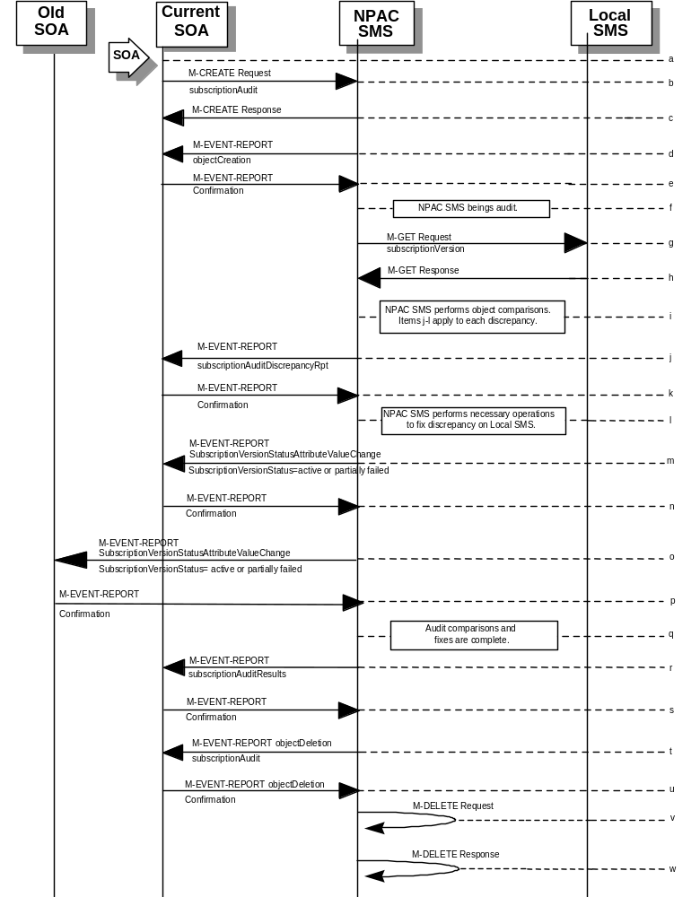
- The SOA sends a M-CREATE request to the NPAC SMS, requesting an audit. The SOA must specify the following attributes in the request:
subscriptionAuditName - English audit name
subscriptionAuditRequestingSP - the service provider requesting the audit
subscriptionAuditServiceProvIdRange - which service provider or all service providers for audit
subscriptionAuditTN-Range - TNs to be audited
If these attributes are not specified, then the create will fail with a missingAttributesValue error. The SOA may also specify the following attributes in the request:
subscriptionAuditAttributeList - subscription version attributes to be audited
subscriptionAuditTN-ActivationRange - time range of activation for subscription versions to be audited
The subscriptionAuditId and the subscriptionAuditStatus will be determined by the NPAC SMS. If any values are deemed invalid, an invalidArgumentValue error will be returned. Once the NPAC SMS creates the audit request object, it sends an M-CREATE response back to the SOA that initiated the request.
- NPAC SMS responds to M-CREATE.
- NPAC SMS sends M-EVENT-REPORT to the service provider SOA for the subscriptionAudit creation.
- The service provider SOA confirms the M-EVENT-REPORT.
- NPAC SMS begins audit.
- NPAC SMS issues a scoped and filtered M-GET for the subscription versions in the audit, to all LSMS’s accepting downloads for the NPA-NXX of the subscription version.
- Local SMS returns M-GET query data.
- NPAC SMS performs the necessary comparisons of each subscription version object.
- If a discrepancy is found, NPAC SMS issues a subscriptionAuditDiscrepancyRpt M-EVENT-REPORT.
- Service provider SOA confirms the M-EVENT-REPORT.
- If a discrepancy is found, NPAC SMS issues the necessary operation to the Local SMS to correct the discrepancy (M-CREATE, M-DELETE, or
M-SET).
- If any corrections were issued to any Local SMSs, the NPAC SMS will send M-EVENT-REPORT to the service provider SOA of the subscriptionVersionStatus change and a list of failed Local SMSs (minus any recently updated Local SMSs that no longer contains a discrepancy).
- The service provider SOA confirms the M-EVENT-REPORT.
- If any corrections were issued to any Local SMSs, the NPAC SMS will send M-EVENT-REPORT to the old service provider SOA of the subscriptionVersionStatus change and a list of failed Local SMSs (minus any recently updated Local SMSs that no longer contains a discrepancy).
- The old service provider SOA confirms the M-EVENT-REPORT.
- NPAC SMS has completed the audit comparisons and corrections.
- NPAC SMS issues the subscriptionAuditResults M-EVENT-REPORT to the service provider SOA.
- The Service provider SOA confirms the M-EVENT-REPORT.
- The NPAC SMS then sends an objectDeletion M-EVENT-REPORT to the SOA for the subscriptionAudit object.
- The service provider SOA confirms the M-EVENT-REPORT.
- The NPAC SMS issues a local M-DELETE request for the subscriptionAudit object to/from the NPAC SMS. This will attempt to delete the subscriptionAudit object on the NPAC SMS. The M-DELETE does not occur until after the “Audit Log Retention Period” which defaults to 90 days.
- The M-DELETE response is received on the NPAC SMS indicating whether the subscriptionAudit object was deleted successfully.

SOA Initiated Audit Cancellation by the SOA
The SOA cancels an audit that it initiated.
- 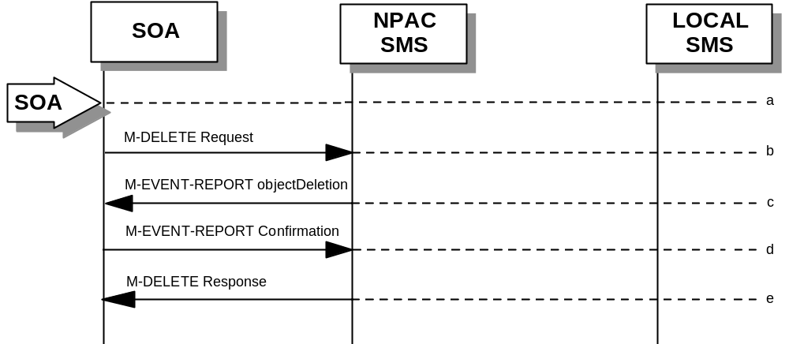Action is taken by SOA personnel to cancel an audit previously initiated by the SOA.
- The SOA sends an M-DELETE request for the subscriptionAudit object to the NPAC SMS, requesting cancellation of an audit. If the audit was not initiated by the SOA requesting cancellation, then the request will be rejected with an accessDenied error.
- The NPAC SMS will respond by sending an objectDeletion M-EVENT-REPORT.
- The SOA confirms the M-EVENT-REPORT.
- The NPAC SMS sends an M-DELETE response to the SOA.

SOA Initiated Audit Cancellation by the NPAC
The NPAC cancels an audit that was initiated by an SOA.
- Action is taken by NPAC personnel to cancel an audit previously initiated by an SOA.
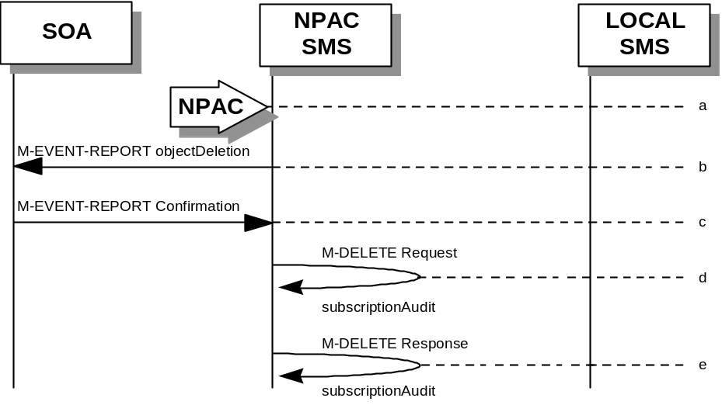
- The NPAC SMS sends an objectDeletion M-EVENT-REPORT to the SOA that initiated the audit request.
- The SOA confirms the M-EVENT-REPORT
- The NPAC SMS issues a local M-DELETE request to/from the NPAC SMS. This will attempt to delete the subscriptionAudit object on the NPAC SMS.
- The M-DELETE response is received on the NPAC SMS indicating whether the subscriptionAudit object was deleted successfully.

NPAC Initiated Audit
In this scenario, the NPAC SMS initiates an audit due to suspected subscription version discrepancies.
- Action is taken by NPAC personnel to start an audit due to suspected network discrepancies.
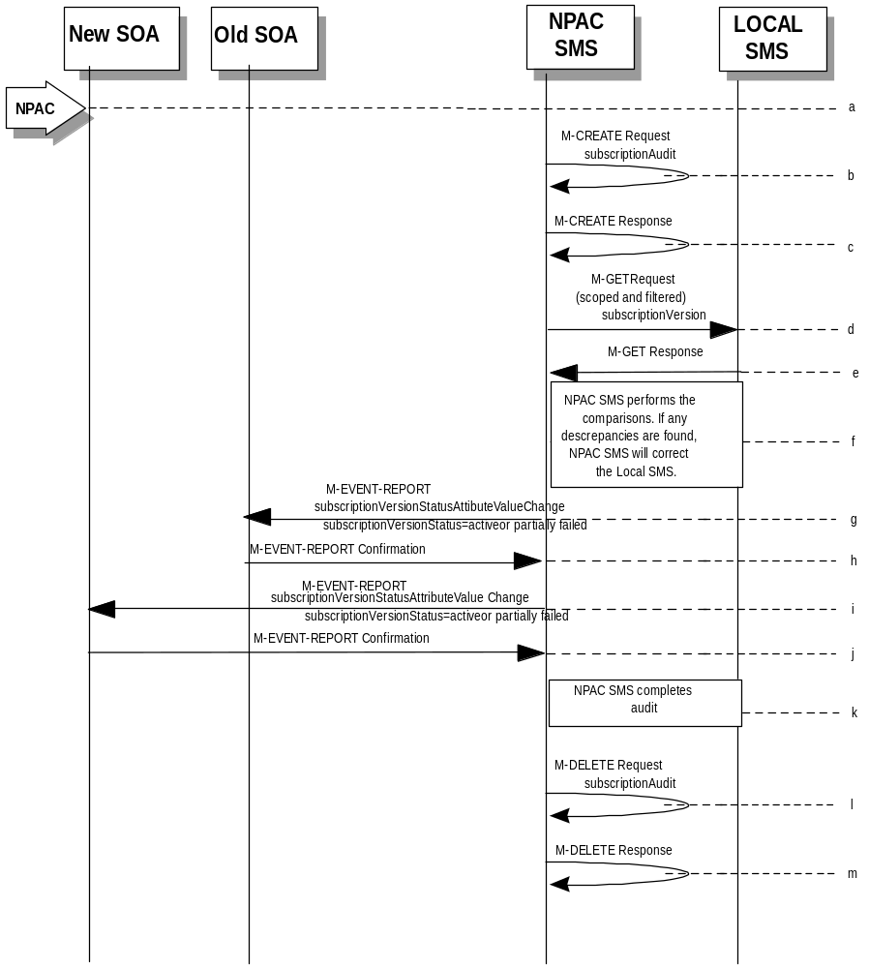
- The NPAC SMS does a Local M-CREATE request to itself for the subscriptionAudit object requesting an audit.
- The NPAC SMS responds with an M-CREATE response indicating that the subscriptionAudit object was created successfully.
- The NPAC SMS sends an M-GET request to the Local SMSs to retrieve the subscription data to use for audit processing. The request uses the CMIP scoping and filtering options to retrieve only the subscriptionVersion objects to be audited.
- The Local SMS responds to the M-GET request by returning the subscription data that satisfies the scope and filter data.
- NPAC SMS performs the comparisons. If any discrepancies are found, the NPAC SMS will perform the necessary fix to the Local SMS.
- If any corrections were issued to any Local SMSs, the NPAC SMS will send M-EVENT-REPORT to the old service provider SOA of the subscriptionVersionStatus change and a list of failed Local SMSs (minus any recently updated Local SMSs that no longer contains a discrepancy).
- The old service provider SOA confirms the M-EVENT-REPORT.
- If any corrections were issued to any Local SMSs, the NPAC SMS will send M-EVENT-REPORT to the new service provider SOA of the subscriptionVersionStatus change and a list of failed Local SMSs (minus any recently updated Local SMSs that no longer contains a discrepancy).
- The new service provider SOA confirms the M-EVENT-REPORT.
- NPAC SMS completes the audit.
- Issue a local M-DELETE request for the subscriptionAudit object to/from the NPAC SMS. This will attempt to delete the subscriptionAudit object on the NPAC SMS. The M-DELETE does not occur until after the “Audit Log Retention Period” which defaults to 90 days.
- The M-DELETE response is received on the NPAC SMS indicating whether the subscriptionAudit object was deleted successfully.

NPAC Initiated Audit Cancellation by the NPAC
The NPAC SMS cancels an audit that it initiated.
- 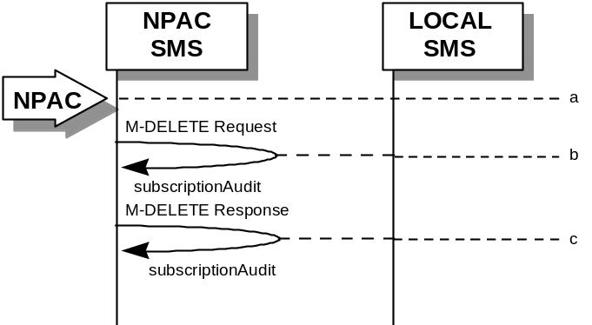Action is taken by NPAC personnel to cancel an audit previously initiated by the NPAC SMS.
- Issue a local M-DELETE request to/from the NPAC SMS. This will attempt to delete the subscriptionAudit object on the NPAC SMS.
- The M-DELETE response is received on the NPAC SMS indicating whether the subscriptionAudit object was deleted successfully.

Audit Query on the NPAC
This scenario shows a service provider query on an existing audit that it initiated.
- The service provider SOA takes action to query an audit that it initiated.
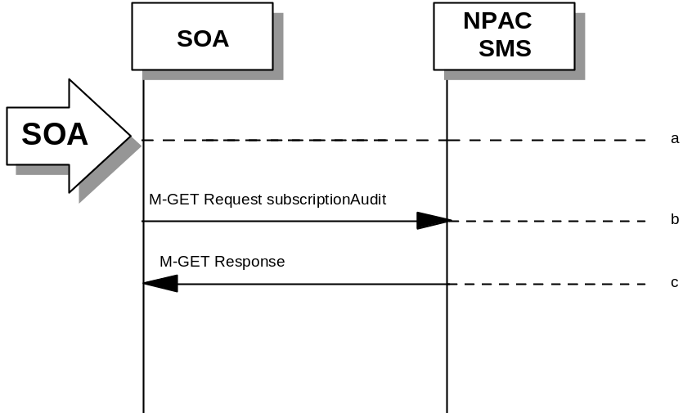
- Service provider SOA sends an M-GET request for a subscriptionAudit on the NPAC SMS.
- NPAC SMS responds to an M-GET with the audit data or a failure and reason for failure. An accessDenied error will be returned to the service provider if they did not originate the audit queried.

Service Provider Scenarios

Service Provider Creation by the NPAC
In this scenario, the NPAC SMS creates data for a new LNP service provider. The addition of NPA-NXX and LRN data for a new service provider will be shown in flows that follow.
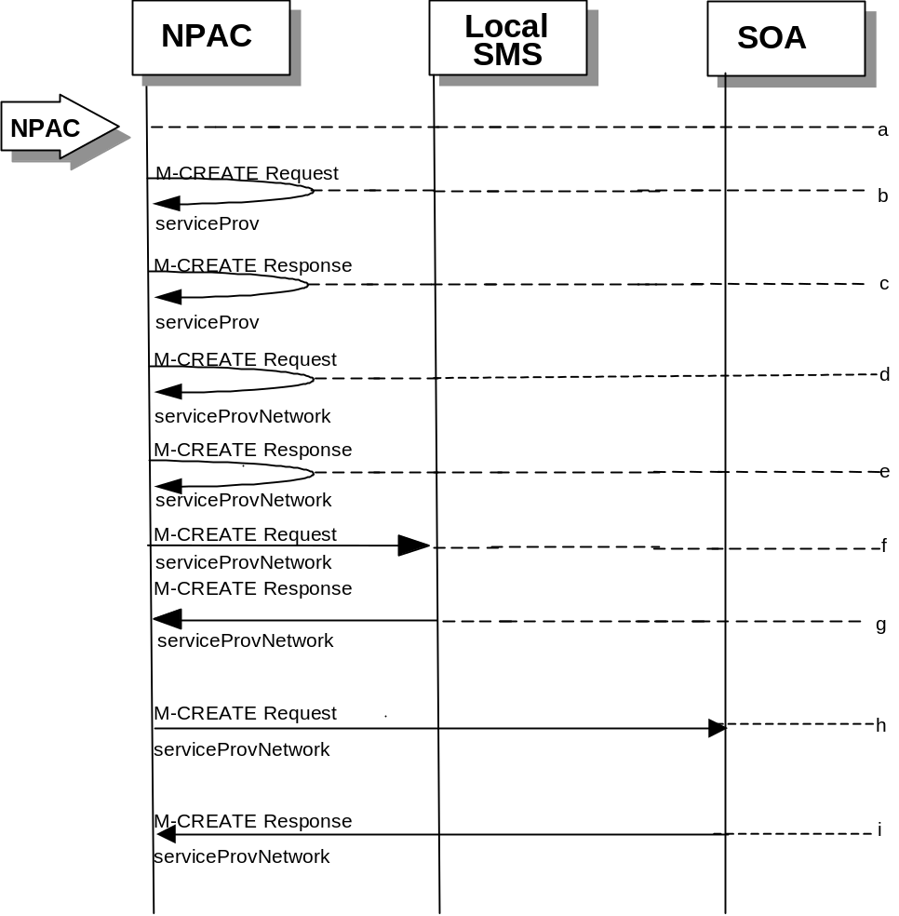
- Action is taken by NPAC SMS personnel to create a new service provider.
- Issue a local M-CREATE request for the serviceProv object to/from the NPAC SMS. This will attempt to create the serviceProv object on the NPAC SMS. If the M-CREATE fails, the appropriate error will be returned.
- The M-CREATE response is received on the NPAC SMS indicating whether the serviceProv object was created successfully. If a failure occurs, processing will stop.
- Issue a local M-CREATE request for the serviceProvNetwork object to/from the NPAC SMS. This will attempt to create the serviceProvNetwork object on the NPAC SMS. If the M-CREATE fails, the appropriate error will be returned.
- The M-CREATE response is received on the NPAC SMS indicating whether the serviceProvNetwork object was created successfully. If the object cannot be created, the serviceProv object is deleted and an error is returned.
- The NPAC SMS sends an M-CREATE request for the serviceProvNetwork object to each of the Local SMS(s).
- The Local SMS(s) will respond by sending an M-CREATE response back to the NPAC SMS.
- The NPAC SMS sends an M-CREATE request for the serviceProvNetwork object to each of the SOA(s).
- The SOA(s) will respond by sending an M-CREATE response back to the NPAC SMS.

Service Provider Deletion by the NPAC
In this scenario, the NPAC SMS deletes data for an LNP service provider with no network data.
- Action is taken by NPAC SMS personnel to delete an existing service provider.
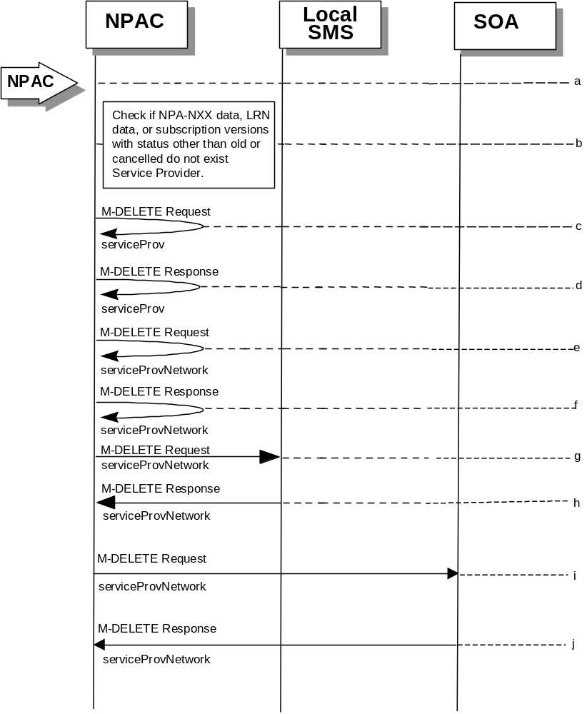
- Check the database to see if the service provider has associated with it NPA-NXX data, LRN data, or subscription versions with status other than old or canceled. If so, deny the request.
- Issue a local M-DELETE request for the serviceProv object to/from the NPAC SMS. This will attempt to delete the serviceProv object on the NPAC SMS.
- The M-Delete response is received on the NPAC SMS indicating whether the serviceProv object was deleted successfully.
- If the serviceProv object was deleted, issue a local M-DELETE request for the serviceProvNetwork object to/from the NPAC SMS. This will attempt to delete the serviceProvNetwork object on the NPAC SMS.
- The M-DELETE response is received on the NPAC SMS indicating whether the serviceProvNetwork object was deleted successfully.
- If the serviceProvNetwork object was deleted, the NPAC SMS sends an M-DELETE request for the serviceProvNetwork object to each of the Local SMS(s).
- The Local SMS(s) will respond by sending an M-DELETE response back to the NPAC SMS.
- If the serviceProvNetwork object was deleted, the NPAC SMS sends an M-DELETE request for the serviceProvNetwork object to each of the SOA(s).
- The SOA(s) will respond by sending an M-DELETE response back to the NPAC SMS.

Service Provider Modification by the NPAC
In this scenario, the NPAC SMS modifies the LNP service provider data.
- Action is taken by the NPAC personnel to modify data for an existing service provider.
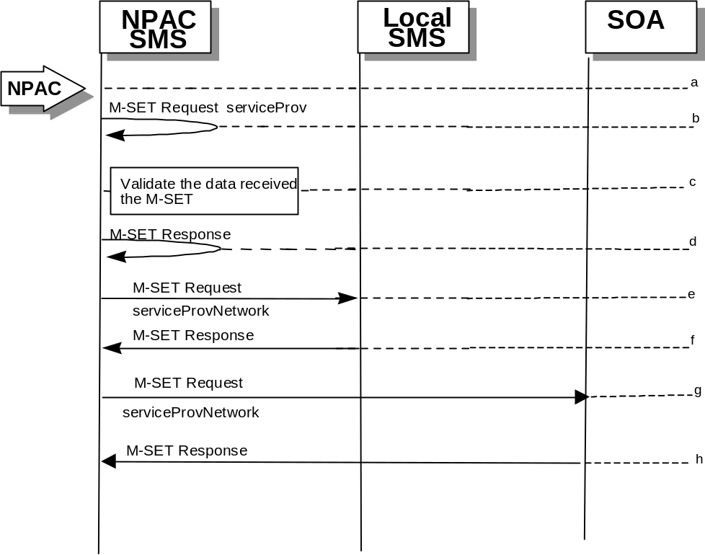
- Issue a local M-SET request for the serviceProv object to/from the NPAC SMS. This will attempt to set the specified information on the NPAC SMS.
- Validate the data to be set in the M-SET request. An M-SET Error Response of invalidArgumentValue is returned if any data is deemed invalid.
- The M-SET response is received on the NPAC SMS indicating whether the serviceProv object was modified successfully.
- NPAC SMS performs an M-SET for the serviceProvNetwork to all the Local SMS(s) if the service provider name changed.
- The Local SMS(s) respond.
- NPAC SMS performs an M-SET for the service ProvNetwork to all the SOA(s) if the service provider name changed.
- The SOA(s) respond.

Service Provider Modification by the Local SMS
In this scenario, the Local SMS modifies its own service provider data.

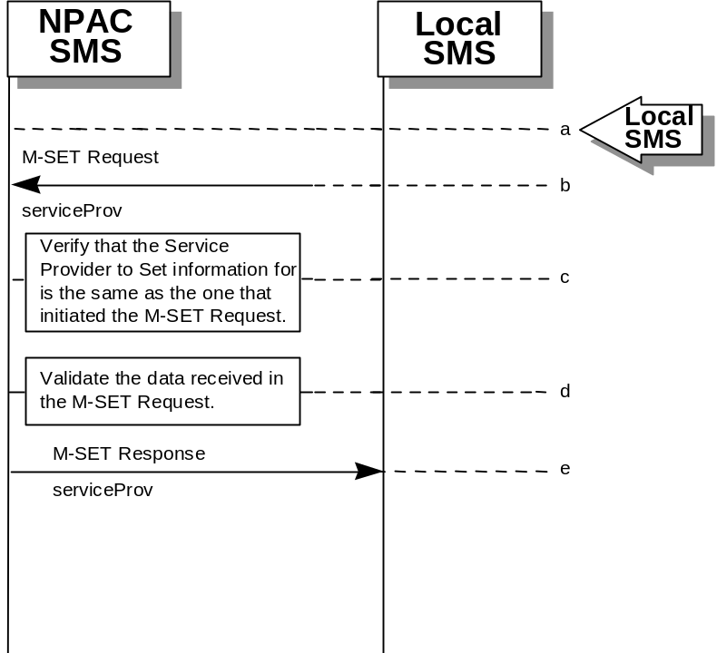
- Action is taken by the Local SMS personnel to modify their own service provider data.
- The Local SMS sends an M-SET request to the NPAC SMS to modify their service provider information.
- The NPAC SMS verifies that the service provider to be modified is owned by the service provider that initiated the request. If not, an access denied M-SET Error Response of invalidArgumentValue is returned.
- Validate the data to be set in the M-SET request. An invalidArgumentValue M-SET Error Response is returned if any data is deemed invalid.
- The NPAC SMS sends an M-SET response back to the Local SMS that initiated the request

Service Provider Modification by the SOA

In this scenario, the SOA modifies its own service provider data.
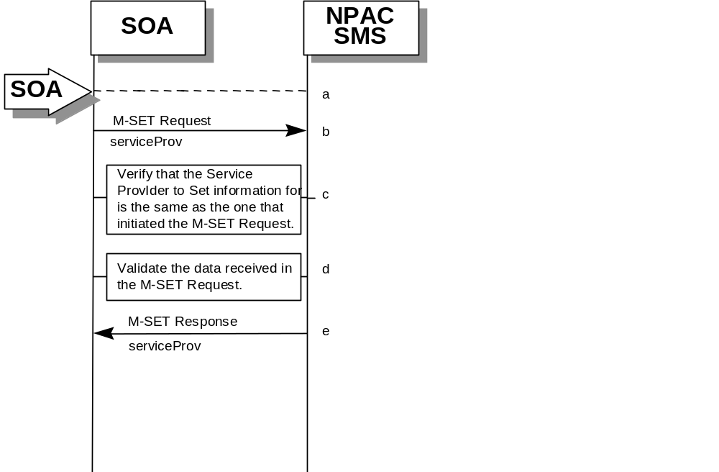

- Action is taken by the SOA to modify their own service provider data.
- The SOA sends an M-SET request to the NPAC SMS to modify their service provider information.
- The NPAC SMS verifies that the service provider to be modified is owned by the service provider that initiated the request. If not, an access denied M-SET Error Response is returned.
- Validate the data to be set in the M-SET request. An invalidArgumentValue M-SET Error Response is returned if any data is deemed invalid.
- The NPAC SMS sends an M-SET response back to the SOA that initiated the request.

Service Provider Query by the Local SMS
In this scenario, the Local SMS queries their own service provider data.
- Action is taken by the Local SMS personnel to query their own service provider data.
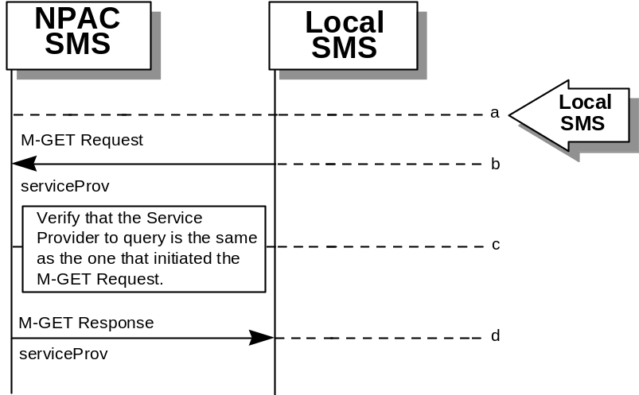
- The Local SMS sends an M-GET request to the NPAC SMS requesting their own service provider information.
- The NPAC SMS verifies that the service provider information to be retrieved is owned by the service provider that initiated the request. If not, an M-GET Error Response of accessDenied is returned if the two service providers do not match.
- The NPAC SMS sends an M-GET response containing the requested service provider information back to the Local SMS or SOA that initiated the request.

Service Provider Query by the SOA
In this scenario, the SOA queries their own service provider data.
- Action is taken by the SOA or SOA personnel to query their own service provider data.
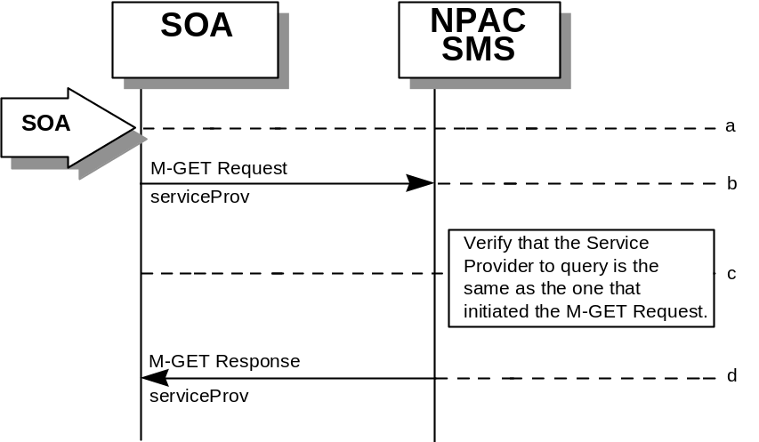
- The SOA sends an M-GET request to the NPAC SMS requesting their own service provider information.
- The NPAC SMS verifies that the service provider information to be retrieved is owned by the service provider that initiated the request. If not, an M-GET error response of accessDenied is returned if the two service providers do not match.
- The NPAC SMS sends an M-GET response containing the requested service provider information back to the SOA that initiated the request.

Service Provider Network Data Scenarios

NPA-NXX Scenarios

NPA-NXX Creation by the NPAC
In this scenario, NPAC SMS creates new NPA-NXX data for an LNP service provider.
- Action is taken by the NPAC Personnel to create an NPA-NXX for a specified service provider.
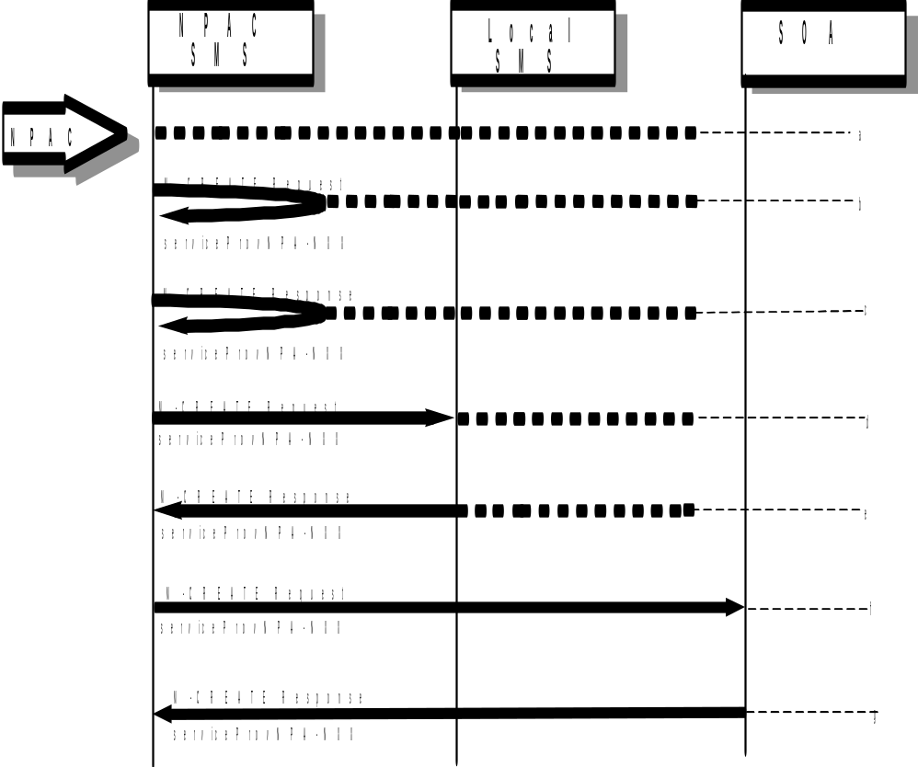
- The NPAC SMS sends an M-CREATE request to itself in order to create a local serviceProvNPA-NXX object.
- The NPAC SMS receives the M-CREATE response indicating whether the serviceProvNPA-NXX object was created successfully.
- If the serviceProvNPA-NXX object was created, the NPAC SMS sends an M-CREATE request to all Local SMS(s) accepting downloads for the NPA-NXX for the serviceProvNPA-NXX object.
- The Local SMS(s) respond by sending an M-CREATE response indicating whether the serviceProvNPA-NXX object was created successfully.
- If the serviceProvNPA-NXX object was created, the NPAC SMS sends an M-CREATE request to all SOA(s) accepting downloads for the NPA-NXX for the serviceProvNPA-NXX object.
- The SOA(s) respond by sending an M-CREATE response indicating whether the serviceProvNPA-NXX object was created successfully.

NPA-NXX Deletion by the NPAC
In this scenario, NPAC SMS deletes an NPA-NXX for an LNP service provider.
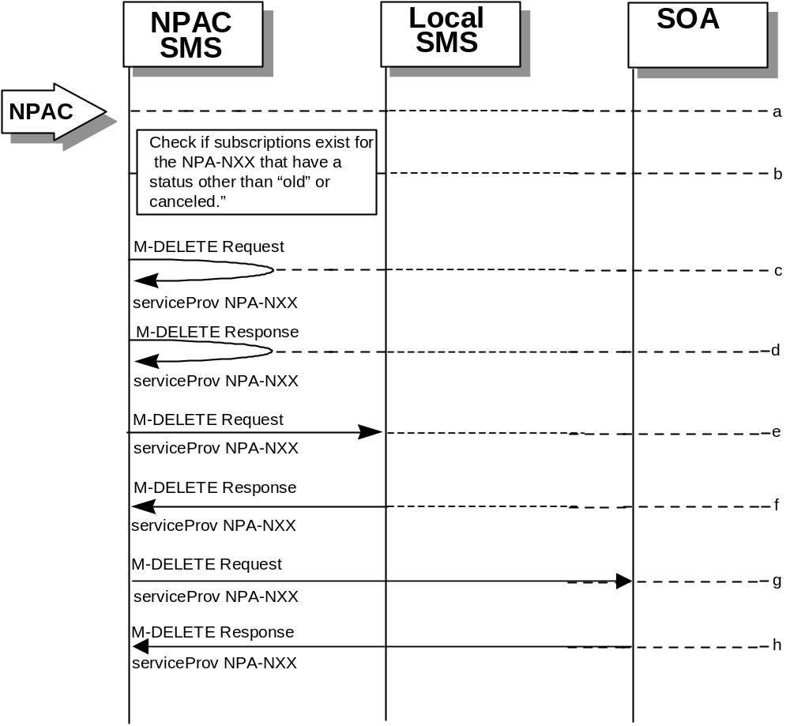
- Action is taken by NPAC SMS personnel to delete an NPA-NXX for a specified service provider.
- Check the subscriptions database to see if subscriptions exist with this NPa-NXX that have a status other than “old” or “canceled.” If so, terminate processing at this point.
- The NPAC SMS sends an M-DELETE request to itself in order to delete the local serviceProvNPA-NXX object.
- The NPAC SMS receives the M-DELETE response indicating whether the serviceProvNPA-NXX object was deleted successfully.
- If the serviceProvNPA-NXX object was deleted, the NPAC SMS sends an M-DELETE request to all Local SMS(s) accepting downloads for the NPA-NXX for the serviceProvNPA-NXX object.
- The Local SMS(s) responds by sending an M-DELETE response to the NPAC SMS indicating whether the serviceProvNPA-NXX object was deleted successfully.
- If the serviceProvNPA-NXX object was deleted, the NPAC SMS sends an M-DELETE request to all SOA(s) accepting downloads for the NPA-NXX for the serviceProvNPA-NXX object.
- The SOA(s) responds by sending an M-DELETE response to the NPAC SMS indicating whether the serviceProvNPA-NXX object was deleted successfully.

NPA-NXX Creation by the Local SMS
In this scenario, the Local SMS creates a new NPA-NXX for its own service provider network data.
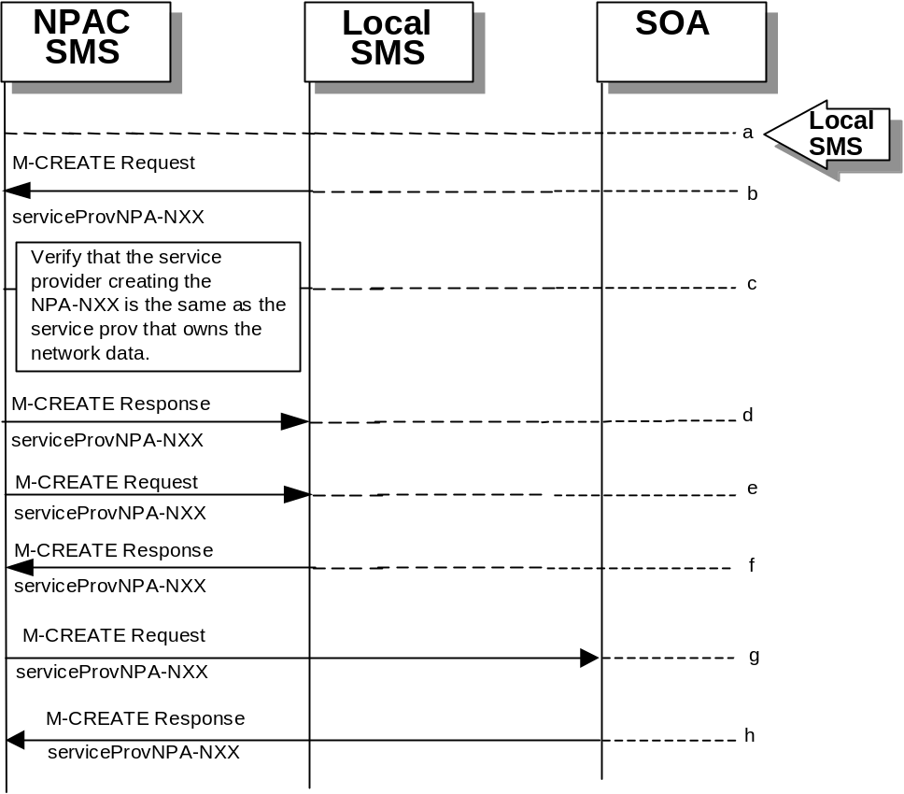
- Action is taken by the Local SMS personnel to create an NPA-NXX available for porting in their own service provider network.
- The Local SMS sends an M-CREATE request to the NPAC requesting that an NPA-NXX object be created for their own service provider network.
- The NPAC SMS verifies that the service provider creating the NPA-NXX information is the same as the service provider that owns the network data. If not, then an access denied M-CREATE accessDenied Error Response is returned.
- The NPAC SMS responds by sending an M-CREATE response to the Local SMS that initiated the request indicating whether the serviceProvNPA-NXX object was created successfully.
- If the serviceProvNPA-NXX object was created, the NPAC SMS sends an M-CREATE request to all Local SMS(s) accepting downloads for the NPA-NXX for the serviceProvNPA-NXX object.
- The Local SMS(s) responds by sending an M-CREATE Response indicating whether the serviceProvNPA-NXX object was created successfully.
- If the serviceProvNPA-NXX object was created, the NPAC SMS sends an M-CREATE request to all SOA(s) accepting downloads for the NPA-NXX for the serviceProvNPA-NXX object.
- The SOA(s) responds by sending an M-CREATE Response indicating whether the serviceProvNPA-NXX object was created successfully.

NPA-NXX Creation by the SOA
In this scenario, the SOA creates a new NPA-NXX for its own service provider network data.
- Action is taken by the SOA personnel to create an NPA-NXX available for porting in their own service provider network.
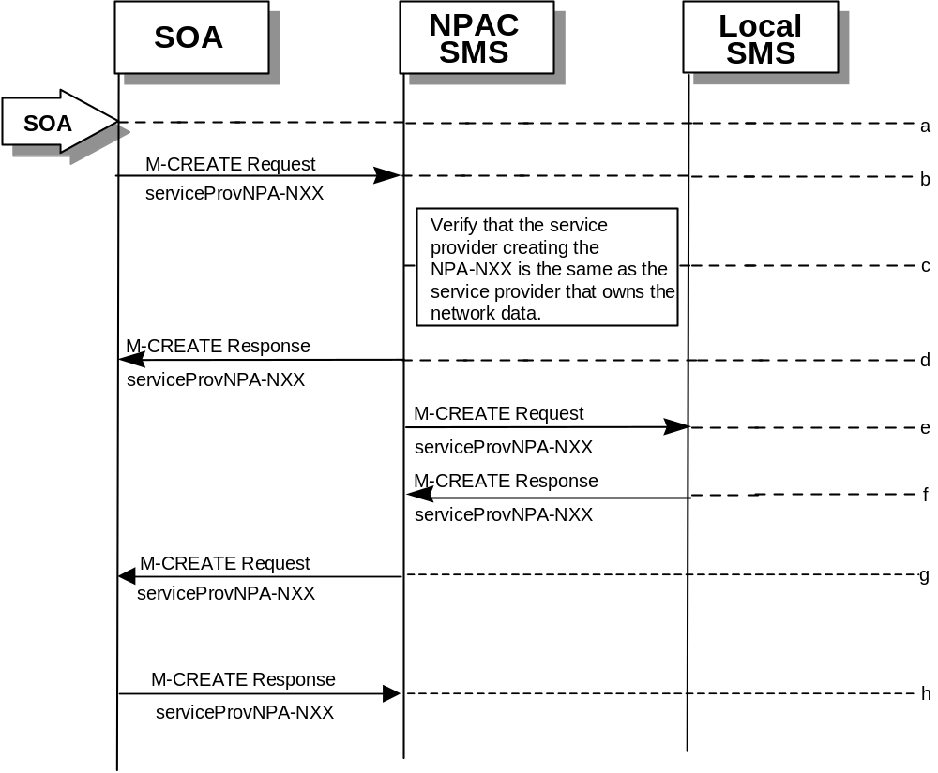
- The SOA sends an M-CREATE request to the NPAC requesting that an NPA-NXX object be created for their own service provider network.
- The NPAC SMS verifies that the service provider creating the NPA-NXX information is the same as the service provider that owns the network data. If not, then an access denied M-CREATE response is returned to the SOA that initiated the request.
- The NPAC SMS sends an M-CREATE response back to the SOA for the serviceProvNPA-NXX object.
- The NPAC SMS sends an M-CREATE request to all Local SMS(s) accepting downloads for the NPA-NXX for the serviceProvNPA-NXX object.
- The Local SMS(s) responds by sending an M-CREATE response indicating whether the serviceProvNPA-NXX object was created successfully.
- The NPAC SMS sends an M-CREATE request to all SOA(s) accepting downloads for the NPA-NXX for the serviceProvNPA-NXX object.
- The SOA(s) responds by sending an M-CREATE response indicating whether the serviceProvNPA-NXX object was created successfully.

NPA-NXX Deletion by the Local SMS
In this scenario, the Local SMS deletes an NPA-NXX in its own service provider network data.
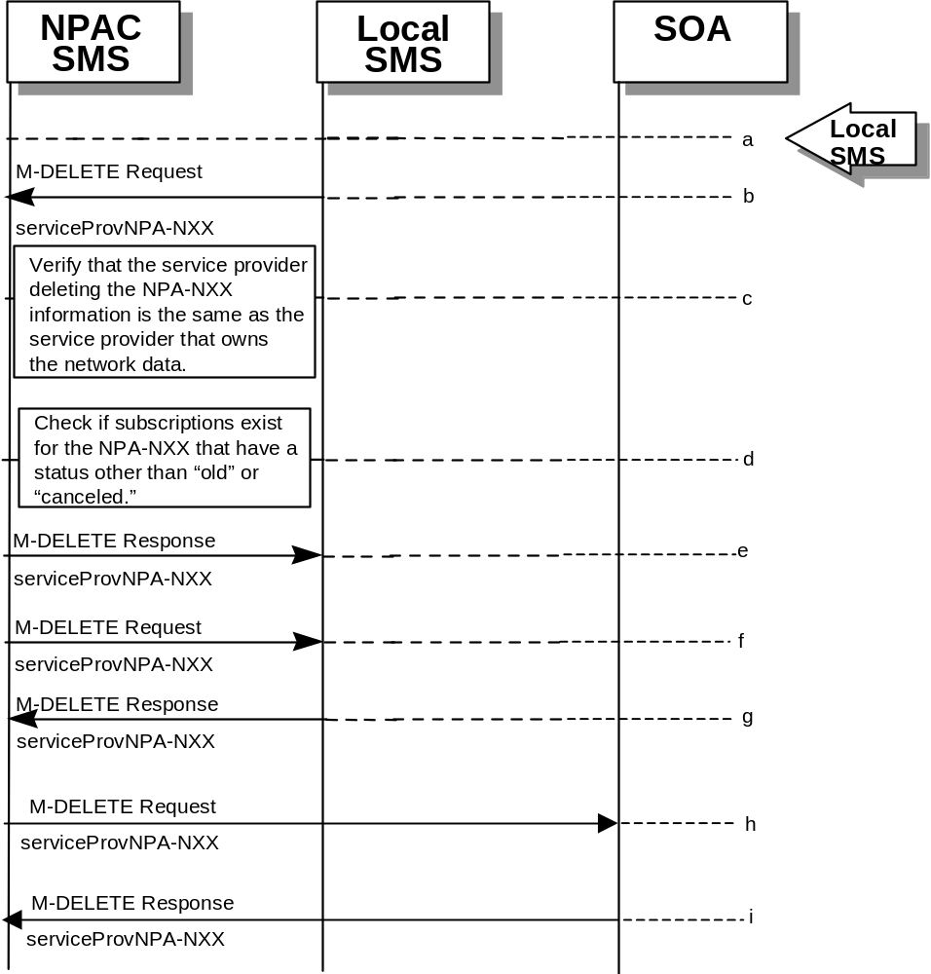
- Action is taken by the Local SMS personnel to delete an NPA-NXX for their own service provider network data.
- The SMS sends an M-DELETE request to the NPAC SMS requesting that an NPA-NXX object be deleted for their own service provider.
- The NPAC SMS verifies that the service provider that owns the NPAC-NXX information to be deleted is the same as the service provider that owns the network data. If not, then an M-DELETE accessDenied error response is returned.
- Check the subscriptions database to see if subscriptions exist with this LRN that have a status other than “old” or canceled.” If so, terminate processing at this point.
- The NPAC SMS responds by sending an M-DELETE response indicating whether the serviceProvNPA-NXX object was deleted successfully.
- If the serviceProvNPA-NXX object was deleted, the NPAC SMS sends an M-DELETE request to all Local SMS(s) accepting downloads for the NPA-NXX for the serviceProvNPA-NXX object.
- The Local SMS(s) responds by sending an M-DELETE response indicating whether the serviceProvNPA-NXX object was deleted successfully.
- If the serviceProvNPA-NXX object was deleted, the NPAC SMS sends an M-DELETE request to all SOA(s) accepting downloads for the NPA-NXX for the serviceProvNPA-NXX object.
- The SOA(s) responds by sending an M-DELETE response indicating whether the serviceProvNPA-NXX object was deleted successfully.

NPA-NXX Deletion by SOA
In this scenario, the SOA deletes a new NPA-NXX for its own service provider network data.
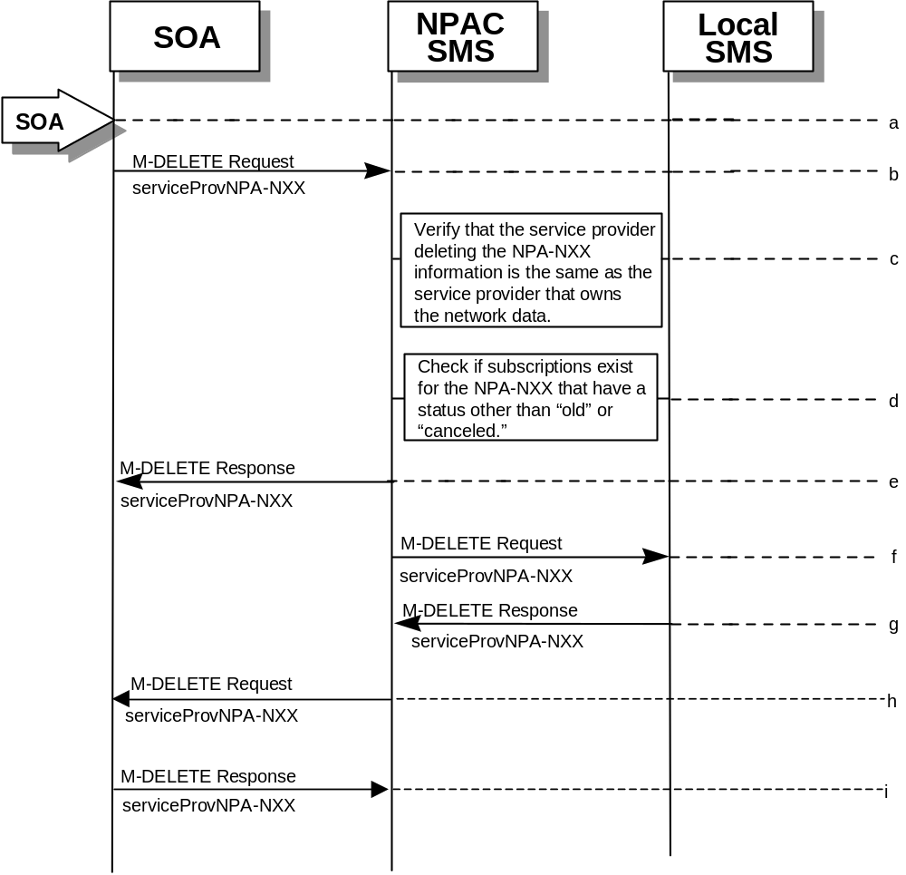
- Action is taken by the SOA personnel to delete an NPA-NXX for their own service provider network data.
- The SOA sends an M-DELETE request to the NPAC SMS requesting that an NPA-NXX object be deleted for their own service provider.
- The NPAC SMS verifies that the service provider that owns the NPA-NXX information to be deleted is the same as the service provider that owns the network data. If not, then an M-DELETE accessDenied Error Response is returned.
- Check the subscriptions database to see if subscriptions exist with this NPA-NXX that have a status other than “old” or “canceled.” If so, terminate processing at this point.
- The NPAC SMS responds by sending an M-DELETE response indicating whether the serviceProvNPA-NXX object was deleted successfully.
- The NPAC SMS sends an M-DELETE request to all Local SMS(s) accepting downloads for the NPA-NXX for the serviceProvNPA-NXX object.
- The Local SMS(s) respond by sending an M-DELETE response indicating whether the serviceProvNPA-NXX object was deleted successfully.
- The NPAC SMS sends an M-DELETE request to all SOA(s) accepting downloads for the NPA-NXX for the serviceProvNPA-NXX object.
- The SOA(s) respond by sending an M-DELETE response indicating whether the serviceProvNPA-NXX object was deleted successfully

NPA-NXX Query by the Local SMS
In this scenario, the Local SMS queries for NPA-NXX data.
- Action is taken by Local SMS personnel to query for a serviceProvNPA-NXX.
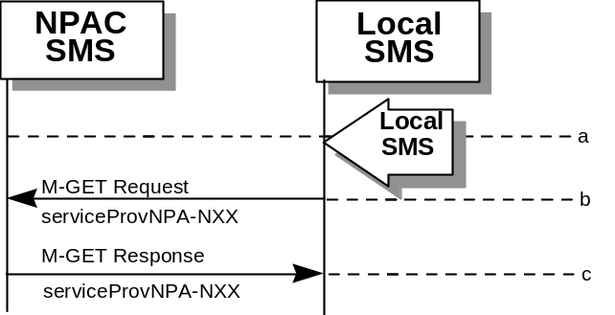
- The Local SMS sends an M-GET request to the NPAC SMS for the serviceProvNPA-NXX object.
- The NPAC SMS responds by sending an M-GET response containing the NPA-NXX data back to the Local SMS.

NPA-NXX Query by the SOA
In this scenario, the SOA queries for NPA-NXX updates.
- 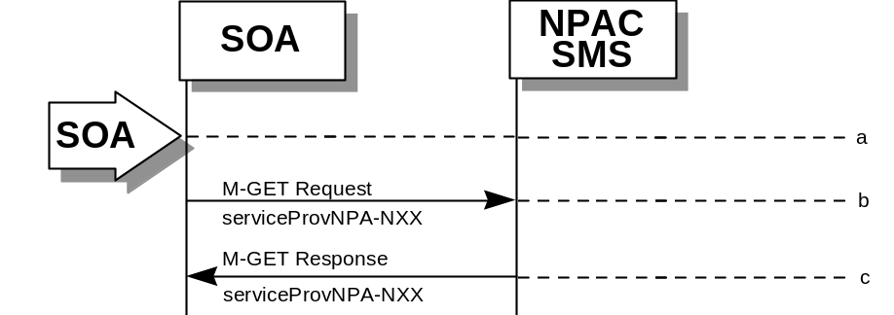Action is taken by SOA personnel to query for a serviceProvNPA-NXX.
- The SOA sends an M-GET request to the NPAC SMS for the serviceProvNPA-NXX object.
- The NPAC SMS responds by sending an M-GET response containing the NPA-NXX data back to the SOA.

LRN Scenarios

LRN Creation by the NPAC
In this scenario, the NPAC SMS creates an LRN.
- Action is taken by the NPAC personnel to create an LRN for an existing service provider.
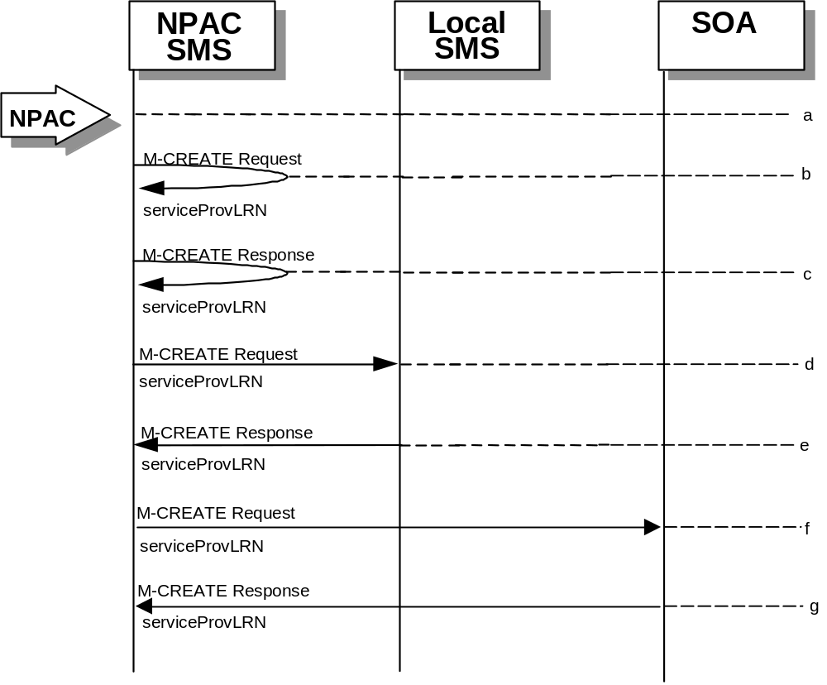
- The NPAC SMS sends an M-CREATE request to itself in order to create a local serviceProvLRN object.
- The NPAC SMS receives the M-CREATE response indicating whether the serviceProvLRN object was created successfully.
- If the serviceProvLRN object was created, the NPAC SMS sends an M-CREATE request to all Local SMS(s) for the serviceProvLRN object.
- The Local SMS(s) responds by sending an M-CREATE response indicating whether the serviceProvLRN object was created successfully.
- If the serviceProvLRN object was created, the NPAC SMS sends an M-CREATE request to all SOA(s) for the serviceProvLRN object.
- The SOA(s) responds by sending an M-CREATE response indicating whether the serviceProvLRN object was created successfully.

LRN Creation by the SOA
In this scenario, the SOA creates an LRN for its own service provider network data.
- Action is taken by the SOA personnel to create an LRN for their own network data.
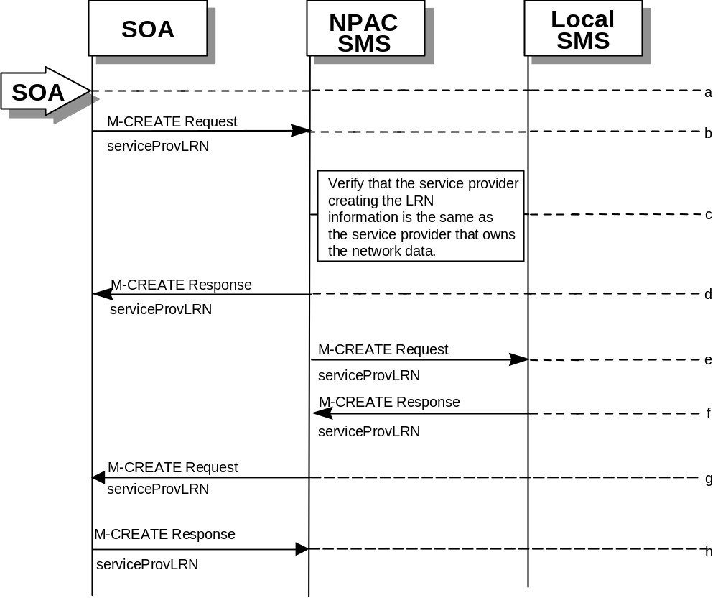
- The SOA sends an M-CREATE request to the NPAC SMS requesting that an LRN object be created for their own network data.
- The NPAC SMS verifies that the service provider creating the LRN information is the same as the service provider that owns the service provider network data. If not, then an accessDenied M-CREATE Error Response is returned.
- The NPAC SMS responds by sending an M-CREATE response back to the SOA that initiated the request, indicating whether the serviceProvLRN object was created successfully.
- The NPAC SMS sends an M-CREATE request to all Local SMS(s) for the serviceProvLRN object.
- The Local SMS(s) respond by sending an M-CREATE response indicating whether the service provider LRN object was created successfully.
- The NPAC SMS sends an M-CREATE request to all SOA(s) for the serviceProvLRN object.
- The SOA(s) respond by sending an M-CREATE response indicating whether the service provider LRN object was created successfully.

LRN Deletion by the SOA
In this scenario, the SOA deletes an LRN for their own service provider network data.
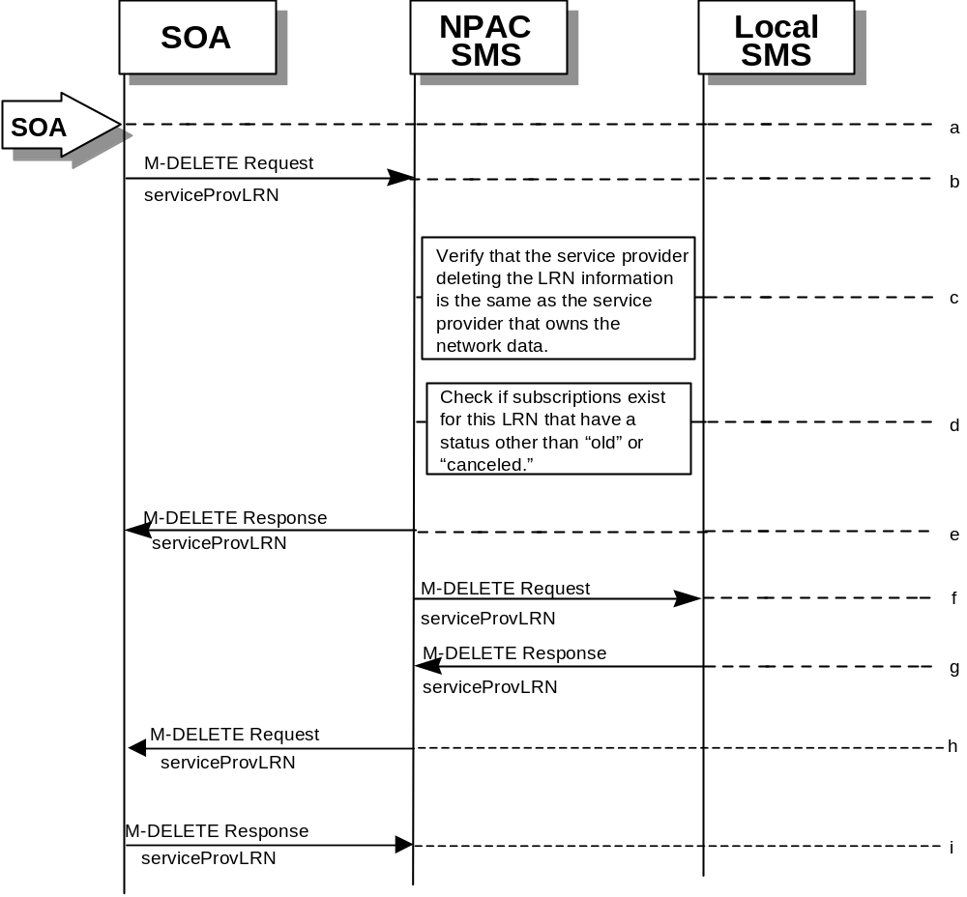
- Action is taken by the SOA personnel to delete an LRN for their own network data.
- The SOA sends an M-DELETE request to the NPA requesting that an LRN object be deleted.
- The NPAC SMS verifies that the service provider deleting the LRN information is the same as the service provider that is associated with the network data. If not, then an accessDenied M-DELETE error response is returned.
- Check the subscriptions database to see if subscriptions exist with this LRN that have a status other than “old” or “canceled.” If so, an M-SET error response complexity limitation is returned.
- The NPAC SMS responds by sending an M-DELETE response indicating whether the serviceProvLRN object was deleted successfully.
- The NPAC SMS sends an M-DELETE request to all Local SMS(s) for the serviceProvLRN object.
- The Local SMS(s) responds by sending a message indicating whether the serviceProvLRN object was deleted successfully.
- The NPAC SMS sends an M-DELETE request to all SOA(s) for the serviceProvLRN object.
- The SOA(s) responds by sending a message indicating whether the serviceProvLRN object was deleted successfully.

LRN Query by the SOA
In this scenario, the SOA queries LRN data.
- 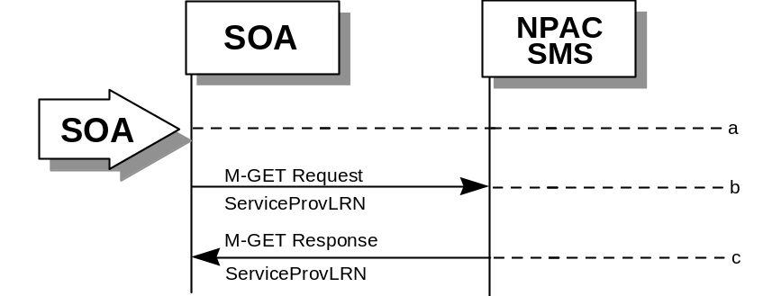Action is taken by SOA personnel to an LRN for a specified service provider.
- The SOA sends an M-GET request to the NPAC SMS for the serviceProvLRN object.
- The NPAC SMS responds by sending an M-GET response containing the data back to the SOA.

LRN Deletion by the NPAC
In this scenario, the NPAC SMS deletes an LRN.
- Action is taken by the NPAC SMS personnel to delete an LRN for a service provider.
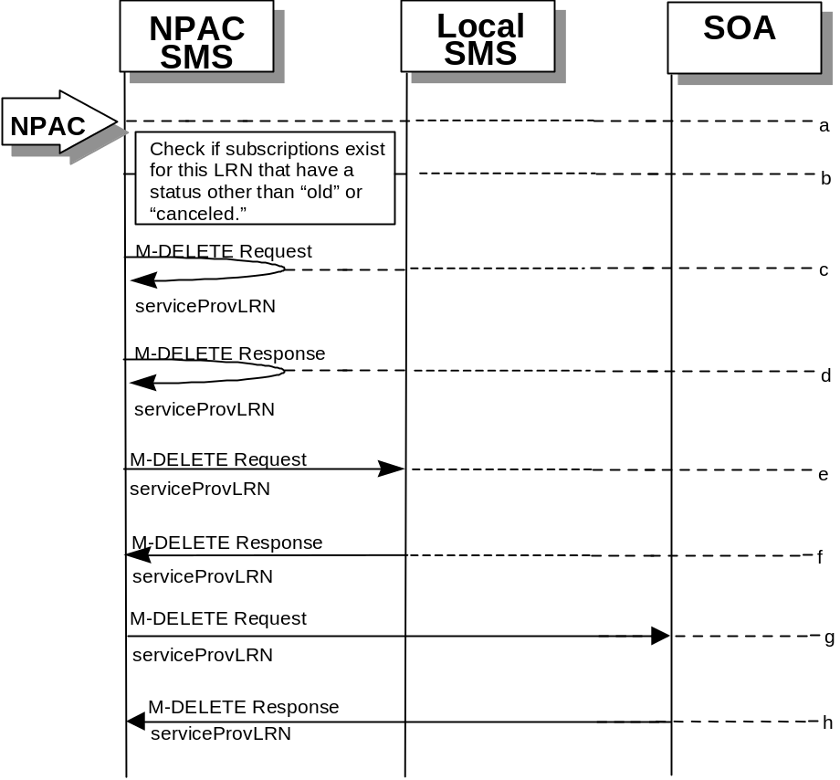
- Check the subscriptions database to see if subscriptions exist with this LRN that have a status other than “old” or “canceled.” If so, terminate processing at this point.
- The NPAC SMS sends an M-DELETE request to itself in order to delete the local serviceProvLRN object.
- The NPAC SMS receives the M-Delete response indicating whether the serviceProvLRN object was deleted successfully.
- If the serviceProvLRN object was deleted, the NPAC SMS sends an M-DELETE request to all Local SMS(s) for the serviceProvLRN object.
- The Local SMS(s) responds by sending an M-Delete response indicating whether the serviceProvLRN object was deleted successfully.
- If the serviceProvLRN object was deleted, the NPAC SMS sends an M-DELETE request to all SOA(s) for the serviceProvLRN object.
- The SOA(s) responds by sending an M-Delete response indicating whether the serviceProvLRN object was deleted successfully.

LRN Creation by the Local SMS
In this scenario, the Local SMS creates an LRN for its own service provider network data.
- Action is taken by the Local SMS personnel to create an LRN for their own network data.
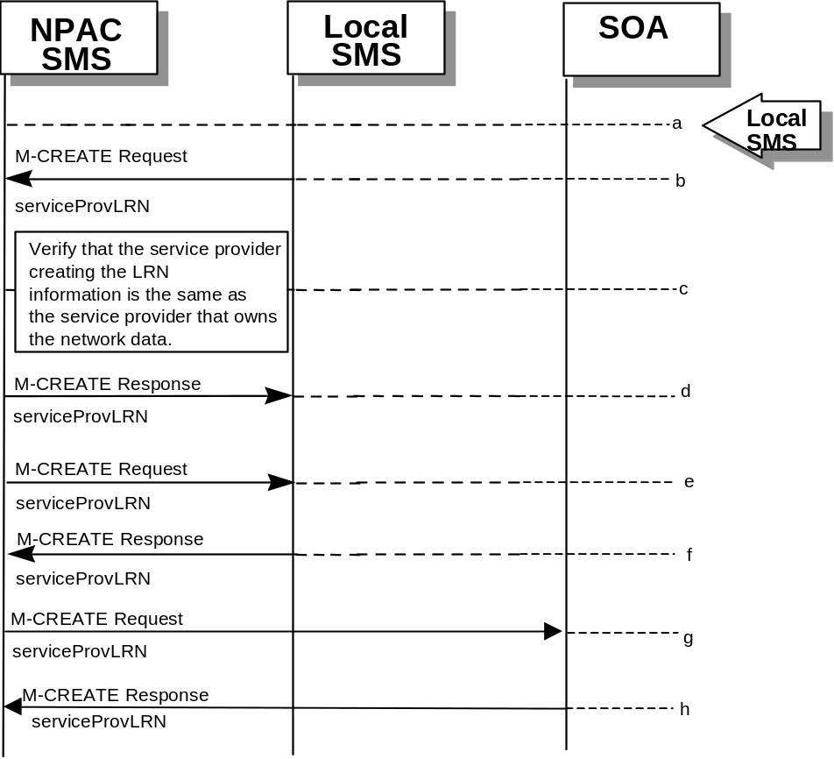
- The SMS sends an M-CREATE request to the NPAC requesting that an LRN object be created for their own network data.
- The NPAC verifies that the service provider creating the LRN information is the same as the service provider that owns the service provider network data. If not, then an accessDenied M-CREATE error response is returned.
- The NPAC SMS responds by sending an M-CREATE response back to the Local SMS that initiated the request, indicating whether the serviceProvLRN object was created successfully.
- If the serviceProvLRN object was created, the NPAC SMS sends an M-CREATE request to all Local SMS(s) for the serviceProvLRN object.
- The Local SMS(s) responds by sending an M-CREATE response indicating whether the serviceProvLRN object was created successfully.
- If the serviceProvLRN object was created, the NPAC SMS sends an M-CREATE request to all SOA(s) for the serviceProvLRN object.
- The SOA(s) responds by sending an M-CREATE response indicating whether the serviceProvLRN object was created successfully.

LRN Deletion by the Local SMS
In this scenario, the Local SMS deletes an LRN for their own service provider network data.
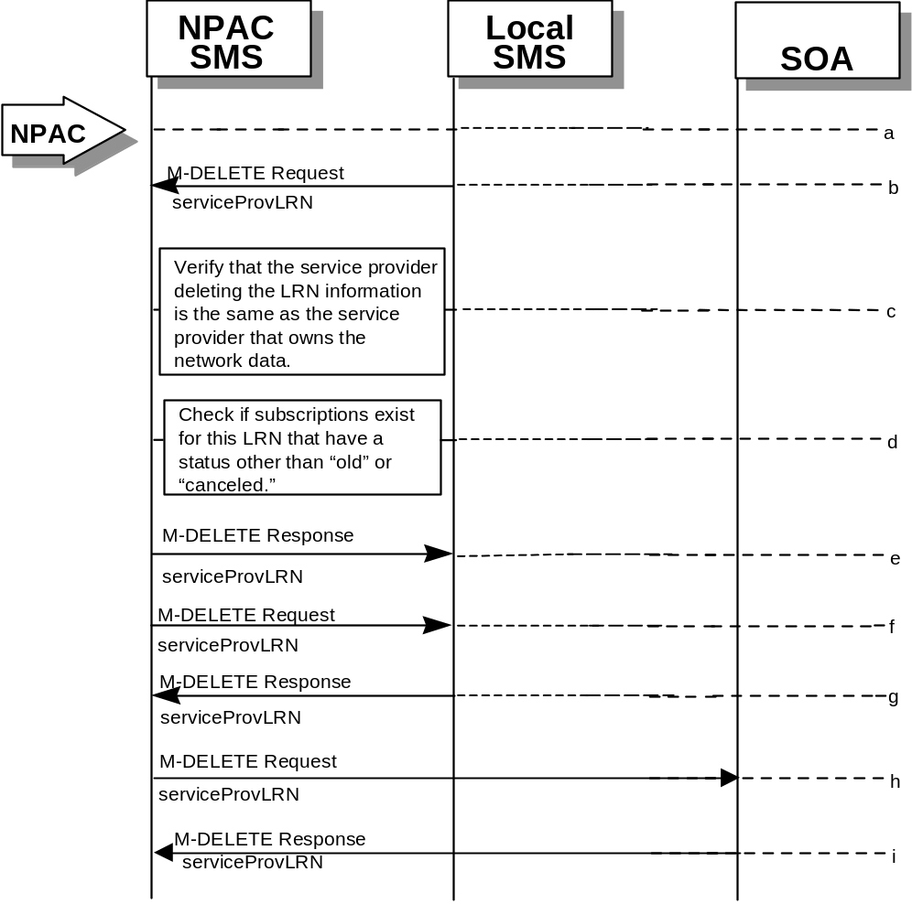
- Action is taken by the Local SMS personnel to delete an LRN for their own network data.
- The Local SMS sends an M-DELETE request to the NPAC requesting that an LRN object be deleted.
- The NPAC SMS verifies that the service provider deleting the LRN information is the same as the service provider that is associated with the network data. If not, then an accessDenied M-DELETE Error Response is returned.
- Check the subscriptions database to see if subscriptions exist with this LRN that have a status other than “old” or “canceled.” If so, an M-SET Error Response complexity limitation is returned.
- The NPAC SMS responds by sending an M-DELETE response indicating whether the serviceProvLRN object was deleted successfully.
- If the serviceProvLRN object was deleted, the NPAC SMS sends an M-DELETE request to all Local SMS(s) for the serviceProvLRN object.
- The Local SMS(s) responds by sending a message indicating whether the serviceProvLRN object was deleted successfully.
- If the serviceProvLRN object was deleted, the NPAC SMS sends an M-DELETE request to all SOA(s) for the serviceProvLRN object.
- The SOA(s) responds by sending a message indicating whether the serviceProvLRN object was deleted successfully.

LRN Query by the Local SMS
In this scenario, the Local SMS queries LRN data.
- 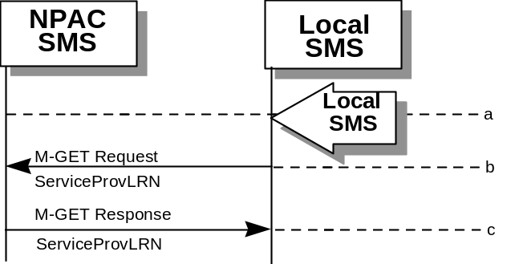Action is taken by Local SMS personnel to query an LRN for a specified service provider.
- The Local SMS sends an M-GET request to the NPAC SMS for the serviceProvLRN object.
- The NPAC SMS responds by sending an M-GET response containing the data back to the Local SMS.

Network Data Download
This scenario shows a Local SMS request for network data download in order to update their view of this data.
- 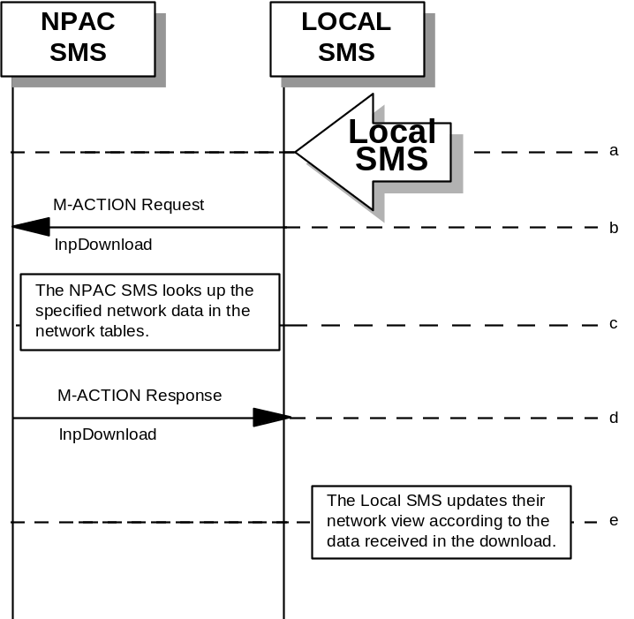Action is taken by the Local SMS personnel to request a network data download. The criteria to decide which network data is to be downloaded is specified by the Local SMS personnel.
- The Local SMS sends an M-ACTION request to the NPAC SMS lnpNetwork object requesting a network data download.
- The NPAC SMS looks up the network data in the network database as specified by the criteria in the M-ACTION request.
- The NPAC SMS responds by sending an M-ACTION response to the Local SMS that initiated the request. The response includes the success/failure of the request along with the requested network data.
- The Local SMS must take appropriate action to update their view of the data.

Scoped/Filtered GET of Network Data
This scenario shows a request for network data via a scoped/filtered M-GET. In this case, scoping is done from the lnpNetwork object. However, scoping and filtering can be done from serviceProvNetwork, serviceProvLRN, and serviceProvNPA-NXX objects.
- 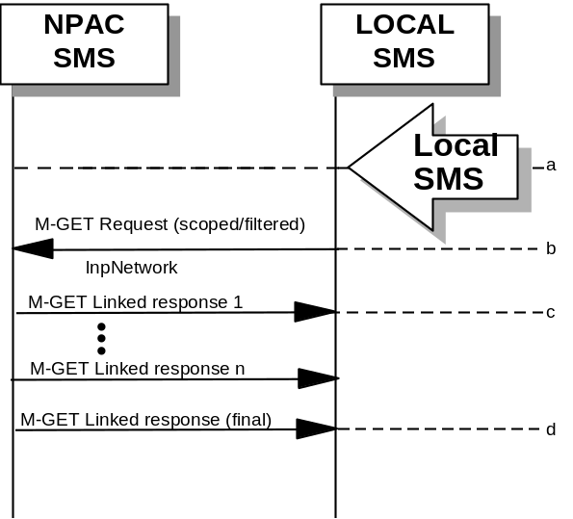Action is taken by the Local SMS personnel to request network data via a scoped/filtered M-GET request.
- The Local SMS sends a scoped/filtered M-GET request to the NPAC SMS.
- The NPAC SMS sends network data objects (serviceProvNetwork, serviceProvNPA-NXX, serviceProvLRN) that pass the scope/filter criteria to the Local SMS that initiated the request.
- A final M-GET response is sent to the Local SMS that initiated the request once all scoped/filtered network objects have been returned.

Scoped/Filtered GET of Network Data from SOA
This scenario shows a request for network data via a scoped/filtered M-GET. Scoping and filtering is done from serviceProvNetwork.
- Action is taken by the SOA personnel to request network data via a scoped/filtered M-GET request.
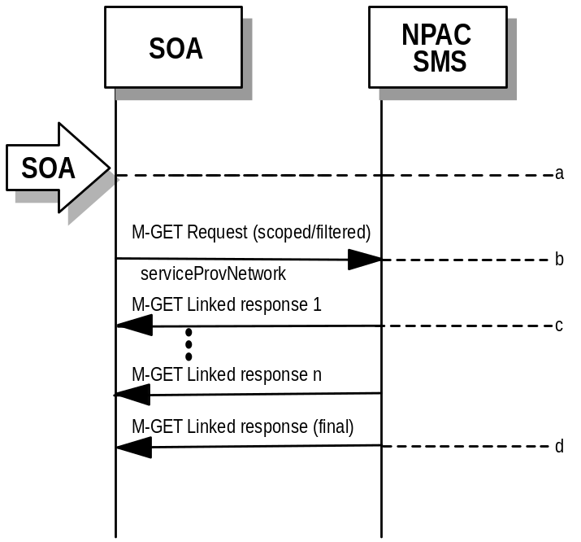

- The SOA sends a scoped/filtered M-GET request to the NPAC SMS.
- The NPAC SMS sends network data objects (serviceProvNetwork, serviceProvNPA-NXX, serviceProvLRN) that pass the scope/filter criteria to the SOA that initiated the request.
- A final M-GET response is sent to the SOA that initiated the request once all scoped/filtered network objects have been returned.

SubscriptionVersion Flow Scenarios
Note: All actions for subscription versions in the flows that follow are atomic. If the operation fails for one TN in a range it fails for all TNs in the range.

SubscriptionVersion Create Scenarios
The subscriptionVersionNPAC object is created by either the new or old service provider SOA issuing their M-ACTION to create the subscription version. If the new service provider SOA issues its subscriptionVersionNewSP-Create action first, the old service provider SOA has the option of sending in the subscriptionVersionOldSP-Create action or not. If they do send in the subscriptionVersionOldSP-Create, the old service provider explicitly states their concurrence or non-concurrence to the port by the value set within the subscriptionOldSP-Authorization field. If the old service provider does not send in their create request within the concurrence window, this implies concurrence to the port. However, the old service provider can send in their create request after the concurrence window before activation of the subscription version and the NPAC SMS will accept the data if valid.
If the old service provider SOA issues its subscriptionVersionOldSP-Create action first, then the new service provider SOA must issue its subscriptionVersionNewSP-Create action.

SubscriptionVersion Create by the Initial SOA (Old Service Provider)
In this scenario, the old service provider is the first to send the M-ACTION to create the subscriptionVersion object.
- Action is taken by the old service provider SOA to create a new version of a subscriber.
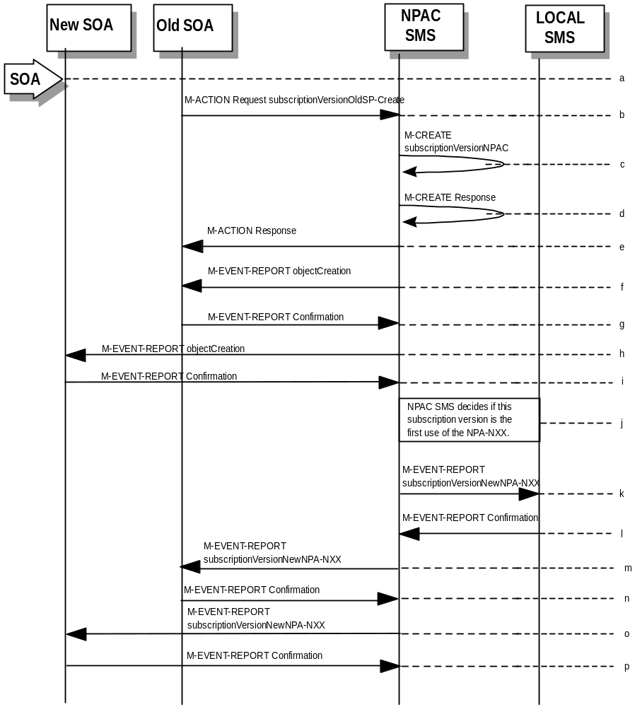
- Old service provider SOA sends M-ACTION subscriptionVersionOldSP-Create to the NPAC SMS lnpSubscriptions object to create a new subscriptionVersionNPAC. The old service provider SOA must specify the following valid attributes:
subscriptionTN or a valid subscriptionVersionTN-Range
subscriptionNewCurrentSP
subscriptionOldSP
subscriptionOldSP-DueDate (seconds set to zeros)
subscriptionOldSP-Authorization
subscriptionLNPType
If the service provider were to give a range of TNs, this would result in an M-CREATE and M-EVENT-REPORT for each TN.
If an attribute value is invalid, an invalidArgumentValue will be returned, indicating invalid data values. Other appropriate errors will also be returned.
- If the request is valid, the NPAC SMS will create the subscriptionVersionNPAC object. The status will be set to “pending” and the subscriptionOldSP-AuthorizationTimeStamp and subscriptionModifiedTimeStamp will be set.
- NPAC SMS responds to M-CREATE.
- NPAC SMS sends action reply with success or failure and reasons for failure.
- If the M-ACTION was successful, the NPAC SMS issues an M-EVENT-REPORT containing the following attributes to old service provider SOA of subscriptionVersionNPAC creation.
subscriptionTN
subscriptionOldSP
subscriptionNewCurrentSP
subscriptionOldSp-DueDate
subscriptionOldSP-Authorization
subscriptionOldSP-AuthorizationTimeStamp
subscriptionStatusChangeCauseCode
(if subscriptionOldSP-Authorization set to false)
subscriptionVersionStatus
- Old service provider SOA responds by sending an M-EVENT-REPORT confirmation back to the NPAC SMS.
- If the M-ACTION was successful, the NPAC SMS issues an M- EVENT-REPORT to new service provider SOA of subscriptionVersionNPAC creation.
- New service provider SOA issues an M-EVENT-REPORT confirmation to NPAC SMS.
- NPAC SMS decides if this subscription version is the first use or the NPA-NXX.
- If this is the first use of the NPA-NXX, the NPAC SMS sends the subscriptionVersionNewNPA-NXX M-EVENT-REPORT to inform the accepting Local SMSs.
- The Local SMS confirms the M-EVENT-REPORT.
- The NPAC SMS sends the subscriptionVersionNew NPA-NXX M-EVENT-REPORT to inform the Old SOA.
- The Old SOA confirms the M-EVENT-REPORT.
- The NPAC SMS sends the subscriptionVersionNew NPA-NXX M-EVENT-REPORT to inform the New SOA.
- The New SOA confirms the M-EVENT-REPORT.
The next scenario would be “SubscriptionVersion Create by the Second SOA (New Service Provider).”

SubscriptionVersion Create by the Initial SOA (New Service Provider)
In this scenario, the new service provider is the first to send the M-ACTION to create the subscriptionVersion object.
- Action is taken by the new service provider SOA to create a new subscription version.
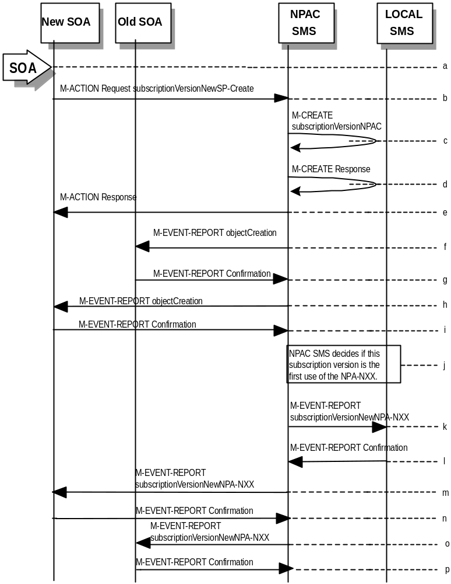

- New service provider SOA sends M-ACTION subscriptionVersionNewSP-Create to the NPAC SMS lnpSubscriptions object to create a new subscriptionVersionNPAC. The new service provider SOA must specify the following valid attributes:
subscriptionTN or a valid subscriptionVersionTN-Range
subscriptionNewCurrentSP
subscriptionOldSP
subscriptionNewSP-DueDate (seconds set to zero)
subscriptionLNPType
subscriptionPortingToOriginal-SP Switch
The following items must be provided unless subscriptionPortingToOriginal-SP is true:
subscriptionLRN
subscriptionCLASS-DPC
subscriptionCLASS-SSN
subscriptionLIDB-DPC
subscriptionLIDB-SSN
subscriptionCNAM-DPC
subscriptionCNAM-SSN
subscriptionISVM-DPC
subscriptionISVM-SSN
subscriptionWSMSC-DPC - if supported by the Service Provider SOA
subscriptionWSMSC-SSN - if supported by the Service Provider SOA
The following attributes are optional:
subscriptionEndUserLocationValue
subscriptionEndUserLocationType
subscriptionBillingId
If the service provider were to give a range of TNs, this would result in an M-CREATE and M-EVENT-REPORT for each TN.
If any attribute is invalid, an action failure will be returned, indicating invalidArgumentValue. Other appropriate errors will also be returned.
- If the request is valid, the NPAC SMS will create the subscriptionVersionNPAC object. The status will be set to “pending” and the subscriptionModifiedTimeStamp and subscriptionCreationTimeStamp will be set.
- NPAC SMS responds to M-CREATE.
- NPAC SMS sends action reply with success or failure and reasons for failure.
- If the M-ACTION was successful, NPAC SMS issues an M-EVENT-REPORT containing the following attributes to old service provider SOA of subscriptionVersionNPAC creation.
subscriptionTN
subscriptionOldSP
subscriptionNewCurrentSP
subscriptionNewSP-CreationTimeStamp
subscriptionVersionStatus
subscriptionNewSP-DueDate
- Old service provider SOA responds by sending an M-EVENT-REPORT confirmation back to the NPAC SMS.
- If the M-ACTION was successful, NPAC SMS issues an M-EVENT-REPORT to new service provider SOA of subscriptionVersionNPAC creation.
- New service provider SOA issues an M-EVENT-REPORT confirmation to NPAC SMS.
- NPAC SMS decides if this subscription version is the first use or the NPA-NXX.
- If this is the first use of the NPA-NXX, the NPAC SMS sends the subscriptionVersionNewNPA-NXX M-EVENT-REPORT to inform the accepting Local SMSs.
- The Local SMS confirms the M-EVENT-REPORT.
- The NPAC SMS sends the subscriptionVersionNew NPA-NXX M-EVENT-REPORT to inform the Old SOA.
- The Old SOA confirms the M-EVENT-REPORT.
- The NPAC SMS sends the subscriptionVersionNew NPA-NXX M-EVENT-REPORT to inform the New SOA.
- The New SOA confirms the M-EVENT-REPORT.
The next scenario is either “SubscriptionVersion Create by the Second SOA (Old Service Provider).” or “SubscriptionVersion Activated by New Service Provider SOA”.

SubscriptionVersion Create by Second SOA (New Service Provider)
In this scenario, the old service provider has already issued its request causing the subscriptionVersionNPAC to be created. The new service provider is now following with its own create action.
- 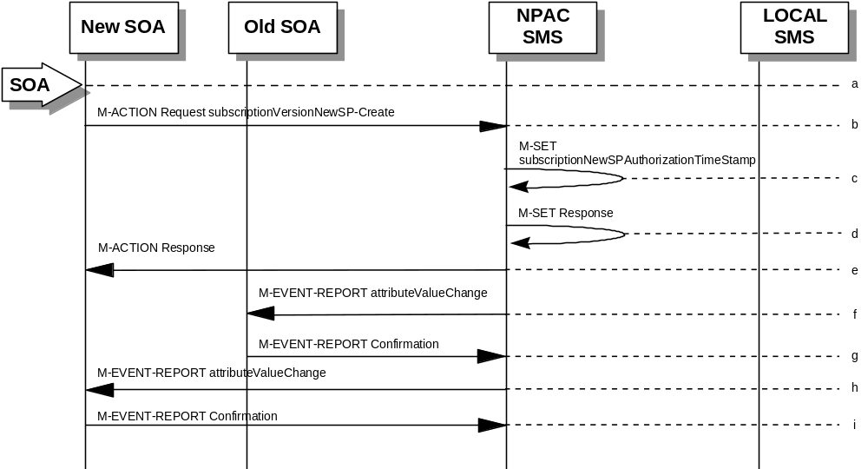New service provider SOA personnel take action to create a new subscription version.
- New service provider SOA sends M-ACTION subscriptionVersionNewSP-Create to NPAC SMS lnpSubscriptions object to create a new subscriptionVersionNPAC. The new service provider SOA must specify the following valid attributes:
subscriptionTN or a valid subscriptionVersionTN-Range
subscriptionNewCurrentSP
subscriptionOldSP
subscriptionNewSP-DueDate (seconds set to zeros)
subscriptionLNPType
subscriptionPortingToOriginal-SP Switch
The following items must be provided unless subscriptionPortingToOriginal-SP is true:
subscriptionLRN
subscriptionCLASS-DPC
subscriptionCLASS-SSN
subscriptionLIDB-DPC
subscriptionLIDB-SSN
subscriptionCNAM-DPC
subscriptionCNAM-SSN
subscriptionISVM-DPC
subscriptionISVM-SSN
subscriptionWSMSC-DPC - if supported by the Service Provider SOA
subscriptionWSMSC-SSN - if supported by the Service Provider SOA
The following attributes are optional:
subscriptionEndUserLocationValue
subscriptionEndUserLocationType
subscriptionBillingId
If a TN range is specified in the request, it would result in an M-SET request and M-EVENT-REPORT for each TN.
If the new service provider is not the new service provider specified in the initial create by the old service provider, an accessDenied error will be returned.
If any attribute is invalid, an action failure will be returned, indicating invalidArgumentValue. Other appropriate errors will be returned.
- If successful, the NPAC SMS sets the subscriptionModifiedTimeStamp, subscriptionCreationTimeStamp, and all data specified in the M-ACTION.
- NPAC SMS responds to M-SET.
- NPAC SMS sends M-ACTION reply with success or failure and reasons for failure.
- NPAC SMS issues the M-EVENT-REPORT with the following attributes to the old service provider when the subscriptionNewSP-DueDate changes value.
subscriptionNewSP-DueDate
subscriptionNewSP-CreationTimeStamp
- Old service provider SOA issues M-EVENT-REPORT confirmation.
- If the M-ACTION was successful, the NPAC SMS issues M-EVENT-REPORT to the new service provider for all attributes updated from the preceding list of modifiable attributes in addition to the following:
subscriptionNewSP-DueDate
subscriptionNewSP-CreationTimeStamp
- New service provider SOA issues M-EVENT-REPORT confirmation.

SubscriptionVersion Create by Second SOA (Old Service Provider) with Authorization to Port
In this scenario, the new service provider has already issued its request causing the subscriptionVersionNPAC to be created. The old service provider is now following with its own create action authorizing the port.
Note: This is an optional step.
- Old service provider SOA personnel take action to create a old subscription version.
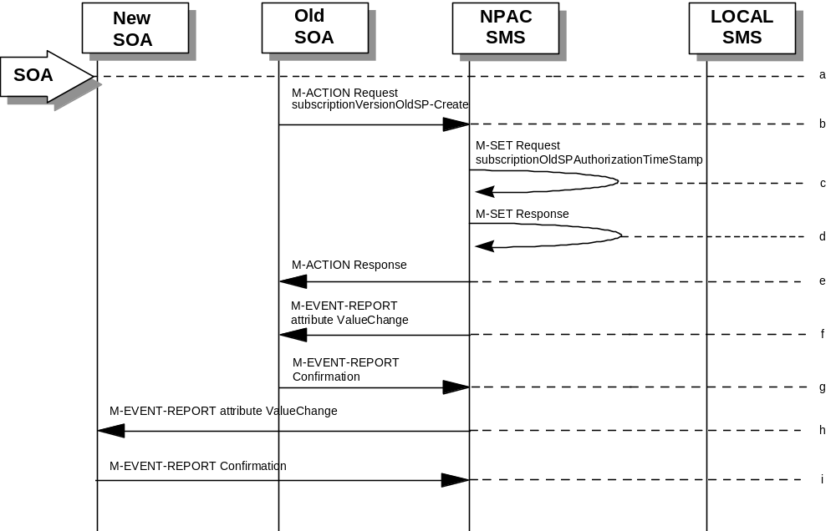
- Old service provider SOA sends M-ACTION subscriptionVersionOldSP-Create to NPAC SMS lnpSubscriptions object to create an old subscriptionVersionNPAC. The old service provider SOA must specify the following valid attributes:
subscriptionTN or a valid subscriptionVersionTN-Range
subscriptionNewCurrentSP
subscriptionOldSP
subscriptionOldSP-Authorization
subscriptionOldSP-DueDate (seconds set to zeros)
subscriptionLNPType
If a TN range is specified in the request, it would result in an M-SET request and M-EVENT-REPORT for each TN.
If the old service provider is not the old service provider specified in the initial create request by the new service provider, an accessDenied error will be returned.
If any attribute is invalid, an invalidArgumentValue will be returned, indicating invalid data values. Other appropriate errors will also be returned.
- If the data is valid, the NPAC SMS sets the subscriptionOldSP-AuthorizationTimeStamp, subscriptionModifiedTimeStamp and all data specified in the M-ACTION.
- NPAC SMS responds to M-SET.
- NPAC SMS sends M-ACTION reply with success or failure and reasons for failure.
- If the M-ACTION was successful, the NPAC SMS issues M-EVENT-REPORT attribute value change to the old service provider for all attributes updated from the following list:
subscriptionOldSP-DueDate
subscriptionOldSP-Authorization
subscriptionOldSP-AuthoriztionTimeStamp
- Old service provider SOA issues M-EVENT-REPORT confirmation.
- If the M-ACTION was successful, the NPAC SMS issues M-EVENT-REPORT attribute value change to the new service provider for all attributes updated from the preceding list. The following attributes are sent in the attributeValueChangeNotification:
subscriptionOldSP-DueDate
subscriptionOldSP-Authorization
subscriptionOldSP-AuthoriztionTimeStamp
- New service provider issues M-EVENT-REPORT confirmation.

SubscriptionVersion Activated by New Service Provider SOA
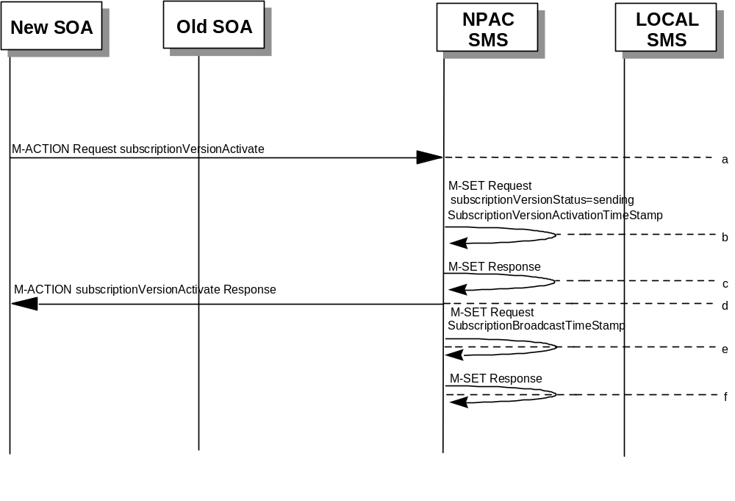In this scenario, either both service providers have sent their create data updates for a new subscription version to the NPAC SMS or the concurrence window has expired for receiving the subscriptionVersionOldSP-Create action. The new service provider can now activate the subscription version.

- The new service provider SOA issues a subscriptionVersionActivate
M-ACTION to the NPAC SMS lnpSubscriptions object to activate the pending subscription version by specifying the subscription version ID, subscription version TN, or a range of subscription version TNs.
- NPAC SMS issues an M-SET request setting the subscriptionVersionStatus to “sending,” subscriptionVersionActivationTimeStamp and subscriptionModifiedTimeStamp on the subscriptionVersionNPAC object.
- NPAC SMS responds to the M-SET.
- The NPAC SMS responds with the M-ACTION response. An error will be returned if the service provider is not the new service provider (accessDenied) or if there is no version to be activated (invalidArgumentValue) or if any other failures occur.
- NPAC SMS issues an M-SET request setting the subscriptionVersionStatus to “sending,” subscriptionBroadcastTimeStamp on the subscriptionVersionNPAC object.
- NPAC SMS responds to the M-SET.
For subscription versions that are not being ported to the original service provider’s switch, processing continues in the “Active SubscriptionVersion Create on Local SMSs” flow.
For ports to the original service provider’s switch, the flow follows an immediate disconnect scenario. The NPAC SMS sets the broadcast timestamp, notifies the service provider SOA of the status change and proceeds to issue M-DELETEs for the subscriptionVersion to the Local SMS.

Active SubscriptionVersion Create on Local SMS
This scenario and associated error scenarios reflect the message flow for all new object create requests from the NPAC SMS to the Local SMSs.
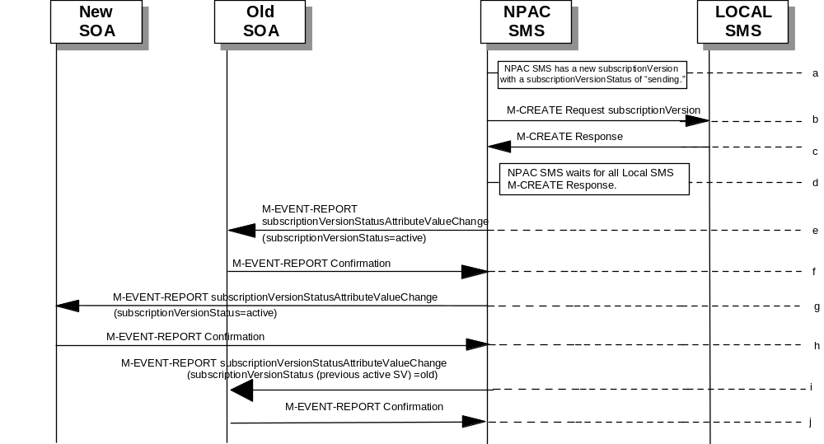
- NPAC SMS has a new subscriptionVersion with a status of “sending.”
- The NPAC SMS issues an M-CREATE for the subscriptionVersion to each of the Local SMSs, that is accepting downloads for the NPA-NXX of the subscriptionVersion.
- Each Local SMS will reply to the M-Create.
- NPAC SMS waits for Local SMSs to report successful objectCreation.
- If this TN has been previously ported (i.e., a previously active subscriptionVersion NPAC object exists), the NPAC SMS will issue an M-EVENT-REPORT notification to the current service provider SOA for the previously active subscriptionVersion NPAC object of the status change using an M-EVENT-REPORT subscriptionVersionStatusAttributeValueChange.
- The current service provider SOA for the previously active subscriptionVersion NPAC object returns an M-EVENT-REPORT confirmation to the NPAC SMS.
- If the subscriptionVersion NPAC object was modified, the NPAC SMS will issue M-EVENT-REPORT notifications to the old service provider SOA of the status change using an M-EVENT-REPORT subscriptionVersionStatusAttributeValueChange.
- The old service provider SOA returns an M-EVENT-REPORT confirmation to the NPAC SMS.
- If the subscriptionVersion NPAC object was modified, the NPAC SMS will issue M-EVENT-REPORT notifications to the new service provider SOA of the status change using an M-EVENT-REPORT subscriptionVersionStatusAttributeValueChange.
- The new service provider SOA returns an M-EVENT-REPORT confirmation to the NPAC SMS.

Active Subscription Version Create on Local SMS Using Create Action
This scenario reflects the message flow for all new object create requests from the NPAC SMS to the Local SMS Using Create Action. This action is used to create a group of subscription versions with the same routing information.
- NPAC SMS has one or more subscription versions with a status of “sending ” that have been activated by the new service provider.
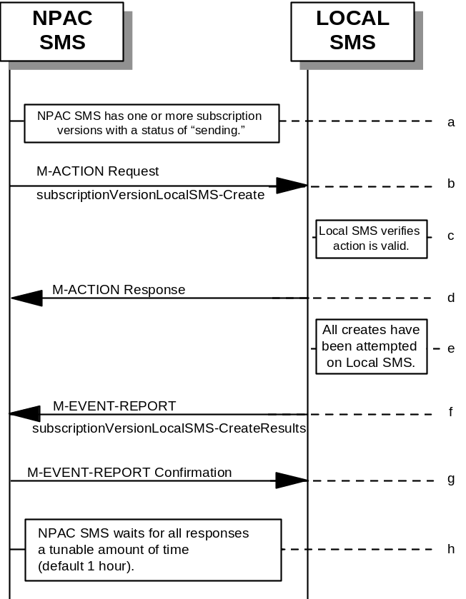
- NPAC SMS issues the subscriptionVersionLocalSMS-Create action to the Local SMS, if it is accepting downloads for the NPA-NXX of the subscriptionVersion. This action contains all data necessary to create the subscription version.
- The Local SMS verifies the action is valid, but does not attempt to create the subscription version(s).
- The Local SMS responds to the M-ACTION.
- The Local SMS proceeds to execute all the creates specified by the action.
- The Local SMS sends to the NPAC SMS the M-EVENT-REPORT specifying the success or failure of the creates.
- NPAC SMS confirms the M-EVENT-REPORT.
- NPAC SMS waits for all responses a tunable amount of time. The default is 1 hour.

SubscriptionVersion Create: No Create Action from the Old Service Provider SOA After Concurrence Window
This scenario shows no response within “Service Provider Concurrence Window” by the old service provider SOA.
In this case, the new service provider SOA issued the create request. The NPAC SMS has issued the ObjectCreation M-EVENT-REPORT back to both the old and new service provider SOAs. No response has yet been received by the old service provider SOA.
- 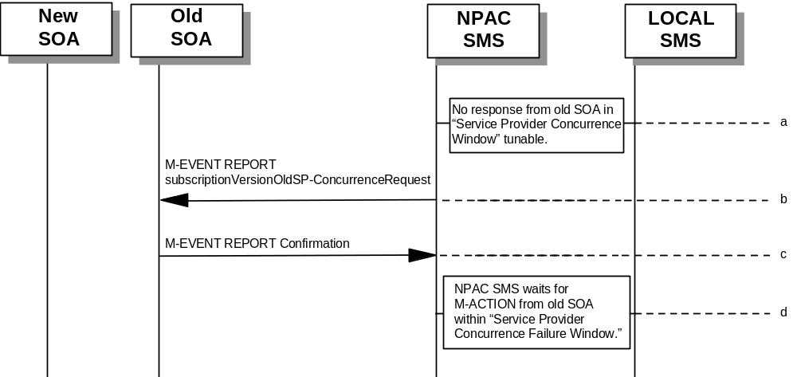NPAC SMS does not receive a response from the old service provider SOA within “Service Provider Concurrence Window” for the pending subscriptionVersionNPAC created by the new service provider SOA.
- NPAC SMS sends the old service provider an M-EVENT-REPORT subscriptionVersionOldSP-ConcurrenceRequest.
- The old service provider SOA returns an M-EVENT-REPORT confirmation to the NPAC SMS.
- Old service provider has up to “Service Provider Concurrence Failure Window” to respond to the request.
If the old service provider SOA responds with a valid M-ACTION or M-SET, processing resumes as a successful create.

SubscriptionVersion Create: No Create Action from the Old Service Provider SOA After Final Concurrence Window
This scenario shows no response within “Service Provider Final Concurrence Window” by the old service provider SOA.
In this case, the new service provider SOA issued the create request. The NPAC SMS has issued the ObjectCreation M-EVENT-REPORT back to both the old and new service provider SOAs as well as a subsciptionVersionOldSP-ConcurrenceRequest
M-EVENT-REPORT to the old service provider SOA. No response has yet been received by the old service provider SOA.
- 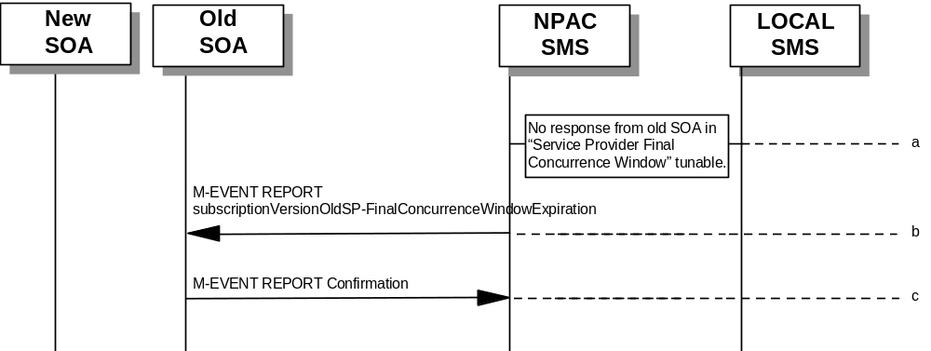NPAC SMS does not receive a response from the old service provider SOA within “Service Provider Final Concurrence Window” for the pending subscriptionVersionNPAC created by the new service provider SOA.
- NPAC SMS sends the old service provider an
M-EVENT-REPORT subscriptionVersionOldSP-Final ConcurrenceWindowExpiration.
- The old service provider SOA returns an M-EVENT-REPORT confirmation to the NPAC SMS.
If the old service provider SOA responds with a valid
M-ACTION or M-SET prior to activation by the new service provider, the subscription version will be updated.

Subscription Version Create: Failure to Receive Response from New SOA
This scenario shows action taken by the NPAC SMS after not receiving any concurrence from the new service provider after the “Final Service Provider Concurrence Failure Window.”
- NPAC SMS receives no occurrence from the new service provider SOA in “Service Provider Concurrence Failure Window” for the pending subscriptionVersionNPAC created by the old service provider SOA.
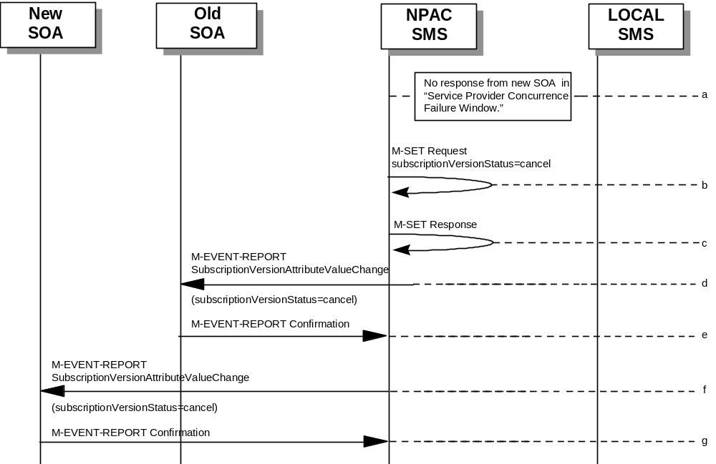
- NPAC SMS issues M-SET for subscriptionVersionStatus to set it to “cancel” and the subscriptionModifiedTimeStamp in the subscriptionVersionNPAC object.
- NPAC SMS responds to M-SET.
- If the subscriptionVersionNPAC object was modified, the NPAC SMS notifies the old service provider of the status change.
- The old service provider SOA returns an M-EVENT-REPORT confirmation to the NPAC SMS.
- If the subscriptionVersionNPAC object was modified, the NPAC SMS notifies new service provider SOA of the status change.
- The new service provider SOA returns an M-EVENT-REPORT confirmation to the NPAC SMS.

SubscriptionVersionCreate M-CREATE Failure to Local SMS
This scenario shows a failure to all of the Local SMS on M-CREATE.
- The new service provider SOA has activated the pending subscription.
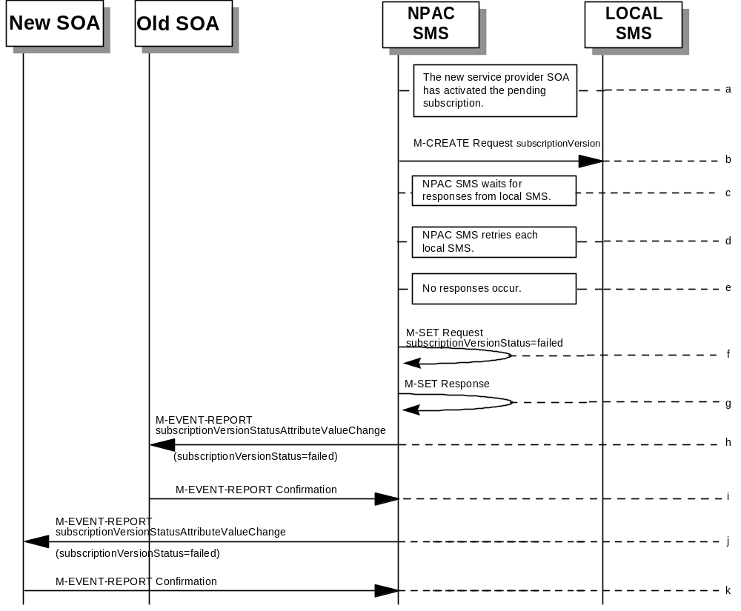
- The NPAC SMS issues an M-CREATE for the subscriptionVersion to each of the Local SMSs, that is accepting downloads for the NPA-NXX of the subscriptionVersion.
- NPAC SMS waits for responses from each Local SMS.
- NPAC SMS resends to each Local SMS up to a tunable number of retries at a tunable interval.
- No responses occur from any Local SMS or all Local SMSs report a failure response to the M-CREATE.
- NPAC SMS issues M-SET to update the subscriptionVersionStatus to “failed” in the subscriptionVersionNPAC object, the subscriptionFailed-SP-List, and the subscriptionModifiedTimeStamp.
- NPAC SMS issues M-SET response.
- If the subscriptionVersionNPAC was modified, the NPAC SMS will send M-EVENT-REPORT to the old service provider SOA of the subscriptionVersionStatus change.
- The old service provider SOA returns an M-EVENT-REPORT confirmation to the NPAC SMS.
- If the subscriptionVersionNPAC was modified, the NPAC SMS will send M-EVENT-REPORT to the new service provider SOA of the subscriptionVersionStatus change.
- The new service provider SOA returns an M-EVENT-REPORT confirmation to the NPAC SMS.

SubscriptionVersion M-CREATE: Partial Failure to Local SMS
This scenario shows a partial failure to a Local SMS on an M-CREATE.
- 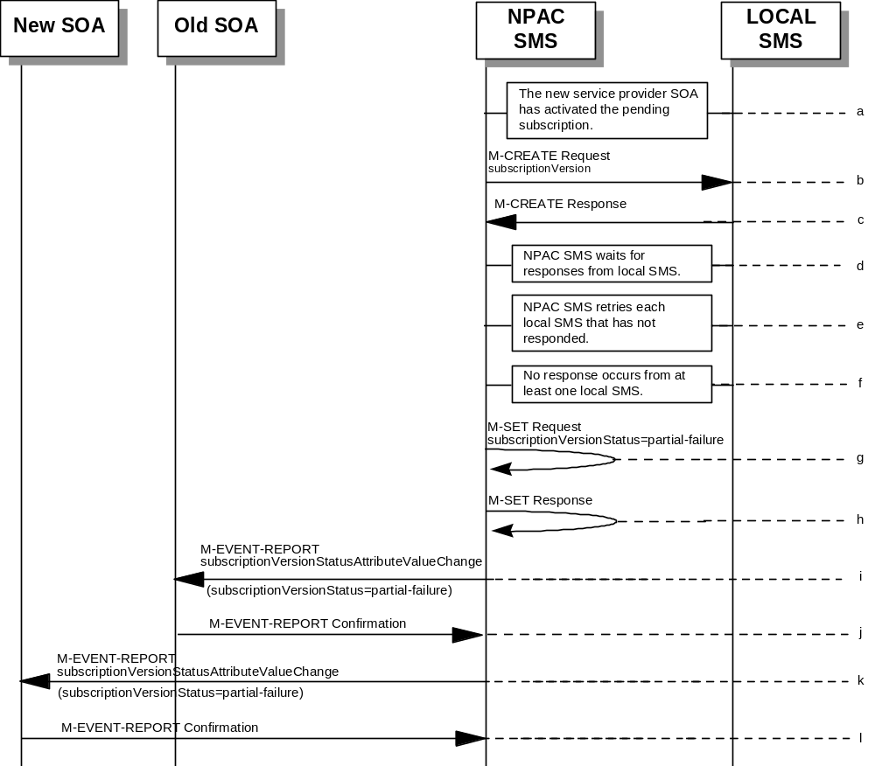The new service provider SOA has activated the pending subscription.
- The NPAC SMS issues an M-CREATE for the subscriptionVersion to each of the Local SMSs, that is accepting downloads for the NPA-NXX of the subscriptionVersion.
- One or more Local SMSs respond to the M-CREATE.
- NPAC SMS waits for responses from each Local SMS.
- NPAC SMS resends, to each unresponsive Local SMS, up to a tunable number of retries at a tunable interval.
- No responses occur from at least one Local SMS, or a Local SMS returns an M-CREATE failure.
- NPAC SMS issues M-SET to the subscriptionVersionStatus to “partial-failure” in the subscriptionVersionNPAC object, subscriptionFailed-SP-List, and the subscriptionModifiedTimeStamp.
- NPAC SMS issues M-SET response.
- If the subscriptionVersionNPAC was modified, the NPAC SMS will send M-EVENT-REPORT to the old service provider SOA of the subscriptionVersionStatus change and a list of failed Local SMSs.
- The old service provider SOA returns an M-EVENT-REPORT confirmation to the NPAC SMS.
- If the subscriptionVersionNPAC was modified, the NPAC SMS will send M-EVENT-REPORT to the new service provider SOA of the subscriptionVersionStatus change and a list of failed Local SMSs.
- The new service provider SOA returns an M-EVENT-REPORT confirmation to the NPAC SMS.

Create Subscription Version: Resend Successful to Local SMS Action
This scenario shows the successful resend of a subscription version create. The resend of a failed subscription version create can only be performed by authorized NPAC personnel.
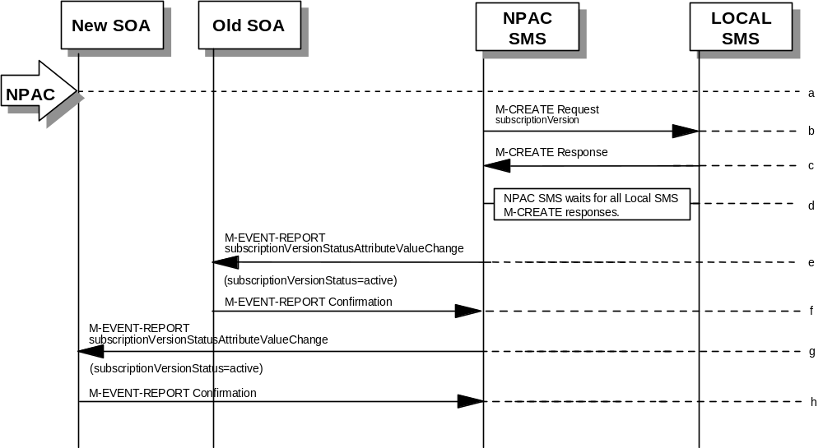
- NPAC personnel take action to resend a failed subscriptionVersion create.
- The NPAC SMS issues an M-CREATE for the subscriptionVersion to each of the Local SMSs that previously failed, and is accepting downloads for the NPA-NXX of the subscriptionVersion.
- Each Local SMS will reply to the M-Create.
- NPAC SMS waits for all Local SMSs to report successful subscription version creation.
- If the subscriptionVersion NPAC object was modified, the NPAC SMS will issue M-EVENT-REPORT notifications to the old service provider SOA of the status change using an M-EVENT-REPORT subscriptionVersionStatusAttributeValueChange.
- The old service provider SOA returns an M-EVENT-REPORT confirmation to the NPAC SMS.
- If the subscriptionVersion NPAC object was modified, the NPAC SMS will issue M-EVENT-REPORT notifications to the new service provider SOA of the status change using an M-EVENT-REPORT subscriptionVersionStatusAttributeValueChange.
- The new service provider SOA returns an M-EVENT-REPORT confirmation to the NPAC SMS.

Subscription Version: Resend Failure to Local SMS
This scenario shows a failure on a resend of a Subscription Version M-CREATE a Local SMS. The resend of a failed version can only be performed by authorized NPAC SMS personnel.
- The NPAC personnel issues a resend for the failed or partially failed subscriptionVersion.
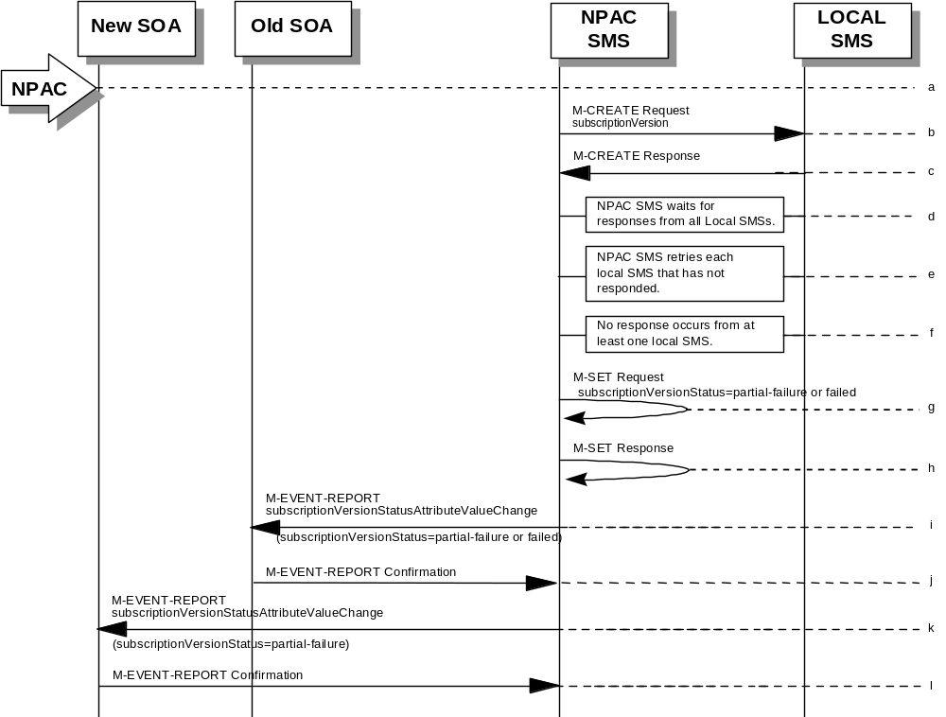
- The NPAC SMS issues an M-CREATE for the subscriptionVersion to each of the Local SMSs for which the M-CREATE previously failed, and is accepting downloads for the NPA-NXX of the subscriptionVersion.
- One or more Local SMSs respond to the M-CREATE.
- NPAC SMS waits for responses from each Local SMS.
- NPAC SMS resends, to each unresponsive Local SMS, up to a tunable number of retries at a tunable interval.
- No responses occur from at least one or all Local SMSs, or one or all Local SMSs return an M-CREATE failure.
- NPAC SMS issues M-SET to the subscriptionVersionStatus to “partial-failure” or “failed” in the subscriptionVersionNPAC object, subscriptionFailed-SP-List, and the subscriptionModifiedTimeStamp.
- NPAC SMS issues M-SET response.
- If the subscriptionVersionNPAC was modified, the NPAC SMS will send M-EVENT-REPORT to the old service provider SOA of the subscriptionVersionStatus change and a list of failed Local SMSs.
- The old service provider SOA returns an M-EVENT-REPORT confirmation to the NPAC SMS.
- If the subscriptionVersionNPAC was modified, the NPAC SMS will send M-EVENT-REPORT to the new service provider SOA of the subscriptionVersionStatus change and a list of failed Local SMSs.
- The new service provider SOA returns an M-EVENT-REPORT confirmation to the NPAC SMS.

SubscriptionVersion Create for Intra-Service Provider Port
This scenario shows how an intra-service port is processed.
- Action is taken by the current provider SOA to create a new version of a subscriber.
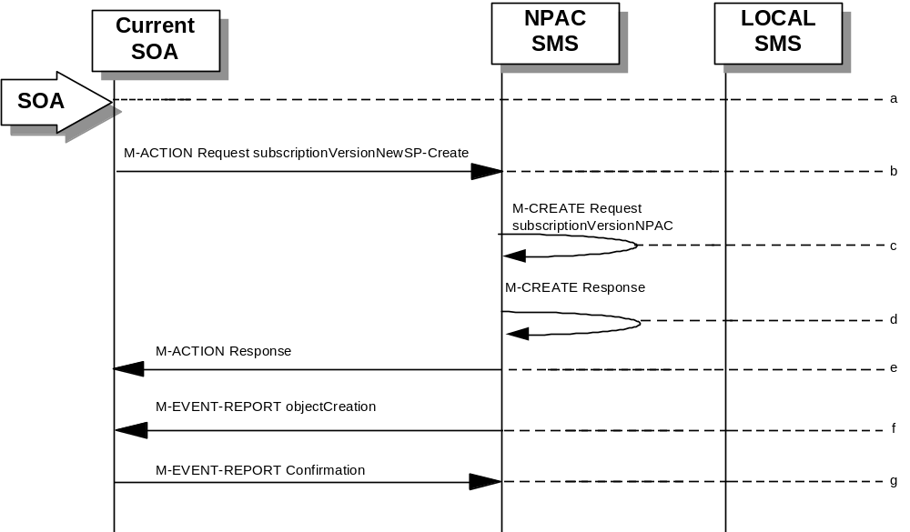
- Current provider SOA sends M-ACTION subscriptionVersionNewSP-Create to the NPAC SMS lnpSubscriptions object to create a new subscriptionVersionNPAC. The SOA must specify the following valid attributes:
subscriptionTN or a valid subscriptionVersionTN-Range
subscriptionNewCurrentSP
subscriptionOldSP
subscriptionNewSP-DueDate (seconds set to zeros)
subscriptionPortingToOriginal-SPSwitch
subscriptionLRN
subscriptionCLASS-DPC
subscriptionCLASS-SSN
subscriptionLIDB-DPC
subscriptionLIDB-SSN
subscriptionCNAM-DPC
subscriptionCNAM-SSN
subscriptionISVM-DPC
subscriptionISVM-SSN
subscriptionLNPType
subscriptionWSMSC-DPC - if supported by the Service Provider SOA
subscriptionWSMSC-SSN - if supported by the Service Provider SOA
The subscriptionNewCurrentServiceProv must be equal to the subscriptionOldServiceProv.
The following attributes are optional:
subscriptionEndUserLocationValue
subscriptionEndUserLocationType
subscriptionBillingId
- If the request is valid, the NPAC SMS will M-CREATE the subscriptionVersionNPAC object. The status will be set to “pending.” Also the subscriptionCreationTimeStamp, the subscriptionNewSP-AuthorizationTimeStamp, subscriptionOldSP-AuthorizationTimeStamp, and the subscriptionModifiedTimeStamp will be set.
- NPAC SMS responds to M-CREATE.
- NPAC SMS sends an action reply with success or failure and reasons for failure. If the action fails, no modifications are applied and processing stops for this scenario.
- NPAC SMS notifies intra-service provider SOA of subscriptionVersionNPAC creation.
- Service provider SOA sends M-EVENT-REPORT confirmation to NPAC SMS.
The intra-service subscriptionVersion now follows the same flow as an inter-service subscriptionVersionCreation to activate the subscriptionVersion on the NPAC SMS and create the subscriptionVersion on the Local SMSs.
The only difference is the M-EVENT-REPORT for the subscriptionVersionStatusAttributeValueChange is only sent to the new provider.

SubscriptionVersion Port-to-Original: Successful
This scenario shows how a port-to-original (successful) port is processed.
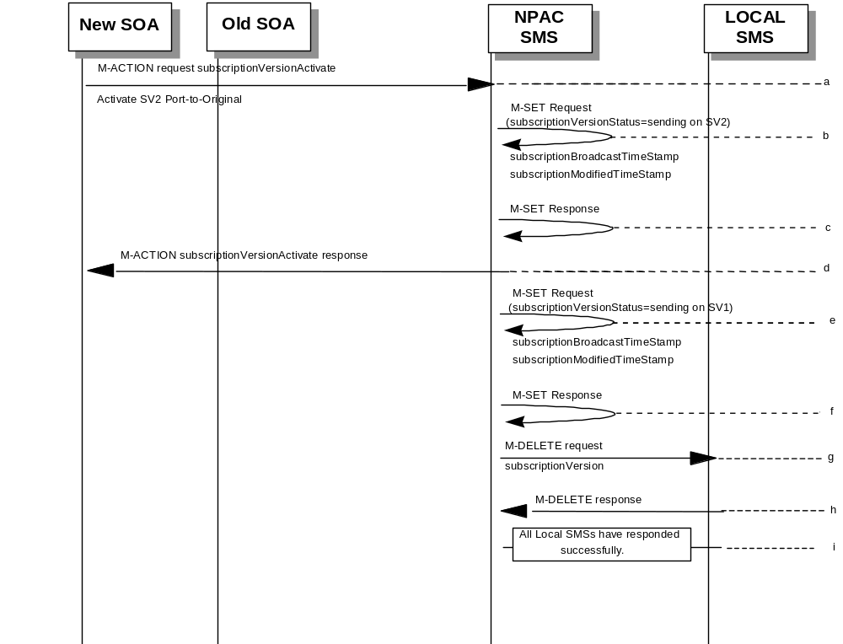

(continued on next page)

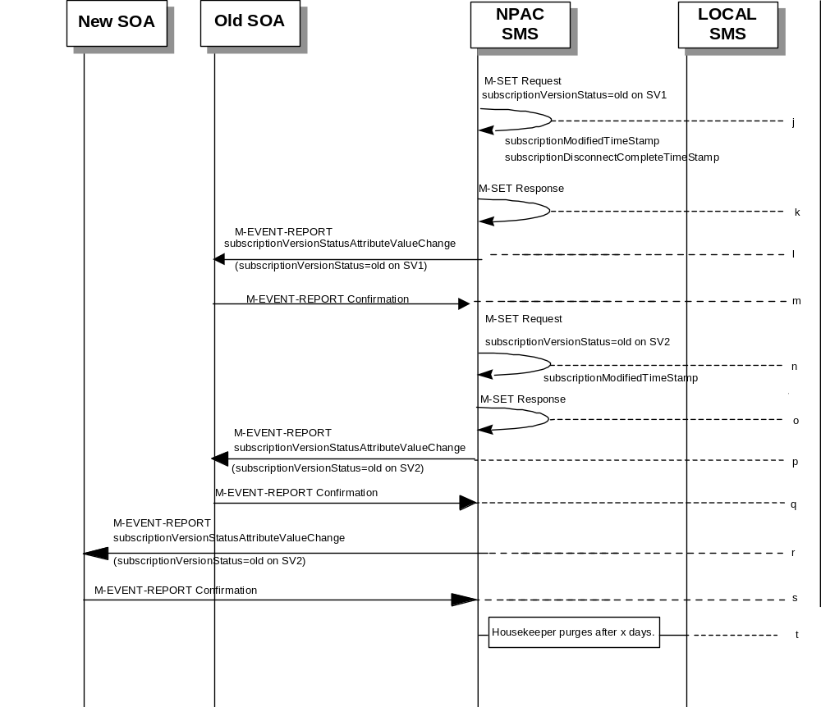

SV 1 is the currently active Subscription Version.
SV 2 is the current pending Subscription Version.
- The new service provider SOA issues a subscriptionVersionActivate M-ACTION to the NPAC SMS lnpSubscriptions object to activate the pending subscription version SV2 by specifying the subscription version ID, subscription version TN, or a range of subscription version TNs.
- The NPAC SMS issues an M-SET request setting the subscriptionVersionStatus to “sending”, subscriptionBroadcastTimeStamp and subscriptionModifiedTimeStamp on the subscriptionVersionNPAC on SV2.
- NPAC SMS response to the M-SET.
- The NPAC SMS responds with the M-ACTION response. An error will be returned if the service provider is not the new service provider (accessDenied) or if there is no version to be activated (invalidArgumentValue) or if any other failures occur.
- The NPAC SMS sets the subscriptionVersionStatus to sending and sets the subscriptionBroadcastTimeStamp and subscriptionModifiedTimeStamp on the subscriptionVersionNPAC on SV1.
- NPAC SMS response to the M-SET.
- NPAC SMS sends out an M-DELETE on the subscription Version SV1 to all Local SMSs, that are accepting downloads for the NPA-NXX of subscription Version SV1. If the M-DELETE is for multiple subscription versions, a scoped and filtered operation will be sent.
- Each Local SMS responds with a successful M-DELETE reply.
- All Local SMSs respond successfully.
- NPAC SMS issues an M-SET updating the subscriptionVersionStatus of SV1 to old. It also sets the subscriptionModifiedTimeStamp and subscriptionDisconnectCompleteTimeStamp.
- NPAC SMS responds to the M-SET.
- The NPAC SMS sends to the current/new service provider SOA a subscriptionVersionStatusAttributeValueChange for the subscriptionVersionStatus being set to old on SV1.
- The current/new service provider SOA returns an M-EVENT-REPORT confirmation to the NPAC SMS.
- NPAC SMS issues an M-SET updating the subscriptionVersionStatus of SV2 to old. It also sets the subscriptionModifiedTimeStamp.
- NPAC SMS responds to the M-SET.
- The NPAC SMS sends to the old service provider SOA a subscriptionVersionStatusAttributeValueChange for the subscriptionVersionStatus being set to old on SV2.
- The old service provider SOA returns an M-EVENT-REPORT confirmation to the NPAC SMS.
- The NPAC SMS sends to the new service provider SOA a subscriptionVersionStatusAttributeValueChange for the subscriptionVersionStatus being set to old on SV2.
- The new service provider SOA returns an M-EVENT-REPORT confirmation to the NPAC SMS.
- After a tunable amount of days, the subscription versions SV1 and SV2 are purged by the NPAC SMS housekeeping process.

SubscriptionVersion Port-to-Original: All LSMSs Fail
This scenario shows how a port-to-original (all fail) port is processed.
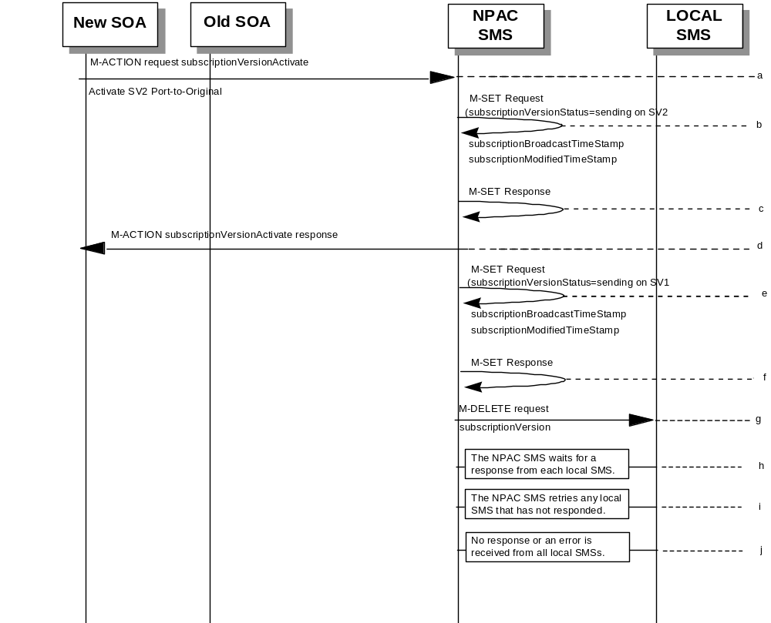

(continued on next page)

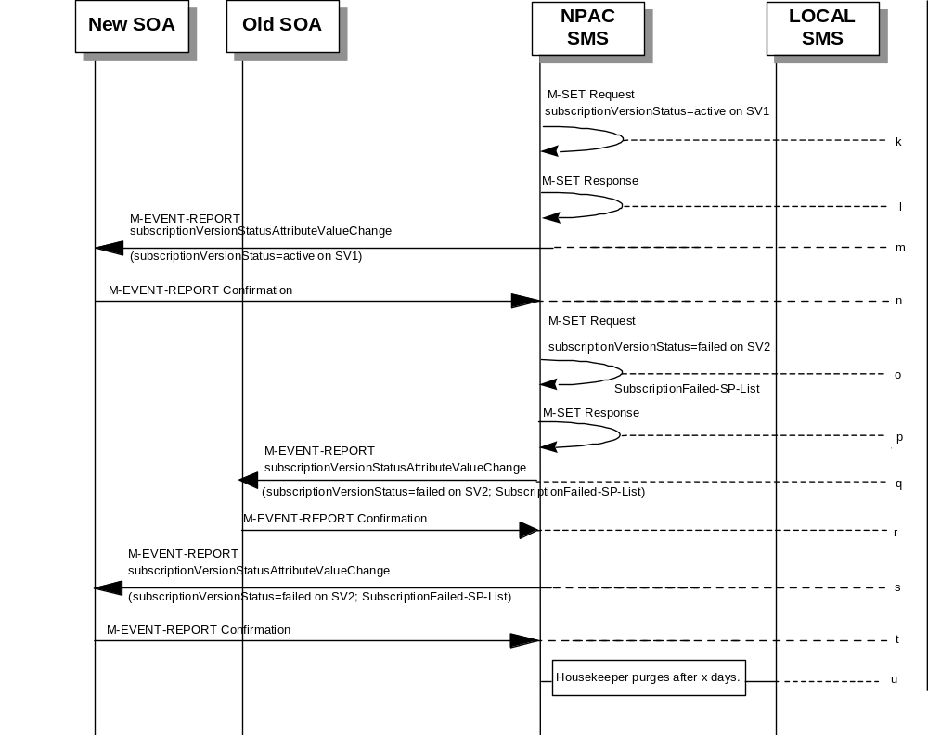

SV 1 is the currently active Subscription Version.
SV 2 is the current pending Subscription Version.
- The new service provider SOA issues a subscriptionVersionActivate M-ACTION to the NPAC SMS lnpSubscriptions object to activate the pending subscription version SV2 by specifying the subscription version ID, subscription version TN, or a range of subscription version TNs.
- The NPAC SMS issues an M-SET request setting the subscriptionVersionStatus to “sending”, subscriptionBroadcastTimeStamp and subscriptionModifiedTimeStamp on the subscriptionVersionNPAC on SV2.
- NPAC SMS response to the M-SET.
- NPAC SMS responds with the M-ACTION response. An error will be returned if the service provider is not the new service provider (accessDenied) or if there is no version to be activated (invalidArgumentValue) or if any other failures occur.
- The NPAC SMS sets the subscriptionVersionStatus to sending and sets the subscriptionBroadcastTimeStamp and subscriptionModifiedTimeStamp on the subscriptionVersionNPAC on SV1.
- NPAC SMS response to the M-SET.
- NPAC SMS sends out an M-DELETE on the subscription Version SV1 to all Local SMSs, that are accepting downloads for the NPA-NXX of subscription Version SV1. If the M-DELETE is for multiple subscription versions, a scoped and filtered operation will be sent.
- NPAC SMS waits for a response from each Local SMS.
- NPAC SMS retries any Local SMS that has not responded.
- No response or an error is received from all Local SMSs.
- NPAC SMS issues an M-SET updating the subscriptionVersionStatus of SV1 to active.
- NPAC SMS responds to the M-SET.
- The NPAC SMS sends to the current/new service provider SOA a subscriptionVersionStatusAttributeValueChange for the subscriptionVersionStatus being set to active on SV1.
- The current/new service provider SOA returns an M-EVENT-REPORT confirmation to the NPAC SMS.
- NPAC SMS issues an M-SET updating the subscriptionVersionStatus of SV2 to failed. It also sets the subscriptionFailed-SP-List.
- NPAC SMS responds to the M-SET.
- The NPAC SMS sends to the old service provider SOA a subscriptionVersionStatusAttributeValueChange for the subscriptionVersionStatus being set to failed on SV2, along with the subscriptionFailed-SP-List.
- The old service provider SOA returns an M-EVENT-REPORT confirmation to the NPAC SMS.
- The NPAC SMS sends to the new service provider SOA a subscriptionVersionStatusAttributeValueChange for the subscriptionVersionStatus being set to failed on SV2, along with the subscriptionFailed-SP-List.
- The new service provider SOA returns an M-EVENT-REPORT confirmation to the NPAC SMS.
- After a tunable amount of days, the subscription versions SV1 and SV2 are purged by the NPAC SMS housekeeping process.
NOTE: SV1 may exist as an old SV that may be associated with SV2 that is in a “partially failed” state for a port to original port. In this case, the housekeeping process should not purge SV1 unless SV2 is also being purged.
NOTE: SV1 and SV2 should be updated to the NPA-NXX for a NPA Split if SV2 is in a “failed” or “partially failed” state.

SubscriptionVersion Port-to-Original: Partial Failure
This scenario shows how a port-to-original (partial fail) port is processed.
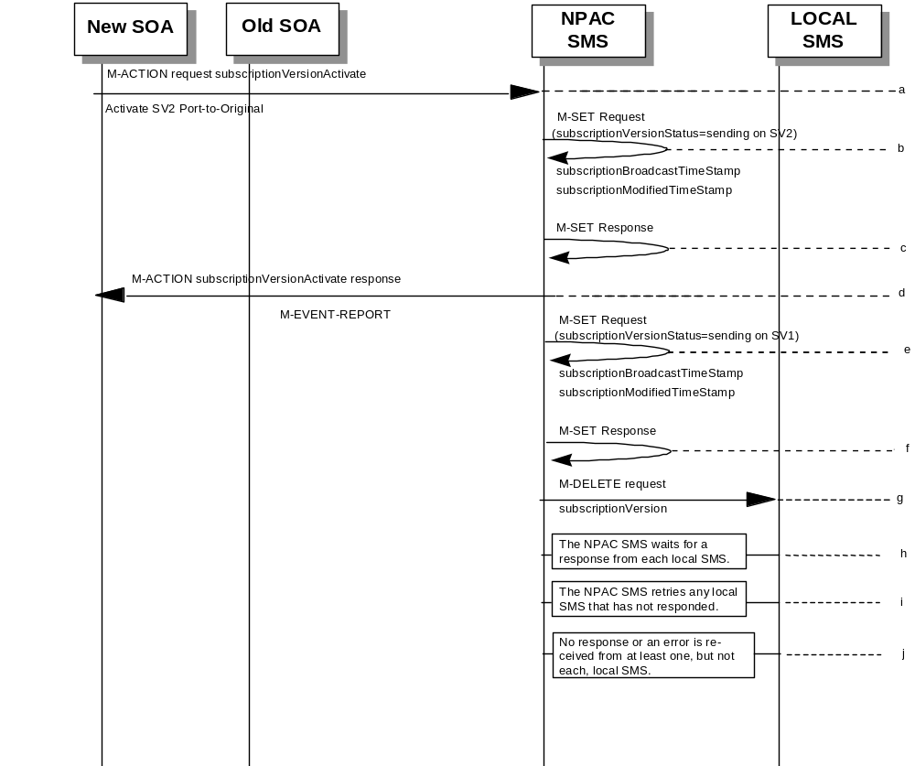

(continued on next page)

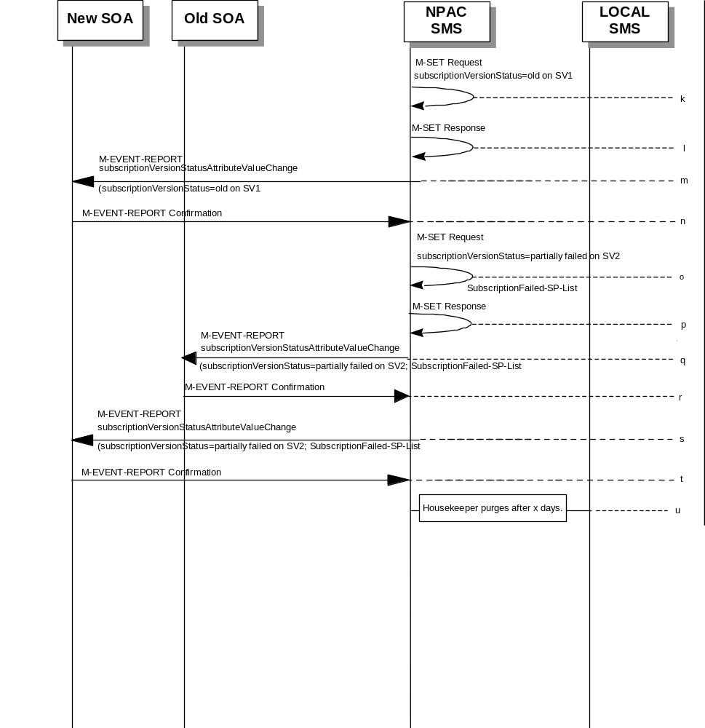

SV 1 is the currently active Subscription Version.
SV 2 is the current pending Subscription Version.
- The new service provider SOA issues a subscriptionVersionActivate M-ACTION to the NPAC SMS lnpSubscriptions object to activate the pending subscription version SV2 by specifying the subscription version ID, subscription version TN, or a range of subscription version TNs.
- The NPAC SMS issues an M-SET request setting the subscriptionVersionStatus to “sending”, subscriptionBroadcastTimeStamp and subscriptionModifiedTimeStamp on the subscriptionVersionNPAC on SV2.
- NPAC SMS response to the M-SET.
- The NPAC SMS responds with the M-ACTION response. An error will be returned if the service provider is not the new service provider (accessDenied) or if there is no version to be activated (invalidArgumentValue) or if any other failures occur.
- The NPAC SMS sets the subscriptionVersionStatus to sending and sets the subscriptionBroadcastTimeStamp and subscriptionModifiedTimeStamp on the subscriptionVersionNPAC on SV1.
- NPAC SMS response to the M-SET.
- NPAC SMS sends out an M-DELETE on the subscription Version SV1 to all Local SMSs, that are accepting downloads for the NPA-NXX of subscription Version SV1. If the M-DELETE is for multiple subscription versions, a scoped and filtered operation will be sent.
- NPAC SMS waits for a response from each Local SMS.
- NPAC SMS retries any Local SMS that has not responded.
- No response or an error is received from at least one, but not each, Local SMS.
- NPAC SMS issues an M-SET updating the subscriptionVersionStatus of SV1 to old.
- NPAC SMS responds to the M-SET.
- The NPAC SMS sends to the current/new service provider SOA a subscriptionVersionStatusAttributeValueChange for the subscriptionVersionStatus being set to old on SV1.
- The current/new service provider SOA returns an M-EVENT-REPORT confirmation to the NPAC SMS.
- NPAC SMS issues an M-SET updating the subscriptionVersionStatus of SV2 to partially failed. It also sets the subscriptionFailed-SP-List.
- NPAC SMS responds to the M-SET.
- The NPAC SMS sends to the old service provider SOA a subscriptionVersionStatusAttributeValueChange for the subscriptionVersionStatus being set to partially failed on SV2, along with the subscriptionFailed-SP-List.
- The old service provider SOA returns an M-EVENT-REPORT confirmation to the NPAC SMS.
- The NPAC SMS sends to the new service provider SOA a subscriptionVersionStatusAttributeValueChange for the subscriptionVersionStatus being set to partially failed on SV2, along with the subscriptionFailed-SP-List.
- The new service provider SOA returns an M-EVENT-REPORT confirmation to the NPAC SMS.
- After a tunable amount of days, the subscription versions SV1 and SV2 are purged by the NPAC SMS housekeeping process.
NOTE: SV1 may exist as an old SV that may be associated with SV2 that is in a “partially failed” state for a port to original port. In this case, the housekeeping process should not purge SV1 unless SV2 is also being purged.
NOTE: SV1 and SV2 should be updated to the NPA-NXX for a NPA Split if SV2 is in a “failed” or “partially failed” state.

SubscriptionVersion Port-to-Original: Resend
This scenario shows how a port-to-original (resend) port is processed.
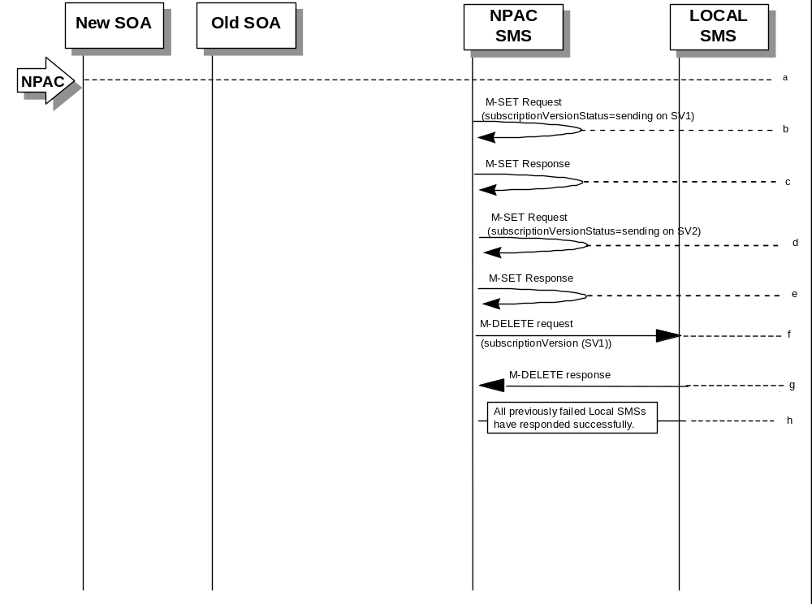

(continued on next page)

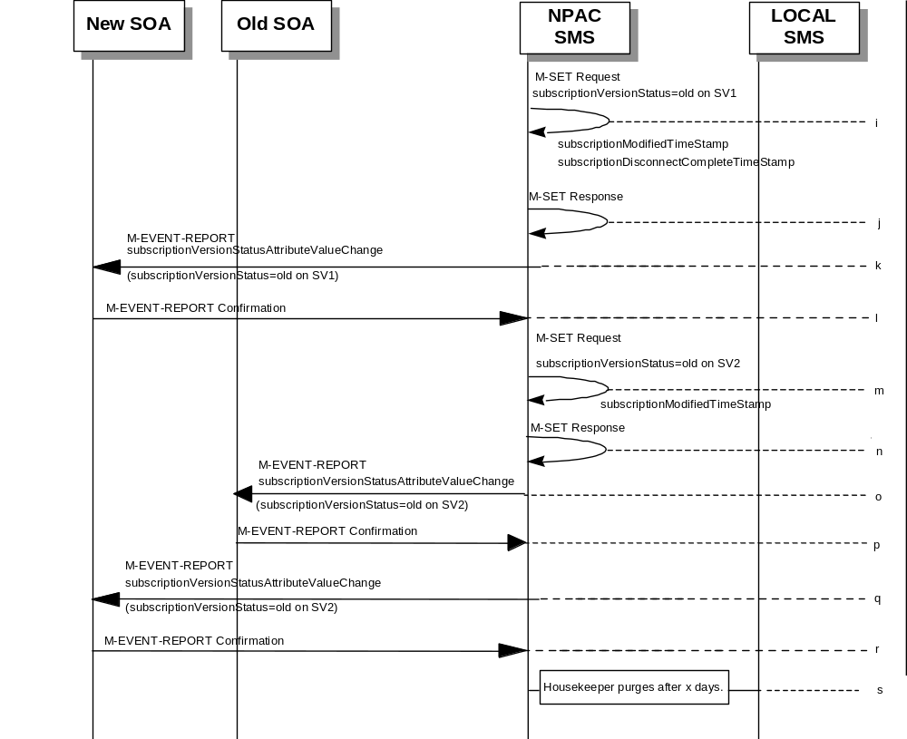

SV 1 is the currently active Subscription Version.
SV 2 is the current pending Subscription Version.
- NPAC personnel take action to resend a failed port-to-original for a subscription version.
- The NPAC SMS issues an M-SET request setting the subscriptionVersionStatus to “sending”, subscriptionBroadcastTimeStamp and subscriptionModifiedTimeStamp on the subscriptionVersionNPAC on SV1.
- NPAC SMS responds to the M-SET.
- The NPAC SMS sets the subscriptionVersionStatus to sending on the subscriptionVersionNPAC on SV2.
- NPAC SMS response to the M-SET.
- NPAC SMS sends out an M-DELETE on the subscription Version SV1 to all Local SMSs that previously failed, that are accepting downloads for the NPA-NXX of the subscription Version SV1. If the M-DELETE is for multiple subscription versions, a scoped and filtered operation may be sent.
- Each previously failed Local SMS responds with a successful M-DELETE reply.
- All previously failed Local SMSs respond successfully.
- NPAC SMS issues an M-SET updating the subscriptionVersionStatus of SV1 to old. It also sets the subscriptionModifiedTimeStamp and subscriptionDisconnectCompleteTimeStamp.
- NPAC SMS responds to the M-SET.
- The NPAC SMS sends to the current/new service provider SOA a subscriptionVersionStatusAttributeValueChange for the subscriptionVersionStatus being set to old on SV1.
- The current/new service provider SOA returns an M-EVENT-REPORT confirmation to the NPAC SMS.
- NPAC SMS issues an M-SET updating the subscriptionVersionStatus of SV2 to old. It also sets the subscriptionModifiedTimeStamp.
- NPAC SMS responds to the M-SET.
- The NPAC SMS sends to the old service provider SOA a subscriptionVersionStatusAttributeValueChange for the subscriptionVersionStatus being set to old on SV2.
- The old service provider SOA returns an M-EVENT-REPORT confirmation to the NPAC SMS.
- The NPAC SMS sends to the new service provider SOA a subscriptionVersionStatusAttributeValueChange for the subscriptionVersionStatus being set to old on SV2.
- The new service provider SOA returns an M-EVENT-REPORT confirmation to the NPAC SMS.
- After a tunable amount of days, the subscription versions SV1 and SV2 are purged by the NPAC SMS housekeeping process.

SubscriptionVersion Port-to-Original: Resend Failure to Local SMS
This scenario shows a failure on a resend of a subscription port-to-original that failed previously to one or more of the Local SMSs. The resend of a failed port-to-original for a subscription can only be performed by authorized NPAC personnel.
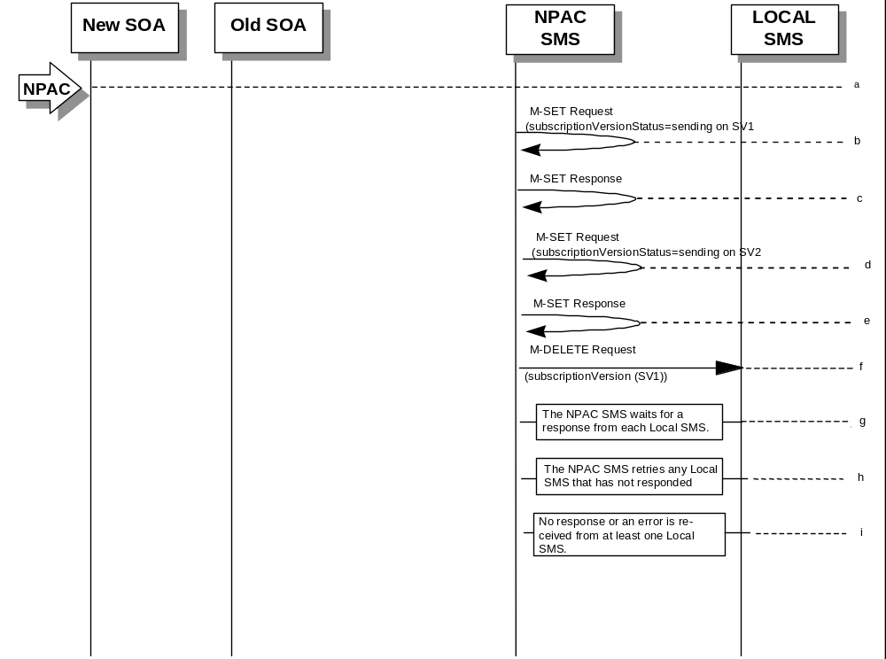

(continued on next page)

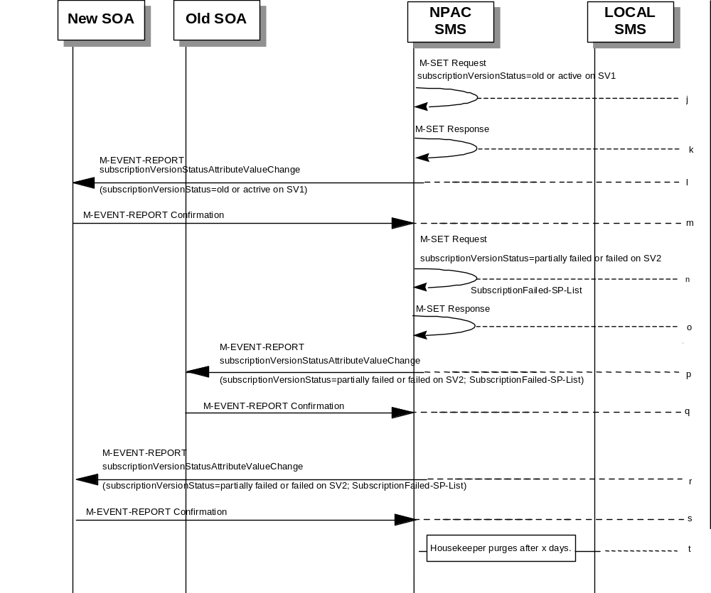

SV 1 is the currently active Subscription Version.
SV 2 is the current pending Subscription Version.
- NPAC personnel take action to resend a failed port-to-original for a subscription version.
- The NPAC SMS issues an M-SET request setting the subscriptionVersionStatus to “sending”, subscriptionBroadcastTimeStamp and subscriptionModifiedTimeStamp on the subscriptionVersionNPAC on SV1.
- NPAC SMS response to the M-SET.
- The NPAC SMS sets the subscriptionVersionStatus to sending on the subscriptionVersionNPAC on SV2.
- NPAC SMS response to the M-SET.
- NPAC SMS sends out an M-DELETE on the subscription Version SV1 to all Local SMSs that previously failed, that are accepting downloads for the NPA-NXX of the subscription Version SV1. If the M-DELETE is for multiple subscription versions, a scoped and filtered operation may be sent.
- NPAC SMS waits for a response from each Local SMS.
- NPAC SMS retries any Local SMS that has not responded.
- No response or an error is received from at least one Local SMS.
- NPAC SMS issues an M-SET updating the subscriptionVersionStatus of SV1 to “old” or “active” (if all Local SMSs accepting download for the NPA-NXX failed) from “sending”. It will also update the subscriptionFailed-SP-List with the service provider ID and name of the Local SMSs that failed to successfully receive the broadcast.
- NPAC SMS responds to the M-SET.
- The NPAC SMS sends to the current/new service provider SOA a subscriptionVersionStatusAttributeValueChange for the subscriptionVersionStatus being set to “old” or “active” on SV1.
- The current/new service provider SOA returns an M-EVENT-REPORT confirmation to the NPAC SMS.
- NPAC SMS issues an M-SET updating the subscriptionVersionStatus of SV2 to partially failed. It also sets the subscriptionFailed-SP-List.
- NPAC SMS responds to the M-SET.
- The NPAC SMS sends to the old service provider SOA a subscriptionVersionStatusAttributeValueChange for the subscriptionVersionStatus being set to “partially failed” or “failed” on SV2, along with the subscriptionFailed-SP-List.
- The old service provider SOA returns an M-EVENT-REPORT confirmation to the NPAC SMS.
- The NPAC SMS sends to the current/new service provider SOA a subscriptionVersionStatusAttributeValueChange for the subscriptionVersionStatus being set to “partially failed” or “failed” on SV2, along with the subscriptionFailed-SP-List.
- The current/new service provider SOA returns an M-EVENT-REPORT confirmation to the NPAC SMS.
- After a tunable amount of days, the subscription versions SV1 and SV2 are purged by the NPAC SMS housekeeping process.
NOTE: SV1 may exist as an old SV that may be associated with SV2 that is in a “partially failed” state for a port to original port. In this case, the housekeeping process should not purge SV1 unless SV2 is also being purged.
NOTE: SV1 and SV2 should be updated to the NPA-NXX for a NPA Split if SV2 is in a “failed” or “partially failed” state.

Modify Scenarios

SubscriptionVersion Modify Active Version Using M-ACTION by a Service Provider SOA
This scenario shows the modification of an active subscription. The modification of an active subscription version can be performed using an M-ACTION only by the current service provider SOA.
- Action is taken by current service provider to modify an active subscription version by specifying the TN, TN range, and the version status, or by specifying the version ID of the subscription version to be modified; and the data to be modified.
The current service provider can only modify the following attributes:
subscriptionLRN
subscriptionCLASS-DPC
subscriptionCLASS-SSN
subscriptionLIDB-DPC
subscriptionLIDB-SSN
subscriptionCNAM-DPC
subscriptionCNAM-SSN
subscriptionISVM-DPC
subscriptionISVM-SSN
subscriptionWSMSC-DPC - if supported by the Service Provider SOA
subscriptionWSMSC-SSN - if supported by the Service Provider SOA
subscriptionEndUserLocationValue
subscriptionEndUserLocationType
subscriptionBillingId
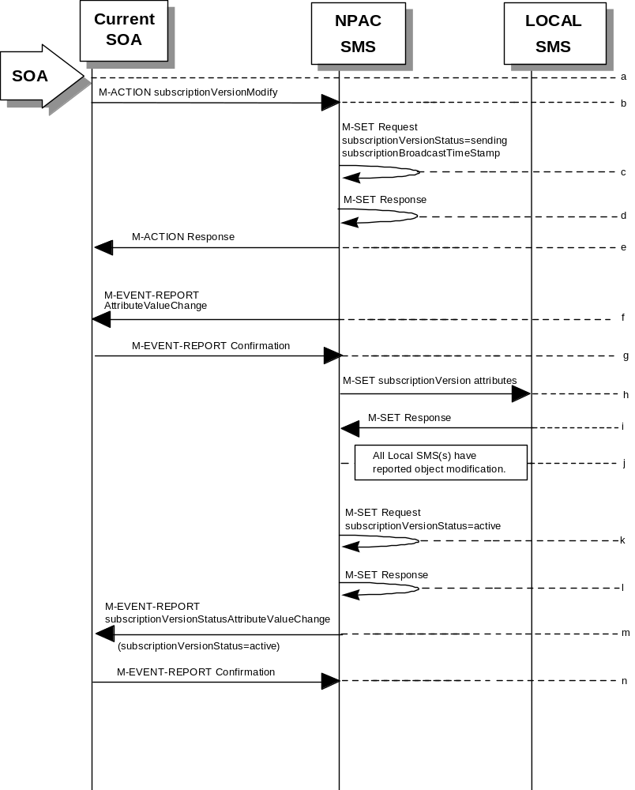
- Current service provider SOA issues M-ACTION ModifySubscriptionVersion to the NPAC SMS lnpSubscriptions object to update the active version. The NPAC SMS validates the data.
- If the M-ACTION data validates, NPAC SMS issues M-SET to the subscriptionVersionNPAC. The subscriptionVersionStatus is updated to “sending,” the subscriptionBroadcastTimeStamp and subscriptionModifiedTimeStamp are set, and any other modified attributes are updated.
- NPAC SMS issues M-SET response indicating success or failure.
- NPAC SMS replies to the M-ACTION with success or failure and reasons for failure to the service provider SOA. If the action fails, no modifications are applied and processing stops. Failure reasons include accessDenied (not the current service provider) and invalidArgumentValue (validation problems).
- NPAC SMS issues M-EVENT-REPORT for the modified attributes.
- Current service provider SOA responds with M-EVENT-REPORT confirmation.
- NPAC SMS issues M-SET to all Local SMSs for the updated attributes, that are accepting downloads for the NPA-NXX of the subscriptionVersion. If the update involves multiple subscription version objects, a scoped and filtered request will be sent.
- Local SMSs reply to M-SET.
- All Local SMSs have reported the object modification.
Failure scenarios for this modification follow the same rules for an objectCreation failure to the Local SMS. However, upon failure the version status is updated to “active” and the subscriptionFailedSP-List is updated to contain the name of the service providers for which the download fails.
- NPAC SMS issues M-SET to update the current subscriptionVersionNPAC object subscriptionVersionStatus to “active.”
- NPAC SMS responds to M-SET.
- NPAC SMS sends M-EVENT-REPORT to the current provider of the subscriptionVersionStatus update.
- Service provider SOA issues M-EVENT-REPORT confirmation.

SubscriptionVersion Modify Active: Failure to Local SMS
This scenario shows the broadcast of a modified active subscription that fails to one or more of the Local SMSs.
- 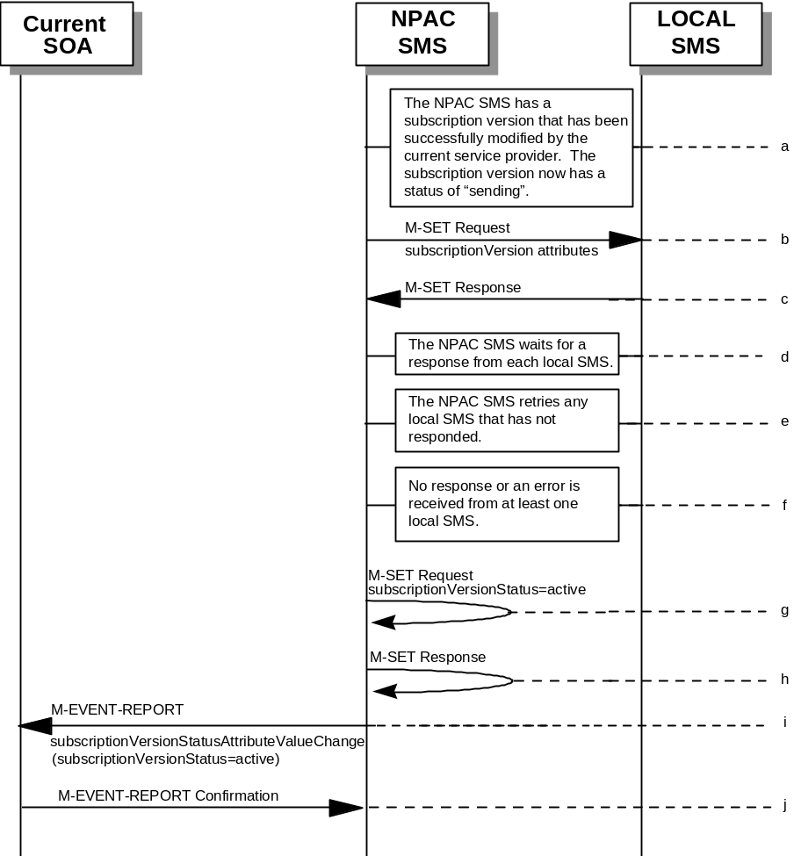The NPAC SMS has an active subscription version that has been successfully modified by the current service provider. The subscription version now has a status of “sending”.
- The NPAC SMS issues M-SET to all Local SMSs for the updated attributes, that are accepting downloads for the NPA-NXX of the subscriptionVersion.
- Local SMSs should respond successfully to the M-SET.
- NPAC SMS waits for responses from each Local SMS.
- NPAC SMS retries any Local SMS that has not responded.
- No response or an error is received from at least one Local SMS.
- NPAC SMS issues the M-SET to update the current subscriptionVersionNPAC object’s subscriptionVersionStatus to “active” from “sending”. It will also update the subscriptionFailed-SP-List with the service provider ID and name of the Local SMS that failed to successfully receive the broadcast.
- NPAC SMS responds to the M-SET.
- NPAC SMS sends the subscriptionVersionStatusAttributeValueChange M-EVENT-REPORT to the current service provider SOA with the current status and failedSP-List.
- The current service provider SOA issues the M-EVENT-REPORT confirmation.

SubscriptionVersion Modify Prior to Activate Using M-ACTION
This scenario can only be performed when the subscriptionVersionStatus is conflict or pending.
- 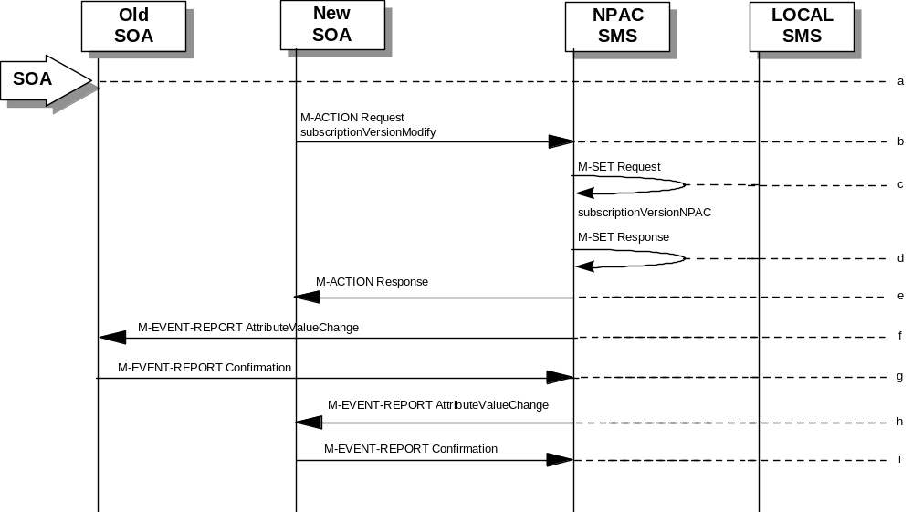Action is taken by a service provider to modify a subscriptionVersion by specifying the TN, TN range, and the version status, or by specifying the version ID of the subscription version to be modified; and the data to be modified.
The old service provider can only update the following attributes:
subscriptionOldSP-DueDate (seconds set to zeros)
subscriptionOldSP-Authorization
subscriptionStatusChangeCauseCode
NOTE: The subscriptionStatusChangeCauseCode can only be modified when the subscriptionOldSP-Authorization is set to FALSE
The new service provider can only update the attributes:
subscriptionLRN
subscriptionNewSP-DueDate (seconds set to zeros)
subscriptionCLASS-DPC
subscriptionCLASS-SSN
subscriptionLIDB-DPC
subscriptionLIDB-SSN
subscriptionCNAM-DPC
subscriptionCNAM-SSN
subscriptionISVM-DPC
subscriptionISVM-SSN
subscriptionWSMSC-DPC - if supported by the Service Provider SOA
subscriptionWSMSC-SSN - if supported by the Service Provider SOA
subscriptionEndUserLocationValue
subscriptionEndUserLocationType
subscriptionBillingId
- Service provider SOA issues M-ACTION subscriptionVersionModify to the NPAC SMS lnpSubscriptions object to update the version. The NPAC SMS validates the data.
- If validation is successful, NPAC SMS will M-SET the attributes modified in the subscriptionVersionNPAC object and set the subscriptionModifiedTimeStamp.
- The NPAC SMS will issue an M-SET response.
- NPAC SMS replies to the M-ACTION with success or failure and reasons for failure.
Note: If the old service provider was the initiator of the M-ACTION that caused the subscription version status to change, the NPAC SMS would issue a subscriptionVersionStatusAttributeValueChange M-EVENT-REPORT to the old and new service provider SOAs.
- NPAC SMS issues M-EVENT-REPORT attributeValueChange to the old service provider SOA.
- The old service provider SOA returns M-EVENT-REPORT confirmation to the NPAC SMS.
- NPAC SMS issues M-EVENT-REPORT attributeValueChange to the new service provider SOA.
- The new service provider SOA returns M-EVENT-REPORT confirmation to the NPAC SMS.

SubscriptionVersion Modify Prior to Activate Using M-SET
This scenario shows a modify using an M-SET. The M-SET can only be performed when the subscriptionVersionStatus is conflict or pending.
- Action is taken by a service provider to modify the subscriptionVersion by specifying the TN, TN range, and the version status, or by specifying the version ID of the subscription version to be modified; and the data to be modified.The old service provider can only update the following attributes:
subscriptionOldSP-DueDate (seconds set to zeros)
subscriptionOldSP-Authorization
subscriptionStatusChangeCauseCode
NOTE: The subscriptionStatusChangeCauseCode can only be modified when the subscriptionOldSP-Authorization is set to FALSE
The new service provider can only update the attributes:
subscriptionLRN
subscriptionNewSP-DueDate (seconds set to zeros)
subscriptionCLASS-DPC
subscriptionCLASS-SSN
subscriptionLIDB-DPC
subscriptionLIDB-SSN
subscriptionCNAM-DPC
subscriptionCNAM-SSN
subscriptionISVM-DPC
subscriptionISVM-SSN
subscriptionWSMSC-DPC - if supported by the Service Provider SOA
subscriptionWSMSC-SSN - if supported by the Service Provider SOA
subscriptionEndUserLocationValue
subscriptionEndUserLocationType
subscriptionBillingId
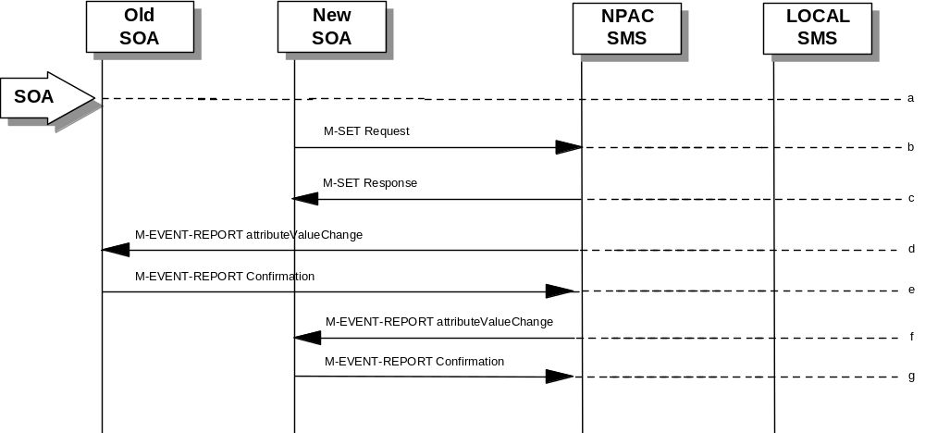
- The new or old service provider SOA will issue an M-SET request for the attributes to be updated in the subscriptionVersionNPAC object. The request will be validated for an authorized service provider and validation of the attributes and values.
- The NPAC SMS will issue an M-SET response indicating success or failure and reasons for failure.
Note: If the old service provider was the initiator of the M-SET that caused the subscription version status to change, the NPAC SMS would issue a subscriptionVersionStatusAttributeValueChange M-EVENT-REPORT to the old and new service provider SOAs
- NPAC SMS issues M-EVENT-REPORT attributeValueChange to the old service provider SOA.
- The old service provider SOA returns M-EVENT-REPORT confirmation to the NPAC SMS.
- NPAC SMS issues M-EVENT-REPORT attributeValueChange to the new service provider SOA.
- The new service provider SOA returns M-EVENT-REPORT confirmation to the NPAC SMS.

Subscription Version Modify Active: Resend Successful to Local SMS
This scenario shows the successful resend of a modification of an active subscription. The resend of a failed modified active version can only be performed by authorized NPAC personnel.
- Action is taken by NPAC personnel to resend the failed modified active version.
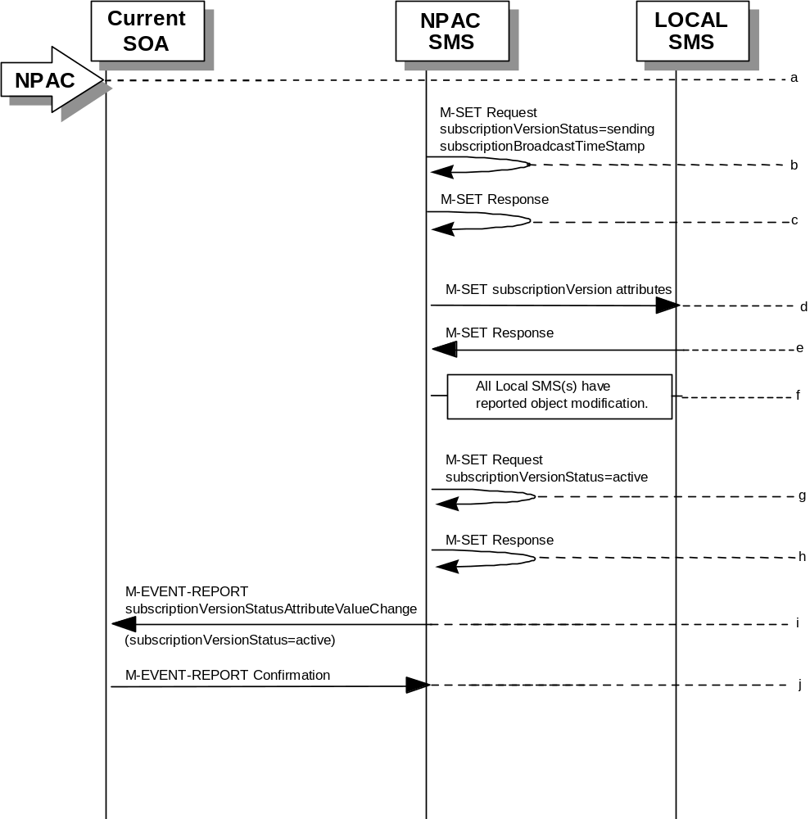
- NPAC SMS issues M-SET to the subscriptionVersionNPAC. The subscriptionVersionStatus is updated to “sending”.
- NPAC SMS issues M-SET response indicating success or failure.
- NPAC SMS issues M-SET to all Local SMSs that previously failed for the updated attributes, and are accepting downloads for the NPA-NXX of the subscriptionVersion.
- Local SMSs reply to M-SET.
- All Local SMSs have reported the object modification.
- NPAC SMS issues M-SET to update the current subscriptionVersionNPAC object subscriptionVersionStatus to “active.”
- NPAC SMS responds to M-SET.
- NPAC SMS sends M-EVENT-REPORT to the current provider of the subscriptionVersionStatus update.
- Service provider SOA issues M-EVENT-REPORT confirmation.

Subscription Version Modify Active: Resend Failure to Local SMS
This scenario shows a failure on a resend of a modified active subscription that failed previously to one or more of the Local SMSs. The resend of a failed modified active version can only be performed by authorized NPAC personnel.
- The NPAC SMS has an active subscription version that has been unsuccessfully modified by the current service provider. The NPAC personnel issues a resend for the failed modified version and the subscription version now has a status of “sending”.
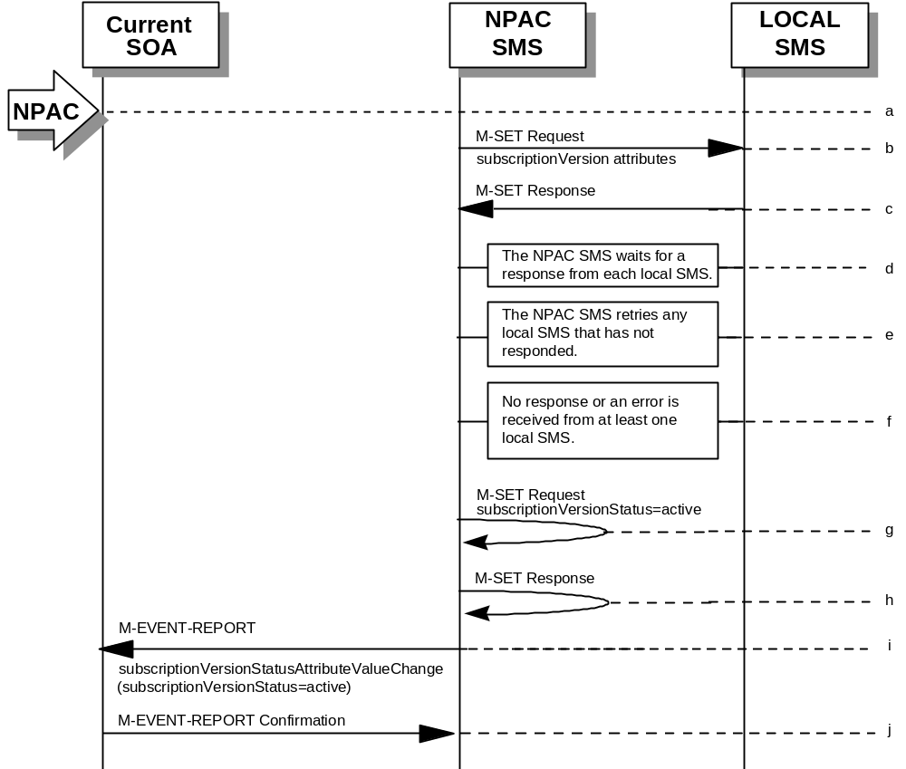
- The NPAC SMS issues M-SET to all Local SMSs that previously failed for the updated attributes, and are accepting downloads for the NPA-NXX of the subscriptionVersion.
- Local SMSs should respond successfully to the M-SET.
- NPAC SMS waits for responses from each Local SMS.
- NPAC SMS retries any Local SMS that has not responded.
- No response or an error is received from at least one or all Local SMSs.
- NPAC SMS issues the M-SET to update the current subscriptionVersionNPAC object’s subscriptionVersionStatus to “active” from “sending”. It will also update the subscriptionFailed-SP-List with the service provider ID and name of the Local SMSs that failed to successfully receive the broadcast.
- NPAC SMS responds to the M-SET.
- NPAC SMS sends the subscriptionVersionStatusAttributeValueChange M-EVENT-REPORT to the current service provider SOA with the current status and failedSP-List.
- The current service provider SOA issues the M-EVENT-REPORT confirmation.

Cancel Scenarios

SubscriptionVersion Cancel by Service Provider SOA After Both Service Provider SOAs Have Concurred
A subscription version can be canceled when the current status is conflict or pending.
In this scenario, the old service provider initiates the cancel after both the old and new service provider SOAs have issued their create actions. Once the new service provider SOA’s cancellation acknowledgment is received, the version status is set to “canceled”. Since the old service provider SOA initiated the cancel, its cancellation acknowledgment is optional.
- Action is initiated by the old or new service provider SOA to cancel a subscription version by specifying the TN, TN range, or version ID of the subscription version to be canceled.
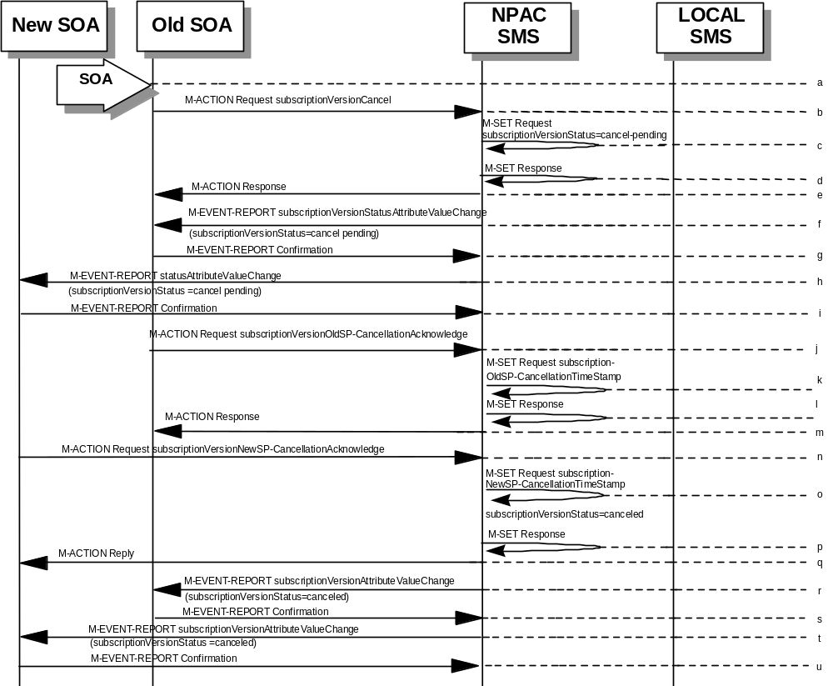
- Service provider SOA issues an M-ACTION subscriptionVersionCancel to the NPAC SMS to the lnpSubscriptions object.
- NPAC SMS issues M-SET to update subscriptionVersionStatus to “cancel-pending” in the subscriptionVersionNPAC object and the subscriptionModifiedTimeStamp.
- NPAC SMS issues M-SET response.
- NPAC SMS returns the M-ACTION reply. This either reflects a success or failure. Failure reasons are version in wrong state, no version to cancel, and authorization service provider. If successful, the subscriptionPre-CancellationStatus is set to the current subscriptionVersionStatus and then the subscriptionVersionStatus is set to “cancel-pending.” If the action fails, no modifications are applied and processing stops.
- An M-EVENT-REPORT for the subscriptionVersionStatus change is sent from the NPAC SMS to the old service provider SOA.
- The old service provider SOA returns an M-EVENT-REPORT confirmation to the NPAC SMS.
- An M-EVENT-REPORT for the subscriptionVersionStatus change is sent from the NPAC SMS to the new service provider SOA.
- The new service provider SOA returns an M-EVENT-REPORT confirmation to the NPAC SMS.

- The old service provider SOA sends an M-ACTion subscriptionVersionOldSP-CancellationAcknowledge to the NPAC SMS lnpSubscription object. This acknowledges the cancellation of the subscriptionVersionNPAC with a status of cancel-pending.
- The NPAC SMS issues M-SET for the subscriptionOldSP-CancellationTimeStamp in the subscriptionVersionNPAC object and subscriptionModifiedTimeStamp.
- NPAC SMS issues an M-SET response.
- NPAC SMS responds to the M-ACTION with either a success or failure and failure reasons. If the action fails, no modifications are applied.
- The new service provider SOA sends an M-ACTION subscriptionVersionNewSP-CancellationAcknowledge to the NPAC SMS lnpSubscriptions object.
- The NPAC SMS issues M-SET for the subscriptionNewSP-CancellationTimeStamp, subscriptionModifiedTimeStamp, subscriptionCancellationTimeStamp, and subscriptionVersionStatus to “canceled.”
- NPAC SMS issues M-SET response.
- NPAC SMS replies to M-ACTION with success or failure and reasons for failure. If the action fails, no modifications are applied.
- If the last M-ACTION was successful, the NPAC SMS sends the M-EVENT-REPORT for the subscriptionVersionStatus update to canceled to the old service provider SOA.
- If the last M-ACTION was successful, the old service provider SOA returns an M-EVENT-REPORT confirmation to the NPAC SMS.
- NPAC SMS sends the M-EVENT-REPORT for the subscriptionVersionStatus update to canceled to the new service provider SOA.
- The new service provider SOA returns an M-EVENT-REPORT confirmation to the NPAC SMS.

SubscriptionVersionCancel: No Acknowledgment from a SOA
The NPAC SMS has set the status of the subscription version to “cancel-pending” upon request of the old SOA. It is now waiting for the acknowledgments from both service provider SOAs. Acknowledgment from the old SOA is optional. In this scenario the new service provider does not respond.
- 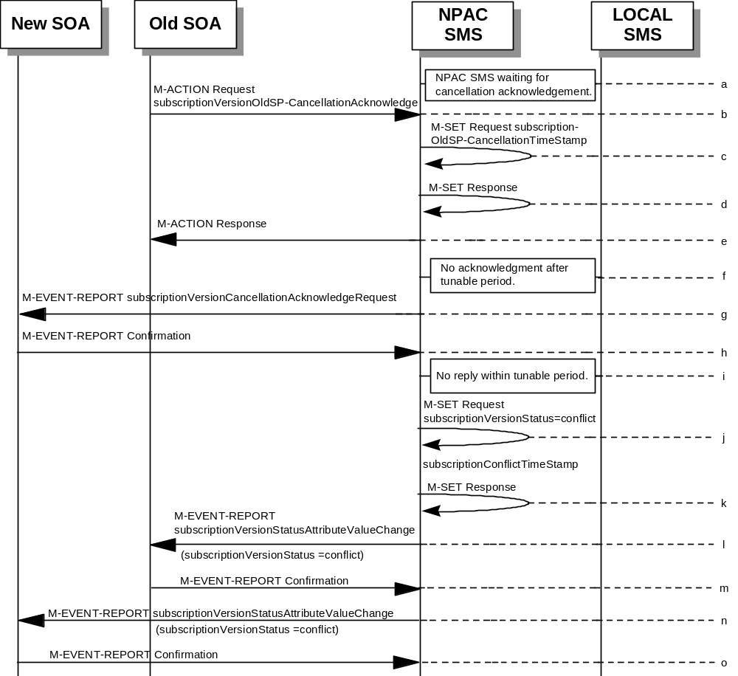NPAC SMS is waiting for the cancellation acknowledgments from both service provider SOAs.
- The old service provider SOA sends a subscriptionVersionOldSP-CancellationAcknowledge M-ACTION to the NPAC SMS lnpSubscriptions object. This acknowledges the cancellation of the subscriptionVersionNPAC with a status of cancel-pending.
- NPAC SMS issues M-SET for the subscriptionOldSP-CancellationTimeStamp and subscriptionModifiedTimeStamp in the subscriptionVersionNPAC object.
- NPAC SMS responds to M-SET.
- NPAC SMS replies to the M-ACTION with either a success or failure and failure reasons. If the action fails, no modifications are applied and processing stops.
- The NPAC SMS waits for the cancellation acknowledgment from the new service provider SOA. No reply is received after a tunable period.
- NPAC SMS issues M-EVENT-REPORT subscriptionVersionCancellationAcknowledgeRequest to the unresponsive new service provider SOA.
- The new service provider SOA returns an M-EVENT-REPORT confirmation to the NPAC SMS.
- The “Service Provider Concurrence Cancellation Window” has expired and still no cancellation acknowledgment is received from the new service provider.
- NPAC SMS issues M-SET to update the subscriptionVersionStatus to conflict and the subscriptionConflictTimeStamp and subscriptionModifiedTimeStamp are set.
- NPAC SMS issues M-SET response.
- The NPAC SMS issues M-EVENT-REPORT, subscriptionVersionStatusAttributeValueChange, to the old service provider SOA.
- The old service provider SOA returns an M-EVENT-REPORT confirmation to the NPAC SMS.
- The NPAC SMS issues M-EVENT-REPORT, subscriptionVersionStatusAttributeValueChange, to the new service provider SOA.
- The new service provider SOA returns an M-EVENT-REPORT confirmation to the NPAC SMS.
At this point, the flow follows the conflict resolution scenarios.

Subscription Version Cancels With Only One Create Action Received
Once one of the subscriptionVersionNewSP-Create or subscriptionVersionOldSP-Create actions has been received, the subscription version can be canceled by the same service provider who created the subscription version. In this case, the subscription version status is set to “canceled”, not “cancel-pending”, and no further acknowledgments are necessary by either the old or new service provider.
If the new service provider SOA creates the pending subscription version and the old service provider attempts to cancel it (or vice-versa), an error is returned to the service provider who requested the cancel.
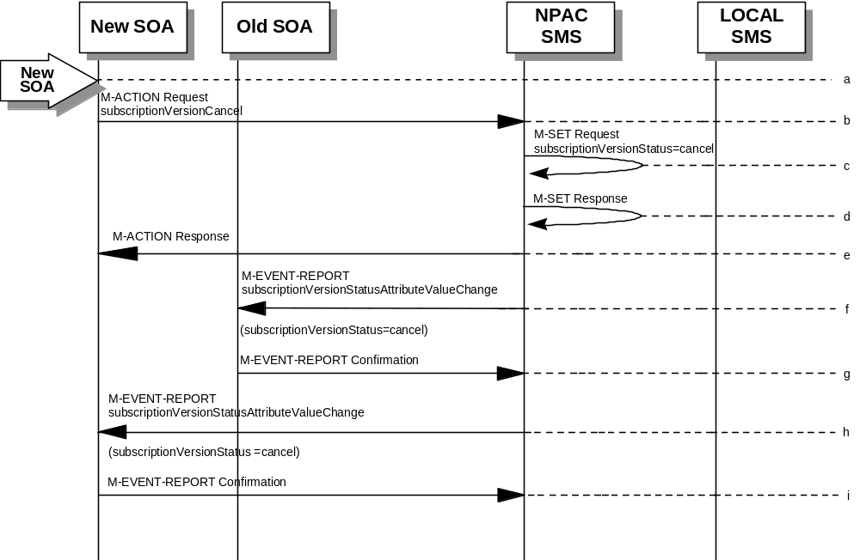In this scenario, the new service provider SOA has already successfully issued the subscriptionVersionNewSP-Create action. The old service provider has not issued its subscriptionVersionOldSP-Create action. Now, the new service provider needs to cancel the pending subscription version.
- Action is taken by the new service provider to cancel a subscription version they created.
- The new service provider SOA sends M-ACTION subscriptionVersionCancel to the NPAC SMS lnpSubscriptions object to cancel a pending subscriptionVersionNPAC.
- NPAC SMS issues M-SET to update the subscriptionVersionStatus to “canceled” and update the subscriptionModifiedTimeStamp in the subscriptionVersionNPAC object.
- NPAC SMS issues M-SET response.
- NPAC SMS returns the M-ACTION reply. This either reflects a success or failure. Failure reasons are version in wrong state, no version to cancel, and service provider not authorized.
If successful, the subscriptionPreCancellationStatus is set to the current subscriptionVersionStatus, and then the subscriptionVersionStatus is set to “canceled”. If the action fails, no modifications are applied and processing stops.
- The subscriptionVersionStatusAttributeValueChange M-EVENT-REPORT is sent to the old service provider SOA.
- The old service provider confirms the M-EVENT-REPORT.
- The subscriptionVersionStatusAttributeValueChange M-EVENT-REPORT is sent to the new service provider SOA.
- The new service provider confirms the M-EVENT-REPORT.

Disconnect Scenarios

SubscriptionVersion Immediate Disconnect
The current service provider can disconnect an active subscription version. In this scenario, the disconnect is immediate.
- Current service provider SOA personnel take action to disconnect a subscription version.
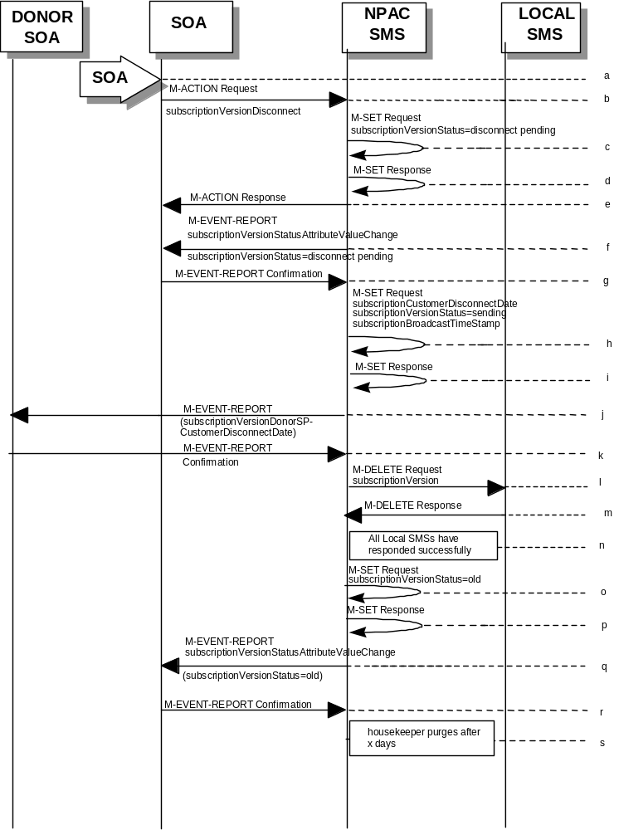
- Service provider SOA issues an M-ACTION request to disconnect to the lnpSubscriptions object. The M-ACTION specifies either the subscriptionVersionId, or subscriptionTN or range of TNs, and also has future dated the subscriptionEffectiveReleaseDate and the subscriptionCustomerDisconnectDate. The subscription version status must be active and no pending, failed, conflict or cancel-pending versions can exist.
- NPAC SMS issues an M-SET to set the subscriptionCustomerDisconnectDate according to the disconnect action. The subscriptionVersionStatus goes to “disconnect pending ”.
- NPAC SMS responds to whether M-SET was successful.
- NPAC SMS responds to the M-ACTION. If the action failed, an error will be returned and processing will stop on this flow.
- NPAC SMS notifies service provider SOA of status change to “disconnect pending.”
- Service provider SOA confirms event report.
- NPAC SMS issues an M-SET to set the subscriptionCustomerDisconnectDate according to the disconnect action. The subscriptionVersionStatus goes to “sending ” and the subscriptionModifiedTimeStamp and the subscriptionBroadcastTimeStamp are both set accordingly.
- NPAC SMS responds to whether M-SET was successful.
- NPAC SMS sends the donor service provider SOA notification that the subscription version is being disconnected with the customer disconnect date.
- The donor service provider SOA confirms the M-EVENT-REPORT.
- NPAC SMS sends out an M-DELETE on the subscriptionVersion to all Local SMSs, that are accepting downloads for the NPA-NXX of the subscriptionVersion. If the M-DELETE is for multiple subscription versions, a scoped and filtered operation will be sent.
- Each Local SMS responds with a successful M-DELETE reply.
- All Local SMSs respond successfully.
- NPAC SMS issues M-SET updating the subscriptionVersionStatus to old for subscriptionVersionNPAC objects. It also sets the subscriptionModifiedTimeStamp and subscriptionDisconnectCompleteTimeStamp.
- NPAC SMS responds to M-SET.
- NPAC SMS issues an M-EVENT-REPORT for the subscriptionVersionStatus equal to “old.”
- Service provider SOA responds to M-EVENT-REPORT.
- After a tunable amount of days, the subscription version is purged by the NPAC SMS housekeeping process.

SubscriptionVersion Disconnect With Effective Release Date
In this scenario, a future dated request is submitted to disconnect an active subscriptionVersion.
- Service provider SOA personnel take action to disconnect a subscription version.
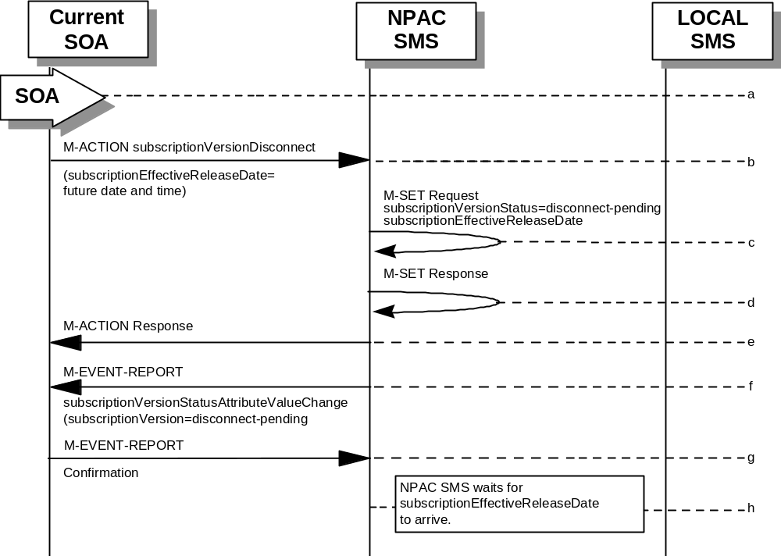
- Service provider SOA issues an M-ACTION request to disconnect to the lnpSubscriptions object. The M-ACTION specifies either the subscriptionVersionId, or subscriptionTN or range of TNs, and also has future dated the subscriptionEffectiveReleaseDate and the subscriptionCustomerDisconnectDate. The subscription version status must be active and no pending, failed, conflict, or cancel-pending versions can exist.
- NPAC SMS M-SETs the status to disconnect-pending, and sets the subscriptionEffectiveReleaseDate of the existing subscriptionVersionNPAC and also the subscriptionModifiedTimeStamp.
- NPAC SMS responds to M-SET.
- NPAC SMS responds to M-ACTION. If the action fails, no modifications are applied and the processing stops.
- NPAC SMS sends the subscriptionVersionStatusAttributeValueChange
M-EVENT-REPORT to the current service provider SOA.
- The current service provider SOA issues the M-EVENT-REPORT confirmation.
- The NPAC SMS waits for the subscriptionEffectiveReleaseDate date to arrive.
At this point, the flow follows an immediate disconnect scenario. First the donor service provider’s Local SMS is notified of the impending disconnect. The NPAC SMS sets the subscriptionVersionStatus to sending the broadcast timestamp, notifies the service provider SOA of the status change, and proceeds to issue M-DELETEs for the subscriptionVersion to the Local SMS.

SubscriptionVersion Disconnect: Failure to Local SMS
This scenario shows the broadcast of a disconnected subscription that fails to all of the Local SMSs.
- 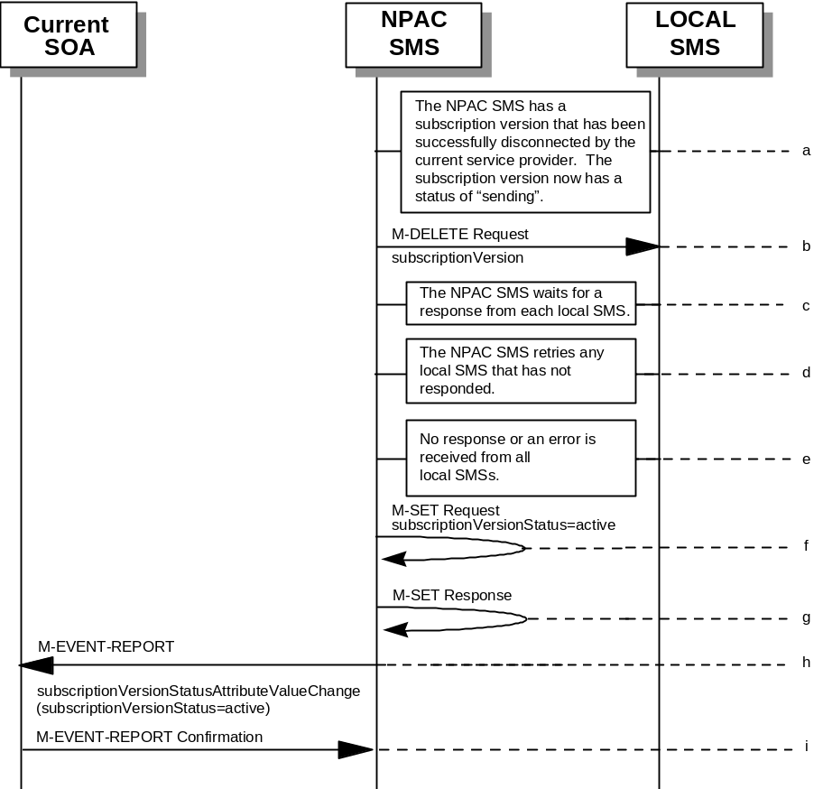The NPAC SMS has an active subscription version that has been successfully disconnected by the current service provider using the subscriptionVersionDisconnect action. The subscription version now has a status of “sending”.
- NPAC SMS issues the M-DELETE to all Local SMSs for the subscriptionVersion, that are accepting downloads for the NPA-NXX of the subscriptionVersion.
- NPAC SMS waits for a response from each Local SMS.
- NPAC SMS retries any Local SMS that has not responded.
- No response or an error is received from all Local SMSs.
- NPAC SMS issues the M-SET to update the current subscriptionVersionNPAC object’s subscriptionVersionStatus to “active” from “sending”. It will also update the subscriptionFailed-SP-List with the service provider ID and name of all the Local SMSs.
- NPAC SMS responds to the M-SET.
- NPAC SMS sends the subscriptionVersionStatusAttributeValueChange
M-EVENT-REPORT to the current service provider SOA with the current status and failedSP-List.
- Current service provider SOA issues the M-EVENT-REPORT confirmation.

SubscriptionVersion Disconnect: Partial Failure to Local SMS
This scenario shows the broadcast of a disconnected subscription that fails to one or more, but not all, of the Local SMSs.
- The NPAC SMS has an active subscription version that has been successfully disconnected by the current service provider using the subscriptionVersionDisconnect action. The subscription version now has a status of “sending”.
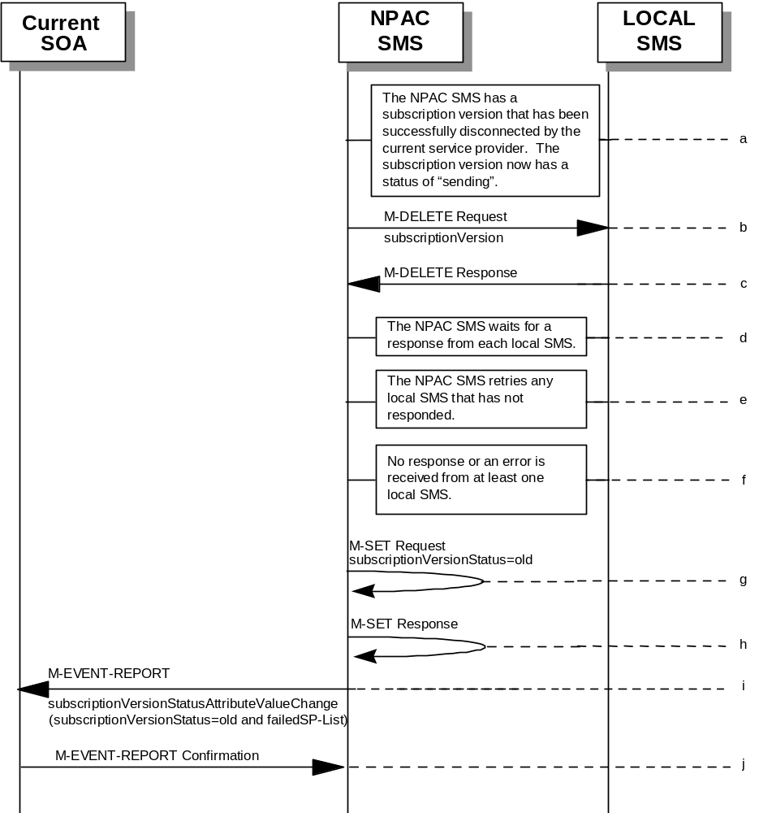
- NPAC SMS issues the M-DELETE to all Local SMSs for the subscriptionVersion, that are accepting downloads for the NPA-NXX of the subscriptionVersion.
- Local SMSs should respond successfully to the M-DELETE.
- NPAC SMS waits for a response from each Local SMS.
- NPAC SMS retries any Local SMS that has not responded.
- No response or an error is received from at least one Local SMS.
- NPAC SMS issues the M-SET to update the current subscriptionVersionNPAC object’s subscriptionVersionStatus to “old” from “sending”. It will also update the subscriptionFailed-SP-List with the service provider ID and name of the Local SMSs that failed to successfully receive the broadcast.
- NPAC SMS responds to the M-SET.
- NPAC SMS sends the subscriptionVersionStatusAttributeValueChange
M-EVENT-REPORT to the current service provider SOA with the current status and failedSP-List.
- Current service provider SOA issues the M-EVENT-REPORT confirmation.

Subscription Version Disconnect: Resend Successful to Local SMS
This scenario shows a successful resend of a disconnect for a subscription that fails to one or more of the Local SMSs. The resend of a failed disconnect can only be performed by authorized NPAC personnel.
- NPAC personnel take action to resend a failed disconnect for a subscription version.
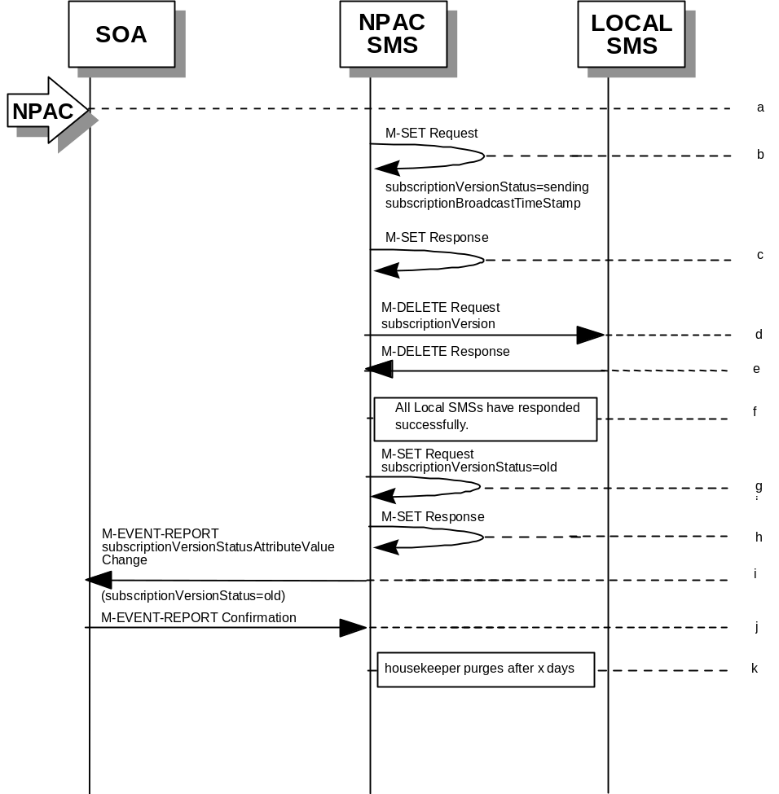
- NPAC SMS issues an M-SET to the existing subscriptionVersionNPAC object to set the status to “sending”.
- NPAC SMS responds to whether M-SET was successful.
- NPAC SMS sends out an M-DELETE on the subscriptionVersion to all previously failed Local SMSs, that are accepting downloads for the NPA-NXX of the subscriptionVersion.
- Each Local SMS responds with a successful M-DELETE reply.
- All Local SMSs respond successfully.
- NPAC SMS issues M-SET updating the subscriptionVersionStatus to old for subscriptionVersionNPAC objects. It also sets the subscriptionModifiedTimeStamp and subscriptionDisconnectCompleteTimeStamp.
- NPAC SMS responds to M-SET.
- NPAC SMS issues an M-EVENT-REPORT for the subscriptionVersionStatus equal to “old.”
- Service provider SOA responds to M-EVENT-REPORT.
- After a tunable amount of days, the subscription version is purged by the NPAC SMS housekeeping process.

Subscription Version Disconnect: Resend Failure to Local SMS
This scenario shows a failure on a resend of a subscription disconnect that failed previously to one or more of the Local SMSs. The resend of a failed disconnect for a subscription can only be performed by authorized NPAC personnel.
- NPAC personnel take action to resend a failed disconnect for a subscription version.
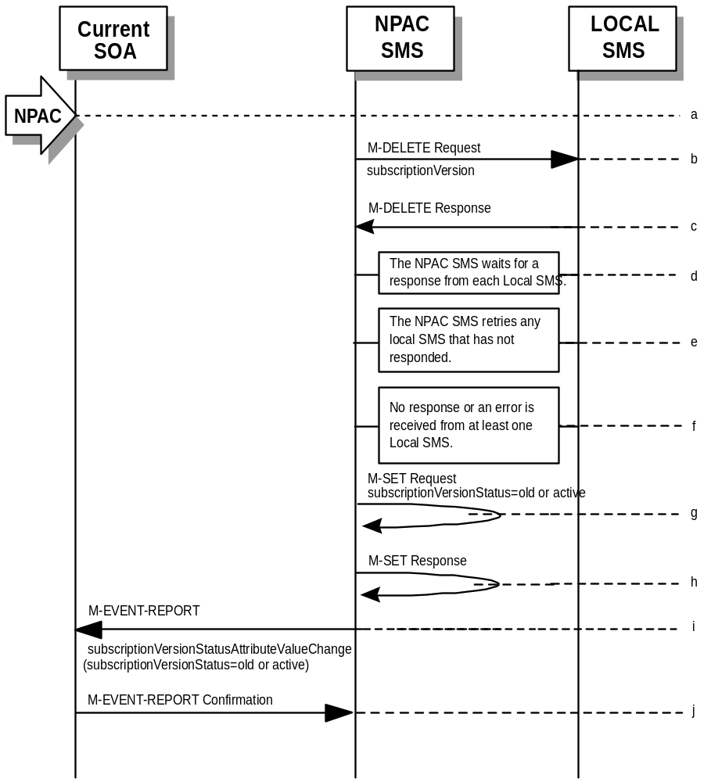
- NPAC SMS issues the M-DELETE to all Local SMSs for which the disconnect previously failed for the subscriptionVersion, and are accepting downloads for the NPA-NXX of the subscriptionVersion.
- Local SMSs should respond successfully to the M-DELETE.
- NPAC SMS waits for a response from each Local SMS.
- NPAC SMS retries any Local SMS that has not responded.
- No response or an error is received from at least one or all Local SMSs.
- NPAC SMS issues the M-SET to update the current subscriptionVersionNPAC object’s subscriptionVersionStatus to “old” or “active” (if all Local SMSs failed) from “sending”. It will also update the subscriptionFailed-SP-List with the service provider ID and name of the Local SMSs that failed to successfully receive the broadcast.
- NPAC SMS responds to the M-SET.
- NPAC SMS sends the subscriptionVersionStatusAttributeValueChange
M-EVENT-REPORT to the current service provider SOA with the current status and failedSP-List.
- Current service provider SOA issues the M-EVENT-REPORT confirmation.

Conflict Scenarios
A situation has arisen which causes the NPAC SMS or NPAC personnel to place the subscriptionVersion into conflict.
A subscription version can be removed from conflict by the NPAC personnel or the new service provider SOA.

SubscriptionVersion Conflict and Conflict Resolution by the NPAC SMS
This scenario shows a version being placed into conflict and removed from conflict by the NPAC personnel.
- NPAC personnel or NPAC SMS take action to set the status of a subscription to “conflict.”
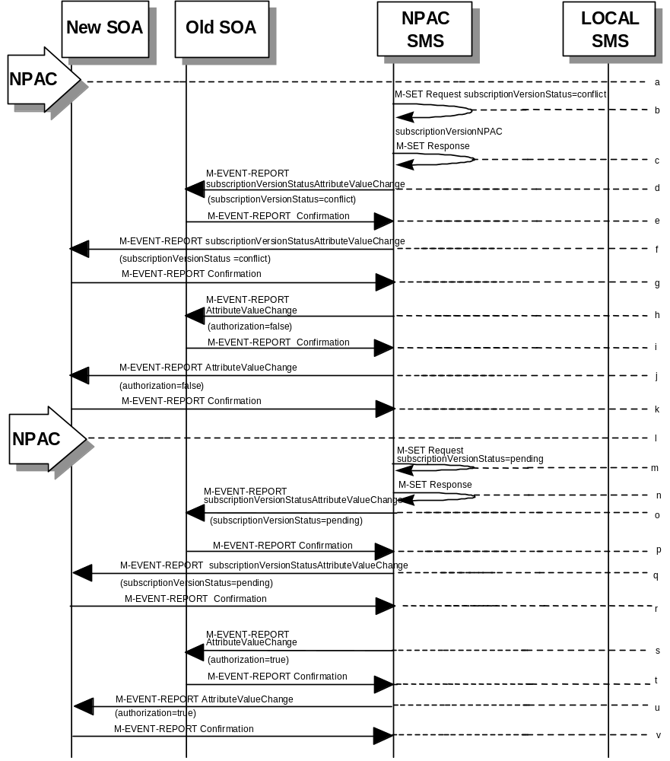
- NPAC SMS issues M-SET request to update subscriptionVersionStatus to “conflict,” subscriptionConflictTimeStamp, and subscriptionModifiedTimeStamp in the subscriptionVersionNPAC object.
- NPAC SMS issues an M-SET response. If the M-SET fails, processing for this scenario stops.
- NPAC SMS issues an M-EVENT-REPORT subscriptionVersionStatusAttributeValueChange to old service provider SOA.
- The old service provider SOA returns an M-EVENT-REPORT confirmation to the NPAC SMS.
- NPAC SMS issues subscriptionVersionStatusAttributeValueChange for status to new service provider SOA.
- The new service provider SOA returns an M-EVENT-REPORT confirmation to the NPAC SMS.
- NPAC SMS sends a subscriptionVersionStatusAttributeValueChange to set the old service provider’s authorization to “FALSE”.
- The old service provider SOA returns an M-EVENT-REPORT confirmation to the NPAC SMS.
- NPAC SMS sends an AttributeValueChange to set the new service provider authorization to “FALSE”.
- The new service provider SOA returns an M-EVENT-REPORT confirmation to the NPAC SMS.
- Once the conflict is resolved, NPAC personnel take action to remove the subscriptionVersion from conflict.
- NPAC SMS issues an M-SET request to update the subscriptionModifiedTimeStamp and the subscriptionVersionStatus to “pending.”
- NPAC SMS issues an M-SET response. If the M-SET fails, processing for this scenario stops.
- NPAC SMS issues subscriptionVersionStatusAttributeValueChange for the new status to the old service provider SOA.
- The old service provider SOA returns an M-EVENT-REPORT confirmation to the NPAC SMS.
- NPAC SMS issues subscriptionVersionStatusAttributeValueChange for the new status to the new service provider SOA.
- The new service provider SOA returns an M-EVENT-REPORT confirmation to the NPAC SMS.
- NPAC SMS sends a subscriptionVersionStatusAttributeValueChange to the old service provider’s indicating the authorization has been set to “TRUE”.
- The old service provider SOA returns an M-EVENT-REPORT confirmation to the NPAC SMS.
- NPAC SMS sends an AttributeValueChange to the new service provider indicating the authorization has been set to “TRUE”.
- The new service provider SOA returns an M-EVENT-REPORT confirmation to the NPAC SMS.

Subscription Version Conflict Removal by the New Service Provider SOA
In this scenario, the new service provider elects to remove the subscription version from conflict.
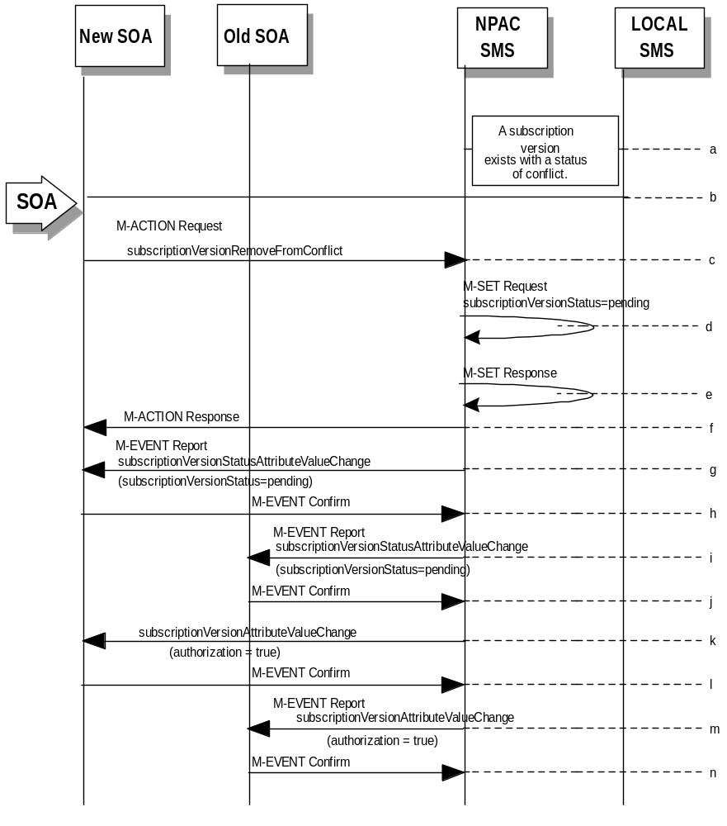
- A subscription version exists on the NPAC SMS with a status of conflict.
- The new service provider SOA personnel take action to remove the subscription version from conflict.
- The new service provider SOA sends the M-ACTION subscriptionVersionNewSP-RemoveFromConflict specifying the subscription version TN or subscription version ID of the subscription version in conflict.
- If the request is valid, the NPAC SMS will set the status to “pending”.
The request will be denied and an error returned if the subscriptionOldSP-Authorization was set to conflict by the old service provider and the conflict restriction window has not expired.
- The NPAC SMS responds to its own M-SET.
- The NPAC SMS responds to the M-ACTION with success or failure and reason for failure.
- The NPAC SMS sends the M-EVENT-REPORT subscriptionVersionStatusAttributeValueChange to the New SOA.
- The New SOA sends the M-EVENT-REPORT confirmation.
- The NPAC SMS sends the M-EVENT-REPORT subscriptionVersionStatusAttributeValueChange to the Old SOA.
- The Old SOA sends the M-EVENT-REPORT confirmation.
- NPAC SMS sends a subscriptionVersionStatusAttributeValueChange to set the old service provider’s authorization to “TRUE”.
- The old service provider SOA returns an M-EVENT-REPORT confirmation to the NPAC SMS.
- NPAC SMS sends an AttributeValueChange to the new service provider indicating the authorization has been set to “TRUE”.
- The new service provider SOA returns an M-EVENT-REPORT confirmation to the NPAC SMS.

SubscriptionVersion Conflict: No Conflict Resolution
This scenario shows the action taken at the NPAC SMS when service providers do not reach a conflict resolution.
- NPAC personnel or NPAC SMS take action to set a subscriptionVersionStatus to “conflict.”
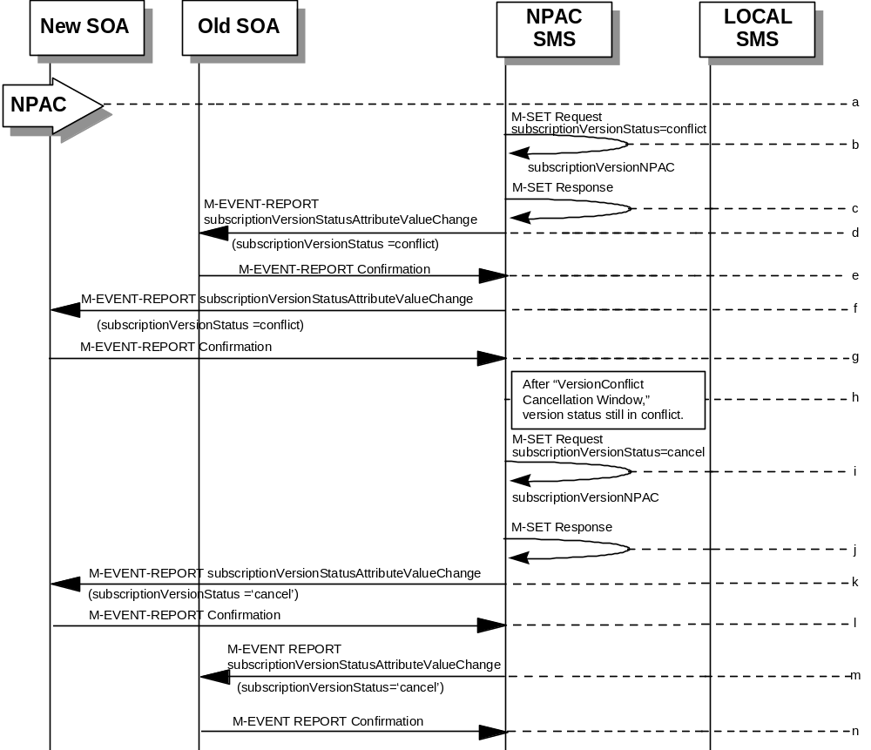
- NPAC SMS issues an M-SET request to set the subscriptionVersionStatus to “conflict,” the subscriptionConflictTimeStamp, and the subscriptionModifiedTimeStamp in the subscriptionVersionNPAC object.
- NPAC SMS responds to M-SET. If the M-SET fails, processing stops for this scenario until the M-SET completes successfully.
- NPAC SMS issues subscriptionVersionStatusAttributeValueChange to old service provider SOA for the new “conflict” status.
- The old service provider SOA returns an M-EVENT-REPORT confirmation to the NPAC SMS.
- NPAC SMS issues subscriptionVersionStatusAttributeValueChange to new service provider SOA for the “conflict” status.
- The new service provider SOA returns an M-EVENT-REPORT confirmation to the NPAC SMS.
- “Version Conflict Cancellation Window” expires without conflict resolution.
- NPAC SMS issues an M-SET request to set the subscriptionVersionStatus to “cancel” in the subscriptionVersionNPAC object and sets the subscriptionCancellationTimeStamp and subscriptionModifiedTimeStamp.
- NPAC SMS responds to M-SET. If the M-SET fails, processing stops for this scenario until the M-SET is successfully completed.
- NPAC SMS issues attribute value change for status to new service provider SOA for the “cancel” status.
- The new service provider SOA returns an M-EVENT-REPORT confirmation to the NPAC SMS.
- NPAC SMS issues attribute value change for status to old service provider SOA for the “cancel” status.
- The old service provider SOA returns an M-EVENT-REPORT confirmation to the NPAC SMS.

Subscription Version Conflict by Old Service Provider Explicitly Not Authorizing (First Create)
The old service provider SOA can put a pending subscription version into conflict by setting its authorization flag to off. This can be done on the subscriptionVersionOldSP-Create action, subscriptionVersionModify action, or M-SET of the attribute on the subscription version object.
This scenario shows the old service provider putting a new pending subscription version into conflict by turning the authorization flag off on the subscriptionVersionOldSP-Create. In this case, the old service provider’s create action is the first sent to the NPAC SMS.
- 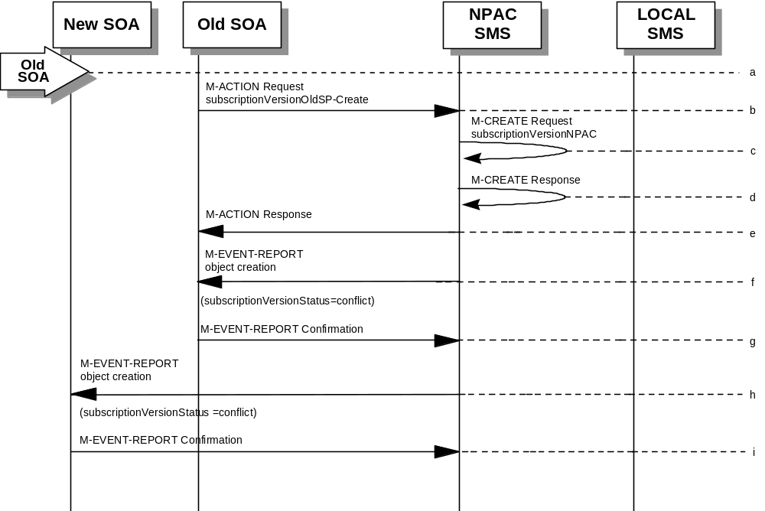Action is taken by the old service provider to set a subscription version to conflict using the subscriptionVersionOldSP-Create action.
- The old service provider SOA sends M-ACTION subscriptionVersionOldSP-Create to the NPAC SMS lnpSubscriptions object to create a new subscriptionVersionNPAC with the status of “conflict”.
The old service provider SOA specifies the following valid attributes:
subscriptionTN or valid subscriptionVersionTN-Range
subscriptionNewCurrentSP
subscriptionOldSP
subscriptionOldSP-DueDate (seconds set to zeros)
subscriptionOldSP-Authorization
subscriptionLNPType
subscriptionStatusChangeCauseCode
In this case, the subscriptionOldSP-Authorization is set to NO.
- NPAC SMS issues M-CREATE to create the subscriptionVersionNPAC with a status of “conflict” and sets all the other attribute values from the subscriptionVersionOldSP-Create action.
- NPAC SMS issues M-CREATE response.
- NPAC SMS returns M-ACTION reply. This either reflects a success or failure and reasons for the failure.
- If the action was successful, the NPAC SMS issues the M-EVENT-REPORT to the old service provider SOA notifying them of the object creation.
- The old service provider SOA confirms the M-EVENT-REPORT.
- If the action was successful, the NPAC SMS issues the M-EVENT-REPORT to the new service provider SOA notifying them of the object creation.
- The new service provider SOA confirms the M-EVENT-REPORT.

SubscriptionVersion Query
This scenario shows subscriptionVersion query from service provider systems to the NPAC SMS.
- Action is taken by either a service provider SOA or Local SMS for retrieving one or more versions of a subscription.
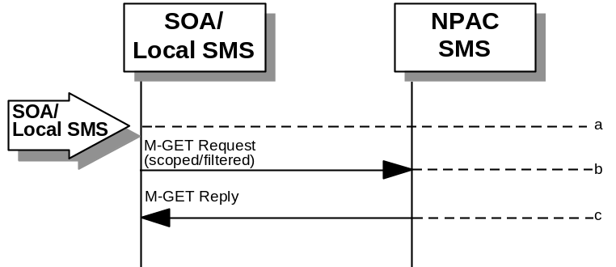
- The service provider SOA or Local SMS issues a scoped filtered M-GET from the lnpSubscriptions object to retrieve a specific version for a subscription version TN or can request all subscription versions. However, the service provider SOA is limited by a scope and filter in their search capabilities. The filter will currently support all the attributes on the subscriptionVersionNPAC.
- The NPAC SMS replies with the requested subscriptionVersion data if the requested number of records is less than or equal to “Max SubscriberQuery” specified in the NPAC SMS. Otherwise a complexityLimitation error will be returned.
The query return data includes:
subscriptionTN
subscriptionLRN
subscriptionNewCurrentSP
subscriptionOldSP
subscriptionNewSP-DueDate
subscriptionNewSP-CreationTimeStamp
subscriptionOldSP-DueDate
subscriptionOldSP-Authorization
subscriptionOldSP-AuthorizationTimeStamp
subscriptionActivationTimeStamp
subscriptionBroadcastTimeStamp
subscriptionConflictTimeStamp
subscriptionCustomerDisconnectDate
subscriptionDisconnectCompleteTimeStamp
subscriptionEffectiveReleaseDate
subscriptionVersionStatus
subscriptionCLASS-DPC
subscriptionCLASS-SSN
subscriptionLIDB-DPC
subscriptionLIDB-SSN
subscriptionCNAM-DPC
subscriptionCNAM-SSN
subscriptionISVM-DPC
subscriptionISVM-SSN
subscriptionWSMSC-DPC - if supported by the Service Provider SOA
subscriptionWSMSC-SSN - if supported by the Service Provider SOA
subscriptionEndUserLocationValue
subscriptionEndUserLocationType
subscriptionBillingId
subscriptionLNPType
subscriptionPreCancellationStatus
subscriptionCancellationTimeStamp
subscriptionOldTimeStamp
subscriptionModifiedTimeStamp
subscriptionCreationTimeStamp
subscriptionOldSP-CancellationTimeStamp
subscriptionNewSP-CancellationTimeStamp
subscriptionOldSP-ConflictResolutionTimeStamp
subscriptionNewSP-ConflictResolutionTimeStamp
subscriptionPortingToOriginal-SPSwitch
subscriptionFailedSP-List
subscriptionDownloadReason
subscriptionTimerType
subscriptionBusinessType

Subscription Data Download
This scenario shows a Local SMS request for subscription data download in order to update their view of this data.
- 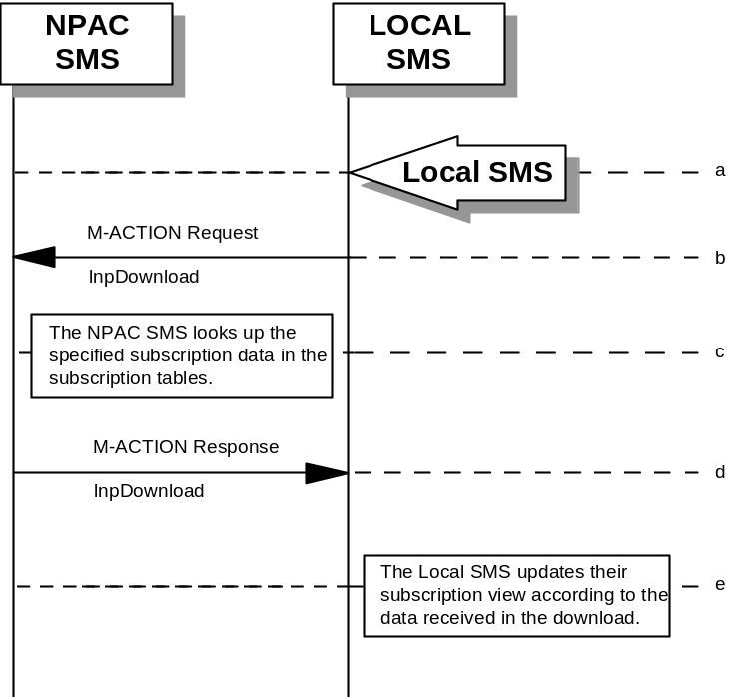Action is taken by the Local SMS personnel to request a subscription data download. The criteria to decide which subscription data is to be downloaded is specified by the Local SMS personnel.
- The Local SMS sends an M-ACTION request to the NPAC SMS lnpSubscription object requesting a subscription data download.
- The NPAC SMS looks up the subscription data in the subscription database as specified by the criteria in the M-ACTION request.
- The NPAC SMS responds by sending an M-ACTION response to the Local SMS that initiated the request. The response includes the success/failure of the request along with the requested subscription data.
- The Local SMS must take appropriate action to update their view of the data.

LSMS Filter NPA-NXX Scenarios

lsmsFilterNPA-NXX Creation by the Local SMS
- Action is taken by the Local SMS personnel to create an lsmsFilterNPA-NXX object.
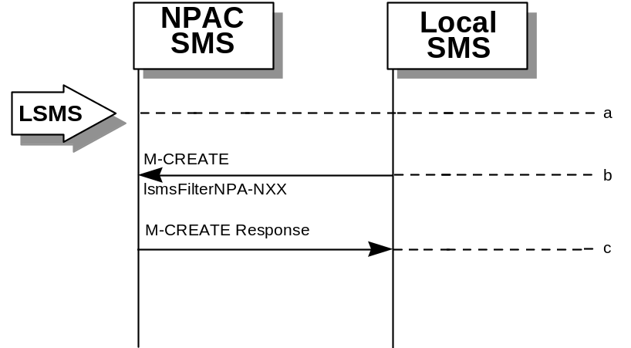
- The Local SMS sends the M-CREATE request to the NPAC for the lsmsFilterNPA-NXX object to be created.
- The NPAC SMS attempts to create the object. If successful, the M-CREATE response is returned. Otherwise, an error is returned.

lsmsFilterNPA-NXX Deletion by the Local SMS
- 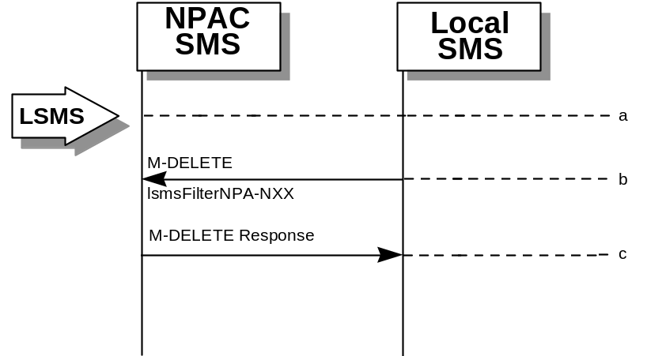Action is taken by the Local SMS personnel to delete an lsmsFilterNPA-NXX object.
- The Local SMS sends the M-DELETE request to the NPAC for the lsmsFilterNPA-NXX object to be removed.
- The NPAC SMS attempts to delete the object. If successful, the M-DELETE response is returned. Otherwise, an error is returned.

lsmsFilterNPA-NXX Query by the Local SMS
- 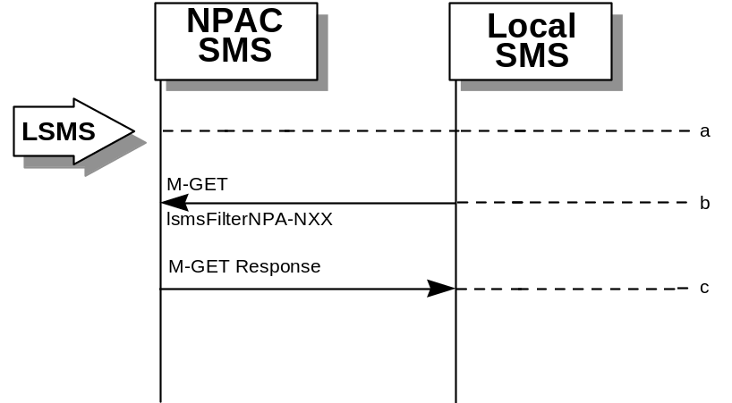Action is taken by the Local SMS personnel to query for one or all lsmsFilterNPA-NXX object(s).
- The Local SMS sends the M-GET request to the NPAC for the lsmsFilterNPA-NXX object(s).
- If the Service Provider ID was specified, all lsmsFilterNPA-NXX objects for that Service Provider are returned. If only one object was requested, that object is returned.

lsmsFilterNPA-NXX Creation by the SOA
- Action is taken by the SOA personnel to create an lsmsFilterNPA-NXX object.
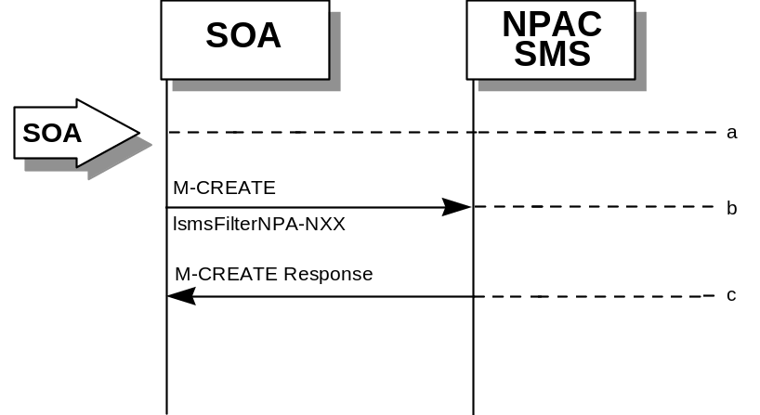
- The SOA sends the M-CREATE request to the NPAC for the lsmsFilterNPA-NXX object to be created.
- The NPAC SMS attempts to create the object. If successful, the M-CREATE response is returned. Otherwise, an error is returned.

lsmsFilterNPA-NXX Deletion by the SOA
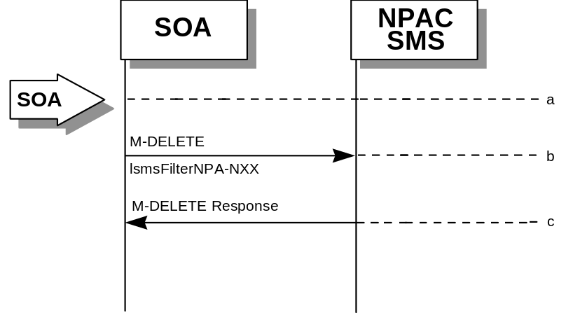
- Action is taken by the SOA personnel to delete an lsmsFilterNPA-NXX object.
- The SOA sends the M-DELETE request to the NPAC for the lsmsFilterNPA-NXX object to be removed.
- The NPAC SMS attempts to delete the object. If successful, the M-DELETE response is returned. Otherwise, an error is returned.

lsmsFilterNPA-NXX Query by the SOA
- 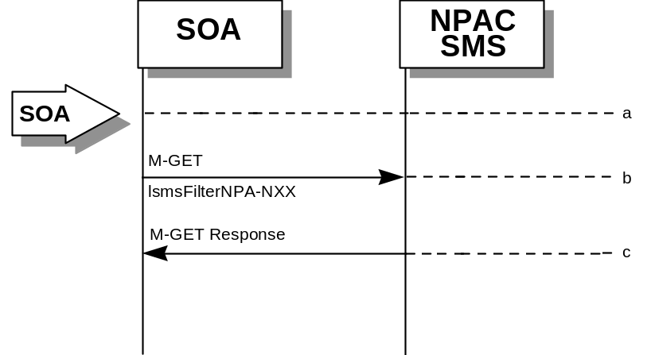Action is taken by the SOA personnel to query for one or all lsmsFilterNPA-NXX object(s).
- The SOA sends the M-GET request to the NPAC for the lsmsFilterNPA-NXX object(s).
- If the Service Provider ID was specified, all lsmsFilterNPA-NXX objects for that Service Provider are returned. If only one object was requested, that object is returned.

Local SMS and SOA Recovery

Sequencing of Events on Initialization/Resynchronization of Local SMS
If the resynchronization flag is TRUE upon association establishment, the NPAC SMS will hold updates to the Local SMS until the flag is turned off. At that time all updates issued since the association establishment will be sent.
If any of the requests in this scenario fail, the Local SMS must correct the problem - retry the action instead of continuing.

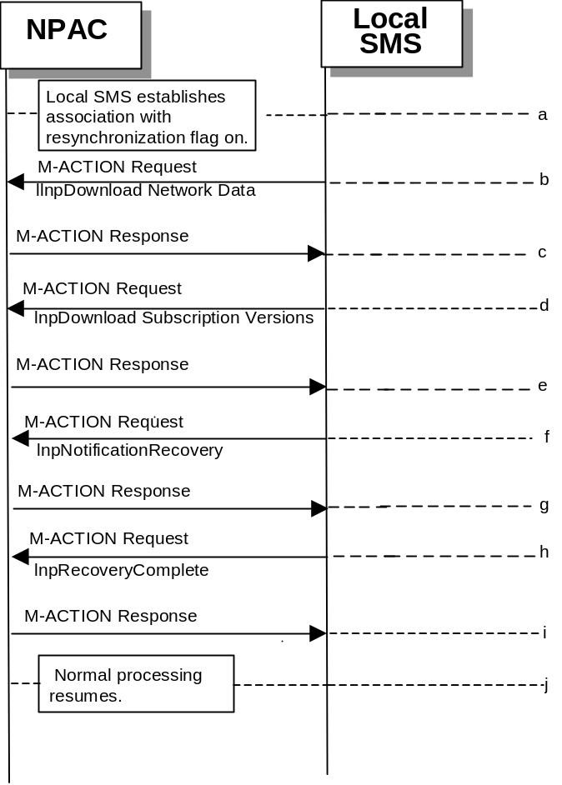
- Local SMS establishes association with resynchronization flag on.
- Local SMS sends M-ACTION to start network data download. The Local SMS specifies the criteria.
- NPAC SMS responds to M-ACTION with updates.
- Local SMS sends M-ACTION to start subscription data download. The Local SMS specifies the criteria.
- NPAC SMS responds to M-ACTION with subscription version updates.
- Local SMS sends M-ACTION to recovery notifications by time range.
- NPAC SMS responds to M-ACTION with notification updates.
- Local SMS sends M-ACTION to set resynchronization flag off.
- NPAC SMS replies to the M-ACTION.
- Normal processing resumes and any activity that the NPAC SMS had queued upduring the recovery period will now be sent.

Sequencing of Events on Initialization/Resynchronization of SOA
If the resynchronization flag is TRUE upon association establishment, the NPAC SMS will hold updates to the SOA until the flag is turned off. At that time all updates issued since the association establishment will be sent.
If any of the requests in this scenario fail, the SOA must correct the problem - retry the action instead of continuing.

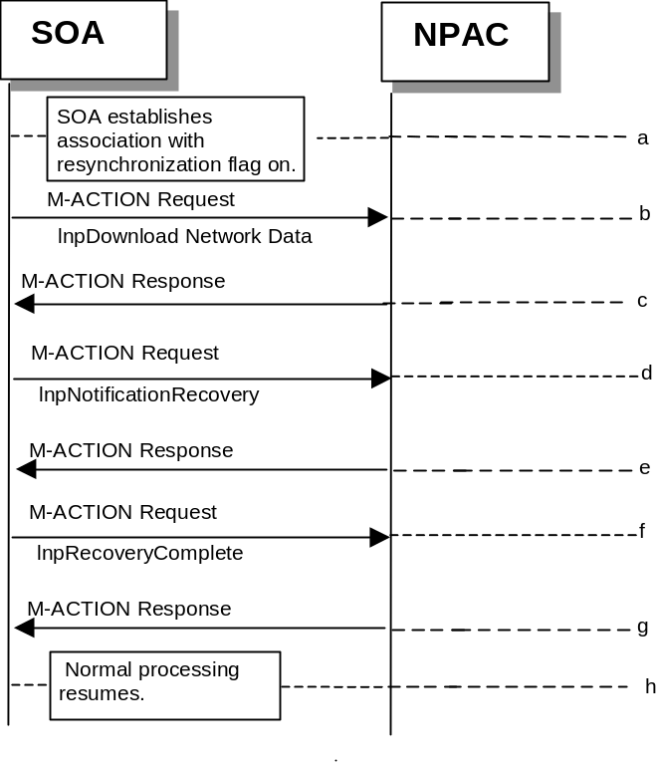
- SOA establishes association with resynchronization flag on.
- Local SMS sends M-ACTION to start network data download. The Local SMS specifies the criteria.
- NPAC SMS responds to M-ACTION with updates.
- SOA sends M-ACTION to recovery notifications by time range.
- NPAC SMS responds to M-ACTION with notification updates.
- SOA sends M-ACTION to set resynchronization flag off.
- NPAC SMS replies with to the M-ACTION.
- Normal processing resumes and any activity that the NPAC SMS had queued upduring the recovery period will now be sent.

Miscellaneous

SOA/Local SMS Notification of Scheduled NPAC Downtime
This scenario shows SOA/Local SMS notification of scheduled NPAC downtime.
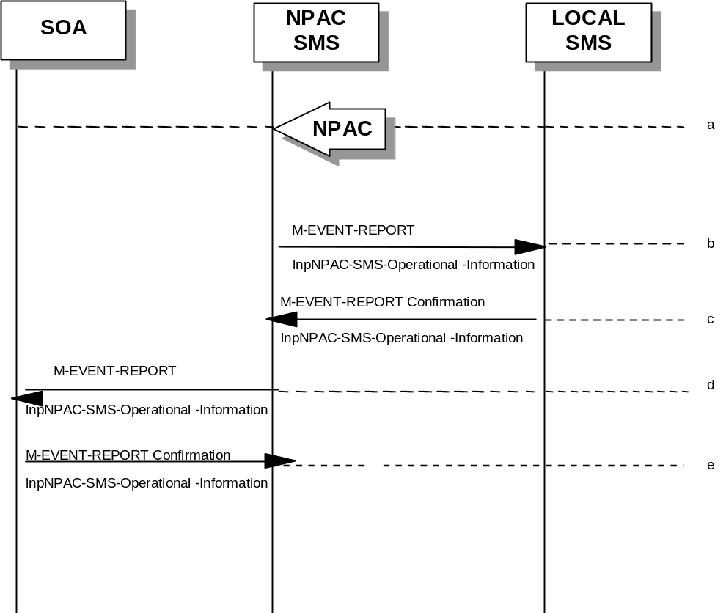
- Action is taken by NPAC SMS personnel to schedule downtime for the NPAC SMS system
- The NPAC SMS sends an lnpNPAC-SMS-Operational-Information M-EVENT-REPORT to the Local SMSs.
- The Local SMSs respond by sending an lnpNPAC-SMS-Operational-Information M-EVENT-REPORT confirmation back to the NPAC SMS.
- The NPAC SMS sends an lnpNPAC-SMS-Operational-Information M-EVENT-REPORT to all SOAs.
- The SOA(s) respond by sending an lnpNPAC-SMS-Operational-Information M-EVENT-REPORT confirmation back to the NPAC SMS.

NPA-NXX Split
This scenario shows NPAC SMS personnel initiation of an NPA-NXX split.
- Action is taken by the NPAC SMS personnel to create an an NPA-NXX split.
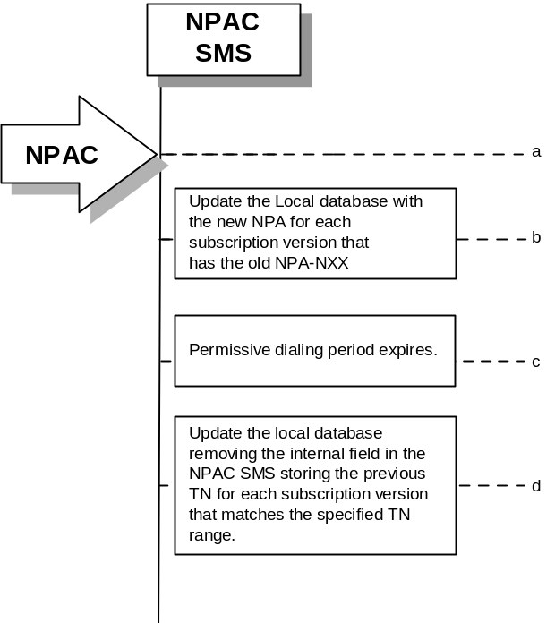
- The NPAC SMS waits until the permissive dialing period starts and then updates all subscription version records in its local database that are affected by the NPA-NXX Split. The TN field will be updated with the new NPA. Internal mapping between the old and new NPA-NXX’s for the TNs is maintained.
- The permissive dialing period expires.
- The NPAC SMS removes the internal mapping between the old and new NPA-NXX’s for the TNs affected by the NPA-NXX Split.

Mass Update
NPAC SMS personnel can perform a mass update on subscription data.
- Action is taken by the NPAC SMS personnel to request that a mass update be performed on active subscription data.
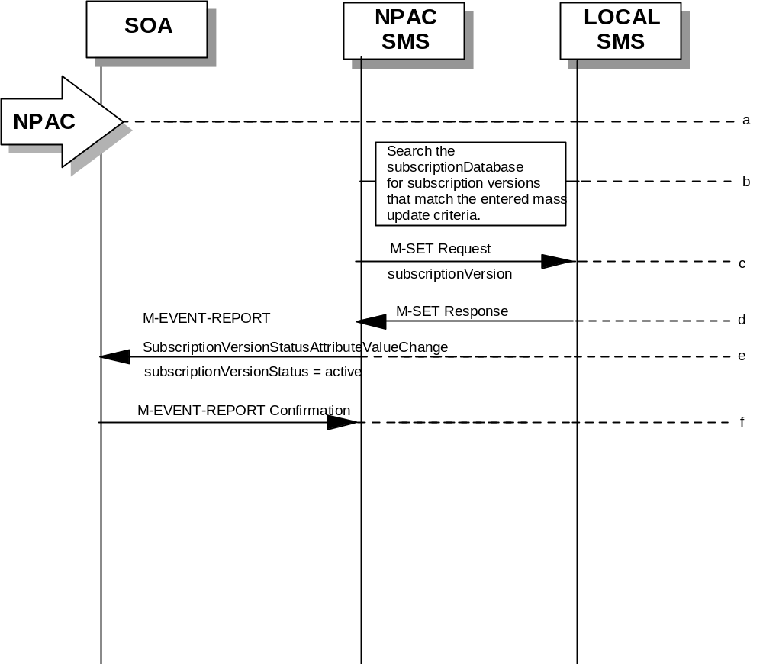
- Search the subscription database for subscription versions that match the specified mass update criteria. Perform steps c-through-f for the allowable range of subscription versions. The NPAC logs as errors subscription versions that match the mass update criteria but are in the wrong state.
- The NPAC SMS sends an M-SET on the subscription versions to the Local SMS, that is accepting downloads for the NPA-NXX of the subscription versions.
- The Local SMS replies to the M-SET.
- The NPAC SMS sends a statusAttributeValueChange M-EVENT-REPORT to the current service provider SOA.
- The service provider SOA sends a confirmation to the M-EVENT-REPORT.

