NANC Release 2 IIS Flows – 4/30/1998

These IIS flows are based off of the 1.8 IIS flows. Modifications of Release 1 flows in subsequent 1.X documents should be reviewed to see if they should be applied to these flows.
1.1 Service Provider Scenarios

1.1.1 Service Provider Creation by the NPAC
In this scenario, the NPAC SMS creates data for a new LNP service provider. The addition of NPA-NXX and LRN data for a new service provider will be shown in flows that follow.
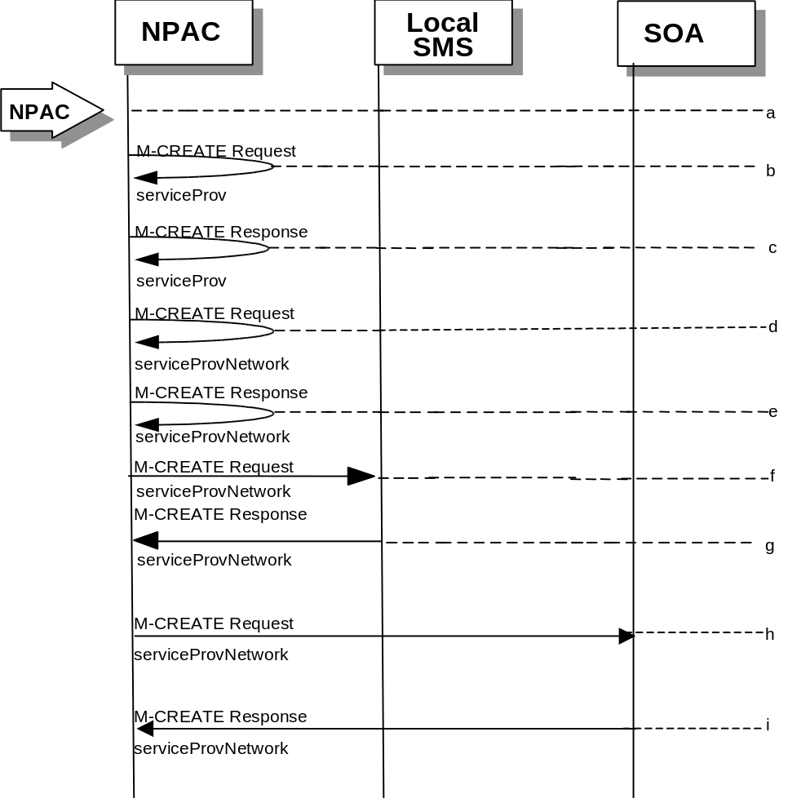
- Action is taken by NPAC SMS personnel to create a new service provider.
- Issue a local M-CREATE request for the serviceProv object to/from the NPAC SMS. This will attempt to create the serviceProv object on the NPAC SMS. If the M-CREATE fails, the appropriate error will be returned.
- The M-CREATE response is received on the NPAC SMS indicating whether the serviceProv object was created successfully. If a failure occurs, processing will stop.
- Issue a local M-CREATE request for the serviceProvNetwork object to/from the NPAC SMS. This will attempt to create the serviceProvNetwork object on the NPAC SMS. If the M-CREATE fails, the appropriate error will be returned.
- The M-CREATE response is received on the NPAC SMS indicating whether the serviceProvNetwork object was created successfully. If the object cannot be created, the serviceProv object is deleted and an error is returned.
- The NPAC SMS sends an M-CREATE request for the serviceProvNetwork object to each of the Local SMS(s).
- The Local SMS(s) will respond by sending an M-CREATE response back to the NPAC SMS.
- The NPAC SMS sends an M-CREATE request for the serviceProvNetwork object to each of the SOA(s).
- The SOA(s) will respond by sending an M-CREATE response back to the NPAC SMS.

1.1.2

Service Provider Deletion by the NPAC
In this scenario, the NPAC SMS deletes data for an LNP service provider with no network data.
- Action is taken by NPAC SMS personnel to delete an existing service provider.
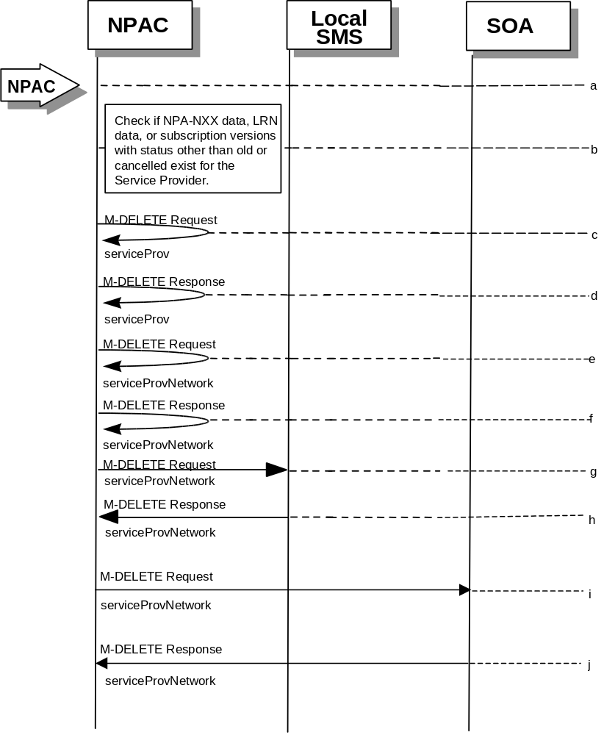
- Check the database to see if the service provider has associated with it NPA-NXX data, LRN data, or subscription versions with status other than old or canceled. If so, deny the request.
- Issue a local M-DELETE request for the serviceProv object to/from the NPAC SMS. This will attempt to delete the serviceProv object on the NPAC SMS.
- The M-Delete response is received on the NPAC SMS indicating whether the serviceProv object was deleted successfully.
- If the serviceProv object was deleted, issue a local M-DELETE request for the serviceProvNetwork object to/from the NPAC SMS. This will attempt to delete the serviceProvNetwork object on the NPAC SMS.
- The M-DELETE response is received on the NPAC SMS indicating whether the serviceProvNetwork object was deleted successfully.
- If the serviceProvNetwork object was deleted, the NPAC SMS sends an M-DELETE request for the serviceProvNetwork object to each of the Local SMS(s).
- The Local SMS(s) will respond by sending an M-DELETE response back to the NPAC SMS.
- If the serviceProvNetwork object was deleted, the NPAC SMS sends an M-DELETE request for the serviceProvNetwork object to each of the SOA(s).
- The SOA(s) will respond by sending an M-DELETE response back to the NPAC SMS.

1.1.3

Service Provider Modification by the NPAC
In this scenario, the NPAC SMS modifies the LNP service provider data.
- Action is taken by the NPAC personnel to modify data for an existing service provider.
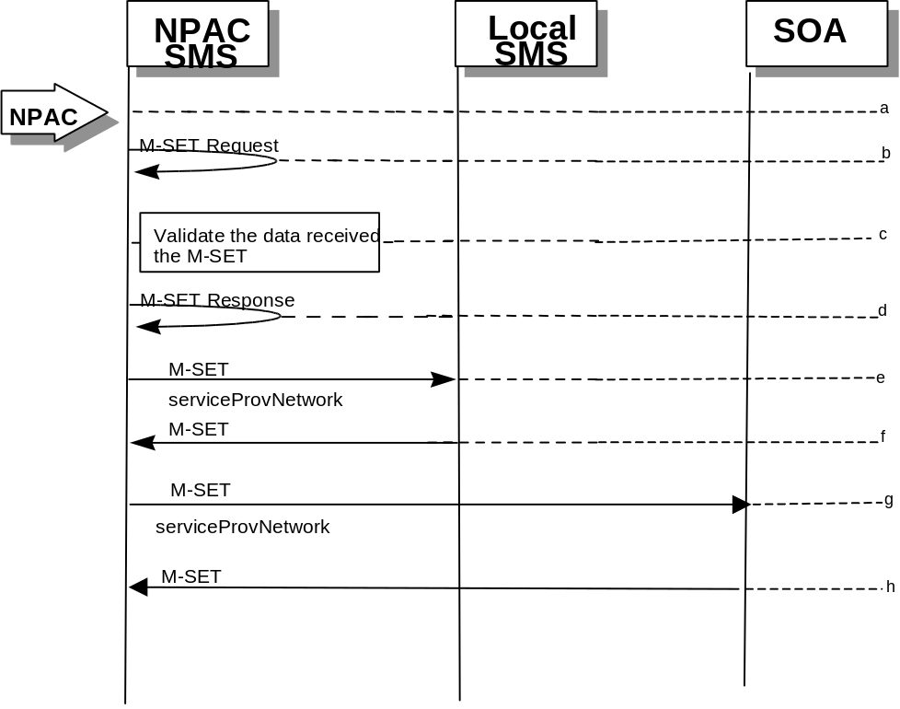
- Issue a local M-SET request for the serviceProv object to/from the NPAC SMS. This will attempt to set the specified information on the NPAC SMS.
- Validate the data to be set in the M-SET request. An M-SET Error Response of invalidArgumentValue is returned if any data is deemed invalid.
- The M-SET response is received on the NPAC SMS indicating whether the serviceProv object was modified successfully.
- NPAC SMS performs an M-SET to all the Local SMS(s) if the service provider name changed.
- The Local SMS(s) respond.
- NPAC SMS performs an M-SET to all the SOA(s) if the service provider name changed.
- The SOA(s) respond.

1.1.4

Service Provider Modification by the Local SMS
In this scenario, the Local SMS modifies its own service provider data.
- Action is taken by the Local SMS personnel to modify their own service provider data.
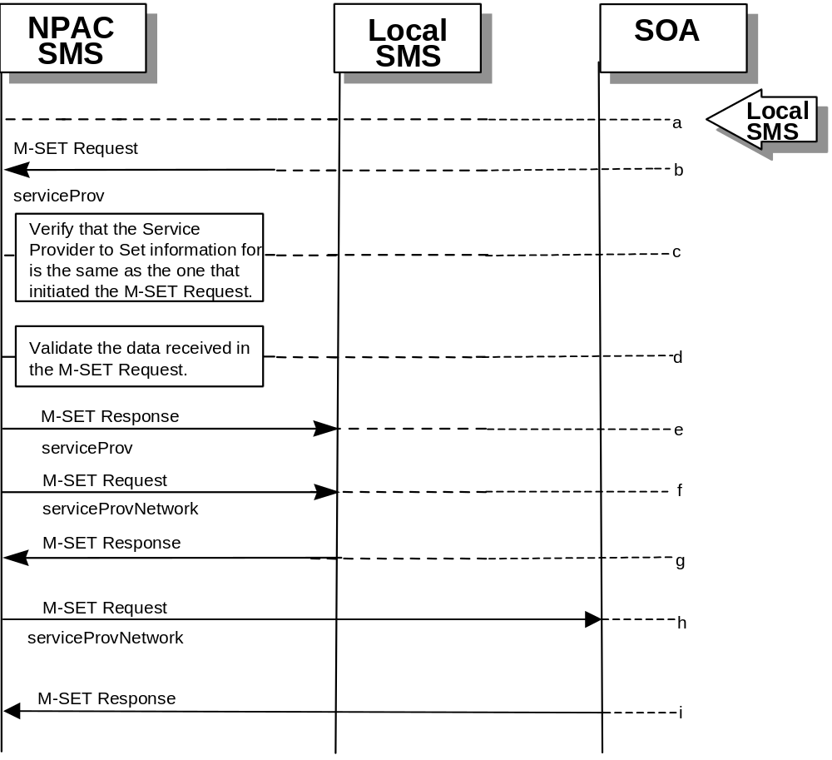
- The Local SMS sends an M-SET request to the NPAC SMS to modify their service provider information.
- The NPAC SMS verifies that the service provider to be modified is owned by the service provider that initiated the request. If not, an access denied M-SET Error Response of invalidArgumentValue is returned.
- Validate the data to be set in the M-SET request. An invalidArgumentValue M-SET Error Response is returned if any data is deemed invalid.
- The NPAC SMS sends an M-SET response back to the Local SMS that initiated the request.
- NPAC SMS performs an M-SET to all Local SMS(s) if the service provider name changed.
- The Local SMS(s) respond.
- NPAC SMS performs an M-SET to all SOA(s) if the service provider name changed.
- The SOA(s) respond.

1.1.5

Service Provider Modification by the SOA
In this scenario, the SOA modifies its own service provider data.
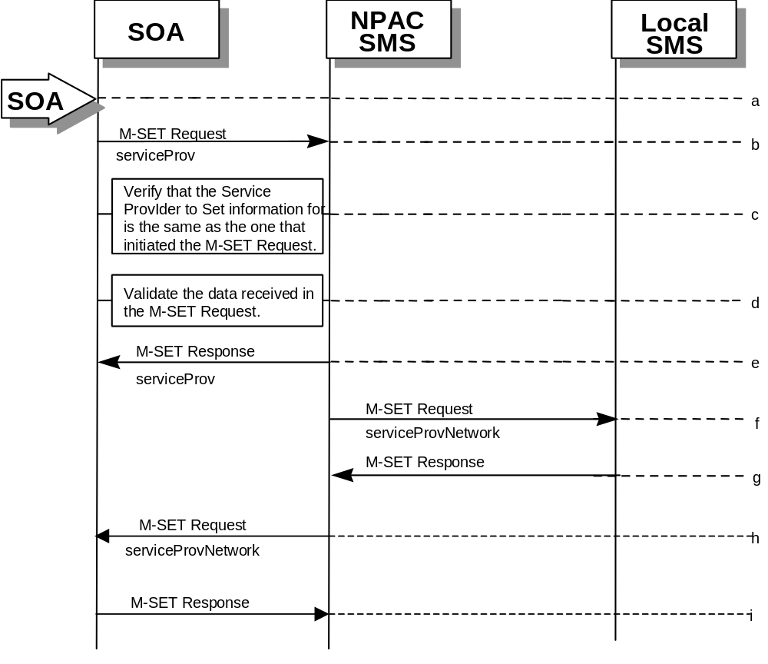
- Action is taken by the SOA to modify their own service provider data.
- The SOA sends an M-SET request to the NPAC SMS to modify their service provider information.
- The NPAC SMS verifies that the service provider to be modified is owned by the service provider that initiated the request. If not, an access denied M-SET Error Response is returned.
- Validate the data to be set in the M-SET request. An invalidArgumentValue M-SET Error Response is returned if any data is deemed invalid.
- The NPAC SMS sends an M-SET response back to the SOA that initiated the request.
- NPAC SMS performs an M-SET to all Local SMS(s) if the service provider name changed.
- The Local SMS(s) respond.
- NPAC SMS performs an M-SET to all SOA(s) if the service provider name changed.
- The SOA(s) respond.

1.2

Service Provider Network Data Scenarios

1.2.1 NPA-NXX Scenarios

1.2.1.1 NPA-NXX Creation by the NPAC
In this scenario, NPAC SMS creates new NPA-NXX data for an LNP service provider.
- Action is taken by the NPAC Personnel to create an NPA-NXX for a specified service provider.
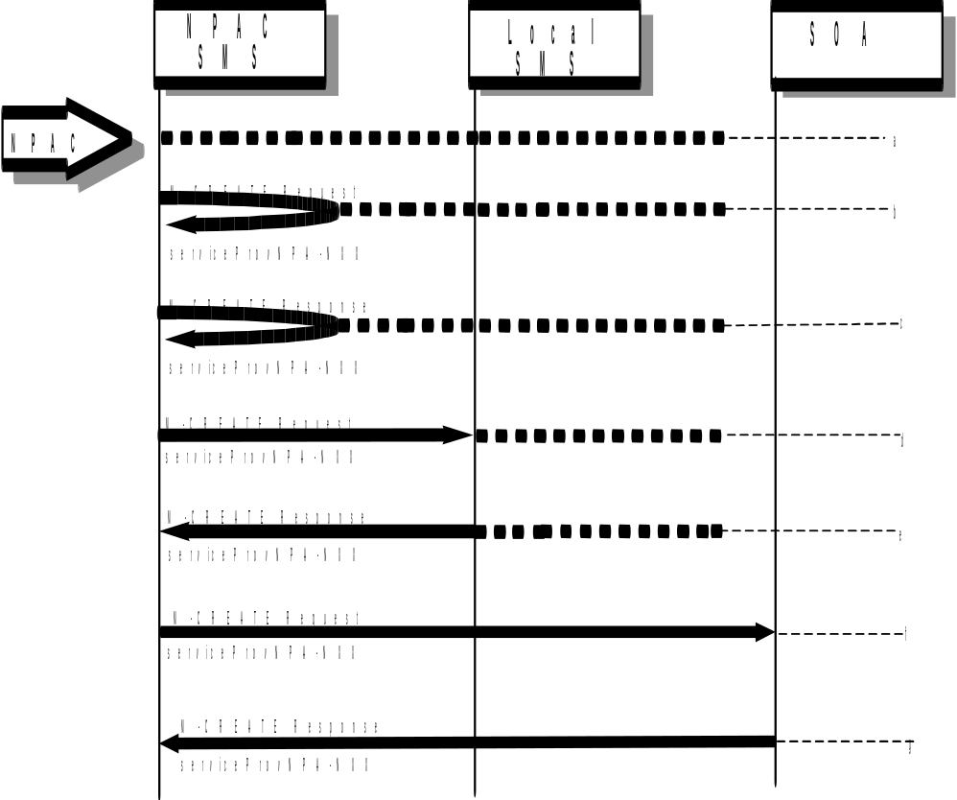
- The NPAC SMS sends an M-CREATE request to itself in order to create a local serviceProvNPA-NXX object.
- The NPAC SMS receives the M-CREATE response indicating whether the serviceProvNPA-NXX object was created successfully.
- If the serviceProvNPA-NXX object was created, the NPAC SMS sends an M-CREATE request to all Local SMS(s) for the serviceProvNPA-NXX object.
- The Local SMS(s) respond by sending an M-CREATE response indicating whether the serviceProvNPA-NXX object was created successfully.
- If the serviceProvNPA-NXX object was created, the NPAC SMS sends an M-CREATE request to all SOA(s) for the serviceProvNPA-NXX object.
- The SOA(s) respond by sending an M-CREATE response indicating whether the serviceProvNPA-NXX object was created successfully.

1.2.1.2

NPA-NXX Deletion by the NPAC
In this scenario, NPAC SMS deletes an NPA-NXX for an LNP service provider.
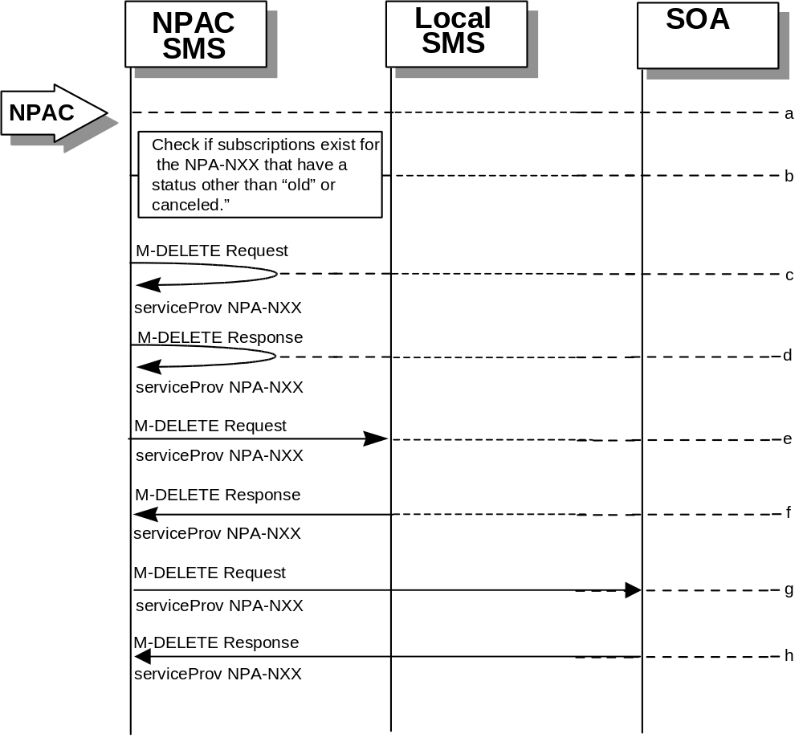
- Action is taken by NPAC SMS personnel to delete an NPA-NXX for a specified service provider.
- Check the subscriptions database to see if subscriptions exist with this NPa-NXX that have a status other than “old” or “canceled.” If so, terminate processing at this point.
- The NPAC SMS sends an M-DELETE request to itself in order to delete the local serviceProvNPA-NXX object.
- The NPAC SMS receives the M-DELETE response indicating whether the serviceProvNPA-NXX object was deleted successfully.
- If the serviceProvNPA-NXX object was deleted, the NPAC SMS sends an M-DELETE request to all Local SMS(s) for the serviceProvNPA-NXX object.
- The Local SMS(s) responds by sending an M-DELETE response to the NPAC SMS indicating whether the serviceProvNPA-NXX object was deleted successfully.
- If the serviceProvNPA-NXX object was deleted, the NPAC SMS sends an M-DELETE request to all SOA(s) for the serviceProvNPA-NXX object.
- The SOA(s) responds by sending an M-DELETE response to the NPAC SMS indicating whether the serviceProvNPA-NXX object was deleted successfully.

1.2.1.3

NPA-NXX Creation by the Local SMS
In this scenario, the Local SMS creates a new NPA-NXX for its own service provider network data.
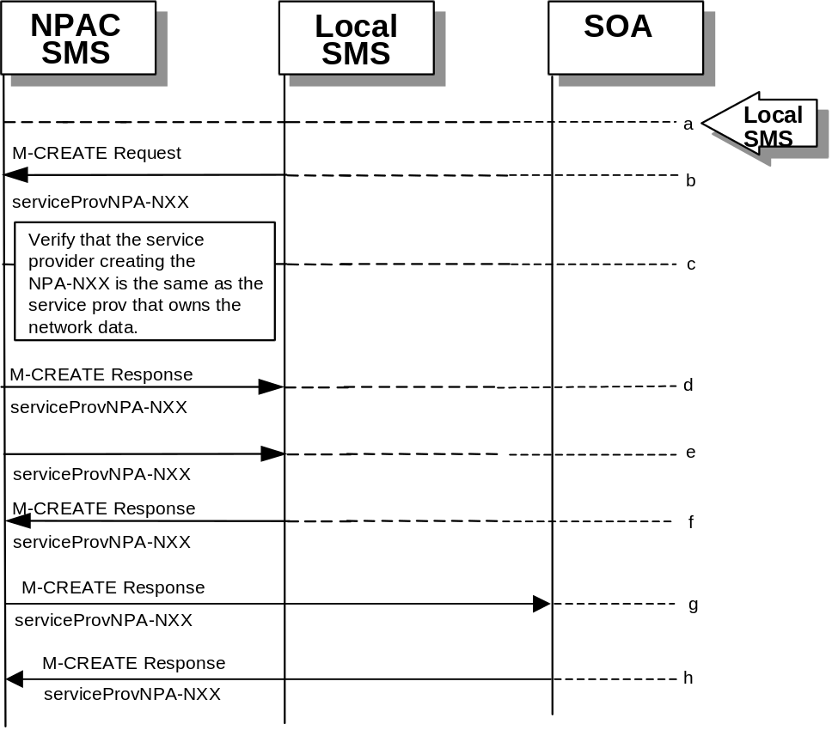
- Action is taken by the Local SMS personnel to create an NPA-NXX available for porting in their own service provider network.
- The Local SMS sends an M-CREATE request to the NPAC requesting that an NPA-NXX object be created for their own service provider network.
- The NPAC SMS verifies that the service provider creating the NPA-NXX information is the same as the service provider that owns the network data. If not, then an access denied M-CREATE accessDenied Error Response is returned.
- The NPAC SMS responds by sending an M-CREATE response to the Local SMS that initiated the request indicating whether the serviceProvNPA-NXX object was created successfully.
- If the serviceProvNPA-NXX object was created, the NPAC SMS sends an M-CREATE request to all Local SMS(s) for the serviceProvNPA-NXX object.
- The Local SMS(s) responds by sending an M-CREATE Response indicating whether the serviceProvNPA-NXX object was created successfully.
- If the serviceProvNPA-NXX object was created, the NPAC SMS sends an M-CREATE request to all SOA(s) for the serviceProvNPA-NXX object.
- The SOA(s) responds by sending an M-CREATE Response indicating whether the serviceProvNPA-NXX object was created successfully.

1.2.1.4

NPA-NXX Creation by the SOA
In this scenario, the SOA creates a new NPA-NXX for its own service provider network data.
- Action is taken by the SOA personnel to create an NPA-NXX available for porting in their own service provider network.
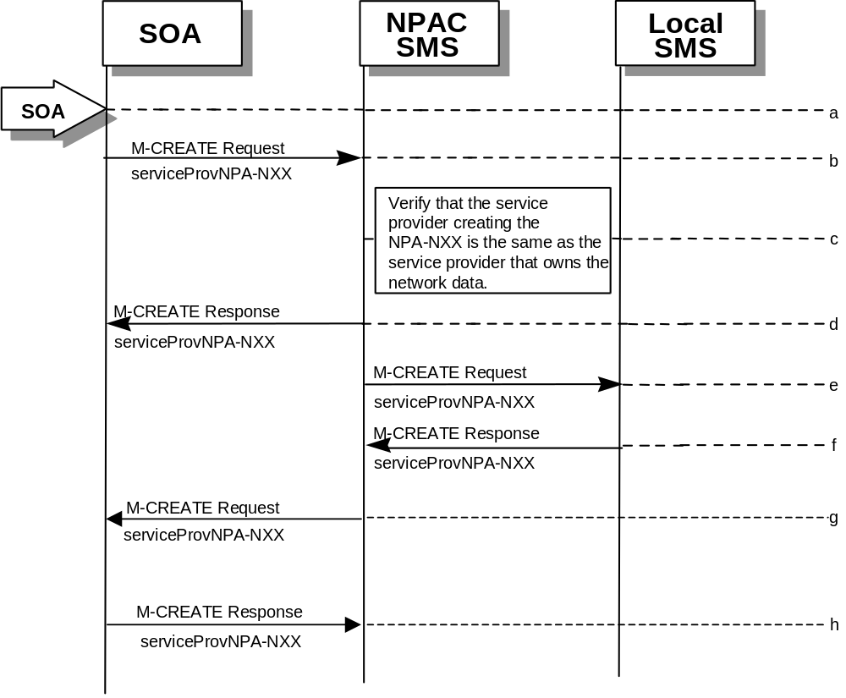
- The SOA sends an M-CREATE request to the NPAC requesting that an NPA-NXX object be created for their own service provider network.
- The NPAC SMS verifies that the service provider creating the NPA-NXX information is the same as the service provider that owns the network data. If not, then an access denied M-CREATE response is returned to the SOA that initiated the request.
- The NPAC SMS sends an M-CREATE response back to the SOA for the serviceProvNPA-NXX object.
- The NPAC SMS sends an M-CREATE request to all Local SMS(s) for the serviceProvNPA-NXX object.
- The Local SMS(s) responds by sending an M-CREATE response indicating whether the serviceProvNPA-NXX object was created successfully.
- The NPAC SMS sends an M-CREATE request to all SOA(s) for the serviceProvNPA-NXX object.
- The SOA(s) responds by sending an M-CREATE response indicating whether the serviceProvNPA-NXX object was created successfully.

1.2.1.5

NPA-NXX Deletion by the Local SMS
In this scenario, the Local SMS deletes an NPA-NXX in its own service provider network data.
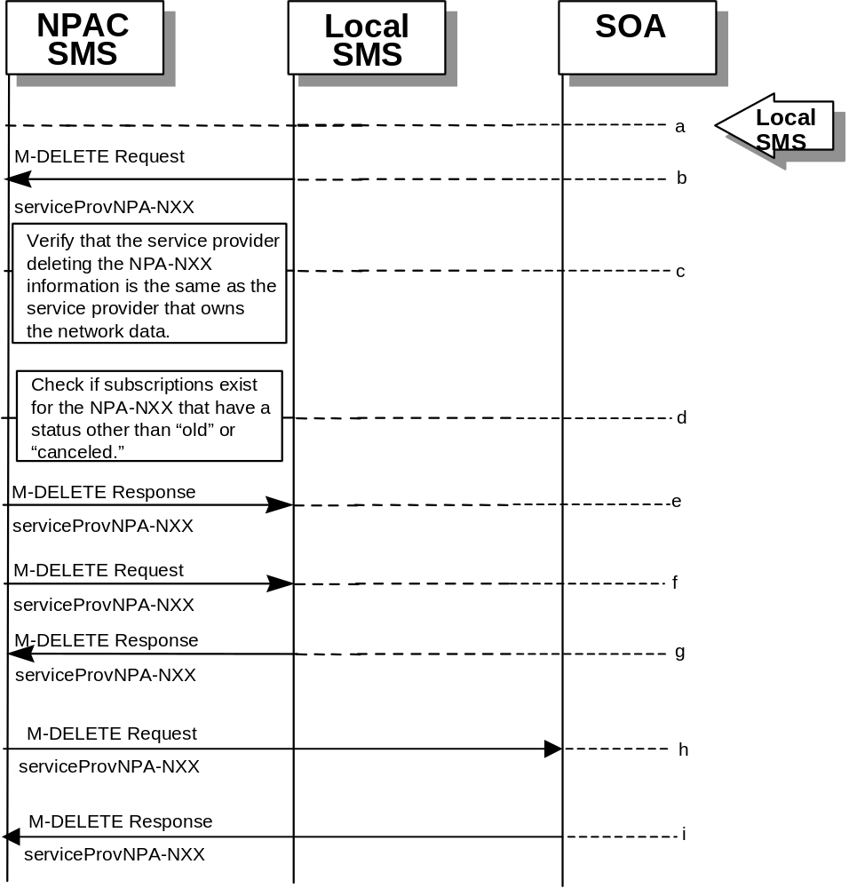
- Action is taken by the Local SMS personnel to delete an NPA-NXX for their own service provider network data.
- The SMS sends an M-DELETE request to the NPAC SMS requesting that an NPA-NXX object be deleted for their own service provider.
- The NPAC SMS verifies that the service provider that owns the NPAC-NXX information to be deleted is the same as the service provider that owns the network data. If not, then an M-DELETE accessDenied error response is returned.
- Check the subscriptions database to see if subscriptions exist with this LRN that have a status other than “old” or canceled.” If so, terminate processing at this point.
- The NPAC SMS responds by sending an M-DELETE response indicating whether the serviceProvNPA-NXX object was deleted successfully.
- If the serviceProvNPA-NXX object was deleted, the NPAC SMS sends an M-DELETE request to all Local SMS(s) for the serviceProvNPA-NXX object.
- The Local SMS(s) responds by sending an M-DELETE response indicating whether the serviceProvNPA-NXX object was deleted successfully.
- If the serviceProvNPA-NXX object was deleted, the NPAC SMS sends an M-DELETE request to all SOA(s) for the serviceProvNPA-NXX object.
- The SOA(s) responds by sending an M-DELETE response indicating whether the serviceProvNPA-NXX object was deleted successfully.

1.2.1.6 NPA-NXX Deletion by the SOA
In this scenario, the SOA deletes a new NPA-NXX for its own service provider network data.
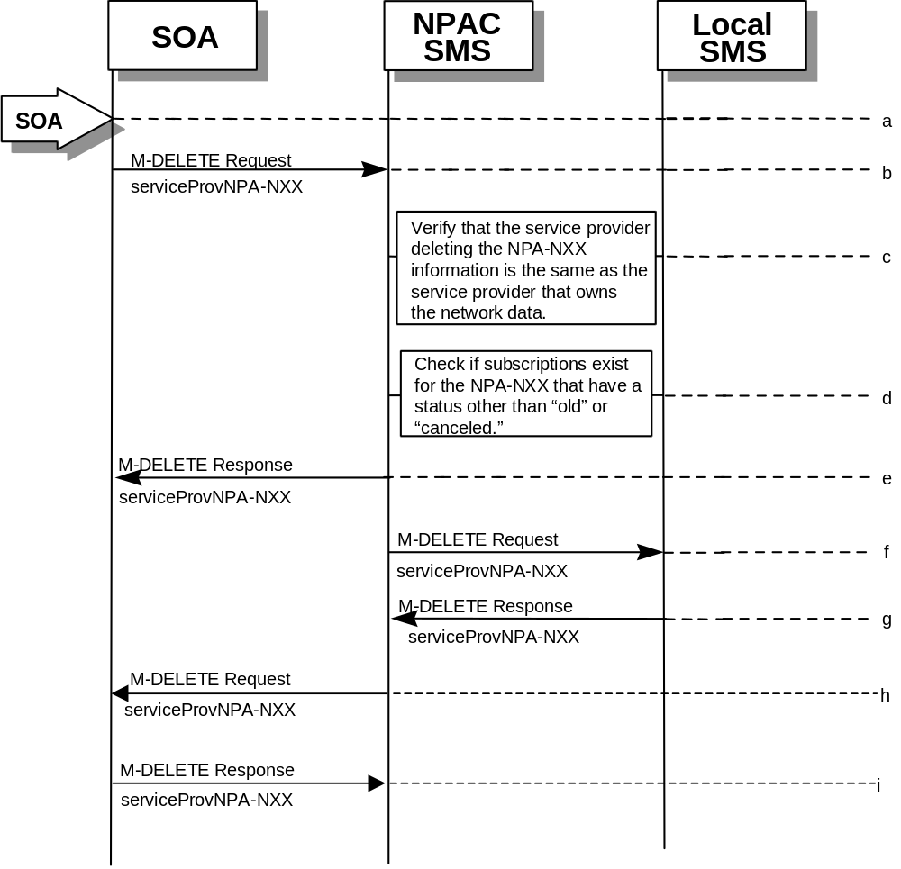
- Action is taken by the SOA personnel to delete an NPA-NXX for their own service provider network data.
- The SOA sends an M-DELETE request to the NPAC SMS requesting that an NPA-NXX object be deleted for their own service provider.
- The NPAC SMS verifies that the service provider that owns the NPA-NXX information to be deleted is the same as the service provider that owns the network data. If not, then an M-DELETE accessDenied Error Response is returned.
- Check the subscriptions database to see if subscriptions exist with this NPA-NXX that have a status other than “old” or “canceled.” If so, terminate processing at this point.
- The NPAC SMS responds by sending an M-DELETE response indicating whether the serviceProvNPA-NXX object was deleted successfully.
- The NPAC SMS sends an M-DELETE request to all Local SMS(s) for the serviceProvNPA-NXX object.
- The Local SMS(s) respond by sending an M-DELETE response indicating whether the serviceProvNPA-NXX object was deleted successfully. LRN Scenarios.
- The NPAC SMS sends an M-DELETE request to all SOA(s) for the serviceProvNPA-NXX object.
- The SOA(s) respond by sending an M-DELETE response indicating whether the serviceProvNPA-NXX object was deleted successfully. LRN Scenarios.

1.2.2

LRN Scenarios

1.2.2.1 LRN Creation by the NPAC
In this scenario, the NPAC SMS creates an LRN for an LNP serviceProvNPA-NXX.
- Action is taken by the NPAC personnel to create an LRN for an existing service provider.
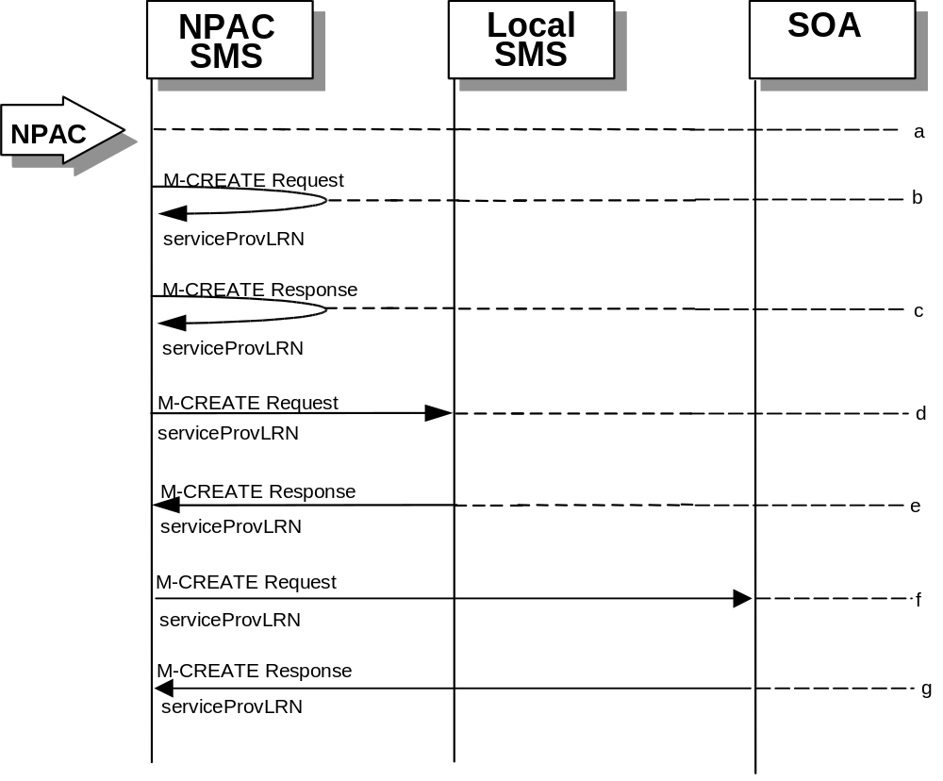
- The NPAC SMS sends an M-CREATE request to itself in order to create a local serviceProvLRN object.
- The NPAC SMS receives the M-CREATE response indicating whether the serviceProvLRN object was created successfully.
- If the serviceProvLRN object was created, the NPAC SMS sends an M-CREATE request to all Local SMS(s) for the serviceProvLRN object.
- The Local SMS(s) responds by sending an M-CREATE response indicating whether the serviceProvLRN object was created successfully.
- If the serviceProvLRN object was created, the NPAC SMS sends an M-CREATE request to all SOA(s) for the serviceProvLRN object.
- The SOA(s) responds by sending an M-CREATE response indicating whether the serviceProvLRN object was created successfully.

1.2.2.2

LRN Creation by the SOA
In this scenario, the SOA creates an LRN for its own service provider network data.
- Action is taken by the SOA personnel to create an LRN for their own network data.
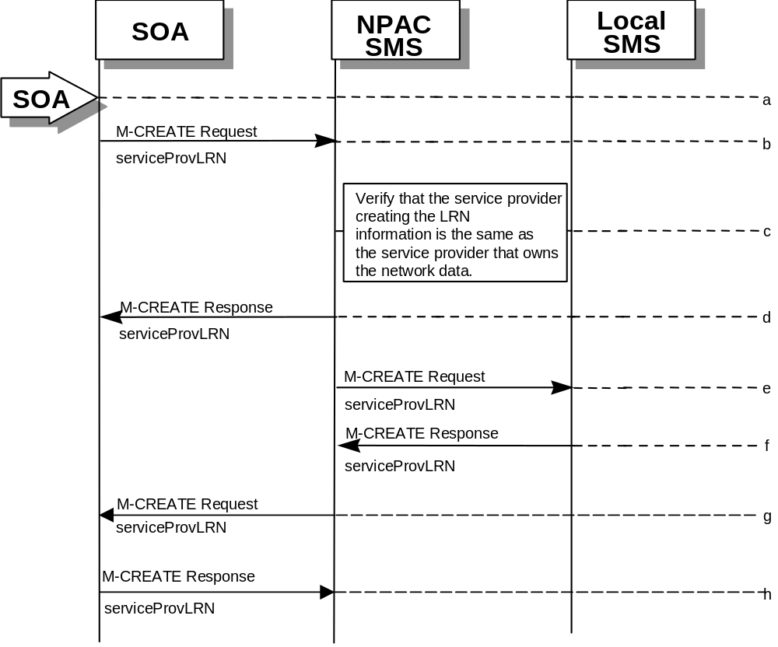
- The SOA sends an M-CREATE request to the NPAC SMS requesting that an LRN object be created for their own network data.
- The NPAC SMS verifies that the service provider creating the LRN information is the same as the service provider that owns the service provider network data. If not, then an accessDenied M-CREATE Error Response is returned.
- The NPAC SMS responds by sending an M-CREATE response back to the SOA that initiated the request, indicating whether the serviceProvLRN object was created successfully.
- The NPAC SMS sends an M-CREATE request to all Local SMS(s) for the serviceProvLRN object.
- The Local SMS(s) respond by sending an M-CREATE response indicating whether the service provider LRN object was created successfully.
- The NPAC SMS sends an M-CREATE request to all SOA(s) for the serviceProvLRN object.
- The SOA(s) respond by sending an M-CREATE response indicating whether the service provider LRN object was created successfully.

1.2.2.3

LRN Deletion by the SOA
In this scenario, the SOA deletes an LRN for their own service provider network data.
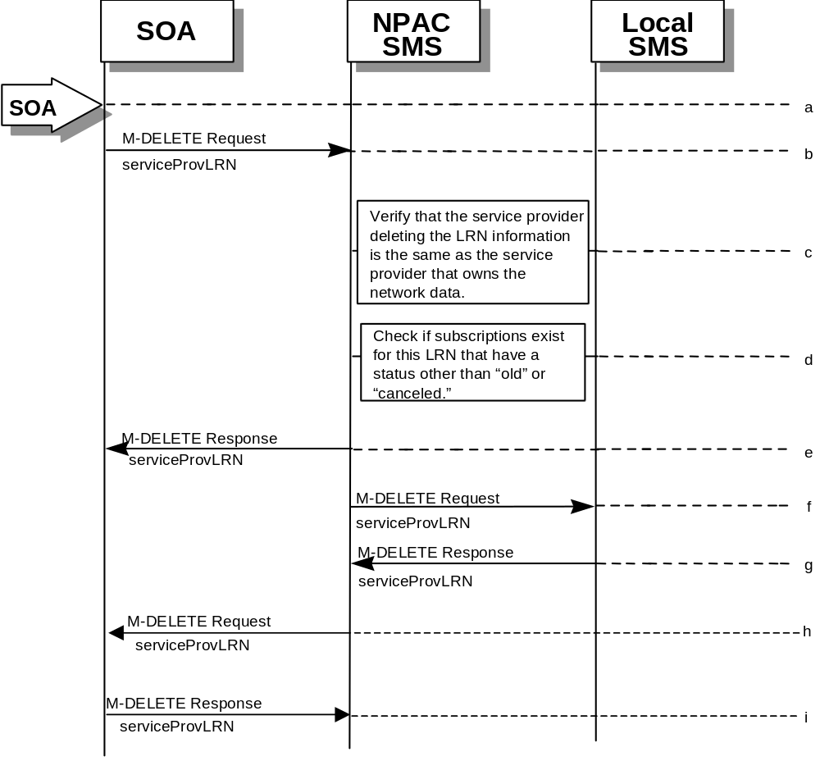
- Action is taken by the SOA personnel to delete an LRN for their own network data.
- The SOA sends an M-DELETE request to the NPA requesting that an LRN object be deleted.
- The NPAC SMS verifies that the service provider deleting the LRN information is the same as the service provider that is associated with the network data. If not, then an accessDenied M-DELETE error response is returned.
- Check the subscriptions database to see if subscriptions exist with this LRN that have a status other than “old” or “canceled.” If so, an M-SET error response complexity limitation is returned.
- The NPAC SMS responds by sending an M-DELETE response indicating whether the serviceProvLRN object was deleted successfully.
- The NPAC SMS sends an M-DELETE request to all Local SMS(s) for the serviceProvLRN object.
- The Local SMS(s) responds by sending a message indicating whether the serviceProvLRN object was deleted successfully.
- The NPAC SMS sends an M-DELETE request to all SOA(s) for the serviceProvLRN object.
- The SOA(s) responds by sending a message indicating whether the serviceProvLRN object was deleted successfully.

1.2.2.4

LRN Query by the SOA
In this scenario, the SOA queries LRN data.
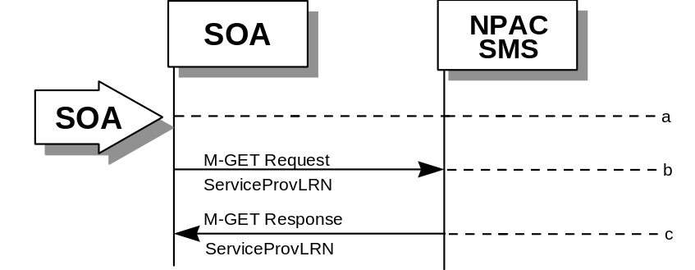
- Action is taken by SOA personnel to an LRN for a specified service provider.
- The SOA sends an M-GET request to the NPAC SMS for the serviceProvLRN object.
- The NPAC SMS responds by sending an M-GET response containing the data back to the SOA.

1.2.2.5

LRN Deletion by the NPAC
In this scenario, the NPAC SMS deletes an LRN for an LNP serviceProvNPA-NXX.
- Action is taken by the NPAC SMS personnel to delete an LRN for a service provider.
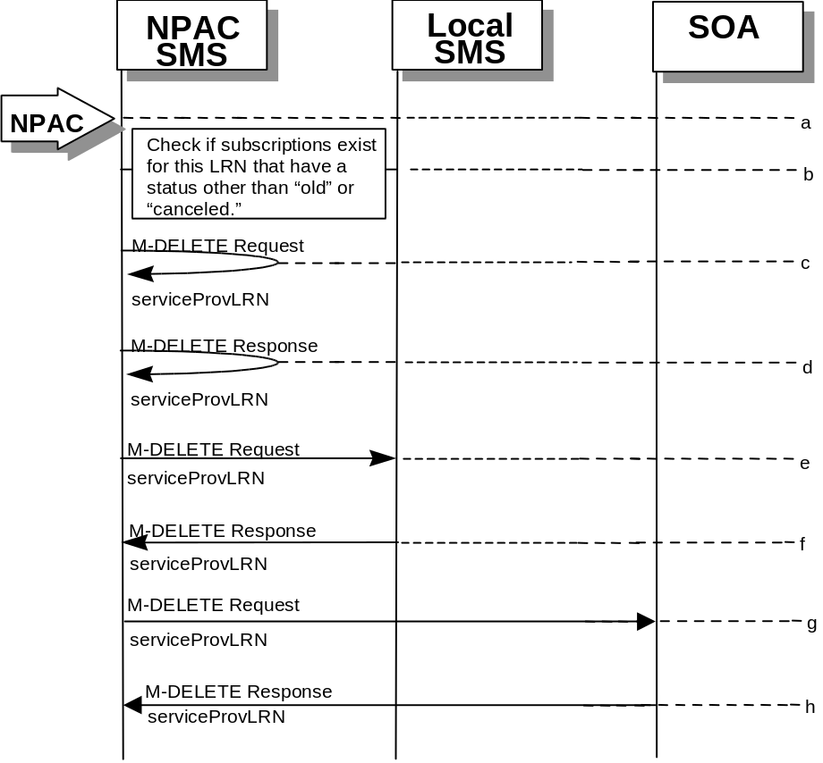
- Check the subscriptions database to see if subscriptions exist with this LRN that have a status other than “old” or “canceled.” If so, terminate processing at this point.
- The NPAC SMS sends an M-DELETE request to itself in order to delete the local serviceProvLRN object.
- The NPAC SMS receives the M-Delete response indicating whether the serviceProvLRN object was deleted successfully.
- If the serviceProvLRN object was deleted, the NPAC SMS sends an M-DELETE request to all Local SMS(s) for the serviceProvLRN object.
- The Local SMS(s) responds by sending an M-Delete response indicating whether the serviceProvLRN object was deleted successfully.
- If the serviceProvLRN object was deleted, the NPAC SMS sends an M-DELETE request to all SOA(s) for the serviceProvLRN object.
- The SOA(s) responds by sending an M-Delete response indicating whether the serviceProvLRN object was deleted successfully.

1.2.2.6

LRN Creation by the Local SMS
In this scenario, the Local SMS creates an LRN for its own service provider network data.
- Action is taken by the Local SMS personnel to create an LRN for their own network data.
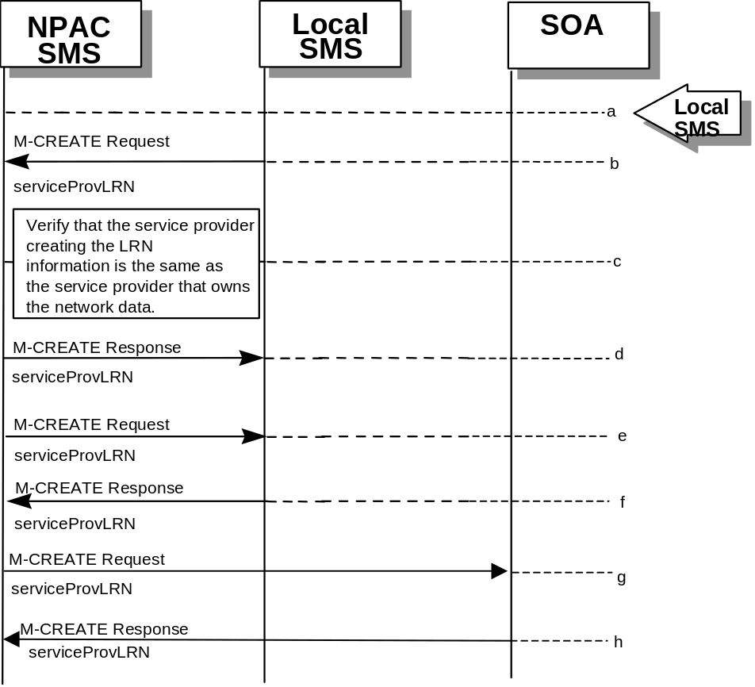
- The SMS sends an M-CREATE request to the NPAC requesting that an LRN object be created for their own network data.
- The NPAC verifies that the service provider creating the LRN information is the same as the service provider that owns the service provider network data. If not, then an accessDenied M-CREATE error response is returned.
- The NPAC SMS responds by sending an M-CREATE response back to the Local SMS that initiated the request, indicating whether the serviceProvLRN object was created successfully.
- If the serviceProvLRN object was created, the NPAC SMS sends an M-CREATE request to all Local SMS(s) for the serviceProvLRN object.
- The Local SMS(s) responds by sending an M-CREATE response indicating whether the serviceProvLRN object was created successfully.
- If the serviceProvLRN object was created, the NPAC SMS sends an M-CREATE request to all SOA(s) for the serviceProvLRN object.
- The SOA(s) responds by sending an M-CREATE response indicating whether the serviceProvLRN object was created successfully.

1.2.2.7

LRN Deletion by the Local SMS
In this scenario, the Local SMS deletes an LRN for their own service provider network data.
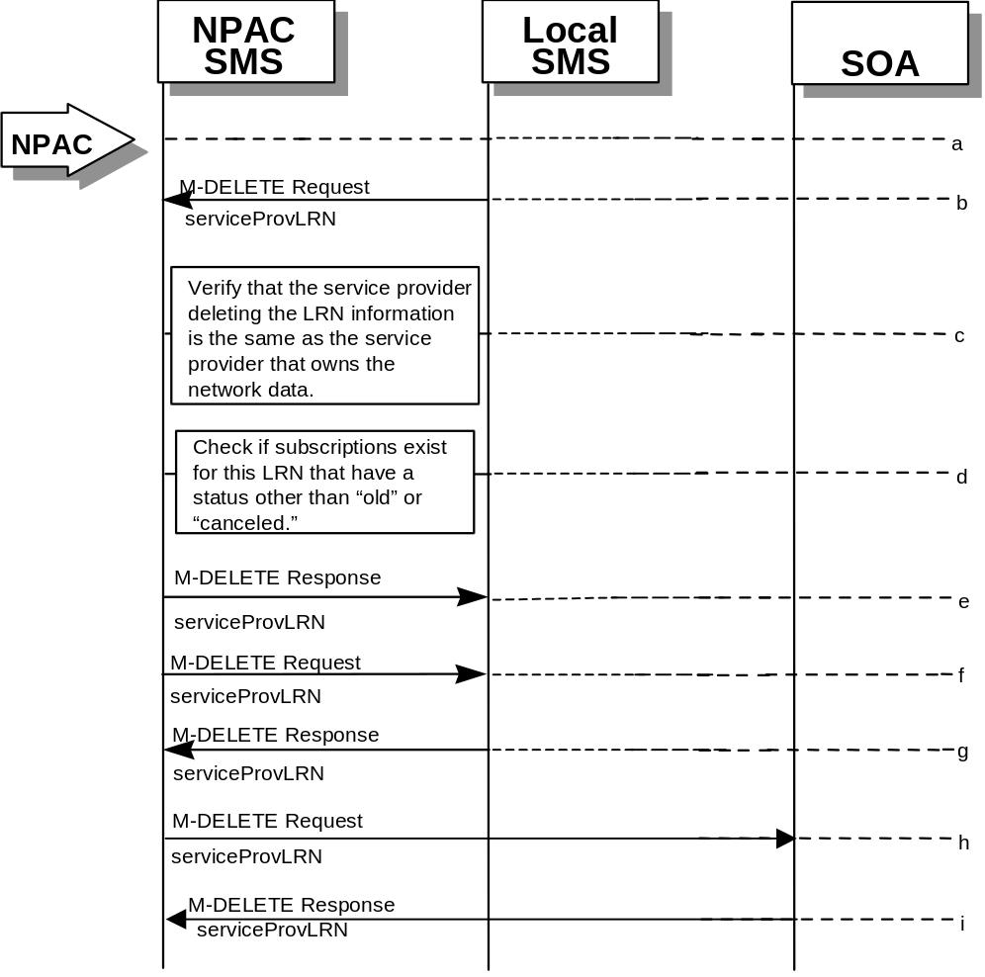
- Action is taken by the Local SMS personnel to delete an LRN for their own network data.
- The Local SMS sends an M-DELETE request to the NPAC requesting that an LRN object be deleted.
- The NPAC SMS verifies that the service provider deleting the LRN information is the same as the service provider that is associated with the network data. If not, then an accessDenied M-DELETE Error Response is returned.
- Check the subscriptions database to see if subscriptions exist with this LRN that have a status other than “old” or “canceled.” If so, an M-SET Error Response complexity limitation is returned.
- The NPAC SMS responds by sending an M-DELETE response indicating whether the serviceProvLRN object was deleted successfully.
- If the serviceProvLRN object was deleted, the NPAC SMS sends an M-DELETE request to all Local SMS(s) for the serviceProvLRN object.
- The Local SMS(s) responds by sending a message indicating whether the serviceProvLRN object was deleted successfully.
- If the serviceProvLRN object was deleted, the NPAC SMS sends an M-DELETE request to all SOA(s) for the serviceProvLRN object.
- The SOA(s) responds by sending a message indicating whether the serviceProvLRN object was deleted successfully.

1.3 Miscellaneous

1.3.1 Sequencing of Events on Initialization/Resynchronization of Local SMS
If the resynchronization flag is TRUE upon association establishment, the NPAC SMS will hold updates to the Local SMS until the flag is turned off. At that time all updates issued since the association establishment will be sent.
If any of the requests in this scenario fail, the Local SMS must correct the problem - retry the action instead of continuing.

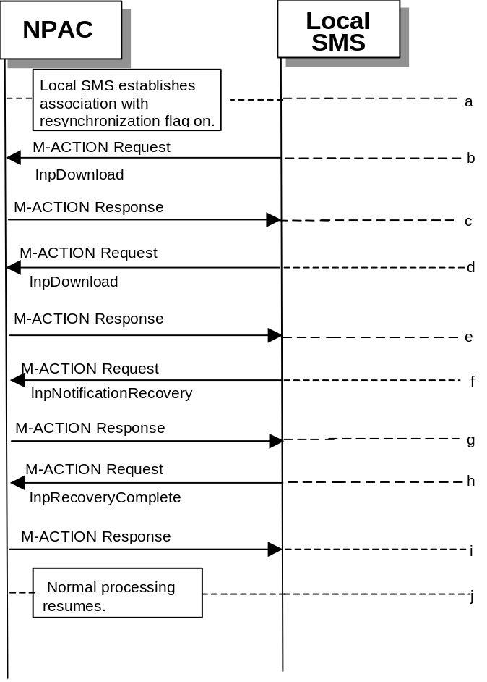

- Local SMS establishes association with resynchronization flag on.
- Local SMS sends M-ACTION to start network data download. The Local SMS specifies the start time.
- NPAC SMS responds to M-ACTION with updates.
- Local SMS sends M-ACTION to start subscription data download. The Local SMS specifies the start time.
- NPAC SMS responds to M-ACTION with subscription version updates.
- Local SMS sends M-ACTION to recovery notifications by time range.
- NPAC SMS responds to M-ACTION with notification updates.
- Local SMS sends M-ACTION to set resynchronization flag off.
- NPAC SMS replies with data updates since association establishment.
- Normal processing resumes.

1.3.2

Sequencing of Events on Initialization/Resynchronization of SOA
If the resynchronization flag is TRUE upon association establishment, the NPAC SMS will hold updates to the SOA until the flag is turned off. At that time all updates issued since the association establishment will be sent.
If any of the requests in this scenario fail, the SOA must correct the problem - retry the action instead of continuing.

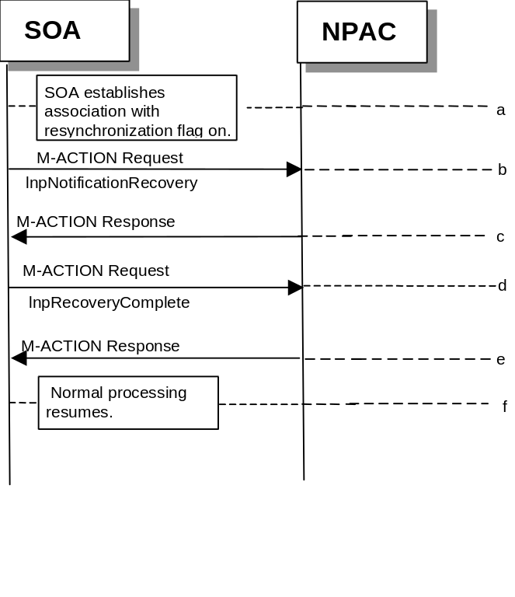
- SOA establishes association with resynchronization flag on.
- SOA sends M-ACTION to recovery notifications by time range.
- NPAC SMS responds to M-ACTION with notification updates.
- SOA sends M-ACTION to set resynchronization flag off.
- NPAC SMS replies with data updates since association establishment.
- Normal processing resumes.

